Apache OpenOffice
Version 4.1
Draw Guide

AOO Documentation Team

Copyright
This document is Copyright © 2025 by The Apache Software Foundation. You may distribute it and/or modify it under the terms of the Creative Commons Attribution License, version 3.0 or later (https://creativecommons.org/licenses/by/3.0/).
Apache, Apache OpenOffice, and OpenOffice.org are trademarks of the Apache Software Foundation. Used with permission.
Acknowledgments
This book is updated from a previous version by the OOoAuthors team. The AOO Documentation Team appreciates the many contributions of Michael Scarborough and Michele Petrovsky.
Publication date and software version
Published December 20, 2025. Based on Apache OpenOffice 4.1.
Note for Mac Users
Some keystrokes and menu items differ on a Mac from those used in Windows and Linux. The table below gives some common substitutions for the instructions in this chapter. For a more detailed list, see the application Help.

Windows/Linux | Mac equivalent | Effect
Tools > Options menu selection | OpenOffice > Preferences | Access setup options
Right-click | Control+click | Open context menu
Ctrl (Control) | z (Command) | Used with other keys
F5 | Shift+z+F5 | Open the Navigator
F11 | z+T | Open Styles & Formatting window

Contents
Chapter 1
Introducing Draw 9
Introduction 10
The Draw Workplace 11
Rulers 11
Status Bar 12
Toolbars and the Sidebar 13
Standard Toolbar 14
Drawing Tools 14
Line and Filling Tools 15
Text Formatting Toolbar 16
Color Bar 17
Choosing a color palette 17
Options Toolbar 18
Drawing Grid and Guides 19
Floating and Moving Toolbars 20
Customizing Toolbars 21
Quick Printing 22
Controlling Printing 22
Selecting General Printing Options 23
Printing Multiple Pages on a Single Sheet of Paper 23
Selecting Pages to Print 24
Printing a Brochure 24
Printing in Black and White (on a Color Printer) 25
Exporting to PDF 26
Quick Export to PDF 26
Controlling PDF Content and Quality 26
Exporting to Other Formats 26
Exporting Draw Documents as Web Pages 27
E-mailing Documents 27
Chapter 2
Drawing Basic Shapes 28
Creating Simple Drawings 29
Drawing Basic Shapes 29
Drawing a Straight Line 29
Drawing an Arrow 31
Drawing Lines and Arrows 31
Drawing a Rectangle or Square 32
Drawing Ellipses (Ovals) and Circles 33
Adding Ellipse and Arc Tools to the Drawing Toolbar 33
Curves 35
Gluepoints and Connectors (Basics) 36
Gluepoints 36
Connectors 36
Drawing Geometric Shapes 37
Basic Shapes 38
Symbol Shapes 38
Block Arrows 38
Flowcharts 39
Callouts 39
Stars and Banners 39
Adding Text to Objects 39
Using Dynamic Text Frames 39
Using Text Elements in Draw Objects 41
Chapter 3
Working with Objects and Object Points 42
Introduction 43
Selection Modes 43
Changing the Selection Mode 44
Selecting Objects 44
Direct Selection 44
Selection by Framing 44
Selecting Hidden Objects 45
Arranging Objects 45
Moving and Dynamically Adjusting an Object’s Size 45
Dynamic Movement of Objects 46
Dynamic Size Modification of Objects 46
Dynamic Size Modification of Objects with the Help of the Status Bar 47
Modifying an Arc 47
Rotating and Shearing an Object Using the Mouse 48
Rotating 48
Changing Inclination or Perspective 49
Setting Size and Position Exactly 50
Position and Size 50
Rotating Objects 51
Slant and Corner Radius 51
Editing Object Points 52
Another Way to Change the Form of Basic Shapes 52
How Curves Work 53
The Edit Points Toolbar 54
The Three Kinds of Tangent 54
Examples 55
Chapter 4
Changing Object Attributes 59
Toolbars and Menus 60
Line and Filling Tools 60
Text Formatting Toolbar 61
The Context Menu 61
Editing Lines and Borders 62
Common Line Properties 63
Drawing Arrows 64
Line Shadows 65
Customizing Line and Arrow Styles 65
Customizing Line Styles 65
Customizing Arrow Styles 66
Editing the Inside (Fill) of an Object 68
Common Fill Properties 68
Fill with a uniform color 68
Fill with a Gradient 69
Fill with a Line Pattern or an Image 70
Adding a Shadow to an Area 70
Advanced Area Fill Options 70
Creating Your Own Fill Color 70
Creating Your Own Gradient 71
Creating Your Own Hatching (Line Pattern) 72
Creating Your Own Bitmap Fill 73
Customizing Shadows 74
Adding Transparency 75
Using Styles 76
Creating a New Style 77
Applying a Style 78
Special Effects 78
Rotating an Object 78
Flip an Object 79
Mirror Copies 79
Distorting an Image 80
Distort an Object 80
Set in Circle (Perspective) 80
Set to Circle (Slant) 81
Dynamic Gradients 82
Chapter 5
Combining Multiple Objects 84
Introduction: Grouping and Combining Objects 85
Grouping Objects 85
Grouping by Common Selection 85
Maintaining Groups and Undoing Groups 85
Editing Individual Objects in a Group 86
Nesting Groups 86
Combining Objects 86
Connecting Lines 87
Merging, Subtracting, or Intersecting Shapes 87
Merge 88
Subtract 88
Intersect 88
Practical Example 88
Aids for Positioning Objects 89
Moving an Object to the Front or to the Back 89
Aligning Objects 91
Distributing the Distance and Space Between Objects 92
Chapter 6
Editing Pictures (Raster Graphics) 94
Introduction 95
Importing Raster and Vector Graphics 95
Link or Embed? 95
Scanning 96
Pasting from the Clipboard 97
Dragging and Dropping 97
Inserting from a File 97
Exporting Graphics 98
Exporting the Entire File 98
Exporting Single Objects 99
Exporting as a Vector Graphic 99
Exporting as a Raster Graphic 99
Modifying Raster Object Properties 101
The Picture (Editing) Toolbar and Graphic Pane 101
Cropping 104
The Graphic Filter Toolbar 105
Changing Colors Using the Color Replacer 108
Practical Example: Changing Wrong Colors to Transparency 108
Effect of the Tolerance Parameter 109
Color Depth 110
Reducing color depth 110
Conversion 111
Convert to a Contoured Image 111
Convert to a Polygon 112
Number of Colors 112
Point Reduction 112
Fill Holes 113
Convert to Bitmap 115
Print Options with Raster Graphics 116
Chapter 7
Working with 3D Objects 118
Creating 3D Objects 119
Creating 3D Bodies 119
Variation 1: Extrusion 119
Variation 2: Body Rotation 119
Variation 3: Using Ready-made Objects 120
3D Scenes 121
Producing 3D Shapes 121
Variation 4: Extrusion of Basic Shapes 121
Variation 5: Fontwork 122
Editing 3D Objects 123
Rotating 3D Objects 123
Procedure for 3D bodies 123
Procedure for 3D Shapes 124
3D settings for 3D Bodies 124
3D Effects Dialog – General Buttons 124
3D Effects - Geometry 126
3D Effects - Shading 130
3D Effects - Illumination 133
3D Effects - Textures 135
3D Effects - Material 138
3D Settings for 3D Shapes 139
Combining Objects in 3D Scenes 141
Examples for Your Own Experiments 143
Chapter 8
Tips and Tricks 145
Positioning Objects with Zoom 146
Zoom adjustments using the status bar 146
The Zoom Toolbar 147
Positioning Objects with Snap Functions 147
Snap to Grid 148
Showing the Grid 148
Changing the Color of the Grid Points 148
Configuring the Grid 148
Snap to Snap Objects (Snap Lines and Snap Points) 150
Inserting a Snap Line with the Mouse 150
Inserting Snap Points and Snap Lines Using Coordinates 151
Editing Snap Points and Snap Lines 151
Snap to Page Margin 151
Snap to Object Frame 152
Snap to Object Points 152
Help to Position Objects with Guiding Lines 152
Drawing to Scale 153
Splitting Drawings on Multiple Layers 153
An Example Drawing: House Plan and Furniture 155
Changing the Layer of a Drawing Object 157
Creating a Multi-page Document 157
Using the Pages Area 158
Using Page Backgrounds 158
Creating a Page Background 159
Assigning and Managing Page Backgrounds 159
Color Palette: Adding or Changing Single Colors 160
Changing Colors Using the Color Dialog 163
Creating Cool Effects 164
Duplication 164
Cross-fading 165
Which Object Goes in Front? 165
Chapter 9
Organization Charts, Flow Diagrams, and More 167
Drawing an Organization Chart 168
Drawing a Flow Diagram 170
Glue Points and Connectors 172
The Connector Toolbar 173
Drawing Connectors—Basics 173
Editing Glue Points 174
Adding Text to Connectors 176
Adjusting Text to Suit the Connecting Line 178
Chapter 10
Advanced Draw Techniques 180
Drawing to Scale 181
Working with the Position and Size Dialog 181
Setting Glue Points 183
Copying Individual Pictures to the Gallery 184
Drawing a Logic Circuit Diagram Using the Gallery 185
Dimensioning a Drawing 189
Configuring the Dimensioning Style 189
Dimensioning Objects 190
Editing Dimension Lines 191
Working with Text in Draw 192
Configuring Text Elements with Styles 192
Text Animation 192
Text 192
Anchoring Text 193
Fitting Text in Frames 195
Distance From Frame 196
Text Frames and Callouts 197
Pictures and Text 199
Fontwork Gallery 199
Writer OLE Object 201
Insert 201
Editing Mode 202
Object Mode 203
Guide to Bézier Curves 204
Bézier Curves—What are They? 204
Direct Drawing of a Bézier Curve 205
Point Mode of the Bézier Curve 206
Drawing a Succession of Bézier Curves 206
Adjusting the Curve Shape 206
Transition Points 207
Changing Point Types 207
Closing the Curve 208
Transformation Between Straight Line and Bézier Curve 208
Transform a Straight Segment into a Bézier Curve 208
Transform a Bézier Curve into a Straight Segment 208
Transform Complete Curves, Polylines, and Polygons 209
Transform a Polygon or a Polyline into a Curve 209
Transform a Curve into a Polygon or a Polyline 209
Freehand Lines 209
Combining Closed Curves 209
Connecting Curves 210
Adding Comments to a Drawing 210
Connecting and Breaking Lines 211

Chapter 1
Introducing Draw
Drawing Vector Graphics in OpenOffice

Introduction
Draw is a vector graphics drawing tool. That means it represents shapes and groups of such objects differently than do “paint” programs. The advantage of vector graphics or drawing is that multiple elements can be manipulated independently of each other. Also, vector graphics make it easier to render objects at different sizes and to transform them in other ways without worrying about image resolution. Additionally, Draw can perform certain operations on raster graphics, which are images based on pixels. Using Draw, you can quickly create a wide variety of graphical images.
Note | For 'raster', read 'a video display that is covered by sweeping the electron beam of the display in a series of horizontal lines from top to bottom'. For 'pixel', read 'The smallest resolvable rectangular area of an image, either on a screen or stored in memory. Each pixel in a monochrome image has its own brightness, from 0 for black to the maximum value (e.g., 255 for an eight-bit pixel) for white. In a color image, each pixel has its own brightness and color, usually represented as a triple of red, green, and blue 'intensities'.
Vector graphics store and display a picture as simple geometric elements such as lines, circles, and polygons rather than as a collection of pixels (points on the screen). This permits more efficient storage and supports precise scaling of the picture elements.
Draw is fully integrated into the OpenOffice suite. This simplifies exchanging graphics with all components of the suite. For example, if you create an image in Draw, reusing it in a Writer document is as simple as copying and pasting the image. You can also work with drawings directly from within Writer or Impress, using a subset of the functions and tools from Draw.
Draw’s functionality is extensive, and although it was not designed to rival high-end graphics applications, it possesses many more features than do the drawing tools generally found in most office productivity suites.
A few examples of drawing functions are:
- layer management: layers influence visibility when printing or editing
- a grid point system that can aid alignment by automatically aligning nearby objects to the grid
- the display of dimensions and measurements
- supplying connectors for such things as organization charts
- 3D functions that enable small three-dimensional drawings to be created, and to include texture and lighting effects
- drawing and page-style integration
- Bézier curves, that is, a parametric curve governed by a set of discrete control points.
The Draw Guide is not a course book to be worked through from beginning to end. Rather, it is a reference work that allows you to browse for guidance on specific topics.
This document describes only the functions associated with Draw. Some concepts, such as file management or the way the OpenOffice environment works, are mentioned only briefly; they are covered in more detail in the Getting Started guide.

The Draw Workplace
The main components of the Draw interface are shown in Figure 1.
The large area in the center of the window is where you make drawings. If you like, you can surround the drawing area with toolbars and information areas. The number and position of the visible tools vary depending on the task at hand and user preferences. Therefore, your setup may look different. For example, many users put the main Drawing toolbar on the left-hand side of the workspace—not at the bottom, as shown here.
You can split drawings in Draw over several pages. Multi-page drawings are used mainly for presentations. The Pages pane, on the left side of the Draw window in Figure 1, gives an overview of the pages you create. If the Pages pane is not visible on your setup, you can enable it from the View menu (View > Page Pane). To change the page order, simply drag and drop one or more pages.
In Draw, the maximum size of a drawing page is 300 cm by 300 cm, approximately 118 inches in each direction.
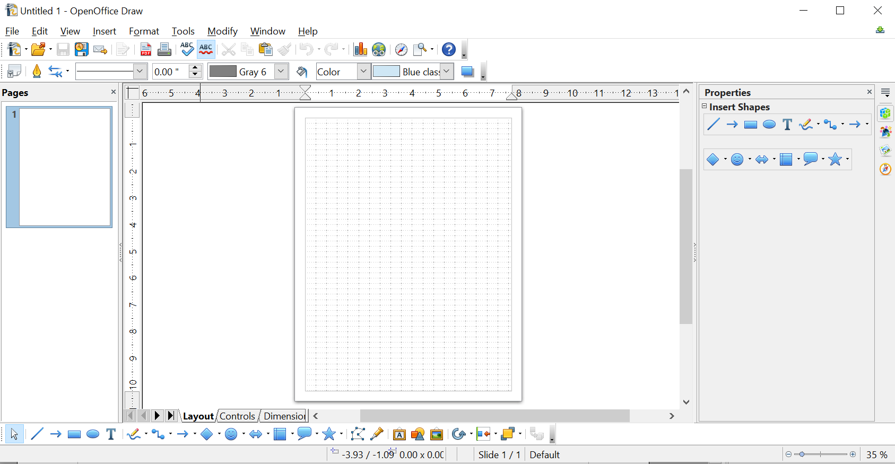

Figure 1: Initial Draw window

Rulers
You should see rulers (bars with numbers) on the upper and left-hand sides of the workspace. If they are not visible, you can enable them by selecting them from the View menu (View > Ruler).
The rulers show the size of a selected object on the page (see the gray double lines, highlighted in Figure 2). When no object is selected, they show the location of the mouse pointer, which helps to position drawing objects more accurately.
You can also use the rulers to manage object handles and guide lines, making it easier to position objects.
The page margins in the drawing area are also represented on the rulers. You can change the margins directly on the rulers by dragging them with the mouse.
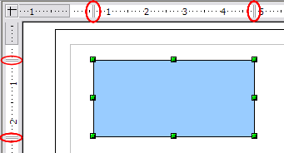Figure 2: Rulers show the size of the selected object
To modify the units of measurement of the rulers (which you can define independently), right-click on the desired ruler, as illustrated for the horizontal ruler in Figure 3.
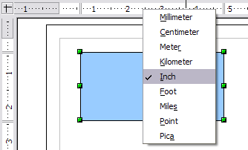Figure 3: Rulers in a drawing

Status Bar
The Status bar is located at the bottom of the Draw window and includes several Draw-specific fields, as identified in Figures 4 and 5.

Figure 4: Left end of Draw status bar

Figure 5: Right end of Draw status bar
The Information field shows the action being performed, or the object type selected.
The Position field shows different information, depending on whether objects are currently selected or not:
- When no object is selected, the left number pair shows the current position (in X,Y Cartesian coordinates) of the mouse cursor.
- While an object is being resized with the mouse, the right number pair shows the size of the object (width and height).
Note | The sizes are given in the current measurement unit (not to be confused with the ruler units). This unit is defined in Tools > Options > OpenOffice Draw > General, where you can also change the scale of the page.
- If an object is selected, the left number pair shows the X, Y coordinates of the upper-left corner, and the right number pair displays the size of the object, as seen in Figure 4. These numbers do not relate to the object itself, but to the selection outline, which is the smallest possible rectangle that can contain the visible part or parts of the object; see also Chapter 3 (Working with Objects and Object Points).
- When an object is selected, a double-click on this field opens the Position and Size dialog, which is described in detail in Chapter 4 (Changing Object Attributes).
In the Indicator field, an asterisk (*) is shown whenever any change is made to the document but not yet saved to disk.
To digitally sign the document, double-click or right-click in the Signature field to open the signature box. Note that a document must be saved at least once before it can be signed. After it is signed, an indicator is present in this field.
The Slide field shows the sequence number for the current drawing page, in addition to the total number of pages that you created so far. This is useful when your drawing has several pages. If you select an object, the field enclosed by parentheses shows the layer in which the object resides within the drawing. In the example of Figure 5, the object is on the Layout layer of Slide 1, and there is a total of one slide so far.
The Page style field shows which template is being used.
The vertical bar in the middle of the Zoom slider represents a zoom factor of 100%. To change the view magnification, drag the Zoom slider, or click on the + and – signs, or right-click on the zoom level percent to pop up a list of magnification values from which to choose. Double-click on the zoom level percent to open the Zoom & View Layout dialog.

Toolbars and the Sidebar
The tools for drawing, positioning, and adjusting the properties of objects are on several toolbars, and many are also available on the Sidebar. Which toolbars you display is a matter of preference and will depend on the particular task and the room available on your screen. Some of the most common tools are briefly described in this section.
You can display or hide the various toolbars as needed. To display or hide a toolbar, click View > Toolbars. On the menu that appears, choose which toolbars you want to display.
You can also select the icons that you wish to appear on the toolbars, as illustrated in Figure 6. To change the visible icons on any toolbar, click the arrow at the right-hand end of that toolbar and choose Visible Buttons from the drop-down menu. Visible icons are indicated by an outline around the icon. Click on icons to hide or show them on the toolbar.

Figure 6: Selection of visible toolbar icons
The view of the Sidebar is toggled with the menu View > Sidebar. The tools in this section are found on the Properties deck, and their content depends on the kind of object that is selected in the drawing area.

Standard Toolbar
The Standard toolbar, shown in Figure 7, is the same for all OpenOffice components and is not described in detail here.
Figure 7: Standard toolbar

Drawing Tools
The Drawing toolbar shown in Figure 8 is the most important toolbar in Draw. It contains all the necessary functions for drawing various geometric and freehand shapes and for organizing them on the page. It is described in detail in Chapter 2 (Drawing Basic Shapes).
Figure 8: Drawing toolbar
Most of the tools on the Drawing toolbar are available on the Sidebar (Figure 9). If no object is selected in the drawing area, these are the only tools visible in the Sidebar.

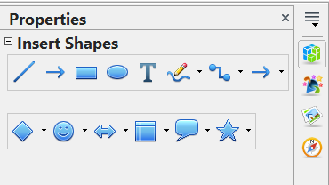Figure 9: The Insert Shapes pane on the Sidebar Properties deck.

Line and Filling Tools
The Line and Filling toolbar, like that in Figure 10, lets you modify the main properties of a drawing object: the icons and pull-down lists vary, according to the type of object selected. For example, to change the thickness of a line with the spinner, select the line, hover the mouse over the spinner, and click the up or down arrow to achieve the desired thickness.
Figure 10: Line and Filling toolbar
In the example above, the available functions enable you to change the color, style, and width of the line drawn, as well as the fill color, style, and other properties of a shape. The object must first be selected with a mouse click.
When a line or shape is selected, the Sidebar Area and Line panes display the tools shown in Figure 11. In addition to the tools shown on the Drawing toolbar, there are tools controlling the transparency of the area and the corner and cap styles of lines.

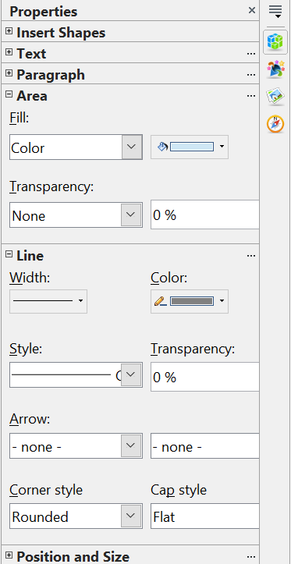Figure 11: The Area and Line panes of the Sidebar

Text Formatting Toolbar
When text is selected, the Line and Filling toolbar changes to the Text Formatting toolbar, shown in Figure 12, which is very similar to the Formatting toolbar in Writer. A more detailed explanation of the buttons on this toolbar can be found in Chapter 4 (Changing Object Attributes).

Figure 12: Text Formatting toolbar
The same tools are available on the Text and Paragraph panes of the Sidebar, as shown in Figure 13, with some additional options, such as adjusting the spacing above and below paragraphs.

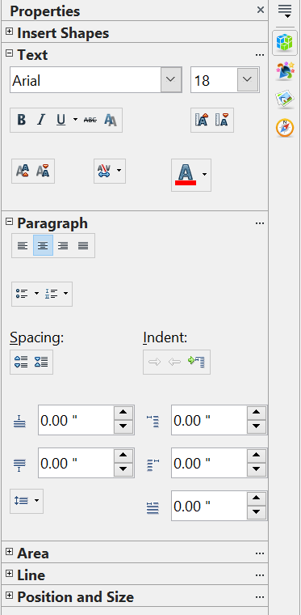Figure 13: The Text and Paragraph panes of the Sidebar

Color Bar
To display the Color bar, use View > Toolbars > Color Bar. The toolbar then appears at the bottom of the workspace, displaying the current color palette.
Figure 14: Color bar
This toolbar, as illustrated in Figure 14, lets you rapidly choose the color of the various objects (lines, areas, and 3D effects) in your drawing. The first box in the panel corresponds to transparency, that is, no color. The same color choices can be made in the Sidebar using the color drop-down lists in the Area and Line panes, as shown in Figure 11.

Choosing a color palette
You can access several specialized color palettes in Draw and customize individual colors to your own taste. This is done using the Area dialog, which can be opened by choosing Format > Area, clicking the pouring can icon on the Line and Filling toolbar (Figure 10), or clicking the three dots at the top right of the Sidebar's Area pane (Figure 11).
On the Area dialog, choose the Colors tab (Figure 15).
To load another palette, click on the Load Color List button (circled). The file selector dialog asks you to choose one of the standard OpenOffice palettes (files bearing the file extension *.soc). For example, web.soc is a color palette that is particularly effective for creating drawings that appear on Web pages. These colors will display correctly on workstations with screens capable of at least 256 colors.
A more detailed description of color palettes and their options can be found in Chapter 8 (Tips and Tricks).
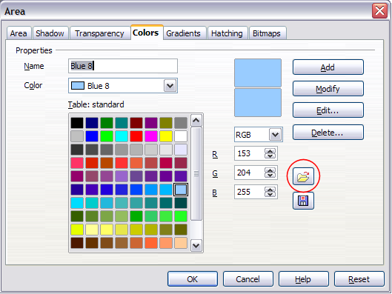
Figure 15. Changing the color palette

Options Toolbar
The Options toolbar, shown in Figure 16, lets you activate or deactivate various drawing aids. The Options Bar is not one of the toolbars displayed by default. To display it, select View > Toolbars > Options. These tools are not available on the Sidebar.
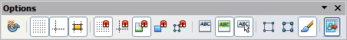
Figure 16: Options toolbar
The options are described in the table below and in greater detail in other chapters of the Draw Guide.
Table 1: Functions on the Options toolbar
Icon | Function
 | Rotation mode after clicking object
 | Display (or hide) the grid
 | Display (or hide) the guides
 | Display (or hide) guides when moving
 | Snap to grid
 | Snap to guides
 | Snap to page margins
 | Snap to object borders
 | Snap to object points
 | Allow quick editing
 | Select text area only
 | Double-click to edit text
 | Simple handles
 | Large handles
 | Modify object with attributes
 | Exit all groups

Drawing Grid and Guides
Draw offers a grid as a drawing aid. The grid can be turned on or off by clicking on the Grid icon on the Options toolbar. The points of the grid displayed on the screen are not shown on the printed drawing. The color, spacing, and resolution of the grid points can be individually chosen for each axis. This is described in more detail in Chapter 8 (in the section titled “Configuring the grid”).
Guides are special “helper lines” that can be turned on or off by clicking on the Guides icon on the Options toolbar. Draw offers a “Snap” function, with which you can place drawings exactly on these guides or on a grid point, a page margin, or a border or point of another object. All snap functions are described in detail in Chapter 8 (Tips and Tricks).
Showing the position of the object while moving it makes positioning the object much easier. If the Guides function is active, pairs of vertical and horizontal lines enclosing the object are shown while moving the object. These lines extend to the edges of the drawing area. This function is also described in detail in Chapter 8.

Floating and Moving Toolbars
Many toolbar icons are marked with a small arrow. The arrow indicates that this icon has additional tools. Click the arrow to display the full set of tools (see Figure 17). You can “tear off” this tool set, making it a floating toolbar. Click the area at the bottom of the toolset, drag it across the screen to a location you want, and then release the mouse button. The icons in the Insert Shapes pane of the Sidebar have the same toolsets, and they can also be torn off
To dock a floating toolbar to the top or side of the Draw workspace, Ctrl+click on the title of the toolbar. To float a docked toolbar, click its handle and drag it off the side of the workspace (see Figure 18). The floating-toolbar capability is common to all components of OpenOffice.

Figure 17: An arrow next to an icon indicates additional functions
Note | When a toolset is made into a floating toolbar, the icon on the existing toolbar remains in the toolbar, and always shows the last command you used. This means that the icon you see on your screen may differ from the icon shown in this Guide.
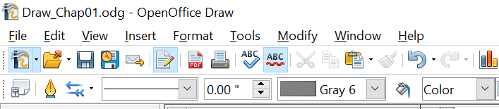

Figure 18: Two toolbars with highlighted handles
Tip | When you double-click on an icon on a floating toolbar, the command corresponding to that icon will run. You can then repeat this action as often as you like. To exit this mode, press the Esc key or click on another icon (for example, ). This may not work for every icon on every toolbar.

Customizing Toolbars
You can customize toolbars in several ways. To show or hide icons defined for a toolbar, see Figure 6 on page 14.
To add functions to a toolbar, move tools between toolbars, or create new toolbars, choose View > Toolbars > Customize, select the Toolbars tab (Figure 19) and the toolbar you want to change, and then select the desired buttons for that toolbar.
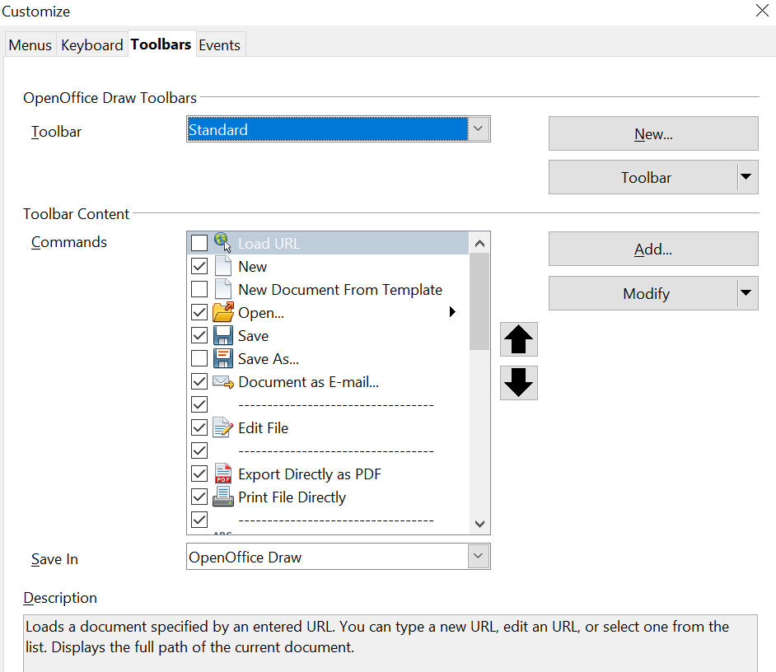

Figure 19: Customizing a toolbar
Each toolbar has a different list of functions. For details, see Chapter 14 (Customizing OpenOffice) in the Getting Started guide. That chapter also describes how to customize menus.

Quick Printing
Click the Print File Directly icon to send the entire document to the default printer defined for your computer.
Note | You can change the action of the Print File Directly icon to send the document to the printer defined for the document instead of the default printer for the computer. Go to Tools > Options > Load/Save > General and select the Load printer settings with the document option.

Controlling Printing
For more control over printing, use the Print dialog (File > Print or Ctrl+P).
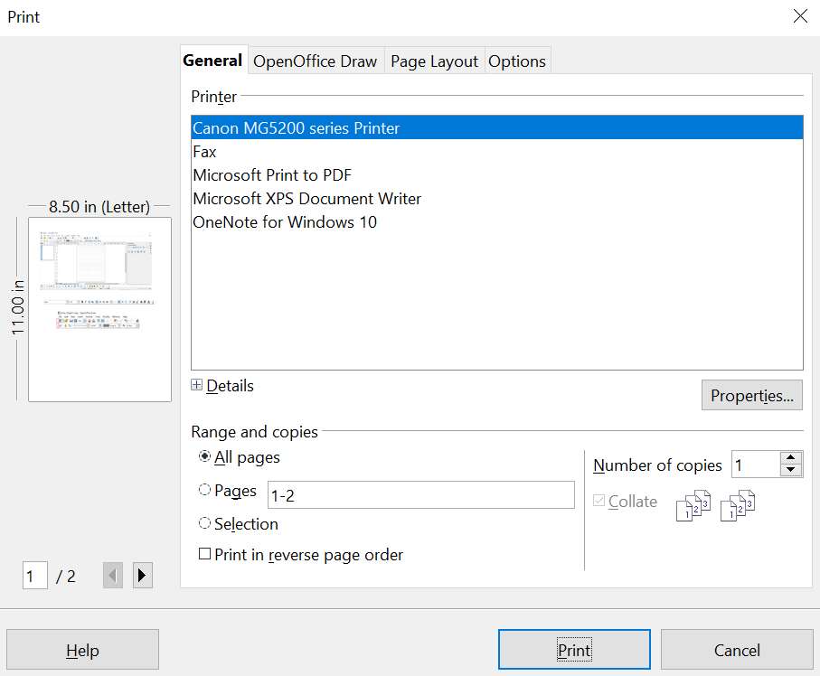

Figure 20. The Print dialog
Note | The options selected on the Print dialog apply to the current printing of the current document only.  To specify default printing settings for OpenOffice, go to Tools > Options > OpenOffice – Print and Tools > Options > OpenOffice Draw – Print.
The Print dialog has four tabs, from which you can choose a range of options, as described in the following sections.

Selecting General Printing Options
On the General tab of the Print dialog, you can choose:
- The printer (from the available printers)
- Which pages to print, the number of copies to print, and whether to collate multiple copies (Range and copies section)
Select the Properties button to display a dialog where you can choose portrait or landscape orientation, which paper tray to use, and the paper size to print on.
On the Options tab of the Print dialog (Figure 21), you can select several other less frequently used options for printing.
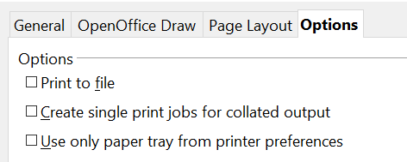

Figure 21: General print options

Printing Multiple Pages on a Single Sheet of Paper
You can print multiple pages of a document on one sheet of paper. To do this:
- In the Print dialog, select the Page Layout tab.
- In the Layout section, select from the drop-down list the number of pages to print per sheet. The preview panel, on the left of the Print dialog, shows how the printed document will look.
When printing more than two pages per sheet, you can choose the order in which they are printed across and down the paper. The two images immediately below show the difference.
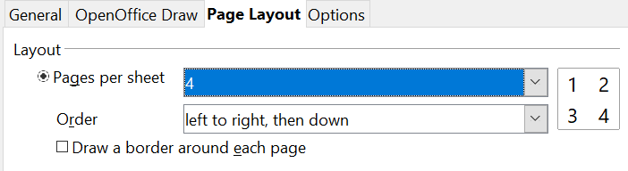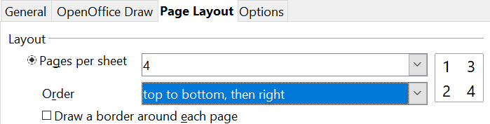
- In the Page sides section, select whether to print all pages or only some pages.
- Click the Print button.

Selecting Pages to Print
In addition to printing a full document, you can choose to print individual pages, ranges of pages, or a selection of a document.
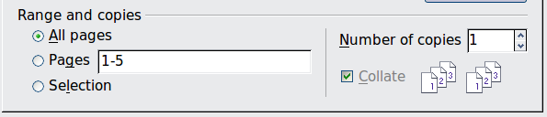
To print an individual page:
- Choose File > Print from the menu bar.
- Select the page to print.
  - In the Ranges and copies section of the Print dialog, select the Pages option.
  - Enter the number of the page to print.
- Click the Print button.
To print a range of pages:
- Choose File > Print from the menu bar.
- Select the pages to print.
  - In the Ranges and copies section of the Print dialog, select the Pages option.
  - Enter the number of the pages to print (for example, 1-4 or 1,3,7,11), or any combination of the two, for example: 1-4,5-9,10.
- Click the Print button.
To print a selection of a page, or a selection from multiple pages:
- In the document, select the section of the page to print.
- Choose File > Print from the menu bar.
- Choose the Selection option in the Ranges and copies section of the Print dialog.
- Click the Print button.

Printing a Brochure
In Writer, Impress, and Draw, you can print a document with two pages on each side of a sheet of paper, arranged so that when the printed pages are folded in half, the pages are in the correct order to form a booklet or brochure.
Tip | Plan your document so that it looks good when printed at half-size; choose appropriate margins, font sizes, and so on. You may need to experiment.
To print a brochure on a single-sided printer:
- Choose File > Print.
- In the Print dialog, click Properties.
- Check that the printer is set to the same orientation (portrait or landscape) as specified in the page setup for your document. Usually, the orientation does not matter, but it does for brochures. Click OK to return to the Print dialog.
- Select the Page layout tab in the Print dialog.
- Select the Brochure option.
- In the Page sides section, select Back sides / left pages option from the Include drop-down list.
- Click the Print button.
- Remove the printed pages from the printer, turn them over, and reinsert them into the printer in the correct orientation to print on the blank side. You may need to experiment a bit to find the correct arrangement for your printer.
- On the Print dialog, in the Page sides section, select Front sides / right pages option from the Include drop-down box.
- Click the Print button.
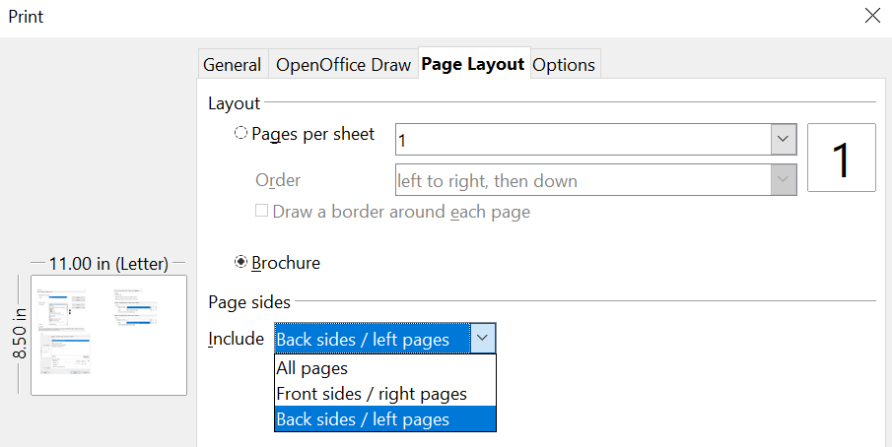
Tip | If your printer can print double-sided automatically, choose All pages.

Printing in Black and White (on a Color Printer)
You may wish to print documents in black and white on a color printer. Several choices are available. Please note that some color printers may print in color regardless of the settings you choose.
To change the printer settings to print in black and white or grayscale:
- Choose File > Print to open the Print dialog.
- Click Properties to open the Properties dialog for the printer. The available choices vary from one printer to another, but you should find options for the Color settings. See your printer’s help or user manual for more information.
- The choices for color might include black and white or grayscale. Choose the required setting.
- Click OK to confirm your choice and return to the Print dialog.
- Click the Print button to print the document.
Tip | Grayscale is best if you have any graphics in the document.
To change the OpenOffice settings to print all color text and graphics as grayscale:
- Choose Tools > Options > OpenOffice > Print.
- Select the Convert colors to grayscale option. Click OK to save the change.
- Open the Print dialog (File > Print).
- Click the Print button to print the document.
To change the Draw settings to print in black and white or grayscale:
- Choose Tools > Options > OpenOffice Draw > Print.
- Under Quality, select either Black & white or Grayscale. Click OK to save the change.
- Open the Print dialog (File > Print).
- Click the Print button to print the document.

Exporting to PDF
OpenOffice can export documents to PDF (Portable Document Format). This industry-standard file format is ideal for sharing the file with others to view using Adobe Reader or other PDF viewers.
The process and dialogs are the same for Writer, Calc, Impress, and Draw, with a few minor differences mentioned in this section.

Quick Export to PDF
Click the Export Directly as PDF icon to export the entire document using your default PDF settings. You are asked to enter the file name and location for the PDF file, but you cannot select a page range, the image compression, or other options.

Controlling PDF Content and Quality
For more control over the content and quality of the resulting PDF, use File > Export as PDF. The PDF Options dialog opens. This dialog has five pages (General, Initial View, User Interface, Links, and Security). Select the appropriate settings, and then click Export. In the following dialog, enter the location and file name of the PDF to be created, and click Save to export the file. See Chapter 10 (Printing, Exporting, Emailing) in the Getting Started book for details.

Exporting to Other Formats
OpenOffice uses the term export for some file operations that involve changing the file type. If you cannot find what you want under File > Save As, also look under File > Export.
OpenOffice can export files to XHTML. Additionally, Draw can export to a variety of image formats.
To export to one of these formats, choose File > Export. On the Export dialog, specify a file name for the exported document, select the required format in the File format list, and click the Export button.
See Chapter 6 (Editing Pictures) for more about exporting graphics.
Note | The content of the exported file will depend on the element(s) selected on the page. No selection results in the entire image being exported. For most export formats, only the image on the current page will be exported.

Exporting Draw Documents as Web Pages
To export a multi-page Draw document to a series of web pages, choose File > Export and select HTML Document as the file type. The HTML Export wizard opens. Follow the prompts to create the web pages. If you wish, the wizard can generate a navigation aid to help in moving from page to page.

E-mailing Documents
OpenOffice provides several options for quickly and easily sending documents as e-mail attachments in one of three formats: OpenDocument (OpenOffice’s default format), Microsoft Office formats, or PDF.
Note | Documents can only be sent from the OpenOffice menu if a mail profile has been set up and if your computer has an email program. If you use a web-based email application, you must attach the Draw document manually to a message.
To send the current document in OpenDocument format:
- Choose File > Send > Document as E-mail. OpenOffice opens your default e-mail program. The document is attached.
- In your e-mail program, enter the recipient, subject, and any text you want to add, then send the e-mail.
If you choose E-mail as PDF, OpenOffice first creates a PDF using your default PDF settings (as when using the Export Directly as PDF toolbar button) and then opens your email program with the PDF file attached.
You can email a document to several recipients. For details, see Chapter 10 (Printing, Exporting, Emailing) in the Getting Started book.

Chapter 2
Drawing Basic Shapes

Creating Simple Drawings
Draw can create 2D and 3D objects. This chapter shows how to draw simple 2D objects; the following chapters describe working with and editing such objects.
All shapes, whether they are lines, rectangles, or more complex shapes, are called objects, a common term in software.
The drawing tools are found on the Drawing toolbar and on the Properties deck of the Sidebar. Figures 22 and 35 show the icons common to the toolbar and the Sidebar. Additional icons will also be on the toolbar as installed with Draw.
As described in Chapter 1 (Introducing Draw), the Drawing toolbar is normally located at the bottom of the window, and the Sidebar is at the right edge. If you do not see them, you can activate them from the View > Toolbars and View > Sidebar menu. As in all components of OpenOffice, you can place the toolbar and Sidebar on the Draw window wherever you wish. Additionally, you can customize the toolbar by adding, moving, hiding, or removing toolbar icons.

Drawing Basic Shapes
Basic shapes include:
- Lines
- Arrows
- Rectangles and squares
- Ellipses and circles
- Curves and polygons
- Connectors
- Lines and arrows
Note | When you draw a basic shape or select one for editing, the Information field in the status bar changes to reflect the action taken or in progress: Line created, Text frame xxyy selected, TextEdit: Paragraph 1, Row 1, Column 8, and so on.
Figure 22 shows part of the Drawing toolbar, highlighting the icons referenced in the following sections. The Text icon is also included. These same icons are available on the Sidebar.
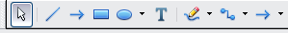
Figure 22: Part of the Drawing toolbar

Drawing a Straight Line
We begin with the drawing of the simplest element—a straight line.
Click on the Line icon and place the mouse pointer at the point where you want to start the line (see Figure 23). Drag the mouse while keeping the mouse button pressed. Release the mouse button at the point where you want to end the line. A blue selection handle appears at each end of the line, showing that this is the currently selected object.
Holding down the Shift key while you draw a line restricts the angle of the line to a multiple of 45 degrees (0, 45, 90, 135, and so on).
Caution   | This is the default behavior of the Shift key. However, if you have used Tools > Options > OpenOffice Draw > Grid to set Snap position to When creating or moving objects, the action of the Shift key is the opposite: lines will always be at a multiple of 45 degrees unless the Shift key is pressed.
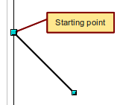
Figure 23: Drawing a straight line

Caution | The effect of the Ctrl key depends on the settings of the Snap to Grid option on the View->Grid menu:  Snap to Grid on: Ctrl deactivates the snap option for this activity.  Snap to Grid off: Ctrl activates the snap option for this activity.
The spacing (resolution) of the grid points can be adjusted under Tools > Options > OpenOffice-Draw > Grid. See also Chapter 8 (Tips and Tricks).
Holding down the Alt key while drawing a line results in the line extending outwards symmetrically in both directions from the start point. This lets you draw lines by starting from the middle of the line.
The line just drawn has all the standard line attributes, such as color and line style. To change any of these properties, select the line by clicking on it, then right-click and select Line.
While you are working with a line (or any other element), you can use the information field on the status bar to monitor the activity. A description of the current activity or selection is shown when you are working with elements. Figure 24 shows two examples.
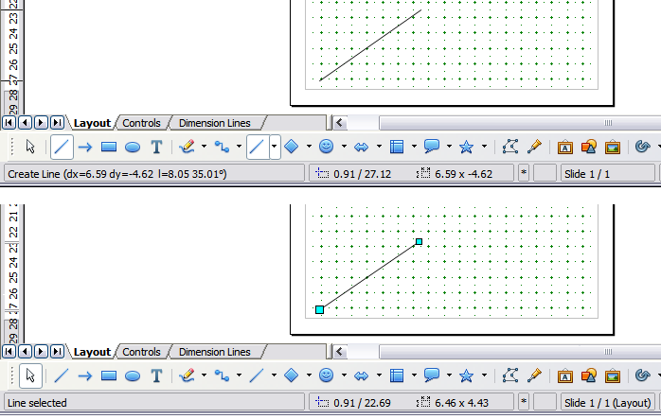
Figure 24: The information area in the status bar

Drawing an Arrow
Arrows are drawn like lines. Draw classifies arrows as a subgroup of lines, that is, lines with arrowheads, but the information field on the status bar shows them only as lines. Click on the Line Ends with Arrow icon to draw an arrow.

Drawing Lines and Arrows
From the Lines and Arrows icon on the Drawing toolbar or Sidebar, you can open a toolbar with ten tools for drawing lines and arrows (Figure 25). (Alternatively, View > Toolbars > Arrows opens the toolbar as a floating toolbar.) In both cases, the last-used command will be stored on the toolbar to make it quicker to access again: click directly on the symbol to repeat the last used command chosen from this toolbar.
After drawing the line, you can change the arrow style by clicking on the Arrow button in the Line and Filling toolbar or on the Arrow box on the Line pane of the Sidebar, and then choosing from many arrow start and end options.
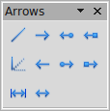

1 | Line | 5 | Line (45°) | 8 | Line with square/arrow
2 | Line Ends with Arrow | 6 | Line starts with arrow | 9 | Dimension line
3 | Line with arrow/circle | 7 | Line with circle/arrow | 10 | Line with arrows
4 | Line with arrow/square
Figure 25: Arrows toolbar
1
2
3
4
5
6
7
8
9
10

Drawing a Rectangle or Square
Drawing a rectangle is similar to drawing a straight line, except that you click on the Rectangle icon , and the (imaginary) line drawn by the mouse corresponds to a diagonal of the rectangle, as illustrated in Figure 26. In addition, the outline of the future rectangle changes shape as you drag the mouse. The outline may be shown as a dashed line until you release the mouse button.
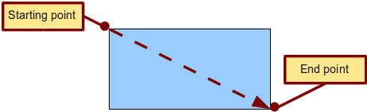
Figure 26: Drawing a rectangle
Draw considers squares to be rectangles with sides of equal length. Hold down the Shift key to draw a square. Hold down the Alt key while dragging with the mouse to create a rectangle with its center (rather than a corner) at the start point (where you first clicked the mouse).
Note | Blue or green selection handles appear around an object composed of more than 2 points, showing that this is the currently selected object. The colors depend on the standard selection mode—green for a normal selection or blue when you are in the point edit mode. This effect is easily seen if both Simple Handles and Large Handles are enabled in the Options toolbar. See Chapter 3 for more details on points.

Drawing Ellipses (Ovals) and Circles
To draw an ellipse (also called an oval) or a circle, click on the Ellipse icon . (A circle is simply an ellipse with both axes the same length.) The ellipse drawn is the largest ellipse that fits within the (imaginary) rectangle drawn by the mouse (Figure 27).
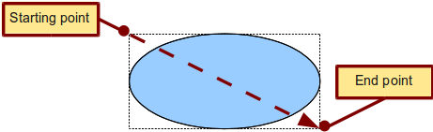
Figure 27: Drawing an ellipse
There are three ways to draw an ellipse or a circle:
- Holding down the Shift key while dragging with the mouse draws a circle.
- Holding down the Alt key (together with the Shift key) draws a symmetrical ellipse (a circle) with the starting point at the center.
- Holding down the Ctrl key while dragging with the mouse draws an ellipse or circle that snaps to the nearest grid points.
Note | If you first press and hold the Ctrl key down and then click on one of the icons for Line, Rectangle, Ellipse, or Text, a standard-sized object is drawn automatically in the work area: the size, shape, and color are all standard values. These attributes can be changed later, if desired. This only works if the icon has no associated toolbar—no arrow on the right side of the icon.

Adding Ellipse and Arc Tools to the Drawing Toolbar
You can add an Ellipse toolbar to the Drawing toolbar that allows you to draw circular or elliptical arcs:
- Click on the arrow on the right-hand end of the Drawing toolbar and select Customize Toolbar.
- On the Toolbars page of the Customize dialog, select Drawing in the Toolbar field and click Add.
- In the Add Commands dialog (Figure 28), select Drawing in the Category list, select the first Ellipse command in the Commands list. You can confirm you have chosen the correct icon by comparing its description to the Description text in Figure 28. Click Add, and then click Close.
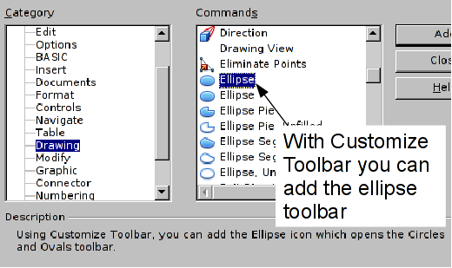
Figure 28: Adding the extended Ellipse toolbar
- On the Customize dialog, ensure that the checkbox by the new Ellipse command is selected, and then use the up and down arrow buttons to move it to the desired position on the toolbar.
- To remove the simple Ellipse icon from the Drawing toolbar, click to highlight it in the Customize dialog, and press the Delete key (or click the Modify button and choose Delete from the drop-down menu).
- Click OK to complete the process.
You should now see this Ellipse icon on the Drawing toolbar. If you use this icon instead of the standard Ellipse icon, all the extended ellipse functions are available. Clicking on the black arrow by the icon opens the floating Circles and Ovals toolbar (Figure 29). The icons are paired in columns. Selecting the icon in the top row draws a filled version of the shape, and the bottom row draws an unfilled shape. The arc shapes can only be unfilled.
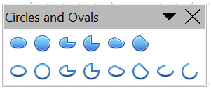

1 | Ellipse | 4 | Circle Pie | 7 | Arc
2 | Circle | 5 | Ellipse Segment | 8 | Circle Arc
3 | Ellipse Pie | 6 | Circle Segment
Figure 29: Circles and Ovals toolbar
1
2
3
5
4
6
7
8

To draw an arc, segment, or pie, choose the appropriate symbol in the Circles and Ovals toolbar. Drag with the mouse to create a guide circle or ellipse. | 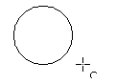
Release the mouse button and move the cursor to the position where you want the shape to start. In the status bar, you can measure the actual angle in degrees. Single-click this point; the circle (or ellipse) disappears, and moving the mouse creates the remaining part of the shape. Again, the status bar shows the current angle. | 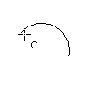
When you have drawn the shape to the desired length, click once more. The drawing of the arc is complete. | 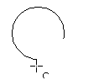

Curves
The tools for drawing curves or polygons are on the toolbar that appears when you click the Curve icon . This toolbar contains eight tools (Figure 30).
Note | Hovering the mouse pointer over this icon provides a tooltip for Curve. If you convert the icon to a floating toolbar, however, the title is Lines, as shown in Figure 30.
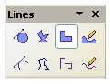

Figure 30: Floating Curves toolbar (incorrectly titled “Lines”)
Freeform Line, Filled
Polygon, Filled
Curve, Filled
Freeform Line
Polygon (45°), Filled
Polygon (45°)
Polygon
Curve
If you move the mouse cursor over one of the icons, a tooltip pops up with a description of the function. For a more detailed description of the handling of Bézier curves (curves and filled curves), see Chapter 10 (Advanced Draw Techniques).
- Polygons: Draw the first line from the start point with the left mouse button held down. As soon as you release the mouse button, a first corner point is drawn; move the mouse to see how subsequent lines will look. Every mouse click sets another corner point. A double-click ends the drawing. A filled polygon automatically joins the last point to the first point to close off the figure and fills it with the current standard fill color. A polygon without filling will not be closed at the end of the drawing.
- Polygon 450: Like ordinary polygons, these are formed from lines but with angles of only 45 or 90 degrees between them.
- Freeform Line: With this tool, you can draw just like with a pencil. Press and hold the left mouse button and drag the mouse. It is not necessary to end the drawing with a double-click. Just release the mouse button, and the drawing is completed. If you have selected Freeform Line, Filled, the endpoint is automatically joined to the start point, and the object is filled with the appropriate color.

Gluepoints and Connectors (Basics)

Gluepoints
All Draw objects have associated invisible gluepoints, which become visible when you choose any of the connectors under the Connectors icon on the Drawing toolbar and then move the mouse pointer over the object.
Most objects have four gluepoints, as shown in Figure 31. You can add more gluepoints, and customize gluepoints, using the toolbar of the same name (Figure 32).
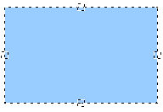
Figure 31: Four gluepoints
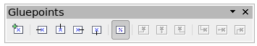Figure 32: Gluepoints toolbar
Gluepoints are not the same as the little blue or green “handles” of an object. The handles are for moving or changing the shape of an object, as described in Chapter 3 (Working with Objects and Object Points). Gluepoints are used to “glue” a connector to an object.
For a more detailed description of the use of gluepoints, see Chapter 9 (Organization Charts, Flow Diagrams, and More).

Connectors
Connectors are lines or arrows whose ends automatically interlock with a gluepoint of an object. Connectors are especially useful in drawing organization charts, flow diagrams, and mind maps. Even when objects are moved or reordered, the connectors remain attached.
Figure 33 shows two Draw objects and a connector.

Figure 33: A connector between two objects
Draw offers a range of different connectors and connector functions. Open the floating Connectors toolbar by clicking the arrow next to the Connector icon (Figure 34).
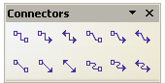

Figure 34: The Connectors toolbar
Line Connector Ends with Arrow
Connector
Connector Ends with Arrow
Connector with Arrows
Line Connector
Straight Connector
Straight Connector Ends with Arrow
Straight Connector with Arrows
Curved Connector with Arrows
Curved Connector
Curved Connector Ends with Arrow
Line Connector with Arrows
For a more detailed description of the use of connectors, see Chapter 9 (Organization Charts, Flow Diagrams, and More).

Drawing Geometric Shapes
Geometric shapes include:
- Basic shapes
- Symbol shapes
- Block arrows
- Flowcharts
- Callouts
- Stars
Note | If you select shapes for editing, the information field in the toolbar shows the type of shape selected and, if multiple objects are selected, the total number.
Figure 35 shows the icons referenced in the following sections. Clicking on the arrow next to the icon opens a floating toolbar with the relevant work tools.
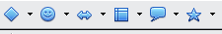
Figure 35: Part of the main Drawing toolbar
Tip | The use of all these tools is similar to that of the Rectangle tool, even though they produce different geometric shapes.

Basic Shapes
The Basic Shapes icon provides a range of tools for drawing basic shapes, including a rectangle tool identical to the one on the main toolbar.  The only differences you will see are in the information field in the status bar, in this case, “Shape selected” rather than “Rectangle selected”. | 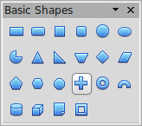
Symbol Shapes  The Symbol Shapes icon gives you an array of tools for drawing various symbols. | 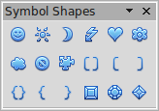
Block Arrows  The Block Arrows icon opens the Block Arrows toolbar. | 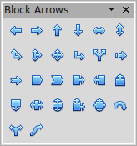
Flowcharts  The tools for drawing flowcharts are accessed by clicking the Flowcharts icon .  The creation of flowcharts, organization charts, and similar planning tools is described in Chapter 9 (Organization Charts, Flow Diagrams, and More). | 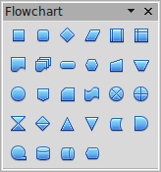
Callouts  Use the Callouts icon , to open the Callouts toolbar. (Callouts are insets in a display; they serve to highlight a key excerpt or detail ) | 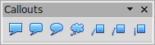
Stars and Banners  These tools are associated with the Stars icon . | 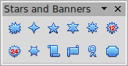
You can add text to all these shapes. See “Using Text Elements in Draw Objects” on page 41.
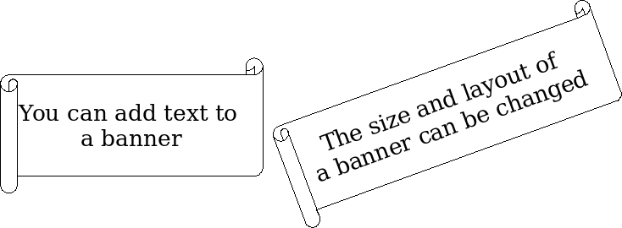

Adding Text to Objects
Draw offers two ways to add text to a drawing: in a dynamic text frame as an independent Draw object, or as text contained within a previously drawn object. In the latter case, the text is integrated with the object.

Using Dynamic Text Frames
The text tool is activated by clicking on the Text icon for horizontal text or the Vertical Text icon for vertical script (to be able to see the icon and use this latter option, you must check Show UI elements for East Asian writings under Tools > Options > Language Settings > Languages). If you still do not see the Vertical Text icon, enable it on the Drawing toolbar by clicking the arrow on the right side of the toolbar, selecting Visible Buttons, and clicking on Vertical Text to make this icon show on the toolbar.
Text frames can be moved and rotated like all Draw objects. For more details on text input, see Chapter 10 (Advanced Draw Techniques).
After activating Text command mode, click at the location where you want to position the text. A small text frame appears. It contains only the cursor. You can move the frame, if desired. The Text Formatting toolbar appears (Figure 36) as do the Paragraph and Text panes of the Properties deck of the Sidebar, and you can choose the font type, font size, and other text properties and begin to type in your text.
Figure 36: Text Formatting toolbar
The text frame grows with the text it contains. You can insert a line break with the Shift+Enter key combination; the Enter key begins a new paragraph. But neither line breaks nor new paragraphs terminate the text frame.
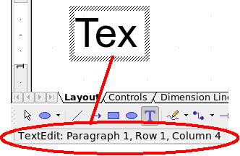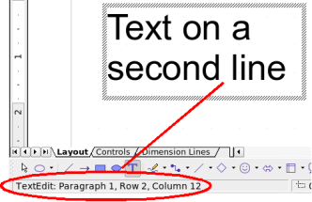
Figure 37: Text input in a dynamic text frame
Observe the information field in the status bar: it shows that you are editing text and also provides details about the current cursor location—paragraph, line, and column numbers.
Text properties can also be changed during text input. Any changes will be reflected from the cursor position onward (Figure 38).
Figure 38: Changing text properties
Text input – properties changed
After choosing the Text icon, you can also draw a frame with the mouse to contain future text. You can move the frame only after typing some text in it. Line breaks are inserted automatically at the right edge of the frame when the text fills the frame width (Figure 39). You can, however,—just as when editing any other text—insert your own line breaks, begin new paragraphs, or change any of the text properties.

Figure 39: Text frame
Text input
in a fixed frame – the text wraps automatically

Using Text Elements in Draw Objects
A text element is associated with most Draw objects. By means of these elements, text can be added to an object (see Figure 37).
The exceptions to this are control elements, such as buttons or list boxes, as well as 3D scenes and their associated elements and groups.
If the Double-click to edit Text icon 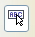 on the Options toolbar is active, you can start editing an object by double-clicking on it (or by pressing F2). In the middle of the Draw object, a black bar indicates the text cursor; start typing to input text. The status bar shows “Text Edit” at the lower left and the position of the cursor within the text.
Text can contain paragraphs, and these can be in the form of bulleted or numbered lists. To begin a new line without starting a new paragraph, use the key combination Shift+Enter (as in text documents). To end the text input, click next to the object or press the Esc key.
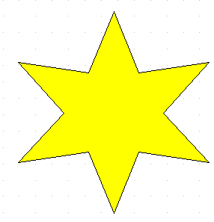 | 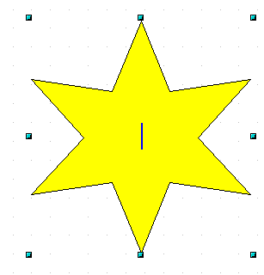 | 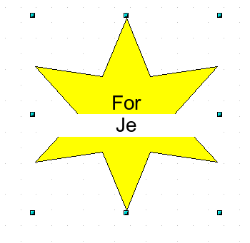 | 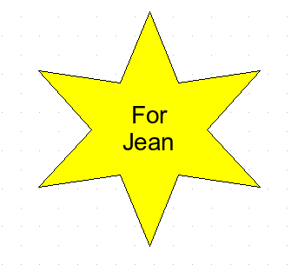
Figure 40: Adding text to objects

Chapter 3
Working with Objects and Object Points

Introduction
This chapter examines tools and functions with which you can modify existing drawings. All the functions apply to a selected object or group of objects, which can be distinguished by small colored squares or circles located around it. These points are called handles.
The handles form a rectangular frame that is just big enough to contain the object. When several objects are selected, the frame around them corresponds to the smallest rectangle that can contain all of them. This frame is called the selection rectangle.
If the Options bar is displayed (select View > Toolbars > Options to enable it, if it is not displayed), you can change the size of the handles using two buttons: Simple Handles shows the handles as flat squares; otherwise, they are shown in 3D. Large Handles increases the size of the handles. You can combine the two effects. Figure 41 below shows the location of the handles and other buttons.
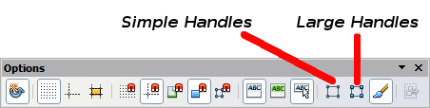
Figure 41: Location of handles on the Options toolbar

Selection Modes
There are three selection modes:
- Moving and changing size
- Editing
- Rotating points
To set the default mode (1 or 2) for selecting objects, click on the Points button on the Drawing toolbar.
In standard mode (when you begin a new drawing), the Points button is not active, and the default mode is for selections to be moved or changed in size; these selections are indicated by small green squares. | 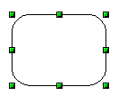
When the Points button is active, the default mode is for selections to be edited; these selections are indicated by blue squares. Some objects will have one or more extra handles, which are larger or colored differently. This is explained in more detail in “Editing Object Points” on page 52. | 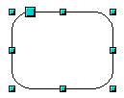
Selections for rotating objects are indicated by small red circles and a symbol representing the center of rotation. To choose these selections, click on the Effects drop-down button from the Drawing toolbar and after that on the object. | 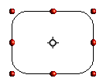

Changing the Selection Mode
To go from one mode to another, you can do one of the following:
- Choose the Points button from the Drawing toolbar to switch from simple selection mode to Points mode. You can also use the keyboard shortcut F8 (Points). See “Editing Object Points” on page 52 for details on using Points mode.
- Choose the Effects drop-down button from the Drawing Toolbar to activate the Rotation mode for a selected object. To exit Rotation mode, click on the Selection icon .
- If you often work in Rotation mode, you can choose the Rotation Mode after Clicking Object button from the Options bar and cycle through normal and rotation modes just by clicking on the object. This can be more convenient than repeatedly clicking the selected object, then clicking the Rotate button from the Drawing toolbar.

Selecting Objects

Direct Selection
The easiest way to select an object is to click directly on it. For objects that are not filled, click on the object’s outline to select it. One click selects; a second click deselects. To select or deselect more than one object, hold the shift button down while clicking.

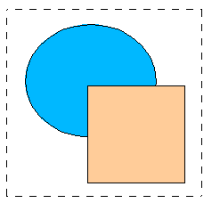
Selection by Framing
You can also select several objects simultaneously by using the mouse to drag a large rectangle around the objects with the Select button, as shown. For this to work, the icon on the Drawing toolbar must be active.
Only objects that lie entirely within the rectangle will be selected.

Selecting Hidden Objects
Even if objects are located behind others and not visible, they can still be selected. Press and hold the Alt key, then click where the object is located. If there are several overlapping objects, hold down the Alt key and click until you reach the object you want. To cycle through the objects in reverse order, hold down the Alt+Shift keys and click. The number and type of selected objects are shown at the left of the status bar; this can help you select the correct object.
Note | This method generally works in Windows, but on a Linux system, it usually does not. If the Alt key on your system does not operate as described above, use the Tab key method described below.
To select an object that is covered by another object using the keyboard, use the Tab key to cycle through the objects, stopping at the object you wish to select. To cycle through the objects in reverse order, press Shift+Tab. This is a very quick way to reach the object you want, but it may not be practical if you have a large number of objects in your drawing.
When you click on the selected object, its outline will appear briefly through the objects covering it.
In the illustration to the right, the square located beneath the circle was selected in this way (the circle has been made semi-transparent to show the square). | 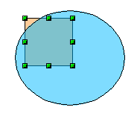

Arranging Objects
In a complex drawing, several objects may be stacked on top of one another. To rearrange the stacking order (move an object to the front or to the back of the stack), select the object, click Modify > Arrange, and choose Bring Forward or Send Backward. Or right-click the object, choose Arrange from the context menu, then choose Bring Forward or Send Backward.
These options are also available from the Arrange tear-off toolbar accessible from the icon on the Drawing toolbar. A keyboard shortcut is Shift+Ctrl+plus sign to bring an object to the top, and Shift+Ctrl+minus sign to send an object to the bottom.
Note, however, that an object located on the Controls layer always lies above all other objects.

Moving and Dynamically Adjusting an Object’s Size
There are several ways to move or resize an object. The dynamic method described here, and illustrated in Figure 42 below, uses the mouse.
When you dynamically change an object, remember to check the left-hand area of the status bar at the bottom of the Draw window. This area shows detailed information about the ongoing manipulation.
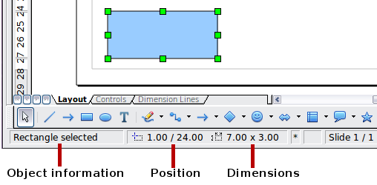
Figure 42: Left end of status bar during dynamic adjustment
For example, when resizing an object, the object information fields show the selected object, its current position in X/Y coordinates, and its dimensions (width x height). The information changes as the mouse is moved. The units of measurement are those selected under Tools > Options > OpenOffice Draw > General.

Dynamic Movement of Objects
To move an object, select it and then click within the object’s border and hold down the left mouse button while dragging the mouse. During movement, the shape of the object appears as a transparent copy or a dashed frame to help with repositioning. The copy of the object will not appear if you click and hold before moving it. Click and immediately begin moving to see the effect | 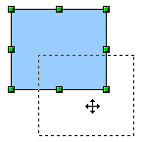
To drop the object at its new location, release the mouse button. The new position appears immediately in the Status Bar.

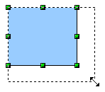
Dynamic Size Modification of Objects
To change the size of a selected object (or a group of selected objects) with the mouse, move one of the handles located around the selection. As shown in the illustration, the outline of the resulting new object appears as a dotted line while the mouse button is pressed.
The results depend on which handle you use. To resize an object along one axis, use the appropriate side handle. To resize along both axes, use a corner handle. The new size appears immediately in the status bar.
Note | If you press the Shift key while resizing an object, the change in size will be carried out symmetrically with respect to the two axes, so that the aspect ratio of the object remains the same.
Caution | This is the default behavior of the Shift key. If you have used Tools > Options > OpenOffice Draw > Grid to set Snap position to When creating or moving objects, the action of the Shift key is the opposite: the aspect ratio will be preserved unless the Shift key is pressed.

Dynamic Size Modification of Objects with the Help of the Status Bar
If you select an object and modify it using the mouse, the changes are immediately reflected in the information field of the status bar. With geometric shapes (such as basic shapes, symbol shapes, block arrows), the only information shown in the status bar is that the shape is being resized, as shown in the top-left image in Figure 43. With geometric elements (rectangles, circles, and so on), the changes to the attributes of the element (either relative or absolute) are also shown, as in the top-right image in Figure 43.
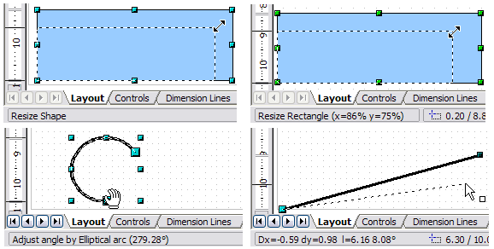Figure 43: The Information field during dynamic size modification of objects
In the case of a rectangle, the new size is shown as a percentage of the original x and y dimensions. For a line, much more information is given: the absolute change in x and y coordinates of the end point being moved, together with the current length and bearing of the modified line. These are updated dynamically as the endpoint is moved (see Figure 43).
This is the only place where the exact start and end angles of an arc or the length and bearing of a sloping line are shown. This information enables you to size the object with considerable accuracy.

Modifying an Arc
The beginning and end points of an arc can be modified. Select the arc and click on the Points icon on the Drawing toolbar to enter the Edit points mode (described later in this chapter). In this mode, the handles on the selection frame change—two larger blue handles appear at the beginning and end points of the arc. When the mouse hovers over one of these points, the cursor will change to a hand, as illustrated in Figure 44.
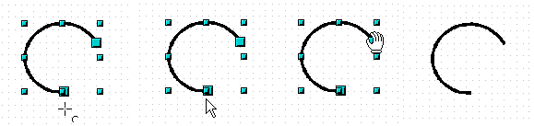Figure 44: Editing an arc
If you click and hold the mouse button when the hand cursor appears, moving the mouse will change the location of the start or end point of the arc. The actual coordinates are shown in the Status Bar (see the lower-left graphic in Figure 43).

Rotating and Shearing an Object Using the Mouse
Use the red rotation handles to either rotate an object around an axis or slant or shear the object.

Rotating
To rotate an object (or a group of objects), drag a red corner handle point of the selection with the mouse. The mouse cursor takes the shape of an arc of a circle with an arrow at each end. A dotted outline of the object being rotated appears, and the current angle of rotation is dynamically shown in the status bar.
Note | Rotation works in a slightly different way for 3D objects because the rotation occurs in 3D space, not in a single plane. See Chapter 7 (Working with 3D Objects) regarding rotation when the Edit Points mode is active.
Rotations are made about an axis, which is displayed as a small symbol like that shown in Figure 45. This is normally located at the midpoint of the object, but you can move the axis of rotation with the mouse to any location you like, even outside the object.
If you hold down the Shift key during the rotation, the operation will be carried out in increments of 15° (subject to whether Snap position is set to When creating or moving objects under Tools > Options > OpenOffice Draw > Grid).
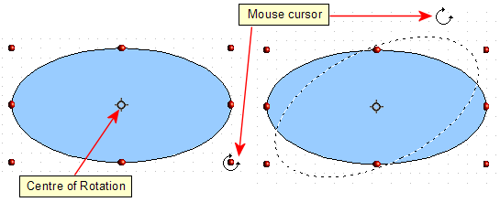Figure 45: Rotating an object

Changing Inclination or Perspective
To slant or shear objects, use the red handles located at the midpoint of an edge of the selected objects. The mouse pointer changes to a bi-directional arrow when the pointer hovers over one of these midpoint handles.
The slant axis is the point directly opposite the midpoint handle, which is used for shearing the object. This point stays fixed in location; the other sides and edges move in relation to it as the mouse is dragged (make sure that the icon is showing before dragging).
Figure 46 shows how the vertices move in relation to each other during the shearing process. The circles represent the path of the vertices. The inclination axis is the bottom vertex of the triangle (the slanting handle used is the midpoint of the upper enclosing frame). All points on the figure will move through the same angle, irrespective of the final shape. The actual angle is shown in the status bar.
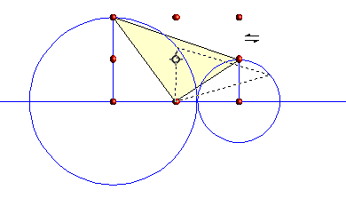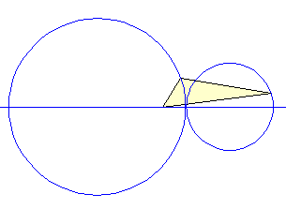
Figure 46: Shearing an object
Note | The triangle in Figure 46 was produced with the (unfilled) polygon tool. Then Close Object was selected from the context menu.
This tool can be used to produce perspective drawings. The series of pictures in Figure 47 shows the method of constructing a box in perspective. The idea is to initially draw the rectangles for the sides of the box to their true size, as if the box had been cut along its seams and flattened. Then, vertically shear the small rectangle that defines the side of the box, going back into the image. Finally, horizontally shear the rectangle that will be the lid of the box until its edge meets the edge of the side. The slant angles displayed in the status bar while each rectangle is moving will sum to 90 when the edges meet.
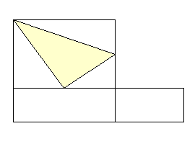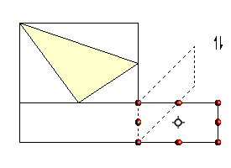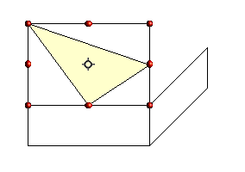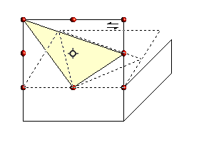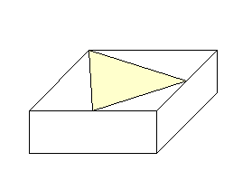
Figure 47: Perspective production of a cuboid
As with rotation, you can make the slanting occur in steps of 15° by pressing the Shift key while moving the handle.

Setting Size and Position Exactly
You can, of course, position and resize objects with the mouse, but this isn't an exact method. If you need precise positioning of objects, use the Position and Size pane in the Properties deck of the Sidebar, or choose Format > Position and Size from the menu bar, or right-click the object and select Position and Size from the context menu, or press F4.

Position and Size
Open the Position and Size dialog (see Figure 48) and click on the first tab to set the appropriate values.
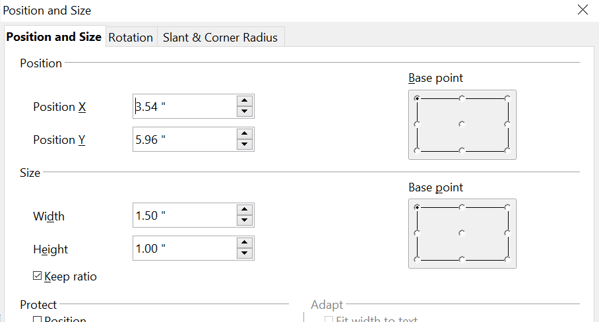

Figure 48: Position and size of an object
Position is defined as an X, Y coordinate relative to a fixed point (the base point), typically located at the upper left of the drawing area. If desired, you can temporarily change this base point to make positioning or dimensioning simpler (click on the radio button corresponding to the location of the base point in either of the two selection windows on the right side of the dialog—upper for positioning or lower for dimensioning). The possible base point positions correspond to the handles on the selection frame plus a central point. The change in position lasts only as long as the dialog is open. When you close this dialog, Draw resets the base point to the standard position.
Tip | The Keep ratio checkbox is very useful. Click it to keep the ratio of width to height fixed while you change the size of an object.
Both the size and the position can be protected so that they cannot be inadvertently changed. Check the appropriate boxes to achieve this.
Tip | If you have trouble moving an object, check to see if its position is protected. The Position and Size tab of the Position and Size dialog has check boxes for protecting an object.

Rotating Objects
Click on the Rotation tab of the Position and Size dialog (see Figure 49). Here you can define the rotation angle, as well as the location of the pivot point.
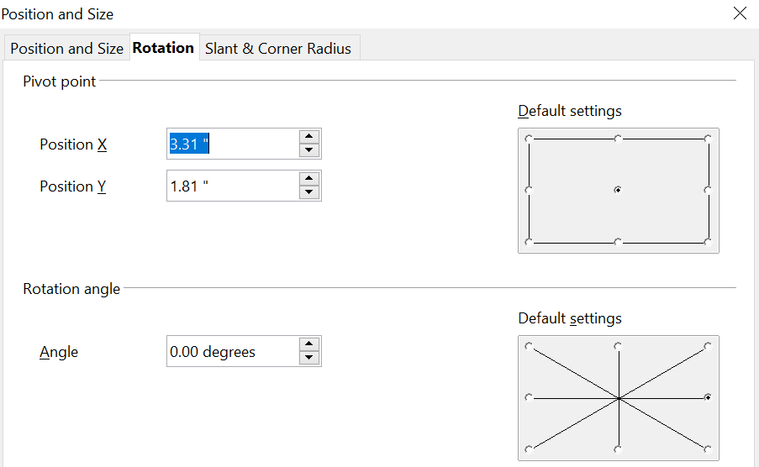
Figure 49: Rotating an object

Slant and Corner Radius
The slant angle (inclination or shearing) and corner radius can be set in this dialog (Figure 50).
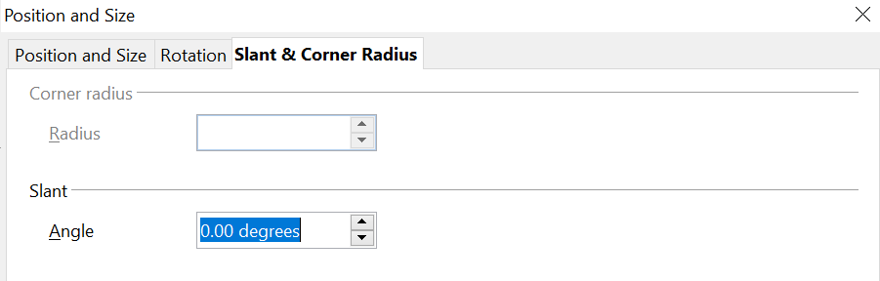
Figure 50: Setting rounded corners and slant angle
Corner radius
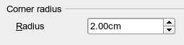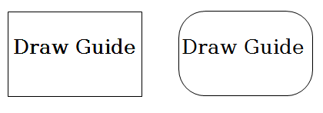

Figure 51: Example of setting rounded corners
You can use this dialog to round the corners of the usual Draw objects—text boxes, legends, rectangles, and squares, as shown in Figure 51. The same effect can be achieved when you are in the points mode (click the Points icon on the Drawing toolbar), by dragging the large handle with the mouse. The larger the value for the corner radius, the rounder the object becomes.
Slant
You can shear shapes to give the appearance of perspective. Enter the slant angle in the box marked Slant Angle.
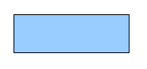 | 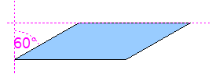 | 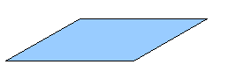
Figure 52: Example of setting the slant angle

Editing Object Points
For polygons and Bézier curves, Draw offers a complete set of tools that let you accurately edit the contour of an object. To edit other objects in the same way, you must first convert them into curves. To do this, select the object, then right-click and choose Convert > To Curve or choose Modify > Convert > To Curve from the menu bar.
You can also convert the shapes to a polygon (Convert > To Polygon). With polygons, the edge points are always connected by straight lines, not curves. Some of the techniques described work equally with polygons as with curves.

Another Way to Change the Form of Basic Shapes
Many shapes can be directly edited without having to convert them to curves first. You can recognize these objects by the presence of one or more circular yellow handles, as shown in Figure 53.
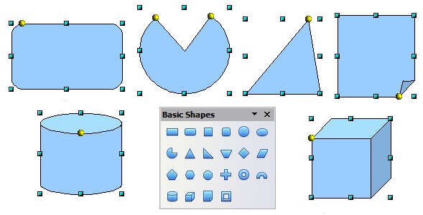
Figure 53: Some basic shapes with yellow “handles”
The mouse pointer changes shape when hovered over a yellow handle. If you drag one of these handles, you can modify the shape of the object; the type of change is dependent on the shape itself. For example, you can round the corners of a rectangle or square, change the angles of an arc or ellipse, or alter the control points of a circular or elliptical segment.

How Curves Work
The editing of curves depends on the mathematics of Bézier curves. The complete study of such curves exceeds the scope of this guide, and only the basics are covered here. Chapter 10 (Advanced Draw Techniques) provides more information on drawing and manipulating Bézier curves.
The editing of a Bézier curve consists, in principle, of moving points or tangents passing through these points. Each tangent has two control points—one at each end—and a junction point where it meets the curve. The relative angle and distance between the control points determine the shape of the curve. Figure 54 shows several variations that start from a basic circle and change only one point on the circle.
You can create many different shapes by moving either the junction point itself or one or both of the round handle points at either end of the tangent.
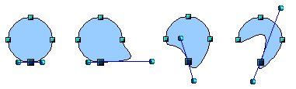
Figure 54: Creating different shapes by changing the tangent
Draw offers even more possibilities with the functions on the Bézier curve Edit Points toolbar.

The Edit Points Toolbar
When you work in Edit Points mode, use the Edit Points toolbar, shown in Figure 55. To activate this toolbar, choose View > Toolbars > Edit Points. It will then appear whenever you select a curve and the Edit Points icon on the Drawing toolbar is active.
On this toolbar, icons may be active or inactive depending on the selected object and object point. With the Convert to Curve icon, you can determine for individual points whether their connection will be made with straight lines or with curves.
Icons for tangents are only activated with curves. An object that contains no curves is treated as a polygon.
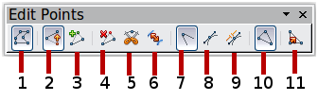
1 Points 5 Split Curve 9 Symmetric Transition
2 Move Points 6 Convert to Curve 10 Close Bézier
3 Insert Points 7 Corner Point 11 Eliminate Points
4 Delete Points 8 Smooth Transition
Figure 55: Edit Points toolbar

The Three Kinds of Tangent
Three buttons in the Edit Points Toolbar let you select the type of tangent and convert from one type to another. Only one of these buttons can be active at any given time. Their use is described in the following chapter.
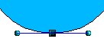Figure 56: Symmetric tangent | Choose the Symmetric Transition button to work with a symmetrical tangent (Figure 56). Any movement of one or the other of the handles is carried over symmetrically to the other handle.
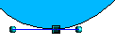Figure 57: Asymmetric tangent | Choose the Smooth Transition button to separately adjust the lengths of the two parts of a tangent, making the curve flatter or steeper. In Figure 57, the curve is flatter on the longest side of the tangent. The tangent remains as a single straight line. This kind of tangent is known as a smooth junction.
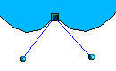Figure 58: Inflection point | It is also possible to separate both sides of the tangent from the curve. In this case, the central point is known as the inflection point. Using this technique, you can draw spikes and troughs in objects. Choose the Corner Point button to create an inflection point like that in Figure 58 around the selected point.

Examples
The other buttons in the Edit Points Toolbar are described here in relation to working examples. The following examples start from a filled circle. As mentioned earlier, in order to use Edit Points mode, you first need to convert the object to a curve.
You will notice that after the conversion, the handles located in the corners of the rectangle have disappeared. This behavior is normal, since handles used in the Edit Points mode are located along the outline or trace of the drawn object.
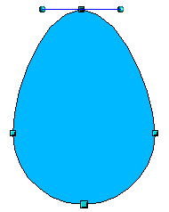  Figure 59: Moving a junction point | Move Points is the default mode when editing points. If it has not been activated, click on its button. When this mode is active, the mouse pointer has the following shape when it is hovered over an edit point:  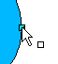  Movement of a point is one of the easiest manipulations to do. Figure 59 illustrates how you can draw an egg very easily by starting from a circle and dragging the top point upwards.
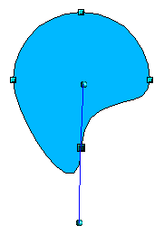  Figure 60: Rotating a tangent | To change the direction or location of the tangents, as shown in Figure 60, move the circular handles at each end. The mouse pointer then looks like this:  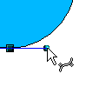
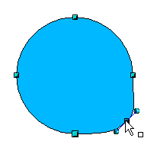Figure 61: Adding an edit point to a curve | Use the Points button to add an extra edit point like that in Figure 61to an existing curve. Click on the curve at the spot where you want to insert a point and then move the mouse slightly in any direction while holding down the button.  The tangent attributes associated with the new point depend on the buttons that are selected on the toolbar.
  Caution | If you just click, the new point will not be added.
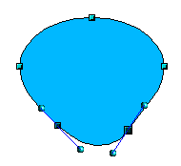 | The Delete Points button has the opposite effect: it subtracts one or more points from the curve, as shown in Figure 62. The resulting curve stretches itself automatically around the remaining points after subtraction.  Select one or more points to delete. You can select several points by holding down the Shift key (➊).  When you have selected the points you want to delete, click the Delete Points button. The selected points disappear from the curve, which then reforms around the remaining points (➋).  You can also delete the selected points by pressing the Del key on the keyboard.
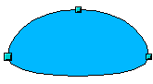

Figure 62: Deleting points from a curve
➊
➋
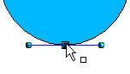  ➊  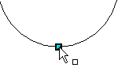  ➋  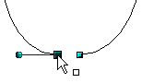  Figure 63: Cutting a curve  3 | Use the Split Curve button to split or cut a curve at the location of the selected handle, like we did in Figure 63. If the object is filled, it will be emptied because the curve that represents the edge is no longer closed.  Check that you have selected the correct handle (➊), click the Split Curve button (➋), and notice that the object is no longer filled. You can then check, by moving the point, that the curve has indeed been separated (➌).  If you have an open curve, the start point of the curve is larger than the others.
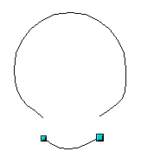Figure 64: Moving a segment | You can also separate a curve at several points simultaneously. Keep the Shift key pressed down and select all of the points at which the cut should occur.  Drag and drop segments with the mouse to move them from the original curve, as was done in Figure 64.
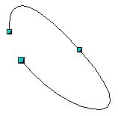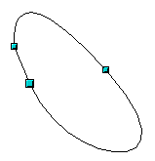Figure 65: Closing an open curve | To close an existing curve, select an open curve and click on the Close Bézier button .  The opening point is identified by a slightly larger handle (Figure 65).

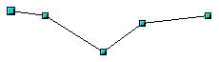1.  Select object and set Edit points mode | The Eliminate Points button button only functions with lines with multiple points.  If the button is active, click on a point, hold the mouse button down, and move the mouse to draw virtual straight lines between the neighboring left and right points.  Release the mouse button when the two lines have more or less coalesced into one straight line. The point is deleted, and the new line replaces the previous two lines, eliminating one point.  Note that this only works when the angle between the two lines (shown dashed in Figure 66) is less than a certain amount.  In the Tools > Options > OpenOffice Draw > Grid window, there are options for snap settings relating to editing points when rotating and in point reduction mode.
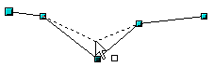2.
Draw virtual lines
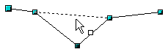3.
Release mouse button

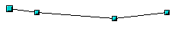
Figure 66: Reducing a line by one point

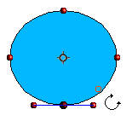  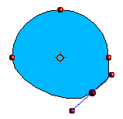  Figure 67: Moving a point on a curve  ➋  ➋ | The Rotate function from the Effects drop-down button on the Drawing toolbar and the Rotation Mode after Clicking Object button on the Options toolbar can be used in Edit Point mode. In this case, it can be used to move single points around the contour of an object, as shown in Figure 67.  Switch into rotation mode by clicking on either of the rotation buttons. Notice that in rotation mode, all of the tangent points become red dots.  ➊  Select the point to be moved and then drag it around the contour, while keeping the left mouse button pressed down (➊). When you release the mouse button, the point will be moved to the new position (➋).  If you move one of the handles located at the end of the tangents during rotation, you will make the object rotate in exactly the same way as with the usual rotation operations.  Important: To exit the effects mode, do not just click on the Effects button; click the Select button on the Drawing toolbar.

Chapter 4
Changing Object Attributes

Toolbars and Menus
You can use the Properties deck of the Sidebar, the Line and Filling toolbar, or the context menu to change an object’s attributes, such as color or border width.

Line and Filling Tools
The Line and Area panes of the Sidebar's Properties deck have tools for modifying the most important fill and line properties of an object. If the Sidebar is not visible, select View > Sidebar. You can then choose the Properties icon, which is the topmost of the four icons on the right edge of the Sidebar. The Line and Area panes will be visible when an object is selected, as we've shown in Figure 68.
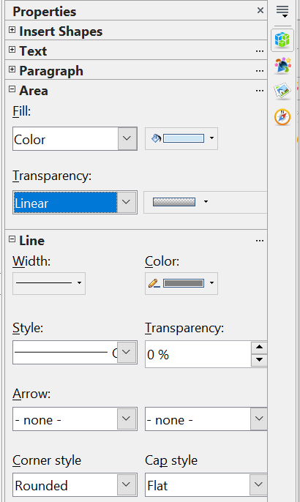

Figure 68: The Area and Line Panes of the Sidebar
The four boxes in the Area pane provide access to a large number of choices. The Fill type, which defaults to Color, can also have the following values: None, Gradient, Hatching, or Bitmap. Each of those choices changes the options in the adjacent drop-down list. Similarly, the Transparency list has eight options: None, Solid, Linear, Axial, Radial, Ellipsoid, Quadratic, and Square. For most of these, multiple parameters, such as the minimum and maximum transparency, are accessed through the adjacent drop-down list.
The tools on the Line pane are self-explanatory, except that the two boxes under the Arrow heading do not refer to the left and right ends of the line. They refer to the beginning and end of the line, which are determined when the line is drawn. If you draw the line from right to left, the beginning is on the right.
Most panes in the Sidebar show only the most commonly used tools. The full set of tools can be accessed by clicking the three dots at the top right of each pane, which brings up a dialog with all available settings. In particular, we will refer to the Area dialog and Line dialog several times.
The Line and Filling toolbar shown in Figure 69 provides many of the same tools as the Sidebar panes. If the Line and Filling toolbar is not visible, you can display it using View > Toolbars > Line and Filling. From here, you can edit the most common object attributes. You can also open the Line dialog by clicking on the Line icon and the Area dialog by clicking on the Area icon to see more options.
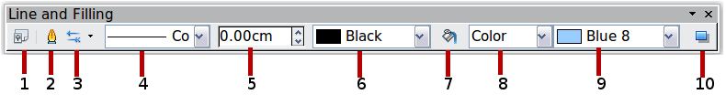
1 Styles and Formatting  2 Line  3 Arrow Style | 4 Line Style  5 Line Width  6 Line Color | 7 Area  8–9 Area Style / Filling  10 Shadow
Figure 69: Line and Filling toolbar

Text Formatting Toolbar
When you select a block of text, the Line and Filling toolbar changes to show text formatting options like those in Figure 70. You can also display the Text Formatting toolbar by choosing View > Toolbars > Text Formatting.
Figure 70: Text Formatting toolbar (when text is selected)

Since any object can contain text, the Properties pane of the Sidebar always provides the Text and Paragraph panes when an object is selected. These panes have most of the same tools as the Text Formatting Toolbar and, as usual, the complete set of tools can be accessed by clicking the three dots at the upper right of each pane.

The Context Menu
When an object is selected, you can right-click on the object to bring up a context menu (Figure 71). The context menu provides additional access to the options shown above and another way to change an object’s attributes. The entries with a small arrow on the right-hand side contain a submenu.
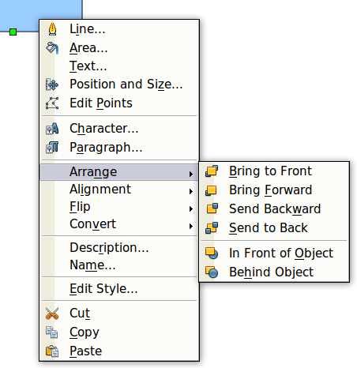
Figure 71: Right-click on an object to see the context menu

Editing Lines and Borders
Lines, arrows, and the borders of an object are all managed through the same dialog (Figure 73) except that the Shadow tab is only available if the selected object is a line. The properties on the other tabs apply to the borders of two-dimensional objects, but the shadow is a property of the Area of a two-dimensional object.
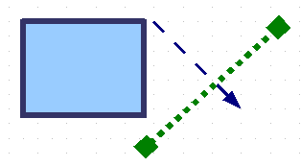
Figure 72: Lines and borders
You can change some properties from the Sidebar or from the Line and Filling toolbar. To see more options, click the three dots at the upper right of the Line pane of the Sidebar or right-click on the object and choose Line from the context menu. This opens the Line dialog.
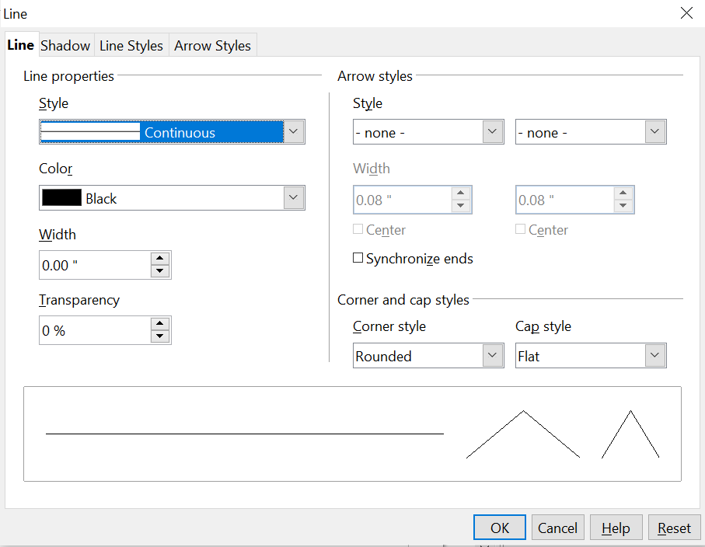
Figure 73: Line dialog .

Common Line Properties
In most cases, the property you want to change is the line’s style (solid, dashed, invisible, and so on), its color, or its width, as is done in Figure 74. These options are all available from the Sidebar's Line pane (Figure 68) or the Line and Filling toolbar.
Figure 74: Common line options (style, width, color)
You can also edit these properties from the Line dialog. They are located on the first tab, in the left column (see Figure 73). From the Line dialog or the Sidebar, you can also change the line’s transparency. Figure 75 illustrates different degrees of transparency.

Figure 75: The vertical lines have different levels of transparency (0%, 25%, and 50%).

Drawing Arrows
Arrowheads and other line endings, usually referred to in this guide as arrows, are a line property. Select a line and click on one of the Arrow drop-down boxes in the Sidebar or the Arrow Style icon in the Line and Filling toolbar. This opens the Arrowheads menu shown in Figure 76.

Figure 76: Arrowheads menu
There are several types of arrowheads available. Each end of a line can have a different arrowhead, or even no arrowhead. Remember that the selection on the left corresponds to the beginning of the line as it was drawn, not to the left end of the line.
Note | Arrowheads are only applicable to lines. They have no effect on the border of an object.
In the Line dialog (Figure 73), Arrow styles on the right contain several options to fine-tune the arrow properties. If Synchronize ends is selected, both line endings will appear the same. The Center option, illustrated in Figure 77, places the center of the arrow over the endpoint of the line. If this option is not selected, the line ends at the far edge of the arrow. The following sketch illustrates the difference.
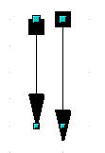
Figure 77: Default arrowheads (left) vs centered arrowheads (right)

Line Shadows
Lines can have a shadow property associated with them, as is done in Figure 78.
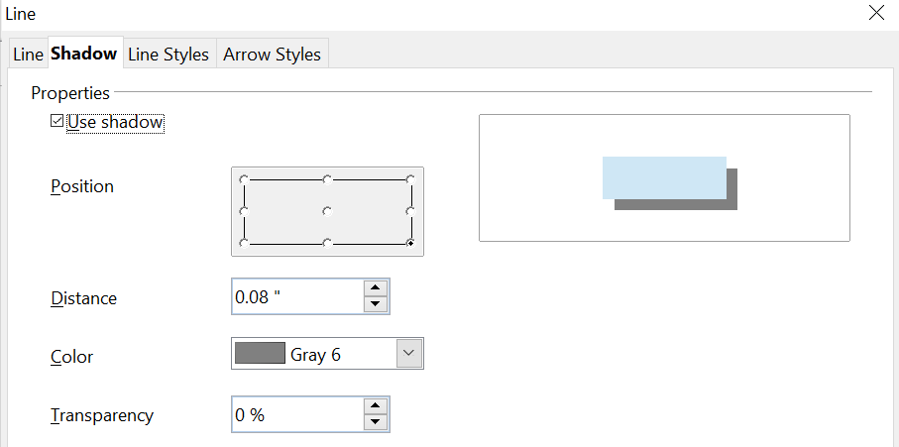
Figure 78: Shadow page of Line dialog
Check the Use shadow box to enable this feature. The properties shown—position, distance, color, and transparency—can be independently adjusted to your choice and the results seen in the preview window. You can also click on the Filling icon on the Line and Filling toolbar—next to the area fill functions – to get a basic shadow.

Customizing Line and Arrow Styles
You are not required to use only the line and arrow styles provided by default in Draw. You can modify the styles and even create your own.

Customizing Line Styles
In the Line dialog, click on the Line Styles tab (see Figure 79). From here, you can customize the line styles or create your own by clicking on the Add button. You can change the length of the dashes, the space between them, and several other attributes.
Use the Load Line Style and Save Line Style icons to save a new definition or read one from disk (file extension .sod).
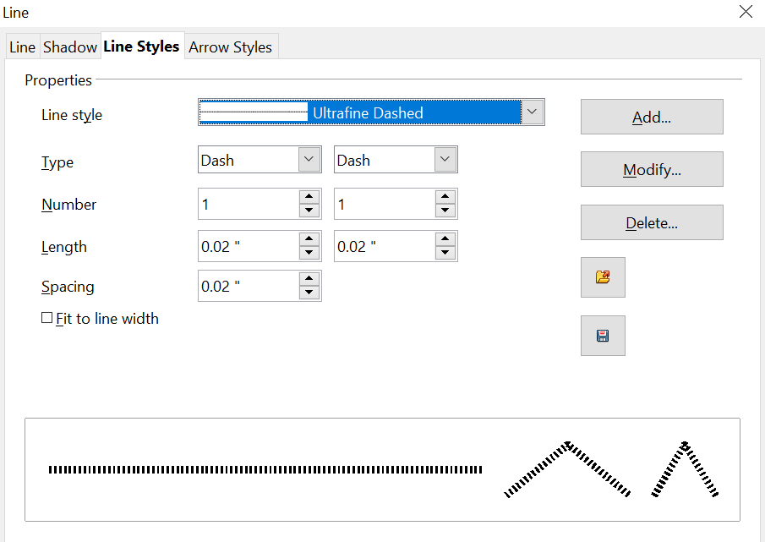

Figure 79: Editing line styles

Customizing Arrow Styles
You can also create your own arrowheads to provide some interesting effects, such as:

The first step is to draw a curve with the shape you want to use as the arrowhead, like we did in Figure 80.
Figure 80: To create your own arrowhead, you must first draw a curve.
Note | The arrowhead must be a curve. A curve is something you could draw without lifting a pencil. For example, is a curve, but is not a curve. You can, however, draw forms that are not curves and then convert them to a curve.
Select the curve, open the Line dialog, and go to the Arrow Styles page. Click on Add, enter a name for the arrow style, and click OK (see Figure 81).
Tip | The part of the shape that should point in the direction of the line must be drawn facing upwards. In Figure 80, the top of the shape will point towards the “outside” of the line.
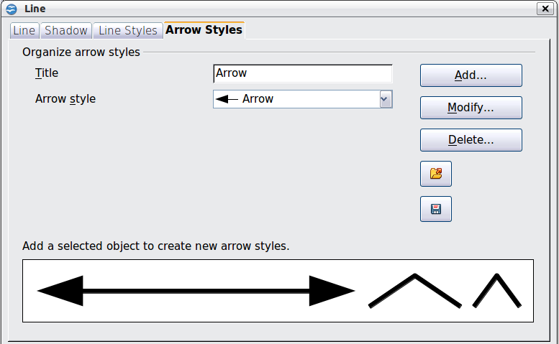
Figure 81: Adding an arrow style
Now you can access the new style from the Arrow style list (Figure 82) or the Arrowheads dialog (Figure 76).
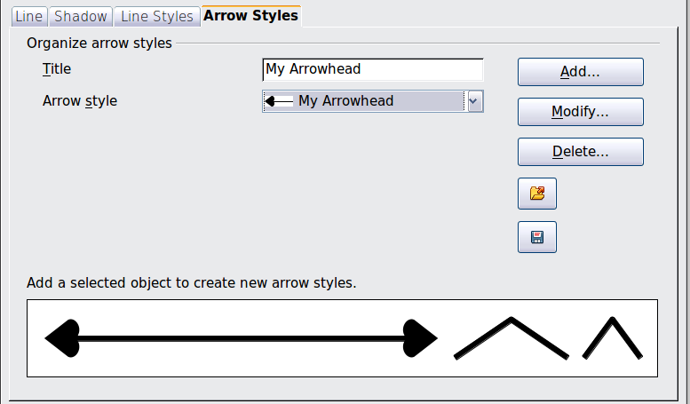
Figure 82: Arrow style list

Editing the Inside (Fill) of an Object
The OpenOffice term for the inside of an object is Area fill. The area fill of an object can be a uniform color, a gradient, a hatching pattern, or an image. It can be made partly or wholly transparent and can throw a shadow.

Figure 83: Different types of area fill

Common Fill Properties
In most cases, you will choose one of the standard fill options, whether it is a color, a gradient, or an image. These options are all available from the Area pane of the Sidebar or the Line and Filling toolbar.
If you want no fill at all, select the object you wish to edit and set the Fill to None on the Area pane of the Sidebar.

Fill with a uniform color
Select the object you wish to edit. On the Area pane, set the Fill to Color or on the Line and Filling toolbar, select Color from the pull-down list at the right of the paint can. In either case, choose a color from the right-hand menu, as we did in Figures 84 and 85.
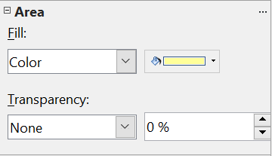

Figure 84: Common fill options in the Sidebar and Line and Filling toolbar

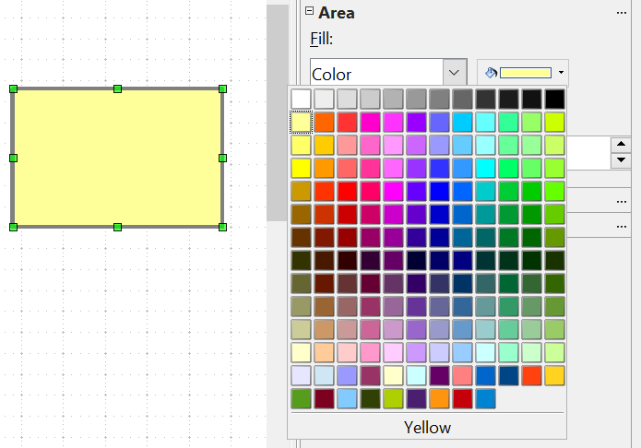
Figure 85: Filling with a color using the Sidebar

Fill with a Gradient
Select the object you wish to edit. Set the Fill type to Gradient and then choose a gradient from the right-hand menu, as Figure 86 illustrates.
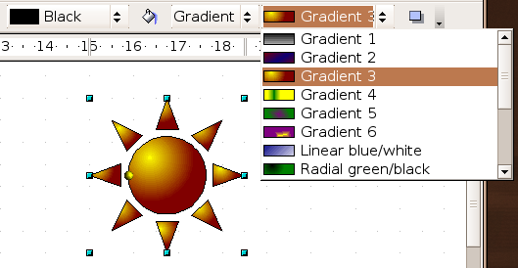
Figure 86: Filling with a gradient using the toolbar

Fill with a Line Pattern or an Image
Objects can also be filled with line patterns or an image. The OpenOffice term for line patterns is Hatching. Images used as fill patterns must be bitmaps, that is, images stored as a pattern of pixels rather than as vector images. Select the object you wish to edit. In the Sidebar or on the Line and Filling toolbar, set the Fill to Hatching or Bitmap. Then choose one of the available patterns from the neighboring drop-down list.

Adding a Shadow to an Area
To get the default shadow for an object, click on the Filling icon on the Line and Filling toolbar—next to the area fill functions (Figure 87).
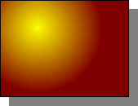
Figure 87: Adding a shadow
You can control the position, distance, color, and transparency of the shadow on the Shadow tab of the Area dialog. This is identical to the shadow dialog in Figure 78.

Advanced Area Fill Options
From the Area dialog, you can fine-tune the area fill of an object in greater detail.

Creating Your Own Fill Color
Click on the Colors tab of the Area dialog (Figure 88). From here, you can modify existing colors or create your own.
Depending on the color model in use (RGB or CMYK can be selected from the pull-down menu), you can change the individual values of the constituent colors—Red, Green, and Blue or Cyan, Magenta, Yellow, and Black. Click on Add to add this color to the color table. Clicking the Modify button changes the values of the current color (Blue 8, as shown in the upper rectangle) to those on the screen in the lower rectangle. The Edit button allows you to fine-tune the color using a palette with visual feedback.
Further explanation about color palettes can be found in Chapter 8 (Tips and Tricks).
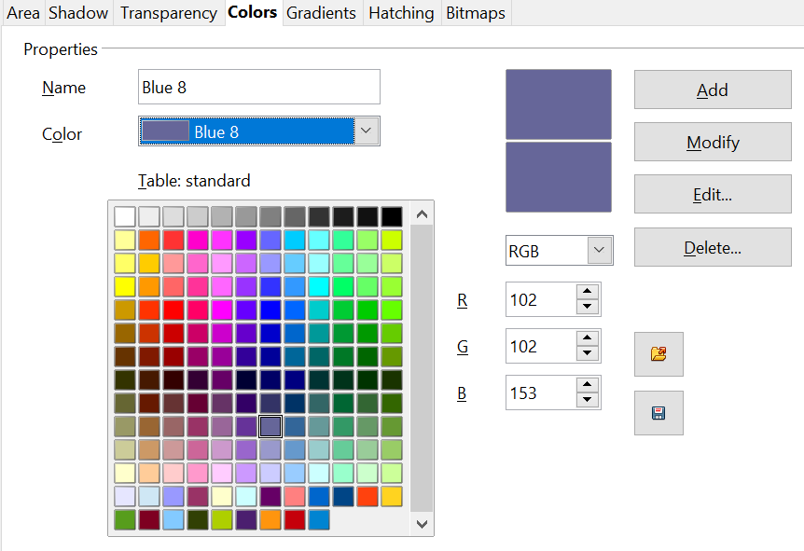
Figure 88: Customizing the color palette

Creating Your Own Gradient
On the Area dialog, click on the Gradients tab. From here, you can modify existing gradients or create your own, as we show in Figure 89.
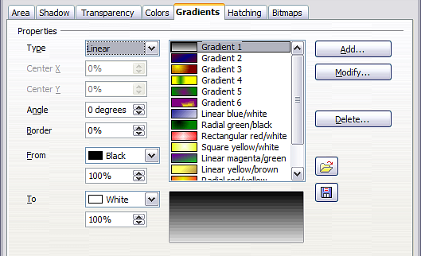
Figure 89: Customizing gradients
A gradient works by creating a smooth transition from one color to another. First, choose two colors (Figure 90).
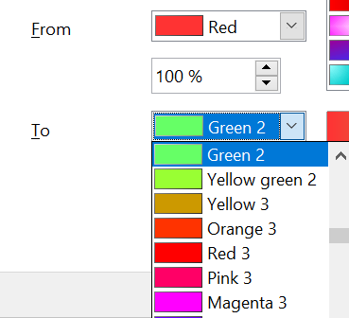

Figure 90: Choosing colors for a gradient
Then choose a type of gradient. There are several available (Linear, Axial, Radial, and so on), and each has up to four different options to specify it in detail. For example, a radial gradient has a center you can specify (Figure 91).
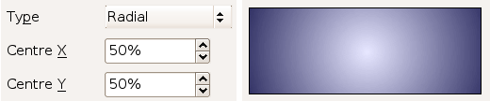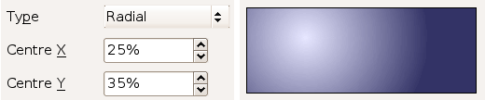

Figure 91: Center option in a radial gradient
Figure 92 shows how an ellipsoid gradient is rotated, moved vertically and horizontally, and the color of the border area is varied.
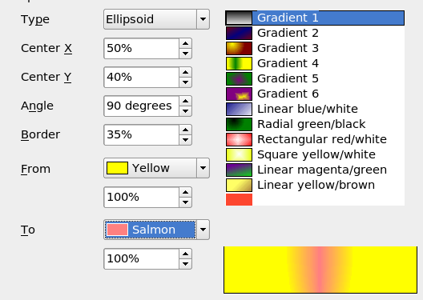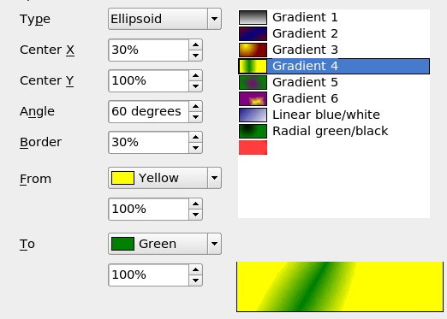Figure 92: Center, Angle, and Border options for a gradient

Creating Your Own Hatching (Line Pattern)
On the Area dialog, click on the Hatching tab (Figure 93). From here, you can modify existing hatchings (line patterns) or create your own.
You can customize options like the spacing between lines, the angle, and the color of the lines. There is no way to edit the line thickness.
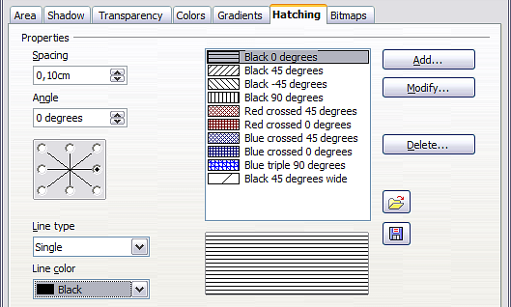
Figure 93: Modifying hatchings

Creating Your Own Bitmap Fill
You can add your own bitmap images to fill an area. First, you need to create the bitmap image. This could be a photo or a sketch you have created in another program. For example, you can draw something with Draw and export it as a PNG format image file.
To export a PNG image file: Create the image, select it, then choose File > Export, choose PNG from the pull-down list of file formats, give the file a name, and save it.
To use an image as a bitmap fill, open the Area dialog and click on the Bitmaps tab (Figure 94).
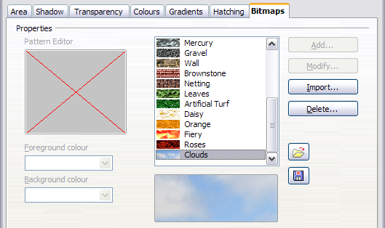
Figure 94: Adding your own bitmap images
From there, you can add new bitmap images to serve as area fills. Click on Import and choose a file you previously saved. Give it a name that's easy to remember. The last imported image will appear at the bottom of the pull-down list of bitmap fills. Now you can use that image as an area fill, like Figure 95 shows.
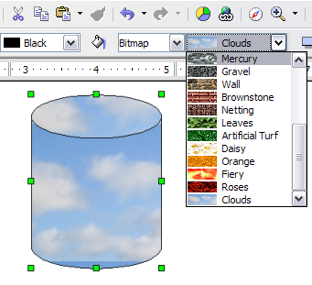
Figure 95: Adding your own bitmap images
Tip | If the imported image appears very small in the preview (Figure 93), you probably forgot to select the image before exporting. In that case, the exported image would be the whole page with a (small) drawing on it.

Customizing Shadows
First, select the object you want to apply a custom shadow to. Open the Area dialog and go to the Shadow tab. There, you can customize the shadow’s position, distance, and color, like we did in Figure 96.
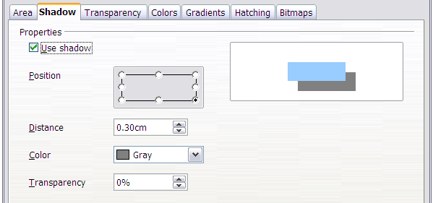Figure 96: Customizing shadows
Shadows can also have transparency, so the shadow does not completely hide objects behind it; Figure 97 illustrates this effect
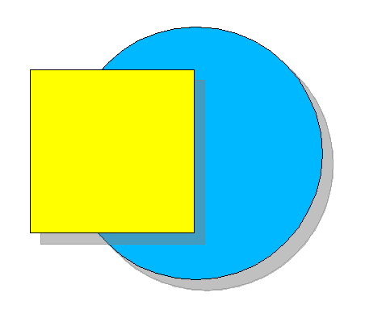
Figure 97: Shadow with 50% transparency

Adding Transparency
You can make objects partly or fully transparent, or even fill them with a varying degree of transparency (as a gradient). This can be done from the Sidebar or from the Area dialog. Figure 98 shows the Area pane of the Sidebar when an object has been selected, the Transparency type has been set to Ellipsoid, and the drop-down list to the right of the Ellipsoid selection has been clicked. Only settings appropriate for the selected transparency type will be displayed. For example, a Solid transparency has only one setting, the fixed transparency value.

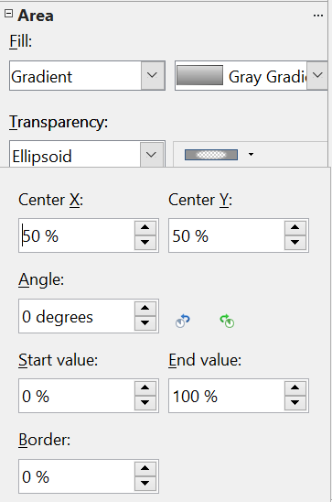Figure 98: Transparency settings on the Sidebar
On the Transparency tab of the Area dialog(Figure 99), choose Transparency (for a uniform transparency) or Gradient for a gradient transparency.
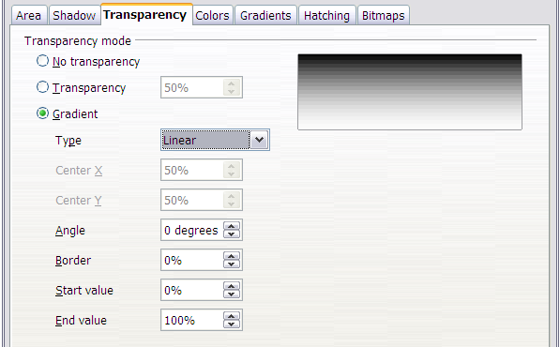Figure 99: Transparency page of Area dialog
An example of gradient transparency is shown in Figure 100. See also “Dynamic Gradients” on page 82.
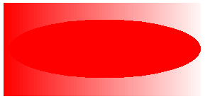
Figure 100: Example of gradient transparency

Using Styles
Suppose that you want to apply the same area fill, line thickness, and border to a set of objects. This repetitive process can be greatly simplified by using styles. Styles allow you to define a formatting template and apply it to multiple objects. For more about styles, see Chapter 6 (Introduction to Styles) in the Writer Guide.
There are many ways to access the Styles and Formatting tool:
- Click the Styles and Formatting icon on the Sidebar.
- Click on the Styles and Formatting icon on the Line and Filling toolbar
- Press the F11 key to open the Styles and Formatting window
- Select Format > Styles and Formatting
The tool shown in Figure 101 will be displayed either as a floating window or in the Sidebar. This window can be docked to the left or right side of the main Draw window, if you wish.
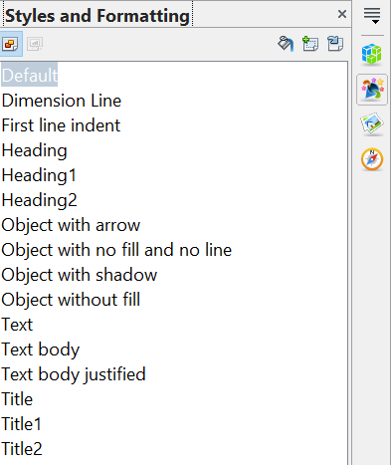
Figure 101: Styles and Formatting window
All of the styles in Draw are Graphics Styles, and they share the same properties. Right-clicking a style and selecting Modify opens a dialog with the 14 tabs shown in Figure 102. Each of the supplied styles has a few properties modified from the Default style values, and the style name hints at what those changes are.

Figure 102: The tabs of the Graphics Style dialog
If you explore the various tabs, you may feel there is an overwhelming number of settings. Keep in mind that for any particular use, you probably only care about the settings of a very few properties.

Creating a New Style
A new style can be defined from the Graphics Style dialog or from an object. To work with the dialog, right-click in the Styles and Formatting window, either on an empty area or on an existing style. You can then choose New or Modify. The New option opens the Graphics Styles dialog with the default name Untitled1 and the properties of the style that was clicked, or if no style was chosen, the Default style. You can then set the style name on the Organizer tab and adjust the properties you want. If you select Modify, the process is the same except that the style will be named after the chosen style, and its settings will overwrite the previous properties of that style. In either case, the changes are effective only in the current document.
To create a style from an object, select an object and customize its properties. When you are satisfied, click the New Style from Selection icon in the Styles and Formatting window. This defines a new style based on the selected object. Type a name for the new style and click OK.

Applying a Style
Once the new style is defined, you can apply it to other objects. Select another object and double-click on the style name you defined. The new object will acquire the properties of that style.
Tip | Question: What happens if I modify a style after it has been applied?  Answer: Every object with that style is updated automatically!

Special Effects
First, make sure that the Drawing toolbar is selected (View > Toolbars > Drawing). On the Drawing toolbar, locate the Effects icon 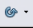. Click on the arrow next to that icon. This opens a submenu with all the special effect tools (see Figure 103).
 | 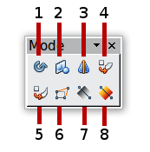
1 Rotate  2 Flip  3 In 3D Rotation Object | 4 Set in Circle (perspective)  5 Set to Circle (slant)  6 Distort | 7 Transparency  8 Gradient
Figure 103: Mode tear-off submenu
The tools are described in the following sections, except for the 3D rotation tool, which is described in Chapter 7 (Working with 3D Objects).

Rotating an Object
Click on the Effects icon to select the Rotate tool. Then select an object. The selected object will have red handles instead of the usual green handles.
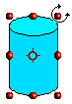 | Grab one of the handles and move it to rotate the object. The black circle in the middle of the object is the pivot, or center of rotation. You can move the pivot location with the mouse. | 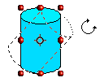

Flip an Object

Select an object and click the Flip icon . You will see a dashed line through the middle of the object.


This dashed line is the axis of symmetry. The object will be reflected about this line. Move one or both ends of the line with your mouse to set the orientation of the axis.


Then, grab any one of the eight green handles and move it across to the other side of the dashed line. The figure's new position is shown faintly until the mouse is released.

Note | If you press the Shift key while moving the line, the line will rotate in 45-degree increments.

Mirror Copies
Officially, this useful command does not exist in Draw. It can, however, be easily emulated.
Move the axis of symmetry to the desired location of the mirror axis. Copy the object to the clipboard. Flip the object, then click on an empty area of the Draw screen in order to deselect the object. Paste from the clipboard to put a copy of the object in its original location, and now you have a mirror copy, like that in Figure 104.

Figure 104: Making a mirror copy of an object

Distorting an Image
Three tools on the Effects menu let you drag the corners and edges of an object to distort the image.
The Distort tool distorts an object in perspective; the Set to Circle (slant) and Set in Circle (perspective) tools both create a pseudo three-dimensional effect.
The results of using these tools are shown in the following figures.

Distort an Object
Select an object and click the Distort icon . Draw will ask if you want to transform the object into a curve. This is a necessary step before distortion, so click Yes. Then you can move the object handles to stretch it.
The corner handles distort, as shown in Figure 105. The midpoint handles distort the figure either horizontally (the handle on the vertical side of the figure) or vertically (the handle on the horizontal side of the figure).
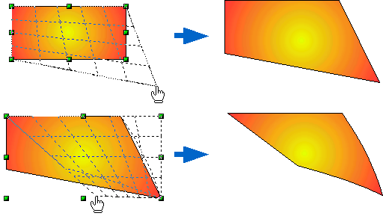Figure 105: Distort an image

Set in Circle (Perspective)
Select an object and click the Set in Circle (perspective) icon. Draw will ask if you want to transform the object into a curve. This is a necessary step before distortion, so click Yes. Then you can move the object handles to create a pseudo-three-dimensional perspective, like that in Figure 106.
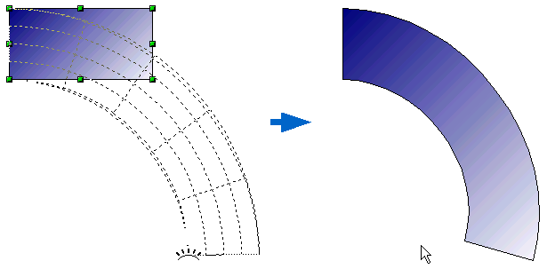
Figure 106: Set an image in a circle with perspective

Set to Circle (Slant)
Select an object and click the Set to Circle (slant) icon. Draw will ask if you want to transform the object into a curve. This is a necessary step before distortion, so click Yes. Then you can move the object handles to give a pseudo-three-dimensional slanted perspective, as Figure 107 shows.
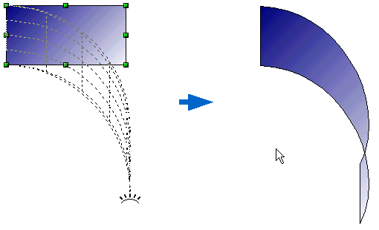
Figure 107: Set an image to a circle with slant perspective
Note | Transforming an object into a curve is a safe operation, but it cannot be reversed other than by clicking the Undo button.

Dynamic Gradients
You can control transparency gradients in the same manner as color gradients. Both types of gradient can be used together. With a transparency gradient, the direction and degree of an object’s fill color change from opaque to transparent (in a regular gradient, the fill changes from one color to another, but the degree of transparency remains the same).
If you have assigned transparency to an object with a color fill, you can control it by clicking the Transparency icon . To define a transparent gradient, select an object, choose a transparency fill from the Sidebar or Line and Filling toolbar. The transparency icon is now active. When you click on this icon, a dashed line connecting two squares appears on the object. Move the two squares to modify the gradient. You can define the gradient direction (vertical, horizontal, or at any angle) and the spot where the transparency begins.
A regular color gradient can be defined in the same manner. Select an object, choose a gradient fill from the Sidebar or Line and Filling toolbar. The Gradient icon is now active. When you click on the gradient icon, a dashed line connecting two squares appears on the object, just as it does for a transparency gradient.
In both cases, click outside the object to set the gradient.
Note | If the transparency and gradient icons are not visible, you can display them using View > Toolbars > Mode.  Moving the squares will have different effects, depending on the type of gradient. For example, in a linear gradient, the start and end squares will always be located to either side of the object's center point.
The three examples in Figure 108 demonstrate how the type and degree of transparency can be controlled.

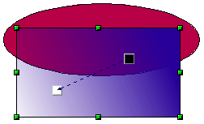 | A single color ellipse and a rectangle with a transparency gradient, covering part of the ellipse.  The gradient can be dynamically adjusted, made more transparent by moving the white square or more opaque by moving the black square.
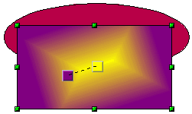 | A rectangle with a color gradient but no transparency, obscuring part of an ellipse.  The gradient is adjusted dynamically by moving the squares – the color of the square relates to the increase or decrease in that color.
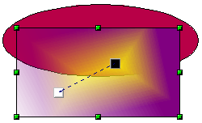 | A rectangle with both color and transparency gradients, partly covering the underlying ellipse.

Figure 108: Dynamic gradients

Chapter 5
Combining Multiple Objects

Introduction: Grouping and Combining Objects
With Draw, you can combine drawing objects together in two distinct ways: grouping and combining. These two methods allow you to treat multiple objects as a single unit or to merge objects to form a new shape.
Grouping is similar to placing objects in a container. You can move them as a group and apply global changes to them. A group can always be undone, and its constituent objects can always be manipulated separately.
A combination is a permanent fusion of objects, resulting in a new object. The original objects are no longer available as individual entities, and the operation is not reversible.
Tip | To select multiple objects, click on each object while holding down the Shift key or click the Select icon (on the Drawing toolbar) and draw a rectangle around the objects.

Grouping Objects

Grouping by Common Selection
When several objects are selected, any operations you carry out are applied to all of the objects. For example, you can rotate a group of objects in its entirety. Groups obtained through the common selection of several objects are undone as soon as you click outside the group. However, you can choose to maintain a grouping so that the selected objects will remain together after they are deselected.

Maintaining Groups and Undoing Groups
To group objects, first select the objects, then right-click and choose Group from the pop-up menu, as shown in Figure 109. You can also use the keyboard shortcut Control+Shift+G or choose Modify > Group from the menu bar.
When objects are grouped, any editing operations performed on that group are applied to all its members. If you click on one member of the group, the whole group is selected.
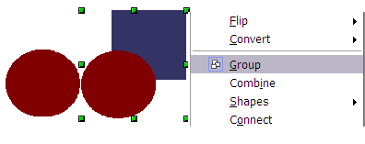
Figure 109: Grouping objects using the right-click menu
The objects of a group retain their unique individual properties. To undo a group, right-click and choose Ungroup from the pop-up menu, use the keyboard shortcut Control+Alt+Shift+G, or choose Modify > Ungroup from the menu bar.

Editing Individual Objects in a Group
You can edit a member of a group individually without breaking up the group. To do this, right-click and choose Enter group or double-click on the group (Figure 110).

Figure 110: When you enter a group, objects outside the group cannot be selected and appear pale
Once inside the group, click on any object to edit it (Figure 111).
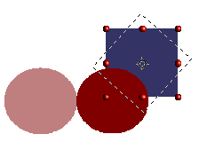
Figure 111: Editing an object inside a group
To leave this mode, right-click and choose Exit group, or double-click outside the group.

Nesting Groups
You can create “nested” groups, that is, groups within groups. In this case, Draw keeps the initial group hierarchy. If you ungroup a group made of other groups, you are left with individual groups that you can then decompose further, until only single objects remain.

Combining Objects
In contrast to grouping functions, combinations create a new object; it is not possible to edit an individual constituent afterwards. Select a collection of objects, then right-click and choose Combine from the pop-up menu or use the keyboard shortcut Control+Shift+K. The result of this operation is shown in Figure 112.
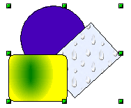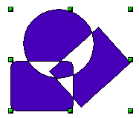
Figure 112: Combining objects
At first glance, the appearance of the combined objects can seem rather surprising. Understanding the rules governing combinations in Draw will clarify things.
- The attributes (for example, area fill) of the resulting object are those of the object furthest back. In this example, it is the circle.
- Where the objects overlap, the overlapping zone is either filled or empty, depending on the number of overlaps. When the number of overlaps is even, you get an empty space; when the number is odd, you get a filled area, see Figure 113.
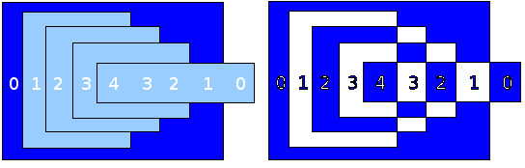Figure 113: Odd numbered overlaps are filled, even numbered overlaps are empty
Tip | You can reorder objects before combining them so that they are positioned further back or further forward. Right-click on the object and select Arrangement from the pop-up menu. See also “Aids for Positioning Objects” on page 89.
An object that is a combination can be broken up again by selecting Modify > Split or using the keyboard shortcut Control+Alt+Shift+K. The combination can also be broken up into its constituent parts by selecting Modify > Break. These are not an exact equivalent to ungrouping, as the objects were converted to Bézier curves when they were combined. An object that is split will, for example, have an ellipse converted to a Bézier curve.
An object that is broken will consist of a set of base-level objects (for example, a rectangle will be broken into four separate lines), and the original formatting—line thickness, colors, and area properties—is not retained.

Connecting Lines
Lines may be connected by selecting them and using Modify > Connect. The connections established are based on joining the ends of pairs of lines with minimum separation. Once a group of lines is connected, you can “close” the remaining gap by selecting the line, right-clicking, and choosing Close Object. The resultant object is filled with the default fill. If you modified the line properties (color, weight), these are retained in the resulting polygon.

Merging, Subtracting, or Intersecting Shapes
After you have selected more than one object, the Merge, Subtract, and Intersect functions can be reached in the Modify > Shapes menu or through the group’s right-click menu under the heading Shapes.

Merge
When you merge objects, the new object covers the entire surface of the original objects, representing the union of the objects. As was the case with combining, the fill of the merged object is determined by the fill of the object furthest in the background. Other properties are not transferred to the new object.

Subtract
When you subtract, the object in front is subtracted from the object behind it.

Intersect
When you intersect two objects, you get only the area covered by both objects.

Tip | For more information on moving objects to the front or back, see page 89.

Practical Example
The following example shows how to use the merge functions to create a complex shape—a knife with a wooden handle.
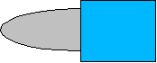
- Draw an ellipse and then a rectangle overlapping half of its width.

- Select both shapes, right-click, and choose Shapes > Subtract from the pop-up menu. The result should resemble the shape to the right, as shown below:
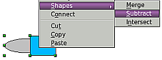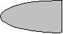
- Draw another rectangle and put it over the top half of the ellipse. Then subtract again.
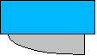
- Draw a small ellipse covering just the lower right corner and subtract again.
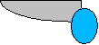
- The knife blade is now complete. To make the handle, draw a rectangle and an ellipse as shown.
- Merge the shapes.
- Group this image with the previous one.

Aids for Positioning Objects
Draw has various tools to help you arrange objects with respect to each other. Here we explore some of the more important ones.

Moving an Object to the Front or to the Back
When you combine or merge objects, the result varies drastically depending on which object is “in front” and which one is “behind”. Figure 114 illustrates the difference.

Figure 114: Subtracting objects: the result varies depending on which object is in front.
If you imagine several objects stacked one on top of another, the one referred to as “Front” is the one on top of the stack. The one referred to as “Back” is the one at the very bottom of the stack.
First, select an object. Then, on the Drawing toolbar, long-click the Arrange icon to open the Position toolbar (Figure 115). This toolbar can be torn off and made to float.
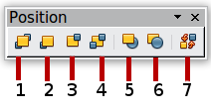
1 Bring to Front 5 In Front of Object
2 Bring Forward 6 Behind Object
3 Send Backward 7 Reverse
4 Send to Back
Figure 115: The floating Position toolbar
Brings the selected object to the front of the group.
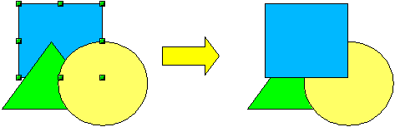
Brings the selected object one step forward.
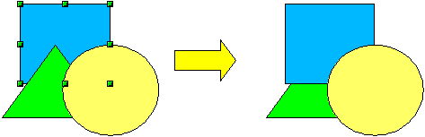
Sends the selected object one step backwards.
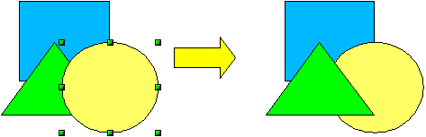
Sends the selected object to the back of the group.
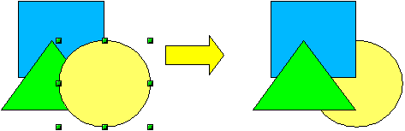
Moves the selected object in front of another chosen object.
Moves the selected object behind another chosen object.
First, click on the object you want to change in position. Next, click on the icon and then move the mouse over the other object. The mouse cursor changes into a hand, and the outline of the second object becomes a dashed line (see below). Clicking on this object completes the rearrangement of position.
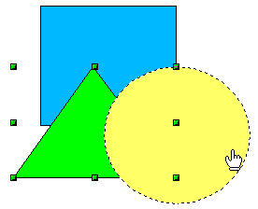
Reverses the order of the selected objects (this option is grayed out if only one object is selected).
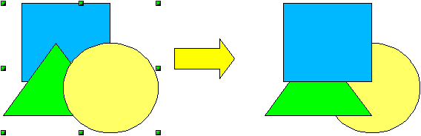

Aligning Objects
Select two objects and long-click the Alignment icon on the Drawing toolbar to open the Align toolbar (Figure 116). This toolbar can be torn off and made to float. The tools help you position objects with respect to each other.
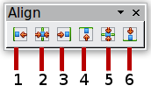
1 Align left | 3 Align right | 5 Center vertically
2 Center horizontally | 4 Align top | 6 Align bottom
Figure 116: The floating Align toolbar
Align left.

Center horizontally.

Align right.

Align top.

Center vertically.

Align bottom.

If you have selected only one object, clicking the various buttons on the Align toolbar positions the object in relation to the drawing page.

Distributing the Distance and Space Between Objects
Select at least three objects. Then you'll be able to select the Distribution option from the Modify menu or from the right-click menu. The Distribution dialog (Figure 117) contains several options, which are described below.
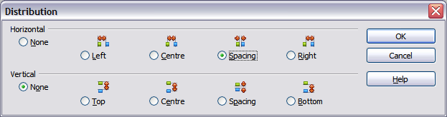
Figure 117: Distribution of spacing between objects
Horizontal distribution
None. Does not distribute the objects horizontally.
Left. The left edges of the objects are evenly spaced from one another.
Center. The horizontal centers of the objects are evenly spaced from one another.
Spacing. The horizontal spacing between the objects is evenly distributed.
Right. The right edges of the objects are evenly spaced from one another.
Vertical distribution
None. Does not distribute the objects vertically.
Top. The top edges of the objects are evenly spaced from one another.
Center. The vertical centers of the objects are evenly spaced from one another.
Spacing. The vertical spacing between the objects is evenly distributed.
Bottom. The bottom edges of the objects are evenly spaced from one another.
Figure 118 shows four objects before horizontal spacing distribution.
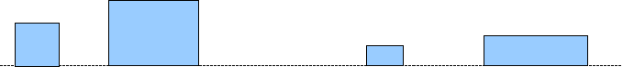
Figure 118: Before distribution
The result of the selections made in Figure 117 is shown in Figure 119.
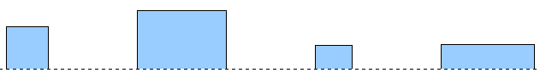
Figure 119: After distribution: change to equal horizontal spacing, no vertical change

Chapter 6
Editing Pictures (Raster Graphics)

Introduction
Earlier chapters of the Draw Guide have dealt only with vector graphics, that is, images created by mathematical formulas that specify the relationships between the elements of the image. However, Draw also contains several functions for handling raster graphics (also called bitmaps), photographs, and scanned pictures, as well as imports, exports, and conversions from one format to another.
Draw can read all common graphics file formats. It has some of the same capabilities as specialized programs like Adobe Photoshop or Gimp.

Importing Raster and Vector Graphics
To import stored graphics files, choose Insert > Picture > From File on the menu bar or click the icon on the Draw toolbar. Draw possesses import filters for many different vector and raster graphics formats. If your file has a nonstandard extension, you must choose the format explicitly when importing it.
If you select the Preview option in the Insert picture dialog (Figure 120), Draw shows a preview of the picture in the box on the right-hand side. This makes it much easier to choose the picture you want and to see whether Draw can import a file of this format.
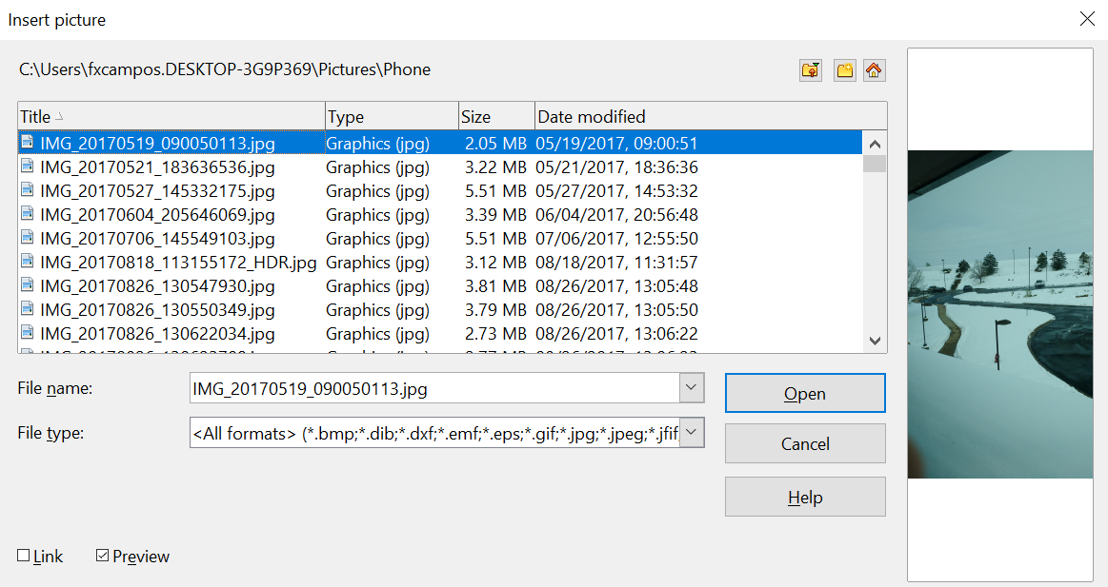

Figure 120: Inserting a picture; notice Link and Preview options in lower left of dialog

Link or Embed?
If you select the Link option in the Insert picture dialog, the graphic is linked to, rather than embedded. It's not inserted into the document. Instead, a link to the graphic is created. This link is relative to the folder where the document is stored, even though it shows up in the Edit Links dialog (see Figure 121) as an absolute link.

Note | If you store the document and the graphic in the same folder and transport the folder as a whole to another computer, the graphic will appear in the document as before.
Linked graphics are not changed as a result of any actions performed within OpenOffice. Such changes affect only the view of the graphic in the document, not the graphic itself. In particular, the format of a linked graphic remains unchanged. In contrast, when a raster graphic is embedded in a document, it is converted into PNG format.
Linking keeps the Draw document's file size small. The picture can be edited or even replaced by another, and the link will still function. As long as the new picture is given the same name as the old one, links will be re-established and updated when the document containing the link is next opened. However, some actions do not last beyond the current session (for example, Filter) or are simply not possible on a linked graphic (for example, using the color replacer to exchange colors).
Links can easily be removed. The linked picture will then be embedded in the document. To break a link, choose Edit > Links from the main menu bar. In the Edit Links dialog (see Figure 121), choose the link to be broken and then click on the Break Link button.
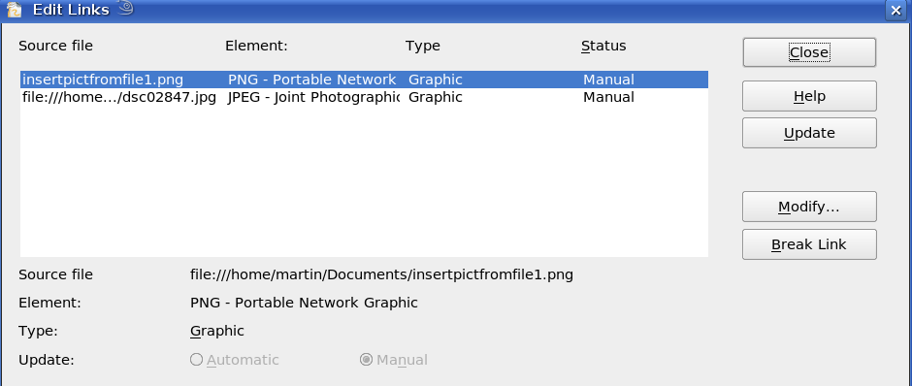Figure 121: Editing links to documents

Scanning
With most scanners, you can directly insert a scanned picture into a document. Scanned images are embedded in the document in PNG format.
Make sure the scanner is supported by the SANE system on Linux or other UNIX-like operating systems, or by TWAIN if you are using Windows. Note also that either of these must already be configured on the machine running OpenOffice. If more than one scanner or equivalent device is present, you can select the source from Insert > Picture > Scan > Select Source.
To insert an image from the scanner:
- Prepare the image on the scanner and make sure that the scanner is ready.
- Choose Insert > Picture > Scan > Request.
- The rest of the procedure depends on the scanner driver and interface. You will normally be required to specify the resolution, a scan window, and other options. Consult the scanner’s documentation for more information.
- When the image is scanned, Draw places it on the page. At this point, it can be edited like any other image.

Pasting from the Clipboard
The clipboard offers another way to insert graphics. Depending on the source and the operating system, figures may be in different formats. You can obtain an overview by choosing Edit > Paste Special from the menu bar or by clicking on the Paste icon’s drop-down menu on the main toolbar. The choices on the list vary with the type of graphic on the clipboard.

Dragging and Dropping
Drag-and-drop is also possible in many cases. The exact way drag-and-drop works is determined by the operating system in use and the source of the graphic, regardless of whether the graphic is embedded or linked. The behavior can be controlled by pressing the Control or Control+Shift keys together.
Draw objects and images that are used frequently can be stored in the Gallery. Objects can be dragged from the Gallery to the Draw surface quite simply. Working with the Gallery is dealt with in Chapter 10 (Advanced Draw Techniques).

Inserting from a File
With this option, you can insert complete pages or single objects from existing Draw or Impress documents into your Draw document. Additionally, you can insert text in Rich Text Format (RTF), HTML format, or plain text. The text will be contained within a text frame. The usual paragraph and character formatting options are available for this text.
Choosing Insert > File brings up the File selection dialog. Select the required file and click Insert. If the file is a Draw or Impress document, the Insert Slides/Objects dialog (Figure 122) opens.
To access single pages or slides of the document, click on the expansion symbol (usually a + or a small triangle, depending on your operating system) to the left of the file name in the selection area. The same method is used to display single objects within slides. Raster graphics (for example, photos) and Metafiles are marked with a , drawing objects with a , and OLE objects with a .
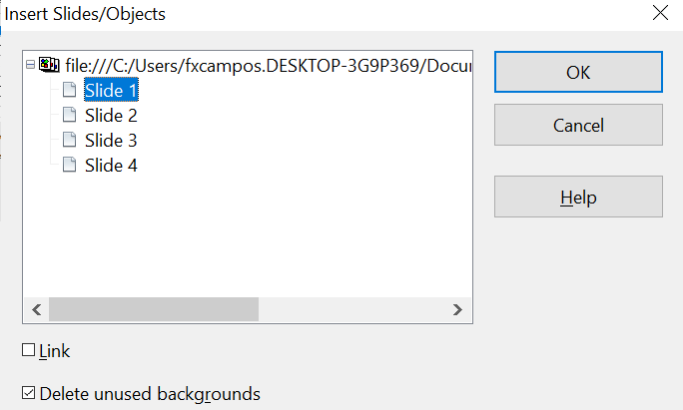
Figure 122: Inserting complete pages or objects on a page
Choose the slides or objects you want to insert; for multiple selections, press the Control or Shift key while clicking on the items. Then click OK to insert the selected items.
If the inserted object was named in the source document, it keeps its original name, unless the name already exists in the current document. In that case, you must give the object a new name before inserting it. To rename an inserted object, right-click and choose Name from the pop-up menu. Renaming has the advantage that the object is then listed in the Navigator.
You can choose whether to embed or link the selected page or object.

Exporting Graphics
Draw saves drawings by default in the *.ODG format. Some programs cannot open these files. To use the drawings in other programs, you can export the graphics in various formats. Choose File > Export, then, in the File format pull-down list, select the desired format (see Figure 123).
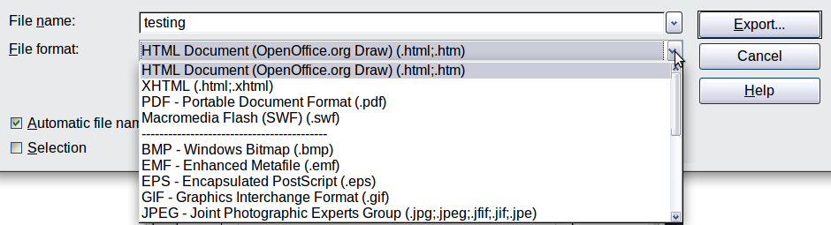
Figure 123: Lower part of the Export dialog

Exporting the Entire File
The file format options in the upper area of the File format box (HTML, XHTML, PDF, and Flash) always apply to the complete file. Using Flash or HTML causes each page of the Draw document to be exported as a raster graphic. After using this option, you will no longer be able to access individual objects on the page.
Flash reached its end-of-life on December 31, 2020. Thereafter, Adobe stopped all support, including security updates. As a result, Adobe strongly recommends uninstalling Flash Player, and major browsers have already removed it.
- Official End-of-Life: Adobe officially announced the end of support in 2017, and the final end-of-life date was December 31, 2020.
- Blocking and Removal: After that date, Adobe began blocking Flash content from running, and major browser vendors have either disabled or fully removed the Flash Player component from their products.
- Reasons for deprecation: The discontinuation was due to several factors, including the maturity of open standards like HTML5, WebGL, and WebAssembly, which offer better performance and security. Flash had persistent security vulnerabilities, and its performance was often poor, consuming high amounts of CPU and battery.
To export a multi-page Draw document as a series of web pages, choose File > Export and select HTML Document as the file type. The HTML Export wizard opens. Follow the prompts to create the web pages. If you wish, the wizard can generate a navigation aid to help in moving from page to page.
If you want to use the objects in other applications, select one of the Metafile formats (JPEG, PNG, BMP, and so on) in the lower part of the File format list (see Figure 124). With this type of export, only the currently active page is exported.
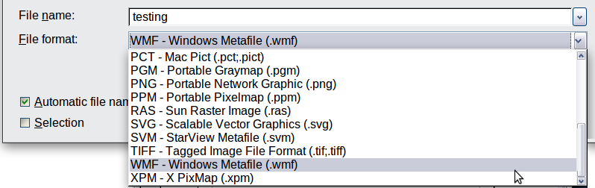
Figure 124: Section of the file selection list

Exporting Single Objects
To export individual drawing objects, you first need to select them. A selection can include more than one object. Take care to choose the Selection option from the Export dialog.

Exporting as a Vector Graphic
The choice of vector formats is still limited. Even exporting a graphic to an SVG file is not yet fully implemented: 2D graphic objects are exported as paths, and 3D objects only as preview images. The Metafile formats are best supported; exporting to one of them is usually successful.

Exporting as a Raster Graphic
The choice of export formats for raster graphics is large enough to support most other applications. In case of doubt, test different formats to see which gives the best results; some programs behave differently depending on the image formats they import.
After entering a name for the exported file and selecting the file format, you may be able to set options for the exported image—compression, color format, and version of Metafile—depending on the format you choose. Some examples of the various option dialogs are shown in Figure 125.
Where the export dialog allows you to specify the image resolution, this does not affect the number of raster points in the image. Rather, it inserts information into the picture that tells other programs the dimensions to use when displaying the image. This means that, among other things, missing raster points can be introduced when the graphic is opened in another program.
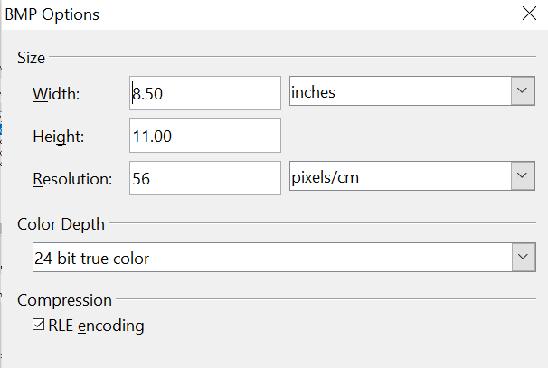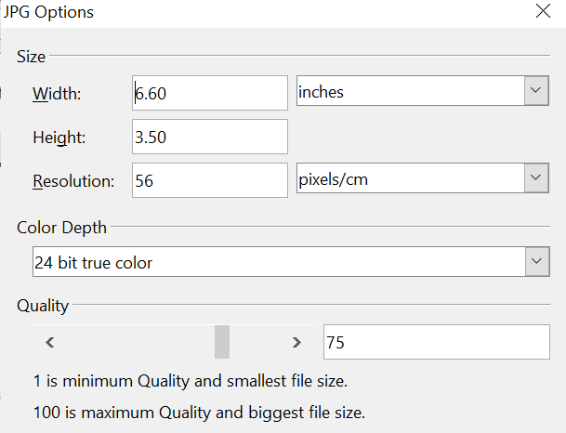

Figure 125: Adjusting format specific properties prior to export
The actual number of pixels used is determined by the screen resolution set up by the operating system, and the Drawing scale factor set in Tools > Options > OpenOffice Draw > General.
Embedded raster graphics, or objects that have been converted to a bitmap or Metafile (from the context menu Convert > To Bitmap / To Metafile), may subsequently be saved as a picture; from the context menu, choose Save as Picture. This saves the picture without Draw-specific additions such as text elements, borders, or shadows, and without the possibility of setting any of the options available when exporting.
Draw objects can easily be imported into Writer, Calc, or Impress documents. For objects used often, this is most easily done by storing them in the Gallery or using the clipboard. Writer and Calc do not possess the same range of tools as Draw. So it makes sense to use Draw to produce a complex drawing, and then to copy it into other AOO applications. A link to single drawing objects is not possible, but you can incorporate Draw documents in the other modules as linked OLE objects.
Tip | To avoid problems when scaling Draw objects containing text after importing them into Writer, convert the object to a polygon before storing it in the Gallery or copying it to the clipboard. See “Convert to a Polygon” on page 112.

Modifying Raster Object Properties
As with other objects, the properties of a raster graphic can be modified. You can format the graphic using the Graphic pane of the Sidebar, the Format menu, or the context menu. Use the Picture toolbar to add or change filters using the Graphic Filter Bar; adjust the Lines, Areas, and Shadows properties. The Transparency property in the Format menu does not relate to the transparency of the raster graphic itself but to the background area. To set the transparency of the graphic, you must use the Picture toolbar.
Graphics can also have a text element. For more on text, see Chapter 10 (Advanced Draw Techniques).
You can change the position and size of graphics, or rotate them, using the methods described in Chapter 3 (Working with Objects and Object Points). Raster graphics can be flipped (Modify > Flip), but note that some Metafile formats may have problems flipping text.
Graphics included as a member of a group behave like other drawing objects when the properties of the group are modified.
It is a good idea to (re-)name the graphic using Name from the Modify menu or the context menu. Only named objects are visible in the Navigator, and only named objects can be directly imported from another file.

The Picture (Editing) Toolbar and Graphic Pane
If you have enabled the Picture toolbar (in View > Toolbars), it will automatically appear on the screen whenever you select a (bitmap) picture (see Figure 126). It appears either directly under the menu bar in place of the formatting toolbar or as a floating toolbar elsewhere on the screen.
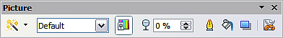
Figure 126: The Picture toolbar
Most of the same tools are available on the Graphics pane of the Properties deck of the Sidebar. A Graphics pane, like that in Figure 127, appears automatically when you select a picture.
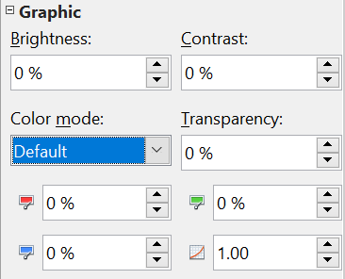

Figure 127: The Graphic pane on the Sidebar
The following table explains the individual functions on the Picture toolbar and illustrates their use with examples.
Filter | Opens the Filter toolbar, which is described in “The Graphic Filter Toolbar” on page 105. This tool is not on the Sidebar.
Graphics Mode | Use the Graphics mode (Color mode on the Sidebar) menu to change the display of the graphic from normal color to grayscale, black and white, or a watermark. This setting affects only the display and printing of the picture; the picture itself remains unchanged.
Default: | The graphic is displayed unaltered in color.
Grayscale: | The graphic is displayed in 256 shades of gray.
Black/White: | The graphic is displayed in black and white.
Watermark: | The brightness and contrast of the graphic are reduced to the extent that the graphic can be used as a watermark (background).
Color | Use the Color tool to adjust the values of the three RGB colors, the brightness, contrast, and the Gamma value. These adjustments do not affect the original picture, but the values are stored in Draw as a separate formatting set.
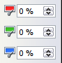 | You can select values from between –100% (no color) to +100% (full intensity); 0% represents the original value of the property.
Brightness | The brightness can be adjusted between –100% (totally black) and +100% (totally white).
Contrast | The contrast can be adjusted between –100% (minimum) and +100% (maximum).
Gamma | The Gamma value affects the brightness of the middle color tones. Values can range from 0.10 (minimum) to 10 (maximum)  Hint: Try adjusting this value if changing brightness /contrast does not give you the result you want.
Transparency | The degree of transparency of the picture can be adjusted from 0% (opaque) to 100% (fully transparent).
Line | Opens the Line dialog. In this context, line refers to the outline of the border. See also Chapter 4 (Changing Object Attributes). A subset of the tools are on the Line pane of the Sidebar and the full menu can be accessed via the three dots on that pane.
Area | Opens the Area dialog. Here you can edit color, gradient, hatching, and fills of the background area that contains the graphic—not the graphic itself. To see the background, you must set the graphic's transparency to a suitably high value. A subset of the tools are in the Area pane of the Sidebar, and the full menu can be accessed via the three dots on that pane.
Shadow | Use this tool to set a default shadow effect around the graphic. More control of the shadow is available on the Area dialog.
Crop  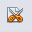 | Use this function to crop (trim) an image. When you click on this icon, crop marks appear on the image (Figure 128). Drag one or more of these marks to crop the picture to your desired size. For more accurate cropping, see “Cropping” below. This tool is not available on the Sidebar.
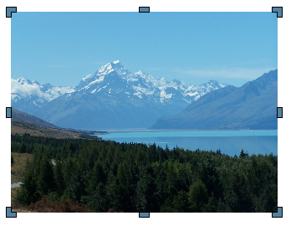
Figure 128: Interactive crop marks on an image

Cropping
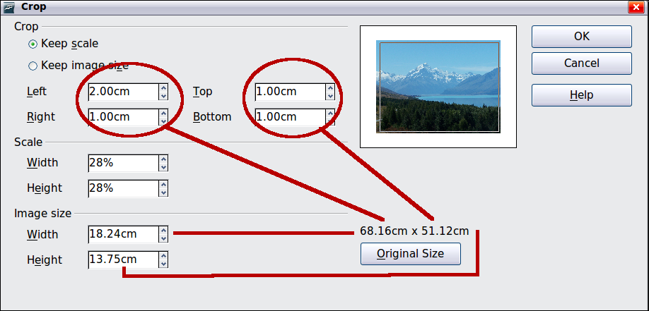
Figure 129: The Crop dialog
More control and accuracy over cropping functions are available via the Format menu. Click Format > Crop Picture, and the dialog box in Figure 129 will appear. The fields Left, Right, Top, and Bottom specify the amount to trim from the appropriate edge.
In addition to cropping, you can enlarge or reduce the graphic's size by changing the percentage scaling values. The new dimensions of the graphic are shown in the Image Size width and height boxes, which can also be directly adjusted.
In Figure 129, you can see that 2 cm from the left side and 1 cm from the top, bottom, and right side will be trimmed from the original object. The preview pane shows the location of the new edges of the graphic. In addition, both height and width have been scaled down by 28%.
- If you choose Keep Scale, the graphic will be cropped to the scales shown in the width and height boxes, and the picture will be reduced in size accordingly.
- If you choose Keep image size, the graphic will be cropped and then enlarged to the original image size.
Take care with these operations; in the Crop dialog, the width and height are treated as totally independent values. Changing one without the other can result in significant image distortion. In that vein, be aware that the Position and Size dialog in the context menu has an option to keep the width-to-height ratio fixed while changing one of the two dimensions. Changing values in one area (Scale or Image Size) will be reflected in the other area.
Caution | Changes made in the Crop dialog affect only the view of the picture. The original picture is not changed. To export a cropped graphic, you must use File > Export. If you use the option Save as Picture from the context menu, the changes are not exported.

The Graphic Filter Toolbar
Click the Filter icon to open the Filter toolbar. Draw offers eleven filter effects. Filters work on the current view of an object, and can be combined. Filters always apply to the entire graphic; it is not possible to use filters to edit only a part of the object.
Invert reverses (inverts) the colors of an image so that it appears as a color negative of the image.

Smooth reduces the contrast between neighboring pixels, resulting in a slight loss of sharpness. If you use the filter several times in a row, the effect will be strengthened.

Sharpen increases the contrast between neighboring pixels, emphasizing the brightness difference. This will accentuate the outlines. The effect will be strengthened if you apply the filter several times in a row.

Remove noise compares every pixel with its neighbors and replaces the extreme values (those that deviate in color by a large amount from a mean value) by a pixel with a mean color value. The amount of picture information does not increase, but because there are fewer contrast changes, our brains can better recognize the resulting graphic. This filter tends to make the picture a little smoother.
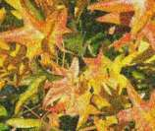
Solarization was originally a photochemical effect. If the location of a photograph is extremely highly lit, you can experience a reversal of color and brightness. Similarly, entry of light during the developing process reverses the brightness values. These phenomena were used for artistic production of pictures.
With this filter, you input a threshold brightness value, above which the color values are reversed (middle picture, threshold value 70%). With the Invert option, the whole of the resulting picture is inverted in color (right picture).
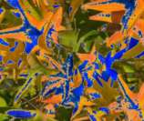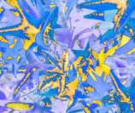
Aging lends pictures a certain “look” resembling that of old photos. The process first produces a grayscale picture from the original and then reduces the intensity of the blue and green color values, so that the final picture appears darker and redder. In the middle example, the aging degree was set to 0%, on the right it was 15%.

Posterize reduces the number of colors in the picture. The fewer colors, the flatter the picture appears. In the picture below on the right, the number of colors was reduced to 8. The results of this filter are not always good.
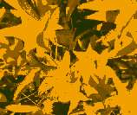
The Pop-Art filter is supposed to change the colors of the picture to a pop-art format, but unfortunately, it does not seem to function correctly at present.
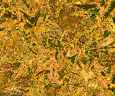
Charcoal sketch makes the picture appear as if it had been drawn with charcoal. The outlines are in black, and the original colors are suppressed.
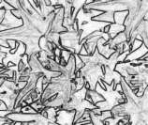
The Relief filter calculates the edges in relief of the picture and produces a picture as if illuminated by a light source, the position of the illuminating light being variable and producing shadows that differ in direction and magnitude.
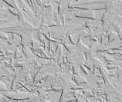
Mosaic takes groups of pixels and converts them into a single color rectangular tile. The whole picture appears to be a mosaic. The center and right pictures below had an element resolution of 5 pixels. The picture on the right also had the Enhance edges option selected; with the greater contrast at the edges, it appears to be a little sharper.
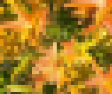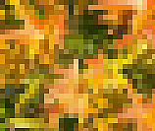
Caution | If your picture is linked, filters are applied only to the current view. The stored picture is not changed. When you close the document, all filtering is lost. You should ensure that you export the picture to create a copy with all the filters applied (File > Export).  If you embed the graphic in the document, all filters are applied directly to the embedded graphic and cannot be undone in a subsequent session. If you do not want to retain a filter, you must use Edit > Undo to return to an earlier state of editing. After you save and close the document, the filter effects are permanent.

Changing Colors Using the Color Replacer
Use the Color Replacer to change one color in a picture with another, or set the color to transparent. The tool always works on the entire picture; you cannot select only a region for editing.
The changes are applied to the graphic itself and therefore require it to be embedded. Attempting to use the eyedropper tool on a linked graphic will result in the following message: This graphic is linked to a document. Do you want to unlink the graphic in order to edit it?
The tool can be used on all raster graphic formats and with many—but not all—Metafile formats.

Practical Example: Changing Wrong Colors to Transparency
Some applications that cannot correctly handle transparency show transparent areas with the color Magenta, then store the graphic with this color and without the correct transparency information.
 | Bitmap graphic with area in magenta, which actually should be shown transparent. On the left is the original picture, right is the picture after saving it with MS Paint.
If you receive such a picture, you can recreate the transparency with the color replacer tool.
Open the Eyedropper dialog via Tools > Color Replacer, then click the picture to be edited. | 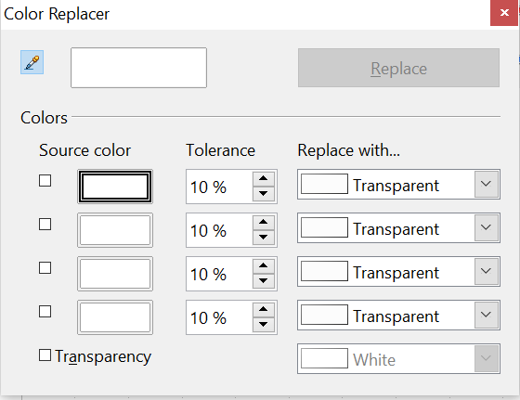
Click the icon 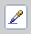 to change to the color selection mode. Outside the dialog, the cursor changes to a hand. The field next to the icon shows the color immediately under the hand cursor. | 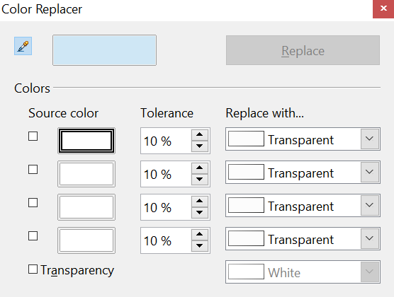
Click on the color to be changed. The first Source Color box is now marked, and the color selected appears in the left box. In the Replace with selection list, the option Transparent is already selected. Click the Replace button in the upper-right of the box to apply the changes to the picture. There is no preview of the effect. If the result is not what you wanted, choose Edit > Undo. | 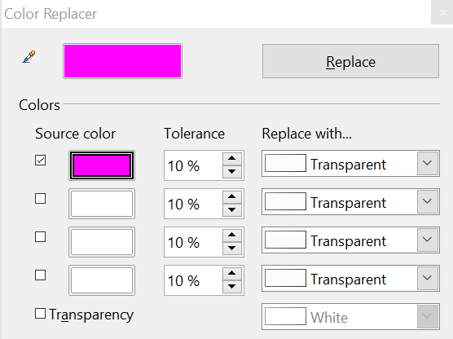
This dialog does not close automatically, so you can carry out further color replacements. First, mark the Source color field. Then choose the replacement color with the cursor. Close the dialog with Ctrl+F4 or the Close icon on the window border. Draw uses a separate Alpha channel for transparency so that pixels of different colors can be made transparent.
It is also possible to perform the operation in reverse, changing a transparent area to a color. Select nothing in the graphic, but choose the Transparency option at the lower left of the dialog and the replacement color at the lower right.
The selection list for replacement colors shows all available colors in the current document's color palette. You cannot define any new colors here, but you can add colors to the available palette before using the color replacer tool. For more on this topic, see Chapter 8 (Tips and Tricks).

Effect of the Tolerance Parameter
The tolerance parameter describes how closely a color value in the picture must match the source color if it's to be replaced. In the figure below, the red color tone at the left edge of the rectangular color palette is used as the source color, and a pure blue as the replacement color, with several different tolerances. The original is a rectangle with a color palette from red to green. Because the color replacer cannot be used on drawings, the rectangle on the left was converted to a raster graphic (Convert > Bitmap). The picture was then exported in an Enhanced Metafile format and inserted on the right for comparison.
Original
0% smallest value
99% largest value
80%
40%
20%

Color Depth
It is possible to reduce the color depth in OpenOffice. The tools are available, but you must create a separate menu and add them to it if you wish to have them available (refer to the help if you are not sure how to do this). To find the tools, click on Tools > Customize >, Toolbars, and > Add (Command). The commands are in the Modify category, at the top of the list.

Reducing color depth
Original with a 24-bit pixel depth (=8 bits per channel)
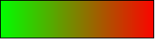
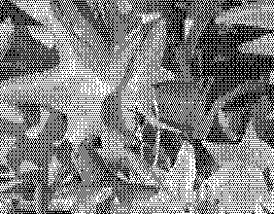 | 1-bit dithered  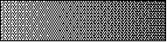  The impression of grayscale is produced by a raster. In reality, there are only two colors.
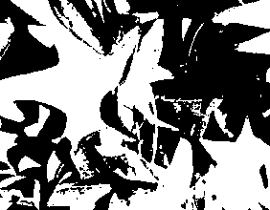 | 1-bit threshold    The threshold determines which pixels are black and which are white. You cannot set it directly, but you can influence which part of the image is set to black by varying color settings on the picture toolbar—red, green, and blue level, brightness, contrast, and/or gamma value—to see what works best for your image. You must export and save the modified image with File > Export and reopen it, before changing the color depth.
 | 4-bit color palette  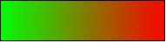  With 4 bits, a total of 16 colors can be produced. The color steps are quite fine because the process does not use the 16 basic RGB colors but instead selects from the palette those that best match the colors in the image.
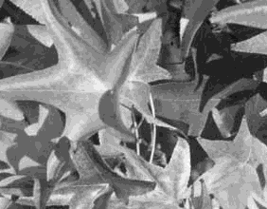 | 4-bit grayscale palette  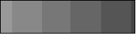
 | 8-bit color palette  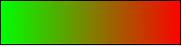  With 8 bits, a total of 256 colors can be produced. The image on left is, at first glance, very difficult to distinguish from the original. A big difference is that the picture file is only one-third of the size of the 24-bit version.
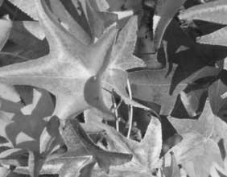 | 8-bit grayscale palette  

Conversion

Convert to a Contoured Image
Select the picture so you see the green handles. From the context menu or the Modify menu, choose Convert > to Contour. This command creates a polygon or group of polygons from the original image, with four corner points, and with the image set as a background graphic. In this state, you cannot edit the graphic further. All of your modifications must be completed before this point.
The polygon is, in fact, a vector graphic, but the picture remains a bitmap image. Using a polygon offers possibilities for further change; for example, you can modify the shape or define a transparency gradient.

Convert to a Polygon
Select the picture so you see the green handles. From the context menu or from the Modify menu, choose Convert > to Polygon,as illustrated in Figure 130. This command converts areas of the same color into small filled polygons. The entire image becomes a vector graphic and can be resized without loss of image quality or distortion of text. The resulting format will be a Metafile.
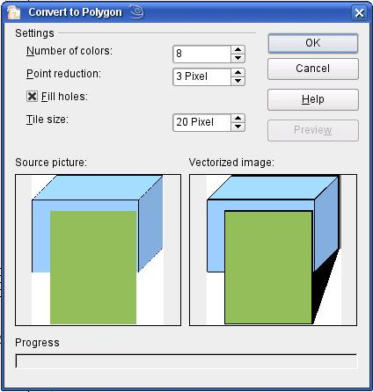
Figure 130: Conversion of a picture to polygons
The Convert to Polygon dialog has several settings that can be tested using the Preview button. Because graphics conversion can sometimes take a while, depending on both the picture and the computer, a progress bar is included at the bottom of the dialog.

Number of Colors
Draw considers 8 to 32 colors during conversion. However, the picture can contain fewer than 8 colors. For every color in the picture, Draw creates a polygon that may consist of several disconnected parts. These polygons are then filled with the relevant color.
The algorithm Draw uses to reduce the number of colors in the picture to the number specified is not yet optimal. You may prefer to reduce the number of colors by changing the color depth or using the Posterize filter (page 107) from the Graphic Filter toolbar (page 105).

Point Reduction
Polygons will only be created if their size is greater than the value given in this setting. The section of the picture below, highly magnified, shows that with a larger point count, small flecks of color—typical of irregular color patterns—simply disappear.
2 Pixel 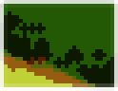 3 Pixel 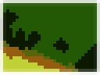

Fill Holes
Point reduction can result in small areas, or “holes,” that are not covered by a polygon. If the Fill holes option is marked, additional square, tiled areas are created with a background color matching the hole. The Tile size option allows the width in pixels of these square areas to be preset.
  Original picture | Original picture with 16 colors and 0-pixel-point reduction vectorized
  Original picture transformed with the Poster filter and 64 colors … | … and then with 16 colors and 0-pixel-point reduction vectorized.
Here, the picture is transformed with the Poster filter, but this time with a point reduction of 4 pixels and a tile size of 16 pixels. | The effect below was generated from the picture to the left (posterized and vectorized); the polygons were split with Modify > Break, and a number (in this case 6) of the (foreground) polygons were deleted until the resulting background was achieved.  Note: To select polygons for deletion, click on a curved colored area (the text in the status bar shows “Polygon nnn corners selected”, where nnn is the number of corners of the polygon) and a frame with green handles encloses the area of the polygons selected. Press Delete to delete the polygons. Repeat until you have achieved the desired effect (which here is to have only the background showing).
If you next ‘split’ the existing Metafile (Modify > Split), access is gained to individual polygons. To be able to operate on these together, you should immediately group them after splitting.
With the vectorized form of an image, you can carry out operations familiar to those from classic drawing programs. One example might be a curved warping operation. For such transformations, it is much less effort to use a conversion with background tiles so that the picture's edges are straight.
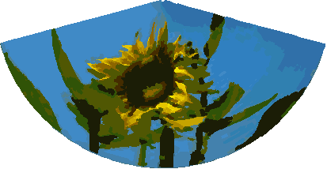
Using the graphic generated in the posterize and vectorize process above, Break and Split it, and then try out some operations using the tools on the Effects toolbar.
To use this tool to vectorize the first letter of a chapter in a special font, convert the graphic to a polygon using no point reduction or background tiling. Use Modify > Break to generate two polygons. An example is shown below.
 | Original polygon, converted from a Metafile. Break the graphic into two polygons.
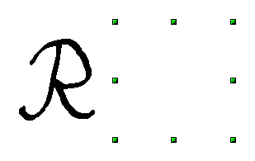 | After the conversion, there are two polygons: one with the visible letter and another, not visible because the lines and area fill are all white. You can select this “invisible” polygon by pressing Tab (click the visible letter first, then press Tab; this moves the current selection to the next object). In the example at the left, the invisible polygon has been moved to the side. If you have Display Grid active and the grid points set to display behind objects, you can see where this invisible polygon is, since it obscures the grid points behind it.
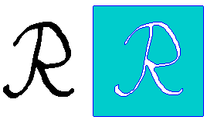 | This invisible polygon encloses the letter. After changing the line(s) and/or area to a different color, the polygon becomes visible.

Convert to Bitmap
All drawing objects are vector graphics. Use the command Convert > To Bitmap from the context menu to convert a vector graphic to a raster graphic. Draw creates a raster graphic in PNG format with a 24-bit color depth. Unfortunately, any transparency effects created in the vector graphic are lost during this conversion, although the PNG format used in Draw does support transparency. Only if you use the color replacer tool to set transparency will an Alpha channel also be produced.

Note | An alpha channel represents the transparency of a computer-generated image.

To determine the height and width of the converted graphic, that is, the number of pixels needed, Draw considers the dots per inch or dpi setting of a given operating system for a monitor's screen, as well as the percentage scaling factor set under Tools > Options > OpenOffice > View in the section User Interface.
Example:
Width of vector graphic: 1.5 inch
Monitor setting of operating system: 96 dpi ( = 96 dots per inch)
Scaling 130 %
Calculation: 1.5 inch x 96 dpi *130% = 187 pixels
The actual number of pixels will vary somewhat from this value, due to rounding. When the format permits, Draw uses a dpi value (in this case 125 dpi) which permits the calculation to be reversed, causing a picture with this pixel value to be reproduced with the correct width of 1.5 inches.
Keep in mind that the above example is for displaying a drawing on a screen. Printed images typically require a higher dpi value.

Print Options with Raster Graphics
If you have only a black-and-white printer or are experiencing printing problems, consider the following settings.
You can set up printing so that all text and all graphics are printed in grayscale, that is, black and white. The general settings are in Tools > Options > OpenOffice Draw > Print, in the section Quality (see Figure 131). To set these for the current document only, use Options in the Print dialog (File > Print). With both Black/white printing and Grayscale printing, no background is printed.
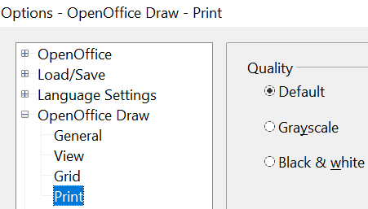

Figure 131: Options - OpenOffice Draw - Print
Other options are in Tools > Options > OpenOffice > Print (see Figure 132). They relate to page options (scaling) and other printing variables. They affect the size of the print file and the time taken to print the document. With most modern systems, you can simply accept the defaults. However, because operating systems and printers have unique requirements, you may need to tailor printing settings to your site's conditions. Refer to the Help file for more information.
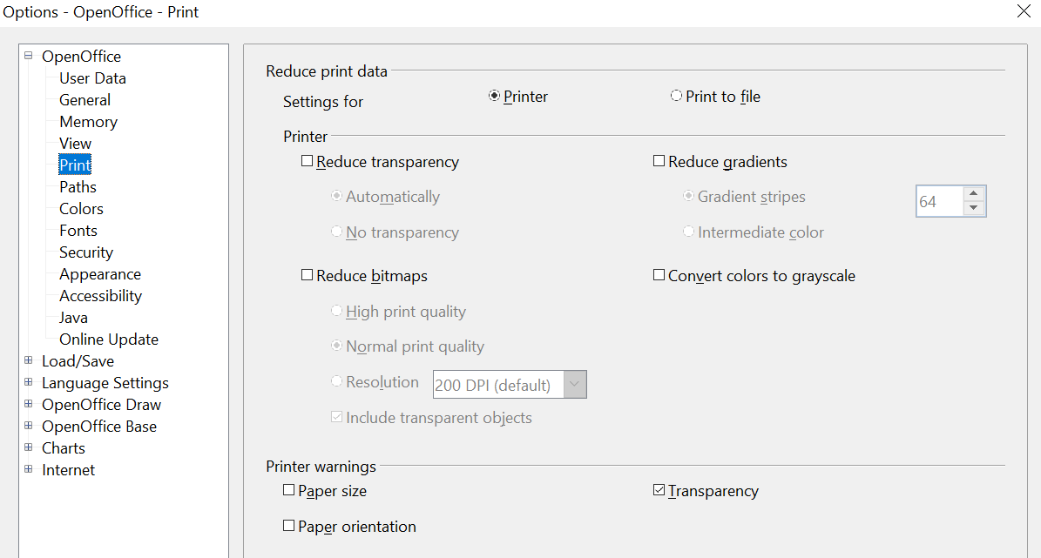

Figure 132: Options - OpenOffice - Print dialog

Chapter 7
Working with 3D Objects

Creating 3D Objects
Although Draw does not match the functionality of leading drawing or picture editing programs, it is capable of producing and editing very good 3D drawings and pictures.
Draw offers two different types of 3D objects: 3D bodies and 3D shapes. Depending on the type you choose, there are different options for further editing the object (rotation, illumination, perspective). 3D shapes are simpler to set up and edit than 3D bodies, but 3D bodies allow for more customization.

Creating 3D Bodies
You can produce 3D bodies in three ways: extrusion, body rotation, and using ready-made objects. In this chapter, these methods are called Variation 1, 2, and 3. Two further variations, extruding Basic Shapes and converting text to 3D, are also described.

Variation 1: Extrusion
First, draw one of the common Draw objects, for example, a square/rectangle, circle/ellipse, or a text box using the or icons on the Drawing toolbar or Sidebar. Next, choose Modify > Convert > To 3D (or right-click on the object and choose Convert > To 3D, or click the icon) to produce a 3D object from the 2D surface. Figure 133 shows two examples.
The icon is not usually visible on the Drawing toolbar. To make it visible, select Visible Buttons from the toolbar menu at the right end, then click the icon.
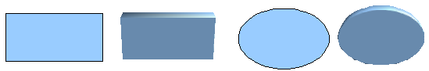
Figure 133: Extruding 3D objects from 2D surfaces
The process of moving parallel surfaces to create a 3D object is known as extrusion. In this case, the 2D surface is moved forward, “out of” the drawing level. At the same time, the object is slightly tilted, and central projection is turned on so that one can better recognize it. Draw uses a default extrusion value (the body depth) based on the 2D object's size. The value can be changed after the extrusion (see “Editing 3D Objects” on page 123).

Variation 2: Body Rotation
Choose a common drawing object, for example, a non-black line. Then change this into a rotation body. Draw provides two methods to do this.
Method 1. Click the icon in the Drawing toolbar (this icon also usually needs to be made visible) or choose Modify > Convert > To 3D Rotation object. With this rotation method, the axis of rotation coincides with the left edge of the enclosing selection rectangle, through the green rectangle handles (Figure 134).

Figure 134: Rotation body created using variation 2.1
Method 2. Click the icon on the Effects pull-down menu on the Drawing toolbar. This icon can also be accessed from the Mode menu, under View > Toolbars > Mode. Notice that this icon lacks the curved red arrow of the fixed-axis rotation icon (Figure 135).
With this method, you can change the location of the rotation axis, which appears as a dotted line with two white circular endpoints.
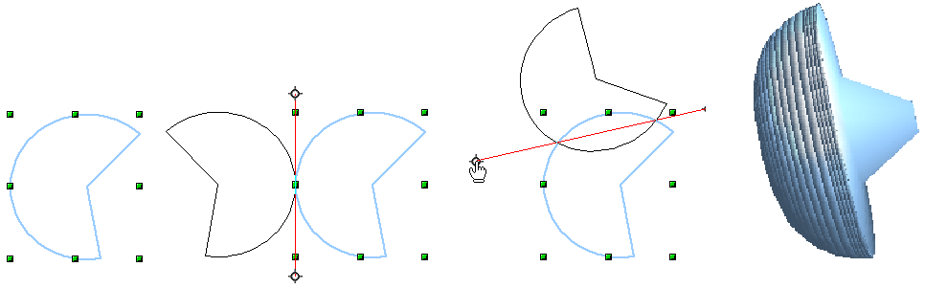Figure 135: Rotation body created using variation 2.2
Click a white endpoint and drag it to move the axis to the desired position. (You may need to move both ends to achieve this.) The outline shows how the figure will be rotated. When you click the figure again, the rotation is applied, and a new 3D body is produced.

Variation 3: Using Ready-made Objects
Use the 3D Objects toolbar/pull-down menu (Figure 136). To activate this toolbar, click View > Toolbars > 3D Objects.
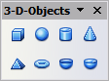
Figure 136: The 3D Objects toolbar
If you add the icon to the Drawing toolbar, the 3D Object bar will be available as a dropdown menu or a floating toolbar.
After choosing the type of object, left-click on the starting point, and drag the mouse diagonally until the outline of the object is the size you want.
After releasing the mouse button, the 3D object appears. To change its height: width ratio, keep the Shift key pressed while dragging the mouse. Most 3D objects are constructed by rotation, but cubes and spheres are special types of 3D objects that are directly defined in the program code.

3D Scenes
Variations 1–3 all produce a 3D scene. If you click a 3D scene, the status bar text shows 3D scene selected. Such a scene is actually a group of objects.
If you constructed the scene using one of the methods above, it consists of the 3D body as a single element. 3D scenes can, however, be extended to include other 3D objects, as described in “Combining Objects in 3D Scenes” on page 141.
As mentioned in Chapter 6 (Editing Pictures), you can access individual elements of the group using Modify > Enter group or the context menu. The status bar text then changes and shows the type of each individual element selected, for example, Sphere selected or Extrusion object selected.

Producing 3D Shapes
Since the release of Version 2.0 of OpenOffice.org in 2005, Draw has contained a type of drawing object known as a (Basic) Shape. A special method of extrusion exists for these shapes.

Variation 4: Extrusion of Basic Shapes
Figure 137: The Basic Shapes toolbar
You use the Basic Shapes toolbar shown in Figure 137 (or another shape toolbar) to produce 2D surfaces. The Basics Shapes toolbar is available as a tear-off toolbar on the Sidebar or the Drawing toolbar. Shapes such as cylinders or cubes are technically possible but not very useful, because they produce curiously curved images. If you have drawn a shape, the last icon on the Drawing toolbar is active. A click on this icon can transform a 2D surface into a 3D object (see Figure 138).
Extrusion of a shape does not create a new object type; it simply changes the shape’s appearance. All the object’s properties and settings are retained. You can use this button to toggle between a 2D and a 3D view. The object's properties and settings are not lost when switching between views.
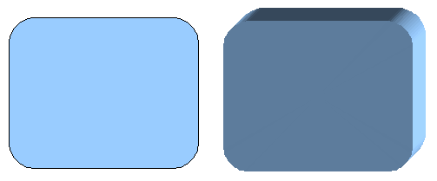
Figure 138: 3D objects from basic shapes
If you click such an object, the 3D-Settings toolbar (Figure 139) appears. If this does not open automatically, enable it in View > Toolbars > 3D-Settings.
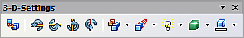
Figure 139: 3D-Settings toolbar
The first icon corresponds to the icon on the Drawing toolbar. This icon also works as a toggle switch. After switching to 2D, the 3D-Settings toolbar is hidden again. To change the object back to 3D, you must use the icon on the Drawing toolbar.

Variation 5: Fontwork
For text, you can also use shapes from the Fontwork Gallery. These produce extrusion objects similar to those from Variation 4.
To open the Fontwork Gallery shown in Figure 140, use the icon on the Drawing toolbar.
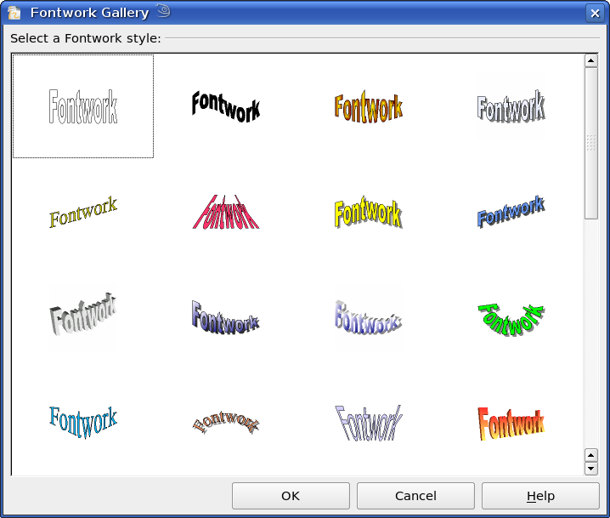
Figure 140: Extrusion Shapes from the Fontwork Gallery

Editing 3D Objects

Rotating 3D Objects

Procedure for 3D bodies
The Rotation command used for 2D objects also works with 3D objects, but due to the additional axis, there are some differences in editing 3D objects (see Figure 141). The procedure for selecting the object is identical to that used for a 2D object.
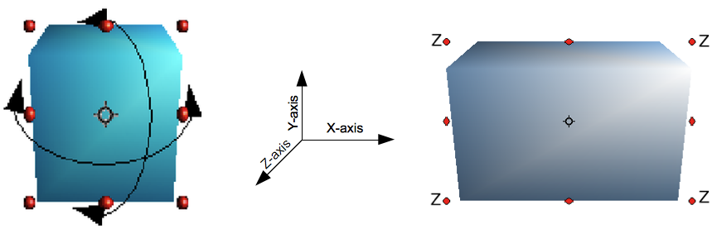
Figure 141: 3D object rotation
You can rotate the object about each axis (X, Y, Z). The X and Y axes are those parallel to the edges of the drawing layer, while the Z axis comes out of the page. It is not possible to change the axis orientation.
The three axes are not shown directly, but the symbol indicates their intersection point.
If you want to … | You must ...
... rotate the object  about the X or Y axis. | ... put the mouse cursor over the object. With the left mouse key pressed, you can rotate the object as you wish. Moving one of the red points at the middle of an edge allows you to rotate the object about only one axis. Note that the cursor initially has the shape for a (2D) shearing movement, but pressing the mouse button changes it to a rotation cursor.
... rotate the object  about the Z axis. | ... move the handle at one corner point while the left mouse button is pressed. Rotation about the Z axis is independent of the rotation angle setting in the Position and Size dialog
... move the axis intersection point. | ... simply drag the Symbol to the desired location. The point is located by default in the middle of the object.
These rotations can be applied to the entire 3D scene or to individual objects within it.

Procedure for 3D Shapes
Objects produced using variations 4 and 5 (see above) can only be rotated about the Z axis when using the three methods described in the previous section. This rotation is applied to the underlying 2D object. It is also possible to rotate the 3D object in the same way as a 2D object, using Format > Position and Size > Rotation (shortcut key for Position and Size is F4), and specify the pivot point and the desired degree of rotation.
Shape objects have their own procedure for rotation about the X and Y axes. If you have activated the 3D-Settings toolbar (under View > Toolbars), it becomes active when you select the 3D object. Icons 2 to 5 on this toolbar (see Figure 142) rotate the object in 5-degree increments about the X and Y axes.
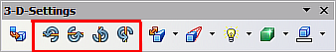
Figure 142: 3D-Settings toolbar with rotation icons indicated

3D settings for 3D Bodies

3D Effects Dialog – General Buttons
The 3D Effects dialog offers a wide range of possible settings for 3D objects produced with variations 1 to 3 (see previous sections). To open the dialog, right-click on the object and choose 3D Effects from the pop-up menu. You can also activate a 3D Effects icon on the Standard toolbar or add it to another toolbar using Customize Toolbar > Add > Category Options > 3D Effects.
Tip | If you cannot see 3D Effects in the pop-up menu, you may have a 3D object extruded from a basic shape. Try clicking the Extrusion On/Off icon in the Drawing Toolbar.
The dialog can be docked in a similar manner to the Navigator or Template windows.
The possible settings are arranged in various thematic categories on separate pages, accessible via the buttons at the top of the window, which function similarly to tabs. To apply the settings you have altered, click the Assign button, which is the checkmark icon at the right end of Figure 143. This applies all the changes you have made to the object on the other pages of the dialog, as well as the current one.
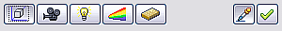
Figure 143: Upper part of the 3D Effects dialog
Note | Only the selected effects are assigned to the object in question. There is no object conversion; thus, a cylinder cannot be transformed into a ring through the application of a 3D effect. However, it is possible to change the appearance to resemble a wooden or metal body. By the assignment of a 3D effect, 2D objects are transformed into 3D objects.
In order for the Effects dialog to take over all the current properties of the object, you must click the button. If you deactivate this button before you leave an object and then click it again when you open the Effects dialog for another object, the settings carry over from the first object to the second. This can be used to transfer favorite settings from one object to another, as all the settings are brought over to the new object. In normal use, however, the icon should remain active.
At the bottom-left of the dialog is another row of buttons (see Figure 144), available on each page.
Figure 144: Buttons for geometric transformations
The first two buttons correspond to the menu commands Modify > Convert > To 3D / To 3D Rotation Object. When the Effects dialog for a 3D object is called up, these buttons are inactive. Selecting a 2D object activates it. The third icon switches a perspective view of the object on or off.
Converts the selected 2D object to an extrusion body.
Converts the selected 2D object to a rotation body.
Switches between a central projection and a perspective projection.
In a central projection, parallel edges appear to meet at a common point in the distance, as shown on the button symbol. Parallel projection preserves all parallel edges; a procedure often used to produce oblique figures. The switching process applies to the entire 3D scene.
With central projection (see Figure 145), Draw creates the object with three vanishing points. The parameters for central projection are set (indirectly) through the camera settings on the Shading dialog page.

Figure 145: Figure shown using central projection. For clarity, the projection lines have been added.

3D Effects - Geometry
On the Geometry page, you can make changes to the geometry of a 3D object. This page is opened with the Geometry button in the upper part of the 3D Effects dialog (Figure 146).
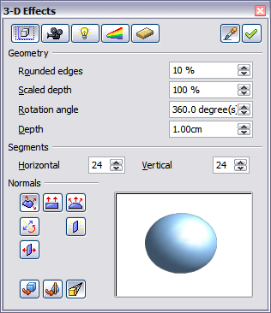
Figure 146: Geometry page
In the first example, the body's depth (length) is to be changed. This is possible only if you created it through extrusion. To illustrate: draw a circle and convert it according to Variation 1 into a 3D object (a flat cylinder); see examples a and b in Figure 147.
If necessary, select the cylinder, open the 3D Effects dialog, make sure the Geometry page is active, change the parameter Depth to 3.5cm, and click on the Assign icon. The cylinder should now resemble object c in Figure 147.
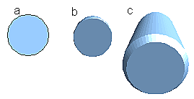Figure 147: Conversion by extrusion of a 2D object (a) into a 3D object (b) and then changing its depth (c)
This parameter has no effect on a rotation body or on ready-made 3D objects, although the input field remains active.
With the Rounding parameter, you can specify how strongly the edges of the 3D object are rounded. Select (if necessary) the lengthened cylinder again, and use the 3D Effects dialog to change the rounding to 30%. The cylinder should now resemble that in Figure 148.
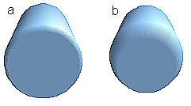
Figure 148: Edge rounding of 10% (a) and 30% (b)
This parameter also has interesting effects when you convert text into a 3D object.
The Scaled Depth parameter sets the front-to-back size ratio for a 3D object produced by extrusion. The front side of such an object always protrudes from the original surface; the rear side is the original surface of the 2D object (i.e., the 2D exit surface), even if the object has been rotated in the meantime.
By default, scaling is set to 100%, so both surfaces scale by the same amount. If you set this scaling to 50%, the cylinder becomes a truncated cone (see Figure 149).
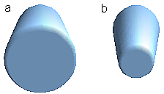
Figure 149: Cylinder with 50% scaling
The diameter of the front side is 50% that of the rear side. It is also possible to create the reverse effect, with the rear side smaller than the front, by using a scaling depth greater than 100%.
For rotation bodies, this parameter influences the width of the surface parallel to the axis of rotation. At the end of the rotation, the figure's surface width is given by the scaling depth. The distance to the rotation axis remains unchanged. In Figure 150, a line is rotated to create a 3D object with a scaling depth figure of 0%.

Figure 150: Scaling depth of a rotation body
The Rotation Angle parameter is only available for rotation bodies. With this parameter, you can create a segment of a complete rotation body by choosing an angle less than 360 degrees. Figure 151 shows a hemisphere with a rotation angle of 270°.
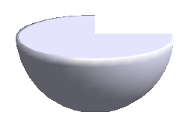
Figure 151: Hemisphere with a rotation angle of 270°
The Horizontal and Vertical Segments parameters define the number of segments out of which Draw builds spheres and rotation objects. For rotation objects, the horizontal segments are more important. The vertical segments influence the degree of edge rounding.
In Figure 152, the left sphere is made up of 10 horizontal and vertical segments, while the right sphere has 25 segments. More segments yield a smoother surface, but such objects take longer to render the figure on screen. By default, spheres and hemispheres are constructed with 24 segments. For a square pyramid, you need four horizontal segments.
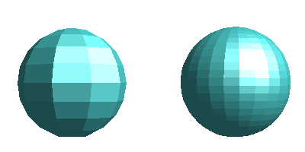
Figure 152: Sphere made from 10 segments (left) and 25 segments (right)
These are properties belonging to individual objects. If you apply the segment settings to a 3D scene, all objects in the scene are modified accordingly.
If you extrude an unfilled circle or intersecting lines with a filling, the result may not be what you expect. In this case, the Double-Sided tool, located in the lower part of the dialog page, may help. It changes the line properties of an object from invisible to continuous, enabling all edges to be seen. Otherwise, some surfaces may receive no fill (see Figure 153). For lines without fill, the effect is enabled by default and cannot be disabled. This is also a property of single objects.

Figure 153: Left: without “Double-Sided”
Middle: with continuous lines but without “Double-Sided”
Right: with “Double-Sided”
Use the buttons in the section Normals to modify the normals of a 3D object.
A Normal is a straight line that is perpendicular to the surface of an object, in the same way that a vector, starting from an inner point and extending outwards, is at right angles to the surface of the object at the point where it exits the object's surface. Figure 154 shows some normals extending outwards from a sphere made up of 10 segments.

Figure 154: Normals (vectors) of a 3D sphere with 10 segments
Using normals, the display of the object's surface and of its variation in colors, textures, and lighting can be controlled, directly influencing how the surface of the object is rendered.
The first three icons in Figure 146 work as “either-or” switches. Only one of the effects can be active at a given time; an effect can be switched off by clicking on one of the other icons.
Settings belong to individual objects, not scenes; each object can have its own settings. The rest of the icons are normal toggle “on-off” switches. The following effects are available:
Object specific: The object is rendered to produce the best result independent of its shape. Single segments are changed, but their “edges” will hardly be visible.
Flat: The surface of the 3D object will be divided into single polygons, whose edges are clearly recognizable. Every polygon is generated with a uniform color.
Spherical: The enclosing sphere is calculated for the object and then projected onto the object. This form of calculation produces an object with a surface whose segments' edges are more smoothly rounded than can be accomplished with the Object-specific effect (see Figure 155). However, surfaces that meet at a point do not show a realistic lighting effect.
Invert Normals: This results in a reversal of the lighting direction. The inside of the body then becomes the outside. This property is particular to each individual object.
Double sided illumination: The lighting is also computed for the inside of the object. In other cases the lighting value for the outside is simply transferred to the inner side. This property is of interest for open objects. It is a property of the 3D scene and affects all objects in the scene.
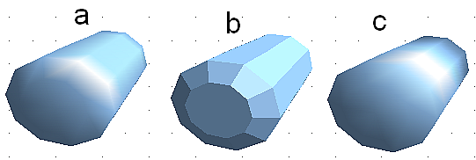
Figure 155: Cylinder with 10 segments
a= Object-specific b=Flat, c=Spherical
The following table shows the linkage between double-sided illumination and inverted normals.
The light source is on the right. | Normals  not inverted | Normals inverted
No double sided illumination
With double sided illumination

3D Effects - Shading
The Shading page shown in Figure 156 offers functions for shading the object surface, adding shadows, and choosing camera settings.
Shading is a rendering method involving a consideration of lighting ratios. Shading is used to produce curved 3D surfaces. The surfaces are broken down into small triangular segments. Draw offers three methods to produce this effect: Flat, Phong, and Gouraud. The setting selected applies to all objects in the 3D scene.
- Flat is the fastest and simplest method. For every individual segment, a special color tone is determined based on the lighting ratio and the direction of the segment area. This tone is used for the whole area of the segment. Segmentation is clearly visible.
- Phong is the most time-consuming method. With Phong, for each pixel, the associated normal is determined by interpolation, based on the normals of the segment edges. This causes the segment area to appear curved, and the segment intersections are no longer visible.
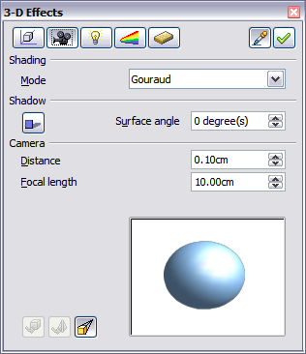
Figure 156: Shading page
- Gouraud is a relatively quick method. It determines the color value for the segment corners and calculates the color value for every pixel through linear interpolation. The segment edges are still recognizable, but significantly less so than with the flat method. The Gouraud method considers only light reflection on diffuse, reflecting surfaces.
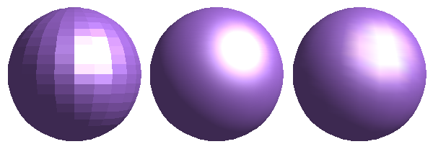
Figure 157: Flat, Phong and Gouraud shading
In Figure 157, the left sphere was rendered with flat shading, the middle with Phong, and the right with Gouraud. The quality of the flat method is clearly inferior to the other two. The difference between Phong and Gouraud is small. With the Gouraud method, the segments can be very faintly seen, and rendered objects have slightly less “shine” than with the Phong method.
All three methods function at the pixel level, and therefore shadowing and mirroring inside the 3D scene (as permitted by ray tracing methods) are not possible..
Using the Shadow button , you can provide a 3D object with a shadow. By changing the Surface angle, you can influence the form of the shadow (see Figure 158). The left sphere has a surface angle of 0° (the paper represents a perpendicular surface behind the object), while the right sphere has a surface angle of 45°. At 90°, the paper would be directly under the object.
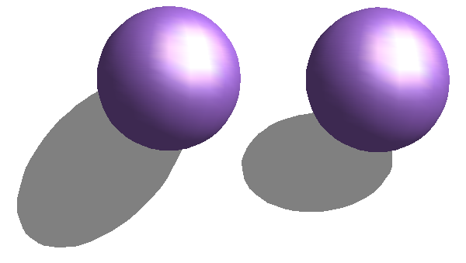
Figure 158: Shadows using different surface angles
The shape and size of the shadow are also influenced by the lighting properties. These can be adjusted on the Illumination page of the dialog. Note that multiple light sources for shadows are not supported. Shadow properties can be set for individual objects in a drawing, but where objects form part of a 3D scene, the shadow produced is that of the entire scene.
It is possible to set the shadow property for individual objects using the Area item from the menu, brought up with a right-click. The shadow is then shown with the color selected in the shadow dialog, but again, the representation of the lighting of the scene determines the end result of the entire scene. In this way, colored shadows, at varying distances from the object, with different colors and transparency effects, can be created.
In the Camera field of the shading dialog, the virtual camera settings can be changed. These settings relate only to the view in central projection and apply to the entire 3D scene. The Distance parameter adjusts the spacing between the camera and the scene. The default value for an extruded body is equal to the depth or length of the body. With equal-length edges front and rear, the effect at large distances is quite small. The standard value of the Focal length is 10cm (3.937 inches). It has the same significance as a real camera. Larger focal lengths simulate a telephoto lens, smaller ones a wide-angle lens. The effects of changes in camera settings on an object are shown in Figure 159.
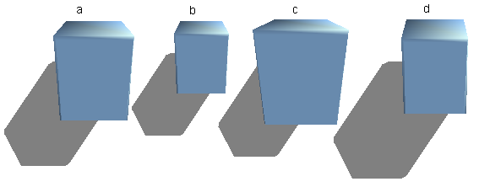
Figure 159: Effect of camera settings
Object a in Figure 159 shows a 3D object with the standard settings. The individual changes to each object are listed in the following table.
 | a | b | c | d
Distance: | 0.81 cm | 3.81 cm | 0.81 cm | 0.81 cm
Focal length: | 10 cm | 10 cm | 5 cm | 15 cm

3D Effects - Illumination
On the Illumination page (see Figure 160), you define how a 3D object is lit. The settings apply to all objects in a scene.
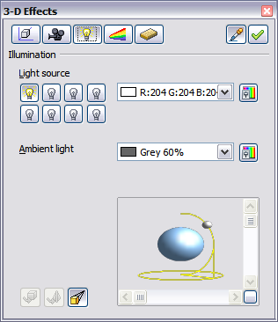
Figure 160: Illumination (lighting) page
You can light a scene with a maximum of eight individual Light sources at the same time. For each of these sources, the light color and position relative to the scene can be set. The light sources are represented by eight small light bulbs. When you select this page, the first bulb “lights up” . At least one light source must be active; otherwise, the rendering and shading functions cannot function correctly.
Each symbol functions like a multi-function press switch. With the first mouse click, the bulb is selected and with the second click, the settings mode for this light source is activated (see Figure 161). A third click deactivates the light source.
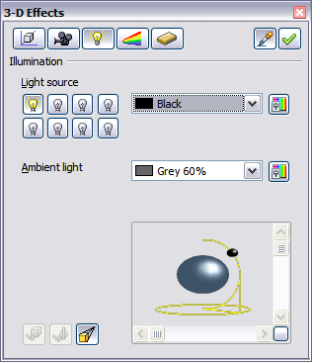
Figure 161: Adjustment of light source
In the selection list next to the symbols, you can choose the color of the active light source. If desired, click the button to open a color palette dialog, where you can define your own color and also adjust the brightness. For the first light source, it is best to retain the neutral color value (default is white); with several light sources, it is advisable to reduce the brightness.
In the lower-right corner of the menu, the light source location and orientation are depicted. With the vertical slider bar, you can adjust the lighting angle; with the horizontal bar, the light is rotated about the object. Alternatively, you can click the light point and drag it as you please (see Figure 162). Click on the small square in the bottom right (circled) to change the preview image from a sphere to a cube.
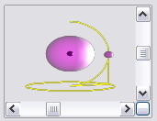
Figure 162: Moving the light source
To apply the changed settings to the selected object, click the Assign button .
Using additional light sources can result in some interesting effects.
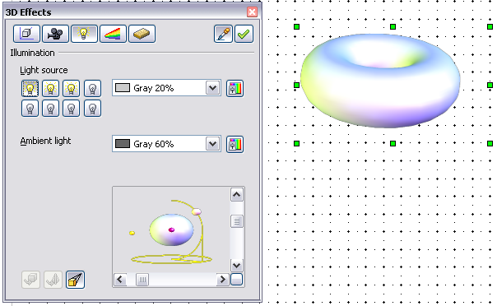
Figure 163: Lighting with three independent light sources
In Figure 163, the ring has the lighting settings from Figure 162 with the standard color white. In addition, it was lit with magenta and, from the left underside, with yellow. The number and position of the light sources are shown in the window at the lower-right. The three light sources in use can be recognized by the “lit” symbols .
To see the effect of a particular lighting effect, you can also temporarily turn it off. With an object selected, clicking a “lit” symbol turns it off . This new setting must then be assigned to the scene. With a further mouse click on the light source, the effect can be switched back on and then re-assigned.
You can also change the settings for the Ambient lighting. The selection of properties (lighting color, brightness, and so on) is carried out in the same way as for light sources.

3D Effects - Textures
Textures are raster graphics (bitmaps), that can be used as an object property for the surface of an object. Every object in a 3D scene can have its own texture.
You can set a raster graphic as a texture for a 3D object in the same way as for a 2D object (the Area pane of the Sidebar, the menu Format > Area > Bitmaps, or right-click on the object and select Area > Bitmaps) – as is the case for Gradient and Hatching. More details are found in Chapter 4 (Changing Object Attributes).
If the Fill setting in the Area dialog is set to Color, the Texture page of the 3D Effects dialog is inactive. Change it to Bitmap to activate the Texture page for 3D objects. If the texture is not tiled or stretched and is smaller than the object, the remaining area will use the color of the Object color property on the Material page.
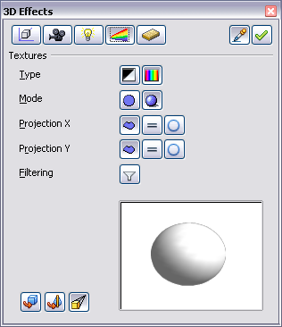
Figure 164: Textures page
In the first row of the page (Figure 164), there are two Type switches that allow you to choose between black-and-white or color for the texture. In Figure 165, the texture has been applied to spheres b and c using the Gallery. Sphere b has the full color pattern, and the pattern in sphere c has the texture converted to black and white using the 3D Effects dialog.
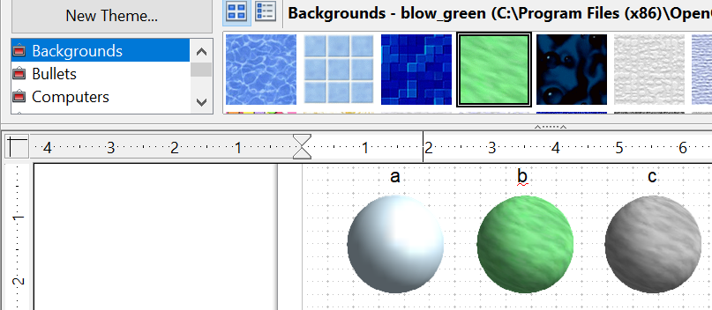

Figure 165: a - standard color setting, b - texture (color), c - texture (black and white)
With the two switches in the row Mode, you can control whether the texture of the selected objects is rendered with light and shadows (Switch 2) or not (Switch 1); see Figure 166. Appropriate lighting and shading adjustments allow the graphic object to be rendered more realistically.
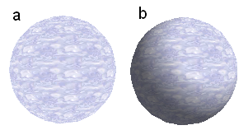
Figure 166: Texture without (a) and with (b) lighting and shadow effects
Projection X / Y
With one of these three buttons, you can determine how the texture for this coordinate axis should be projected onto the object. The default setting, Object specific, usually gives the best results. Examples of the use of each button are shown below.
 | Object specific | The texture is automatically adjusted for the best fit with the object's form and size.
 | Parallel | The texture is projected parallel to the object's axis. It is mirrored on the object's rear side.
 | Circular | The axis of the texture pattern is wrapped around the object.
For a rotation body (Figure 167), the turning axis is the Z-axis and the wrapping is the X-direction; for an extrusion body (Figure 168), the extrusion direction is the Z-axis and the extruded surface is the X-direction. Different texture positions result depending on how the object was produced.
Area fill without tiling, with adjustments | Projection X | Projection X | Projection X
Projection Y

Projection Y  (Difference is small) |  | Front and rear side
Figure 167: Cylinder as a rotation body
Area fill without tiling, with adjustments | Projection X | Projection X | Projection X
Projection Y

Projection Y  (Difference is small) |  | Upper and under sides
Figure 168: Cylinder as an extrusion object
The Filter button switches on and off a soft-focus filter. It can often remove slight faults and errors in the texture.

3D Effects - Material
On this page (Figure 169), you can assign the appearance of different materials to the 3D object.
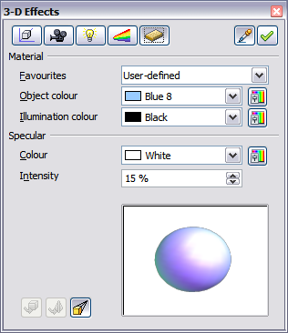
Figure 169: Material menu
In the selection list under Favorites, are the most commonly used materials (see Figure 170).
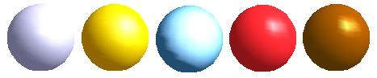Figure 170: The favorites (from left to right): Metal, Gold, Chrome, Plastic and Wood
With the individual color parameters, additional effects can be produced. The meaning of these parameters corresponds to those on the Illumination dialog page.
Materials and textures can be combined. Settings only simulate materials, so achieving the desired result can sometimes require trial and error.
Tip | Do not use a brightness value that is too high for individual colors. These are additive, and it's easy to end up with a totally white “colored” area.
The Illumination color brightens parts of the object that are in shadow, making the body appear more illuminated.
When textures are used as well, the Illumination color is combined with the white color part of the texture. On the left, the object has a black Illumination color, on the right, bright green.
The Specular color simulates the reflecting capacity of the surface. The position of the illuminated point is determined by the setting of the first light source.
Left: Set the Specular color the same as the object color and the illumination point intensity to a low value, to create the impression of a matte body.
Right: Set the Illumination point color the same as the light source color, in order to give a shiny appearance to the object's surface.
Metallic surfaces and glass are poorly simulated because their appearance is produced by reflection. Such a simulation cannot be performed by OpenOffice.

3D Settings for 3D Shapes
3D shapes are handled quite differently from objects in 3D scenes. The appearance of a shape object is changed using the 3D-Settings toolbar (see Figure 171). The 3D Effects dialog described above should not be used for shape objects, as it will not give the correct formatting results.
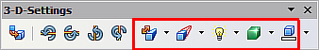
Figure 171: 3D-Settings toolbar, indicating icons for formatting 3D shapes
If you have used it in error, you can remove the incorrect formatting with Format > Default Formatting.
Using the buttons on this toolbar, you can adjust the extrusion depth, perspective, lighting, material properties, and the extrusion color. There are tear-off bars that you open by clicking the small black triangle. The purpose of each button is described in its tooltip. You do not need to assign the result of any of the functions to the object as you do with the 3D Effects dialog used with 3D scenes; every action is immediately applied, and you can see its effect on the object in the main Draw window.
Here are some examples of the formatting of 3D shapes:
Depth
The tool has six preset values from zero to infinity, plus a custom option to set any value.
left: 0.3cm
right: 1cm
Direction 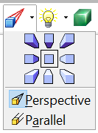

The tool allows you to change the direction from which the object is viewed, and between parallel and perspective views.
The examples show a cross after choosing the lower-left or lower-right icon from the nine direction options in the tool.
Illumination 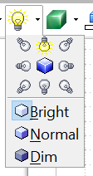

The tool provides eight illumination directions and three light levels. The examples show an object illuminated from the lower-left and the top.
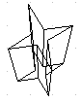 | Surface  Only four built-in variations are possible. At present, only Wireframe and Matt are correctly rendered.  left: Wireframe  right: Matt  You can also choose a gradient, hatching, or bitmap for the surface; these are only applied to the extruded surface—the sides remain in the color of the object.
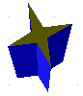 | 3D Color  Here, you can choose the color of the sides of the extruded surface.  The symbol shows the color of the most recently chosen shape object.

Combining Objects in 3D Scenes
3D objects produced by extrusion or rotation are shown in the status bar as a 3D scene. You can group several of these objects together. Other object types cannot be grouped in this way. Management of the group is carried out in the same way as described elsewhere in this guide (Modify > Enter Group or Modify > Exit Group). Also see “Grouping Objects” in Chapter 5 (Combining Multiple Objects).
As an example, we will produce a game piece.
First, produce both objects independently of each other. The subsequent combination is made easier if you use parallel projection and rotate the objects into an upright, straight position.
Click on the sphere and use Edit > Copy to take over the scene and put the sphere on the clipboard. If you are sure you no longer need the original, you can use Edit > Cut. In any case, move the sphere a little to the side.
Click now on the cone. The status bar will show 3D Scene selected. Right-click and enter the group. You will see that, as usual, elements that do not belong to the group are less bright.
Use Edit > Paste. Now the objects (not the whole scene) from the clipboard are pasted into this scene.
The original position of the sphere now contains a new sphere that belongs to the scene. This new sphere can be dragged over to the cone. Exit the group after moving the sphere.
Notice that combining 3D objects results in them being more or less “fused” together – there is no stacking or layering as with 2D objects.
Adjust the position of the objects as you wish. You cannot arrange objects in front of or behind others, as with 2D objects, but can only move them parallel to the drawing plane.
Enter the group again and adjust the objects. The status bar indicates which object is marked. Use the Tab key to change from one object to the next in the group if it is not possible to do so with the mouse. Exit the group.
Now you can rotate the entire 3D scene and view your game piece from all sides.

Examples for Your Own Experiments
All examples use objects in 3D scenes.
Hello Jean | Extruding a 2D object with text generates letters as separate objects; they have a larger extrusion depth than the background.
 | 3D objects of the Shape type can be rendered as wireframe models. This effect can be produced in other 3D objects by setting the Area fill to None and the line style to Continuous.
 | If you select several 2D objects—without grouping them—and extrude the selection, they are transformed, according to their stacking order, with different extrusion depths. The previously topmost object will be uppermost on the extruded object.
 | For 2D objects, use Modify > Shapes > Merge/Subtract/Intersect to produce complex objects. The resulting figures can be extruded, rotated, and so on.
 | Rotation of lines produces concave bodies. Use a bright line color. With a high number of vertical segments, the transition to the ground is relatively sharp-edged. Remember to switch on two-sided illumination.
The transparency of the platter is adjusted in the surface properties of the body. The best effect is obtained only when the transparent body is combined with other objects.
The fruit's color shadow is produced using multiple light sources; they are not “real” and do not rotate or change as the scene rotates.

Chapter 8
Tips and Tricks

Positioning Objects with Zoom
With zoom, you can place objects with greater precision, as Figure 172 illustrates.

Figure 172: Using zoom to place objects with greater precision

Zoom adjustments using the status bar
The current zoom value is shown at the right-hand end of the status bar, next to the zoom slider, as you see below in Figure 173.
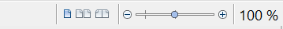

Figure 173: Zoom level on Status Bar
You can adjust the zoom value by using the slider, right-click on the zoom percent to select from a menu of preset values, or double-click to open the Zoom & View Layout dialog shown in Figure 174.
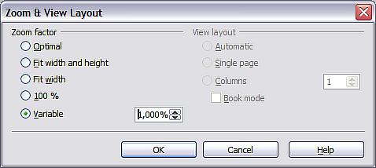
Figure 174: Zoom & View Layout
You can enter a zoom factor in the Variable field, select 100%, or use one of the three other choices shown in Figure 175. Note that the three options on the right side of the dialog are not available in Draw; they are active only for text documents.
- Optimal: The drawing or selected object, not the page, is enlarged so that it fits comfortably but optimally in the Draw page area.
- Fit width and height: The drawing page edges are set to show the entire page within the Draw page area. This is the same effect as choosing “Entire Page” from the right-click menu on the status bar.
- Fit width: The right and left page edges are set to the vertical edges of the Draw page area.
The exact effect of choosing one of these options depends on whether the Page pane is on or off.
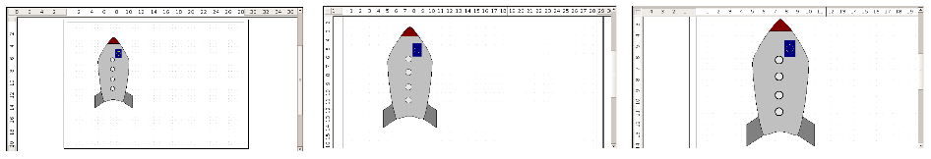
Figure 175: Zoom values – Fit width and height, Fit width, and Optimal

The Zoom Toolbar
The Zoom toolbar provides additional zoom options. On the Standard toolbar (View > Toolbars > Standard), click on the downwards arrow of the Zoom button . You can also permanently display the toolbar shown in Figure 176 by clicking on View > Toolbars > Zoom.
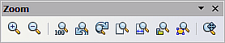
Figure 176: Zoom Toolbar
 | Zoom in. Enlarges the monitor picture. First, click on the button, then on the object. Alternatively, drag to create a zoom “window”.
 | Zoom out. Makes the monitor picture smaller. Just click on the button.
 | Returns objects to their original size.
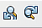 | Changes display to the previous and next zoom factors. If these buttons are not visible, turn them on by clicking on the small black arrow on the title bar of the Zoom toolbar, then on Visible Buttons and finally on either of these two buttons.
 | Shows the entire page.
 | Zooms to page width.
 | Resizes the display to include all objects on the page.
 | Zooms the selected object to Optimal.
 | Allows the whole drawing to be moved inside the Draw window, using the mouse.

Positioning Objects with Snap Functions
In Draw, objects can be accurately and consistently positioned using grid points, special snap points and lines, object frames, individual points on objects, or page edges. This function is known as Snap.
To use the snap function easily, work with the highest practical zoom value. You can use two different snap functions at the same time, for example, snapping to a guideline and to the page edge. However, it is best to activate only those functions that you really need.
Examples for setting up the snap functions are found in Chapter 10 (Advanced Draw Techniques).

Snap to Grid
Use this function to move an object exactly to a grid point. This function can be switched on and off with View > Grid > Snap to Grid, as illustrated in Figure 177, and on the Options toolbar with the icon .
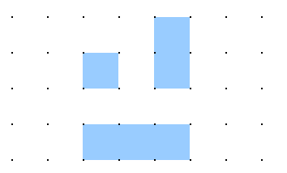
Figure 177: Exact positioning with the snap to grid function

Showing the Grid
To make the grid visible, choose View > Grid > Display Grid. Alternatively, turn the grid on (or off) with the icon on the Options toolbar.

Changing the Color of the Grid Points
By default, the grid points are bright gray and not always easy to see. Go to Tools > Options > OpenOffice > Appearance. In the Drawing / Presentation section, you can change the color of the grid points as shown in Figure 178. On the Color Settings pull-down menu, select a more suitable or visible color, for example, black.
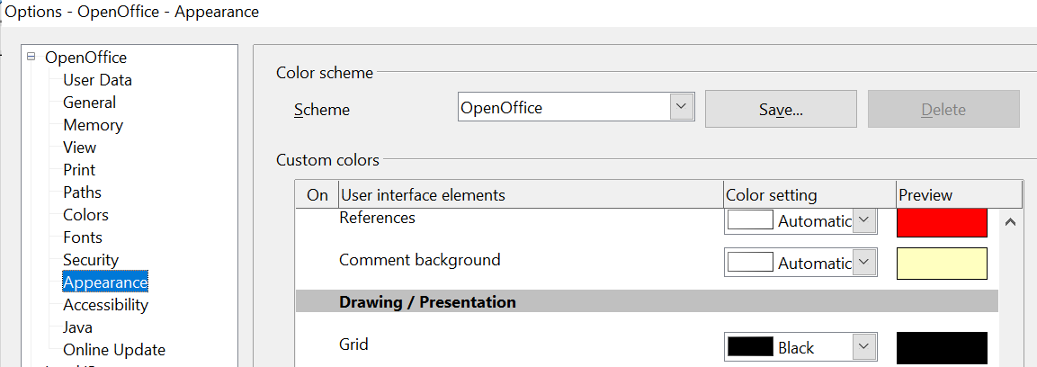

Figure 178: Changing the color of the grid points

Configuring the Grid
Under Tools > Options > OpenOffice Draw > Grid, you can change the grid settings (Figure 179).
There is no need to use the Grid section. Those settings can be changed directly from the icons on the Options toolbar.
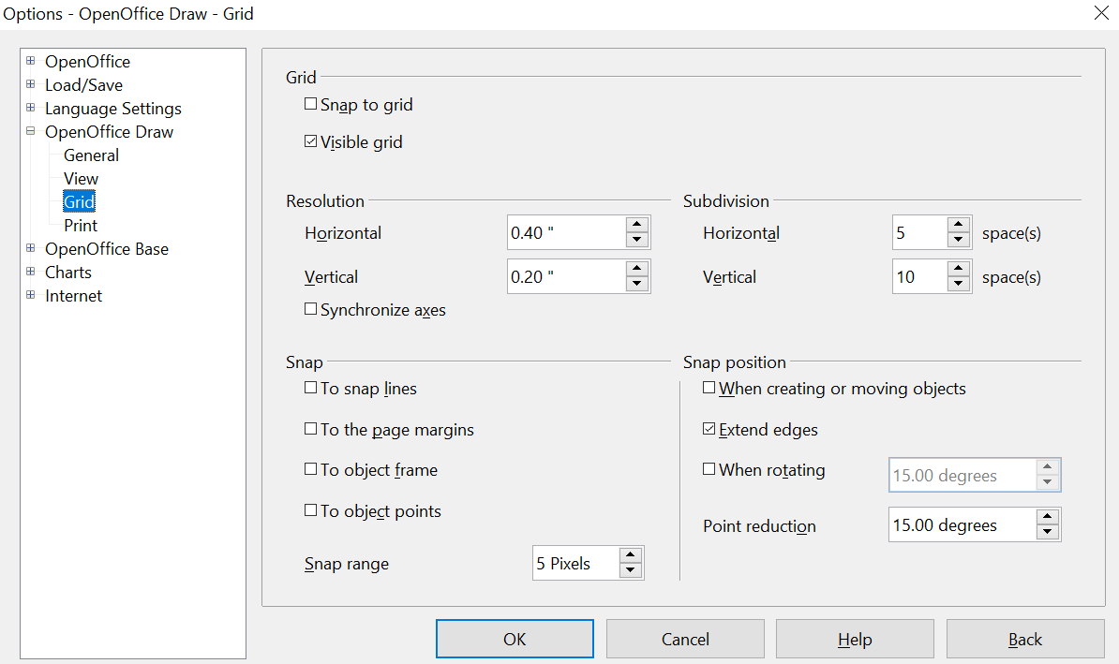

Figure 179: Configuring the grid
Resolution: sets the horizontal and vertical distance between two grid points, like those in Figure 180.
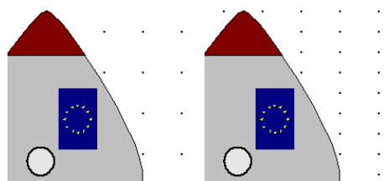
Figure 180: Grids with different resolutions
Subdivisions: determines the number of steps between adjacent grid points. Intermediate steps, as shown in Figure 181, allow a larger separation between two grid points, so the drawing remains clearer. Objects can snap to intermediate points in exactly the same way as to grid points.
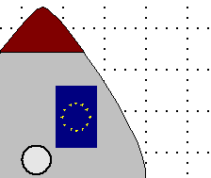
Figure 181: Grid with intermediate steps (subdivisions)
The snap field settings are largely self-explanatory. One important setting in this group is the Snap range. Grid points and snap lines are both visual help elements that are managed separately by Draw. If you have activated a snap function and then move an object, Draw looks in the vicinity of the object for these special help elements to determine the final position of the object. With the snap range setting, you can determine the extent of this search area. Exactly how large the snap area will be depends on the current environment: which particular snap functions are in use, how the grid is configured, and whether there may be collisions with other objects. It is usually necessary to experiment a little to find what best suits your needs.

Snap to Snap Objects (Snap Lines and Snap Points)
Unlike grid points, Snap lines and Snap points are created by the user. Snap lines run horizontally or vertically and appear as dashed lines. Snap points appear as small crosses, again with dashed lines.
Note | In Draw, the names of the buttons in the Options toolbar are Display Guides and Snap to Guides, when what is actually meant is Display Snap line and Snap to Snap line.
If you have activated this function, you can position objects exactly. Horizontal and vertical snap lines can be used together. Snap lines are not active immediately after inserting them, but are turned on (or off) using the Display Guides icon or the View menu, as shown in Figure 182. If the snap line is no longer needed, you can hide it (or display it again) with the icon or the View menu.
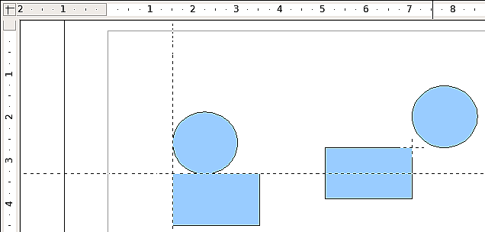
Figure 182: Objects ‘connected’ to snap lines (left) or to a snap point (right). Note that the snap point functions as if it were the intersection of two snap lines.

Inserting a Snap Line with the Mouse
To insert a snap line in a drawing:
- Hover the mouse cursor over the vertical ruler to create a vertical snap line, or over the horizontal ruler to create a horizontal snap line. Click and hold the left mouse button.
- Drag the mouse into the drawing area to produce a snap line.
The snap line can be moved at any time by dragging it with the mouse. Moving a snap line will not, however, move any objects that have already been snapped to that line.

Inserting Snap Points and Snap Lines Using Coordinates
The command Insert > Snap point / line opens a dialog like that in Figure 183, where you can specify X and Y coordinates and choose the type of snap object: point, vertical line, or horizontal line. You can also access this menu by right-clicking in the draw area and selecting Insert Snap Point/Line.
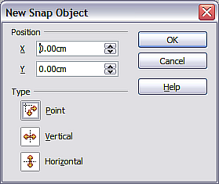
Figure 183: Setting a) snap object type and
b) snap object position using X,Y coordinates

Editing Snap Points and Snap Lines
All snap objects can be edited after they are set. If you right-click a snap object, an appropriate menu opens, allowing you to edit or delete it. Snap points and lines can also be deleted by dragging them entirely off of the page.

Snap to Page Margin
You can activate snapping to the page margin in the dialog, like that in Figure 184, accessed via Tools > Options > OpenOffice Draw > Grid. It is also possible to combine this with snap lines and snapping to grid.
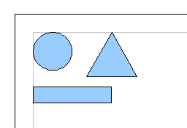
Figure 184: Objects positioned on the page margins

Snap to Object Frame
With this function, you can position one drawing object on the border of another. The connection point can lie anywhere on the object's border. To use this function, first deactivate Snap to grid. Figure 185 shows some examples. Note that a typical object border will touch the border of a round object at only one of its four points.
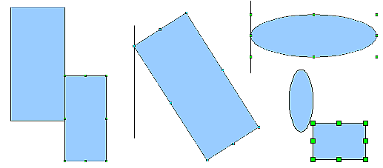
Figure 185: Objects positioned on the border of another object

Snap to Object Points
This function operates similarly to the one just described. The difference is that the connection point can lie at only one of the four corner points of both the object being moved and the target object, as Figure 186 demonstrates. This leads to the situation where two round objects have a connection point that does not lie on either object, but at one of the red circled points.
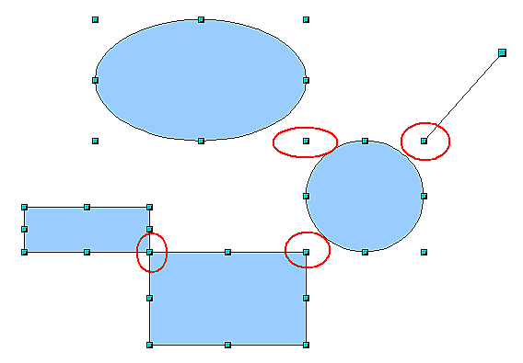
Figure 186: Objects connected to the object point of another object

Help to Position Objects with Guiding Lines
To simplify the positioning of objects, it is possible to make visible guidelines—extensions of the edges of an object—while it is being moved. These guidelines have no snap function.
Guidelines, like those in Figure 187, can be (de-)activated under Tools > Options > OpenOffice Draw > View > Guides when moving, or by clicking the icon on the Options toolbar.
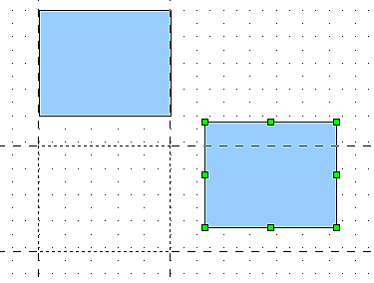
Figure 187: Working with guiding lines

Drawing to Scale
In Draw, a drawing is created within a predefined drawing area or canvas. This will usually be in the Letter or A4 format, depending on your local settings, and will be output to the printer you have set up on your computer, which is usually the default printer. Depending on the actual size of drawn objects, it is often necessary or convenient to reduce or enlarge a drawing by some scaling value. You can specify the scale you want under Tools > Options > OpenOffice Draw > General.
The scale and selected unit of measurement are automatically reflected in the rulers, the window position, and the window size. Scale settings can be stored permanently in a template that you can then use for new drawings.
The scale you use has no effect on basic drawing operations. Draw will automatically calculate the necessary values (for example, dimension lines). The grid spacing is independent of drawing scale, since the grid is not a drawing element, but only an optical drawing aid.
Note | If you want to insert elements into a drawing from the Gallery or Clipboard, draw them at the same scale as the drawing to maintain the proper size ratio.

Splitting Drawings on Multiple Layers
Layers allow you to group parts of a drawing. You can insert and extract single layers as desired. For example, in architecture, the floor plan, heating, and electrical wiring can all occupy separate layers. With complex drawings, this layer technique offers many advantages. You can make layers visible or invisible as needed, or you can protect a layer from further changes while you work.
In Draw, three layers are always present by default: Layout, Controls, and Dimension Lines. Layout is the default layer when you create a new drawing.
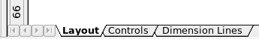
To change to a layer, click on its tab. Everything that is drawn will be placed on the currently selected layer. The Controls layer is for control elements, such as icons and pull-down menus, and is not usually used for ordinary drawing elements. The Dimension Lines layer is used whenever you insert a dimension line on a drawing (unless the layer is made invisible). Use Insert > Layer to insert a new layer into a drawing (Figure 188).
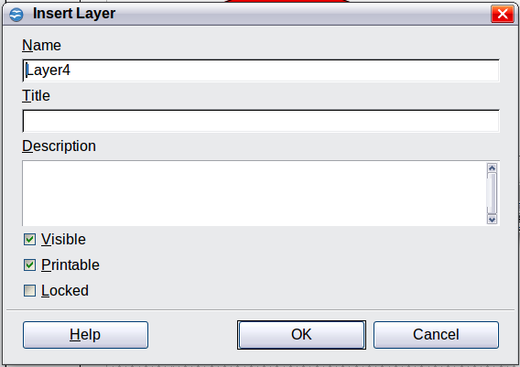
Figure 188: Inserting a new layer
On the Insert Layer dialog, you can specify the following properties:
- Visible: If this property is not activated, the layer will not be shown.
- Printable: If this property is not activated, the layer will not be printed. This is useful if you use a ‘draft’ layer for guides or annotations that you use in making the drawing, but should not appear in the final output.
- Locked: All objects on this layer are protected from deletion, editing, or moving. No additional objects can be added to a protected layer. This property is useful when a base plan is to be protected while adding a new layer with other details.
Right-click on a layer tab to bring up a menu that allows you to insert or delete a layer, rename an existing layer, or modify a layer. You can change the names of the user-defined layers; the default layer names cannot be changed.
If you choose Modify, the dialog is similar to Figure 188, but you cannot edit the Name. You can edit the Title and Description and change the layer's properties (Visible, Printable, Locked).
Tip | You can move objects on one layer while you are working on another layer. To avoid doing this accidentally, lock layers that you are not currently working on.

An Example Drawing: House Plan and Furniture
A popular application for programs like Draw is the “moving the furniture” scenario. You can easily draw the floor plan of a room or a house using Draw. The simplest way is to draw walls as thick lines. Draw single rectangles or polygons, then combine them: place them together, select them, and from the right-click menu choose Shapes > Merge to make a single figure, and add a hatching pattern. Before doing this, you should read the section “Drawing to Scale” on page 153.
For this example, a suitable unit of measurement is the centimeter. The drawing scale and grid settings depend on the size of the floor plan.
Use the Position and Size dialog (right-click and choose Position and Size) to easily position and dimension individual wall sections. Make sure the rectangles completely overlap (see Figure 189); otherwise, merging will produce uneven edges.
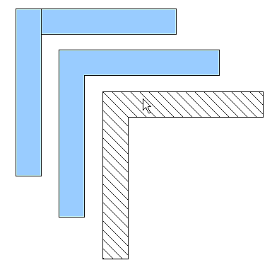
Figure 189: Wall corner from two rectangles. From upper to lower: before merging, after merging and after hatching
Figure 190 shows the finished floor plan. In addition, a chest of drawers has been added.
The body of the chest is drawn on the Layout layer; the pulled-out drawer and the open doors are drawn as a group and put on a separate user-defined layer (Layer 4 in our example). Figure 191 shows how this is done. Making the layer with the drawers and doors visible or hidden will show them open and closed (see Figure 192). Hidden layers are shown with a colored tab.
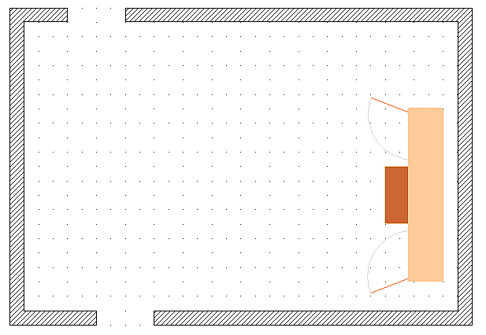Figure 190: Floor plan with chest of drawers
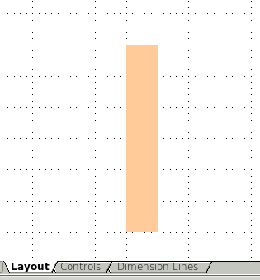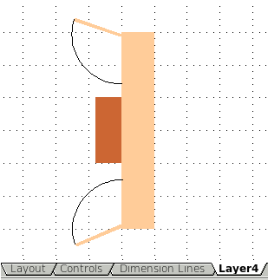
Figure 191: Using layers for different parts of a drawing. (Left) Draw the body of the chest on the Layout layer. (Right) Create a new layer and draw the open drawers and doors, keeping the Layout layer visible to help you position the additional objects.
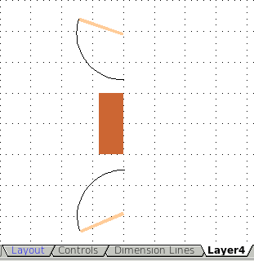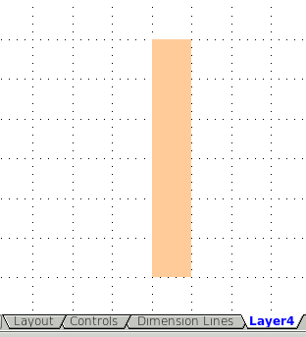
Figure 192: Making layers visible or hidden. (Left) Hide the Layout layer to see what is on Layer4. (Right) Show the Layout layer and hide Layer4 to show chest with drawers closed.
Caution | If you copy a drawing object to the Clipboard or into the Gallery, all layers other than the three standard layers (Layout, Controls, and Dimension Lines) are lost. Furthermore, all objects are pasted into the Layout layer. Reconstructing layers is much easier if you assemble objects on a layer into a group before copying.

Changing the Layer of a Drawing Object
Draw has no direct command to change layers. To move an object to another layer, change to the new layer, select the desired object or group, and then cut and paste it into position. Watch the status bar (the selected object’s layer name is shown in the information field) to follow and check the change.
You can also click the object, hold the mouse button down for about two seconds until the cursor changes from a hand to a pointer with an open rectangle, then drag and drop it onto the appropriate layer.

Creating a Multi-page Document
Draw documents, like presentation (Impress) documents, can consist of multiple pages. As in Impress, tools to manage pages and backgrounds are available.
Pages are automatically named as Slide 1, Slide 2, and so on. This description is relative; if you move pages around, they are automatically renumbered. If you want to have fixed slide (page) names, you must name them yourself. Page names are useful for working with the Navigator, and when you want to insert single pages using Insert > File into another document.

Using the Pages Area
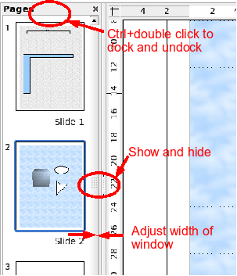 | By default, the Pages area is docked on the left of the Draw window. It shows every page in the document as a small picture. Select a picture from the Pages area, and the corresponding page is loaded in the main workspace. Click on the page to activate it for editing.  The Pages area behaves similarly to the Styles and Formatting area. Drag on the gray separator line to change the width of the Pages pane. Click on the middle of this line to show or hide the pane. Double-click with the Control key pressed in the upper gray area to dock or undock the area, which can be turned into a floating window.
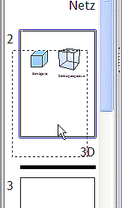 | In the Pages area, you can drag and drop a picture to change the order of pages in the document; a black horizontal line indicates where the page will be inserted.
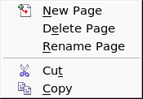  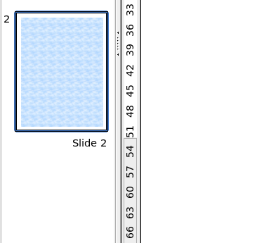 | Using the context menu, you can insert or delete pages or duplicate pages with copy and paste (alternatively, create duplicate pages using Insert > Duplicate Slide on the menu).

Using Page Backgrounds
With background pages, you can set common settings for multiple pages of the Draw document. These include setting the color or graphics of the background, background objects, and fields such as page numbering and author.
Note | The terms used in this area may not be completely consistent, so that the terms Slide/Page and Master/Background/Page Template are sometimes used more or less interchangeably. When looking for information in Help, you may need to use alternative search terms.

Creating a Page Background
Change with View > Master to the Master view and note that a related Master View toolbar opens (Figure 193). If this toolbar does not appear, activate it with View > Toolbars. This toolbar offers switches for a new background page and for renaming the master page. These functions are also available by right-clicking on a page picture in the Pages area of the Master view. The button for deleting a master page is only available when you select a background page in the Pages area that has not yet been assigned to any page.
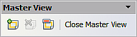
Figure 193: Master View toolbar
To return to normal mode, click the Close Master View button shown in Figure 193, or View > Normal.
You can edit background pages just like normal pages. With Format > Page > Background, you can set the color, pattern, or background picture. These settings are specific to each background page. In the Master view, you can set the page size and orientation; these settings apply to all pages.
If you insert drawing objects on a background page, they are visible on all pages that use this background. This is a convenient way, for example, to place a logo on every page.
Master pages are organized in layers just like normal pages. The layers of normal pages are associated with the layer of the same name on the Master page. Accordingly, the layers Layout/Control/Dimension Lines are considered to be a unit, and the Master page layer Background objects are associated with them.
With Insert > Fields, you can insert the date, time, page number, author, and filename. No other fields are available. With page number, you cannot insert a fixed page number; only a variable is allowed. The actual number appears on the page itself and is determined by the page's position. The number is automatically adjusted if the page is subsequently moved.

Assigning and Managing Page Backgrounds
You can open the Slide Design dialog (Figure 194) in two ways:
- Right-click on the page and choose Page > Slide design, or
- Look in the status bar to see which background page is the current one. Double-click in this field.
The Slide Design dialog (Figure 194) shows the available background pages for that page.
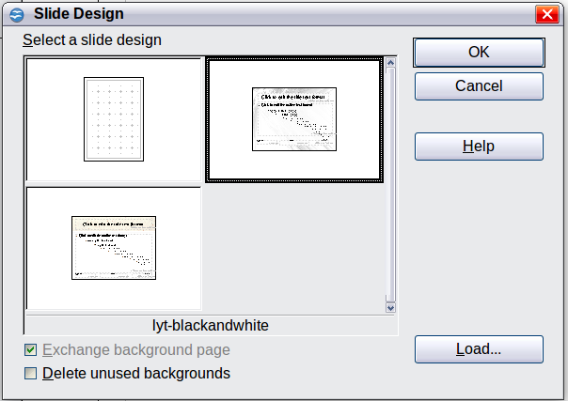
Figure 194: Slide design dialog
If the Exchange background page option is selected, the selected background page will be applied to all pages of the document, not just the currently active page.
The Delete unused backgrounds option deletes any backgrounds (as shown in the Slide Design dialog) that have not been assigned to a page.
Click the Load button to open the Load Slide Design dialog shown in Figure 195. From there, you can load previously prepared background pages. All Draw and Impress templates can be used for this purpose. Note, however, that using Impress templates will bring in only the background and not the other elements prepared in Impress.
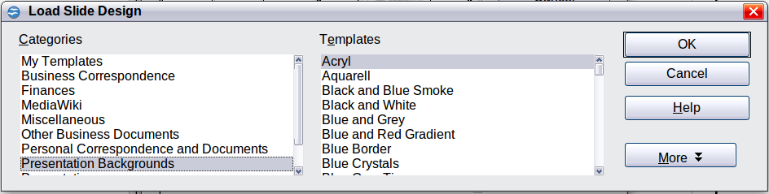
Figure 195: Load Slide Design dialog
There is no special means of storing background pages as templates. Instead, you can load a document with the desired background page, and store this document as a document template with File > Template > Save.

Color Palette: Adding or Changing Single Colors
Draw, like all OpenOffice components, uses color palettes to represent colors. In addition, you can customize color palettes to suit your preferences. You can modify colors in a palette, add other colors, or create new color palettes.
Reach these options with Tools > Options > OpenOffice > Colors or with Format > Area > Colors (tab) (see Figure 196). The latter method allows color palettes to be loaded or stored for future use. Any modifications made to colors apply only to the currently active palette.
OpenOffice always uses the RGB color model internally. Other methods are also available for defining a color value.
The color values can be input directly as numbers. Choose between the RGB color model (base colors Red, Green, and Blue) and CMYK (base colors Cyan, Magenta, Yellow, and blacK). The conversion to RGB values is made automatically.
Tip | Information about color models can be found under:  http://en.wikipedia.org/wiki/Color_model or with https://www.w3schools.com/html/tryit.asp?filename=tryhtml_styles_color
Individual color tones are produced by using different values of the base colors. The color value can be any integer value between 0 and 255. As an example, Red 3 has a red value of 184, a green value of 71, and a blue value of 0 in the RGB model. The CMYK color model uses percentages (in this case, 0%, 44%, 72%, and 28% respectively).
Change these values to manipulate the color tone. Either enter a number directly or use the spinners on the right side of each field. The change in color will be shown in the lower color field (see Figure 196). Click the Modify button to apply and store the new setting.
To add a new color to the current palette, enter a new name in the Name field and set the desired color values. Click Add. The new color will be added to the end of the palette and stored in the currently active palette.
You can also delete colors from a palette. Select a color from the Color pull-down menu, click the Delete button, then click OK to confirm the change.
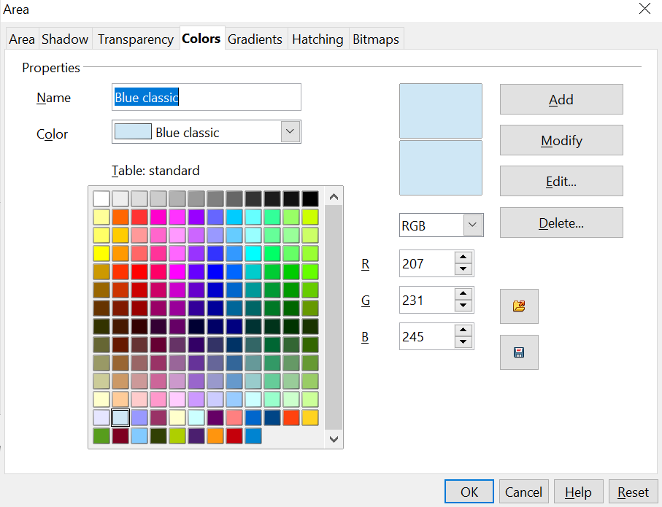

Figure 196: The Colors tab in the Area dialog
Click on the Edit button to open a dialog where you can set individual colors (see Figure 197). Many more input possibilities are available in this dialog.
In the lower area, you can enter values in the RGB, CMYK, and HSB (Hue, Saturation, and Brightness) models.
The two color samples at the lower right show the current color (left) and the new color specified by the color value fields (right).
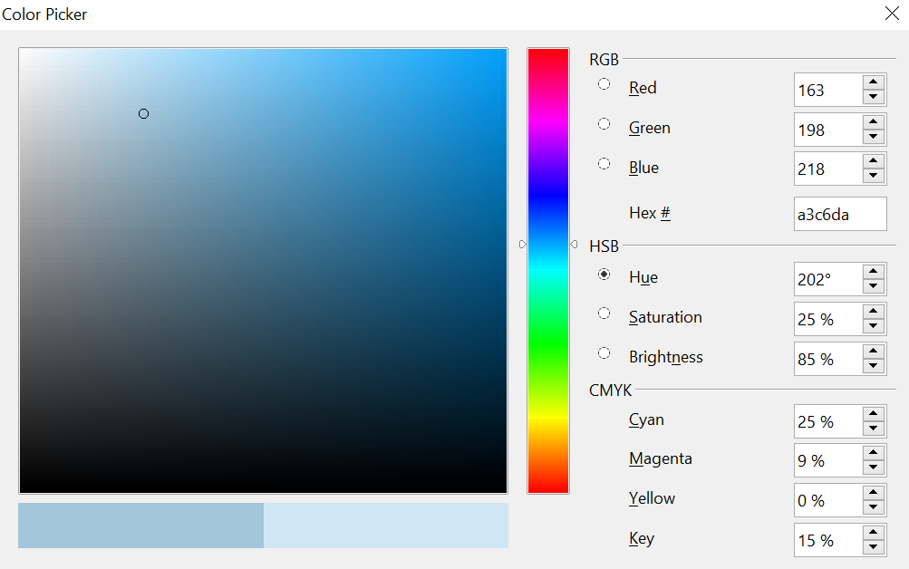

Figure 197: Color dialog
The color window permits a direct selection of color without any knowledge of color values. The color window is linked directly with the various color model input fields; if you click on a color in this window, the numbers change accordingly, and a preview of the color appears on the left of the two color fields (lower left in Figure 197; see also Method 2 below).
If you click OK, the color window closes, and the input field becomes active again. At this stage, you can select the color you just defined, give it a new name, and store it by clicking the Add button. The old color will then be overwritten (without any further warning).

Changing Colors Using the Color Dialog
Method 1
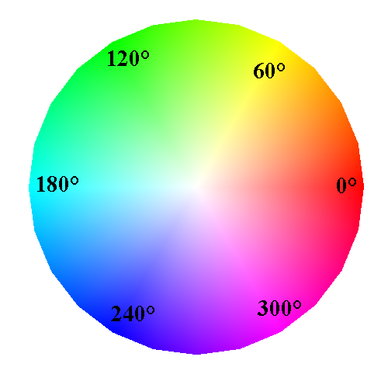
You can change the current color by modifying the individual color values explicitly. It is possible to change from one color model to another during this process, but settings are always calculated and stored according to the RGB model. This may result in some slight adjustment to your input values in the other models.
The color wheel to the right illustrates the HSB color model. This model defines color tone using three parameters: Hue (possible values from 0 to 359), Saturation (possible values from 0 to 100), and Brightness (possible values from 0 to 100). The hue number represents the angle on the color wheel; the other two are percentage values.
Method 2
You can select a new color by clicking on a point in the color window of the dialog (Figure 197). The chosen color is shown in a black circle, which can be dragged with the mouse. If this color is not quite right, you can fine-tune it as described above in Method 1 by changing the color values.
As you drag the small circle, you will see the value change in the number fields. The CMYK and RGB are more or less self-explanatory. To make the HSB model a little clearer, some additional comments are necessary.
To better understand the working of the HSB model, move the circle from left to right and top to bottom. Horizontal movements change the Saturation, and vertical movements change the Brightness. The Hue is chosen from the color bar to the right of the color window. You can click the bar to choose a specific hue, or click and drag to continuously adjust it.

Creating Cool Effects

Duplication
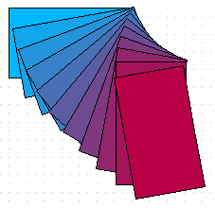
Figure 198: Duplication example
Duplication makes copies of an object while applying a set of changes (such as color or rotation) to the duplicates, as Figure 198 shows.
To start duplication, click an object or group, then choose Edit > Duplicate. The Duplicate dialog (Figure 199) appears.

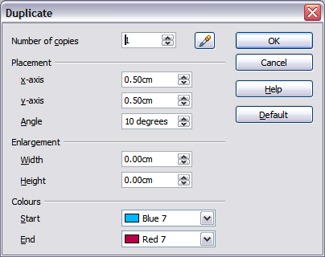
Figure 199: Duplicate dialog
Choose the number of copies, their separation (placement), rotation, and so on. The choices above, when applied to a blue rectangle, produce the result shown in Figure 198.

Cross-fading
Cross-fading transforms one shape into another. The result is a new group of objects, including the two endpoints and the intermediate steps.

Figure 200: Cross-fading example
To do a cross-fade, like that in Figure 200, first select two objects as illustrated in Figure 201.

Figure 201: The two objects selected for cross fading
Then choose Edit > Cross-fading, as we did in Figure 202.
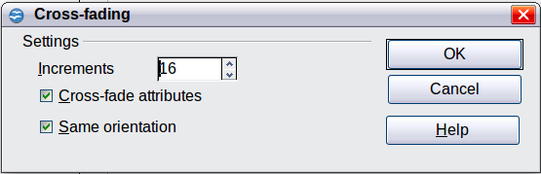
Figure 202: Cross-fading dialog
In the dialog, choose the number of increments (transition steps). You probably want to check the Cross-fade attributes and Same orientation options, as shown in Figure 200.

Which Object Goes in Front?
How do I tell Draw that I want and not ?
Select (the object we want in front), right-click and choose Arrange > Bring to Front (or press Ctrl+Shift+plus). Or select (the object we want behind), right-click and choose Arrange > Send to Back, or press Ctrl+Shift+minus.

Chapter 9
Organization Charts, Flow Diagrams, and More

Drawing an Organization Chart
Even though Draw does not have an organization chart toolbar, you can draw these charts by drawing rectangles and connector lines (see Figure 203). You can indicate hierarchies by using a color progression, from dark to light tones or vice versa. Your color choices should maintain a good contrast between text color and background so you can easily read the printed diagram.
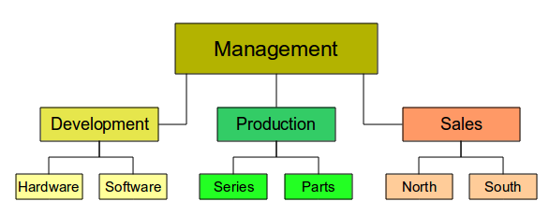
Figure 203: Example of an Organization Chart
Before you begin, prepare a setup page or draft with snap lines (shown in Figure 204) to assist in drawing the various hierarchies, responsibility paths, and typical boxes you will use in drawing the chart.
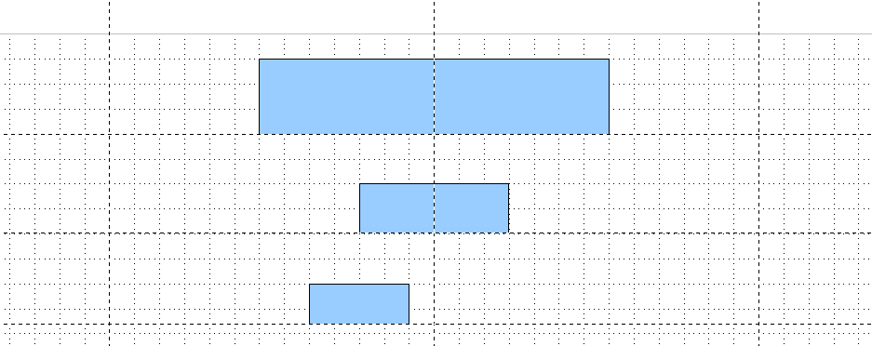Figure 204: Draft with snap lines
Place and dimension the individual boxes according to the size of the overall chart. The exact size, and particularly the width, position, and color, will be fixed later. It is sometimes easier to draw only one box per level. That way, you can copy and paste this box and move the copies to the desired positions. Using styles can also be helpful; see the relevant section in Chapter 4 (Changing Object Attributes).
You can also select one or more boxes and use Edit > Duplicate to make copies (see Figure 205). The spacing of the duplicated objects relative to the original can be controlled using the placement fields for the X and Y axes. Note that positive values for X and Y are to the right and downwards from the original object.
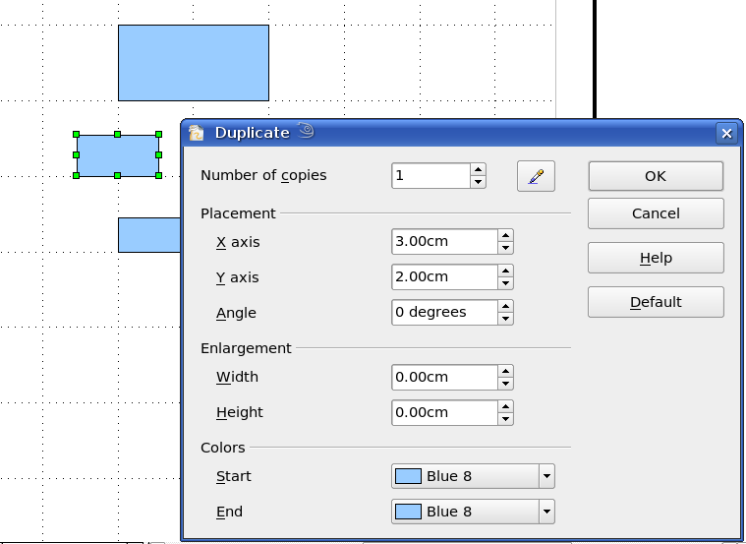
Figure 205: Duplicating an object
The replication technique to use is up to you. The draft for the example in this chapter should look similar to that in Figure 206.
Figure 206: The finished draft
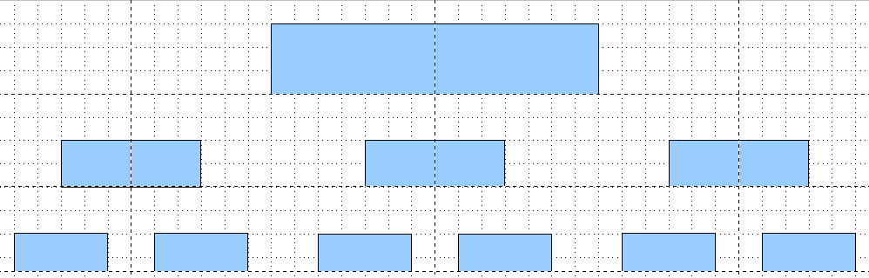
The next step is to add text to the boxes, most easily by inserting it as a text element within the box. Activate the 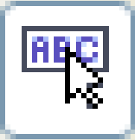 icon on the Options toolbar, then double-click the box to enter text into it. Alternatively, select the box and press F2. You should then see a blinking cursor in the box, and the Text Formatting toolbar should be visible.
Set the text formatting and type the text. Depending on the length and format of the text, you may need to adjust the size of the box and the spacing to neighboring boxes, or change the formatting of the text to fit the box. Adjustments can be made initially with the mouse and fine-tuned with the Position and Size dialog.
Now set up the fill colors and save the drawing. The connections between the boxes are not drawn with ordinary lines, but rather with Draw’s connectors. How to draw these connectors and add text to them is described in “Glue Points and Connectors” starting on page 172.
In addition, you can use dynamic text frames instead of boxes. These frames offer the advantage of automatic line breaks. Figure 207 shows the sequence of text input into a frame, adding borders, and setting the background color. The Line and Filling toolbar may not be visible until you have set a line type for the frame. Set the line type using Format > Line, or right-click the text frame and select Line. All of the tools for setting the text properties, line type, and background color are also available in the Sidebar once the text frame object is selected.
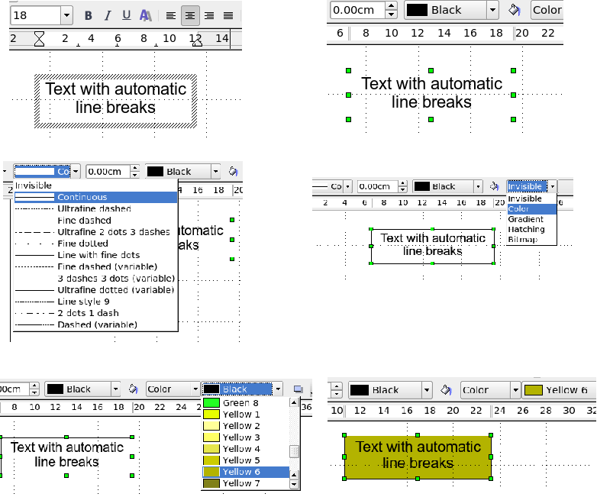
Figure 207: Working with text frames

Drawing a Flow Diagram
For drawing flowcharts, Draw offers a separate toolbar (Figure 208); click the flowchart icon on the main Drawing toolbar.
The easiest way to draw a flowchart is to follow the same setup procedure as for organization charts. Select the symbols from the toolbar and drag them into position as described in Chapter 2 (Drawing Basic Shapes). See Figure 209 for an example of a typical flowchart.
The individual symbols must be exactly positioned if the connectors joining them are to form a vertical line. The midpoints of all the symbols that lie in a vertical straight line should have the same X coordinate, and those on the same level on a horizontal line should have the same Y coordinate.
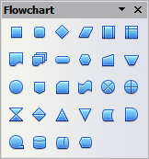
Figure 208: The Flowchart toolbar
Select the shapes that should lie in a vertical straight line and center them using Modify > Alignment > Centered. For those on a horizontal line, select the shapes and center them with Modify > Alignment > Center. You can also set snap lines if you need several vertical lines.
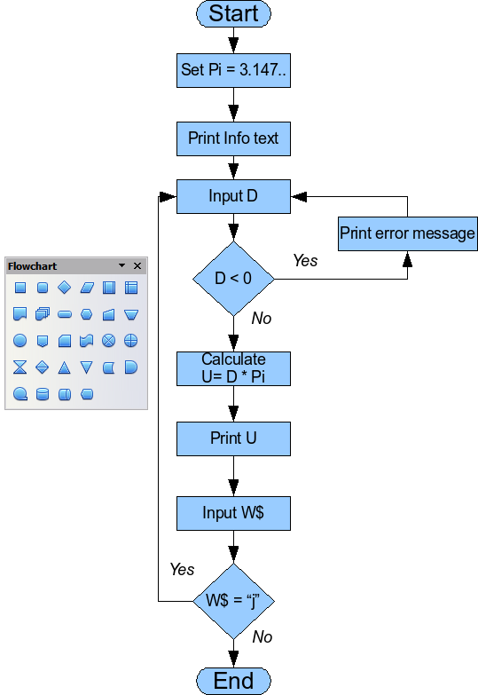
Figure 209: Example of a flow diagram

After adding text and setting the fill color, you can join individual symbols together and add text to the connectors. This technique is described in the next section.

Glue Points and Connectors
These elements were briefly introduced in Chapter 2 (Drawing Basic Shapes). This section describes how to use them.
Connectors are lines or arrows whose ends automatically dock to a connection or glue point on an object. Connectors are particularly useful when drawing organization charts, flow diagrams, and mind maps. The connecting lines between the symbols remain intact even when the latter are moved or rearranged.

The Connector Toolbar
Click on the arrow of the button on the Draw toolbar to open the Connectors toolbar.
If the type of connector you want isn't shown, drag the toolbar to make it float, then click the arrow in the toolbar’s title bar. In the list that appears, click on Visible buttons to open a menu from which you can activate additional types of connectors (Figure 210).
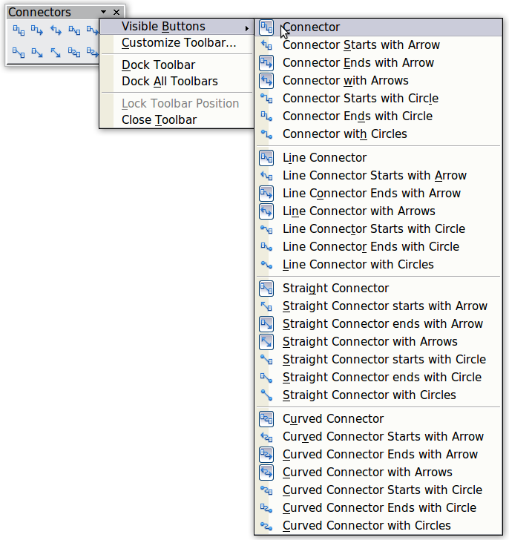
Figure 210: Activating additional connectors

Connector types fall into four groups:
- Standard connectors – the line segments run vertically and horizontally. All angles are right angles. The connector does not bend around the objects it binds.
- Line connectors – consist of a line segment and two smaller horizontal or vertical segments at the ends.
- Straight connectors – consist of a single line.
- Curved connectors – are based on Bézier curves, as described in Chapter 10 (Advanced Draw Techniques).
You can modify all the connector types from the context menu. Select Connector to change from one connector type to another (as well as some other properties). With the Line pane on the Sidebar, you can change the appearance of the line (color, arrow style, and line style) but not the connector type.

Drawing Connectors—Basics
When you choose a connector from the toolbar, the mouse pointer changes to 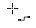. As you move the cursor over an object, the available connection points (also referred to as glue points) become visible. To connect two shapes, move the mouse cursor over a glue point, click and hold down the left mouse button to establish the first point, and then, while pressing the left mouse button, drag the mouse cursor to the other glue point. Then release the mouse button. The ends of the line are now docked, and the connection is established (see Figure 211).
Figure 211: Gluing a connector to a shape

As with all other objects, connectors have one or more control points to simplify the construction of the drawing. You can use these points to change the shape, length, and proportions of the connector line (see Figure 212).
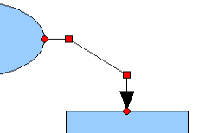Figure 212: Control points of a connector
To remove a connector from an object, either move the end of the connector away from the glue point of the object or simply delete the connector entirely.

Editing Glue Points
Glue points can be edited using a separate toolbar (see Figure 213). This toolbar appears when you click on the Glue Points icon on the Drawing toolbar or select Edit > Glue Points from the main menu.
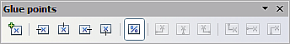
Figure 213: The Glue points toolbar
The following briefly describes the function of each button on this toolbar.
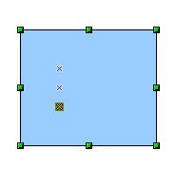
Use this button to insert a new glue point into an object you have drawn. If the object is filled, you can place a glue point anywhere inside the object or on its frame. With unfilled objects, you can place a glue point only on the outside frame, but you can then drag it inside the object, provided that the Glue Points icon on the Drawing toolbar is still active.
The glue points you add remain visible while the Glue Points icon is active. They appear as small blue crosses. A selected glue point has a gray square behind the cross. You can move a selected glue point with the mouse or delete it with the Del key.
Use these four buttons to choose one or more directions permitted for a connector to join to a particular glue point.
Activate Glue Points and then choose the direction. If, for example, you activate only the button, every connector will be forced to come to that glue point from the left side.
In the drawing on the left below is a glue point in the circle with a left entry, and one in the square with a right entry. The effect of this when adding a connector between the two glue points is shown in the drawing on the right
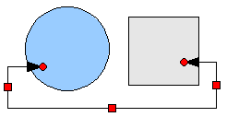
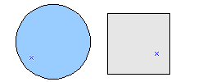
If you are in glue point editing mode and add another direction to a glue point (for example, by activating the button), Draw tries to optimize the length of the connector. For the example above, the connection inside the circle would change as shown below.
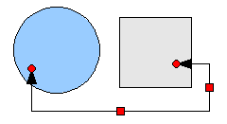
If the Glue Point Relative button is active (as it is by default), the glue point will move when you change the size of the object, as shown below.
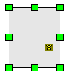
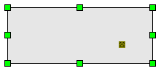
If the Glue Point Relative button is deactivated, the remaining buttons on the toolbar, previously grayed out, become active. With these buttons, you can decide how a glue point will be placed when the size of the object is changed.
These buttons determine how the horizontal position of a glue point changes when you resize the object containing the glue point. You can choose whether the glue point remains at a fixed distance from the left edge of the object, from a vertical line through the middle, or from the right edge of the object when you change the size of the object. If the width of the object becomes less than that distance, the glue point is attached to the object frame.
The following example shows what happens when an object’s width is changed, and the glue point is set to be a fixed distance from the left frame.
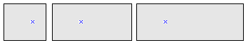
These buttons determine, in a similar manner, the vertical position of a glue point when the size of the object is changed.

Adding Text to Connectors
To add text to a connector, double-click the connector. The end and control points become active, and the familiar flashing text cursor appears, with the cursor position determined by the most recent setting. The Text pane of the Sidebar appears, and the Text Formatting toolbar also appears under the menu bar. Use this toolbar to set text properties, then insert the text directly.
If you draw a connector and then click on it, only the endpoints and control points become visible. Despite this, a connector has its own object frame—in this case, an invisible one. You can picture it easily by imagining a rectangle enclosing the start and end points of the connector (Figure 214).
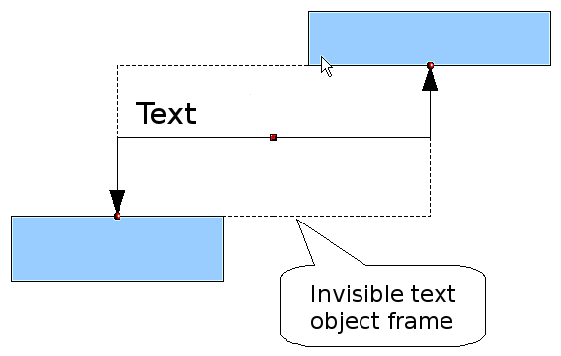
Figure 214: Object frame of a connector
When you add text to a connector, the location of the text is relative to this rectangle. The exact position of the text can be set in the Text dialog (Figure 215). This dialog appears when you double-click on text and then choose Text from the pop-up menu, or when you single-click on the connector and select Format > Text from the menu bar.
Take particular note of the Spacing to borders and Text anchor sections in the Text dialog. In the Text anchor section, you can see the possible locations for the text. In the example below, the text is anchored at the top left. In the Spacing to borders section at the lower left, negative values of spacing will position the text outside the frame.
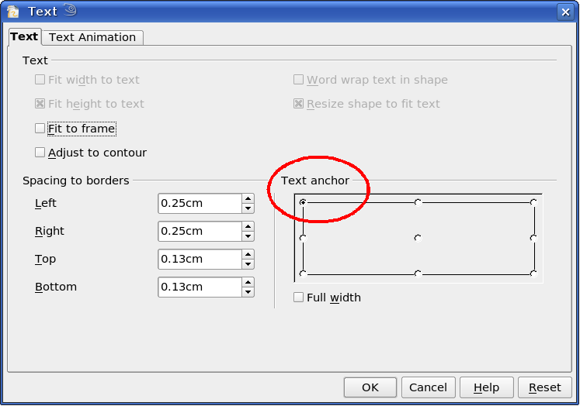
Figure 215: The Text dialog

Adjusting Text to Suit the Connecting Line
If you want the text to follow the slope or curve of a line, you need to activate and use the Fontwork tool. To add this tool to the Draw toolbar:
- Choose Tools > Customize from the menu bar.
- On the Toolbars tab, select Drawing from the Toolbars pull-down list. In the Toolbar content section, click Add.
- In the Add Commands dialog, select Format from the left-hand list, and select the command Fontwork. Click Add, then Close to return to the Customize dialog.
- In the list of commands under Toolbar Content, move the Fontwork icon 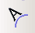 to the location you want by using the up/down arrows, and then click OK.
To write slanting text, follow these steps:
- Add the text to the connector as described earlier. The anchor location of the text is not important at this stage (Figure 216).
- Select the object with the text (in this case, the connector) and click on the Fontwork icon to open the Fontwork dialog (Figure 217).
- To make the text lie along the inclined line, click the Rotate icon and set the distance to the line you wish.
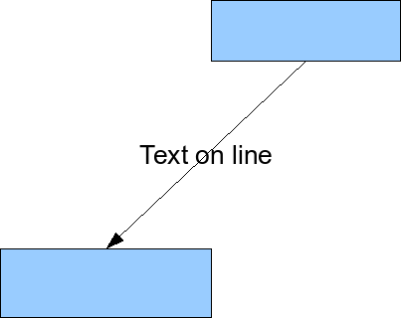
Figure 216: Adding text to an inclined line, Step 1
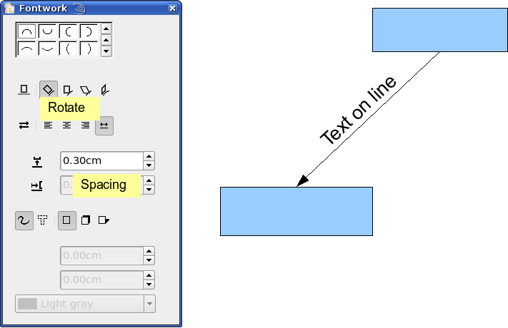
Figure 217: Adding text to an inclined line, Step 2
The Fontwork dialog provides many other possibilities for manipulating text. You can, for example, rotate the text 180 degrees with the Orientation icon, as done in the example above, or place the text under the line by assigning a negative value to the spacing between text and line.
In addition, you can use the Fontwork dialog to generate curved text that follows the shape of a curved line. Experiment a little to investigate the possibilities.

Chapter 10
Advanced Draw Techniques

Drawing to Scale
Draw is not a CAD (computer-aided design) program but a graphics program with which you can produce drawings to scale. The example used in this chapter is a drawing of a Logic Circuit Diagram. The exact meaning of the individual symbols is not given here; we are only interested in the drawing techniques used to produce the diagram.
The logic symbols in Figure 218 form the building-block library for our scale drawing.
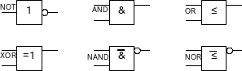
Figure 218: Logic Symbol library

Working with the Position and Size Dialog
To ensure that the edges of building block symbols do not border on the wiring, those symbols should be 8 mm wide and 8 mm high. The connections to the symbols should have a length and separation of at least 5 mm. These values are all random; you can substitute values that suit your needs.
For the drawing, we measured in millimeters, using a grid spacing of 5 mm, and a grid subdivision of 4 points. In addition, activate Display grid and Guides when moving, as well as Snap to grid (see Chapter 8). The drawing we're creating will later serve as a collection of available symbols; not only draw the symbols, but also fully detail them.
The first step is to draw a base element, an AND gate block. You can then dimension and detail this element (use the Position and Size dialog, as shown in Figure 219; double-click on the status bar or context menu to help with dimensioning). For this example, the left upper corner of the block is at x=10 mm and y=5 mm.
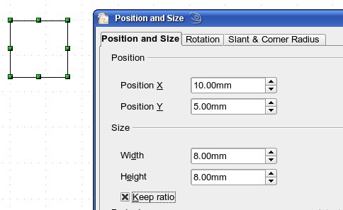
Figure 219: Positioning and dimensioning a Draw object
Draw the first connection lead by eye and dimension and position it using the Position and Size dialog (Figure 220).
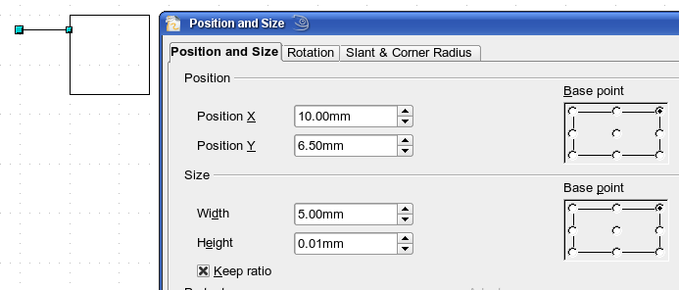
Figure 220: Setting the position and dimension of the upper input
Use the same method to draw the remaining two leads. To position the input leads, fix the right endpoints; for the output lead, fix the left one. The first wire lies 1.5 mm below the upper edge of the block. The leads have a 5 mm spacing between them. The following table shows the relevant coordinates of the upper corner points and the leads.
For the lower input lead, increase the Y coordinate of Input 1 by 5 mm to 11.5.
left (X/Y) [mm] | right (X/Y) [mm] | Input 1 (X/Y) [mm] | Output (X/Y) [mm]
10 / 5 | 18 / 5 | 10 / 6.5 (right EP.) | 18 / 6.5 (left EP.)
The AND gate block is almost finished. We can use it as the basis for all the other gates. We use Edit > Duplicate (Figure 221), to ensure uniformity of shape and size, so that the drawing gives a good visual impression
Because we want to copy the block vertically downwards, use a Placement on the X Axis of 0 mm and on the Y Axis 15 mm.
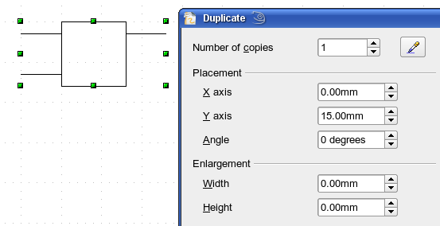
Figure 221: Duplicating an object
Using the same method, copy both blocks twice more to the right. Select both blocks, open the Duplicate dialog, and use placement values of 30 mm (X) and 0 mm (Y). Your drawing should look similar to Figure 222.
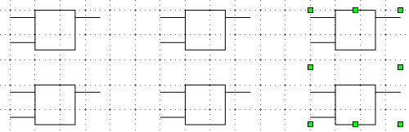
Figure 222: The blocks after duplication
For the INVERTER or NOT gate, the connection leads must be amended. Move one input and one output lead to the middle of the block and delete the superfluous input lead.
Draw the missing circle for negation with a diameter of 2 mm. Place it by eye in the center, then position it and dimension the connections in the Position and Size dialog as described above.
You can copy the circle to the Clipboard, then paste it as many times as needed, positioning it and adjusting the lead lengths as above.
A wiring diagram also needs a symbol to show a connection point. Draw a filled circle for this.
Next, add text to the symbols (&, =1, etc.). Activate the icon on the Options Toolbar. Double-clicking a symbol will now put you in a special text input mode. This integrates the text as an element in the object (see also Chapter 2 of this guide). You will find the OR symbol (≤) in the list of special characters (Insert > Special Characters).
It is probably a good idea to create a group for each type of gate. This will make it easier to use them in a diagram. Your diagram should now resemble Figure 218; save it.
If you wish, add a name to each gate symbol (AND, OR, etc.), and use a separate layer to add this text so you can switch it off when necessary.
You can place glue points at the end of each connection lead. This will simplify wiring up when you add in the connectors later.

Setting Glue Points
This section assumes a basic knowledge of connectors and glue points. For additional information, refer to Chapters 2, 8, and 9 of this guide.
The glue points on the connection leads must be placed exactly at the ends of the lines; otherwise, the wires will not be properly aligned. Unfortunately, you cannot set the position of glue points using numerical values. It must be done by hand.
The best solution is to use the Zoom toolbar to enlarge the diagrams. You can make it visible by going to View > Toolbars > Zoom. It contains (among others) tools for zooming in and out, that is, enlarging or shrinking the current page view. If you click the Zoom In tool, then click the page, the scale is doubled and the view centers on the place you clicked.
As the ends of the connection leads in this example do not lie on grid points, you must disable Snap to Grid and enable Snap to Object Points.
When you have done this, you can open the Glue Points toolbar shown in Figure 223 with the Insert Glue Point icon 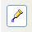 on the Drawing toolbar or using View > Toolbars from the menu bar.
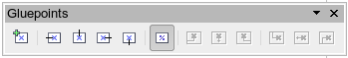
Figure 223: The Glue Points toolbar
Select the block on which you want to insert a glue point. Click the Insert Glue Point icon . It is now activated and appears with a different background. The mouse cursor changes to a small cross; you can set the first glue point. Click the mouse at the desired location. If the point is not exactly where you want it, move it by dragging with the mouse.
When you are satisfied with the location, in the Glue Points toolbar, click the icon with the exit direction you want (left, right, top, or bottom). The selected icon now has a different (lighter or darker) background. Set the exit direction of the input connection leads to the left and the output leads to the right.
When you have set a glue point at the end of each gate’s connection lead, you can copy it into the Gallery.

Copying Individual Pictures to the Gallery
The Gallery is a convenient way of controlling building blocks for drawings. It also functions as a symbol library.
First, open the Gallery in the Sidebar or via the menu Tools > Gallery, or by clicking its icon if it is present in one of the toolbars.
The Gallery appears as two panes in either the Sidebar or above the drawing page. The smaller pane shows the available folders, and the larger pane shows the images contained in the current folder. Choose an image by clicking on it; additional information about the image appears in the header bar.
In the folder pane, click the New Theme button to create a new folder. A new window opens. Click on the General tab and give the new theme a meaningful name (for example, Logic) to replace the default of New Theme. You can rename a theme by right-clicking it in the folders pane.
To import existing images into the Gallery, click on the Files tab and then on the Find Files... button. You can bring in complete folders or individual files; the procedure is self-evident from the dialog windows that open, or see Chapter 14 (Working with the Gallery) in the Getting Started guide.
You can drag and drop Draw objects straight into the Gallery. (The Properties window can be closed after typing in the name.) First, select the destination folder, then click the first symbol you wish to add to the Gallery. Position the mouse cursor inside the selection frame of the symbol. When the crossed arrows are visible, click the symbol and keep the mouse button pressed. After a couple of seconds, the cursor will briefly blink and change to the drag symbol. Drag the object into the Gallery and release the mouse button. When you move the mouse into the Gallery field, the cursor shape changes again (see Figure 224).
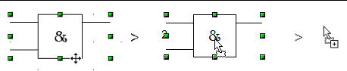
Figure 224: Crossed arrows > Drag symbol > Gallery symbol
When you have placed all desired symbols in the Gallery, they can be titled. Right-click on a symbol, choose Title from the menu, and type the symbol name (AND, OR).
Tip | Zoom in on very small graphics before you try to move them, so that the crossed arrow symbol can be clearly seen.
The symbol library is available to all AOO modules, at least for users with permission/rights to access it. Making the drawing collection available as a Draw file is the simplest way to distribute a symbol library to other users. After opening the drawing, other users can easily transfer the drawing objects into their own Gallery, as described above.

Drawing a Logic Circuit Diagram Using the Gallery
The use of the symbol library, which you have created and placed in the Gallery, can be illustrated by using the blocks to draw a half adder as shown in Figure 225 below (see http://en.wikipedia.org/wiki/Half_adder#Half_adder).
You can precisely place all the drawing objects with the help of Draw’s snap functions. The following instructions are only one way to achieve this objective.
Note | Don't struggle to understand the fine points of the illustrations in this chapter. Just know that they were chosen as top-notch representations of Draw's advanced capabilities.
Begin with a new drawing. Set the unit of measurement to centimeter, a grid point spacing of 0.5 cm, and subdivision of 4 points. Activate the grid, guiding lines, and associated snap functions.
In the first part of the exercise, you should draw only the two signal leads a and b, the two INVERTER gates, and the two AND gates.
Begin by drawing the two signal leads. To make it easier, you can use the values in the following table.
 | Start point | Length
Signal wire a | X = 2 cm / Y = 3.0 cm | 5.5 cm
Signal wire b | X = 3 cm / Y = 3.0 cm | 5.5 cm
After drawing the two signal leads, the hardest part follows. With grouped objects, the snap function applies only to points on the outer contours. The only way to work with these blocks as a unit, however, is to treat them as a grouped object. The input and output leads must lie right on grid points if the connecting lines are to be exactly horizontal or vertical.
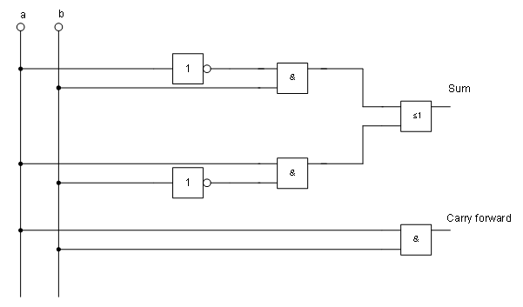
Figure 225: Half adder drawn using logic symbol building blocks
Position two horizontal guiding lines (A, B) on the grid with Y=4.0 cm and Y=6.0 cm. With Snap to Grid active, this should be no problem. With an INVERTER gate, the input and output leads lie in the middle of the block, 4 mm below the upper edge. To ensure the input and output are docked to the guiding line, the upper edges of the INVERTER gate must be positioned at Y=4.1 cm and Y=6.1 cm (for a 5 mm grid spacing). Right-click on the guiding line, select Edit guiding line from the context menu, and set the guiding lines to 4.1 cm and 6.1 cm.
To ensure the blocks lie exactly underneath each other, insert vertical guiding lines at X=5.0 cm (INVERTER gate) and X=8.0 cm (AND gate).
Now open the Gallery and drag the Inverter gate into approximately 0.64, the desired position. If the function Snap to guiding line is still active, you can accurately position both blocks at the correct location. Your diagram should now look like Figure 226 and you can save it.
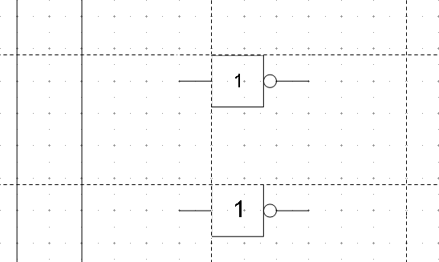
Figure 226: Drawing a half adder – Step 1
The input and output leads of the INVERTER lie at Y=4.5 cm and Y=6.5 cm. Move the mouse over a guiding line. When the mouse cursor changes to a double arrow, drag the guiding line (with the left mouse button pressed) onto the input and output leads of the block. If grid snap is still active, this should be exactly positioned without much effort.
The leads of the AND gate lie 1.5 mm below the upper edges of the two horizontal guiding lines. They must be moved up for the next step. The Y coordinates are reduced to 4.35 cm and 6.35 cm (the top edges of the AND gates). After moving the lines, you can drag both AND gates from the Gallery and position them. Your drawing should now resemble that in Figure 227.
Next, drag the horizontal guiding lines again over the input and output of the gates (Y=4.5/6.5 cm), so that when you position the connection point of the leads (a small black circle), it will sit exactly on top of the leads from the gates.
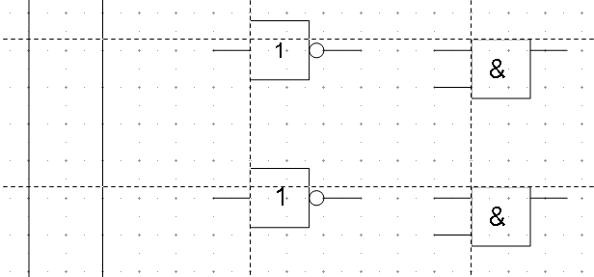
Figure 227: Drawing a half adder – Step 2
To position the two last gates, you need to set the following additional guiding lines: a vertical line at X=11 cm and two horizontal lines (C, D) at Y=5.5 cm and Y=7.5 cm, respectively. Shift the horizontal lines C and D each 1.5mm upwards (so that Y=5.35 cm and Y=7.35 cm).
Drag the OR and the last AND gate from the gallery and position them as in Figure 228.
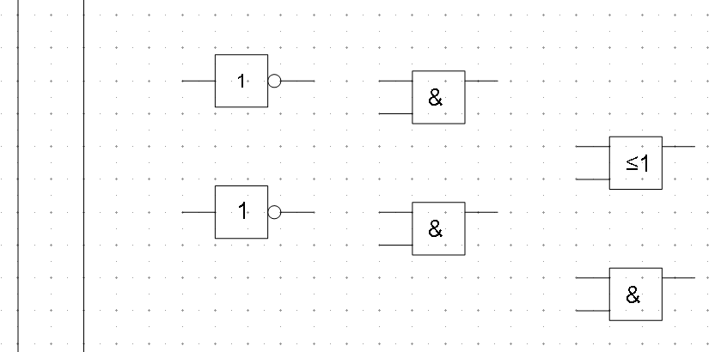
Figure 228: Drawing a half adder – Step 3
Since the OR gate will be connected to the two previously positioned AND gates, you can delete the guiding line of the OR gate. Drag the 0.64 horizontal guiding lines C and D over the inputs of the AND gates (Y=7.0 and 7.5 cm) and put two other lines (E, F) on the remaining connections (Y=5.0 and 8.0 cm) as shown in Figure 229.
Deactivate all snap functions except snap to grid. It is a good idea to zoom in so that you can place the lead connections exactly over the intersection points. Drag the connections singly from the Gallery to where you want to position them. You will need to adjust their position with the mouse. The easiest way is to move the connection diagonally to the desired location (see Figure 230).
The guiding lines are no longer needed and can be hidden; it is better to wait until you have finished the drawing before deleting them. Your drawing should now start to look like Figure 229 and can be saved again.
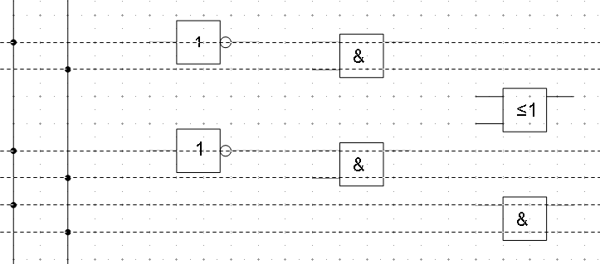
Figure 229: Drawing a half adder – Step 4
The individual blocks must now be joined so that the gates function as a half-adder system. To do this, you use connectors. Open the Connector toolbar. Use the standard connector to join the OR to the two AND gates. All the other leads run horizontally, and you can use the direct connector .
When all six lead connections have been positioned, both signal wires should have a small black circle added to their connection points. You can use the symbol for NOT from the Gallery as the basis for this.
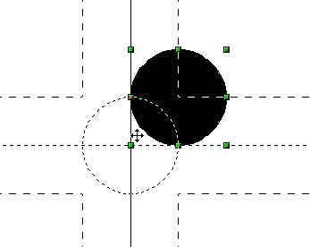
Figure 230: Setting the connections
If you have correctly positioned the symbols in the drawing, all the connection leads will be straight lines. At this time, you can delete all the guiding lines, add text to the drawing, and your finished drawing should resemble Figure 225 on page 186.

Dimensioning a Drawing

Configuring the Dimensioning Style
As is usual with Draw, you configure dimensioning using a style.
After opening a drawing, access the Styles and Formatting window. In the Graphic Styles list, right-click on the style Dimension Line and select Modify. The dialog that opens contains the current settings. Click the Dimensioning tab (Figure 231).
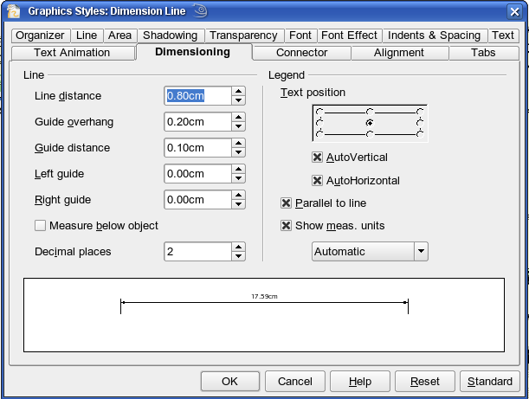
Figure 231: Configuring dimension lines
You can configure all the properties shown in this window to suit your own needs. The left section includes the basic settings for dimension lines and dimension guidelines; these indicate where on the object the dimension is referenced:
- Line distance: the distance of the dimension arrow from the object edge
- Guide overhang: the distance the guideline extends past the arrow
- Guide distance: the distance of the guideline from the object edge
As you change these settings, the example at the bottom of the dialog changes, making it easy to understand the effect of the settings. You can set the line lengths of the right and left guidelines individually, and use positive or negative values to position the line above or below the reference point. The direction of the line with positive or negative distances depends on the setting of the Measure below object option (box checked or not). This is easy to check by referring to the example dimension line in the bottom window of the dialog. For this exercise, click the box and activate this option.
In the right section, you can change the settings for the Legend, the text of the dimension line. You can use the Text position choices to change the location of the text – but only if one or both of the AutoVertical and AutoHorizontal checkboxes are unchecked. Use the options on the Text and Alignment tabs to further change the text format.
Calculation of dimensions always takes into account the scale and dimension units contained in Tools > Options > Draw > General. If you set a scale of 1:10 and a unit of centimeter, a 6 cm long object in the drawing will be shown with a dimension of 60 cm when the option Show meas. unit is activated, and the selection window is set to Automatic. Deselecting this option turns off the display of units. You can change the units displayed from Centimeters to, for example, Millimeters, by choosing Millimeter instead of Automatic in the selection window.
Adjust the font type and size for the text of a dimension line by means of the Text tab.
The Standard button at the bottom of the dialog sets all properties of the dimension line to the inherited, standard properties of the style.

Dimensioning Objects
Note | The dimensioning style Dimension Line is always linked and stored with the current work page. All the changes that you make apply only to this page. New drawings are started with the standard properties of Draw. If you want to use the amended style for future drawings, save the page as an additional template.
In this exercise, you will dimension some logic blocks (see Figure 232). They are used here to demonstrate the technique; you may use your own drawing or retrieve a picture from the Gallery.
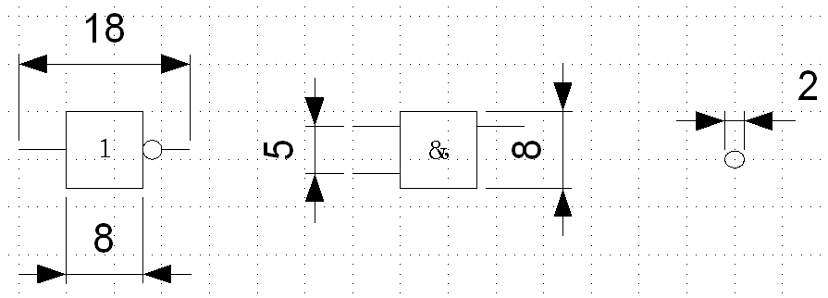Figure 232: Dimensioned logic blocks
So that Draw can clearly recognize the edges to be measured, you should set a number of guidelines delineating those edges. The previous sections explain how to do this. To place the guidelines exactly and easily, change the resolution of the Grid. Suitable values for this work are a resolution of 5 mm and a subdivision of 4 points. With this setting, you should have a snap to grid function with 1 mm point separation.
We will begin by dimensioning the NOT gate. For this block, we want the total width (18 mm) and the width of the block itself (8 mm) to have dimension lines. The first step is to add guidelines to delimit the dimension lines. With Snap to grid activated, you can position these quite accurately (see Figure 233, item a). Be sure that the function Snap to guide lines is active and zoom in to the part of the block to be dimensioned. The block should not be selected.
Start the dimensioning command by clicking the Dimension Line icon on the Arrows toolbar. This toolbar is not visible by default. The dimension line is placed automatically on the Dimension Lines layer so that you can hide dimension lines if you wish.
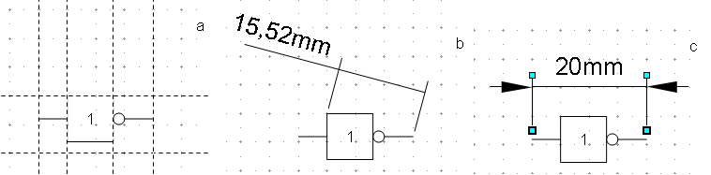
Figure 233: a) Delimiting the edges with guidelines
b) Dragging the dimension line (counterclockwise)
c) Finished dimension line
After clicking the Dimension Line icon, the mouse cursor changes into a small cross. As we activated the option Dimension Line – Measure below Object, the dimensioning should be made in a counterclockwise direction. Place the mouse cursor at the left dimensioning point. Press the left mouse button and drag the mouse to the right dimensioning point. Release the mouse button. If you press the Shift key while dragging the mouse, you will restrain the dimensioning line in a horizontal (or vertical) direction (see Figure 233, item b).
In the same way, you can draw a vertical dimension line on the AND gate. The dimensioning of the NEGATION symbol should also be simple to accomplish, but it is important that for such small components, you zoom in enough to accurately position the lines.

Editing Dimension Lines
Dimension lines can be edited. You can select single dimension lines, which are displayed with four handles, located at the end of the dimension lines (Figure 234).
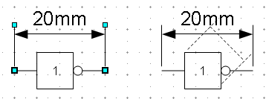
Figure 234: Editing dimension lines
With the upper handles, you can change only the length of the guidelines. With the lower handles, you can move the points being dimensioned. If you select the dimension text, you can edit the font type and size as well as change the dimension units of the text.
If you only want to edit the text of the dimension, double-click on an unselected dimension line to enter text edit mode.
All the changes that you make relate only to the selected dimension line. They are stored and persistent, but do not affect the settings of the Dimension Line style. If you insert other dimension lines, they will have the settings contained in the style.
If you want to make general setting changes to the Dimension Lines style, change the appropriate style. As soon as you confirm the changes with OK, the new settings will be applied to all dimension lines.

Working with Text in Draw
You can use text in Draw in various ways:
- as a text element
- as text associated with a picture
- as an element from the Fontwork gallery
- as a Writer OLE object

Configuring Text Elements with Styles
Text, like all drawing objects, can be associated with styles. The text settings in styles (Figure 235) always affect the whole text element. You can format individual parts of a text element, but only by using manual formatting, which is not related at all to styles and templates. Styles for characters and paragraphs do not exist in Draw.
Open the Styles and Formatting dialog in the Sidebar or by pressing F11. Access the formatting dialogs using the toolbar icons, the context menu, or the Format menu.
The Indents and Spacing, Text, Text effects, Tabs, and Alignment tabs of the style dialog function the same way as in text documents, although some options are not available in Draw. Specific to drawing objects are the Text and Text Animation tabs.

Text Animation
On the Text Animation tab, you can set how the text moves within the object frame. Such effects are interesting mainly for documents that are to be shown on the screen. They are therefore more commonly used in the Impress module. For printed text, they do not make sense and are not addressed further in this guide.

Text
On the Text tab, you can determine the behavior of the text block in relation to the border of the drawing object. The same settings can be altered—as manual formatting—under the Text... command in the Format menu or in the context menu.
The type of drawing object determines which settings are active and what effect they have on the text. Shapes behave differently from other drawing objects. To experiment with the settings, use objects with rounded edges so that differences in spacing and alignment show up better.
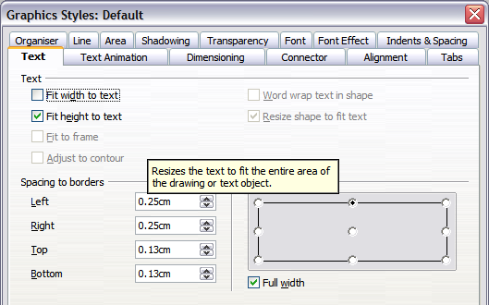
Figure 235: Text tab of Graphic Styles dialog

Anchoring Text
To try out the different settings possible for text anchors, start by drawing an ellipse from the Drawing or Basic Shapes toolbars , change into Text edit mode by double-clicking on the ellipse, and write several brief lines of text. Repeat with an ellipse from the Circles and Ovals toolbar. This toolbar is not available by default; you must customize the Drawing toolbar to add it.
Note | To tell whether you have selected a basic shape or a classical drawing object, look on the left side of the status bar; you will see either Ellipse selected (Classical object) or Shape selected (Basic Shape).
In the Text tab of the Edit Style dialog, set the values of the Spacing to Borders to 0 cm for all four directions. | 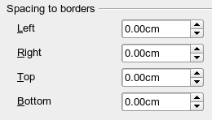
Set Options as Left in the tab Alignment. Also, set the alignment under Format > Paragraph to Left. | 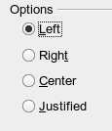
Now we can try out some of the different possibilities for text anchoring.
 | Shapes | Classical drawing objects
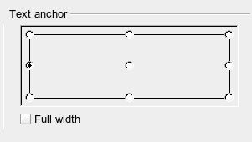  Text anchored to left middle – the text block is placed on the left side and centered vertically. | 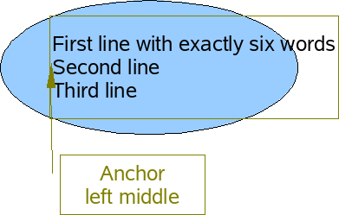  “Left edge” here means the edge of the text frame whose left side fits totally within the figure. | 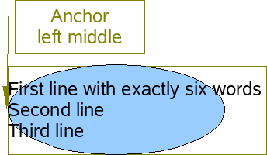  “Left edge” here means the left side of the object frame – the frame with the green handles, which is visible when you click on the object.
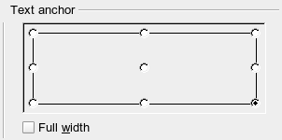  Text anchor to lower right. | 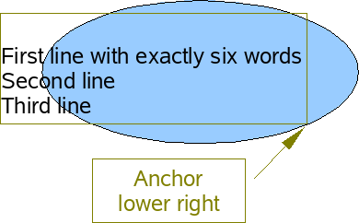  The lower-right corner of the text block sits against the edge of the figure. | 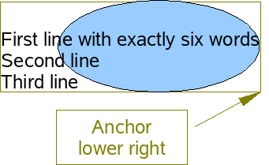  The lower-right corner of the text block lies in the lower-right corner of the (invisible) object frame.
The text anchoring always relates to the entire block, even when single lines are set differently from the other text through manual formatting. | 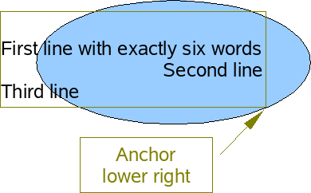 | 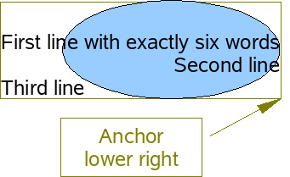
If you checked the option Full width, the text block is always centered horizontally. The area of the text block is maximized; here it extends either to the edge of the figure or object frame or (when not that wide) to the width that is necessary to fit the longest line. The difference becomes clear when you position the text on the left and set single lines through hand formatting to be aligned on the right.
In the examples below, the first line of text was shortened to “First line with”, spacings was set to 0, and the text anchor was set to middle-left.

Fitting Text in Frames
 | Shapes | Classical drawing objects
Without option “Full width”. | 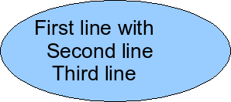 | 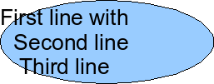
With option “Full width”. | 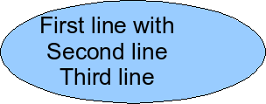 | 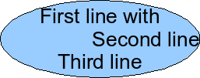
Here, you find that shapes and classic Draw objects behave completely differently.
For shapes, the options on the right are active (Figure 236).
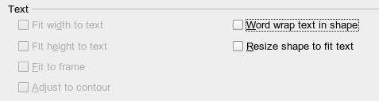
Figure 236: Options active for shapes
These have the following effects.
Word wrap text in shape:  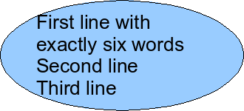  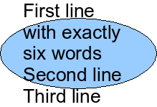 | No automatic hyphenation is available, and you cannot insert a fixed hyphen.  If the text does not fit within the shape, the overflow appears above or below the shape.
Resize shape to fit text:  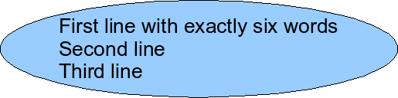 | Watch out! If you turn on this option, it is not possible to undo the size changes – whether by using the Undo function on the menu or by switching off the option in the dialog.
For the classic drawing objects, both lower-left options in the dialog are active.
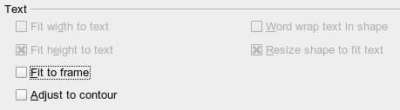
These options have the following effects.
Fit to frame:  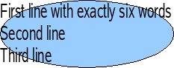 | The text is widened and compressed so that it fills to the object frames.
Adjust to contour:  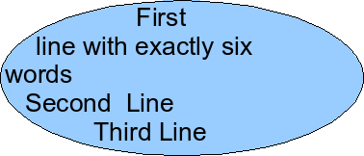  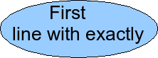 | All the text is contained within the figure. It is split over several lines if necessary. Any text that does not fit in the figure is not shown, but is still retained.  Note that even if you have activated hyphenation, words will be split without regard to the hyphenation rules.

Distance From Frame
Spacing settings are added to the text. In this way, the text block is invisibly reduced or (with negative values) made bigger.
In the examples below, the text (M) is centered horizontally, and the text block is anchored in the upper middle part of the frame.
Value for spacing “Above” | –2 cm | –1 cm | 0 cm | 1 cm | 2 cm | 3 cm
The behavior is the same for classic drawing objects and shapes. | 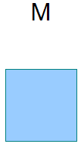 | 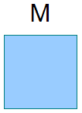 | 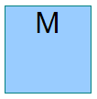 | 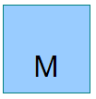 | 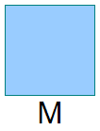 | 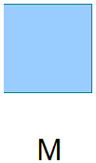
If you anchor text above, below, right, or left, a positive spacing value positions the text in such a way that it sits close to the outside of the object frame at the anchoring point. Anchoring in the middle does not result in this movement.
It is easier to add text to a straight line if the line is created as a very thin rectangle. Choose an anchor point in the middle of the rectangle, then determine the exact text position by setting the spacing accordingly.
Text added to open line types, such as Bézier curves (curves and freehand lines), Polylines (polygon and polygon 45°), and Arcs, is also positioned in relation to the enclosing object frame. If you want to see the extent of this frame, just click on the object. To add text along one of these lines, you can use the Fontwork tool described on page 200.
Text added as described above is rotated when the object is rotated. The property settings, particularly those dealing with spacing relative to the frame, only apply to situations where the object is not rotated.

Text Frames and Callouts
To test the range of possible settings, use a text frame or a callout with rounded corners. For text frames, as for rectangles, you can set the rounding in the Position and Size dialog (Slant & Corner radius) or in Points mode. The latter makes sense only if you have a visible outline. With callouts (as with text frames in Points mode), drag the larger handle in the upper-left corner with the mouse to set the desired amount of rounding. An example of this is shown in Figure 237.
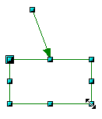 | 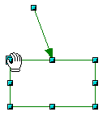 | 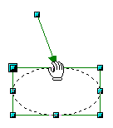 | 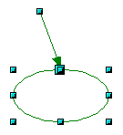 | 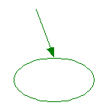
Figure 237: Legend with rounded corners
Unlike drawing objects, text frames and callouts support automatic line breaks. You can switch on automatic hyphenation under Tools > Language > Hyphenation.
Non-breaking dashes and protected separators are not available. For a manual line break, use (as elsewhere) the key combination Shift+Enter.
With the text and callout icons ( and ), you can create text frames and callouts with vertical text. You need to activate Enhanced language support > Enabled for Asian languages in Tools > Options > Language Settings > Languages. Text frames can be rotated like drawing objects, but callouts can not be rotated.
Text frames and callouts do not have a separate text element, but you still use the Text dialog to set formatting properties. As soon as you have supplied text, the upper three settings on the left side become active (Figure 238). The settings for Spacing to Borders and Text anchors in the lower window area function in a similar manner to normal drawing objects and are not covered further here.
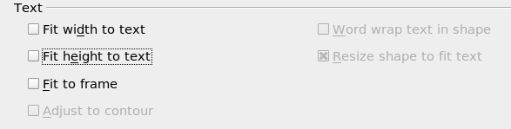Figure 238: Text options active for text frames and callouts
All options off  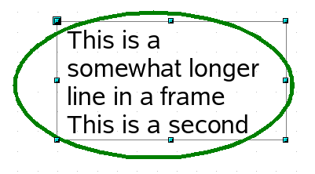 | As with normal drawing objects, the text positioning relates not to the figure itself but to the object frame. Observe that the text frame in the example on the left extends outside the ellipse.
Fit width to text  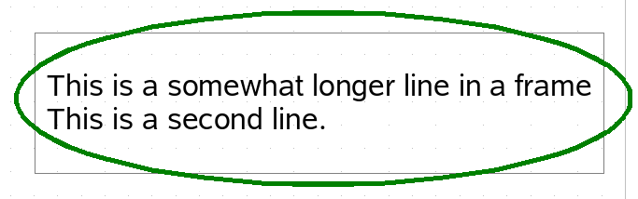  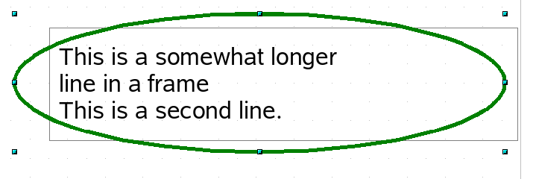 | The width of the text frame or callout is enlarged so that the longest line fits, without a line break, inside the object frame.  A previously inserted manual line break  (in this example, after the word “longer”) remains in effect.
Fit to frame  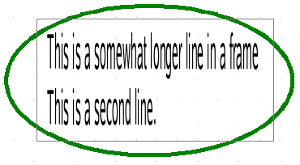 | The text is widened or compressed to fit within the entire object frame. This effect is the same as with normal drawing objects.  With the symbols and you can produce a text frame that has this property already set.
Fit height to text  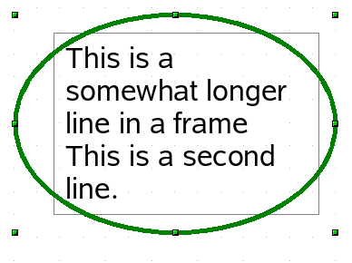 | The height of the text frame or callout is enlarged so that all lines fit within the height of the object frame.

Pictures and Text
Pictures also possess a text element. You can use this text element to place lettering over the picture, or to give the picture a caption. To format this text, proceed as for a normal rectangle. Usually, you produce text as a separate object and then group it with the picture, because this gives you more flexibility.
Here are two examples showing what is technically possible with text elements.
The construction of each example was carried out using a graphics style. Right-click on the picture and choose Edit Style to open the Graphics Styles dialog (Figure 235). You may first wish to choose a different style to edit for the picture, or create a new style for a special purpose. For more about styles, see Chapter 4 (Changing Object Attributes).
 | tab: Font, Comic Sans MS, Bold, 40pt  tab: Font Effect, color white, with shadows  tab: Alignment, Options Right  tab: Text, Text anchor “upper right” and  Spacing to borders right 0.5 cm, top 0.5 cm, others 0.0 cm
 | tab: Font, Bitstream Vera Serif, 14pt  tab: Alignment, Options Left  tab: Text, Text anchor “lower left” and Spacing to borders bottom -1.3 cm  Note: the line break after the word “sea,” was inserted manually. The negative value of the Spacing to borders places the text outside the picture.
If you store the picture using File > Export, the text is exported along with the graphic. If you use the context menu option Save as Picture, the text is not exported.

Fontwork Gallery
Click the icon to open the Fontwork Gallery (Figure 239), which you can use to insert a caption to an image. Fontwork drawing objects belong to the shape category. The Gallery contains a selection of popular text forms.
Figure 239: The Fontwork Gallery
You are not limited to these samples; you can subsequently edit and customize the chosen caption type. Proceed as follows.
Choose a caption type from the Gallery and click OK. The caption is then inserted into the middle of your document.  Use the handles to drag and resize the caption. | 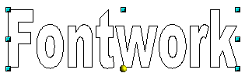
Double-click to enter text editing mode and replace the placeholder text “Fontwork” with your own text. | 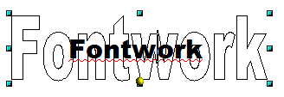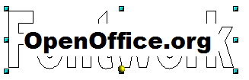
Click outside the object or press the Esc key to leave editing mode. | 
With the Area dialog from the Format menu or the context menu, you can set fill and shadow properties. Use the Line dialog to set a frame around the lettering. | 
For further adjustments, use the Fontwork toolbar. If this does not open automatically, turn it on with View > Toolbars > Fontwork.  The symbol on the far left is already familiar. It opens the Fontwork Gallery. | 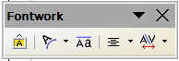
Use the small triangle on the symbol 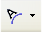 to open the tear-off Fontwork Shape toolbar and choose a shape for the frame of your caption. | 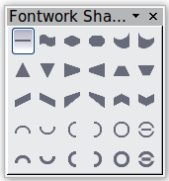
Use the yellow handle to modify the form of the caption. | 
With the other icons, you can further customize the text direction and spacings. | 
To change the font type of the caption, use (as for other text) the dialog from the Format > Character menu or the context menu.  To give the text a 3D appearance, refer to the relevant section in Chapter 7 (Working with 3D Objects). | 

Writer OLE Object
In some cases, text frames are not flexible enough to meet your needs and offer too few possibilities for adjustment. For example, you may want to show a figure in Draw in exactly the form it was created in Writer. The best solution might be to insert an OLE object. This means the object is linked to the application that created it. Draw makes only one viewing window available to other applications. The object itself is not edited in Draw; it is edited in the other application.

Insert
Use Insert > Object > OLE Object to open the dialog as shown in Figure 240. Use the Create new option to embed the OLE object in the Draw document. With the Create from file option, you can choose whether the object should be embedded or linked. With a linked file, any change in the stored file will be shown in Draw. Conversely, any change you make in Draw will be stored in the file on disk.
If you have decided to embed the object, you can still create an independent text document from the OLE object. For this, use the Save Copy as command from the context menu.

Editing Mode
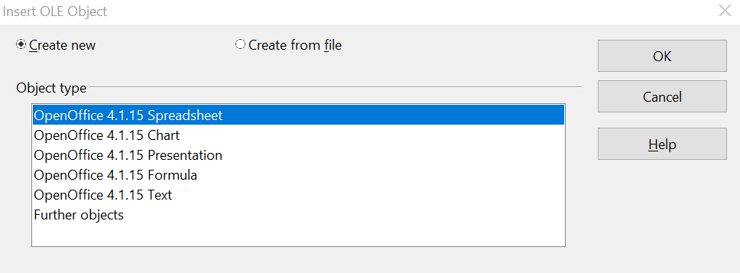
Figure 240: Inserting an OLE Object
When you click OK, the object is created and opens in editing mode. You can recognize this mode by the gray frame around the object and the small black handles, see Figure 241.
Take special note of the toolbars. These are no longer those of the Draw module; they're from the Writer module. Input text and format it almost as if you were in Writer itself. You now have access to all format styles available in Writer.
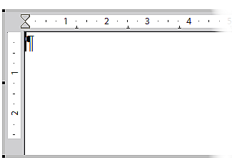
Figure 241: Writer OLE object in editing mode
With the handles of the gray frame, you can determine which section of the entire text document is visible. You should switch off the ruler view.
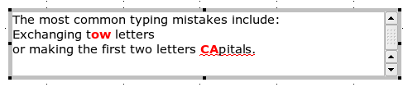
Figure 242: Editing in Writer as an OLE object
Click outside the object to leave editing mode. Double-click on the object or use Edit > Object > Edit to change again into editing mode (Figure 242).
In an embedded Writer OLE object, you can connect to further “sub” OLE objects. This is possible only if you open the embedded object as a standalone object in Writer. Similarly, you cannot edit a linked Writer “sub” OLE object directly in Draw; you must open it as a text document in Writer. This limitation can be illustrated using formulas. Such formulas are technically OLE objects that belong to the Math module. To use mathematical formulas inside flowing text, save the text in a separate text document and insert it as a linked OLE object in Draw. Inserting graphics from a file is, however, possible within the OLE environment in Writer.

Object Mode
Click an object to enter object mode, indicated by the green handles. In object mode, you're still in the Draw module.
In edit mode, there is no Zoom. Set the size of the OLE object on the Draw page in Object mode from the Position and Size dialog. In the left image of Figure 243, the object was inserted at the original size, in the right one, the size was reduced. If you change the size, take care that the option Keep ratio is checked. Otherwise, the object will become distorted. Line and Area properties are not available for OLE objects, nor is it possible to rotate objects as with text frames.
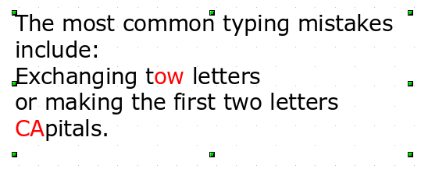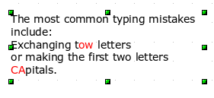
Figure 243: Zoom vs resizing of an OLE Writer object
Like other drawing objects, OLE objects can be overlaid. In Figure 244, a drawing object from the basic shapes menu has been placed behind the OLE object.
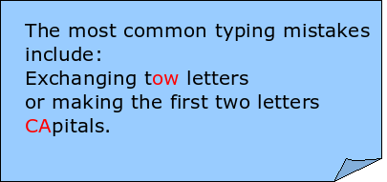
Figure 244: Draw object behind an OLE object
The page with the text document has the background property set to transparent. If you change the background color of the OLE object in Edit mode, it will also show in the Draw document.
The Format menu has the entries Area and Line grayed out because they are not usable, but the menu entries Paragraph, Character, Text, and Bullets and Numbering are all available. These relate not to the text object which you are currently editing, but rather to a separate, independent text element within the object, which you can open by pressing F2. (This is similar to the way that pictures are linked with an OLE object.) The double-click, which opens the text element in images, does not work here because it puts you into the OLE object’s edit mode.

Guide to Bézier Curves

Bézier Curves—What are They?
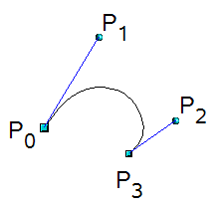 | OpenOffice uses cubic Bézier curves. A curve is defined by means of a start point P₀, an end point P₃, and two control points P1 and P2 (see the figure at left). For points on the curve, the terms nodes or anchors are often used.  For the mathematical background of Bézier curves, see http://en.wikipedia.org/wiki/Bezier_curve.
Bézier curves are very useful for experimenting with the shape and form of curves. In point mode, you can change the curve alignment by dragging the points with the mouse. The curve leaves the starting point P0 in the direction of the control point P1 and arrives at the end point P3 from the direction of the control point P2. These directions are shown in Draw by blue lines. The more distant a control is from its starting or end point, the smaller the curvature at that point. If a control point lies directly on one of these points, it has no influence on the curve.

Direct Drawing of a Bézier Curve
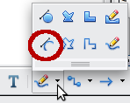 | Open the Curve toolbar by clicking on the small black triangle of the symbol on the Drawing toolbar. Click on the Curve icon . The mouse cursor changes to 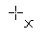.
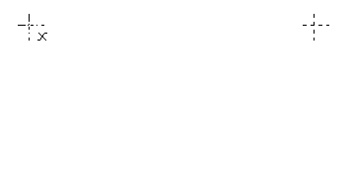 | Click the starting point of the curve and hold the mouse button down (starting and end points are shown in the figures as snap points).
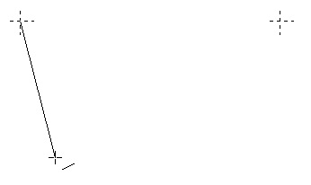 | Drag the mouse to approximately the position of your first control point. It does not matter if this is not exactly right; you can move the control point location later. If you hold the Shift key down while dragging, the control point will lie on a 45-degree grid.
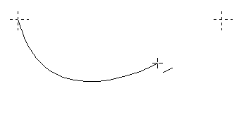 | Release the mouse button and move the mouse to the position of the end point of the curve. You can see that the line of the curve follows the movement of the mouse. Double-click at the end position.
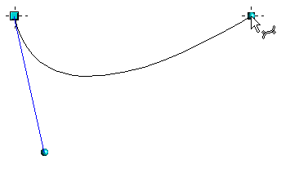 | Turn on point mode using the icon in the Draw toolbar.  At the end of the curve, you will see not only the endpoint but also an associated control point, the round handle. Hover the mouse cursor over this point; the cursor shape changes to show that you are in edit mode of a control point. You may need to click the control point to see this change in behavior (see the next section).
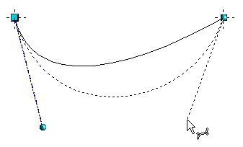 | Now you can drag the control point to its correct position, if necessary.

Point Mode of the Bézier Curve
After drawing a curve, you can use the icon from the Draw toolbar or the Edit points command from the context menu to switch to point mode, from which you edit individual points on the curve. Points on the curve are shown with a square handle ; the control points with a round handle . The starting point of a curve appears somewhat larger than the other points. When you hover the mouse over a curve point, the mouse cursor changes to over a control point, it changes to 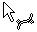. In point mode, the toolbar Edit Points should appear. If not, turn it on by going to View > Toolbars > Edit Points.
You can enable the All control points in Bézier editor option under Tools > Options > OpenOffice Draw > View. This is a good option to have when you are learning to use Bézier curves. The default is to show the control points and guidelines only when a point is marked by clicking it. By holding the Shift key down as you mark, you can select and mark several points at the same time. A marked point is shown slightly darker 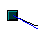.

Drawing a Succession of Bézier Curves
Several lines or Bézier curves can be linked together. The single parts are referred to as segments. Technically, such a succession of Bézier curves and lines is known as a path.
Begin the drawings with a simple Bézier curve. At the end position of the first segment, do not double-click, but do one of the following:
- Single click and then move the mouse to the end position of the second segment. This segment will be a straight line, but it is also a Bézier curve whose shape can be adjusted. Either double-click to finish the curve or single-click again to add another segment.
or
- Click and hold, then drag the cursor to set the position of the initial control point for the second segment. Release the mouse button at the desired position of the control point, then move the mouse to the end position of the second segment. The curve follows the line of movement of the mouse. If you double-click the endpoint, the curve will be complete. If you click and hold, you can set the control point for a third segment.
To generate a closed curve, select the curve and click on the Close Bézier icon 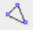 on the Edit Points toolbar, or right-click and select Close object from the context menu.

Adjusting the Curve Shape
You will likely want to adjust the shape of the curve. This is especially true if you used the first method above, which produces straight segments after the first segment. Be sure to be in Points mode and have the option All control points in Bézier editor turned on. When you select the curve, you will see square handles at the end of each segment and round handles at the control points. It may be that not all the control points are visible, especially on the straight segments. You can make them appear by selecting the associated square handle and clicking whichever Point Type icon is active in the Edit Points toolbar. Move the square handle to set where a segment ends, and move the control points to change the direction from which the segment approaches the endpoint. How the curve behaves as it moves from one segment to another is controlled by the transition point setting.

Transition Points
For the transition from one segment to the next, there are three different types of points, each with its own properties.

Corner Points
In a Corner Point transition, the lines meet at a point but are otherwise independent. It is likely that the curve has a kink at this point (depending on the angle of the tangents, the lines from the corner point to each control point; see Figure 245).
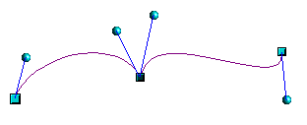
Figure 245: Corner point

Smooth transition points
In a Smooth transition, the segments form a straight line at the meeting point as shown in Figure 246. If you change the position of one of the control points, the other also moves so that the tangents remain in a straight line. This also applies when a Bézier curve meets a straight line: the tangent line lies on the straight line and cannot be moved sideways.
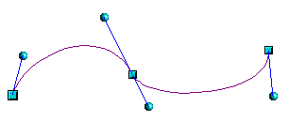
Figure 246: Smooth transition point

Symmetric Transition Points
In this case, the tangents not only lie on a straight line, but the distance of the control points from the curve point is the same, see Figure 247. The segments have the same direction and the same curvature at the transition point.
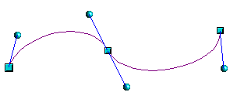
Figure 247: Symmetric transition point

Changing Point Types
When a point is selected, the Edit Points toolbar activates the three corner-point icons (circled in the illustration below).
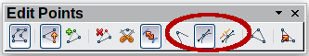
The circled icons are, from left to right, Corner point, Smooth transition, and Symmetric transition. At any time, only one of the three icons will be active. To change the type of point, click one of the other two icons.

Closing the Curve
Note | If you cannot see the control point for a segment, try clicking the active point type icon. This often forces a redraw, after which you can see both control points of the common corner point.
To close an open curve, use Close object from the context menu or the Close Bézier icon from the Edit Points toolbar. A straight line is drawn between the start and end points if these points are Corner points.
If the start and end points are Smooth points or Symmetric points, and the control point does not lie directly on the curve point, it changes position so it is in a straight line with the line segment, and the closing line will be a curve (see Figure 248 for a comparison).
To prevent this, change the curve point type before closing to a corner point.
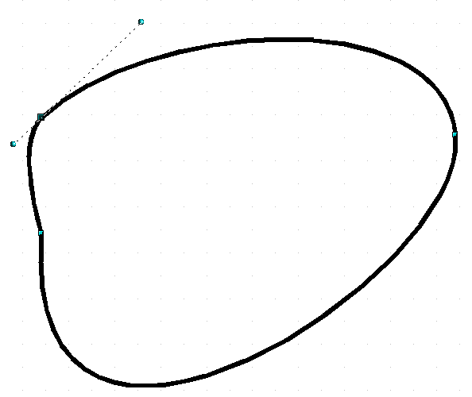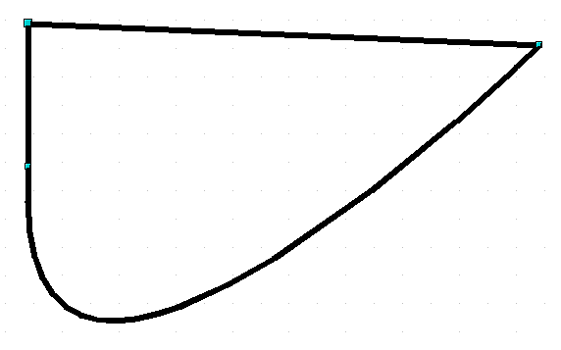
Figure 248: Close curve – start and end points are corner points (left), smooth or symmetric points (right)

Transformation Between Straight Line and Bézier Curve

Transform a Straight Segment into a Bézier Curve
Select the larger of the two handles at the ends of the straight line; this will be the starting point of the curve. After a short time, the Convert to curve icon on the Edit Points toolbar becomes active. It starts in the “out” position. Click the icon to turn on the function. The straight line is transformed into a Bézier curve. The type of the segment endpoint remains as it was. Using this function, you can convert one side of a polygon or a part of a polyline into a Bézier curve.

Transform a Bézier Curve into a Straight Segment
Select the larger of the two handles at the ends of the curve; this will be the starting point of the straight segment. After a short time, the Convert to curve icon on the Edit Points toolbar becomes active. It starts in the “in” position. Click the icon to disable the function. The Bézier curve segment is transformed into a straight line. The type of the segment endpoint remains unchanged. If all segments are straight lines, Draw converts the object to a polygon or a polyline.

Transform Complete Curves, Polylines, and Polygons

Transform a Polygon or a Polyline into a Curve
Select the whole polygon or polyline. The object does not need to be in point mode. Choose Convert > To curve from the context menu or the Modify menu. The points in the resulting curve are all of the type Corner point, and the control points lie on the curve segments. All the segments thus appear as straight lines.
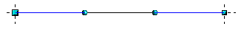

Transform a Curve into a Polygon or a Polyline
Select the whole curve. Choose Convert > To polygon from the context menu or the Modify menu. The curve does not need to be in point mode to do this. The individual segments are not replaced by straight lines. Instead, additional points are generated on the curve so that the line of the polygon/polyline matches that of the curve as closely as possible. These points are placed closer together as the curvature increases.
before 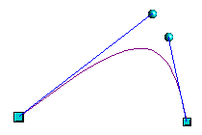 after 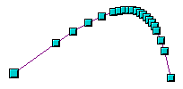

Freehand Lines
You can also produce a curved line from a Bézier curve using the freehand line tool . This tool automatically inserts anchor points and control points to render the curve as close as possible to the original Bézier curve.
Place the mouse cursor at the beginning point and keep the mouse button pressed until you reach the end of the curve. As soon as you release the mouse button, the curve is complete.
Normal view 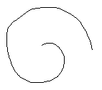 Point mode 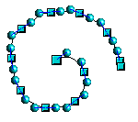

Combining Closed Curves
If you draw a Bézier curve segment and, at the end point of the segment, click while holding the Alt key, the curve is closed with a straight line, and you are placed in Combining mode. You can now begin a second curve. Release the Alt key and drag the mouse without clicking to position the cursor where you want the control point of the next segment. Click to set the control point position and move the mouse cursor to the desired end point of the second segment. Ending the drawing with a double-click also closes this curve. If you end it with an Alt-click, you can draw further curves. The curves that you have just drawn form a common object, a so-called Combination. You can use a Combination to place holes in filled curves.
If you want to bind two curves together into a Combination at some stage, select both curves and use Modify > Combine.
Even if you use a Combination, the individual curves are still available as objects. You can use Modify > Split to convert the Combination back to single objects.
You can create Combinations only from closed curves. Other objects, such as rectangles or polygons, will be automatically transformed into curves, and curves that are not closed will be closed with a straight line.

Connecting Curves
To join curves together, select them and use Modify > Connect. A connection is only possible with open curves. If you use this tool on closed curves, they are first opened, and an additional endpoint is inserted at the starting point. A straight line connects the curves.
The behavior of connected curves cannot be modified. It is not obvious in advance how the transition properties of the connected curves are calculated, nor which endpoints will be connected. It is therefore a good idea to work on a copy and test the effect with different positions of the endpoints of the individual curves. To avoid changes to a shape, first set the property of the new connection point to the type Corner point.

Adding Comments to a Drawing
To insert a comment, choose Insert > Comment from the menu bar. A small box containing your initials appears in the upper left-hand corner of the Draw page, with a larger text box beside it. Draw has automatically added your name and the date at the bottom of this text box.
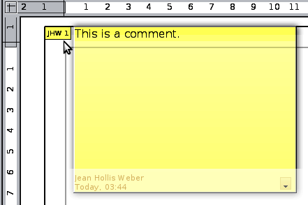
Type or paste your comment into the text box. You can optionally apply basic formatting to parts of the text by selecting it, right-clicking, and choosing from the pop-up menu. From this menu, you can also delete the current comment, all the comments from the same author, or all the comments in the document.
You can move the small comment markers anywhere you wish on the page. Typically, you might place it on or near an object you refer to in the comment.
To show or hide the comment markers, choose View > Comments.
Select Tools > Options > User Data to configure the name you want to appear in the Author field of the comment, or to change it.
If more than one person edits the document, each author is automatically allocated a different background color.

Connecting and Breaking Lines
In Draw, you can join separate line elements into a single line. Select a number of lines and choose Modify > Connect. The lines are converted to curves, and adjacent endpoints are joined. The resulting shape is a polyline, not a closed shape.
To add text to the polyline, press F2 and type the text. To make a closed shape from the polyline, right-click the polyline and choose Close Object. You can add text and also change area properties and edit the object as with any polygon object. Note that you can only use the Close Object command on connected lines, freehand lines, and unfilled curves.
If you select a shape and choose Modify > Break, this does not reverse the Connect process but simply converts the polygon into a collection of individual lines. Text added to the shape will be associated with one of the lines (typically the last). You cannot apply a fill to a closed shape made up of lines resulting from the Break command.

Bézier curves were invented by Pierre Bézier, an engineer working with the Renault car manufacturer, who developed the technique in the 1960s. The technology was intended to make modeling the surface of vehicles easier.
To reduce both calculation time and data storage, circles are often constructed as regular polygons. If you cut a sphere or cylinder of 10 segments through the middle, you end up with a 20-cornered cut section (10-cornered for a hemisphere).

