Apache OpenOffice
Version 4.1
Draw Guide

AOO Documentation Team

Chapter 1
Introducing Draw
Drawing Vector Graphics in OpenOffice

Copyright
This document is Copyright © 2025 by The Apache Software Foundation. You may distribute it and/or modify it under the terms of the Creative Commons Attribution License, version 3.0 or later (https://creativecommons.org/licenses/by/3.0/).
Apache, Apache OpenOffice, and OpenOffice.org are trademarks of the Apache Software Foundation. Used with permission.
Acknowledgments
This book is updated from a previous version by the OOoAuthors team. The AOO Documentation Team appreciates the many contributions of Michael Scarborough and Michele Petrovsky.
Publication date and software version
Published December 20, 2025. Based on Apache OpenOffice 4.1.
Note for Mac Users
Some keystrokes and menu items differ on a Mac from those used in Windows and Linux. The table below gives some common substitutions for the instructions in this chapter. For a more detailed list, see the application Help.

Windows/Linux | Mac equivalent | Effect
Tools > Options menu selection | OpenOffice > Preferences | Access setup options
Right-click | Control+click | Open context menu
Ctrl (Control) | z (Command) | Used with other keys
F5 | Shift+z+F5 | Open the Navigator
F11 | z+T | Open Styles & Formatting window

Contents
Chapter 1
Introducing Draw 1
Introduction 4
The Draw Workplace 5
Rulers 5
Status Bar 6
Toolbars and the Sidebar 7
Standard Toolbar 8
Drawing Tools 8
Line and Filling Tools 9
Text Formatting Toolbar 10
Color Bar 11
Choosing a color palette 11
Options Toolbar 12
Drawing Grid and Guides 13
Floating and Moving Toolbars 14
Customizing Toolbars 15
Quick Printing 16
Controlling Printing 16
Selecting General Printing Options 17
Printing Multiple Pages on a Single Sheet of Paper 17
Selecting Pages to Print 18
Printing a Brochure 18
Printing in Black and White (on a Color Printer) 19
Exporting to PDF 20
Quick Export to PDF 20
Controlling PDF Content and Quality 20
Exporting to Other Formats 20
Exporting Draw Documents as Web Pages 21
E-mailing Documents 21

Introduction
Draw is a vector graphics drawing tool. That means it represents shapes and groups of such objects differently than do “paint” programs. The advantage of vector graphics or drawing is that multiple elements can be manipulated independently of each other. Also, vector graphics make it easier to render objects at different sizes and to transform them in other ways without worrying about image resolution. Additionally, Draw can perform certain operations on raster graphics, which are images based on pixels. Using Draw, you can quickly create a wide variety of graphical images.
Note | For 'raster', read 'a video display that is covered by sweeping the electron beam of the display in a series of horizontal lines from top to bottom'. For 'pixel', read 'The smallest resolvable rectangular area of an image, either on a screen or stored in memory. Each pixel in a monochrome image has its own brightness, from 0 for black to the maximum value (e.g., 255 for an eight-bit pixel) for white. In a color image, each pixel has its own brightness and color, usually represented as a triple of red, green, and blue 'intensities'.
Vector graphics store and display a picture as simple geometric elements such as lines, circles, and polygons rather than as a collection of pixels (points on the screen). This permits more efficient storage and supports precise scaling of the picture elements.
Draw is fully integrated into the OpenOffice suite. This simplifies exchanging graphics with all components of the suite. For example, if you create an image in Draw, reusing it in a Writer document is as simple as copying and pasting the image. You can also work with drawings directly from within Writer or Impress, using a subset of the functions and tools from Draw.
Draw’s functionality is extensive, and although it was not designed to rival high-end graphics applications, it possesses many more features than do the drawing tools generally found in most office productivity suites.
A few examples of drawing functions are:
- layer management: layers influence visibility when printing or editing
- a grid point system that can aid alignment by automatically aligning nearby objects to the grid
- the display of dimensions and measurements
- supplying connectors for such things as organization charts
- 3D functions that enable small three-dimensional drawings to be created, and to include texture and lighting effects
- drawing and page-style integration
- Bézier curves, that is, a parametric curve governed by a set of discrete control points.
The Draw Guide is not a course book to be worked through from beginning to end. Rather, it is a reference work that allows you to browse for guidance on specific topics.
This document describes only the functions associated with Draw. Some concepts, such as file management or the way the OpenOffice environment works, are mentioned only briefly; they are covered in more detail in the Getting Started guide.

The Draw Workplace
The main components of the Draw interface are shown in Figure 1.
The large area in the center of the window is where you make drawings. If you like, you can surround the drawing area with toolbars and information areas. The number and position of the visible tools vary depending on the task at hand and user preferences. Therefore, your setup may look different. For example, many users put the main Drawing toolbar on the left-hand side of the workspace—not at the bottom, as shown here.
You can split drawings in Draw over several pages. Multi-page drawings are used mainly for presentations. The Pages pane, on the left side of the Draw window in Figure 1, gives an overview of the pages you create. If the Pages pane is not visible on your setup, you can enable it from the View menu (View > Page Pane). To change the page order, simply drag and drop one or more pages.
In Draw, the maximum size of a drawing page is 300 cm by 300 cm, approximately 118 inches in each direction.
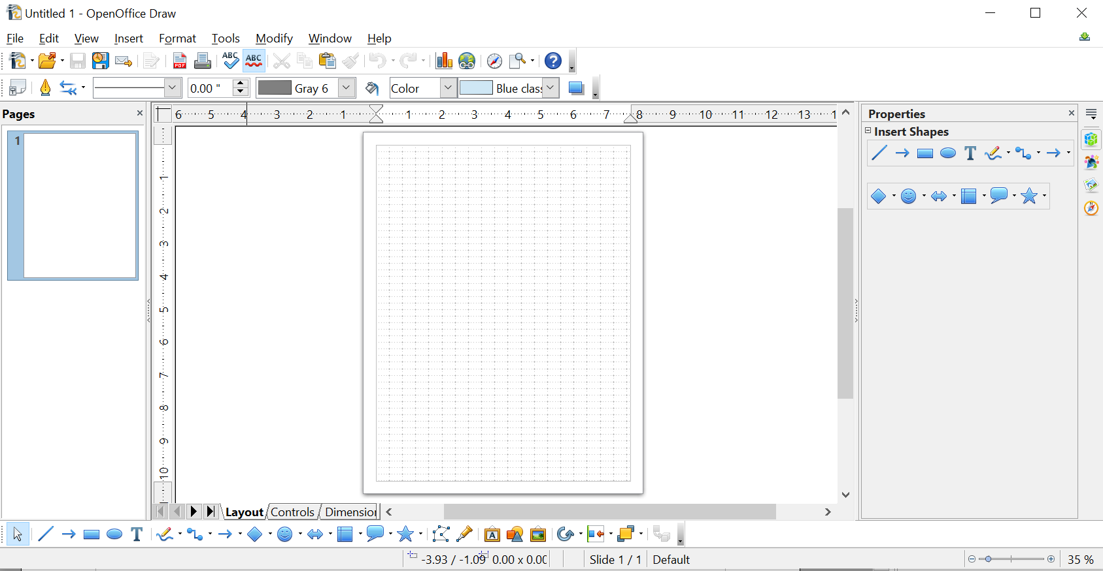

Figure 1: Initial Draw window

Rulers
You should see rulers (bars with numbers) on the upper and left-hand sides of the workspace. If they are not visible, you can enable them by selecting them from the View menu (View > Ruler).
The rulers show the size of a selected object on the page (see the gray double lines, highlighted in Figure 2). When no object is selected, they show the location of the mouse pointer, which helps to position drawing objects more accurately.
You can also use the rulers to manage object handles and guide lines, making it easier to position objects.
The page margins in the drawing area are also represented on the rulers. You can change the margins directly on the rulers by dragging them with the mouse.
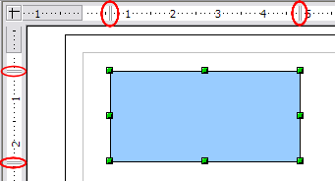Figure 2: Rulers show the size of the selected object
To modify the units of measurement of the rulers (which you can define independently), right-click on the desired ruler, as illustrated for the horizontal ruler in Figure 3.
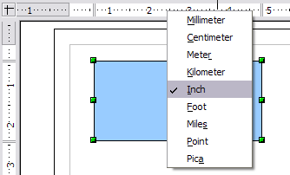Figure 3: Rulers in a drawing

Status Bar
The Status bar is located at the bottom of the Draw window and includes several Draw-specific fields, as identified in Figures 4 and 5.

Figure 4: Left end of Draw status bar

Figure 5: Right end of Draw status bar
The Information field shows the action being performed, or the object type selected.
The Position field shows different information, depending on whether objects are currently selected or not:
- When no object is selected, the left number pair shows the current position (in X,Y Cartesian coordinates) of the mouse cursor.
- While an object is being resized with the mouse, the right number pair shows the size of the object (width and height).
Note | The sizes are given in the current measurement unit (not to be confused with the ruler units). This unit is defined in Tools > Options > OpenOffice Draw > General, where you can also change the scale of the page.
- If an object is selected, the left number pair shows the X, Y coordinates of the upper-left corner, and the right number pair displays the size of the object, as seen in Figure 4. These numbers do not relate to the object itself, but to the selection outline, which is the smallest possible rectangle that can contain the visible part or parts of the object; see also Chapter 3 (Working with Objects and Object Points).
- When an object is selected, a double-click on this field opens the Position and Size dialog, which is described in detail in Chapter 4 (Changing Object Attributes).
In the Indicator field, an asterisk (*) is shown whenever any change is made to the document but not yet saved to disk.
To digitally sign the document, double-click or right-click in the Signature field to open the signature box. Note that a document must be saved at least once before it can be signed. After it is signed, an indicator is present in this field.
The Slide field shows the sequence number for the current drawing page, in addition to the total number of pages that you created so far. This is useful when your drawing has several pages. If you select an object, the field enclosed by parentheses shows the layer in which the object resides within the drawing. In the example of Figure 5, the object is on the Layout layer of Slide 1, and there is a total of one slide so far.
The Page style field shows which template is being used.
The vertical bar in the middle of the Zoom slider represents a zoom factor of 100%. To change the view magnification, drag the Zoom slider, or click on the + and – signs, or right-click on the zoom level percent to pop up a list of magnification values from which to choose. Double-click on the zoom level percent to open the Zoom & View Layout dialog.

Toolbars and the Sidebar
The tools for drawing, positioning, and adjusting the properties of objects are on several toolbars, and many are also available on the Sidebar. Which toolbars you display is a matter of preference and will depend on the particular task and the room available on your screen. Some of the most common tools are briefly described in this section.
You can display or hide the various toolbars as needed. To display or hide a toolbar, click View > Toolbars. On the menu that appears, choose which toolbars you want to display.
You can also select the icons that you wish to appear on the toolbars, as illustrated in Figure 6. To change the visible icons on any toolbar, click the arrow at the right-hand end of that toolbar and choose Visible Buttons from the drop-down menu. Visible icons are indicated by an outline around the icon. Click on icons to hide or show them on the toolbar.

Figure 6: Selection of visible toolbar icons
The view of the Sidebar is toggled with the menu View > Sidebar. The tools in this section are found on the Properties deck, and their content depends on the kind of object that is selected in the drawing area.

Standard Toolbar
The Standard toolbar, shown in Figure 7, is the same for all OpenOffice components and is not described in detail here.
Figure 7: Standard toolbar

Drawing Tools
The Drawing toolbar shown in Figure 8 is the most important toolbar in Draw. It contains all the necessary functions for drawing various geometric and freehand shapes and for organizing them on the page. It is described in detail in Chapter 2 (Drawing Basic Shapes).
Figure 8: Drawing toolbar
Most of the tools on the Drawing toolbar are available on the Sidebar (Figure 9). If no object is selected in the drawing area, these are the only tools visible in the Sidebar.

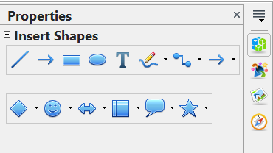Figure 9: The Insert Shapes pane on the Sidebar Properties deck.

Line and Filling Tools
The Line and Filling toolbar, like that in Figure 10, lets you modify the main properties of a drawing object: the icons and pull-down lists vary, according to the type of object selected. For example, to change the thickness of a line with the spinner, select the line, hover the mouse over the spinner, and click the up or down arrow to achieve the desired thickness.
Figure 10: Line and Filling toolbar
In the example above, the available functions enable you to change the color, style, and width of the line drawn, as well as the fill color, style, and other properties of a shape. The object must first be selected with a mouse click.
When a line or shape is selected, the Sidebar Area and Line panes display the tools shown in Figure 11. In addition to the tools shown on the Drawing toolbar, there are tools controlling the transparency of the area and the corner and cap styles of lines.

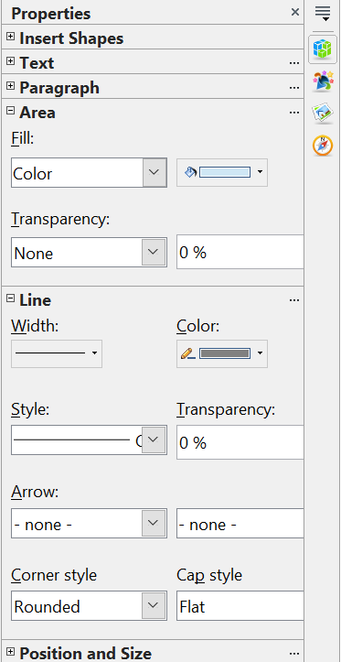Figure 11: The Area and Line panes of the Sidebar

Text Formatting Toolbar
When text is selected, the Line and Filling toolbar changes to the Text Formatting toolbar, shown in Figure 12, which is very similar to the Formatting toolbar in Writer. A more detailed explanation of the buttons on this toolbar can be found in Chapter 4 (Changing Object Attributes).

Figure 12: Text Formatting toolbar
The same tools are available on the Text and Paragraph panes of the Sidebar, as shown in Figure 13, with some additional options, such as adjusting the spacing above and below paragraphs.

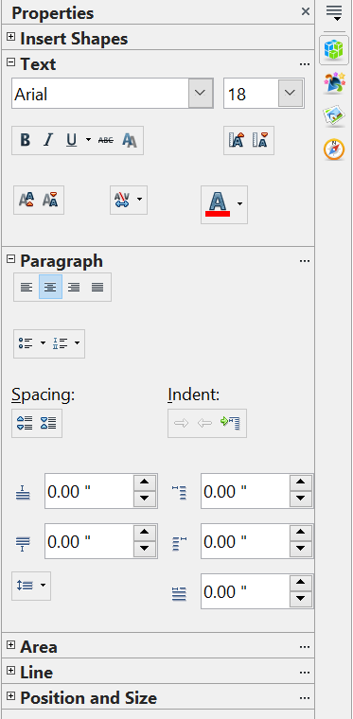Figure 13: The Text and Paragraph panes of the Sidebar

Color Bar
To display the Color bar, use View > Toolbars > Color Bar. The toolbar then appears at the bottom of the workspace, displaying the current color palette.
Figure 14: Color bar
This toolbar, as illustrated in Figure 14, lets you rapidly choose the color of the various objects (lines, areas, and 3D effects) in your drawing. The first box in the panel corresponds to transparency, that is, no color. The same color choices can be made in the Sidebar using the color drop-down lists in the Area and Line panes, as shown in Figure 11.

Choosing a color palette
You can access several specialized color palettes in Draw and customize individual colors to your own taste. This is done using the Area dialog, which can be opened by choosing Format > Area, clicking the pouring can icon on the Line and Filling toolbar (Figure 10), or clicking the three dots at the top right of the Sidebar's Area pane (Figure 11).
On the Area dialog, choose the Colors tab (Figure 15).
To load another palette, click on the Load Color List button (circled). The file selector dialog asks you to choose one of the standard OpenOffice palettes (files bearing the file extension *.soc). For example, web.soc is a color palette that is particularly effective for creating drawings that appear on Web pages. These colors will display correctly on workstations with screens capable of at least 256 colors.
A more detailed description of color palettes and their options can be found in Chapter 8 (Tips and Tricks).
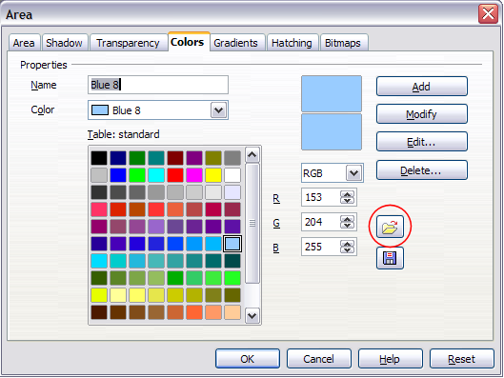
Figure 15. Changing the color palette

Options Toolbar
The Options toolbar, shown in Figure 16, lets you activate or deactivate various drawing aids. The Options Bar is not one of the toolbars displayed by default. To display it, select View > Toolbars > Options. These tools are not available on the Sidebar.
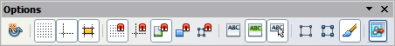
Figure 16: Options toolbar
The options are described in the table below and in greater detail in other chapters of the Draw Guide.
Table 1: Functions on the Options toolbar
Icon | Function
 | Rotation mode after clicking object
 | Display (or hide) the grid
 | Display (or hide) the guides
 | Display (or hide) guides when moving
 | Snap to grid
 | Snap to guides
 | Snap to page margins
 | Snap to object borders
 | Snap to object points
 | Allow quick editing
 | Select text area only
 | Double-click to edit text
 | Simple handles
 | Large handles
 | Modify object with attributes
 | Exit all groups

Drawing Grid and Guides
Draw offers a grid as a drawing aid. The grid can be turned on or off by clicking on the Grid icon on the Options toolbar. The points of the grid displayed on the screen are not shown on the printed drawing. The color, spacing, and resolution of the grid points can be individually chosen for each axis. This is described in more detail in Chapter 8 (in the section titled “Configuring the grid”).
Guides are special “helper lines” that can be turned on or off by clicking on the Guides icon on the Options toolbar. Draw offers a “Snap” function, with which you can place drawings exactly on these guides or on a grid point, a page margin, or a border or point of another object. All snap functions are described in detail in Chapter 8 (Tips and Tricks).
Showing the position of the object while moving it makes positioning the object much easier. If the Guides function is active, pairs of vertical and horizontal lines enclosing the object are shown while moving the object. These lines extend to the edges of the drawing area. This function is also described in detail in Chapter 8.

Floating and Moving Toolbars
Many toolbar icons are marked with a small arrow. The arrow indicates that this icon has additional tools. Click the arrow to display the full set of tools (see Figure 17). You can “tear off” this tool set, making it a floating toolbar. Click the area at the bottom of the toolset, drag it across the screen to a location you want, and then release the mouse button. The icons in the Insert Shapes pane of the Sidebar have the same toolsets, and they can also be torn off
To dock a floating toolbar to the top or side of the Draw workspace, Ctrl+click on the title of the toolbar. To float a docked toolbar, click its handle and drag it off the side of the workspace (see Figure 18). The floating-toolbar capability is common to all components of OpenOffice.

Figure 17: An arrow next to an icon indicates additional functions
Note | When a toolset is made into a floating toolbar, the icon on the existing toolbar remains in the toolbar, and always shows the last command you used. This means that the icon you see on your screen may differ from the icon shown in this Guide.
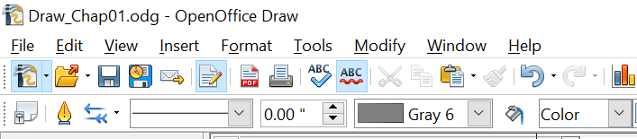

Figure 18: Two toolbars with highlighted handles
Tip | When you double-click on an icon on a floating toolbar, the command corresponding to that icon will run. You can then repeat this action as often as you like. To exit this mode, press the Esc key or click on another icon (for example, ). This may not work for every icon on every toolbar.

Customizing Toolbars
You can customize toolbars in several ways. To show or hide icons defined for a toolbar, see Figure 6 on page 9.
To add functions to a toolbar, move tools between toolbars, or create new toolbars, choose View > Toolbars > Customize, select the Toolbars tab (Figure 19) and the toolbar you want to change, and then select the desired buttons for that toolbar.
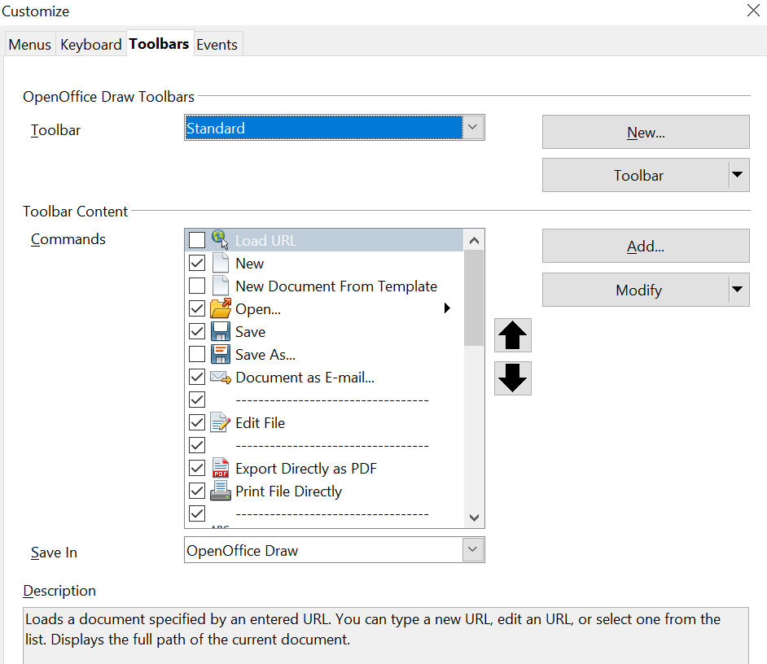

Figure 19: Customizing a toolbar
Each toolbar has a different list of functions. For details, see Chapter 14 (Customizing OpenOffice) in the Getting Started guide. That chapter also describes how to customize menus.

Quick Printing
Click the Print File Directly icon to send the entire document to the default printer defined for your computer.
Note | You can change the action of the Print File Directly icon to send the document to the printer defined for the document instead of the default printer for the computer. Go to Tools > Options > Load/Save > General and select the Load printer settings with the document option.

Controlling Printing
For more control over printing, use the Print dialog (File > Print or Ctrl+P).
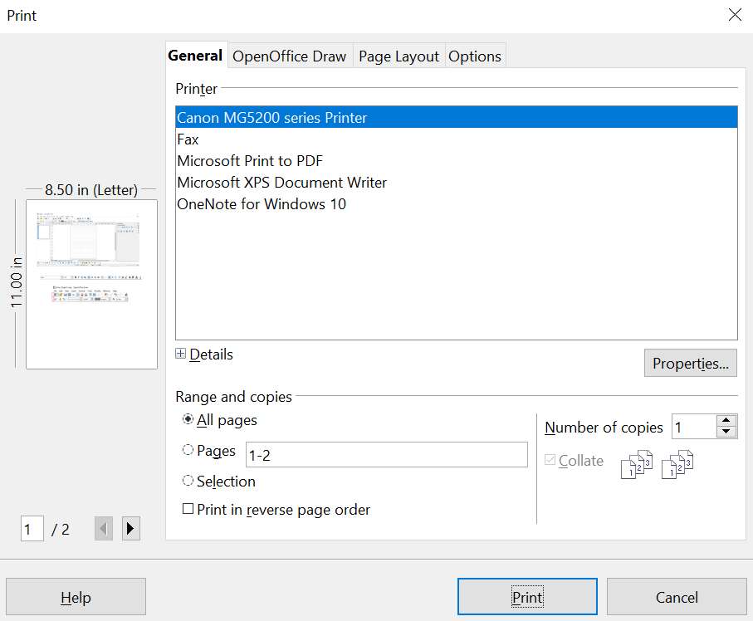

Figure 20. The Print dialog
Note | The options selected on the Print dialog apply to the current printing of the current document only.  To specify default printing settings for OpenOffice, go to Tools > Options > OpenOffice – Print and Tools > Options > OpenOffice Draw – Print.
The Print dialog has four tabs, from which you can choose a range of options, as described in the following sections.

Selecting General Printing Options
On the General tab of the Print dialog, you can choose:
- The printer (from the available printers)
- Which pages to print, the number of copies to print, and whether to collate multiple copies (Range and copies section)
Select the Properties button to display a dialog where you can choose portrait or landscape orientation, which paper tray to use, and the paper size to print on.
On the Options tab of the Print dialog (Figure 21), you can select several other less frequently used options for printing.
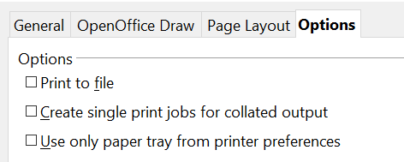

Figure 21: General print options

Printing Multiple Pages on a Single Sheet of Paper
You can print multiple pages of a document on one sheet of paper. To do this:
- In the Print dialog, select the Page Layout tab.
- In the Layout section, select from the drop-down list the number of pages to print per sheet. The preview panel, on the left of the Print dialog, shows how the printed document will look.
When printing more than two pages per sheet, you can choose the order in which they are printed across and down the paper. The two images immediately below show the difference.
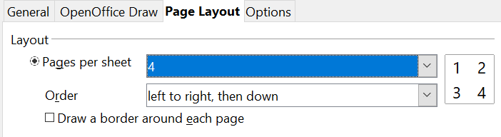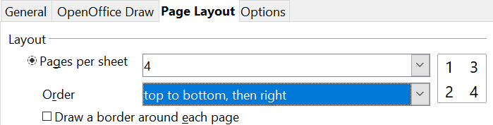
- In the Page sides section, select whether to print all pages or only some pages.
- Click the Print button.

Selecting Pages to Print
In addition to printing a full document, you can choose to print individual pages, ranges of pages, or a selection of a document.
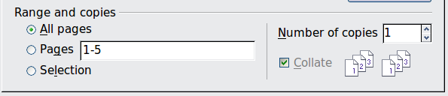
To print an individual page:
- Choose File > Print from the menu bar.
- Select the page to print.
  - In the Ranges and copies section of the Print dialog, select the Pages option.
  - Enter the number of the page to print.
- Click the Print button.
To print a range of pages:
- Choose File > Print from the menu bar.
- Select the pages to print.
  - In the Ranges and copies section of the Print dialog, select the Pages option.
  - Enter the number of the pages to print (for example, 1-4 or 1,3,7,11), or any combination of the two, for example: 1-4,5-9,10.
- Click the Print button.
To print a selection of a page, or a selection from multiple pages:
- In the document, select the section of the page to print.
- Choose File > Print from the menu bar.
- Choose the Selection option in the Ranges and copies section of the Print dialog.
- Click the Print button.

Printing a Brochure
In Writer, Impress, and Draw, you can print a document with two pages on each side of a sheet of paper, arranged so that when the printed pages are folded in half, the pages are in the correct order to form a booklet or brochure.
Tip | Plan your document so that it looks good when printed at half-size; choose appropriate margins, font sizes, and so on. You may need to experiment.
To print a brochure on a single-sided printer:
- Choose File > Print.
- In the Print dialog, click Properties.
- Check that the printer is set to the same orientation (portrait or landscape) as specified in the page setup for your document. Usually, the orientation does not matter, but it does for brochures. Click OK to return to the Print dialog.
- Select the Page layout tab in the Print dialog.
- Select the Brochure option.
- In the Page sides section, select Back sides / left pages option from the Include drop-down list.
- Click the Print button.
- Remove the printed pages from the printer, turn them over, and reinsert them into the printer in the correct orientation to print on the blank side. You may need to experiment a bit to find the correct arrangement for your printer.
- On the Print dialog, in the Page sides section, select Front sides / right pages option from the Include drop-down box.
- Click the Print button.
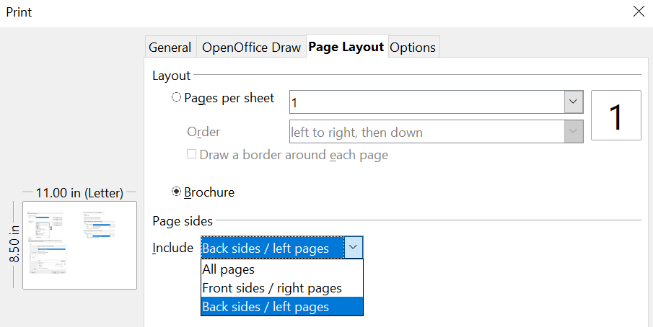
Tip | If your printer can print double-sided automatically, choose All pages.

Printing in Black and White (on a Color Printer)
You may wish to print documents in black and white on a color printer. Several choices are available. Please note that some color printers may print in color regardless of the settings you choose.
To change the printer settings to print in black and white or grayscale:
- Choose File > Print to open the Print dialog.
- Click Properties to open the Properties dialog for the printer. The available choices vary from one printer to another, but you should find options for the Color settings. See your printer’s help or user manual for more information.
- The choices for color might include black and white or grayscale. Choose the required setting.
- Click OK to confirm your choice and return to the Print dialog.
- Click the Print button to print the document.
Tip | Grayscale is best if you have any graphics in the document.
To change the OpenOffice settings to print all color text and graphics as grayscale:
- Choose Tools > Options > OpenOffice > Print.
- Select the Convert colors to grayscale option. Click OK to save the change.
- Open the Print dialog (File > Print).
- Click the Print button to print the document.
To change the Draw settings to print in black and white or grayscale:
- Choose Tools > Options > OpenOffice Draw > Print.
- Under Quality, select either Black & white or Grayscale. Click OK to save the change.
- Open the Print dialog (File > Print).
- Click the Print button to print the document.

Exporting to PDF
OpenOffice can export documents to PDF (Portable Document Format). This industry-standard file format is ideal for sharing the file with others to view using Adobe Reader or other PDF viewers.
The process and dialogs are the same for Writer, Calc, Impress, and Draw, with a few minor differences mentioned in this section.

Quick Export to PDF
Click the Export Directly as PDF icon to export the entire document using your default PDF settings. You are asked to enter the file name and location for the PDF file, but you cannot select a page range, the image compression, or other options.

Controlling PDF Content and Quality
For more control over the content and quality of the resulting PDF, use File > Export as PDF. The PDF Options dialog opens. This dialog has five pages (General, Initial View, User Interface, Links, and Security). Select the appropriate settings, and then click Export. In the following dialog, enter the location and file name of the PDF to be created, and click Save to export the file. See Chapter 10 (Printing, Exporting, Emailing) in the Getting Started book for details.

Exporting to Other Formats
OpenOffice uses the term export for some file operations that involve changing the file type. If you cannot find what you want under File > Save As, also look under File > Export.
OpenOffice can export files to XHTML. Additionally, Draw can export to a variety of image formats.
To export to one of these formats, choose File > Export. On the Export dialog, specify a file name for the exported document, select the required format in the File format list, and click the Export button.
See Chapter 6 (Editing Pictures) for more about exporting graphics.
Note | The content of the exported file will depend on the element(s) selected on the page. No selection results in the entire image being exported. For most export formats, only the image on the current page will be exported.

Exporting Draw Documents as Web Pages
To export a multi-page Draw document to a series of web pages, choose File > Export and select HTML Document as the file type. The HTML Export wizard opens. Follow the prompts to create the web pages. If you wish, the wizard can generate a navigation aid to help in moving from page to page.

E-mailing Documents
OpenOffice provides several options for quickly and easily sending documents as e-mail attachments in one of three formats: OpenDocument (OpenOffice’s default format), Microsoft Office formats, or PDF.
Note | Documents can only be sent from the OpenOffice menu if a mail profile has been set up and if your computer has an email program. If you use a web-based email application, you must attach the Draw document manually to a message.
To send the current document in OpenDocument format:
- Choose File > Send > Document as E-mail. OpenOffice opens your default e-mail program. The document is attached.
- In your e-mail program, enter the recipient, subject, and any text you want to add, then send the e-mail.
If you choose E-mail as PDF, OpenOffice first creates a PDF using your default PDF settings (as when using the Export Directly as PDF toolbar button) and then opens your email program with the PDF file attached.
You can email a document to several recipients. For details, see Chapter 10 (Printing, Exporting, Emailing) in the Getting Started book.

