Apache OpenOffice
Version 4.1
Draw Guide

AOO Documentation Team

Chapter 3
Working with Objects and Object Points

Copyright
This document is Copyright © 2025 by The Apache Software Foundation. You may distribute it and/or modify it under the terms of the Creative Commons Attribution License, version 3.0 or later (https://creativecommons.org/licenses/by/3.0/).
Apache, Apache OpenOffice, and OpenOffice.org are trademarks of the Apache Software Foundation. Used with permission.
Acknowledgments
This book is updated from a previous version by the OOoAuthors team. The AOO Documentation Team appreciates the many contributions of Michael Scarborough and Michele Petrovsky.
Publication date and software version
Published December 20, 2025. Based on Apache OpenOffice 4.1.
Note for Mac Users
Some keystrokes and menu items differ on a Mac from those used in Windows and Linux. The table below gives some common substitutions for the instructions in this chapter. For a more detailed list, see the application Help.

Windows/Linux | Mac equivalent | Effect
Tools > Options menu selection | OpenOffice > Preferences | Access setup options
Right-click | Control+click | Open context menu
Ctrl (Control) | z (Command) | Used with other keys
F5 | Shift+z+F5 | Open the Navigator
F11 | z+T | Open Styles & Formatting window

Contents
Chapter 3
Working with Objects and Object Points 1
Introduction 4
Selection Modes 4
Changing the Selection Mode 5
Selecting Objects 5
Selecting Hidden Objects 5
Moving and Dynamically Adjusting an Object’s Size 6
Dynamic Movement of Objects 7
Dynamic Size Modification of Objects 7
Dynamic Size Modification of Objects with the Help of the Status Bar 8
Modifying an Arc 8
Rotating and Shearing an Object Using the Mouse 9
Rotating 9
Changing Inclination or Perspective 10
Setting Size and Position Exactly 11
Position and Size 11
Rotating Objects 12
Slant and Corner Radius 12
Editing Object Points 13
Another Way to Change the Form of Basic Shapes 13
How Curves Work 14
The Edit Points Toolbar 15
The Three Kinds of Tangent 15
Examples 16

Introduction
This chapter examines tools and functions with which you can modify existing drawings. All the functions apply to a selected object or group of objects, which can be distinguished by small colored squares or circles located around it. These points are called handles.
The handles form a rectangular frame that is just big enough to contain the object. When several objects are selected, the frame around them corresponds to the smallest rectangle that can contain all of them. This frame is called the selection rectangle.
If the Options bar is displayed (select View > Toolbars > Options to enable it, if it is not displayed), you can change the size of the handles using two buttons: Simple Handles shows the handles as flat squares; otherwise, they are shown in 3D. Large Handles increases the size of the handles. You can combine the two effects. Figure 1 below shows the location of the handles and other buttons.
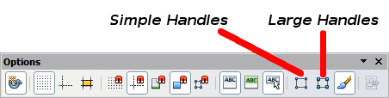
Figure 1: Location of handles on the Options toolbar

Selection Modes
There are three selection modes:
- Moving and changing size
- Editing
- Rotating points
To set the default mode (1 or 2) for selecting objects, click on the Points button on the Drawing toolbar.
In standard mode (when you begin a new drawing), the Points button is not active, and the default mode is for selections to be moved or changed in size; these selections are indicated by small green squares. | 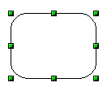
When the Points button is active, the default mode is for selections to be edited; these selections are indicated by blue squares. Some objects will have one or more extra handles, which are larger or colored differently. This is explained in more detail in “Editing Object Points” on page 13. | 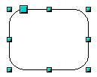
Selections for rotating objects are indicated by small red circles and a symbol representing the center of rotation. To choose these selections, click on the Effects drop-down button from the Drawing toolbar and after that on the object. | 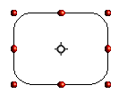

Changing the Selection Mode
To go from one mode to another, you can do one of the following:
- Choose the Points button from the Drawing toolbar to switch from simple selection mode to Points mode. You can also use the keyboard shortcut F8 (Points). See “Editing Object Points” on page 13 for details on using Points mode.
- Choose the Effects drop-down button from the Drawing Toolbar to activate the Rotation mode for a selected object. To exit Rotation mode, click on the Selection icon .
- If you often work in Rotation mode, you can choose the Rotation Mode after Clicking Object button from the Options bar and cycle through normal and rotation modes just by clicking on the object. This can be more convenient than repeatedly clicking the selected object, then clicking the Rotate button from the Drawing toolbar.

Selecting Objects

Direct Selection
The easiest way to select an object is to click directly on it. For objects that are not filled, click on the object’s outline to select it. One click selects; a second click deselects. To select or deselect more than one object, hold the shift button down while clicking.

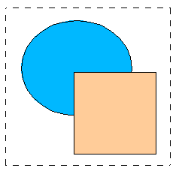
Selection by Framing
You can also select several objects simultaneously by using the mouse to drag a large rectangle around the objects with the Select button, as shown. For this to work, the icon on the Drawing toolbar must be active.
Only objects that lie entirely within the rectangle will be selected.

Selecting Hidden Objects
Even if objects are located behind others and not visible, they can still be selected. Press and hold the Alt key, then click where the object is located. If there are several overlapping objects, hold down the Alt key and click until you reach the object you want. To cycle through the objects in reverse order, hold down the Alt+Shift keys and click. The number and type of selected objects are shown at the left of the status bar; this can help you select the correct object.
Note | This method generally works in Windows, but on a Linux system, it usually does not. If the Alt key on your system does not operate as described above, use the Tab key method described below.
To select an object that is covered by another object using the keyboard, use the Tab key to cycle through the objects, stopping at the object you wish to select. To cycle through the objects in reverse order, press Shift+Tab. This is a very quick way to reach the object you want, but it may not be practical if you have a large number of objects in your drawing.
When you click on the selected object, its outline will appear briefly through the objects covering it.
In the illustration to the right, the square located beneath the circle was selected in this way (the circle has been made semi-transparent to show the square). | 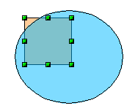

Arranging Objects
In a complex drawing, several objects may be stacked on top of one another. To rearrange the stacking order (move an object to the front or to the back of the stack), select the object, click Modify > Arrange, and choose Bring Forward or Send Backward. Or right-click the object, choose Arrange from the context menu, then choose Bring Forward or Send Backward.
These options are also available from the Arrange tear-off toolbar accessible from the icon on the Drawing toolbar. A keyboard shortcut is Shift+Ctrl+plus sign to bring an object to the top, and Shift+Ctrl+minus sign to send an object to the bottom.
Note, however, that an object located on the Controls layer always lies above all other objects.

Moving and Dynamically Adjusting an Object’s Size
There are several ways to move or resize an object. The dynamic method described here, and illustrated in Figure 2 below, uses the mouse.
When you dynamically change an object, remember to check the left-hand area of the status bar at the bottom of the Draw window. This area shows detailed information about the ongoing manipulation.
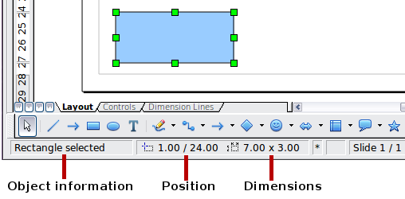
Figure 2: Left end of status bar during dynamic adjustment
For example, when resizing an object, the object information fields show the selected object, its current position in X/Y coordinates, and its dimensions (width x height). The information changes as the mouse is moved. The units of measurement are those selected under Tools > Options > OpenOffice Draw > General.

Dynamic Movement of Objects
To move an object, select it and then click within the object’s border and hold down the left mouse button while dragging the mouse. During movement, the shape of the object appears as a transparent copy or a dashed frame to help with repositioning. The copy of the object will not appear if you click and hold before moving it. Click and immediately begin moving to see the effect | 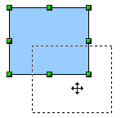
To drop the object at its new location, release the mouse button. The new position appears immediately in the Status Bar.

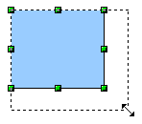
Dynamic Size Modification of Objects
To change the size of a selected object (or a group of selected objects) with the mouse, move one of the handles located around the selection. As shown in the illustration, the outline of the resulting new object appears as a dotted line while the mouse button is pressed.
The results depend on which handle you use. To resize an object along one axis, use the appropriate side handle. To resize along both axes, use a corner handle. The new size appears immediately in the status bar.
Note | If you press the Shift key while resizing an object, the change in size will be carried out symmetrically with respect to the two axes, so that the aspect ratio of the object remains the same.
Caution   | This is the default behavior of the Shift key. If you have used Tools > Options > OpenOffice Draw > Grid to set Snap position to When creating or moving objects, the action of the Shift key is the opposite: the aspect ratio will be preserved unless the Shift key is pressed.

Dynamic Size Modification of Objects with the Help of the Status Bar
If you select an object and modify it using the mouse, the changes are immediately reflected in the information field of the status bar. With geometric shapes (such as basic shapes, symbol shapes, block arrows), the only information shown in the status bar is that the shape is being resized, as shown in the top-left image in Figure 3. With geometric elements (rectangles, circles, and so on), the changes to the attributes of the element (either relative or absolute) are also shown, as in the top-right image in Figure 3.
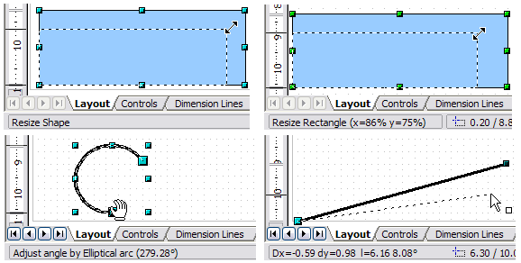Figure 3: The Information field during dynamic size modification of objects
In the case of a rectangle, the new size is shown as a percentage of the original x and y dimensions. For a line, much more information is given: the absolute change in x and y coordinates of the end point being moved, together with the current length and bearing of the modified line. These are updated dynamically as the endpoint is moved (see Figure 3).
This is the only place where the exact start and end angles of an arc or the length and bearing of a sloping line are shown. This information enables you to size the object with considerable accuracy.

Modifying an Arc
The beginning and end points of an arc can be modified. Select the arc and click on the Points icon on the Drawing toolbar to enter the Edit points mode (described later in this chapter). In this mode, the handles on the selection frame change—two larger blue handles appear at the beginning and end points of the arc. When the mouse hovers over one of these points, the cursor will change to a hand, as illustrated in Figure 4.
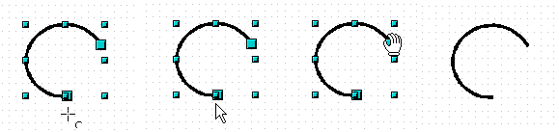Figure 4: Editing an arc
If you click and hold the mouse button when the hand cursor appears, moving the mouse will change the location of the start or end point of the arc. The actual coordinates are shown in the Status Bar (see the lower-left graphic in Figure 3).

Rotating and Shearing an Object Using the Mouse
Use the red rotation handles to either rotate an object around an axis or slant or shear the object.

Rotating
To rotate an object (or a group of objects), drag a red corner handle point of the selection with the mouse. The mouse cursor takes the shape of an arc of a circle with an arrow at each end. A dotted outline of the object being rotated appears, and the current angle of rotation is dynamically shown in the status bar.
Note | Rotation works in a slightly different way for 3D objects because the rotation occurs in 3D space, not in a single plane. See Chapter 7 (Working with 3D Objects) regarding rotation when the Edit Points mode is active.
Rotations are made about an axis, which is displayed as a small symbol like that shown in Figure 5. This is normally located at the midpoint of the object, but you can move the axis of rotation with the mouse to any location you like, even outside the object.
If you hold down the Shift key during the rotation, the operation will be carried out in increments of 15° (subject to whether Snap position is set to When creating or moving objects under Tools > Options > OpenOffice Draw > Grid).
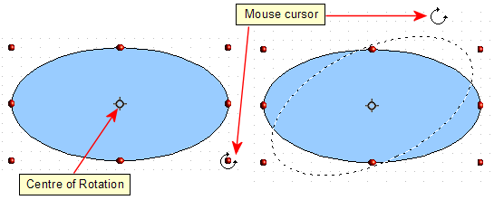Figure 5: Rotating an object

Changing Inclination or Perspective
To slant or shear objects, use the red handles located at the midpoint of an edge of the selected objects. The mouse pointer changes to a bi-directional arrow when the pointer hovers over one of these midpoint handles.
The slant axis is the point directly opposite the midpoint handle, which is used for shearing the object. This point stays fixed in location; the other sides and edges move in relation to it as the mouse is dragged (make sure that the icon is showing before dragging).
Figure 6 shows how the vertices move in relation to each other during the shearing process. The circles represent the path of the vertices. The inclination axis is the bottom vertex of the triangle (the slanting handle used is the midpoint of the upper enclosing frame). All points on the figure will move through the same angle, irrespective of the final shape. The actual angle is shown in the status bar.
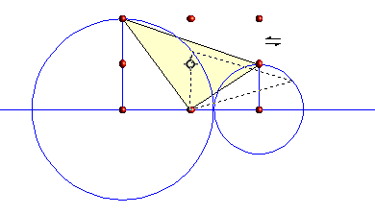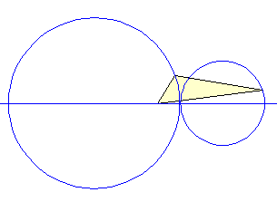
Figure 6: Shearing an object
Note | The triangle in Figure 6 was produced with the (unfilled) polygon tool. Then Close Object was selected from the context menu.
This tool can be used to produce perspective drawings. The series of pictures in Figure 7 shows the method of constructing a box in perspective. The idea is to initially draw the rectangles for the sides of the box to their true size, as if the box had been cut along its seams and flattened. Then, vertically shear the small rectangle that defines the side of the box, going back into the image. Finally, horizontally shear the rectangle that will be the lid of the box until its edge meets the edge of the side. The slant angles displayed in the status bar while each rectangle is moving will sum to 90 when the edges meet.
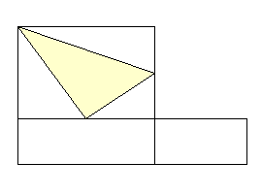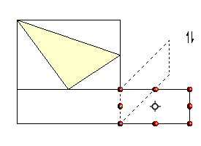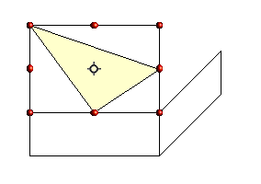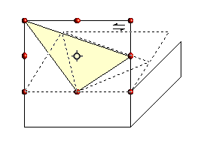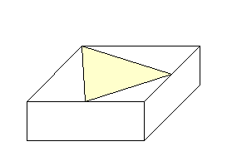
Figure 7: Perspective production of a cuboid
As with rotation, you can make the slanting occur in steps of 15° by pressing the Shift key while moving the handle.

Setting Size and Position Exactly
You can, of course, position and resize objects with the mouse, but this isn't an exact method. If you need precise positioning of objects, use the Position and Size pane in the Properties deck of the Sidebar, or choose Format > Position and Size from the menu bar, or right-click the object and select Position and Size from the context menu, or press F4.

Position and Size
Open the Position and Size dialog (see Figure 8) and click on the first tab to set the appropriate values.
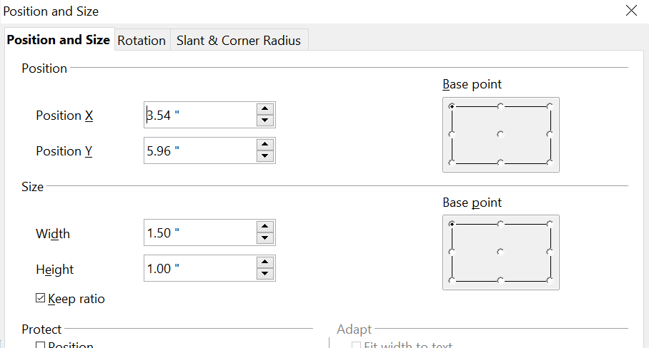

Figure 8: Position and size of an object
Position is defined as an X, Y coordinate relative to a fixed point (the base point), typically located at the upper left of the drawing area. If desired, you can temporarily change this base point to make positioning or dimensioning simpler (click on the radio button corresponding to the location of the base point in either of the two selection windows on the right side of the dialog—upper for positioning or lower for dimensioning). The possible base point positions correspond to the handles on the selection frame plus a central point. The change in position lasts only as long as the dialog is open. When you close this dialog, Draw resets the base point to the standard position.
Tip | The Keep ratio checkbox is very useful. Click it to keep the ratio of width to height fixed while you change the size of an object.
Both the size and the position can be protected so that they cannot be inadvertently changed. Check the appropriate boxes to achieve this.
Tip | If you have trouble moving an object, check to see if its position is protected. The Position and Size tab of the Position and Size dialog has check boxes for protecting an object.

Rotating Objects
Click on the Rotation tab of the Position and Size dialog (see Figure 9). Here you can define the rotation angle, as well as the location of the pivot point.
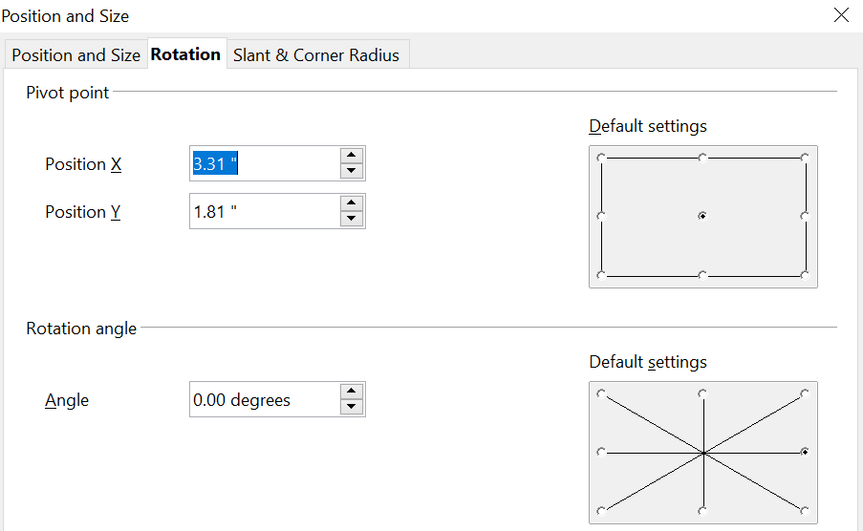
Figure 9: Rotating an object

Slant and Corner Radius
The slant angle (inclination or shearing) and corner radius can be set in this dialog (Figure 10).
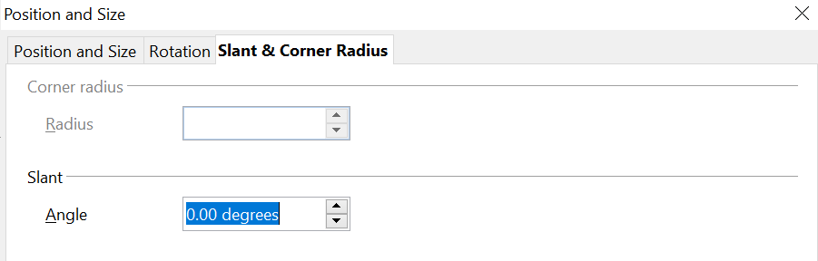
Figure 10: Setting rounded corners and slant angle
Corner radius
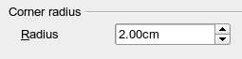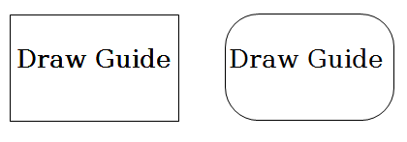

Figure 11: Example of setting rounded corners
You can use this dialog to round the corners of the usual Draw objects—text boxes, legends, rectangles, and squares, as shown in Figure 11. The same effect can be achieved when you are in the points mode (click the Points icon on the Drawing toolbar), by dragging the large handle with the mouse. The larger the value for the corner radius, the rounder the object becomes.
Slant
You can shear shapes to give the appearance of perspective. Enter the slant angle in the box marked Slant Angle.
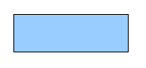 | 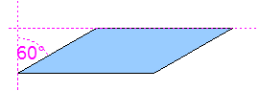 | 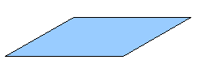
Figure 12: Example of setting the slant angle

Editing Object Points
For polygons and Bézier curves, Draw offers a complete set of tools that let you accurately edit the contour of an object. To edit other objects in the same way, you must first convert them into curves. To do this, select the object, then right-click and choose Convert > To Curve or choose Modify > Convert > To Curve from the menu bar.
You can also convert the shapes to a polygon (Convert > To Polygon). With polygons, the edge points are always connected by straight lines, not curves. Some of the techniques described work equally with polygons as with curves.

Another Way to Change the Form of Basic Shapes
Many shapes can be directly edited without having to convert them to curves first. You can recognize these objects by the presence of one or more circular yellow handles, as shown in Figure 13.
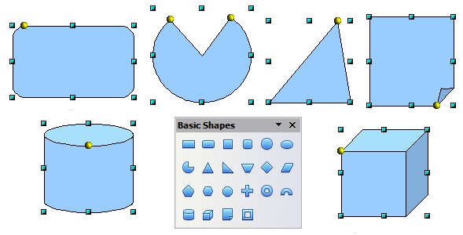
Figure 13: Some basic shapes with yellow “handles”
The mouse pointer changes shape when hovered over a yellow handle. If you drag one of these handles, you can modify the shape of the object; the type of change is dependent on the shape itself. For example, you can round the corners of a rectangle or square, change the angles of an arc or ellipse, or alter the control points of a circular or elliptical segment.

How Curves Work
The editing of curves depends on the mathematics of Bézier curves. The complete study of such curves exceeds the scope of this guide, and only the basics are covered here. Chapter 10 (Advanced Draw Techniques) provides more information on drawing and manipulating Bézier curves.
The editing of a Bézier curve consists, in principle, of moving points or tangents passing through these points. Each tangent has two control points—one at each end—and a junction point where it meets the curve. The relative angle and distance between the control points determine the shape of the curve. Figure 14 shows several variations that start from a basic circle and change only one point on the circle.
You can create many different shapes by moving either the junction point itself or one or both of the round handle points at either end of the tangent.
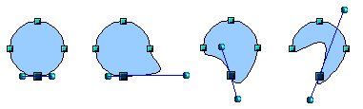
Figure 14: Creating different shapes by changing the tangent
Draw offers even more possibilities with the functions on the Bézier curve Edit Points toolbar.

The Edit Points Toolbar
When you work in Edit Points mode, use the Edit Points toolbar, shown in Figure 15. To activate this toolbar, choose View > Toolbars > Edit Points. It will then appear whenever you select a curve and the Edit Points icon on the Drawing toolbar is active.
On this toolbar, icons may be active or inactive depending on the selected object and object point. With the Convert to Curve icon, you can determine for individual points whether their connection will be made with straight lines or with curves.
Icons for tangents are only activated with curves. An object that contains no curves is treated as a polygon.
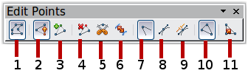
1 Points 5 Split Curve 9 Symmetric Transition
2 Move Points 6 Convert to Curve 10 Close Bézier
3 Insert Points 7 Corner Point 11 Eliminate Points
4 Delete Points 8 Smooth Transition
Figure 15: Edit Points toolbar

The Three Kinds of Tangent
Three buttons in the Edit Points Toolbar let you select the type of tangent and convert from one type to another. Only one of these buttons can be active at any given time. Their use is described in the following chapter.
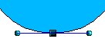Figure 16: Symmetric tangent | Choose the Symmetric Transition button to work with a symmetrical tangent (Figure 16). Any movement of one or the other of the handles is carried over symmetrically to the other handle.
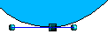Figure 17: Asymmetric tangent | Choose the Smooth Transition button to separately adjust the lengths of the two parts of a tangent, making the curve flatter or steeper. In Figure 17, the curve is flatter on the longest side of the tangent. The tangent remains as a single straight line. This kind of tangent is known as a smooth junction.
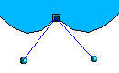Figure 18: Inflection point | It is also possible to separate both sides of the tangent from the curve. In this case, the central point is known as the inflection point. Using this technique, you can draw spikes and troughs in objects. Choose the Corner Point button to create an inflection point like that in Figure 18 around the selected point.

Examples
The other buttons in the Edit Points Toolbar are described here in relation to working examples. The following examples start from a filled circle. As mentioned earlier, in order to use Edit Points mode, you first need to convert the object to a curve.
You will notice that after the conversion, the handles located in the corners of the rectangle have disappeared. This behavior is normal, since handles used in the Edit Points mode are located along the outline or trace of the drawn object.
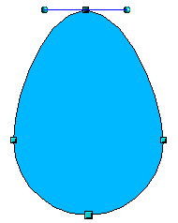  Figure 19: Moving a junction point | Move Points is the default mode when editing points. If it has not been activated, click on its button. When this mode is active, the mouse pointer has the following shape when it is hovered over an edit point:  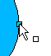  Movement of a point is one of the easiest manipulations to do. Figure 19 illustrates how you can draw an egg very easily by starting from a circle and dragging the top point upwards.
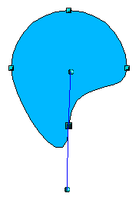  Figure 20: Rotating a tangent | To change the direction or location of the tangents, as shown in Figure 20, move the circular handles at each end. The mouse pointer then looks like this:  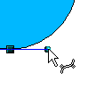
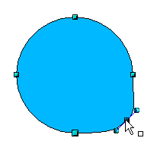Figure 21: Adding an edit point to a curve | Use the Points button to add an extra edit point like that in Figure 21to an existing curve. Click on the curve at the spot where you want to insert a point and then move the mouse slightly in any direction while holding down the button.  The tangent attributes associated with the new point depend on the buttons that are selected on the toolbar.
  Caution | If you just click, the new point will not be added.
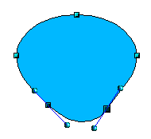 | The Delete Points button has the opposite effect: it subtracts one or more points from the curve, as shown in Figure 22. The resulting curve stretches itself automatically around the remaining points after subtraction.  Select one or more points to delete. You can select several points by holding down the Shift key (➊).  When you have selected the points you want to delete, click the Delete Points button. The selected points disappear from the curve, which then reforms around the remaining points (➋).  You can also delete the selected points by pressing the Del key on the keyboard.
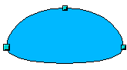

Figure 22: Deleting points from a curve
➊
➋
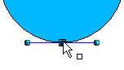  ➊  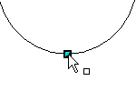  ➋  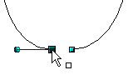  Figure 23: Cutting a curve  3 | Use the Split Curve button to split or cut a curve at the location of the selected handle, like we did in Figure 23. If the object is filled, it will be emptied because the curve that represents the edge is no longer closed.  Check that you have selected the correct handle (➊), click the Split Curve button (➋), and notice that the object is no longer filled. You can then check, by moving the point, that the curve has indeed been separated (➌).  If you have an open curve, the start point of the curve is larger than the others.
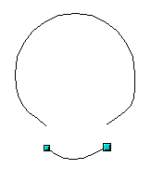Figure 24: Moving a segment | You can also separate a curve at several points simultaneously. Keep the Shift key pressed down and select all of the points at which the cut should occur.  Drag and drop segments with the mouse to move them from the original curve, as was done in Figure 24.
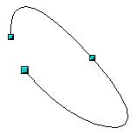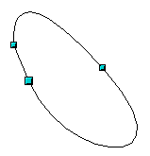Figure 25: Closing an open curve | To close an existing curve, select an open curve and click on the Close Bézier button .  The opening point is identified by a slightly larger handle (Figure 25).

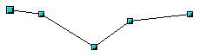1.  Select object and set Edit points mode | The Eliminate Points button button only functions with lines with multiple points.  If the button is active, click on a point, hold the mouse button down, and move the mouse to draw virtual straight lines between the neighboring left and right points.  Release the mouse button when the two lines have more or less coalesced into one straight line. The point is deleted, and the new line replaces the previous two lines, eliminating one point.  Note that this only works when the angle between the two lines (shown dashed in Figure 26) is less than a certain amount.  In the Tools > Options > OpenOffice Draw > Grid window, there are options for snap settings relating to editing points when rotating and in point reduction mode.
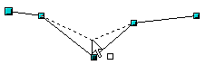2.
Draw virtual lines
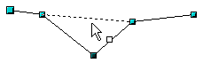3.
Release mouse button

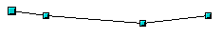
Figure 26: Reducing a line by one point

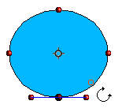  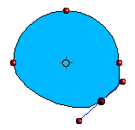  Figure 27: Moving a point on a curve  ➋  ➋ | The Rotate function from the Effects drop-down button on the Drawing toolbar and the Rotation Mode after Clicking Object button on the Options toolbar can be used in Edit Point mode. In this case, it can be used to move single points around the contour of an object, as shown in Figure 27.  Switch into rotation mode by clicking on either of the rotation buttons. Notice that in rotation mode, all of the tangent points become red dots.  ➊  Select the point to be moved and then drag it around the contour, while keeping the left mouse button pressed down (➊). When you release the mouse button, the point will be moved to the new position (➋).  If you move one of the handles located at the end of the tangents during rotation, you will make the object rotate in exactly the same way as with the usual rotation operations.  Important: To exit the effects mode, do not just click on the Effects button; click the Select button on the Drawing toolbar.

Bézier curves were invented by Pierre Bézier, an engineer working with the Renault car manufacturer, who developed the technique in the 1960s. The technology was intended to make modeling the surface of vehicles easier.

