
Calc Guide

Chapter 8
Using the Pivot Tables

Copyright
This document is Copyright © 2009–2011 by its contributors as listed below. You may distribute it and/or modify it under the terms of the Creative Commons Attribution-Share Alike License (https://creativecommons.org/licenses/by-sa/3.0/), version 3.0 or later.
All trademarks within this guide belong to their legitimate owners.
Authors
Stefan Weigel Jean Hollis Weber Sigrid Kronenberger
Andy Brown Sharon Whiston Claire Wood
Martin Fox
Feedback
Please direct any comments or suggestions about this document to: doc@openoffice.apache.org
Acknowledgments
The chapter is adapted from a German original written by Stefan Weigel and translated into English by Sigrid Kronenberger. Andy Brown, Jean Hollis Weber, and Sharon Whiston edited the translation, and Andy Brown recaptured the illustrations from an English version of OpenOffice.org. Martin Fox updated it for version OpenOffice.org 3.3.
Publication date and software version
Published 18 April 2022. Based on Apache OpenOffice 4.1.

Note for Mac users
Some keystrokes and menu items are different on a Mac from those used in Windows and Linux. The table below gives some common substitutions for the instructions in this chapter. For a more detailed list, see the application Help.
Windows/Linux | Mac equivalent | Effect
Tools > Options menu selection | OpenOffice > Preferences | Access setup options
Right-click | Control+click | Open context menu
Ctrl (Control) | z (Command) | Used with other keys
F5 | Shift+z+F5 | Open the Navigator
F11 | z+T | Open Styles & Formatting window

Contents
Chapter 8
Using the Pivot Tables 1
Copyright 2
Note for Mac users 2
Introduction 4
Examples with step by step descriptions 4
Example 1: Sales volume overview 4
Example 2: Timekeeping 11
Example 3: Frequency distribution 17
Pivot Table functions in detail 24
The database (preconditions) 24
Start 25
Data source 26
The Pivot Table dialog 27
Working with the results of the Pivot Table 35
Multiple data fields 44
Shortcuts 49
Function GETPIVOTDATA 49
Difficulty 49
Syntax 50

Introduction
Many requests for software support are the result of using complicated formulas and solutions to solve simple day to day problems. More efficient and effective solutions use a Pivot Table, a tool for combining, comparing, and analyzing large amounts of data easily. Using a Pivot Table, you can view different summaries of the source data, display the details of areas of interest, and create reports, whether you are a beginner, an intermediate or advanced user.
This chapter is divided into two sections:
- “Examples with step by step descriptions” uses three typical cases to demonstrate the advantages and applications of a Pivot Table. Follow the examples to learn how easy it is to use this tool.
- “Pivot Table functions in detail” starting on page 24 describes the use of Pivot Tables in detail. You can use this part to look up how a function is used.

Examples with step by step descriptions
This section demonstrates some of the possibilities of Pivot Tables in typical use cases. By following the step by step description, you can recreate the examples and learn about the power of Pivot Tables.

Example 1: Sales volume overview
A typical introductory example in courses and books for beginners with spreadsheets is a simple sales volume overview.
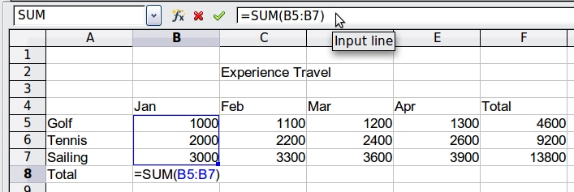
Figure 1: Typical example for beginners
This example demonstrates the user interface and how to insert text and numbers into cells. Useful aids like AutoFill and drag and drop have been demonstrated in other chapters. The most important part is the connection between cells through formulas, for example addition with the plus operator or the SUM function.
This small exercise might be useful for a first contact with the program, but it shows only a very small fraction of the tasks in an office. To create such a sales overview, you also need the original base data. That is, before you can use a spreadsheet to create a sales overview, you need to add the (possibly many) single purchases from different lists and then enter the sums into the relevant cells C5 to F7.

Practical problems and questions
- To display additional values for May, June, July, and so on, you need to add extra columns; that is, you have to change the structure of the calculation sheet. This is not only somewhat inefficient from a workflow point of view, but it also raises some practical questions: How do references react if you add more columns or rows to the sum formulas?
- The layout, where the timeline is displayed horizontally, is less convenient if you want to add more months. A vertical layout might be a more efficient use of space. How can the table be transposed? Do you have to enter everything again?
- What if management asks unexpected questions or adds an additional subdivision for the different sales regions or a constraint of the sales for a given employee? In these cases you again have to manually add all the sums and create different tables in many variations.
- Is it really acceptable and realistic to create such an overview by adding the different values manually? This is really a lot of work and extremely error-prone!

Solution
The most important part of your task in the example is the addition of the Total sales per month cells, which had to be done manually. To do this automatically with the program, just get the data into Calc. You can enter the single numbers by hand or you can import a file from your bookkeeping software. In any case we assume a continuous table that keeps track of all sales in a somewhat primitive form.
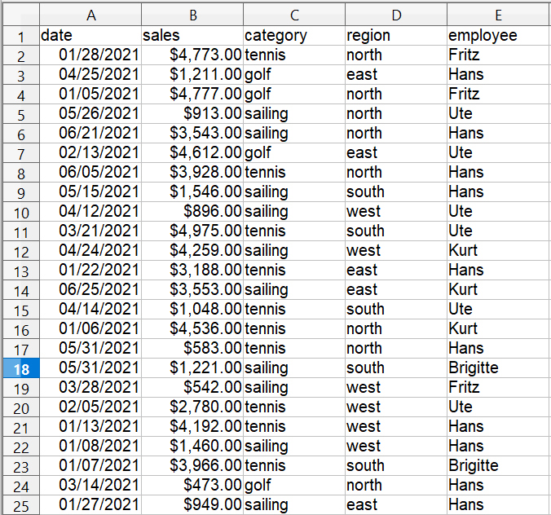

Figure 2: Basic data in Calc
You can create the sales volume overview by following these instructions:
- Select the cell A1 (or any other single cell within the list).
- Select Data > Pivot Table > Create. On the Select Source dialog, choose Current selection and click OK.
- The Pivot Table dialog (Figure 3) has four white layout areas and several fields that look like buttons. These small fields are the titles of the different columns of your list.
  - Move (drag and drop with the mouse) the date field into the Column Fields area.
  - Move the sales field into the Data Fields area.
  - Move the category field into the Row Fields area.
- Click More, to see more options in the lower part of the dialog.
- In the Results to drop-down list, select – new sheet –.
- Click OK.
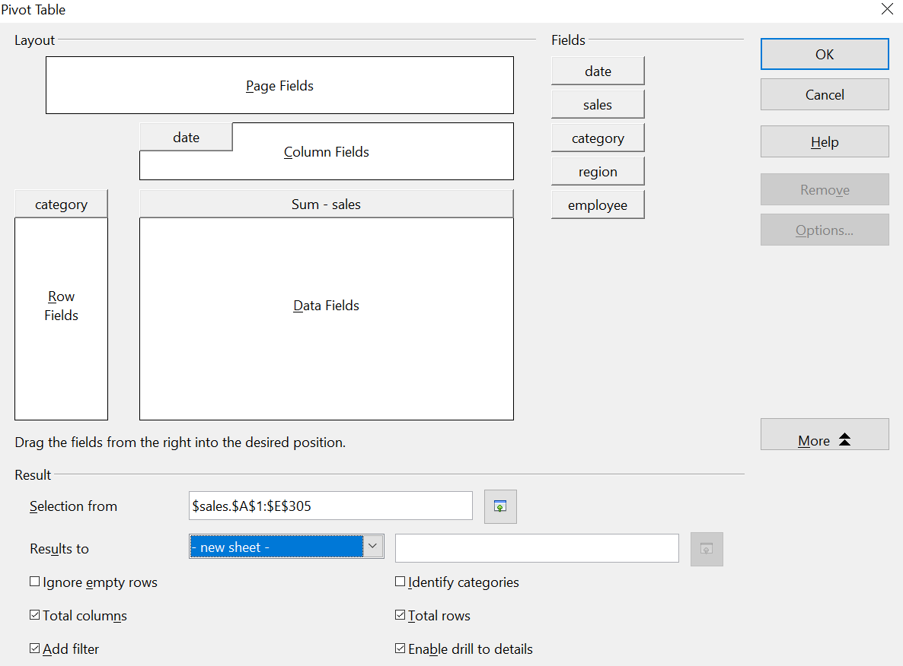

Figure 3: Pivot Table dialog
- The result appears on a new sheet. It has the desired structure, but the columns are not yet grouped into months.
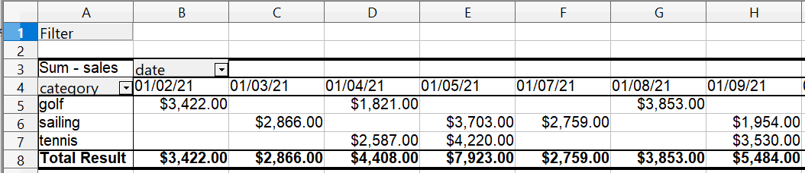

Figure 4: Pivot Table result without grouping
- To group the columns, select cell B4 or any other cell that contains a date. Then select Data > Group and Outline > Group. On the Grouping dialog (Figure 5), make sure Intervals and Months are selected in the Group by section, and click OK. The result is now grouped for months (Figure 6).
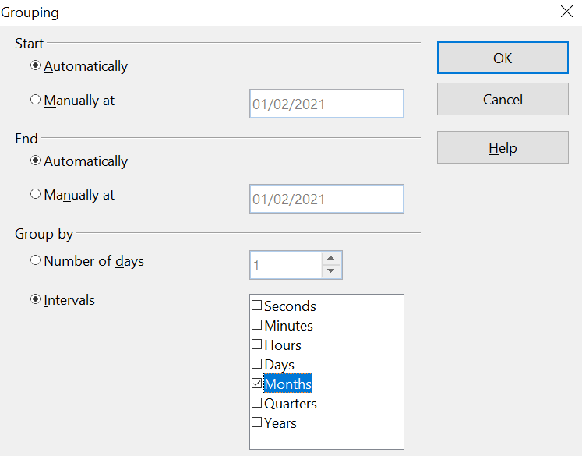

Figure 5: Grouping on months
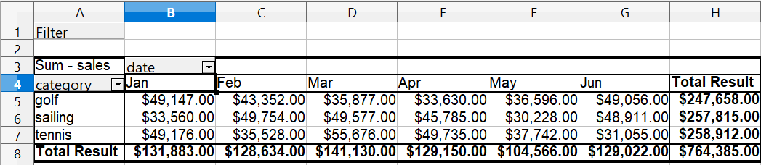

Figure 6: Pivot Table grouped for months
In this result you will recognize the beginners’ example. It is very easy to produce, without any further knowledge about the spreadsheet. You do not have to enter any formulas.

Advantages
- No manual entering or adding of any values is necessary. There is less work and fewer errors.
- The layout is very flexible: months horizontal and categories vertical or vice versa, in two mouse clicks.
- Additional differentiating factors are immediately available.
- Many types of evaluation are possible; for example, number or average instead of sum, accumulated values, comparisons, and so on.
- If more data are inserted into the original data set, the Pivot Table can be updated with two clicks.
We will now demonstrate some of these advantages.
Starting with the result of Figure 6, use the mouse to drag the Date field under the Category field, as shown in Figure 7.

Figure 7: Drag Date field under Category field
Now the summary is as shown in Figure 8.
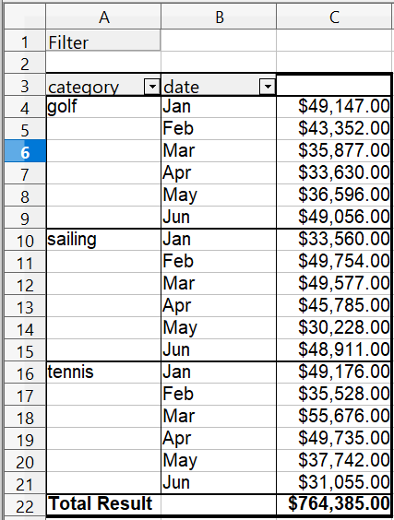
Figure 8: Changed layout
To transpose the table completely, just drag the Category field above the area of the displayed values, to cell C3 (see Figure 9). The result of this action is shown in Figure 10.

Figure 9: Reposition Category field
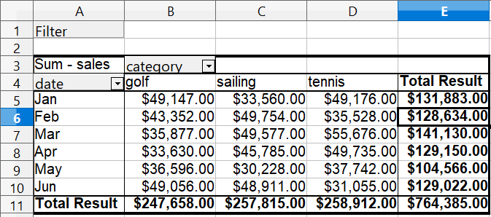

Figure 10: Transposed layout of Figure 8
In contrast to the beginners’ example in Figure 1, it is now very simple to view or add different aspects of the underlying data. For example, to see the values for different regions, do the following:
- Select the cell A3 (or any other single cell that is part of the Pivot Table result).
- Select Data > Pivot Table > Create to start the Pivot Table again.
Drag the Region field into the Row Fields area. Depending on the order you choose for the row fields, the result is either regions with date subdivisions or vice versa.
- Click OK. The result is shown in Figure 11.
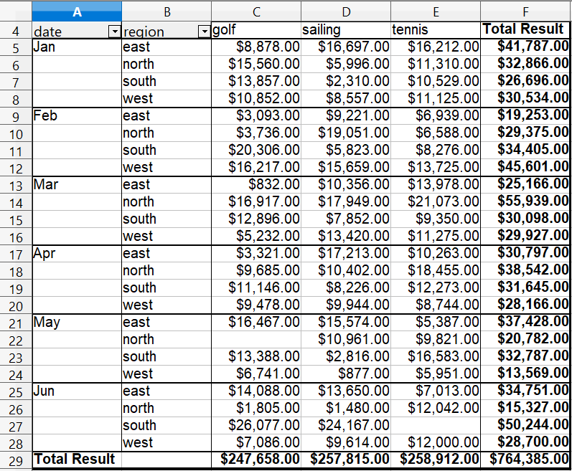
Figure 11: Additional subdivision into regions, added later
In another variation you may want to add the employees.
- Select the cell A3 (or any other single cell that is part of the Pivot Table result).
- Select Data > Pivot Table > Create, to start the Pivot Table again.
  - You do not need the Region field in this case. Drag it out of the layout area.
  - Drag the Employee field into the Page Fields area.
- Click OK. The result is shown in Figure 12.
Fields that you use as page fields are placed in the result above the summary with the name Filter. You then have a drop-down list that you can use to show only the sums of a given employee.
Up to now we have not seen the most powerful features of the Pivot Table. The following examples will show you more.
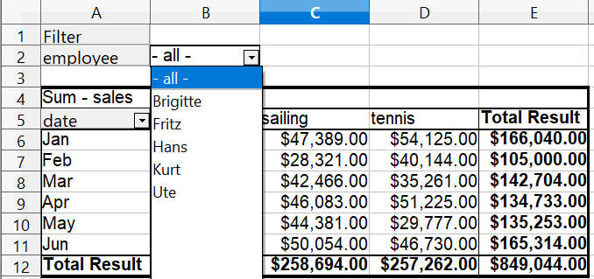

Figure 12: Selection of subtotals for an employee.

Example 2: Timekeeping
This example is often used by consultants and in several variations in user support. The task is to provide a means for one or more users to keep track of working hours.
Note | In the real world, timekeeping requires tracking working time on individual projects. Specialized database software is often used but for simple applications in a small company a Calc spreadsheet and a Pivot Table might be all that is needed to track work done.

A typical way of doing this is to create a spreadsheet per month and a sum sheet with all the results of one year. For each employee, there is one file (see Figures 13 and 14 for examples of two pages from the file for one employee).

Practical problems and questions
- It is very difficult and time-consuming to create the timekeeping table: 12 sheets that have to be copied from a raw template and adjusted for each month, and a sheet with all the yearly sums with references to all the other sheets. Users often search for a macro to make the creation easier.
- The file shown contains only the data of one employee. How can you get all the data for all the employees, so that you can have a summary of all the work hours from all employees of a department or the whole company?
- How can you compare employees and/or departments?
- The file shown contains data for one year. How can you compare it with the data of the previous years?
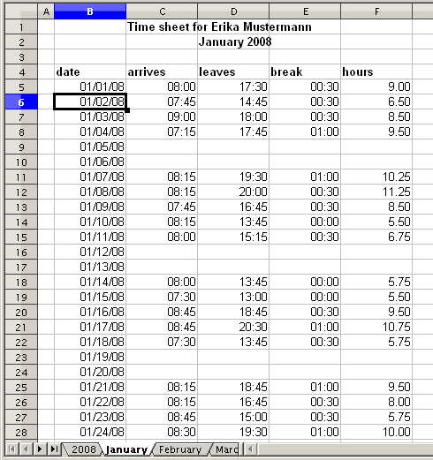
Figure 13: One month of timekeeping for one employee
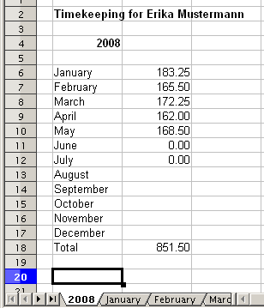
Figure 14: Yearly sums for one employee

Solution
To use a Pivot Table for this task, collect all the data into one single table. This can be done either manually or by importing a file from a time entry system.
In very simple cases, each employee takes care of their own working hours. If you need calculations that cover several employees, departments, or the whole company, just copy everything into one huge table (Figure 15).
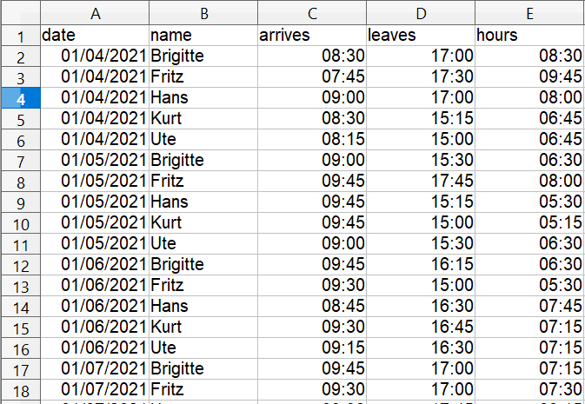

Figure 15: Employee time in Calc
Using a Pivot Table requires only 12 mouse clicks and gives you a nice overview within seconds:
- Select the cell A1 (or any other single cell within the data).
- Choose Data > Pivot Table > Create and click OK.
- On the Pivot Table dialog (Figure 16):
  - Drag date into the Row Fields area.
  - Drag hours into the Data Fields area. Notice that it becomes Sum – hours.
  - Drag name into the Column Fields area.
- Click More to show more options in the lower part of the dialog.
- Choose – new sheet – for Results to.
- Click OK.
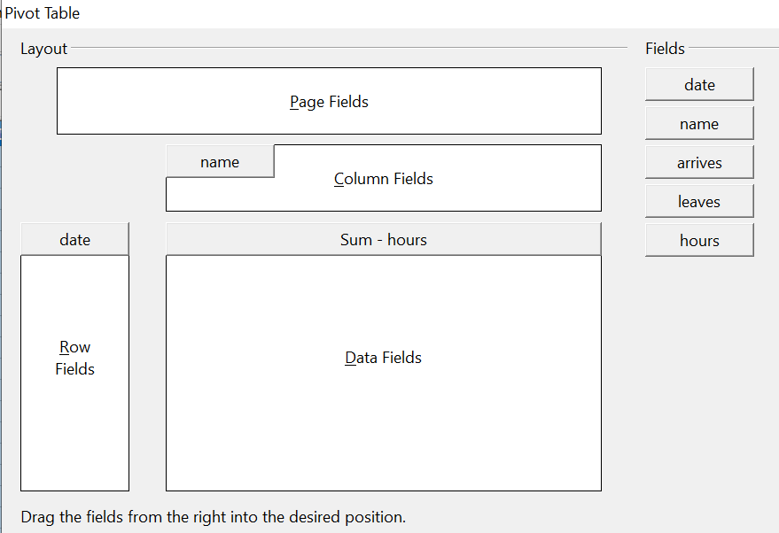

Figure 16: Part of the Pivot Table dialog
The result appears on a new sheet (Figure 17).
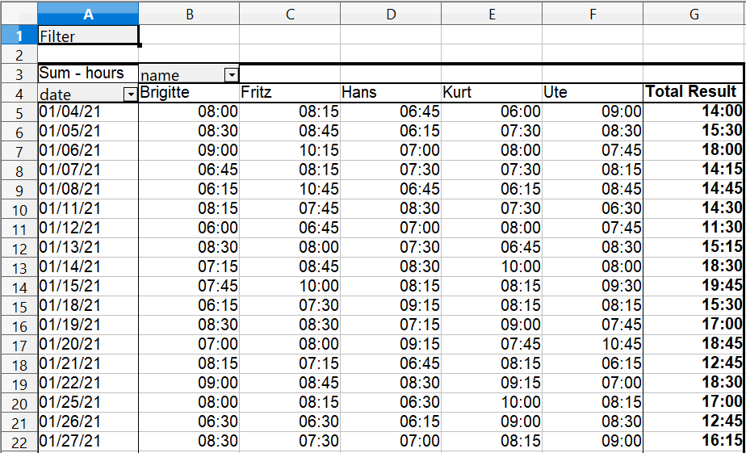

Figure 17: The evaluation, done within seconds with a Pivot Table
The result is much more powerful than is possible with the classic formula-based calculation. For example, you can summarize the daily results to a monthly result very easily:
- To group together the rows, select the cell A5 (or any other cell that contains a date).
- Choose Data > Group and Outline > Group . On the Grouping dialog, leave Start and End as Automatically; in the Group by section, choose Intervals and Months. Click OK. The result is now grouped into months.
- You may have to set the format of the cells to display values of hours larger than 24. This can be done with the menu Format > Cells and choosing a Time format whose format code has the hours in brackets: [HH]:MM
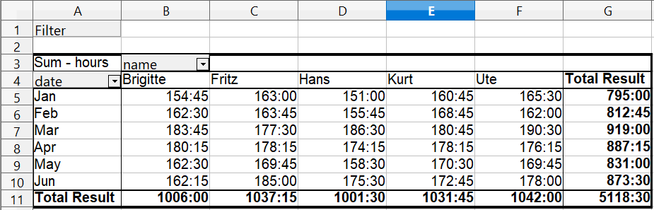

Figure 18: Monthly sums
If you need a result with a percentage, start the Pivot Table from this page.
- Select the cell A3 (or any other single cell that contains a result of the Pivot Table).
- Choose Data > Pivot Table > Create.
- Double-click on Sum – hours to open the Data Field dialog (Figure 19).
- Click on More, to see more options.
- Switch Displayed value > Type to % of column.
- Click OK to return to the Pivot Table dialog, then click OK again.
An example of the output is shown in (Figure 20).
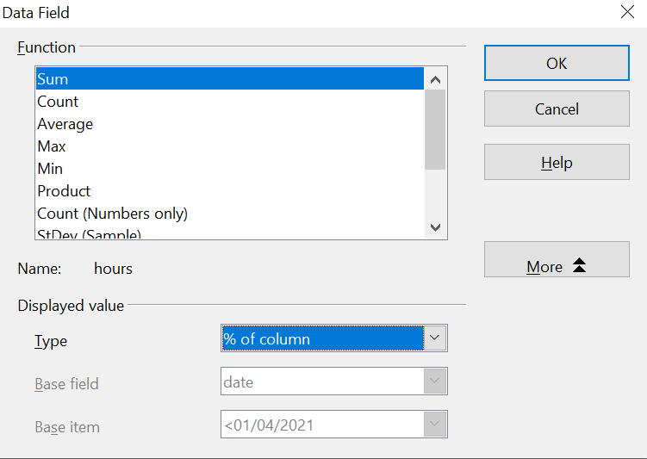

Figure 19: Properties of the data field
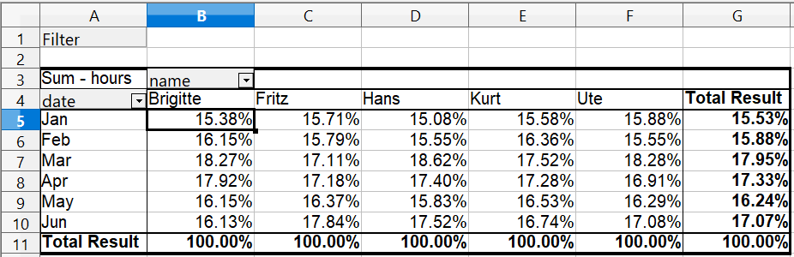

Figure 20: Result with percentages
To get a comparison between employees, start the Pivot Table again from the output sheet:
- Select the cell A3 (or any other cell that contains a result of the Pivot Table).
- Choose Data > Pivot Table > Create.
- Double-click on Sum – hours to open the Data Field dialog.
- Click More, to see more options.
  - Switch the Type of the displayed value to Difference from.
  - Switch the Base field to name.
  - Switch the Base item to Brigitte.
- Click OK to return to the Pivot Table dialog, then click OK again.
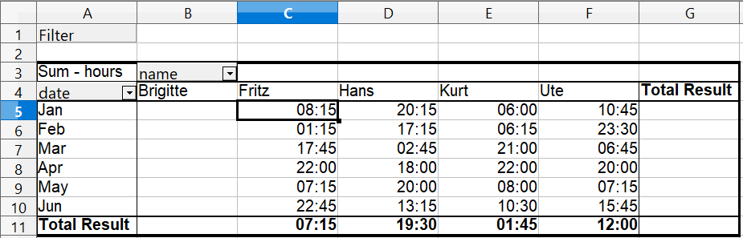

Figure 21: Absolute comparison with Brigitte
As a final example we switch to an accumulated view; that is, continuing sums of all values:
- Select the cell A3 (or any other cell that contains a result of the Pivot Table).
- Choose Data > Pivot Table > Create.
- Double-click on Sum – hours to open the Data Field dialog.
- Click More, to see more options.
  - Switch the type of the displayed value to Running total in.
  - Switch the Base field to Date.
- Click OK to return to the Pivot Table dialog, then click OK again.
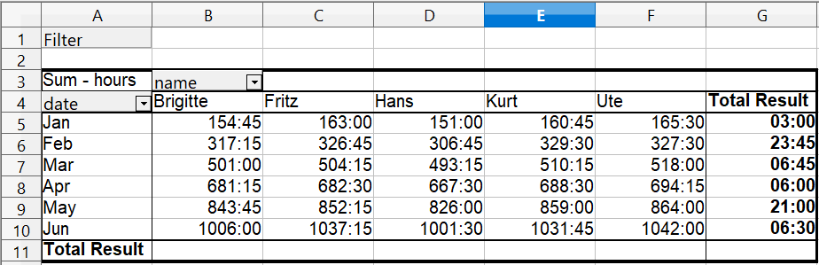
Figure 22: The Pivot Table now shows accumulated values

Differences and advantages
These examples show an important aspect of the Pivot Tables. Normally you have to collect your data according to the way you want the result to be represented. This means you have to use a specific structure and you are stuck with it.
The Pivot Table works more like a real database. The source data are collected in a simple spreadsheet that contains all data. Only when you want to look at it do you select which part of the data you want to use.

Example 3: Frequency distribution
For showing the frequency of incidents, Calc uses the function FREQUENCY. This formula has to be used in a so-called array formula. This is an advanced feature. Alternatively you can use a Pivot Table, which requires almost no knowledge of spreadsheets.
In our example we want to investigate the number of emails that go to a mailing list. We want to know how the activity on the list is distributed during the day.
The starting point for this example is a text file that contains one line for each message, with date and time. (See Figure 23.)
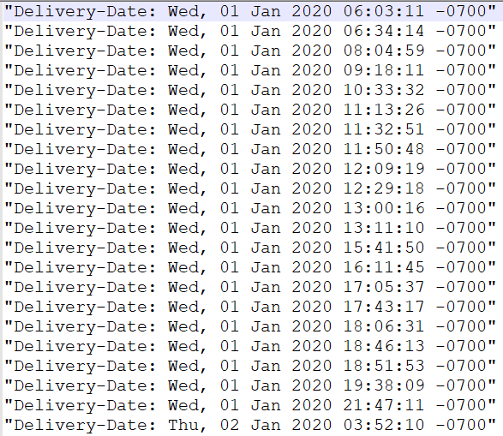

Figure 23: Raw data for the frequency of the messages
To import the data into a table in Calc, choose Insert > Sheet From File and select the text file containing the raw data. The Text Import dialog (Figure 24) appears. Here you can choose your import options. Use the following properties:
Separator options: Fixed width
Select Detect special numbers
Divide into columns at position 20, 32 and 42
Column types:
Column 1: Hide
Column 2: Date (DMY)
Column 3: Standard
Column 4: Hide

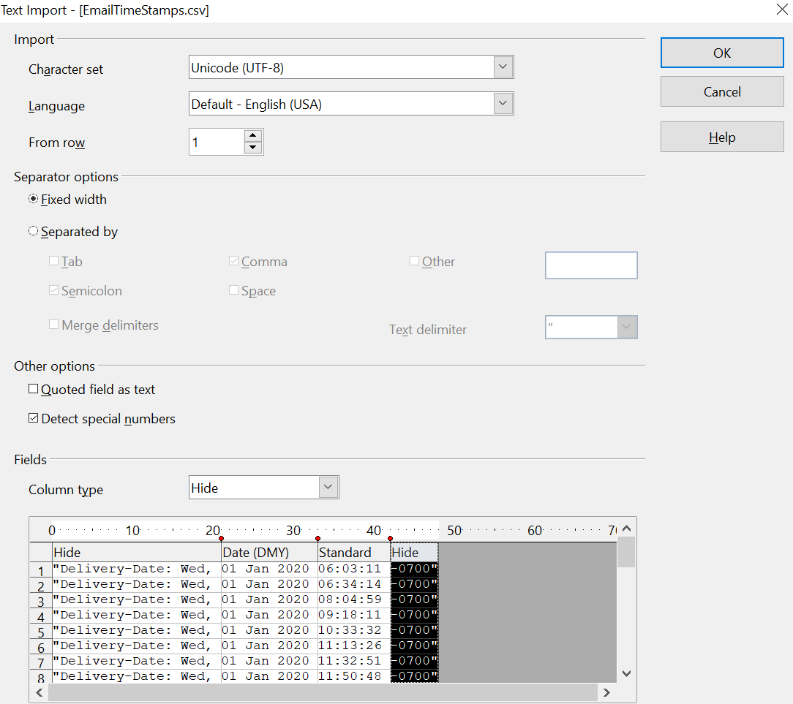

Figure 24: Import settings
Figure 25 shows the imported raw data with a row added at the top containing titles for each column.
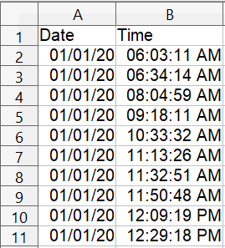
Figure 25: Data in Calc

Solution with a matrix formula
To calculate the frequency you have to create 24 classes, one for each hour. In the next column you enter the number of emails with the function FREQUENCY.
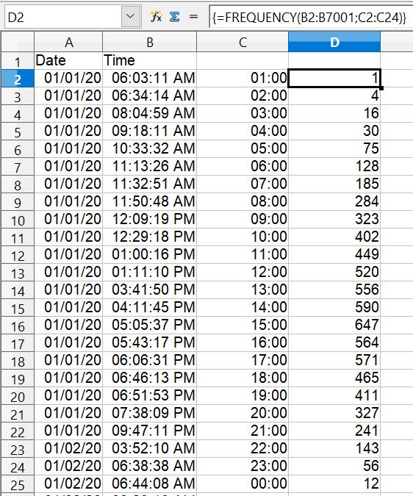

Figure 26: FREQUENCY function in an
array formula
The first argument is the cell area with the times of all 7000 emails. The second argument is the cell area D2:D25 that describes the frequency classes. To enter the formula, first select the cell area F2:F25, then enter the formula. Then finish the formula by using the key combination Shift+Ctrl+Enter. This indicates to the program that you want to use a matrix formula. To indicate the array formula, the program uses curly brackets.

Solution with a Pivot Table
With a Pivot Table, you can achieve the same result much easier and faster. Starting with the raw data (Figure 25), you need only a few mouse clicks.
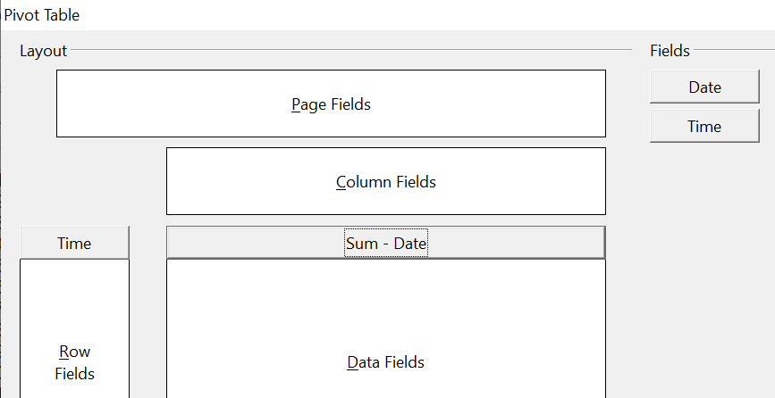
Figure 27: Part of Pivot Table dialog
- Select the cell A1 (or any other cell within the list).
- Choose Data > Pivot Table > Create and click OK.
- In the Pivot Table dialog:
  - Drag Time into the Row Fields area.
  - Drag Date into the Data Fields area.
- Click More to show more options in the lower part of the dialog.
- Choose – new sheet – for Results to.
- In this case we need to count the number of values, not their sum. Double-click on Sum – Date to open the Data Field dialog and select the function Count (see Figure 28).
- Click OK. As an intermediate result, you get a Pivot Table that has for every time within the raw data a separate line.
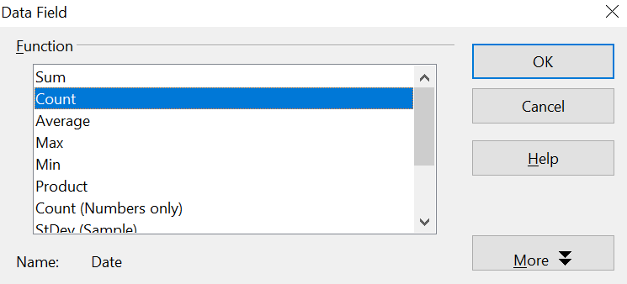

Figure 28: Properties of the data field
Note | This may be a very time-consuming process because of the large number of items. The time does not depend that much on the number of lines but rather on the number of rows needed for the table that contains the results.

- For grouping the rows, select the cell A4 or any other cell that contains a time.
- Choose Data > Group and Outline > Group, select for the interval Hours and click OK. The result is now grouped according to hours as shown in Figure 31.
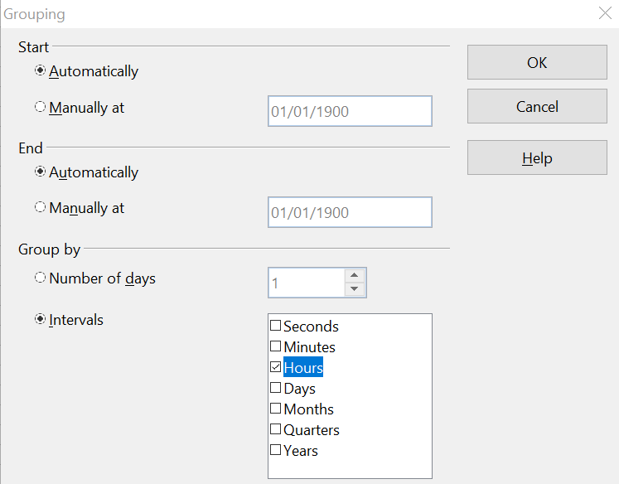

Figure 29: properties for grouping according to hours
- Restart the Pivot Table and double-click on the Count-Date data field. Figure 30 shows the Data Field dialog for the data field Number – Date. Click More and select as type % of column. The result is shown in Figure 32. Figure 31 shows the absolute occurrence.
Whether the relative values are shown as a decimal (0.1) or as a percentage (10%) depends only on the cell formatting.
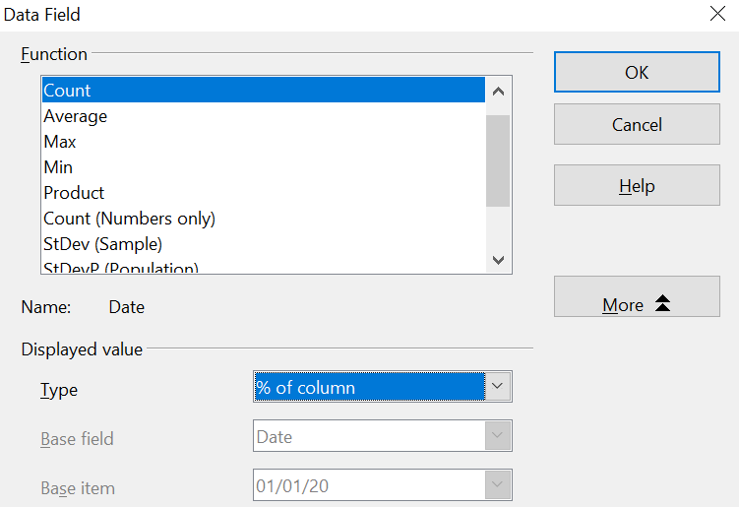

Figure 30: Data Field settings for relative values
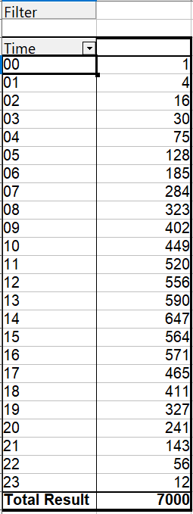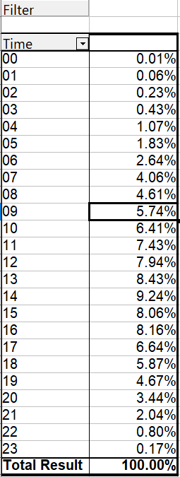

Figure 31: Frequency distribution

Figure 32: Relative occurrence

Pivot Table functions in detail
This part describes the use and options of the Pivot Tables in detail.

The database (preconditions)
The first thing needed to work with a Pivot Table is a list of raw data, similar to a database table, consisting of rows (data sets or records) and columns (data fields). The field names must be in the first row of the list.
The data source could be an external file or database. For the simplest case, where data is contained in a Calc spreadsheet, Calc offers sorting functions that do not require a Pivot Table.
For processing data in lists, the program needs to know where in the spreadsheet the list is. The list can be anywhere in the sheet, in any position. A spreadsheet can contain several unrelated lists.
Calc recognizes your lists automatically. It uses the following logic:
Starting from the cell you’ve selected (which must be within your list), Calc checks the surrounding cells in all 4 directions (left, right, above, below). The border is recognized if the program discovers an empty row or column, or if it hits the left or upper border of the spreadsheet.
This means that the described functions can only work correctly if there are no empty rows or columns in your list. Avoid empty lines (for example for formatting). You can format your list by using cell formats.
Caution   | No empty rows or empty columns are allowed within lists.

If you select more than one single cell before you start sorting, filtering or calling the Pivot Table, then the automatic list recognition is switched off. Calc assumes that the list matches exactly the cells you have selected.
Caution | For sorting, filtering, or using the Pivot Table, always select only one cell or carefully select the entire data set.

In addition to these formal aspects, the logical structure of your table is very important when using the Pivot Table.

Caution | Calc lists must have the normal form; that is, they must have a simple linear structure.

When entering the data, do not add outlines, groups, or summaries. This becomes clear when we think about what we could have done wrong in our Sales list example in the section “Examples with step by step descriptions” starting at page 4. Here are some mistakes commonly made by inexperienced spreadsheet users:
- You made several sheets, for example, a sheet for each group of articles. Analyses are then possible only within each group. Analyses for several groups would be a lot of work.
- In the Sales list, instead of only one column for the amount, you made a column for the amounts for each employee. The amounts then had to be entered into the appropriate column. An analysis with a Pivot Table would not be possible any more. In contrast, one result of the Pivot Table is that you can get results for each employee if you have entered all of the amounts in one column.
- You entered the amounts in chronological order. At the end of each month you made a sum total. In this case, sorting the list for different criteria is not possible because the Pivot Table will treat the sum totals the same as any other figure. Getting monthly results is one of the very fast and easy features of Pivot Tables.

Start
Start the Pivot Table with Data > Pivot Table > Create. If the list to be analyzed is in a spreadsheet table, select only one cell within this list. Calc recognizes and selects the list automatically for use with the Pivot Table.
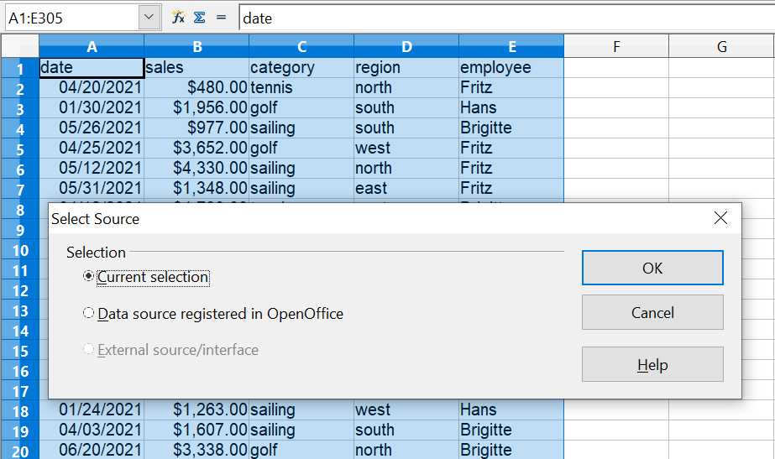

Figure 33: After starting the Pivot Table

Data source
There are two possible data sources for the Pivot Table: a Calc spreadsheet or an external data source that has to be registered in OpenOffice.

Calc spreadsheet
The simplest and most often used case is analyzing a list in a Calc spreadsheet. The list might be updated regularly or the data might be imported from a different application.
For example, a huge list can be copied from a different application and pasted into Calc. The behavior of Calc while inserting the data depends on the format of the data. If the data is in a common spreadsheet format, it is copied directly into Calc. However, if the data is in plain text, the Text Import dialog appears; see Figure 24 in this chapter and Chapter 1 (Introducing Calc) for more information.
Calc can import data from many foreign data formats, for example from other spreadsheets, from databases (like dBase), and from simple text files, including CSV formats.
The drawback of copying or importing foreign data is that it will not update automatically if there are changes in the source file.

Registered data source
A registered data source in OpenOffice is a connection to data held in a database outside Calc. This means that the data to be analyzed will not be saved in Calc; Calc always uses the data from the original source. Calc is able to use many different data sources and also databases that are created and maintained with OpenOffice Base. See Chapter 10 (Linking Calc Data) for more information.

The Pivot Table dialog
The function of the Pivot Table is managed in two places: first in the Pivot Table dialog and second through manipulations of the result in the spreadsheet. This section describes the dialog in detail.

Basic layout
In the Pivot Table dialog (Figure 34), there are four white areas that show the layout of the result. Next to these white areas are buttons with the names of the fields (columns) in your data source. To choose a layout, drag and drop the field buttons into the white areas.
The Data Fields area in the middle must contain at least one field. Advanced users can use more than one field here. For the data field an aggregate function is used. For example, if you move the sales field into the Data Fields area, it appears there as Sum – sales.
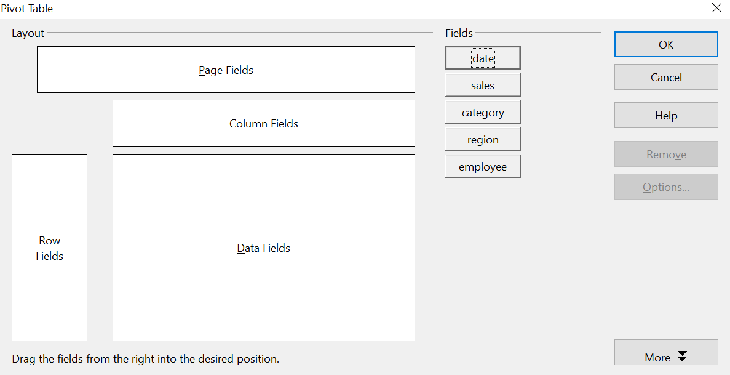

Figure 34: Pivot Table dialog
Row Fields and Column Fields indicate in which groups the result will be sorted in the rows and columns. If there are no entries in one of these area, then partial sums will not be provided for the corresponding rows or columns. Often more than one field is used at the same time to get partial sums for rows or columns. The order of the fields gives the order of the sums from overall to specific.
For example, if you drag region and employee into the Row Fields area, the sum will be divided into the employees. Within the employees will be the listing for the different regions.
Fields that are placed into the Page Fields area appear in the result above as a drop down list. The summary in your result takes only that part of your base data into account that you have selected. For example, if you use employee as a page field, you can filter the result shown for each employee.
To remove a field from the white layout area just drag it to the border and drop it (the cursor will change to a crossed symbol), or click the Remove button.

More options
To expand the Pivot Table dialog and show more options, click More.
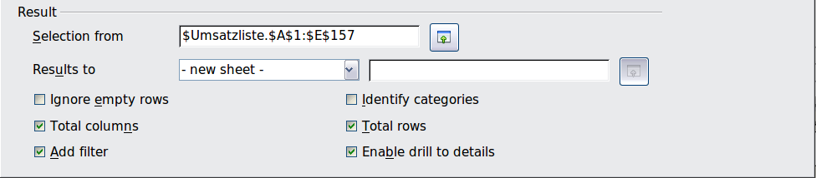
Figure 35: Expanded Pivot Table dialog
Selection from
Shows the range of cells used in the Pivot Table.
Results to
Results to defines where your result will be shown. If you do not enter anything, the Pivot Table result will be below the list that contains your data. This could result in overwriting any data that is already in that location. To avoid overwriting data, you can leave Results to as – undefined – and enter a cell reference to tell Calc where to show the results. However, a generally better approach is to use - new sheet – to add a new sheet to the spreadsheet file and place the results there.
Ignore empty rows
If the source data is not in the recommended form, this option tells the Pivot Table to ignore empty rows.
Identify categories
If the source data has missing entries in a list and does not meet the recommended data structure (see Figure 36), the Pivot Table fills the gaps with category above it. If this option is not chosen, then the Pivot Table inserts (empty) (see Figure 38).
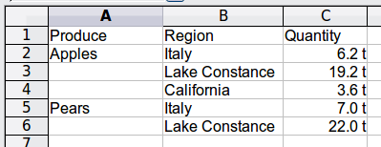
Figure 36: Example of data with missing entries in Column A
The option Identify categories ensures that in this case rows 3 and 4 are added to the product Apples and row 6 is added to Pears (see Figure 37).
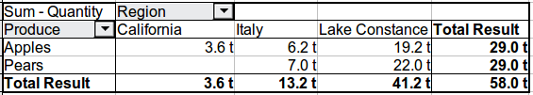
Figure 37: Pivot Table result with Identify categories selected
Without category recognition, the Pivot Table shows an (empty) category (Figure 38).
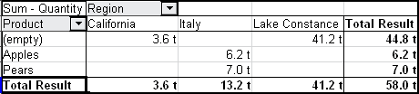
Figure 38: Pivot Table result without Identify categories selected
Logically, the behavior without category recognition is better. A list with the shown missing entries is also less useful, because you cannot use other functions such as sorting or filtering.
Total columns / total rows
With this option you decide if the Pivot Table will show an extra row with the sums of each column or if it adds on the very right a column with the sums of each row. In some cases, an added total sum is meaningless, for example if your entries are accumulated or the result of comparisons.
Add filter
Use this option to add or hide the cell labeled Filter above the Pivot Table results. This cell is a convenient button for additional filtering options within the Pivot Table.
Enable drill to details
If you double-click on a single cell in the Pivot Table result, this function gives a more detailed listing of an individual entry. If this function is disabled, the double-click will keep its usual edit function within a spreadsheet.

More settings for the fields – Field Options
The options discussed in the previous section are valid for the Pivot Table in general. Additionally, you can change settings for every field that you have added to the Pivot Table layout. Do this either by clicking on the Options button in the Pivot Table dialog or by double-clicking on the appropriate field.
There are differences between data fields, row or column fields, and page fields of the Pivot Table.

Data fields
In the Options dialog of a data field you can select the Sum function for accumulating the values from your data source. In many cases you will need the sum function, but other functions (like standard distribution or a counting function) are also available. For example, the counting function can be useful for non-numerical data fields.
On the Data Field dialog, click More to see more options.
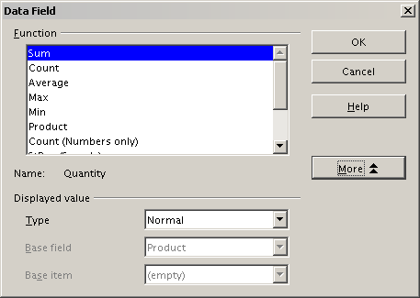
Figure 39: Expanded dialog for a data field
In the Displayed value section, you can choose other possibilities for analysis by using the aggregate function. Depending on the setting for Type, you may have to choose definitions for Base field and Base item. The table below lists the possible types of displayed value and associated base field and item, together with a note on usage.
Type | Base field | Base item | Analysis
Normal | — | — | Simple use of the chosen aggregate function (for example, sum)
Difference from | Selection of a field from the data source of the Pivot Table (for example, employee) | Selection of an item from the selected base field (for example, Brigitte) | Result as difference from the result of the base item (for example, Sales volume of the employees as difference from the sales volume of Brigitte)
% of | Selection of a field from the data source of the Pivot Table (for example, employee) | Selection of an item from the selected base field (for example, Brigitte) | Result as a ratio based on the result of the base item (for example, Sales result of the employee relative to the sales result of Brigitte)
% difference from | Selection of a field from the data source of the Pivot Table (for example, employee) | Selection of an item from the selected base field (for example. Brigitte) | Result as relative difference to the result of the base item (for example, Sales volume of the employees as relative difference of the sales volume of Brigitte)
Running total in | Selection of a field from the data source of the Pivot Table (for example, date) | — | Result as a continuing sum (for example, running sum of the sales volume for days or months)
% of row | — | — | Result as relative part of the result in the whole row (for example the row sum)
% of column | — | — | Result as relative part of the total column (for example, the column sum)
% of total | — | — | Result as relative part of the overall result (for example the total sum)
Index | — | — | Default result x total result / (row result x column result)

Row and column fields
In the Options dialog for the row or column fields, you can choose to show partial sums for each category. Partial sums are deactivated by default. They are only useful if the values in one row or column field can be divided into partial sums for another (sub)field.
Some examples are shown in the next three figures.
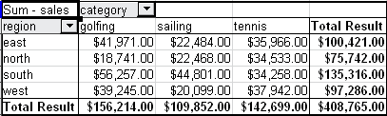
Figure 40: No subdivision with only one row or column field
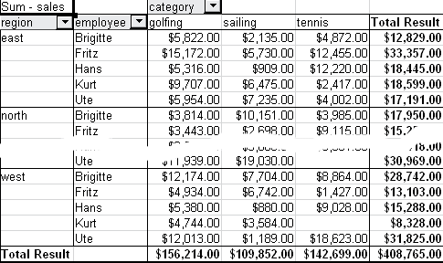
Figure 41: Division of the regions by employees (two row fields) without partial sums
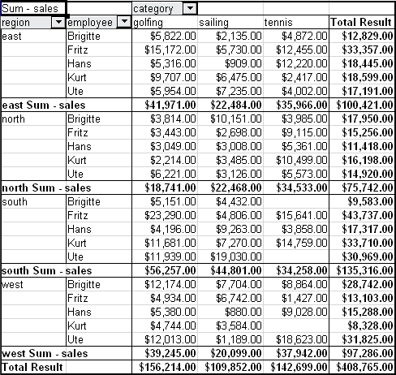
Figure 42: Division of the regions for employees with partial sums (by region)
Choose the option Automatically to use the aggregate function for the partial results that can also be used for the data fields (see above). To set up the aggregate function for the partial results independently from the overall settings of the Pivot Table, choose User-defined.
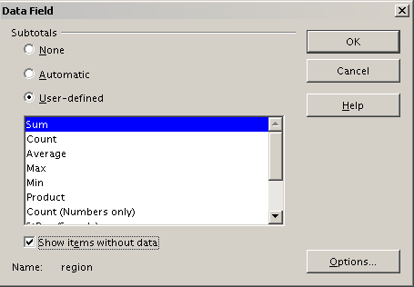
Figure 43: Preferences dialog of a row or column field
Normally, the Pivot Table does not show a row or column for categories that have no entries in the underlying database. By choosing the Show items without data option, you can force this.
For illustration purposes, the data was manipulated in such a way, that the employee Brigitte has no sales values for the category golfing.
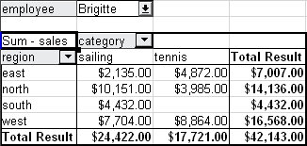
Figure 44: Default setting
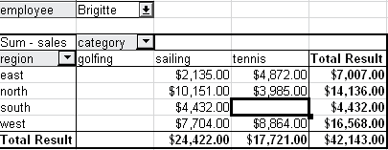
Figure 45: Setting “Show Items without data”

Page fields
The Options dialog for page fields is the same as for row and column fields, even though it appears to be useless to have the same settings as described for the row and column fields. With the flexibility of the Pivot Table you can switch the different fields between pages, columns or rows. The fields keep the settings that you made for them. The page field has the same properties as a row or column field. These settings only take effect when you use the field not as page field but as row or column field.

Working with the results of the Pivot Table
As mentioned above, the Pivot Table is very flexible. An analysis can be totally restructured with only a few mouse clicks. Some functions of the Pivot Table can be used only with the results of an analysis.

Start the dialog
Right-click in the area of the resulting table of the Pivot Table. The command Edit Layout opens the Pivot Table dialog with all current settings.

Change layout by using drag and drop
The easiest and fastest method to change the layout of the Pivot Table is drag and drop. Within the result table of the Pivot Table, move one of the page, column, or row fields to a different position (see “Examples with step by step descriptions” starting on page 4).
You can remove a column, row, or page field from the Pivot Table by clicking on it and dragging it out of the Pivot Table.

Grouping rows or columns
For many analyses or summaries, the categories have to be grouped. You can merge the results in classes or periods. In the Pivot Table you do a grouping only after you have first made an ungrouped Pivot Table.
You can access the grouping with the menu entry Data > Group and Outline > Group or by pressing F12. It is important that you select the correct cell area. If you want to group some date, click on one of the date cells before starting the grouping process. How the grouping function works is determined mainly by the type of values that have to be grouped. You need to distinguish between scalar values, date or time values, or other values, such as text, that you want grouped.
Note | Before you can group, you have to produce a Pivot Table with ungrouped data. The time needed for creating a Pivot Table depends mostly on the number of columns and rows in the resulting table and not on the size of the basic data. Through grouping you can produce the Pivot Table with a small number of rows and columns. The Pivot Table can contain a lot of categories, depending on your data source.

Grouping of categories with scalar values
For grouping scalar values, select a single cell in the row or column of the category to be grouped.
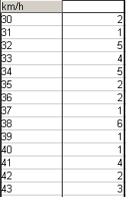
Figure 46: Pivot Table without grouping (frequency of the km/h values of a radar control)
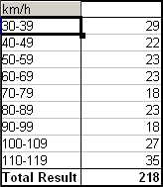
Figure 47: Pivot Table with grouping (classes of 10 km/h each)
Choose Data > Group and Outline > Group from the menu bar or press F12; you get the following dialog.
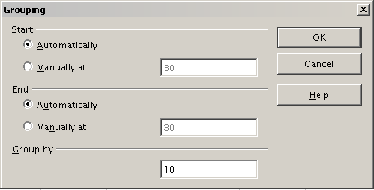
Figure 48: Grouping dialog with scalar categories
You can define in which value range (start/end) the grouping should take place. The default setting is the whole range from smallest to biggest value. In the field Group by you can enter the class size, this means the interval size (in this example groups of 10 km/h each).

Grouping of categories with date or time values
For grouping date or time values select a single cell in the column or row of the category to be grouped. This was demonstrated in all three examples in the section “Examples with step by step descriptions” starting on page 4.
With the menu entry Data > Group and Outline > Group or by pressing F12, you get the following dialog.
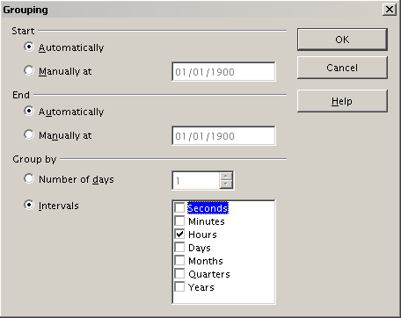
Figure 49: Grouping dialog for categories with dates or times
You can decide the range of dates or times (start/finish) over which grouping should take place. The default setting is the entire period from the earliest to the latest value. In the field Group by you can enter the class size (the interval), that should be used for grouping.
Possible intervals are: seconds, minutes, hours, days, months, quarters and years. These can be combined, for example grouping first by years and then within each year according to month.
Alternatively you can enter any number of days as grouping interval.
Tip | For grouping the output of the Pivot Table in calendar weeks, choose the beginning date on a Sunday or Monday and enter the grouping interval (Number of Days) as 7.

Grouping without the automatic creation of intervals
If the categories contain text fields, then the automatic creation of intervals is not possible. You can define for each field (for example Department) which values you want to put together in one group.
Every time you use the menu entry Data > Group and Outline > Group or you press F12 and you have more than one cell selected, then all the cells will be selected as one group.
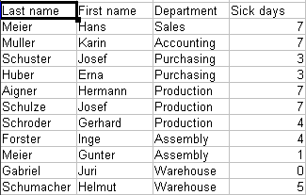
Figure 50: Database with nonscalar categories (departments)
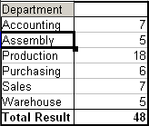
Figure 51: Pivot Table with nonscalar categories
For grouping of non scalar categories, select in the result of the Pivot Table all the individual field values that you want to put in the one group.
Tip | You can select several non-contiguous cells in one step by pressing and holding the Control key while left-clicking with the mouse.

Given the input data shown in Figure 50, execute the Pivot Table with Department in the Row Field and Sum (Sick Days) in the Data Field. The output should look like that in Figure 51. Select with the mouse the Departments Accounting, Purchasing and Sales.
Choose the Data > Group and Outline > Group from the Menu bar or press F12. The output should now look like that in Figure 52. Repeat this for all groups that you want to create from the different categories (Select Assembly, Production and Warehouse and Group again. The output should look like Figure 53.
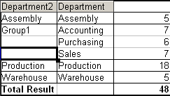
Figure 52: Summary of single categories in one group
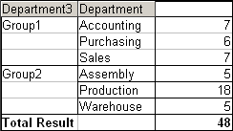
Figure 53: Grouping finished
You can change the automatically given names for the groups and the newly created group field by editing the name in the input field (for example changing 'Group2' to 'Technical'). The Pivot Table will remember these settings, even if you change the layout later on. For the following pictures, the dialog was called again (with a right-click, Edit Layout) and by selecting the icon “Department 2”, then Options, and finally from the preferences menu Automatic was selected. This generated the partial sum results shown in Figure 54. Double-clicking Group 1 and Technical collapses the entries, as shown in Figure 55.
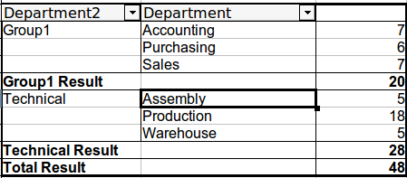
Figure 54: Renamed groups and partial results
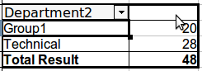Figure 55: Reduced to the new groups
Note | A well-structured database makes manual sorting within the Pivot Table obsolete. In the example shown, you could add another column with the name Department, that has the correct entry for each person based on whether the employee’s department belongs to the group Office or Technical. The mapping for this (1:n relationship) can be done easily with the VLOOKUP function from Calc.

Sorting the result
The result of any Pivot Table is sorted (categories) in columns and rows in an ascending order. You can change the sorting in three ways:
- Select sort order from drop-down menus on each column heading.
- Sort manually by using drag and drop.
- Sort automatically by choosing the options in the preferences dialog of the row or column field.
Select sort order from drop-down menus on each column heading
The simplest way to sort entries is to click the arrow on the right side of the heading and check the box(es) for the desired sort order. The custom sorting dialog is shown in Figure 56. Additional options exist to show all, only the current item or to hide only the current item.
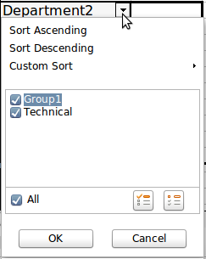
Figure 56: Custom sorting
Sort manually by using drag and drop
You can change the order within the categories by moving the cells with the category values in the result table of the Pivot Table.
Be aware that in Calc a cell must be selected. It is not enough that this cell contains the cell cursor. The background of a selected cell is marked with a different color. To achieve this, click in one cell with no extra key pressed and redo this by pressing also the Shift or Ctrl key. Another possibility is to keep the mouse button pressed on the cell you want to select, move the mouse to a neighbor cell and move back to your original cell before you release the mouse button.
Sort automatically
To sort automatically, start the options of the preferences of the row or column field: right-click on the table area with the Pivot Table result and choose Edit Layout to open the Pivot Table dialog (Figure 3). Within the Layout area of the Pivot Table dialog, double-click the field you want to sort. In the Data Field dialog (Figure 43), click Options to display the Data Field Options dialog (Figure 57).
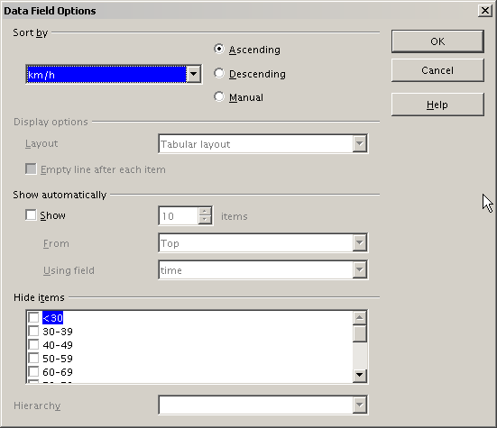
Figure 57: Options for a row or column field
For Sort by choose either Ascending or Descending. On the left side is a drop-down list where you can choose the field this setting should apply to. With this method you can specify that sorting does not happen according to the categories but according to the results of the data field.

Drilling (showing details)
Drill Down allows you to show the related detailed data for a single, compressed value in the Pivot Table result. To activate a drill down, double-click on the cell or choose Data > Group and Outline > Show Details. You have to distinguish two cases:
- The active cell is the category of a row or column field.
In this case drill down means an additional breakdown into the categories of another field.
For example, double-click on the cell with the value golfing in the row field region. In this case the values that are aggregated in the category golfing are subdivided according to another field.
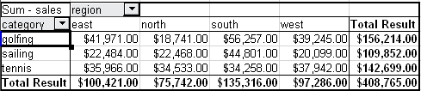
Figure 58: Before the drill down for the category golfing
Since there are more possibilities for subdivision, a dialog appears so you can choose your setting.
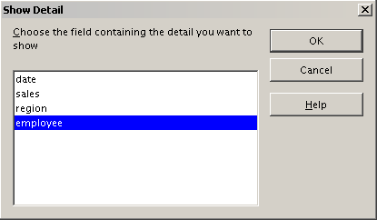
Figure 59: Selection of the field for the subdivision
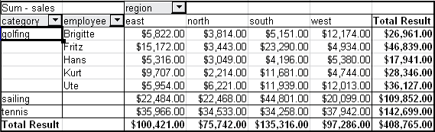
Figure 60: After the drill down
To hide the details again, double-click on the cell golfing or choose Data > Group and Outline > Hide Details.
The Pivot Table remembers your selection (in our example the field employee), so that for the next drill down for a category in the field region the dialog does not appear. To remove the selection employee, open the Pivot Table dialog by right-clicking and choosing Edit Layout, then delete the unwanted selection in the row or column field.
- The active cell is a value of the data field.
In this case drill down means a listing of all data entries of the data source that aggregates to this value.
Double-click on the cell with the value $18,741 from Figure 58. You now have a new list of all data sets that are included in this value. This list is shown in a new sheet.
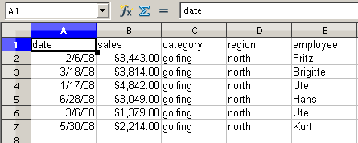
Figure 61: New table sheet after the drill down for a value in a data field

Filtering
To limit the Pivot Table analysis to a subset of the information that is contained in the data basis, you can filter the Pivot Table.
Note | An Autofilter or default filter used on the source data has no effect on the Pivot Table analysis process. The Pivot Table always uses the complete list that was selected when it was started.

To do this, click Filter on the top left side above the results.
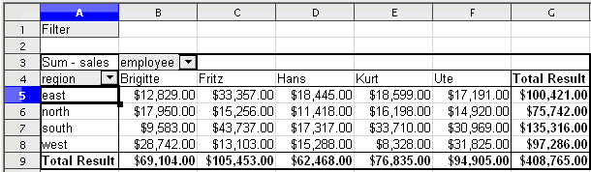
Figure 62: Filter field in the upper left area of the Pivot Table
In the Filter dialog, you can define up to 3 filter options that are used in the same way as Calc’s default filter.
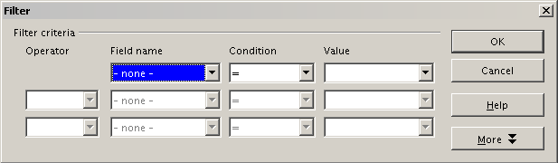
Figure 63: Dialog for defining the filter
Note | Even if they are not called a filter, page fields are a practical way to filter the results. The advantage is that the filtering criteria used are clearly visible.

Updating (refreshing) changed values
After you have created the Pivot Table, changes in the source data do not cause an automatic update in the resulting table. You have to update (refresh) the Pivot Table manually after changing any of the underlying data values or inserting new data rows.
Changes in the source data could appear in two ways:
- The content of existing data sets has been changed.
For example, you might have changed a sales value afterward. To update the Pivot Table, right-click in the result area and choose Refresh (or choose Data > Pivot Table > Refresh from the menu bar).
- You have added or deleted data sets in the original list.
In this case the change means that the Pivot Table has to use a different area of the spreadsheet for its analysis. If you insert the data within the currently used data range, for example, by using the menu Insert > Cells, you can update the Pivot Table result using the Refresh option. If you simply type data into cells outside of the original area, you must redo the Pivot Table from the beginning.

Cell formatting
The cells in the results area of the Pivot Table are automatically formatted in a simple format by Calc. You can change this formatting using all the tools in Calc, but note that if you make any change in the design of the Pivot Table or any updates, the formatting will return to the format applied automatically by Calc.
For the number format in the data field, Calc uses the number format that is used in the corresponding cell in the source list. In most cases, this is useful (for example, if the values are in the currency format, then the corresponding cell in the result area is also formatted as currency). However, if the result is a fraction or a percentage, the Pivot Table does not recognize that this might be a problem; such results must either be without a unit or be displayed as a percentage. Although you can correct the number format manually, the correction stays in effect only until the next update.

Multiple data fields
Until now we have assumed that the layout of the Pivot Table contains only one data field. However, it is possible to have several data fields in the middle of the layout. This makes summaries and analyses of multiple aspects possible.
You could, for example, list all the sales values per day and additionally give the number of entries per day. To do this, put both the sales field and the date field into the Data Fields area. For the date field, choose the Count option for the aggregate function (see Figure 64).
Since every entry has a specific date, this field will give you the number of entries for each date. If you group the values per month, you get an overview with the sales value and the number of closed sales for each category and month (see Figure 65).
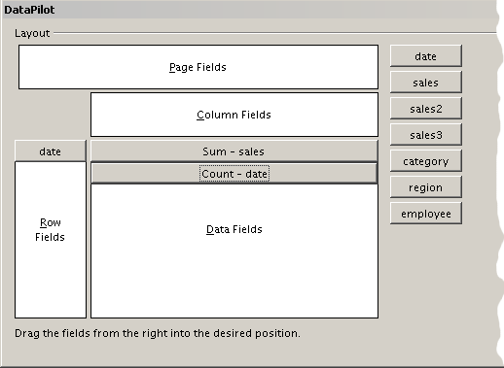
Figure 64: Multiple data fields in the Pivot Table
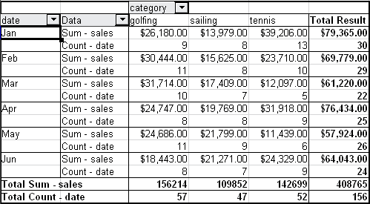
Figure 65: Pivot Table shows sales value and number of entries
When using multiple data fields, the Pivot Table result area contains a field called Data to allow for manipulating the existing data fields. You can move this field just like any other row or column field by using drag and drop. This is an easy way to achieve different structures for the results (see Figures 66 and 67; drag and drop the Data field onto the date field label, or onto the category field label).
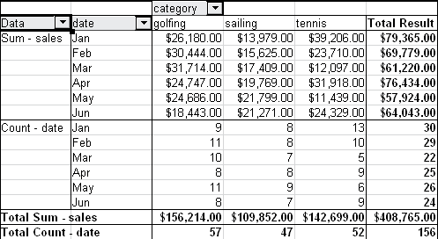
Figure 66: Layout option for presenting the sums and numbers of the sales values
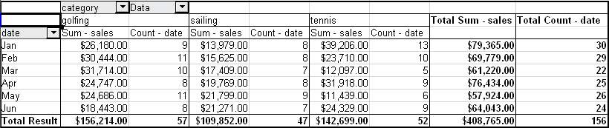
Figure 67: Another layout option for presenting the sums and numbers of the sales values
If you want to put the different data fields in different columns and your Pivot Table does not contain another column field, or you sort the different data fields in different rows and don’t have another row field, then it is useful to disable the view of the row or column sums. Just drag the category field label up to the Filter area.
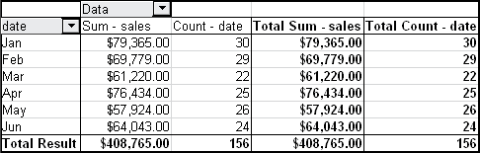
Figure 68: Unnecessary columns
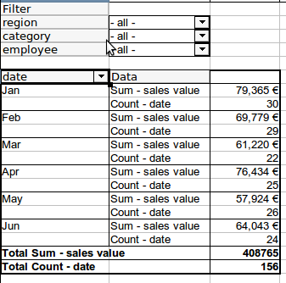
Figure 69: Disabled column sums
A frequent use case for multiple data fields is the aggregation of one value according to different aggregate functions at the same time. You can create a Pivot Table that shows you the monthly sales values and shows you additionally the smallest and the largest amounts.
To do this during the Pivot Table creation, after you drag the sales button to the Data Fields area, double click on it to open the Data Field Options dialog. Hold the Ctrl key while you click on the various aggregation function. Figure 70 shows the selection of the Sum, Max and Min function for the sales field.
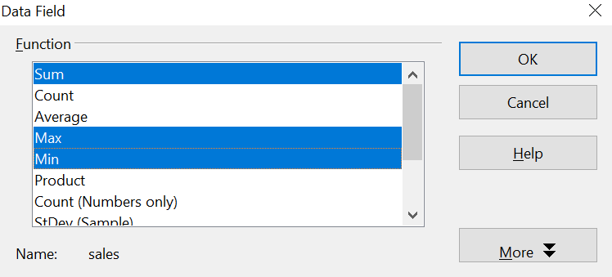

Figure 70: Multiple analyses for the same data field

After you click OK in the Data Field dialog, the Pivot Table dialog will show Result – sales, as shown in Figure 71.
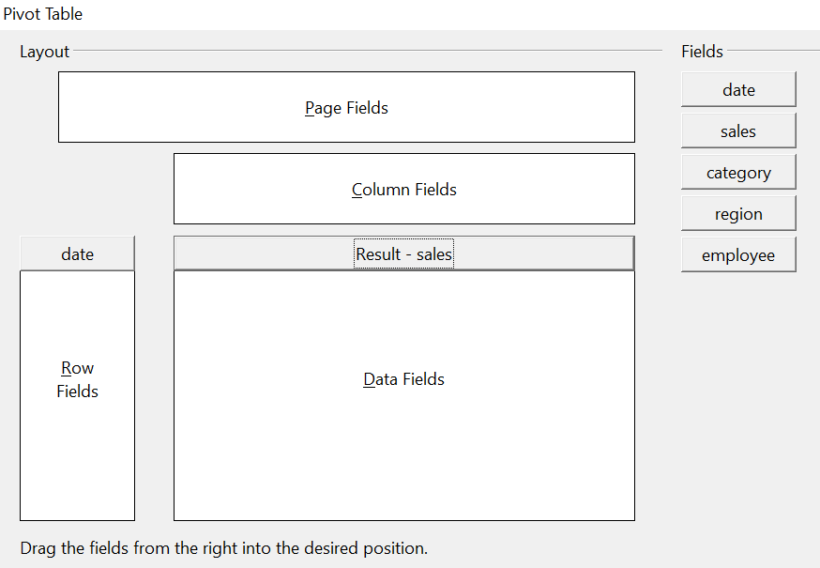
Figure 71: Pivot Table dialog after choosing multiple functions
The resulting Pivot Table, after grouping by month is shown in Figure 72
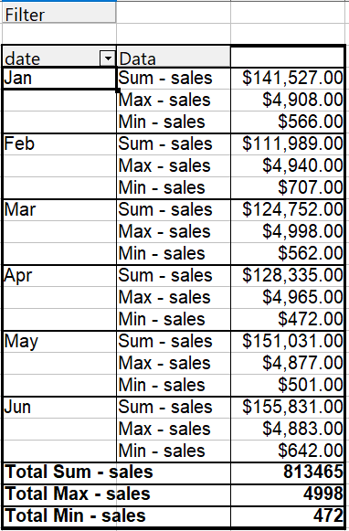

Figure 72: Sum, Max, and Min of the sales data

Shortcuts
If you use Pivot Tables very often, you might find the frequent use of the menu paths (Data > Pivot Table > Create and Data > Group and Outline > Group) inconvenient.
For grouping, a shortcut is already defined: F12. For creating the Pivot Table, you can define your own keyboard shortcut. If you prefer to have toolbar icons instead of keyboard shortcuts, you can create a user-defined symbol and add it to either your own custom made toolbar or the Standard toolbar.
For an explanation how to create keyboard shortcuts or add icons to toolbars, see Chapter 14 (Setting Up and Customizing Calc).

Function GETPIVOTDATA
The function GETPIVOTDATA can be used with formulas in Calc if you want to reuse the results from the Pivot Table elsewhere in your spreadsheet.

Difficulty
Normally you create a reference to a value by entering the address of the cell that contains the value. For example, the formula =C6*2 creates a reference to cell C6 and returns the doubled value.
If this cell is located in the results area of a Pivot Table, it contains the result that was calculated by referencing specific categories of the row and column fields. In Figure 73, the cell C6 contains the sum of the sales values of the employee Hans in the category Sailing. The formula in the cell C12 uses this value.
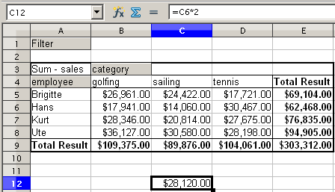
Figure 73: Formula reference to a cell of the Pivot Table
If the underlying data or the layout of the Pivot Table changes, then you must take into account that the sales value for Hans might appear in a different cell. Your formula still references the cell C6 and therefore uses a wrong value. The correct value is in a different location. For example, in Figure 74, the location is now C7 because the employee Fritz is included in the Pivot Table.
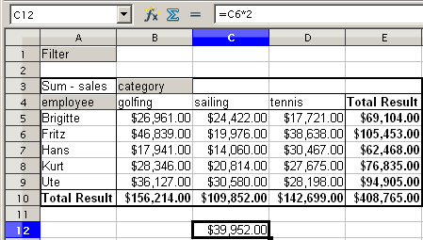
Figure 74: The value that you really want to use can be found now in a different location.
The function GETPIVOTDATA allows you to have a reference to a value inside the Pivot Table by using the specific identifying categories for this value.

Syntax
The syntax has two variations:
GETPIVOTDATA(target field, pivot table; [ Field name / Element; ... ])
GETPIVOTDATA(pivot table; specification)

First syntax variation
The target field to specify which data field of the Pivot Table is used within the function. If your Pivot Table has only one data field, this entry is ignored, but you must enter it anyway.
If your Pivot Table has more than one data field, then you have to enter the field name from the underlying data source (for example “sales”) or the field name of the data field itself (for example “sum – sales”).
The argument pivot table specifies the Pivot Table that you want to use. It is possible that your document contains more than one Pivot Table. Enter here a cell reference that is inside the results area of your Pivot Table. It might be a good idea to always use the upper left corner cell of your Pivot Table, so you can be sure that the cell will always be within your Pivot Table even if the layout changes.
Example: GETPIVOTDATA("sales";A1)
If you enter only the first two arguments, then the function returns the total result of the Pivot Table (“Sum – sales” as the field will return a value of 408,765).
You can add more arguments as pairs with field name and item to retrieve specific partial sums. In the example in Figure 73, where we want to get the partial sum of Hans for sailing, the formula in cell C12 would look like this:
=GETPIVOTDATA("sales";A1;"employee";"Hans";"category";"sailing")
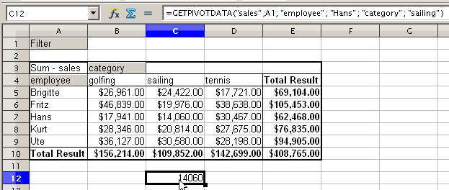Figure 75: First syntax variation

Second syntax variation
The argument pivot table has to be given in the same way as for the first syntax variation.
For the specifications, enter a list separated by spaces to specify the value you want from the Pivot Table. This list must contain the name of the data field, if there is more than one data field, otherwise it is not required. To select a specific partial result, add more entries in the form of Field name[item].
In the example in Figure 73, where we want to get the partial sum of Hans for Sailing, the formula in cell C12 would look like this:
=GETPIVOTDATA(A1;"sales employee[Hans] category[sailing]")
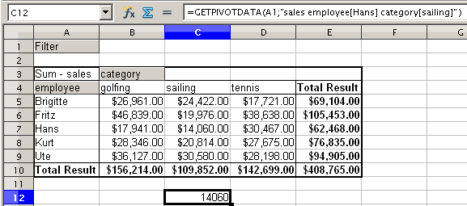Figure 76: Second syntax variation

In this case the word - undefined – is misleading because the output position is in fact defined.

