
Writer Guide

Chapter 10
Working with Templates

Copyright
This document is Copyright © 2005–2010 by its contributors as listed below. You may distribute it and/or modify it under the terms of either the GNU General Public License (http://www.gnu.org/licenses/gpl.html), version 3 or later, or the Creative Commons Attribution License (http://creativecommons.org/licenses/by/3.0/), version 3.0 or later.
All trademarks within this guide belong to their legitimate owners.
Contributors
Alan Madden
Paul Miller
Catherine Waterman
Jean Hollis Weber
Michele Zarri
Preston Bernstein
Feedback
Please direct any comments or suggestions about this document to: authors@documentation.openoffice.org
Publication date and software version
Published 22 October 2010. Based on OpenOffice.org 3.3.

Note for Mac users
Some keystrokes and menu items are different on a Mac from those used in Windows and Linux. The table below gives some common substitutions for the instructions in this chapter. For a more detailed list, see the application Help.
Windows/Linux | Mac equivalent | Effect
Tools > Options menu selection | OpenOffice > Preferences | Access setup options
Right-click | Control+click | Open context menu
Ctrl (Control) | z (Command) | Used with other keys
F5 | Shift+z+F5 | Open the Navigator
F11 | z+T | Open Styles & Formatting window

Contents
Copyright 2
Note for Mac users 2
Introduction 4
Using a template to create a document 4
Creating a template 5
Creating a template from a document 5
Creating a template using a wizard 6
Editing a template 7
Updating a document from a changed template 8
Adding templates with Extension Manager 9
Setting a default template 10
Setting a custom template as the default 10
Resetting Writer’s Default template as the default 11
Associating a document with a different template 11
Organizing templates 12
Creating a template folder 12
Deleting a template folder 12
Moving a template 12
Deleting a template 13
Importing a template 13
Exporting a template 13

Introduction
A template is a model that you use to create other documents. For example, you can create a template for business reports that has your company’s logo on the first page. New documents created from this template will all have your company’s logo on the first page.
Templates can contain anything that regular documents can contain, such as text, graphics, a set of styles, and user-specific setup information such as measurement units, language, the default printer, and toolbar and menu customization.
All documents in OpenOffice (AOO) are based on templates. If you do not specify a template when you start a new Writer document, the document is based on the default template for text documents. If you have not specified a default template, Writer uses the blank template for text documents that is installed with AOO. See “Setting a default template” on page 10 for more information.

Using a template to create a document
To use a template to create a document:
- From the main menu, choose File > New > Templates and Documents. The Templates and Documents dialog box opens. (See Figure 1.)
- In the box on the left, click the Templates icon if it is not already selected. A list of template folders appears in the center box.
- Double-click the folder that contains the template that you want to use. A list of all the templates contained in that folder appears in the center box.
- Select the template that you want to use. You can preview the selected template or view the template’s properties:
  - To preview the template, click the Preview icon . A preview of the template appears in the box on the right.
- To view the template’s properties, click the Document Properties icon . The template’s properties appear in the box on the right.
- Click Open. The Templates and Documents dialog box closes and a new document based on the selected template opens in Writer. You can then edit and save the new document just as you would any other document.
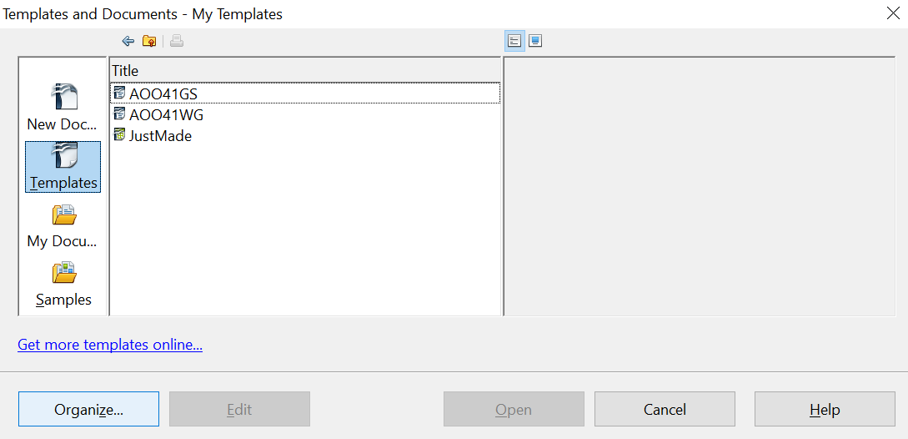

Figure 1. Templates and Documents dialog box

Creating a template
You can create your own templates in two ways: from a document, and using a wizard.

Creating a template from a document
To create a template from a document:
- Open a new or existing document you want to make into a template.
- Add the content and styles that you want.
- From the main menu, choose File > Templates > Save. The Templates dialog box opens (see Figure 2).
- In the New template field, type a name for the new template.
- In the Categories list, select the category to which you want to assign the template. The category is simply the template folder in which you want to save the template. For example, to save the template in the “My Templates” folder, click the My Templates category.
- To learn more about template folders, see “Organizing templates” on page 12.
- Click OK to save the new template.

Figure 2. Saving a new template
Any settings that can be added to or modified in a document can be saved in a template. For example, below are some of the settings (although not a full list) that can be included in a Writer document and then saved as a template for later use:
- Printer settings: which printer, single-sided or double-sided printing, paper size, and so on.
- Styles to be used, including character, page, frame, numbering, and paragraph styles.
- Format and settings regarding indexes, tables, bibliographies, table of contents.
Templates can also contain predefined text, saving you from having to type it every time you create a new document. For example, a letter template may contain your name, address and salutation.
You can also save menu and toolbar customizations in templates; see Chapter 14 (Customizing OpenOffice) for more information.

Creating a template using a wizard
You can use wizards to create Writer templates for letters, faxes, and agendas.
For example, the Letter Wizard steps you through the following choices:
- Type of letter (business, formal personal or personal)
- Document elements like the date, subject line (business or formal letters), salutation, and complimentary close
- Options for sender and recipient information (business or formal personal letters)
- Text to include in the footer (business or formal personal letters)
To create a template using a wizard:
- From the main menu, choose File > Wizards > [type of template required].

Figure 3: Creating a template using a wizard
- Follow the instructions on the pages of the wizard. This process is slightly different for each type of template, but the format is similar for all of them.
- In the last section of the wizard, you can specify the name and location for saving the template. The default location is your user templates directory, but you can choose a different location if you prefer.
- Finally, you have the option of creating a new document from your template immediately, or manually changing the template. For future documents, you can re-use the template created by the wizard, just as you would use any other template.

Editing a template
You can edit a template’s styles and content, and then, if you wish, you can reapply the template’s styles to documents that were created from that template. (Note that you can only reapply styles. You cannot reapply content, except for content in headers and footers.)
To edit a template:
- From the main menu, choose File > Templates > Organize. The Template Management dialog box opens (see Figure 4).
- In the box on the left, double-click the folder containing the template that you want to edit. A list of all the templates contained in that folder appears underneath the folder name.
- Select the template that you want to edit.
- Click the Commands button and choose Edit from the drop-down menu.
- Edit the template just as you would any other document. To save your changes, choose File > Save from the main menu.
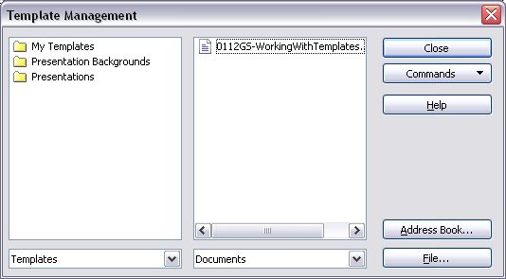
Figure 4. Template management dialog box

Updating a document from a changed template
The next time that you open a document that was created from the changed template, a message similar to the following appears.
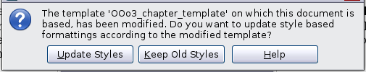
Figure 5. Update styles message
Click Update Styles to apply the template’s changed styles to the document. Click Keep Old Styles if you do not want to apply the template’s changed styles to the document (but see Caution notice below).
Caution   | If you choose Keep Old Styles in the message box shown in Figure 5, that message will not appear again the next time you open the document after changing the template it is based on. You will not get another chance to update the styles from the template, although you can use the macro given in the Note below to re-enable this feature.  You can also use the Template Changer extension (see page 11) to reactivate the template.
Note | To re-enable updating from a template:  - Use Tools > Macros > Organize Macros > OpenOffice Basic. Select the document from the list, click the expansion symbol (+ or triangle), and select Standard. If Standard has an expansion symbol beside it, click that and select a module.  - If the Edit button is active, click it. If the Edit button is not active, click New.  - In the Basic window, enter the following:  Sub FixDocV3  ' set UpdateFromTemplate  oDocSettings = ThisComponent.createInstance( _  "com.sun.star.document.Settings" )  oDocSettings.UpdateFromTemplate = True  End Sub 'FixDocV3  - Click the Run BASIC icon, then close the Basic window.  - Save the document.  Next time when you open this document you will have the update from template feature back.

Adding templates with Extension Manager
The Extension Manager provides an easy way to install collections of templates, graphics, macros, or other add-ins that have been “packaged” into files with a .OXT extension. See Chapter 16 (Customizing Writer) for more about the Extension Manager.
This Web page lists many of the available extensions: https://extensions.openoffice.org/.
To install an extension, follow these steps:
- Download the extension package and save it anywhere on your computer.
- In Writer, select Tools > Extension Manager from the menu bar. In the Extension Manager dialog box, click Add.
- A file browser window opens. Find and select the package of templates you want to install and click Open. The package begins installing. You may be asked to accept a license agreement.
- When the package installation is complete, restart OpenOffice. The templates are available for use through File > New > Templates and Documents and the extension is listed in the Extension Manager.
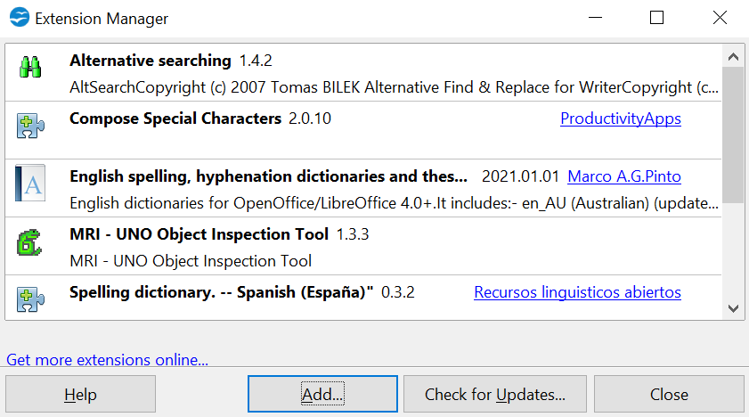
Figure 6: Newly-added package of templates

Setting a default template
If you create a document by choosing File > New > Text Document from the main menu, Writer creates the document from the Default template for text documents. You can, however, set a custom template to be the default. You can reset the default later if you choose.

Setting a custom template as the default
You can set any template to be the default, as long as it is in one of the folders displayed in the Template Management window. If necessary, you can add the template to a folder as described in “Importing a template” on page 13.
To set a custom template as the default:
- From the main menu, choose File > Templates > Organize. The Template Management dialog box (Figure 4) opens.
- In the box on the left, select the folder that contains the template that you want to set as the default, then select the template.
- Click the Commands button and choose Set as Default Template from the drop-down menu.
The next time that you create a document by choosing File > New > Text Document, the document will be created from this template.
Although many important settings can be changed in the Options dialog (see Chapter 2), for example default fonts and page size, more advanced settings (such as page margins) can only be changed by replacing the default template with a new one.

Resetting Writer’s Default template as the default
To re-enable Writer’s Default template as the default:
- In the Template Management dialog box (Figure 4), select any folder in the box on the left.
- Click the Commands button and choose Reset Default Template > Text Document from the drop-down menu.
The next time that you create a document by choosing File > New > Text Document, the document will be created from Writer’s Default template.

Associating a document with a different template
At times you might want to associate a document with a different template, or perhaps you’re working with a document that did not start from a template.
One of the major advantages of using templates is the ease of updating styles in more than one document, as described in Chapter 7 (Working with Styles). If you update styles by loading a new set of styles from a different template (as described in Chapter 7), the document has no association with the template from which the styles were loaded—so you cannot use this method. What you need to do is associate the document with the different template.
You can do this in two ways. In both cases, for best results the names of styles should be the same in the existing document and the new template. If they are not, you will need to use Search and Replace to replace old styles with new ones. See Chapter 3 (Working with Text) for more about replacing styles using Search and Replace.
Method 1
This method includes any graphics and wording (such as legal notices) that exists in the new template, as well as including styles. If you don’t want this material, you need to delete it.
- Use File > New > Templates and Documents. Choose the template you want. A new file is created from the template. If the template has unwanted text or graphics in it, delete them from this new file.
- Open the document you want to change. (It opens in a new window.) Press Control+A to select everything in the document. Paste into the blank document created in step 1.
- Update the table of contents, if there is one. Save the file.
Method 2
This method does not include any graphics or text from the new template, except material in headers and footers; it simply includes styles from the new template and establishes an association between the template and the document.
- Download the Template Changer extension from https://extensions.openoffice.org/ and install it as described on page 9.
- Close and reopen OpenOffice. Now the File > Templates menu has two new choices: Assign Template (current document) and Assign Template (folder).
- Open the document whose template you want to change. Choose File > Templates > Assign Template (current document).
- In the Select Template window, find and select the required template and click Open.
- Save the document. If you now look in File > Properties, you will see the new template listed at the bottom of the General page.

Organizing templates
Writer can only use templates that are in AOO template folders. You can, however, create new AOO template folders and use them to organize your templates. For example, you might have one template folder for report templates and another for letter templates. You can also import and export templates.
To begin, choose File > Templates > Organize from the main menu. The Template Management dialog box (Figure 4) opens.
Note | All the actions made by the Commands button in the Template Management dialog box can be made as well by simply right-clicking on the templates or the folders.

Creating a template folder
To create a template folder:
- In the Template Management dialog box, select any folder.
- Click the Commands button and choose New from the drop-down menu. A new folder called Untitled appears.
- Type a name for the new folder, and then press Enter. Writer saves the folder with the name that you entered.

Deleting a template folder
You cannot delete template folders supplied with AOO or installed using the Extension Manager; you can only delete template folders that you have created. (If you have administrator privileges, you can delete any folder.)
To delete a template folder:
- In the Template Management dialog box, select the folder that you want to delete.
- Click the Commands button and choose Delete from the drop-down menu. A message box appears and asks you to confirm the deletion. Click Yes.

Moving a template
To move a template from one template folder to another template folder:
- In the Template Management dialog box, double-click the folder that contains the template that you want to move. A list of all the templates contained in that folder appears underneath the folder name.
- Click the template that you want to move and drag it to the desired folder. If you do not have the authority to delete templates from the source folder, this action copies the template instead of moving it.

Deleting a template
You cannot delete templates supplied with AOO or installed using the Extension Manager; you can only delete templates that you have created. (If you have administrator privileges, you can delete any template.)
To delete a template:
- In the Template Management dialog box, double-click the folder that contains the template that you want to delete. A list of all the templates contained in that folder appears underneath the folder name.
- Click the template that you want to delete.
- Click the Commands button and choose Delete from the drop-down menu. A message box appears and asks you to confirm the deletion. Click Yes.

Importing a template
If the template that you want to use is in a different location, you must import it into an AOO template folder.
To import a template into a template folder:
- In the Template Management dialog box, select the folder into which you want to import the template.
- Click the Commands button and choose Import Template from the drop-down menu. A standard file browser window opens.
- Find and select the template that you want to import, and then click Open. The file browser window closes and the template appears in the selected folder.
- If you want, type a new name for the template, and then press Enter.

Exporting a template
To export a template from a template folder to another location:
- In the Template Management dialog box, double-click the folder that contains the template that you want to export. A list of all the templates contained in that folder appears underneath the folder name.
- Select the template that you want to export.
- Click the Commands button and choose Export Template from the drop-down menu. The Save As window opens.
- Find the folder into which you want to export the template and click Save.

