Apache Open Office
Version 4.1
Writer Guide
AOO Documentation Team

Chapter 11
Using Mail Merge
Form letters, mailing labels, and envelopes

Copyright
This document is Copyright © 2023 by The Apache® Software Foundation . You may distribute it and/or modify it under the terms of the Creative Commons Attribution License (https://creativecommons.org/licenses/by/3.0/), version 3.0 or later.
All trademarks within this guide belong to their legitimate owners.
Acknowledgments
This document is updated from a previous version by OOoAuthors.

Feedback
Please direct any comments or suggestions about this document to: :doc@openoffice.apache.org
Publication date and software version
Published <date>. Based on Apache OpenOffice 4.1.

Note for Mac Users
Some keystrokes and menu items are different on a Mac from those used in Windows and Linux. The table below gives some common substitutions for the instructions in this chapter. For a more detailed list, see the application Help.
Windows/Linux | Mac equivalent | Effect
Tools > Options menu selection | OpenOffice > Preferences | Access setup options
Right-click | Control+click | Open context menu
Ctrl (Control) | z (Command) | Used with other keys
F5 | Shift+z+F5 | Open the Navigator
F11 | z+T | Open Styles & Formatting window

Contents
Chapter 11
Using Mail Merge 1
Copyright 2
Note for Mac users 2
What is mail merge? 4
Creating the data source 4
Registering a data source 5
Creating a form letter 8
Editing merged documents 12
Printing mailing labels 13
Preparing for printing 13
Removing blank lines from labels 15
Printing 16
Editing a saved file of mailing labels 16
Printing envelopes 17
Setting up envelopes for printing 17
Merging and printing the envelopes 21
Creating an envelope template 21
Using the Mail Merge Wizard to create a form letter 21
Step 1: Select starting document 22
Step 2: Select document type 23
Step 3: Insert address block 23
Step 4: Create salutation 28
Step 5: Adjust layout 28
Step 6: Edit document and insert extra fields 29
Step 7: Personalize documents 31
Step 8: Save, print or send 31

What is Mail Merge?
Apache OpenOffice (AOO) Writer provides very useful features to create and print:
- Multiple copies of a document to send to a list of different recipients (form letters)
- Mailing labels
- Envelopes
All these capabilities, though different in application, are based around the same concept – that of a registered “data source”, from which Writer determines the information necessary to complete each individual member of a set of documents.
This chapter describes the entire process. The steps include:
- How to create and register a data source.
- How to create and print form letters, mailing labels, and envelopes.
- Optionally, how to save the output in an editable file, instead of printing it directly.

Creating the Data Source
A data source is a database containing the name and address records (and optionally other information) from which a mailing list can be created. Although you can produce and print mailing labels and envelopes without using a data source, in most cases using one is the optimal approach. This chapter assumes that you are using a data source.
AOO can access a wide variety of such sources, including spreadsheets, text files and databases such as MySQL. If the information to be used in the mail merge is currently in a format that AOO cannot access directly, you need to convert it, for example by exporting it to a comma-separated values (CSV) file.
For the following example we use a spreadsheet with the following column (field) headers: Title, First name, Last name, Address, State/County, Country, Post Code, Gender, Points. A sample data source is shown in Figure 1.
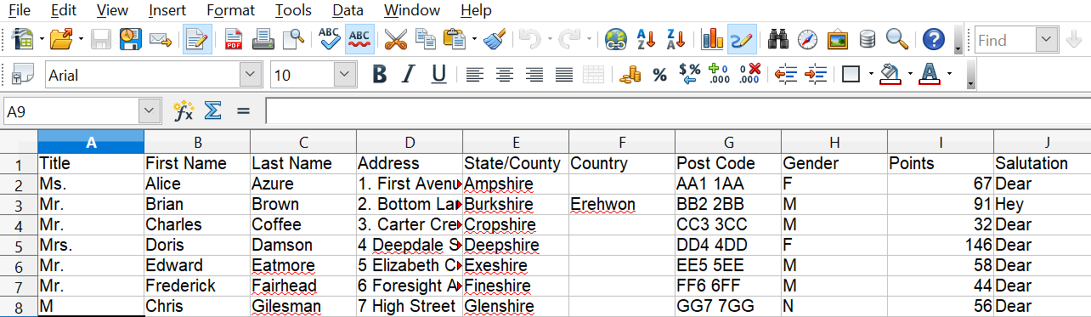

Figure 1: Spreadsheet data source

Registering a Data Source
For a data source to be directly accessible from within a Writer document, it must first be registered as described below. You only need to do this once. Having done so, the data source is available to all documents in OpenOffice.
- From within any OpenOffice document, or from the OpenOffice Start Center, choose File > Wizards > Address Data Source.
- The choices on the first page of the wizard vary with your operating system. Select the appropriate type of external address book. In this example, it is Other external data source. Click Next.
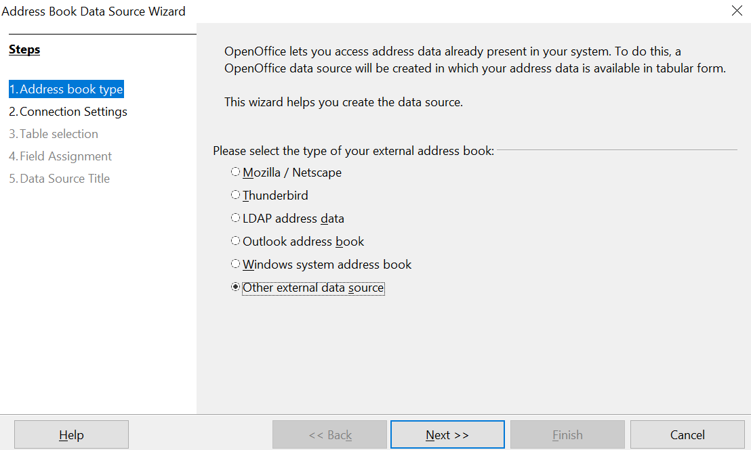

Figure 2: Select type of external address book
- On the next page of the Wizard, click the Settings button.
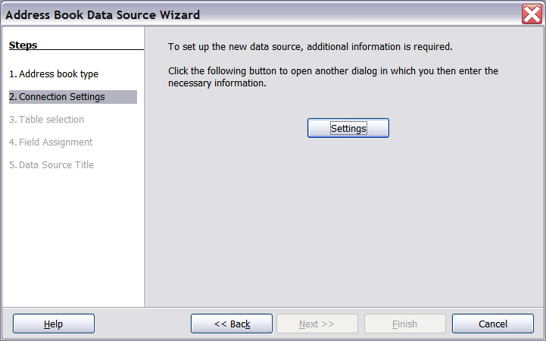

Figure 3: Starting the Settings part of the Wizard
- In the Data Source Properties page, select the Database type. In our example, it is Spreadsheet. Click Next.
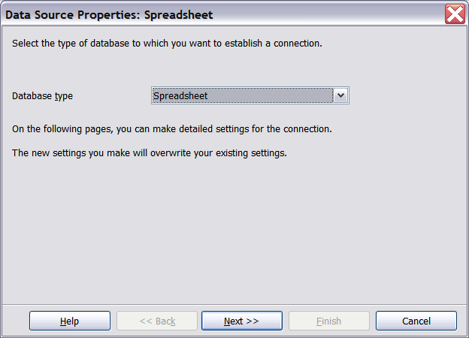

Figure 4: Selecting the database type
- In the next dialog box, click Browse and navigate to the spreadsheet that contains the address information. Select the spreadsheet and click Open to return to this dialog box. At this time you may wish to test that the connection has been correctly established by clicking on the Test Connection button.
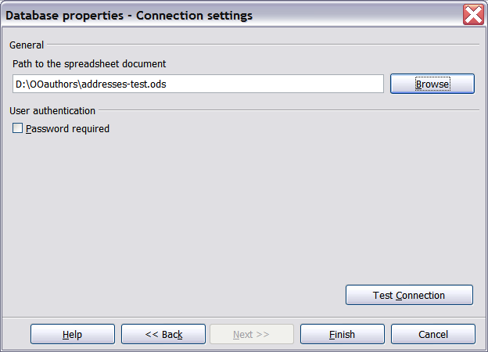

Figure 5: Selecting the spreadsheet document
- Click Finish.
- On the following page, click Next. Because this is a spreadsheet, do not click Field Assignment.
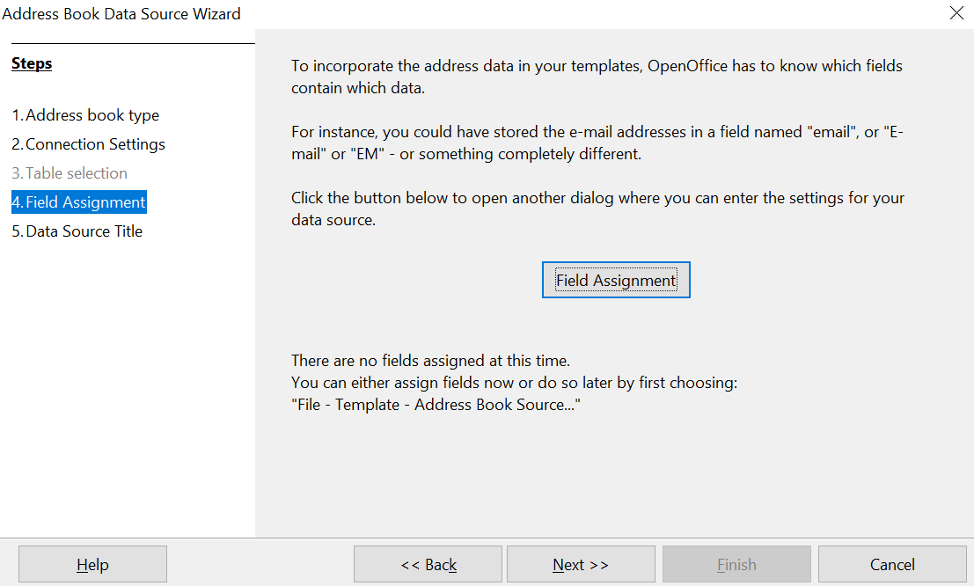

Figure 6: Because this is a spreadsheet, do not click Field Assignment
- Name the file in the Location field. The default is …\Addresses.odb; but you may replace Addresses with another name if you wish. You may also change the name in the “Address book name” field. In our example, the name “Points” was used for both.
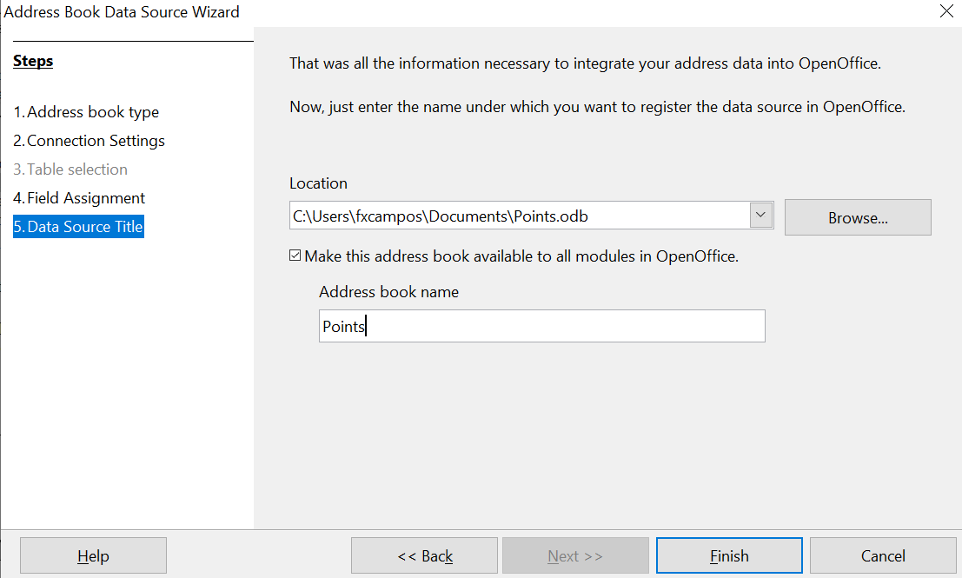
Figure 7: Name the .odb file and the address book
- Click Finish. The data source is now registered.

Creating a Form Letter
Example: Sending a letter to your customer base
A mail order company organized a campaign to assign credit points to their customers according to the quantity of goods they buy during one year.
At the end of the year, they want to send a letter to each customer to show the total of credit points collected.
Creating a form letter manually is the simplest and most comprehensive method; it's described here. Or, you can use the Mail Merge wizard as described in “Using the Mail Merge Wizard to Create a Form Letter” starting on page 21. If you elect to use the wizard, pay close attention to its current limitations, identified within its description.
- Create a new text document: File > New > Text Document, or open a pre-existing form letter with File > Open.
- Display the registered data sources: View > Data sources (or press F4).
- Find the data source that you wish to use for the form letter, in this case Points. Expand the Points and Tables folders, and select Sheet1. The address data file is displayed.
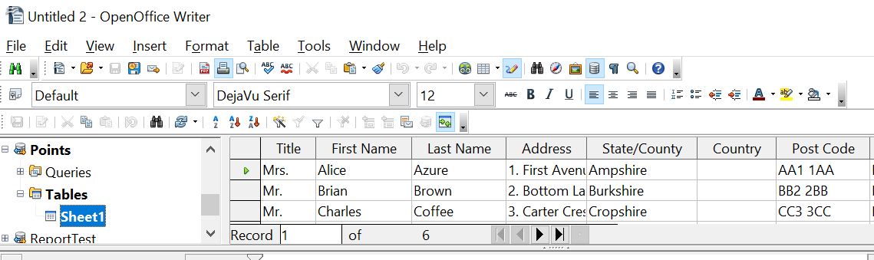

Figure 8: Selecting the data source
- Now create or modify the form letter by typing in the text, punctuation, line breaks, and so on that will be present in all the letters.
- To add the mail-merge fields where needed (such as names and addresses), click in the field heading and drag it to the appropriate point in the letter.
Note that address lines should be in individual paragraphs made with the Enter key, not separated by line breaks made with Shift + Enter. This allows suppressing blank lines, as explained below.

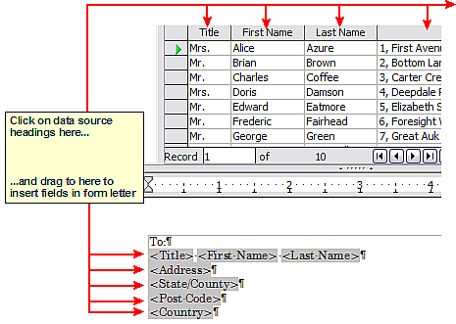
Figure 9: Dragging fields to the body of the form letter
- Continue until you have composed the entire document. At this time you may wish to consider suppressing any blank lines that may appear in the resulting letters. If not, skip Step 7.
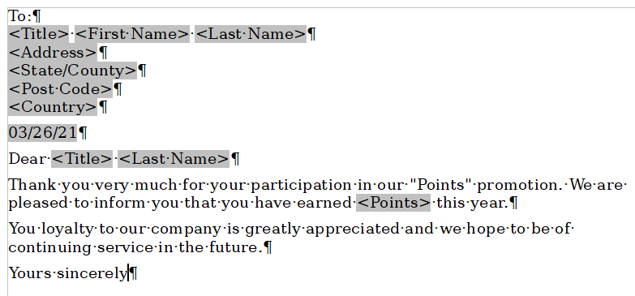
Figure 10: The completed form letter
- To suppress blank lines:
  - Click at the end of the first paragraph to be suppressed and then choose Insert > Fields > Other.
  - Select the Functions tab and then click on Hidden Paragraph in the Type column.
  - Now click in the Condition box and enter the details of the condition that defines a blank address field. It has the general form of:
![Database.Table.Database field]
where the ‘!’ (NOT) character indicates the negative case, that is, the inverse of the stated condition, and the square brackets indicate the condition.
For example, in our Points database the condition to test if the Last Name field is empty would be:
![Points.Sheet1.Last Name] as illustrated in Figure 11.
To test for multiple conditions use the operators AND and/or OR between the conditional statements, for example:
![Points.Sheet1.Title]AND![Points.Sheet1.Last Name]
  - Click Insert, but do not close the dialog box until you have amended all the lines that should be suppressed.

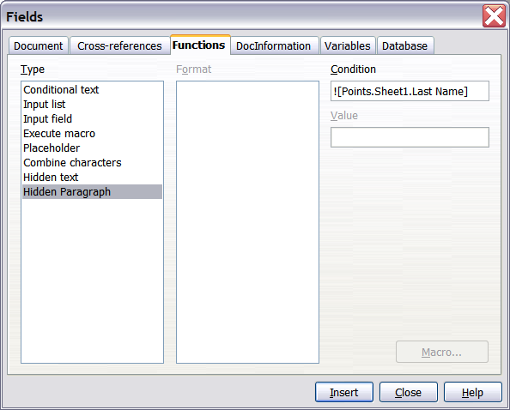
Figure 11: Hidden paragraph insertion
The document is now ready to be printed.

- Choose File > Print and respond with Yes in the message box.
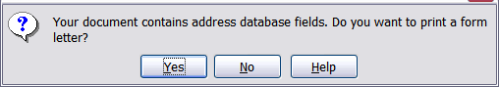
Figure 12: Confirmation message for merging database fields
- In the Mail Merge dialog box (Figure 13), you can choose to print all records or selected records. To select records to be printed, use Ctrl+click to select individual records. To select a block of records, select the first record in the block, scroll to the last record in the block, and Shift+click on the last record.
- Click OK to send the letters directly to the printer. Or, you can save the letters to a file for further editing or formatting; see “Editing Merged Documents” below.
- If you have not saved the original, prototype form letter document (template) previously, do so now. Having a form letter template could greatly simplify the creation of other form letters in the future and is highly recommended.
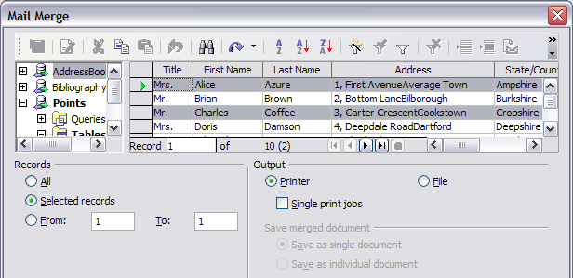Figure 13: The Mail Merge dialog box

Editing Merged Documents
You may prefer to save the letters to a file, to allow for proofreading or some later formatting. To do this:
- In the Mail Merge dialog box (Figure 13), select File in the output section, instead of using the default Printer selection.
- This changes the dialog box to display the Save merged document section, where Save as single document is preselected. You can choose to save each letter as an individual document instead.
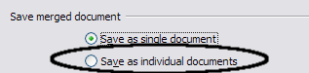
- Click OK. In the Save as dialog box, enter a file name for the saved letters and choose a folder in which to save them. The letters will be saved consecutively as separate pages in the single document, or numbered consecutively in individual files if saved as separate documents.
You can now open the letters and edit them individually as you would edit any other document.

Printing Mailing Labels
Before beginning this process, note the brand and type of labels you intend to use.

Preparing for Printing
To prepare mailing labels for printing:
- Choose File > New > Labels.
- On the Options tab, ensure that the Synchronize contents option is selected.
- On the Labels tab (Figure 14), select the Database and Table. Select the Brand of labels to be used, and then select the Type of label.
Tip | If the type of label you wish to use is not on the list, use the Format tab to define a new Brand and Type. This is beyond the scope of this document, but is relatively simple to implement, if you know the dimensions of the label.

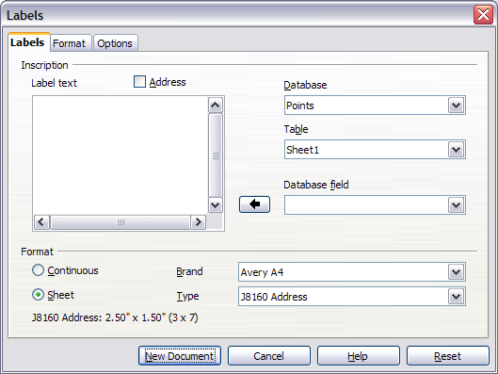
Figure 14: Select Database, Table, label Brand, and label Type
- Click the drop-down arrow under Database field. Select the first field to be used in the label (in this example, Title). Click the left arrow button to move this field to the Label text area, as shown in Figure 15.
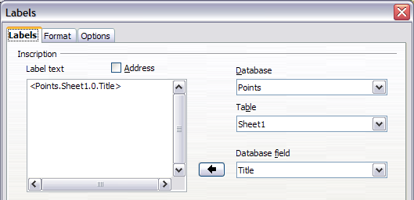
Figure 15: Move fields from Database field list to Label text area
- Continue adding fields and inserting desired punctuation, spaces, and line breaks until the label is composed. Figure 16 shows the completed label.
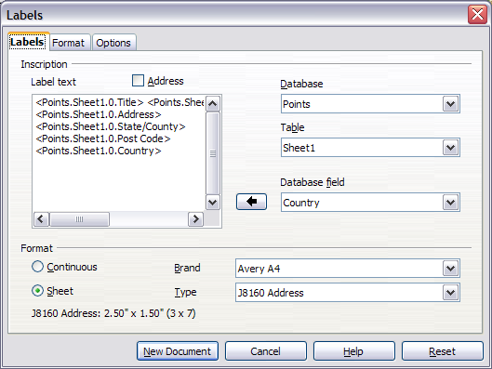Figure 16: The completed label
- Click New Document. You now have a new, single-page document containing a series of frames, one for each label of the selected type and filled with the data source address fields that you selected. Quite often some fields in your address data source will be unused, leading to blank lines in your labels. If this is not important, go to “Printing” on page 16; otherwise, follow the instructions in “Removing Blank Lines from Labels” on page 16.

Removing Blank Lines from Labels
- First ensure that the label frames are showing the field contents (data source headings), rather than their underlying field names. If this is not the case, then either press Ctrl+F9 or choose View > Field Names to toggle the view.
- Next, ensure that you can see non-printing characters, such as paragraph marks, line breaks and so on. If these are not already visible, choose View > Nonprinting Characters from the menu bar, or press Ctrl+F10, or click on the paragraph icon in the Standard toolbar.
You will now see that address field separation is created by line breaks , rather than paragraphs . As the suppression of blank address fields depends on hiding paragraphs, not lines, you need to replace line breaks with paragraphs as follows.
- Click in the first label, at the end of the last data source address field in the first line of the label. Press Delete to remove the new line character and then press Return (or the Enter key) to insert a paragraph marker. Repeat this action for each line in the address.
If the line spacing in the first label is not satisfactory, you may wish to correct this before proceeding, by modifying the paragraph style associated with the address. Unless you have changed it, the address uses the Default style.
Caution   | The objective of step 3 is to replace all line breaks at the end of data source address fields with paragraphs. Sometimes the address data field may be longer than the width of the label and will wrap to the next physical line: make sure that you are not misled by this into deleting and replacing anything other than line break characters.

- Click again at the end of the first paragraph to be conditionally suppressed and then choose Insert > Fields > Other. Select the Functions tab and then click on Hidden Paragraph in the Type column. Now click in the Condition box and enter the details of the condition that defines a blank address field. It has the general form of:
![Database.Table.Database field]
where the ‘!’ (NOT) character indicates the negative of the condition contained by the square brackets.
For example, in our Points database the condition to test if the Last Name field is empty would be
![Points.Sheet1.Last Name] as illustrated in Figure 11.
To test for multiple conditions, use the operators AND and/or OR between the conditional statements, for example:
![Points.Sheet1.Title]AND![Points.Sheet1.Last Name]
Click Insert, but do not close the dialog box until all lines have been amended.
- Repeat for each paragraph to be conditionally suppressed, remembering to advance the cursor to the end of the line in question before changing the last element of the condition and Inserting the result.
Caution | The last paragraph of the label address block ends with a special field, Next record:Database.Table (Next record:Points.Sheet1 in our example), and the Hidden paragraph field MUST be inserted before this field. This can generally be accomplished by clicking at the end of the paragraph and then using the Left Arrow key once to skip back over it.  A clue that you omitted this action is the observation that some records have been skipped and are missing from the final output.

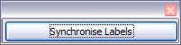
- Remembering that we selected Synchronize contents earlier, you should now be able to see a small window containing a button labeled Synchronize Labels. Click on this button and the hidden paragraph fields are propagated to all the labels in your document.
You now have a template suitable for future use with the same data source and type of label. If you wish to save it, use File > Templates > Save as to save it as an Open Document Text Template (.ott) into the private template directory (folder) that you have previously defined in Tools > Options > OpenOffice > Paths > Templates.

Printing
- Choose File > Print. The message shown in Figure 12 appears. Click Yes.
- In the Mail Merge dialog box (Figure 13), you can choose to print all records or selected records. To select records to be printed, use Ctrl+click to select individual records. To select a block of records, select the first record in the block, scroll to the last record in the block, and Shift+click on the last record.
- Click OK to send the labels directly to the printer.
If you prefer to save the labels to a file, perhaps to allow some later editing such as changing the typeface or paragraph format, then you should select File in the output section of the Mail Merge dialog box, rather than using the default Printer selection. This changes the dialog box to highlight the Save merged document section, where Save as single document is preselected.
In this case, clicking OK brings up the Save as dialog box, where a file name can be entered for the saved labels.
If you did not save the prototype label fields document (template) in step 6 in the previous section, then you are prompted to do so now by another Save as dialog box.
In either case, whether printing or saving to file, despite there apparently being only one page of labels, the printed or saved output will be expanded to include all the selected records from the data source.

Editing a Saved File of Mailing Labels
To edit a saved file of mailing labels, open the saved label file in the normal way. You will be prompted to update all links. Choose No for the following reason: The first label on the page is termed the “Master Label” and all other labels are linked to it. If you update the links, then all labels will end up containing the same data, which may not be what you want.
You can edit individual records in the normal way, by highlighting and changing the font name, for example.
However, you cannot edit all labels globally (for example, to change the font name for all records) by selecting the entire document. To achieve this result you have to edit the paragraph style associated with the label records as follows:
- Right-click any correctly spelled word in a label record. Select Edit Paragraph Style from the pop-up menu. (Note: If you click on a misspelled word, a different menu appears.)
- Then from the Paragraph Style dialog box, you can make changes to the font name, the font size, the indents, and other attributes.

Printing Envelopes
Instead of printing mailing labels, you may wish to print directly onto envelopes. There are two basic ways to create envelopes, one where the envelope is embedded within a letter, generally as the first page (Insert in the Envelope dialog box), and another where the envelope is an independent document (New Doc. in the dialog box). In each case the addressing data may be manually entered, for example by copying and pasting from the letter with which it is associated, or it may originate within an address data source.
This section assumes the use of an address data source and, for convenience, a freestanding envelope.
The production of envelopes involves two steps, setup and printing, as described in this section.

Setting up Envelopes for Printing
- Choose Insert > Envelope from the menu bar.
- In the Envelope dialog box, select the Format tab (Figure 17), where you can select the envelope format to use. You can then arrange the layout of the envelope to suit your requirements, together with the character and paragraph attributes to be used in the Sender and Addressee areas. These attributes are accessed using the Edit buttons to the right of the dialog box, next to the word Format.
Note | If the list of envelope formats in the Size section of this dialog box does not include the size you need, choose User Defined (at the bottom of the list) and specify the envelope size using the Width and Height boxes.

Tip | At this stage it is not possible to vary the dimensions of the frames that will hold the Sender and Addressee information, but once the envelope has been created this will become possible, and you may wish to make some cosmetic adjustments.

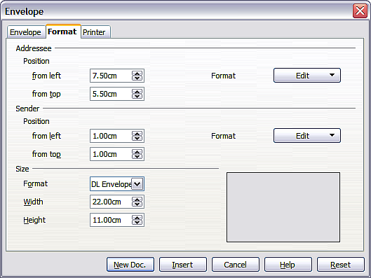
Figure 17: Envelope formatting dialog box
- The next step is to select the Printer tab (Figure 18), from where you may choose the printer you intend to use, its setup—for example, specification of the tray holding envelopes—and other printer-related options such as envelope orientation and shifting. You may need to experiment with these settings to achieve the best results with your printer.
- You now have the choice of creating the Addressee fields by dragging and dropping from the data source headings (as described in “Creating a Form Letter” on page 8, and in particular in Figure 9) or using the facilities of the Envelope tab.
If you prefer dragging and dropping, then click New Doc., drag your data source headings into the Addressee area on your new envelope and skip to step 7), otherwise continue with steps 5 and 6.
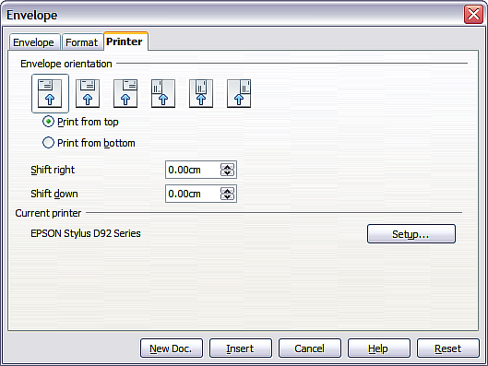
Figure 18: Choosing printer options for an envelope
- Select the Envelope tab (Figure 19).
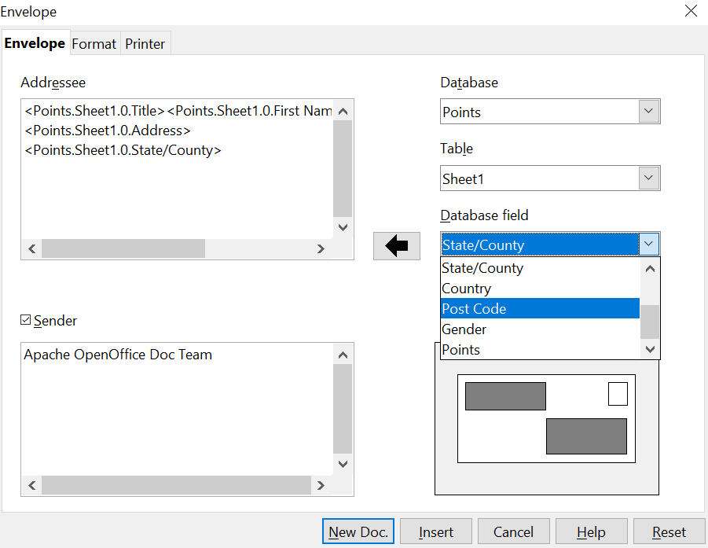

Figure 19: Choosing addressee and sender information for envelopes
Verify, add, or edit the information in the Addressee and Sender boxes (Sender is the “from” on the envelope). You can use the right-hand dropdown lists to select the database and table from which you can access the Addressee information, similarly to that described for “Printing Mailing Labels”, paragraphs 3, 4 and 5 on page 13. The similarity of the method with Figure 15 and Figure 16 will be clear.
- When you have finished formatting, click either the New Doc. or Insert button to finish. As might be expected, New Doc creates only the envelope template in a new document, whereas Insert inserts the envelope into your current document as page 1.
If you don’t want to proceed with this envelope, click Cancel or press the Esc key. You can also click Reset to remove your changes and return to the settings that were present in it when the dialog box opened.
You can now modify the placement of the frames containing the sender and addressee information, or make further changes to the character and paragraph attributes (for example, the font) or add a logo or other graphic to the envelope.
Tip | If you frequently print envelopes from the same database onto the same size envelopes, at this point you may wish to create a template from this setup. See “Creating an Envelope Template” on page 21.

- Quite often some fields in your address data source will be unused, leading to blank lines in your envelope Addressee area. If this is not important, you can skip the next few paragraphs and go directly to “Merging and Printing the Envelopes” on page 21, otherwise continue as described here.
Tip | The following procedure is very similar to that used the section on printing mailing labels. It is reproduced here for ease of reference.

- First ensure that the envelope is showing the field contents (data source headings), rather than their underlying field names. If this is not the case, either press Ctrl+F9 or choose View > Field Names to toggle the view.
  - Next, ensure that you can see non-printing characters, such as paragraph marks, line breaks and so on. If these are not already visible, choose View > Nonprinting Characters from the menu bar, or press Ctrl+F10, or click on the large paragraph icon in the Standard toolbar.
You will now see that address field separation is created by line breaks , rather than paragraphs . Since suppressing blank address fields depends on hiding paragraphs, not lines, you need to replace line breaks with paragraphs as follows.
  - Click at the end of the last data source address field in the first line of the label. Press Delete to remove the new line and then press Return (or the Enter key) to insert a paragraph. Repeat this action for each line of the label.
If the line spacing in the Addressee area is not satisfactory, you may wish to correct this before proceeding, by modifying the paragraph style associated with the address. Unless you have changed it, the address uses the Default style.
  - Click again at the end of the first paragraph to be conditionally suppressed and then choose Insert > Fields > Other. Select the Functions tab and then click on Hidden Paragraph in the Type column. Now click in the Condition box and enter the details of the condition that defines a blank address field. It has the general form of:
![Database.Table.Database field]
where the ‘!’ (NOT) character indicates the negative case and the square brackets indicate the condition.
For example, in our Points database the condition to test if the Last Name field is empty would be:
![Points.Sheet1.Last Name] as illustrated in Figure 11.
To test for multiple conditions, use the operators AND and/or OR between the conditional statements, for example:
![Points.Sheet1.Title]AND![Points.Sheet1.Last Name]
Click Insert, but do not close the dialog box until all lines have been amended.
  - Repeat for each paragraph to be conditionally suppressed, remembering to advance the cursor to the end of the line in question before changing the last element of the condition and Inserting the result.

Merging and Printing the Envelopes
To merge addresses and print the envelopes:
- Choose File > Print. A message box (Figure 12) appears. Click Yes.
- The Mail Merge dialog box (Figure 13) appears. As with form letters and mailing labels, you can choose to print envelopes for one, several or all address records in the database.
- Make your selections and then click OK to print directly to the printer. If you wish to check the envelopes before printing them, see Step 9 of “Creating a Form Letter” on page 8 for instructions.

Creating an Envelope Template
When your envelope layout and fields are complete to your satisfaction, you can save the result as a template.
- Choose File > Templates > Save.
- On the Templates dialog box, type a name for the new template and choose a category in which to store your template.
- Click OK to save the template.

Using the Mail Merge Wizard to Create a Form Letter
The manual method of creating a form letter described in “Creating a Form Letter” on page 8 provides the most control over the result and is therefore recommended. If you prefer to use the Mail Merge wizard, the technique is described below.
Before starting, you should note that the layout made in Step 5 of the Wizard is idiosyncratic, with many paragraph marks to space the address block frame and salutation. Creating a professional looking document requires significant editing.

To begin the process, open a new document with File > New > Text Document and start the Mail Merge wizard using Tools > Mail Merge Wizard. The wizard opens, as shown in Figure 20.

Step 1: Select Starting Document
The wizard gives various options to select your starting document:
- Use the current document.
- Create a new document.
- Start with an existing document.
- Start from a template.
For the purposes of this description, we assume that you opened a new text document. This will ensure that all the steps in the wizard are fully explored, although with experience you may find it more practical to use a draft you prepared earlier, which allows skipping some steps.
Select Use the current document and click Next.
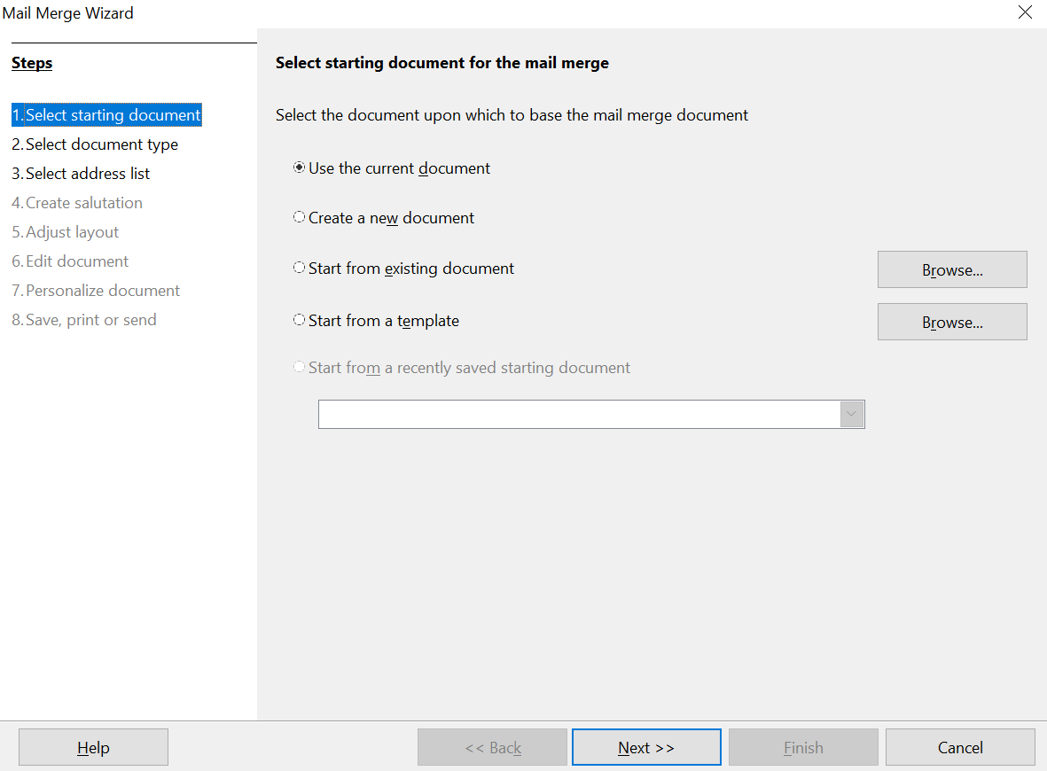

Figure 20: Select starting document

Step 2: Select Document Type
The wizard can produce letters or, if a Java Mail connection exists, email messages. You can see these options in Figure 21. In this example, we are producing a letter. Select Letter and click Next.
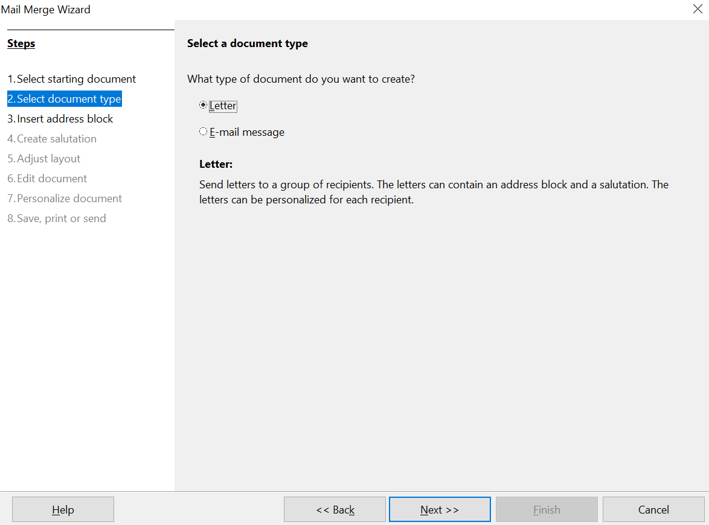

Figure 21: Choose document type

Step 3: Insert Address Block
This is the most complex step in the wizard. In this step (Figure 22) you will do three things:
- Tell the wizard which data source to use. The data source must be an existing file; in this example it is the “Points” spreadsheet created earlier.
- Select the address block to use in the document. This means choosing which fields appear (for example, whether the country is included) and how they look.
- Make sure that the fields all match correctly. This is very important. For example, the wizard has a field called <Last Name>. If your spreadsheet has a column called “Surname”, you need to tell the wizard that <Last Name> and “Surname” are equivalent. This is described in “Matching the Fields” on page 26.
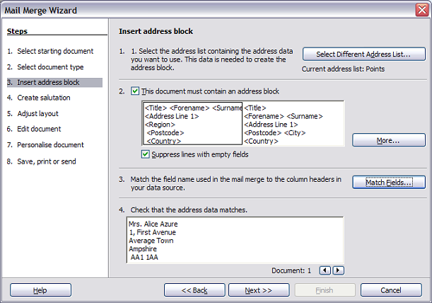Figure 22: Insert address block

Selecting the Data Source (address list)
- If the current address list, identified beneath the Select Different Address List button in section 1, is not the one you wish to use, click the button to open the Select Address List dialog box (Figure 23) for choosing a data source.
- If you have not already created the address list, you may click Create to do so now. This step allows you to create a CSV (Comma Separated Values) file with a new list of address records.
If you already have an address list that is not the one you want to use, click Add and select the file in which it resides.
In each of the above cases a new data source will be created and registered.
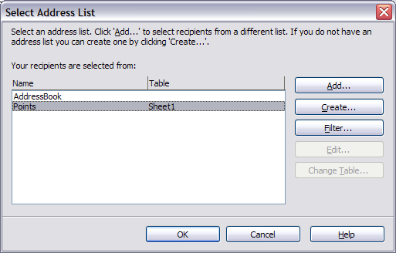Figure 23: Select address list dialog box
- Select the address list and click OK to return to step 3 of the wizard. For this example, the preceding steps are all you need to do. The wizard can also exclude certain records; click Filter to choose them.

Selecting the Address Block
- In step 3 of the wizard (shown in Figure 22), section 2 allows you to. select the address block to appear on the letter, and define its appearance and the fields it contains. The main page gives two examples. If neither of those is exactly what you want, click More to see more choices, in the Select Address Block dialog box (shown in Figure 24).
- The Select Address Block dialog box offers six choices for the format of the address block (scroll down to see the last two choices). You can also optionally include or exclude the country (for example, a resident of England might only include the country if it is not England). The six formats provided are relatively common, but they might not exactly match your preference. If this is the case, select the address block that is closest to what you want and click Edit, which opens the New Address Block dialog box.
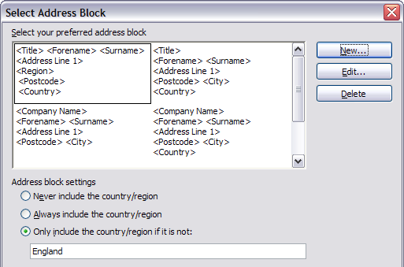
Figure 24: Select address block
- In the New Address Block dialog box (Figure 25), you can add or delete address elements using the arrow buttons on the left. To move elements around, use the arrow buttons on the right. For example, to add an extra space between first and last names in Figure 25, click <Surname> and then click the right arrow button.
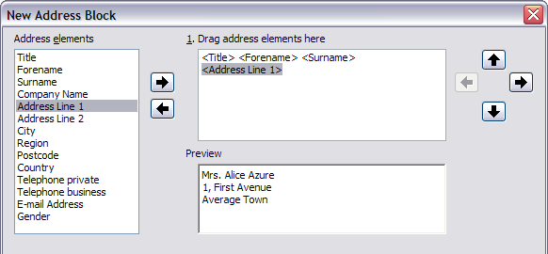Figure 25: New address block

Matching the Fields
Finally, it is time to match the wizard’s fields with the spreadsheet fields, so that items like <Last Name> and “Surname” match correctly.
- Look at section 3 of step 3 of the wizard (shown in Figure 22 on page 24). The box at the bottom displays one record at a time, using the address block format you selected. Use the right and left arrow buttons below that address box to step through the addresses, checking that they display correctly. Do not assume that all the records display correctly, just because one or two do. Check them all if you can, or at least a significant portion.
- If the addresses do not display correctly, (and they may not, right away), click Match Fields, as shown in Figure 26.
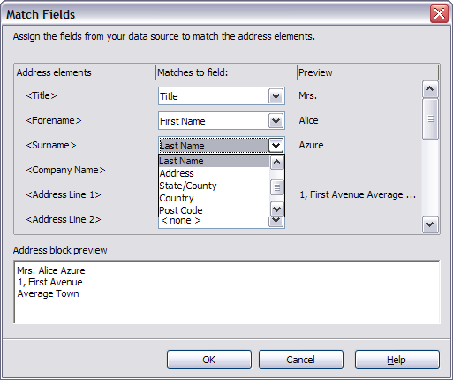Figure 26: Match fields dialog box
The Match Fields dialog box has three columns:
  - Address Elements are the terms the wizard uses for each field, such as <Forename> and <Surname>.
  - Use the Matches to Field column to select, for each address element, the field from your data source that matches it.
  - The Preview column shows what will be shown for this field from the selected address block, so you can double-check that the match is correct.When you have matched all the fields, click OK to return to step 3 of the wizard. Now, when you use the arrow buttons to look at all the addresses, they should all look correct. If not, go back and change anything you’re not happy with, before clicking Next to move to step 4.
Note that you will not be able to continue until you have correctly matched all the fields in your chosen address block. Seeing <not available> in a field position indicates the field in question is not correctly matched.
- Notice the option for Suppress lines with empty fields. Using the Wizard, you do not have to create your own conditional suppression fields.

Step 4: Create Salutation
The salutation is the initial greeting, for example, Dear Mr Jones. In step 4, select the salutation that will appear in the letter, as illustrated in Figure 27.
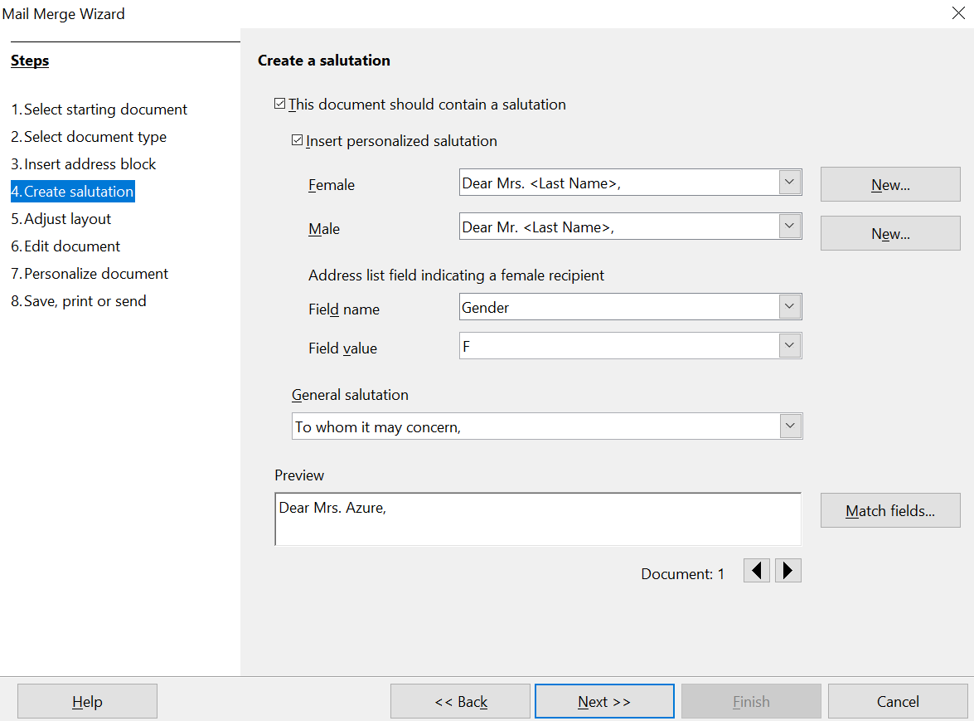

Figure 27: Create a salutation
The default arrangement is unlikely to meet your needs but adjustments are easily made and can be very flexible if your data source is appropriately prepared.
Figure 27 shows the default settings of the dialog except that the boxes Field name and Field value have been filled in appropriately for the Points data source we have been using. The selection of the options This document should contain a salutation and Insert personalized salutation activate separate salutations for addressees labeled as Female or not Female. The labeling is done by looking at the field in the data source that is listed in the Field name box under Address list field indicating a female recipient, which is the Gender field in the Points data source. If that field has the value listed in the Field value box, F in our data, the addressee is given the Female salutation. Otherwise, the Male salutation is used. The default salutations are Dear Mr. or Dear Mrs. followed by the last name.
If the Insert personalized salutation box is not checked, the General salutation will be used. There are a few preset options for the salutation or one may be entered manually.
Much more flexibility is available if you use the Match fields and New buttons to the right of the Female and Male boxes to build a custom salutation. First click Match fields to open a dialog nearly identical to the one in Figure 26. The only difference is that you are mapping fields from the data source to salutation elements rather than to address elements. Your data source should contain fields storing a value for the Title element and a value for the salutation, such as "Dear". Unfortunately, the Match Fields dialog does not include an element dedicated to the salutation, so you have to map your salutation field to some other element that was also not used in the address. We chose the <telephone private> element to map to the Salutation field in the data source.
Now click one of the New buttons. This opens the dialog shown in Figure 28 except that the boxes in the middle will be empty. Click on the first element you want in the salutation then on the right arrow to move the element to the box. After each element is moved to the box, it remains highlighted. You can see this with <Last Name> in the figure. Click to the right of it so that the cursor appears with a space between it and the element and the next element can be inserted with the correct spacing. After inserting all the elements of the salutation, click OK.
In the Preview box of Figure 28, you can see that the Salutation field of the data source (mapped to the <Telephone private> element) has the value "Dear" for this person and the Title is M. Other records in the data source may have different values in those fields. Instead of the hard coded Mr. and Mrs. titles of the default settings, you can include any number of titles such as Ms., Dr., and Prof. All that is required is storing those values in your data source. You can see how this was set up for our data source in Figure 1.
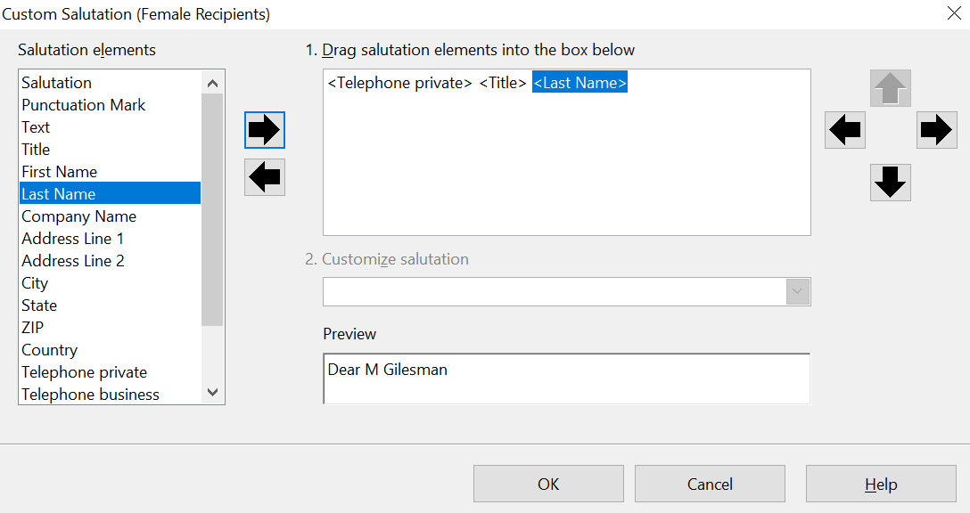

Figure 28: The New Dialog for a Salutation
You should now click the other New button next to the Male or Female box and set it up with the same method and probably identically. The Field name and Field value boxes in Figure 27 still need to be filled out but all the work of handling different people is done in the data source by changing the Title and Salutation fields. You can also erase the content of the General salutation.

As in step 3, step 4 of the wizard has a preview pane at the bottom. You should check more than one record to ensure that other records look the way you expect.

Step 5: Adjust Layout
In step 5, you can adjust the position of the address block and salutation on the page. You can place the address block anywhere on the page. The salutation is always on the left, but you can move it up or down the page. Use the buttons shown in Figure 29 to move the elements.
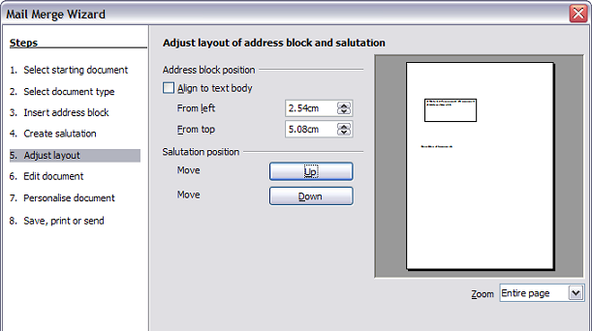Figure 29: Adjust layout

Step 6: Edit Document and Insert Extra Fields
In step 6 you have another opportunity to exclude particular recipients from the mail merge, as shown in Figure 30.
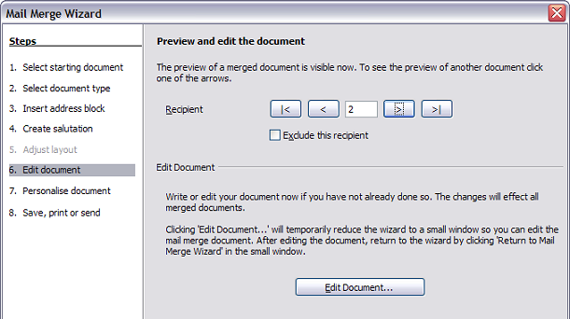Figure 30: Edit document
You can also edit the body of the document. If you started with a blank document, you can write the whole letter in this step. Click Edit Document to shrink the wizard to a small window (Figure 31) so you can easily edit the letter.
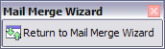
Figure 31: Minimized mail merge wizard
At this point, you need to perform one more important task. The wizard only inserts information from the name and address fields, but you may wish to add additional data. In our example, we want to tell each person how many points they had accumulated during the year; that information is in the spreadsheet.
To do this:
- Click Edit Document in step 6 of the wizard.
- Choose Insert > Fields > Other. The Fields dialog box shown in Figure 32 opens.
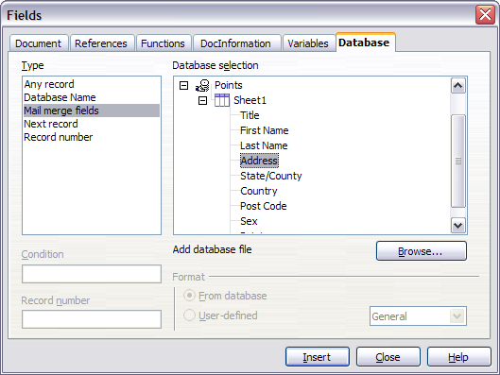Figure 32: Insert mail merge fields dialog box
- Click the Database tab.
- On the left-hand side, select Mail merge fields.
- Under Database selection find your data source (in this example, it is a spreadsheet). Expand it to see the fields.
- Click the field you want to insert, then click Insert to insert the field.
You can insert any number of fields any number of times into your mail merge document.
- Click Close when you are done.
Note | The Database selection lists the data source you selected in step 3. All the information you need for the letter must be contained in that data source.

Step 7: Personalize Documents
In step 7, AOO creates all your letters, one per recipient.
Clicking the Edit individual Document button here is similar to step 6. The difference is that you now edit a long file containing all the letters, so you can make changes to a particular letter to one person. In this step of the Mail Merge wizard (Figure 33), click Find to open a dialog box that allows searches within the document, perhaps for an individual addressee.
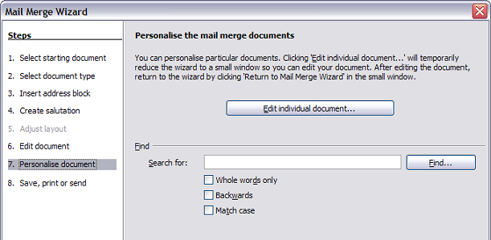Figure 33: Personalize document
As with step 6, when editing the document, the wizard shrinks to a small window (Figure 31). Click on this window to expand the wizard to its full size.

Step 8: Save, Print or Send
You've now completed the mail merge process. The only remaining step is using what you've created. In step 8, you can save the original sample letter, save the merged document, print the letters right away or, if you created email messages, send them.
You probably want to save both the initial, draft (prototype) document, and the merged document. To do this, select Save starting document to reveal the Save starting document section containing the Save starting document button shown in Figure 34 This button will be active only if the document has not already been saved. Clicking on this button brings up the standard Save as dialog box. Once you have named and saved the document, return to the Step 8 dialog box shown in Figure 35.
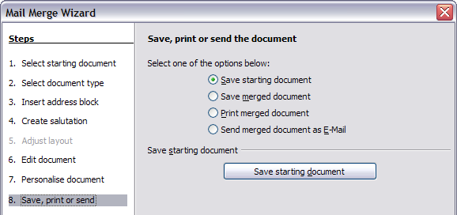Figure 34: Step 8: Save, print or send
The merged document can now be saved by selecting Save merged document. This will reveal the Save merged document settings section, from which you can select to save either as one large file containing all the individual, generated letters or as a separate file for each letter.
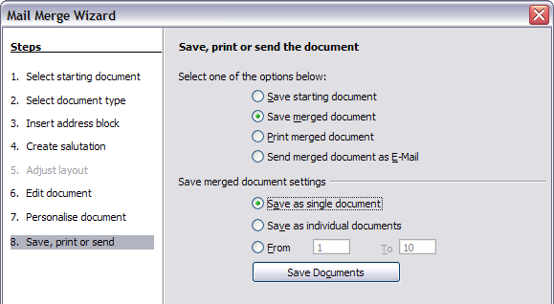
Figure 35: Saving a merged document
When you have saved the merged document, you can print the final letters now or later; and you can still manually check and edit the letters if necessary. If you elect to print at this stage, the dialog box shown in Figure 36 appears; it should be self-explanatory.
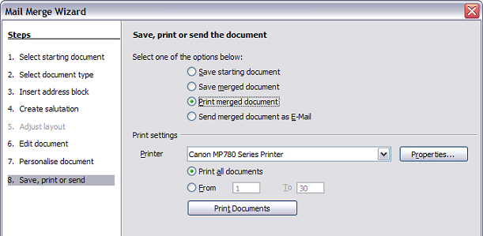Figure 36: Printing the merged document

