Apache OpenOffice
Version 4.1
Calc Guide
AOO Documentation Team

Chapter 5
Using Graphics in Calc

Copyright
This document is Copyright © 2025 by The Apache Software Foundation. You may distribute it and/or modify it under the terms of the Creative Commons Attribution License, version 3.0 or later (https://creativecommons.org/licenses/by/3.0/).
Apache, Apache OpenOffice, and OpenOffice.org are trademarks of the Apache Software Foundation. Used with permission.
Acknowledgments
This document is updated from a previous version by the OOoAuthors team. The AOO Documentation Team appreciates the many contributions of Michael Scarborough and Michele Petrovsky.
Publication date and software version
Published August 25, 2025. Based on Apache OpenOffice 4.1.
Note for Mac Users
Some keystrokes and menu items differ on a Mac from those used in Windows and Linux. The table below gives some common substitutions for the instructions in this chapter. For a more detailed list, see the application Help.
Windows/Linux | Mac equivalent | Effect
Tools > Options menu selection | OpenOffice > Preferences | Access setup options
Right-click | Control+click | Open context menu
Ctrl (Control) | z (Command) | Used with other keys
F5 | Shift+z+F5 | Open the Navigator
F11 | z+T | Open Styles & Formatting window

Contents
Chapter 5
Using Graphics in Calc 1
Graphics in Calc 4
Adding Graphics (Images) 5
Inserting an Image File 5
Linking an Image File 6
Inserting an Image from the Clipboard 8
Inserting an Image from the Gallery 8
Modifying Images 9
Using the Picture Toolbar 10
Using the Picture Context Menu 15
Using the Sidebar 18
Using Calc’s Drawing Tools 19
Set or Change Properties for Drawing Objects 21
Resizing a Drawing Object 22
Grouping Drawing Objects 22
Positioning Graphics 22
Arranging Graphics 22
Anchoring Graphics 23
Aligning Graphics 24
Creating an Image Map 25

Graphics in Calc
Calc is often used to present data and make forecasts and predictions. Effectively using graphics can turn an average document into a memorable one. Calc can import various vector (line drawing) and raster (bitmap) file formats. The most commonly used graphic formats are GIF, JPG, PNG, and BMP. See the Help for a full list of the formats Apache OpenOffice (AOO) can import.

Note | If you are choosing among graphics file formats, you may want to consider the following information.  GIF: a standard for digitized images defined in 1987 by CompuServe.  JPG: an image compression algorithm designed for compressing either full-color or grey-scale digital images. JPEG does not work well on images such as cartoons or line drawings.  PNG: a file format for the lossless, portable, well-compressed storage of raster images; designed especially for online viewing. Note that a raster image is one in which the image is composed of an array of pixels arranged in rows and columns; whereas a vector image is one which represents shapes such as lines, polygons and text, and groups of such objects.  BMP: BMP files contain uncompressed data, making it ideal for storing and displaying high-quality digital images. However, this lack of compression generally creates larger file sizes.

Graphics in Calc are of three basic types:
- Image files, such as photos, drawings, and scanned images
- Diagrams created using AOO’s drawing tools
- Charts and graphs created using AOO’s Chart facility
This chapter covers images and diagrams. Charts are described in Chapter 3 (Creating Charts and Graphs).
Although using graphics in Calc is very similar to using graphics in any other component of AOO, this chapter explains some of the differences in that use. It also covers some more advanced graphics functions and how they can further enhance your spreadsheet.
Note | The term graphics refers to both pictures and drawing objects. Often, the word images is used when referring to pictures and other graphics that were not produced by a drawing application such as OpenOffice Draw.

Adding Graphics (Images)
Images (also called pictures in AOO), such as corporate logos and photographs of people and products, are probably the most common types of graphics added to a Calc document. They may be downloaded from the Internet, scanned, created with a graphics program, or photos taken with a camera.
Images can be inserted in four ways:
- Using the Insert File dialog
- By dragging and dropping a supported file
- From the gallery
- From the clipboard by copying and pasting

Inserting an Image File
Perhaps the most common way to insert graphics is to use an existing file.
To insert an image from a file, use either of the following methods:
- Insert Picture dialog
- Drag and drop

Insert Picture Dialog
- Click on the location in the Calc document where you want the image to appear. Do not worry too much about the exact placement of the image at this stage; placement can be changed easily as described in “Positioning Graphics” on page 22.
- Choose Insert > Picture > From File from the menu bar, or click the Insert Picture icon on the Picture toolbar.
- On the Insert Picture dialog, navigate to the file to be inserted, select it, and click Open.
Note | The picture is inserted into Calc floating above the cells and anchored to the cell in which the cursor was placed. See “Positioning Graphics” on page 22 for more about positioning and anchoring graphics.

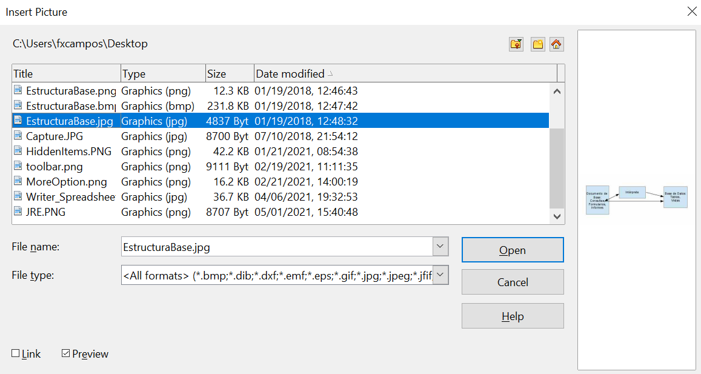

Figure 1: Inserting a picture from a file
At the bottom of the dialog are two options: Preview and Link. Select Preview to view a thumbnail of the selected image on the right so you can verify that you have the correct file. The Link option is discussed on page 6. When the Link option is not selected, the picture is embedded in the Calc document.
Note | Your Insert Picture dialog may look quite different from the one shown here, depending on your operating system and your choice in Tools > Options > OpenOffice > General of whether to use the AOO Open and Save dialogs.

Drag and Drop
- Open a file browser window and locate the image you want to insert.
- Drag the image into the Calc document and drop it where you want it to appear. A faint vertical line marks where the image will be dropped. The picture will be anchored to the cell where it was dropped.
This method always embeds (saves a copy of) the image file in the Calc document.

Linking an Image File
To create a link to the file containing the image instead of saving a copy of the image in the Calc document, use the Insert picture dialog and select the Link option. The image is then displayed in the document, but when the document is saved, it contains only a reference to the image file—not the image itself. The document and the image remain as two separate files, which are merged temporarily only when you open the document again.
Linking an image has two advantages and one disadvantage:
- Advantage – Linking can reduce the document's size when it is saved because the image file itself is not included. File size is usually not a problem on a computer with sufficient memory unless the document includes many large graphics files.
- Advantage – You can modify the image file separately without changing the document because the link to the file remains valid, and the modified image will appear when you next open the document. This can be a big advantage if you (or someone else, perhaps a graphic artist) are updating images.
- Disadvantage – If you send the document to someone else or move it to a different computer, you must also send the image files, or the receiver will not be able to see the linked images. You need to keep track of the location of the images and make sure the recipient knows where to put them on another machine so the Calc document can find them. For example, you might keep images in a subfolder named Images (under the folder containing the Calc document); the recipient of the Calc file needs to put the images in a subfolder with the same name (under the folder containing the Calc document).
Note | When inserting the same image several times in a document, it might seem beneficial to create links. However, this isn't necessary; AOO embeds only one copy of the image file in the document. Deleting one or more of the copies does not affect the others.

Embedding Linked Images
If you originally linked the images, you can easily embed one or more of them in the Calc document later if you wish. To do so:
- Open the document in Calc.
- Choose Edit > Links from the menu bar.
The Edit Links dialog shows all the linked files. In the Source file list, select the files you want to change from linked to embedded.
- Click the Break Link button.
- Save the Calc document.
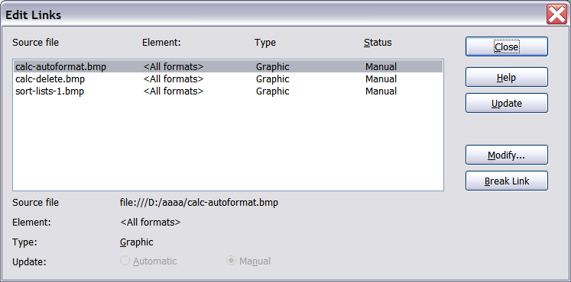
Figure 2: The Edit Links dialog
Note | Going the other way, from embedded to linked, is not simple. You must delete and reinsert each image, one at a time, selecting the Link option when you do so.

Inserting an Image from the Clipboard
With the clipboard, you can copy images into a Calc document from another Calc document, from another component of AOO (Writer, Draw, and so on), and even from other programs.
To do this:
- Open both the source document and the Calc document into which you want to copy the image.
- In the source document, select the image to be copied.
- Press Control+C to copy the image to the clipboard.
- Switch to the Calc window.
- Click to place the cursor where the graphic is to be inserted.
- Press Control+V to insert the image.
Caution   | If the application from which the graphic was copied is closed before the graphic is pasted into Calc, the image stored on the clipboard could be lost from the clipboard.

Inserting an Image from the Gallery
The Gallery provides a convenient way to group reusable objects like graphics and sounds, which can then be inserted into documents.
The Gallery is available in all components of AOO. It does not include many graphics, but you can add your own or find extensions that contain more. The Gallery is explained in more detail in Chapter 11 (Graphics, the Gallery, and Fontwork) in the Getting Started guide. For more about extensions, see Chapter 14 (Setting Up and Customizing Calc) in this book.
This section explains the basics of inserting a Gallery image into a Calc document.
- To open the Gallery (Figure 3), select the Gallery deck in the Sidebar, click on the Gallery icon (located on the right side of the Standard toolbar), or choose Tools > Gallery from the menu bar.
- Navigate through the Gallery to find the desired picture.
- To insert the picture, either right-click on the picture and choose Insert > Copy or click and drag the picture from the Gallery into the Calc document.
If your computer has a wide screen, displaying the Gallery in the Sidebar is likely the most convenient option. There are other options for resizing and repositioning the Gallery if you don't plan to place it in the Sidebar. In such cases, the Gallery is docked above the Calc workspace. To expand the Gallery, position the pointer over the line that divides it from the top of the workspace. When the pointer changes to parallel lines with arrows, click and drag downward. The workspace resizes in response.
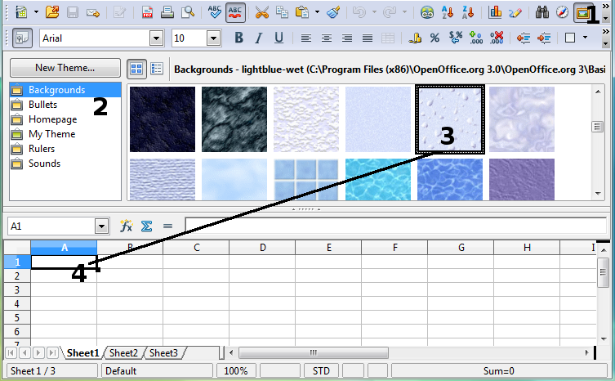
Figure 3: Gallery in Calc
To expand the Gallery without affecting the workspace, undock it so it floats over the workspace. To do so, hold down the Control key and double-click on the upper part of the Gallery next to the View icons. Double-click in the same area while holding down the Control key to dock it again (restore it to its position over the workspace).
When the Gallery is docked, to hide it and view the full Calc workspace, click the Hide/Show button in the middle of the thin bar separating the Gallery from the workspace.
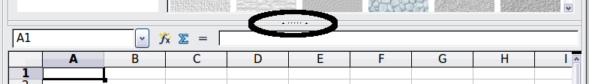
To close the Gallery, choose Tools > Gallery to uncheck the Gallery entry, or click on the Gallery icon again.

Modifying Images
When you insert a new image, you may need to modify it to suit the document. This section describes the use of the Picture toolbar, resizing, cropping, and a workaround for rotating a picture. (Changes made in Calc do not affect the original picture, whether embedded or linked.)
Calc provides many tools for working with images. These tools are sufficient for most people’s everyday requirements. However, for professional results, it is generally better to use an image manipulation program to modify images (for example, to crop, resize, rotate, and change color values) and then insert the result into Calc.

Using the Picture Toolbar
When you insert an image or select one already present in the document, the Picture toolbar appears. You can set it to always be present (View > Toolbars > Picture). Picture control buttons from the Picture toolbar can also be added to the Standard Toolbar. See Chapter 14 (Setting Up and Customizing Calc) for more information.
This toolbar can be either floating or docked. Figure 4 shows the Picture toolbar when it is floating. A brief explanation of the tools is given in Table 1. See the Draw Guide for a more detailed explanation.
Two other toolbars can be opened from this one: the Graphic Filter toolbar, which can be torn off and placed elsewhere on the window, and the Color toolbar, which opens as a separate floating toolbar.
Several of the tools available on the Picture toolbar are also available on the Properties deck of the Sidebar. The Sidebar layout for images is described on page 18.
From these three toolbars, you can apply small corrections to the graphic or obtain special effects.
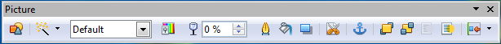
Figure 4: The Picture Toolbar
Table 1: Picture toolbar functions (from left to right)
Icon | Name | Behavior
 | From File | Use of this icon is described in “Inserting an Image File” on page 5.
 | Filter | Displays the Graphic Filter toolbar. See page 12.
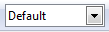 | Graphics Mode | Provides several color modes in the drop-down list. See page 11.
 | Color | Opens the Color toolbar, described on page 13.
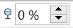 | Transparency | Sets the transparency of the selected image. See page 13.
 | Line | Adjusts the border style of the selected image.
 | Area | Fills an area with the selected color or pattern.
 | Shadow | Adds a drop shadow to the edges of the picture.
 | Crop | Opens the Crop dialog, where you can remove a selected part of the picture. See page 13.
 | Anchor | Toggles between anchoring the image to the cell or to the page. See page 23.
 | Bring to Front | Brings the selected image to the front of the stack. See page 22.
 | Send to Back | Pushes the selected image to the rear of the stack. See page 22.
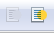 | To Foreground / Background | Allows image to float in the foreground or makes it part of the background (behind the cells). See page 22.
 | Alignment | If two or more pictures are selected, adjusts the horizontal and vertical alignment of the pictures in relation to each other. See page 24.

Choosing a Graphics Mode
You can change color images to grayscale by selecting the image and then selecting Grayscale from the Graphics mode list.
Table 2: Graphics modes
Graphics mode | Behavior
Default | Keeps the picture the same as it was inserted.
Grayscale | Shows the picture in gradual shades of gray.
Black / White | Converts the picture into a monochromatic black and white image.
Watermark | Makes the picture into a watermark that blends into the background.

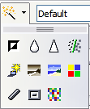
Using Graphic Filters
Click the Filter icon to display the Graphic Filter toolbar, which provides options for applying basic photographic and effect filters to images within Calc. To “tear off” this toolbar and place it anywhere on the screen, click on the three parallel lines and drag it away.
Table 3: Graphic filters and their effects
Icon | Name | Behavior
 | Invert | Inverts the colors in the picture so they resemble a negative.
 | Smooth | Applies a Gaussian blur to the image, which softens edges.
 | Sharpen | Sharpens the image.
 | Remove Noise | Applies crude noise reduction.
 | Solarization | Reverses a portion of the tones, then produces pronounced outlines of the highlights.
 | Aging | Applies a Sepia, that is,a brownish-grey to dark olive brown, filter.
 | Posterize | Opens a dialog to determine the number of poster colors. This effect is based on the reduction of the number of colors. It makes photos look like paintings.
 | Pop Art | Applies a Pop Art style to the image.
 | Charcoal Sketch | Applies a Charcoal Sketch look to the image.
 | Relief | Displays a dialog for creating reliefs. The position of the imaginary light source that determines the type of shadow can be chosen.
 | Mosaic | Joins small groups of pixels into rectangular areas of the same color. The larger the individual rectangles are, the fewer details the graphic image has.

Caution | Applying AOO picture filters to any image consecutively will progressively degrade the quality of the image. The picture filters used in Calc utilize what is known as a Destructive Editing algorithm, whereby each filter is applied to the image immediately, changing the original data of the image. Successive transformations result in less and less original data remaining, thus compromising the quality of the inserted picture. While this might be acceptable for use in simple documents, it is still recommended that dedicated photo or image editing software be used to perform anything but the simplest of manipulations.

Adjusting Colors
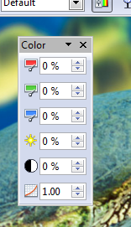
Use the Color toolbar to independently adjust an image’s red, green, and blue channels, as well as its brightness, contrast, and gamma.

Setting Transparency
Modify the percentage value in the Transparency box on the Picture toolbar to make the image more transparent. This is particularly useful when creating a watermark or wrapping an image in the background.

Customizing Lines, Areas, and Shadows
The Line, Area, and Shadow icons open dialogs where you can customize these elements. Details are in the Draw Guide.

Cropping Pictures
When you are only interested in a section of the image for your document, you may wish to crop (cut off) parts of it. The user interface in Calc for cropping an image is not very friendly, so it may be a better choice to use a graphics package.
Click the Crop icon to open a dialog to select which portion of the image you want to remove.
Dealing with cropping images in Calc is unlike what's done on Draw; in Calc, it's impossible to use the mouse to select an area to be cropped. Instead, in the Crop dialog, specify how far from the image's top, bottom, left, and right borders the crop should be, as illustrated in Figure 5. On the thumbnail in the figure, notice that the cropped selection is highlighted with an inner rectangle.
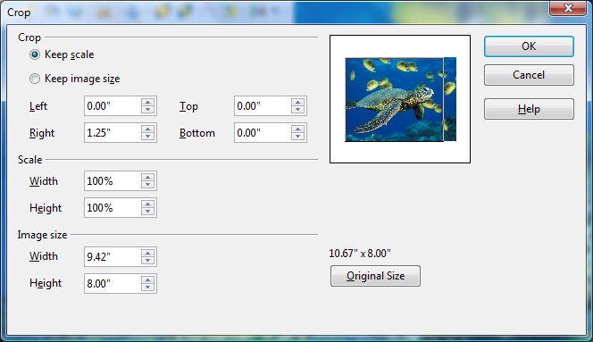

Figure 5: The Crop dialog
On the Crop dialog, you can control the following parameters:
Keep scale / Keep image size
When Keep scale is selected (default), cropping the image does not change the scale of the picture.
When Keep image size is selected, cropping enlarges, for positive cropping values, shrinks, for negative cropping values, or distorts of the image so that the image size remains constant.
Left, Right, Top, and Bottom
The image is cropped by the amount entered in these boxes. For example, a value of 3cm in the Left box cuts 3 cm from the left side of the picture.
- When Keep scale is selected, the size of the image also changes, so in this example, the width will be reduced by 3 cm.
- When Keep image size is selected, the remaining part of the image is enlarged (when you enter positive values for cropping) or shrunk (when you enter negative values for cropping) so that the width and height of the image are not changed.
Width and Height
The Width and Height fields under either Scale or Image size change as you enter values in the Left, Right, Top, and Bottom fields. Use the thumbnail next to these fields to determine the correct amount by which to crop.
The cropped shape is always a rectangle; more complex cropped shapes are impossible in Calc. Instead, use a dedicated photo or image editing software for the job, then import the image into Calc.
Note | If you crop an image in Calc, the picture itself is not changed. If you export the document to HTML, the original image, not the cropped image, is exported.

Resizing an Image
To resize an image.
- Click the picture, if necessary, to show the green resizing handles.
- Position the pointer over one of the green resizing handles. The pointer changes shape, giving a graphical representation of the direction of the resizing.
- Click and drag to resize the picture.
- Release the mouse button when satisfied with the picture's new size.
The corner handles resize the graphic object's width and height simultaneously, while the other four handles only resize one dimension at a time.
Tip | To retain the original proportions of the graphic, Shift+click one of the corner handles, then drag. Be sure to release the mouse button before releasing the Shift key.

Resizing a bit-mapped (raster) image, such as a photograph, adversely affects the resolution, causing some degree of blurring. It's better to use a graphics package to size your picture correctly before inserting it into your document.
For more accurate resizing, use the Position and Size dialog, described on page 16.

Rotating a Picture
Calc provides tools for rotating a picture through the context menu and the Sidebar, as described in the next sections. To use OpenOffice's full capability for rotating pictures interactively, you need to work with the picture in Draw or Impress. To do so:
- Open a new Draw or Impress document.
- Insert the image you want to rotate.
- Select the image, then in the Drawing toolbar (shown by default at the bottom of the window in Impress and Draw), select the Rotate icon .
- Rotate the image as desired. Use the red handles at the corners of the picture and move the mouse in the direction you wish to rotate. By default, the picture rotates around its center (indicated by a black crosshair), but you can change the pivot point by moving the black crosshair to the desired rotation center.
Tip | To restrict the rotation angle to multiples of 15 degrees, keep the Shift key pressed while rotating the image.

- Select the rotated picture by pressing Ctrl+A, then copy the image to the clipboard with Ctrl+C.
- To finish, go back to the Calc document, place the cursor where the image is to be inserted, and press Ctrl+V.

Using the Picture Context Menu
Many options accessible from the Picture toolbar can also be reached by right-clicking on an image to pop up a context menu. Some additional options are only available from the context menu; these are described in this section. Some of these options are also available on the Sidebar.

Text
Opens a dialog where you can set the options for text that goes over a picture. To write text over a graphic, click on the graphic to select it, and then press Enter. There should be a cursor inside the graphic. Any text entered is part of the graphic, so if the graphic is moved the text will move with it.

Position and Size
Opens the dialog shown below, where you can change the size, location, rotation, slant, and corner radius of the image.
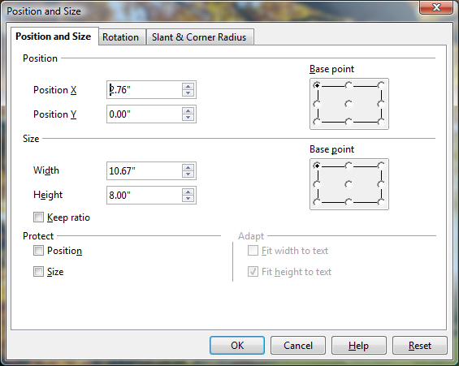

Figure 6: Position and Size dialog
Figure 7 shows the Rotation tab of the Position and Size dialog. You can change the point around which the rotation occurs, as well as the angle. The changes made in the dialog only happen when the dialog is closed. The rotation angle can be changed interactively using the Sidebar, as explained below.
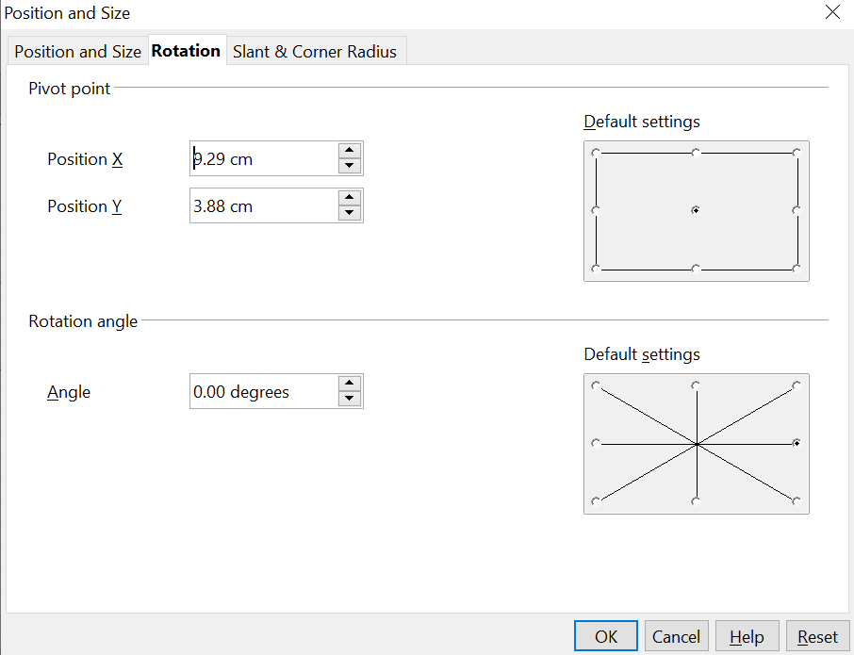

Figure 7: The Rotation tab of the Position and Size dialog

Original Size
Resets the image's dimensions to the values it had when it was initially inserted into the document.

Description
You can add metadata to the image in the form of a title and description. This information is used by accessibility tools (such as screen reader software) and as ALT (alternative) attributes if you export the document to HTML.

Name
You can assign the image a custom name to make it easier to find in the Navigator.
Tip | When collaborating with a team on a large, multi-page publication, it's beneficial to give graphics, figures, and other objects meaningful names and descriptions to aid in clear communication.

Flip
Flips the image either horizontally or vertically.

Assign Macro
Adds programmable functionality to the image. Calc provides rich macro functionality. Macros are introduced in Chapter 12 (Calc Macros).

Group
To group images:
- Select one image, then hold down the Shift key and click in turn on each of the others that you want to include in the group. The invisible “bounding box” with its 8 green handles, expands to include all the selected images.
- With the images selected, choose Format > Group > Group from the menu bar.
Or, hover the mouse pointer over one of the images. When the pointer changes shape from an arrow to a hand, right-click and choose Group > Group from the pop-up menu.
Note | You cannot include drawing objects in a group with pictures.

After images are grouped, the context menu provides other choices (Ungroup and Edit Group), and the Format > Group menu includes Ungroup and Enter Group. For more information about grouping, see the Draw Guide.

Using the Sidebar
When an image is selected, the Sidebar's Properties deck displays three panels: Graphic, Line, and Position and Size. These panels have many of the controls available on the Picture toolbar and the Picture context menu, which were discussed in the previous sections. If the Sidebar is not visible, use View > Sidebar to open it.
Figure 8 shows the three panels expanded individually, with the Graphic panel on the left, the Line panel in the center, and the Position and Size on the right. All of the panels can be expanded at the same time. They are shown individually in the figure to focus on their particular functions.
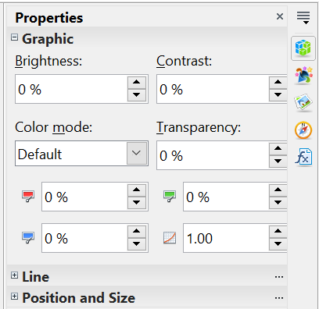
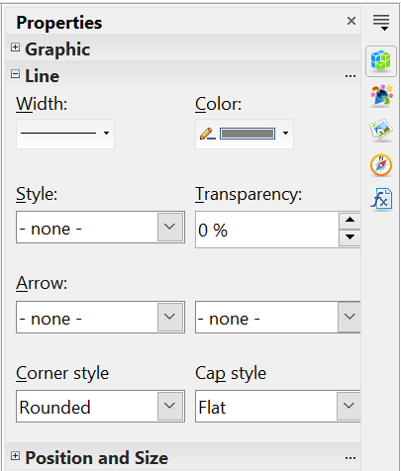
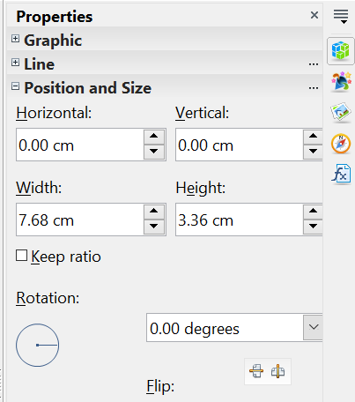

Figure 8: The three panels of the Properties deck for an image.

Graphic Panel
The Graphic panel contains the same controls as the Color toolbar accessed from the Picture toolbar, and also the Color mode (called Graphic mode on the Picture toolbar) and Transparency. The Color mode can be set to Default, Grayscale, Black/White, and Watermark. The Color mode settings are explained in Table 2

Line Panel
The Line panel displays controls for setting the width, color, line style, transparency, arrow properties, and line end properties. In OpenOffice, the term arrow refers not only to typical arrow heads but also circles, squares, and diamonds drawn at the end of the line. The left and right Arrow boxes control the beginning and end of the line, respectively, not necessarily the left and right end. Keep this in mind if you draw the line from right to left.
The dialog for controlling all aspects of a line is available by clicking the three small dots at the right edge of the Line panel's title bar.

Position and Size Panel
The Position and Size panel displays the controls for adjusting the location and size of the image. Making these adjustments through this panel has the advantage that the image changes immediately as the values change, which can be very convenient for fine-tuning an image's position. In addition to x,y, and size adjustments, the image can be rotated and flipped. As with the Line panel, the full Position and Size dialog is available by clicking the three small dots on the panel's title bar.

Using Calc’s Drawing Tools
Calc, like the other components of AOO, has a range of tools to create custom drawings. This chapter covers the default options in Calc. For a more detailed explanation of the drawing tools and their uses, see the Draw Guide.
In general, if you need to create complex drawings, your best choice is to use OpenOffice Draw or a similar drawing program.
To begin using the drawing tools, choose View > Toolbars > Drawing. The Drawing toolbar appears at the bottom of the screen. You can tear off this toolbar and move it to a convenient place on the window.
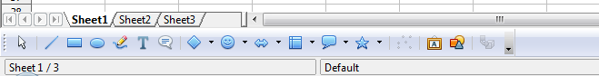
Figure 9: The Drawing toolbar showing default icons
Table 4: Drawing toolbar functions (from left to right)
Icon | Name | Behavior
 | Select | Selects objects.
 | Line | Draws a line.
 | Rectangle | Draws a rectangle. To draw a square, hold down Shift while you drag.
 | Ellipse | Draws an ellipse. To draw a circle, hold down Shift while you drag.
 | Freeform Line | Draws a freeform line.
 | Text | Draws a text box with no border.
 | Callouts | Draws a line that ends in a rectangular callout.
 | Basic Shapes | Opens the Basic Shapes toolbar.
 | Symbol Shapes | Opens the Symbol Shapes toolbar.
 | Block Arrows | Opens the Block Arrows toolbar of shapes.
 | Flowcharts | Opens the Flowchart toolbar of shapes.
 | Callouts | Opens the Callouts toolbar of shapes.
 | Stars | Opens the Stars toolbar of shapes.
 | Points | Allows editing the points of a selected polygon.
 | Fontwork Gallery | Opens the Fontwork Gallery.
 | From File | Inserts a picture using the Insert Picture dialog.
 | Extrusion On/Off | Opens the 3-D Setting toolbar and converts the selected shape (if any) to 3-D.
To display other icons, click the down arrow at the right-hand end of the toolbar, select Visible Buttons, and choose the tools you want to appear on the toolbar.
Icon | Name | Behavior
 | Polygon | Draws a line composed of a series of straight line segments. Hold down the Shift key to position new points at 45 degree angles.
 | Curve | Draws a smooth Bézier curve.
 | Arc | Draws an arc.
 | Ellipse Pie | Draws a filled shape that is defined by the arc of an oval and two radius lines. To draw a circle pie, hold down Shift while you drag.
 | Circle Segment | Draws a filled shape that is defined by the arc of a circle and a diameter line. To draw an ellipse segment, hold down Shift while you drag.
 | Text Animation | Inserts animated text.
If support for Asian languages has been enabled (in Tools > Options > Language Settings > Languages), two more tools can be added to the Drawing toolbar: Vertical Text and Vertical Callouts.
To use a drawing tool:
- Click in the document where you want the drawing to be anchored. If necessary, you can change the anchor later.
- Select the tool from the Drawing toolbar (Figure 9). The mouse pointer changes to a cross-hair pointer.
- Move the cross-hair pointer to the place in the document where you want the graphic to appear, and then click and drag to create the drawing object. Release the mouse button. (Some tools have other requirements; see the Help or the Draw Guide for details.)
The selected drawing function remains active so you can draw another object of the same type.
- To cancel the selected drawing function, press the Esc key or click on the Select icon (the arrow) on the Drawing toolbar.
- You can now change the properties (fill color, line type, weight, anchoring, and others) of the drawing object using the Sidebar, the Drawing Object Properties toolbar (Figure 10), or the choices and dialog boxes reached by right-clicking on the drawing object.

Set or Change Properties for Drawing Objects
To set the properties for a drawing object before you draw it:
- On the Drawing toolbar (Figure 9), click the Select tool.
- On the Drawing Object Properties toolbar (Figure 10), click on the icon for each property and select the value you want for that property.
- For more control or to define new attributes, click on the Area or Line icons on the toolbar to display detailed dialogs.
These default properties are applied only to the current document and session. They are not retained when you close the document, and they do not apply to any other document. The defaults apply to all drawing objects except text objects.
To change the properties for an existing drawing object, select the object and either continue as described above or use the Properties deck of the Sidebar.
Other tools and methods for modifying and positioning graphics are described in “Positioning Graphics” below.
1 | Line | 5 | Line Color | 9 | Change Anchor | 13 | Alignment
2 | Arrow Style | 6 | Area | 10 | Bring to Front
3 | Line Style | 7 | Area Style / Filling | 11 | Send to Back
4 | Line Width | 8 | Rotate | 12 | To Foreground / To Background
Figure 10. Drawing Object Properties toolbar

Resizing a Drawing Object
Select the object, click on one of the eight handles around it, and drag it to its new size. For scaled resizing, select one of the corner handles and keep the Shift key pressed while dragging the handle.
For more control of the size of the object, use the Position and Size dialog (see "Position and Size Panel" on page 19 or “Position and Size” on page 16) to set the width and height independently. If the Keep ratio option is selected, the two dimensions change to maintain the proportion, allowing for scaled resizing.

Grouping Drawing Objects
To group drawing objects:
- Select one object, hold down the Shift key, and select the others you want to include in the group. The bounding box expands to include all selected objects.
- With the objects selected, choose Format > Group > Group from the menu bar or hover the mouse pointer over one of the objects, right-click, and choose Group > Group from the pop-up menu.
Note | You cannot include an embedded or linked graphic in a group with drawing objects.

Positioning Graphics
Graphics can be positioned in AOO Calc to work together and build more complex features.

Arranging Graphics
Graphics in a Calc document are maintained like a deck of cards. As you add more images to the document, each image occupies a new layer at the top of the stack. To arrange graphics, you tell Calc to change the order of layers in the stack.
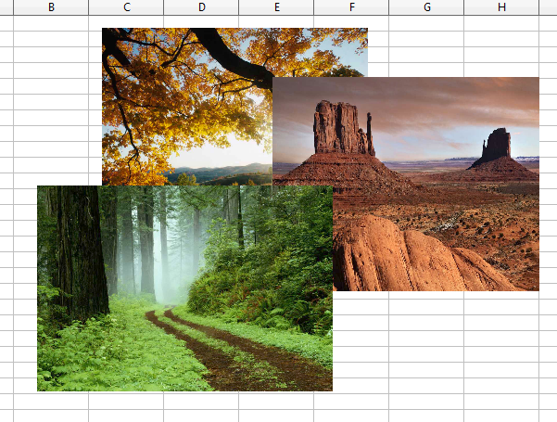
Figure 11: Layering effect
Calc provides five options shown below to re-arrange the order of images. These options can be accessed from both the Picture toolbar and the picture context menu:
Bring to Front
Places the image on top of any other graphics or text.
Bring Forward
Brings the image one level up in the stack (z-axis). Depending on the number of overlapping objects, you may need to apply this option several times to obtain the desired result.
Send Backward
The opposite of Bring Forward; sends the selected image one level down in the object stack.
Send to Back
Sends the selected graphic to the bottom of the stack so that other graphics and text cover it.
To Background and To Foreground
An image or a drawing object can also be sent to the background. This is not the same as Bring Forward and Send Backward, which set the order of several overlapping graphics. This feature pushes a graphic behind the cells, allowing cells to be edited without affecting the graphic.
A graphic in the background will have To Foreground as a menu item instead of To Background.

Anchoring Graphics
Anchors tell a graphic where to stay in relation to other items.
Anchor to page
Anchoring a graphic to the page allows it to be positioned in a specific place. The graphic does not move when cells are added or deleted. This is equivalent to an absolute reference. The graphic will always stay by cell B10 if that is where it is placed.
Anchor to cell
Anchoring a graphic to a cell ensures that it always stays with the content it is originally anchored to. If a graphic is anchored to cell B10 and a new row is inserted, the graphic will then be anchored to cell B11. This is equivalent to a relative reference.
For example, in Figure 12 the normal Otto and Tux picture is anchored To Cell B10 (XXX shows where the picture is anchored). The inverse Otto and Tux picture is anchored to the page.
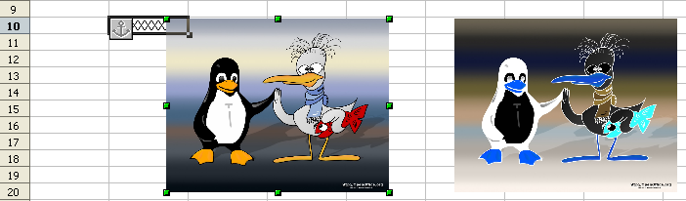
Figure 12: Anchoring 1
If two rows are inserted above the pictures, the normal picture (anchored to cell) will shift down two rows, and the anchor will change. The inverse picture (anchored to page) will not move. This is illustrated in Figure 13. Note that the anchor symbol and the XXX have moved down to cell B12.
.
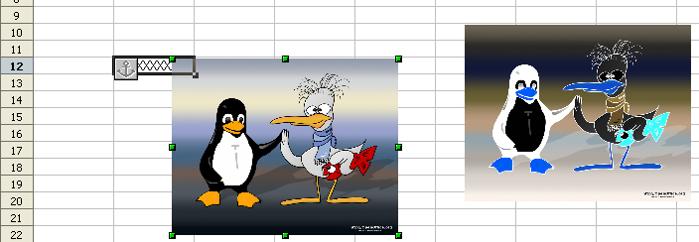
Figure 13: Anchoring

Aligning Graphics
You can align several graphics relative to each other. To do this:
- Select all of the graphics to be aligned (Shift+click on each in turn). The graphics will be surrounded by an invisible bounding box with eight green handles.
- On the Picture toolbar, click the Alignment icon and select one of the six options.
Or, position the mouse pointer over any of the graphics, right-click and choose Alignment, then select from the six options.
The six options include three for aligning the graphics horizontally (left, center, right) and three for aligning the graphics vertically (top, center, bottom).

Creating an Image Map
An image map defines areas of an image called hotspots, associating them with hyperlinks to web addresses, other files on the computer, or parts of the same document. Hotspots are the graphic equivalent of text hyperlinks. Clicking on a hotspot causes Calc to open the linked page in the appropriate program (for example, the default browser for an HTML page; AOO Calc for a .ODS file; a PDF viewer for a PDF file). You can create hotspots of various shapes and include several hotspots in the same image.
To use the image map editor:
- In your spreadsheet, select the picture where you want to define the hotspots.
- Choose Edit > ImageMap from the menu bar. The ImageMap Editor (Figure 14) opens.
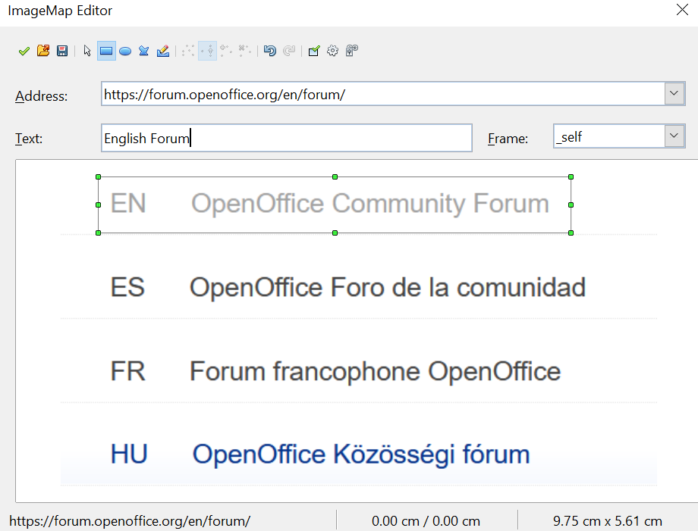

Figure 14: The dialog to create or edit an image map
- Use the tools and fields in the dialog (described below) to define the hotspots and links necessary.
- Click the Apply icon to apply the settings.
- When done, click the Save icon to save the image map to a file, then click the X in the upper right corner to close the dialog.
The main part of the dialog shows the image on which the hotspots are defined. A hotspot is identified by a line indicating its shape.
The toolbar at the top of the dialog contains the following tools:
- Apply button: click this button to apply the changes.
- Load, Save, and Select icons.
- Tools for drawing a hotspot shape: these tools work in exactly the same way as the corresponding tools in the Drawing toolbar.
- Edit, Move, Insert, Delete Points: advanced editing tools to manipulate the shape of a polygon hotspot. Select the Edit Points tool to activate the other tools.
- Active icon: toggles the status of a selected hotspot between active and inactive.
- Macro: associates a macro with the hotspot instead of simply associating it with a hyperlink.
- Properties: sets the hyperlink properties and adds the Name attribute to the hyperlink.
Below the toolbar, specify for the selected hotspot:
- Address: the address pointed by the hyperlink. You can also point to an anchor in a document; to do this, write the address in this format: file:///<path>/document_name#anchor_name
- Text: type the text you want displayed when the mouse pointer is moved over the hotspot.
- Frame: where the target of the hyperlink will open: pick among:
  - _blank (opens in a new browser window)
  - _self (opens in the active browser window
  - _top (opens in the current layer)
  - _parent (opens in the layer preceding the current one)
Tip | The value _self for the target frame will work just fine in most cases. However, while it's not necessary to use the other choices regularly, you may find them effective in specific circumstances. For instance, _blank, which opens the target in a new browser window, helps keep content visually orderly.

