Apache OpenOffice
Version 4.1
Calc Guide
AOO Documentation Team

Chapter 12
Calc Macros
Automating repetitive tasks

Copyright
This document is Copyright © 2025 by The Apache Software Foundation. You may distribute it and/or modify it under the terms of the Creative Commons Attribution License, version 3.0 or later (https://creativecommons.org/licenses/by/3.0/).
Apache, Apache OpenOffice, and OpenOffice.org are trademarks of the Apache Software Foundation. Used with permission.
Acknowledgments
This document is updated from a previous version by the OOoAuthors team. The AOO Documentation Team appreciates the many contributions of Michael Scarborough and Michele Petrovsky.
Publication date and software version
Published August 25, 2025. Based on Apache OpenOffice 4.1.
Note for Mac Users
Some keystrokes and menu items differ on a Mac from those used in Windows and Linux. The table below gives some common substitutions for the instructions in this chapter. For a more detailed list, see the application Help.
Windows/Linux | Mac equivalent | Effect
Tools > Options menu selection | OpenOffice > Preferences | Access setup options
Right-click | Control+click | Open context menu
Ctrl (Control) | z (Command) | Used with other keys
F5 | Shift+z+F5 | Open the Navigator
F11 | z+T | Open Styles & Formatting window

Contents
Chapter 12
Calc Macros 1
Introduction 4
The OpenOffice Basic Language 4
Using the Macro Recorder 6
Write Your Own Functions 10
Using a Macro as a Function 12
Passing Arguments to a Macro 15
Arguments are Passed as Values 17
Writing Macros that Act Like Built-in Functions 17
Accessing Cells Directly 17
Sorting 19
Conclusion 20

Introduction
A macro is a saved sequence of instructions stored for later use. An example of a simple macro is one that “types” your address. OpenOffice macros are very flexible, allowing automation of a range of tasks, from simple to very complex. In the right situation, a macro can improve the speed and accuracy of using a spreadsheet. However, it is important to remember that Calc includes powerful tools like Pivot Tables and Database Ranges. It is wise to investigate whether a built-in tool can do what you need before deciding to make a macro.
Macros are especially useful for repetitive tasks. This chapter briefly discusses common problems related to macro programming using Calc. Macros can be written in several programming languages, but the most common is Basic. Before we get into the details of making Calc macros, we will briefly explain some features of the OpenOffice Basic language.

The OpenOffice Basic Language
OpenOffice Basic is a simple programming language, both in its ease of use and relatively small number of features. It is too large a topic to cover in detail here. An entire top-level section of the Help documentation is devoted to it, just as there are sections for Writer, Calc, and other major applications. A Basic Programming Guide is also linked at the end of this chapter. Here, we will briefly mention a few aspects of Basic to help you understand the macros shown in the rest of this chapter.
Basic was developed in 1964 and is still used today. It allows a programmer to:
- define the type of data being manipulated. A certain value might be defined as an integer, a boolean, or a set of three texts. There are several data types. Such definitions make code easier to read because the intent is clear, which prevents misleading results due to bad inputs.
- define what the manipulation will consist of. A macro may do calculations in a spreadsheet, search text documents for certain words, save copies of the document, or almost anything else you can do with a document manually.
- define what conditions or circumstances will trigger the manipulation. Basic allows the code to take different actions depending on user input or the current content of a document.
The table below shows some keywords you will find in macros. Keywords are discussed in greater detail later in this chapter.
Basic | Means
rem | A remark, that is, internal documentation
dim | Sets up, that is dimensions, the extent or the type of the item being established
double | The double data type can hold 64 bits of decimal numbers, also called floating points
integer | The INTEGER data type stores whole numbers ranging from -2,147,483,647 to 2,147,483,647 for 9 or 10 digits of precision. An INTEGER value is typically used for quantities like counts.
for | A "For" Loop repeats a specific block of code a known number of times. For example, if we want to check the grade of every student in a class, we loop our program instructions to start from 1 and to complete when the correct number is reached.
sub, end sub | Indicators for the beginning and end of a subroutine, a part of a macro

Macros rely on Basic and some of the mechanisms it offers. Below is a macro made with the macro recorder. Notice it begins with sub and ends with end sub. From this example, you learn that lines that start with rem are documentation, and lines that start with dim define the extent or type of a variable. Let's focus on the variable document that will represent a document. First, that variable is defined as the type object. This means the variable will not contain just a number or text but something more complicated, in this case, a whole document.
dim document as object
Later in the code, a comment explains that the next line assigns something (an object) to the document variable, giving the macro access to the OpenOffice document. Then, there is the line that does the assignment.
rem get access to the document
document = ThisComponent.CurrentController.Frame
The final line of the code acts on the document variable, inserting some text.
dispatcher.executeDispatch(document, ".uno:InsertContents", "", 0, args1())

sub EnterMyName
rem -------------------------------------------------------------
rem define variables
dim document as object
dim dispatcher as object
rem -------------------------------------------------------------
rem get access to the document
document = ThisComponent.CurrentController.Frame
dispatcher = createUnoService("com.sun.star.frame.DispatchHelper")

rem -------------------------------------------------------------
dim args1(0) as new com.sun.star.beans.PropertyValue
args1(0).Name = "Text"
args1(0).Value = "Andrew Pitonyak"

dispatcher.executeDispatch(document, ".uno:InsertText", "", 0, args1())
end sub

If you are new to programming, those steps may appear complicated and confusing. However, the basic ideas are simple. You start by defining a variable and its type; then, you assign it a value using the format: variable = Something. Afterward, you do things with that variable using functions formatted as a function name followed by parentheses, like dispatcher.executeDispatch(). (Remember, not everything that has parentheses after it is a function. It might be a collection of values, an array, such as the args1() variable in the code above.)
Basic offers two other programming techniques - conditional statements such as IF, which carry out actions based upon the passing or failing of a test, and loops like FOR – programming instructions that ensure the repetition of an action or actions.
It's unnecessary for users to be proficient in Basic or to use it to create macros like those presented later in this chapter. In many scenarios, users don't need such tools - the macro recorder will be sufficient. The recorder easily handles what Merriam-Webster defines as a macro – a single computer instruction that stands for a sequence of operations.

Using the Macro Recorder
Chapter 12 of the Getting Started guide (Getting Started with Macros) provides a basis for understanding the general macro capabilities in OpenOffice using the macro recorder. An example is shown here without the explanations in the Getting Started guide. The following steps create a macro that performs paste special with multiply.
- Open a new spreadsheet.
- Enter numbers into a sheet, as shown in Figure 1.
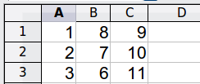
Figure 1: Enter numbers
- Select cell A3, which contains the number 3, and copy the value to the clipboard.
- Select the range A1:C3.
- Use Tools > Macros > Record Macro to start the macro recorder. The Record Macro dialog is displayed with a Stop Recording button (Figure 2).
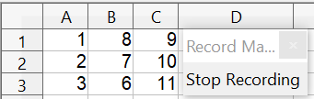

Figure 2: Stop Recording button
- Use Edit > Paste Special to open the Paste Special dialog (Figure 3).
- Set the operation to Multiply and click OK. The cells are now multiplied by 3 (Figure 4).
- Click Stop Recording to stop the macro recorder. The OpenOffice Basic Macros dialog (Figure 5) opens.
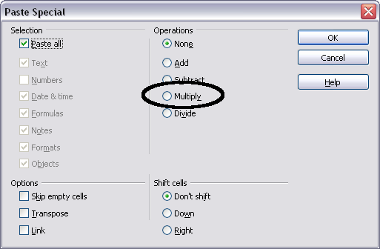
Figure 3: Paste Special dialog
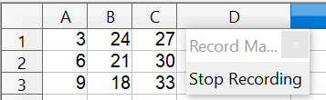
Figure 4: Cells multiplied by 3
- Select the current document (see Figure 5). In this example, the current Calc document is named Untitled 1. Existing documents show a library named Standard. This library is not created until the document is saved or the library is needed, so currently, your new document does not contain a library. You can create a new library containing the macro, but this is unnecessary.
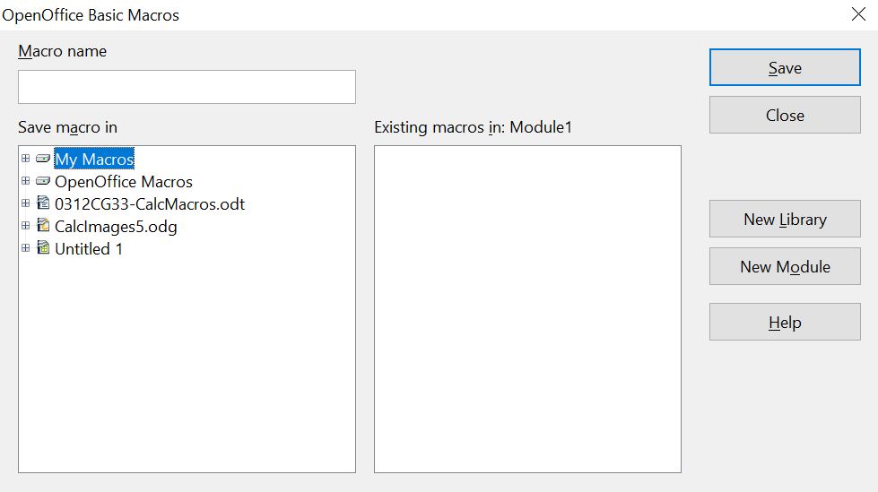

1 | My Macros | 5 | Create new module in library
2 | OpenOffice Macros | 6 | Macros in selected library
3 | Open documents | 7 | Current document
4 | Create new library | 8 | Expand/collapse list
Figure 5: Parts of the OpenOffice Basic Macros dialog
1
2
3
4
5
6
7
8
- Click New Module. If no libraries exist, the Standard library is automatically created and used. In the New Module dialog, type a name for the new module or leave the name as Module1.
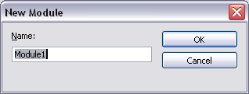
- Click OK to create a new module named Module1. Select the newly created Module1, type PasteMultiply in the Macro name box at the upper left, and click Save. (See Figure 6.)
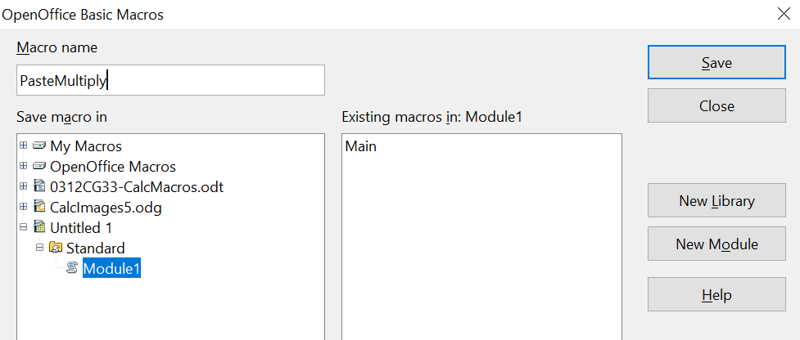

Figure 6: Select the module and name the macro
The created macro is saved in Module1 of the Standard library within the Untitled 1 document. Listing 1 shows the macro's contents.
Listing 1. Paste special with multiply.
sub PasteMultiply
rem --------------------------------------------------------------
rem define variables
dim document as object
dim dispatcher as object
rem --------------------------------------------------------------
rem get access to the document
document = ThisComponent.CurrentController.Frame
dispatcher = createUnoService("com.sun.star.frame.DispatchHelper")

rem --------------------------------------------------------------
dim args1(5) as new com.sun.star.beans.PropertyValue
args1(0).Name = "Flags"
args1(0).Value = "A"
args1(1).Name = "FormulaCommand"
args1(1).Value = 3
args1(2).Name = "SkipEmptyCells"
args1(2).Value = false
args1(3).Name = "Transpose"
args1(3).Value = false
args1(4).Name = "AsLink"
args1(4).Value = false
args1(5).Name = "MoveMode"
args1(5).Value = 4

dispatcher.executeDispatch(document, ".uno:InsertContents", "", 0, args1())
end sub
Chapter 12 (Getting Started with Macros) in the Getting Started guide provides more detail on recording macros; we recommend you read it if you have not already done so. Additional detail is provided in the following sections, but not as related to recording macros.

Write Your Own Functions
Calc can consider and execute macros as Calc functions. Use the following steps to create a simple macro.
- Create a new Calc document named CalcTestMacros.ods.
- Use Tools > Macros > Organize Macros > OpenOffice Basic to open the OpenOffice Basic Macros dialog shown in Figure 7. The Macro from box lists available macro library containers, including currently open documents. My Macros contains macros that you write or add to OpenOffice. OpenOffice Macros contains macros that are included with OpenOffice and should not be changed.
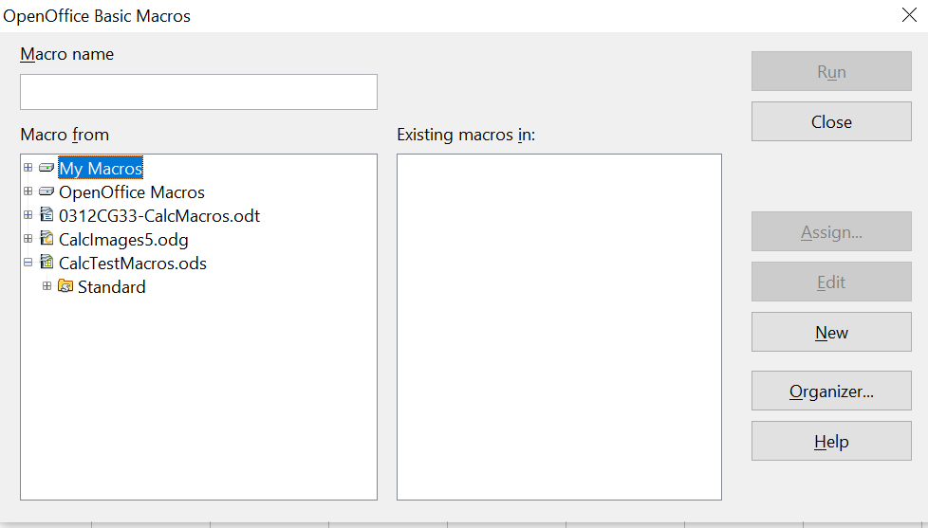

Figure 7: OpenOffice Basic Macros dialog
Open document with library
- Click Organizer to open the Basic Macro Organizer dialog (Figure 8). On the Libraries tab, select the document to contain the macro.
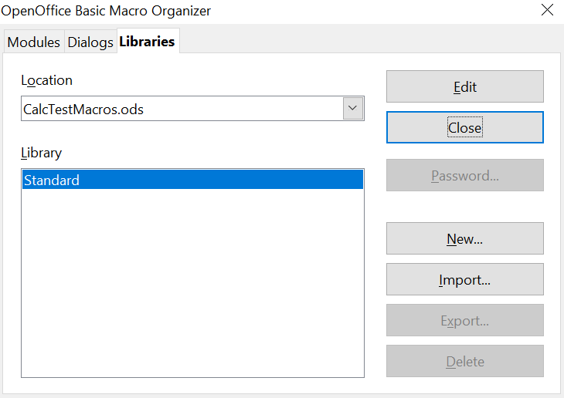

Figure 8: OpenOffice Basic Macro Organizer
Choose the document from the list
List of libraries in the document
- Click New to open the New Library dialog (Figure 9).
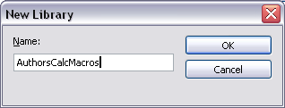
Figure 9: New Library dialog
- Enter a descriptive library name (such as AuthorsCalcMacros) and click OK to create the library. The new library name is shown in the library list, but the dialog may show only a portion of the name (Figure 10).
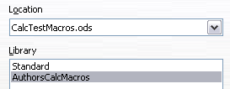
Figure 10: The library is shown in the organizer
- Select AuthorsCalcMacros and click Edit to edit the library. Calc automatically creates a module named Module1 and a macro named Main (Figure 11).
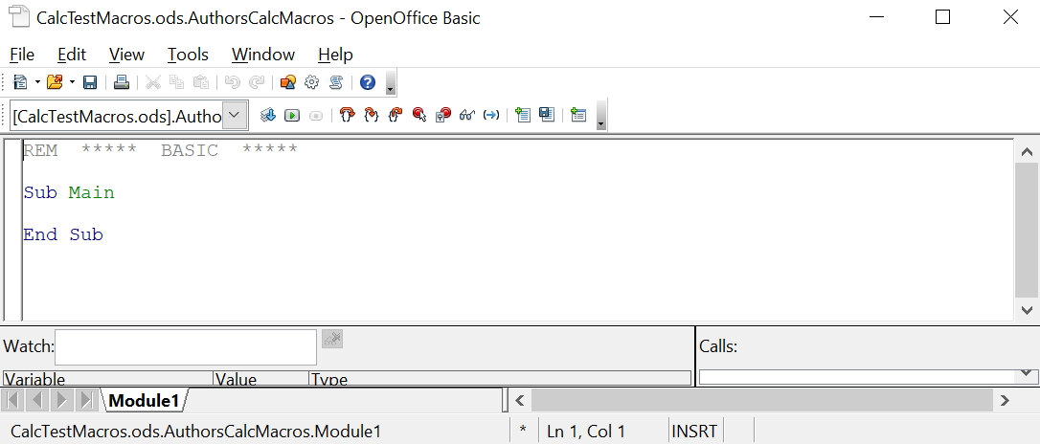

Figure 11: Basic Integrated Development Environment (IDE)
- Modify the code so that it is the same as that shown in Listing 2. The important addition is the creation of the NumberFive function, which returns the number five. The Option Explicit statement forces all variables to be declared before they are used. If Option Explicit is omitted, variables are automatically defined at first use as type Variant.
- Save the modified Module1.
Listing 2. Function that returns five.
REM ***** BASIC *****
Option Explicit

Sub Main

End Sub

Function NumberFive()
NumberFive = 5
End Function

Using a Macro as a Function
Using the newly created Calc document CalcTestMacros.ods, enter the formula =NumberFive() (see Figure 12). Calc finds the macro and calls it.
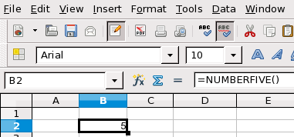
Figure 12: Use the NumberFive() Macro as a Calc function
Tip | Function names are not case-sensitive. In Figure 12, you can enter =NumberFive(), and Calc clearly shows =NUMBERFIVE().

Save the Calc document, close it, and open it again. Depending on your settings in Tools > Options > OpenOffice > Security > Macro Security, Calc will display the warning in Figure 13 or the one in Figure 14. You must click Enable Macros, or Calc will not allow any macros to be run inside the document. If you do not expect a document to contain a macro, it is safer to click Disable Macros in case the macro is a virus.
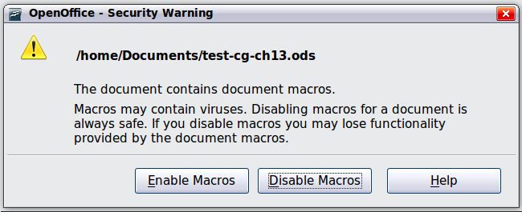
Figure 13: OpenOffice warns you that a document contains macros
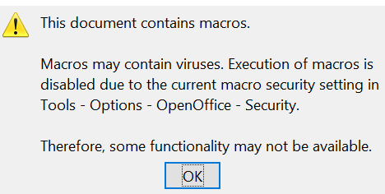
Figure 14: Warning if macros are disabled

Caution! | If you choose to disable macros, when the relevant document loads, Calc will no longer be able to find your function.

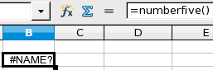
Figure 15: The function is gone
When a document is created and saved, it automatically contains a library named Standard. The Standard library is automatically loaded when the document is opened. No other library is automatically loaded.
Calc does not contain a function named NumberFive() (Figure 15), so it checks all opened and visible macro libraries for the function. Libraries in OpenOffice Macros, My Macros, and the Calc document are checked for an appropriately named function (see Figure 7). The NumberFive() function is stored in the AuthorsCalcMacros library, which is not automatically loaded when the document is opened.
Use Tools > Macros > Organize Macros > OpenOffice Basic to open the Basic Macros dialog (see Figure 16). Expand CalcTestMacros and find AuthorsCalcMacros. The icon for a loaded library is a different color than the icon for a library that is not loaded.
Click the expansion symbol (usually a plus or a triangle) next to AuthorsCalcMacros to load the library. The icon changes color to indicate the library is now loaded. Click Close to close the dialog.

Unfortunately, the cells containing =NumberFive() are in error. Calc does not recalculate cells in error unless you edit or change them. The usual solution is to store macros used as functions in the Standard library. If the macro is large or there are several macros, a stub with the desired name is stored in the Standard library. The stub macro loads the library containing the implementation and then calls the implementation.
- Use Tools > Macros > Organize Macros > OpenOffice Basic to open the Basic Macros dialog (see Figure 16). Select the NumberFive macro and click Edit to open the macro for editing.

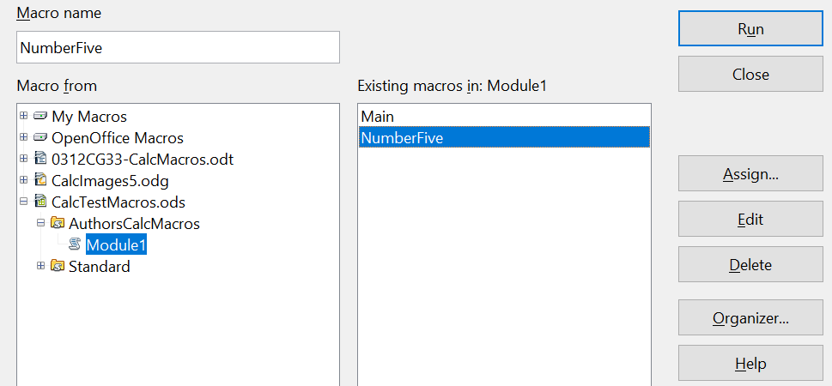

Figure 16: Select a macro and click Edit
- Change the name of NumberFive to NumberFive_Implementation (Listing 3).
Listing 3. Change the name of NumberFive to NumberFive_Implementation
Function NumberFive_Implementation()
NumberFive_Implementation() = 5
End Function
- In the Basic IDE (see Figure 11), hover the mouse cursor over the toolbar buttons to display the tool tips. Click the Select Macro button to open the OpenOffice Basic Macros dialog (see Figure 16).
- Select the Standard library in the CalcTestMacros document and click New to create a new module. Enter a meaningful name, such as CalcFunctions, and click OK. OpenOffice automatically creates a macro named Main and opens the module for editing.
- Create a macro in the Standard library that calls the implementation function (see Listing 4). The new macro loads the AuthorsCalcMacros library if it is not already loaded and then calls the implementation function.
- Save, close, and reopen the Calc document. Now, the NumberFive() function works.
Listing 4. Change the name of NumberFive to NumberFive_Implementation.
Function NumberFive()
If NOT BasicLibraries.isLibraryLoaded("AuthorsCalcMacros") Then
BasicLibraries.LoadLibrary("AuthorsCalcMacros")
End If
NumberFive = NumberFive_Implementation()
End Function

Passing Arguments to a Macro
To illustrate a function that accepts arguments, we will write a macro that calculates the sum of its positive arguments while ignoring arguments that are less than zero (see Listing 5).
Listing 5. PositiveSum calculates the sum of the positive arguments.
Function PositiveSum(Optional x)
Dim TheSum As Double
Dim iRow As Integer
Dim iCol As Integer

TheSum = 0.0
If NOT IsMissing(x) Then
If NOT IsArray(x) Then
If x > 0 Then TheSum = x
Else
For iRow = LBound(x, 1) To UBound(x, 1)
For iCol = LBound(x, 2) To UBound(x, 2)
If x(iRow, iCol) > 0 Then TheSum = TheSum + x(iRow, iCol)
Next
Next
End If
End If
PositiveSum = TheSum
End Function
The macro in Listing 5 demonstrates some important techniques:
- The argument x is optional. When an argument is not optional and the function is called without it, OpenOffice displays a warning message each time the macro is called. Consequently, if Calc calls the function multiple times, the error message appears repeatedly.
- IsMissing checks that an argument was passed before the argument is used.
- IsArray checks if the argument is a single value or an array. For example, =PositiveSum(A1) or =PositiveSum(A1:A4). In the former case, the value of A1 is passed as a simple number to the argument; in the latter, the values of A1:A4 are passed as an array to the function.
- A range of values is passed as a two-dimensional array to the function, even if the cells are in a single column or row, such as =PositiveSum(A2:B5). LBound and UBound are used to determine the array bounds that are used. Although the lower bound is one, it is considered safer to use LBound in case it changes in the future.
Tip | The macro in Listing 5 verifies whether the argument is an array or a single argument. It does not check if each value is numeric. You may be as thorough as you like; adding more checks increases the macro's robustness but may also decrease its performance.

Passing one argument is as easy as passing two: add another argument to the function definition (see Listing 6). When calling a function with two arguments, separate the arguments with a semicolon; for example, =TestMax(3; -4).
Listing 6. TestMax accepts two arguments and returns the larger of the two.
Function TestMax(x, y)
If x >= y Then
TestMax = x
Else
TestMax = y
End If
End Function

Arguments are Passed as Values
Arguments passed to a macro from Calc are always values; it's impossible to know what cells are used. For example, =PositiveSum(A3) passes the value stored in A3. The function PositiveSum has no way of knowing that cell A3 was used. If you must know which cells are referenced, send the range as a string to the function, then determine the value in the referenced cell.

Writing Macros that Act Like Built-in Functions
Although Calc finds and calls macros as normal functions, they do not behave as built-in functions. For instance, macros do not appear in Calc's function list. It is possible to write functions that behave as regular functions by writing an Add-In. However, this is an advanced topic not covered here. For additional information, refer to the following link:
https://wiki.openoffice.org/wiki/SimpleCalcAddIn

Accessing Cells Directly
You can access the OpenOffice internal objects directly to manipulate a Calc document. For example, the macro in Listing 7 adds the values in cell A2 from every sheet in the current document. ThisComponent is set by OpenOffice Basic when the macro starts to reference the current document. A Calc document has, as a sub-object, a collection of sheets: ThisComponent.getSheets(). You can get a particular sheet from that collection using the getByIndex() method. (There is also a getByName() method.) Use getCellByPosition(col, row) to return a cell at a specific row and column.

Listing 7. Add cell A2 in every sheet.
Function SumCellsAllSheets()
Dim TheSum As Double
Dim i As integer
Dim oSheets
Dim oSheet
Dim oCell

oSheets = ThisComponent.getSheets()
For i = 0 To oSheets.getCount() - 1
oSheet = oSheets.getByIndex(i)
oCell = oSheet.getCellByPosition(0, 1) ' GetCell A2
TheSum = TheSum + oCell.getValue()
Next
SumCellsAllSheets = TheSum
End Function
Tip | A cell object supports the methods getValue(), getString(), and getFormula() to get the numerical value, the string value (what is visible in the cell), or the formula used in a cell. Use the corresponding set functions to set appropriate values.

Use oSheet.getCellRangeByName("A2") to return a range of cells by name. If a single cell is referenced, then a cell object is returned. If a cell range is given, then an entire range of cells is returned (see Listing 8). Notice that a cell range returns data as an array of arrays, which is more cumbersome than treating it as an array with two dimensions, as done in Listing 5.
Listing 8. Add cell A2:C5 in every sheet
Function SumCellsAllSheets()
Dim TheSum As Double
Dim iRow As Integer, iCol As Integer, i As Integer
Dim oSheets, oSheet, oCells
Dim oRow(), oRows()

oSheets = ThisComponent.getSheets()
For i = 0 To oSheets.getCount() - 1
oSheet = oSheets.getByIndex(i)
oCells = oSheet.getCellRangeByName("A2:C5")
REM getDataArray() returns the data as variant so strings
REM are also returned.
REM getData() returns data as type Double, so only
REM numbers are returned.
oRows() = oCells.getData()
For iRow = LBound(oRows()) To UBound(oRows())
oRow() = oRows(iRow)
For iCol = LBound(oRow()) To UBound(oRow())
TheSum = TheSum + oRow(iCol)
Next
Next
Next
SumCellsAllSheets = TheSum
End Function
Tip | When a macro is called as a Calc function, the macro cannot modify any value in the sheet except the value of the cell that called the function.

Sorting
Consider sorting the data in Figure 17. First, sort on column B descending, then column A ascending.
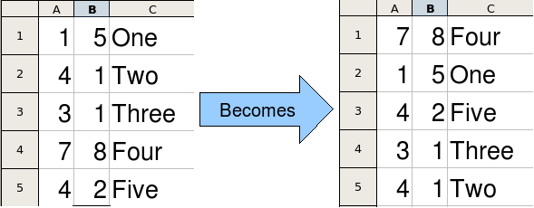
Figure 17: Sort column B descending and column A ascending
The example in Listing 9 demonstrates how to sort on two columns.
Listing 9. Sort cells A1:C5 on Sheet 1.
Sub SortRange
Dim oSheet ' Calc sheet containing data to sort.
Dim oCellRange ' Data range to sort.

REM An array of sort fields determines the columns that are
REM sorted. This is an array with two elements, 0 and 1.
REM To sort on only one column, use:
REM Dim oSortFields(0) As New com.sun.star.util.SortField
Dim oSortFields(1) As New com.sun.star.util.SortField

REM The sort descriptor is an array of properties.
REM The primary property contains the sort fields.
Dim oSortDesc(0) As New com.sun.star.beans.PropertyValue

REM Get the sheet named "Sheet1"
oSheet = ThisComponent.Sheets.getByName("Sheet1")

REM Get the cell range to sort
oCellRange = oSheet.getCellRangeByName("A1:C5")

REM Select the range to sort.
REM The only purpose would be to emphasize the sorted data.
'ThisComponent.getCurrentController.select(oCellRange)

REM The columns are numbered starting with 0, so
REM column A is 0, column B is 1, etc.
REM Sort column B (column 1) descending.
oSortFields(0).Field = 1
oSortFields(0).SortAscending = FALSE

REM If column B has two cells with the same value,
REM then use column A ascending to decide the order.
oSortFields(1).Field = 0
oSortFields(1).SortAscending = True

REM Setup the sort descriptor.
oSortDesc(0).Name = "SortFields"
oSortDesc(0).Value = oSortFields()

REM Sort the range.
oCellRange.Sort(oSortDesc())
End Sub
As this macro is a subroutine, execute it with Tools > Macros > Run Macro and then open CalcTestMacros > AuthorsCalcMacros > Module1. Click on the macro SortRange and then Run.

Conclusion
We briefly covered how macros are organized into libraries and modules, how to use the macro recorder, using macros as Calc functions, and writing macros using the Application Programming Interface (API) rather than the recorder. The macro recorder stores the effects of keystrokes or mouse clicks and can be used without any programming knowledge. It cannot record every possible user action but can often automate tedious, repetitive tasks, saving time and reducing errors. Writing functions and macros using the API are more advanced topics requiring some programming knowledge. They can be used to make very powerful tools but may require spending a lot of time learning the Application Programming Interface , writing code, and testing it. When the situation requires it, OpenOffice provides the infrastructure to implement complex and robust macros.

