Apache OpenOffice
Version 4.1
Impress Guide
AOO Documentation Team

Chapter 4
Adding and Formatting Pictures

Copyright
This document is Copyright © 2025 by The Apache Software Foundation. You may distribute it and/or modify it under the terms of the Creative Commons Attribution License, version 3.0 or later (https://creativecommons.org/licenses/by/3.0/).
Apache, Apache OpenOffice, and OpenOffice.org are trademarks of the Apache Software Foundation. Used with permission.
Acknowledgments
This book is updated from a previous version by the OOoAuthors team. The AOO Documentation Team appreciates the many contributions of Michael Scarborough and Michele Petrovsky.
Publication date and software version
Published October 30, 2025. Based on Apache OpenOffice 4.1.
Note for Mac Users
Some keystrokes and menu items differ on a Mac from those used in Windows and Linux. The table below gives some common substitutions for the instructions in this chapter. For a more detailed list, see the application Help.

Windows/Linux | Mac equivalent | Effect
Tools > Options menu selection | OpenOffice > Preferences | Access setup options
Right-click | Control+click | Open context menu
Ctrl (Control) | z (Command) | Used with other keys
F5 | Shift+z+F5 | Open the Navigator
F11 | z+T | Open Styles & Formatting window

Contents
Chapter 4
Adding and Formatting Pictures 1
Introduction 4
Inserting Pictures 4
Inserting a Picture from a File 4
Inserting a Picture from a Scanner 5
Inserting a Picture from the Gallery 6
Managing the Gallery Themes 7
Adding Images to the Gallery 7
Deleting Images from the Gallery 8
Adding a New Theme to the Gallery 8
Formatting Pictures 9
Moving a Picture 9
Resizing a Picture 9
Rotating a Picture 10
Formatting using the Picture Toolbar 11
Deleting a Picture 14
Creating an Image Map 14

Introduction
Why are pictures so often used in presentations? They can convey a large amount of information more quickly than the written word. They can also give the presentation a professional look by adding logos and hallmarks. You can use Impress to create a presentation consisting only of pictures, such as a slideshow of holiday snapshots to share with friends.
This chapter describes how to insert and format pictures.

Inserting Pictures
This section describes several ways to insert a picture from an external source into an Impress presentation. Once the picture has been inserted, it can be formatted as explained later in this chapter.

Inserting a Picture from a File
Inserting a picture from a file is quick and easy. First, choose the slide layout, as described in Chapter 1 (Introducing Impress). Most layouts include a set of icons for inserting objects, but you can insert a picture into any slide.

Figure 1: Slide with a placeholder for inserting objects
Whether you are using an AutoLayout for the placement of the picture or you are just inserting a picture, follow these steps:
- Click on the Insert Picture icon or choose Insert > Picture > From file from the menu bar.
- In the Insert picture dialog, navigate to the directory containing the desired picture.
- Select the file. AOO recognizes a large number of image types. If the Preview option (in the lower left-hand area) is selected, a thumbnail of the selected file will be displayed in the preview pane on the right (not shown below).
- Click Open to place the picture on the current (selected) slide. The picture is now displayed on the slide with green resizing handles around it.
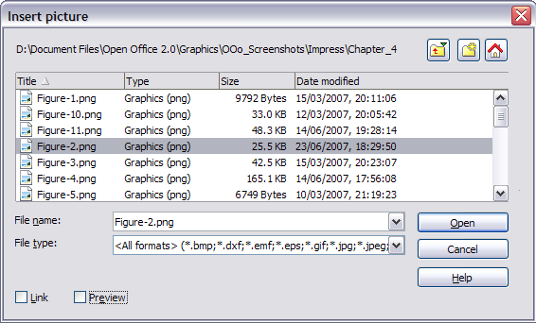Figure 2: Inserting a picture from a file
Notice the two options, Link and Preview, in the lower left of the Insert picture dialog. Their position is determined by the underlying operating system, but most frequently, they are located at the bottom left.
Select the Link option to insert the picture as a link to the file rather than embedding it in the file itself. In general, it is preferable to embed images so that the presentation can be copied to other computers. However, on some occasions, it makes sense to link the image rather than embed it. These include:
- When the image file is quite large, linking rather than embedding will dramatically reduce the size of the presentation file
- When the same image file is used in many presentations (for example, when using the same background image for all the presentations created)
- When the linked file will be available when loading the presentation (for example, if the presentation is a slide show of holiday pictures)

Inserting a Picture from a Scanner
Inserting an image from a scanner is usually straightforward. Make sure the scanner is supported by the SANE system if you are running Linux or any other UNIX-like system, or TWAIN if you are using a Windows version. Also, make sure the scanner is already configured on the machine where AOO is running. In case more than one scanner or equivalent device is present, select the source from Insert > Picture > Scan > Select Source.
To insert an image from the scanner:
- Prepare the image in the scanner and make sure that the scanner is ready.
- Choose Insert > Picture > Scan > Request.
- The rest of the procedure depends on the scanner driver and interface. You will normally be required to specify the resolution, a scan window, and other parameters. Consult the scanner’s documentation for more information.
- When the image is ready, Impress places it in the slide. At this point, it can be edited as would any other image.

Inserting a Picture from the Gallery
The Gallery contains a collection of images that you can use in a presentation. You can also add your own images to the Gallery, making it an essential tool for creating presentations quickly and with a consistent look. The Gallery is available in all components of OpenOffice. For an introduction to the Gallery, see Chapter 10 (Graphics, the Gallery, and Fontwork) in the Getting Started guide.
Choose Tools > Gallery or click the Gallery icon on the Drawing toolbar or select the Gallery deck in the Sidebar (Figure 3).
The Gallery displays named themes with images stored under each category. Select a theme from the theme pane and then scroll through the images to find a suitable one. Click on the image and drag it onto the workspace. Figure 3 shows an example of the Sidebar Gallery deck.
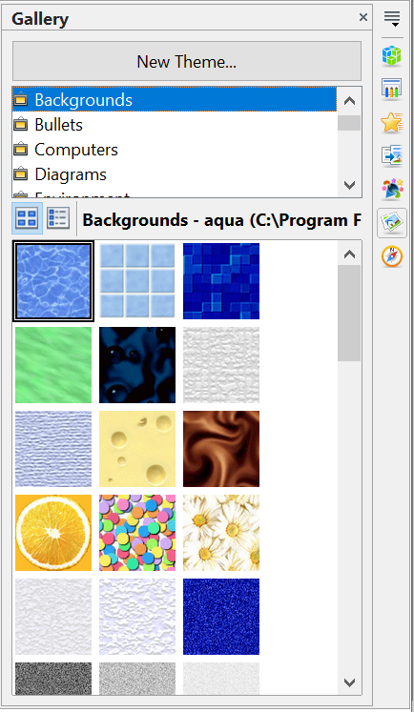

Figure 3. The Gallery Deck of the Sidebar

At this point, the image will be in your slide, but its size may not be satisfactory. If necessary, resize it as described in “Resizing a Picture” on page 9.

Positioning the Gallery
If you access the Gallery with Tools > Gallery or with the icon on the Drawing toolbar, it appears above the workspace. This shrinks the workspace, and you may want to optimize the size of the Gallery, undock it to place it in a more convenient position, or hide it. On modern wide screens, it is usually more convenient to use the Gallery in the Sidebar
To expand the Gallery when it's above the workspace, position the pointer over the line that divides it from the top of the workspace. When the pointer changes to parallel lines with arrows, click and drag downward. The workspace will resize in response.
By default, the Gallery is docked above the Impress workspace. To undock it, hold down the Control key and double-click on the upper part of the Gallery next to the View icons. To dock it again, double-click in the same area.
When the Gallery is docked, to hide it and view the full Impress workspace, click the Hide/Show button in the middle of the thin bar separating the Gallery from the workspace (see Figure 4). The Hide/Show button lets you keep the Gallery open for quick access while you create your slide show, yet out of the way when you need it to be.
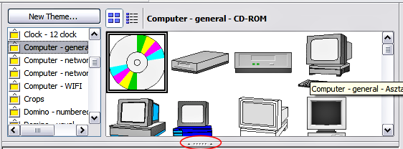Figure 4: The Gallery with the Hide/Show selector circled

Managing the Gallery Themes
Graphics in the Gallery are grouped by themes, such as Bullets, Rulers, and Text shapes. The box above or on the left of the gallery window lists the available themes. Click on a theme to see its graphics displayed in the Gallery window.
The default themes are locked; no items can be added or deleted from these themes. The locked themes are easily recognizable by right-clicking on them; the only available option in the pop-up menu is Properties.
In a default installation, only the My Theme theme is customizable. You can add your own graphics to this gallery or add new themes as explained on page 8.

Adding Images to the Gallery
You can add new images to themes that you created, or to My Theme :
- Right-click on the theme name in the list of themes and choose Properties from the pop-up menu.
- Click the Files tab, if necessary.
- Click Add.
- Select a file; click Open. The image is added to the theme.

Deleting Images from the Gallery
To delete an image from a theme:
- Right-click on the image in the Gallery window.
- Choose Delete from the pop-up menu. A message appears, asking if you want to delete this object.
- Click Yes.
Note | The image is deleted from the Gallery only. The original image file is not deleted.
All the images in a gallery are actually linked files. From time to time, it is beneficial to update the gallery theme to ensure that all the files are still there. To do so, right-click on the theme where you added at least one file and then select Update from the pop-up menu.

Adding a New Theme to the Gallery
- Click the New Theme button above the list of themes.
- Click the General tab and type a name for the new theme.
- Click the Files tab (Figure 5).
- Click Find Files. The Select Path dialog opens. Navigate to the folder that contains the image files for the new theme and click Select.
- Back on the Files tab, either click on Add All to install all of the files in the selected folder, or use File Type and/or select one or more files from the displayed list, and click on Add to install a selection of files to the new theme.
- Click OK when finished.
- The new theme will now be displayed on the list of themes in the Gallery.
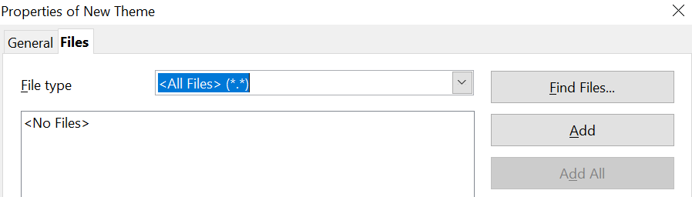

Figure 5. Setting up a new theme in the Gallery

Formatting Pictures
This section discusses formatting pictures inserted with one of the methods explained in “Inserting Pictures” on page 4.

Moving a Picture
- Click the picture, if necessary, to show the green resizing handles.
- Move the pointer over the picture until the pointer changes shape. On most operating systems, the cursor associated with moving objects is a four-headed arrow, but it may also be a hand or other similar symbol.
- Click and drag the picture to the desired position.
- Release the mouse button.
For a more accurate placement of the picture, use the Position and Size dialog described in Chapter 6 (Formatting Graphic Objects).

Resizing a Picture
- Click the picture in order to see its green resizing handles.
- Position the pointer over one of these handles. The pointer changes shape, giving a graphical representation of the direction of the resizing.
- Click and drag to resize the picture.
- Release the mouse button when satisfied with the image's new size.
The corner handles resize both the width and the height of the graphic object simultaneously, while the other four handles only resize one dimension at a time.
Tip | To retain the original proportions of the graphic, Shift+click one of the corner handles, then drag. Be sure to release the mouse button before releasing the Shift key.
For more accurate resizing of the graphic object, use the Position and Size dialog described in Chapter 6 (Formatting Graphic Objects).
Caution   | Be aware that re-sizing a bit-mapped (raster) image will adversely affect the resolution, causing some degree of blurring. Some image formats, such as .bmp (Microsoft bit map), create files which, when compressed, actually enlarge the physical size of the file. It is better to use a specialized graphics manipulation program to correctly scale the picture to the desired size before inserting it into your presentation.

Be aware of the following regarding the structure, file formats, and file name extensions for raster images.

- .JPEG or .JPG (Joint Photographic Experts Group): Excellent for photographs, often using lossy compression to balance quality and file size.
- .PNG (Portable Network Graphics): Good for web graphics, supporting lossless compression, which is ideal for images with sharp lines and transparency.
- .GIF (Graphics Interchange Format): Suitable for simple web graphics and animations, though less common now than PNG for static images.)
- .TIFF (or .TIF (Tagged Image File Format): A versatile format that can handle both lossy and lossless compression and is frequently used in GIS and professional photography.)
- .BMP (Bitmap): A simple, uncompressed raster format often used for basic images.

Rotating a Picture
As with the position of the image on the page, rotation of a picture can be done manually or using a dedicated dialog. The Rotation dialog is described in Chapter 6 (Formatting Graphic Objects). To rotate a picture manually, do as follows:
- Select the picture if necessary so that the green handles around it show.
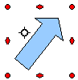
Figure 6: Shape showing the red rotating handles
- Click the Rotate button on the Drawing toolbar. This toolbar is usually located at the bottom of the screen, but it can be undocked and used as a floating toolbar. If the toolbar is not showing, select View > Toolbars > Drawing. The Drawing toolbar is discussed in detail in Chapter 5 (Creating Graphic Objects).
At this stage, a black crosshair with a circle appears in the center of the picture, representing the pivot point for the rotation. Normally, the center of the picture will be just fine, but on some occasions, you may wish to rotate around a corner or even around a point outside the picture. To do this, click on the crosshair and drag it to the desired position before applying the rotation, as shown in Figure 6.
Note | Icons representing functions in toolbars are different, depending on the operating system used. When in doubt, hover the mouse over the icons and wait for the tooltip to appear, showing the name of the button.
- Eight red circular handles replace the green square handles, as shown in Figure 6. Move the mouse over one of the corner handles, and the mouse cursor shape will change. Click the mouse and move in the direction you want to rotate the picture.
- When satisfied, release the mouse button.
To restrict rotation angles to multiples of 15 degrees, press the Shift key while rotating the graphic. This is a very handy way to rotate pictures of right angles, for example, from portrait to landscape or vice versa.

Formatting using the Picture Toolbar
When a picture is selected, the Picture toolbar shown in Figure 7 becomes available. This toolbar provides several formatting options, which are described in this section. If the picture toolbar does not appear when an image is selected, display it by selecting View > Toolbars > Picture from the menu bar.
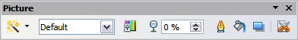Figure 7: The Picture toolbar

Applying Filters
Use the icon on the toolbar to apply various filters to the selected picture. The best way to judge if a filter works for your picture is to try it. To apply a filter:
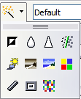
Figure 8: The graphic filters available in Impress
- Select the image so that the green handles around it are displayed.
- Click on the icon in the Picture toolbar. The toolbar will expand to show the icons in Figure 8.
- Select the filter you wish to apply. To show the name of the filter, hover the mouse pointer over the icon and wait for the tooltip to appear.
If you are not satisfied with the effect obtained or want to try a different one, before doing anything else, click the Undo button or select Edit > Undo: Bitmap Graphic Filter from the menu bar, or press Control+Z.
Table 1 describes briefly each of the available graphic filters and their effects. See the Draw Guide for examples of the effects.
Table 1: Graphic filters and their effects
Icon | Name | Effect
 | Invert | Inverts the color values of a color image, or the brightness values of a grayscale image.
 | Smooth | Softens the contrast of an image.
 | Sharpen | Increases the contrast of an image.
 | Remove noise | Removes single pixels from an image.
 | Solarization | Mimics the effects of too much light in a picture. A further dialog opens to adjust the parameters.
 | Aging | Simulates the effects of time on a picture. It can be applied several times. A further dialog will open to adjust the aging level.
 | Posterize | Makes a picture appear like a painting by reducing the number of colors used.
 | Pop Art | Modifies the picture dramatically.
 | Charcoal | Displays the image as a charcoal sketch.
 | Relief | A dialog is displayed to adjust the light source, which in turn will create the shadow and hence the relief effect.
 | Mosaic | Joins groups of pixels into a single area of one color.

Changing the Graphics Mode
Use the graphics mode drop-down list in the Picture toolbar to change the mode of the image. Choose between:
- Default: No changes to the graphic object.
- Grayscale: The image is converted to scales of gray.
- Black/White: Each pixel of the image is converted to black or white depending on the brightness value.
- Watermark: adjusts the brightness of the image, making it suitable for use as a watermark. For more information on inserting watermarks in the presentation, refer to Chapter 2 (Slide Masters).

Adjusting the Color
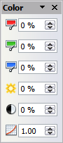
Figure 9: The color adjustment dialog
Clicking the color adjustment button on the Picture toolbar opens the color adjustment dialog, like that in Figure 9.
Use this dialog to modify the individual color components of the image (red, green, blue) as well as the brightness, contrast, and gamma of the image. If the result is not satisfactory, press Control+Z to restore the default values.
Increasing the gamma value of a picture makes it more suitable for use as a background or watermark; an image modified in this way will interfere less with dark text.
In the context of either image processing or image transmission, gamma refers to the clarity or cloudiness of an image. Under the hood, gamma involves the number of bits needed to encode an image, or the bandwidth needed to transport it. Too many bits, or too much bandwidth, can result in highlights indistinguishable to the human eye, while too few bits or too little bandwidth might produce unintended shadows.

Setting the Object Transparency
Modify the percentage value in the Transparency box on the Picture toolbar to make the image more transparent. Note that this differs from the transparency settings for a line or a shape (described in Chapter 5). As with the gamma value, increasing the transparency of a picture makes the picture blend more smoothly into the background, making overlay text easier to read.

Adjusting the Line, Area, and Shadow Settings
These settings are not very commonly used for images, except for the shadow setting, which applies a shadow to the image.

Cropping Pictures
Impress provides two ways to crop a picture: interactively or using a dialog. The interactive method is easier to use, but the dialog provides more precise control. You can use both methods: first, cropping interactively, then using the dialog to fine-tune the result.
To crop a selected picture interactively, click the Crop icon on the Picture toolbar (Figure 7). A set of crop marks appears around the picture (see Figure 10).
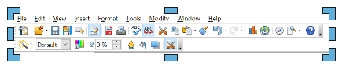

Figure 10: Interactive crop marks
When you place the cursor over any of the crop marks, the cursor changes shape. Drag the mark to crop the picture. Click outside the picture to deactivate cropping mode.
Press the Shift button while working on the crop marks to produce the following effects:
- For a corner mark, the two sides of the picture forming the corner are cropped proportionally, with the picture anchored to the opposite corner mark.
- For a side mark, both dimensions are changed proportionally, with the image anchored to the opposite side mark.
The interactive crop mode operates in Keep Scale mode (see below).
To crop using the dialog, right-click a selected picture and choose Crop Picture (or choose Format > Crop Picture from the menu bar).
The Crop dialog (Figure 11) has the following options:
- Keep scale / Keep image size buttons: when Keep scale is selected (default), cropping the image does not alter the scale of the picture. When Keep image size is selected, cropping produces enlargement (for positive cropping values), shrinking (for negative cropping values), or distortion of the image so that the image size remains constant.
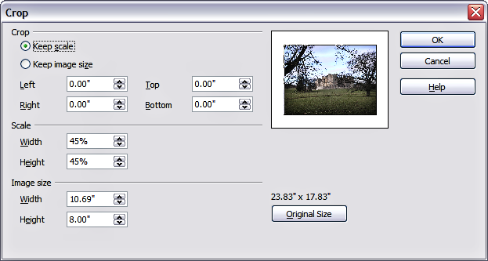
Figure 11: The options available when cropping a picture
- Left, Right, Top, and Bottom: The function of these boxes changes according to the choice made between Keep scale and Keep image size. In both cases, when a value is entered in one of these boxes, the image is cropped by that amount. For example, a value of 3cm in the Left box will cut 3cm from the left side of the picture.
When Keep scale is selected, the size of the image also changes, so in this example, the width will be reduced by 3 cm. If Keep image size is selected instead, the remaining part of the image is enlarged (positive values for cropping) or shrunk (negative values for cropping) so that the width and height of the image remain unchanged.
Note that the Width and Height fields change as you enter the values when in this mode. Use the thumbnail next to these fields to determine the correct amount by which to crop.
- Scale Width and Height: specify in percentages the scaling of the picture. The size of the image changes accordingly.
- Image size: specify the size of the image in your preferred unit of measurement. The image enlarges or shrinks accordingly.
- Original size: when clicked, restores the original image size.

Deleting a Picture
- Click on the picture, if necessary, to show the green resizing handles.
- Press Delete.

Creating an Image Map
An image map defines areas of an image (called hotspots) that are associated with a URL (a web address or a file on a computer). Hotspots are the graphic equivalent of text hyperlinks. Clicking on a hotspot causes Impress to open the linked page in the appropriate program (for example, the default browser for an HTML page, AOO Writer for an .ODT file, or a PDF viewer for a PDF file). You can create hotspots of various shapes and include several hotspots in the same image.
To use the image map tool:
- Select the picture where hotspots will be defined.
- Choose Edit > ImageMap from the menu bar. The ImageMap Editor dialog in Figure 12 opens. The main part of the dialog shows the image on which the hotspots will be defined. In this image, an active hotspot is indicated by a white shading, while an inactive hotspot is identified by a red border but no shading.
- Use the tools and fields in the dialog to define the hotspots and links necessary.
- Click the Apply icon to apply the settings.
- When done, click the Save icon to save the imagemap to a file, then click the X in the upper-right corner to close the dialog.
The top part of the dialog contains the following tools:
- Apply button: Click this button to apply the changes.
- Load, Save, and Select icons.
- Tools for drawing a hotspot shape: these tools work in exactly the same way as the corresponding tools in the Drawing toolbar (described in Chapter 5).
- Edit, Move, Insert, Delete Points: advanced editing tools to manipulate the shape of a polygon hotspot. Select the Edit Points tool to activate the other tools.
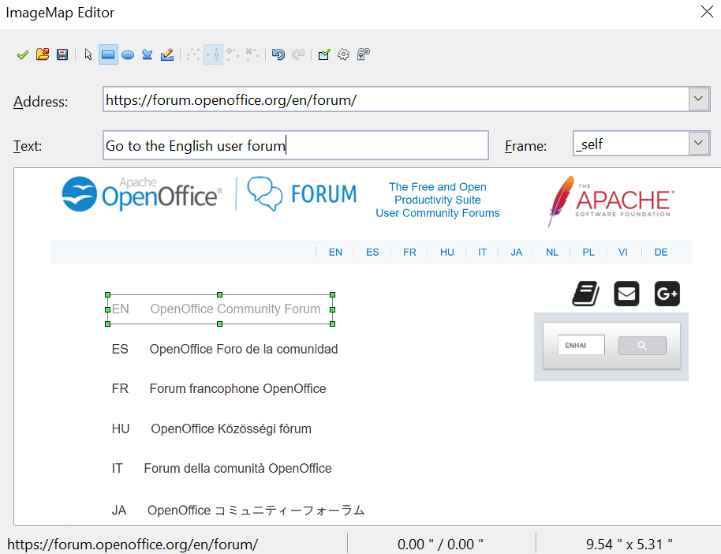

Figure 12: The dialog to create or edit an image map
- Active icon: toggles the status of the hotspot, activating a selected hotspot or deactivating it if it's active.
- Macro: associates a macro with the hotspot instead of a hyperlink.
- Properties: sets the hyperlink properties and adds the Name attribute to the hyperlink.
Below the toolbar, specify for the selected hotspot:
- Address: the address pointed to by the hyperlink. You can also point to an anchor in a document, such as a specific slide number; to do this, write the address in this format: file:///<path>/document_name#anchor_name
- Text: enter the text that will be displayed when the mouse is moved over the hotspot.
- Frame: where the target of the hyperlink will open: pick among _blank (opens in a new browser window), _self (opens in the active browser window), _top, or _parent.
Tip | The value _self for the target frame will work just fine in the vast majority of contexts. It is therefore not recommended to use the other values unless absolutely necessary.

