Chapter 7
Getting Started with Base

What is Base?
Base is the component of Apache OpenOffice that allows the office suite to interact with a wide variety of data sources. For example, a data source could be a list of names and addresses used for producing a mail merge letter. A shop stock list could be a data source managed through AOO.
Note | Apache OpenOffice uses the terms “Data Source” and “Database” to refer to the same thing, which could be a database such as MySQL or dBase or a spreadsheet or text document holding data.
This chapter covers creating a database, viewing and entering data, and loading the data into OpenOffice documents. It also covers using the Base component of AOO to register other data sources. A data source can be a database, spreadsheet, or text document.
Note | Base is not a database engine. OpenOffice includes the HSQL database engine in the installation files, which is used by default to manipulate data. All of the files created by this engine in the default configuration, called an embedded database, are kept within the Base file. It is possible, and sometimes preferable, to connect Base to an external database engine.
Databases bear a superficial similarity to the more widely encountered spreadsheets but there are important differences. A database consists of a number of columns or fields that contain the individual pieces of data. Groups of fields make up a table of the database. When creating a table, you also determine the characteristics of each field in the table. This is one key difference from spreadsheets. Each field or column may contain only one kind of data. Within the broad data types of text and numbers, there may be further restrictions. For example, the text might have to contain a certain number of characters or numbers might be restricted to be only integers. These restrictions are applied, if they are desired, when the table is defined. Forms are used to interact with the data tables, either for data entry or viewing. This is another difference from spreadsheets where you routinely directly view and manipulate the data tables. Forms format the data display and enable convenient navigation through the rows or records of a table. Database tables do not have the formatting or interactive tools to support convenient direct viewing but they hold much more data and allow more flexible handling of lists. A query creates a new temporary table from the existing tables according to instructions you provide. The query may sort, order, filter, summarize and match data from many tables. A report organizes the information of the fields of a query in a document according to your requirements.
Caution   | The database engine in AOO requires a Java Runtime Environment (JRE). If you do not have one on your computer, you can download it from www.java.com or adoptopenjdk.net and install it following the instructions on the site. In AOO, use Tools > Options > OpenOffice > Java to register Java.
Base creates relational databases. This makes it fairly easy to create a database in which the fields of the database have relationships with each other.
For example: Consider a database for a library. It will contain a field for the names of the authors and another field for the names of the books. There is an obvious relationship between the authors and the books they have written. The library may contain more than one book by the same author. This is what is known as a one-to-many relationship: one author and more than one book. Most if not all the relationships in such a database are one-to-many relationships.
Consider an employment database for the same library. One of the fields contains the names of the employees while others contain the social security numbers, and other personal data. The relationship between the names and social security numbers is one-to-one: only one social security number for each name.
If you are acquainted with mathematical sets, a relational database can easily be explained in terms of sets: elements, subsets, unions, and intersections. The fields of a database are the elements. The tables are subsets. Relationships are defined in terms of unions and intersections of the subsets (tables).
To explain how to use a database, we will create one for the sales and expenses of a small group of people. It is not intended to be realistic for any purpose; it will merely supply concrete but highly simplified examples of data. In the process, we will be explaining how a database works.

Planning a database
Planning a database's structure is a very important step which should not be skipped or minimized. A well planned database can answer all the questions you know you will want to ask and can be adapted easily to changing needs. A poorly planned database will likely be hard to use and may have to be restructured for even a modest change in the data or in the questions to be answered.
The first planning step is to define the purpose and use of the database as carefully as possible. What information do you want to get out of the database and what information has to go in to achieve that? Be sure to consider not only the immediate questions you want to answer but how those questions might change with time.
The second step is to decide how to store the data in one or more tables to facilitate producing the results you want. Answering this question for a broad range of cases is far beyond the scope of this guide. We will work through a simple case of tracking the expenses and sales of a group of people to illustrate some concepts. It would also be very beneficial to understand database normalization, about which there are many tutorials on the internet. A key point is that there may be a clear difference between structuring the data to take advantage of how database engines work and how the data are best presented for humans to read. The former should govern the database table structure, the latter should be handled with Forms.

Creating a new database
To begin the process of making the example database, we will make a new Base file with the default configuration of embedded HSQL tables. Choose File > New > Database from the menu bar, or click the arrow next to the New icon on the Standard toolbar and select Database from the drop-down menu. Both methods open the Database Wizard.
On the first page of the Database Wizard, select Create a new database and then click Next.
The second page has two questions. Make sure the choice for the first question is Yes, register the database for me and the choice for the second question is Open the database for editing. Click Finish.
Note | If the database is not registered, it will not be accessible to the other AOO components such as Writer and Calc. If the database is registered, other components can access it. Registering the database only informs your local OpenOffice program that this Base file exists. No information is sent to any other program or outside of your computer.
Save the new database with the name Finance. This opens the Finance – OpenOffice Base window. Figure 1 shows part of this window.
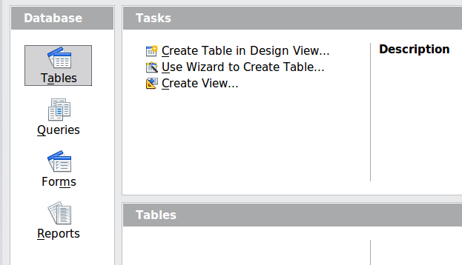
Figure 1: Creating database tables
Tip | Every time the Finance Base file is opened, the Finance – OpenOffice Base window opens. Changes can then be made to the database. The title for this window is always <database name> – OpenOffice Base.
Caution | As you create a database, you should save your work regularly. This means more than just saving what you have just created. You must save the whole database as well. For some common tasks, Base opens a separate document window where you may, for example, design a Form to enter data. Saving the document in that window saves the Form inside of the Base document but you should then also save the Base document from its main window.

Creating database tables
In a database, a table stores information for a group of things we call fields or columns. For example, a table might hold an address book, a stock list, a phone book or a price list. A database can have from one to several tables.
To work with tables, click the Tables icon in the Database list, or press Alt+A. The three tasks that you can perform on a table are in the Tasks list (see Figure 1).

Using the Wizard to create a table
Wizards are designed to do the basic work. Sometimes this is not sufficient for what we want; in those cases we can use a wizard as a starting point and then build upon what it produces.
The Table Wizard in Base contains two categories of suggested tables: business and personal. Each category contains sample tables from which to choose. Each table has a list of available fields. We can delete some of these fields and add other fields.
A field in a table is one piece of information. For example, a price list table might have one field for item name, one for the description, and a third for the price.
Caution | Every table requires a Primary key field. (What this field does will be explained later.) We will use this field to number our entries and want that number to automatically increase as we add each entry.
Click Use Wizard to Create Table. This opens the Table Wizard (Figure 2).
Step 1: Select fields.
We will use the Expenses sample table in the Business category to select the fields we need for our first table.
- Category: Select Business. The Sample Tables drop down list changes to a list of business sample tables.
- Sample tables : Select Expenses. The Available fields box changes to a list of available fields for this table.
- Selected fields : Using the > button, move the following fields from the Available fields window to the Selected fields window in this order: AmountSpent, DatePurchased, EmployeeID, ExpenseType. You can select multiple fields by pressing the Ctrl key while clicking and then move all of the chosen fields at once.
At this point, you could select another sample table and move fields from it to the Selected Fields list but that is not necessary in this case.
- If you make a mistake in selecting fields, click on the field name in the Selected fields list and use the < button to move it from the Selected fields list back to the Available fields list.
- If you make a mistake in the order of the selected fields, click on the field name that is in the wrong order and use the Up or Down arrow on the right side of the Selected fields list to move the field name to the correct position.
- Click Next.
Notice that none of the field names include spaces. It is possible to have spaces in field names but it is best to avoid them.
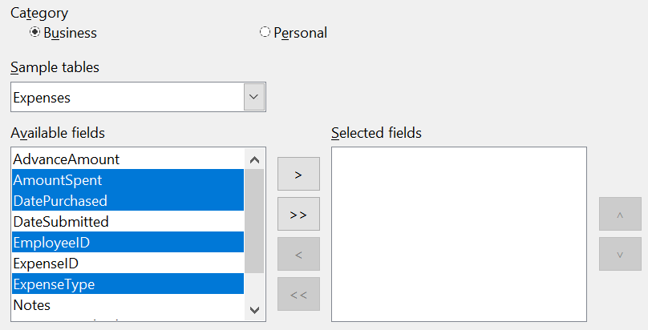

Figure 2: Selecting fields for the table
Step 2: Set field types and formats
In this step you give the fields their properties. When you click a field, the information on the right changes. (See Figure 3) You can then make changes to meet your needs. Click each field, one at a time, and make the changes listed below. Some questions you might consider in a real application are included in the changes.
Note | If any of these fields requires an entry, set Entry required to Yes. An entry with that field blank will then not be allowed. In general, only set Entry required to Yes if something must always be put in that field. By default, Entry required is set to No.
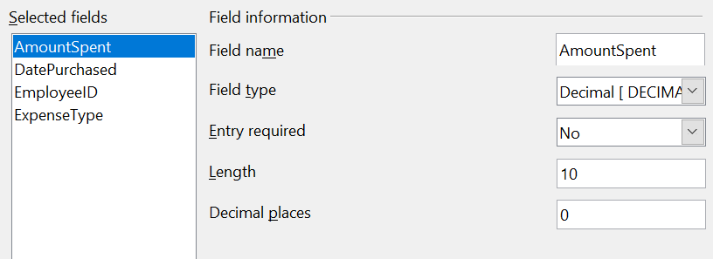

Figure 3: Changing field types
- AmountSpent: Change Decimal places to 2. You should consider whether you want to allow an expense with no amount recorded. If not, change Entry required to Yes.
- DatePurchased : Notice the Field type is Date, which is correct. If you want to require a date, change Entry required to Yes.
- EmployeeID : If you want to require that every expense be assigned to an employee, change Entry required to Yes.
- ExpenseType: The Field type is Text [VARCHAR]. With Length set to 50, this field must be no more than 50 characters long. Is that enough?
Note | In Base the maximum length of each field must be specified on creation. It is not easy to change this later, so if in doubt specify a greater length. Base uses VARCHAR as the default field format for text fields. This format only uses the actual number of characters in a field up to the limit set. So, a field containing 20 characters will only use space for 20 characters even if the limit is set at 50.
- When you have finished, click Next.
Note | Each field has a Field Type, which must be specified. Types include text, integer, date, and decimal. If the field is going to have general information in it (for example, a name or a description), use text. If the field will always contain a number (for example, a price), the type should be decimal or another numerical field. The wizard picks the right field type, so to get an idea of how this works, see what the wizard has chosen for different fields.
Step 3: Set primary key
- Create a primary key should be checked.
- Select the option Automatically add a primary key and check Auto Value
- Click Next.
Note | A primary key uniquely identifies an item (or record) in the table. For example, you might know two people called “Randy Herring” or three people living at the same address and the database needs to distinguish between them.  The simplest method is to assign a unique number to each one: number the first person 1, the second 2, and so on. Each entry has one number and every number is different, so it is easy to say “record ID 172”. This is the option chosen here.
Step 4: Create the table.
- If desired, rename the table at this point. If you rename it, make the name meaningful to you. For this example, make no changes.
- Leave the option Insert data immediately checked. We will view the table but not actually enter data.
- Click Finish to complete the table wizard.
A window will appear titled Expenses – Finance – OpenOffice Base: Table Data View. This displays the empty table with the fields (columns) you selected plus a column named ID that is labeled <AutoField> and it was created in Step 3 above. The ID column will be filled with integers automatically when data is added and those numbers will never repeat even if data is deleted. The ID column is the Primary Key of the table.
Close the window displaying the table and you will be back to the main window of the database with the listing of the tables, queries, forms, and reports. Notice that a table named Expenses is now listed in the Tables portion of the window. Now is a good time to save the Base file.

Creating a table by copying an existing table
A situation may arise where you want to have two or more tables with the same structure but different data. Rather than creating each table from the wizard, you can make copies of the original table, naming each differently.
- Click on the Tables icon in the Database pane to see the existing tables.
- Right-click on the icon of the table you want to copy. Choose Copy from the pop-up menu.
- Move the mouse pointer below this table, right-click, and select Paste. The Copy table dialog opens.
- Change the table name and click Next.
- Click the >> button to move all the fields from the left box to the right box and click Next.
- Since all the fields already have the proper Field type, no changes should be needed. However, this is the time and place to make any changes if they are needed. (See Caution below for the reason why.) Click Create. The new table is created.
Caution | Once tables have been created using the wizard and data has been entered, editing them should be very limited. Fields can be added or deleted, but adding a field requires taking the time to enter the data for that one field for every record having an entry for that field.  Deleting a field deletes all the data once contained in that field. Changing the field type of a field can lead to data being lost either partially or completely if the two data types are not compatible. When creating a new table, it pays to create the fields with the correct names, length, and format before you add any data.  Deleting a table removes all of the data contained in every field of the table. Unless you are sure, do not delete a table.

Creating tables in Design View
Design View is a more flexible method for creating a new table, in which you directly enter information about each field in the table. We will use this method for the rest of the tables of our database.
Note | While the Field type and formatting are different in Design View, the concepts are the same as in the Wizard.
The first table to be created is People. Its fields are PeopleID, FirstName, and LastName.
- Click Create Table in Design View. A table similar to Figure 4 will appear but with no entries.
- PeopleID field:
  - Type PeopleID as the first Field Name. Press the Tab key to move to the Field Type column.
  - Select Integer [INTEGER] as the Field Type from the dropdown list. (The default setting is Text [VARCHAR].)

Tip | A shortcut for selecting from the Field Type dropdown list: press the key for the first letter of the choice. You can cycle through the choices for a given letter by repeatedly pressing that key.
  - Change the Field Properties in the bottom section.
Change AutoValue from No to Yes.
  - As a result of choosing AutoValue, when you move the cursor to the next row, PeopleID will be set as the Primary key and a small key icon will appear next to the field name. To set the primary key manually, right-click on the green triangle to the left of the field name (Figure 4) and choose Primary Key from the menu. This places a key icon in front of the field name. However, if AutoValue has not been set, you will need a method to track what values have been used and to create values for new entries.
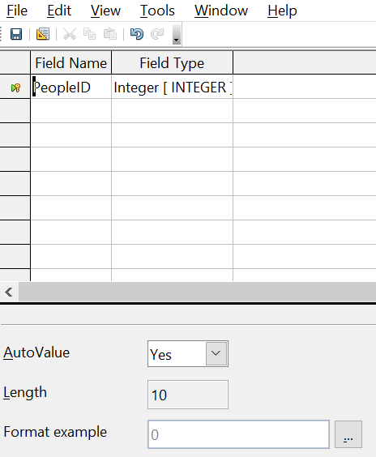

Figure 4: Table definition after the first row is defined
Note | The primary key serves only one purpose: to uniquely identify the record. Any name can be used for this field. We have used PeopleID for convenience, so we know to which table it belongs.
- FirstName and LastName fields:
- Type the next field name in the Field Name column.
- Select the Field Type TEXT [VARCHAR] for each field.
- To save and close the table, choose File > Save. Name the table People. Close the table.
Follow the same steps to create a table named Sales. The fields and their field types are listed in Figure 5. Make sure you make the SaleID field the primary key before closing. This should be true if you define the field with AutoValue = Yes. Be sure to set the Decimal places of the Amount field to 2 as shown in the figure.
You can set the display format of either the Date field or the Amount field. To do this, click the button at the right end of the Format example box to bring up the Field Format dialog. This dialog is shown in Figure 6 with a currency format chosen, which might be appropriate for the Amount field.
Once all of the fields are defined, save the table and name it Sales. Close the Sales table and save the Base document.
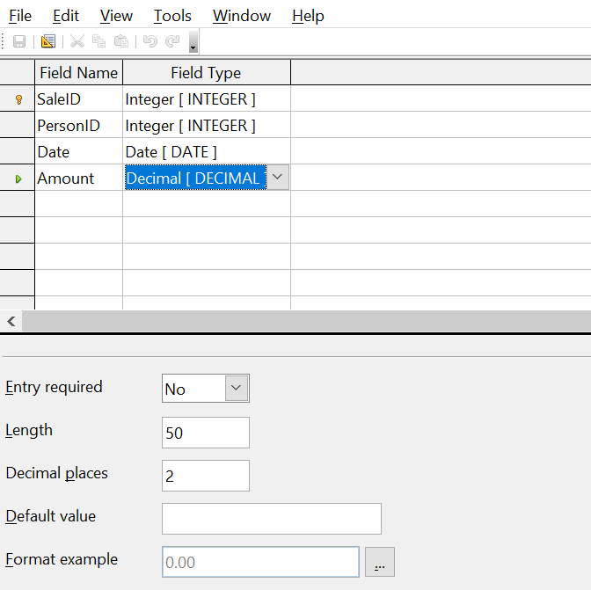

Figure 5: Fields in Sales table
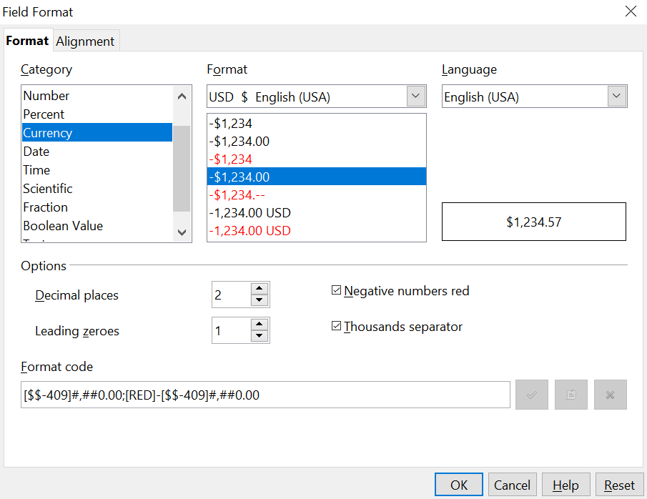

Figure 6: Field Format dialog

Creating auxiliary tables for data entry
It is often useful to have tables that provide a list of the possible values that a field in another table may have. For example, the Expenses table defined above has a field named ExpenseType. If people are allowed to enter anything in that field, a variety of words may be entered for one item. Buying gasoline might be entered as gasoline, gas, Gas, fuel or several other possibilities. The entries might also have leading or trailing spaces that are hard to notice. All of that can be dealt with when the table is queried but limiting the entries, even if only you will use the database, leads to a cleaner data set.
For the present case of the ExpenseType field, we will make the simplest possible table with just one column that will serve as both the primary key and the useful data.
Click the Tables icon in the Database region of the main window and choose Create Table in Design View in the Tasks pane. Give the field the name ExpType and leave the field type as TEXT [VARCHAR]. Before leaving that row of the design table, right click on the small green arrow at the left edge of the row and select Primary Key Save the table using File > Save with the name Expense_Categories and close it.

Adding data to the list table
You should now be back at the main Base window. In the Tables pane, right click on the icon for Expense_Categories and select Open. Enter the values Supplies, Equipment, Travel, Meals as the first four values of the ExpType column. You can close the table without saving it because the values were saved automatically as you entered them. Do be sure to complete the entry of the last value by pressing Enter or the down arrow to move to a new row before closing the window.
An alternative to this very simple table structure is to define a primary key column that is separate from the values you want to display in the Form when entering data. This is discussed further in the next section.

Defining relationships
The structure that we have defined for the database tables assumes some relationships that have not yet been made explicit. The following table shows each database table and its fields.
Expense_Categories | Expenses | People | Sales
ExpType | ID | PeopleID | SalesID
 | AmountSpent | FirstName | PersonID
 | DatePurchased | LastName | Date
 | EmployeeID |  | Amount
 | ExpenseType

Both the Expenses table and the Sales table have fields to identify people: EmployeeID and PersonID. When data is being entered into these tables, the PeopleID values are imported from the People table This is known as a Foreign Key. The advantage of this relationship is that the FirstName and LastName values associated with the ID appear in only one place, a single row in the People table. If a person's name should change for some reason, only one row in one table needs to be edited. In this very simple example, that is not a very daunting task but in a real situation where there might be tables for salary, medical benefits, vacation, leaves, emergency contacts and much more, updating every entry in all of the tables would be prone to error and quickly result in very unreliable data.
A similar relationship exists between the Expenses_Categories and the Expenses table, though the purpose is different. In that case, the values of ExpType serve to control the values that can be entered as an ExpenseType in the Expenses table. This is another form of a Foreign Key.
Tip | As you create your own databases, you need to also determine where tables are related and how.
- To begin defining relationships in the database, choose Tools > Relationships. The Finance – OpenOffice Base: Relation Design window opens and the Add Tables dialog pops up. (You can also open it by clicking the Add Tables icon, highlighted in red in Figure 7 , on the Relation Design window.)
- In this database, all of the tables have a relationship to another table and must be added to the Relation Design Window. On the Add Tables dialog, use either of these ways to add a table to the Relation Design window:
- Double-click the name of the table.
- Or, click the name of the table and then click Add for each table.
- Click Close to close the Add Tables dialog when you have added the tables you want. Figure 7 shows the Relation Design window in its final state after the relations have been created. At the current state of the process you will not see the lines connecting the tables. The tables may also be closer together and not display all of their fields. Feel free to drag the tables farther apart and resize them by clicking on their edge and dragging.
- You can define the relationship between pairs of tables in two ways:
- Click and drag the primary key field in one table to the foreign key field in the other table. When you release the mouse button, a connecting line forms between the two date fields. For example, drag from ExpType in Expense_Categories to ExpenseType in the Expenses table.
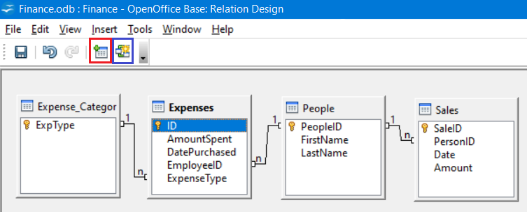
Figure 7: Designation for a 1:n relationships
- Or, click the New Relation icon, highlighted in blue in Figure 7. This opens the Relations window (Figure 8). The available tables are listed in the drop down lists in the Tables involved section.
- Select a table that holds the primary key from the left hand dropdown list and the corresponding table holding the foreign key from the right hand dropdown list. Figure 8 shows the tables Expense_Categories and Expenses selected.
- In the Fields involved section, click the dropdown list under the Expense_Categories label.
- Select ExpType from the list.
- Click in the cell to the right of this dropdown list. This opens a dropdown list for the Expenses table.
- Select ExpenseType from the Expenses table list. The dialog should now look like the top half of Figure 8.
- Under Update options select Update cascade and under Delete options select Delete cascade.
- Click OK

Figure 8: Selected fields in a relationship

The Update cascade and Delete cascade options control what happens when one of the primary key options is updated (changed) or deleted. The cascade option means that any rows in the Expenses table using the modified or deleted value will likewise be modified or deleted. While these options are not strictly necessary, they do help. Having them selected permits you to update a table that has a relationship defined with another table. It also permits you to delete a field from the table.
You can now repeat the process of step 4 to make the relationships between the People table and the Expense and Sales tables. At this point the Relation Design window should look like Figure 7. After closing the Relation Design window, it is a good idea to save the Base document.

Creating a database form
Databases are used to store data. But how is the data put into the database? Forms are used to do this. In the language of databases, a form is a front end for data entry and editing.
A simple form consists of the fields from a table. More complex forms can contain much more, including additional text, graphics, selection boxes, and many other elements. We will make three simple forms to demonstrate the basics of tying form controls to database tables, viewing and entering data, and modifying the function and appearance of form controls. The data tables are so simple that they are not realistic but they serve the purpose of showing how forms work. The examples do not use all of the available types of form controls but the principles are much the same for all controls.

Using the Wizard to create a simple form

Making the form
We will first use the Form Wizard to create a very simple People form for entering data in the People table.
In the main database window (Figure 1), click the Forms icon in the left column. In the Tasks list, click Use Wizard to Create Form to open the Form Wizard (Figure 9). On the left, you can see the possible steps to create a form. Simple forms require only some of these steps, while more complex forms may use all of them. Towards the center, there is a dropdown list titled Tables or queries where you can see that the People table has been chosen.
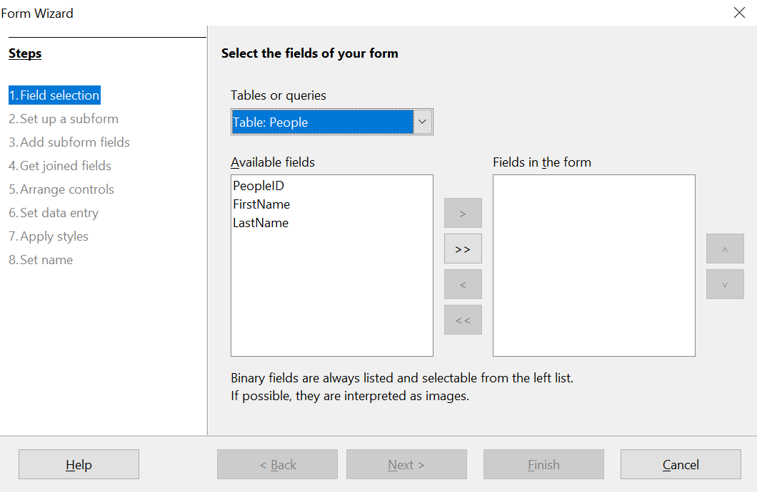

Figure 9: Form Wizard steps
Step 1: Select fields.
- Under Tables or queries, select Table: People. Available fields lists the fields for the People table.
- Click the field FirstName and then on the right single arrow to move it to the Fields in the form list. Do the same with LastName. Click Next. We do not put the PeopleID field on the form because it was defined as an AutoValue field and it will be populated automatically.
Step 2: Set up a subform
This form will not have a subform. Click Next and the dialog will jump to Step 5.
Step 5: Arrange controls.
Each control in a form consists of two parts: a label and a field. This step in creating the form determines where a control’s label and field are placed in relationship with each other. The four choices from left to right are Columnar left , Columnar - Labels on top , As Data Sheet, and In Blocks - Labels Above. Click the third icon from the left in the Arrangement of the main form section, the As Data Sheet icon, then click Next.

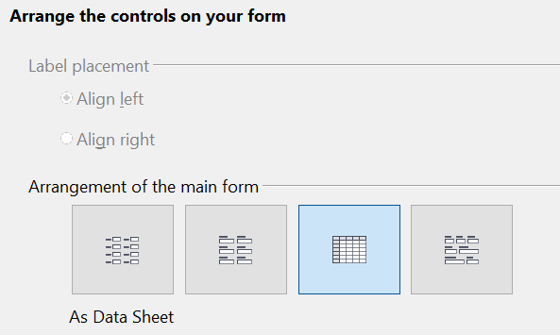
Figure 10: Form Wizard Step 5 - Detail

Step 6: Set data entry.
This step allows limiting what can be done with the form, such as preventing data deletion or viewing existing data. We will leave the defaults in place but this could be an important step in securing data. Click Next.
Step 7: Apply styles.
You can adjust the appearance of the form at this step with different colors and borders. We will leave the default in place but you might want to try different settings. Click Next.
Step 8: Set name.
You can give the form any name; there is no need to match the name of the table to which it is connected. We will keep the default name of People and also accept the option Work with the form. Click Finish and the form will be ready for data entry. It is a good idea to close the form now and save the main Base document.

Entering data with the new formIf you have closed the form, you can open it by clicking on the Forms icon in the main Base window (Figure 1) and then double clicking on the People icon in the list of Forms.
Data can be entered into the People table by typing into the FirstName and LastName fields. You can navigate from field to field by selecting them with the mouse, using the Tab key or using the buttons of the navigation bar along the bottom of the form's data sheet. The navigation bar shows the current record number, the total number of records and buttons which move the selection to the first record, the previous record, the next record, the last record, and a new record. As you enter data, moving out of a record automatically saves it to the database table. Be sure to exit the last row into which you enter data so that it gets written to the database table.
In later sections, we will add controls to forms that include dropdown lists and there are also other methods of automating data input such as buttons to increment numeric values. The basic steps are always same. You navigate from field to field by clicking or with the Tab key and moving to another record automatically saves the entered data. If a record does not meet a requirement placed on the table, for example, not entering data in a field for which input is required, the form will not move to a new record and an error message may appear.

Modifying the form
The Form Wizard 's choices for the size and layout of controls will probably not be ideal. Adjustments can easily be made by opening the form in edit mode. When the form is closed, right click on its icon and select Edit. The form should open ready to be edited but we will explain how to toggle in and out of Edit Mode. If the Form Control toolbar is not visible, open it with View > Toolbars > Form Controls. The toolbar is shown in Figure 11 with Edit Mode on and off and with the button that does the toggling highlighted with red. When Edit Mode is off, most of the toolbar's icons are gray.

Figure 11: Form Control toolbar with Edit Mode on and off
With Edit Mode on, you can click on the form's data sheet to select it. Eight green handles will appear at the edges of the data sheet. You can click and drag with these to resize the it. You can also resize the data sheet's columns by dragging the boundary between them. When resizing the sheet, pay attention to the navigation bar at the bottom so that you do not obscure some of the controls. You can control more details of the appearance of the data sheet using the Table Control dialog. To access this, right click on the data sheet and select Control or select it with a left click and then click on the Control icon on the Form Control toolbar. The Control button is highlighted in blue in Figure 11. In the dialog, you can adjust the size and position, font, background color, border style, and turn off the navigation bar.

Using the Wizard to make a form with a subform

Making the form
Forms can be arranged in a hierarchy so that the data selected in one form influences the data shown on the second form. The objects referred to as forms here are different than what we have previously called a form. If you click on the Forms icon on the main Base page, you will see a pane labeled Forms that displays forms previously saved in the Base file. In the file we have been working with there is now one form called People. A more precise descriptor for People would be Form Document. A Form Document contains one or more groups of Form Controls that interact with a database table or query. In the People Form Document, there is only one control, a data sheet, and it reads data from and writes to the People table. We could have had multiple controls, one dealing with each field in the table, but they all would have interacted with one table. Such a group of controls is also called a form, though a more precise name would be a Data Form. It is possible, even common, to have a Form Document that contains two or more Data Forms, each Data Form interacting with a different table but also some Data Forms influencing other Data Forms. We will now use the Form Wizard to make a Form Document that contains two Data Forms arranged as Form – Subform. The main Form will use the People table and the Subform will use the Expenses table. The two Data Forms will allow us to view and record the expenses of a chosen person.
In the main database window (Figure 1), click the Forms icon in the left column. In the Tasks list, click Use Wizard to Create Form to open the Form Wizard (Figure 9).
Step 1: Select fields.
- Under Tables or queries, select Table: People. The box Available fields lists the fields for the People table.
- Click the field FirstName and then on the right single arrow to move it to the Fields in the form list. Do the same with LastName. Click Next.
Step 2: Set up a subform
Since we have already created a relationship between the People and Expenses tables, we will use that relationship. If no relationship had been defined, this would be done in step 4.
- Click the box labeled Add Subform.
- Click Subform based upon existing relation.
- Both the Expenses and Sales tables have a relation with People, so both are listed as possible choices. Click Expenses to highlight it, as in Figure 12. Click Next. Even if only one table were listed, it would still be necessary to click on it to select it for the subform
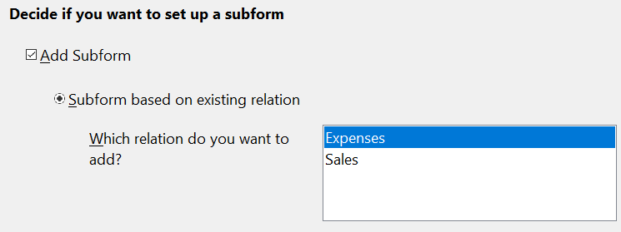

Figure 12: Adding a subform and choose the relation.
Step 3: Add subform fields.
This step is much like step 1.
- Expenses is preselected under Tables or queries.
- Use the >> button to move all the fields to the right.
- Click the ID field to highlight it.
- Use the < button to move the ID to the left (Figure 13). We are excluding the ID field because its value is set automatically. There can be circumstances where you would want to be able to view the ID and displaying it in the form is a valid choice. Click Next.
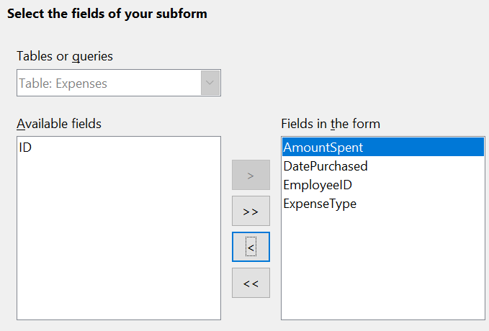

Figure 13: Selecting fields of a subform
Step 4: Get joined fields.
This step is for tables or queries for which no relationship has been defined. Because we have already defined the relationship, the wizard skips this step.
Note | It is possible to create a relationship between two tables that is based upon more than one pair of fields.
Caution | When selecting a pair of fields from two tables to use as a relationship, they have to have the same field type. The chosen columns in our example are both INTEGER.  Whether a single pair of fields from two tables are chosen as the relationship or two or more pairs are chosen, certain requirements must be met for the form to work.  - No field from the subform can be the Primary key for its table. (ID cannot be used.)  - Each pair of joined fields must have the same field type.  - One of the fields from the main form must be the Primary key for its table.
Step 5: Arrange controls.
Set the arrangement of both the main form and the subform to be As Data Sheet , which is the third icon from the left. Click Next.

Step 6: Set data entry.
Accept the default settings. Click Next.
Step 7: Apply styles.
- Select the color you want in the Apply Styles list.
- Select the Field border you want.
- Click Next.
Step 8 : Set name.
- Enter the name for the form. In this case, it is Expenses.
- Click Work with the form.
- Click Finish. The form opens ready for use. Though you can use the form immediately, it is a good time to close the form and save the main Base document.

Entering data in the subform
Reopen the Expenses form document if you closed it. If you have already entered data in the People table as described in Entering data with the new form , you will see that data in the main form. Figure 14 shows three people entered in the People table and the subform ready for data.
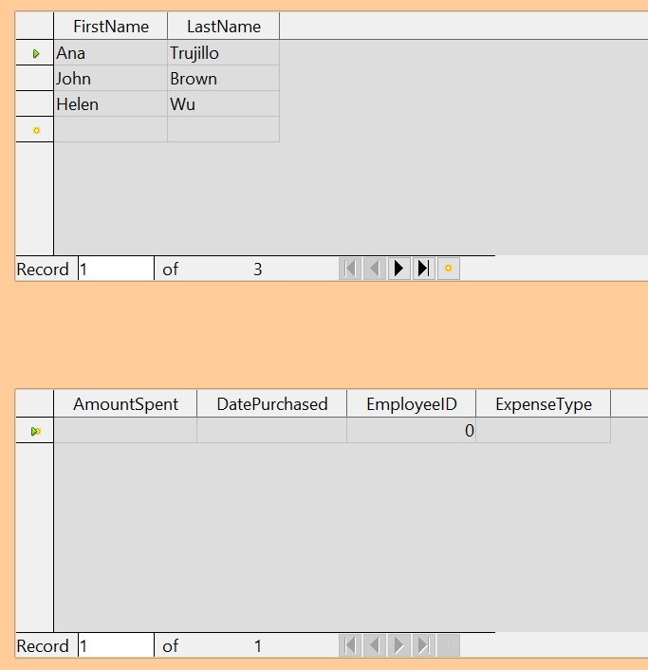

Figure 14: Main and subform of Expenses
Notice that the EmployeeID of the subform is already populated. The 0 is the PeopleID of Ana Trujillo in the People table, which is the record that is currently selected as can be seem by the green triangle at the left edge of the row. Remember that PeopleID and EmployeeID have a foreign key relationship as seen in Figure 7. If you select another person by clicking on the record or using the navigation bar, the EmployeeID in the subform will automatically change.
We could enter data for each employee now. The AmountSpent can be any number, the DatePurchased should be in the format appropriate for your locale, though YYYY-MM-DD should work anywhere, and the ExpenseType must be one of the values in the Expense_Categories table. If you try to enter some other value, say, Fish, the database will refuse to accept it. No error message appears but you cannot move down to the next row with an invalid value in ExpenseType. Similarly, you can enter a number in EmployeeID but if is not a value that exists in the People table, it will not be accepted. This is a result of the foreign key relationships set up earlier and is an important tool for maintaining data integrity. Rather than struggling to remember valid ExpenseTypes, we can modify the form to improve the ease of data entry.

Modifying the subform
In addition to making it easier to enter the ExpenseType, there are a few other changes that would improve the usability or appearance of the form. The column headers currently show the field names and could be replaced with labels closer to nontechnical language. Also, the DatePurchased column would benefit from a calendar widget to decrease the amount of typing.
Open the form document by right clicking on its icon and selecting Edit. The first step is to put the two Data Sheets into Design Mode. If the Form Controls toolbar is not visible, open it with the menu View > Toolbars > Form Controls. As shown in Figure 11, use the Design Mode button, which is highlighted in red, to toggle Design Mode to On .
Right click the ExpenseType header and select Replace with > Combo Box. The column had been a set of Text Boxes. These are controls which accept text entries. A Combo Box is very similar except that it provides a dropdown list of entries. To set the properties of the Combo Box, right click again on the ExpenseType header and select Column. A dialog titled Properties: Combo Box will appear.
- On the General tab, change the Label to Expense Type , with a space between the words.
- On the Data tab, make sure Type of list contents is Sql and List content is
SELECT "ExpType" FROM "Expense_Categories".
The code SELECT "ExpType" FROM "Expense_Categories" is in the SQL language that is used to interact with databases. We will not cover SQL in any detail but understanding simple statements like this is useful for setting up Combo Boxes and List Boxes that can display values stored in database tables. The SELECT keyword means "Show the following columns" and the FROM keyword means "Use the following tables to find the data". So, the entire statement means "Show the ExpType column from the Expense_Categories table". The only other detail is that the column and table names are in double quotes.
To make the other changes in the Data Sheet, click on each column header and select Column.
- For the AmountSpent field, change the Label to Amount Spent. You may also Adjust the Formatting property by clicking the small button with three dots at it right edge and using the dialog to set the Category to Currency and the Format to whichever setting you prefer.
- For the DatePurchased field, select the General tab and set the Label to Date Purchased then scroll down to find the Dropdown listing and change it to Yes.
It would also make sense to delete the EmployeeID column. Its value is set through the foreign key relation. It was displayed only to show the effect of the relation. We will not do that, but a column is deleted by clicking on the header and selecting Delete Column.
Take the forms out of Design Mode and try entering some data. You should be able to use dropdown lists in the Purchase Date and Expense Type columns and the Amount Spent column will be displayed with a currency format if you chose to set that up.

Laying out a form with multiple controls
A form with multiple controls will likely need some adjustments to their layout and appearance. We will make a form for the Sales table as a tool to demonstrate how to do this. The form could be made with a Form – Subform arrangement as was done for the Expenses form document.

Making the form
In the main database window (Figure 1), click the Forms icon in the left column. In the Tasks list,click Use Wizard to Create Form to open the Form Wizard (Figure 9).
Step 1: Select fields.
- Under Tables or queries, select Table: Sales.
- Move all of the fields to the list on the right using the >> button then click Next. Since SaleID is an AutoValue field, you might normally choose to not display it in the form.
Step 2: Set up a subform.
This form will not have a subform. Click Next and the dialog will jump to Step 5.

Step 5: Arrange controls.
In the Arrangement of the main form section, choose the second icon from the left which sets the layout to Columnar – Labels on top
Step 6: Set data entry.
Accept the defaults by clicking Next.
Step 7: Apply styles.
Accept the defaults by clicking Next.
Step 8: Set name.
Choose the name Sales and the option Modify the form and then click Finish.
You will now have a data form with four controls in a single column as shown in Figure 15. This is a perfectly serviceable arrangement but we will change it to have the controls horizontally arranged towards the middle of the form. If the Form Controls toolbar is not visible, open it with the menu View > Toolbars > Form Controls. Use the Design Mode button, which is highlighted in red, to toggle Design Mode to On as shown in Figure 11.
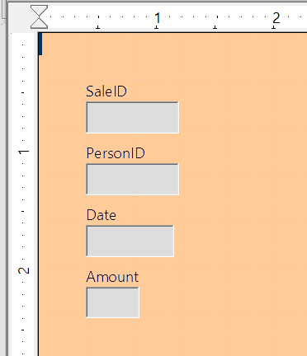Figure 15: Initial control arrangement of the Sales form
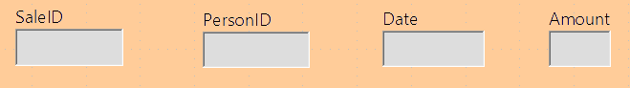
The entire group of controls can be moved by selecting them with click and drag. Make sure the cursor is in select mode by clicking the Select icon on the Form Controls toolbar. It is the first icon on the toolbar. Click and hold above and to the left of the SaleID label and drag down and to the right to form a rectangle around all of the controls. When you release the mouse button, green handles will define a rectangle encompassing all of the controls. Click and hold within this rectangle and drag the group to the right. Click anywhere outside of the rectangle to release the grouping of the controls. To arrange the controls horizontally, we will first drag them into their approximate positions and then fine tune them with Position and Size dialogs. Each control consists of a label and a field and if you click on one of the controls, both the label and the field are selected. After placing the label/field pairs close to their desired final positions, we can examine and adjust their precise positions. Figure 19 shows the controls after clicking and dragging.
Figure 16: Controls approximately horizontally arranged
Since we are dealing with an artificial set of data, we do not have strong reasons to arrange the controls in any particular way. We will make the rather arbitrary decision to make each field box one inch long and put a half inch between them. We also want them all at the same vertical position.
The label and the field are actually two objects that can be edited independently. To access one of them, use Ctrl + Click. Figure 18 shows the difference between clicking on the field of the SaleID control using just the left mouse button or using Ctrl + Click.
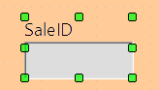
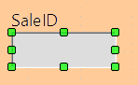

Figure 17: Click vs. Ctrl + Click
Click
Ctrl +Click
After using Ctrl + Click, you can move from the field to the label and vice versa with the Tab key. If you want to move both the label and the field, you should be careful that you have selected both with a plain click so you do not undo their alignment accidentally.
To examine and adjust a control's position, click on it, then right click and select Position and Size. The resulting dialog is shown in Figure 18.
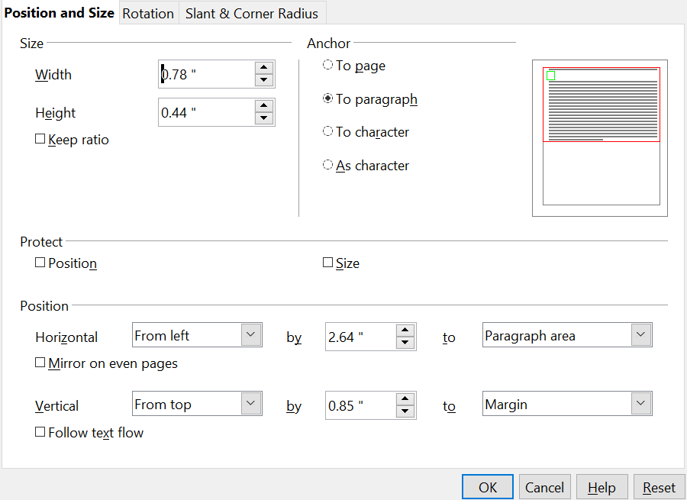Figure 18: Position and Size dialog of a control
The width and size of the label/field pair is shown at the top left while the position on the page is shown at the bottom. We will set the horizontal position to 2.50 and note that the vertical position is 0.85. We will leave the width unchanged because we want to change the width of only the field and not the label. We then exit the dialog and use Ctrl + Click to select only the data field of the SaleID control. We can then right click on the field, choose Position and Size and adjust its width to one inch. We can also use Ctrl + Click to select the label, right click on it, select Control, and change the label text, font color, or any other property. We can then proceed to the other controls, setting them to be on a 1.5 inch pitch with each data field having a width of one inch and placing them all at the 0.85 inch vertical position. We should also set the Date field to have a dropdown list by using Ctrl + Click to select only the date field, then right clicking and choosing Control.
The controls are now evenly positioned but there are three remaining adjustments to make the form easily usable.

Navigation bar
The first adjustment is to add a Navigator Bar to move from record to record and add new records. There is a Navigation Bar icon available in the More Controls auxiliary toolbar of the Form Controls toolbar. Figure 19 shows the location of the More Controls icon and the Navigation Bar icon.
Figure 19: More Controls toolbar and Navigation Bar icon

Click the Navigation Bar icon and use click and drag to place the bar. You can select it and lengthen it manually until all of its buttons are visible and use the methods just discussed to position it precisely. It has buttons which move the selection to the first record, the previous record, the next record, the last record, and a new record.

Adding a List Box
Another change needed to improve the usability of the form is to change the PersonID field into a List Box. The Form Wizard chose a Formatted Field for this control, which is basically a numeric field. You can see this by selecting only the PersonID data field, right clicking and selecting Control. The title bar shows that the control is a Formatted Field. The PersonID field is indeed numeric, it stores the PeopleID value from the People table as shown in Figure 7. To input data easily, we would want to know which FirstName and LastName correspond to a PeopleID value. A List Box is like a Combo Box in that it displays values but it displays one value and stores another. We will use a List Box to display the combined FirstName and LastName values of a row from the People table and store the corresponding PeopleID value in the Sales table PersonID field.
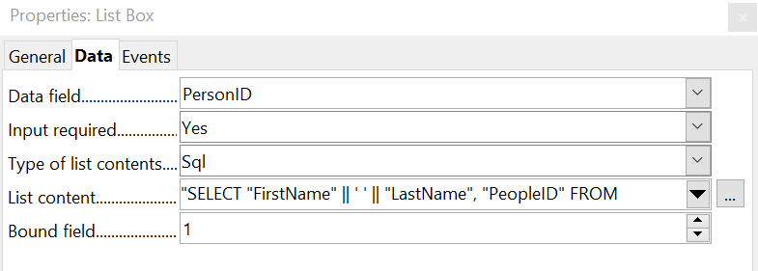
Use Ctrl + Click to select the field of the PersonID field then right click and choose Replace with > List Box. Right click again on the field and select Control. On the Data tab set Type of list contents to Sql and set List content to
SELECT "FirstName" || ' ' || "LastName", "PeopleID" FROM "People"
The Bound field should be set to 1 and on the General tab, the Dropdown list should be set to Yes.
Figure 20: List Box set up
The meaning of a very similar SQL statement was explained in the section Modifying the subform . The fields named after the SELECT keyword are a little more complicated here. The || symbol acts to concatenate or glue together the text on each side of it. "FirstName" || ' ' || "LastName" means "The value of the FirstName field followed by a space followed by the value of the LastName field". We will call this the Full Name of the record. The full SELECT clause returns the Full Name followed by the PeopleID of the record in the People table. The Bound Field value tells the control to store the second returned item (the control counts from zero) in the target table. This means PeopleID will be sent to the PersonID field of the Sales table. Fout: Bron van verwijzing niet gevonden shows the result of setting up the List Box. The Person ID dropdown list shows the full name of the person, but the value stored in the Sales table is the integer PeopleID. This can be confirmed after some data are entered by going to the main window of the Base file, selecting the Tables icon and double clicking on the Sales table.
The advantage of this arrangement is that if a person's name should change, the information only needs to be updated in one table. A database might have many tables that need to tie records with a particular person. If the name were input into each of these, a name change would require updating many tables, which is likely to lead to errors. It is a common practice to give people employee or customer identification numbers which look more elaborate than our simple integers but serve the same purpose in the database.
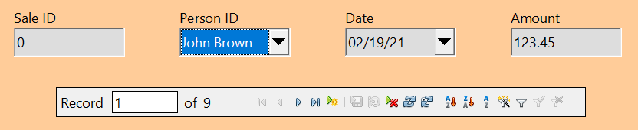
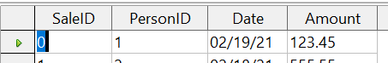
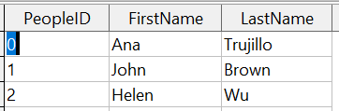
Figure 21: A List Box displays one value from the source table but sends another value to the target table.
Form Content
Sales Table Content
People Table Content
Changing the tab order
The last change for usability is to adjust the tab order of the controls. In the very simple form we have made, this is not needed but in forms with many controls, it is much more convenient to jump from one control to the next with the tab key than to repeatedly click on the form. To adjust the tab order, open the Form Design tool bar with View > Toolbars > Form Design. The toolbar is shown in Figure 85 with the Activation Order icon highlighted in red. Click that icon to open a dialog showing all of the controls in the order in which they will be chosen by the Tab key.
Figure 22: Form Design toolbar with Activation Order highlighted
The dialog, shown in Figure 86, has buttons to move controls up and down the list. The control names are the automatically assigned ones unless you have changed them while editing other control properties. The easiest way to make these names meaningful is to give the database table fields meaningful names, which is good practice in any case. The list has the controls in a reasonable order but in a form with more fields, it is likely that the order of the fields in the database will not be convenient for data entry.
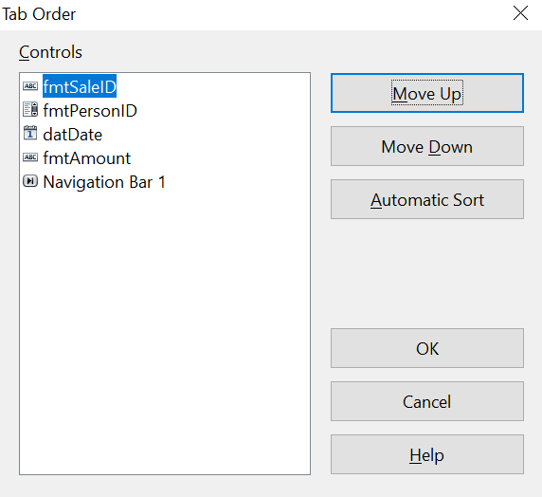

Figure 86: Tab order dialog

Creating forms and subforms in Design View
This method requires using the Form Controls and Form Design toolbars extensively. These techniques are beyond the scope of this document.

Accessing other data sources
OpenOffice allows data sources to be accessed and then linked into AOO documents. For example, a mail merge links an external document containing a list of names and addresses into a letter, with one copy of the letter being generated for each entry.
To access an external data source:
- File > New > Database opens the Database Wizard window.
- Select Connect to an existing database. Click the arrow next to the Database type field and select the database type from the drop-down list. Click Next.
- Click Browse and select the database. Click Next.
- Accept the default settings: Register the database for me, and Open the database for editing. Click Finish. Name and save the Base file in the location of your choice.

Accessing a spreadsheet as a data source
Accessing a spreadsheet is similar to accessing other databases:
- Choose File > New > Database.
- Select Connect to an existing database. Select Spreadsheet as the Database type.
- Click Browse to locate the spreadsheet you want to access. If the spreadsheet is password protected, check the Password required box. Click Next.
- If the spreadsheet requires a user’s name, enter it. If a password is also required, check its box. Click Next.
Note | Using this method of accessing a spreadsheet, you cannot change anything in the spreadsheet. You can only view the contents of the spreadsheet, run queries, and create reports based upon the data already entered into the spreadsheet.  All changes in a spreadsheet must be made in the spreadsheet itself, using Calc. After modifying the spreadsheet and saving it, you will see the changes in the database. If you create and save an additional sheet in your spreadsheet, the database will have a new table the next time you access it.

Registering *.odb databases
Registering a *.odb database is simple:
- Choose Tools > Options > OpenOffice Base > Databases.
- Under Registered databases, click New.
- Browse to where the database is located.
- Make sure the registered name is correct.
- Click OK.

Using data sources in Apache OpenOffice
Having registered the data source, whether a spreadsheet, text document, external database or other accepted data source, you can use it in other AOO components including Writer and Calc.

Viewing data sources
Open a document in Writer or Calc. To view the data sources available, press F4 or select View > Data Sources from the pull-down menu. This brings up a list of registered databases, which will include Bibliography and any other database registered, such as the database created earlier in this chapter.
To view each database, click on the + to the left of the database’s name (see Figure 87). This brings up Tables and Queries. Click on the + next to Tables to view the individual tables created. Now click on a table to see all the records held in it.
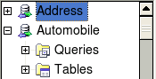
Figure 87: Databases

Editing data sources
Some data sources can be edited in the View Data Sources dialog. A spreadsheet can not. In other cases, a record can be edited, added, or deleted.
The data is displayed on the right side of the screen. Click in a field to edit the value.
Figure 88: View Data Sources navigation buttons
Beneath the records are five tiny buttons. The first four move backwards or forwards through the records, or to the beginning or end. The fifth button, with a small star, inserts a new record.

To delete a record, right-click on the gray box to the left of a row to highlight the entire row, and select Delete Rows to remove the selected row.
Figure 89: Deleting a row in the Data View window

Launching Base to work on data sources
You can launch Base at any time from the View Data Source pane. Just right-click on a database or the Tables or Queries icons and select Edit Database File. Once in Base, you can edit, add, and delete tables, queries, forms, and reports.

Using data sources in Writer and Calc
Data can be placed into Writer and Calc documents from the tables in the data source window. In Writer, values from individual fields can be inserted. Or, a complete table can be created in the Writer document. One common way to use a data source is to perform a mail merge.
Tip | Choosing Tools > Mail Merge Wizard or clicking on the Mail Merge icon on the View Data Source pane launches the Mail Merge wizard which steps you through creating a mail merge document. See Chapter 11 in the Writer Guide.

Writer documents
To insert a field from a table opened in the data source window into a Writer document, click on the field name (the gray square at the top of the field list) and, with the left mouse button held down, drag the field onto the document. In a Writer document, it will appear as <FIELD> (where FIELD is the name of the field you dragged).
For example, to enter the information about an expense you can follow these steps.
- Open the list of data sources by pressing F4 and select the Finance database and its Expenses table.
- Type the sentence in the Writer document to contain the information from the table, but do not write anything in the locations where database information will go. See Figure 90.
- Click and hold on the column header of one of the desired fields, e.g. DatePurchased, and drag it to the desired location. Do this for each field. The text in the document will now look like
On <DatePurchased>, an expense of <AmountSpent> was submitted for <ExpenseType>.
- Click on the gray box at the left end of the row holding the desired information.
- Click on the Data to Fields icon, which is highlighted in red in Figure 90
- The values from the selected row will appear in the document. If View > Field Shadings is selected, the values will appear with gray shading. This shading does not print. If the record with ID = 9 was selected, the text in the Writer document will say:
On 02/02/21, an expense of 213.56 was submitted for Travel.
Figure 90: Sending data from Base to Writer with fields

Adding data in table format is a little easier and takes perhaps fewer steps. Some of the steps will be quite similar.
- Navigate to the place you want to place the table and click the location.
- Control+Click the gray box to the left of each row of the data source that you want to be a row in your table when the rows are not consecutive. To select consecutive rows, click the gray box to the left of the top desired row and Shift+Click the bottom desired row.
- Click the Data to text icon to open the Insert Database Columns dialog (Figure 91). (The Data to text icon is to the left of the Data to Fields icon in Figure 90.
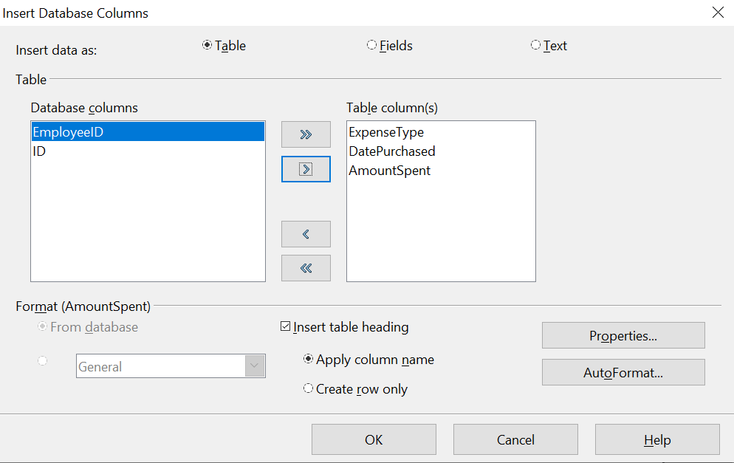

Figure 91: Insert Database Columns dialog
- Move the fields you want in your table from the Database columns list to the Table column(s) list.
- To place the fields in the order you select, click the field and use the single arrow to move the fields in the order you desire. You can also limit the fields you use to less than all of the fields available.
- If you want to use all of the fields, use the double arrow pointing to the right to move all of them at one time. The order of the fields in the table you create will be the same as in the data source table.
- To remove a single field from the Table Column(s) list, click the field and use the single arrow pointing to the left.
- To start over, click the double arrow pointing to the left.
- Select the settings for your table. Use the default settings as in Figure 91.
- Click OK. Save the document.

Calc spreadsheets
There are two ways to enter data in a Calc spreadsheet. One enters the data into the spreadsheet cells. The other creates controls to display the data in the spreadsheet just as is done in creating a form document in a Base file. While you can directly access the data in the spreadsheet cells, you can only see the data in the controls created in the spreadsheet.
Entering data directly to the spreadsheet cells uses the Data to Text icon as we did to make a table in a Writer document. But differences exist in these two situations.
The steps are straightforward:
- Click the cell of the spreadsheet which you want to be the top left of your data including the column names.
- Use F4 to open the database source window and select the table whose data you want to use.
- Select the rows of data you want to add to the spreadsheet:
  - Click the gray box to the left of the row you want to select if only selecting one row. That row is highlighted.
  - To select multiple rows, hold down the Control key while clicking the gray box of the rows you need. Those rows are highlighted.
  - To select all the rows, click the gray box in the upper left corner. All rows are highlighted.
- Click the Data to text icon to insert the data into the spreadsheet cells.
- Save the spreadsheet.
Adding records displayed in form controls to a spreadsheet is fairly easy. You need to have the Data Source window open, your spreadsheet open, and the table you want to use selected.
- Click the gray box above a field name.
- Drag and drop the gray box for the field to where you want the record to appear in the spreadsheet.
- Repeat until you have moved all of the fields you need to where you want them.
- Name and save the spreadsheet.
- Click a row of the table in the Data Source window.
- Drag the data, not the header, in the first field in the selected row onto its corresponding control in the spreadsheet. The Save icon should activate.
- Click the Edit File button to make the spreadsheet read only. Click Save when asked if you want to save the file.
- The Data Source window goes blank, the fields in the spreadsheet are populated with data from the row you selected, and the Form Navigation toolbar appears at the bottom of the spreadsheet.

Figure 92: Navigation arrows of a form
Click the arrows on the Form Navigation toolbar to view the different records of the table. (The arrows are circled in red.) The number in the box changes when you change the record number by clicking an arrow. The data in the fields changes correspondingly to the data for that particular record number.

Creating queries
Queries are used to get specific information from a database. Query results are special tables within the database but the results are not permanently stored; only the code to produce the results is stored.
To demonstrate the use of queries, we will use both the query Wizard and query Design View to look at the Sales data from the Finance database we made in previous sections.

Using the Wizard to create a query
Queries created by the wizard provide a list or lists of information based upon what one wants to know. It is possible to obtain all of the records meeting the desired conditions or aggregated results such as the sum of data from multiple records.
In the main database window (Figure 1), click the Queries icon in the Databases section, then in the Tasks section, click Use Wizard to Create Query. The Query Wizard window opens (Figure 93). We want to display the PersonID, the date and the amount of each sale, sorted by the date and including only sales with an Amount greater than or equal to 100.
Note | When working with a query, more than one table can be used. Since different tables may contain the same field names, the format for naming fields in a query is Table name.field name, with a period (.) between the table name and the field name. For example, the Date field of the Sales table used in a query has the name Sales.Date.
Step 1: Select the fields.
1) Select the Sales table from the dropdown list of tables.
2) Select fields in the Available fields list. This step has already been done in the figure.
- Click PersonID , and use the > button to move it to the Fields in the Query list.
- Move the Date and Amount fields in the same manner.
- Click Next.
Tip | To change the order of the fields, select the field you want to move and click the up or down arrow.
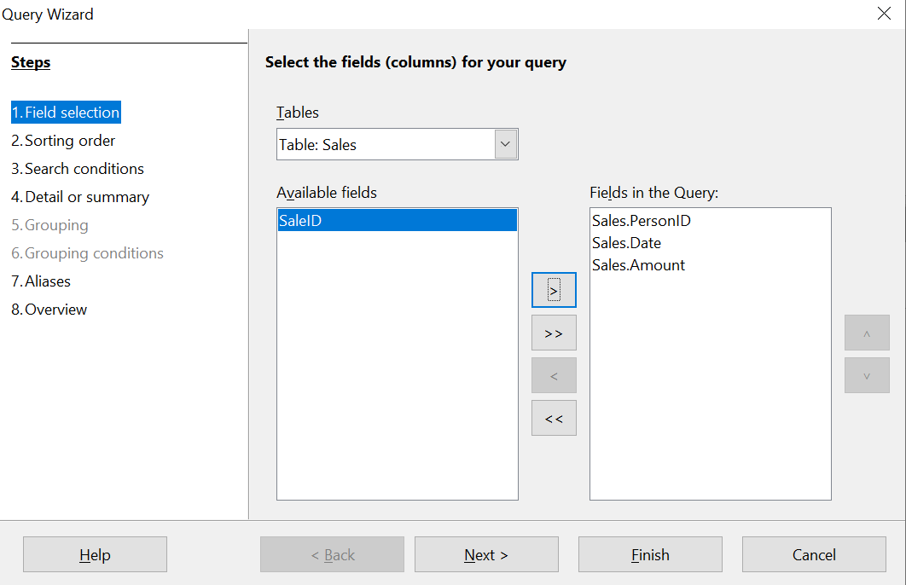

Figure 93: First page of the Query Wizard
Step 2: Select the sorting order.
The Wizard allows up to four fields to be used to sort the information of our query. The query language, SQL, does not have a limit on the number of fields that can be used for sorting. In our case, we only want to sort by the date. Set the Sort by list to Sales.Date, leave the Ascending button selected and click Next. Figure 94 shows the dialog just before clicking Next.

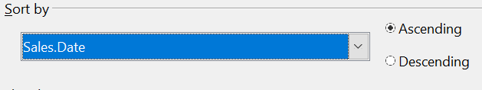

Figure 94: Sorting order page
Step 3: Select the search conditions
The search conditions allow us to compare the field values with desired values and decide whether to include a particular record in our query result or not. Among the choices are:
- is equal to
- is not equal to
- is smaller than
- is greater than
- is equal or less than
- is equal or greater than
- like (used for wildcard matching of text)
Note | These conditions apply to numbers, letters (using the alphabetical order), and dates.
The conditions can be related to each other with AND, so that all of the conditions have to be met, or with OR, so that only one condition need be met. We want to limit the records to amounts greater than or equal to 100.
- Since we are only setting one condition, we will use the default setting of Match all of the following.
- We are looking for data beyond a certain value. Select Sales.Amount in the Fields list and is equal or greater than as the Condition.
- Set the Value box to 100. Click Next.
Step 4: Select type of query
We want all of the records that meet the criterion returned, so the default setting: Detailed query is what we want. Click Next at the bottom of the window.
Note | Since we have a simple query, the Grouping and Grouping conditions are not needed. Steps 5 and 6 of the wizard are skipped in our query.
Step 7: Assign aliases if desired.
We use the default settings but it is often useful to give descriptive names at this point. Click Next.
Step 8: Overview.
Name the query (suggestion: SalesAbove100). To the right of this are two choices. Select Display Query. Click Finish. You will now see a display of the selected rows in the same style that database tables are displayed.

Using the Design View to create a query

Make a basic query
Creating a query using Design View is not difficult but does require learning the conventions of the tool. We will start with a duplicate of the query from the last section and then make some more complicated queries.
Our first query will display all of the sales with an amount greater than or equal to 100, sorted by date.
Step 1: Open the query in Design View.
Click Create Query in Design View in the Queries pane of the main Base window.
Step 2: Add tables.
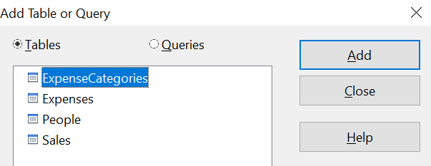

Figure 95: Add Tables or Query window
- Click Sales to highlight it.
- Click Add. Click Close.
Tip | Move the cursor over the bottom edge of the Sales table (Figure 96) and drag it to make it longer and easier to see all of the fields in the table.
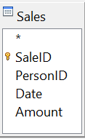

Figure 96: Sales table in query
Step 3: Add fields to the query definition table at the bottom.
Double-click the PersonID, Date, and Amount fields to add them to the query definition table.
The table at the bottom of the query window should now have three columns populated. The row labeled Visible is used to toggle the visibility of the field in the final query result. The default is to show all of the fields.
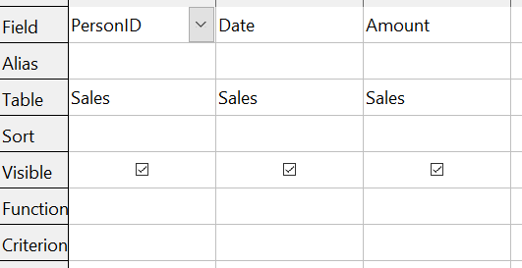

Figure 97: Query definition table
Step 4: Set the criterion for the query.
We want the query results to have Amount greater than or equal to 100 and the dates to be sorted in ascending order.
- Type >= 100 in the Criterion cell under Amount in the query definition table.
- Choose ascending from the dropdown list in the Sort row of the Date column.
- Click the Run Query icon in the Query Design toolbar, which is highlighted in red in Figure 98.

Figure 98: Query Design toolbar
Step 5: Save and close the query.
Save the query and also save the main Base document.

Make a query with a calculated field
Imagine you would like to calculate a commission for each sale that is 7% of the sale amount. The process is just like the last query except that at step 3 an additional column is added manually to the query description, as shown in Figure 99. Notice the fourth column where the Field is defined as "Amount" * 0.07. The name of the column upon which the calculation is based should be enclosed in double quotes. Besides the usual arithmetical operators of +, -, *, and /, many other functions such as square root (sqrt) and the trigonometric functions are available. The calculations may also use more than one column, so you could, for example, calculate the difference or ratio of two columns.
Some other details to note in the calculated column are that it has the text Commission written in its Alias row, and that the Table row is blank. These changes should make sense. The column is not stored in a table and therefore it does not have a good default name. If the alias is not supplied, the text of the calculation is used, which is not often a helpful column header. Note also that the criterion in the Amount column has been removed. This was not required; it is perfectly possible to do the calculation only on rows that meet any number of criteria.
An important point in database design is that calculations based on field values should be done in queries and not stored in the regular database tables. The main reason for this is that if the underlying values are updated, the calculated values in a regular table will not be automatically updated. You have to explicitly recalculate them. In a query, on the other hand, only the code to run the query is stored, so any calculated values are updated every time the query is run.

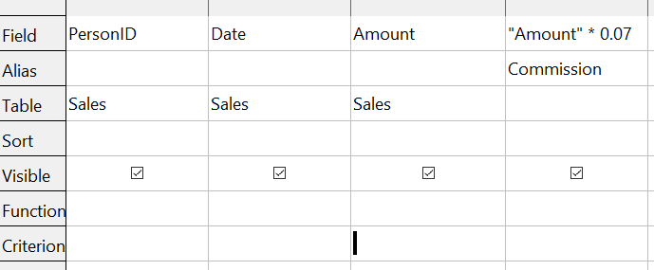Figure 99: A query with a calculated field

Query with two related tables
An obvious deficiency in the previous queries is that the people associated with an expense or a sale are only identified by the value of the PeopleID field in the People table. Adding their names to the query output is simple because we have established relations between the People table and the Expenses and Sales tables. We will make a new query that displays sales information along with the name of the associated person.
Step 1: Start the query in Design View
From the main Base window, click Queries in the left pane and then Create Query in Design View from the Tasks pane.
Step 2: Add tables to the query
In the Add Query or Table dialog, click on People and then the Add button and do the same for the Sales table. Click Close. You will now have small representation of the two tables with a line running from the PeopleID field of one to the PersonID field of the other, as shown in Figure 100. You may want to resize the tables by dragging down their lower edges.
Step 3: Add fields to the query

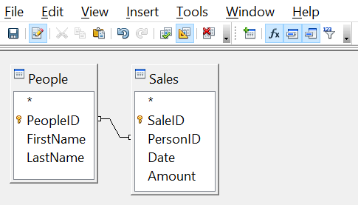Figure 100: The People and Sales tables in a query
Double click on the FirstName and LastName from the People table and Date and Amount from the Sales table to add them to the query definition table.
We now have a query that will display the names along with the information from the Sales table. Save both the query and the main Base document. The query can be enhanced with criteria in any column or with calculated columns as shown in the previous sections.

Query that summarizes data
All of the queries we have written so far display all of the rows that meet the query criteria. It is very common to want a summary of the data that displays quantities like the sum or the average of a field calculated over some group of rows. For example, we might want the sum of sales for each person. Writing such a query can be done using the Function row of the query definition table in Design View.
Step 1: Start the query in Design View
From the main Base window, click Queries in the left pane and then Create Query in Design View from the Tasks pane.
Step 2: Add tables to the query
In the Add Query or Table dialog, click on People and then the Add button and do the same for the Sales table. Click Close.
Step 3: Add fields to the query
Double click on the FirstName and LastName from the People table and Amount from the Sales table to add them to the query definition table.
Step 4: Set the grouping and the sum function
In the Function row of the query definition table, use the dropdown list to set FirstName and LastName to Group and set Amount to Sum. Also set the Alias of the Amount column to Sales_Sum. The final settings of the query definition table are shown in Fout: Bron van verwijzing niet gevonden.

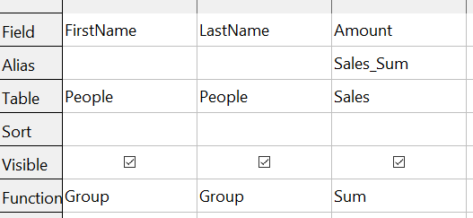Query summing Amount for each person
Note | In a query that uses one or more summarizing functions, also known as aggregating functions, every column must have an entry in the Function row, either as Group or one of the other functions.

Query summarizing over a calculated field
As a final example of a query, we will calculate the total sales of each person for each month and year. We will need to use the Date column from the Sales table twice, one to calculate the year and again to calculate the month, and we will also use the fields FirstName, LastName from the People table and Amount from the Sales table.
Step 1: Start the query in Design View
From the main Base window, click Queries in the left pane and then Create Query in Design View from the Tasks pane.
Step 2: Add tables to the query
In the Add Query or Table dialog, click on People and then the Add button and do the same for the Sales table. Click Close.
Step 3: Add fields to the query
Double click on the Date field from the Sales table twice, then double click on FirstName and LastName from the People table and Amount from the Sales table to add them to the query definition table.
Step 4: Set the calculation of the year and the month
Change the Field row of the first Date column to read YEAR("Date") and change the Field row of the second Date column to read MONTH("Date"). Set the Alias row to read Sale_Year and Sale_Month for these two columns. The YEAR and MONTH functions are among the many functions provided by the HSQL database engine. A complete list is available in the documentation at https://www.hsqldb.org/doc/1.8/guide/guide.html#N1251E.
Step 5: Set the grouping and the sum function
Set the Function row of every field except Amount to read Group. Set the Function row of the Amount column to read Sum.
Step 6: Set the sorting
For a more logical presentation of the data, set the Sort column of the year, month and LastName columns to read ascending.
Be sure to save the query and the main Base document. We saved the query with the name GrpCalcColumn and we will use it in the reports in the next section.
The final configuration of the query definition table and the query results are shown in Figure 102.
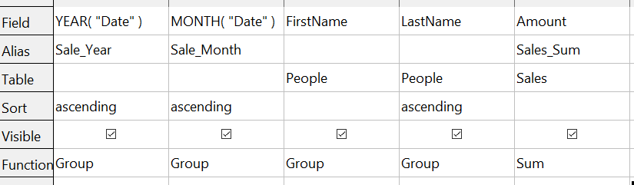
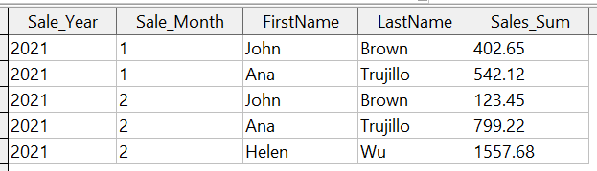

Figure 102: Definition and result of a query that groups on a calculated column

Creating reports
Reports provide information found in the database in a useful way. In this they are similar to queries. Reports are generated from the database’s tables or queries. They can contain all of the fields of the table or query or just a selected group of fields. Reports can be static or dynamic. Static reports contain the data in the selected fields at the time the report was created. Dynamic reports can be updated to show the latest data.
For example, a report on expenses in the past should probably be a static report because it is based upon specific data that does not change. However, a report on year-to-date expenses should probably be a dynamic report, because this report depends upon data that does change.
All reports are based upon a single table or query and you need first to decide what fields you want to use in the report. If you want to use fields from different tables, you must first combine these fields in a single query. Then you can create a report on this query.
The most flexible method for making a report is to write a query that returns the desired columns and sorts the rows and then save this query as a View in the database. A View is simply a query whose code has been stored alongside the database tables and it can be treated just like a table. To make a View from a query, click on the Queries icon in the main Base window then click on the name of the specific query and select Create as View. You will be prompted for a name to give the View. A good practice is to give the View the same name as the query with View as either a prefix or suffix. For the View made from the GrpCalcColumn query that we will use in the reports, we used the name GrpCalcColumn_View. This makes it easy to see the code saved in the View. Keep in mind that editing the query after saving the View does not change the View. You would have to make a new View to embody the new query. Once the View is saved, it will be listed along with the tables in the database.
Once a View is ready for the report, making the report is very simple.

Simple static report
Step 0: Start the Report Wizard
On the main Base window, click the Reports icon and then click Use Wizard to Create Report.
Step 1: Choose the fields from the View
Choose the View you want to use from the Tables and queries dropdown list. The available fields will be listed. Use the >> button to move all of them to the Fields in report list. You can just move a subset of the fields by choosing them individually and using the > button. The fields can also be reordered with the up and down arrow buttons. Click Next.
Step 2: Labeling the fields

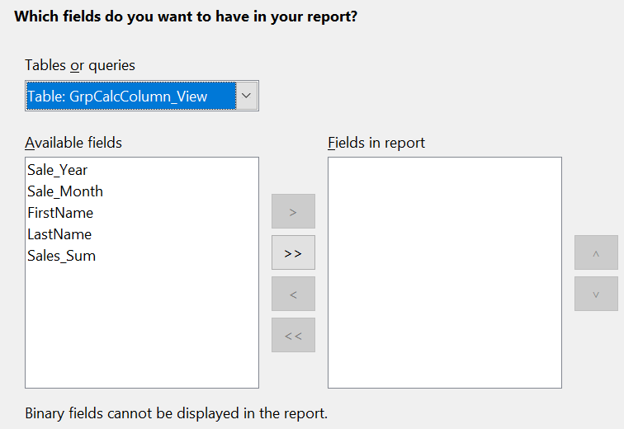Figure 103: Dialog for choose the fields in a report.
Here you can modify the field labels from their default values. We will remove the underscores from the field names and add spaces so that Sale_Year becomes Sale Year and LastName becomes Last Name. Click Next.
Step 3: Grouping levels
In this first report we will not add grouping levels. In the next iteration of the report, we will do that. Click Next.
Step 4: Sort options
It is better to sort in the View rather than using the Report Wizard's sort. Click Next.
Step 5: Choose layout
There are many layout options. We will leave the defaults in place but you can explore alternatives. A mock version of the report is visible behind the Report Wizard dialog and if you drag the dialog low in the screen, you can see the effect of different layouts.
Step 6: Create report
In this step, you give the report file a name, rather misleadingly called Title of report and choose whether the report is static or dynamic. We will choose static for this version. Click Finish.
We now have a Writer file that looks like Figure 104.

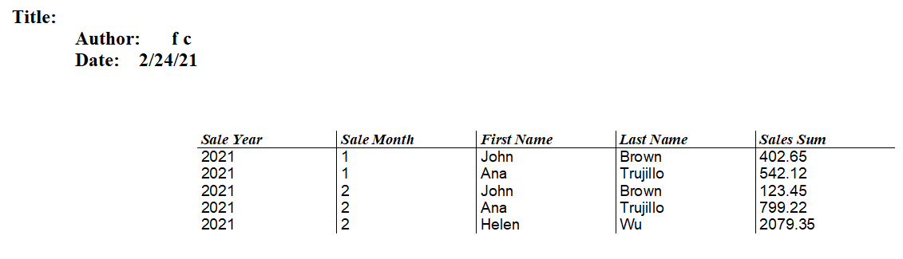

Figure 104: Static report
The Author field is taken from Tools > Options > OpenOffice > User Data > First/Last name. All of the information is locked and not easily edited. It can be copied to a new document and edited there. If you do that, the Title field can be filled out in the new document by selecting the menu File > Properties and filling out the Title on the Description tab.

Grouped dynamic report
We will now change the report in two ways. We will make it dynamic and we will add some Grouping Levels. Keep in mind that these two are independent. The Grouping Levels could have been added to the static report in the last section.
Step 0: Start the Report Wizard
On the main Base window, click the Reports icon and then click Use Wizard to Create Report.
Step 1: Choose the fields from the View
Choose the View you want to use from the Tables and queries dropdown list. The available fields will be listed. Use the >> button to move all of them to the Fields in report list. Click Next.
Step 2: Labeling the fields
Here you can modify the field labels from their default values. We will remove the underscores from the field names and add spaces so that Sale_Year becomes Sale Year and LastName becomes Last Name. Click Next.
Step 3: Grouping levels
Use the > button to move the Sale_Year and Sale_Month, in that order, from the Fields to the Groupings column. Click Next.
Step 4: Sort options
Note that Sale_Year and Sale_Month are now listed as sort fields. Click Next.
Step 5: Choose layout
We will keep the defaults but, as mentioned in the previous section, you can try many alternatives.
Step 6: Create report
Set the name of the report file, choose Dynamic report and Create report now. Click Finish.
The top part of the report looks much like Figure 104 but the data table now has a hierarchical structure with the year being the outermost category, then the month and then the data for each person's monthly sales in a table.
The report layout can be edited by closing the report then right clicking on its icon and selecting Edit. The report will appear filled with dummy data. The Title field can be populated by selecting the menu File > Properties and filling out the Title on the Description tab. The Author field is taken from Tools > Options > OpenOffice > User Data > First/Last name. The date format in the header area can be adjusted by right clicking on it and selecting Fields. A dialog with a long list of formats will appear. Choose one then click OK. In the data table, the column widths can be adjusted by hovering the cursor over a border until it becomes a double headed arrow then clicking and dragging it left or right.
When you are done changing the format, save the document and also save the main Base document. If you double click on the report now, you will see the format changes along with the actual data from the View. Compare Figure 105 to Figure 104 to see the effect of the groupings by the Sale Year and Sale Month. Remember that the grouping could have been done in the static report. Since this report is dynamic, if data is added or deleted from the People and Sales tables, the report will reflect the changes.
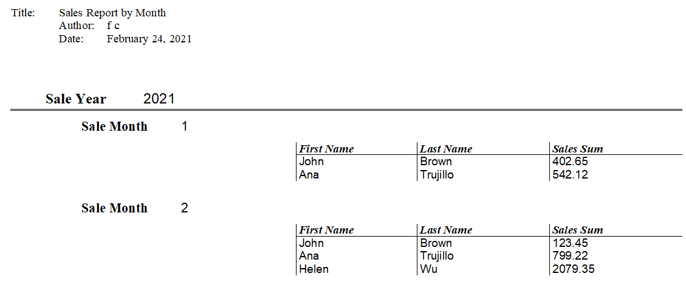

Figure 105: Dynamic report with grouped data

