Apache OpenOffice
Version 4.1
Writer Guide

AOO Documentation Team

Copyright
This document is Copyright © 2025 by The Apache Software Foundation. You may distribute it and/or modify it under the terms of the Creative Commons Attribution License, version 3.0 or later (https://creativecommons.org/licenses/by/3.0/).
Apache, Apache OpenOffice, and OpenOffice.org are trademarks of the Apache Software Foundation.
Acknowledgments
This book is updated from a previous version (by the OOoAuthors team). with additional material adapted from Getting Started with LibreOffice 3.4 (by the ODF Authors Team).
Publication date and software version
Published Tuesday June 17. Based on Apache OpenOffice 4.1.

Contents
Chapter 1
Introducing Writer 13
What is Writer? 13
Parts of the Main Writer Window 14
Title Bar 14
Menus 14
Toolbars 15
Right-click (Context) Menus 17
Rulers 18
Status Bar 18
Sidebar 20
Changing Document Views 22
Starting a New Document 22
Starting a New Document from a Template 24
Opening an Existing Document 24
Saving a Document 25
Saving a Document Automatically 25
Saving as a Microsoft Word Document 25
Password Protection 27
Closing a Document 28
Closing OpenOffice 28
Using the Navigator 29
Moving Quickly through a Document 31
Rearranging Chapters Using the Navigator 32
Setting Reminders 33
Choosing Drag Mode 33
Getting Help 34
What Are All These Things Called? 34
Undoing and Redoing Changes 35
Using Writer on a Mac 36
Chapter 2
Setting up Writer 37
Choosing Options that Affect all of AOO 37
User Data Options 38
General Options 39
Memory Options 40
View Options 41
Print Options 43
Path Options 44
Color Options 44
Font Options 46
Security Options 47
Appearance Options 48
Choosing Options for Loading and Saving Documents 49
General Load/Save Options 49
VBA Properties Load/Save Options 51
Microsoft Office Load/Save Options 51
HTML Compatibility Load/Save Options 52
Choosing Options for Writer 54
General Options 54
View Options 55
Formatting Aids Options 56
Grid Options 57
Default Fonts 58
Print Options 59
Default Table Options 60
Change Tracking Options 60
Compatibility Options 61
AutoCaption Options 63
Mail Merge E-mail Options 64
Choosing Options for HTML Documents 64
Choosing Language Settings 65
Install the Required Language Pack 65
Install the Required Dictionaries 65
Change Some Locale and Language Settings 65
Choose Spelling Options 66
Controlling Writer’s AutoCorrect Functions 67
Chapter 3
Working with Text 69
Introduction 69
Selecting Text 70
Selecting Items that are not Consecutive 70
Selecting a Vertical Block of Text 70
Cutting, Copying, and Pasting Text 71
Finding and Replacing Text 72
Find and Replace Specific Formatting 73
Find and Replace Paragraph Styles 74
Use Wildcards (regular expressions) 74
Inserting Special Characters 75
Inserting Non-breaking Spaces and Hyphens 76
Inserting en and em Dashes 76
Formatting Paragraphs 77
Setting Tab Stops and Indents 79
Changing the Default Tab Stop Interval 80
Formatting Characters 80
Autoformatting 82
Creating Numbered or Bulleted Lists 83
Using the Bullets and Numbering Toolbar 83
Example: Configuring a Nested List 84
Using Footnotes and Endnotes 86
Inserting Footnotes/Endnotes 86
Defining the Format of Footnotes/Endnotes 87
Checking Spelling and Grammar 88
Using Built-in Language Tools 90
Using Paragraph and Character Styles 90
Using Tools > Language 90
Using Language Settings in Options 90
Using the Status Bar 91
Using Synonyms and the Thesaurus 92
Hyphenating Words 93
Automatic Hyphenation 93
Manual Hyphenation 95
Using AutoCorrect 95
Using Word Completion 96
Using AutoText 97
Creating AutoText 98
Inserting AutoText 99
Printing a List of AutoText Entries 99
Line Numbering 99
Tracking Changes to a Document 100
Preparing a Document for Review 100
Recording Changes 101
Accepting or Rejecting Changes 102
Merging Modified Documents 103
Comparing Documents 104
Adding Other Comments 104
Linking to Another Part of a Document 105
Using Cross-References 106
Using Bookmarks 106
Using Hyperlinks 106
Inserting Hyperlinks Using a Dialog Box 108
Editing Hyperlinks 109
Switching Between Insert and Overwrite Mode 109
Counting the Words in a Selection 110
Changing the Case of Selected Text 110
Chapter 4
Formatting Pages 111
Introduction 111
Choosing a Layout Method 112
Setting up Basic Page Layout Using Styles 114
Inserting a Page Break without Switching the Style 114
Defining a Different First Page for a Document 114
Changing Page Orientation within a Document 116
Changing Page Margins 118
Using Columns to Define the Page Layout 119
Defining the Columns on a Page 119
Changing the Number of Columns for Existing Text 121
Distributing Text Across Columns 122
Using Frames for Page Layout 122
Creating Frames 123
Moving, Resizing, and Changing Frame Attributes 124
Anchoring Frames 126
Linking Frames 126
Other Frame Options 128
Using Tables for Page Layout 128
Example: Creating Sideheads Using Tables 128
Using Sections for Page Layout 130
Creating Sections 131
Saving a New Section 136
Editing and Deleting Sections 136
Updating Links 137
Updating Links Automatically 137
Updating Links Manually 138
Creating Headers and Footers 139
Formatting Headers and Footers 140
Portrait Headers on Landscape Pages 140
Numbering Pages 142
Preliminaries: Fields 143
Preliminaries: Insert and Format a Header 143
Simple Page Numbering 143
Combining Header Text and Page Number 143
Changing the Number Format 144
Numbering the First Page Something Other than 1 144
Numbering Pages by Chapter 145
Restarting Page Numbering 147
Problems with Restarting Page Numbering 150
Numbering Portrait and Landscape Pages 152
Defining Borders and Backgrounds 152
Adding a Border 152
Adding Color to the Background 153
Adding a Graphic to the Background 154
Deleting Color or Graphics from the Background 155
Chapter 5
Printing, Exporting, Faxing, and E-Mailing 156
Introduction 156
Quick Printing 156
Controlling Printing 156
Selecting General Printing Options for a Document 157
Printing Multiple Pages on a Single Sheet of Paper 158
Selecting What to Print 159
Printing a Brochure 160
Printing in Black and White (on a Color Printer) 161
Previewing Pages Before Printing 162
Printing Envelopes 163
Printing Labels 165
Exporting to PDF 167
Quick Export to PDF 167
Controlling PDF Content and Quality 167
Exporting to XHTML 173
E-mailing Writer Documents 173
E-mailing a Document to Several Recipients 174
Digital Signing of Documents 177
Removing Personal Data 177
Chapter 6
Introduction to Styles 179
What Are Styles? 179
Why Use Styles? 179
Style Categories 180
The Styles and Formatting Window 180
Style Selection Basics 181
Using Fill Format Mode 182
New Style from Selection, Update Style, and Load Styles Functions 182
Using the Visible Styles Filters 184
Drag-and-Drop a Selection to Create a Style 184
Applying Styles 185
Applying Paragraph Styles 185
Applying Character Styles 187
Applying Frame Styles 188
Applying Page Styles 188
Applying List Styles 190
Modifying Styles 191
Changing a Style Using the Style Dialog Box 192
Examples: Modifying Paragraph Styles 193
Using AutoUpdate 195
Creating Custom Paragraph Styles: Examples 195
Creating the Poem Paragraph Style 196
Creating the PoemHeading Style 197
Sample Poem 197
Changing the Formatting of Your Styles 198
Final result 198
Copying and Moving Styles 199
Deleting styles 201
Assigning Styles to Shortcut Keys 201
Defining a Hierarchy of Headings 202
Choosing Paragraph Styles for Outline Levels 202
Assigning Outline Levels to Other Styles 203
Setting Heading Numbering 203
Setting Up the Indentation of Headings 206
Chapter 7
Working with Styles 210
Introduction 210
Creating Custom (New) Styles 210
The Style Dialog 211
The Organizer Tab 211
Understanding Linked Styles 213
Working with Paragraph Styles 214
Settings on the Indents & Spacing Tab 214
Settings on the Alignment Tab 216
Text Flow Options for Paragraph Styles 217
Font Options for the Paragraph Style 218
Options for Positioning Text 220
Controlling Tab Stops 222
Using the Outline & Numbering Tab 223
Setting Up a Drop Cap 223
Setting Up Paragraph Background and Borders 224
Working with Conditional Paragraph Styles 225
Working with Character Styles 227
Why Use Character Styles? 227
Creating a New Character Style 228
Migrating to Character Styles 228
Working With Frame Styles 229
How Frame Styles Work 229
Planning the Styles 229
Creating New Frame Styles 230
Working With Page Styles 231
Creating a New Page Style 231
The Next Style Property 231
General Settings for the Page Style 232
Background and Border Tabs 234
Header and Footer Tabs 234
Columns Tab 234
Footnote Tab 234
Example: A Book Chapter Sequence of Pages 235
Working with List Styles 238
Defining the Appearance of a Nested List 239
Creating a New List Style 239
Combining List and Paragraph Styles 243
Example: Creating a Simple List Style 244
Chapter 8
Working with Graphics 246
Graphics (images) in Writer 246
Creating and Editing Images 246
Preparing images for black-and-white printing 247
Adding Images to a Document 248
Inserting an Image File 248
Linking an Image File 249
Inserting an Image from the Clipboard 250
Inserting an Image Using a Scanner 251
Inserting an Image from the Gallery 251
Modifying an Image 252
Using the Picture Toolbar 253
Using the Formatting Toolbar and Picture Dialog 256
Cropping Images 256
Resizing an Image 257
Rotating a picture 259
Other Settings 259
Deleting a Picture 260
Using Writer’s Drawing Tools 260
Creating Drawing Objects 260
Set or Change Properties for Drawing Objects 261
Resizing a Drawing Object 262
Grouping Drawing Objects 262
Positioning Graphics within the Text 263
Arranging Graphics 264
Anchoring Graphics 264
Aligning Graphics 265
Wrapping Text Around Graphics 265
Adding Captions to Graphics 271
Adding Captions Automatically 271
Using the Caption Dialog Box 272
Overriding the Default Positioning of Captions 273
Adding Captions Manually 273
Creating an Image Map 274
Adding an Image to the Gallery 276
Chapter 9
Working with Tables 278
Introduction 278
Creating a Table 278
Inserting a New Table 279
Creating Nested Tables 280
Using AutoCorrect to Create a Table 280
Formatting the Table Layout 282
Default Parameters 282
Resizing and Positioning the Table 282
Resizing Rows and Columns 283
Inserting Rows and Columns 285
Merging and Splitting Cells 286
Specifying Table Borders 286
Selecting Background Colors and Graphics 287
Displaying or Hiding Table Boundaries 289
Formatting the Table Text 290
Specifying Text Flow 290
Vertical Alignment 291
Number Formats 291
Rotating Text in a Table Cell 292
Data Entry and Manipulation in Tables 293
Moving Between Cells 293
Using Spreadsheet Functions in a Table 293
Additional Table Operations 295
Adding a Caption 295
Cross-referencing a Table 297
Automatic Formatting of Tables 297
Creating a Heading Row in an Existing Table 298
Merging and Splitting Tables 298
Deleting a Table 299
Copying a Table 299
Moving a Table 300
Inserting a Paragraph Before or After a Table 300
Using Tables as a Page Layout Tool 300
The Table menu and toolbar 300
Chapter 10
Working with Templates 303
Introduction 303
Using a Template to Create a Document 303
Creating a Template 304
Creating a Template from a Document 304
Creating a Template Using a Wizard 305
Editing a Template 306
Updating a Document from a Changed Template 307
Adding Templates with Extension Manager 308
Setting a Default Template 309
Setting a Custom Template as the Default 309
Resetting Writer’s Default Template as the Default 310
Associating a Document with a Different Template 310
Organizing Templates 311
Creating a Template folder 311
Deleteing a Template Folder 311
Moving a Template 311
Deleting a Template 311
Importing a Template 312
Exporting a Template 312
Chapter 11
Using Mail Merge 313
What is Mail Merge? 313
Creating the Data Source 313
Registering a Data Source 314
Creating a Form Letter 317
Editing Merged Documents 321
Printing Mailing Labels 322
Preparing for Printing 322
Removing Blank Lines from Labels 324
Printing 325
Editing a Saved File of Mailing Labels 325
Printing Envelopes 326
Setting up Envelopes for Printing 326
Merging and Printing the Envelopes 330
Creating an Envelope Template 330
Using the Mail Merge Wizard to Create a Form Letter 330
Step 1: Select Starting Document 331
Step 2: Select Document Type 332
Step 3: Insert Address Block 332
Step 4: Create Salutation 336
Step 5: Adjust Layout 338
Step 6: Edit Document and Insert Extra Fields 339
Step 7: Personalize Documents 341
Step 8: Save, Print or Send 341
Chapter 12
Tables of Contents, Indexes, and Bibliographies 343
Introduction 343
Tables of Contents 343
Creating a Table of Contents Quickly 344
Customizing a Table of Contents 344
Protecting against Manual Changes 346
Creating a Table of Contents from an Outline 346
Creating from Additional Styles 347
Creating from Index Marks 347
Maintaining a Table of Contents 352
Alphabetic Indexes 354
Adding Index Entries 354
Creating an Alphabetic Index Quickly 356
Customizing Index Entries 356
Customizing the Appearance of an Index 357
Maintaining an Index 362
Viewing and Editing Existing Index Entries 362
Other Types of Indexes 362
Example: Creating an Index of Figures 363
Bibliographies 364
Creating a Bibliographic Database 365
Adding Entries to the Database 368
Maintaining Entries in the Database 369
Adding a Reference (Citation) into a Document 369
Formatting the Bibliography 370
Defining the Paragraph Style for the Bibliography 372
Updating and Editing an Existing Bibliography 374
Chapter 13
Working with Master Documents 375
Why Use Master Documents? 375
Styles in Master Documents and Subdocuments 376
Creating a Master Document: Scenarios 376
Splitting a Document into Master and Subdocuments 377
Combining Several Documents into a Master Document 378
Starting with no Existing Documents 378
Step 1. Plan the Project 379
Step 2. Create a Template 380
Step 3. Create the Master Document 380
Step 4. Create subdocuments 380
Step 5. Add Some Pages to the Master Document 381
Step 6. Insert the Subdocuments into the Master Document 382
Step 7. Add Table of Contents, Bibliography, Index 383
Restarting Page Numbering 384
Editing a Master Document 386
Changing the Appearance of the Master Document 386
Editing Subdocuments 386
Adding, Deleting, or Renaming Subdocuments 387
Cross-referencing between Subdocuments 387
Preparing Items as Targets for Cross-referencing 387
Inserting the Cross-references 389
Using the Navigator 391
Creating One File from a Master Document and Its Subdocuments 392
Problem Solving 394
Anchoring Pictures to a Page 394
Restarting List Numbering When Using Custom Styles 395
Chapter 14
Working with Fields 397
Introduction to Fields 397
Quick and Easy Field Entry 398
Using Document Properties to Hold Metadata and Information That Changes 398
Using Other Fields to Hold Information That Changes 400
Using AutoText to Insert Often-Used Fields 402
Defining Your Own Numbering Sequences 402
Create a Number Range Variable 403
Use AutoText to Insert a Number Range Field 404
Using Automatic Cross-References 404
Inserting Cross-References 406
Available Formats 406
Preparing Items as Targets for Cross-Referencing 407
Using Fields in Headers and Footers 408
Using Fields Instead of Outline Numbering for Appendix Numbering 410
Tricks for Working with Fields 411
Keyboard Shortcuts for Fields 411
Fixing the Contents of Fields 411
Converting Fields into Text 411
Developing Conditional Content 411
Choose the Types of Conditional Content to Use 411
Plan Your Conditional Content 412
Create the Variable 413
Apply the Condition to the Content 414
Change the Value of the Variable 417
Using Placeholder Fields 418
Using Input Fields and Input Lists 419
Chapter 15
Using Forms in 423
Introduction to Forms 423
When to Use Forms 423
Alternatives to Using Forms in Writer 424
Creating a Simple Form 424
Create a Document 424
Open the Form Toolbars 424
Activate Design Mode 425
Insert Form Controls 425
Configure Controls 426
Use the Form 426
Form Controls Reference 427
Example: a Simple Form 431
Create the Document 431
Add Form Controls 431
Configure Form Controls 434
Finishing Touches 436
Accessing Data Sources 436
Creating a Database 437
Accessing an Existing Data Source 439
Creating a Form for Data Entry 440
Entering Data into a Form 442
Advanced Form Customization 443
Linking a Macro to a Form Control 443
Read-Only Documents 444
Fine-Tuning Database Access Permissions 444
Form Control Formatting Options 445
XForms 446
Chapter 16
Customizing Writer 447
Introduction 447
Customizing Menu Content 447
Creating a New Menu 448
Modifying Existing Menus 449
Adding a Command to a Menu 449
Modifying Menu Entries 450
Customizing Toolbars 450
Modifying Existing Toolbars 451
Adding a Command to a Toolbar 451
Choosing Icons for Toolbar Commands 452
Creating a New Toolbar 453
Assigning Shortcut Keys 453
Example: Assigning Styles to Shortcut Keys 454
Example: Assigning Macros to Shortcut Keys 455
Saving Changes to a File 457
Loading a Saved Keyboard Configuration 458
Resetting the Shortcut Keys 458
Assigning Macros to Events 458
Adding Functionality with Extensions 458
Installing Extensions 458
Using Extensions 459
Appendix A
Keyboard Shortcuts 461
Introduction 461
Tip for Macintosh users 461
Opening menus and menu items 462
Controlling dialogs 462
Stopping macros 463
Function keys for Writer 464
Shortcut keys for Writer 466
Shortcut keys for tables in Writer 468
Shortcut keys for paragraphs and heading levels 469
Shortcut keys for moving and resizing frames, graphics and objects 470

Chapter 1
Introducing Writer

What is Writer?
Writer is the word processor component of Apache OpenOffice (AOO). It provides the usual features of a word processor: enter and edit text, check spelling, thesaurus, hyphenation, autocorrect, find and replace, automatic generation of tables of contents and indexes, mail merge, and others.
In addition, Writer provides these important features:
- Templates and styles
- Page-layout methods, including frames, columns, and tables
- Embedding or linking of graphics, spreadsheets, and other objects
- Built-in drawing tools
- Master documents—to group a collection of documents into a single document
- Change tracking during revisions
- Database integration, including a bibliography database
- Export to PDF, including bookmarks
- And many more
Styles are central to using Writer. Using styles, you can easily format your document consistently and change the format with minimal effort. A style is a named set of formatting options. Writer defines several types of styles, for different types of elements: characters, paragraphs, pages, frames, and lists. Often, you are using styles whether you realize it or not. The use of styles is described in more detail in Chapter 6 (Introduction to Styles) and Chapter 7 (Working with Styles).
The other features of Writer listed above are covered in other chapters of this guide.

Parts of the Main Writer Window
The main Writer workspace is shown in Figure 1. Its features are described in this section.

Title Bar
The Title bar, located at the top of the Writer window, shows the file name of the current document. When the document is newly created, the document name will appear as Untitled X, where X is a number.

Menus
The Menu bar is located just below the Title bar. When you choose one of the menus listed below, a submenu drops to show commands.
- File contains commands that apply to the entire document such as Open, Save, Print, and Export as PDF.
- Edit contains commands for editing the document such as Undo: xxx (where xxx is the command to undo) and Find & Replace. It also contains commands to cut, copy, and paste selected parts of your document.
- View contains commands for controlling the display of the document such as Zoom and Web Layout.
- Insert contains commands for inserting elements into your document such as headers, footers, and pictures.
- Format contains commands, such as Styles and Formatting, Paragraph, and Bullets and Numbering, for formatting the layout of your document
- Table shows all commands to insert and edit a table in a text document.
- Tools contains functions such as Spelling and Grammar, Customize, and Options. (On macOS, Options is under OpenOffice > Preferences)
- Window contains commands for the display window.
- Help contains links to the OpenOffice Help file, What’s This?, and information about the program. See “Getting Help” on page 34.

Figure 1: Main Writer workspace in Print view
`
Standard
Toolbar
Formatting
Toolbar
Status Bar
Menus
Rulers
Title bar
Sidebar

Toolbars
Writer has several types of toolbars: docked (fixed in place), floating, and tear-off. Docked toolbars can be moved to different locations or made to float, and floating toolbars can be docked.
The top toolbar, just under the Menu bar, is called the Standard toolbar. It is consistent across the OpenOffice applications (Writer, Calc, Draw, Impress).
The second toolbar at the top is the Formatting bar. It is context-sensitive; that is, it shows the tools relevant to the cursor’s current position or selection. For example, when the cursor is on a graphic, the Formatting bar provides tools for formatting graphics; when the cursor is in text, the tools are for formatting text.

Displaying or Hiding Toolbars
To display or hide toolbars, choose View > Toolbars, then click on the name of a toolbar in the list. An active toolbar shows a check mark beside its name. Tear-off toolbars are not listed in the View menu.

Submenus and Tear-off Toolbars
Toolbar icons with a small triangle to the right will display submenus, tear-off toolbars, and other ways of selecting things, depending on the icon.
An example of a tear-off toolbar is shown in Figure 2. Tear-off toolbars can be floating or docked along an edge of the screen or in one of the existing toolbar areas. To move a floating tear-off toolbar, drag it by the title bar, as shown in Figure 4.


Figure 2: Example of a tear-off toolbar

Moving Toolbars
To move a docked toolbar, place the mouse pointer over the toolbar handle, hold down the left mouse button, drag the toolbar to the new location, and then release the mouse button.
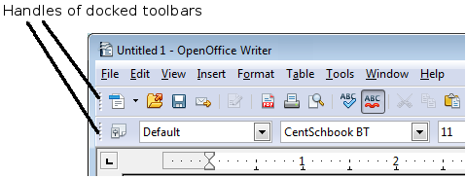
Figure 3: Moving a docked toolbar
To move a floating toolbar, click on its title bar and drag it to a new location.

Figure 4: Moving a floating toolbar

Floating Toolbars
Writer includes several additional context-sensitive toolbars, whose defaults appear as floating toolbars in response to the cursor’s current position or selection. For example, when the cursor is in a table, a floating Table toolbar appears, and when the cursor is in a numbered or bullet list, the Bullets and Numbering toolbar appears. You can dock these toolbars to the top, bottom, or side of the window, if you wish (see “Moving Toolbars” on page 16).

Docking/Floating Windows and Toolbars
Toolbars and some windows, such as the Navigator and the Styles and Formatting window, are dockable. You can move, resize, or dock them to an edge.
To dock a window or toolbar, hold down the Control key and double-click on the frame of the floating window (or in a vacant area near the icons at the top of the floating window) to dock it in its last position.

Figure 5: Control+click to dock or undock
To undock a window, hold down the Control key and double-click on the frame (or a vacant area near the icons at the top) of the docked window.

Customizing Toolbars
You can customize toolbars in several ways, including choosing which icons are visible and locking the position of a docked toolbar.
To access a toolbar’s customization options, use the down-arrow at the end of the toolbar or on its title bar (Figure 6).

Figure 6: Customizing toolbars
To show or hide icons defined for the selected toolbar, choose Visible Buttons from the drop-down menu. Visible icons are indicated by a border around the icon (Figure 7). Click on icons to hide or show them on the toolbar.
You can also add icons and create new toolbars, as described in Chapter 16.
Figure 7: Selection of visible toolbar icons

Right-click (Context) Menus
Right-click on a paragraph, graphic, or other object to open a context menu. Often, the context menu is the fastest and easiest way to reach a function. If you’re not sure where in the menus or toolbars a function is located, you can typically find it by right-clicking.

Rulers
To show or hide rulers, choose View > Ruler. To enable the vertical ruler, select Tools > Options > OpenOffice Writer > View and select Vertical ruler.

Figure 8. Turning on the vertical ruler

Status Bar
The Writer status bar is located at the bottom of the workspace. It provides information about the document and convenient ways to quickly change some document features.
Figure 9: Left end of status bar
Figure 10: Right end of status bar
Page number
Shows the current page number, the sequence number of the current page (if different from the page number), and the total number of pages in the document. For example, if a document has 14 pages, and you restarted page numbering at 1 on the third page, its page number is 1, its sequence number is 3, and the total number of pages is 14; this field would show 1 3/14.
If any bookmarks have been defined in the document, a right-click on this field pops up a list of bookmarks; click on the required one to go to the bookmark.
To jump to a specific page in the document, double-click on this field. The Navigator opens (see page 29). Click in the Page Number field in the Navigator and type the sequence number of the required page. After a brief delay, the display jumps to the selected page.
Page style
Shows the style of the current page. To change the page style, right-click on this field. A list of page styles pops up; choose a different style by clicking on it.
To edit the current page style, double-click on this field. The Page Style dialog box opens. See Chapter 6 and 7 in this book for more information about styles.
Language
Shows the language for the selected text.
Click to open a menu where you can choose another language for the selected text or for the paragraph where the cursor is located. You can also select None (Do not check spelling) to exclude the text from a spelling check or pick More to open the Character dialog box. See Chapter 3 (Working with Text) for more information.
Insert mode
Click to toggle between Insert and Overwrite modes when typing. In Insert mode, any text after the cursor position moves forward to make room for the text you type; in Overwrite mode, text after the cursor position is replaced by the text you type.
Selection mode
Click to toggle between STD (Standard), EXT (Extend), ADD (Add) and BLK (Block) selection. EXT is an alternative to Shift+click when selecting text. See Chapter 3 (Working with Text) for more information about these modes.
Unsaved changes
An asterisk (*) appears here if changes to the document have not been saved.
Digital signature
If the document has been digitally signed, an icon shows here. To view the certificate, double-click the icon.
Section or object information
When the cursor is in a section, heading, or list item, or when an object (such as a picture or table) is selected, information about that item appears in this field. Double-clicking in this area opens a relevant dialog box.
Object | Information shown | Dialog box opened
Picture | Size and position | Format Picture
List item | Level and list style | Bullets and Numbering
Heading | Outline numbering level | Bullets and Numbering1
Table | Name or number and cell reference of cursor | Table Format
Section | Name of section | Edit Sections
Other | (Blank) | Fields (Cross-References page)
View layout
Click an icon to change between single page, side-by-side, and book layout views. (See Figure 11.) You can edit the document in any view. Zoom settings (see below and next page) interact with the selected view layout to determine how many pages are visible in the document window.
Figure 11. View layouts: single, side-by-side, book
Zoom
To change the view magnification, drag the Zoom slider, or click on the + and – signs, or right-click on the zoom level percent to pop up a list of magnification values from which to choose.

Sidebar
The Sidebar brings together many functions that are otherwise available on several toolbars or menus. Its details are shown in Figure 12. It contains one or more decks, based on the current document context. Decks are organized into panels. A tab bar on the right side of the sidebar allows you to switch between different decks. The decks in Writer provide access to Properties, Styles, the Gallery, and the Navigator. More information about using these decks is provided in the appropriate chapters.
A panel is like a combination of a toolbar and a dialog. For example, you can freely mix working on the text in the main edit window and using the panels in the Properties or Styles decks in the Sidebar to change text attributes. The view of the Properties deck shown in Figure 12 is what appears when working with text. If you were to select a figure or a drawing shape, the panels would change to display properties such as position or fill colors that are appropriate for those objects.
Toolbars and Sidebar panels share many functions. For example, the buttons for making text bold or italic are in both the Formatting toolbar and the Properties panel.
If the Sidebar is not visible, you can show it by using View > Sidebar on the menu bar. To hide the Sidebar, click on the gray Hide button on the left. Click on the same button to show the Sidebar again.
To undock the Sidebar and make it floating, and to dock a floating Sidebar, use the Sidebar settings drop-down list at the top of the tab bar (see Figures 12 and 13). From the same list you can choose which items to show in the Sidebar.


Figure 12: Properties panel of Sidebar in Writer
Settings
Tabs
Tab Title
Panel Title
Panel Contents
Deck
MoreOptions



Figure 13: Floating (undocking) or docking the Sidebar

Changing Document Views
Writer has three ways to view a document: Print Layout, Web Layout, and Full Screen. To change the view, go to the View menu and click on the required view.
Print Layout is the default view in Writer. In this view, you can use the Zoom slider and the View Layout icons on the Status bar to change the magnification.
You can also choose View > Zoom from the menu bar to display the Zoom & View Layout dialog box (see Figure 14), where you can set the same options as on the Status bar.
Figure 14. Choosing Zoom and View Layout options
In Web Layout view, you can use the Zoom slider; the View Layout buttons on the Status bar are disabled, and most of the choices on the Zoom & View Layout dialog box are not available.
In Full Screen view, the document is displayed using the zoom and layout settings previously selected. To exit Full Screen view and return to either Print or Web Layout view, press the Esc key or click the Full Screen icon in the top left-hand corner. You can also use Ctrl+Shift+J to enter or exit Full Screen view.

Starting a New Document
You can start a new, blank document in Writer in several ways.
- From the operating system menu, in the same way that you start other programs. When AOO was installed on your computer, in most cases a menu entry for each component was added to your system menu. If you are using a Mac, you should see the OpenOffice icon in the Applications folder. When you double-click this icon, AOO opens at the Start Center (Figure 16).
- From the Quickstarter, which is found on Windows, some Linux distributions, and (in a slightly different form) in macOS. The Quickstarter is an icon that is placed in the system tray or the dock during system startup. It indicates that OpenOffice has been loaded and is ready to use.
Right-click the Quickstarter icon (Figure 15) in the system tray to open a pop-up menu from which you can open a new document, open the Templates and Documents dialog box, or choose an existing document to open. You can also double-click the Quickstarter icon to display the Templates and Documents dialog box.
See Chapter 1 (Introducing OpenOffice) in the Getting Started guide for more information about starting Writer and using the Quickstarter.

Figure 15: Quickstarter pop-up menu on Windows 10
- From the Start Center. When AOO is open, but no document is open (for example, if you close all the open documents but leave the program running), the Start Center is shown. Click one of the icons to open a new document of that type, or click the Templates icon to start a new document using a template. If a document is already open in AOO, the new document opens in a new window.
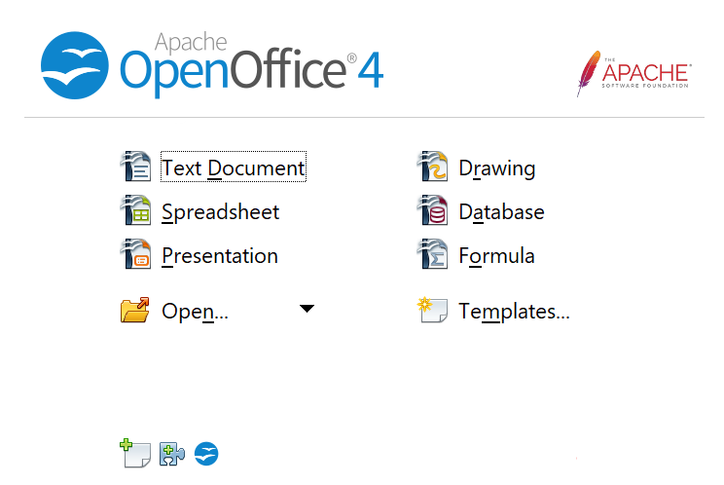

Figure 16: Apache OpenOffice Start Center
When AOO is open, you can also start a new document in one of the following ways.
- Press the Control+N keys.
- Use File > New > Text Document.
- Click the New button on the main toolbar.

Starting a New Document from a Template
You can use templates to create new documents in Writer. A template is a set of predefined styles and formatting. Templates serve as the foundation of a set of documents, to make sure they all have a similar layout. For example, all the documents of the Writer Guide are based on the same template. As a result, all the documents look alike; they have the same headers and footers, use the same fonts, and so on.
A new OpenOffice installation does not contain many templates. It is possible for you to add new templates to your installation and use them for new documents. This is explained in Chapter 10 (Working with Templates). Many templates can be downloaded from https://extensions.openoffice.org/, and you can easily make your own.
Once you have templates on your system, you can create new documents based on them by using File > New > Templates and Documents. This opens a window where you can choose the template you want to use for your document.
The example shown in Figure 17 uses a template called “AOO41GS” in the My Templates folder. Select it, then click the Open button. A new document is created based on the styles and formats defined in the template.
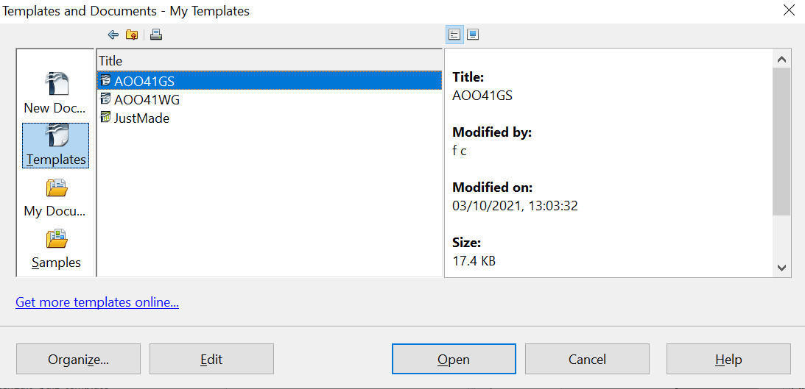

Figure 17. Creating a document from a template

Opening an Existing Document
When no document is open, the Start Center (Figure 16) provides an icon for opening an existing document or choosing from a list of recently-edited documents.

You can also open an existing document in one of the following ways. If a document is already open in AOO, the second document opens in a new window.
- Choose File > Open….
- Click the Open button on the main toolbar.
- Press Control+O on the keyboard.
- Use the Open Document or Recent Documents selections on the Quickstarter.
In each case, the Open dialog box appears. Select the file you want, and then click Open.
In the Open dialog box, you can reduce the list of files by selecting the type of file you are looking for. For example, if you choose Text documents as the file type, you will only see documents Writer can open (including *.odt, *.doc, *.txt). This method opens Word (*.doc) files as well as AOO files and other formats.
You can also open an existing Writer document using the same methods you would use to open any document in your operating system.
If you have associated Microsoft Office file formats with OpenOffice, you can also open these files by double-clicking on them.

Saving a Document
To save a new document in Writer, do one of the following:
- Press Control+S.
- Choose File > Save.
- Click the Save button on the main toolbar.
When the Save As dialog box appears, enter the file name, verify the file type (if applicable), and click Save.
To save an open document with the current file name, choose File > Save. This will overwrite the last saved state of the file.

Saving a Document Automatically
You can choose to have Writer save a recovery copy of your document automatically at regular intervals. Automatic saving, unlike manual saving, does not overwrite the last saved state of the file. It saves a temporary version that can be recovered in case of a program crash. Using this feature does not replace periodically saving your work. To set up automatic file saving:
- Select Tools > Options > Load/Save > General.
- Click on Save AutoRecovery information every and set the time interval. The default value is 15 minutes. Enter the value you want by typing it or by pressing the up or down arrow keys.

Saving as a Microsoft Word Document
If you need to exchange files with users of Microsoft Word, they may not know how to open and save .odt files. Any version of Microsoft Word since Microsoft Office 2007 with Service Pack 2 (SP2) can do this.
Some users of Microsoft Word may be unwilling to work with *.odt files. In this case, you can save a document as a Microsoft Word file.
- Important—First save your document in the file format used by AOO Writer, *.odt. If you do not, any changes you made since the last time you saved will only appear in the Microsoft Word version of the document.
- Then click File > Save As in the Save As dialog box, in the File type (or Save as type) drop-down menu, select the type of Word format you need.
- Click Save.
From this point on, all changes you make to the document will occur only in the Microsoft Word document. You have changed the name and file type of your document. If you want to go back to working with the *.odt version of your document, you must open it again.
Tip | To have Writer save documents by default in the Microsoft Word file format, go to Tools > Options > Load/Save > General. In the section named Default file format and ODF settings, under Document type, select Text document, then under Always save as, select your preferred file format. Saving in a foreign format may lead to the loss of formatting, particularly with complex documents.



Figure 18. Saving a file in Microsoft Word format

Password Protection
Writer provides two levels of document protection: read-protect (file cannot be viewed without a password) and write-protect (file can be viewed in read-only mode but cannot be changed without a password). Thus, you can make the content available for reading by a selected group of people and for reading and editing by a different group.
- Use File > Save As when saving the document. (You can also use File > Save the first time you save a new document.)
- On the Save As dialog box, select the Save with password option, and then click Save.

- The Set Password dialog box opens.

Figure 19: Two levels of password protection
Here you have several choices:
- To read-protect the document, type a password in the two fields at the top of the dialog box.
- To write-protect the document, click the More Options button and select the Open file read-only checkbox.
- To write-protect the document but allow selected people to edit it, select the Open file read-only checkbox and type a password in the two boxes at the bottom of the dialog box.
- Click OK to save the file. If either pair of passwords do not match, you receive an error message. Close the message box to return to the Set Password dialog box and enter the password again.
Caution | AOO uses a very strong encryption mechanism that makes it almost impossible to recover the contents of a document if you lose the password.

Closing a Document
To close a document, choose File > Close or click the Close icon on the document window. On Windows, this icon looks like the X in the red box shown in Figure 20.
If more than one AOO window is open, each window looks like the sample shown on the left in Figure 20. Closing this window leaves the other AOO windows open.
If only one AOO window is open, it looks like the sample shown on the right in Figure 20. Notice the small black X below the larger X in the red box. Clicking the small black X closes the document but leaves AOO open. Clicking the larger X closes AOO completely.

Figure 20. Close icons
If the document has not been saved since the last change, a message box is displayed. Choose whether to save or discard your changes.
- Save: The document is saved and then closed.
- Discard: The document is closed, and all modifications since the last save are lost.
- Cancel: Nothing happens, and you return to the document.

Closing OpenOffice
To close AOO completely, click File > Exit, or close the last open document as described in “Closing a Document” above.
If all the documents have been saved, Writer closes immediately. If any documents have been modified but not saved, a warning message appears. Follow the procedure in “Closing a Document” to save or discard your changes.

Using the Navigator
In addition to the Page Number field on the Status bar (described on page 18), Writer provides other ways to move quickly through a document and find specific items by using the many features of the Navigator, the Navigation toolbar, and related icons.
The Navigator lists all the headings, tables, text frames, graphics, bookmarks, and other objects contained in a document.
To open the Navigator, click its icon from the Sidebar tabs or on the Standard toolbar, or press F5, or choose View > Navigator on the menu bar, or double-click on the Page number field on the status bar. If the Navigator is displayed separately from the Sidebar, you can dock the Navigator to either side of the main Writer window or leave it floating (see “Docking/Floating Windows and Toolbars” on page 16).
To hide the list of categories and show only the icons at the top, click the List Box On/Off icon . This icon is not available in the Sidebar display of the Navigator since it is unnecessary. Click this icon again to show the list. Click the + sign by any of the lists to display the contents of the list.
Table 1 summarizes the functions of the icons at the top of the Navigator.
Note | The Navigator has different functions in a master document. See Chapter 13 (Working with Master Documents).

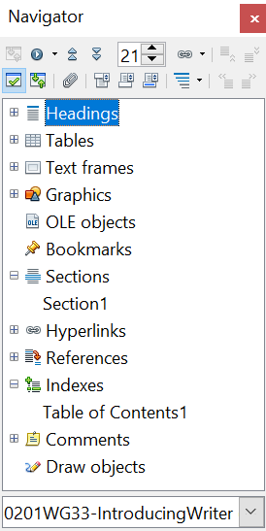

Figure 21. The Navigator
Table 1: Function of icons in the Navigator
 | Toggle: Not active in ordinary documents (left image). In a master document (right image), switches between the master document file and its subdocuments.
 | Navigation: Opens the Navigation toolbar (see page 31).
 | Previous, Next: Jumps to the previous or next item in the selected category (page, graphic, hyperlink, comment, and so on). To select the category of items, see “Using the Navigation Toolbar“ on page 31.
 | Page number: Jumps to the page sequence number showing in the box. Type the required page number or select it using the up and down arrows.
 | Drag Mode: Select Hyperlink, Link, or Copy. See “Choosing Drag Mode” on page 33 for details.
 | List Box On/Off: Shows or hides the list of categories.
 | Content View: Switches between showing all categories and showing only the selected category.
 | Set Reminder: Inserts a reminder (see page 33).
 | Header/Footer: Jumps between the text area and the header or footer area (if the page has them).
 | Anchor <–> Text: Jumps between a footnote anchor and the corresponding footnote text.
 | Heading Levels Shown: Choose the number of heading levels to be shown.

Moving Quickly through a Document
The Navigator provides several convenient ways to move around a document and find items in it:
- To jump to a specific page in the document, type its sequence number in the box at the top of the Navigator.
- When a category is showing the list of items in it, double-click on an item to jump directly to that item’s location in the document. For example, you can jump directly to a selected heading, graphic, or comment by using this method.
To see the content in only one category, highlight that category and click the Content View icon. Click the icon again to display all the categories. You can also change the number of heading levels shown when viewing Headings.
- Use the Previous and Next icons to jump to other objects of the type selected in the Navigation toolbar. (See below for details.)

Tip | Objects are much easier to find if you have given them names when creating them, instead of keeping AOO’s default names of graphics1, graphics2, Table1, Table2, and so on—which may not correspond to the position of the object in the document.  To rename an image, right-click on the image, select Picture > Options, and then edit the name in the dialog box. Similarly, to rename a table, right-click on the table, select Table > Table, and then edit the name.

Note | A hidden section (or other hidden object) in a document appears gray in the Navigator, and displays the word “hidden” as a tooltip. For more about hidden sections, see Chapter 4 (Formatting Pages).
Using the Navigation Toolbar
To display the Navigation toolbar (Figure 22), click the Navigation icon (second icon from the left at the top of the Navigator, Figure 21) or the small Navigation icon near the lower right-hand corner of the window below the vertical scroll bar (Figure 23).
Figure 22: Navigation toolbar

Figure 23: Previous, Navigation, and Next icons
The Navigation toolbar shows icons for all the object types shown in the Navigator, plus some extras (for example, the results of a Find command).
Click an icon to select that object type. Now all the Previous and Next icons (in the Navigator itself, in the Navigation Toolbar, and on the scroll bar) will jump to the previous or next object of the selected type. This is particularly helpful for finding items like index entries, which can be difficult to see in the text. The names of the icons (shown in the tooltips) change to match the selected category; for example, Next Graphic or Next Bookmark.

Rearranging Chapters Using the Navigator
You can rearrange chapters and move headings in the document by using the Navigator.
- Click the Content View icon to expand the headings, if necessary.
- (Optional) If you have several subheading levels, you can more easily find the headings you want, by changing the Heading Levels Shown selection to show only 1 or 2 levels of headings.
- Click on the heading of the block of text that you want to move and drag the heading to a new location on the Navigator, or click the heading in the Navigator list, and then click either the Promote Chapter or Demote Chapter icon shown in Figure 24. All the text and subsections under the selected heading move with it.
To move only the selected heading and not the text associated with the heading, hold down Control, and then click the Promote or Demote icon.
Tip | The tooltips Promote Chapter and Demote Chapter can be misleading; all headings—whether at Level 1 (chapter) or lower—can be rearranged using this function; and the feature might be better described as Move Up or Move Down (within the document, without changing the heading level) to distinguish it more clearly from Promote Level and Demote Level, which change the heading level within the document (see below).

- To quickly change the outline level of a heading and its associated subheadings, select the heading in the Navigator, and then click either the Promote Level or Demote Level icon. This action does not change the location of the heading, only its level.
To increase the outline level of only the selected heading, but not its associated subheadings, hold down Control, and then click the icon.

Figure 24. Reorganizing with the Navigator

Setting Reminders
One of the little-known features of Writer that you may find quite useful is the possibility of jumping between reminders. Reminders let you mark places in your document that you want to return to later on, to add or correct information, make some other change, or simply mark where you finished editing. The possible uses of reminders are limited only by your imagination.
To set a reminder at the cursor's current location, click on the icon in the Navigator. You can set up to 5 reminders in a document; setting another causes the first to be deleted.
Reminders are not highlighted in any way in the document, so you cannot see where they are, except when you jump from one to the next—the location of the cursor then shows the location of the reminder.
To jump between reminders, first select the Reminder icon on the Navigation toolbar. Then click the Previous and Next icons.

Choosing Drag Mode
To select the drag and drop options for inserting items such as other documents and images, into a document using the Navigator, choose one of the following from the drop-down menu of the Drag Mode icon .
Insert As Hyperlink
Creates a hyperlink when you drag and drop an item into the current document.
Insert As Link
Inserts the selected item as a link where you drag and drop in the current document. Text is inserted as protected sections. However, you cannot create links for graphics, OLE objects, references, or indexes using this method.
Insert As Copy
Inserts a copy of the selected item where you drag and drop in the current document. You cannot drag and drop copies of graphics, OLE objects, or indexes.

Getting Help
Writer provides several forms of help. In addition to a full Help file (reached by pressing F1 or choosing Help > OpenOffice Help from the menu bar), you can choose whether to activate tooltips, extended tips, and the Help Agent from Tools > Options > OpenOffice > General.
Placing the mouse pointer over any of the icons displays a small box, called a tooltip. It gives a brief explanation of the icon’s function. For a more detailed explanation, select Help > What’s This? and hold the mouse pointer over the icon you need more help with.

What Are All These Things Called?
The terms used in OpenOffice for most parts of the user interface (the parts of the program you see and use, in contrast to the behind-the-scenes code that actually makes it work) are the same as for most other programs.
A dialog box is a special type of window. Its purpose is to inform you of something, or request input from you, or both. It provides controls for you to use to specify how to carry out an action. The technical names for common controls are shown in Figure 25; not shown is the list box (from which you select an item). In most cases we do not use the technical terms in this book, but it is useful to know them because the Help and other sources of information often use them.
In most cases, you can interact only with the dialog box (not the document itself) as long as the dialog box remains open. When you close the dialog box after use (usually, clicking OK or another button saves your changes and closes the dialog box), then you can again work with your document.
Some dialog boxes can be left open as you work, so you can switch back and forth between the dialog box and your document. An example of this type is the Find & Replace dialog box. The Sidebar also remains visible unless you choose to hide it.

Figure 25: Dialog box (not from Writer) showing common controls:
1=Tabbed page (not strictly speaking a control)
2=Radio buttons (only one can be selected at a time)
3=Checkbox (more than one can be selected at a time)
4=Spin box (click the up and down arrows to change the number
shown in the text box next to it, or type in the text box)
5=Thumbnail or preview
6=Drop-down list from which to select an item
7=Push buttons

Undoing and Redoing Changes
When a document is open, you can undo the most recent change by pressing Control+Z, or clicking the Undo icon on the Standard toolbar, or choosing Edit > Undo from the menu bar.
The Edit menu shows the latest change that can be undone. Click the small triangle to the right of the Undo icon to get a list of all the changes that can be undone. You can select multiple changes and undo them at the same time.

Figure 26: List of actions that can be undone
After changes have been undone, Redo becomes active. To redo a change, select Edit > Redo, or press Control+Y or click on the Redo icon . As with Undo, click on the triangle to the right of the arrow to get a list of the changes that can be reapplied.

Using Writer on a Mac
Some keystrokes and menu items are different on a Mac from those used in Windows and Linux. The following table gives some common substitutions for the instructions in this book. For a more detailed list, see the application Help.
Windows/Linux | Mac equivalent | Effect
Tools > Options menu selection | OpenOffice > Preferences | Access setup options
Right-click | Control+click | Open context menu
Ctrl (Control) | z (Command) | Used with other keys
F5 | Shift+z+F5 | Open the Navigator
F11 | z+T | Open the Styles and Formatting window

Chapter 2
Setting up Writer
Choosing Options to Suit the Way You Work

Choosing Options that Affect all of AOO
This section covers some of the settings that apply to all the components of AOO and are particularly important when using Writer. Other general options are discussed in Chapter 2 (Setting Up OpenOffice) in the Getting Started guide.
Click Tools > Options (on macOS use OpenOffice > Preferences). The list on the left-hand side of the Options—OpenOffice dialog box varies depending on which component of AOO is open. The illustrations in this chapter show the list as it appears when a Writer document is open.
Click the expansion symbol (+ sign or triangle) by OpenOffice on the left-hand side. A list of pages drops. Selecting an item in the list causes the right-hand side of the dialog box to display the relevant page.
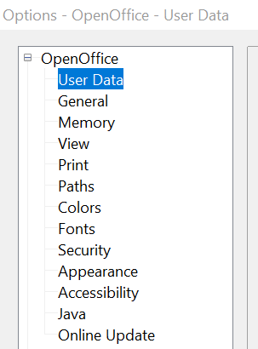

Figure 27: OpenOffice options
Note | The Back button has the same effect on all pages of the Options dialog box. It resets options to the values that were in place when you opened AOO.

User Data Options
Because Writer uses the name or initials stored in the OpenOffice—User Data page for several things, including document properties (created by and last edited by information) and the name of the author of notes and changes, you will want to ensure that the correct information appears here.
Fill in the form (shown inFigure 27) or amend or delete any existing incorrect information.
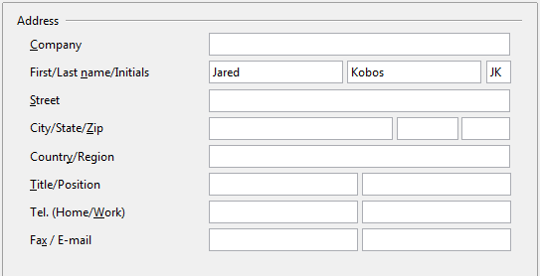
Figure 28: Filling in user data

General Options
The options on the OpenOffice—General page are described below.
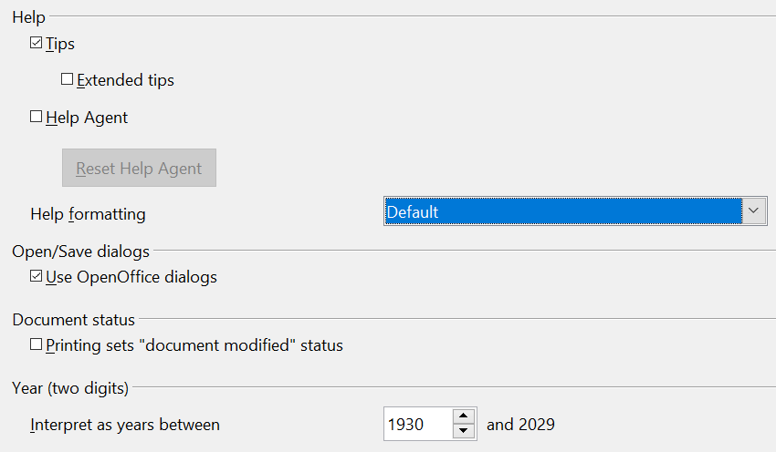
Figure 29: Setting general options for OpenOffice
Help—Tips
When Tips is active, one or two words will appear when you hold the mouse pointer over an icon or field, without clicking.
Help—Extended tips
When Extended tips are active, a brief description of the function of a particular icon or menu command or a field on a dialog box appears when you hold the mouse pointer over that item.
Help—Help Agent
To turn off the Help Agent, deselect this option. To restore the default behavior, click Reset Help Agent.
Help—Help formatting
High contrast is an operating system setting that changes the system color scheme to improve readability. To display Help in high contrast (if your computer’s operating system supports this), choose one of the high-contrast style sheets from the pull-down list.
High-contrast style | Visual effect
Default | Black text on white background
High Contrast #1 | Yellow text on black background
High Contrast #2 | Green text on black background
High Contrast Black | White text on black background
High Contrast White | Black text on white background
Open/Save dialogs
To use the standard Open and Save dialog boxes for your operating system, deselect the Use OpenOffice dialogs option. When this option is selected, the Open and Save dialog boxes supplied with OpenOffice will be used. This book uses the AOO Open and Save dialog boxes in illustrations.
Document status
If this option is selected, then the next time you close the document after printing, the print date is recorded in the document properties as a change, and you will be prompted to save the document again, even if you did not make any other changes.
Year (two digits)
Specifies how two-digit years are interpreted. For example, if the two-digit year is set to 1930, and you enter a date of 1/1/30 or later into your document, the date is interpreted as 1/1/1930 or later. An “earlier” date is interpreted as being in the following century; that is, 1/1/20 is interpreted as 1/1/2020.

Memory Options
In the Options dialog, click OpenOffice > Memory. Some considerations:
- More memory can make OpenOffice faster and more convenient (for example, more undo steps require more memory); but the trade-off is less memory available for other applications, and you could run out of memory altogether.
- If your documents contain a lot of objects such as images, or the objects are large, AOO’s performance may improve if you increase the memory for AOO or the memory per object. If you find that objects seem to disappear from a document that contains a lot of them, increase the number of objects in the cache. (The objects are still in the file even if you cannot see them on screen.)
- To load the Quickstarter (an icon on the desktop or in the system tray) when you start your computer, select the option near the bottom of the dialog. This makes OpenOffice start faster; the trade-off is that AOO uses some memory even when not being used. This option (sometimes called Enable systray quickstarter) is not available on all operating systems.
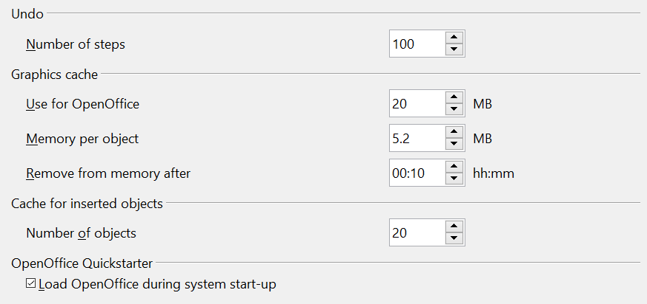
Figure 30: Choosing Memory options for the OpenOffice applications

View Options
The options on the OpenOffice— View page affect the way the document window looks and behaves. Some of these options are described below. Set them to suit your personal preferences.
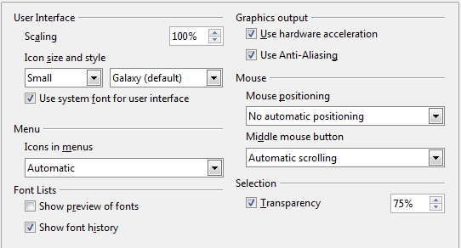
Figure 31: Choosing View options for OpenOffice applications
User Interface—Scaling
If the text in the help files or on the menus of the AOO user interface is too small or too large, you can change it by specifying a scaling factor. Sometimes a change here can have unexpected results, depending on the screen fonts available on your system. However, it does not affect the font size of the text in your documents.
User Interface—Icon size and style
The first box specifies the display size of toolbar icons (Automatic, Small, or Large); the Automatic icon size option uses the setting for your operating system. The second box specifies the icon style (theme); here the Automatic option uses an icon set compatible with your operating system and choice of desktop: for example, KDE or Gnome on Linux.
User Interface—Use system font for user interface
If you prefer to use the system font (the default font for your computer and operating system) instead of the font provided by AOO for the user interface, select this option.
User interface—Screen font Anti-Aliasing
(Not available in Windows; not shown in Figure 31.) Smooths the screen appearance of text. Enter the smallest font size to apply anti-aliasing.
Menu—Icons in menus
Causes icons as well as words to be visible in menus.
Font Lists—Show preview of fonts
Causes the font list to look like Figure 32, Left, with the font names shown as an example of the font; with the option deselected, the font list shows only the font names, not their formatting (Figure 32, Right). The fonts you will see listed are those that are installed on your system.
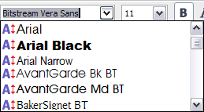 | 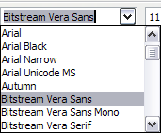
Figure 32: Font list (Left) showing preview; (Right) without preview
Font Lists—Show font history
Causes the last five fonts you have assigned to the current document to be displayed at the top of the font list.
Graphics output—Use hardware acceleration
Directly accesses hardware features of the graphical display adapter to improve the screen display. Not supported on all operating systems and AOO distributions.
Graphics output—Use Anti-Aliasing
Enables and disables anti-aliasing, which makes the display of most graphical objects look smoother and with fewer artifacts. Not supported on all operating systems and AOO distributions.
Tip | Press Shift+Control+R to restore or refresh the view of the current document.

Mouse positioning
Specifies if and how the mouse pointer will be positioned in newly opened dialog boxes.
Middle mouse button
Defines the function of the middle mouse button.
- Automatic scrolling – dragging while pressing the middle mouse button shifts the view.
- Paste clipboard – pressing the middle mouse button inserts the contents of the “Selection clipboard” at the cursor position.
The “Selection clipboard” is independent of the normal clipboard that you use by Edit > Copy/Cut/Paste or their respective keyboard shortcuts. The clipboard and “Selection clipboard” can contain different contents at the same time.
Function | Clipboard | Selection clipboard
Copy content | Edit > Copy Control+C | Select text, table, or object.
Paste content | Edit > Paste Control+V pastes at the cursor position. | Clicking the middle mouse button pastes at the mouse pointer position.
Pasting into another document | No effect on the clipboard contents. | The last marked selection is the content of the selection clipboard.

Print Options
On the OpenOffice—Print page, set the print options to suit your default printer and your most common printing method.
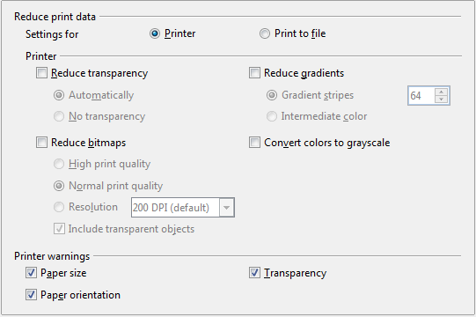
Figure 33: Choosing general printing options to apply to all AOO components
In the Printer warnings section near the bottom of the page, you can choose whether to be warned if the paper size or orientation specified in your document does not match the paper size or orientation available for your printer. Having these warnings turned on can be quite helpful, particularly if you work with documents produced by people in other countries where the standard paper size is different from yours.
Tip | If your printouts are incorrectly placed on the page or chopped off at the top, bottom, or sides or the printer is refusing to print, the most likely cause is page-size incompatibility.

Path Options
On the OpenOffice—Paths page, you can change the location of files associated with, or used by, AOO to suit your working situation. In a Windows system, for example, you might want to store documents by default somewhere other than Documents.
To make changes, select an item in the list shown in Figure 34 and click Edit. On the Select Paths dialog (not shown), add or delete folders as required, and then click OK to return to the Options dialog. Note that many items can have at least two paths listed: one to a shared folder (which might be on a network) and one to a user-specific folder (normally on the user’s personal computer).
Tip | You can use the entries in the OpenOffice—Paths dialog to compile a list of files, such as those containing AutoText, that you need to back up or copy to another computer.

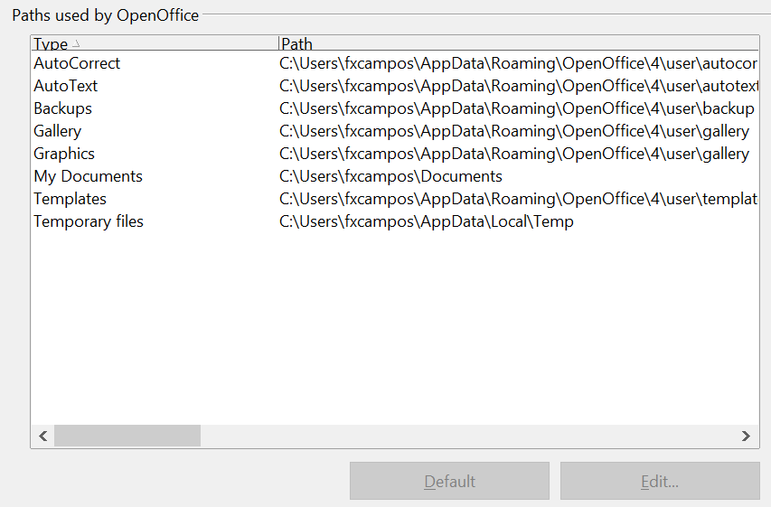
Figure 34: Viewing the paths of files used by AOO

Color Options
On the OpenOffice—Colors page, you can specify colors to use in AOO documents. You can select a color from a color table, edit an existing color, or define new colors. These colors will then be available in color selection palettes in AOO.
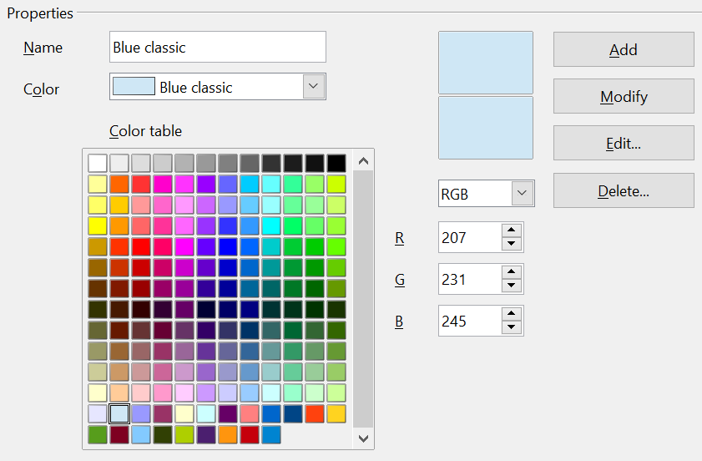
Figure 35: Defining colors to use in color palettes in AOO
To modify a color:
- Select the color to modify from the list or the color table.
- Enter the new values that define the color. If necessary, change the settings from RGB (Red, Green, Blue) to CMYK (Cyan, Magenta, Yellow, Black) or vice versa. The changed color appears in the lower of the two color preview boxes at the top.
- Modify the Name as required.
- Click the Modify button. The newly defined color is now listed in the Color table.
Alternatively, click the Edit button to open the Color dialog, shown in Figure 36. Here you can select a color from the color window in the upper area, or you can enter values on the right using your choice of RGB, CMYK, or HSB (Hue, Saturation, and Brightness) values.
The upper color window is linked directly with the color input fields; as you choose a color in the upper window, the numbers change accordingly. The two color fields at the bottom show the appearance of the adjusted color on the left and the original color on the right.
Modify the color components as required and click OK to exit the dialog. The newly defined color now appears in the lower of the color preview boxes shown in Figure 35. Type a name for this color in the Name box, then click the Add button. A small box showing the new color is added to the Color table.
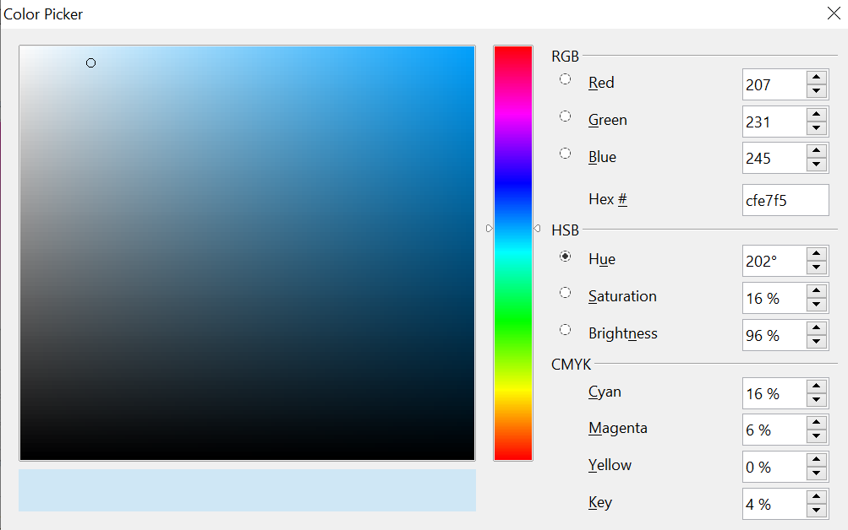
Figure 36: Editing colors
Another way to define or alter colors is through the Colors page of the Area dialog, where you can also save and load palettes, a feature that is not possible here. In Writer, draw a temporary draw object and use the context menu of this object to open the Area dialog.

Font Options
You can define replacements for any fonts that might appear in your documents. If you receive from someone else a document containing fonts that you do not have on your system, AOO will substitute fonts for those it does not find. You might prefer to specify a different font from the one the program chooses.
On the OpenOffice—Fonts page:
- Select Apply Replacement Table option.
- Select or type the name of the font to be replaced in the Font box. (If you do not have this font on your system, it will not appear in the drop-down list in this box, so you need to type it in.)
- In the Replace With box, select a suitable font from the drop-down list of fonts installed on your computer.
- The check mark to the right of the Replace with box turns green. Click on this check mark. A row of information now appears in the larger box below the input boxes. Select the boxes under Always and Screen.
- In the bottom section of the page, you can change the typeface and size of the font used to display source code such as HTML and Basic (in macros).
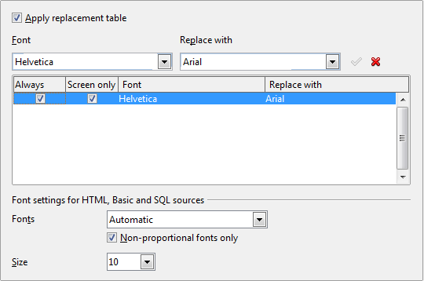
Figure 37: Defining a font to be substituted for another font

Security Options
Use the OpenOffice—Security page to choose security options for saving documents and for opening documents that contain macros.
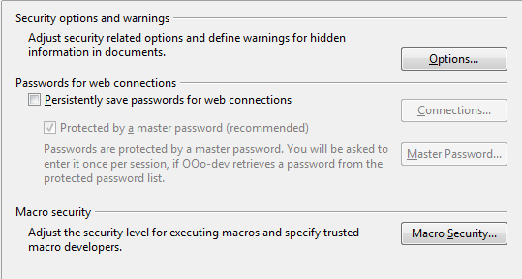
Figure 38: Choosing security options for opening and saving documents
Security Options and warnings
If you record changes, save multiple versions, or include hidden information or notes in your documents, and you do not want some recipients to see that information, you can set warnings to remind you to remove it, or you can have AOO remove some of it automatically. Note that (unless removed) much of this information is retained in a file whether the file is in OpenOffice’s default OpenDocument format, or has been saved to other formats, including PDF.
Click the Options button to open a separate dialog with specific choices (Figure 38).
Remove personal information on saving. Select this option to always remove user data from the file properties when saving the file. To manually remove personal information from specific documents, deselect this option and then use the Delete button under File > Properties > General.
Figure 39: Security options and warnings dialog box
Ctrl-click required to follow hyperlinks. Many people find creating and editing documents easier when accidental clicks on links do not activate the links.
The other options on this dialog should be self-explanatory.
Macro security
Click the Macro Security button to open the Macro Security dialog, where you can adjust the security level for executing macros and specify trusted sources.

Appearance Options
Writing, editing, and (especially) page layout are often easier when you can see the page margins (text boundaries), the boundaries of tables and sections, grid lines, and other features. In addition, you might prefer to use colors that are different from AOO’s defaults for such items as note indicators or field shadings.
On the OpenOffice—Appearance page, you can specify which items are visible, and the colors used to display various items.
- To show or hide items such as text boundaries, select or deselect them.
- To change the default colors for items, click the down-arrow in the Color setting column by the name of the item and select a color from the pop-up box.
- To save your color changes as a color scheme, type a name in the Scheme box and click Save.
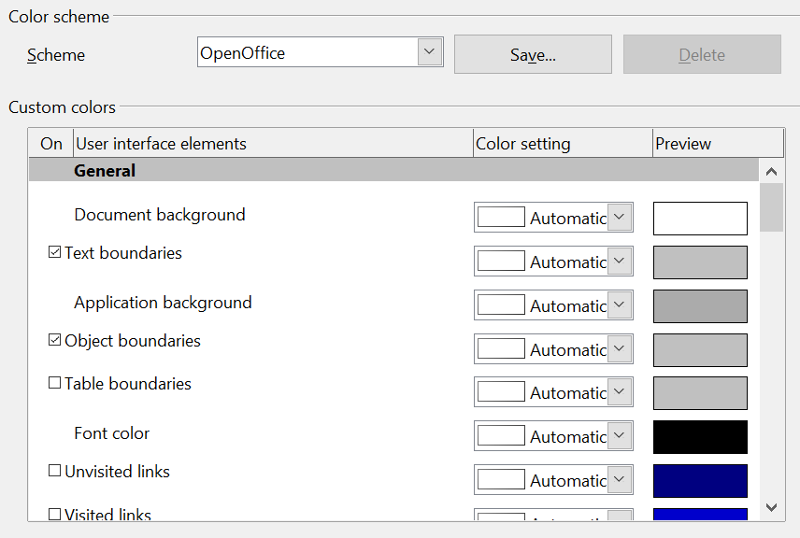
Figure 40: Showing or hiding text, object, and table boundaries

Choosing Options for Loading and Saving Documents
You can set the Load/Save options to suit the way you work.
If the Options dialog is not already open, click Tools > Options. Click the expansion symbol (+ sign or triangle) to the left of Load/Save.
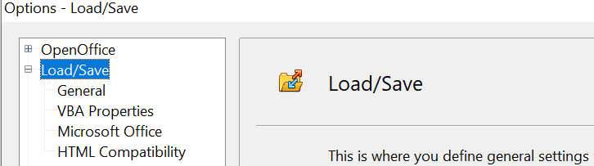
Figure 41: Load/Save options

General Load/Save Options
Most of the choices on the Load/Save—General page (Figure 37) are familiar to users of other office suites. Some items of interest are described below.
Load user-specific settings with the document
When you save a document, certain settings are saved with it. Some settings (printer name, data source linked to the document) are always loaded with a document, whether this option is selected. If you select this option, these document settings are overruled by the user-specific settings of the person who opens it. If you deselect this option, the user’s personal settings do not overrule the settings in the document. For example, your choice (in the options for AOO Writer) of how to update links is affected by the Load user-specific settings option.
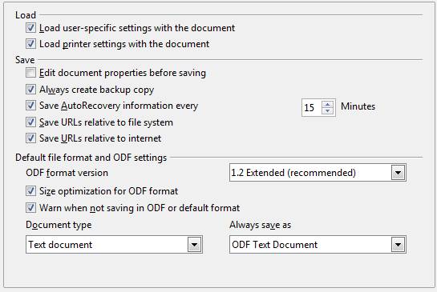
Figure 42: Choosing Load and Save options
Load printer settings with the document
If this option is not selected, the printer settings that are stored with the document are ignored when you print it using the Print File Directly icon. The default printer in your system is used instead.
Edit document properties before saving
If this option is selected, the Document Properties dialog pops up to prompt you to enter relevant information the first time you save a new document (or whenever you use Save As).
Save AutoRecovery information every __ Minutes
Choose whether to enable AutoRecovery and how often to save the information used by the AutoRecovery process. AutoRecovery in OpenOffice does not overwrite the original file; it saves a temporary version.
Note | Using this option is not a substitute for regularly saving your work.

Save URLs relative to file system / internet
Relative addressing to a file system is only possible if the source document and the referenced document are both on the same drive. A relative address always starts from the directory in which the current document is located. It is recommended to save relatively if you want to create a directory structure on an Internet server.
Default file format and ODF settings
ODF format version. OpenOffice by default saves documents in Open Document Format (ODF) version 1.2. This format has been the default for many years and only very old versions of OpenOffice or other software would not be able to handle such documents.
Size optimization for ODF format. OpenOffice's documents are XML files. When you select this option, AOO writes the XML data without indents and line breaks. If you want to be able to read the XML files in a text editor in a structured form, deselect this option.
Document type. If you routinely share documents with users of Microsoft Word, you might want to change the Always save as attribute for text documents to one of the Word formats.
Note | Although Writer can open files in the .docx format produced by Microsoft Word, it cannot save in .docx format.

VBA Properties Load/Save Options
On the Load/Save—VBA Properties page, you can choose whether to keep any macros in Microsoft Office documents that are opened in OpenOffice. These macros are disabled in AOO.
If you choose Load Basic code, you can edit the macros in AOO. The changed code is saved in an AOO document but is not retained if you save into a Microsoft Office format.
If you choose Save original Basic code, the macros are retained unchanged if you save the file into Microsoft Office format.
Save original Basic code takes precedence over Load Basic code. If both options are selected, and you edit the disabled code in AOO, the original Microsoft Basic code will be saved when saving in a Microsoft Office format.
To remove any possible macro viruses from the Microsoft Office document, deselect Save original Basic code. The document will be saved without the Microsoft Basic code.
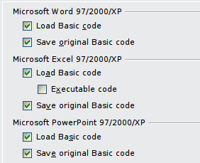
Figure 43: Choosing Load/Save VBA Properties

Microsoft Office Load/Save Options
On the Load/Save—Microsoft Office page, you can choose what to do when importing and exporting Microsoft Office OLE objects (linked or embedded objects or documents such as spreadsheets or equations).
Select the [L] check boxes to convert Microsoft OLE objects into the corresponding OpenOffice OLE objects when a Microsoft document is loaded into AOO (mnemonic: “L” for “load”).
Select the [S] check boxes to convert OpenOffice OLE objects into the corresponding Microsoft OLE objects when a document is saved in a Microsoft format (mnemonic: “S” for “save”).
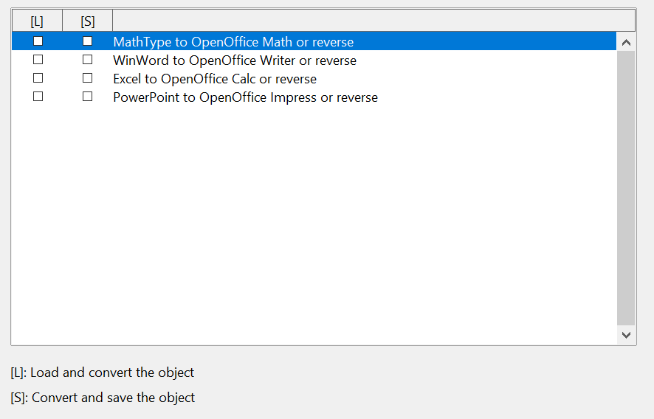
Figure 44: Choosing Load/Save Microsoft Office options

HTML Compatibility Load/Save Options
Choices made on the Load/Save—HTML Compatibility page affect HTML pages imported into OpenOffice and those exported from AOO. See HTML documents; importing/exporting in the Help for more information.
Font sizes
Use these fields to define the respective font sizes for the HTML <font size=1> to <font size=7> tags, if they are used in the HTML pages. (Many pages no longer use these tags.)
Import—Use 'English (USA)' locale for numbers
When importing numbers from an HTML page, the decimal and thousands separator characters differ according to the locale of the HTML page. The clipboard, however, contains no information about the locale. If this option is not selected, numbers will be interpreted according to the Language—Locale setting in Tools > Options > Language Settings > Languages (see page 65). If this option is selected, numbers will be interpreted as for the English (USA) locale.
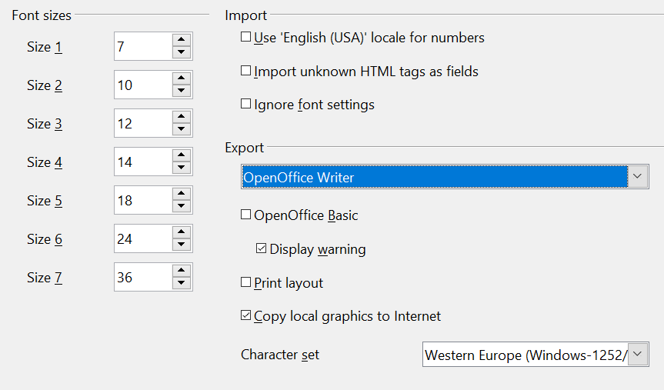
Figure 45: Choosing HTML compatibility options
Import—Import unknown HTML tags as fields
Select this option if you want tags that are not recognized by AOO to be imported as fields. For an opening tag, an HTML_ON field will be created with the value of the tag name. For a closing tag, an HTML-OFF will be created. These fields will be converted to tags in the HTML export.
Import—Ignore font settings
Select this option to have AOO ignore all font settings when importing. The fonts that were defined in the HTML Page Style will be used.
Export
To optimize the HTML export, select a browser or HTML standard from the Export box. If OpenOffice Writer is selected, specific OpenOffice Writer instructions are exported.
Export—OpenOffice Basic
Select this option to include AOO Basic macros (scripts) when exporting to HTML format. You must activate this option before you create the OpenOffice Basic macro; otherwise the script will not be inserted. OpenOffice Basic macros must be located in the header of the HTML document. Once you have created the macro in the OpenOffice Basic IDE, it appears in the source text of the HTML document in the header.
If you want the macro to run automatically when the HTML document is opened, choose Tools > Customize > Events.
Export—Display warning
When the OpenOffice Basic option (see above) is not selected, the Display warning option becomes available. If the Display warning option is selected, then when exporting to HTML a warning is shown that OpenOffice Basic macros will be lost.
Export—Print layout
Select this option to export the print layout of the current document as well.
The HTML filter supports CSS2 (Cascading Style Sheets Level 2) for printing documents. These capabilities are only effective if print layout export is activated.
Export—Copy local graphics to Internet
Select this option to automatically upload the embedded pictures to the Internet server when uploading using FTP.
Export—Character set
Select the appropriate character set for the export.

Choosing Options for Writer
Settings chosen on the pages in the OpenOffice Writer section of the Options dialog box determine how your Writer documents look and behave while you are working on them.
If the Options dialog box is not already open, click Tools > Options.
Click the expansion symbol (+ sign or triangle) by OpenOffice Writer on the left-hand side of the Options—OpenOffice dialog box. A list of pages appears.
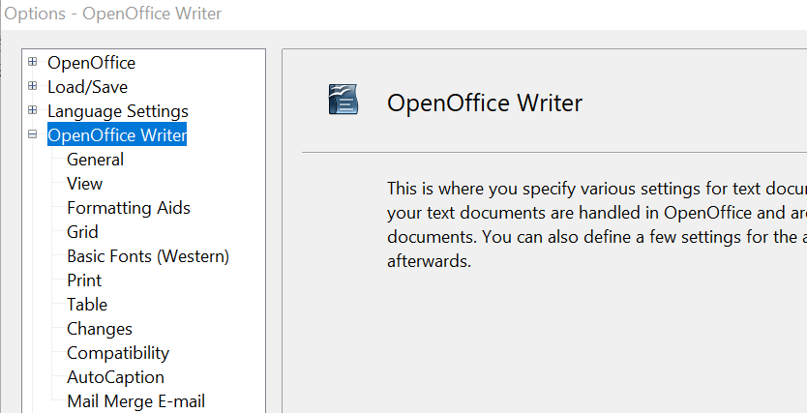
Figure 46: OpenOffice Writer options

General Options
The choices on the OpenOffice Writer—General page affect the updating of links and fields, the units used for rulers and other measurements, and the default tab stop positions.
Update links when loading
Depending on your work patterns, you may not want links to be updated when you load a document. For example, if your file links to other files on a network, you won’t want those links to update when you are not connected to the network.
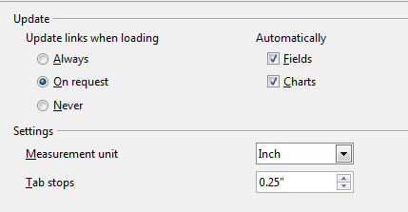
Figure 47: Choosing general options for Writer
Update fields and charts automatically
You may not want fields or charts to update automatically when you are working, because that slows down performance.
Settings—Tab stops
The Tab stops setting specifies the distance the cursor travels for each press of the Tab key. This setting is also used for the indent distance applied by the Increase Indent and Decrease Indent buttons on the Formatting Bar, which affect the indentation of entire paragraphs.
Using the default tab stops to space out or indent material on a page is not recommended. If you use the default tab interval and then send the document to someone who uses a different default tab interval, then your tabbed material will be displayed using the other person’s default tab settings. In addition, any changes to the default tab stops will change the existing default tab stops in any document you open afterward, as well as tab stops you insert after making the change.
To avoid these unwanted changes, define your own tabs in paragraph styles or individual paragraphs (see “Defining your own tab stops and indents” in Chapter 3, Working with Text).

View Options
Two pages of options set the defaults for viewing Writer documents: View (described here) and Formatting Aids (described below).
If the items on the OpenOffice Writer—View page are not self-explanatory, you can easily test their effects in a blank document.
This is a good page to check if, for example, you cannot see graphics on the screen, or you see field codes instead of the text or numbers you are expecting.
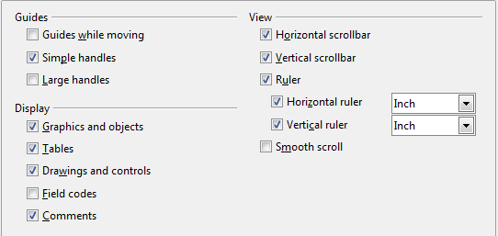
Figure 48: Choosing View options for Writer

Formatting Aids Options
The display of symbols such as paragraph ends and tabs helps you when writing, editing, and doing page layout. For example, you might want to know if any blank paragraphs or tabs are included or if any tables or graphics are too wide and intrude into the margins of the page.
On the OpenOffice Writer—Formatting Aids page, select the required options.
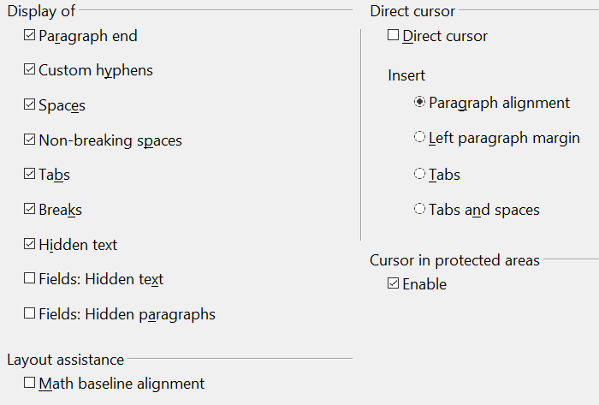
Figure 49: Choosing Formatting Aids options
Note | Direct cursor lets you enter text, images, tables, frames, and other objects in any blank area in your document. Writer inserts blank paragraphs and tabs to position the text or objects.  This feature is incompatible with rigorous use of styles and can lead to many formatting oddities, so it should be avoided by professional writers.

Grid Options
Specifying “snap to grid” can be very helpful when you are trying to align several objects such as graphics or tables.
On the OpenOffice Writer—Grid page, you can choose whether to enable this feature and what grid intervals to use. If the grid intervals (subdivisions) are too large, you may find that you do not have enough control in placing the objects.
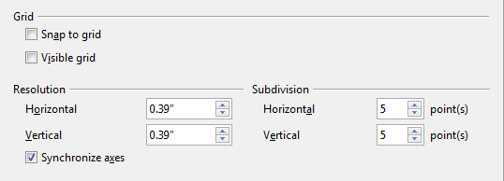
Figure 50: Choosing Grid options

Default Fonts
The default fonts specified on the OpenOffice Writer—Basic Fonts (Western) page apply to both Writer documents and HTML (Web) documents.
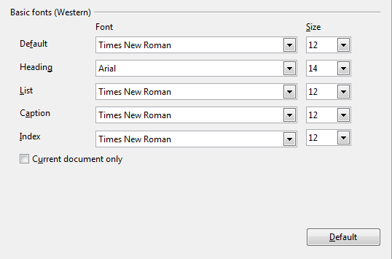
Figure 51: Choosing default fonts
- If you want to change the defaults, do so on this page. You can, of course, choose other fonts for use in specific documents, either by applying direct formatting or by defining and applying styles in those documents.
- When choosing fonts on this page you are not limited to single fonts or to the ones shown in the drop-down list. You can specify a “font family” as a comma separated set of fonts that includes those suitable for Windows, Macintosh, Linux, and other operating systems. These choices are particularly important in HTML documents.
- If the document is viewed on a system that does not have the first font specified, it will use one of the other fonts if that one is available. Otherwise, it will substitute a font that is available on the system.
- Type the list of fonts, separated by commas, in the boxes. If you want these defaults to apply to the current document only, select that option. The Default button resets the values on this page to the defaults installed with OpenOffice.

Print Options
On the OpenOffice Writer—Print page (Figure 28), you can choose which items are printed with the document by default. These options are in addition to those on the OpenOffice—Print page (Figure 33).
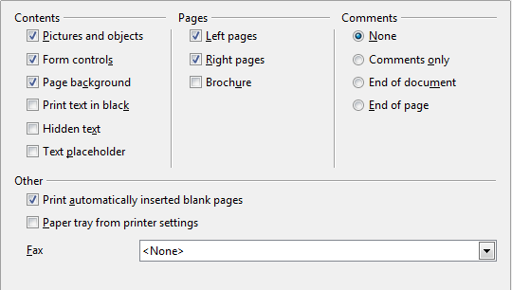
Figure 52: Choosing Print options for Writer
Some considerations:
- When you are working on drafts, and you want to save printer ink or toner, you might want to deselect some items in the Contents section.
- The Print text in black selection causes colored text (but not graphics) to print as black on a color printer; on a black-and-white printer, this option causes color text to print as solid black instead of shades of gray (dithered).
- The Print text in black option has a different effect than the Convert colors to gray scale on the Options—OpenOffice—Print page (Figure 29), which prints all graphics as gray scale on color printers. (On black-and-white printers, color in graphics normally prints as gray scale.)
- If you are printing double-sided on a non-duplexing printer, you might choose to print only left or right pages, then turn the stack over and print the other pages.
- Depending on how your printer ejects pages (face up or face down), you might need to print the pages in reverse order, so they stack in the correct order as they are printed.
Tip | You can override any of these defaults when printing a document. Click File > Print, then click the Options button on the Print dialog box. The Printer Options dialog box that appears is similar to the one shown in Figure 28.

Default Table Options
On the OpenOffice Writer—Table page, you can specify the default behavior of tables.
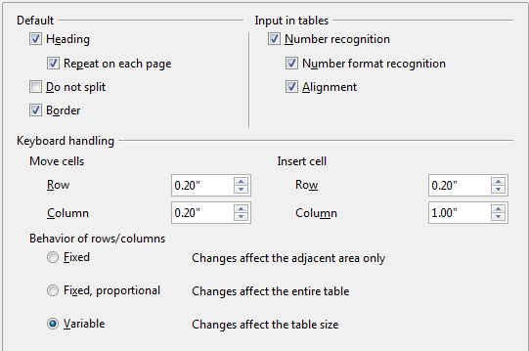
Figure 53: Choosing default Table options
Some considerations:
- If most of your tables will require borders or headings, select those options. If most of your tables are used for page layout, deselect borders and headings.
- Number recognition can be very useful if most of your tables contain numerical data; Writer will recognize dates or currency, for example, and format the numbers appropriately. However, if you want the numbers to remain as ordinary text, this feature can be quite irritating, so you will want to deselect it.
- The Keyboard handling section specifies the distances that cells move when you use keyboard shortcuts to move them and the size of rows and columns inserted using keyboard shortcuts.
- The choices in the Behavior of rows/columns section determine the effects that changes to rows or columns have on adjacent rows or columns and the entire table. You might need to test these selections to fully understand the effects.

Change Tracking Options
If you plan to use the change-tracking feature of Writer, use the OpenOffice Writer—Changes page to choose the way inserted and deleted material is marked, whether and how attribute changes are marked, and whether and how change bars are marked in the margins.
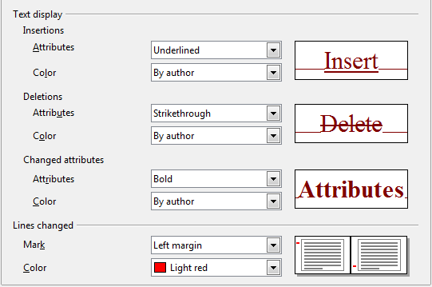
Figure 54: Choosing options for tracking changes

Compatibility Options
Do you need to import Microsoft Word documents into AOO Writer? If so, you might want to select some or all of the settings on the OpenOffice Writer—Compatibility page. If you are not sure about the effects of these settings, leave them as the defaults provided by AOO. For information about the settings not described below, see the Help.
Use printer metrics for document formatting
If this option is selected, the printer specified for the document determines how the document is formatted for viewing on screen. The line breaks and paragraph breaks you see on screen match those that apply when the document is printed on that printer.
This setting can be useful when several people are reviewing a document that will eventually be printed on a specific printer or when the document is exported to PDF (a process that uses “Adobe PDF” as the printer).
If this option is not selected, a printer-independent layout will be used for screen display and printing.
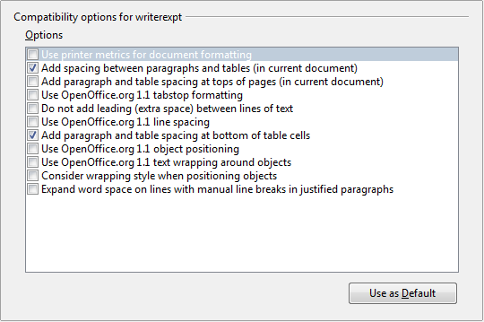
Figure 55: Choosing compatibility options
Add spacing between paragraphs and tables (in current document)
In OpenOffice Writer, paragraph spacing is defined differently than it is in MS Word documents. If you have defined spacing between two paragraphs or tables, spacing is also added in the corresponding MS Word documents.
If this option is selected, MS Word-compatible spacing is added between paragraphs and tables in OpenOffice Writer documents.
Add paragraph and table spacing at tops of pages (in current document)
You can define paragraphs to have space appear before (above) them. If this option is selected, any space above a paragraph will also appear if the paragraph is at the beginning of a page or column, if the paragraph is positioned on the first page of the document, or after a manual page break.
If you import an MS Word document, the spaces are automatically added during the conversion.
Add paragraph and table spacing at bottom of table cells
Specifies that the bottom spacing is added to a paragraph, even when it is the last paragraph in a table cell.
Use as Default
Click this button to use the current settings on this page as the default in OpenOffice.

AutoCaption Options
Do you want AOO to automatically insert captions for tables, pictures, frames, and OLE objects that have been inserted in a Writer document?
Note | You may not always want captions for every table, for example, if you use tables for layout as well as for tables of data. You can always add captions to individual tables, graphics, or other objects (right-click > Caption).

If you do want automatic captions on one or more object types:
- Choose OpenOffice Writer > AutoCaption on the Options dialog box.
- On the OpenOffice Writer—AutoCaption page (Figure 30), select the checkbox next to an object you want to be automatically captioned (Picture in the example shown).
- With the item highlighted, specify the characteristics of the caption. The supplied categories for captions are Drawing, Illustration, Table, and Text. However, you are not limited to the supplied categories. If you want to use another name (for example, Figure) for the caption label, type the required term in the box. In the example shown, I have added the category “Figure” to the list.
Additional information about numbering captions by chapter, character styles, frame styles, and other items on the AutoCaption page, is given in later chapters in the Writer Guide.
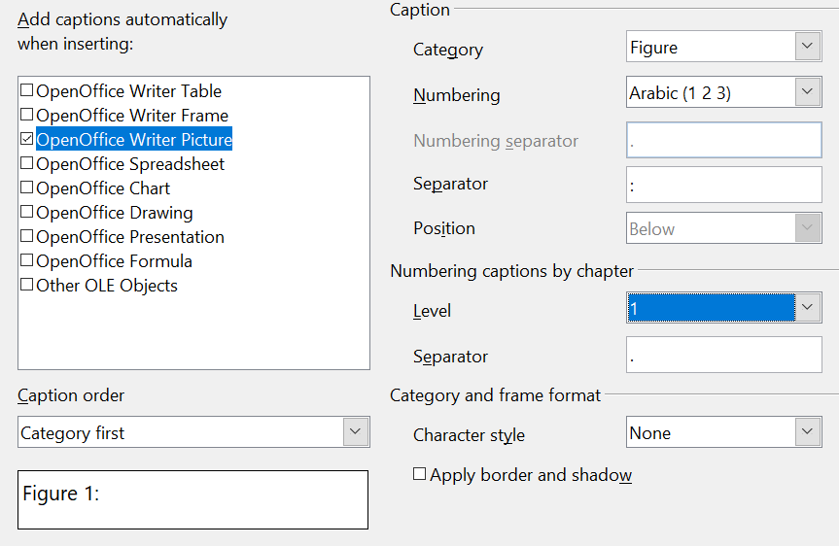
Figure 56: Setting up a new category for automatic captions on graphics

Mail Merge E-mail Options
You can produce form letters using Writer and then use the mail merge function to personalize those letters and send them to a number of addresses taken from a data source, such as an address book. Mail merged documents can be printed and mailed, or sent by e-mail.
Use the OpenOffice Writer—Mail Merge E-mail page to set up the user and server information for sending form letters by e-mail. If you are not sure what information to put in any of the fields, consult your e-mail program or your Internet service provider.
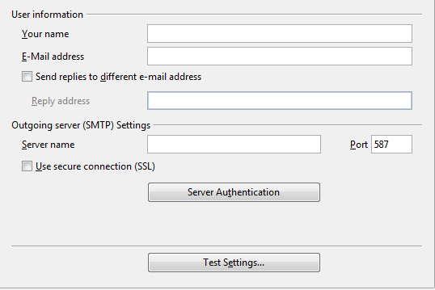
Figure 57: Specifying settings for use when e-mailing mail-merged form letters

Choosing Options for HTML Documents
You can configure OpenOffice to treat HTML documents in Writer differently than regular documents.
- If the Options dialog box is not already open, click Tools > Options.
- Click the expansion symbol (+ sign or triangle) by OpenOffice Writer/Web on the left-hand side of the Options—OpenOffice dialog box. A list of pages drops.
Here you can customize settings related to printing, formatting aids, view options, table defaults, the grid, and a default background for HTML documents you're working with in Writer.
Note | Many of the options available under Options—OpenOffice Writer/Web are identical to the settings under Options—OpenOffice Writer but will only affect HTML documents opened in Writer. The previous sections contain detailed discussion on these options.

Choosing Language Settings
You may need to do several things to set the language settings to what you want:
- Install the required Language Pack
- Install the required dictionaries
- Change some locale and language settings
- Choose spelling options

Install the Required Language Pack
If you need to change the language of the user interface so that menus, dialogs, the Help files and so on are in a different language than your current installation, you must download a Language Pack. These are available at the same web page as the full installation of OpenOffice, https://www.openoffice.org/download/index.html. Choose your operating system, language, and software version and click the Download language pack button. A page at SourceForge will automatically open, and the download will start automatically after a few seconds. Navigate to the folder you saved the download in and install the Language Pack in the same way that you installed OpenOffice. The Language Pack does not include a dictionary.

Install the Required Dictionaries
OpenOffice automatically installs several dictionaries with the program. To add other dictionaries, be sure you are connected to the Internet, and then use Tools > Language > More Dictionaries Online. AOO will open your default web browser to a page containing links to additional dictionaries that you can install. Follow the prompts to select and install the ones you want.

Change Some Locale and Language Settings
You can change some details of the locale and language settings that AOO uses for all documents or for specific documents.
In the Options dialog box, choose Language Settings > Languages.
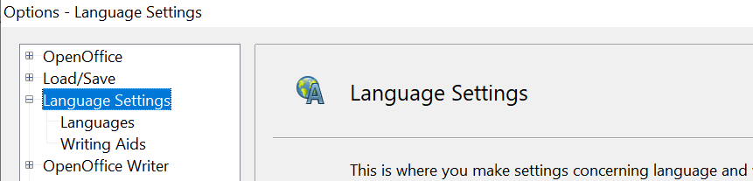
Figure 58: OpenOffice language options
On the right-hand side of the Language Settings—Languages page (Figure 39), change the User interface, Locale setting, Default currency, and Default languages for documents as required. In the example, English (USA) has been chosen for all the appropriate settings.
If you want the language (dictionary) setting to apply to the current document only, instead of being the default for all new documents, select For the current document only.
If necessary, select the options to enable support for Asian languages (Chinese, Japanese, Korean) and support for CTL (complex text layout) languages such as Hindi, Thai, Hebrew, and Arabic. If you choose either of these options, the next time you open this page, you will see some extra pages under Language Settings, as shown in Figure 40. These pages (Searching in Japanese, Asian Layout, and Complex Text Layout) are not discussed here.
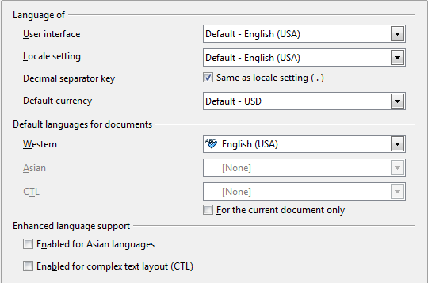
Figure 59: Choosing language options
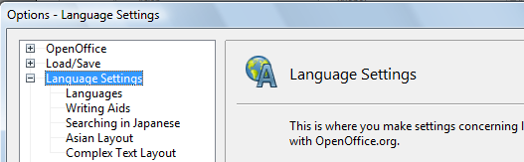
Figure 60: Extra pages available when enhanced language support options are selected

Choose Spelling Options
To choose the options for checking spelling, choose Language Settings > Writing Aids. In the Options section of the page, select the settings that are useful for you.
Some considerations:
- If you do not want spelling checked while you type, deselect Check spelling as you type.
- If you use a custom dictionary that includes words in all uppercase and words with numbers (for example, AS/400), select Check uppercase words and Check words with numbers.
- Check special regions includes headers, footers, frames, and tables when checking spelling.
Here you can also check which of the user-defined (custom) dictionaries are active, or you can add or remove dictionaries by clicking the New or Delete buttons.
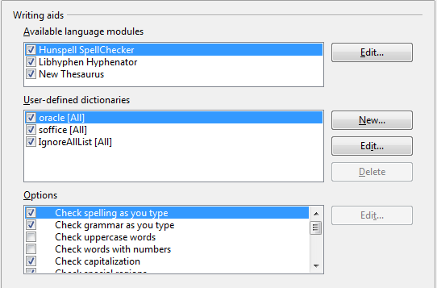
Figure 61: Choosing languages, dictionaries, and options for checking spelling
Note | OpenOffice does not have a grammar checker, but you can install a grammar checker extension such as LanguageTool and access that tool from Tools > Spelling and Grammar. See Chapter 14 for more about installing extensions.

Controlling Writer’s AutoCorrect Functions
Some people find some or all of the items in Writer’s AutoCorrect feature annoying because Writer changes what you type when you do not want it changed. Many people find some AutoCorrect functions quite helpful; if you do, then select the relevant options. But if you find unexplained changes appearing in your document, this is a good place to look to find the cause.
To open the AutoCorrect dialog box, choose Tools > AutoCorrect Options. (You need to have a document open for this menu item to appear.) In Writer, this dialog box has five tabs. Many of the options are described in Chapter 3 (Working with Text) in this book.
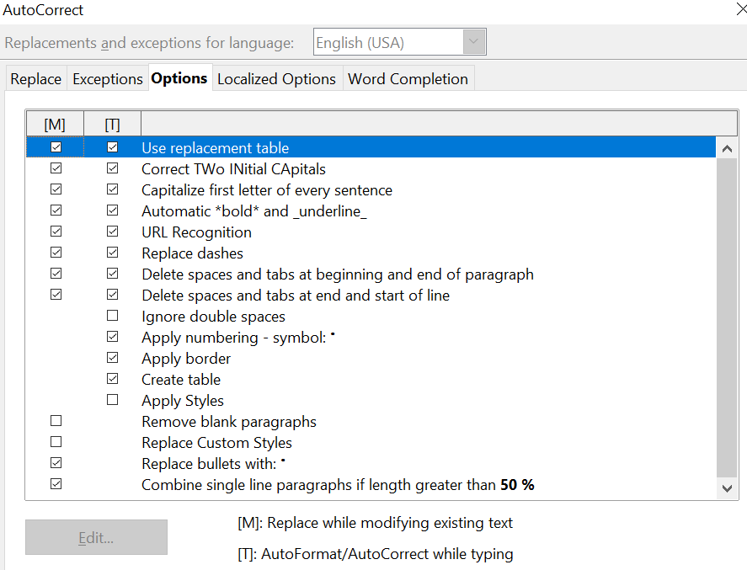
Figure 62: The AutoCorrect dialog box in Writer, showing the five tabs and some of the choices on the Options tab

Chapter 3
Working with Text

Introduction
This chapter covers the basics of working with text in Writer, the word-processing component of Apache OpenOffice (AOO). It assumes that you are familiar with the use of a mouse and keyboard and that you have read about Writer’s menus and toolbars and other topics covered in Chapter 1 (Introducing Writer).
We recommend that you also follow the suggestions in Chapter 2 (Setting up Writer) about displaying formatting aids, such as end-of-paragraph marks, and selecting other setup options.
When you have read this chapter, you should know how to:
- Select, cut, copy, paste, and move text
- Find and replace text
- Insert special characters
- Format paragraphs and characters
- Create numbered or bulleted lists
- Check spelling, use the thesaurus, and choose hyphenation options
- Use the autocorrection, word completion, autotext, and line numbering features
- Track changes, undo and redo changes, and insert notes
- Link to other parts of a document

Selecting Text
Before you can do anything with text, you need to select it. Selecting text in Writer is similar to selecting anything, whatever the application.
In addition to selecting blocks of text, you can select items that are not consecutive, as well as columns (vertical blocks) of text.

Selecting Items that are not Consecutive
To select nonconsecutive items (as shown in Figure 63) using the mouse:
- Select the first piece of text.
- Hold down the Control (Ctrl) key and use the mouse to select the next piece of text.
- Repeat as often as needed.
Now you can work with the selected text (copy it, delete it, change the style, and so on).
To select nonconsecutive items using the keyboard:
- Select the first piece of text. (For more information about keyboard selection of text, see the topic “navigating;in text, with keyboard” in the OpenOffice Help (F1).
- Press Shift+F8. This puts Writer in “ADD” mode. The word ADD appears on the Status Bar.
- Use the arrow keys to move to the start of the next piece of text to be selected. Hold down the Shift key and select the next piece of text.
- Repeat as often as required.
Now you can work with the selected text.
Press Esc to exit from this mode.
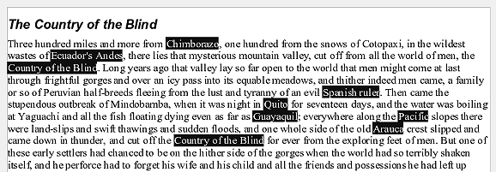Figure 63: Selecting items that are not next to each other

Selecting a Vertical Block of Text
You can select a vertical block or “column” of text that is separated by spaces or tabs (as you might see in text pasted from e-mails, program listings, or other sources), using AOO’s block selection mode. To change to block selection mode, use Edit > Selection Mode > Block Area, or click several times in the status bar on STD until it changes to BLK.
Now you can highlight the selection, using mouse or keyboard, as shown in Figure 64.
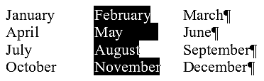
Figure 64: Selecting a vertical block of text

Cutting, Copying, and Pasting Text
Cutting and copying text in Writer is similar to cutting and copying text in other applications. You can copy or move text within a document, or between documents, by dragging or by using menu selections, icons, or keyboard shortcuts. You can also copy text from other sources such as Web pages and paste it into a Writer document.
To move (cut and paste) selected text using the mouse, drag it to the new location and release it. To copy selected text, hold down the Control key while dragging. The text retains the formatting it had before dragging.
When you paste text, the result depends on the source of the text and how you paste it. If you click on the Paste icon, then the pasted text keeps its original formatting (such as bold or italics). Text pasted from Websites and other sources may also be placed into frames or tables. If you do not like the results, click the Undo icon or press Control+Z.
To make the pasted text take on the formatting of the text surrounding where it is pasted, you can:
- Edit > Paste Special, or
- Click the triangle to the right of the Paste icon, or
- Click the Paste icon without releasing the left mouse button.
Then select Unformatted text from the resulting menu.
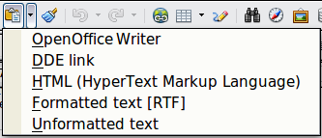
Figure 65: Paste Special menu
The range of choices on the Paste Special menu varies depending on the origin and formatting of the text (or other object) to be pasted. See Figure 65 for an example with text on the clipboard.
This example includes the formatting option DDE link. DDE is an acronym for Dynamic Data Exchange, a mechanism whereby selected data in document A can be pasted into document B as a linked, ‘live’ copy of the original. It would be used, for example, in a report written in Writer containing time varying data, such as sales results sourced from a Calc spreadsheet. The DDE link ensures that, as the source spreadsheet is updated so is the report, thus reducing the scope for error and reducing the work involved in keeping the Writer document up to date.

Finding and Replacing Text
Writer has two ways to find text within a document: the Find toolbar for fast searching and the Find & Replace dialog box. In the dialog box, you can:
- Find and replace words and phrases
- Use wildcards and regular expressions to fine-tune a search
- Find and replace specific formatting
- Find and replace paragraph styles
If the Find toolbar is not visible, you can display it using View > Toolbars > Find.

To display the Find & Replace dialog box, use the keyboard shortcut Control+F or choose Edit > Find & Replace from the menu bar. Figure 66 shows the dialog as it appears after clicking the More Options button.

Figure 66: Expanded Find & Replace dialog box
- Type the text you want to find in the Search for box.
- To replace the text with different text, type the new text in the Replace with box.
- You can select various options, such as matching the case, matching whole words only, or doing a search for similar words. (See below for some other choices.)
- When you have set up your search, click Find. To replace text, click Replace instead.
Tip | If you click Find All, Writer selects all instances of the search text in the document. Similarly, if you click Replace All button, Writer replaces all matches.

Caution | Use Replace All with caution; otherwise, you may end up with some hilarious (and highly embarrassing) mistakes. A mistake with Replace All might require a manual, word-by-word search to fix, if not discovered in time to undo.

Find and Replace Specific Formatting
A very powerful use of Find & Replace takes advantage of the format option. For example, you might want to replace underlined words with italics.
On the Find & Replace dialog box (with More Options displayed, as in Figure 66):
- To search for text with specific formatting, enter the text in the Search for box. To search for specific formatting only, delete any text in the Search for box.
- Click Format to display the Text Format (Search) dialog box. The tabs on this dialog box are similar to those on the Paragraph format and Paragraph Style dialog boxes.
- Choose the formats you want to search for and then click OK. The names of selected formats appear under the Search for box. For example, you might search for all text in 14-point bold Times New Roman.
- To replace text as well as formatting, type the replacement text in the Replace with box.
To search for specific text with specific formatting (for example, the word hello in bold), specify the formatting, type the text in the Search for box and leave the Replace with box blank.
To remove specific character formatting, select the Replace with box then click Format, select the Font tab, then select the opposite format (for example, No Bold). The No Format button on the Find & Replace dialog box clears all previously selected formats.
- Click Find, Find All, Replace, or Replace All.
Tip | Unless you plan to search for other text using those same attributes, click No Format to remove the attributes after completing your search. If you forget to do this, you may wonder why your next search fails to find words you know are in the document.

Find and Replace Paragraph Styles
If you combine material from several sources, you may discover that lots of unwanted paragraph styles have suddenly shown up in your document. To quickly change all the paragraphs from one (unwanted) style to another (preferred) style:
- On the expanded Find & Replace dialog box (Figure 66), select Search for Styles. (If you have attributes specified, this option is labeled Including Styles.) The Search for and Replace with boxes now contain a list of styles.
- Select the styles you want to search for and replace.
- Click Find, Find All, Replace, or Replace All.
Repeat steps 2 and 3 for each style that you want to replace.

Use Wildcards (regular expressions)
Wildcards (also known as regular expressions) are combinations of characters that instruct AOO how to search for something. Regular expressions are very powerful but not very intuitive. They can save time and effort by combining multiple finds into one.

Table 2 shows a few of the regular expressions used by AOO.

Tip | The online help describes many more regular expressions and their uses. There are also many online tutorials available.

Note | To search for a character that is defined as a wildcard, type a backslash (\) before the character. For example, to find the text $5.00, you would conduct a search using \$5\.00.

To use wildcards and regular expressions when searching and replacing:
- On the Find & Replace dialog box, click More Options to see more choices. On this expanded dialog box (Figure 66), select the Regular expressions option.
- Type the search text, including the wildcards, in the Search for box and the replacement text (if any) in the Replace with box. Not all regular expressions work as replacement characters.
- Click Find, Find All, Replace, or Replace All (not recommended).
Table 2. Examples of search wildcards (regular expressions)
To find | Use this expression | Examples and comments
Any single character | . | b.d finds bad, bud, bid, and bed.
One of the specified characters | [xyz] | b[iu]n finds bin and bun.
Any single character in this range | [x-y] | [r-t]eed finds reed, seed, and teed; ranges must be in alphabetically ascending order.
Any single character except the characters inside the brackets | [^x] | p[^a]st finds post and pest, but not past.
The beginning of a word | \<start | \<log finds logbook and logistics, but not catalog.
The end of a word | end\> | log\> finds catalog, but not logistics.
A paragraph marker | $ | Does not work as a replacement character. Use \n instead.
A line break | \n | Finds a line break that was inserted with Shift+Enter. When used as a replacement character, it inserts a paragraph marker.

Inserting Special Characters
A “special” character is one not found on a standard keyboard. For example, © ¾ æ ç ñ ö ø ¢ are all special characters in English. To insert a special character:
- Place the cursor in your document where you want the character to appear.
- Click Insert > Special Character to open the Special Characters dialog box.
- Select the characters (from any font or mixture of fonts) you wish to insert in order; then click OK. The selected characters are shown in the lower left of the dialog box. As you select each character, it is shown on the lower right, along with the numerical code for that character.
Figure 67: The Special Characters dialog box, where you can insert special characters
Tip | Notice that the characters selected appear in the bottom-left corner of the dialog box.

Note | Different fonts include different special characters. If you do not find a particular special character you want, try changing the Font selection.

Inserting Non-breaking Spaces and Hyphens
Non-breaking spaces
To prevent two words from being separated at the end of a line, press Control+space bar after the first word.
Non-breaking hyphen
You can use a non-breaking hyphen in cases where you do not want the hyphen to appear at the end of a line, for example in a number such as 123-4567. To insert a non-breaking hyphen, press Shift+Control+minus sign.

Inserting en and em Dashes
To enter en and em dashes, you can use the Replace dashes option under Tools > AutoCorrect Options (Figure 102). This option replaces two hyphens, under certain conditions, with the corresponding dash.
In the following table, the A and B represent text consisting of letters A to z or digits 0 to 9.
Another means of inserting en or em dashes is through the Insert > Special Characters menu. Select the U+2013 or U+2014 character, respectively.
A third method uses keyboard shortcuts. These shortcuts vary depending on your operating system.
Text that you type: | Result
A - B (A, space, minus, space, B) | A – B (A, space, en-dash, space, B)
A -- B (A, space, minus, minus, space, B) | A – B (A, space, en-dash, space, B)
A--B (A, minus, minus, B) | A—B (A, em-dash, B)
A-B (A, minus, B) | A-B (unchanged)
A -B (A, space, minus, B) | A -B (unchanged)
A --B (A, space, minus, minus, B) | A –B (A, space, en-dash, B)
Tip | You can also record macros to insert en and em dashes and assign those macros to unused key combinations, for example Ctrl+Shift+N and Ctrl+Shift+M. For more information, see Chapter 17 (Customizing Writer).
Windows
Hold down one of the Alt keys and type on the numeric keypad: 0150 for an en dash or 0151 for an em dash. The dash appears when you release the Alt key.
Linux
Hold down the Compose key and type two hyphens and a period for an en dash, or three hyphens for an em dash. The dash appears when you release the Compose key.
Tip | The key that operates as a Compose key varies with the Linux distribution. It is usually one of the Alt or Win keys, but may be another key, and should be user selectable.
macOS
Hold down the Option (Alt) key and type a hyphen for an en dash. For an em dash, the combination is Shift+Option+Hyphen.

Formatting Paragraphs
You can apply many formats to paragraphs using the Sidebar's Properties deck or the buttons on the Formatting toolbar. Figure 103 shows the Paragraph panel of the Properties deck of the Sidebar when the cursor is in a text area. In addition to the controls shown, the complete paragraph formatting dialog can be called using the tiny More Options button at the top right of the pane.
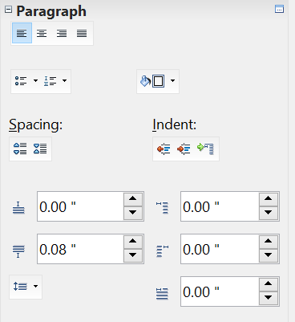

Figure 68: Paragraph panel of the Sidebar Properties pane
Alignment: Left, Center,
Right, Justify
Bullets and Numbering
Background color
Paragraph Spacing/Indent:
AboveBefore
BelowAfter
First Line
Buttons to adjust
paragraph indentation
Line spacing
More options
Buttons to adjust
paragraph spacing
Figure 69 shows the Formatting toolbar as a floating toolbar, customized to show only the buttons for paragraph formatting.
Tip | It is highly recommended that you use paragraph styles rather than manually formatting paragraphs, especially for long or standardized documents. For information on the advantages of styles and how to use them, see Chapters 6 and 7.


1 | Open Styles and Formatting Window | 5 | Align Right | 10 | Numbering On/Off
 | Open Styles and Formatting Window | 6 | Justified | 11 | Bullets On/Off
2 | Apply Style | 7 | Line Spacing: 1 | 12 | Decrease Indent
3 | Align Left | 8 | Line Spacing: 1.5 | 13 | Increase Indent
4 | Centered | 9 | Line Spacing: 2 | 14 | Paragraph format dialog box
Figure 69: Formatting toolbar, showing icons for paragraph formatting
Figure 70 shows examples of the text alignment options.
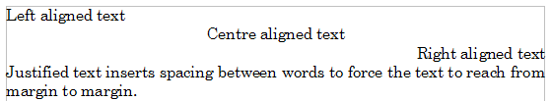Figure 70: Text alignment options
When using justified text, the last line is by default aligned to the left; however, if so desired, you can also align the last line to the center of the paragraph area or justify it so that spaces are inserted between the words in order to fill the whole line. In the case where the last line consists of a single word, you can also have this word stretched to cover the entire line. Figure 71 shows an example of the effect obtained when setting each of these options.
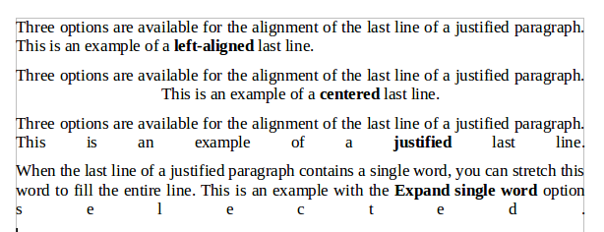
Figure 71: Four choices for the last line of a justified paragraph
These options are controlled in the Alignment page of the Format > Paragraph dialog box shown in Figure 72.
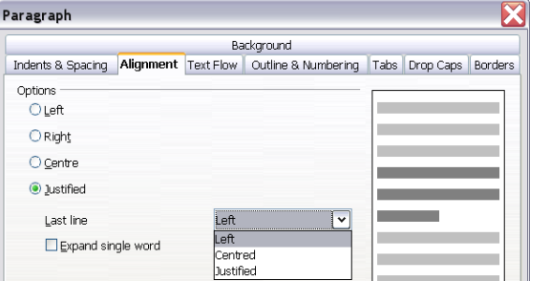
Figure 72: Options for the last line of a justified paragraph

Setting Tab Stops and Indents
The horizontal ruler shows both the default tab stops and any tab stops that you have defined. Tab settings affect indentation of full paragraphs (using the Increase Indent and Decrease Indent icons on the Formatting toolbar) as well as indentation of parts of a paragraph (by pressing the Tab key on the keyboard).
Using the default tab spacing can cause formatting problems if you share documents with other people. If you use the default tab spacing and then send the document to someone else who has chosen a different default tab spacing, tabbed material will change to use the other person’s settings. Instead of using the defaults, define your own tab settings, as described in this section.
To define indents and tab settings for one or more selected paragraphs, double-click on a part of the ruler that is not between the left and right indent icons to open the Indents & Spacing page of the Paragraph dialog box. Double-click anywhere between the left and right indent icons on the ruler to open the Tabs page of the Paragraph dialog box shown in Figure 73.
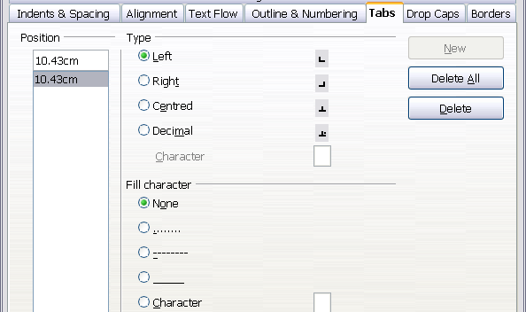
Figure 73: Specifying tab stops and fill characters
A better strategy is to define tabs for the paragraph style. Refer to Chapters 6 and 7 for more about paragraph styles.
Tip | Using tabs to space out material on a page is not recommended. Depending on what you are trying to accomplish, a table is usually a better choice.

Changing the Default Tab Stop Interval
Note | Any changes to the default tab setting will affect the existing default tab stops in any document you open afterward, as well as tab stops you insert after making the change.

To set the measurement unit and the spacing of default tab stop intervals, go to Tools > Options > OpenOffice Writer > General and make changes in the Settings area shown in Figure 74.

Figure 74: Selecting a default tab stop interval
You can also set or change the measurement unit for rulers in the current document by right-clicking on the ruler to open a list of units, as shown in Figure 75. Click on one of them to change the ruler to that unit. The selected setting applies only to that ruler.
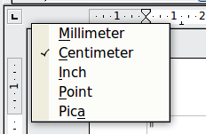
Figure 75: Changing the measurement unit for a ruler

Formatting Characters
You can apply many formats to characters using the buttons on the Text panel of the Properties deck of the Sidebar or the Formatting toolbar.
Figure 102 shows the Sidebar's Text panel with the controls labeled.

Figure 76: Text panel of the Sidebar
Figure 77 shows the Formatting toolbar as a floating toolbar, customized to show only the buttons for character formatting.
It is highly recommended that you use character styles rather than manually formatting characters. For information on styles and how to use them, see Chapters 6 and 7.
1 | Open Styles and Formatting Window | 6 | Italic | 12 | Font Color
 | Open Styles and Formatting Window | 7 | Underline | 13 | Highlighting
2 | Apply Style | 8 | Superscript | 14 | Background Color
3 | Font Name | 9 | Subscript | 15 | Open Character Format dialog box
4 | Font Size | 10 | Increase Font |  | Open Character Format dialog box
5 | Bold | 11 | Reduce Font
Figure 77: Formatting toolbar, showing icons for character formatting
Tip | To remove manual formatting, select the text and choose Format > Default Formatting from the main menu bar, or right-click and choose Default Formatting from the pop-up menu.

Autoformatting
You can set Writer to automatically format parts of a document according to the choices made on the Options page of the AutoCorrect dialog box (Tools > AutoCorrect Options) shown in Figure 78.
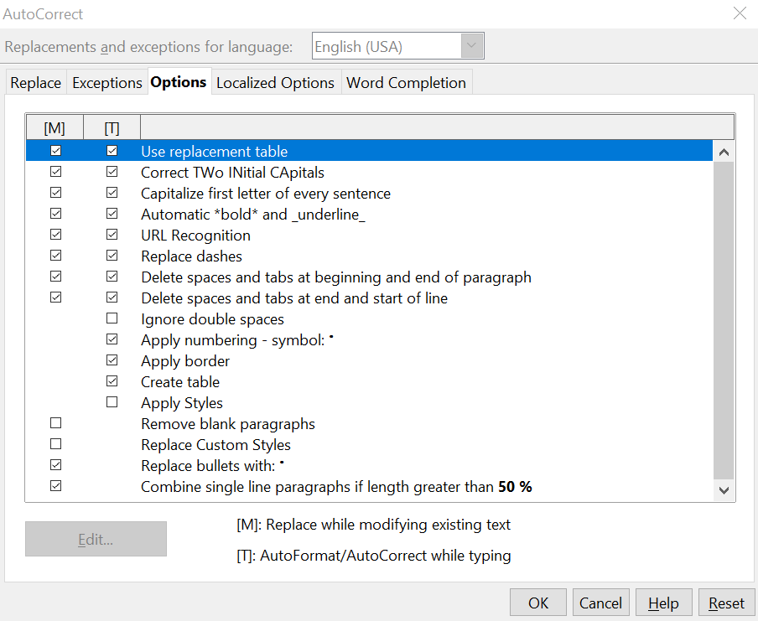
Figure 78: Autoformat choices on the Options page of the AutoCorrect dialog box
The Help describes each of these choices and how to activate the autoformats. Some common unwanted or unexpected formatting changes include:
- Horizontal lines. If you type three or more hyphens (---), underscores (___) or equal signs (===) on a line and then press Enter the paragraph is replaced by a horizontal line as wide as the page. The line is actually the lower border of the preceding paragraph.
- Bulleted and numbered lists. A bulleted list is created when you type a hyphen (-), asterisk (*), or plus sign (+), followed by a space or tab at the beginning of a paragraph. A numbered list is created when you type a number followed by a period (.), followed by a space or tab at the beginning of a paragraph. Automatic numbering is only applied to paragraphs formatted with the Default, Text body or Text body indent paragraph styles.
Tip | If you notice unexpected formatting changes occurring in your document, this is the first place to look for the cause.

To automatically format the file according to the options you have set, choose Format > AutoCorrect and select or deselect the items on the submenu.
While Typing
Automatically formats the document while you type.
Apply
Automatically formats the document.
Apply and Edit Changes
Automatically formats the file and then opens a dialog box where you can accept or reject the changes.
AutoCorrect Options
Opens the AutoCorrect dialog (Figure 78).

Creating Numbered or Bulleted Lists
There are several ways to create numbered or bulleted lists:
- Use autoformatting, as described above.
- Use list styles, as described in Chapter 7 (Working with Styles).
- Use the Numbering and Bullets icons on the paragraph formatting toolbar (see Figure 79). This method is described here.
To produce a numbered or bulleted list, select the paragraphs in the list and then click on the appropriate icon on the toolbar.
Note | It is a matter of personal preference whether you type your information first, then apply Numbering/Bullets or apply these as you type.

Using the Bullets and Numbering Toolbar
You can create a nested list (where one or more list items has a sublist under it, as in an outline) by using the buttons on the Bullets and Numbering toolbar (Figure 79). You can move items up or down the list, create subpoints, and even change the style of bullets.
Tip | It is possible to move a list entry up, together with all of its sub-entries. Do this by clicking the Promote One Level With Subpoints button.


1 | Bullets On/Off | 6 | Promote One Level with Subpoints | 10 | Move Down
2 | Numbering On/Off | 6 | Promote One Level with Subpoints | 11 | Move Up with Subpoints
3 | Numbering Off | 7 | Demote One Level with Subpoints | 12 | Move Down with Subpoints
4 | Promote One Level | 8 | Insert Unnumbered Entry | 13 | Restart Numbering
5 | Demote One Level | 9 | Move Up | 14 | Bullets and Numbering
Figure 79: Bullets and Numbering toolbar
If you create a nested list using the predefined styles, all the levels of the list (up to 10) apply the same numbering (or bullet). However, in many circumstances you will want to use a combination of numbering formats and bullets when creating nested lists. Such lists, with a mixture of numbering formats and bullets, can be easily configured as described in the following example. Additional information on lists, in particular the technique to create your own list style, is described in Chapter 7 (Working with Styles).
Tip | When creating nested lists, one option is to enter all the list paragraphs first and apply the levels afterward.  You can use keyboard shortcuts to move paragraphs up or down the outline levels. Place the cursor at the beginning of the numbered paragraph and press:  Tab Down a level  Shift+Tab Up a level  To insert a tab stop at the beginning of a numbered paragraph (that is, after the number but before the text), press Control+Tab.

Example: Configuring a Nested List
We will use a numbering style to produce the following effect:
I. Level-1 list item
A. Level-2 list item
i. Level-3 list item
a) Level-4 list item
This example uses one of the supplied styles, Numbering 1, however if you intend to reuse this type of nested list you can also create a new style as illustrated in Chapter 7 (Working with Styles).
- In the SideBar, select the Styles and Formatting deck and click the List Styles icon at the top. Right-click on the Numbering 1 style and choose Modify from the pop-up menu as shown in Figure 80.
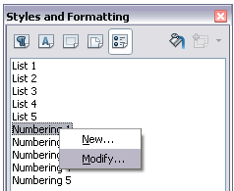
Figure 80: Modifying a list style
- On the Numbering Style dialog box, go to the Outline tab (Figure 81), where you will find that one style matches our requirements. Click once on that style.
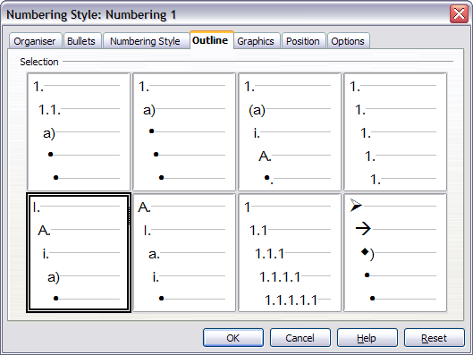
Figure 81: Choosing a predefined outline-numbering style
- To modify the layout of the list, use the Options tab (Figures 82 and 83). Notice that the preview on the right shows the outline selected. In the Level box on the left, select 1, then 2, 3, and 4 and see how the information in the Numbering and After boxes changes.
Use the Options page to set different punctuation; for example, a period (full stop) after “a” on level 4 instead of a parenthesis.
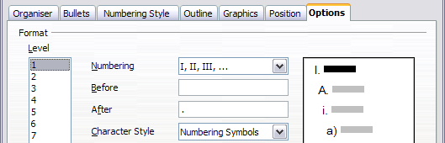
Figure 82: Checking the outline numbering for level-1 list items
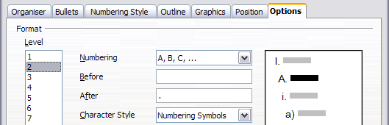
Figure 83: Numbering style for level-2 list items
To make the indentation at each level greater or less than the default, change it on the Position tab. Select the level, then make any changes in the indentation, spacing, or numbering alignment.
- Repeat for each level as required, then click OK.
Tip | With outline numbering you can define different bullet styles for the different levels of a bullet list. Use the Bullets tab of the Bullets and Numbering dialog box (not shown) to select the basic style. Return to the Options tab to customize the bullet for each indent level. Here you can set bullets to any character. See the Graphics tab for more bullets.

Using Footnotes and Endnotes
Footnotes appear at the bottom of the page on which they are referenced. Endnotes are collected at the end of a document.
To work effectively with footnotes and endnotes, you need to:
- Insert footnotes.
- Define the format of footnotes.
- Define the location of footnotes on the page, as described in Chapter 4 (Formatting Pages).

Inserting Footnotes/Endnotes
To insert a footnote or an endnote, put the cursor where you want the footnote/endnote marker to appear. Then select Insert > Footnote/Endnote from the menu bar or click the Insert Footnote/Endnote Directly or Insert Endnote Directly icon on the Insert toolbar shown in Figure 84.
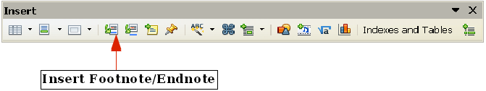
Figure 84: Using the Insert Footnote Directly icon on the toolbar
A footnote or endnote marker is inserted in the text and, depending on your choice, the cursor is relocated either to the footnote area at the bottom of the page or to the endnote area at the end of the document. Type the footnote or endnote content in this area.
If you use Insert > Footnote/Endnote, the Insert Footnote/Endnote dialog box (Figure 85) is displayed. Here you can choose whether to use the automatic numbering sequence specified in the footnote settings and whether to insert the item as a footnote or an endnote.
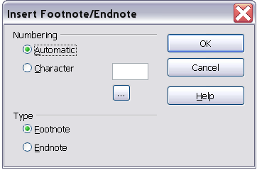
Figure 85: Inserting a footnote/endnote directly
If you use the Insert Footnote/Endnote Directly or Insert Endnote Directly icon, the footnote, or endnote automatically takes on the attributes previously defined in the Footnote Settings dialog box.
You can edit an existing footnote or endnote the same way you edit any other text.
To delete a footnote or endnote, delete the footnote marker. The contents of the footnote or endnote are deleted automatically, and the numbering of other footnotes or endnotes is adjusted automatically.

Defining the Format of Footnotes/Endnotes
To format the footnotes themselves, click Tools > Footnotes/Endnotes. On the Footnote Settings dialog box (Figure 86), choose settings as required. The Endnotes page has similar choices.
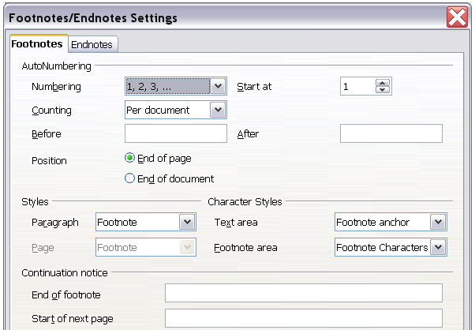
Figure 86: Defining footnote formatting

Checking Spelling and Grammar
Writer provides a spelling checker, which can be used in two ways.
AutoSpellcheck checks each word as it is typed and displays a wavy red line under any misspelled words. When the word is corrected, the red wavy line disappears.
To perform a separate spelling check on the document (or a text selection) click this button. This checks the document or selection and opens the Spelling and Grammar dialog box (Figure 87) if any misspelled words are found.
Here are some more features of the spelling checker:
- You can right-click on a word with a wavy underline, to open a powerful context menu. If you select from the suggested words on the menu, the selection will replace the misspelled word in your text. Other menu options are discussed below.
- You can change the dictionary language (for example, Spanish, French, or German) on the Spelling and Grammar dialog box.
- You can add a word to a dictionary. Click Add in the Spelling and Grammar dialog box and pick the dictionary to add it to.
- Click the Options button on the Spelling and Grammar dialog box to open a dialog box similar to the one in Tools > Options > Language Settings > Writing Aids described in Chapter 2. There you can choose whether to check uppercase words and words with numbers, and you can manage custom dictionaries, that is, add or delete dictionaries and add or delete words in a dictionary.
Writer does not include a grammar checker, but you can install an extension such as LanguageTool and access it from Tools > Spelling and Grammar. (See Chapter 17 for more about installing extensions.)
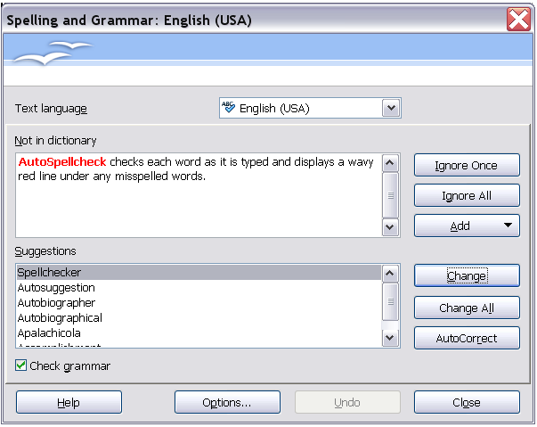
Figure 87: Selecting a word from dictionary using the Spelling and Grammar dialog box
LanguageTool adds a new menu item and submenu to the Tools menu, from which you can configure the tool and check or recheck the document. Figure 88 shows an example of the LanguageTool extension in use.
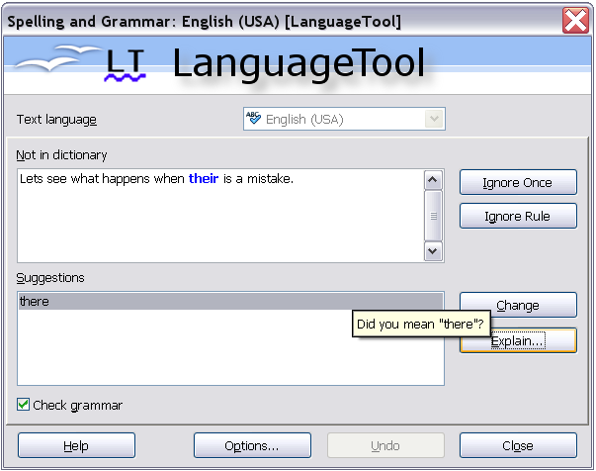
Figure 88: The LanguageTool extension

Using Built-in Language Tools
Writer provides some tools that make your work easier if you mix multiple languages within the same document or if you write documents in various languages:
- Paragraph and character styles
- Using Tools > Language
- Using language settings in Options
- Using the status bar
The main advantage of changing the language for a text selection is that you can then use the correct dictionaries to check spelling and apply the localized versions of AutoCorrect replacement tables, thesaurus, and hyphenation rules.
You can also set the language for a paragraph or a group of characters as None (Do not check spelling). This option is especially useful when you insert text such as web addresses or programming language snippets that you do not want to check for spelling.

Using Paragraph and Character Styles
Specifying the language in character and paragraph styles is the preferred method, because styles allow a greater level of control and make changing the language much faster. On the Font tab of the Paragraph Styles dialog box, you can specify that the paragraphs using that style be checked in a language that is different from the language of the rest of the document. See Chapter 7 (Working with Styles) for information on how to manage the language settings of a style.

Using Tools > Language
You can also set the language for the whole document, for individual paragraphs, or even for individual words and characters, all from Tools > Language on the menu bar.
For Selection
Applies a specified language to the selected text (the selection can be as short as a few characters or as long as several paragraphs).
For Paragraph
Select this option to apply the specified language to the paragraph where the cursor is located.
For all Text
Select this option to apply the specified language to all the document.

Using Language Settings in Options
Another way to change the language of a whole document is to use Tools > Options > Language Settings > Languages. In the Default languages for documents section (Figure 89), you can choose a different language for all the text.
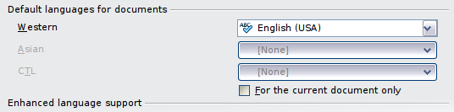
Figure 89: Options available in the Languages settings
Caution | Unlike the menu tool that applies to the individual document, a change in the default language from the Options dialog box is a general change of settings of AOO and will therefore apply to all the documents created in the future. If you want to change the language for the current document only, be sure to select the For the current document only option.
The spelling checker works only for those languages in the list which have the symbol next to them. If you do not see this symbol next to your preferred language, you can install the dictionary using Tools > Languages > More dictionaries online.

Using the Status Bar
The language used for checking spelling is also shown in the status bar, next to the page style in use as shown in Figure 90. You can change the language for the paragraph or the entire document; click on the language in the status bar to pop up a menu of choices.
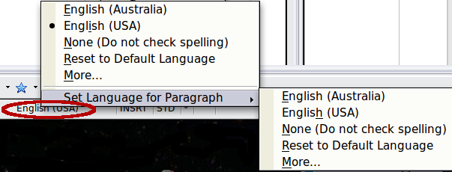
Figure 90: Language choices on the status bar
Notice the Reset to Default Language option on the menu and submenu. This is the fastest way to return a paragraph or the entire document to the default language set in Tool > Options (described above).

Using Synonyms and the Thesaurus
You can access a short list of synonyms from the context menu:
- Select a word or phrase, right-click, and point to Synonyms on the pop-up menu. A submenu of alternative words and phrases is displayed.
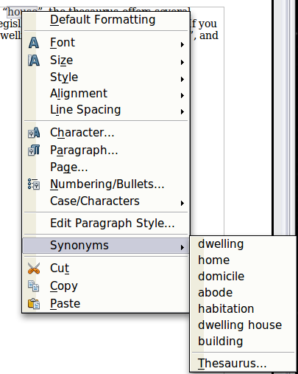
Figure 91: Synonyms on the context menu
- Click on a word or phrase to select it and replace the highlighted word or phrase in the document.
The thesaurus gives a more extensive list of alternative words and phrases. To use the thesaurus:
- Select a word or phrase, and then choose Tools > Language > Thesaurus, or press Control+F7, or right-click and choose Thesaurus from the pop-up menu.
- In the dialog box, click on a meaning to show alternative words and phrases for that meaning of the word.
For example, when given the word house, the thesaurus offers several meanings, including dwelling, legislature, sign of the zodiac, and others. If you click on dwelling, you will see dwelling, home, domicile, abode, and other alternatives, as shown in Figure 92.

Note | If the current language does not have a thesaurus installed, this feature is disabled.

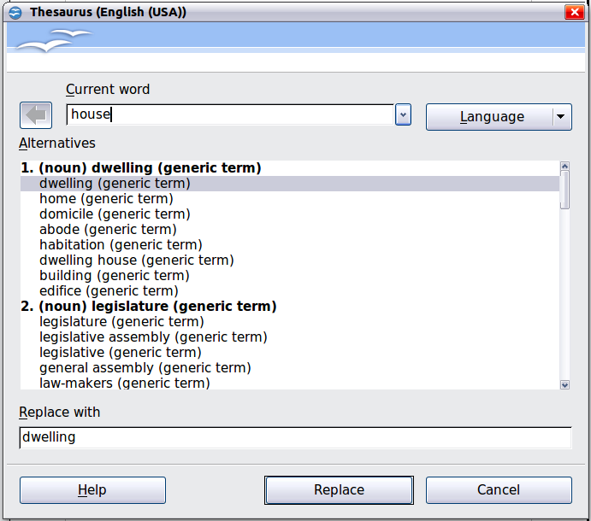
Figure 92: The thesaurus offers alternatives to words

Hyphenating Words
You have several choices regarding hyphenation: let Writer do it automatically (using its hyphenation dictionaries), insert conditional hyphens manually where necessary, or don’t hyphenate at all. Each choice has its pros and cons.

Automatic Hyphenation
To turn automatic hyphenation of words on or off:
- Choose the Styles and Formatting deck of the Sidebar or Press F11 to open the Styles and Formatting window. On the Paragraph Styles tab, right-click on Default and select Modify as shown in Figure 93.
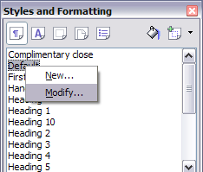
Figure 93: Modifying a paragraph style
- On the Paragraph Style dialog box, select the Text Flow tab.
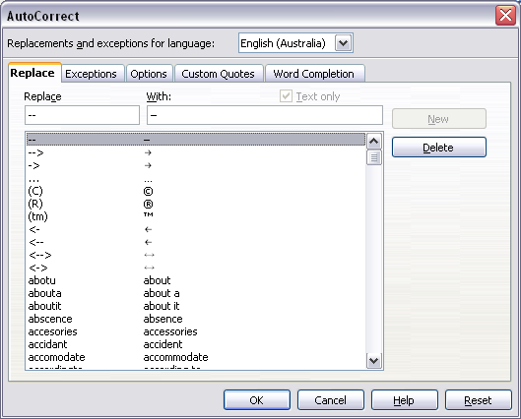Figure 94: Turning on automatic hyphenation
- Under Hyphenation, select or deselect the Automatically option.
- Click OK to save.
Note | Turning on hyphenation for the Default paragraph style affects all other paragraph styles that are based on Default. You can individually change other styles so that hyphenation is not active; for example, you might not want headings to be hyphenated. Any styles that are not based on Default are not impacted. For more on paragraph styles, see Chapter 6 (Introduction to Styles) and Chapter 7 (Working with Styles).

You can also set hyphenation choices through Tools > Options > Language Settings > Writing Aids. In Options, near the bottom of the dialog box, scroll down to find the hyphenation settings as shown in Figure 95.
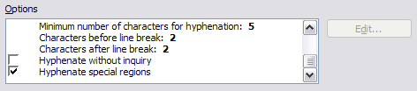
Figure 95: Setting hyphenation options
To change the minimal number of characters for hyphenation, the minimum number of characters before a line break, or the minimum number of characters after a line break, select the item, and then click the Edit button in the Options section.
Hyphenate without inquiry
Specifies that you will never be asked to manually hyphenate words that the hyphenation dictionary does not recognize. If this box is not selected, when a word is not recognized, a dialog box will open where you can manually enter hyphens.
Hyphenate special regions
Specifies that hyphenation will also be carried out in footnotes, headers, and footers.
Hyphenation options set on the Writing Aids dialog box are effective only if hyphenation is turned on through paragraph styles.
Choices on the Writing Aids dialog box for Characters before line break and Characters after line break override settings in paragraph styles for Characters at line end and Characters at line begin.

Manual Hyphenation
To manually hyphenate words, do not use a normal hyphen, which will remain visible even if the word is no longer at the end of a line when you add or delete text or change margins or font size. Instead, use a conditional hyphen, which is visible only when required.
To insert a conditional hyphen inside a word, click where you want the hyphen to appear and press Control+hyphen. The word will be hyphenated at this position when it is at the end of the line, even if automatic hyphenation for this paragraph is switched off.

Using AutoCorrect
Writer’s AutoCorrect function has a long list of common misspellings and typing errors, which it corrects automatically. For example, “the” will be changed to “the.”
Select Tools > AutoCorrect Options to open the AutoCorrect dialog box. There you can define what strings of text are corrected and how. In most cases, the defaults are fine.
AutoCorrect is turned on when Writer is installed. To turn it off, uncheck Format > AutoCorrect > While Typing.
To stop Writer replacing a specific spelling, go to the Replace tab, highlight the word pair, and click Delete.
To add a new spelling to the list, type it into the Replace and With boxes on the Replace tab, and click New.
See the different pages of the dialog box (Figure 96) for the wide variety of other options available to fine-tune AutoCorrect.
Tip | AutoCorrect can be used as a quick way to insert special characters. For example, (C) will be autocorrected to ©. You can add your own special characters.

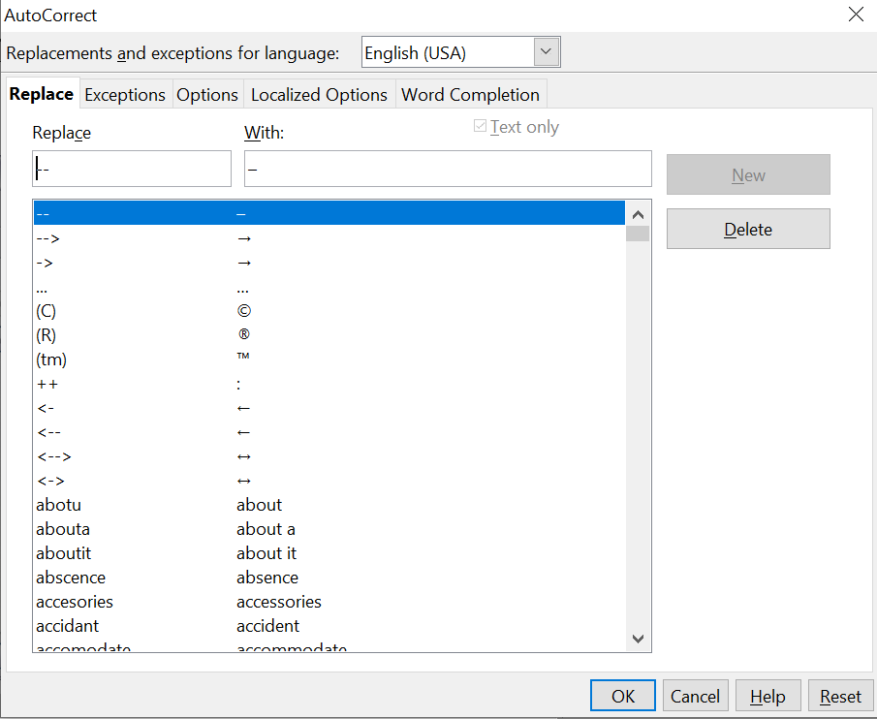
Figure 96: Replace tab of AutoCorrect dialog box

Using Word Completion
If Word Completion is enabled, Writer tries to guess which word you are typing and offers to complete the word for you. To accept the suggestion, press Enter. Otherwise, continue typing.
To turn off Word Completion, select Tools > AutoCorrect Options > Word Completion and deselect Enable word completion.
You can customize word completion from the Word Completion page of the AutoCorrect dialog, shown in Figure 97.
- Add (append) a space automatically after an accepted word.
- Show the suggested word as a tip (hovering over the word) rather than completing the text as you type.
- Collect words when working on a document, and then either save them for later use in other documents or select the option to remove them from the list when closing the document.
- Change the maximum number of words remembered for word completion and the length of the smallest words to be remembered.
- Delete specific entries from the word completion list.
- Change the key that accepts a suggested entry—the options are Right arrow, End key, Enter (Return), Space bar, and Tab.
Note | Automatic word completion only occurs after you type a word for the second time in a document.

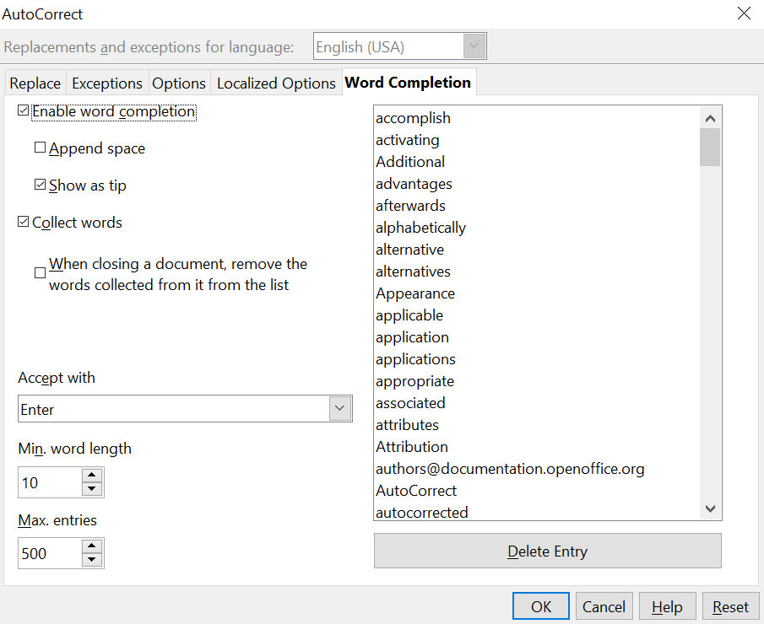
Figure 97: Customizing word completion

Using AutoText
Use AutoText to store text, tables, fields, and other items for reuse and assign them to a key combination for easy retrieval. For example, rather than typing “Senior Management” every time you use that phrase, you can set up an AutoText entry to insert those words when you type “sm” and press F3.
AutoText is especially powerful when used with fields. See Chapter 14 (Working with Fields) for more information.

Creating AutoText
To store some text as AutoText:
- Type the text into your document.
- Select the text.
- Go to Edit > AutoText (or press Control+F3).
- In the AutoText dialog box (Figure 98), type a name for the AutoText in the Name box. Writer will suggest a one-letter shortcut, which you can change.
- In the large box to the left, choose the category for the AutoText entry, for example My AutoText.
- Click the AutoText button on the right of the dialog box and select New (text only) from the menu (to have the AutoText take on the formatting where it is inserted into a document) or select New (to have the AutoText retain specific formatting no matter where it is inserted).
- Click Close to return to your document.
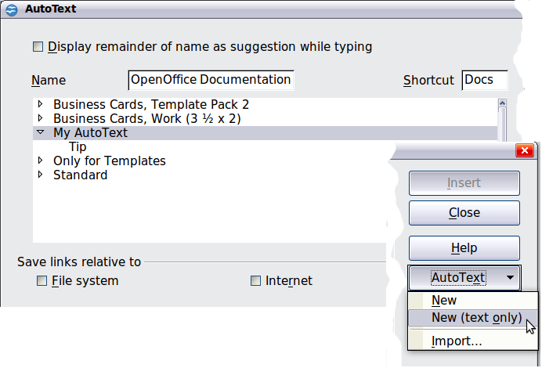
Figure 98: Defining a new AutoText entry
Tip | If the only option under the AutoText button is Import, either you have not entered a name for your AutoText or there is no text selected in the document.

To save a table (such as the formatted Tip on this page) as AutoText:
- Create a table and format it the way you want.
- Select the table.
- Go to Edit > AutoText (or press Control+F3).
- Type a name for the AutoText, optionally amend the suggested shortcut, and choose the category for the AutoText entry.
- Click the AutoText button and select New (because you want the formatting of the table preserved).
- Click Close to return to your document.

Inserting AutoText
To insert AutoText, type the shortcut and press F3.

Printing a List of AutoText Entries
- Choose Tools > Macros > Organize Macros > OpenOffice Basic.
- In the Macro from list, choose OpenOffice Macros > Gimmicks.
- Select AutoText and then click Run. A list of the current AutoText entries is generated in a separate text document. You can then print this document.
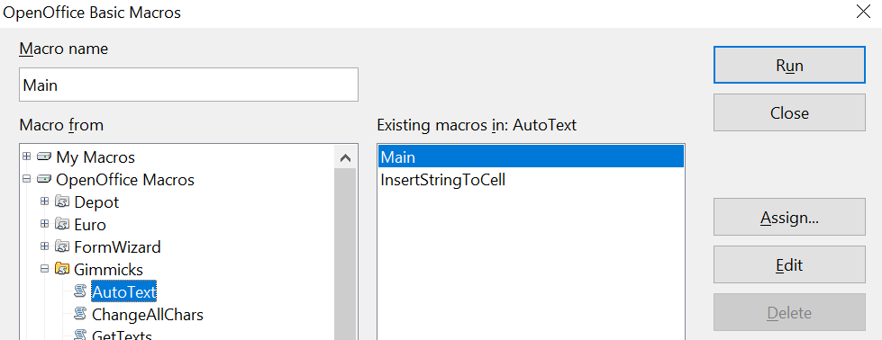

Line Numbering
Line numbering puts line numbers in the margin. The line numbers are displayed on screen and are printed. Figure 99 shows an example with numbering on every line.
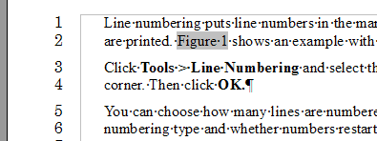Figure 99: Line numbering example
Click Tools > Line Numbering and select the Show numbering option in the top left corner of the Line Numbering dialog box (Figure 100). Then click OK.
You can choose how many lines are numbered (for example, every line or every tenth line), the numbering type and whether numbers restart on each page. In addition, a text separator (any text you select) can be set on a different numbering scheme (one every 12 lines, for example).
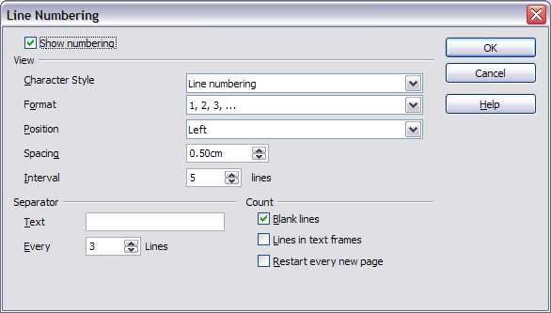Figure 100: The Line Numbering dialog box

Tracking Changes to a Document
You can use several methods to keep track of changes made to a document.
- Make your changes to a copy of the document (stored in a different folder, under a different name, or both), then use Writer to combine the two files and show the changes you made. Click Edit > Compare Document. This technique is particularly useful if you are the only person working on the document, as it avoids the increase in file size and complexity caused by the other methods.
- Save versions that are stored as part of the original file. However, this method can cause problems with documents of nontrivial size or complexity, especially if you save a lot of versions. Avoid this method if you can.
- Use Writer’s change marks (often called “redlines” or “revision marks”) to show where you have added or deleted material or changed formatting. Later, you or another person can review and accept or reject each change.
Tip | Not all changes are recorded. For example, changing a tab stop from align left to align right and changes in formulas (equations) or linked graphics are not recorded.

Preparing a Document for Review
When you send a document to someone else to review or edit, you may want to prepare it first so that the editor or reviewer does not have to remember to turn on the revision marks. After you have protected the document, any user must enter the correct password in order to turn off the function or accept or reject changes.
- Open the document. To check whether it contains multiple versions, click File > Versions. If multiple versions are listed, save the current version as a separate document with a different name and use this new document as the review copy.
- With the review copy open, make sure that change recording is turned on. The Edit > Changes > Record menu item has a check mark next to it when recording is turned on.
- Click Edit > Changes > Protect Records. On the Enter Password dialog box, type a password (twice) and click OK.
Tip | A slightly faster alternative to steps 2 and 3 above is to choose File > Properties > Security tab, click Protect, and enter the password.

Recording Changes
See Chapter 2 (Setting up Writer) for instructions on setting up how your changes will be displayed.
- To begin tracking (recording) changes, click Edit > Changes > Record. To show or hide the display of changes, click Edit > Changes > Show.
Tip | Hold the mouse pointer over a marked change; you will see a Help Tip showing the type of change, the author, date, and time of day for the change. If Extended Tips are enabled, you will also see any comments recorded for this change.

- To enter a comment on a marked change, place the cursor in the area of the change and then click Edit > Changes > Comment. A dialog similar to Figure 101 will appear. In addition to being displayed as an extended tip, the comment is also displayed in the list in the Accept or Reject Changes dialog box (Figure 91).
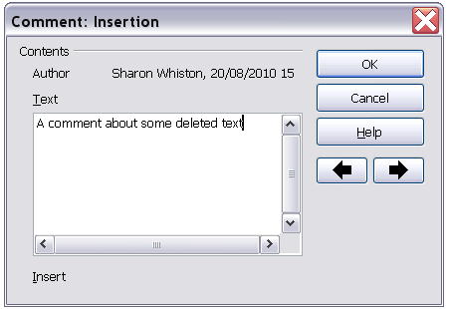
Figure 101: Inserting a comment during change recording
To move from one marked change to the next, use the arrow buttons. If no comment has been recorded for a change, the Text field is blank.

Tip | See also “Adding Other Comments” on page 104 for a way to annotate text that is not associated with a recorded change.

- To stop recording changes, click Edit > Changes > Record again.

Accepting or Rejecting Changes
To accept or reject recorded changes, use either of these methods:
- Right-click (context) menu
- Accept or Reject Changes dialog box
The results of accepting or rejecting a change are as follows:
- Accepting an insertion removes the change indicator (usually a color) from the inserted text.
- Rejecting an insertion removes the text from the document.
- Accepting a deletion removes the text from the document.
- Rejecting a deletion removes the change indicator and restores the text to the document.
Right-click (context) menu
- If recorded changes are not showing, click Edit > Changes > Show.
- Hover the mouse pointer over a recorded change. A box appears with information about the type of change, who made it, and the date and time.
- Right-click on the changed text. In the pop-up (context) menu, choose Accept Change or Reject Change.
Accept or Reject Changes dialog box
- Click Edit > Changes > Accept or Reject. The Accept or Reject Changes dialog box (Figure 91) opens.
- When you select a change in the dialog box, the actual change is highlighted in the document, so you can see what the editor changed.
- Click Accept or Reject to accept or reject the selected change. You can also click Accept All or Reject All if you do not want to review the changes individually.
Changes that have not yet been accepted or rejected are displayed in the list.
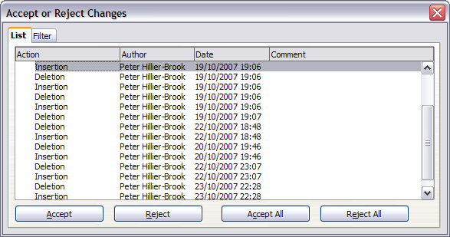
Figure 102: The List tab of the Accept or Reject Changes dialog box
To show only the changes of certain people or only the changes on specific days or various other restrictions, use the Filter tab (Figure 94) on the Accept or Reject Changes dialog box. After specifying the filter criteria, return to the List tab to see those changes that meet your criteria.
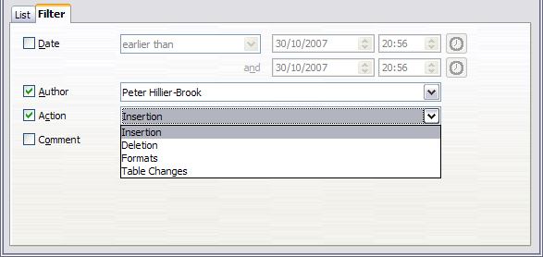
Figure 103: The Filter page of the Accept or Reject Changes dialog box

Merging Modified Documents
The processes discussed to this point are effective when you have one reviewer at a time. Sometimes, however, multiple reviewers all return edited versions of a document at the same time. In this case, it may be quicker to review all of these changes at once, rather than one review at a time. For this purpose, you can merge documents in Writer.
To merge documents, all the edited documents need to have recorded changes in them.
- Open one copy.
- Click Edit > Changes > Merge Document and select and insert another copy of the document to be merged with the first.
- After the documents merge, the Accept or Reject Changes dialog box opens, as in Figure 91, showing changes by more than one reviewer. If you want to merge more documents, close the dialog box, and then repeat step 2.
- Repeat until all copies are merged.
All recorded changes are now included in the open copy. Save this file under another name.

Comparing Documents
Sometimes reviewers may forget to record the changes they make. This is not a problem with Writer because you can find the changes if you compare documents.
In order to compare documents, you need to have the original document and the one that is edited. To compare them:
- Open the edited document. Select Edit > Compare Document.
- The Insert dialog box appears. Select the original document and click Insert.
Writer finds and marks the changes and displays the Accept or Reject Changes dialog box. From this point, you can go through and accept or reject changes as described earlier.

Adding Other Comments
Writer provides another type of comments (formerly called “notes”), which authors and reviewers often used to exchange ideas, ask for suggestions, or brainstorm during the review process.
To insert a comment in the text, place the cursor in the place the comment refers to and select Insert > Comment or press Ctrl+Alt+C. The anchor point of the comment is connected by a dotted line to a box on the right-hand side of the page where you can type the text of the comment. Writer automatically adds at the bottom of the comment the author’s name and a time stamp indicating when the comment was created. Figure 67 shows an example of text with comments from two different authors.
Select Tools > Options > OpenOffice > User Data to configure the name you want to appear in the Author field of the comment, or to change it.
If more than one person edits the document, each author is automatically allocated a different background color.
Figure 104: Comments in AOO
Right-clicking on a comment pops up a menu where you can delete the current comment, all the comments from the same author, or all the comments in the document. From this menu, you can also apply some basic formatting to the text of the comment. You can also change font type, size, and alignment from the main menu.
To navigate from one comment to another, open the Navigator in the Sidebar or press F5, expand the Comments section, and click on the comment text to move the cursor to the anchor point of the comment in the document. Right-click on the comment to quickly edit or delete it.
You can also navigate the comments using the keyboard. Use Ctrl+Alt+Page Down to move to the next comment and Ctrl+Alt+Page Up to move to the previous comment.

Linking to Another Part of a Document
If you type in references to other parts of the document, those references can easily get out of date if you reorganize the order of topics, add or remove material, or reword a heading, Writer provides two ways to ensure that your references are up-to-date, by inserting links to other parts of the same document or to a different document:
- Hyperlinks
- Cross-references
The two methods have the same result if you Control+click the link when the document is open in Writer: you are taken directly to the cross-referenced item. However, they also have major differences:
- The text in a hyperlink does not automatically update if you change the text of the linked item (although you can change it manually), but changed text does automatically update in a cross-reference.
- When using a hyperlink, you do not have a choice of the content of the link (for example text or page number), but when using a cross-reference, you have several choices, including bookmarks.
- To hyperlink to an object such as a graphic, and have the hyperlink show useful text such as Figure 6, you need to either give such an object a useful name instead of leaving it as the default name (“Graphics6”), or you need to use the Hyperlink dialog to modify the visible text. In contrast, cross-references to figures with captions automatically show useful text, and you have a choice of several variations of the name.
- If you save a Writer document to HTML, hyperlinks remain active, but cross-references do not. (Both remain active when the document is exported to PDF.)

Using Cross-References
To ensure that references update if you reword a heading, caption, or other linked item, use automatic cross-references. See “Using automatic cross-references” in Chapter 14 (Working with Fields) for details.

Using Bookmarks
Bookmarks are listed in the Navigator and can be accessed directly from there with a single mouse click. In HTML documents, bookmarks are converted to anchors that you can jump to by hyperlink. For more about bookmarks, see “Using bookmarks” in Chapter 14 (Working with Fields).

Using Hyperlinks
When you type text (such as website addresses or a URL) that can be used as a hyperlink, and then press the space bar or the Enter key, Writer automatically creates the hyperlink and applies formatting to the text (usually a color and underlining).
If this does not happen, you can enable this feature using Tools > AutoCorrect > Options and selecting the URL Recognition option.
If you do not want Writer to convert a specific URL to a hyperlink, choose Edit > Undo Insert from the menu bar or press Control+Z immediately after the formatting has been applied.
You can also insert hyperlinks using the Navigator and the Hyperlink dialog, and you can modify all hyperlinks using the Hyperlink dialog, as described in this section.
Note | Hyperlinks between documents can be set as relative or absolute, using the Save URLs relative to option in Tools > Options > Load/Save > General.  Relative linking is only possible when the document you are working on and the link destination are on the same drive, and you need to create the same directory structure on your hard disk as will apply on the destination website.  AOO uses absolute path names internally, so when you move your mouse cursor over a hyperlink, the tooltip displays the absolute reference even when it is set to be a relative link.

Inserting Hyperlinks Using the Navigator
The easiest way to insert a hyperlink to another part of the same document is by using the Navigator:
- Open the document containing the items you want to cross-reference.
- Open the Navigator (by clicking its icon in the Sidebar or the Standard toolbar, choosing View > Navigator, or pressing F5).
- Click the arrow next to the Drag Mode icon, and select Insert as Hyperlink.
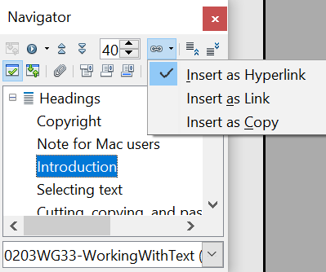

Figure 105: Inserting a hyperlink using the Navigator
- In the list at the bottom of the Navigator, select the document containing the item that you want to cross-reference.
- In the Navigator list, select the item that you want to insert as a hyperlink.
- Drag the item to where you want to insert the hyperlink in the document. The name of the item is inserted in the document as an active hyperlink.
You can also use the Hyperlink dialog to insert and modify hyperlinks within and between documents (see next page).

Inserting Hyperlinks Using a Dialog Box
To display the Hyperlink dialog box (Error: Reference source not found), click the Hyperlink icon on the Standard toolbar or choose Insert > Hyperlink from the menu bar. To turn existing text into a link, highlight it before opening the dialog box.
On the left-hand side, select one of the four types of hyperlink:
- Internet: a web address, normally starting with HTTP:// or HTTPS://
- Mail & News: for example an email address.
- Document: the hyperlink points to another document or to another place in the present document.
- New document: the hyperlink creates a new document.
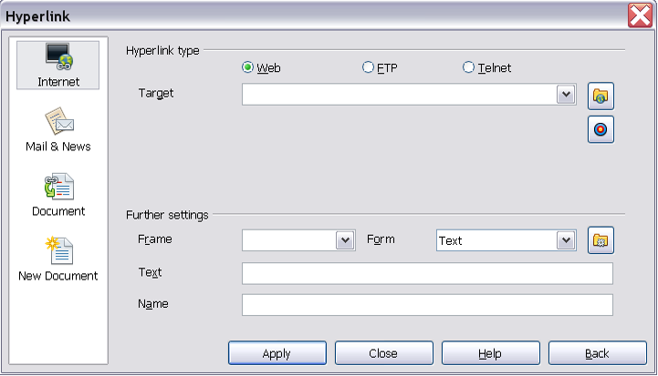
Figure 106. Hyperlink dialog box showing details for Internet links
The top right part of the dialog box changes according to your choice for the hyperlink type. A full description of all the choices, and their interactions, is beyond the scope of this chapter. Here is a summary of the most common choices.
For an Internet type hyperlink, choose the type of hyperlink (choose between Web, FTP or Telnet), and enter the required web address (URL).
For a Mail and News type hyperlink, specify whether it is a mail or news link, the receiver address and for email, also the subject.
For a Document type hyperlink, specify the document path (the Open File button opens a file browser); leave this blank if you want to link to a target in the same document. Optionally specify the target in the document (for example a specific heading). Click on the Target icon to open the Navigator where you can select the target, or if you know the name of the target, you can type it into the box.
For a New Document type hyperlink, specify whether to edit the newly created document immediately or just create it (Edit later) and the type of document to create (text, spreadsheet, etc.). For a presentation, Edit now is the more likely choice. The Select path button opens a directory picker.
The Further settings section in the bottom right part of the dialog box is common to all the hyperlink types, although some choices are more relevant to some types of links.
- Set the value of Frame to determine how the hyperlink will open. This applies to documents that open in a Web browser.
- Form specifies if the link is to be presented as text or as a button.
- Text specifies the text that will be visible to the user.
- Name is applicable to HTML documents. It specifies text that will be added as a NAME attribute in the HTML code behind the hyperlink.
- Event button: this button will be activated to allow AOO to react to events for which the user has written some code (macro). This function is not covered in this book.

Editing Hyperlinks
To edit a hyperlink, click anywhere in the link text and then open the Hyperlink dialog box by clicking the Hyperlink icon on the Standard toolbar or choosing Edit > Hyperlink from the menu bar. Make your changes and click Apply. If you need to edit several hyperlinks, you can leave the Hyperlink dialog box open until you have edited all of them. Be sure to click Apply after each one. When you are finished, click Close.
The standard (default) behavior for activating hyperlinks within AOO is to use Ctrl+click. This behavior can be changed in Tools > Options > OpenOffice > Security > Options, by deselecting the option Ctrl-click required to follow hyperlinks. If clicking in your links activates them, check that page to see if the option has been deselected.
To change the color of hyperlinks, go to Tools > Options > OpenOffice > Appearance, scroll to Unvisited links and/or Visited links, select those options, pick the new colors and click OK.
Caution | This will change the color for all hyperlinks in all components of OpenOffice—this may not be what you want.

In Writer and Calc (but not Draw or Impress), you can also change the Internet link character style or define and apply new styles to selected links.

Switching Between Insert and Overwrite Mode
With the keyboard, press Insert to toggle between overwrite mode and insert mode. In insert mode, any text after the cursor position moves forward to make room for the text you type; in overwrite mode, text after the cursor position is replaced by the text you type. The current mode is displayed on the Status Bar.
With the mouse, click in the area on the Status Bar that indicates the current mode in order to switch to the other mode.

Counting the Words in a Selection
Select a block of text and choose Tools > Word Count. AOO displays the number of words and characters in the selection as well as the number of words in the document. You can also see the number of words and characters (and other information) in the entire document in File > Properties > Statistics.

Changing the Case of Selected Text
To quickly change the case of text, select it, choose Format > Change Case from the menu bar, and then choose one of the following:
- Sentence case, where only the first word (and any proper nouns) is capitalized
- lower case, where no words (except proper nouns) are capitalized
- UPPER CASE, where all letters are capitalized
- Capitalize Every Word, where every word is capitalized
- tOGGLE cASE, which changes every letter to the opposite case
Writer does not have an automated way to do Title Case, where all words are capitalized except for certain subsets defined by rules that are not universally standardized.

Chapter 4
Formatting Pages
Using Page Styles, Tables, Frames, Columns, and Sections

Introduction
Writer provides several ways for you to control page layouts:
- Page styles
- Columns
- Frames
- Tables
- Sections
This chapter describes these methods, and some associated things:
- Headers and footers
- Numbering pages
- Changing page margins
Tip | Page layout is usually easier if you select the options to show text, object, table, and section boundaries in Tools > Options > OpenOffice > Appearance and if you select the options for paragraph ends, tabs, breaks, and other items in Tools > Options > OpenOffice Writer > Formatting Aids.

Choosing a Layout Method
The best layout method depends on what the final document should look like and what sort of information will be in the document. Here are some examples. Do not worry if all this does not mean much to you now. The techniques mentioned are all described in this chapter.
For a book similar to this user guide with one column of text, some figures without text beside them, and some other figures with descriptive text, use page styles for basic layout, and use tables to place figures beside descriptive text, where necessary. | 
Use page styles (with two columns) for an index or other document with two columns of text where the text continues from the left-hand column to the right-hand column and then to the next page, all in sequence (also known as snaking columns of text). If the title of the document (on the first page) is full-page width, put it in a single-column section. | 
For a newsletter with a complex layout, two or three columns on the page, and some articles that continue from one page to some place several pages later, use page styles for basic layout. Place articles in linked frames and anchor graphics to fixed positions on the page, if necessary. | 
For a document with terms and translations to appear side-by-side in what appear to be columns, use a table to keep items lined up, so you can type in both “columns”. | 

Setting up Basic Page Layout Using Styles
In Writer, page styles define the basic layout of all pages, including page size, margins, the placement of headers and footers, borders and backgrounds, number of columns, and so on.
Writer comes with several page styles, which you can build on or modify, and you can define new (custom) page styles. You can have one or many page styles in a single document.
Note | All pages in a Writer document are based on styles. If you do not specify a page style, Writer uses the Default page style.
To change the layout of individual pages, either define a new page style or use one of the techniques (sections, frames, or tables) described later in this chapter.
This chapter describes some uses of page styles. Some other uses are discussed in Chapter 6 (Introduction to Styles). The Page Style dialog box is covered in detail in Chapter 7 (Working with Styles).
Tip | Any modifications of page styles, including the Default page style, apply only to the document you are working on. If you want the changes to be the default for all documents, you need to put the changes into a template and make that template the default template. See Chapter 10 (Working with Templates) for details.

Inserting a Page Break without Switching the Style
In many documents (for example, a multipage report), you may want the text to flow from one page to the next as you add or delete information. Writer does this automatically, unless you override the text flow using one of the techniques described earlier.
If you do want a page break in a particular place, for example, to put a heading at the top of a new page, here is how to do it:
- Position the cursor in the paragraph you want to be at the start of the next page. Right-click and choose Paragraph in the pop-up menu.
- On the Text Flow page of the Paragraph dialog box (Figure 107), in the Breaks section, select Insert. Do not select With Page Style.
- Click OK to position the paragraph at the start of the next page.
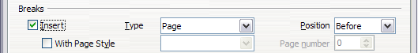Figure 107: Inserting a manual page break

Defining a Different First Page for a Document
Many documents, such as letters and reports, have a first page that is different from the other pages in the document. For example, the first page of a letterhead typically has a different header, as shown in Figure 108, or the first page of a report might have no header or footer, while the other pages do. With Writer, you can define the style for the first page and specify the style for the following page to be applied automatically.
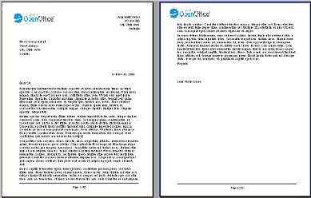Figure 108: Letterhead with different page styles for first and following pages
As an example, we can use the First Page and Default page styles that come with Writer. Figure 109 shows what we want to happen: the first page is to be followed by the default page, and all the following pages are to be in the Default page style.
Figure 109: Flow of page styles
To set up this sequence:
- Open the Styles and Formatting window. (Do one of the following: select the Styles and Formatting deck of the Sidebar, click the Styles and Formatting icon located at the left-hand end of the Formatting toolbar, choose Format > Styles and Formatting, or press F11.)
- On the Styles and Formatting window, click on the Page Styles icon to display a list of page styles.
- Right-click on First Page and select Modify from the pop-up menu.
- On the Organizer page of the Page Style dialog box, look at the Next Style property. This property defines what the page style for the next page will be. It should be set to Default, but if it is not, you can change the next style by clicking on the drop-down button and choosing Default from the list of page styles, as shown in Figure 110
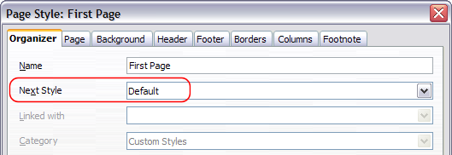Figure 110: Set the Next Style property for a page style
- On the other pages of this dialog box, you can turn on or off the header and footer for the first page and define other characteristics, such as columns, a page border, or a page background. For more information, see Chapter 7 (Working with Styles).
- Click OK to save the changes.
Note | You can override the Next Style property by manually inserting a page break and specifying a page style or by starting a page with a paragraph or table that has its own page style property defined. These techniques are described in “Inserting a Landscape Page into a Portrait Document” on page 117.

Changing Page Orientation within a Document
A document can contain pages in more than one orientation. A common scenario is to have a landscape page in the middle of a document, whereas the other pages are in a portrait orientation. Here are the steps to achieve it.

Setting Up a Landscape Page Style
- Note the page style that is current and the margin settings. (You can find the margin settings on the Page tab of the Page Style dialog box, as shown in Figure 112.)
- Create a new style. (Right-click on the current page style in the Styles and Formatting window and choose New from the pop-up menu)
- On the Organizer tab of the Page Style dialog box (Figure 111), name (by typing in the Name field) this new style Landscape and set the Next Style property to Landscape (to allow for having more than one sequential landscape page). If a style named Landscape already exists, you can choose any other name and use it in all the following commands.
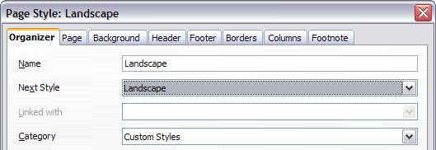
Figure 111: Name the new style and set the next page style to Landscape
- On the Page tab of the Page Style dialog box (Figure 112), set the Orientation to Landscape. The width and height attributes of the page will automatically change.
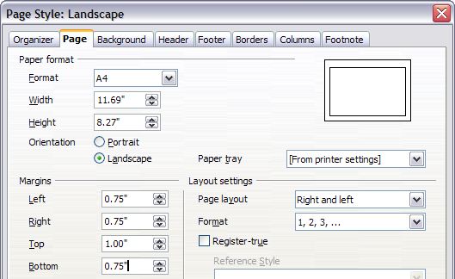
Figure 112: Set orientation and margins for a landscape page
- Change the margins so that they correspond with the margins of the portrait page. That is, the portrait top margin becomes the landscape left margin, and so on. Click OK to save the changes.

Inserting a Landscape Page into a Portrait Document
Now that you have defined the Landscape page style, here is how to apply it.
- Position the cursor in the paragraph or table at the start of the page that is to be set to landscape. Right-click and choose Paragraph or Table, respectively, in the pop-up menu.
- On the Text Flow tab of the Paragraph dialog box (Figure 114) or the Table Format dialog box (Figure 113), select Insert (or Break for a table) and With Page Style. Set the Page Style property to Landscape. Click OK to close the dialog box and to apply the new page style.
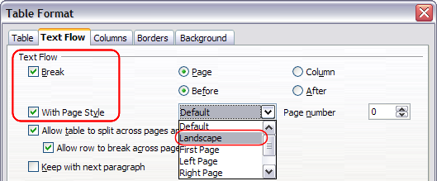Figure 113: Specifying a page break before a table
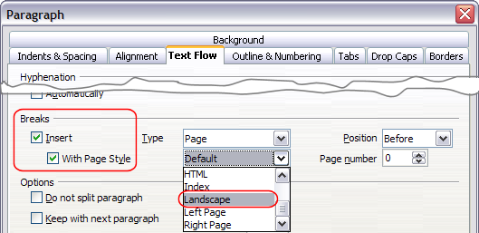Figure 114: Specifying a page break before a paragraph
- Position the cursor in the paragraph or table where the page is to return to portrait orientation and change the properties of that paragraph or table properties so that With Page Style is the portrait page style that was used before the Landscape page style.
- Click OK to return to the previous portrait page style.
Tip | If you need the headers or footers on the landscape pages to be in portrait orientation, see “Portrait Headers on Landscape Pages” on page 140.

Changing Page Margins
You can change page margins in two ways:
- Using the page rulers—quick and easy, but does not have fine control.
- Using the Page Style dialog box—can specify margins to two decimal places.

Note | If you change the margins using the rulers, the new margins affect the page style and will be shown in the Page Style dialog box the next time you open it.
To change margins using the rulers:
- The shaded sections of the rulers are the margins (see Figure 115). Put the mouse cursor over the line between the gray and white sections. The pointer turns into a double-headed arrow.
- Hold down the left mouse button and drag the mouse to move the margin.
Tip | The small arrows on the ruler are used for indenting paragraphs. They are often in the same place as the page margins, so you need to be careful to move the margin marker, not the arrows. Place the mouse pointer between the arrows and, when the pointer turns into a double-headed arrow, you can move the margin (the indent arrows will move with it).

Figure 115: Moving the margins
To change margins using the Page Style dialog box (Figure 112):
- Right-click anywhere on the page and select Page from the pop-up menu.
- On the Page tab of the dialog box, type the required distances in the Margins boxes.

Using Columns to Define the Page Layout
You can use columns for page layout in these ways:
- Define the number of columns and their layout on a page, using page styles.
- Change the number of columns for existing text.

Defining the Columns on a Page
It is a good idea to define your basic page style (such as Default) with the most common layout to be used in your document, either single-column or multiple-column. You can then either define extra page styles for pages with different numbers of columns or use sections (described in “Using Sections for Page Layout” starting on page 130) for pages or parts of pages with different numbers of columns.
To define the number of columns on a page, as shown in Figure 116:
- Choose Format > Columns or go to the Columns page of the Page Style dialog box,
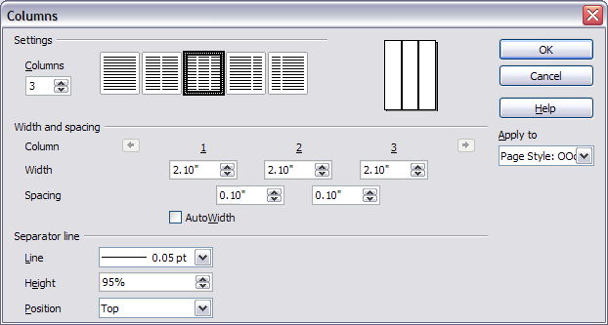Figure 116: Defining the number of columns on a page
- In the Settings area, choose the number of columns and specify any spacing between the columns and whether you want a vertical separator line to appear between the columns. You can use one of Writer’s predefined column layouts, or you can create a customized column layout. The preview box, located to the right of the Settings area, shows how the column layout will look.
- Notice the Apply to box on the right-hand side of the dialog box. In this case, the changes are being applied to the OOoDefault page style.
- Click OK to save the changes.

Specifying the Number of Columns
The Settings area displays five predefined column layouts. To use one of them, click the desired layout.
If you prefer to create a customized column layout, you must specify the number of columns that you want by entering the desired number in the Columns box.

Formatting Column Width and Spacing
To create evenly-spaced columns that are all the same width, select the AutoWidth option in the Width and Spacing area.
To customize the width and spacing of the columns, follow these steps:
- In the Width and Spacing area, deselect the AutoWidth option.
- On the Width line, enter a width for each column.
- On the Spacing line, enter the amount of space that you want between each pair of columns.
If you specify more than three columns, use the arrow keys on the Column line to scroll among the columns.

Formatting Separator Lines
To display separator lines between the columns:
- Six separator line options exist: None or various lines of thicknesses ranging from 0.05 to 5 pt (2.37 l). From the Line drop-down list in the Separator line area, select the type of line that you want. (1 pt = 1 point = 1/12 pica = 1/72 inch = 127/360 mm = 0.3527 mm.)
- The default format is for the separator lines to have the same height as the columns. If you want the separator lines to be shorter than the columns, use the Height box to enter the height of the separator lines as a percentage of the height of the columns. For example, if you enter 50%, the separator lines will be half as high as the columns.
- If you entered a height of less than 100%, use the Position drop-down list to select a vertical alignment for the separator lines. The vertical-positioning options are: Top, Centered, or Bottom.

Reverting to a Single-Column Layout
To revert to a single-column layout for the page style, go to the Settings area and either reset the number in the Columns box to 1 or click the single-column layout icon.

Changing the Number of Columns for Existing Text
You might want some parts of a page to have one column and other parts of the page to have two or more columns. For example, you might have a page-width headline over a three-column news story.
You can create columns and then type or paste text into them, or you can select some existing text and change the number of columns for displaying it.
When you select text and change the number of columns for that text, Writer turns the selected text into a section, as described in “Using Sections for Page Layout” on page 130.
To apply columns to selected text, use the menu Format > Columns. Figure 117 shows the Columns dialog box for a selection. The Apply to box on the right-hand side has Selection highlighted and an extra option (Evenly distribute contents to all columns) appears in the upper left-hand part of the dialog box.
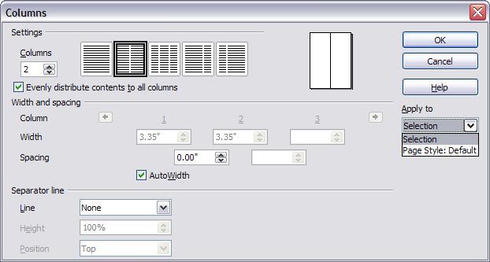Figure 117: Specifying columns for a selection
Tip | You cannot select text on a two-column page and change it to a single column using this method. Instead, you need to define a single-column page and then select the text you want to be in a two-column section.

Distributing Text Across Columns
As you add text to the section, you will see that the text flows from one column to the next. You can distribute text across the columns in one of two ways:
- Evenly—Writer adjusts the length of the columns to the amount of text, so that all the columns are approximately the same height. As you add or delete text, the columns readjust.
- Newspaper-style—Writer fills the columns one at a time, beginning with the first column. The last column may be shorter than the others.
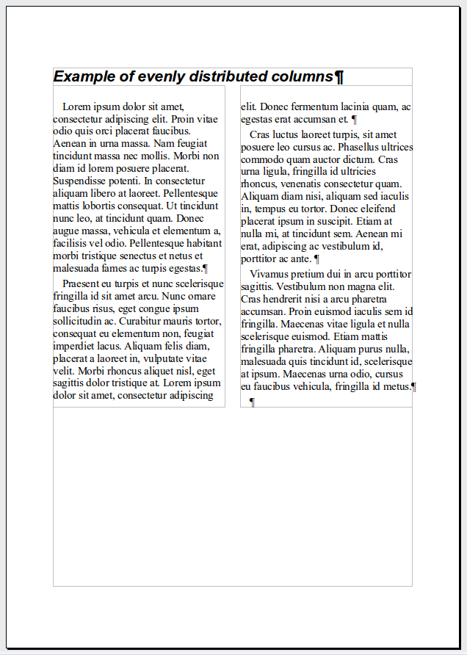 | 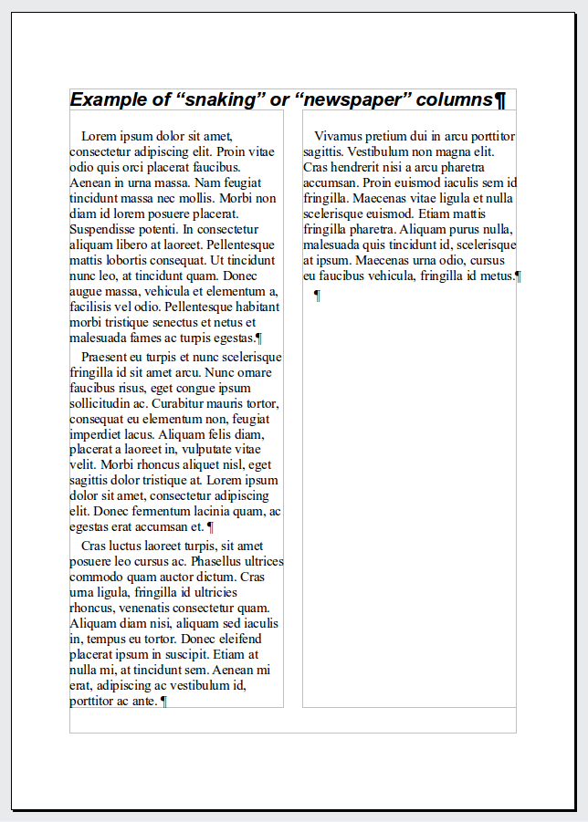
Figure 118: (Left) Evenly distributed columns; (Right) Newspaper-style columns.
To distribute text evenly, select the Evenly distribute contents to all columns option in the Settings area. Deselect this option if you want to distribute text newspaper-style.
Tip | Choose View > Nonprinting Characters (or press Ctrl+F10) to display end of paragraph markers (¶). Often, unexpected behavior of columns is due to extra paragraphs that are normally invisible to the user but are taking up space.

Using Frames for Page Layout
Frames can be very useful when producing a newsletter or other layout-intensive documents. Frames can contain text, tables, multiple columns, pictures, and other objects.
Use frames when you need to:
- Position something in a particular place on a page, for example, a logo or a “stop press” news box in one corner of a page.
- Allow text on one page to continue on another page, somewhere more distant than the next one, by linking the content of one frame to another so the contents flow between them as you edit the text.
- Wrap text around an object, such as a photograph.
Because OpenOffice does not allow you to define page styles with recurring frames, consider doing some quick sketches of the basic page layouts you need, indicating the approximate positions of different frames and their purposes. Try to keep the number of different page layouts as low as possible in order to avoid chaos in your design.
Pay special attention to the positioning of frames. Many of the predefined styles default to a center alignment. Although centering all frames looks reasonably good in most cases, it is rarely the best choice.
One of the most visually effective ways to position a frame is to align its left margin with that of the paragraph above it. To achieve this effect, insert the frame in a blank paragraph of the same style as the paragraph above. Then, select Insert > Frame > Type > Position > Horizontal > From Left to position the frame exactly where you want it.
You also should think about the type of wrap and the spacing between the frame and text. Instead of cramming a frame close to the text, use the Wrap tab to place some white space between them.
You can format frames individually or define and apply frame styles—see Chapter 7 (Working with Styles).
Example: Using a frame to center text on a page
Although you can center text horizontally as part of a paragraph style or by using manual formatting, those methods do not work for vertical centering. To center text vertically, you need to place the text in a frame, anchor the frame to a page or a paragraph, and then center the frame vertically on the page. See “Anchoring Frames” on page 126.

Creating Frames
However, you create a frame, it is a good idea to give it a meaningful name using the Options page of the Frame dialog (Figure 123). This will make it easier to use the Navigator to select a desired frame.
You can create a frame in several ways, depending on your needs.
- Choose Insert > Frame) to create an empty frame. The Frame dialog box (Figure 120) appears. You can click OK and come back to customize it later, or you can set the frame’s characteristics at this stage.
- Select text or a graphic, choose Insert > Frame, and click OK to create a frame containing the selection. The selected text is automatically deleted from the normal text flow and inserted into the frame, and the Frame dialog box appears.
- Insert a picture or other object by selecting Insert > Picture > From file or Insert > Object to start the process to insert a picture or object. The item inserted automatically appears in a frame, but the Frame dialog box does not appear.
- Use the Insert Frame Manually 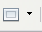 button on the Insert toolbar (go to View > Toolbars > Insert to display it), select the number of frames in the drop-down menu, and drag the mouse to draw the frame.
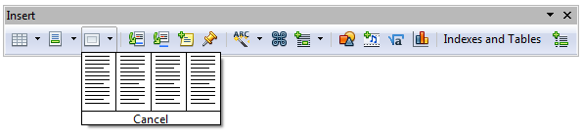
Figure 119: Using an icon on the Insert toolbar to create a frame
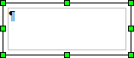
When you release the mouse button, a box appears where the cursor is located in the document. This box represents the frame: an area isolated from the main document.
To add content to a frame, first deselect the frame by clicking somewhere else on the page. Then, click inside the frame so that the cursor shifts its focus there. Now add content just like you would on the main page. When you are done, deselect the frame.

Moving, Resizing, and Changing Frame Attributes
When an object is added to Writer, it is automatically enclosed in a frame of a predetermined type. The frame sets how the object is placed on the page, as well as how it interacts with other elements in the document. You can edit the frame by modifying the frame style it uses or by using a manual override when a frame is added to the document. Frame styles are discussed in Chapter 7 (Working with Styles).
To change the size or location of a frame, first select the frame, then use either the mouse or the Frame dialog box (Figure 120). Using the mouse is faster but less accurate. You might want to use the mouse for gross layout and the dialog box for fine-tuning.
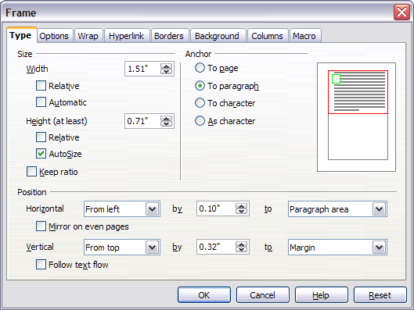Figure 120: Frame dialog box
You can resize the frame manually (by clicking on the green squares and dragging to the appropriate size) or start adding content to it (the frame will resize automatically if, for example, you add a large picture to it) or go back to the Frame dialog box and set the size and other characteristics.
To change the location of the frame using the mouse, drag and drop one of the edges or put the cursor anywhere within the frame. (The I-bar cursor changes to a four-headed arrow when properly positioned for a drag-and-drop move.)
To change the size of the frame, drag one of the handles. Drag a handle on one of the sides to enlarge or reduce the text frame in one dimension only; drag a corner handle to enlarge or reduce it in both dimensions.
These resizing actions distort the proportions of the frame. Holding down the Shift key while dragging one of the handles makes the frame keep the same proportions.
You can open the Frame dialog box at any time by selecting the frame, right-clicking, and choosing Frame from the pop-up menu.
To remove the default border on a newly created frame, as shown in Figure 121, open the Frame dialog box, go to the Borders page, and under Line Style, select None. Alternatively, you can assign a borderless style to the frame; see the Chapter 7 (Working with Styles) for information on frame styles.
Tip | Do not confuse a frame’s border with the text boundaries that are made visible using the View menu (by selecting View > Text Boundaries).

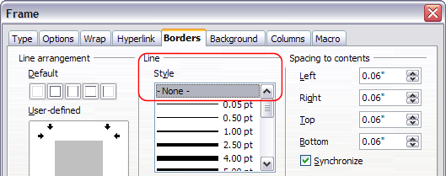Figure 121: Removing the border from a frame

Anchoring Frames
Using the Frame dialog box (or by right-clicking and pointing to Anchor), you can anchor a frame to a page, paragraph, or character, or you can anchor it as a character.
To Page
The frame keeps the same position in relation to the page margins. It does not move as you add or delete text. This method is useful when the frame does not need to be visually associated with a particular piece of text. It is often used when producing newsletters or other documents that are very layout-intensive. This method is also used to center text on a page.
To Paragraph
The frame is associated with a paragraph and moves with the paragraph. It may be placed in the margin or another location. This method is useful as an alternative to a table for placing icons beside paragraphs. It is also used to center text on a page in documents which will be used in a master document (frames anchored to pages will disappear from the master document).
To Character
The frame is associated with a character but is not in the text sequence. It moves with the paragraph but may be placed in the margin or another location. This method is similar to anchoring to a paragraph.
As Character
The frame is placed in the document like any other character and, therefore, affects the height of the text line and the line break. The frame moves with the paragraph as you add or delete text before the paragraph. This method is useful for adding a small icon in sequence in a sentence. It is also the best method for anchoring a graphic to an empty paragraph, so it does not move around the page in unexpected ways.

Linking Frames
You can link frames to each other even when they are on different pages of a document. The contents will automatically flow from one to the next. This technique is very useful when designing newsletters, where articles may need to be continued on a different page.
Note | You cannot link from a frame to more than one other frame.
To link one frame to another:
- Select the frame to be linked from.
- Click the Link Frames icon on the Formatting bar.
- Click the next frame in the series (which must be empty).

When a linked frame is selected, any existing links are indicated by a faint connecting line, as shown in Figure 122. Note that any frame-linking line may not be as clear as illustrated in the figure if there is other content on the page.
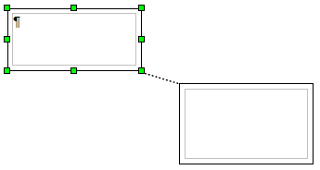Figure 122: Linked frames
The height of a frame that is being linked from is fixed; you can change this height manually or by using the Frame dialog box, but it does not automatically adjust to the size of the contents (that is, the AutoHeight attribute is disabled). Only the last frame of a chain can adapt its height to the content.
The Options tab of the Frame dialog box (Figure 123) shows the names of the selected frame and any frames it is linked to or from. You can change this information here. On this page, you can also select options to protect the contents, position, and size of the frame.
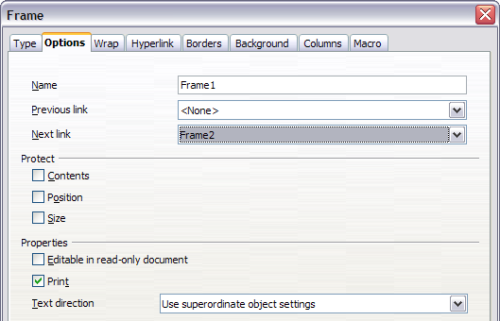Figure 123: Options page of the Frame dialog box

Other Frame Options
On the Hyperlink tab (Figure 124), you can specify the file for the hyperlink to open. This file can be on your machine, a network, or the Internet.
The Wrap, Borders, Background, Columns, and Macro tabs of the Frame dialog box are the same as those for frame styles. Refer to the Chapter 7 (Working with Styles) for details.
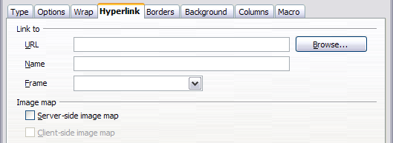Figure 124: Hyperlink page of the Frame dialog box

Using Tables for Page Layout
Writer’s tables can serve several purposes, such as holding data as you might see it in a spreadsheet, lining up material, and creating more complex page layouts. For information about using tables of data, see Chapter 9 (Working with Tables).
This topic describes how to achieve some common layouts by using tables.

Example: Creating Sideheads Using Tables
Sideheads and marginal notes are commonly used in documents from resumes to computer user guides. The main body of the text is offset to leave white space (usually on the left-hand side) in which the sideheads or notes are placed. The first paragraph is aligned beside the sidehead, as in Figure 125.
Example of a sidehead | In some cases you may want to put only one or two paragraphs in the table itself and the rest of the text and graphics in ordinary paragraphs (formatted to line up with the paragraphs in the table) so that text and graphics will flow more easily from one page to another when you add or delete material.  In other cases, you might put each paragraph in a separate row of the table and allow the table to break between pages.
Figure 125: Example of a sidehead
Note | Sideheads can also be created by placing text in a frame using the Marginalia frame style, as described in the Chapter 7 (Working with Styles).
To create a table for use with a sidehead:
- Place the cursor where you want the table to appear and choose Insert > Table (Ctrl+F12).
- In the Insert Table dialog box (Figure 159), define a one-row, two-column table with no border and no heading. Click OK to create the table.
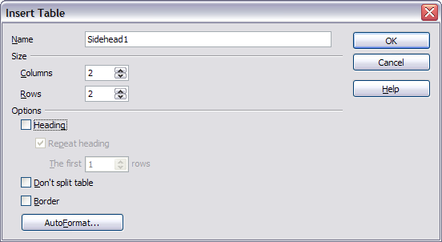Figure 126: Defining a two-column borderless table with no header
- Right-click on the table and choose Table from the pop-up menu. On the Columns tab of the Table Format dialog box, shown in Figure 127, make the columns the required width.
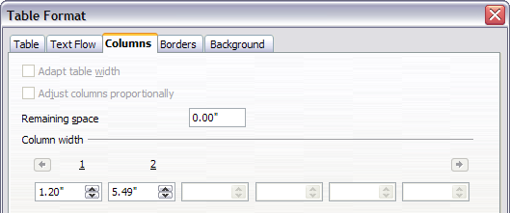
Figure 127: Defining a two-column table to line up with text offset at 1.2 inches
- On the Table tab of the Table Format dialog box (Figure 128), in the Spacing section, make the Above and Below values the same as the Top and Bottom spacing you have defined for ordinary paragraphs of text. Click OK to save your settings.
Tip | To check the top and bottom spacing for ordinary paragraphs:  - Position the cursor in a paragraph and select the Styles and Formatting deck of the Sidebar. Check that the Styles and Formatting window shows paragraph styles (top left button).  - The current style should be highlighted. If no paragraph style is highlighted, select All Styles in the bottom drop-down list. Right-click on it and select Modify from the pop-up list.  - Go to the Indents & Spacing page and look in the Spacing area for the values in Above paragraph and Below paragraph.
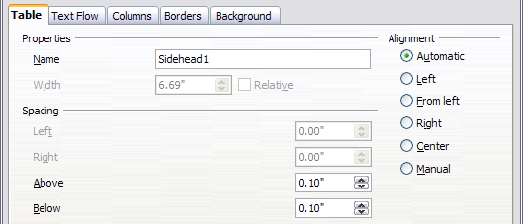
Figure 128: Defining the space above and below a table
You may also want to turn off number recognition so that Writer will not try to format numbers if you want them to be plain text. To turn number recognition off:
- Right-click in the table and then click Number Format on the pop-up menu.
- On the Number Format dialog box, make sure the Category is set to Text (Figure 129). Click OK.
Tip | If you use this table format often, you may want to save it as AutoText, as described in Chapter 3 (Working with Text). Select the table (not just the contents) to assign the shortcut.
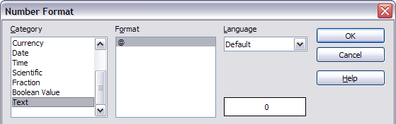Figure 129: Setting number format to Text

Using Sections for Page Layout
A section is a block of text that has special attributes and formatting. You can use sections to:
- Write-protect text
- Hide text
- Dynamically insert the contents of another document
- Add columns, margin indents, a background color, or a background graphic to a portion of your document
- Customize the footnotes and endnotes for a portion of your document

Creating Sections
To create a section:
- Place the cursor at the point in your document where you want to insert the new section. Or, select the text that you want to place in the new section.
- From the main menu, choose Insert > Section. The Insert Section dialog box opens.
- Click the Section tab, if it is not already displayed.
The Insert Section dialog box shown in Figure 130 has five tabbed pages.
- Use the Section tad to set the section’s attributes.
- Use the Columns tab to format the section into columns.
- Use the Indents tab to set indents in the right and left margins of the section.
- Use the Background tab to add color or a graphic to the section’s background.
- Use the Footnotes/Endnotes tab to customize the section’s footnotes and endnotes.
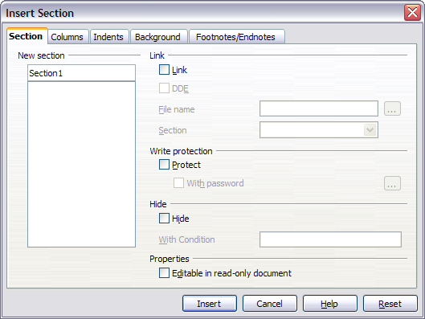Figure 130: Inserting a section using the Insert Section dialog box
At any time, you can reset a tabbed page to its default settings by clicking the Reset button. (Note, however, that you cannot reset the Section tab. If you wish to undo changes to the Section page, you must do so manually.)
Use the Section page to set the attributes of the current section.

Naming Sections
Writer automatically enters a name for the current section in the top box of the New section area. To change the name, select it and type over it. The name is displayed in the Sections category of the Navigator window. If you give your sections meaningful names, you can navigate to them more easily.

Linking Sections
You can insert the contents of another document into the current section and then have Writer update the section whenever the other document is updated. This is called linking the section to the other document.
To link the current section to another document, follow these steps:
- In the Link area (Figure 131), select the Link option.
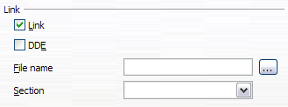Figure 131: Linking sections
- Click the (…) button to the right of the File name field. The Insert dialog box opens.
- Find and select the document you want to insert and then click the Insert button. The Insert dialog box closes and the name of the selected document appears in the File name field.
- If you want to insert only a section of the selected document, select the desired section from the Section drop-down list.
Note | The section must already exist in the selected document. You cannot create a section in the selected document at this point.
You can update links automatically or manually. See “Updating Links” on page 137.

Write Protecting Sections
To protect the current section so that its contents cannot be edited, select the Protected option (Figure 132) in the Write protection area.
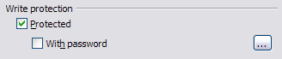Figure 132: Write protecting sections
Note | Write protection protects only the section’s contents, not its attributes or format.

Password Protecting Sections
To prevent others from editing the section’s attributes or format, protect the section with a password, as follows:
- Select the With password option. The Enter Password dialog box shown in Figure 133 opens.
- Type a password in the Password field and then confirm the password by typing it again in the Confirm field.
- Click OK. The Enter Password dialog box closes. Anyone who tries to edit the section’s attributes or format will be prompted to enter the password.
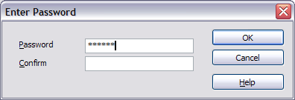Figure 133: Password protecting a section
Note | Passwords must contain at least five characters. The OK button remains inactive until you have typed five characters.

Hiding Sections
You can hide the current section so that it will not be displayed on the screen or printed. You can also specify conditions for hiding the section. For example, you can hide the section only from certain users.
Note | You cannot hide a section if it is the only content on the page or if the section is in a header, footer, footnote, endnote, frame, or table cell.
To hide a section, select the Hide option in the Hide area (Figure 134).
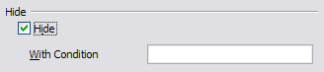Figure 134: Hiding sections
To hide the section only under certain conditions, enter the desired conditions in the With Condition field. The syntax and operators that you use to enter conditions are the same ones that you use to enter formulas. For syntax and a list of operators, see Writer’s online help under conditions.
If the section is write-protected with a password, the password must be entered to hide or reveal the text.
Note | Hiding text is not a secure way to stop someone else reading it. It will stop the casual reader but will not prevent someone who actively wants to find out what you have hidden―even if it is password protected.

Formatting a Section into Columns
Use the Columns tab of the Insert Section dialog box to format the current section into columns. This page is very similar to the Columns dialog box shown in Figure 117 on page 121. Please refer to that topic for details.

Indenting the Section from Margins
Use the Indents tab, pictured in Figure 135, to set indents in the right and left margins of the current section.
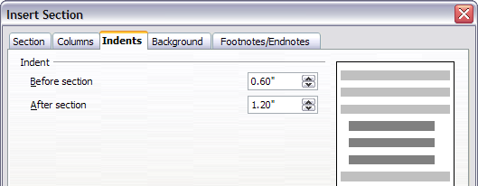Figure 135: Indenting sections
Enter the desired left-margin indent in the Before section box. Enter the desired right-margin indent in the After section box. The preview box on the right-hand side of the page shows you how the section will look with the indents applied.

Changing the Background of the Section
Use the Background page to add color or a graphic to the background of the current section. This page is similar to the Background pages for paragraphs, frames, tables, and other objects in AOO. For more information, refer to Chapter 7 (Working with Styles).

Customizing Footnotes and Endnotes in a Section
Use the Footnotes/Endnotes tab, pictured in Figure 136, to customize the current section’s footnotes and endnotes.
Customizing footnotes
If you want the current section’s footnotes to appear separately from the other footnotes in the document, select the Collect at end of text option in the Footnotes area.
To number the current section’s footnotes separately from the other footnotes in the document, follow these steps:
- In the Footnotes area, make sure that the Collect at end of text option is selected.
- Select the Restart numbering option.
- If you want the section’s footnotes to start at a number other than 1, enter the desired starting number in the Start at spin box.
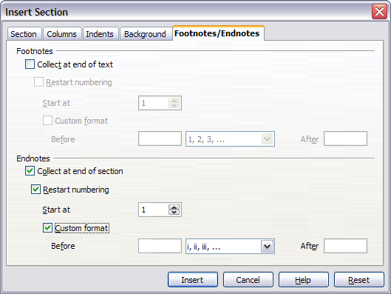Figure 136: Setting footnotes and endnotes for sections
To edit the format of the section’s footnotes, follow these steps:
- In the Footnotes area, make sure that the Collect at end of text and Restart numbering options are selected.
- Select the Custom format option.
- From the drop-down list under and to the right of the Custom format option, select a numbering format for the footnotes.
- To add text to the selected numbering format, use the Before and After fields. For example, if you want the footnote numbers to be preceded by the word “Note” and followed by a colon, fill the Before and After fields like this:
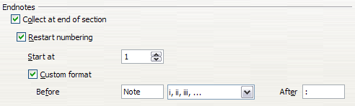Figure 137: Numbering footnotes for sections
Customizing endnotes
If you want the current section’s endnotes to appear at the end of the section rather than at the end of the document, select the Collect at end of section option in the Endnotes area.
To number the current section’s endnotes separately from the other endnotes in the document, follow these steps:
- In the Endnotes area (Figure 158), make sure that the Collect at end of section option is selected.
- Select the Restart numbering option.
- If you want the section’s endnotes to start at a number other than 1, enter the desired starting number in the Start at spin box.
To edit the format of the section’s endnotes, follow these steps:
- In the Endnotes area, make sure that the Collect at end of section and Restart numbering options are selected.
- Select the Custom format option.
- From the drop-down list under and to the right of the Custom format option, select a numbering format for the endnotes.
- To add text to the selected numbering format, use the Before and After fields, as shown above for footnotes (Figure 158).

Saving a New Section
To save a new section so that it appears in your document, click the Insert button. The Insert Section dialog box closes and the new section appears in your document.

Editing and Deleting Sections
You can edit a section’s attributes and formatting, or delete sections, by using Format > Sections.
To select the section that you want to edit or delete, follow these steps:
- From the main menu, choose Format > Sections. The Edit Sections dialog box shown in Figure 138 opens.
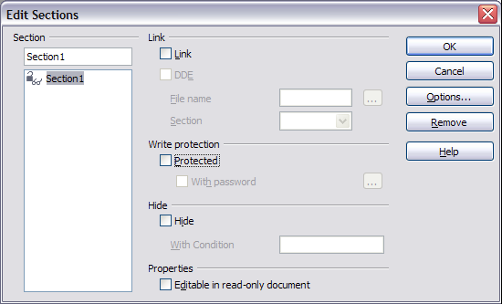Figure 138: Edit Sections dialog box
- The name of the current section appears in the Section area, in the field above the list box. If you want to edit or delete a different section, click the name of the desired section in the list. The selected section becomes the current section, and its name appears in the field above the list box.

Deleting Sections
To delete the current section, click the Remove button.
Note | Writer will not prompt you to confirm the delete! To undo a delete, click the Cancel button.

Editing Section Attributes
To rename the current section, simply type over its name in the Section area.
From the Edit Sections dialog box, you can also edit the current section’s link, write-protect, and hide attributes. To learn how to edit these attributes, see:
“Linking Sections” on page 132.
“Write Protecting Sections” on page 132.
“Hiding Sections” on page 133.

Editing the Format of a Section
To edit the format of the current section, click the Options button.
The Options dialog box (Figure 139) has four tabbed pages: Columns, Indents, Background, and Footnotes/Endnotes. The use of these pages is described earlier in this topic.
To reset a page to its most recently saved settings, click the Reset button.
To save your Options settings and return to the Edit Sections dialog box, click OK.
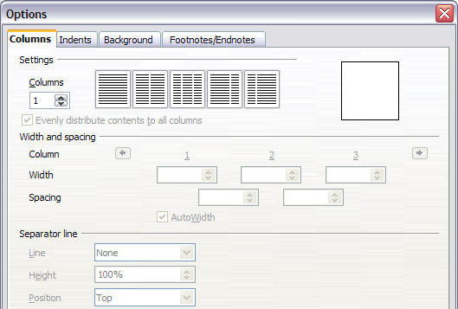Figure 139: Options dialog box for sections

Updating Links
You can set Writer to update linked sections automatically, and you can also update links manually.

Updating Links Automatically
To set Writer to update links without prompting you, or to turn off automatic updating, follow these steps:
- Choose Tools > Options > OpenOffice Writer > General. The dialog box displays general text document settings.
- In the Update area, under Update links when loading, select one of the following three options:
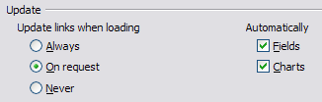
  - Select Always if you want Writer to update links automatically, without prompting you, whenever you open a document that contains links.
  - Select On request if you want Writer to prompt you before updating links.
  - Select Never if you do not want Writer to update links.
- Click OK to save your settings. The Options dialog box closes.

Updating Links Manually
To update a link manually:
- Open the document that contains the link.
- Choose Edit > Links. The Edit Links dialog box (Figure 140) opens.
- The list in the Edit Links dialog box displays the names of all the files that are linked to the current document. Click the file that corresponds to the link that you want to update.
- Click the Update button. The most recently saved contents of the linked file appear in the current document.
- To close the Edit Links dialog box, click Close.
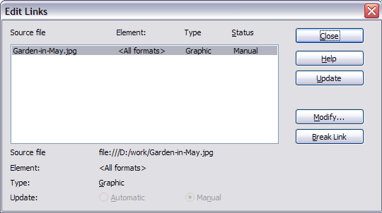Figure 140: Edit Links dialog box

Creating Headers and Footers
Headers are portions of a document that always appear at the top of a page; footers appear at the bottom of a page. Typically, headers display the title or chapter name of a document.
In AOO, headers are specified by page styles; therefore, when inserted, all the pages with the same page style will display the same header. Chapter 7 describes how to format a header as part of the page style formatting. For the purpose of this example, we will insert a header in the Default pages using manual formatting.
Select from the main menu Insert > Header > [Page Style]. The submenu lists the page styles used in your document. In addition, the submenu includes the entry All, which activates headers on all the pages of the document regardless of their page style.
For our example, select the Default menu item to activate the headers only on the pages that use the Default page style. Similarly, to insert a footer, choose Insert > Footer.
Caution | The Insert Menu can also be used for deleting a preexisting header or footer for a page style. If that page style has a check mark in front of it, clicking on it opens an AOO dialog box warning about this and asking whether you want to delete the header or footer for that particular page style.
Depending on which option you choose, an area such as that in Figure 141 will appear at the top or bottom of the page. In this area you can enter text and graphics that will appear on every page.
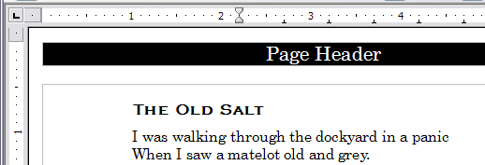Figure 141. A page with a page header
Items such as document titles, chapter titles, and page numbers, which often go into headers and footers, are best added as fields. That way, if something changes, the headers, and footers are all updated automatically.
Fields are covered in Chapter 14 (Working with Fields), but one example here may be useful. To insert the document title into the header:
- Select File > Properties > Description, enter a title for your document in the Title area, and click OK to close the dialog box.
- Add a header (Insert > Header > Default).
- Place the cursor in the header part of the page.
- Select Insert > Fields > Title. The title should appear on a gray background (which does not show when printed and can be turned off).
- To change the title for the whole document, choose File > Properties > Description.

Formatting Headers and Footers
In Writer, headers and footers are considered paragraphs, and therefore you can format the header or footer text using the same techniques you use for formatting text in the main body of the document.
Tip | You can define styles for headers and footers so that you can quickly obtain a consistent formatting in case you use several page styles. Writer includes three predefined header styles and three footer styles: generic ones, for left pages, and for right pages. You can also add custom header and footer styles.

Portrait Headers on Landscape Pages
When you define a header and footer on a landscape page, they will be aligned with the long side of the page. If your landscape pages are going to be inserted between portrait pages, you might want the headers and footers to be on the short sides of the landscape pages, so the final printed product looks like the contents of the landscape pages have been rotated 90 degrees on portrait pages.
You can set up portrait headers and footers on landscape pages by using a trick involving frames. These are a bit tedious to set up, but once you have done so, you can copy and paste them to other landscape pages. There does not appear to be a way to make this part of the landscape page style.
To set up portrait headers and footers on landscape pages:
- Calculate the required margins, so the text area of the landscape page is the same size as the text area on the portrait pages, taking into account the space for headers and footers on the portrait pages.
For example, consider a book which uses the margins shown in the following table. The landscape right and left margins are 1 cm larger than the portrait top and bottom margins, respectively. This difference accounts for the extra space used by the portrait header and footer (0.5 cm for the height of the header or footer and a 0.5 cm gap between the header or footer and the main text).
Portrait page (right page) |  | Landscape page (right page)
Top margin | 1.5 cm | Right margin | 2.5 cm
Bottom margin | 1.5 cm | Left margin | 2.5 cm
Left (inner) margin | 2.8 cm | Top margin | 2.8 cm
Right (outer) margin | 1.8 cm | Bottom margin | 1.8 cm
- Create the Landscape page style.
- Measure the distance from the upper and left edges of the page to the upper left-hand corner of the space where you want the footer to appear. Measure the width and length of the space the footer will occupy (to match footers on portrait pages). (See Figure 142.)
- In a blank paragraph in the text, type the footer text or insert fields such as the page number or the chapter number and name—to match the footer text and fields on the portrait pages. Assign the Footer style to this paragraph so the typeface, font size, and tab settings match those of the footers on the portrait pages.
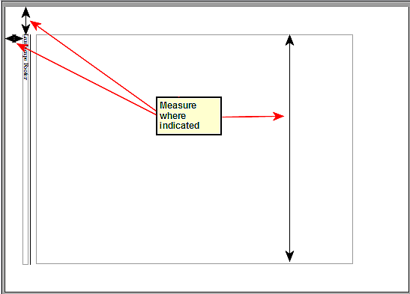Figure 142: Measuring the location and size of the footer frame
- Select the text (including the fields) you just entered. Choose Format > Character. On the Character dialog box, select the Position tab (Figure 143) and set Rotation / scaling to 270 degrees (counterclockwise). Click OK.
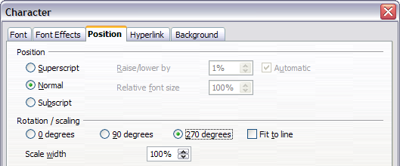Figure 143: Rotating the footer text 270 degrees
- With the text still selected, choose Insert > Frame. In the Frame dialog box (Figure 144), pick the Type tab and enter the width, height, and horizontal and vertical position for the footer.
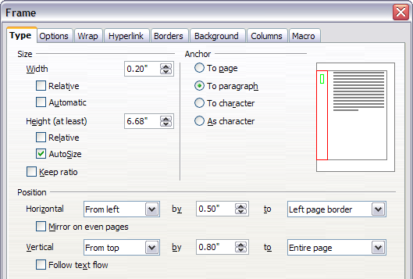
Figure 144: Defining the size and position of the footer frame
- If your footer has a line above the text, as in this book, on the Borders tab (Figure 145), select a right border and specify the line width and spacing to the frame’s contents.
- Click OK to save these settings. The footer should now appear in the required position and orientation.
Repeat these steps (using appropriate measurements) to set up a portrait header on the landscape page.
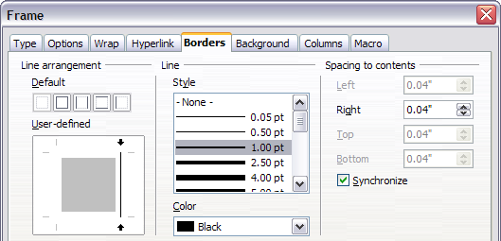Figure 145: Specifying the border position, line width, and spacing to contents

Numbering Pages
This section describes techniques to insert page numbers and related information in a document. Some basic knowledge of page styles, which are fully described in chapters 6 and 7, may be needed to follow some examples given.

Preliminaries: Fields
OpenOffice uses fields to manage page numbers. To insert a page number field, position the cursor where you want to insert the number and choose Insert > Fields > Page Number. The page number appears with a gray background. The gray background denotes a field.
Note | The gray background is simply there to denote a field. This background is not printed. If you wish to turn this feature off, choose View > Field Shadings (or press Ctrl+F8).
The page number field always displays the page number for the page where it is placed. If you see the words “Page number” instead of a number, press Ctrl+F9. This shortcut key toggles AOO between displaying the field’s contents (what the field is for) and the field’s results (what the field creates).
Note | For a full introduction to fields, see Chapter 14 (Working with Fields).

Preliminaries: Insert and Format a Header
For the purpose of this example, we will insert a header in the Default page style pages using manual formatting. See “Creating Headers and Footers” on page 139.

Simple Page Numbering
The simplest case is to have the page number at the top of every page and nothing more. To do this, put the cursor on the header (Figure 146) and select Insert > Fields > Page Number.
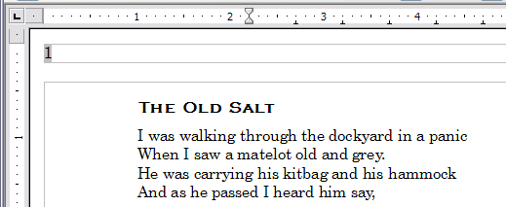Figure 146: Page number inserted in the header
Now the correct page number appears on every page.

Combining Header Text and Page Number
There are a lot of interesting variations that you can apply without further knowledge of page styles. Here are some suggestions:
- Right-align the header to make the page number appear on the top-right.
- Type the word page before the page number field, so the header reads page 1, page 2, and so on. This also requires using the Page Number field, discussed earlier (page 143).
- Add the document title, so the header reads, for example: Peter's favorite poems, left justified, and page x with right justification, where x is the value of the Page Number field. Consider using a (right-aligned) tab to separate the title from the page number.
- AOO also has a Page Count field (Insert > Fields > Page Count). Using it, you could, for example, have a header that reads page 2 of 12.
These variations are all illustrated in Figure 147.
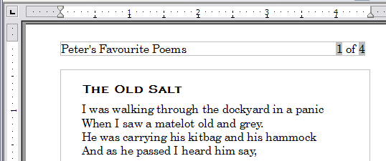Figure 147: Variations on the simple page numbering method

Changing the Number Format
Many more variations are possible. For example, you can set the page number to display in Roman numerals. To do that, you could double-click on the page number and select the desired format; however, a better choice is to specify the format of numbers in the page style as explained here.
In the Styles and Formatting window (select its Sidebar icon or press F11 if not already displayed) select the Page Styles icon and right-click on the highlighted entry for the current style. Select Modify, which opens the Page Style dialog box.
On the Page tab of the Page Style dialog box, in the Layout settings section, select i, ii, iii, … from the Format drop-down list.
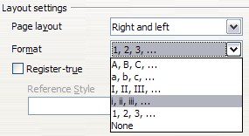Figure 148: Changing format of page numbers

Numbering the First Page Something Other than 1
Sometimes you may want to start a document with a page number greater than 1. For example, you may be writing a book, with each chapter in a separate file. Chapter 1 may start with page 1, but Chapter 2 could begin with page 25 and Chapter 3 with page 51.
Follow these instructions to start the page numbering in a document at a number greater than 1. (These instructions are for a page number in a footer, but you could use a header instead.)
Tip | Do not set a starting page number that is an even number because you will end up with a blank page before the first page when you print the file or export it as a PDF.
- Choose Insert > Footer > [page style] to activate the footer. (If the page style is already selected in the Footer menu, point to it and click OK in the dialog box that appears. Then point to that page style again to select it.)
- The cursor is now in the footer. To insert the page number, choose Insert > Fields > Page Number. The page number will be 1.
- Click in the first paragraph in the text area or type a paragraph of text.
- Choose Format > Paragraph (or right-click and choose Paragraph from the pop-up menu) to display the Paragraph dialog box.
- On the Text Flow tab, in the Breaks section, select Insert and select Page in the Type drop-down list. Select With Page Style and the page style you are using for the first page of the document.
- The Page number field is now active. Type the page number you want to start with. Click OK to close the Paragraph dialog box.

Numbering Pages by Chapter
Technical documents often include the chapter number with the page number in the header or footer. For example, 1-1, 1-2, 1-3, …; 2-1, 2-2, 2-3, …
To set up this type of page numbering in AOO, you need to do three things:
- Ensure that your chapter titles are all identified by the same paragraph style, for example, the Heading 1 style.
- Use Tools > Outline Numbering (Figure 149) to tell AOO what paragraph style you are using for Level 1 in your outline, and specify “1,2,3” in the Number box.
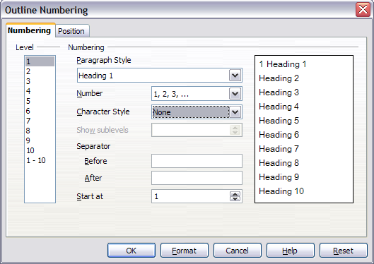Figure 149: Specifying paragraph style and numbering for chapter titles
- Insert the chapter number in your document. To do this:
    - Place the cursor in the header or footer just before the page number you inserted earlier, and choose Insert > Fields > Other from the menu bar.
    - On the Fields dialog (Figure 150), go to the Document tab. Select Chapter in the Type list, Chapter number in the Format list, and 1 in the Level box. Click Insert.
    - Type a hyphen or other punctuation between the chapter number and the page number.
For more information, see “Choosing paragraph styles for outline levels” and “Including chapter or section information in page headers” in Chapter 7 (Working with Styles).
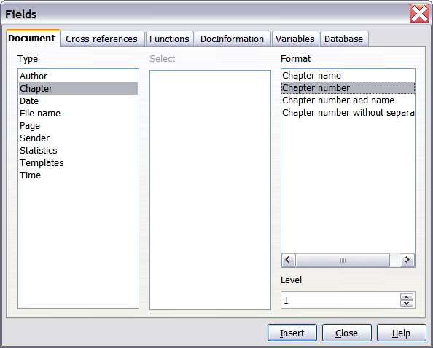
Figure 150: Inserting a chapter number field

Restarting Page Numbering
Often you will want to restart the page numbering at 1, for example, on the page following a title page or a table of contents. In addition, many documents have the front matter (such as the table of contents) numbered with Roman numerals and the main body of the document numbered in Arabic numerals, starting with 1.
You can restart page numbering in two ways.
Method 1:
- Place the cursor in the first paragraph of the new page.
- Choose Format > Paragraph.
- On the Text Flow tab of the Paragraph dialog box (Figure 114 on page 118), select Insert in the Breaks area.
- In the Type drop-down list, select Page.
- In the Position drop-down list, select Before or After to position where you want to insert the page break.
- Select With Page Style and specify the page style to use.
- Specify the page number to start from and then click OK.
Method 2:
- Place the cursor in the first paragraph of the new page.
- Choose Insert > Manual break.
- Page break is the default selected on the Insert Break dialog box shown in Figure 151.
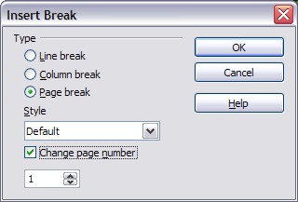
Figure 151: Restarting page numbering after a manual page break
- Choose the required page style in the Style drop-down list.
- Select Change page number.
- Specify the page number to start from and then click OK.

Example: Restart Page Numbering: a Preface
A standard preface has the following properties:
- Page numbers are displayed in Roman numerals (i, ii, iii, iv, …).
- After the preface, the document starts on a Default page.
- The page number resets to 1, and the number format becomes Arabic (1, 2, 3, 4, …).
Resetting the page number requires page breaks.
First, let’s get the preliminary work done for the Preface style:
- Create a new page style and name it Preface.
- Set its Next Style to Preface because a preface could span multiple pages.
- Add a header to Preface and insert the Page Number field. Make the page numbers display as Roman numerals, as in Figure 152 (i, ii, iii, iv, …):
    - Open the page style window for Preface (if not already open) and click the Header tab. Select Header on under Header.
    - Click the Page tab. Under Layout settings, in the Format drop-down list, set the format to i, ii, iii, …. Click OK to close the dialog box.
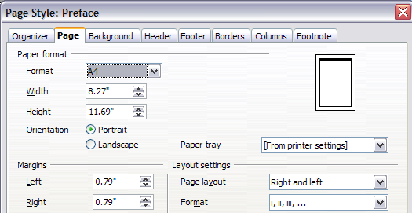Figure 152. Set page number format to Roman numerals.
After the preface is written, we are ready to restart the page numbering in the main body of the document to Arabic numerals. Follow these steps:
- Make an empty paragraph at the very end of the preface.
- Put the cursor on the blank line.
- Choose Insert > Manual Break.
- Select Page break and choose the Default style.
- Select the Change page number option and set the new value to 1. Click OK to close the dialog box.
These settings are shown in Figure 153.
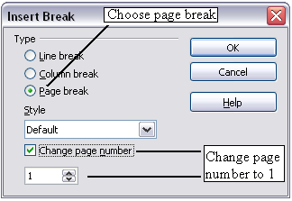
Figure 153: Set the new page number to 1 and the page style to Default.
Note | You cannot assign an odd page number to a left page or an even page number to a right page. AOO strongly adheres to the convention that odd page numbers go on right-hand pages and even page numbers on left-hand pages.
This change is also reflected on the status bar. The Page section of the status bar (Figure 154) now includes both the total page count and the entry of the page number field.
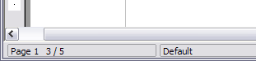
Figure 154: Page number in the status bar

Problems with Restarting Page Numbering
Restarting page numbering may lead to two problems.
- The Statistics page in the document’s Properties (File > Properties) always displays the total number of pages in the document, which may not be what you want to appear in the Page Count field.
- When page numbering is restarted, AOO always makes odd-numbered pages to be on the right and even-numbered pages to be on the left. It does this by inserting a blank page, if necessary. Sometimes this blank page is not desired, particularly when creating PDFs or when printing single sided.

Solving the page count problem
Suppose you know exactly how many pages are not to be included in the page count. (You want one page to be excluded in the page count for the following example.)
Instead of inserting a Page Count field, you can do the following:
- Position the cursor where you want the page count to appear.
- Press F2 to open the formula bar, just above the horizontal ruler in the main Writer window (see Figure 155).
- After the equal sign, type page –1. If you want to exclude several pages, substitute the number of excluded pages for 1 in the formula.
- Press Enter to close the formula bar and insert the resulting field into the document.
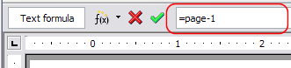Figure 155: Formula bar
If you do not know the total number of pages in advance, then one approach is to create a bookmark on the last page and then insert a cross-reference to it.
To create a bookmark on the last page:
- Go to the last page (Ctrl+End).
- Choose Insert > Bookmark.
- In the Insert Bookmark dialog (Figure 156), type a name for the bookmark, for example LastPage. Click OK.
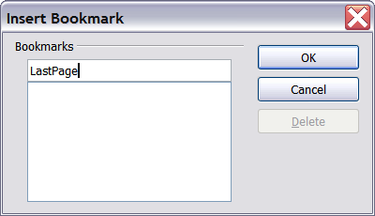
Figure 156: Inserting a bookmark
To insert a cross-reference to the last page in the header or footer where you want to refer to the total number of pages:
- Position the cursor at the desired location—for example after the space added after of in the header or footer, as in page xx of yy.
- Choose Insert > Cross-reference.
- On the Cross-references tab of the Fields dialog box, (Figure 157) select Bookmarks in the Type column and LastPage in the Selection column. LastPage now appears in the Name box.
- In the Insert Reference to box, select As page style. Click Insert.
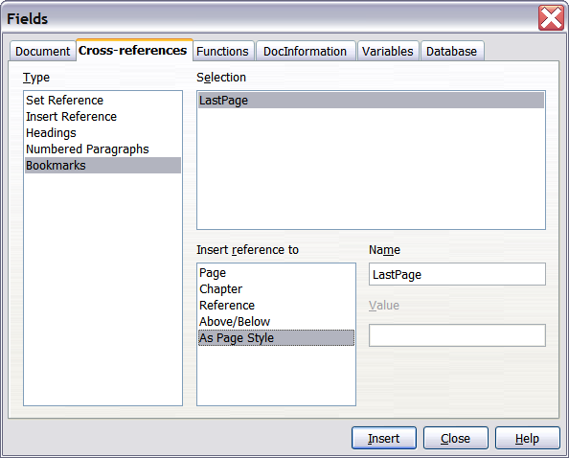
Figure 157: Inserting a cross-reference to a bookmark on the last page of a document
Note | Do not delete the bookmark at the end of the document. If you do, the cross-reference will not work.  If a field, such as a cross-reference, does not automatically update, select the text containing the field and press F9.

Numbering Portrait and Landscape Pages
To create page numbers on portrait and landscape pages in the same place and orientation:
- Refer to “Portrait Headers on Landscape Pages” on page 140 to create a landscape page style and landscape header or footer styles. When creating the page style, select the Use dynamic spacing option in the Spacing area in the Header or Footer pages of the Page Style dialog box.
- Insert the page break and choose the landscape page style; do not change the page numbering.
- In the relevant header or footer, insert the page number field (Insert > Fields > Page Number).

Defining Borders and Backgrounds
You can apply borders and backgrounds to many elements in Writer. Paragraphs, pages, frames, sections, page styles, paragraph styles, and frame styles can include both borders and backgrounds; character styles, tables of contents, and indexes can include backgrounds only.
The dialog box pages for borders and backgrounds are similar in each case. To illustrate their use, we will define a border and background for a text frame.
Tip | Page backgrounds fill only the area within the margins, including the header or footer (if any). To extend the background color or graphic into the margins, you need to define a frame of appropriate size and position, anchor it to the page or a paragraph, and send it to the background. For more about anchoring frames, see Chapter 8 (Working with Graphics).

Adding a Border
To begin, select the frame, right-click, and choose Frame from the pop-up menu. Select the Borders tab shown in Figure 148.
Borders have three components: where they go, what they look like, and how much space is left around them.
- Line arrangement specifies where the borders go. Writer provides five default arrangements, but you can just as easily click on the line you want to customize in the User-defined area to get exactly what you want. Each line can be individually formatted.
- Line specifies what the border looks like: the style and color. There are a number of different styles and colors to choose from. The Line Style and Color will apply to those borders highlighted by a pair of black arrows in the User-defined map on the left-hand side of the dialog box.
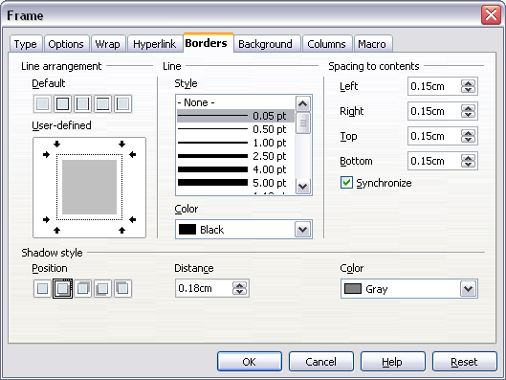
Figure 158: Frame dialog box: Borders page
- Spacing to contents specifies how much space to leave between the border and the contents of the element. Spaces can be specified to the left, right, above, and below. Check Synchronize to have the same spacing for all four sides. This spacing is like a padding, and it is not factored in when calculating the text measurements.
- Shadow style properties always apply to the whole element. A shadow has three components: where it is, how far from the element it is cast, and what color it is.

Adding Color to the Background
In the Frame dialog box, choose the Background page (Figure 119). Here you can add color or a graphic.
To add color to the background, select from the color grid. You can adjust the transparency of the color to make any text easier to read.

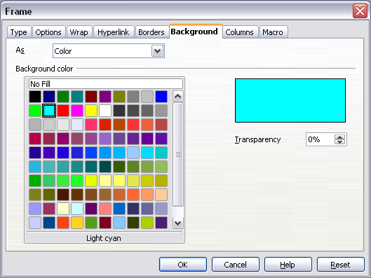
Figure 159: Frame dialog box: Background page showing color choices

Adding a Graphic to the Background
To add a graphic to the background:
- From the As drop-down list on the Background page, select Graphic. The page now displays the graphics options, as shown in Figure 118.
- Click the Browse button. The Find Graphics dialog box opens.
- Find the file you want and then click the Open button. The Find Graphics dialog box closes and the selected graphic appears in the preview box on the right-hand side of the Background tab. (If you do not see the graphic, select the Preview option.)
- To embed the graphic in your document, deselect Link. To link the graphic to the document but not embed it, select Link. For more about linking graphics, see Chapter 8 (Working with Graphics).
- In the Type area, choose how you want the background graphic to appear:
  - To position the graphic in a specific location, select Position and then click the desired location in the position grid.
  - To stretch the graphic to fill the entire background area, select Area.
  - To repeat the graphic across the entire background area, select Tile.
- In the Transparency area, you can adjust the transparency of the graphic. This adjustment is often necessary to make any text easier to read.

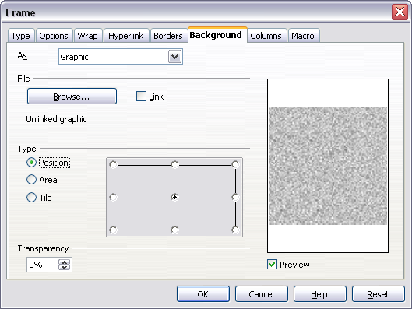Figure 160: Graphic options on the Background page of the Frame dialog box

Deleting Color or Graphics from the Background
To delete color or graphics from the background:
- From the As drop-down list, select Color.
- Click No Fill on the color grid.

Chapter 5
Printing, Exporting, Faxing, and E-Mailing

Introduction
General information about printing and faxing documents from AOO is provided in the Getting Started guide. This chapter describes some items of particular interest to users of Writer.

Quick Printing
Click the Print File Directly icon to send the entire document to the default printer defined for your computer.
Note | You can change the action of the Print File Directly icon to send the document to the printer defined for the document instead of the default printer for the computer. Go to Tools > Options > Load/Save > General and select the Load printer settings with the document option.

Controlling Printing
For more control over printing, use the Print dialog box (File > Print or Ctrl+P).
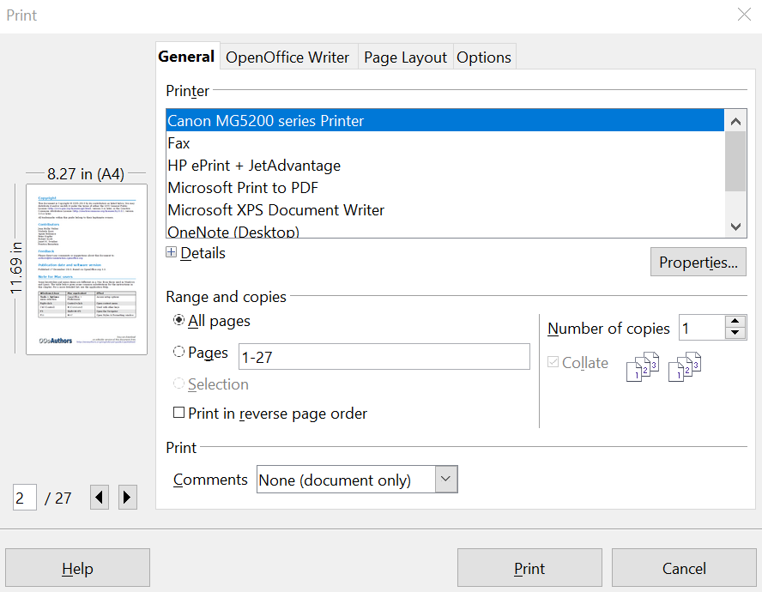

Figure 161: The Print dialog General page

The Print dialog box has four tabs, from which you can choose a range of options, as described in the following sections.
Note | The options selected on the Print dialog box apply to this printing of this document only.  To specify default printing settings for AOO, go to Tools > Options > OpenOffice – Print and Tools > Options > OpenOffice Writer – Print. See Chapter 2 (Setting Up Writer) for more details.

Selecting General Printing Options for a Document
On the General tab of the Print dialog box, you can choose:
- The printer (from the printers available)
- Which pages to print, the number of copies to print, and whether to collate multiple copies (Range and copies section)
- Whether to print any comments that are in the document, and where to print the comments.
Figure 162: Choosing whether and where to print comments
Select the Properties button to display a dialog box where you can choose portrait or landscape orientation, which paper tray to use, and the paper size to print on.
On the Options tab of the Print dialog box, you can choose various other options for printing.
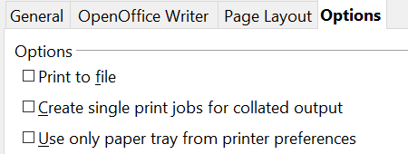

Figure 163: General print options

Printing Multiple Pages on a Single Sheet of Paper
You can print multiple pages of a document on one sheet of paper. To do this:
- In the Print dialog box, select the Page Layout tab (Figure 162).
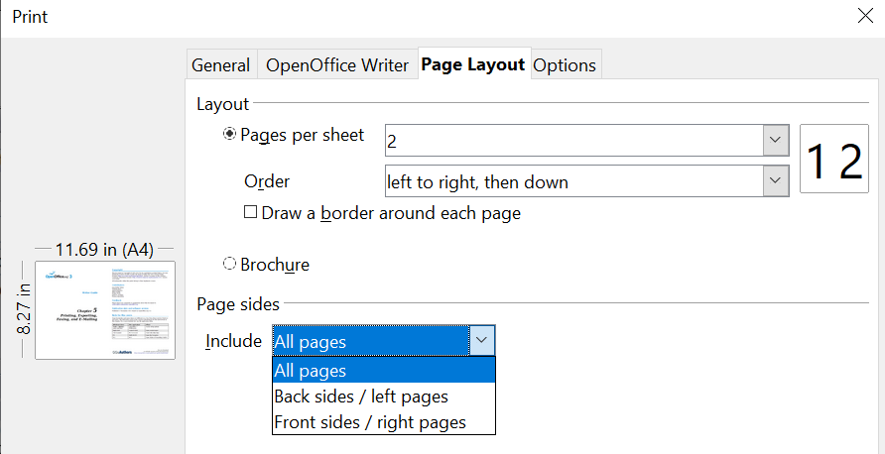
Figure 164: Printing multiple page per sheet of paper
- In the Layout section, select from the drop-down list the number of pages to print per sheet. The preview panel on the left of the Print dialog box shows how the printed document will look.
When printing more than 2 pages per sheet, you can choose the order in which they are printed across and down the paper. The two pictures below show the difference.
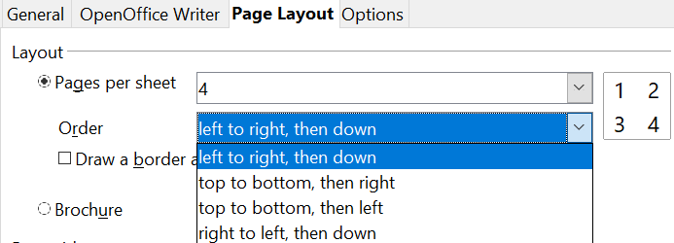

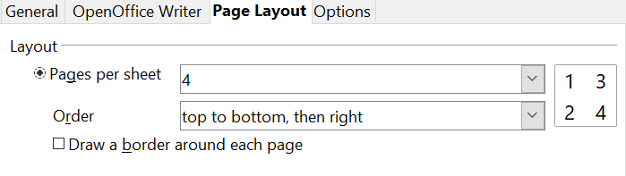
- In the Page sides section, select whether to print all pages or only some pages.
- Click the Print button.
Tip | To print two pages per sheet in “facing pages” (book layout) style, print from Print Preview instead. See page 162.

Selecting What to Print
In addition to printing a full document, you can choose to print individual pages, ranges of pages, or a selection of a document, as described in this section.
Printing an individual page:
- Choose File > Print from the menu bar.
- On the Print dialog box, select the page to print.
  - In the Ranges and copies section of the General page, select the Pages option.
  - Enter the sequence number of the page you want to print. The preview box changes to show the selected page.
If you have restarted page numbering within the document, the sequence number is not the same as the page number.

- Click the Print button.
Printing a range of pages:
- Choose File > Print from the menu bar.
- On the Print dialog box, select the range of pages to print.
  - In the Ranges and copies section of the General page, select the Pages option.
  - Enter the sequence numbers of the pages to print (for example, 1–4 or 1,3,7,11).
- Click the Print button.
Printing a selection of text:
- In the document, select the material (text and graphics) to print.
- Choose File > Print from the menu bar.
- The Ranges and copies section of the Print dialog box now includes a Selection option and the preview box shows the selected material. See Figure 165.
- Click the Print button.
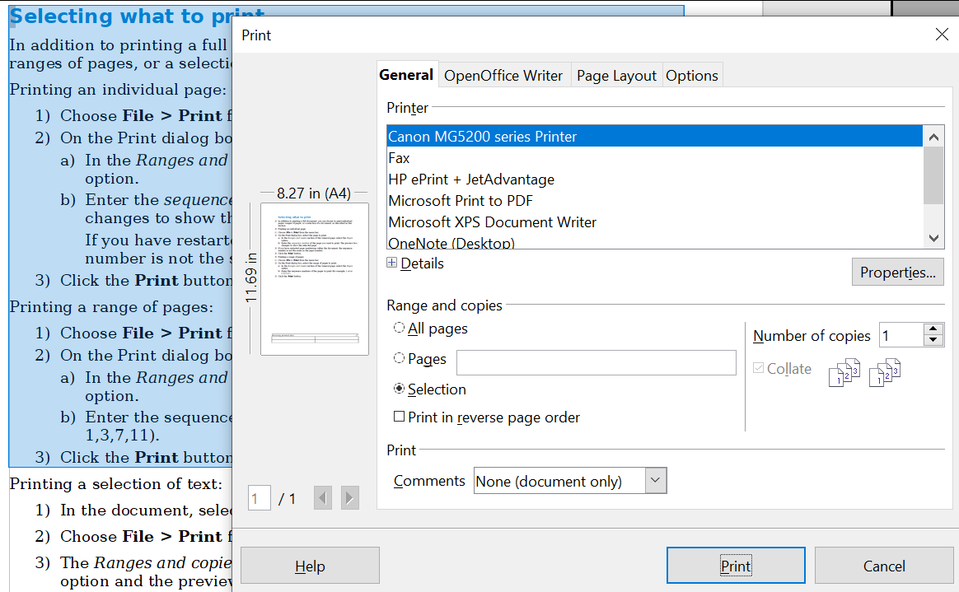

Figure 165: Printing a selection of text

Printing a Brochure
In Writer, Impress, and Draw, you can print a document with two pages on each side of a sheet of paper, arranged so that when the printed pages are folded in half, the pages are in the correct order to form a booklet or brochure.
Tip | Plan your document so it will look good when printed half size; choose appropriate margins, font sizes, and so on. You may need to experiment.

To print a brochure on a single-sided printer:
- Choose File > Print.
- In the Print dialog box, click Properties.
- Check if the printer is set to the same orientation (portrait or landscape) as specified in the page setup for your document. Usually the orientation does not matter, but it does for brochures. Click OK to return to the Print dialog box.
- Select the Page layout tab in the Print dialog box.
- Select the Brochure option.
- In the Page sides section, select Back sides / left pages option from the Include drop-down list.
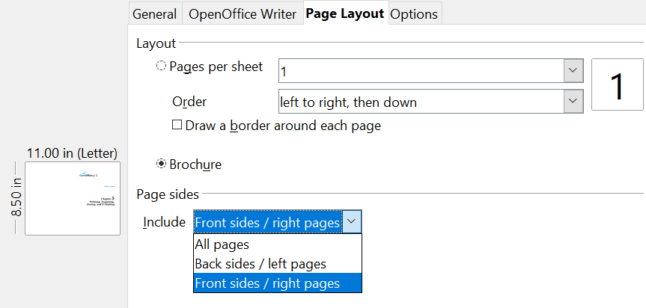

- Click the Print button.
- Take the printed pages out of the printer, turn the pages over, and put them back into the printer in the correct orientation to print on the blank side. You may need to experiment a bit to find out what the correct arrangement is for your printer.
- On the Print dialog box, in the Page sides section, select Front sides / right pages option from the Include drop down box.
- Click the Print button.
Tip | If your printer can print double-sided automatically, choose All pages.

Printing in Black and White (on a Color Printer)
You may wish to print documents in black and white on a color printer. Several choices are available. Please note that some color printers may print in color regardless of the settings you choose.
Change the printer settings to print in black and white or gray scale:
- Choose File > Print to open the Print dialog box.
- Click Properties to open the Properties dialog box for the printer. The available choices vary from one printer to another, but you should find options for the Color settings. See your printer’s help or user manual for more information.
- The choices for color might include black and white or gray scale. Choose the required setting.
- Click OK to confirm your choice and return to the Print dialog box,
- Click the Print button to print the document.
Tip | Gray scale is best if you have any graphics in the document.
Change the AOO settings to print all color text and graphics as gray scale:
- Choose Tools > Options > OpenOffice > Print.
- Select the Convert colors to gray scale option. Click OK to save the change.
- Open the Print dialog box (File > Print).
- Click the Print button to print the document.
Change the AOO Writer settings to print all color text as black, and all graphics as gray scale:
- Choose Tools > Options > OpenOffice Writer > Print.
- Under Contents, select the Print text in black option. Click OK to save the change.
- Open the Print dialog box (File > Print).
- Click the Print button to print the document.

Previewing Pages Before Printing
The normal page view in Writer shows you what each page will look like when printed, and you can edit the pages in that view. If you are designing a document to be printed double-sided, you may want to see what facing pages look like. Writer provides two ways to do this:
- View Layout (editable view): use the Facing Pages (Book Preview) button on the status bar.
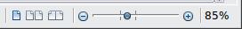
- Page Preview (read-only view).
To use Page Preview:
- Choose File > Page Preview (or click the Page Preview button on the Standard toolbar). Writer now displays the Page Preview toolbar instead of the Formatting toolbar.
Figure 166. Page Preview toolbar (Writer)
- Select the required preview icon: Two Pages (), Multiple Pages () or Book Preview ().
- To print the document from this view, click the Print document icon() to open the Print dialog box.
- Choose the print options and click the Print button.

Printing Envelopes
Printing envelopes involves two steps: setup and printing.
To set up an envelope to be printed by itself or with your document:
- Click Insert > Envelope from the menu bar.
- In the Envelope dialog box, start with the Envelope tab. Verify, add, or edit the information in the Addressee and Sender boxes (the “from” on the envelope).
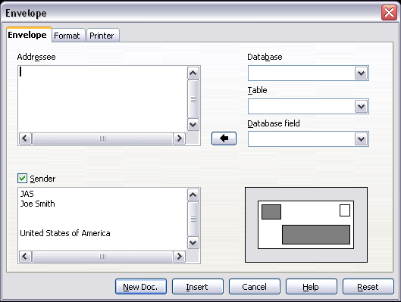
Figure 167. Choosing addressee and sender information for an envelope
You can type information directly into the Addressee and Sender boxes, or use the right-hand drop-down lists to select the database or table from which you can draw the envelope information, if desired. See Chapter 11 (Using Mail Merge) for details on how to print envelopes from a database.
- On the Format page, verify or edit the positioning of the addressee and the sender information. The preview area on the lower right shows the effect of your positioning choices.
- To format the text of these blocks, click the Edit buttons to the right. In the drop-down list you have two choices: Character and Paragraph.
- In Character, you can choose Fonts (Sizes…), Fonts Effects (Underlining, Color…), Position (Rotating/scaling…), Hyperlink, Background and more.
- In Paragraph, you can choose Indents & Spacing, Alignment, Text Flow, Tabs, Drop Caps, Borders and Backgrounds.
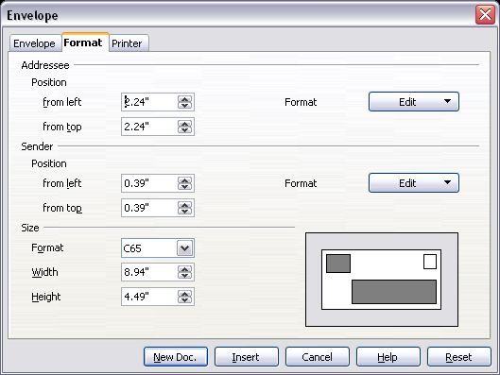
Figure 168. Choosing positioning and size of elements for an envelope
- In the lower left of this page, choose the envelope format from the drop-down list. The width and height of the selected envelope then show in the boxes below the selected format. If you selected a preexisting format, just verify these sizes. If you picked User defined in the Format list, then you can edit the sizes.
- After formatting, go to the Printer page to choose printer options such as envelope orientation and shifting. You may need to experiment a bit to see what works best for your printer. You can also decide on a different printer or alter the printer setup (for example, specify the tray that holds envelopes) for this print job.
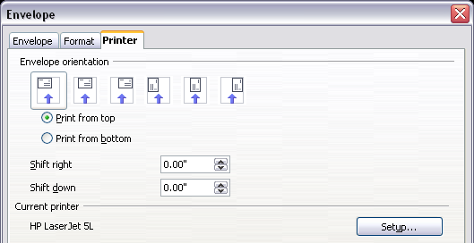
Figure 169. Choosing printer options for an envelope
- When you have finished formatting and are ready to print, click either the New Doc or Insert button to finish. New Doc makes only an envelope or starts a new document with the envelope. Insert puts the envelope into your existing document as page 1. To not proceed with this envelope, click Cancel or press the Esc key. You can also click Reset to remove your changes and return to the original settings when the dialog box opened.
When the Envelope dialog box closes, you are returned to your document, which now has the envelope in the same file as the document. Save this file before you do anything else.
To print the envelope:
- Choose File > Print from the menu bar.
- On the Print dialog box, under Print range, choose Pages and type 1 in the box. Click OK to print.

Printing Labels
Labels are commonly used for printing address lists (where each label shows a different address), but they can also be used for making multiple copies of one label only, for example return-address stickers.
To print labels:
- Choose File > New > Labels on the menu bar. The Labels dialog box opens.
- On the Labels tab, fill in your own label text in the Inscription box, or use the Database and Table drop-down lists to choose the required information, as described in Chapter 11 (Using Mail Merge).
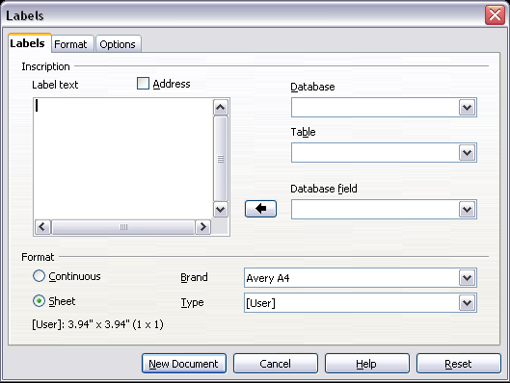
Figure 170. Labels dialog box, Labels page
- Select the label stock in the Brand drop-down list. The types for that brand then appear in the Type drop-down list. Select the size and type of labels required. You can also select User in the Type drop-down list and then make specific selections on the Format page.
- On the Format page, choose the pitch, sizes, margins, columns, and rows for user-defined labels, or just verify with a brand of label stock you have loaded into the printer.
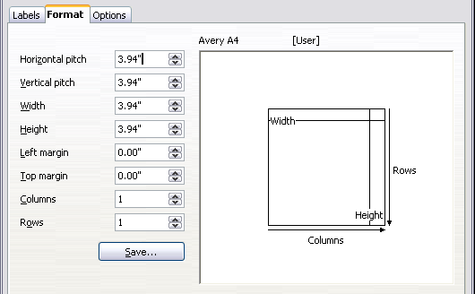
Figure 171. Labels dialog box, Format page
- Click Save to save your new format.
- On the Options tab, choose to print the entire page of labels or one single label, then select which one by the column and row. You can also change printer setup.
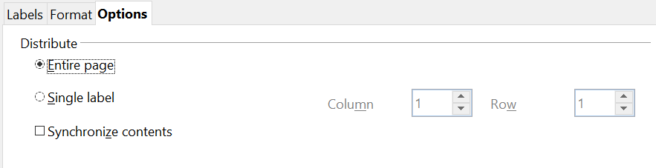

Figure 172. Labels dialog box, Options page
- When you have finished formatting, click New Document to make your sheet of labels or click Cancel (or press the Esc key). You can also click Reset to remove your changes and return to the original settings when the dialog box opened.
- You can print using the Print File Directly icon on the toolbar or by choosing File > Print from the menu bar, or you can save the file to print later.

Exporting to PDF
OpenOffice can export documents to PDF (Portable Document Format). This industry-standard file format for file viewing is ideal for sending the file to someone else to view using Acrobat Reader or other PDF viewers. Unlike exporting to other formats, PDF documents will look exactly as the document appears on your screen. The only limitation of PDF is that the recipient will not be able to edit the document.

Quick Export to PDF
Click the Export Directly as PDF icon to export the entire document using the default PDF settings. You are asked to enter the file name and location for the PDF file, but you do not get a chance to choose a page range, the image compression, or other options.

Controlling PDF Content and Quality
For more control over the content and quality of the resulting PDF, use File > Export as PDF. The PDF Options dialog box opens. This dialog box has five tabs (General, Initial View, User Interface, Links, and Security). Make your selections, and then click Export. Then you are asked to enter the location and file name of the PDF to be created, and click Save to export the file.

General tab of PDF Options Dialog Box
On the General tab (Figure 168), you can choose which document pages to include in the PDF, the type of compression to use for images (which affects the quality of images in the PDF), and other options.
Range section
- All: Exports the entire document.
- Pages: To export a range of pages, use the format 3-6 (pages 3 to 6). To export single pages, use the format 7;9;11 (pages 7, 9, and 11). You can also export a combination of page ranges and single pages, by using a format like 3-6;8;12.
- Selection: Exports whatever material is selected.
Images section
- Lossless compression: Images are stored without any loss of quality. Tends to make large files when used with photographs. Recommended for other kinds of images or graphics.
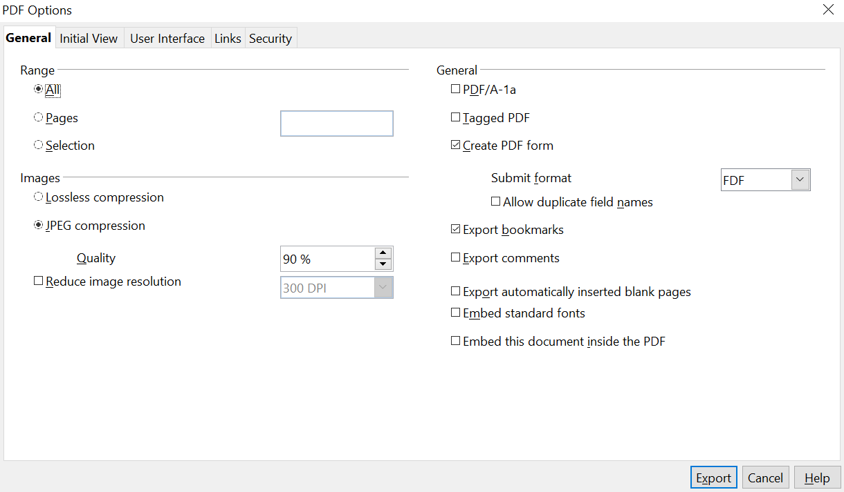

Figure 173: General page of PDF Options dialog box
- JPEG compression: Allows for varying degrees of quality. A setting of 90% works well with photographs (small file size, little perceptible loss of quality).
- Reduce image resolution: Lower-DPI (dots per inch) images have lower quality. For viewing on a computer screen generally a resolution of 72dpi (for Windows) or 96dpi (GNU/Linux) is sufficient, while for printing it is generally preferable to use at least 300 or 600 dpi, depending on the capability of the printer. Higher dpi settings greatly increase the size of the exported file.
Note | EPS images with embedded previews are exported only as previews. EPS images without embedded previews are exported as empty placeholders.

General section
- PDF/A-1: PDF/A is an ISO standard for long-term preservation of documents, by embedding all the information necessary for faithful reproduction (such as fonts) while forbidding other elements (including forms, security, and encryption). PDF tags are written. If you select PDF/A-1a, the forbidden elements are grayed-out (not available).
- Tagged PDF: Tagged PDF contains information about the structure of the document’s contents. This can help to display the document on devices with different screens, and when using screen reader software. Some tags that are exported are the table of contents, hyperlinks, and controls. This option can increase file sizes significantly.
- Create PDF form—Submit format: Choose the format of submitting forms from within the PDF file. This setting overrides the control’s URL property that you set in the document. There is only one common setting valid for the whole PDF document: PDF (sends the whole document), FDF (sends the control contents), HTML, and XML. Most often you will choose the PDF format.
- Export bookmarks: Creates PDF bookmarks (a table of contents list displayed by most PDF viewers) for all outline paragraphs and for all table of contents entries for which you assigned hyperlinks.
- Export comments: Exports comments as PDF notes.
- Export automatically inserted blank pages: If selected, automatically inserted blank pages are exported to the PDF. This is best if you are printing the PDF double-sided. For example, books usually have chapters set to always start on an odd-numbered (right-hand) page. When the previous chapter ends on an odd page, AOO inserts a blank page between the two odd pages. This option controls whether to export that blank page.
- Embed standard fonts: You can choose to embed the standard fonts (Times, Helvetica, Courier, Symbol, and ZapfDingbats) in all PDF documents created by AOO to enhance display accuracy in PDF viewers.

Initial View Tab of PDF Options Dialog Box
On the Initial View page (Figure 167), you can choose how the PDF opens by default in a PDF viewer. The selections should be self-explanatory.

User Interface Tab of PDF Options Dialog Box
On the User Interface tab (Figure 166), you can choose more settings to control how a PDF viewer displays the file. Some of these choices are particularly useful when you are creating a PDF to be used as a presentation or a kiosk-type display.
Window options section
- Resize window to initial page. Causes the PDF viewer window to resize to fit the first page of the PDF.
- Center window on screen. Causes the PDF viewer window to be centered on the computer screen.
- Open in full screen mode. Causes the PDF viewer to open full-screen instead of in a smaller window.
- Display document title. Causes the PDF viewer to display the document’s title in the title bar.

Figure 174: Initial View page of PDF Options dialog box

Figure 175: User Interface page of PDF Options dialog box
User interface options section
- Hide menu bar Causes the PDF viewer to hide the menu bar.
- Hide toolbar. Causes the PDF viewer to hide the toolbar.
- Hide window controls. Causes the PDF viewer to hide other window controls.
Bookmarks
Select how many heading levels are displayed as bookmarks, if Export bookmarks is selected on the General page.

Links Tab of PDF Options Dialog Box
On this page you can choose how links in documents are exported to PDF.

Figure 176: Links page of PDF Options dialog box
Export bookmarks as named destinations
If you have defined Writer bookmarks, this option exports them as “named destinations” to which Web pages and PDF documents can link.
Convert document references to PDF targets
If you have defined links to other documents with OpenDocument extensions (such as .ODT, .ODS, and .ODP), this option converts the files names to .PDF in the exported PDF document.
Export URLs relative to the file system
If you have defined relative links in a document, this option exports those links to the PDF.
Cross-document links
Set up the behavior of the PDF links to other files. Select one among the following alternatives:
- Default mode: The PDF links will be handled as specified in your operating system.
- Open with PDF reader application: Use the same application used to display the PDF document to open linked PDF documents.
- Open with Internet browser: Use the default Internet browser to display linked PDF documents.

Security Tab of PDF Options Dialog Box
PDF export includes options to encrypt the PDF (so it cannot be opened without a password) and apply some digital rights management (DRM) features.
- With an open password set, the PDF can only be opened with the password. Once opened, there are no restrictions on what the user can do with the document (for example, print, copy, or change it).
- With a permissions password set, the PDF can be opened by anyone, but its permissions can be restricted. See Figure 164.
- With both the open password and permission password set, the PDF can only be opened with the correct password, and its permissions can be restricted.
Note | Permissions settings are effective only if the user’s PDF viewer respects the settings.

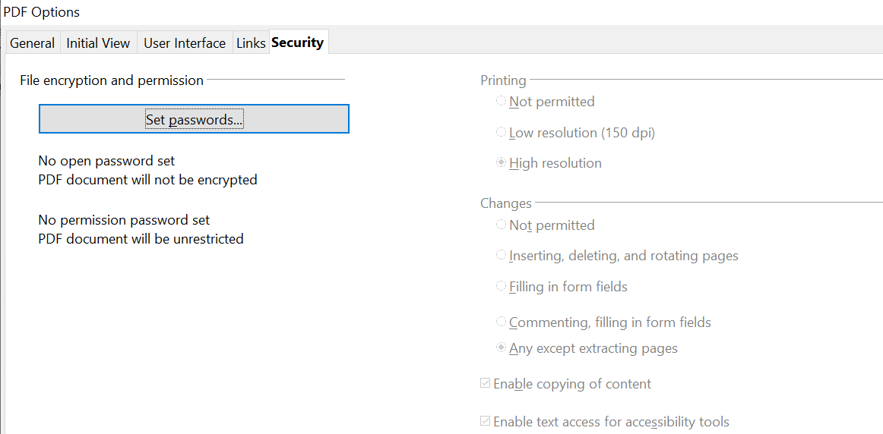

Figure 177: Security page of PDF Options dialog box
Figure 164 shows the pop-up dialog box displayed when you click the Set passwords button on the Security page of the PDF Options dialog box.
After you set a password for permissions, the other choices on the Security page (shown in Figure 163) become available. These selections should be self-explanatory.
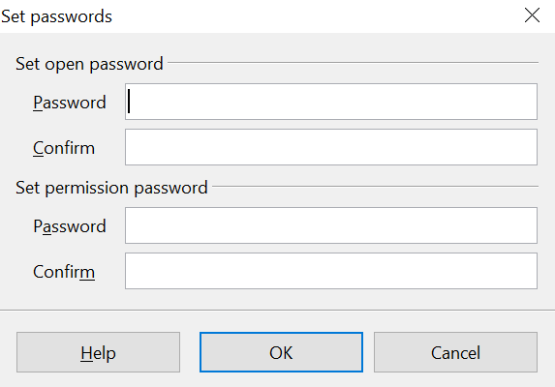
Figure 178: Setting a password to encrypt a PDF

Exporting to XHTML
AOO uses the term “export” for some file operations involving a change of file type. AOO can export files to XHTML. Other formats may be made available through extensions.
To export to XHTML, choose File > Export. On the Export dialog box, specify a file name for the exported document, then select the XHTML in the File format list and click the Export button.

E-mailing Writer Documents
AOO provides several ways to quickly and easily send a Writer document as an e-mail attachment in one of three formats: .ODT (OpenDocument Text, Writer’s default format), .DOC (Microsoft Word format), or PDF. These options are available if you have an email program installed on your computer. If you only use an internet service accessed through a browser, you must go to that service and simply attached your saved document to a message.
To send the current document in .ODT format:
- Choose File > Send > Document as E-mail. Writer opens your default e-mail program. The document is attached.
- In your e-mail program, enter the recipient, subject, and any text you want to add, then send the e-mail.
File > Send > E-mail as OpenDocument Text has the same effect.
If you choose E-mail as Microsoft Word, Writer first creates a .DOC file and then opens your e-mail program with the .DOC file attached. Similarly, if you select E-mail as PDF, Writer first creates a PDF using your default PDF settings (as when using the Export Directly as PDF toolbar button) and then opens your email program with the .PDF file attached.

E-mailing a Document to Several Recipients
To e-mail a document to several recipients, you can use the features in your e-mail program, or you can use AOO’s mail merge facilities to extract email addresses from an address book.
Note | Documents can only be sent from the AOO mail merge wizard if a mail profile has been set up in Tools > Options > OpenOffice Writer > Mail Merge E-mail.

You can use AOO’s mail merge to send e-mail in two ways:
- Use the Mail Merge Wizard to create the document and send it. See Chapter 11 (Using Mail Merge) for details.
- Create the document in Writer without using the Wizard, then use the Wizard to send it. This method is described here.
To use the Mail Merge Wizard to send a previously-created Writer document:
- Open the document in Writer. Click Tools > Mail Merge Wizard. On the first page of the wizard, select Use the current document and click Next.
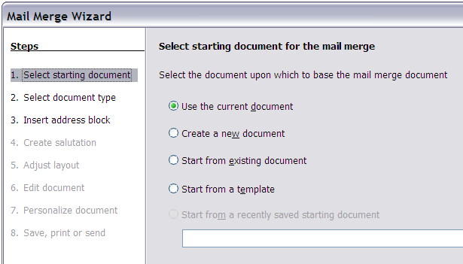Figure 179: Select starting document
- On the second page, select E-mail message and click Next.
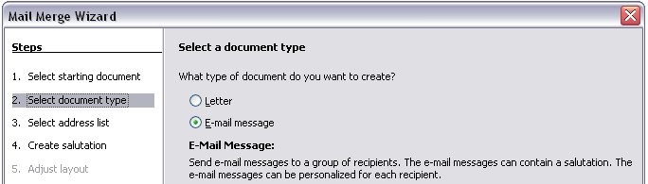
Figure 180: Select document type
- On the third page, click the Select Address List button. Select the required address list (even if only one is shown) and then click OK. (If the address list you need is not shown here, you can click Add to find and add it to the list.)
Figure 181: Selecting an address list
- Back on the Select address list page, click Next. On the Create salutation page, deselect the checkbox by This document should contain a salutation.
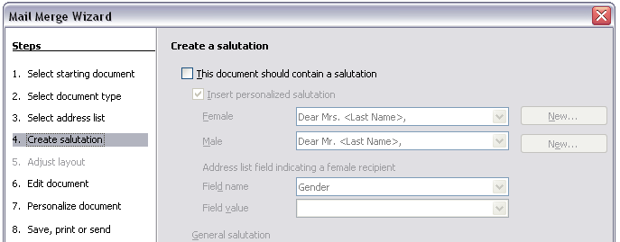Figure 182: Deselecting a salutation
- In the left-hand list, click 8. Save, print or send. AOO displays a “Creating documents” message and then displays the Save, print or send page of the Wizard.
- Select Send merged document as E-Mail. The lower part of the page changes to show e-mail settings choices.
- Type a subject for your email and click Send documents. AOO sends the e-mails.
Figure 183: Sending a document as an email message

Digital Signing of Documents
To sign a document digitally, you need a personal key, also known as a certificate. A personal key is stored on your computer as a combination of a private key, which must be kept secret, and a public key, which you add to your documents when you sign them. You can get a certificate from a certification authority, which may be a private company or a governmental institution.
When you apply a digital signature to a document, a kind of checksum is computed from the document’s content plus your personal key. The checksum and your public key are stored together with the document.
When someone later opens the document on any computer with OpenOffice, the program will compute the checksum again and compare it with the stored checksum. If both are the same, the program will signal that you have the original, unchanged document. In addition, the program can show you the public key information from the certificate. You can compare the public key with the public key that is published on the website of the certificate authority.
Whenever someone changes something in the document, this change breaks the digital signature.

To sign a document:
- Choose File > Digital Signatures.
- If you have not saved the document since the last change, a message box appears. Click Yes to save the file.
- After saving, you see the Digital Signatures dialog box. Click Add to add a public key to the document.
- In the Select Certificate dialog box, select your certificate and click OK.
- You return to the Digital Signatures dialog box, where you can add more certificates if you want. Click OK to add the public key to the saved file.
A signed document shows an icon in the status bar. You can double-click the icon to view the certificate.

Removing Personal Data
You may wish to ensure that personal data, versions, notes, hidden information, or recorded changes are removed from files before you send them to other people or create PDFs from them.
In Tools > Options > OpenOffice > Security > Options, you can set AOO to remind (warn) you when files contain certain information and remove personal information automatically on saving.
To remove personal and some other data from a file, go to File > Properties. On the General tab, uncheck Apply user data and then click the Reset button. This removes any names in the created and modified fields, deletes the modification and printing dates, and resets the editing time to zero, the creation date to the current date and time, and the version number to 1.
To remove version information, either go to File > Versions, select the versions from the list and click Delete, or use Save As and save the file with a different name

Chapter 6
Introduction to Styles

What Are Styles?
Most people are used to writing documents according to physical attributes. For example, you might specify the font family, font size, and weight (for example: Helvetica 12pt, bold).
Styles are logical attributes. We use styles every day. For example, there are two styles of personal computer: desktop and laptop. Each has its own distinctive set of properties. You never say “my computer is a low-weight, one-piece unit with an LCD screen attached to a rectangular casing containing the computing components and the keyboard”. Instead, you could say that you have a laptop.
OpenOffice (AOO) styles are a way to do the same thing for your document. Using styles means that you could stop saying “font size 14pt, Times New Roman, bold, centered” and start saying “title” for describing that particular font usage. In other words, styles mean that you shift the emphasis from what the text looks like to what the text is.

Why Use Styles?
Styles help improve consistency in a document. They also make major formatting changes easy. For example, you might decide to change the indentation of all paragraphs or change the font of all titles. For a long document, this simple task could be prohibitive. Styles make the task easy.
The time is 9:50 AM, and Jane is finishing the 30-page paper for school that is due at 10:00 AM. She looks over the assignment one more time, and suddenly she realizes that:
- The text must use Arial font instead of Times New Roman.
- The headings must be dark blue and indented.
- The title must appear at the top-right of every page except the first.
- Even-numbered pages must have a wider right margin, and odd-numbered pages must have a wider left margin.
Thankfully, Jane used AOO Writer and styles. She makes all the changes in only two minutes and hands in the paper on time.

Style Categories
AOO Writer has five style categories:
- Paragraph styles affect entire paragraphs represented with those styles.
- Character styles affect a block of text inside a paragraph.
- Page styles affect page formatting (page size, margin, and the like).
- Frame styles affect frames and graphics.
- List styles affect outlines, numbered lists, and bulleted lists.
In the same way that characters are the building blocks for creating words, paragraphs are the building blocks of every document. Headings (subheads) are paragraphs; headers, footers, and numbered lists are also paragraphs. Paragraph styles are, therefore, the most frequently used styles and are the ones treated in more detail in this and the next chapter.

The Styles and Formatting Window
Styles are available through the Sidebar's Styles and Formatting deck or a floating/ dockable window called Styles and Formatting, shown in Figure 184. This window is at the center of styles management. Do not worry if, at first, some contents of this section seem obscure while progressing through this or the next chapter. This guide describes how to use all these functions.

Figure 184: Styles and Formatting window buttons
To open the Styles and Formatting window, do any one of the following:
- Click the Styles and Formatting icon of the Sidebar.
- Click on the icon located at the left-hand end of the Formatting toolbar.
- Select Format > Styles and Formatting.
- Press F11.
Tip | We will emphasize using the Sidebar but the floating Styles and Formatting window has the same appearance and functions. Which you use is a matter of preference.

Tip | You can move the Styles and Formatting window to a convenient position on the screen or dock it to an edge. The Sidebar is docked at the right edge by default.

Style Selection Basics
The first five icons at the top of the Styles and Formatting window select the category of styles to work on. Click on one of these icons to display a list of styles in that category, such as paragraph or character styles, in the main window.
To apply a character style to existing text, select the text and then double-click on the name of the style in the Character Styles list. To apply any other style, put the cursor in the paragraph, frame, or page you want to modify and double-click on the name of the style in the corresponding section. You can select more than one paragraph or frame and apply the same style to all of them at the same time.

Using Fill Format Mode
The sixth icon at the top of the Styles and Formatting window activates the Fill Format mode. Use Fill Format to apply a style to many areas quickly without having to go back to the Styles and Formatting window and double-click every time. This method is useful for formatting many scattered paragraphs, words, or other items with the same style, and it may be easier to use than making multiple selections first and then applying a style to all of them.
- Open the Styles and Formatting window (Figure 184) and select a style.
- Click the Fill Format Mode icon .
- To apply a paragraph, page, or frame style, hover the mouse over the paragraph, page, or frame and click. To apply a character style, hold down the mouse button while selecting the characters. Clicking on a word applies the character style to that word.
- Repeat step 3 until you have made all the changes for that style.
- To quit the Fill Format mode, click the icon again or press the Esc key.
Caution | When this mode is active, a right-click anywhere in the document undoes the last Fill Format action. Be careful not to accidentally right-click and mistakenly undo actions you want to keep.

New Style from Selection, Update Style, and Load Styles Functions
The last button in the toolbar of the Styles and Formatting window is a multipurpose button that gives access to three different functions: New Style from Selection, Update Style, and Load Styles.

Using New Style from Selection
Use the first function of the multipurpose button to create a new style from the formatting of an object in the current document. For instance, you can change the formatting of a paragraph or frame until it appears as you like, and then you can turn that object’s formatting into a new style. This procedure can save time because you do not have to remember all the formatting settings you want, as is necessary when creating a new style with the Style dialog box. Besides, unlike when setting the formatting parameters in dialog box pages as you will learn to do later, you can immediately see how the objects will look when formatted with the style you are creating.
Follow these steps to create a new style from a selection:
- Change the formatting of the object (paragraph, frame, etc.) to your liking.
- From the icons at the top of the window, choose the type of style to create (paragraph, character, and so on).
- In the document, select the item to save as a style.
- Go back to the Styles and Formatting window and click the New Style from Selection icon.
In the Create Style dialog box, enter a name for the new style. The list shows the names of existing custom styles of the selected type, if any. Click OK to save the new style.
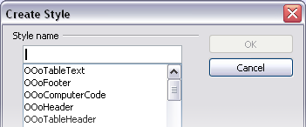
Figure 185: Dialog to name a new style from selection

Update Style (from a selection)
Let’s use paragraph styles as an example.
- Create a new paragraph (or modify an existing paragraph) and edit all the properties you want to go into the style (such as indentation, font properties, alignment, among others).
Caution | Make sure that there are unique properties in this paragraph. For example, if there are two different font sizes in the paragraph selected to update the style, that particular property will not be updated.

- Select the paragraph by clicking anywhere in the paragraph.
- In the Styles and Formatting window, select the style you want to update (single-click, not double-click) and then click on the New Style from Selection icon and select Update Style.

Figure 186: Updating a style from a selection
The procedure to update another type of style (character, page, or frame styles) is the same. Just select the item in question, select the style you want to update, and choose Update Style.

Load Styles (from a template or document)
The last option in the New Style from Selection icon is used to copy styles into the current document by loading them from a template or another document. This method copies all styles, or groups of styles, at one time.
- Open the document to copy styles into.
- In the Styles and Formatting window, click on the New Style from Selection icon and then on Load Styles (see Figure 186).
- In the Load Styles dialog box (Figure 187), find and select the template to copy styles from. Click on the From File button if the styles you want are contained in a text document rather than a template. In this case, a standard file selection dialog box opens up, allowing you to select the desired document.
- Select the checkboxes for the types of styles to be copied. If you select Overwrite, the styles being copied will replace any styles of the same names in the target document.
- Click OK to copy the styles.
Figure 187: Loading styles from a template

Using the Visible Styles Filters
At the bottom of the Styles and Formatting window, use the drop-down menu to select a filtering criterion for the contents of the main body of the window. Normally, you will find that only a handful of styles are needed in any given document, and it makes sense to have only these styles shown.
So, at the beginning of the writing process, you may want to have access to all the available styles (by selecting All Styles). However, as the document develops, it is useful to reduce the size of the list displayed to only the styles already in use (by selecting Applied Styles). If you work on a document where you want to apply special-purpose styles only (such as those styles used in writing this user guide), select instead Custom Styles. The Hierarchical Styles view is most useful when modifying styles as it reveals which styles are linked together. This topic is discussed in more detail in Chapter 7 (Working with Styles).

Drag-and-Drop a Selection to Create a Style
Another little known property of the Styles and Formatting window is the capability of creating a new style with a simple drag-and-drop of a text selection into the Styles and Formatting window.
- Open the Styles and Formatting window.
- Select the style category you are going to create (for example a character style) using one of the five icons in the top left part of the window.
- Select the object you want to base the style on and drag it to the Styles and Formatting window. The cursor changes its shape indicating whether the operation is possible or not.
- In the Create Style dialog box (Figure 185), enter a name for the new style. The list shows the names of existing custom styles of the selected type, if any. Click OK to save the new style.
Note | You cannot use the drag-and-drop method to create a custom page style.

Applying Styles
Styles can easily be applied by means of the Styles and Formatting window. However, alternative ways exist to apply certain styles, as explained in this section.

Applying Paragraph Styles
The style family most used when drafting a document is the paragraph style. AOO offers two quick alternatives to the Styles and Formatting window to apply this category of style: the Apply Style menu and the Format Paintbrush icon.
When a paragraph style is in use in a document, the style name appears on the Apply Style menu near the left end of the formatting bar, to the right of the Styles and Formatting icon. You can select styles from this menu, just as you can from the Styles and Formatting window.
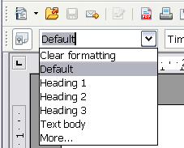Figure 188: Apply Style menu
To apply a style from this menu, click on the desired style or use the up or down arrow keys to move through the list, then press Enter to apply the highlighted style.

Tip | Select More… at the bottom of the list to open the Styles and Formatting window.
The format paintbrush can be used to apply a certain paragraph style to another paragraph (or group of paragraphs). Start by placing the cursor inside the paragraph you want to copy, then press the Format Paintbrush icon in the standard toolbar. The cursor changes into an ink bottle. Select now the paragraphs to which you want to apply the copied style. Note that it is not required to select the whole paragraph.

Example: Applying a Paragraph Style
Let's see the three methods described above in action with an example.
- Create a new document (choose File > New > Text Document or press Control+N).
- Type the words Heading 1 in the new document, but do not press Enter so that the cursor remains in that same line where you typed.
- Click the Styles and Formatting icon on the Sidebar to display the Styles and Formatting deck. This is shown as a floating window in (Figure 189) but it is normally docked.
- Make sure the window is showing the Paragraph Styles section—click on the top-left icon of the Styles and Formatting window.
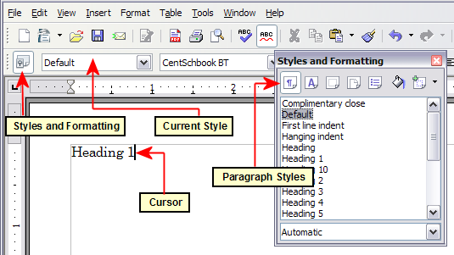
Figure 189: Click on the Styles and Formatting icon to bring up the window
Double-click the Heading 1 entry of Styles and Formatting (Figure 190). This does two things:
- Gives the line (actually, its entire paragraph) you typed the Heading 1 style.
- Adds Heading 1 to the Apply Style menu.
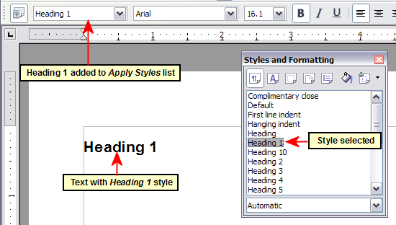
Figure 190: Applying paragraph styles
To use the Apply Styles drop-down menu (Figure 224):
- Move the cursor to a new line or create a new line by pressing the Enter key at the end of the previous line and type some text.
- Keeping the cursor on the same paragraph, select Heading 1 in the Apply Styles list.
The text acquires the properties of the Heading 1 style. If the paragraph style you want is not in the Apply Style list, select More to bring up the Styles and Formatting window. If the Styles and Formatting window is still open, you may notice that the Heading 1 style is also highlighted in the main window, as shown in Figure 190.
Finally, try the Format Paintbrush:
- Move the cursor to a new line or create a new line by pressing the Enter key at the end of the previous line and type some text.
- Move the cursor to one of the two paragraphs with style Heading 1 and select the Format Paintbrush icon to activate it (the cursor changes shape).
- Move the cursor over the paragraph you have created and click the left mouse button.
The cursor shape changes back to the normal one, and the text acquires the properties of the Heading 1 style.
If the Styles and Formatting window is open, you may notice that the Heading 1 style is also highlighted in the main window.

Applying Character Styles
Select the Styles and Formatting deck on the Sidebar and click the second button in the top bar. The list of available character styles is displayed. To apply a character style, follow these steps:
- Select the block of text where you wish to apply the style.
- Double-click the appropriate character style in the Styles and Formatting window.
Some examples include:
This example uses the AOO-supplied Strong Emphasis character style.
Definition: A statement describing the meaning of a word or phrase.
Note | One difference between character styles and paragraph styles is the need for selecting text (highlighting). Character styles require you to select the text you want to apply them to; paragraph styles do not.

Unset/Undo Character Styles
Sometimes, you will want to remove the formatting from a block of text. You must resist the temptation to do this manually. This will only cause trouble down the road. There are four easy ways to remove character formatting after you select the text:
- Right-click and choose Default Formatting.
- Choose Format > Default Formatting from the menu bar.
- Press the keys Ctrl + M.
- If you have the Styles and Formatting deck visible, double-click the Default character style.
Note | The first three methods also work for removing manual formatting.

Applying Frame Styles
Whenever you insert an object, such as a picture, into a document, it will automatically have a frame around it. Some designers like to add frame styles to introduce variety. For example, you could have two different frame styles for graphics: one that is centered for small graphics and another that is left-aligned for graphics that take up the entire width of the main frame. In such a case, you need to add at least one frame style.
To apply a style to a frame:
- Select the frame.
- Bring up the Styles and Formatting deck in the Sidebar.
- Click the Frame Styles icon (the third one from the left).
- Double-click the frame style you want.
Tip | When a frame is selected, the Frame toolbar replaces the Formatting toolbar. Then, the Apply Style list at the left of the Frame toolbar displays frame styles. You can use this to change the style of a frame.

Most of a frame’s design can be set in a style. However, the following options must be set manually:
- Anchoring: how the frame is positioned in relation to the rest of the page’s contents (Format > Anchor).
- Arrangement: the frame’s position in a stack of objects (Format > Arrange).
- Adding a hyperlink: so that a click on the frame opens a Web page or another document in an HTML file (Insert > Hyperlink).
The right-click menu also has items for anchoring and arrangement, as well as for wrap and alignment.

Applying Page Styles
To apply a page style, place the cursor anywhere on the page to which the style should be applied. You can easily check which page style is applied because it is shown on the status bar.
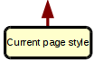

Figure 191: The current page style is displayed on the status bar
If you want to apply a different style, you can either right-click on the style in the status bar and select a new style from the pop-up menu, or you can open the Styles and Formatting deck, select the page style icon at the top of the window (fourth icon), and then double-click on the desired style.
Caution | Changing a page style will usually cause the style of all other pages to change as well. The results may not be what you want. To change the style of only one page, you may need to insert a manual page break, as described below.

As discussed in Chapter 7 (Working with Styles), a correctly set up page style will, in most cases, contain information on what the page style of the next page should be. For example, when you apply a Left page style to a page, you can indicate in the style settings that the next page has to apply a Right page style, a First page style could be followed by either a Left page style or a Default page style, and so on.
Another very useful mechanism to change the page style is to insert a manual page break and specify the style of the subsequent page. The idea is simple: you break a sequence of page styles and start a new sequence. To insert a page break, choose Insert > Manual Break and choose Page break. This section illustrates two common scenarios where page breaks are useful.

Example: Chapters
A possible scenario: You are writing a book that is divided into chapters. Each chapter starts with a page style called New Chapter. The following pages use the Default page style. At the end of each (except the last) chapter, we return to the New Chapter page style for the first page of the next chapter.
Figure 192 illustrates the flow of page styles when using page breaks.
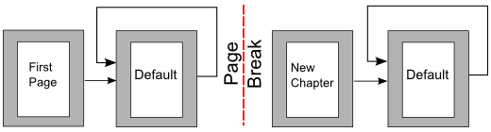Figure 192: Page style flow using a page break
AOO doesn’t have a predefined New Chapter style, so you must create a custom style (see Chapter 7). Let’s suppose that you already have the page styles with the following properties:
Page style | Next Style
New Chapter | Default
Default | Default
At some point, you will want to start a new chapter. Follow these steps:
- Put the cursor at the end of the chapter, on a blank line (empty paragraph) of its own.
- Choose Insert > Manual Break. The Insert Break dialog box (Figure 193) appears.
- Under Type, choose Page break and under Style, select New Chapter.
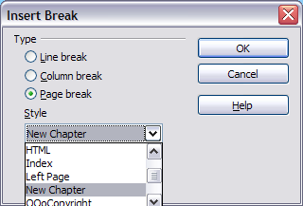
Figure 193: Choose Page break and select the New Chapter page style

Example: Page with Special Formatting
Sometimes you may need to insert a page with special formatting, for example a landscape page or a page with more columns. This can also be done with page breaks. Suppose that the current page has the Default page style.
- Choose Insert > Manual Break.
- Select the desired page style (say, Special Page) in the Insert Break dialog box.
- Fill in the contents for this page.
- Insert another page break and select Default as the style. The pagination continues on as normal, except that one page has been replaced by a different page style.
This concept is illustrated in Figure 194.
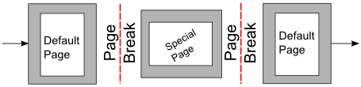
Figure 194: Inserting a page with special formatting

Applying List Styles
List styles define properties such as indentation, numbering style (for example, 1,2,3; a, b, c; or bullets), and punctuation after the number, but they do not by themselves define properties such as font, borders, text flow, and so on. The latter are properties of paragraph styles.
If you need your list to have specific paragraph-style properties, you should embed the list style into paragraph styles, as explained in Chapter 7. You can then create a numbered list by applying paragraph styles alone.
Each of the list styles predefined in Writer has four associated paragraph styles. For example, the Numbering 1 list style is associated with four paragraph styles:
- Numbering 1
- Numbering 1 Cont.
- Numbering 1 End
- Numbering 1 Start
Numbering 1 is a default paragraph style to which you can attach a list style. If you want to make exclusive use of paragraph styles and never use the Formatting toolbar when creating a numbered list, you could use the other three styles. All you need to do is to create a suitable list style and set up the Next Style property in the Organizer page of the Paragraph Style dialog box so that the Numbering 1 Start paragraph is followed by the Numbering 1 Cont. style, while the Numbering 1 End paragraph style is followed by a default style paragraph.
If you only want to apply a list style (that is, the numbering or bullet symbol and the indentation) then, when the cursor is on the paragraph to be numbered, double-click on the desired list style.
When creating a list style, you can define up to ten levels of depth for nested lists. Switch from one level to the other with either the Promote or the Demote buttons on the Bullets and Numbering toolbar or by pressing the Tab key (one level down) or Shift+Tab key combination (one level up) or by right-clicking on the list element and select Up One Level or Down One Level from the pop-up menu.

Restarting the Numbering
When creating more than one numbered list of the same type within the same chapter, Writer applies progressive numbering to all the lists. Sometimes this is exactly what you want, while at other times you want to restart the numbering. To do so, either click on the Restart numbering icon on the Bullets and Numbering toolbar or right-click on the first element of the list and select Restart numbering.

Modifying Styles
Writer provides several predefined styles, but you may find that they do not fit your preferences. You can build your own library of custom styles to use in place of the predefined ones, or you can modify the existing styles. AOO offers four mechanisms to modify both predefined and custom (user-created) styles:
- Update a style from a selection.
- Load or copy styles from another document or template.
- Change a style using the Style dialog box.
- Use AutoUpdate (paragraph and frame styles only).
The first two methods are discussed in “Update Style (from a selection)” on page 183 and “Load Styles (from a template or document)” on page 183, while Chapter 7 (Working with Styles) discusses at length the process of creating a new style.
This section shows how you can quickly make simple modifications to existing paragraph styles using the same tools you would use for applying formatting manually.
Tip | Any changes made to a style are effective only in the current document. If you want to reuse modified or new styles in other documents, you need either to save the styles in a template—see Chapter 10 (Working with Templates)—or copy the styles into the other documents, as described in “Copying and Moving Styles” on page 199.

Changing a Style Using the Style Dialog Box
To change an existing style using the Style dialog box, right-click on the style in the Styles and Formatting deck and select Modify from the pop-up menu.
The dialog box displayed depends on the type of style selected. Figure 195 shows an example of the dialog box for a paragraph style. Each style’s dialog box has several tabs. The various properties on these dialog boxes are described in the next chapter.
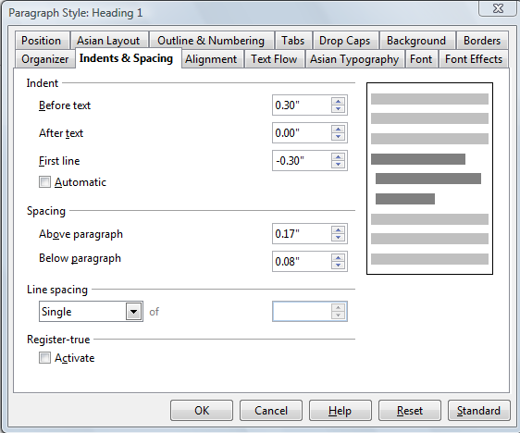
Figure 195: Example of the Paragraph Style dialog box
Move to the page where the setting you want to modify is specified and input the new value. You can click the Help button at any time to bring up the online guide where all the options of the current page are briefly described. When you are done, click OK to close the dialog box. As discussed above, the great advantage of styles is that all the instances of such style in your document are now modified to your liking.

Examples: Modifying Paragraph Styles
For this example, we need three lines of text with three AOO-supplied paragraph styles: Heading 1, Heading 2, and Heading 3. These paragraph styles could be used in formatting headings (subheads) in the framework for a document that will be “fleshed out” afterward.
Open a new text document for this exercise and type Title on the first line, click the Paragraph Styles icon on the Styles and Formatting deck, and double-click Heading 1 in the drop-down list. Repeat this procedure for the other entries of Figure 197, using the proper paragraph style for each: the Heading 1 style for the paragraph containing the word Title, Heading 2 for Subtitle 1, and so on.
Your document should resemble Figure 196.
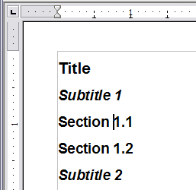
Figure 196: Headings 1–3 with default styles
Suppose you decide to make some changes to these styles, namely:
- Heading 1 should be centered.
- Heading 3 should be indented.

Center Heading 1
On the Styles and Formatting deck, select the Paragraph Styles icon (if it isn’t already chosen), right-click on Heading 1, and choose Modify.
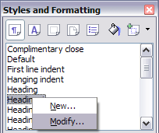
Figure 197: Modifying a style
After the Paragraph Style window opens, choose the Alignment tab, select Center (as shown in Figure 198), and click OK.
Now, every paragraph marked as Heading 1 will be centered (as shown in Figure 200). If you make another Heading 1 entry, it will be centered as well.
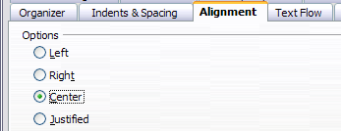
Figure 198: Center Heading 1
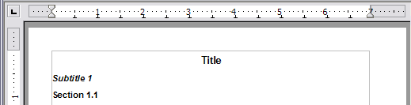
Figure 199: The text Title, which is formatted as a centered Heading 1 style

Indent Heading 3
On the Styles and Formatting deck, right-click on the Heading 3 paragraph style and choose Modify, as before. After the Paragraph Style dialog box opens, follow the steps below:
- Click the Indents & Spacing tab.
- Under the Indent section, set the indentation before the text to 0.60", as shown in Figure 200. Your display might be different, depending upon what measurement unit was set in the options (Tools > OpenOffice Writer > General > Settings).
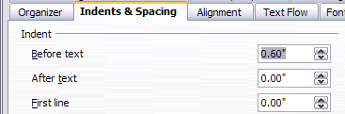
Figure 200: Set indentation
The result should resemble Figure 201.
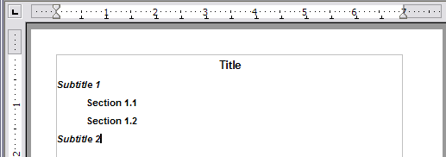
Figure 201: The text formatted as Heading 3 style is now indented

Using AutoUpdate
On the Organizer page of the Paragraph Style dialog box there's a checkbox labeled AutoUpdate (Figure 202). It is intended for paragraph and frame styles only. If this checkbox is selected, then AOO will apply, to the style itself, any modification made manually to a paragraph formatted with that style.
Caution | If you are in the habit of manually overriding styles in your document, be sure that AutoUpdate is not enabled, or you will suddenly find whole sections of your document reformatting unexpectedly.

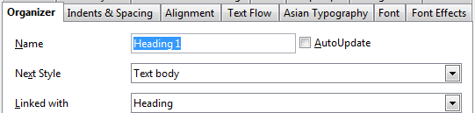
Figure 202: The Organizer page of the Paragraph Style dialog box

Creating Custom Paragraph Styles: Examples
You have seen that the Styles and Formatting window provides several predefined styles, such as Heading 1 and Text body. But what if you need something different, like a poem style, that is not in Styles and Formatting? With Writer, you can make your own styles to suit your needs.
Chapter 7 (Working with Styles) describes in detail the options on the various pages of the Paragraph Style dialog box. This section provides an example of a typical use of custom paragraph styles.
We create a Poem paragraph style and a Poem Header paragraph style, with the following properties:
- Poem: Centered, with a font size of 10pt.
- PoemHeading: Centered, bold, with a 12pt font size.
In addition, a PoemHeading style is to be followed by a Poem style. In other words, when you press Enter, the next paragraph style in the document changes to Poem.
Note | You may have noticed this behavior already. After you enter a heading using a Heading paragraph style and press Enter, the next style automatically switches to Text body.

Creating the Poem Paragraph Style
Our next example uses the Poem style. We will use the Default style as a starting point.
- Select the Styles and Formatting deck of the Sidebar.
- Click the Paragraph Styles icon (first from the left).
- Right-click Default and choose New.
This opens the Paragraph Style dialog box, with the Organizer page selected. To create a custom style, you have to understand and configure the top three entries.
Style fields | Description
Name | This is the name of the style itself, like Heading 1 or Text body.  Set (type in the text box) the name to Poem.
Next Style | This is the default style for the paragraph that follows the Poem style. When you press Enter while typing text in the Poem style, this style is used.  Set this value to Poem. When you press Enter, the text will remain in the Poem style.
Linked with | If the Poem style is linked with another, say Default, then any change in Default will affect Poem, just as you saw with Heading in the previous section.  For our example, this is not the behavior we want. Set this entry to – None –. This means that Poem is not linked with any other style.
After making these changes, your dialog box should look like Figure 203.
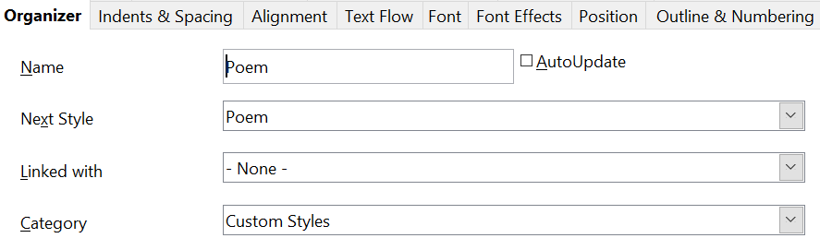
Figure 203: Initial configuration for the Poem style. Set the first three entries as shown.
The next step is to configure the alignment and font properties of this style.
- On the Alignment page, select the Center option.
- On the Font page, select the 10pt font size.
Click OK to save the new Poem style.

Creating the PoemHeading Style
Create a new PoemHeading style. Use the same procedure as before, with these changes:
- Next Style: Select Poem, not PoemHeading.
- Linked with: Heading.
The dialog box should look like Figure 204.
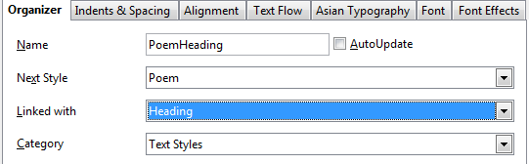

Figure 204: Settings for the PoemHeading style
Edited Entries
Now set the settings of the new style:
- On the Alignment tab, select Center.
- On the Font tab, choose Bold and size 12pt.
Click OK to save the new PoemHeading style.

Sample Poem
It is a good idea to test out your new styles to see if you're happy with them. Typing a poem using the styles we have just defined should produce the results in Figure 205.

Changing the Formatting of Your Styles
One of the main advantages of styles is that they allow the document formatting to be changed after the content has been written. For example, suppose you have written a 100-page book of poetry. Then you change your mind about the way the poems should look.
To learn about reconfiguring styles, we add an indentation to the Poem style instead of centering it.
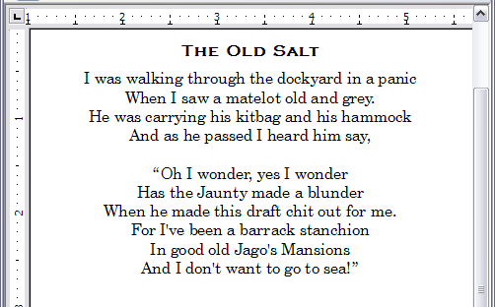
Figure 205: Sample poem

Indent Poem
First, set the Poem style to left alignment:
- In the Styles and Formatting deck, select Poem and right-click and select Modify.
- On the Alignment tab, select Left.
Set the indentation:
- Click the Indents & Spacing tab.
- Under Indent, set the indentation before the text to 5 cm (or about 2 in).
Repeat the steps above for the PoemHeading style.
Done! Click OK, and you should see the text change.

Final result
After all these changes, the poem should look similar to Figure 206. Note in the figure that a third style has been created for the author of the poem.
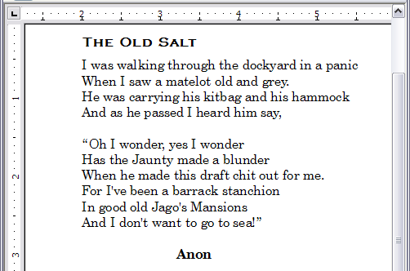
Figure 206: Final result, using three custom styles

Copying and Moving Styles
Styles are part of a document's properties. Therefore changes made to a style, or new styles you create, are only available within the document to which they belong. Styles always stay with a document. So, for example, if you e-mail a document to another person, the styles go with it.
If you want to reuse modified or new styles in other documents, you need either to:
- save the styles in a template (see Chapter 10), or
- copy the styles into the document in which you want to use them.
You can copy or move styles from one template or document to another in two ways:
- Using the Template Management dialog box.
- Loading styles from a template or document (see page 183).
To copy or move styles using the Template Management dialog box:
- Click File > Templates > Organize.
- At the bottom of the Template Management dialog box, choose either Templates or Documents, as needed. For example, if you are copying styles between two documents, both entries should say Documents.
Figure 207: Choosing to copy styles from a document, not a template
- To load styles from a file, click the File button. When you return to this window, both lists show the selected file, and all the currently open documents.
- Double-click on the name of the template or document and then double-click the Styles icon to show the list of individual styles.
- To copy a style, hold down the Control key and drag the name of the style from one list to the other.
- Repeat for each style you want to copy or move. When you're finished, click Close.
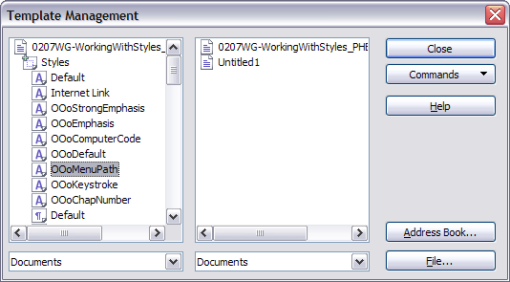
Figure 208: Copying a style from one document to another
Caution | If you do not hold down the Control key when dragging, the style will be physically moved from one list to the other. In other words, the style will be deleted from the list you are dragging it from.

Deleting styles
It is not possible to delete AOO’s predefined styles from a document or template, even if they are not in use. However, custom styles can be deleted.
To delete an unwanted style, right-click on it in the Styles and Formatting window and choose Delete. If the style is in use, the message shown in Figure 209 appears.
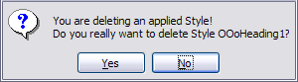
Figure 209: Deleting an applied style
Caution | Make sure the style is not in use before deletion. Otherwise, all objects with that style will return to the Default style and retain their formatting as manual formatting. This can be very problematic in a long document.

Tip | If an unwanted style is in use, use Find & Replace to replace it with a substitute style before deleting it.

If the style is not in use, the message shown in Figure 210 appears.
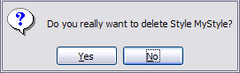
Figure 210: Deleting a style that is not in use

Assigning Styles to Shortcut Keys
You can configure shortcut keys to quickly assign styles in your document. Some shortcuts are predefined, such as Ctrl+1 for the Heading 1 paragraph style and Ctrl+2 for Heading 2. You can modify these shortcuts and create your own. See Chapter 17 (Customizing Writer) for details.

Defining a Hierarchy of Headings
Tools > Outline Numbering defines the hierarchy of headings in a document. Headings can be numbered or not; typically the first-level headings in a book-length document are the next level of headings after the chapter titles, which may be numbered, but lower-level headings are not numbered. Some chapter title and heading styles (such as those commonly used in engineering documents) number each chapter and heading level, for example 1, 1.1, 1.2, 2, 2.1, and so on. When chapters or sections are added or deleted, the numbering is automatically changed.
Paragraph styles are the key to AOO’s outline numbering feature. The default paragraph styles assigned to outline levels are the heading styles supplied with AOO: Heading 1, Heading 2, and so on. However, you can substitute any styles you wish, including custom (user-defined) styles.
The headings defined using the outline numbering feature can be used for more than the table of contents (described in Chapter 12). For example, fields are commonly used to display headings in headers and footers of pages (see Chapter 14, Working with Fields), and Writer can send the outline to Impress to use as the basis for a presentation (see the Impress Guide for details).

Choosing Paragraph Styles for Outline Levels
If you are using the default heading styles for the headings in your outline, and you do not want to use heading numbering, you do not need to do anything on the Outline Numbering dialog box. The default outline numbering scheme uses the default heading styles (Heading 1, Heading 2, and so on).
To use custom styles in place of one or more of the default heading styles:
- Choose Tools > Outline Numbering to open the Outline Numbering dialog box (Figure 211).
- Click the number in the Level box that corresponds to the heading you want to use to change the paragraph style.
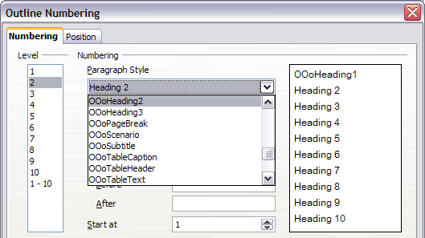
Figure 211: Choosing paragraph styles for outline levels
- In the Numbering: Paragraph Style section, choose the paragraph style you want to assign to that heading level from the drop-down list . For example, when setting up a chapter in the Writer Guide, you would click Level 1 and select OOoHeading1 (a custom style defined for the project) to replace Heading 1 and for Level 2, OOoHeading2 to replace Heading 2.
- Repeat for each outline level that you want to change. Click OK when done.

Assigning Outline Levels to Other Styles
You can assign an outline level to any paragraph style. This feature enables you to create a table of contents that includes those headings along with the headings using styles listed in the Outline Numbering dialog box. For example, you might use a different sequence of styles for annexes (appendixes), but you want the annex headings and subheadings to appear in the TOC at the same levels as the chapter headings and subheadings.
To assign an outline level to a paragraph style, go to the Outline & Numbering tab for the style, and select the required outline level. Click OK to save this change.
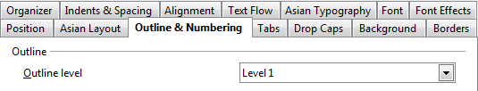
Figure 212: Specifying an outline level on the Outline & Numbering page for a paragraph style

Setting Heading Numbering
If you want one or more heading levels to be numbered, many choices are available; this example defines a scheme to create headings that look like those in Figure 213.
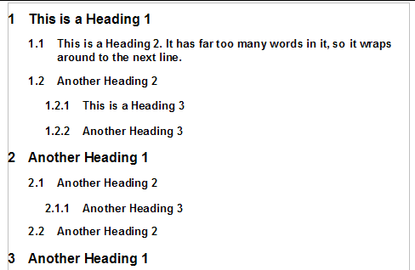
Figure 213: The numbering scheme to be set up.
Use the Numbering page of the Outline Numbering dialog box to define the numbering scheme and its appearance. Use Tools > Outline Numbering to access this dialog. Figure 214 shows the default settings.
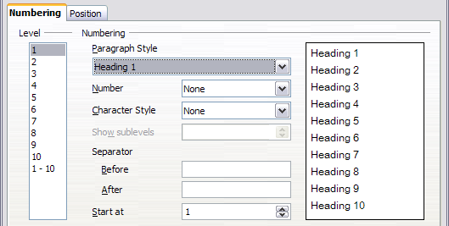
Figure 214: Default settings on the Outline Numbering dialog box.
- In the Level list, choose 1. In the Number list, choose 1, 2, 3, …. The result is shown in the preview box on the right in Figure 215.
- In the Level list, choose 2. In the Number list, select 1, 2, 3, …. The Show sublevels list is now active; it should show 2 (if not, select 2). The result is shown in Figure 216.
- In the Level list, choose 3. In the Number list, pick 1, 2, 3, …. The Show sublevels list should show 3 (if not, pick 3). The result is shown in Figure 217.
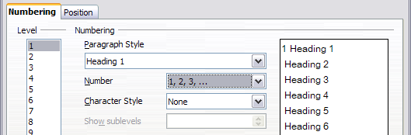
Figure 215: Specifying numbering of Level 1 headings.
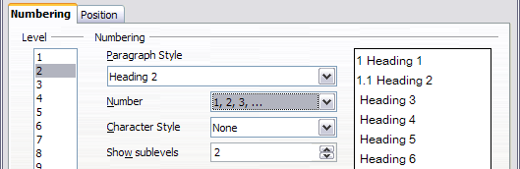
Figure 216: Specifying numbering of Level 2 headings.
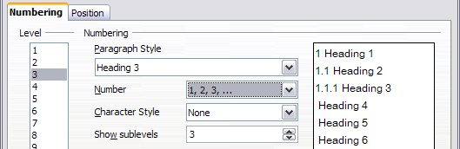
Figure 217: Specifying numbering of Level 3 headings.
These choices produce the layout shown in Figure 218.
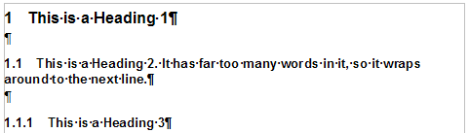
Figure 218: Results of numbering choices for headings

Setting Up the Indentation of Headings
Even when headings are numbered, you may want to change some of their formatting. For example, you may want the second-level and third-level headings to be indented from the margin. For numbered headings, you may also want the second line of long headings to line up with the first word of the heading, not the number. For such changes, use the Position page of the Outline Numbering dialog box.

Tip | OpenOffice documents created before version 3 display a different Position page. See the section Positioning in AOO3.x and AOO4.x Documents immediately below.

Positioning in AOO3.x and AOO4.x Documents
Figure 219 shows the Position page as it appears for documents created in OOo3.x.
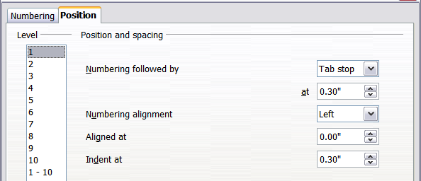
Figure 219: Setting up the position of level 1 headings
- In the Level list on the left, choose 2. Change the values for Numbering followed by… at and Aligned at, as shown in Figure 220. You may want to use a different value. This indents the entire heading but does not affect the way long headings wrap around (see Figure 221).
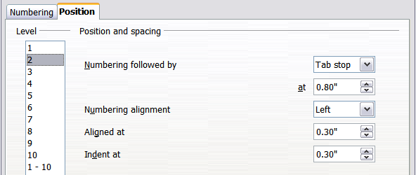
Figure 220: Indenting Level 2 headings
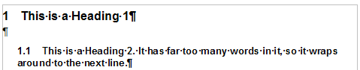
Figure 221: Result of changes to indentation of Level 2 headings
- To change the wrapping behavior of long headings, change Indent at to a larger value, as shown in Figure 222. The result is shown in Figure 212.
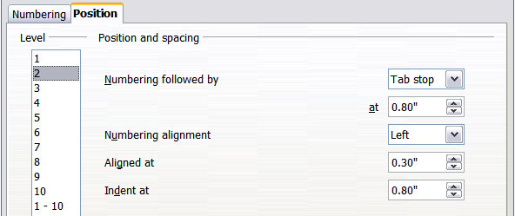Figure 222: Wrapping long headings
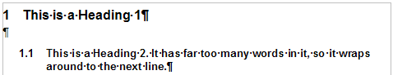
Figure 223: Result of changing Indent at value
- In the Level list, choose 3. Change the values for Numbering followed by… at, Aligned at, and Indent at, as shown in Figure 223. The final result is shown in Figure 212.
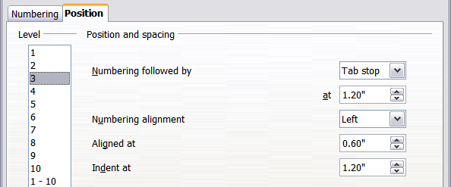Figure 224: Indenting level 3 headings

Positioning in older documents
Figures 208, 207, 199, and 191 show the Position page as it appears for documents created in earlier versions of AOO and opened in AOO4.x.
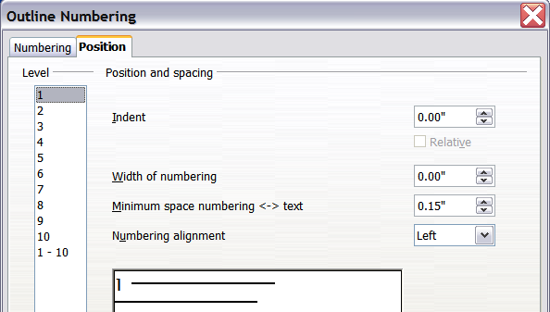
Figure 225: Setting up level 1 headings
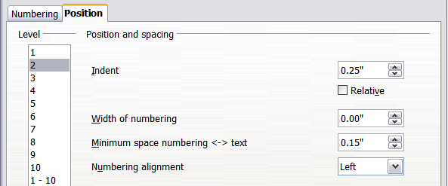
Figure 226: Indenting Level 2 headings
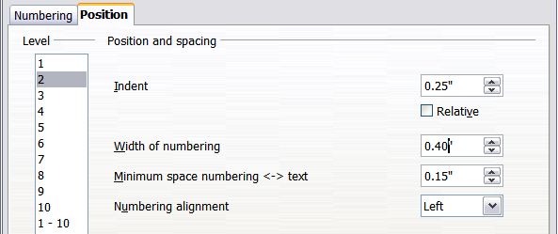
Figure 227: Changing the Width of numbering value to wrap long headings
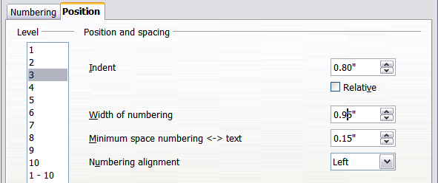
Figure 228: Indenting Level 3 headings

Chapter 7
Working with Styles

Introduction
Chapter 6 (Introduction to Styles) described the basics of using, applying, and managing styles. This chapter gives a more detailed description of creating or modifying styles, using the many options available on the various tabs of the Style dialogue. You will learn how these options affect the appearance of the style, and how to use them efficiently. Examples and hints are also provided.
The Style dialogues share many of the same pages as the manual formatting dialogues, so you can also use this chapter to help you apply manual formatting, though that may not be needed if you use styles.

Creating Custom (New) Styles
In addition to using the predefined styles provided by AOO, you can add new custom user-defined styles. In Chapter 6, two methods were given for creating a new style: the drag-and-drop approach and the New Style from Selection icon in the Styles and Formatting window.

These methods are very convenient, because they make it possible to check immediately the visual effects that the style produces, even before creating it. However, they may require you to access several menus, and you have a somewhat reduced amount of control of the style (particularly when it comes to organizing them). The method described in this chapter, therefore, concerns only the use of the Style dialog.

The Style Dialog
Open the Styles and Formatting deck of the Sidebar or the Styles and Formatting window. Select first the category of style you want to create by clicking on the appropriate icon in the top part of the Styles and Formatting window. For example, select the third icon from the left if you want to create a new frame style.
Right-click on the main window and select New from the pop-up menu. If you right-click on an existing style, the new style will be linked to the style you clicked on. If you right-click on an empty area, then the initial settings of the style are copied from the Default style of the corresponding category.
The dialog that is displayed depends on the type of style you selected. Many of the tabs are the same as those that are displayed when manual formatting is applied. Therefore, if you are familiar with manual formatting, you will find that you already know how to use most of the options. The dialog used to create a new style and to modify an existing one is exactly the same.
Tip | An exception to the above rule is conditional styles, which have a different dialog. See “Working with Conditional Paragraph Styles” on page 225.

The Organizer Tab
When creating a new style, the first tab you need to set up is the Organizer, which is shown in Figure 229. This tab is common to all style categories. Therefore, we'll describe it only once.

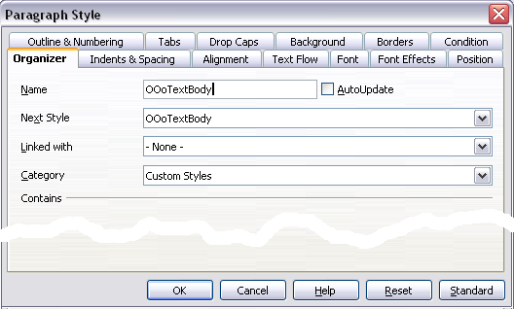
Figure 229: The Organizer tab displayed when a new style is created.
Depending on the style you are creating, you will find the following information on this tab:
- Name: present on all the categories—use this field to give a name to the style you are creating.
- AutoUpdate: only present for paragraph and frame styles. If it is checked, then Writer will apply any modification made manually to a paragraph formatted with that style to the style itself.

Caution | If you manually override styles in your document, be sure that AutoUpdate is not enabled. Neglecting this step may suddenly reformat whole sections of your document unexpectedly.

- Next Style: only available for paragraph and page styles. Use it to specify which style will be applied to the next element. It is customary, for example, to have a left page style followed by a right page, a first page followed by a left page, a heading followed by body text, and so on. You will see in a later example how this property is used. Predefined paragraph styles for lists or bullets also make large use of the Next Style property.
- Linked with: available for paragraph, character, and frame styles; it determines the position of the style in the hierarchy. When creating a new style and linking it to an existing style, all the starting properties of the style are copied from the linked style. Refer to “Understanding Linked Styles” on page 213 for further information on how linked styles work.
- Category: available for all styles; use it to associate the new style with one of the categories. Note that you cannot change the category of the predefined styles. Setting this field is useful when filtering the contents of the Styles and Formatting window.
- Contains: shows a summary of the properties of the style.

Understanding Linked Styles
When creating a new paragraph or a new character style, you may use an existing style as a starting point. In this sense, AOO links the styles together.
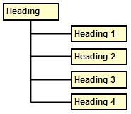Figure 230: Hierarchical view of linked styles.
When styles are linked, a change in the parent style affects every style linked to it. You can easily visualize the connections between styles by switching to the Hierarchical view in the Styles and Formatting window filter.
For example, every Heading style (such as Heading 1, Heading 2) is linked with a style called Heading. This relationship is illustrated in Figure 245.
Linking styles is a very powerful method to create “families” of styles, and allows you to change their properties simultaneously. For example, if you decide that all the headings should be blue (such as in this guide), you only need to change the font color of the parent style to achieve the desired result. Note however, that changes made to a parameter of the parent style do not override changes previously made to the same parameter in the child styles. For example, if you changed the Heading 2 font color to green, a change of the font color of the Heading style (the parent style) to red will not affect the Heading 2 font color.
You can easily check which properties are specific to a style by looking at the Contains section of the Organizer tab. In case you want to reset the properties of a child style to that of the parent style, click the Standard button located at the bottom of each Paragraph and Character style dialog tab.
Note | You cannot define a hierarchical style structure for Page, Frame, and List styles.

Creating a Linked Style
To create a linked style, you can either specify the parent style (the “linked with” style) in the Organizer tab of the Style dialog, or you can start creating a new style by right-clicking in the Styles and Formatting window on the style to be linked with and selecting New from the drop-down menu.

Example: Changing a Property of a Parent Style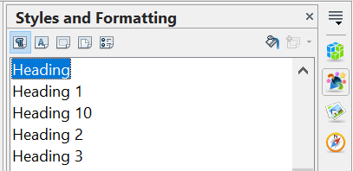

Figure 231: Select Heading style.
Suppose that you want to change the font of not only Heading 1 or Heading 2, but all headings. The easiest way to do that is to take advantage of linking.
Select the Sidebar's Styles and Formatting deck and select Heading.
Open the Paragraph Style dialog for the Heading style (right-click > Modify) and select the Font tab. Select a font and click OK (Figure 239).
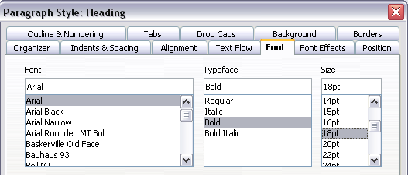
Figure 232: Select the heading font.
Now, the fonts of all the heading styles (Heading 1 through Heading 10) are changed in a single operation. Figure 233 shows on the left a document using the headings 1, 2 and 3 and on the right the same document after changes have been made to the Heading style.
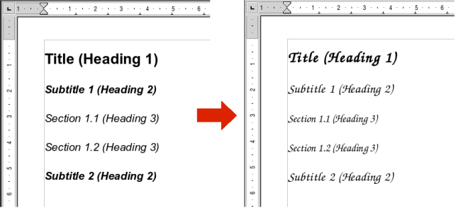
Figure 233: Effects of changing the Heading style font.

Working with Paragraph Styles
Although this section describes most of the parameters scattered over the twelve tabs shown in Figure 229, you do not need to configure them all. In fact, in the vast majority of cases it is sufficient to modify only a few attributes, particularly if you make use of the linking properties of styles or when basing the new style on one which is already similar.

Settings on the Indents & Spacing Tab
On the Indents & Spacing tab, you can set up the parameters that affect the position of the paragraph on the page, and the spacing between lines and between this paragraph and the paragraphs nearby. The right-hand side of the tab shows a preview of the applied settings.
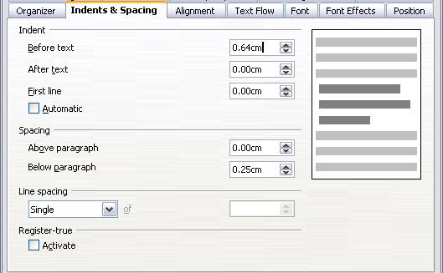
Figure 234: Settings on the Indents and Spacing tab of a paragraph style
Use the Indent section of the page to set up the indentation, using these parameters:
- Before text: controls the space in the selected unit of measurement between the left margin of the page and the leftmost part of the paragraph area. Entering a negative value results in the text starting on the left of the margin. This may be useful in situations where your left margin is quite wide, but you want the headings to be centered in the page.
- After text: controls the space in the selected unit of measurement between the right margin of the page and the rightmost part of the paragraph area. Entering a negative value results in the text extending into the right margin of the page.
- First line: enter into this box the offset (either positive or negative) of the first line of the paragraph relative to the paragraph area. A positive value increases the indentation of the first line, while a negative value makes the first line start to the left of the paragraph area.
- Automatic: check this box to allow Writer to automatically control the indentation of the first line. The value is calculated by Writer on the basis of the font size and other parameters.
Use the Spacing section of the tab to determine the amount of vertical space above and below the paragraph. It is customary to include some “space above” in heading styles, so that they are separated from the text body of the previous section without the need to insert empty paragraphs. Spacing between paragraphs is also normal in certain types of documents. For instance, the body text style of this guide is configured to leave some space between consecutive paragraphs.
The spacing between paragraphs does not affect the spacing between lines, which is instead controlled using the drop-down box in the Line spacing section. You can select one of the following values:
- Single: the default setting—applies a single line spacing to the paragraph. This is calculated automatically based on the font size.
- 1.5 lines: sets the line spacing to 1.5 lines.
- Double: sets the line spacing to 2 lines.
- Proportional: this value activates the edit box next to the drop-down list where you can enter a percentage value. 100% means a single line spacing, 200% double line spacing and so on.
- At least: this choice activates the edit box next to the drop-down list, where you can enter the minimum value (in your selected unit of measurement) to be used for the line spacing.
- Leading: if this value is selected, you can control the height of the vertical space inserted between two lines (from the bottom of the font of the line above to the top of the font of the line below). See Figure 237.
- Fixed: this choice activates the edit box next to the drop-down list, where you can enter the exact value of the line spacing.
Tip | When using different font sizes in the same paragraph, the line spacing will be uneven, as Writer automatically calculates the optimal value. To obtain evenly spaced lines, select Fixed or At least in the drop-down list and a value that is large enough to create a spacing between the lines sufficient to account for the largest font size used.

The last parameter that can be set in this tab is Register-true. If you have activated the Register-true for the page style in use (refer to “General Settings for the Page Style” on page 232) then the Reference style and all the styles hierarchically dependent on it will have the Register-True box selected, you may want however, to activate the vertical grid also for other styles (or not apply it to styles dependent on the reference style) and this is where this can be done.

Settings on the Alignment Tab
Use the Alignment page to modify the horizontal alignment of the text, choosing between Left, Right, Center, and Justified. The results of the selection are shown in a preview window on the right-hand side of the page.
When selecting the Justified alignment, you can also decide how Writer should treat the last line of the paragraph. By default, Writer aligns the last line to the left, but you can choose to align it to the center or to justify it, meaning that the words on the last line will be spaced in order to occupy it fully. If you select the Expand single word option, whenever the last line of a justified paragraph consists of a single word, this word will be stretched by inserting spaces between characters so that it occupies the full length of the line.
The alignment tab is also used to control the Text to Text vertical alignment—useful when you have mixed font sizes on the same row. Choose the element of the fonts on the line that will be aligned between Automatic, Baseline, Top, Middle, Bottom. Refer to Figure 235 for a graphical representation of these reference points.
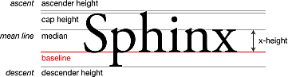
Figure 235: Typographic measurements (from Wikipedia.org)

Text Flow Options for Paragraph Styles
The tab of the dialog controlling the text flow options is shown in Figure 236. This tab is divided into three parts: Hyphenation, Breaks, and Options.
In the Hyphenation section, you can change three parameters:
- Characters at line end: controls the minimum number of characters to be left on a line before inserting a hyphen.
- Characters at line begin: controls the minimum number of characters that can be placed at the beginning of a new line following a hyphen.
- Maximum number of consecutive hyphens: controls the number of consecutive lines that terminate with a hyphen.
If you prefer Writer to automatically control the hyphenation, select the Automatically option.
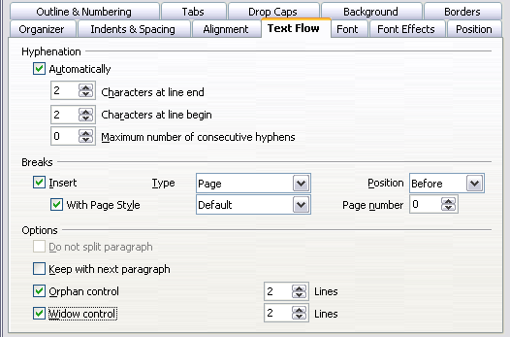Figure 236: The options on the Text Flow tab of the Paragraph dialog
In the Breaks section, you can require a paragraph to start on a new page or column, as well as specify the position of the break, the style of the new page, and the new page number. A typical use for this option is to ensure that the first page of a new chapter always starts on a new (usually right-hand) page.
To always start a style on a new page, choose the following settings on the Text Flow tab of the Paragraph Style dialog:
- In the Breaks section, select Insert. Make sure that Type is set to Page and Position is set to Before.
- Select With Page Style and choose the page style from the list.
- To continue page numbering from the previous chapter, leave Page number set at 0. To restart each chapter’s page numbering at 1, set Page number to 1. Click OK.
Note | If you want the first page of a new chapter to always start on a right page, make sure that the page style for the first chapter page is set for the right page only by making this selection in the Layout settings field on the Page tab of the Page Style dialog. Also note that a page that is intended to be read first is called a recto.

The Options section of the Text Flow tab provides settings to control what happens when a paragraph does not fit on the bottom of a page:
- Do not split paragraph means that the paragraph is never split across two pages. If it does not fit on the bottom of one page, the entire paragraph moves to the top of the next page.
- Keep with next paragraph is appropriate for headings or the lead-in sentence to a list, to ensure that it is not the last paragraph on a page.
- Orphan control and Widow control. Widows and orphans are typographic terms. An orphan is the first line of a paragraph alone at the bottom of a page or column. A widow is the last line of a paragraph that appears alone at the top of the next page or column. Use these options to allow paragraphs to split across pages or columns but require at least two or more lines to remain together at the bottom or top of a page or column. You can specify how many lines must remain together.

Font Options for the Paragraph Style
Three tabs of the Paragraph Style dialog are dedicated to settings controlling the appearance of the font, namely, the Font, Font Effects, and Position tabs. The use of the first two pages is straightforward. Many of the options used when creating a character style are discussed in “Figure 236: The options on the Text Flow tab of the Paragraph dialog” on page 217. Options that can be used when creating a paragraph style are described here.

Specifying a Relative Font Size
If you are creating a style based on another style (linked style), you can specify a font size relative to that other style—either as a percentage or as a plus or minus point value (–2pt or +5pt). Relative font sizes are commonly used for Web pages.
For example, the paragraph style Heading 1 is based on the paragraph style Heading. The font size of the paragraph style Heading is 14pt, and the font size of paragraph style Heading 1 is specified as 115%. Thus, the resultant font size of text in a paragraph formatted with the Heading 1 paragraph style is 14pt times 115% = 16.1pt.
To specify a percentage font size: in the Paragraph Style dialog, select the Font tab. In the Size box, enter the percentage amount followed by the symbol % (see Figure 237). Similarly, you can enter a plus or minus sign followed by the number of points to be added or subtracted from the base font size.
To change from a relative font size back to an absolute font size, enter the desired font size in points followed by the letters pt.
It is also possible to use a Percentage Font size for character styles.
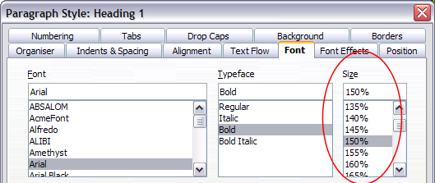Figure 237: Selecting a type size based on a percentage

Selecting a Language for a Paragraph Style
The language you select for a document (on Tools > Options > Language Settings > Languages) determines the dictionary used for spell checking, thesaurus, hyphenation, the decimal, and thousands delimiter used, and the default currency format.
Within the document, you can apply a separate language to any paragraph style. This setting has priority over the language of the whole document. On the Font tap of the Paragraph Style dialog, languages with installed dictionaries are marked in the Language list by a small ABC icon (Figure 238). When checking spelling, Writer will use the correct dictionary for paragraphs with this style. If you write documents in multiple languages, you can use the linked styles to create two paragraph styles that differ only in the language option. If you then want to change some other properties of the paragraph style, all you need do is to change the parent style.
To insert occasional words in a different language and avoid their being picked by mistake with the check-spelling function, it is more convenient to use a character style, as discussed in “Working with Character Styles” on page 227.
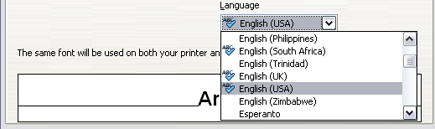Figure 238: Selecting a language for a paragraph style

Options for Positioning Text
The Position tab of the Paragraph Style dialog collects all the options that affect the position of the text on the screen or printed page. This tab is divided into three sections, plus a preview area. They are: Position, Rotation, and Scaling.
Use the Position section to control the appearance of superscripts and subscripts. However, you will normally apply superscript and subscripts to groups of characters, rather than to entire paragraphs. Therefore, it is strongly recommended to change these parameters only when defining a character style and, instead, leave the default settings for the paragraph styles.
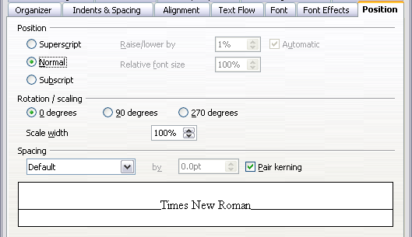Figure 239: The position tab of the Paragraph Style (default options)
The second section of the Position tab controls the rotation of the paragraph area. Two common uses for rotated paragraphs are:
- To put portrait headers and footers on a landscape page
- To fit headings above narrow table columns (as shown in Figure 240)
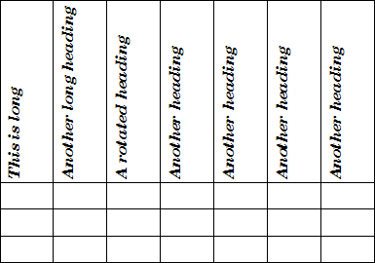Figure 240: A table with rotated headings
The Scale width box controls the percentage of the font width by which to compress or stretch the rotated text horizontally.
Chapter 4 (Formatting Pages) describes how to create portrait headers and footers on landscape pages by rotating characters. You can achieve the same effect by defining a separate header or footer paragraph style specifically for landscape pages.

Example: Rotating the Text in a Paragraph Style
As an example, we will apply rotated table headings to a preexisting table.
- Create a new paragraph style. Name it Table Heading Rotated.
- On the Position page of the Paragraph Style dialog, in the Rotation / scaling section, select 90 degrees. Click OK to save the new style.
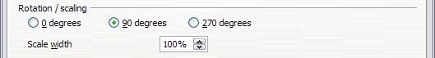Figure 241: Rotating a paragraph 90 degrees
- Select the heading row of the table and apply the new style. Any text in the cells of the heading row is now rotated.
- If the headings are aligned to the top of the cells, you may want to change the alignment to the bottom of the cells, as shown in Figure 240. To do this, click the Bottom button on the Table toolbar or select Format> Alignment > Bottom from the main menu.

Spacing Options
Use the Spacing section of the Position page to control the spacing between individual characters in the paragraph. When selecting an option other than default in the drop-down menu, use the edit box to enter the value in points by which you want to expand or condense the text.
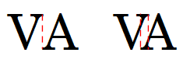Figure 242: Kerning disabled (left) and enabled (right).
The Pair Kerning option (selected by default) increases or decreases the amount of space between certain pairs of letters to improve the overall appearance of the text. Kerning automatically adjusts the character spacing for specific letter combinations. Kerning is only available for certain font types and, for printed documents, only works if your printer supports it.

Controlling Tab Stops
Although borderless tables are generally considered a much better solution to space out material across a page, in many situations tabs are sufficient to do what you need, with the added advantages of being simpler to manage and quicker to apply.
Tip | If you need to use tabs, and you will be sending a document to other people, do not use the default tab stops. If the recipients of the document have defined default tab stops that are different from the ones you use, the paragraph may look very different on their machines. Instead, define the tab stops explicitly in the paragraph or the paragraph style. That way, you can be sure that everyone will see the same layout.

To define tab stops in your paragraph style, use the tab shown in Figure 243. Here you can choose the type of tab: left, right, centered, or decimal; the character to be used as a decimal point; and the fill character—the characters that appear between the end of the text before the tab and the beginning of the text after the tab. You can also create a custom fill character by entering it in the corresponding box. Common use of a fill character is adding dots between a heading and a page number in a table of contents, or using the underscore character when creating a form to fill in.
Creating a new tab stop, therefore, is just a matter of deciding its position relative to the left margin, the type, the fill character and clicking the New button. The tab stop will be entered in the Position list on the left-hand side. Unfortunately, the only way to modify the position of a tab stop is to create a new one in the desired position, and then delete the old one using the buttons on the right-hand side of the page.
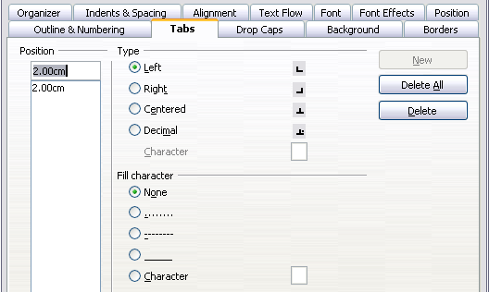Figure 243: Specifying tab stops for a paragraph style
Note that it is not possible to define tabs that exceed the page margin. In the rare cases where that may be needed, use a borderless table instead.

Using the Outline & Numbering Tab
Use the Outline & Numbering tab if you want to number the paragraph, for example if this style is to be used for a heading or list item.
You can assign an outline level to any paragraph style. This feature enables you to create a table of contents that includes those headings along with the headings using styles listed in Tools > Outline Numbering. For example, you might use a different sequence of styles for appendixes, but you want the headings and subheadings to appear in the TOC at the same levels as the chapter headings and subheadings.
To assign an outline level to a paragraph style, go to the Outline & Numbering tab for the style, and select the required outline level. Click OK to save this change.
This tab should be used in combination with list styles when you need to associate a certain paragraph style with a list style. Refer to “Combining List and Paragraph Styles” on page 243 for additional information on how to use this page, as well as an example.
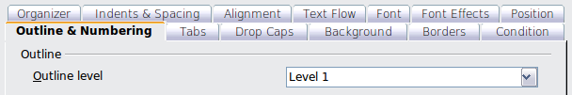Figure 244: Specifying an outline level on the Outline & Numbering tab for a paragraph style

Setting Up a Drop Cap
If you want your paragraph to use drop caps (usually this is suitable for a first paragraph style), then you can predefine the properties in the Drop Caps tab of the paragraph style dialog. Selecting the option to display drop caps enables the subsequent options where you can fine tune the appearance: the number of lines occupied, the number of characters to enlarge (if you want the whole first word, check the corresponding box), and the space between the drop caps and the text.
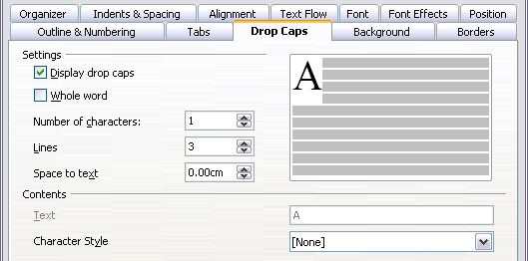
Figure 245: Options for adding a drop cap to the paragraph style

Drop caps use the same font and have the same properties as the rest of the paragraph. However, you can easily modify their appearance by creating a specific character style and using it. For example, you may want the drop caps to be of a different color or apply an outline effect. Select the character style you want to use in the corresponding drop-down menu.

Setting Up Paragraph Background and Borders
Adding a background color and a border to a paragraph is a good way to make it stand out without having to insert a frame. You can customize the background and border of the paragraph areas using the corresponding tabs of the paragraph style dialog. In addition to highlighting, borders are also often used to separate header and footer areas from the main text area (such as in this guide) as well as to provide decorative elements in some heading styles.
The two tabs are fairly intuitive. You may want to pay attention to the following points when working with the Background page:
- In case you do not find the desired color in the list of predefined ones, you can define your own by selecting Tools > Options > OpenOffice > Colors.
- You can use a graphic instead of a solid color as background. In the As drop-down list, select Graphic, then select the graphic object you want to use and adjust the parameters, as required. Detailed instructions on working with graphic backgrounds can be found in the Impress Guide.
- The background is applied only to the paragraph area. If you have defined an indented paragraph, the space between the paragraph and the margin does not have the paragraph’s background color.
On the Borders tab, the following points are worth considering:
- Watch out for the effects on indentations and tabulations that the spacing between borders and paragraph area produces,.
- If you want the border to be drawn around multiple paragraphs, leave the Merge with next paragraph option at the bottom of the tab marked.

Working with Conditional Paragraph Styles
A conditional paragraph style is another way of formatting text differently in different parts of a document. In some cases, you may find it saves time to use conditional styles rather than switching between styles as you type.
Making a paragraph style conditional means it changes its formatting depending on where it is used. For example, you may want the style MyTextBody to be black by default but turn white when inside a frame with a blue background.
Probably the most common use for conditional formatting is with single-style outlining. Single-style outlining is a type of outline numbering designed with a Numbering style, rather than with Tools > Outline Numbering. Instead of using different styles, it changes the number formatting whenever you press the Tab key to create a subordinate heading.
The only trouble with single-style outlining is that all levels look the same. This is where a conditional paragraph style comes in handy. Assign the paragraph style to an outline numbering style in the Outline & Numbering tab and then open the Condition page. There, you can assign the levels of the outline numbering style to other paragraph styles. Then, when you press the Tab key while using the paragraph style, each level of the outline takes on different formatting, making single-style outlining even more convenient than it is on its own.
Note | Predefined styles (other than Text body) such as Default, Heading 1, and Heading 2 cannot be defined as conditional.

Caution | If you want to make a style conditional, you have to do it while the style window is still open for the first time. After the window closes, the Condition tab no longer appears in the window.

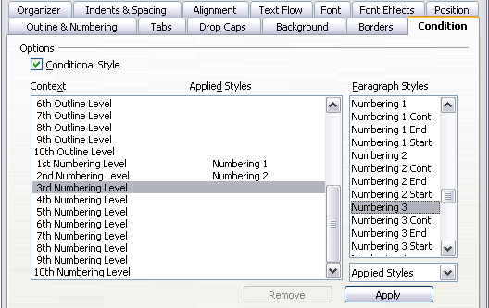Figure 246: Condition page for paragraph styles
When you create a conditional style, you are saying “in this condition, make this style look like that other style”. For example, “When typing into a footer, make this style look like the my_footer paragraph style; when typing into a table, make this style look like the table_text paragraph style”.
In addition to setting the normal (unconditional) properties of the style, you need to define which other style it will look like in different situations. You do this on the Condition tab.
To set up a conditional paragraph style:
- Define a new paragraph style.
- Select all the paragraph properties for the style. Do not click OK!
- Click the Condition tab.
- Select the Conditional Style option.
- Select the first condition in the Context list (left side of the dialog) and select the style you want for this condition in the Paragraph Styles list on the right-hand side.
- Click Apply. The name of the paragraph style appears in the middle list.
- Repeat steps 5 and 6 for each condition you want to link to a different style.
- Click OK.
When the style is selected, you will see that the formatting of your text depends on the context.

Working with Character Styles
Character styles complement paragraph styles and are applied to groups of characters, rather than whole paragraphs. They are mainly used when you want to change the appearance or attributes of parts of a paragraph without affecting other parts. Examples of effects that can be obtained by means of character styles are bold or italic typeface or colored words.
Two of the character styles used in this document are:
- Keystrokes use the custom OOoKeyStroke style.
  - For example:to set Writer to full screen, press Control+Shift+J.
- Menu paths use the custom OOoMenuPath style.
  - For example: to turn field shadings on or off, choose View > Field Shadings
Other ways of using character styles are described elsewhere in the Writer Guide. These uses include making chapter numbers, page numbers, or list numbers larger than the surrounding text and formatting hyperlinks. When inserting words in different languages, or words you don't want the spell checker to detect as mistakes (for example names in some programming languages for structures they support), character styles are quite useful, because you can define the language to be applied in the character-style properties.

Why Use Character Styles?
Beginning Writer users often wonder, “Why use character styles?” or “How is this different from clicking the bold icon to change the font typeface?” The following real-life event illustrates the difference.
Jean is a technical writer from Australia. She learned the value of character styles after her publisher told her to unbold menu paths in her 200-page book. Jean had not used character styles. She had to edit all 200 pages by hand, with some help from Find & Replace. This was the last time Jean failed to used character styles.
Character styles do not have as many options as paragraph styles or page styles. Their benefits are of a different nature:
- Formatting changes
As Jean’s story illustrates, the ability to make formatting changes throughout a document can be important. Character styles provide this.
- Consistency
Character styles help ensure that typesetting guidelines are applied consistently.
- Focus on content
“Was I supposed to bold keystrokes? How about menus?”
A writer should not have to remember the answers to these questions. Typesetting details distract you from the real content of your work. A properly named custom character style (such as OOoKeyStroke or OOoMenuPath) will remove this burden from you.

Creating a New Character Style
This section illustrates the use of the style dialog for creating a new character style.
The pages used to configure the character style have already been seen in the previous section on paragraph styles. Therefore, once you are familiar with creating paragraph styles, it will only take a few minutes to create a character style.
- Use the Organizer to set up the hierarchical level of the new character style (if needed) and to give it a name.
- Use the Font tab to determine the font, typeface, and size for your character style. As with paragraph styles, you can specify the size as a percentage rather than providing the absolute value. For example, 150% means that when the character style is applied to a 10pt font size, the new font size will be 15pt, while if applied to a 14pt font size, the new size will be 21pt. You can also specify the Language of the text to which a certain character style is applied, so you can insert words in a different language and have them spell checked using the correct dictionary.
- In the Font Effects tab, you can set up attributes such as font color, underlining, relief, or other effects. If you frequently use hidden text, for example, it is very convenient to define a character style where the Hidden option is marked. This way you only need a few mouse clicks to hide text. Relief effects may be appropriate for a drop cap or to give more emphasis to the chapter number or other parts of the title.
- You can use the Position page to create a subscript in case you are not satisfied with the default one or even a sub-subscript which may be useful for certain scientific publications. In the same page, you can create rotated, condensed, or expanded text.
Note | When rotating a group of characters, you also need to specify whether the rotated text should fit in the line or if, instead, it is allowed to expand above and below the line. This property only becomes active for character styles.

- Finish creating a character style by assigning a background, if so desired. Applying a background to a character style yields the same effect as using the highlighting tool on the standard toolbar.

Migrating to Character Styles
For people accustomed to formatting text manually, character styles may take some getting used to. Here are suggestions for making the transition easier:
- Never mix character styles and manual formatting. Manual formatting supersedes character styles. If you combine them, you may end up wasting hours in frustration trying to figure out why your character styles don’t work.
- Right-clicking and choosing Default Formatting removes any text formatting (both manual and character styles).
- Realize that clicking the Bold icon in the toolbar is not easier than double-clicking on a character style that is preset for bolding the font typeface.
- Use the Sidebar's Styles and Formatting deck to make character styles easy to access.

Working With Frame Styles
Frames are often used as containers for text or graphics. To provide consistency in the appearance of frames used for related purposes, it's a good idea to define styles for frames. For example, you might want photographs to be enclosed in a frame with a drop-shadowed border, line drawings in a frame with a plain border, marginal notes in a frame without a border but with a shaded background, and so on.
Writer provides several predefined frame styles, which you can modify as needed, and you can define new frame styles. The technique for defining and applying frame styles is similar to that for other styles.
Tip | There is considerable overlap between the uses of frames and of sections for some page layout purposes. You may find it useful to take a look at Chapter 4 (Formatting Pages) for information about the use of frames and sections.

How Frame Styles Work
When an object is added to Writer, it is automatically enclosed in a frame of a predetermined type. The frame sets how the object is placed on the page, as well as how it interacts with other elements in the document. You can edit the frame by modifying the frame style it uses or by using a manual override when a frame is added to the document.
Because frames and objects are used together, it is sometimes easy to forget they are separate elements. In some cases, such as charts, you can edit the frame and object separately, so the distinction is worth remembering.
Unlike other elements that use styles, frames, because their use can vary so much, can be defined only partly by their style. Several elements of frames, such as the anchor and protected elements, need to be defined manually for individual frames.
You can format a frame manually when you select Insert > Frame. The dialog that opens contains all the settings available when frame styles are set up, as well as some only available when the frame is inserted. As with other styles, the most efficient way to format frames is in the Styles and Formatting deck of the Sidebar.

Planning the Styles
If you are using a mix of graphics, you may want to define two related styles, one with a borderline for graphics with white backgrounds, and another without a border, for all other backgrounds. You also may want to design one or more frames for text only.
Otherwise, the default frame styles (listed in Table 3) cover most users’ needs. The only significant addition that many users might need is one or more styles for text frames.

Creating New Frame Styles
You can access frame settings by selecting New or Modify in the Styles and Formatting window for a frame style.
Table 3. Various frame styles and their uses
Style | Comments and Use
Formula | The frame style used for formulas. The default includes AutoSize, which adjusts the size of the frame to the formula.
Frame | The default frame style.
Graphics | The default style for graphics. The defaults include autosizing to fit the graphic, no text wrap, and a thin border around the frame. These are reasonable defaults, except for the border. Unless the background of the graphic is white and the document’s background also is white, the border usually is unnecessary.
Labels | The default style for use with File > New > Labels. It seems to be used by OpenOffice automatically and is not intended for users at all.
Marginalia | A style for placing a frame beside the left margin. As the name suggests, the Marginalia style is intended for comments added in the margin of text. The style also is useful for creating sideheads—headings against the left margin, which often are used in technical documentation. To set up sideheads, create body-text paragraph styles with two inches or more indentation from the left. Then, place the cursor at the start of a body-text paragraph, add the frame, and apply the Marginalia style.
OLE | The default style for OLE objects and floating frames. The default places the frame at the top and center of a body of text.
Watermark | The default style for a watermark, a graphic placed as the background to a body of text. The default is a Through wrap, with text passing over the frame and anything in it. The graphic should be faint enough that text still is readable over top of it.
Frame settings are available from the following tabs:
- Type tab: sets the size and position of the frame. One of the most useful options here is AutoSize, which automatically adjusts the frame to the object it contains. If the frame style is one used automatically, then this option should be selected.
- Options tab: sets whether the contents of the frame are printed and able to be edited in a read-only document. This page also sets the text direction, which is useful if you are using the frame for contents in a language that uses right-to-left text direction.
- Wrap tab: sets how text is positioned in relation to the frame and how close text comes to a frame. If you want the frame contents to stand out from the surrounding paragraphs, set the wrap to None. This probably is the single most important page for frames.
- Background tab: sets the background color or graphic. This page is useful mostly for text frames in complex page layouts, in which a text frame has an appearance different from the general background of the page.
- Border tab: sets the line around the frame, if any. Many beginning designers make the mistake of adding a border to every frame. However, when a colored background distinctly marks the division between the frame’s contents and the rest of the page, borders are unnecessary.
- Columns tab: this page can be ignored unless the frame is being used for text. The page is the same as is used to set up a page style, and its parameters are described in the section “Columns Tab” on page 234.
- Macro tab: sets a macro to use with the frame in order to trigger an action when the user interacts with the frame.

Working With Page Styles
Page styles control page properties (margins, page size, header and footers, among others). However, unlike paragraphs, which can have directly applied properties, pages only have a page style and no directly applied properties.
Christian is a lawyer from California. For his letters, the first page has his letterhead, and subsequent pages only identify the recipient, the date, and the page number. Christian accomplishes this with page styles. He also uses page styles to comply with the spacing requirements (such as margins) for legal briefs in California State courts.
This section describes how to create a new page style, explains the meaning of some options in the Page style dialog, and illustrates their usage.

Creating a New Page Style
Unlike other styles, page styles can be created or modified only by using the Styles and Formatting tool. Open the Styles and Formatting deck or window and click the Page Styles icon . Right-click anywhere in the main window and select New.
The Page Style dialog consists of the eight tabs.
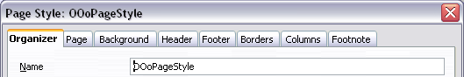Figure 247: The tabs for the Page Style dialog

The Next Style Property
As for the other styles, use the Next style property (described in “The Organizer Tab” on page 211) to specify the style for the subsequent pages. This property is particularly important for a page style, as the following example demonstrates.

Setting Up a Title Page
Consider a common scenario: you want the document to have a title page that is different from the rest of the document:
- It should not have a header or page number.
- The left and right margins should be the same.
For the title page, we can use the predefined First Page page style that comes with AOO, and for the rest of the document, we can use the Default page style.
Figure 244 shows the required flow of page styles. On the Organizer page of the Default page style, leave the Next Style property set to Default. On the Organizer page of the First Page style, make sure that the Next Style property is set to Default.
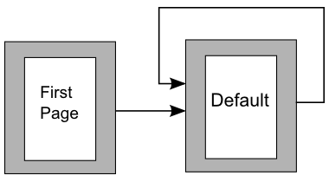Figure 248: Flow of page styles

General Settings for the Page Style
The Page tab of the Page Style dialog is where you can control the general settings of the page. The tab consists of three sections, plus a preview area in the top right corner.
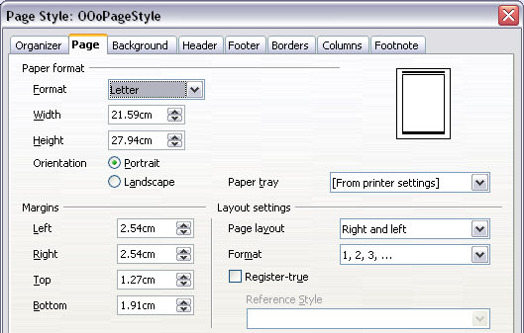
Figure 249: The Page tab for the Page Style dialog
In the Paper format section, you can specify the size of the paper, choosing from one of the many predefined formats. Selecting “user”, you can use the Width and Height fields to define your own paper size. If using a predefined format, select the orientation of the paper between portrait and landscape. If your printer has more than one tray, you can specify the tray from which to print pages in the new page style.
In the Margins section, specify the size of the margins in your preferred unit of measurement. If you select Mirrored margins in the Page layout settings, the left margin becomes the Inner margin, while the right margin becomes the Outer margin.
In the Layout settings section, choose the desired Page layout from the four available options. Decide whether the page style being defined applies to both left and right pages (default) or if instead it should be applied only to left pages, only to right pages, or be used in a mirrored layout. Some considerations:
- If you plan to bind printed pages that use this style like a book, select a mirrored layout.
- Use the Format drop-down menu to determine the page numbering style to apply to this page style.
- A common practice in page layouts is to have asymmetrical page margins—both for left and right margins and for top and bottom margins. There are various schemes for accomplishing this. The most frequently used follow these two general rules for printed page layouts: (a) The outer margin (right margin on a right-hand page) would have a wider margin than an inner margin (left margin on a right-hand page); (b) The bottom margin would be larger than a top margin. The rationale for an asymmetrical page layout is allowing more space for readers to place their hands while holding the books or other printed documents.
- If you want the first page of a new chapter to always start on a right (recto) page, make sure that the page style for the first chapter page is set for the right page only by making this selection in the Layout settings field. The typical procedure for the rest of a chapter is to define a single “mirrored” page style for both left and right pages. A mirrored page can have different headers and footers. If done this way, every chapter will use two page styles.
- You can choose to define separate page styles for left and right pages, if you want the pages to be very different in appearance (for example, different margins or headers and footers only on right pages but not on left pages; imagine a book with a full-page photograph on the left pages and text on the right pages). In that case, make sure that the Next Style field for the first page style is then set for a left-only page, which, in turn, is then set to be followed by a right-only page style. If done this way, every chapter will use three page styles. A hypothetical case might have these page-style names: First page, Left, and Right.
If you check the Register-true box, Writer will create a vertical grid on the page with a spacing between grid points that depends on the selected Reference Style. The vertical grid makes sure that text printed on adjacent columns, opposite pages, or even both sides of the same sheet of paper, is aligned—making it easier to read and being more pleasant to see.

Background and Border Tabs
Use the Background tab to apply a background or the Border tab to draw a border around text area of the page. You can choose between a solid color or a graphic image for the background and several styles of line for the borders. Note that the page area affected by these changes does not include the area outside the margins. If you plan to print on colored paper and want to have a feel of the final result you will obtain or want to use a light color for the font, rather than changing the background, then go to Tools > Options > OpenOffice and in the Appearance section, change the Document background color.

Header and Footer Tabs
You can associate a different header or footer to each page style. This property makes it very easy to have different headers on left and right pages, to avoid headers on pages at the start of a new chapter, and so on.
Setting up the header and footer pages is straightforward. The instructions here refer to the header, but the footer page has the same options. Activate the input boxes by selecting Header on, then specify the left margin, right margin, and spacing to the main text area. For the height of the header area, you can either select the AutoFit height box, which will make Writer adapt the size to the contents, or specify the height manually. Clicking More opens a new dialog, where you can set the borders and background of the header area.
If you deselect the Same content left/right box, you can specify a different header for left or right pages, even if you use a single style for both as shown here.
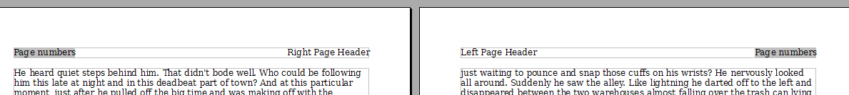
Figure 250: Different content on left and right pages

Columns Tab
Use this tab to create the desired column layout for the page style. The page is subdivided into three sections: Settings, Width and Spacing and Separator Line. The Settings section contains thumbnails of predefined columns settings you can select, as well as a text box where you can enter the desired number of columns if you need to create a customized one.
After you select more than one column, the Width and Spacing section becomes active. If you are not satisfied with the predefined settings (equally spaced columns), deselect the AutoWidth option and enter the parameters manually. When you work with multiple columns per page, you can also fine tune the position and size of a separator line between the columns.

Footnote Tab
Use this page to adjust the appearance of the footnotes. Keeping the default setting Not larger than page area, the footnotes area is calculated automatically on the basis of the number of footnotes. If you prefer to control manually the maximum space that footnotes can take, select the Maximum footnote height option and enter the value in the preferred unit of measurement. Use the second section of the page to customize the separator between the footnotes and the main area.

Example: A Book Chapter Sequence of Pages
Book chapters typically start on a right-hand page, with the first page of the chapter having a different layout from the rest of the pages. The other pages in the chapter are “mirrored” for double-sided printing. For example, page numbers in the header or footer may be positioned on the outside edge of pages and a wider margin (allowing for binding) may be placed on the inside edge.
Table 4 shows the properties of two page styles (Right Page and Default) set up for a typical book chapter’s sequence of pages.
Table 4. Properties of customized page styles for book chapter
Page Style | Desired effect |  | Property: setting
Right Page | First page always on the right (an odd-numbered page) | Page > Page layout > Only right
Right Page | No header or footer | Header > Header > Header on: Not selected
Right Page | Top margin of page larger than on other pages | Page > Margins > Top: 6.00 cm
Default | Mirrored margins | Page > Page layout: Mirrored
Default | Header with page number on the top outside of the page and chapter title in the top center of the page | Header > Header on: Selected  Header > Header > Same content left/right: Not selected
Figure 244 illustrates the transitions from the Right Page to Default page styles, with the change of header between left and right pages shown by the # symbol.
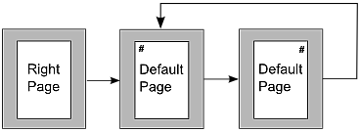
Figure 251: Right Page and then the Default page style with different headers for alternate pages.
Step 1. Set up the Right Page style.
- On the Styles and Formatting deck, click the Page Styles icon to display a list of page styles.
- Right-click on Right Page and select Modify from the pop-up menu.
- On the Organizer tab of the Page Style: Right Page dialog, change Next Style to Default.
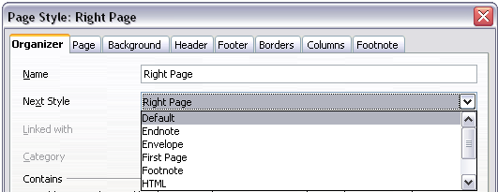
Figure 252: Specifying the next style after the first page of a chapter
- On the Page tab, specify a larger left margin for binding, and a larger top margin to move the chapter title down the page.
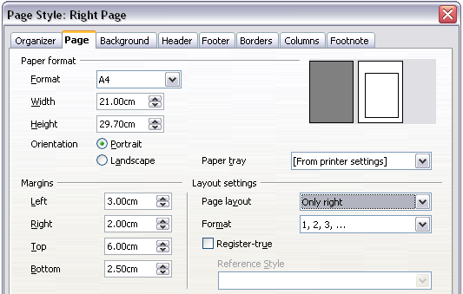
Figure 253: Setting page margins and layout for the Right Page style
- On the Header and Footer tabs, be sure the Header on and Footer on options are not selected. Click OK to save your changes.
Step 2. Set up the Default page style.
- On the Styles and Formatting deck, in the list of page styles, right-click on Default and select Modify from the pop-up menu.
- On the Organizer tab of the Page Style: Default dialog, be sure Next Style is set to Default.
- On the Page tab of the Page Style: Default dialog, select Mirrored for Page layout and set the Inner and Outer margins to the same width as the Left and Right margins, respectively, on the Right Page style.
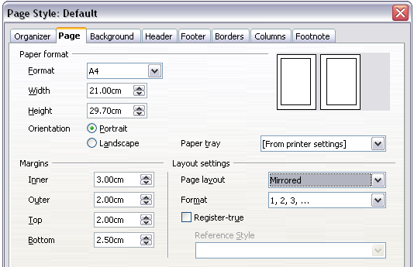Figure 254: Setting page margins and layout for the Default page style
- On the Header tab of the Page Style: Default dialog, select the Header on option and deselect the Same content left/right option. Click OK to save your changes.
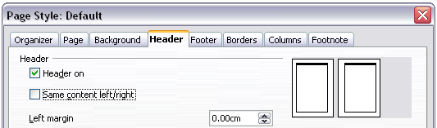Figure 255: Setting up the header properties for the Default page style
Step 3. Set up the Heading 1 paragraph style to start on a new right-hand page.
- In the Styles and Formatting deck, on the Paragraph Styles page, right-click on Heading 1 and select Modify.
- On the Text Flow tab of the Paragraph Style dialog, in the Breaks section, select Insert, With Page Style, and Right Page. The Type box should be set to Page and the Position should be Before. Click OK to save your changes.
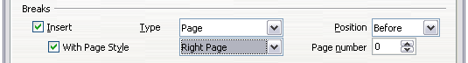Figure 256: Setting a paragraph style to start on a page of a selected style
Step 4. Start a new chapter.
Apply the Heading 1 paragraph style to the first paragraph, which is the title of the chapter.
Note | By default, the Heading 1 paragraph style is assigned to Outline Level 1. The assignment of paragraph styles to outline levels is done through Tools > Outline Numbering.

Step 5. Set up the page headers.
- On a left page, put the cursor in the header and insert a page number field on the left (Insert > Fields > Page Number).
- Press Tab to put the cursor in the middle of the page.
- Press Control+F2 (or choose Insert > Fields > Other from the menu bar) to display the Fields dialog (Figure 241).
- On the Document tab, for Type, select Chapter and for Format, select Chapter name. Make sure that Level is set to 1 and then click Insert.
- On a right page, put the cursor in the header, press the Tab key, insert a Chapter reference, press Tab again, and insert a page number field.
- If you need to adjust tab stops for the header, modify the Header paragraph style; don't manually adjust the tab stops.
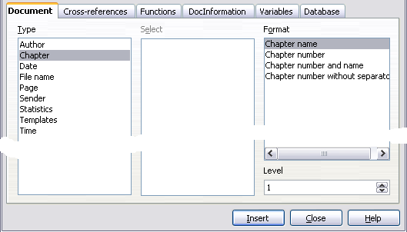Figure 257: Inserting a chapter title into the header of a page

Working with List Styles
List styles (also called numbering styles) work together with paragraph styles. They define indentation, alignment, and the numbering or bullet characters used for list items. You can define many list styles, from simple bulleted lists to complex multi-level (nested) lists.
As with other styles, the main reasons for using list styles are consistency and speeding up your work. Although you can create simple lists quickly by clicking the Numbering On/Off or Bullets On/Off icons on the Formatting toolbar, and create quite complex nested lists using the icons on the Bullets and Numbering toolbar, the appearance of the resulting lists may not be what you want—and you might want to have more than one style of list. You can use the Bullets and Numbering choice on the Format menu to manually format the appearance of some or all of the lists, but if you later need to change their appearance, you will have a lot of manual work to do.
Note | AOO uses the terms “numbering style” and “list style” inconsistently, but they are the same thing. For example, the tooltip in the Styles and Formatting window says “List Styles”, but its style dialog says “Numbering Style”.

Defining the Appearance of a Nested List
A nested list is a numbered or bulleted list with subordinate (usually indented) numbered or bulleted lists. Rather than just a list of numbered items (1,2,3…), a nested list may have item 1, then indented items numbered a, b, c or i, ii, iii or some other numbering method before the main number 2. With numbering styles, you can achieve any combination of numbering formats you want. A nested list may even combine numbered items with bulleted items.
There is no difference between defining a nested list style or a simple list, although nested lists require more work. An example of a nested list is given in Chapter 3 (Working with Text). In that case, the list was built using one of the predefined outline schemes as a starting point, while in this section we follow a more general approach so that the list can more fully suit your needs.

Creating a New List Style
The dialog to create a new list style consists of six tabs, in addition to the usual Organizer page discussed in “The Organizer Tab” on page 211. Bring up the dialog by right clicking in the Styles and Formatting window and selecting New. If you right click on a style name, the new style will be linked to the existing style. Right click on an empty area to make an independent style.

Bullets, Numbering Styles, and Graphics Tabs
The Bullets, Numbering Style, and Graphics tabs contain predefined formatting for list item symbols (bullets or numbers). To use one of them for your style, click on the image. A thick border indicates the selection. The bullets on the Bullets tab are font characters; those on the Graphics tab are graphics.
If you choose a graphics bullet, you can select the Link Graphics option to create a link to the graphic object rather than embedding it in the document. If you decide to link the graphic, keep in mind that the bullet will not be displayed when the document is opened on a different computer (unless the same graphic file is located in the same location on both computers) or if the graphic file used is moved to a different location on the originating computer.

Outline Tab
Use the Outline page to select from eight predefined nested lists. You can also select one and use it as a starting point for your own style, customizing the list using the Position tab and the Options tab, as described below.

Position Tab
Use the Position tab to fine tune the indentation and spacing of the list item symbol and the text of the list item. This tab is particularly effective when used in combination with the Options page.
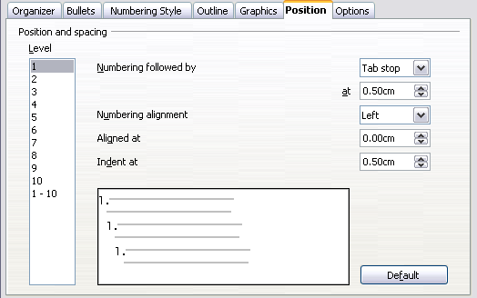Figure 258: Position settings for a List style
You can adjust the following settings for each individual level, or all at once to make them all the same. It is generally easier to adjust the settings in the order given below, instead of the order on the dialog. That is, start from the overall indentation for the list elements, then fix the position of the symbols, and finally adjust the alignment of the symbols.
- Numbering followed by: the character to follow the numbering symbol (plus any characters—for example a punctuation mark—chosen on the Options page to appear after the number). Decide between a tab stop, a space, or nothing. If you select the tab stop, you can specify the position of the tab.
- Indent at: how much space is reserved for the numbering symbol, measured from the left page margin. The alignment of the first line of the list is also affected by any tab you may have set to follow the numbering.
- Aligned at: the position of the numbering symbol, measured from the left margin of the page.
- Numbering alignment: how the numbering (including any text before or after as set in the Options page) will be aligned. The Aligned at value determines the symbol alignment.

Note | When defining an indentation different from 0, the position of the tabulation is not considered.

Tip | In normal circumstances, setting the Numbering followed by distance to be equal to the Indent at distance works well. See Figure 232 for a graphic representation of the effects of the above parameters.

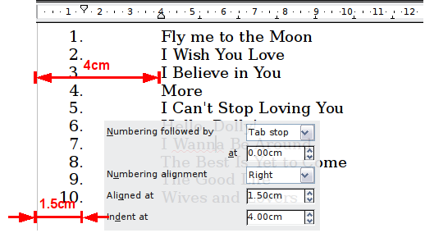
Figure 259: A numbered list of music tracks highlighting the various elements

Position Tab for Earlier Versions of AOO
If your document was created with an early version of AOO, or if the document was saved using the ODF file format version 1.1 or earlier, the position dialog will appear as in Figure 239.
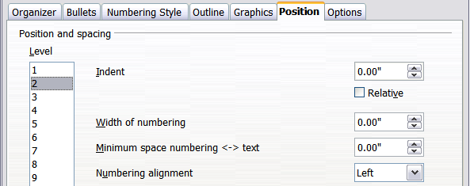
Figure 260: The Position tab for documents created with earlier versions of AOO
In this case you can adjust the following settings:
- Indent: the indentation of the number or bullet area, measured from the left margin of the paragraph linked to the numbering style. In other words, if the paragraph style already has an indentation, when the list style is applied the indentations are added together.
For any level other than Level 1, the Relative option causes the indentation to be measured from the start of the previous level rather than from the page margin.
- Width of numbering: how much space is used by the numbering symbol. Writer reserves this space, even if only part of it is used.
- Minimum spacing numbering <-> text: the spacing between the right edge of the numbering symbol and the text. If the spacing to text is not sufficient, Writer will honor this setting by expanding the numbering area. Setting the minimum spacing between numbering and text is very useful when right-aligning the numbering or when there is much text before or after the numbering.
- Numbering alignment: how the numbering (including any text before or after) will be aligned.
Tip | To fully appreciate how Numbering alignment works, try to create a numbered list with more than ten elements, making sure there's enough room for numbers with two or more digits. You may also wish to right-align numbers 10 or greater, as in Figure 234 on page 215.

Options Tab
Use the Options page to define the style of the outline levels. The options available on this depend on the type of marker selected for the list. First, on the left side, select the level you want to modify. To modify all ten levels at once, select 1-10 as the level. If you started from a predefined outline, some levels will already have settings.
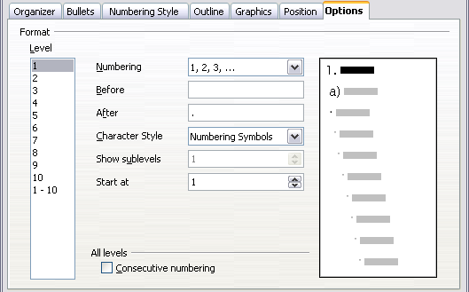Figure 261: The Options tab for a list style
Depending on the numbering style selected in the Numbering box (bullet, graphic, numbering), some of the following options become available on the page:
- Before: any text to appear before the number (for example, Step).
- After: any text to appear after the number (for example, a punctuation mark).
- Color: the color for the list marker (number or bullet character).
- Relative size: the size of the number relative to the size of the characters in the paragraph of the list.
- Start at: the first value of the list (for example, you might want the list to start at 4 instead of 1).
- Character Style: the style to be used for the number or bullet.
- Character button: click to select the character for the bullet.
- Graphics selection button: opens a list of available graphics (Gallery) or allows the selection of a file to be used as the list marker.
- Width and Height: the dimensions of the graphic marker.
- Alignment: the alignment of the graphic object.
- Keep ratio option: fixes the ratio between the width and the height of the graphic marker.
The right-hand side of the dialog shows a preview of the modifications made.
To revert to the default values, click the Reset button in the bottom right corner. Finally, if you wish to use consecutive numbers regardless of the outline level, check the Consecutive numbering box at the bottom of the page.

Combining List and Paragraph Styles
When applying a list style, the underlying paragraph style remains unchanged. If your list must also have a certain font size, indentations, and so on, you might expect to first apply a paragraph style and then a list style (or vice versa). However, you can embed a list style in a paragraph style using the Numbering page of the Paragraph Style dialog, and then apply only the paragraph style to the list.
This section gives an example of combining list and paragraph styles.
- Create a list style you want to use for the paragraph. For example: MyNumberedList.
- Create a new paragraph style.
- On the Organizer tab of the Paragraph Style dialog:
  - Give the new paragraph style a name, say NumberedParagraph.
  - For the Next Style, choose NumberedParagraph (this will make the following paragraph also be in this style, until you choose a different style).
  - In Linked with, choose None.
  - Leave Custom Styles, in the Category field.
- Set up this paragraph style to your liking. Because the indentation is controlled by the List style, to avoid undesired interactions do not change the indent settings on the Indents & Spacing page. (You might want to change the spacing above and below the paragraph.)
- On the Outline & Numbering page, choose the MyNumberedList style created in step 1.
- Click OK to save this style.
To accomplish full control of your lists, it is common practice to define three base paragraph styles for them: List Start for the first element of the list, List Continue for the subsequent elements of the list, and List End for the last element of the list. You should also define a paragraph style to be used for unnumbered list items (one for each nested level you intend to use) as well as an introductory style for the paragraph preceding the start of the list (to allow for keeping the introductory paragraph with the first list item, or for specifying spacing before the first list item that is different from the spacing between other paragraphs).

Example: Creating a Simple List Style
In this example, we will create a numbered list that is used to number the songs on a play list. The numbers are right aligned, and some space is left between the number and the title of the track.
As we want to reuse the same numbered list for other play lists, we will define a new list style and then apply it to the tracks list.

Creating the Tracks Numbered List
As for the previous example, start by clicking the List Styles icon (fifth from the left) in the Styles and Formatting deck. Then right-click anywhere in the list box and choose New.
The Numbering style dialog is displayed. For the Tracks style, we need to customize fields in the Organizer, the Options, and the Position tabs.
Style fields | Description
Name | Enter Tracks
Category | Custom styles will be OK for us.
Modify the options of the Options tab as follows:
- In the Level box, choose 1.
- In the Numbering list, choose 1, 2, 3, ….
- Leave the Before and After boxes empty.
- Leave the Character Style field as None.
- Show sub-levels should be grayed out.
- Make sure Start at is set to 1.
- Do not select Consecutive numbering.
As discussed above, the numbering list will adopt settings of the underlying paragraph style. If you want to use a special font, size, or color for the numbering, you can create a character style and apply it in the Options page.
If you want the word Track to appear before the number, just add it to the Before field in the Options dialog tab. Do not forget to add a space character to separate the word from the number.
Set up the final parameters of the Tracks list style in the Position tab.
- In the Level box, choose 1.
- For Numbering followed by, choose tab stop and set it at 4.0cm.
- For Numbering alignment, choose Right.
- For Aligned at choose 1.5 cm. (this refers to the alignment of the numbers)
- For Indent at choose 4.0 cm. (This sets the indentation of the whole list.) Click OK to finish.

Applying the List Style
Now that the list style is available, it can be quickly applied to any list in the document:
- If starting a new list, before pressing Enter to start a new line, double-click on the desired list style name in the Styles and Formatting deck.
- If you already have a list, select it and then double-click on the desired list style name in the Styles and Formatting deck.
Tip | Remember that applying a list style does not affect the characteristics of the underlying paragraph; therefore you may want to check if you are satisfied with the paragraph style before applying the list style.

If you have more than one list in a document, the second and subsequent lists with the same style continue their numbering from the previous list. To restart at 1, place the cursor anywhere in the paragraph you want numbered 1, right-click, and choose Restart numbering.
To stop using numbering, press the Numbering On/Off icon on the Standard toolbar. The final result is illustrated in Figure 232.

Chapter 8
Working with Graphics

Graphics (images) in Writer
When you create a text document using Apache OpenOffice (AOO) Writer, you may want to include illustrations. Graphics are added to documents for a wide variety of reasons: from supporting the description provided in the text—as used in this Guide—to providing an immediate visual representation of the contents, like those often found in a newspaper.
Graphics in Writer are of three basic types:
- Image files, such as photos, drawings, and scanned images
- Diagrams created using AOO’s drawing tools
- Charts created using AOO’s Chart facility
This chapter covers images and diagrams.
More detailed descriptions on working with drawing tools can be found in the Draw Guide and Impress Guide. Instructions on how to create charts are given in the Calc Guide.

Creating and Editing Images
You might create images, sometimes also called pictures in OpenOffice using a graphics program, scan them, or download them from the Internet.

Tip | If you download images from the Web, be careful to adhere to copyright. In other words, make sure you have permission to use such material.

Writer can import various vector (line drawing) and raster (bitmap) file formats. The most common are GIF, JPG, PNG, and BMP.
Some things to consider when choosing or creating pictures include image quality and whether the picture will be printed in color or black and white (gray scale).
Writer's image manipulation tools have the power and quality needed for everyday tasks like internal business documents or personal work. If illustrations of the highest quality are needed, it is better to use other software to prepare the images. To edit photos and other bitmap images, use a bitmap editor. To edit line drawings, use a vector drawing program. You do not need to buy expensive programs. Open-source (and usually no-cost) tools such as Gimp, a bitmap editor, and Inkscape, a vector drawing program, are excellent. For many graphics, AOO Draw is sufficient. These and many other programs work on Windows, Macintosh OS X, and Linux.
For best results:
- Create images that have the exact dimensions required for the document, or use an appropriate graphics package to scale photographs and large drawings to the appropriate dimensions.
- Do any other image manipulation (brightness and contrast, color balance, cropping, conversion to gray scale, and so on) in a graphics package.
- If the document is meant for screen use only, there is no need to use high resolution images of 300 or more dpi (dots per inch). Most computer monitors work at between 72 and 96 dpi; reducing the resolution (and the file size) has no negative impact on what is displayed but does make Writer more responsive.

Preparing images for black-and-white printing
If color images are to be printed in gray scale, check that any adjacent colors have good contrast and print dark enough. Test by printing on a black-and-white printer using a gray scale setting. Better still: change the “mode” of the image to gray scale, either in a photo editor or in Writer itself (see “Graphics Mode ” on page 253).
For example, the following diagram looks good in color. The circle is dark red and the square is dark blue. In gray scale, the difference between the two is not at all clear. The third element in the diagram, the yellow arrow, is almost invisible in gray scale.
Original drawing in color |   Drawing printed in gray scale
Changing the colors of the circle and the arrow improves the contrast and visibility of the resulting gray scale image.
  Original drawing in color | 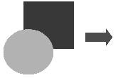  Drawing printed in gray scale
If the document will be available in black-and-white print only, a better result can often be obtained by choosing gray scale fills, not color fills. This choice ensures you won’t have to guess and test to see if you’ve made good choices.

Adding Images to a Document

Images can be added to a document in several ways: by inserting an image file, directly from a graphics program or a scanner, or from the AOO gallery.

Inserting an Image File
When the image is in a file stored on the computer, you can insert it into an AOO document using either of the following methods.

Drag and Drop
- Open a file-browser window and locate the image you want to insert.
- Drag the image into the Writer document and drop it where you want it to appear. A faint vertical line marks where the image will be dropped.
This method embeds (saves a copy of) the image file in the Writer document. To link the file instead of embedding it, hold down the Control+Shift keys while dragging the image.

Insert Picture Dialog
- Click in the AOO document where you want the image to appear.
- Choose Insert > Picture > From File from the menu bar.
- On the Insert Picture dialog, navigate to the file to be inserted, select it, and click Open.
At the bottom of the dialog are two options, Preview and Link. Select Preview to view a thumbnail of the selected image on the right, so you can verify that you have the correct file. See below for the use of Link.

Figure 262. Insert picture dialog

Linking an Image File
If the Link option in the Insert picture dialog is selected, AOO creates a link to the file containing the image instead, of saving a copy of the image in the document. The result is that the image is displayed in the document, but when the document is saved, it contains only a reference to the image file—not the image itself. The document and the image remain as two separate files, and they are merged together only when you open the document again.
Linking an image has two advantages and one disadvantage:
- Advantage – Linking can reduce the size of the document when it is saved, because the image file itself is not included. File size is usually not a problem on a modern computer with a reasonable amount of memory, unless the document includes many large graphics files; AOO can handle quite large files.
- Advantage – You can modify the image file separately without changing the document because the link to the file remains valid, and the modified image will appear when you next open the document. This can be a big advantage if you (or someone else, perhaps a graphic artist) is updating images.
- Disadvantage – If you send the document to someone else, or move it to a different computer, you must also send the image files, or the receiver will not be able to see the linked images. You need to keep track of the location of the images and make sure the recipient knows where to put them on another machine, so the document can find them. For example, you might keep images in a subfolder named Images, under the folder containing the document. The recipient of the file needs to put the images in a subfolder with the same name, again under the folder containing the document.
Note | When inserting the same image several times in the document it might appear beneficial to create multiple links. But this isn't necessary. AOO embeds only one copy of a given image file in the document.

Embedding Linked Images
If you originally linked images, you can easily embed one or more of them later if you wish. To do so:
- Open the document in OpenOffice and choose Edit > Links.
- The Edit Links dialog shows all the linked files. In the Source file list, select the files you want to change from linked to embedded.
- Click the Break Link button.
- Save the document.
Note | Going the other way, from embedded to linked, is not so easy. You must delete and reinsert each image, one at a time, selecting the Link option every time you do so.

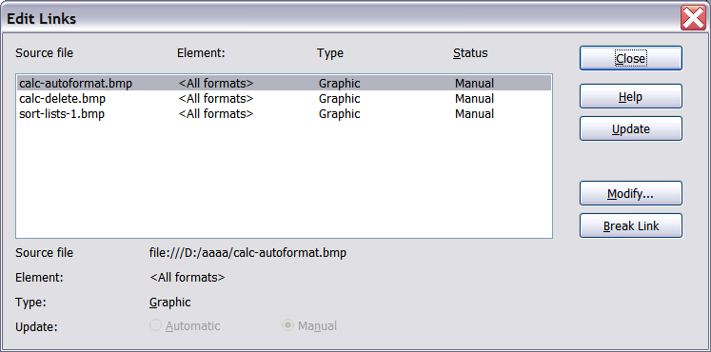
Figure 263: The Edit Links dialog

Inserting an Image from the Clipboard
Using the clipboard, you can copy images into an AOO document from another AOO document and from other programs. To do this:
- Open both the source document and the target document.
- In the source document, select the image to be copied.
- Press Control+C to copy the image to the clipboard.
- Switch to the target document.
- Click to place the cursor where the graphic is to be inserted.
- Press Control+V to insert the image.
Caution | If the application from which the graphic was copied is closed before the graphic is pasted into the target, the image stored on the clipboard could be lost.

Inserting an Image Using a Scanner
If a scanner is connected to your computer, AOO can call the scanning application and inserted the scanned item into the AOO document as an image. To start this procedure, click where you want the graphic to be inserted and select Insert > Picture > Scan > Select Source.
Although this practice is quick and easy, it is unlikely to result in a high-quality image of the correct size. You may get better results by scanned the desired material into a graphics program, and then cleaning it up, before inserting the resulting image into AOO.

Inserting an Image from the Gallery
The Gallery provides a convenient way to group reusable objects, such as graphics and sounds, that you can insert into your documents. The Gallery is available in all components of AOO. It doesn't provide many graphics, but you can add your own pictures or find extensions containing more graphics. The Gallery is explained in more detail in Chapter 11 (Graphics, the Gallery, and Fontwork) in the Getting Started guide. For more about extensions, see Chapter 17 (Customizing Writer) in this book.
This section explains the basics of inserting a Gallery image into a Writer document:
- To open the Gallery, click on the Gallery icon on the Sidebar or the Gallery icon of the Standard toolbar or choose Tools > Gallery from the menu bar.
- Navigate through the Gallery to find the desired picture.
- To insert the picture, click and drag it from the Gallery into the Writer document. You can also right-click on the picture and choose Insert > Copy.
Figure 264 shows an example of an image dragged from the Gallery.
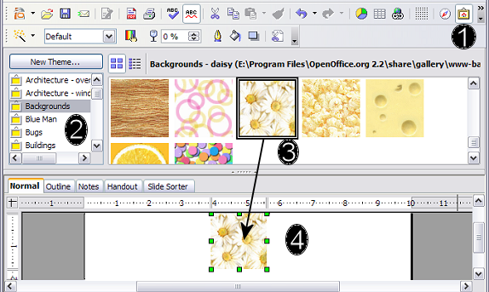
Figure 264. Inserting an image from the Gallery
The Gallery is most conveniently placed when it is accessed though the Sidebar, If the Gallery is opened from the Standard toolbar or the menu bar, by default it is docked above the Writer workspace. To expand the Gallery, position the pointer over the line that divides it from the top of the workspace. When the pointer changes to parallel lines with arrows, click and drag downward. The workspace resizes in response.
To expand the Gallery without affecting the workspace, undock it, so it floats over the workspace. To do so, hold down the Control key and double-click on the upper part of the Gallery next to the View icons. Double-click in the same area while holding down the Control key to dock it again (restore it to its position over the workspace).
When the Gallery is docked, to hide it and view the full Writer workspace, click the Hide/Show button in the middle of the thin bar separating the Gallery from the workspace.
To close the Gallery, choose Tools > Gallery to uncheck the Gallery entry, or click on the Gallery icon again.

Modifying an Image
When you insert a new image, you may need to modify it to suit the document. The placement of the picture relative to the text is discussed in “Positioning Graphics within the Text” on page 263. This section describes the use of the Picture toolbar, resizing, cropping, and a workaround to rotate a picture.
Writer provides many tools for working with images. These tools are sufficient for most people’s everyday requirements. However, for professional results it is generally better to use an image manipulation program such as GIMP to modify images (for example, to crop, resize, rotate, and change color values) and then insert the result into Writer.

Using the Picture Toolbar
When you insert an image or select one already present in the document, the Picture toolbar appears. You can set it to always be present (View > Toolbars > Picture). Picture control buttons from the Picture toolbar can also be added to the Standard toolbar. See Chapter 17 (Customizing Writer) for more information.
This toolbar can be either floating or docked. Figure 265 shows what the Picture toolbar looks like when it is floating.
Two other toolbars can be opened from this one: the Graphic Filter toolbar, which can be torn off and placed elsewhere on the window, and the Color toolbar, which opens as a separate floating toolbar.
From these three toolbars, you can apply small corrections to a graphic, or obtain special effects.
Many of the controls in the Picture and Color toolbars are available on the Graphic panel of the Sidebar's Properties deck when an image is selected. Figure 280 displays the panel. The functions provided by the Graphic Filter toolbar are not available on the Sidebar.

Graphics Mode
You can change color images to gray scale by selecting the image and then selecting Gray scale from the Graphics mode list.

Flip Vertically or Horizontally
To flip an image vertically or horizontally, select the image, and then click the relevant icon.

Filters
Table 5 provides a short description of the available filters. But as is so often the case, the best way to understand them is to see them in action. Feel free to experiment with the different filters and filters settings, remembering that you can undo all the changes by pressing Ctrl+Z or Alt+Backspace or by selecting Edit > Undo.
The Picture and Color toolbars
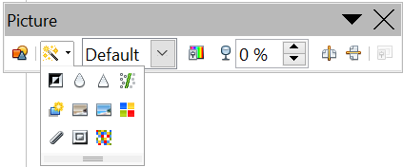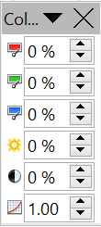  1  4  3  5  2  6  7  8  9  10  11  12  13  14  15  16  17  18  19  20  21  22  23  24  25  Note: Graphics mode (3) can be Default, Gray scale, Black/White, or Watermark.  Figure 265. Picture toolbar plus tear-off Graphic Filter toolbar and floating Color toolbar. | 1 | From File
 | 2 | Filter
 | 3 | Graphics mode
 | 4 | Color
 | 5 | Transparency
 | 6 | Flip Horizontally
 | 7 | Flip Vertically
 | 8 | Frame Properties
 | 9 | Invert
 | 10 | Smooth
 | 11 | Solarization
 | 12 | Aging
 | 13 | Charcoal Sketch
 | 14 | Relief
 | 15 | Mosaic
 | 16 | Posterize
 | 17 | Pop Art
 | 18 | Sharpen
 | 19 | Remove Noise
 | 20 | Red
 | 21 | Green
 | 22 | Blue
 | 23 | Brightness
 | 24 | Contrast
 | 25 | Gamma
The Graphic panel of the Sidebar's Properties deck
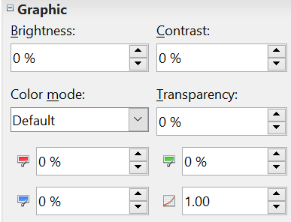  Figure 266: Sidebar Picture and Color controls | Color mode in the Sidebar is the same as Graphics mode in the Picture toolbar
 | See the note in Figure 265

Color
Use this toolbar or the same tools in the Sidebar to modify the individual RGB color components of the image as well as the brightness, contrast, and gamma of it.

Note | RGB is shorthand for red, green, and blue - the three colors of light which can be mixed to produce any other color

Note | Gamma refers to the fact that computer monitors produce light intensity which may not be in sync with the value expected by the computer's display. So, to arrive at precise colors, a process called gamma correction might be used.

If the result is not satisfactory, you can press Control+Z to restore the default values.
Table 5: Graphic filters and their effects
Icon | Name | Effect
 | Invert | Inverts the color values of a color image or the brightness values of a gray scale image.
 | Smooth | Softens the contrast of an image.
 | Sharpen | Increases the contrast of an image.
 | Remove noise | Removes single pixels from an image.
 | Solarization | Mimics the effects of too much light in a picture. A further dialog box opens to adjust the parameters.
 | Aging | Simulates the effects of time on a picture. Can be applied several times. A further dialog box opens to adjust the aging level.
 | Posterize | Makes a picture appear like a painting by reducing the number of colors used.
 | Pop Art | Modifies the picture dramatically.
 | Charcoal | Displays the image as a charcoal sketch.
 | Relief | A dialog box is displayed to adjust the light source that will create the shadow and, hence, the relief effect.
 | Mosaic | Joins groups of pixels into a single area of one color.

Transparency
Modify the percentage value in the Transparency box on the Picture toolbar or the Sidebar to make the image more transparent. This is particularly useful when creating a watermark or when wrapping the image in the background.

Using the Formatting Toolbar and Picture Dialog
When an image is selected, you can customize some of how it looks using the tools available on the Formatting toolbar (shown in Figure 270) as well as in the dialog that is shown.

To make this work, you should click on the More Options icon at the right edge of the title area of the Position and Size panel on the Sidebar, or right-click on the image and select Picture. You can, for example, create a border around the image, selecting style and color; or you can (in the Borders page of the Picture dialog) add a shadow to the image.

Cropping Images
When you are only interested in a section of the image for the purpose of your document, you may wish to crop (cut off) parts of it.
Note | If you crop an image in Writer, the picture itself is not changed. If you export the document to HTML, the original image is exported, not the cropped image.

To start cropping the image, click on the More Options icon of the Sidebar's Position and Size panel or right-click on it and select Picture from the pop-up menu. In the Picture dialog box, select the Crop page.
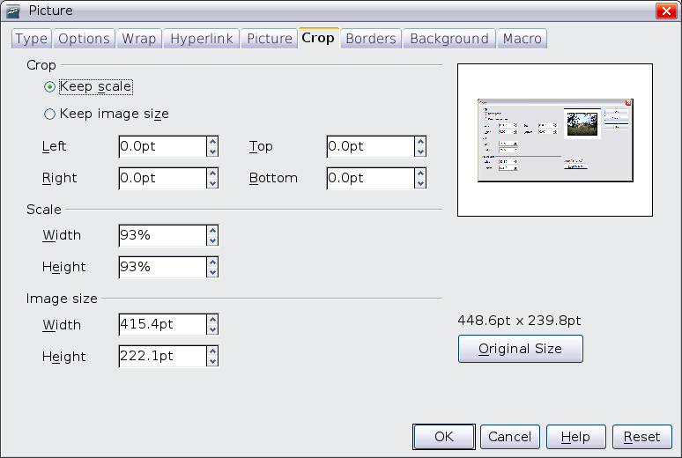

Figure 267: The options available when cropping a picture
In the Crop page, you can control the following parameters:
Keep scale / Keep image size
When Keep scale is selected (default), cropping the image does not change the scale of the picture.
When Keep image size is selected, cropping produces enlargement (for positive cropping values), shrinking (for negative cropping values), or distortion of the image so that the image size remains constant.
Left, Right, Top, and Bottom
The image is cropped by the amount entered in these boxes. For example, a value of 3 cm in the Left box cuts 3 cm from the left side of the picture.
- When Keep scale is selected, the size of the image also changes, so in this example the width will be reduced by 3 cm.
- When Keep image size is selected, the remaining part of the image is enlarged, if you've entered positive values, or shrunk if you enter negative values, so that the overall width and height of the image remains unchanged.
Width and Height
The Width and Height fields under either Scale or Image size change as you enter values in the Left, Right, Top, and Bottom fields. The thumbnail of the image at the top right of the dialog will show where the image will be cropped.

Resizing an Image
The inserted image might not fit perfectly into the document if it is too big or too small. In these cases you can use Writer to resize the image.
- Click the picture, if necessary, to show the green resizing handles.
- Position the pointer over one of the green resizing handles. The pointer changes shape giving a graphical representation of the direction of the resizing.
- Click and drag to resize the picture.
- Release the mouse button when satisfied with the new size.
The corner handles resize both the width and the height of the graphic object simultaneously, while the other four handles only resize one dimension at a time.
Tip | To retain the original proportions of the graphic, Shift+click one of the corner handles, then drag. Be sure to release the mouse button before releasing the Shift key.

Be aware that re-sizing a bit-mapped (raster) image will adversely affect the resolution, causing some degree of blurring. It is better to externally size your picture correctly before insertion into your presentation, if possible.

Note | A bit-mapped image is one in which each pixel displayed on the monitor screen corresponds directly to one or more bits in the computer's video memory.

Figure 268 shows three examples of an image inserted into a document and resized.
Example 1:  This is an image from the Gallery inserted without modification. | 
Example 2:
The image has been proportionally resized by dragging a corner handle while holding the Shift key.
Example3:
The image has been resized by dragging handles but not holding the Shift key, causing the proportions to change.

Figure 268. Three examples of resized images, plus the original image
For more accurate resizing, use either the Crop page of the Picture dialog box (Figure 267) or, for images, the Type page of the Picture dialog box. On the Crop page you can either adjust the following settings or use the settings in the Crop section as described on page 256.
- Scale Width and Height: specify in percentages the scaling of the picture. The size of the image changes accordingly. For a scaled resizing, both values should be identical.
- Image size: specify the size of the image in your preferred unit of measurement. The image enlarges or shrinks accordingly.
- Original size button: when clicked, restores the image to its original size.
In the Type page of the Picture dialog box, select the Relative option to toggle between percentage and actual dimension. For a scaled resizing, select the Keep ratio option. As for the Crop page, clicking on the Original Size button restores the original image size.

Rotating a picture
Writer does not provide a tool for rotating a picture; however, there is a simple workaround:
- Open a new Draw or Impress document (File > New > Drawing or File > New > Presentation).
- Insert the image you want to rotate. You can use any of the mechanisms described in “Adding Images to a Document” on page 248, although there are some slight variations in the position of the menu entries and icons.
- Select the image, then in the Drawing toolbar (shown by default at the bottom of the window in Impress and Draw), select the Rotate icon 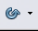 from the Effects tear-off toolbar .
- Rotate the image as desired. Use the red handles at the corners of the picture and move the mouse in the direction you wish to rotate. By default, the picture rotates around its center (indicated by a black crosshair), but you can change the pivot point by moving the black crosshair to the desired rotation center.
Tip | To restrict the rotation angle to multiples of 15 degrees keep the Shift key pressed while rotating the image.

- Select the rotated picture by pressing Ctrl+A, then copy the image to the clipboard with Ctrl+C.
- Finish by going back to the location of the Writer document where the image is to be inserted and pressing Ctrl+V.

Other Settings
The Picture dialog box (Figure 267) consists of nine pages. The Crop page was described on page 256, while the use of the Type and the Wrap pages is explained in “Positioning Graphics within the Text” on page 263. The other pages serve the following purposes:
- Options: use this page to give the picture a descriptive name (as you want it to appear in the Navigator), display alternative text when the mouse hovers over the picture, and protect some picture settings from accidental changes. You can also prevent the picture from being printed by deselecting the corresponding option.
- Borders: use this page to create borders around the picture. The Borders dialog box is the same as the one used for defining table or paragraph borders. Should you wish, you can also add a shadow to the image.
- Background: use this page to change the background color of the picture. This setting produces the desired results only for images with a transparent color.
- Hyperlink: use this page to associate a hyperlink to the picture. You can also create an image map so that only certain areas of the picture respond to a mouse click by opening the associated URI (Uniform Resource Identifier) in the default browser. More information on image maps can be found in the Impress Guide.
- Picture: use this page to flip the picture as well as to display the original location of the file in case the image is linked rather than embedded.
- Macro: allows you to associate a macro to the picture. You can choose among the predefined macros or write your own.

Deleting a Picture
To delete a picture:
- Click on the picture, to show the green resizing handles.
- Press Delete.

Using Writer’s Drawing Tools
You can use Writer’s drawing tools to create graphics that rely on rectangles, circles, lines, text, and other predefined shapes. You can also group several drawing objects, to make sure they maintain their relative position and proportion.
You can place the drawing objects directly on a page in your document, or you can insert them into a frame.
You can also use the drawing tools to annotate photographs, screen captures, or other illustrations produced by other programs, but this is not recommended because:
- You cannot include images in a group with drawing objects, so they may get out of alignment in your document.
- If you convert a Writer document to another format, such as HTML, the drawing objects and the graphics will not remain associated; they are saved separately.
In general, if you need to create complex drawings, OpenOffice Draw, may better meet your needs. Draw includes many features such as layers, styles, and so on.

Creating Drawing Objects
To begin using the drawing tools, display the Drawing toolbar (Figure 269), by clicking View > Toolbars > Drawing.
If you are planning to use the drawing tools repeatedly, you can tear off this toolbar and move it to a convenient place on the window.

1 | Select | 5 | Free form Line | 9 | Symbol Shapes | 13 | Stars
2 | Line | 6 | Text | 10 | Block arrows | 14 | Points
3 | Rectangle | 7 | Callouts | 11 | Flowcharts | 15 | Fontwork Gallery
4 | Ellipse | 8 | Basic Shapes | 12 | Callouts | 16 | From File
 |  |  |  |  |  | 17 | Extrusion On/Off
Figure 269. The Drawing toolbar
To use a drawing tool:
- Click in the document where you want the drawing to be anchored. You can change the anchor later, if necessary.
- Select the tool from the Drawing toolbar (Figure 269). The mouse pointer changes to a drawing-functions pointer .
- Move the cross-hair pointer to the place in the document where you want the graphic to appear and then click-and-drag to create the drawing object. Release the mouse button. The selected drawing function remains active, so you can draw another object of the same type.
- To cancel the selected drawing function, press the Esc key or click on the Select icon (the arrow) on the Drawing toolbar.
- You can now change the properties (fill color, line type and weight, anchoring, and others) of the drawing object using either the Properties deck of the Sidebar, the Drawing Object Properties toolbar (Error: Reference source not found) or the choices and dialog boxes reached by right-clicking on the drawing object.

Set or Change Properties for Drawing Objects
To set the properties for a drawing object before you draw it:
- On the Drawing toolbar (Error: Reference source not found), click the Select tool.
- On the Sidebar or the Drawing Object Properties toolbar (Figure 270), click on the icon for each property and select the value you want for that property.
- For more control, or to define new attributes, you can click on the Area or Line icons on the toolbar or the More Options icons of the Sidebar to display detailed dialog boxes.
The default you set applies to the current document and session. It is not retained when you close the document or close Writer, and it does not apply to any other document you open. The defaults apply to all the drawing objects except text objects.
1 | Line | 5 | Line Color | 9 | To Foreground | 13 | Alignment
2 | Arrow Style | 6 | Area | 10 | To Background | 14 | Change Anchor
3 | Line Style | 7 | Area Style / Filling | 11 | Bring to Front | 15 | Ungroup
4 | Line Width | 8 | Rotate | 12 | Send to Back | 16 | Group
Figure 270. Drawing Object Properties toolbar
To change the properties for an existing drawing object:
- Select the object.
- Continue as described above.
You can also specify the position and size, rotation, and slant and corner radius properties of the drawing object:
- Right-click on the drawing object and then click Position and Size from the pop-up menu. The Position and Size dialog box is displayed.
- Choose any properties, as required.

Resizing a Drawing Object
The same considerations for resizing an image apply to resizing an object. Select the object, click on one of the eight handles around it and drag it to its new position. For a scaled resizing, select one of the corner handles and keep the Shift key pressed while dragging the handle to its new position.
For more sophisticated control of the size of the object, select Format > Object > Position and Size from the menu bar. Use the Position and Size dialog box to set the width and height independently. If the Keep ratio option is selected, then the two dimensions change so that the proportion is maintained, allowing for a scaled resizing.

Grouping Drawing Objects
To group drawing objects:
- Select one object, then hold down the Shift key and select the others you want to include in the group. The bounding box expands to include all the selected objects.
- With the objects selected, hover the mouse pointer over one of the objects and choose Format > Group > Group from the menu bar or right-click and choose Group > Group from the pop-up menu.
Note | You cannot include an embedded or linked graphic in a group with drawing objects.

Positioning Graphics within the Text
When you add a graphic to a text document, you need to choose how to position it with respect to the text and other graphics. The positioning of graphics is often rather time-consuming, and may be very frustrating for both inexperienced and experienced users. As Writer is a word processor rather than a desktop publishing program, there are some limitations to its flexibility in positioning images; it takes time to get things exactly as you would like them.
Positioning of a graphic is controlled by four settings:
- Arrangement refers to the placement of a graphic on an imaginary axis perpendicular to the plane of the page. Arrangement controls how graphics are stacked upon each other or relative to the text.
- Alignment refers to the vertical or horizontal placement of a graphic in relation to the chosen anchor point.
- Anchoring refers to the reference point for the graphics. This point could be the page, or frame where the object is, a paragraph, or even a character. An image always has an anchor point.
- Text wrapping refers to the relation of graphics to the surrounding text, which may wrap around the graphic on one or both sides, be overprinted behind or in front of the graphic, or treat the graphic as a separate paragraph or character.
The settings can be accessed in a number of ways, depending on the nature of the graphics:
- From the Format menu, where you can find Alignment, Arrange, Wrap, and Anchor (both for images and drawing objects).
- From the pop-up menu displayed when you right-click on the graphic.
- From the Object toolbar shown in Figure 271.
- For images, from the Type and Wrapping pages of the Picture dialog box. Note that you cannot control the arrangement using the dialog box. To open the Picture dialog box, click on the image to select it and then choose Format > Picture or right-click on the graphic and choose Picture on the pop-up menu.
- For drawing objects, from the Position and Size page of the Position and Size dialog box. To open the Position and Size dialog box, click on the drawing object to select it and then choose Format > Object > Position and Size or right-click on the graphic and choose Position and Size on the pop-up menu. Note that you can only control the alignment and anchoring.
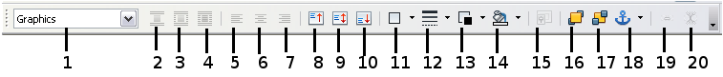
1 | Apply Style | 6 | Center Horiz. | 11 | Borders | 16 | Bring to Front
2 | Wrap Off | 7 | Align Right | 12 | Line Style | 17 | Send to Back
3 | Page Wrap | 8 | Top | 13 | Line Color (of border) | 18 | Change Anchor
4 | Wrap Through | 9 | Center | 14 | Background Color | 19 | Link Frames
5 | Align Left | 10 | Bottom | 15 | Frame Properties | 20 | Unlink Frames
Figure 271. Object toolbar (graphical control of positioning for images)

Arranging Graphics
Arranging a graphic object means to determine its position stacked in the plane of the page relative to other graphic objects or text. Arranging is only relevant when objects are overlapping. You can choose between four settings, plus a special setting for drawing objects:
Bring to Front
Places the graphic on top of any other graphics or text.
Bring Forward
Brings the graphic one level up in the stack (z-axis). Depending on the number of overlapping objects, you may need to apply this option several times to obtain the desired result.
Send Backward
The opposite of Bring Forward; sends the selected graphic one level down in the object stack.
Send to Back
Sends the selected graphic to the bottom of the stack, so that other graphics and text cover it.
To Background / To Foreground
Only available for drawing objects; moves the drawing object behind or in front of the text respectively.– e.g., Bring to Front vs Bring Forward ...

Anchoring Graphics
You can anchor graphics as individual characters, or to a page, paragraph, or character. You can also place graphics in a frame and anchor the frame to a page, paragraph, or character. Which method you choose depends on what you are trying to achieve.
Here are the ways you can anchor graphics or drawing objects:
To Page
The graphic keeps the same position in relation to the page margins. It does not move as you add or delete text or other graphics. This method is useful when the graphic does not need to be visually associated with a particular piece of text. It is often used when producing newsletters or other documents that are very layout intensive, or for placing logos in letterheads.
Caution | If you plan to use a document within a master document, do not anchor graphics To Page because the graphics will disappear from the master document. See Chapter 13 (Working with Master Documents) for more information.
To Paragraph
The graphic is associated with a paragraph and moves with the paragraph. It may be placed in the margin or another location. This method is useful as an alternative to a table for placing icons beside paragraphs.
To Character
The graphic is associated with a character but is not in the text sequence. It moves with the paragraph but may be placed in the margin or another location. This method is similar to anchoring to a paragraph but cannot be used with drawing objects.
As Character
The graphic is placed in the document like any other character and, therefore, affects the height of the text line and the line break. The graphic moves with the paragraph as you add or delete text before the paragraph. This method is useful for keeping screenshots in sequence in a procedure (by anchoring them as a character in a blank paragraph) or for adding a small (inline) icon in sequence in a sentence.
To Frame
If the graphic has been placed in a frame, you can anchor the graphic in a fixed position inside the frame. The frame can then be anchored to the page, a paragraph, or a character, as required.

Aligning Graphics
Once you have established the anchor point of the graphic, you can decide the position of the graphic relative to this anchor. That is, you can then align the graphic. Choose from six options: three for aligning the graphic horizontally (left, center, right) and three for aligning the graphic vertically (top, center, bottom). Horizontal alignment is not available for images anchored as character.
For finer control of the alignment, use the Position options on the Type page of the Picture dialog box, shown in Figure 272.
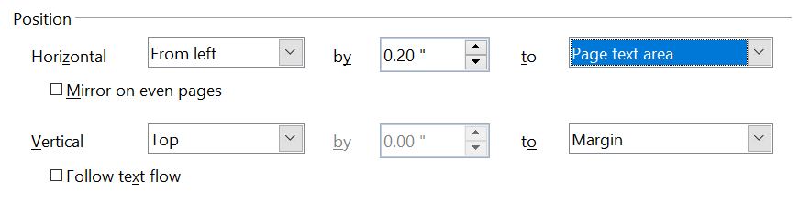

Figure 272: Fine tuning the alignment
For both the horizontal and vertical position, start by picking the reference point in the right-hand side drop down menu, then select in the first drop-down menu among Left, Right, or Center. If you select the value From left (or From top for the vertical positioning) you can specify the amount in your selected unit of measurement. In the example in Figure 272, the upper-left corner of the image will be placed at 0.2 in. from the left margin of the page horizontally and on the top margin vertically.

Wrapping Text Around Graphics
The Wrap setting determines the relation between the text and the graphic. Several possibilities are provided:
No Wrap
With this option the text is placed above and below the image but not around it. This is the wrapping type used for most of the figures in this guide.
Page Wrap or Optimal Page Wrap
The text flows around the image. Moving the image around the page causes the text to be rearranged to fill the space to the left and right of it. Optimal Page Wrap prevents text from being placed to the side of the image if the spacing between the image and the margin is less than 2 cm.
Wrap Through
Superimposes the image on the text. That is, the image is above the text. This option must be used in conjunction with the image-transparency setting in order to make the text under the picture visible.
In Background
Similar to Wrap Through, but the image is placed below the text so there may be no need to change the transparency to make the text visible.
Note | The No Wrap option found in the pop-up menu of a picture is equivalent to the Wrap Off menu item in the Format > Wrap menu.

The wrap format is normally selected after the anchoring and the alignment of the picture have been decided. To set the position of an image to the the desired wrap format, follow these steps:
- Select a graphic by clicking on it.
- Right-click to display the pop-up menu and move the mouse pointer to Wrap to display the available wrap formats. Alternatively you can select Format > Wrap from the main menu or use the Wrap panel on the Properties deck of the Sidebar.
- Select the desired wrap format.
Note | When anchoring a graphic as character, you can adjust the distance between the image and the text, but no wrapping option is available.
To fine tune the wrapping options, open the Picture dialog box and select the Wrap page shown in Figure 273. For images, you can open this dialog box by selecting Format > Picture from the main menu or right-click and select Picture from the pop-up menu. For drawing objects, you can access the Wrap page by selecting Format > Wrap > Edit in the main menu or right-click and select Wrap > Edit from the pop-up menu.
This page is divided into three sections. In the top part you can select among the wrap types mentioned above, plus two additional wrap formats that prevent the text from filling the area to the left (After) or to the right (Before) of the picture. Use the Spacing section of the page to adjust the spacing between the image and the text. The contents of the Options section of the page may change depending on the selected wrap format.
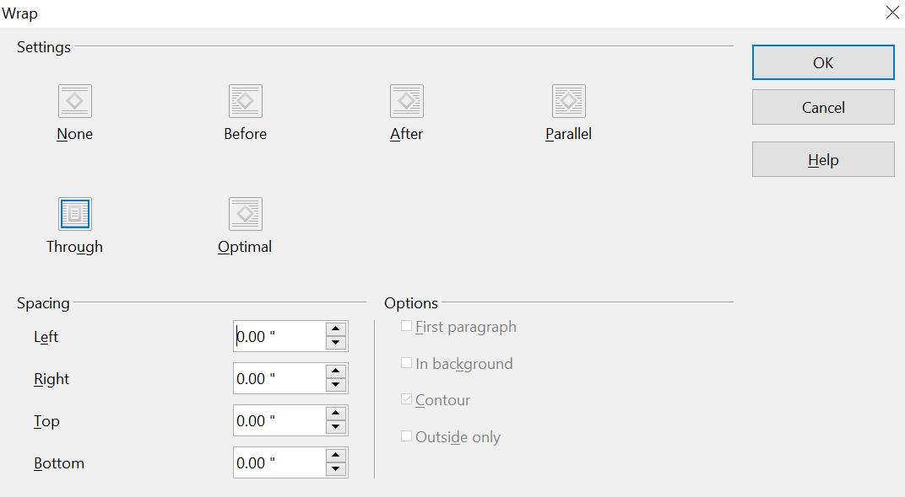

Figure 273: The advanced wrap format options
First paragraph
Check this box if you want AOO to start a new paragraph after the image, even if it could still wrap around the image.
In background
This option becomes available if Through Wrap is selected; it moves the image in the background.
Contour
Wraps the text around a custom contour rather than around the edge of the picture. This option is only available for Page or Optimal Page Wrap.
Outside only
Forces the text to wrap on the outside of the image, even if the contour contains open areas within the shape.

Editing the Contour
This option is only available for image wrapping. If you select wrapping around a drawing object, AOO automatically creates a contour. You can access the Contour Editor by selecting Format > Wrap > Edit Contour or from the right-click menu.
The dialog box of Figure 274 opens with the image loaded in the main window. Use the tools to draw the region of the image you do not want to be covered by the text—such area will be shaded.
Some familiarity with drawing tools is required to create complex contours; however, in most circumstances there is no need for high accuracy. Figure 274 shows the actual contour used for “Example 2: Simple Contour Wrapping in Action” and as you can see the shape of the line around the edge of the sphere is far from perfect.
When you are done, click on the Apply button to save the contour. If you are not satisfied with the result, you can select the contour line and press the Delete key to restart. You can also undo the previous steps, or you can select the Edit Points button and adjust the contour shape point by point.
For simple images, the AutoContour button does a decent job. If the contour has to be drawn around an area with the same or a similar color, you can select this region using the eyedropper. Select this tool, then click on a point in the image having the desired color. AOO automatically selects all the points which have the same or a similar color. The similarity level can be changed by modifying the value in the tolerance box (100% = perfect match).
Note | While all the positioning techniques discussed in this section apply equally to frames, contour wrapping is not possible.

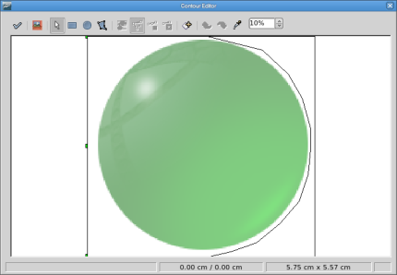
Figure 274: The Contour Editor in action

Example 1: Page Wrapping
Figure 275 shows an example of page wrapping in action.
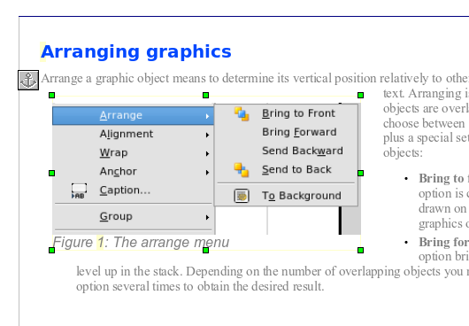

Figure 275: Example of image with Page Wrap formatting
Margin to image distance
Spacing image to text
Image anchor
The process to obtain this is the following:
- Insert the image into the document, then anchor it to the first paragraph. To move the anchor, select the image and move it until the anchor symbol is at the beginning of the paragraph. Do not worry about the position as that will be fixed in the next step.
- Align the image so that the left margin of the image is in line with the paragraph indentation. This can be done with the mouse or using the advanced settings. In the example, the image is placed 1 cm from the left margin.
- Change the wrap to Page Wrap. It starts out OK; however, there is still too little space between the image and the text. To correct it, access the Wrap page of the Picture dialog box and set the gap between the image and text to 0.2 cm in the Right and Bottom boxes.
- The last touch is to change the position so that the image is below the first line of the paragraph. Again, you can use the mouse to drag the image or use the advanced settings, which require a bit of trial and error. The line height used in this guide—0.75 cm from the top margin of the paragraph—is a good value.

Example 2: Simple Contour Wrapping in Action
In this example we again apply page wrapping as in example 1, but this time using the contour option. We will work on an image and on a drawing object as the contour option works slightly differently in the two cases.
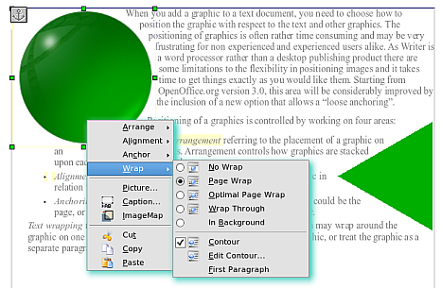
Figure 276: Image and drawing object with contour wrapping
The example of Figure 276 was built with the steps below,; use them to practice.
- Create some text (a very quick way to do that is to use the dummy text AutoText. That is, type DT and then press the F3 key).
- Insert an image of your choice and anchor it to the first paragraph. Adjust the alignment as desired, then change the wrap type to Page Wrap.
- Right-click on the picture to select the option Wrap > Contour, then right-click again and select Wrap > Edit Contour from the pop-up menu.
- Use the technique discussed in “Editing the Contour” on page 267 to create a custom contour and click Apply. If needed, adjust the spacing between the edge of the image and the text.
- Insert an AutoShape of your choice (a rotated triangle in the example) and proceed as in step 2 above.
- Enable the contour wrap by selecting Format > Wrap > Contour from the main menu. As discussed previously, AOO automatically generates the contour. You may need to adjust the distance between the drawing object and the text.

Example 3: Wrap Through and In Background
This example shows how to use an image as a watermark by wrapping it through the text and adjusting the transparency. This is not the best way to create watermarks; it's presented here only for purposes of illustration. If you need to create a watermark, it is best to use a Fontworks object wrapped in the background.
The Wrap Through option inserts an image overlapping the text which as a result will be hidden. To make the text appear, change the transparency of the picture; although the words under the image become visible, they may be difficult to read and will appear lighter than the rest of the text.
To reproduce the example of Figure 277, first create some dummy text. Then insert the image of your choice. Anchor the image (to the page in the example) and select the wrap through option from the Format > Wrap menu or right-clicking on the image and selecting Wrap > Wrap Through from the pop-up menu. Move the image into the desired position. The Picture toolbar should be displayed when the image is selected. Change the transparency to a suitable value (in the example this is 60%) so that the text can be read. In the example, a shadow effect is applied to the text (Format > Character then select Shadow in the Font Effects page).
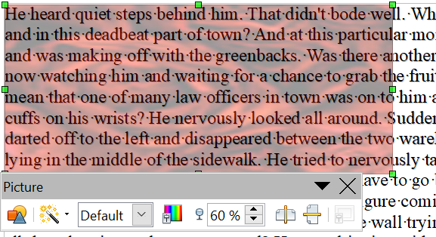

Figure 277: Transparent image added over the text
You can obtain a better result if you set a graphic’s wrap to In Background. In this case all the text will be clearly readable, with characters that have the same intensity as long as the background is not too dark. Also in this case you may want to adjust the transparency of the image.

Adding Captions to Graphics
You can add captions to graphics in three ways: automatically, by using the Caption dialog box, or manually.

Adding Captions Automatically
You can set up AOO to add captions automatically whenever you insert a graphic, a table, or other objects into a document. You can choose which objects are captioned automatically, what the sequence name is for each caption (for example, “Table” or “Illustration”), and the position of the caption.
To set up automatic captions:
- Click Tools > Options. On the Options dialog box, click on the + sign next to OpenOffice Writer to show a list of options.
- Select AutoCaption. Now you can see several choices at the right of the dialog box for adding captions automatically.
- Choose which objects you want to be automatically captioned and specify the characteristics of the captions.
For more information, see “AutoCaption options” in Chapter 2 (Setting up Writer).
When you insert a graphic, if automatic captioning is enabled, the graphic is placed in a frame along with a caption containing the default sequence name for graphics―Illustration. Position the cursor in the caption area and type the text for the caption. You can change the sequence name by selecting one from the drop-down Category list.
Note | You can specify where to place an automatic caption for any object except a picture; picture captions can only be automatically placed below the picture. If you need a caption above the picture (for example, for data plots in scientific publications), you must add the captions manually, as described in “Adding Captions Manually” on page 273.

Tip | A common sequence name—Figure—is not one of the names provided: <None>, Drawing, Illustration, Table, and Text. If you want the name “Figure” or any other custom name for your graphics, do the following:  - Open the Options – OpenOffice Writer – AutoCaption dialog box, as described above.  - In the Add captions automatically when inserting section, select OpenOffice Writer Picture. This activates the Caption area in the dialog box for pictures (graphics).  - Under the Category drop-down list, enter the name that you want added (say, Figure), by overwriting any sequence name in the list. (Overwriting a term does not delete it from the drop-down list.) You can also set some options for the number style and for a separator between the name and the number, if desired. Click OK to save the changes.

Using the Caption Dialog Box
To add captions using the Caption dialog box:
- Insert the graphic, then select it and click Insert > Caption.
- Under Properties on the Caption dialog box (Figure 278), make your selections for the Category, Numbering, and Separator fields (Illustration, Arabic (1 2 3), and a colon (:), respectively, for the example in Figure 278 and type your caption text in the Caption text box at the top. Whatever text you enter for the caption appears in the box at the bottom, after the sequence name, number, and separator.
- Click OK. The graphic and its caption are placed in a frame, as shown in Figure 279.
Tip | In the Category box, you can type any name you want, for example, Figure. AOO will create a numbering sequence using that name.

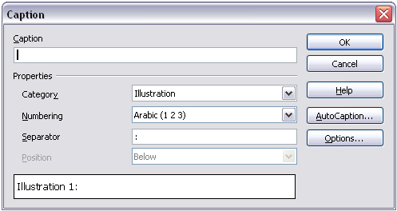
Figure 278. Defining the caption for an illustration
Illustration 1. An example
Figure 279. An example of a graphic and its caption contained in a frame. The outer box shows the edge of the frame; this border is normally set to be invisible.

Overriding the Default Positioning of Captions
The default positioning for picture captions is Below, and that position cannot be changed using the Caption dialog. However, you can override the positioning manually, as follows:
- Follow the instructions in “Using the Caption Dialog Box” on page 272 to create the caption.
- Right-click on the picture (not the frame surrounding picture and caption) and make sure that Anchor > To paragraph is selected.
- Left-click on the picture and drag it below the caption.
Tip | You may wish to adjust the spacing above and below the caption text, to fine-tune the appearance of the picture and its caption.

Adding Captions Manually
If you need to save as *.doc files or export in other formats, you may find that captions applied as described above (either automatically or using the Caption dialog box) are lost during the export. To avoid export problems, or as another way to put captions above pictures or below them (the usual case), you can add a caption manually, in either of two ways:
- Place the graphic and its caption in separate paragraphs.
- Use a table.

Place the Graphic and Its Caption in Separate Paragraphs
Insert the graphic and anchor it to its paragraph as a character. Press Enter to create a new paragraph for the caption.
- In the caption paragraph, type, for example, Figure and add a space.
- To insert the figure number automatically, click Insert > Fields > Other (Control + F2) and select the Variables tab.
- Select Number range in the Type list. Select Figure in the Selection list and choose, for example, Arabic (1 2 3) in the Format drop-down list. Click the Insert button.
- A number will appear after the word “Figure” in the caption. Now, type the text of the caption.
Tip | If you are manually adding captions to a lot of figures using this method, you might want to make an AutoText entry containing, for example, Figure and a space, the figure-number field, and an optional separator and a space after it.  To ensure the picture and its caption stay together on the page: if the picture is going above the caption, define the text flow of the Figure paragraph style as Keep with next paragraph and the next style as Caption. Conversely, if the caption is going above, define the Caption paragraph style as Keep with next paragraph and the next style as Figure.

Use a Table
Create a one-column, two-row table. Place the picture in one row and type the caption in the other row—or use two or more rows for the caption and other text. This method can be especially useful for pictures with numbered legends, such as Figure 271 in this chapter.

Creating an Image Map
An image map defines areas of an image, called hotspots, with hyperlinks to web addresses, other files on the computer, or parts of the same document. Hotspots are the graphic equivalent of text hyperlinks (described in Chapter 12). Clicking on a hotspot causes AOO to open the linked page in the appropriate program (for example, the default browser for an HTML page; AOO Calc for a .ODS file; a PDF viewer for a PDF file). You can create hotspots of various shapes and include several hotspots in the same image.
To use the image map editor:
- In your AOO document, select the picture where you want to define the hotspots.
- Choose Edit > ImageMap from the menu bar. The ImageMap Editor (Figure 263) opens.
- Use the tools and fields in the dialog (described on the next page) to define the hotspots and links necessary.
- Click the Apply icon to apply the settings.
- When done, click the Save icon to save the imagemap to a file, then click the X in the upper right corner to close the dialog.
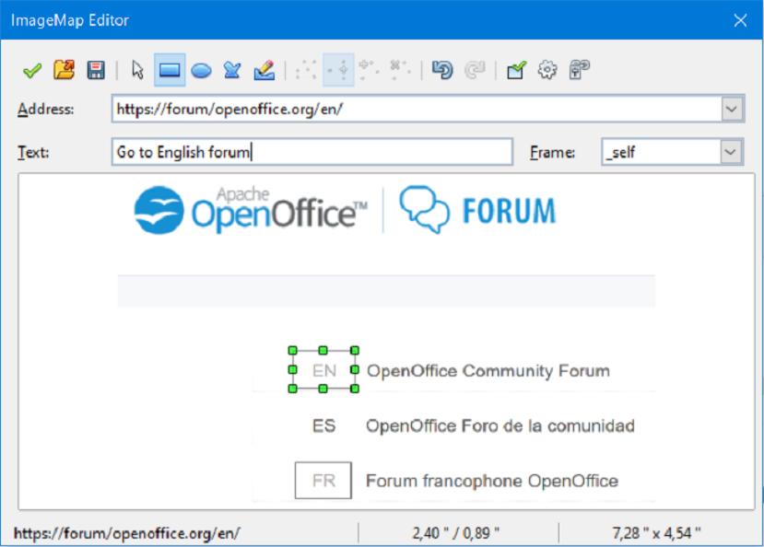Figure 280: The dialog to create or edit an image map
The main part of the dialog shows the image on which the hotspots are defined. A hotspot is identified by a line indicating its shape.
The toolbar at the top of the dialog contains the following tools:
- Apply button: click this button to apply the changes.
- Load, Save, and Select icons.
- Tools for drawing a hotspot shape: these tools work in exactly the same way as the corresponding tools in the Drawing toolbar.
- Edit, Move, Insert, Delete Points: advanced editing tools to manipulate the shape of a polygon hotspot. Select the Edit Points tool to activate the other tools.
- Active icon: toggles the status of a selected hotspot between active and inactive.
- Macro: associates a macro with the hotspot instead of just associating a hyperlink.
- Properties: sets the hyperlink properties and adds the Name attribute to the hyperlink.
Below the toolbar, specify for the selected hotspot:
- Address: the address pointed by the hyperlink. You can also point to an anchor in a document; to do this, write the address in this format (where <path> is the full directory path to the file): file:///<path>/document_name#anchor_name
- Text: type the text that you want to be displayed when the mouse pointer is moved over the hotspot.
- Frame: where the target of the hyperlink will open: pick among _blank (opens in a new browser window), _self (opens in the active browser window), _top or _parent.
Tip | The value _self for the target frame will work just fine in the vast majority of occasions. It is therefore not recommended to use the other choices unless absolutely necessary.

Adding an Image to the Gallery
You may wish to add to the Gallery any images that you use frequently, for example, a company logo. You can then very easily insert these graphics into a document later.
To add images to the Gallery, proceed as follows:
- Open the Gallery in the Sidebar.
- Select the theme to which you want to add images, or create a new theme. Note that you can add images only to “My Theme” or to any other theme that you have created; these are indicated by a green icon in the list of themes. You cannot add images to the built-in themes, indicated by an icon of another color.
To create a new theme:
  - Click the New Theme button above the list box of Themes. The Properties of New Theme dialog box opens, which is similar to the one shown in Figure 262.
  - Select the General tab (not shown) and type a name for the new theme in the text box.
  - Select the Files tab, skip step 3, and continue with step 4.
- Right-click on the desired theme and select Properties in the pop-up menu. You'll then see a window from which you can select the files to be added.
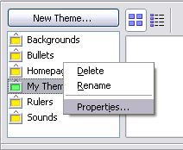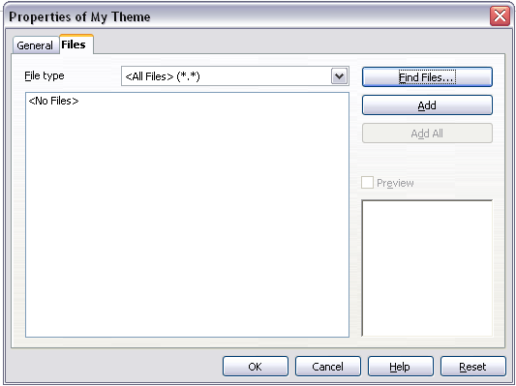

Figure 281. Gallery properties dialog box
- On the Files page, click the Find Files button. The Select path dialog box opens.
- You can enter the path for the file’s directory in the Path text box, or you can navigate to locate the file’s directory. Use the File type drop-down list to help limit the search.
- Click the Select button to start the search. A list of graphic files is then displayed in the window. You can use the File type filter again to further limit the search.
- Select the files to add. To select more than one file, hold the Control key down while you click on each file.
- Finally, click Add.
Note | This procedure assumes that graphic files for the themes already exist. You may need to import some, or to create your own, if the existing files are insufficient.

Note | Similar to the file search function on various operating systems, Find Files searches for graphic files in any subfolders of the directory selected in step 5.

Chapter 9
Working with Tables

Introduction
Tables in Apache OpenOffice (AOO) are a useful way to organize and present large amounts of information, for example:
- Technical, financial, or statistical reports
- Product catalogs showing descriptions, prices, characteristics, and photographs of products
- Bills or invoices
- Lists of names with address, age, profession, and other information
Tables can often be used to organize materials, as an alternative to spreadsheets . A well-designed table can help readers understand better what you're trying to say. While you would normally use tables for text or numbers, you can also include other objects, such as pictures, in a table's cells.
Tables can also be used as a page-layout tool; instead of using several Tab characters to position text in areas of a document, tables can do the job. For example, the descriptions under Figure 285 were created in a table with invisible borders. Another, perhaps better, example would be using tables in this fashion in headers and footers to support independent positioning of elements like page number, document title etc. This use of tables is described in detail in Chapter 4 (Formatting Pages).

Creating a Table
Before you insert a table into a document, have an idea of the visual result you're after, as well as an estimate of the number of rows and columns required. Every parameter can be changed; however, thinking ahead can save a lot of time, since changes to fully formatted tables often require significant effort.

Inserting a New Table
To insert a new table, position the cursor where you want the table to appear, then use any of the following methods to open the Insert Table dialog box:
- From the main menu, choose Table > Insert > Table.
- Press Control+F12.
- From the Standard toolbar, click the Table icon
Here you can specify the properties for the new table.
Under Name, you can enter a different name than the AOO-generated default for the table. This might come in handy when using the Navigator to jump to a table quickly.
Under Size, specify the initial number of columns and rows for the new table. You can change either of these later, if necessary.
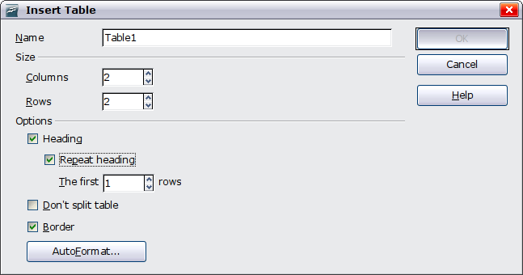Figure 282: Inserting a new table using the Insert Table dialog box
Under Options, set up the initial table characteristics. Selecting the options in this section of the dialog produces the following results:
- Heading — Defines the first row(s) in the table as headings. The default Table Heading paragraph style is applied to the heading rows and thus makes the text centered, bold, and italic. You can edit the AOO-predefined Table Heading paragraph style in the Styles and Formatting deck of the Sidebar to change these default settings. When splitting a table into two tables, the Heading row(s) are copied in the second table.
- Repeat heading — Repeats the heading row(s) of the table at the top of subsequent pages if the table spans more than one page.
- The first … rows —Specifies the number of rows to be repeated. The default is 1.
- Don’t split table — Prevents the table from spanning more than one page. This can be helpful if the table starts near the end of a page, and would look better if it were completely located on the following page. If the table becomes longer than would fit on one page, you will need to either deselect this option or manually split the table.
- Border — Surrounds each cell of the table with a border. This border can be modified or deleted later.
The AutoFormat button opens a dialog box from which you can select one of the many predefined table layouts. See “Automatic Formatting of Tables” on page 297 for more information.
After making your choices, click OK. Writer creates a table as wide as the text area (from the left page margin to the right page margin), with all columns the same width and all rows the same height. You can adjust columns and rows later to suit your needs.
Tip | To directly insert a table with the default properties, click on the little arrow next to the Table icon on the Standard toolbar. A graphic appears where you can choose the table’s size (rows and columns). To create the table, click on the cell that you want to be on the last row of the last column. Holding down the mouse button over the Table icon will also display the graphic.

Creating Nested Tables
You can create tables within tables, nested to a depth only limited by imagination and practicality. Figure 283 demonstrates a simple, two-level example.
To achieve this, simply click in a cell of an existing table and use any of the methods mentioned in “Inserting a New Table” above.
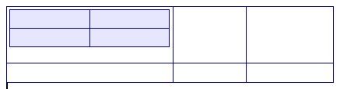Figure 283: Nested table example. The shaded table is nested in a cell of the larger table.

Using AutoCorrect to Create a Table
You can also create a table by typing a series of hyphens (-) or tabs separated by plus signs. Use the plus signs to indicate column dividers, while hyphens and tabs are used to indicate the width of a column.
For example, this character sequence:
+-----------------+---------------+------+
creates a table like this:
Note | This function can be disabled or enabled in Tools > AutoCorrect. On the Options tab, deselect or select Create table.
Caution | When using tabs instead of a table to line up your data, always make sure that you know how wide they are set, and remember that default tabs may be different when the document is displayed on a different computer, or even when copying the same data in a new document.

Create a Table from Formatted Text
It is possible to create a table from plain text by means of the Table > Convert > Text to Table menu. In order for this command to work effectively, the starting text needs to have clear demarcation between what will become the columns of the table. Paragraph marks indicate the end of a row.
To convert text to a table, start by selecting the text you want to convert and choose Table > Convert > Text to Table to open the dialog shown in Figure 284.
In the top part of the dialog, select the symbol that separates the columns. This would normally be a tab, but it could be a semicolon or comma if you are importing a CSV file. The other options in this dialog are the same as those in the dialog used to insert a table shown in Figure 282.
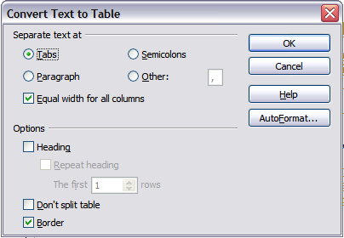Figure 284: Dialog box to configure the text to table conversion

Example
In this example we will convert the following text into a table.
Row 1 Column 1; Row 1 Column 2; Row 1 Column 3
Row 2 Column 1; Row 2 Column 2; Row 2 Column 3
In this case, the separator between elements is a semicolon. By selecting the text and applying the conversion, we obtain the following result.
Row 1 Column 1 | Row 1 Column 2 | Row 1 Column 3
Row 2 Column 1 | Row 2 Column 2 | Row 2 Column 3
Note that, unlike creating a table with other mechanisms, conversion from text to table preserves the paragraph style applied to the original text.
You can also use the Convert menu to perform the opposite operation; that is, to transform a table into plain text. This may be useful when you want to export the table contents into a different program.
To transform a table into text, place the cursor anywhere in the table, choose Table > Convert > Table to Text in the main menu, pick the preferred row separator, and click OK to finish.

Formatting the Table Layout
Formatting a table is, generally speaking, a two-step process: formatting of the table layout (the subject of this section) and formatting of the table text (the subject of the next section).
Formatting the layout normally involves one or more of the following operations: adjusting the size of the table and its position on the page, adding or removing rows or columns, merging and splitting individual cells, changing borders and background.

Default Parameters
If you create a table using the Insert Table dialog box or the Table icon on the Standard toolbar and activate the Heading option, the following defaults are set:
- The cells in the heading row (or rows) use the Table Heading paragraph style. In the default template, the text is centered and set with a bold and italic font.
- The remaining cells use the Table Contents paragraph style, which, in the default template, is identical to the Default paragraph style.
- The default table occupies all the space from margin to margin (text area).
- The default table has thin black borders around each cell (grid).

Resizing and Positioning the Table
Using the default settings, any newly created table will occupy the entire width of the text area. This is sometimes what you want, or you may prefer a smaller table. To quickly resize a table, first move the mouse to either the left or right edge. When the cursor changes shape into a double arrow, drag the border to the new position. This operation only changes the size of the first or last column; it does not change the alignment of the table on the page.
If you need more precise control over the size and position of the table on the page, open the Table Format dialog box by choosing Table > Table Properties or by right-clicking anywhere in the table and choosing Table from the pop-up menu. Select the first page of the dialog box (Table).
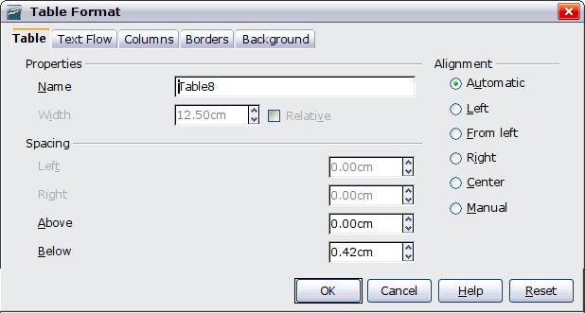
Figure 285: The Table page of the Table Format dialog box
On this page you can set the alignment of the table, choosing from the following options:
- Automatic: the default setting for a table.
- Left: aligns the table with the left margin.
- Right: aligns the table with the right margin.
- From Left: lets you specify under Spacing exactly how far from the left margin the table is placed.
- Center: aligns the table in the middle between the left and right margins. If the table width is greater than the margin, the table will extend outside the margins.
- Manual: lets you specify the distances from both left and right margins under Spacing.
Selecting an alignment option other than Automatic activates the Width field in the Properties section, where you can enter the desired size of the table. Select Relative to see the width as percentage of the text area.
In the Spacing section, use the Above and the Below boxes to modify the separation between the text and the table. When the size of the table is less than the size of the text area, AOO will insert some values in the Left and Right boxes. You can only change both values if you select Manual alignment, and you can change the Left box value only when you select the From Left alignment. Note that the sum of the table width, and the values in the Left and Right boxes, needs to equal the width of the text area.

Resizing Rows and Columns
You can adjust the height of rows and the width of columns in a table in several ways.
- Move the mouse next to the edge of the cell and when a double-headed arrow appears, click and hold the left mouse button, drag the border to the desired position, and release the mouse button.
- On the horizontal ruler, column dividers are marked by a pair of thin gray lines; the vertical ruler indicates row dividers in the same way. You can resize a row or column by holding the mouse button down on the appropriate divider and dragging it to the desired location.
- Use the keyboard as described below.
Selecting Table > Autofit from the main menu also offers resizing options:
- The Optimal Column Width or Optimal Row Height options make the selected columns or rows as narrow as possible while still fitting their contents.
- Selected columns and rows can be distributed evenly to quickly bring them back to all being the same width or height.
For greater control over the width of each column, use the Columns tab of the Table Format dialog box.
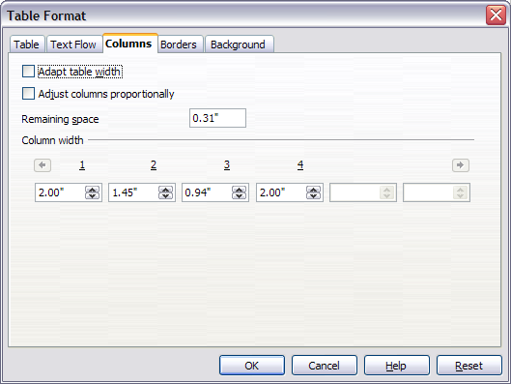Figure 286: Table Format dialog box: Columns page
Right-click on the table and choose Table from the pop-up menu or choose Table > Table Properties from the menu bar. On the Table Format dialog box, select the Columns tab.
- Adapt table width: If a table already stretches to the page margins, it cannot stretch any wider, and the Adapt table width option is not available. If the table is narrower, increasing the width of a column will increase the width of the whole table.
If the table width already extends pasts the margins with the Adapt table width option checked, attempting to change a column width will automatically decrease that column’s size so that the table will now shrink to the page margins while keeping any other column sizes intact.
- Adjust columns proportionally results in all columns changing their widths by the same percentage when one is changed. For example, if you reduce by half the size of a column, all the other columns sizes will be halved.
- Remaining space shows how much further the table can expand before hitting the limit of the margins. This value cannot be edited and will not be negative in the event that the table width is already larger than the space between the left and right margins.
- Under Column width, each individual column can be adjusted. If you have more than six columns, use the arrows at the right and left to view them all.
Rather than start from the Table Format dialog box, it is often more efficient to make rough adjustments to a new table using the mouse, and then fine tune the layout using the Columns page in conjunction with the Table page of the Table Format dialog box.
It is also possible to resize a table using only the keyboard; this is sometimes easier than using the mouse.
- Place the cursor on the cell whose size you want to change.
- Press and hold the Alt key while using the arrow keys to change the size.
To adjust the resizing parameters and behavior for keyboard handling, choose Tools > Options > OpenOffice Writer > Table.
Use the Row and Column values in the Move cells section to determine the amount of change produced by a single keystroke while resizing. In the Behavior of rows/columns section you can choose one of the following three strategies when resizing:
- Fixed: select this if you want the resizing to only affect the adjacent cell, and not the entire table. The width of the table does not change when resizing its cells.
- Fixed, proportional: when resizing a cell with this option selected, all the other cells are also resized proportionally, Also in this case the width of the table remains constant.
- Variable: this is the default value. Resizing a cell affects the table size. For example, when you widen a cell, the width of the table increases.

Inserting Rows and Columns
To insert any number of rows or columns:
- Place the cursor in the row or column where you want to add new rows or columns and right-click.
- On the pop-up menu, choose Row > Insert or Column > Insert. This will display a dialog box where you can select the number of rows or columns to add, and whether they appear before or after the selected one.
- Set Amount to the number of rows or columns to insert, and Position to Before or After.
- Click OK to close the dialog box.
Note | Clicking on the Insert Row icon on the Table toolbar inserts one row below the selected one. Clicking on the Insert Column icon on the Table toolbar inserts a column after (to the right of) the selected one.  Regardless of how they are inserted, new rows or columns have the same formatting as the row or column where the cursor was when the insert command was issued.

You can also quickly insert a row or a column using only the keyboard:
- Place the cursor in the row or column next to the row or column you want to insert.
- Press Alt+Insert to activate keyboard handling.
- Use the arrow keys as desired to add a row or column:
Left to insert a new column to the left of the cell where the cursor is located.
Right to insert a new column to the right of the cell where the cursor is.
Down to insert a new row below the cell where the cursor is.
Up to insert a new row above the cell where the cursor is.

The above keyboard technique can also be used to delete rows or columns by substituting the Alt+Insert keystroke combination in Step 2 with Alt+Delete.

Merging and Splitting Cells
To merge a group of cells into one cell:
- Select the cells to merge.
- Right-click and choose Cell > Merge on the pop-up menu, or choose Table > Merge Cells from the menu bar.
To split a cell into multiple cells:
- Position the cursor inside the cell.
- Right-click and choose Cell > Split on the pop-up menu, or choose Table > Split Cells from the menu bar.
- Select how to split the cell. A cell can be split either horizontally (create more rows) or vertically (create more columns), and you can specify the total number of cells to create.
It is generally a good rule to merge and split cells after completing other layout formatting. This is because some operations such as deleting a column or a row may produce a result difficult to predict when applied to a table with merged or split cells.

Specifying Table Borders
On the Table Format dialog box, select the Borders tab.
With this tab, you can set borders for a whole table or groups of cells within a table. In addition, a shadow can be set for the entire table.
Borders have three components: where they go, what they look like, and how much space is left around them.
- Line arrangement specifies where the borders go. If a group of cells is selected, the border will be applied only to those cells. You can specify individually the style of the border for the outside edges of the selected cells as well as for the cell divisions. Writer provides five default arrangements, but you can just as easily click on the line you want to customize in the User-defined area to get exactly what you want. When multiple cells are selected, the User-defined area allows you to select the edges of the selection as well as the cell dividers. By clicking at the intersection of the lines, you can modify multiple borders simultaneously. For example, in Figure 286 the right edge and horizontal separators are modified with a single operation.
Note | When the selected cells have different styles of border the User-defined area shows the border as a gray line. You can click on the gray line to choose a new border style (first click), leave the border as it is (second click) or delete the border (third click).
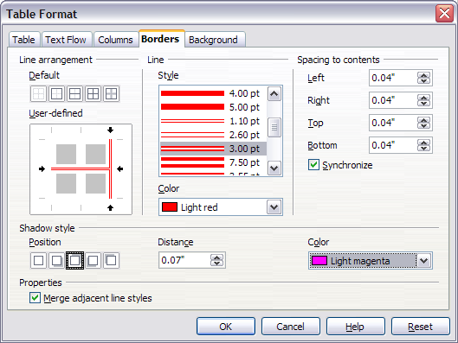Figure 287: Table Format dialog box: Borders page
- Line specifies what the border looks like: the style and color. There are a number of different styles and colors to choose from. The Line Style and Color will apply to those borders highlighted by a pair of black arrows in the User-defined map on the left-hand side of the dialog box.
- Spacing to contents specifies how much space to leave between the border and the cell contents. Spaces can be specified to the left, right, above, and below. Check Synchronize to have the same spacing for all four sides. This spacing is like a padding, and it is not factored in when calculating the text measurements.
- Shadow style properties always apply to the whole table. A shadow has three components: where it is, how far from the table it is cast, and what color it is.
- If Merge adjacent line styles is checked, two cells sharing a common border will have their borders merged, rather than being side by side.
Tip | To reset everything if you are having problems with borders, right-click in the table and choose Table or choose Table > Table Properties from the menu bar. On the Borders tab, select the Set No Borders icon under Line arrangement: Default (the box on the left).

Selecting Background Colors and Graphics
A table background can greatly improve the readability of the data, visually highlight important parts of the table (such as the heading or a specific cell), or just make the table more appealing. You can choose between two types of background when formatting the table: solid color or graphic. The background can be applied to the whole table, to a single cell, or to a row. The background selected for a cell will be in front of, that is layered over, the row background; in similar fashion, the row background will hide the table background.
The row background option is quite handy when you want to create alternate color rows or assign a different background to the heading of the table. The tables in this guide adopt this technique.
To set the background for a cell, row, or table:
- Place the cursor anywhere inside the cell, row or table you want to work with. If you want to apply a background to a group of cells, select the group.
- Right-click and choose Table from the pop-up menu, or choose Table > Table Properties from the main menu.
- In the Table Format dialog box, select the Background tab.
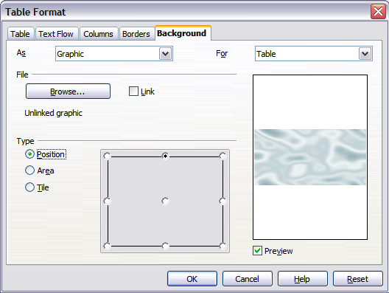Figure 288: Table Format dialog: inserting a graphic background
- In the For section, choose whether to apply the settings to cell, row, or table.
  - If you choose Cell, changes apply only to the selected cells, or the cell where the cursor currently resides. Even when selecting a group of cells, the background settings are applied to each cell individually.
  - If you choose Row, changes affect the entire row where the cursor resides.
  - If you choose Table, changes will set the background for the entire table, regardless of the cursor position or selected cells.
- In the As section, choose whether the background is a color or a graphic.
To apply a color, select the color and click OK. Remember that you can add custom colors by choosing Tools > Options > Colors.
To apply a graphic:
  - First select the graphic from your computer’s file system with the Browse button. (Writer supports numerous graphics formats.)
  - You can use the Link option to link the graphic file. If it is linked, changes to the graphic (for example, if you edit it in a different software package) are reflected in your document. However, you also need to keep the linked graphic file with the document file. If, for example, you email the document without the graphic file, the graphic will no longer be visible.
  - Under Type, select the type of placement for the graphic.
    - If you choose Position, you can select in the position map where the graphic will be displayed in the selected area.
    - If you choose Area, the graphic is stretched to fill the whole area.
    - If Tile, the graphic is tiled (repeated horizontally and vertically) to fill the area.
- If the Preview option is checked, the graphic displays in the pane on the right.
- To apply the graphic, click OK.
Figure 289 shows an example of a table set with a background image, and the first row background colored. As you can see, the row background, by virtue of being superimposed on the row, covers the table background for that row.
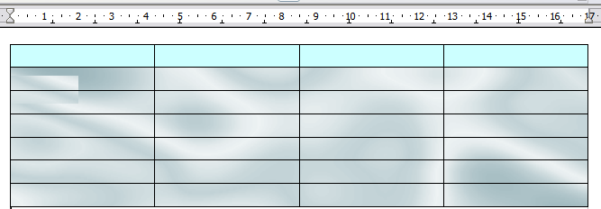
Figure 289: Example of table with different row and table backgrounds

Displaying or Hiding Table Boundaries
A table boundary is a set of pale (usually gray) lines around the cells when viewed on-screen in AOO. These boundaries are not printed; their only function is to help you see where the table cells are.
To display the table the same way on the screen as on the printed page, with no boundary lines, right-click on the table and choose Table Boundaries from the pop-up menu. Repeat this to have the boundaries appear again.
Note | Turning boundaries off does not hide the borders that the table may have.

Tip | You can also turn table boundaries on and off through Tools > Options > OpenOffice > Appearance. On that page, you can display or hide boundaries around text, pages headers and footers, figures, and other parts of a document.

Formatting the Table Text
Once the table layout is satisfactory, you can move on to formatting text in the individual cells. You can apply manual formatting as with any other paragraph in the text, but it's highly recommended, for the sake of consistency and ease of maintenance, that you define your own paragraph and character styles.
Besides the paragraph and character styles, there are other aspects to consider when placing text in a table cell; Always be aware of such factors as text flow, alignment and orientation.
You can format each cell independently of other cells, or you can simultaneously format a group of cells by selecting them before applying the desired formatting.

Specifying Text Flow
On the Text Flow page of the Table Format dialog box (Figure 290), you can:
- Insert a page or column break either before or after the table. Use the Text Flow: Break option, combined with the Page or Column and the Before or After buttons.
If you insert a page break before the table (that is, start the table on a new page), you can also change the page style that will go with it by checking the With Page Style box and selecting a new page style. As with any page break, you can also reset the page numbers using the Page number box.
- Keep a table on one page by deselecting the Allow table to split across pages and columns option. If this item is deselected, the next item is not active.
- Keep each row on one page by deselecting the Allow row to break across pages and columns option.
- Use the Keep with next paragraph option to keep the table and an immediately following paragraph together, should you have inserted a page break.
- Use the Repeat heading option, and its associated numbers box, to select the number of table heading rows that will be repeated on each page. A complicated table may need two or three heading rows to be easily read and understood.
- Use the Text direction list to select the direction for the text in the cells. The most common setting is Left to right, the norm for Western languages.
Note | The phrase Use superordinate object settings shown in Figure 290 means “use the formatting settings from the paragraph before the table”.

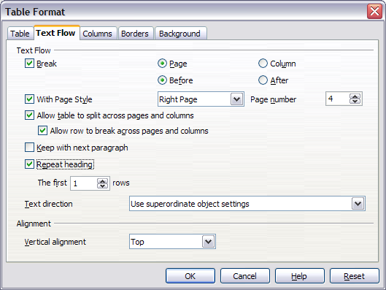Figure 290: Table Format dialog box: Text Flow page
- Select the vertical alignment of the text in the table or the selected cells; the choices are to align with the top of the cell, the center of the cell, or the bottom of the cell. This alignment is in addition to the Left-Right alignment options available on the Table page of the Table Format dialog box.
Note | A table heading row cannot span two pages, but any other row can. A one-row table (often used for page layout purposes), if set up with the default of including a heading, will not break across pages. One solution to this seeming puzzle is to make sure the table is defined without a heading row.

Vertical Alignment
By default, text entered into a table is aligned to the top-left of the cell. You can change the default for the entire table, as described above, or for individually selected cells.
To vertically align the text in specific cells:
- Place the cursor in the cell you wish to change, or click and drag to select multiple cells.
- Right-click in the selected area and choose Cell > Center, Top, or Bottom in the pop-up menu to vertically align the text as desired.

Number Formats
The number format can be set for a whole table or group of cells. For example, cells can be set to display in a particular currency, to four decimal places, or in a particular date format.
Number recognition specifies that numbers in a text table are recognized and formatted as numbers. If number recognition is selected, numbers are automatically bottom-right aligned. The Number recognition option can be enabled under Tools > Options > OpenOffice Writer > Table or by right-clicking on the table and selecting Number Recognition.
Select the cells to format, then right-click and choose Number Format from the pop-up menu. The Number Format dialog box opens that allows you to set options for various categories of numerical data.
- In the Category list, select the category you want, such as currency, date, or text.
- In the Format list, choose a format for the category you just selected.
- For some categories, such as date, you may wish to change the language using the Language list while for other numerical categories the Options section of the dialog box allows you to customize the appearance.
Tip | You will notice that AOO displays the formatting code for the category and format selected in the Format Code section at the bottom of the dialog box. For example, if you select a date format such as 31 Dec 1999 the corresponding code is D MMM YYYY. As you become more experienced with AOO, you can easily customize this formatting code, and even create new user-defined codes.

Rotating Text in a Table Cell
You can rotate text in a table cell by 90 or 270 degrees. Text rotation is useful when you have long headings for narrow columns.
- Select the text to be rotated and then choose Format > Character.
- On the Position page, in the Rotation / scaling section, choose the rotation angle and click OK.
Figure 291 shows a sample table with rotated headings.
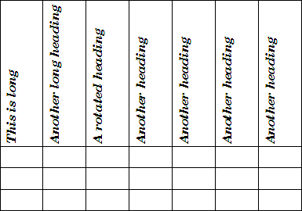
Figure 291: A table with rotated headings
Note | Text rotation within table cells can also be achieved with the use of paragraph styles, discussed in greater detail in Chapter 7 (Working with Styles).

Data Entry and Manipulation in Tables

Moving Between Cells
Within a table, you can use the mouse, the cursor keys, or the Tab key to move between cells.
The cursor keys move to the next cell only if there is no text in the way. For example, pressing the right cursor key will move the cursor to the right within the text in the current cell, then to the next cell.
The Tab key moves directly to the next cell and, if the cursor is in the last cell in the table, creates a new row. Pressing Shift+Tab moves the cursor back a cell.
Tip | To enter a Tab character as part of the text of the cell, press the Control and Tab keys at the same time.
Sorting data in a table
Just as in a spreadsheet, Writer allows data in a table to be sorted. Up to three levels of sorting can be specified (for example, sort first by age numerically, then alphabetically by name within each age).
To sort data in a table:
- Select the table (or part of the table) to be sorted.
- From the menu bar, choose Table > Sort.
- In the Sort dialog box:
  - Decide whether you want to sort in the direction of rows or columns. The default sorting direction is by rows, which results in sorting the data in a column.
  - Select up to three keys to sort on, in the correct order.
  - For each key, select which column or row to sort on, whether the sort is Numeric or Alphanumeric and whether it is Ascending or Descending.
- Click OK to perform the sort.
Note | You have to select all cells that might be affected by the sorting. For example, if you select only the cells of one column, the sort affects that column only, while the others remain unchanged. In such a case, you risk mixing the data of the rows.

Using Spreadsheet Functions in a Table
In a table in a Writer document, you can use some of the mathematical functions that are normally implemented by OpenOffice Calc. For many simple functions, Writer tables can be used as basic spreadsheets.
Just as in a spreadsheet, each table cell is identified by a letter (for the column) and a number (for the row). For example, cell C4 is the cell in the third column from the left and fourth row from the top. When the cursor is in a cell, this cell reference is displayed on the formula bar once formula entry is activated.
Tip | Basic spreadsheet functions in tables are much the same as in OpenOffice Calc. The main difference is that cell references are formatted differently. Cell A2 (first column, second row) is referred to in Calc as A2 (or $A$2 for an absolute reference). In Writer tables, it is referred to as <A2>.
For example, suppose you had two numbers in cells <B1> and <C2> and wanted to display the sum of the two in cell <A1>, as shown in Figure 288.
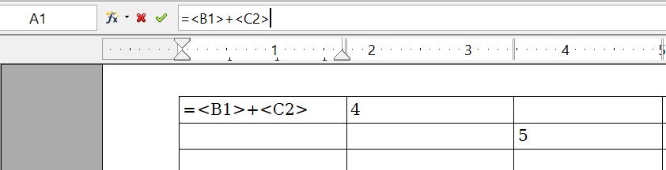

Figure 292: Using spreadsheet functions in a table
Do the following:
- Click in cell <A1> and press the = key. The Formula bar appears automatically, near the top of the screen. In the leftmost side of the bar, you can see the coordinates of the selected cell.
- Click in cell <B1>. The identifiers of this cell are automatically displayed in the Formula bar and inserted into cell <A1>.
- Press the + key.
- Click on cell <C2>. You can see the final formula = <B1>+<C2> displayed both in the selected cell and in the Formula bar.
- Press the Enter key or click the green tick (check mark) on the Formula Bar.
Tip | To display the list of the mathematical functions that you can use in a table:  - Display the Formula toolbar by pressing F2 or by selecting a blank cell and pressing the = key.  - Click and hold the Formula f(x) icon.
In our example, this gives the result 9 in the top left cell. For contiguous cells, you can simply select the cells in the row, column, or the rectangle of rows and columns. Thus, for example, to add a column of numbers, do this:
- Type an equals sign = in an empty cell.
- Select the cells to be added together—in this case the cells from A2 to A5. The formula should be something like =<A2:A5>.
- Press the Enter key or click the green tick (check mark) on the Formula Bar.
- The answer appears in the cell you have selected.
When using a function, you can enter the cells manually or by selecting them. Thus, to add up the four numbers that we added above (A2, A3, A4, A5), do this:
- Type an equals sign = in an empty cell.
- Type sum or select it from the function list f(x).
- Select the cells to be added together. The formula should be something like =sum<A2:A5>.
- Press the Enter key or click the green tick (check mark) on the Formula Bar.
- The answer appears in the cell you have selected.
Caution | Unlike Calc, when inserting or deleting rows or columns of the table, formulas are not updated automatically. If you plan to use complex formulas you should consider embedding a Calc spreadsheet in your Writer document. This is done with the menu item Insert > Object > OLE Object.

Additional Table Operations

Adding a Caption
You can easily add a caption to any table. Writer will keep track of all your captioned tables, automatically number them, and update any links to them.
To add a caption to a table:
- Place the cursor in the table.
- Right-click and choose Caption from the pop-up menu. Alternatively, the Insert > Caption menu option becomes available whenever your cursor is inside a table cell.
- Enter the text for your caption, your category selection, the numbering style, separator, and position (above or below the table).
- Click OK.
Note | Once the category, numbering style and separator are established in the Caption dialog box, you can edit them in the document if you choose. However, doing so may damage the automatic numbering and reference links. If you need to establish the numbering and reference link for the caption, you can decide to leave your caption blank in the Caption dialog box and add it later.
Writer supplies five different category labels for captions: <None>, Drawing, Table, Illustration, and Text.
You can also create your own category labels, formatting, and separators. For example, you might want your tables to be labeled as Fantasia, formatted with Roman numerals, and using a period (‘.’) as a separator, as follows:
Fantasia I. Interesting data
Fantasia II. More interesting data
Fantasia III. Yet more interesting data
To accomplish this:
- Open the Caption dialog box following the instructions above.
- In the Category field, select the text and type the word Fantasia.
- In the Numbering drop-down, select the Roman (I II III) option.
- In the Separator field, select the text and type a period (.) followed by a space.
Note | AOO will use exactly what you type into the Category and Separator fields, so be sure to include any additional spaces or punctuation you want to see in your caption.
Additional options for numbering captions by chapter are available under the Options button in the Captions dialog box. Some of these settings which refer to the outline level will only have an effect if you are using outline level paragraph styles on the chapter headings within your document. See Chapter 7 (Working With Styles) for information.
By adding chapter numbers to your captions, AOO will restart the caption numbering for each chapter it encounters. For example, if the last figure caption you create in chapter 1 is Figure 1.15, and the next figure caption you create is in chapter 2, the numbering will start over at Figure 2.1.
Options available to chapter numbering for captions include the following:
- Use Level to specify the outline levels that triggers a restart of the numbering as well as how many levels of outline numbering are shown before the table number. As an example, consider this. Suppose your document uses Heading 1 style for chapters and Heading 2 style for subheadings, and that this is how you set up your outline numbering. If you want all the tables in a chapter (that is, between two Heading 1 paragraphs) to be numbered sequentially independently of the sub heading they are under, select 1 as Level. If instead you want to restart the numbering at each sub-heading select level 2.
- Use the Separator field to establish the separator between the chapter number and figure number.
- Use Character style to set a character style for the caption. This is useful if the separator of your choice is not a symbol included in the default font type of your document, or if you want the caption to have a special color, size and so on.
- The Apply border and shadow option does not apply to table captions. AOO normally wraps the objects you can add a caption to in a frame, but not for tables.
- Use Caption order to specify whether you want the category or numbering to appear first in the caption.
All the features described above can also be set up to automatically apply to any new tables you create in your document.
To automatically caption all your tables:
- Place the cursor in a table.
- Right-click and choose Caption > AutoCaption from the pop-up menu.
- Select OpenOffice Writer Table and select the settings you want and click OK. This dialog box is covered in more detail in Chapter 2 (Setting up Writer).
When AutoCaption is enabled for tables, any new tables will be captioned according to your selections in the AutoCaption dialog box; however, you will need to add the specific text for each caption into the table manually.

Cross-referencing a Table
You can insert a cross-reference to a captioned table. Clicking on the cross-reference takes the reader directly to the table.
- Position the cursor where you want the cross-reference.
- Choose Insert > Cross-reference from the main menu.
- Set the Type to Table. A list of captioned tables will be shown in the Selection panel; select the one you want to reference.
- In the Format pane, choose how the cross-reference will appear.
  - Page creates a reference of the page number that the caption appears on.
  - Chapter places a reference to the chapter number in which the caption appears. This will only produce an empty space unless you have set up your chapter headings with outline level paragraph styles.
  - Reference inserts the entire caption's category, number and caption text as a reference.
  - Above/Below inserts “above” or “below” depending on whether the table appears above or below the cross-reference.
  - As Page Style creates a reference of the number of the page on which the caption appears, using the page style format.
  - Category and Number creates a cross-reference with only the caption's category and number; for example, Table 1 for the first table.
  - Caption Text creates the reference using the caption text, leaving off the category and number.
  - Numbering inserts only the number of the caption.
- Click Insert to add the cross-reference and click Close to exit the dialog box.

Automatic Formatting of Tables
Using AutoFormat, you can apply an elaborate format to your table with just a few clicks. AutoFormat is somewhat similar to paragraph styles and will enable you to obtain consistent looking tables across your document. You can also create your own table formats and save them as another AutoFormat option.
To apply an AutoFormat, place the cursor anywhere in the table and choose Table > AutoFormat. This opens the dialog box shown in Figure 287.
Select from the list on the left the Format most suitable for your table and click OK to apply it. Clicking the More button opens another section of the dialog box where you can rename the selected table format scheme as well as decide which parts of the predefined formatting you want to apply to your table. You can selectively apply the number format, the font, the alignment, the border, or the pattern.
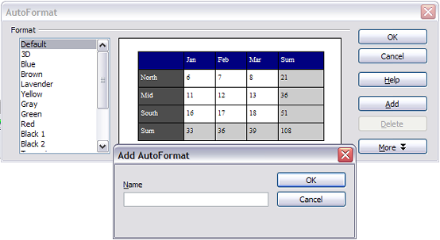Figure 293: The table AutoFormat dialog
To create your own AutoFormat, proceed as follows:
- Create a table and manually format it as you wish, including borders, spacing of text from the top and bottom borders, fonts to be used in the table heading and data cells, and background colors.
- Position the cursor anywhere in the table and then click Table > AutoFormat.
- On the AutoFormat dialog box, click Add and give the table format a name in the Add AutoFormat dialog box and click OK.
- The newly named AutoFormat now appears as an available format. Click OK to close the AutoFormat dialog box.
Tip | This technique does not include table and column widths in the table format. To insert a table with predefined full formatting, save it as AutoText. See “Using AutoText” in Chapter 3 (Working with Text) for instructions.

Creating a Heading Row in an Existing Table
To create a heading row in an existing table that does not have one, you need to apply an AutoFormat that does have a heading defined. (Here is where having some personalized table formats could come in very handy.) Place the cursor anywhere in the table and then click Table > AutoFormat. Choose a format. Click OK. Use the More button and deselect the formatting options you do not want to apply to your table.

Merging and Splitting Tables
One table can be split into two tables, and two tables can be merged into a single table. Tables are split only horizontally (the rows above the split point are put into one table, and those below into another).
To split a table:
- Place the cursor in a cell which will be in the top row of the second table after the split (the table splits immediately above the cursor).
- Right-click and choose Split Table in the pop-up menu. You can also use Table > Split Table from the menu bar.
- A Split Table dialog box pops up. You can select No heading or an alternative formatting for the heading—the top row(s) of the new table.
- Click OK. The table is then split into two tables separated by a blank paragraph.
Note | If cells in one table include formulas using data from the other table, those cells will contain an error message: **Expression is faulty**.
To merge two tables:
- Delete the blank paragraph between the tables. You must use the Delete key (not the Backspace key) to do this.
- Select a cell in the second table.
- Right-click and choose Merge Tables in the pop-up menu. You can also use Table > Merge Table from the menu bar.
Tip | To see clearly where the paragraphs are and to delete them easily, choose View > Nonprinting Characters (Ctrl+F10) or click the ¶ button in the Standard toolbar.

Deleting a Table
To delete a table:
- Click anywhere in the table.
- Choose Table > Delete > Table from the main menu.
Or:
- Select from the end of the paragraph before the table to the start of the paragraph after the table.
- Press the Delete or the Backspace key.
Note | The second method also merges the paragraph after the table with the paragraph before the table, which may not be what you want.

Copying a Table
To copy a table from one part of the document and paste it into another part:
- Click anywhere in the table.
- From the main menu choose Table > Select > Table.
- Press Control+C or click the Copy icon on the Standard toolbar.
- Move the cursor to the target position and click on it to fix the insertion point.
- Press Control+V or click the Paste icon in the Standard toolbar.

Moving a Table
To move a table from one part of a document to another part:
- Click anywhere in the table.
- From the main menu, choose Table > Select > Table.
- Press Control+X or click the Cut icon in the Standard toolbar. (This step removes the contents of the cells but leaves the empty cells, which must be removed in step 6.)
- Move the cursor to the target position and click on it to fix the insertion point.
- Press Control+V or click the Paste icon in the Standard toolbar. (This pastes the cells and their contents and formatting.)
- Return to the original table, click somewhere in it and then choose Table > Delete > Table from the main menu.

Inserting a Paragraph Before or After a Table
To insert a paragraph before a table, position the cursor before any text or other contents in the first (upper left-hand) cell and press Alt+Enter. To insert a paragraph after a table, position the cursor after any text in the last (lower right-hand) cell and press Alt+Enter.

Using Tables as a Page Layout Tool
Tables may be used as a page layout tool to position text in a document instead of using tabs or spaces. For example, the Tip below is formatted as a table.
For more information and tips about using tables in page layout, see Chapter 4 (Formatting Pages).

Tip | When inserting a table used for layout, you may wish to deselect the Heading and Border options (see Inserting a New Table on page 279).  To remove the borders from an existing table, right-click on the table, choose Table from the pop-up menu, select the Borders tab (see Figure 286 on page 284), and select the icon for no borders.

The Table menu and toolbar
All the table commands described in this chapter are conveniently located in the main menu under the Table item and on the Table toolbar, shown in Figure 285. Not all the icons may appear on your toolbar, depending on the settings for it in Tools > Customize > Toolbars.
Table 6 describes the effects of using these icons. When you create a table or select an existing table, the Table toolbar may be displayed automatically, or you can manually display it by clicking View > Toolbars > Table. The toolbar can float over the main Writer window (as shown in Figure 285), or it can be docked along any edge of the main window. See Chapter 1 (Introducing Writer) for more about docking and floating toolbars, and how to hide and display specific tools on a toolbar.
1 | Table | 9 | Top | 17 | Select Column
2 | Line Style | 10 | Center (vertical) | 18 | Select Row
3 | Line Color (border) | 11 | Bottom | 19 | AutoFormat
4 | Borders | 12 | Insert Row | 20 | Table Properties
5 | Background Color | 13 | Insert Column | 21 | Sort
6 | Merge Cells | 14 | Delete Row | 22 | Sum
7 | Split Cells | 15 | Delete Column
8 | Optimize | 16 | Select Table
Figure 294: Table toolbar
1
2
3
4
5
6
7
8
9
10
11
12
13
14
15
16
17
18
19
20
21
22
Table 6: Functions of the icons on the Table toolbar
Name | Description
Table | Opens the Insert Table dialog box where you can set up and insert a table into the document, name the table for use with the Navigator, and set some other options. If you press the small black triangle pointing down next to the icon, you can use the mouse to drag to select the number of rows and columns to include in the table.
Line Style | Opens the Border Style window where you can modify the borderline style.
Line Color (border) | Opens the Border Color window where you can modify the border color.
Borders | Opens the Borders window where you can select which sides of the table or of the selected cells will have a border.
Background Color | Opens the Background toolbar where you can select the background color of the table or of the selected cells.
Merge Cells | Combines the selected cells into a single cell. Refer to Merging and Splitting Cells on page 286 for an example of using this button.
Split Cells | Opens the Split Cell dialog box where you can define how to split a cell. Refer to Merging and Splitting Cells on page 286 for an example of using this button.
Optimize | Opens a drop-down menu with four options you can use to let AOO optimize the distribution of the columns or rows or optimize the row height or column width.
Top | Press this button to align the contents of the selected cells to the top of the cell.
Center (vertical) | Press this button to align the contents of the selected cells to the vertical center of the cell.
Bottom | Press this button to align the contents of the selected cells to the bottom of the cell.
Insert Row | Inserts a row below the selected row.
Insert Column | Inserts a column after the selected column.
Delete Row | Deletes the selected row(s) from the table.
Delete Column | Deletes the selected column(s) from the table.
Select Table | Selects the entire table.
Select Column | Selects the column in which the cursor is positioned.
Select Row | Selects the row in which the cursor is positioned.
AutoFormat | Opens the AutoFormat dialog box where you can select among several predefined formatting sets. Each set is characterized by its own fonts, shading, and borders styles. You can also select AutoFormat from the Insert Table dialog box.
Table Properties | Opens the Table Format dialog box where you can control all the properties of the table, for example name, alignment, spacing, column width, borders, and background.
Sort | Opens the Sort dialog box where you can specify the sort criteria for the selected cells.
Sum | Activates the Sum function. Refer to “Using Spreadsheet Functions in a Table” on page 293 for an example of using this function.

Chapter 10
Working with Templates

Introduction
A template is a model that you use to create other documents. For example, you can create a template for business reports that has your company’s logo on the first page. New documents created from this template will all have your company’s logo on the first page.
Templates can contain anything that regular documents can contain, such as text, graphics, a set of styles, and user-specific setup information such as measurement units, language, the default printer, and toolbar and menu customization.
All documents in OpenOffice (AOO) are based on templates. If you do not specify a template when you start a new Writer document, the document is based on the default template for text documents. If you have not specified a default template, Writer uses the blank template for text documents that is installed with AOO. See “Setting a Default Template” on page 309 for more information.

Using a Template to Create a Document
To use a template to create a document:
- From the main menu, choose File > New > Templates and Documents. The Templates and Documents dialog box opens. (See Figure 295.)
- In the box on the left, click the Templates icon if it is not already selected. A list of template folders appears in the center box.
- Double-click the folder that contains the template that you want to use. A list of all the templates contained in that folder appears in the center box.
- Select the template that you want to use. You can preview the selected template or view the template’s properties:
  - To preview the template, click the Preview icon . A preview of the template appears in the box on the right.
  - To view the template’s properties, click the Document Properties icon . The template’s properties appear in the box on the right.Click Open. The Templates and Documents dialog box closes and a new document based on the selected template opens in Writer. You can then edit and save the new document just as you would any other document.
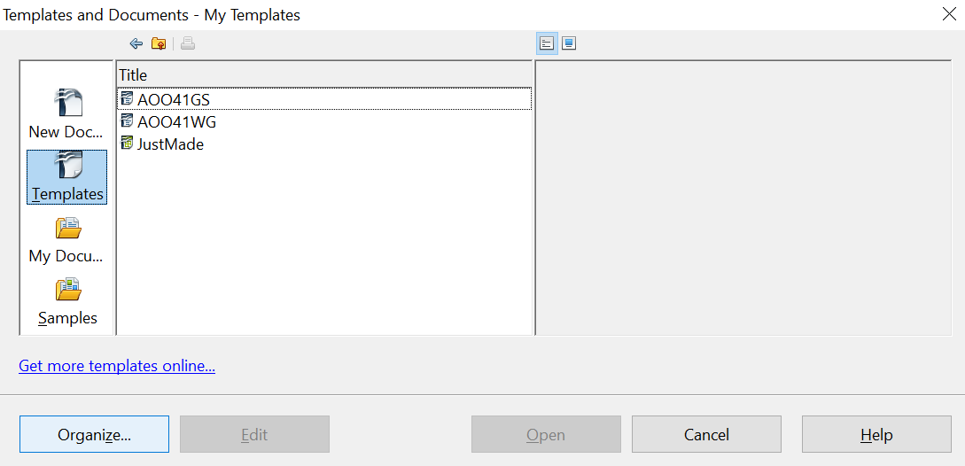

Figure 295. Templates and Documents dialog box

Creating a Template
You can create your own templates in two ways: from a document, and using a wizard.

Creating a Template from a Document
To create a template from a document:
- Open a new or existing document you want to make into a template.
- Add the content and styles that you want.
- From the main menu, choose File > Templates > Save. The Templates dialog box opens (see Figure 296).
- In the New template field, type a name for the new template.
- In the Categories list, select the category to which you want to assign the template. The category is simply the template folder in which you want to save the template. For example, to save the template in the “My Templates” folder, click the My Templates category.
- To learn more about template folders, see “Organizing Templates” on page 311.
- Click OK to save the new template.

Figure 296. Saving a new template
Any settings that can be added to or modified in a document can be saved in a template. For example, below are some of the settings (although not a full list) that can be included in a Writer document and then saved as a template for later use:
- Printer settings: which printer, single-sided or double-sided printing, paper size, and so on.
- Styles to be used, including character, page, frame, numbering, and paragraph styles.
- Format and settings regarding indexes, tables, bibliographies, table of contents.
Templates can also contain predefined text, saving you from having to type it every time you create a new document. For example, a letter template may contain your name, address and salutation.
You can also save menu and toolbar customizations in templates; see Chapter 14 (Customizing OpenOffice) for more information.

Creating a Template Using a Wizard
You can use wizards to create Writer templates for letters, faxes, and agendas.
For example, the Letter Wizard steps you through the following choices:
- Type of letter (business, formal personal or personal)
- Document elements like the date, subject line (business or formal letters), salutation, and complimentary close
- Options for sender and recipient information (business or formal personal letters)
- Text to include in the footer (business or formal personal letters)
To create a template using a wizard:
- From the main menu, choose File > Wizards > [type of template required].

Figure 297: Creating a template using a wizard
- Follow the instructions on the pages of the wizard. This process is slightly different for each type of template, but the format is similar for all of them.
- In the last section of the wizard, you can specify the name and location for saving the template. The default location is your user templates directory, but you can choose a different location if you prefer.
- Finally, you have the option of creating a new document from your template immediately, or manually changing the template. For future documents, you can re-use the template created by the wizard, just as you would use any other template.

Editing a Template
You can edit a template’s styles and content, and then, if you wish, you can reapply the template’s styles to documents that were created from that template. (Note that you can only reapply styles. You cannot reapply content, except for content in headers and footers.)
To edit a template:
- From the main menu, choose File > Templates > Organize. The Template Management dialog box opens (see Figure 297).
- In the box on the left, double-click the folder containing the template that you want to edit. A list of all the templates contained in that folder appears underneath the folder name.
- Select the template that you want to edit.
- Click the Commands button and choose Edit from the drop-down menu.
- Edit the template just as you would any other document. To save your changes, choose File > Save from the main menu.
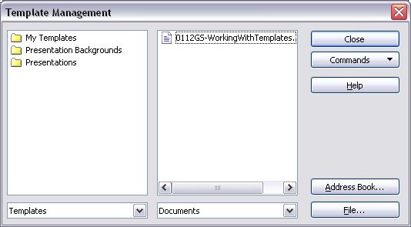
Figure 298. Template management dialog box

Updating a Document from a Changed Template
The next time that you open a document that was created from the changed template, a message similar to the following appears.
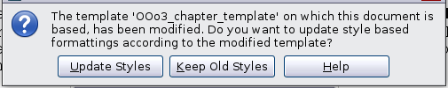
Figure 299. Update styles message
Click Update Styles to apply the template’s changed styles to the document. Click Keep Old Styles if you do not want to apply the template’s changed styles to the document (but see Caution notice below).
Caution | If you choose Keep Old Styles in the message box shown in Figure 298, that message will not appear again the next time you open the document after changing the template it is based on. You will not get another chance to update the styles from the template, although you can use the macro given in the Note below to re-enable this feature.  You can also use the Template Changer extension (see page 310) to reactivate the template.

Note | To re-enable updating from a template:  - Use Tools > Macros > Organize Macros > OpenOffice Basic. Select the document from the list, click the expansion symbol (+ or triangle), and select Standard. If Standard has an expansion symbol beside it, click that and select a module.  - If the Edit button is active, click it. If the Edit button is not active, click New.  - In the Basic window, enter the following:  Sub FixDocV3  ' set UpdateFromTemplate  oDocSettings = ThisComponent.createInstance( _  "com.sun.star.document.Settings" )  oDocSettings.UpdateFromTemplate = True  End Sub 'FixDocV3  - Click the Run BASIC icon, then close the Basic window.  - Save the document.  Next time when you open this document you will have the update from template feature back.

Adding Templates with Extension Manager
The Extension Manager provides an easy way to install collections of templates, graphics, macros, or other add-ins that have been “packaged” into files with a .OXT extension. See Chapter 16 (Customizing Writer) for more about the Extension Manager.
This Web page lists many of the available extensions: https://extensions.openoffice.org/.
To install an extension, follow these steps:
- Download the extension package and save it anywhere on your computer.
- In Writer, select Tools > Extension Manager from the menu bar. In the Extension Manager dialog box, click Add.
- A file browser window opens. Find and select the package of templates you want to install and click Open. The package begins installing. You may be asked to accept a license agreement.
- When the package installation is complete, restart OpenOffice. The templates are available for use through File > New > Templates and Documents and the extension is listed in the Extension Manager.
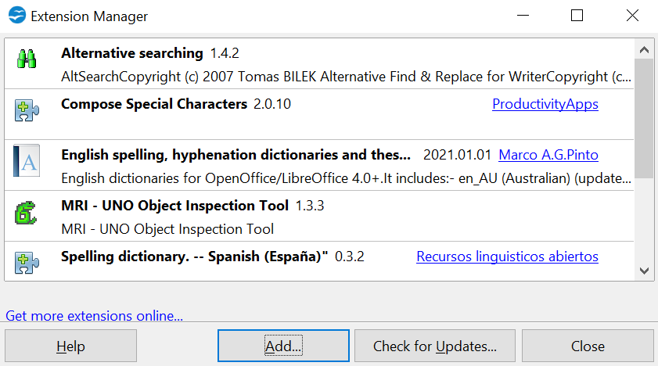
Figure 300: Newly-added package of templates

Setting a Default Template
If you create a document by choosing File > New > Text Document from the main menu, Writer creates the document from the Default template for text documents. You can, however, set a custom template to be the default. You can reset the default later if you choose.

Setting a Custom Template as the Default
You can set any template to be the default, as long as it is in one of the folders displayed in the Template Management window. If necessary, you can add the template to a folder as described in “Setting a Default Template” on page 309.
To set a custom template as the default:
- From the main menu, choose File > Templates > Organize. The Template Management dialog box (Figure 297) opens.
- In the box on the left, select the folder that contains the template that you want to set as the default, then select the template.
- Click the Commands button and choose Set as Default Template from the drop-down menu.
The next time that you create a document by choosing File > New > Text Document, the document will be created from this template.
Although many important settings can be changed in the Options dialog (see Chapter 2), for example default fonts and page size, more advanced settings (such as page margins) can only be changed by replacing the default template with a new one.

Resetting Writer’s Default Template as the Default
To re-enable Writer’s Default template as the default:
- In the Template Management dialog box (Figure 297), select any folder in the box on the left.
- Click the Commands button and choose Reset Default Template > Text Document from the drop-down menu.
The next time that you create a document by choosing File > New > Text Document, the document will be created from Writer’s Default template.

Associating a Document with a Different Template
At times you might want to associate a document with a different template, or perhaps you’re working with a document that did not start from a template.
One of the major advantages of using templates is the ease of updating styles in more than one document, as described in Chapter 7 (Working with Styles). If you update styles by loading a new set of styles from a different template (as described in Chapter 7), the document has no association with the template from which the styles were loaded—so you cannot use this method. What you need to do is associate the document with the different template.
You can do this in two ways. In both cases, for best results the names of styles should be the same in the existing document and the new template. If they are not, you will need to use Search and Replace to replace old styles with new ones. See Chapter 3 (Working with Text) for more about replacing styles using Search and Replace.
Method 1
This method includes any graphics and wording (such as legal notices) that exists in the new template, as well as including styles. If you don’t want this material, you need to delete it.
- Use File > New > Templates and Documents. Choose the template you want. A new file is created from the template. If the template has unwanted text or graphics in it, delete them from this new file.
- Open the document you want to change. (It opens in a new window.) Press Control+A to select everything in the document. Paste into the blank document created in step 1.
- Update the table of contents, if there is one. Save the file.
Method 2
This method does not include any graphics or text from the new template, except material in headers and footers; it simply includes styles from the new template and establishes an association between the template and the document.
- Download the Template Changer extension from https://extensions.openoffice.org/ and install it as described on page 310.
- Close and reopen OpenOffice. Now the File > Templates menu has two new choices: Assign Template (current document) and Assign Template (folder).
- Open the document whose template you want to change. Choose File > Templates > Assign Template (current document).
- In the Select Template window, find and select the required template and click Open.
- Save the document. If you now look in File > Properties, you will see the new template listed at the bottom of the General page.

Organizing Templates
Writer can only use templates that are in AOO template folders. You can, however, create new AOO template folders and use them to organize your templates. For example, you might have one template folder for report templates and another for letter templates. You can also import and export templates.
To begin, choose File > Templates > Organize from the main menu. The Template Management dialog box (Figure 297) opens.
Note | All the actions made by the Commands button in the Template Management dialog box can be made as well by simply right-clicking on the templates or the folders.

Creating a Template folder
To create a template folder:
- In the Template Management dialog box, select any folder.
- Click the Commands button and choose New from the drop-down menu. A new folder called Untitled appears.
- Type a name for the new folder, and then press Enter. Writer saves the folder with the name that you entered.

Deleteing a Template Folder
You cannot delete template folders supplied with AOO or installed using the Extension Manager; you can only delete template folders that you have created. (If you have administrator privileges, you can delete any folder.)
To delete a template folder:
- In the Template Management dialog box, select the folder that you want to delete.
- Click the Commands button and choose Delete from the drop-down menu. A message box appears and asks you to confirm the deletion. Click Yes.

Moving a Template
To move a template from one template folder to another template folder:
- In the Template Management dialog box, double-click the folder that contains the template that you want to move. A list of all the templates contained in that folder appears underneath the folder name.
- Click the template that you want to move and drag it to the desired folder. If you do not have the authority to delete templates from the source folder, this action copies the template instead of moving it.

Deleting a Template
You cannot delete templates supplied with AOO or installed using the Extension Manager; you can only delete templates that you have created. (If you have administrator privileges, you can delete any template.)
To delete a template:
- In the Template Management dialog box, double-click the folder that contains the template that you want to delete. A list of all the templates contained in that folder appears underneath the folder name.
- Click the template that you want to delete.
- Click the Commands button and choose Delete from the drop-down menu. A message box appears and asks you to confirm the deletion. Click Yes.

Importing a Template
If the template that you want to use is in a different location, you must import it into an AOO template folder.
To import a template into a template folder:
- In the Template Management dialog box, select the folder into which you want to import the template.
- Click the Commands button and choose Import Template from the drop-down menu. A standard file browser window opens.
- Find and select the template that you want to import, and then click Open. The file browser window closes and the template appears in the selected folder.
- If you want, type a new name for the template, and then press Enter.

Exporting a Template
To export a template from a template folder to another location:
- In the Template Management dialog box, double-click the folder that contains the template that you want to export. A list of all the templates contained in that folder appears underneath the folder name.
- Select the template that you want to export.
- Click the Commands button and choose Export Template from the drop-down menu. The Save As window opens.
- Find the folder into which you want to export the template and click Save.

Chapter 11
Using Mail Merge
Form letters, mailing labels, and envelopes

What is Mail Merge?
Apache OpenOffice (AOO) Writer provides very useful features to create and print:
- Multiple copies of a document to send to a list of different recipients (form letters)
- Mailing labels
- Envelopes
All these capabilities, though different in application, are based around the same concept – that of a registered “data source”, from which Writer determines the information necessary to complete each individual member of a set of documents.
This chapter describes the entire process. The steps include:
- How to create and register a data source.
- How to create and print form letters, mailing labels, and envelopes.
- Optionally, how to save the output in an editable file, instead of printing it directly.

Creating the Data Source
A data source is a database containing the name and address records (and optionally other information) from which a mailing list can be created. Although you can produce and print mailing labels and envelopes without using a data source, in most cases using one is the optimal approach. This chapter assumes that you are using a data source.
AOO can access a wide variety of such sources, including spreadsheets, text files and databases such as MySQL. If the information to be used in the mail merge is
currently in a format that AOO cannot access directly, you need to convert it, for example by exporting it to a comma-separated values (CSV) file.
For the following example we use a spreadsheet with the following column (field) headers: Title, First name, Last name, Address, State/County, Country, Post Code, Gender, Points. A sample data source is shown in Error: Reference source not found.
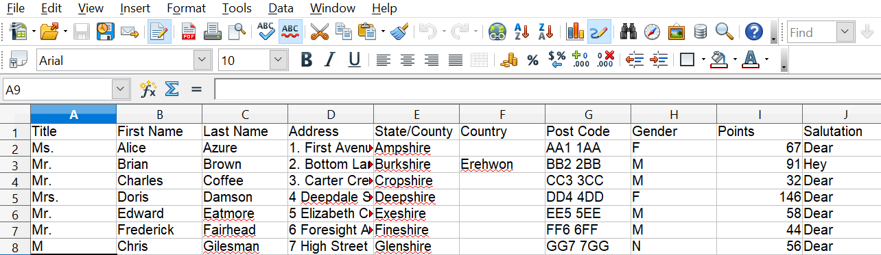

Figure 301: Spreadsheet data source

Registering a Data Source
For a data source to be directly accessible from within a Writer document, it must first be registered as described below. You only need to do this once. Having done so, the data source is available to all documents in OpenOffice.
- From within any OpenOffice document, or from the OpenOffice Start Center, choose File > Wizards > Address Data Source.
- The choices on the first page of the wizard vary with your operating system. Select the appropriate type of external address book. In this example, it is Other external data source. Click Next.
- On the next page of the Wizard, click the Settings button.
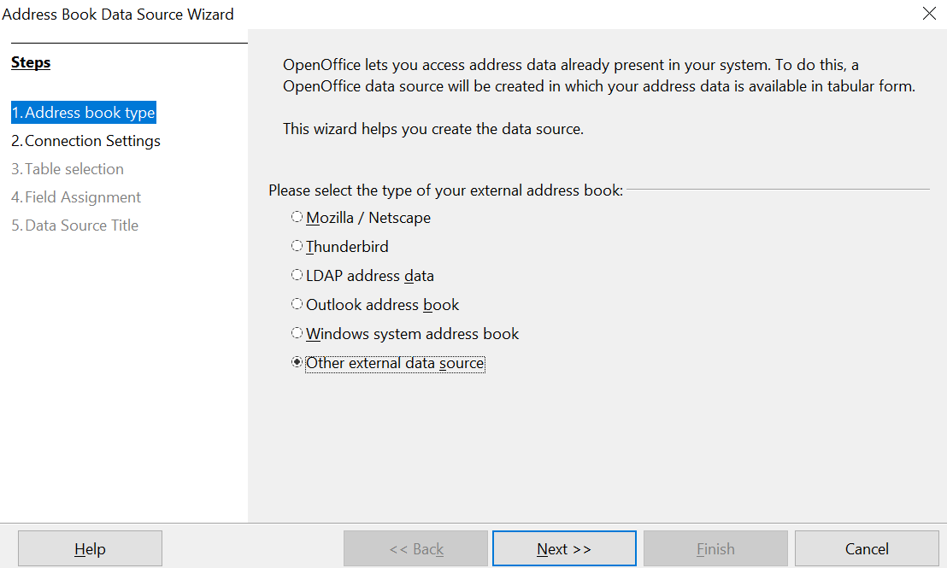

Figure 302: Select type of external address book
- In the Data Source Properties tab, select the Database type. In our example, it is Spreadsheet. Click Next.
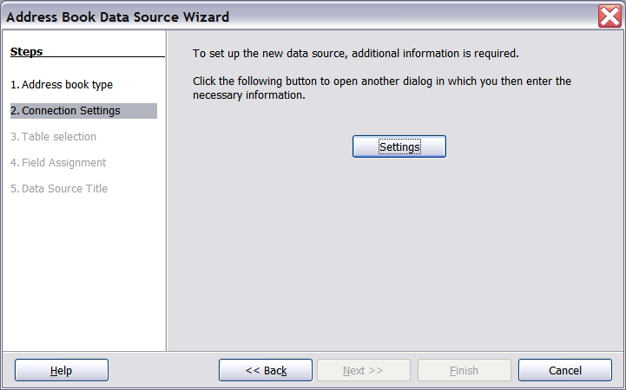

Figure 303: Starting the Settings part of the Wizard
- In the next dialog box, click Browse and navigate to the spreadsheet that contains the address information. Select the spreadsheet and click Open to return to this dialog box. At this time you may wish to test that the connection has been correctly established by clicking on the Test Connection button.
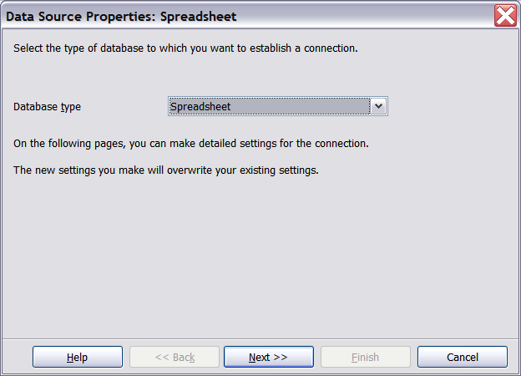

Figure 304: Selecting the database type
- Click Finish.
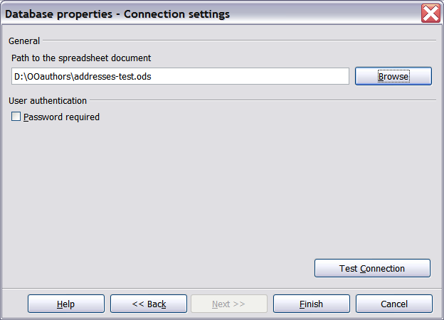

Figure 305: Selecting the spreadsheet document

- On the following page, click Next. Because this is a spreadsheet, do not click Field Assignment.
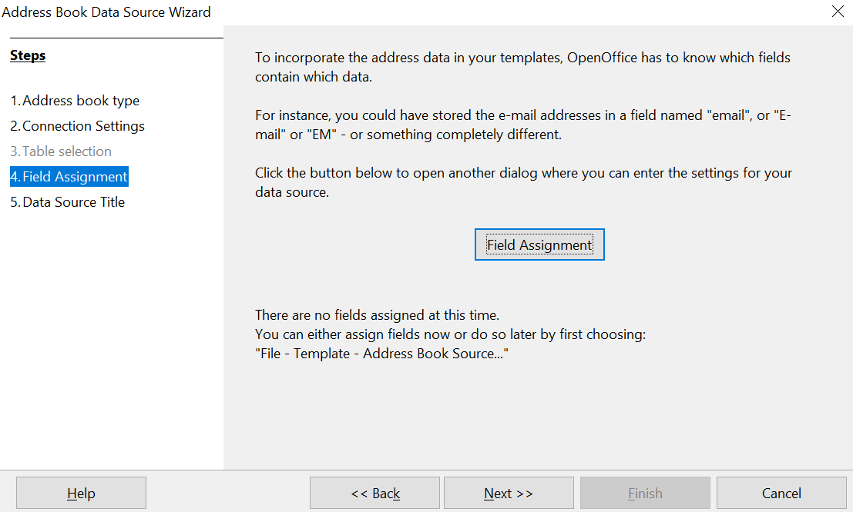

Figure 306: Because this is a spreadsheet, do not click Field Assignment
- Name the file in the Location field. The default is …\Addresses.odb; but you may replace Addresses with another name if you wish. You may also change the name in the “Address book name” field. In our example, the name “Points” was used for both.
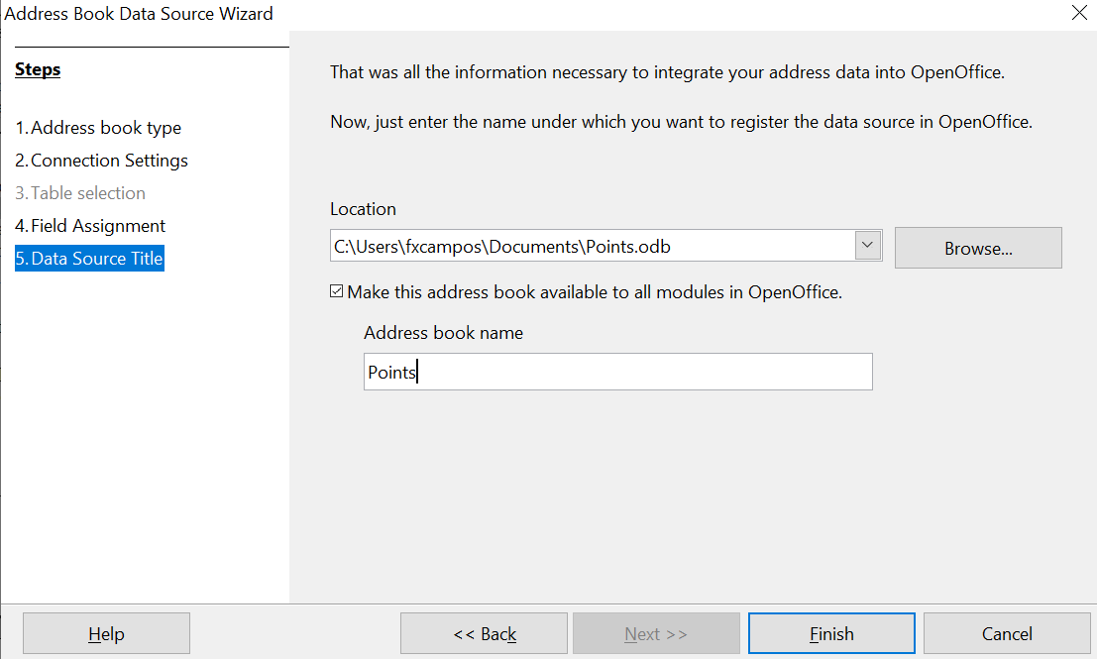
Figure 307: Name the .odb file and the address book
- Click Finish. The data source is now registered.

Creating a Form Letter
Example: Sending a letter to your customer base
A mail order company organized a campaign to assign credit points to their customers according to the quantity of goods they buy during one year.
At the end of the year, they want to send a letter to each customer to show the total of credit points collected.
Creating a form letter manually is the simplest and most comprehensive method; it's described here. Or, you can use the Mail Merge wizard as described in “Using the Mail Merge Wizard to Create a Form Letter” starting on page 330. If you elect to use the wizard, pay close attention to its current limitations, identified within its description.
- Create a new text document: File > New > Text Document, or open a pre-existing form letter with File > Open.
- Display the registered data sources: View > Data sources (or press F4).
- Find the data source that you wish to use for the form letter, in this case Points. Expand the Points and Tables folders, and select Sheet1. The address data file is displayed.
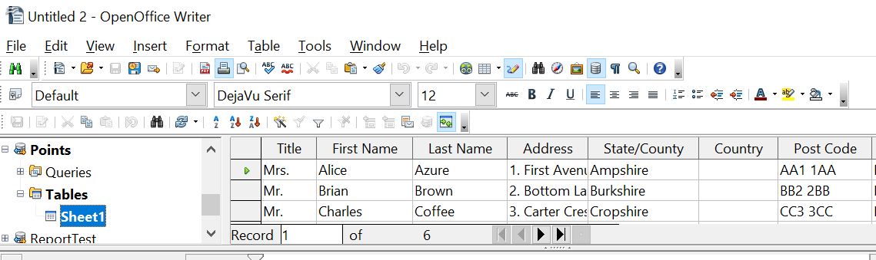

Figure 308: Selecting the data source
- Now create or modify the form letter by typing in the text, punctuation, line breaks, and so on that will be present in all the letters.
- To add the mail-merge fields where needed (such as names and addresses), click in the field heading and drag it to the appropriate point in the letter.
Note that address lines should be in individual paragraphs made with the Enter key, not separated by line breaks made with Shift + Enter. This allows suppressing blank lines, as explained below.

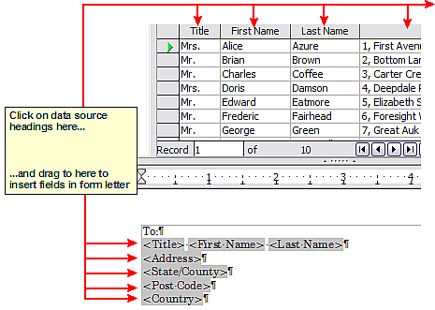
Figure 309: Dragging fields to the body of the form letter
- Continue until you have composed the entire document. At this time you may wish to consider suppressing any blank lines that may appear in the resulting letters. If not, skip Step 7.
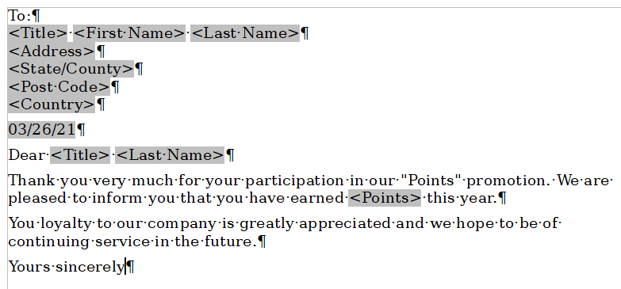
Figure 310: The completed form letter
- To suppress blank lines:
  - Click at the end of the first paragraph to be suppressed and then choose Insert > Fields > Other.
  - Select the Functions tab and then click on Hidden Paragraph in the Type column.
  - Now click in the Condition box and enter the details of the condition that defines a blank address field. It has the general form of:
![Database.Table.Database field]
where the ‘!’ (NOT) character indicates the negative case, that is, the inverse of the stated condition, and the square brackets indicate the condition.
For example, in our Points database the condition to test if the Last Name field is empty would be:
![Points.Sheet1.Last Name] as illustrated in Error: Reference source not found.
To test for multiple conditions use the operators AND and/or OR between the conditional statements, for example:
![Points.Sheet1.Title]AND![Points.Sheet1.Last Name]
  - Click Insert, but do not close the dialog box until you have amended all the lines that should be suppressed.

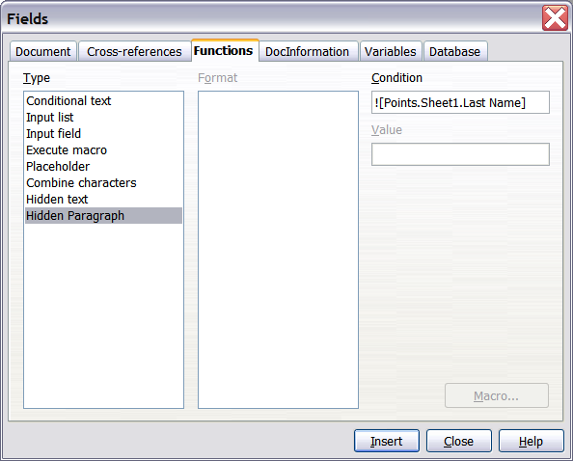
Figure 311: Hidden paragraph insertion
The document is now ready to be printed.

- Choose File > Print and respond with Yes in the message box.
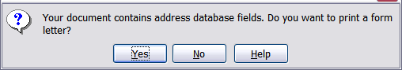
Figure 312: Confirmation message for merging database fields
- In the Mail Merge dialog box (Error: Reference source not found), you can choose to print all records or selected records. To select records to be printed, use Ctrl+click to select individual records. To select a block of records, select the first record in the block, scroll to the last record in the block, and Shift+click on the last record.
- Click OK to send the letters directly to the printer. Or, you can save the letters to a file for further editing or formatting; see “Error: Reference source not found” below.
- If you have not saved the original, prototype form letter document (template) previously, do so now. Having a form letter template could greatly simplify the creation of other form letters in the future and is highly recommended.
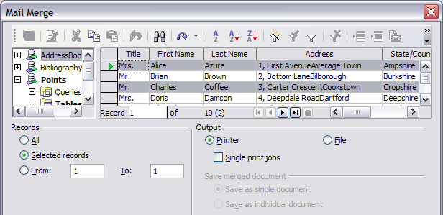Figure 313: The Mail Merge dialog box

Editing Merged Documents
You may prefer to save the letters to a file, to allow for proofreading or some later formatting. To do this:
- In the Mail Merge dialog box (Error: Reference source not found), select File in the output section, instead of using the default Printer selection.
- This changes the dialog box to display the Save merged document section, where Save as single document is preselected. You can choose to save each letter as an individual document instead.
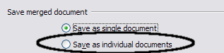
- Click OK. In the Save as dialog box, enter a file name for the saved letters and choose a folder in which to save them. The letters will be saved consecutively as separate pages in the single document, or numbered consecutively in individual files if saved as separate documents.
You can now open the letters and edit them individually as you would edit any other document.

Printing Mailing Labels
Before beginning this process, note the brand and type of labels you intend to use.

Preparing for Printing
To prepare mailing labels for printing:
- Choose File > New > Labels.
- On the Options tab, ensure that the Synchronize contents option is selected.
- On the Labels tab (Error: Reference source not found), select the Database and Table. Select the Brand of labels to be used, and then select the Type of label.
Tip | If the type of label you wish to use is not on the list, use the Format tab to define a new Brand and Type. This is beyond the scope of this document, but is relatively simple to implement, if you know the dimensions of the label.

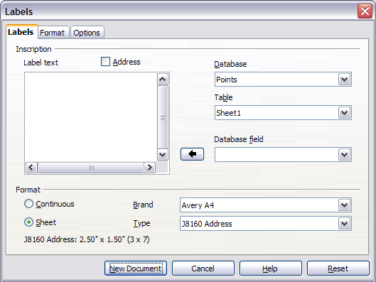
Figure 314: Select Database, Table, label Brand, and label Type
- Click the drop-down arrow under Database field. Select the first field to be used in the label (in this example, Title). Click the left arrow button to move this field to the Label text area, as shown in Figure Error: Reference source not found.
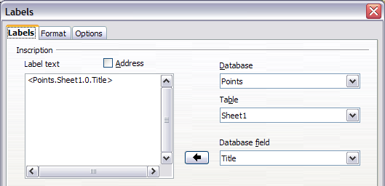
Figure 315: Move fields from Database field list to Label text area
- Continue adding fields and inserting desired punctuation, spaces, and line breaks until the label is composed. Error: Reference source not found shows the completed label.
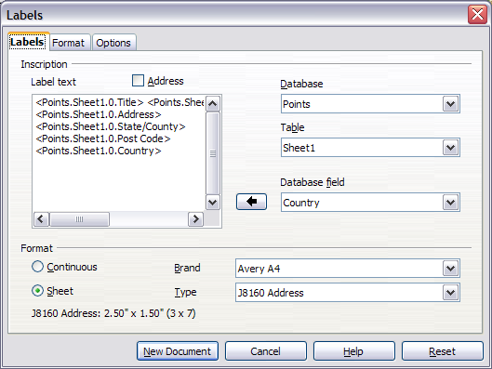Figure 316: The completed label
- Click New Document. You now have a new, single-page document containing a series of frames, one for each label of the selected type and filled with the data source address fields that you selected. Quite often some fields in your address data source will be unused, leading to blank lines in your labels. If this is not important, go to “Error: Reference source not found” on page Error: Reference source not found; otherwise, follow the instructions in “Error: Reference source not found” on page Error: Reference source not found.

Removing Blank Lines from Labels
- First ensure that the label frames are showing the field contents (data source headings), rather than their underlying field names. If this is not the case, then either press Ctrl+F9 or choose View > Field Names to toggle the view.
- Next, ensure that you can see non-printing characters, such as paragraph marks, line breaks and so on. If these are not already visible, choose View > Nonprinting Characters from the menu bar, or press Ctrl+F10, or click on the paragraph icon in the Standard toolbar.
You will now see that address field separation is created by line breaks , rather than paragraphs . As the suppression of blank address fields depends on hiding paragraphs, not lines, you need to replace line breaks with paragraphs as follows.
- Click in the first label, at the end of the last data source address field in the first line of the label. Press Delete to remove the new line character and then press Return (or the Enter key) to insert a paragraph marker. Repeat this action for each line in the address.
If the line spacing in the first label is not satisfactory, you may wish to correct this before proceeding, by modifying the paragraph style associated with the address. Unless you have changed it, the address uses the Default style.
Caution | The objective of step 3 is to replace all line breaks at the end of data source address fields with paragraphs. Sometimes the address data field may be longer than the width of the label and will wrap to the next physical line: make sure that you are not misled by this into deleting and replacing anything other than line break characters.

- Click again at the end of the first paragraph to be conditionally suppressed and then choose Insert > Fields > Other. Select the Functions tab and then click on Hidden Paragraph in the Type column. Now click in the Condition box and enter the details of the condition that defines a blank address field. It has the general form of:
![Database.Table.Database field]
where the ‘!’ (NOT) character indicates the negative of the condition contained by the square brackets.
For example, in our Points database the condition to test if the Last Name field is empty would be
![Points.Sheet1.Last Name] as illustrated in Error: Reference source not found.
To test for multiple conditions, use the operators AND and/or OR between the conditional statements, for example:
![Points.Sheet1.Title]AND![Points.Sheet1.Last Name]
Click Insert, but do not close the dialog box until all lines have been amended.
- Repeat for each paragraph to be conditionally suppressed, remembering to advance the cursor to the end of the line in question before changing the last element of the condition and Inserting the result.
Caution | The last paragraph of the label address block ends with a special field, Next record:Database.Table (Next record:Points.Sheet1 in our example), and the Hidden paragraph field MUST be inserted before this field. This can generally be accomplished by clicking at the end of the paragraph and then using the Left Arrow key once to skip back over it.  A clue that you omitted this action is the observation that some records have been skipped and are missing from the final output.

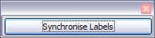
- Remembering that we selected Synchronize contents earlier, you should now be able to see a small window containing a button labeled Synchronize Labels. Click on this button and the hidden paragraph fields are propagated to all the labels in your document.
You now have a template suitable for future use with the same data source and type of label. If you wish to save it, use File > Templates > Save as to save it as an Open Document Text Template (.ott) into the private template directory (folder) that you have previously defined in Tools > Options > OpenOffice > Paths > Templates.

Printing
- Choose File > Print. The message shown in Error: Reference source not found appears. Click Yes.
- In the Mail Merge dialog box (Error: Reference source not found), you can choose to print all records or selected records. To select records to be printed, use Ctrl+click to select individual records. To select a block of records, select the first record in the block, scroll to the last record in the block, and Shift+click on the last record.
- Click OK to send the labels directly to the printer.
If you prefer to save the labels to a file, perhaps to allow some later editing such as changing the typeface or paragraph format, then you should select File in the output section of the Mail Merge dialog box, rather than using the default Printer selection. This changes the dialog box to highlight the Save merged document section, where Save as single document is preselected.
In this case, clicking OK brings up the Save as dialog box, where a file name can be entered for the saved labels.
If you did not save the prototype label fields document (template) in step 6 in the previous section, then you are prompted to do so now by another Save as dialog box.
In either case, whether printing or saving to file, despite there apparently being only one page of labels, the printed or saved output will be expanded to include all the selected records from the data source.

Editing a Saved File of Mailing Labels
To edit a saved file of mailing labels, open the saved label file in the normal way. You will be prompted to update all links. Choose No for the following reason: The first label on the page is termed the “Master Label” and all other labels are linked to it. If you update the links, then all labels will end up containing the same data, which may not be what you want.
You can edit individual records in the normal way, by highlighting and changing the font name, for example.
However, you cannot edit all labels globally (for example, to change the font name for all records) by selecting the entire document. To achieve this result you have to edit the paragraph style associated with the label records as follows:
- Right-click any correctly spelled word in a label record. Select Edit Paragraph Style from the pop-up menu. (Note: If you click on a misspelled word, a different menu appears.)
- Then from the Paragraph Style dialog box, you can make changes to the font name, the font size, the indents, and other attributes.

Printing Envelopes
Instead of printing mailing labels, you may wish to print directly onto envelopes. There are two basic ways to create envelopes, one where the envelope is embedded within a letter, generally as the first page (Insert in the Envelope dialog box), and another where the envelope is an independent document (New Doc. in the dialog box). In each case the addressing data may be manually entered, for example by copying and pasting from the letter with which it is associated, or it may originate within an address data source.
This section assumes the use of an address data source and, for convenience, a freestanding envelope.
The production of envelopes involves two steps, setup and printing, as described in this section.

Setting up Envelopes for Printing
- Choose Insert > Envelope from the menu bar.
- In the Envelope dialog box, select the Format tab (Error: Reference source not found), where you can select the envelope format to use. You can then arrange the layout of the envelope to suit your requirements, together with the character and paragraph attributes to be used in the Sender and Addressee areas. These attributes are accessed using the Edit buttons to the right of the dialog box, next to the word Format.
Note | If the list of envelope formats in the Size section of this dialog box does not include the size you need, choose User Defined (at the bottom of the list) and specify the envelope size using the Width and Height boxes.

Tip | At this stage it is not possible to vary the dimensions of the frames that will hold the Sender and Addressee information, but once the envelope has been created this will become possible, and you may wish to make some cosmetic adjustments.

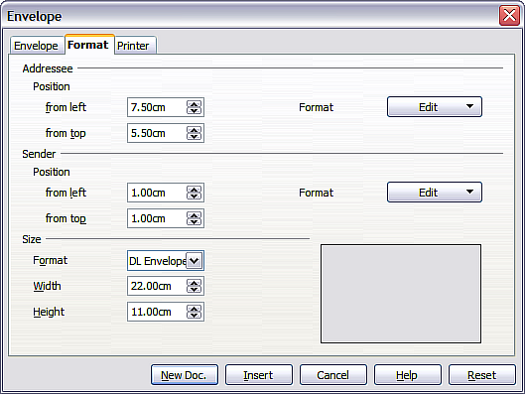
Figure 317: Envelope formatting dialog box
- The next step is to select the Printer tab (Error: Reference source not found), from where you may choose the printer you intend to use, its setup—for example, specification of the tray holding envelopes—and other printer-related options such as envelope orientation and shifting. You may need to experiment with these settings to achieve the best results with your printer.
- You now have the choice of creating the Addressee fields by dragging and dropping from the data source headings (as described in “Creating a Form Letter” on page 317, and in particular in Error: Reference source not found) or using the facilities of the Envelope tab.
If you prefer dragging and dropping, then click New Doc., drag your data source headings into the Addressee area on your new envelope and skip to step 7), otherwise continue with steps 5 and 6.
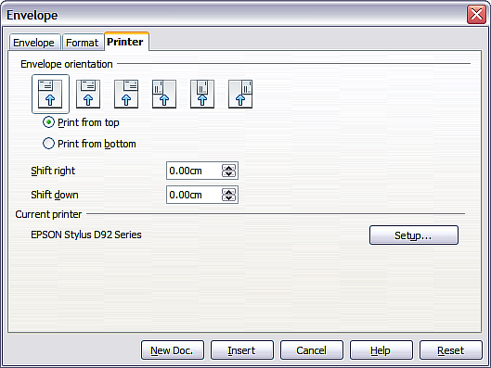
Figure 318: Choosing printer options for an envelope
- Select the Envelope tab (Error: Reference source not found).
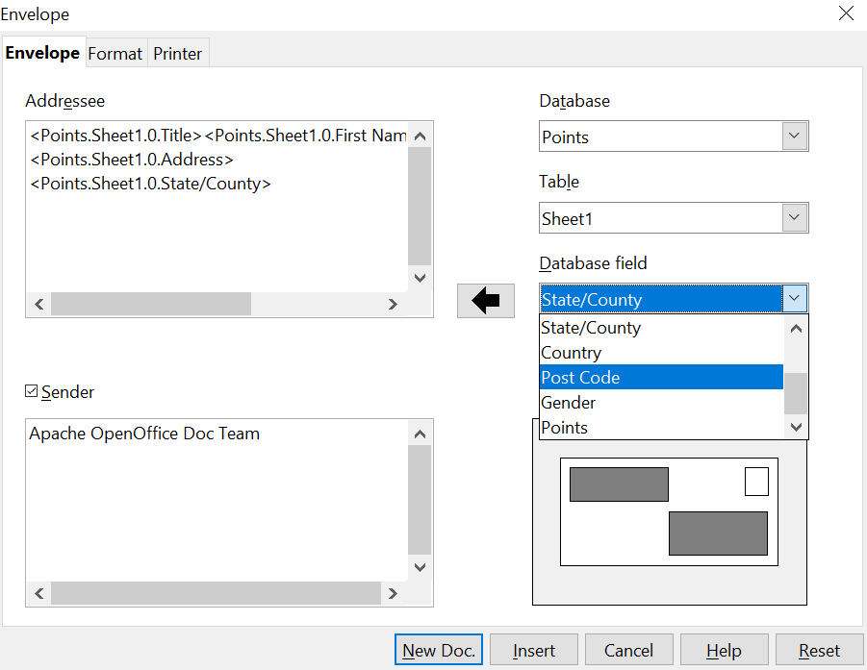

Figure 319: Choosing addressee and sender information for envelopes
Verify, add, or edit the information in the Addressee and Sender boxes (Sender is the “from” on the envelope). You can use the right-hand dropdown lists to select the database and table from which you can access the Addressee information, similarly to that described for “Printing Mailing Labels”, paragraphs 3, 4 and 5 on page 322. The similarity of the method with Error: Reference source not found and Error: Reference source not found will be clear.
- When you have finished formatting, click either the New Doc. or Insert button to finish. As might be expected, New Doc creates only the envelope template in a new document, whereas Insert inserts the envelope into your current document as page 1.
If you don’t want to proceed with this envelope, click Cancel or press the Esc key. You can also click Reset to remove your changes and return to the settings that were present in it when the dialog box opened.
You can now modify the placement of the frames containing the sender and addressee information, or make further changes to the character and paragraph attributes (for example, the font) or add a logo or other graphic to the envelope.
Tip | If you frequently print envelopes from the same database onto the same size envelopes, at this point you may wish to create a template from this setup. See “Error: Reference source not found” on page Error: Reference source not found.

- Quite often some fields in your address data source will be unused, leading to blank lines in your envelope Addressee area. If this is not important, you can skip the next few paragraphs and go directly to “Merging and Printing the Envelopes” on page 330, otherwise continue as described here.
Tip | The following procedure is very similar to that used the section on printing mailing labels. It is reproduced here for ease of reference.

- First ensure that the envelope is showing the field contents (data source headings), rather than their underlying field names. If this is not the case, either press Ctrl+F9 or choose View > Field Names to toggle the view.
  - Next, ensure that you can see non-printing characters, such as paragraph marks, line breaks and so on. If these are not already visible, choose View > Nonprinting Characters from the menu bar, or press Ctrl+F10, or click on the large paragraph icon in the Standard toolbar.
You will now see that address field separation is created by line breaks , rather than paragraphs . Since suppressing blank address fields depends on hiding paragraphs, not lines, you need to replace line breaks with paragraphs as follows.
  - Click at the end of the last data source address field in the first line of the label. Press Delete to remove the new line and then press Return (or the Enter key) to insert a paragraph. Repeat this action for each line of the label.
If the line spacing in the Addressee area is not satisfactory, you may wish to correct this before proceeding, by modifying the paragraph style associated with the address. Unless you have changed it, the address uses the Default style.
  - Click again at the end of the first paragraph to be conditionally suppressed and then choose Insert > Fields > Other. Select the Functions tab and then click on Hidden Paragraph in the Type column. Now click in the Condition box and enter the details of the condition that defines a blank address field. It has the general form of:
![Database.Table.Database field]
where the ‘!’ (NOT) character indicates the negative case and the square brackets indicate the condition.
For example, in our Points database the condition to test if the Last Name field is empty would be:
![Points.Sheet1.Last Name] as illustrated in Error: Reference source not found.
To test for multiple conditions, use the operators AND and/or OR between the conditional statements, for example:
![Points.Sheet1.Title]AND![Points.Sheet1.Last Name]
Click Insert, but do not close the dialog box until all lines have been amended.
  - Repeat for each paragraph to be conditionally suppressed, remembering to advance the cursor to the end of the line in question before changing the last element of the condition and Inserting the result.

Merging and Printing the Envelopes
To merge addresses and print the envelopes:
- Choose File > Print. A message box (Error: Reference source not found) appears. Click Yes.
- The Mail Merge dialog box (Error: Reference source not found) appears. As with form letters and mailing labels, you can choose to print envelopes for one, several or all address records in the database.
- Make your selections and then click OK to print directly to the printer. If you wish to check the envelopes before printing them, see Step 9 of “Creating a Form Letter” on page Error: Reference source not found for instructions.

Creating an Envelope Template
When your envelope layout and fields are complete to your satisfaction, you can save the result as a template.
- Choose File > Templates > Save.
- On the Templates dialog box, type a name for the new template and choose a category in which to store your template.
- Click OK to save the template.

Using the Mail Merge Wizard to Create a Form Letter
The manual method of creating a form letter described in “Creating a Form Letter” on page 317 provides the most control over the result and is therefore recommended. If you prefer to use the Mail Merge wizard, the technique is described below.
Before starting, you should note that the layout made in Step 5 of the Wizard is idiosyncratic, with many paragraph marks to space the address block frame and salutation. Creating a professional looking document requires significant editing.

To begin the process, open a new document with File > New > Text Document and start the Mail Merge wizard using Tools > Mail Merge Wizard. The wizard opens, as shown in Error: Reference source not found.

Step 1: Select Starting Document
The wizard gives various options to select your starting document:
- Use the current document.
- Create a new document.
- Start with an existing document.
- Start from a template.
For the purposes of this description, we assume that you opened a new text document. This will ensure that all the steps in the wizard are fully explored, although with experience you may find it more practical to use a draft you prepared earlier, which allows skipping some steps.
Select Use the current document and click Next.
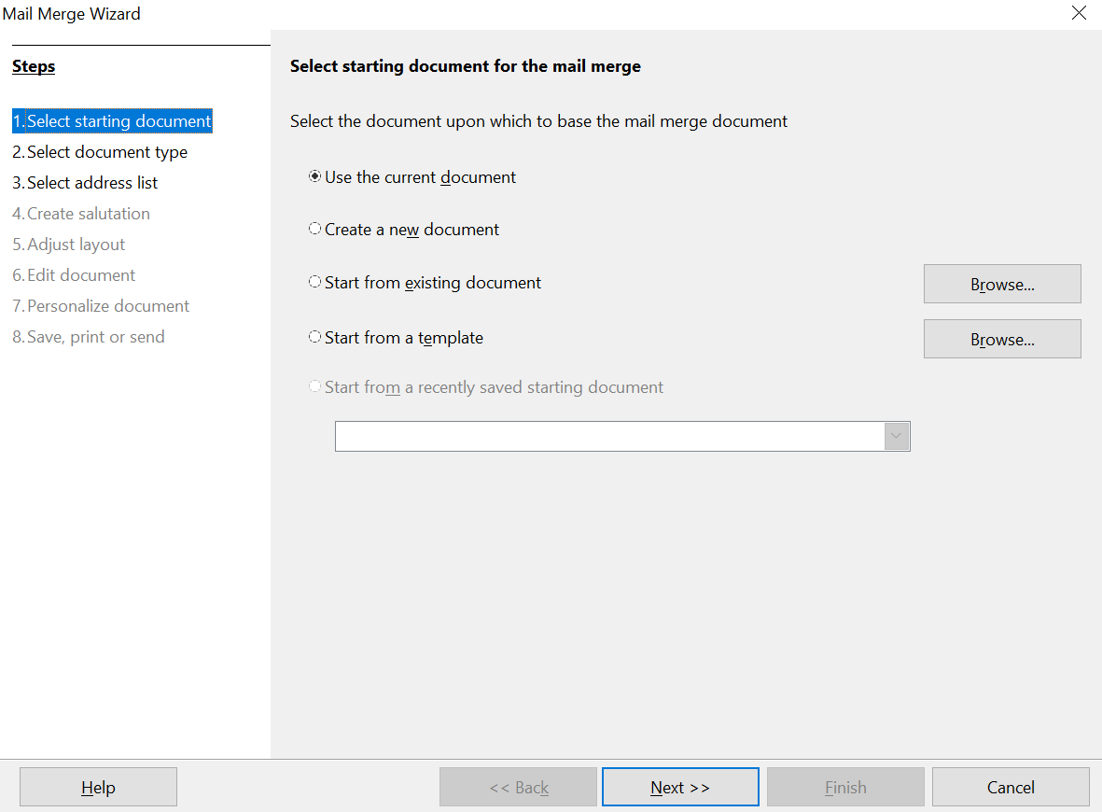

Figure 320: Select starting document

Step 2: Select Document Type
The wizard can produce letters or, if a Java Mail connection exists, email messages. You can see these options in Error: Reference source not found. In this example, we are producing a letter. Select Letter and click Next.
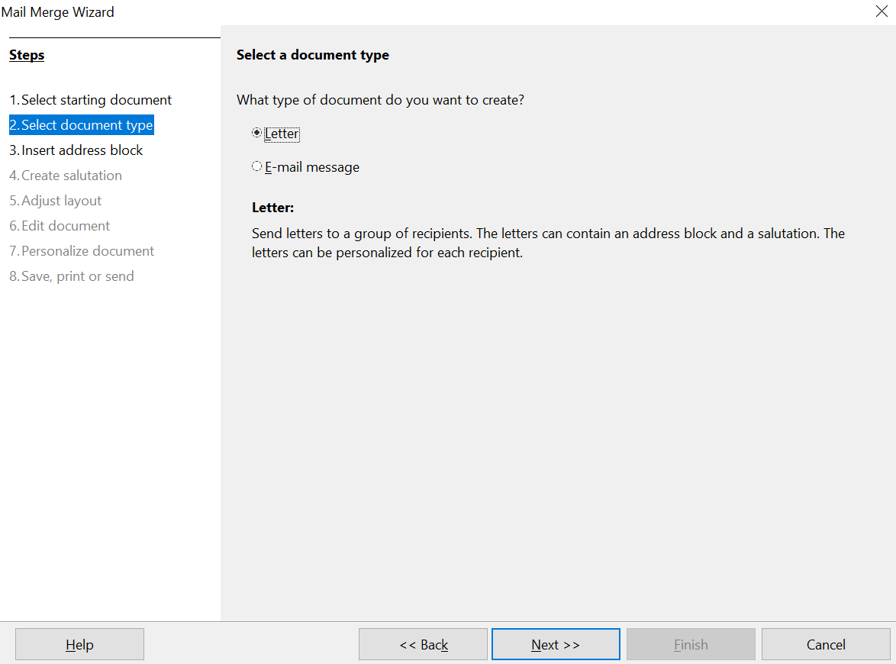

Figure 321: Choose document type

Step 3: Insert Address Block
This is the most complex step in the wizard. In this step (Error: Reference source not found) you will do three things:
- Tell the wizard which data source to use. The data source must be an existing file; in this example it is the “Points” spreadsheet created earlier.
- Select the address block to use in the document. This means choosing which fields appear (for example, whether the country is included) and how they look.
- Make sure that the fields all match correctly. This is very important. For example, the wizard has a field called <Last Name>. If your spreadsheet has a column called “Surname”, you need to tell the wizard that <Last Name> and “Surname” are equivalent. This is described in “Matching the Fields” on page 335.
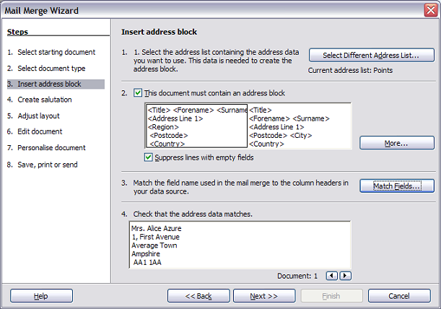Figure 322: Insert address block

Selecting the Data Source (address list)
- If the current address list, identified beneath the Select Different Address List button in section 1, is not the one you wish to use, click the button to open the Select Address List dialog box (Error: Reference source not found) for choosing a data source.
- If you have not already created the address list, you may click Create to do so now. This step allows you to create a CSV (Comma Separated Values) file with a new list of address records.
If you already have an address list that is not the one you want to use, click Add and select the file in which it resides.
In each of the above cases a new data source will be created and registered.
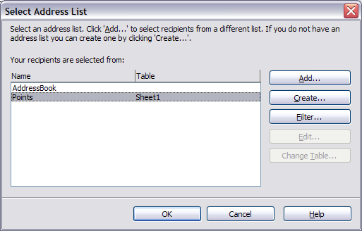Figure 323: Select address list dialog box
- Select the address list and click OK to return to step 3 of the wizard. For this example, the preceding steps are all you need to do. The wizard can also exclude certain records; click Filter to choose them.

Selecting the Address Block
- In step 3 of the wizard (shown in Error: Reference source not found), section 2 allows you to select the address block to appear on the letter, and define its appearance and the fields it contains. The main page gives two examples. If neither of those is exactly what you want, click More to see more choices, in the Select Address Block dialog box (shown in Error: Reference source not found).
- The Select Address Block dialog box offers six choices for the format of the address block (scroll down to see the last two choices). You can also optionally include or exclude the country (for example, a resident of England might only include the country if it is not England). The six formats provided are relatively common, but they might not exactly match your preference. If this is the case, select the address block that is closest to what you want and click Edit, which opens the New Address Block dialog box.
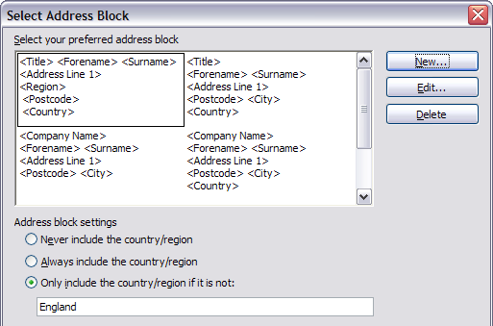
Figure 324: Select address block
- In the New Address Block dialog box (Error: Reference source not found), you can add or delete address elements using the arrow buttons on the left. To move elements around, use the arrow buttons on the right. For example, to add an extra space between first and last names in Error: Reference source not found, click <Surname> and then click the right arrow button.
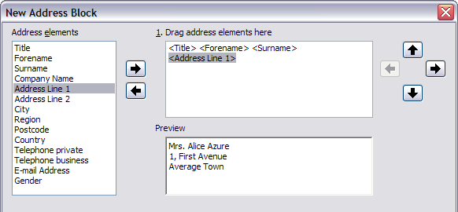Figure 325: New address block

Matching the Fields
Finally, it is time to match the wizard’s fields with the spreadsheet fields, so that items like <Last Name> and “Surname” match correctly.
- Look at section 3 of step 3 of the wizard (shown in Error: Reference source not found on page Error: Reference source not found). The box at the bottom displays one record at a time, using the address block format you selected. Use the right and left arrow buttons below that address box to step through the addresses, checking that they display correctly. Do not assume that all the records display correctly, just because one or two do. Check them all if you can, or at least a significant portion.
- If the addresses do not display correctly, (and they may not, right away), click Match Fields, as shown in Error: Reference source not found.
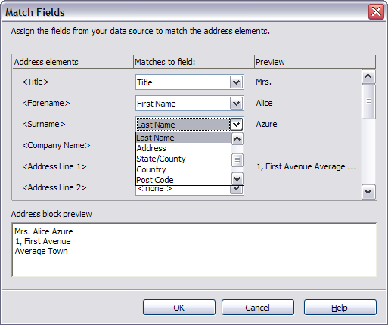Figure 326: Match fields dialog box
The Match Fields dialog box has three columns:
  - Address Elements are the terms the wizard uses for each field, such as <Forename> and <Surname>.
  - Use the Matches to Field column to select, for each address element, the field from your data source that matches it.
  - The Preview column shows what will be shown for this field from the selected address block, so you can double-check that the match is correct. When you have matched all the fields, click OK to return to step 3 of the wizard. Now, when you use the arrow buttons to look at all the addresses, they should all look correct. If not, go back and change anything you’re not happy with, before clicking Next to move to step 4.
Note that you will not be able to continue until you have correctly matched all the fields in your chosen address block. Seeing <not available> in a field position indicates the field in question is not correctly matched.
- Notice the option for Suppress lines with empty fields. Using the Wizard, you do not have to create your own conditional suppression fields.

Step 4: Create Salutation
The salutation is the initial greeting, for example, Dear Mr Jones. In step 4, select the salutation that will appear in the letter, as illustrated in Error: Reference source not found.
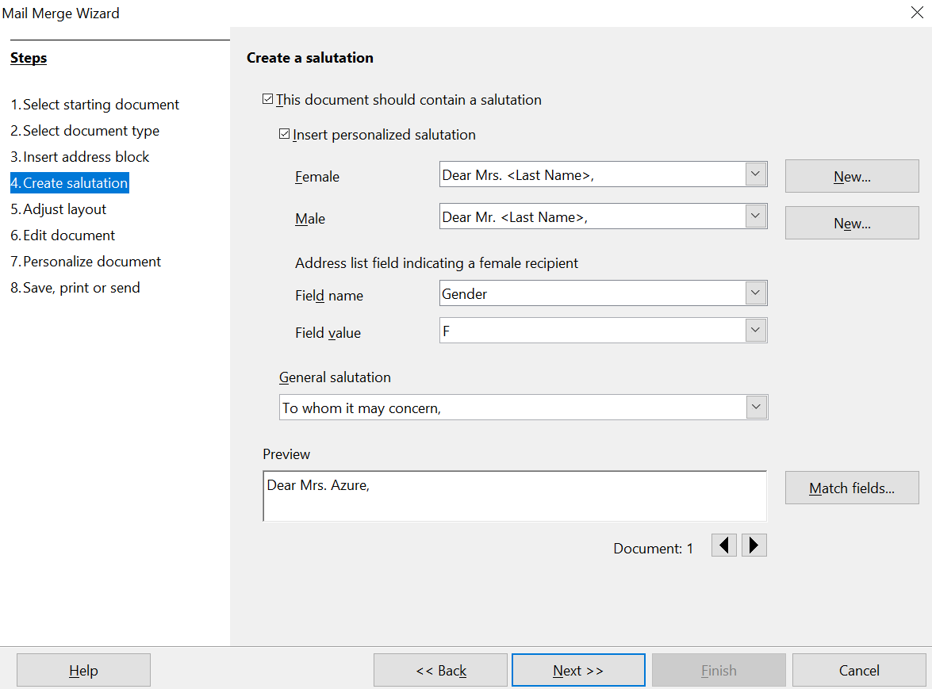

Figure 327: Create a salutation
The default arrangement is unlikely to meet your needs, but adjustments are easily made and can be very flexible if your data source is appropriately prepared.
Error: Reference source not found shows the default settings of the dialog except that the boxes Field name and Field value have been filled in appropriately for the Points data source we have been using. The selection of the options This document should contain a salutation and Insert personalized salutation activate separate salutations for addressees labeled as Female or not Female. The labeling is done by looking at the field in the data source that is listed in the Field name box under Address list field indicating a female recipient, which is the Gender field in the Points data source. If that field has the value listed in the Field value box, F in our data, the addressee is given the Female salutation. Otherwise, the Male salutation is used. The default salutations are Dear Mr. or Dear Mrs. followed by the last name.
If the Insert personalized salutation box is not checked, the General salutation will be used. There are a few preset options for the salutation or one may be entered manually.
Much more flexibility is available if you use the Match fields and New buttons to the right of the Female and Male boxes to build a custom salutation. First click Match fields to open a dialog nearly identical to the one in Error: Reference source not found. The only difference is that you are mapping fields from the data source to salutation elements rather than to address elements. Your data source should contain fields storing a value for the Title element and a value for the salutation, such as “Dear”. Unfortunately, the Match Fields dialog does not include an element dedicated to the salutation, so you have to map your salutation field to some other element that was also not used in the address. We chose the <telephone private> element to map to the Salutation field in the data source.
Now click one of the New buttons. This opens the dialog shown in Error: Reference source not found except that the boxes in the middle will be empty. Click on the first element you want in the salutation then on the right arrow to move the element to the box. After each element is moved to the box, it remains highlighted. You can see this with <Last Name> in the figure. Click to the right of it so that the cursor appears with a space between it and the element and the next element can be inserted with the correct spacing. After inserting all the elements of the salutation, click OK.
In the Preview box of Error: Reference source not found, you can see that the Salutation field of the data source (mapped to the <Telephone private> element) has the value “Dear” for this person and the Title is M. Other records in the data source may have different values in those fields. Instead of the hard coded Mr. and Mrs. titles of the default settings, you can include any number of titles such as Ms., Dr., and Prof. All that is required is storing those values in your data source. You can see how this was set up for our data source in Error: Reference source not found.
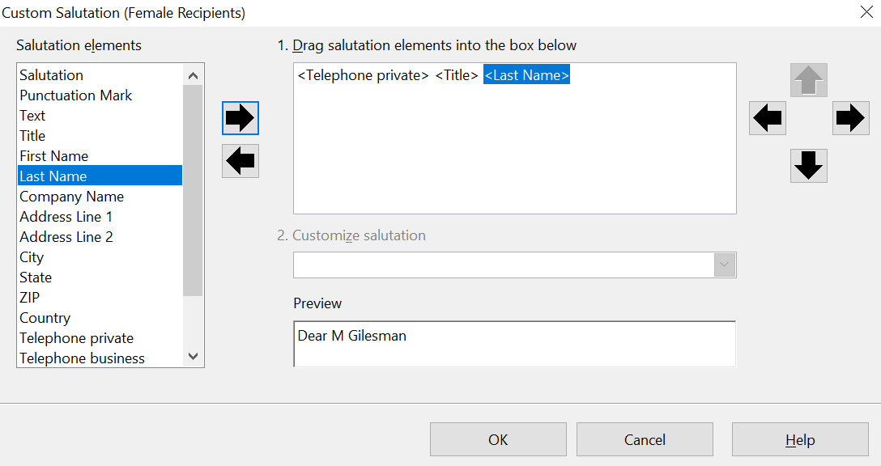

Figure 328: The New Dialog for a Salutation
You should now click the other New button next to the Male or Female box and set it up with the same method and probably identically. The Field name and Field value boxes in Error: Reference source not found still need to be filled out but all the work of handling different people is done in the data source by changing the Title and Salutation fields. You can also erase the content of the General salutation.

As in step 3, step 4 of the wizard has a preview pane at the bottom. You should check more than one record to ensure that other records look the way you expect.

Step 5: Adjust Layout
In step 5, you can adjust the position of the address block and salutation on the page. You can place the address block anywhere on the page. The salutation is always on the left, but you can move it up or down the page. Use the buttons shown in Error: Reference source not found to move the elements.
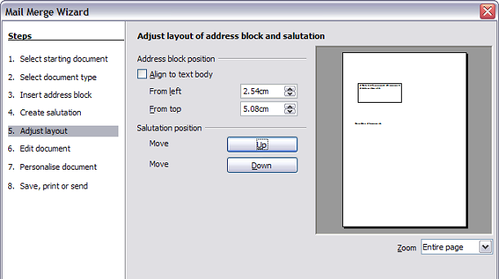Figure 329: Adjust layout

Step 6: Edit Document and Insert Extra Fields
In step 6 you have another opportunity to exclude particular recipients from the mail merge, as shown in Error: Reference source not found.
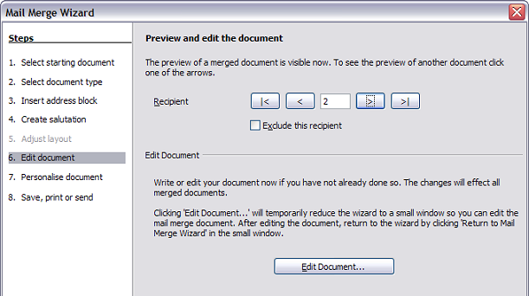Figure 330: Edit document
You can also edit the body of the document. If you started with a blank document, you can write the whole letter in this step. Click Edit Document to shrink the wizard to a small window (Error: Reference source not found) so you can easily edit the letter.
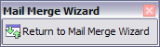
Figure 331: Minimized mail merge wizard
At this point, you need to perform one more important task. The wizard only inserts information from the name and address fields, but you may wish to add additional data. In our example, we want to tell each person how many points they had accumulated during the year; that information is in the spreadsheet.
To do this:
- Click Edit Document in step 6 of the wizard.
- Choose Insert > Fields > Other. The Fields dialog box shown in Error: Reference source not found opens.
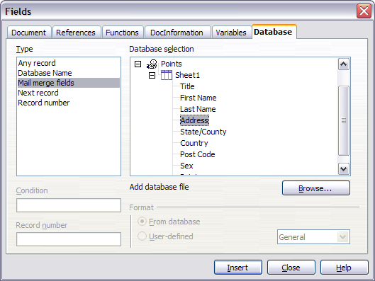Figure 332: Insert mail merge fields dialog box
- Click the Database tab.
- On the left-hand side, select Mail merge fields.
- Under Database selection find your data source (in this example, it is a spreadsheet). Expand it to see the fields.
- Click the field you want to insert, then click Insert to insert the field.
You can insert any number of fields any number of times into your mail merge document.
- Click Close when you are done.
Note | The Database selection lists the data source you selected in step 3. All the information you need for the letter must be contained in that data source.

Step 7: Personalize Documents
In step 7, AOO creates all your letters, one per recipient.
Clicking the Edit individual Document button here is similar to step 6. The difference is that you now edit a long file containing all the letters, so you can make changes to a particular letter to one person. In this step of the Mail Merge wizard (Error: Reference source not found), click Find to open a dialog box that allows searches within the document, perhaps for an individual addressee.
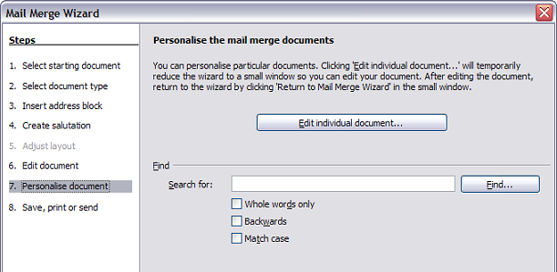Figure 333: Personalize document
As with step 6, when editing the document, the wizard shrinks to a small window (Error: Reference source not found). Click on this window to expand the wizard to its full size.

Step 8: Save, Print or Send
You've now completed the mail merge process. The only remaining step is using what you've created. In step 8, you can save the original sample letter, save the merged document, print the letters right away or, if you created email messages, send them.
You probably want to save both the initial, draft (prototype) document, and the merged document. To do this, select Save starting document to reveal the Save starting document section containing the Save starting document button shown in Figure Error: Reference source not found This button will be active only if the document has not already been saved. Clicking on this button brings up the standard Save as dialog box. Once you have named and saved the document, return to the Step 8 dialog box shown in Error: Reference source not found.
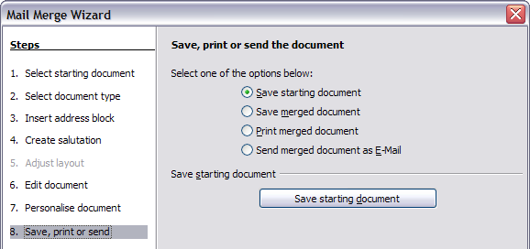Figure 334: Step 8: Save, print or send
The merged document can now be saved by selecting Save merged document. This will reveal the Save merged document settings section, from which you can select to save either as one large file containing all the individual, generated letters or as a separate file for each letter.
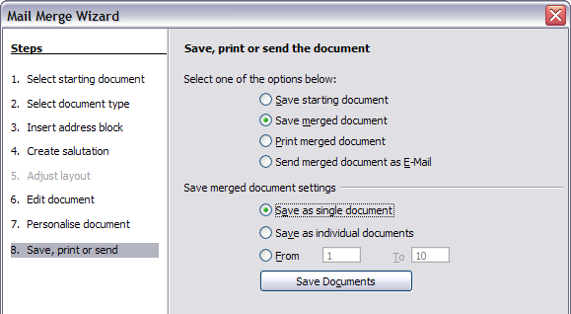
Figure 335: Saving a merged document
When you have saved the merged document, you can print the final letters now or later; and you can still manually check and edit the letters if necessary. If you elect to print at this stage, the dialog box shown in Error: Reference source not found appears; it should be self-explanatory.

Chapter 12
Tables of Contents, Indexes, and Bibliographies

Introduction
This chapter describes how to create and maintain a table of contents (TOC), an index, and a bibliography for a text document using Apache OpenOffice Writer. To understand the instructions, you need to have a basic familiarity with Writer and styles (see Chapters 6 and 7).
This chapter does not cover all the possible ways to use the features available through the TOC/Index dialog boxes in Writer., but some common usage examples are given that cover a wide range of needs.

Tables of Contents
Writer’s table of contents feature lets you build an automated table of contents from the headings in your document. Whenever changes are made to the text of a heading in the body of the document or the page on which the heading appears, those changes automatically appear in the table of contents when it is next updated.
Before you start, make sure that the headings are styled consistently. For example, you can use the Heading 1 style for chapter titles and the Heading 2 and Heading 3 styles for chapter subheadings.
This section shows you how to:
- Create a table of contents quickly, using the defaults.
- Customize a table of contents.
Note | You can use any style for the different levels you want to include in the table of contents. But, for the sake of simplicity, most of this chapter uses the default Heading [x] styles.

Creating a Table of Contents Quickly
Most often, you'll find the default table of contents to be what you need. Inserting a default TOC is simple:
- When you create your document, use the following paragraph styles for different heading levels (such as chapter and section headings): Heading 1, Heading 2, and Heading 3. These are what will appear in your TOC, since Writer can evaluate up to ten levels of headings.
- Click in the document where you want the TOC to appear.
- Choose Insert > Indexes and Tables > Indexes and Tables.
- Click OK. The result will be a typical table of contents.
Some tips you may find useful:
- If some of your headings do not show up in the table of contents, check that the headings have been tagged with the correct paragraph style. If a whole level of headings does not show up, check the settings in Tools > Outline Numbering. See “Defining a hierarchy of headings” in Chapter 6 (Introduction to Styles) for more information.
- The TOC appears with a gray background. This background is there to remind you that the text is generated automatically. It is not printed and does not appear if the document is converted to a PDF. To turn off this gray background, go to Tools > Options > OpenOffice > Appearance, then scroll down to the Text Document section and deselect the option for Index and table shadings.
This change may leave a gray background showing behind the dots between the headings and the page numbers, because the dots are part of a tab. To turn that shading off, go to Tools > Options > OpenOffice Writer > Formatting Aids and deselect the option for Tabs.
- If you cannot place the cursor in the TOC, choose Tools > Options > OpenOffice Writer > Formatting Aids, and then select Enable in the Cursor in protected areas section.
If you add or delete text (so that headings move to different pages) or you add, delete, or change headings, you need to update the table of contents. To do this:
- Click anywhere in the TOC.
- Right-click and select Update Index/Table from the pop-up menu.

Customizing a Table of Contents
Almost every aspect of the table of contents can be customized to suit the style and requirements of your document. However, this flexibility also carries some complexity; it's good to have in mind the desired end result.
Start by clicking in the document where you want the table of contents to appear and choose Insert > Indexes and Tables > Indexes and Tables to open the Insert Index/Table dialog box shown in Figure 336.
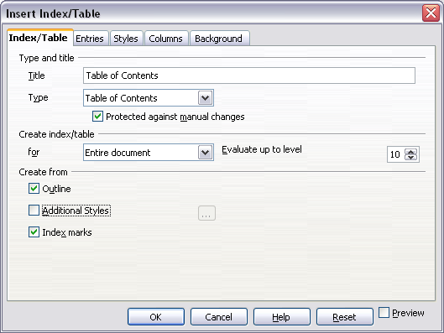
Figure 336. Index/Table page of Insert Index/Table dialog box
You can also access this dialog box at any time by right-clicking anywhere in an existing table of contents and choosing Modify from the pop-up menu.
The Insert Index/Table dialog box has five tabs. Each of them covers a different aspect of the TOC structure and appearance:
- Use the Index/Table tab to set the attributes of the TOC, most importantly the type of index.
- Use the Entries and Styles tabs to format the entries in the TOC.
- Use the Columns tab to put the TOC into more than one column.
- Use the Background tab to add color or a graphic to the background of the TOC.
You can display a preview box, located on the left-hand side of each page, to show as you work how the TOC will look. (If you do not see the preview box, select the Preview option in the lower right-hand corner of the dialog box.) The illustrations in this chapter show the dialog box as it appears with the preview box hidden.
After making all your changes, click OK to apply them. If you need to revert to the default settings, click the Reset button.

Index/Table Tab
Use the Index/Table tab, pictured in Figure 336, to set the attributes of the TOC.

Changing the Title
To give the table of contents a different title, type it in the Title field. To delete the title, clear the Title field.

Setting the Type of Index
In computer terminology, a table of contents is one of several types of indexes. Be sure the Type of Index is set to Table of Contents. See “Alphabetic Indexes” on page 354 and “Other Types of Indexes” on page 362 for more about creating other types of indexes.
Note | You can only change the type of index when you first create it. Once you define an index type (for example, a table of contents) you cannot change the type.

Protecting against Manual Changes
To prevent the TOC from being changed accidentally, select Protected against manual changes. If this option is selected, the TOC can only be changed by using the right-click menu or the Insert Table/Index dialog box. If the option is not selected, the TOC can be changed directly on the document page, just like other text. However, any manual changes will be lost when you update it.

Changing the Number of Levels Included
Writer uses 10 levels of headings when it builds the table of contents (or the number of levels used in the document, whichever is smaller). To change the number of levels included, enter the required number in the Evaluate up to level box. For example, the TOC in this book includes only the first four heading levels.

Choosing the Scope of the Table of Contents
The for drop-down list in the Create index/table area, allows you to select whether the TOC will cover all the document's headings (Entire document) or just the headings of the chapter where it is inserted. Writer identifies a “chapter” as all the headings between two first level outline headings (normally Heading 1).

Creating a Table of Contents from an Outline
The third section of the Index/Table page is used to determine what Writer should use to create the TOC. The available choices (not mutually exclusive) are:
- Outline
- Additional styles
- Index marks
By default, Writer uses the outline levels; that is, paragraphs formatted with the paragraph styles associated with outline levels in Tools > Outline Numbering. In the default document, Heading 1 has outline level 1, Heading 2 outline level 2 and so on up to Heading 10.
You can change the paragraph styles included in the outline as described in “Defining a hierarchy of headings” in Chapter 6 of this guide. You can include other paragraph styles in the TOC by assigning an outline level to those styles. To do this, modify the paragraph style definition: go to the Outline & Numbering tab for the style, and select the required outline level. Click OK to save the change.
Figure 337: Specifying an outline level on the Outline & Numbering page for a paragraph style

Creating from Additional Styles
By selecting the Additional Styles option on the Index/Table tab, you can add more paragraph styles to the TOC. This can be useful when you want to include an appendix in the TOC. If the Outline option is also selected, the additional styles will be included in the table of contents together with the ones defined in the outline numbering.

Creating from Index Marks
This selection adds any index entries that you have inserted into the document by using Insert > Indexes and Tables > Entry. Normally you would not use this selection for a table of contents. However, if you do wish to use it, be sure to select Table of Contents from the drop-down list in the Insert Index Entry dialog box (see Figure 344) when you are entering the index entries for use in a TOC, so that Writer can distinguish between them and any index entries intended for inclusion in an alphabetic index.

Entries Page
Use the Entries page to define and format the entries in the TOC. Each outline level can be styled independently of the other levels by adding and deleting elements.
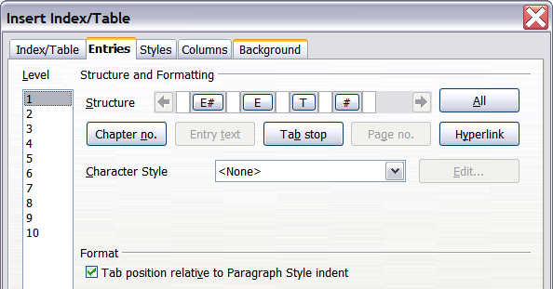
Figure 338. Entries page of Insert Index/Table dialog box
Click on a number in the Level column to select the outline level whose elements you want to format. This will display the Structure line which contains the elements included in the entries for that level. The available elements are displayed just below the structure line, and are grayed out if already included:
- The E# button represents the “chapter number”, which means the heading number, not just for chapters but also for other levels of headings.
- The E button represents the chapter (or sub-chapter) heading text.
- The T button represents a tab stop.
- The # button represents the page number.
- The LS button represents the start of a hyperlink. (This button does not appear on the default Structure line.)
- The LE button represents the end of a hyperlink. (This button does not appear on the default Structure line.)
Each white field on the Structure line represents a blank space. You can add custom text if you desire.
Note | If the chapter number defined for your document includes the word “Chapter” before the number itself, then the E# field in the TOC will also include the word “Chapter”. If you want to include the chapter number with the page number (for example, in the style “1-1, 1-2, …”) , you will find that the page number appears in the TOC as “Chapter 1-1”, which is probably not what you want.

Adding Elements
To add an element to the Structure line:
- Click in the white field where you want to insert the element.
- Click one of the five buttons just below the Structure line. (For example, to add a tab, click the Tab stop button.) A button representing the new element appears on the Structure line.
- To add custom text, such as the word Chapter, type the text in the white field.

Changing Elements
To change an element in the Structure line, click the button representing that element and then click the element that you want to substitute in the row of buttons just below the Structure line. For example, to change a chapter number to a tab stop, click the E# button on the Structure line (it shows then as being pressed) and then click the Tab stop button in the row of available elements.

Applying Changes to All Outline Levels
To apply the displayed structure and formatting to all outline levels, click the All button.

Deleting Elements
To delete an element from the Structure line, click the button representing that element and then press the Delete key on your keyboard. For example, to delete a tab stop, click the T button and then press the Delete key (Function+Delete on a Mac).

Hyperlinking an Entry
To change the default Structure line so that the chapter number and the entry text form a hyperlink, follow these steps:
- On the Structure line, place the cursor in the white field to the left of the E# button.
- Click the Hyperlink button. An LS button, representing the start of the hyperlink, appears on the Structure line.
- On the Structure line, place the cursor in the white field to the right of the E button.
- Click the Hyperlink button again. An LE button, representing the end of the hyperlink, appears on the Structure line.
Figure 339 represents the completion of the above steps. The number and the text of the entries on that level will now be hyperlinks.
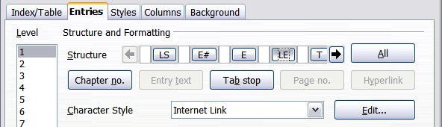
Figure 339: Hyperlink in table of contents

Applying Character Styles
You might want an element to be a bit different from the rest of the line. For example, you might want the page number to be bold. To apply a character style to an element:
- Be sure you have defined a suitable character style.
- On the Structure line, click the button representing the element to which you want to apply a style.
- From the Character Style drop-down list, select the desired style.
To view or edit the attributes of a character style, select the style from the Character Style drop-down list and then click the Edit button.
Tip | The default character style for hyperlinks is Internet Link, which by default is underlined and shown in blue. If you want the TOC entries to work as hyperlinks, but not appear underlined and blue, you can change the attributes of the Internet Link character style. However, this changes the attributes of all hyperlinks in the document.  If you want other hyperlinks (for example, website addresses) to remain in the default style, select the LS button on the Structure line and change the character style selection for TOC entries to Index Link. If necessary, change the attributes for Index Link to what you want.

Tab Position Relative to Paragraph Style Indent
When this option is selected, entries are indented according to the settings of their individual formats. Where a paragraph style specifies an indent on the left, tab stops are relative to this indent. If this option is not selected, tab stops are relative to the left margin position.

Styles Tab
Use the Styles tab, pictured in Figure 340, to change which paragraph style is assigned to each level in the table of contents. In most cases, the best strategy is to keep the assigned styles, but change their settings as needed to make the TOC look as you've imagined.
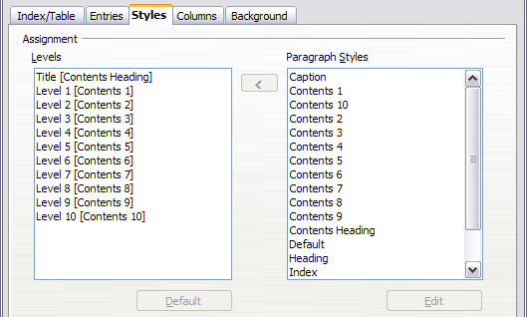Figure 340. Styles page of Insert Index/Table dialog box
To apply a custom paragraph style to an outline level:
- In the Levels list box, select the outline level.
- In the Paragraph Styles list box, click the desired paragraph style.
- Click the < button to apply the selected paragraph style to the selected outline level.
The style assigned to each level appears in square brackets in the Levels list.
To remove paragraph styling from an outline level, select the outline level in the Levels list box, and then click the Default button.
To view or edit the attributes of a paragraph style, click the style in the Paragraph Styles list box, and then click the Edit button.
Note | Be careful; changes to a paragraph style will affect any text in the document that is formatted using this style, not just the format of the table of contents.

Columns Tab
Use the Columns tab to change the number of columns for the TOC. Multiple columns are more likely to be used in indexes than in a TOC, so this page is described in the section on indexes. See Figure 348.

Background Tab
Use the Background tab to add color or a graphic to the background of the TOC.
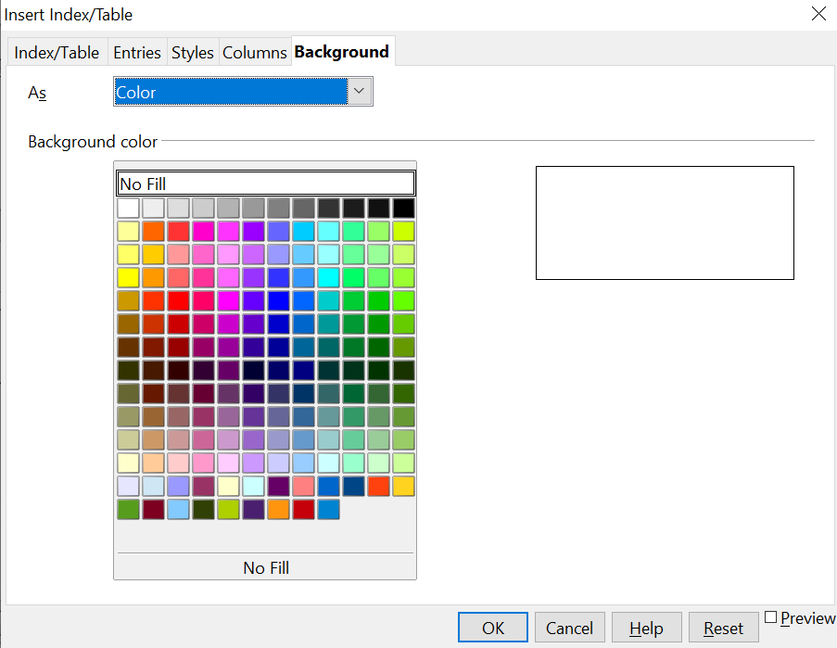

Figure 341: Background page, showing Color choices.

Adding Color
To add color to the background of the table of contents, select from the color grid.
Note | Even though the TOC may have a shade behind it while editing, it is actually not shaded by default. It appears shaded because it is a field and will appear to have the same shading all fields have.

Adding a Graphic
To add a graphic to the background of the table of contents:
- From the As drop-down list, select Graphic. The Background tab now displays the graphics options Figure 342.
- Click the Browse button. The Find graphics dialog box opens.
- Find the graphic file you want and then click the Open button. The Find graphics dialog box closes and the selected graphic appears in the graphic preview box on the right-hand side of the Background tab. (If you do not see the graphic, select the Preview checkbox.)
- To embed the graphic in your document, clear the Link checkbox. To link the graphic to the document but not embed it, select the Link checkbox.
- In the Type area of the Background tab, choose how you want the background graphic to appear:
  - To position the graphic in a specific location, select Position and then click the desired location in the position grid.
  - To stretch the graphic to fill the entire background area, select Area.
  - To repeat the graphic across the entire background area, select Tile.
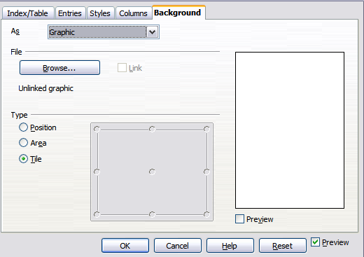Figure 342: Graphic options on the Background tab of the Insert Index/Table dialog box

Deleting a Color or Graphic
To delete color or a graphic from the table background:
- From the As drop-down list, select Color.
- Click No Fill on the color grid.

Maintaining a Table of Contents
This section shows you how to:
- Edit an existing TOC
- Update a TOC when changes are made to the document
- Delete a TOC

Editing a table of contents
To edit an existing TOC:
- Right-click anywhere in the TOC.
- From the pop-up menu, choose Edit Index/Table. The Insert Index/Table dialog box (Figure 336 on page 345) opens, and you can edit and save the table as described in the previous section.
Tip | If you cannot click in the TOC, it is probably because it is protected. To disable this protection, choose Tools > Options > OpenOffice Writer > Formatting Aids, and then select Enable in the Cursor in protected areas section. If you wish to edit the TOC without enabling the cursor, you can access it from the Navigator.
You can also access the Index/Table dialog box from the Navigator (Figure 343).
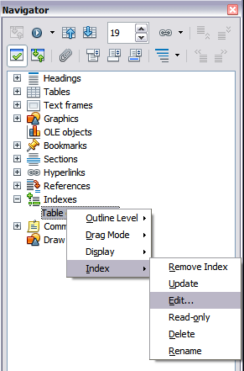
Figure 343: Access an index from the Navigator
- Open the Navigator deck in the Sidebar or press F5.
- Click the expansion symbol (+ sign or triangle) next to Indexes.
- Right-click on Table of Contents1 and choose Index > Edit.

Updating a Table of Contents
Writer does not update the TOC automatically, so after any changes to the headings, you must update it manually. To update a TOC when changes are made to the document:
- Right-click anywhere in the TOC.
- From the pop-up menu, choose Update Index/Table. Writer updates the TOC to reflect the changes in the document.
You can also update the index from the Navigator by right-clicking on Indexes > Table of Contents1 and choosing Index > Update.

Deleting a Table of Contents
To delete the TOC from a document:
- Right-click anywhere in the TOC.
- From the pop-up menu, choose Delete Index/Table. Writer deletes the TOC.
Note | Since Writer will not prompt you to confirm the delete, use caution when deleting a TOC!
You can also delete the index from the Navigator by selecting Index > Delete from the menu shown in Figure 343.

Alphabetic Indexes
An alphabetical index (referred to as an index) is a list of keywords or phrases used throughout a document that, if listed in order with page numbers, may help the reader find information quickly. Generally an index is found in the back of a book or document.
This section describes how to:
- Add index entries.
- Create an alphabetic index quickly.
- Customize the display of index entries.
- Customize the appearance of the index.
- View and edit existing index entries.

Adding Index Entries
Before you can create an index, you must create some index entries.
- Either highlight the word or phrase to add to the index or place the cursor at the beginning of the word or phrase. (If you want to add multiple words as one entry it will generally be better to highlight the entire phrase.)
- Choose Insert > Indexes and Tables > Entry to display a dialog box similar to that shown in Figure 344. You can accept the word or phrase shown in the Entry box or change it to whatever you want. If you placed the cursor at the beginning of a word, clicking on the Entry text box inserts the word into the text box.
- Click Insert to create the entry.
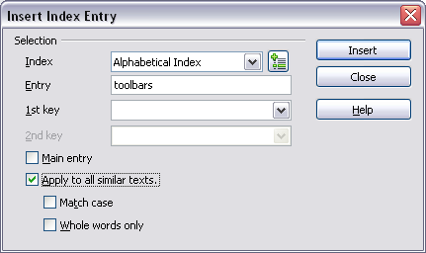Figure 344. Inserting an index entry
See “Customizing Index Entries” on page 356 for an explanation of the fields on this dialog box.
You can create multiple entries without closing the dialog box. For each one:
- Click at the location in the document that you want to index.
- Click again on the dialog box.
- Change the entry if needed, and click Insert.
- Repeat steps 1–3 until you have finished with the entries, then click Close.
Note | If field shading is active (see View > Field Shadings and Tools > Options > OpenOffice > Appearance > Text Document > Field shadings), when a selected word or phrase has been added to the index, it is shown in the text with a gray background. Index entries whose text is different from the text in the document are marked by a small gray rectangle.

Tip | You can also open the Insert Index Entry dialog box by clicking the Entry icon on the Insert toolbar, as shown in Figure 345.

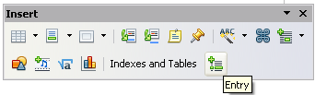Figure 345. Entry icon on Insert toolbar

Creating an Alphabetic Index Quickly
Now that you have some index entries, you can create the index.
Although indexes can be customized extensively in Writer, most of the time you need to make only a few choices.
To create an index quickly:
- Click in the document where you want to add the index and click Insert > Indexes and Tables > Indexes and Tables.
- In the Type box on the Index/Table page (Figure 346), select Alphabetical Index.
- In the Options section, you may want to uncheck Case sensitive (so that capitalized and lower-case words are treated as the same word) and uncheck Combine identical entries with p or pp.
- Click OK. The result will be a typical index.
Writer does not update an index automatically. If you add, delete, or change the text of index entries, you need to update the index. To do this, follow the steps outlined in “Updating a Table of Contents” on page 353.

Customizing Index Entries
Below is a brief explanation of the fields in the Insert Index Entry dialog box and how to use them.
Index
The type of index this entry is for. The default is Alphabetical Index, but you can use this field to create extra entries for a table of contents or user-defined indexes or lists of almost anything. For example, you might want an index containing only the scientific names of species mentioned in the text, and a separate index containing only the common names of species. See “Other Types of Indexes” on page 362.
Entry
The word or phrase to be added to the selected index. This word or phrase does not need to be in the document itself; you can add synonyms and other terms that you want to appear in the index.
1st key
An index key is an entry that has no associated page number and has several subentries that do have page numbers. Using keys is a useful way of grouping related topics. (See “Example of Using an Index Key” on page 357.)
2nd key
You can have a three-level index, where some first-level keys have level-2 entries that are also keys (without page numbers). This degree of index complexity is not often necessary.
Main entry
When the same term is indexed on several pages, often one of those pages has more important or detailed information on that topic, so you want it to be the main entry. To make the page number for the main, or most significant, entry stand out, select this option and then define the character style for the page number of a main index entry to be bold, for example.
Apply to all similar texts
Select this option to have Writer automatically identify and mark any other word or phrase that matches the current selection. The Match case and Whole words only options become available if this option is selected. Use this option with care, as it may result in many unwanted page numbers (for minor uses of a word) being listed in the index.

Example of Using an Index Key
An index key is a primary entry under which subentries are grouped. For example, you might want to create a grouping similar to this:
OpenOffice
Calc 10
Impress 15
Writer 5
In this example, OpenOffice is the 1st key. The subentries (with the page numbers showing) are the indexed entries. To insert an index entry for the topic Writer, on the Insert Index Entry dialog box (Figure 344 on page 355), type Writer in the Entry box and OpenOffice in the 1st key box.

Customizing the Appearance of an Index
To customize an existing index, right-click anywhere in the index and choose Modify from the pop-up menu.
The Insert Index/Table dialog box (Figure 346) has five tabs. Any or all of them can be used to customize the appearance of an index.
- Use the Index/Table page to set the attributes of the index.
- Use the Entries and Styles tabs to format the entries in the index.
- Use the Columns tab to put the index into more than one column.
- Use the Background tab to add color or a graphic to the background of the index.
The preview box, located on the left-hand side of the dialog box, shows as you work how the index will look. (If you do not see the preview box, select Preview in the lower right-hand corner of the dialog box.)
After making your changes, click OK to save the index, so it appears in your document.

Index/Table Page
Use the Index/Table page (Figure 346) to set the basic attributes of the index.
- To give the Index a different title, type it in the Title field. To delete the title, clear the Title field.
- Be sure the Type of Index is set to Alphabetic Index.
- To prevent the index from being changed accidentally, select Protected against manual changes. If this option is selected, the index can only be changed using the right-click menu or the Insert Table/Index dialog box. If the option is not selected, the index can be changed directly on the document page, just like other text, but any manual changes to an index are lost when you update it.
- From the drop-down list in the Create index/table area, select Entire document. You can also choose to create an index for just the current chapter.
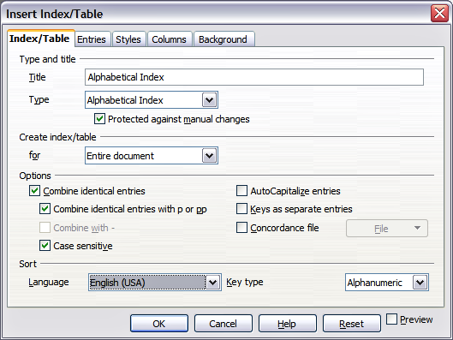
Figure 346. Index/Table page of Insert Index/Table dialog box
- Various other options determine how the index handles entries:
  - Combine identical entries. Defines how identical entries are dealt with. Normally each page number of an indexed word or phrase will be shown in the index; however these can be combined using the Combine identical entries with p or pp option. If you want a page range displayed, select Combine with – (which will produce something similar to 23–31). If you want different entries based on what letters are capitalized, select Case sensitive.
  - AutoCapitalize entries. Automatically capitalizes the first letter of each entry regardless of how they show within the document itself.
  - Keys as separate entries. For the keys to have their own page numbers, select this option.
  - Concordance file. Enables a list of words in an external file to be imported (select using the File button) and then used within the index. The concordance file has a special file format; for further information, refer to concordance file in Help > OpenOffice Help. Using a concordance file can speed up production of an index, but unless the words are very carefully selected, and you edit the index afterward, the resulting index can be full of entries for minor mentions of a term, making it less useful than a more selective index.
  - Sort. Defines how the entries are sorted when displayed. The only option is alphanumeric, but you can define which language alphabet will be used.

Entries Tab
Use the Entries tab to set exactly how and what will be displayed for each of the entries. The page is similar to Figure 347.
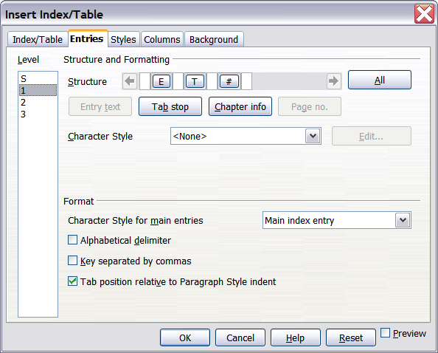
Figure 347. Entries page for creating an alphabetical index
To begin, click a number in the Level column to select the index level whose elements you want to format. (You will be able to apply your changes to all index levels later.) The Structure line displays the elements for entries in that level. Each button on the Structure line represents one element:
- The E button represents the entry text.
- The T button represents a tab stop.
- The # button represents the page number.
- The CI button represents chapter information. This may not be displayed immediately, but can be added.
Each white field on the Structure line represents a blank space. You can add custom text if you desire.

Adding Elements
To add an element to the Structure line:
- Place the cursor in the white field to the left of where you want to insert the element.
- Click one of the buttons below the Structure line. (For example, to add a tab stop, click the Tab stop button.) A button representing the new element appears on the Structure line.

Changing Elements
To change an element in the Structure line, click the button representing that element and then click the element that you want to substitute in the row of buttons just below the Structure line. For example, to change entry text to a tab stop, click the E button on the Structure line (it shows then as being pressed) and then click the Tab stop button in the row of available elements.

Deleting Elements
To delete an element from the Structure line, click the button that represents that element, and then press the Delete key. For example, to delete a tab stop, click the T button and then press the Delete key, or Function+Delete on a Mac.

Applying Character Styles
Each of the items that can be added to the Structure line may have additional formatting. For example, you may want the page number to be a different size from the rest of the index text. To do this, apply a character style to one of the elements in the Structure line.
To apply a character style to an element:
- On the Structure line, click the button representing the element to which you want to apply a style.
- Select the desired style from the Character Style drop-down list. Writer applies the style to the selected element.
To view or edit the attributes of a character style, select the style from the Character Style drop-down list and then click the Edit button.

Formatting Entries
Apply additional formatting using the options in the Format section.
- Alphabetical delimiter. This separates the index entries into blocks that start with the same first letter, using that letter as a header. For example, if your index begins:
apple, 4
author, 10
break, 2
bus, 4
then selecting this option will give you:
A
apple, 4
author, 10

B
break, 2
bus, 4
- Key separated by commas. Arranges the entries in the index on the same line but separated by commas.
- Tab position relative to Paragraph Style indent. When checked, entries are indented according to the settings of their individual formats. Where a paragraph style with an indent on the left is in use, tab stops will be relative to this indent. If this option is not selected, tab stops will be relative to the left margin position.

Styles, and Background Tabs
Refer to “Styles Tab” on page 350 and “Background Tab” on page 351.

Columns Tab
Use the Columns tab (Figure 348) to change the number of columns for the index.
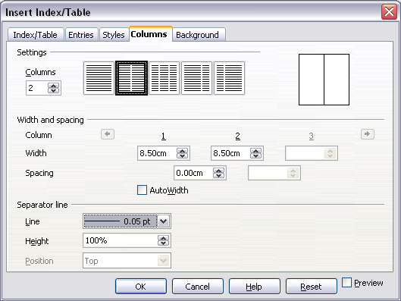
Figure 348. Columns page of the Insert Index/Table dialog box

Adding Multiple Columns
To display the index in more than one column:
- Either enter the number of columns desired in the box labeled Columns or select the icon representing the number of columns.
- To evenly distribute the columns according to the page width, check the AutoWidth box. If it is unchecked, you can manually set either or both of the following:
  - Width between each of the columns
  - Spacing between each of the columns
- You can choose to have a separator line between the columns:
  - Line: The width (thickness) of the line.
  - Height: The height of the line.
  - Position: Position of the line relative to the columns (top, middle, or bottom) if the height is less than 100%.

Maintaining an Index
To modify the appearance of an index:
- Right-click anywhere in the index.
- From the pop-up menu, choose Edit Index/Table. The Insert Index/Table dialog box opens, and you can edit and save the index using the five tabs described in the previous section.
To update or delete an index, follow the process described in the sections “Updating a Table of Contents” on page 353 and “Deleting a Table of Contents” on page 354.

Viewing and Editing Existing Index Entries
Once you have added the initial entries, you can make changes, or add new entries. You can view and edit either of these using the following steps:
- Ensure that field shading is active (Tools > Options > OpenOffice> Appearance > Text Document > Field shadings and View > Field Shadings), so you can locate index entries more easily.
- Place the cursor immediately to the left of an existing index entry in the body of your document and select Edit > Index Entry. Alternatively, right-click on the word or phrase and from the pop-up menu select Index Entry.
- A dialog box similar to Figure 349 appears. You can move through the various index entries using the forward and back arrow buttons. If there is more than one entry for a single word or phrase, then you can scroll through each of the entries.
- Make the necessary modifications or additions to the index entries and, when finished, click OK.
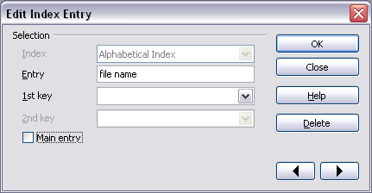Figure 349. Viewing and editing index entries

Other Types of Indexes
An alphabetical index is not the only type of index Writer can build. Other types of indexes supplied with Writer include those for illustrations, tables, and objects. You can even create a user-defined index. Because,they're numerous, this chapter can't give examples of all possibilities.
To create other indexes:
- Place the cursor where you want the index created.
- Select Insert > Indexes and Tables > Indexes and Tables from the menu bar.
- On the Insert Index/Table dialog box, in the Type drop-down list, select the index wanted.
- Modify the various pages, which are very similar to those discussed in previous sections.
- Select OK when everything has been set.

Example: Creating an Index of Figures
Creating an index (list) of figures or tables is easy if the figure captions were created using the menu Insert > Caption or manually using a number range variable as described in Chapter 14 (Working with Fields).
- On the Insert Index/Table dialog box, in the Type drop-down list, choose Illustration Index. You can change the title of the index to something else; we have used Table of Figures as our title.
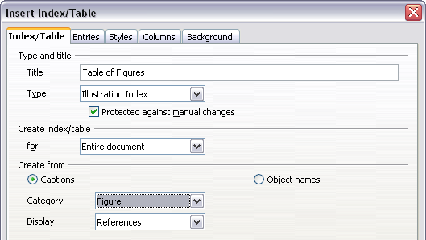
Figure 350. Creating other types of indexes
- Be sure Captions is selected in the Create from section, and choose the category of caption. The default category is Illustration; in our example we have used Figure for the figure captions.
(The category Figure is not supplied with AOO; however, if you have defined it when creating a caption in your document, it will appear on this list. See Chapter 8, Working with Graphics, for more about creating captions.)
- Under Display, you can choose References (to include the category, number, and caption text), Category and Number, or Caption Text. We have selected References.
- On the Entries tab, notice that hyperlinking from the index to the body of the document is not available, but you can make some other selections.
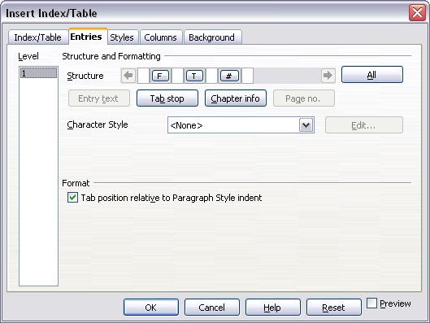Figure 351: Entries tab for Illustration Index
- Click OK. The result is shown below.
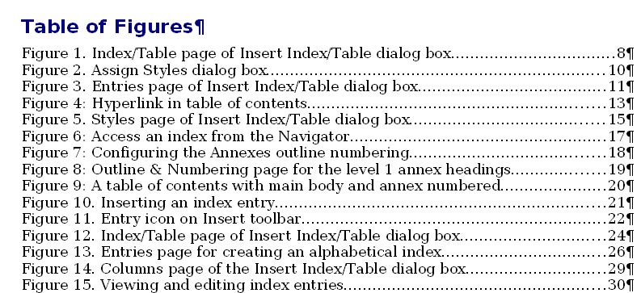Figure 352: Resulting index of illustrations

Bibliographies
A bibliography is useful for displaying references that occur throughout a document. These references are either stored in a bibliographic database or within the document itself.
This section shows you how to:
- Create a bibliographic database; add and maintain entries.
- Add a reference into a document.
- Format the bibliography.
- Update and edit an existing bibliography.
For most of this section, the database table used is the sample one that comes with Writer. For information on creating a new table in the bibliographic database, see Chapter 8 (Getting Started with Base) in the Getting Started guide.

Creating a Bibliographic Database
Although you can create references within the document itself, creating a bibliographic database allows reuse in other documents and saves a lot of time.
Select Tools > Bibliography Database. A window similar to that in Figure 353 is shown.
You can use the top portion of this window to:
- Filter for specific records within the database (see “Filtering Records” below).
- Change some details of columns in the database (see “Changing Column Details” on page 366).
- Select an alternative data source (another database or table) or change details of the fields in the database.
The middle portion of the window shows each of the records in a table layout similar to that of a spreadsheet. Additional fields can be viewed by scrolling the table to the right.
The bottom portion of the window shows the contents of the selected record.
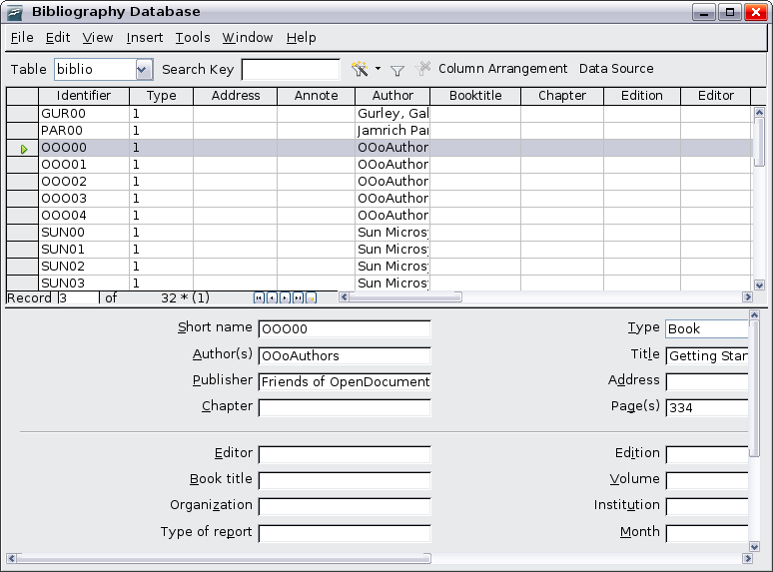
Figure 353. Bibliography Database main window

Filtering Records
To set up a filter for specific records within the bibliographic database, select Tools > Filter from the Bibliographic Database menu bar. On the Standard Filter dialog box (Figure 354), choose the fields, conditions, and values for the filter and click OK.
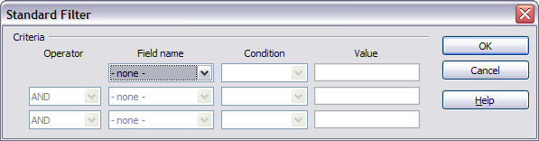
Figure 354. Setting up a filter for the bibliographic database

Changing Column Details
To change the details of columns in the bibliographic database, click the Column Arrangement button near the top of the window. The Column Layout for Table biblio dialog box (Figure 355) is displayed.
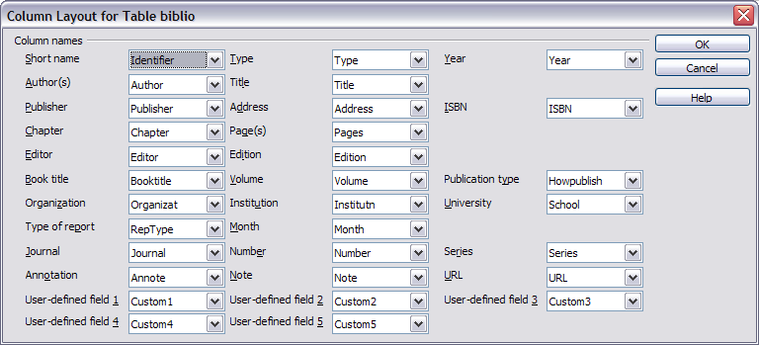
Figure 355. Changing column layout for bibliographic database

Changing the Data Source
To change the data source in use (for example, if you have more than one bibliographic database for different purposes), click the Data Source button near the top of the window. The Choose Data Source dialog box (Figure 356) is displayed.
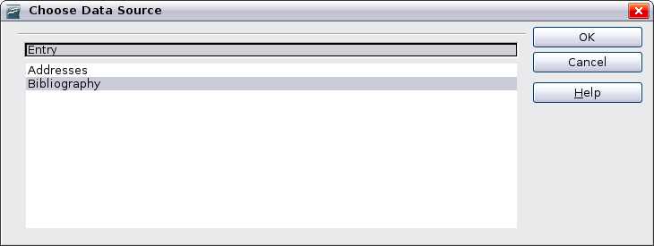Figure 356: Choosing a different data source for the bibliographic database

Changing Field Details
You can make changes to the bibliography database (for example, rename fields or change the length of fields) by doing the following:
- In the main document (not the Bibliography Database window), press F4 or click View > Data Sources to open the data source window, similar to Figure 357.
- Make sure that the Bibliography database is selected as well as the correct table. You may have to expand some levels to be able to select the correct ones.
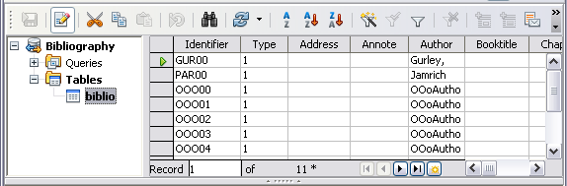
Figure 357. Data Source view of Bibliography database
- Right-click on the table entry (biblio in the example) and select Edit Database File from the pop-up menu. This opens a window similar to Figure 358, which is the main menu for Base, the database component of OpenOffice.
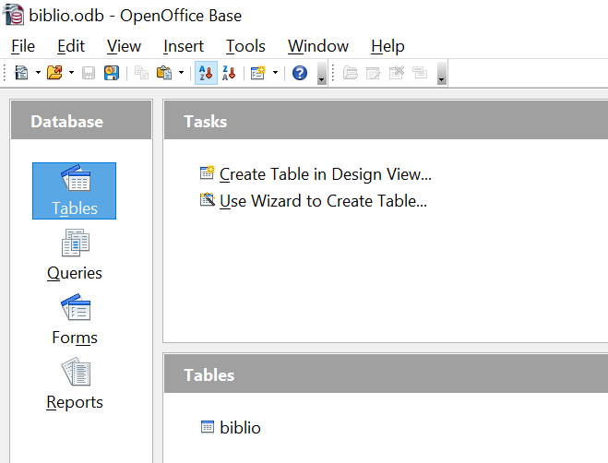

Figure 358. Main window for working with databases
- If Tables (under the Database view) is not selected, select it now.
- Right-click on the biblio table name in the Tables section and select Edit from the pop-up menu to display a window similar to that in Figure 359.
- You can now select each of the rows and modify the Field Properties as required.
- When finished, confirm that you want the changes saved.
Note | For more information on how to use AOO’s database features, see Chapter 8 (Getting Started with Base) in the Getting Started guide.
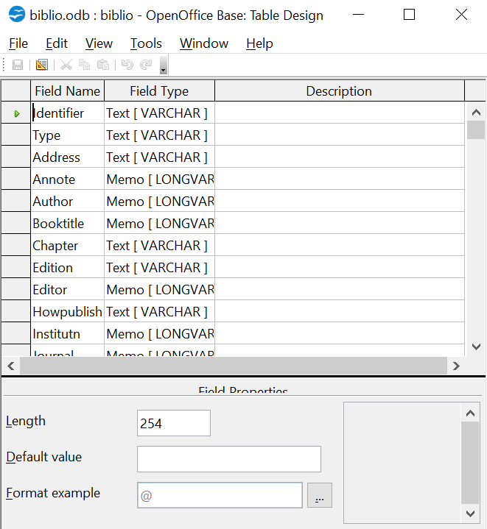

Figure 359. Modify table properties window

Adding Entries to the Database
To add entries to the database:
- You can add records directly into the database using the lower portion of the window shown in Figure 353 on page 365.
- Complete each of the fields as required. Use the Tab key to move between fields.
- It is best to use a unique name in the Short name field. This is used when inserting entries into documents.
- To complete the entry, move to the last field and press Tab once more.
Note | The Identifier column in the upper portion of the Bibliography Database window is labeled Short name in the lower portion of the window.
If your document requires [Author, date] style citations, use the Identifier (Short name) field of the database to record the information in the required format. If you are using a simple citation numbering system (for example, [1],[2],...), use a unique reference of some sort in the Identifier (Short name) field. Writer will auto-number entries based on the position within the document.

Maintaining Entries in the Database
To maintain entries in the database, use the Bibliography Database window as in the previous section. Click on the appropriate field and modify the text as appropriate.
Modified entries are saved automatically to the database when the cursor moves off the record.

Adding a Reference (Citation) into a Document
Writer supports two ways of showing references (citations) in the text of a document:
- Using authors’ names and dates of the referenced documents, for example [Smith, 2004], as recorded in the Identifier (Short name) of each bibliographic entry.
- By numbering the referenced documents in the sequence they occur in the text, for example [1].
Tip | To specify which citation style is used in the document, use the Index/Table tab on the Insert Index/Table dialog, described on page 370.
To add references from the bibliographic database into a document:
- Place the cursor where you want the reference to appear.
- From the main menu, choose Insert > Indexes and Tables > Bibliographic entry.
- In the Insert Bibliographic Entry dialog box, shown in Figure 360, choose From bibliography database at the top of the dialog box. (You can also insert a reference from the document itself by selecting From document content, but that method is not covered in this chapter.)
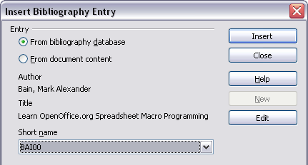
Figure 360. Inserting bibliographic entries into a document
- Select the reference from the Short name drop-down list near the bottom of the dialog box. The Author and Title of the selected reference are shown in the middle of the dialog box, to help you verify that it is the reference you want.
- To insert the reference into the document, click Insert.
- You can keep the dialog box open and insert another reference into the document; you don’t need to close and reopen it.
- When you have finished inserting all the references, select Close.

Formatting the Bibliography
Formatting the bibliography involves choices made in two places:
- Insert Index/table dialog (covered in this section)
- Bibliography 1 paragraph style (see page 372)
To create the bibliography:
- Place the cursor at the point where you wish to insert the bibliography.
- Select Insert > Indexes and Tables > Indexes and Tables and change the Type to Bibliography, to see a dialog box similar to that shown in Figure 352.
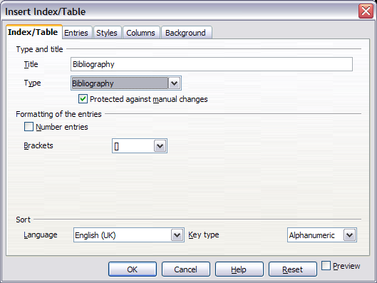Figure 361. Inserting a bibliography
The Insert Index/Table dialog box has five pages.

Index/Table tabs
The basic settings are selected on this page.
- While a title for a bibliography isn't required, you can supply one by entering it in the Title field.
- You can protect the bibliography from being changed accidentally, by checking Protected against manual changes. If this option is selected, the bibliography can only be changed using the right-click menu or the Insert Table/Index dialog. If the option is not selected, the bibliography can be changed directly on the document page, just like other text, but any manual changes will be lost when you update the bibliography.
- To have the bibliographic entries numbered within the body of the document (for example, [1], [2], …), select Number entries. If, however, you wish to have the field Identifier (from the database) appear in the document, deselect the Number Entries option.
- Select the type of brackets that you want for the referenced entries shown within the body of the document.
- Define the sorting you require. Currently, only alphanumeric sorting is supported. Sorting by the sequence that entries appear in the text is done on the Entries page.

Entries Tab
The structure of this tab is similar to that for tables of contents and indexes (see Figure 351).
You can define how the entry will appear based on the Type of the entry, or simply apply the same format to all entries by selecting the All button.
The Structure of the entry is based on the fields available in the bibliographic database. The ones shown by default are:
- Au—Author
- Ti—Title
- Ye—Year
To determine how entries are sorted, modify the Sort by options. To sort by the sequence that entries appear in the text, choose Document position. To sort alphanumerically, select Content. Use Sort keys to group similar references.
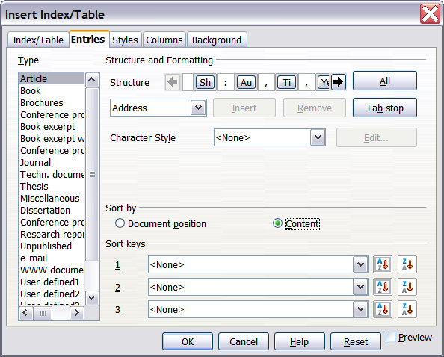
Figure 362. Entries page for bibliographies

Styles, Columns and Background tabs
Refer to “Styles Tab” on page 350 and “Columns Tab” on page 351 and Background Tab on page 351.

Generating the Bibliography
To generate a bibliography so that it appears in your document, click OK. The Insert Index/Table dialog box closes and the bibliography appears in your document.

Defining the Paragraph Style for the Bibliography
You can modify the Bibliography 1 paragraph style to suit your requirements. For example, to number the entries in the bibliography list, you need to define a numbering style and link that numbering style to the Bibliography 1 paragraph style. To do this:
- On the Styles and Formatting deck of the Sidebar, click on the List Styles icon. You can either define a new list style or modify one of those supplied. In this example, we will modify the Numbering 1 style. Right-click on Numbering 1 and choose Modify from the pop-up menu.
- On the Numbering Style dialog, go to the Options tab. In our example we want to have the numbers enclosed in square brackets. To do this, type [in the Before box and] in the After box, as shown in Figure 350.
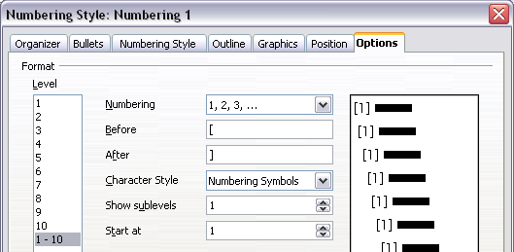
Figure 363: Specifying square brackets before and after the number in a list
- Now go to the Position tab of the Numbering style dialog. In the Spacing to text box, specify how much indentation you want for the second and following lines of any item in the bibliography list of your document. Often you will need to experiment a bit to see what is the best setting. In our example (Figure 341), we have chosen 1 cm.
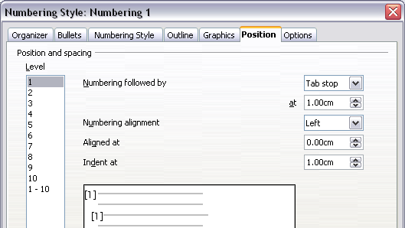
Figure 364: Setting the spacing between the margin and the text
- Click OK to save these settings and close the Numbering Style dialog. Return to the Styles and Formatting window, click on the Paragraph Styles icon, choose All Styles from the list at the bottom of that window, then right-click on Bibliography 1 and choose Modify.
- On the Paragraph Style dialog, go to the Numbering tab and select Numbering 1 from the drop-down list. (See Figure 338.) Click OK to save this change to the Bibliography 1 paragraph style.
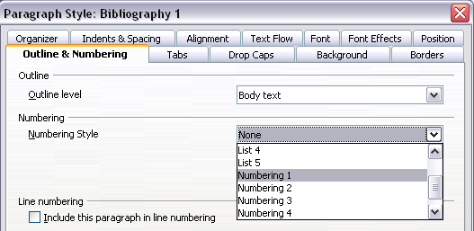
Figure 365: Applying a numbering style to a paragraph style
Now when you generate the bibliography, the list will look something like the one shown in Figure 337.
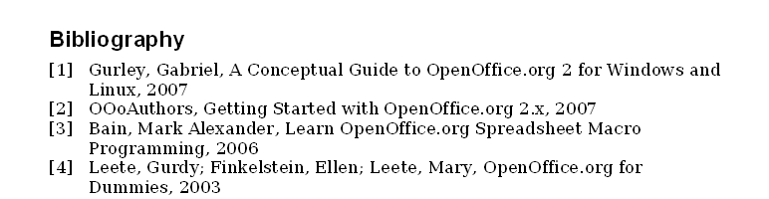
Figure 366: Result of settings for Bibliography 1 paragraph style

Updating and Editing an Existing Bibliography
To modify the display of bibliography entries:
- Right-click anywhere in the bibliography.
- From the pop-up menu, choose Edit Index/Table. The Insert Index/Table dialog box opens, and you can edit and save the table using the five tabs described in Formatting the Bibliography on page 370.
To update or delete the bibliography, follow the same process as described in the sections “Updating a Table of Contents” on page 353and “Deleting a Table of Contents” on page 354.

Chapter 13
Working with Master Documents

Why Use Master Documents?
Master documents are typically used for producing large documents such as a book, a thesis, or a detailed report. A master document (*.ODM) joins separate text documents (*.ODT) into one larger document, and unifies the formatting, table of contents (TOC), bibliography, index, and other tables or lists.
A master document is especially useful in these situations:
- When graphics, spreadsheets, or other material cause the file size or number of pages to become quite large; writing, reviewing, and editing may be easier when done on subsets of the full document.
- When different people are writing different chapters or other parts of the full document.
- When files will be published as stand-alone documents as well as becoming part of a larger document. The chapters of this Writer Guide are an example of this.
- When subdocuments are used in more than one final document.
You can use several methods to create master documents. Each method has advantages and disadvantages. Which method you choose depends on what you're trying to accomplish. The different methods are described in this chapter, along with suggestions on when to use each.
Tip | A master document is not always the best method to use in any of the situations given above. You may find that an ordinary document (.ODT) containing sections linked to other files may do the job just as well. For more about using sections to combine files, see Chapter 4 (Formatting Pages).

Styles in Master Documents and Subdocuments
A subdocument can be used in several master documents. Each master document may have different style definitions (font, type size, color, page size, margins, and so on), which affect the appearance of the final document, but the individual subdocuments retain their original characteristics.
The relationship between styles in a master document (*.ODM) and its subdocuments (*.ODT) is as follows:
- Custom styles used in subdocuments, such as paragraph styles, are automatically imported into the master document.
- If more than one subdocument uses a custom style with the same name (for example, myBodyText), then only the one in the first subdocument is imported into the master document.
- If a style with the same name exists in the master document and in the subdocuments (for example, Default), then the style is applied as defined in the master document.
- The styles in the subdocuments are only changed in the master document, so when a subdocument is opened for editing the original styles are not affected.

Tip | If you use the same document template for the master document and its subdocuments, the subdocuments will look the same when loaded into the master document as they do when viewed as individual files. When you modify or create a style, make the change in the template, not in the master document or any of the subdocuments. Then, when you reopen the master document or a subdocument, the styles will update from the template.  For subdocuments used in several master documents with different templates, this tip may not be helpful.

Creating a Master Document: Scenarios
The three most common scenarios for creating a master document depend on the current state of your document:
- You have one existing document (a book) that you want to split into several subdocuments (chapters) that will be controlled by the master document.
- You have several existing documents (chapters) by one or more authors that you want to combine into one book, controlled by the master document.
- You have no existing documents but intend to write a long book containing several chapters, possibly by multiple authors.
We will look at each of these scenarios in turn.

Splitting a Document into Master and Subdocuments
When you have one existing document that you want to split into a master document and several subdocuments, you can have Writer split the document automatically at headings with an outline level of your choice.
Although this method is quick and easy, some cleanup work may be necessary:
- The page style of the first page (and possibly all pages) in each subdocument reverts to Default. If you are using custom page styles, and you want the subdocuments to use the same page layout, whether part of the master document or standalone, you will need to reapply at least the first page style.
- The automatically generated file names for the subdocuments are maindocnameX.odt, where X is 1, 2, 3, and so on. If you have a Preface or other “chapter” starting with a Heading 1 before Chapter 1, the file names will not directly correspond to the chapter numbers. You may wish to rename the subdocuments; see “Error: Reference source not found” on page Error: Reference source not found.
- If the original document is associated with a template, the .ODM file will also be associated with that template, but the subdocuments will not. The subdocuments will inherit the styles in the original document, but their association with the template will be lost. You may wish to use the Template Changer extension to reassociate the template with each of the subdocuments.
How to do it:
- Open the document and choose File > Send > Create Master Document.
- On the Name and Path of Master Document dialog box (Error: Reference source not found):
  - Navigate to the folder where you want to save the master document and its subdocuments (or create a new folder).
  - Type a name for the master document in the File name box.
  - In the separated by: list, choose the outline level where the file should be split into subdocuments. Usually this is Outline: Level 1 for a chapter heading, but your document may be structured differently. For more information about outline levels, see “Defining a hierarchy of headings” in Chapter 6 (Introduction to Styles) in this book.
  - Leave the Automatic file name extension option selected, and click Save to split the document into subdocuments and create the master document.
If you selected Outline: Level 1 and the paragraph style at that level is Heading 1, each of the subdocuments begins with a Heading 1 paragraph.
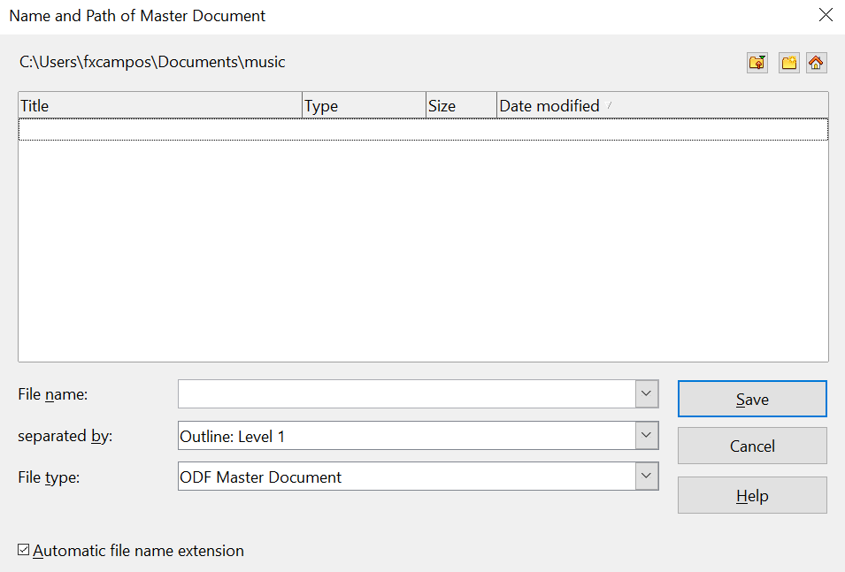

Figure 367: Splitting a document into master and subdocuments

Combining Several Documents into a Master Document
When you have several existing documents, you can combine them into one document controlled by a master document.
This method works best when all the documents were created from the same template, but you can also use it when the documents have been created from different templates. This method is especially useful when the subdocuments are created or maintained by multiple writers. For example, you might be creating an anthology of short stories or a book of symposium papers.
How to do it:
Use one of the techniques described in “Starting with no Existing Documents” below to create a blank master document and insert the other documents as subdocuments of the master document.

Starting with no Existing Documents
When you start with no existing documents, from the beginning you can set up everything the way you want. Follow these steps, in the order given. Each step is explained in detail in the following subsections.
Step 1. Plan the Project
Step 2. Create a Template
Step 3. Create the Master Document
Error: Reference source not found
Step 5. Add Some Pages to the Master Document
Step 6. Insert the Subdocuments into the Master Document
Step 7. Add Table of Contents, Bibliography, Index

Step 1. Plan the Project
Although you can make changes at most steps in this process, the more you can plan before you start, the less work you will have to do to correct any problems later. Here are some things you need to plan.
Parts of book or report required. What pages will be in the master document and what will be in the subdocuments?
Consider as an example a book with the parts given in the table below.
Part | Location
Title (cover) page | In master document
Copyright page | In master document
Table of contents (TOC) | In master document
Preface (Foreword) | Subdocument
Chapters 1 to 7 | Subdocuments
Index | In master document
Page, paragraph, character, frame, and numbering styles. See Chapter 6 (Introduction to Styles) and Chapter 7 (Working with Styles) for instructions on how to create or modify styles and examples of the use of styles in book design. Pay particular attention to setting up headings using styles, as described in “Defining a hierarchy of headings” in Chapter 6 (Introduction to Styles) in this Guide.
Fields and AutoText entries, as required. See Chapter 3 (Working with Text) and Chapter 14 (Working with Fields) in this book for ideas.
One or more templates for master and subdocuments. If you are starting a new project, create the master document and all the subdocuments from the same template. Not using the same template can create inconsistencies of structure and appearance in your document. For example, if two subdocuments have a style with the same name that is formatted differently in each document, the master document will use the formatting from the first subdocument that was added.
Page numbering. In our example, the pages are numbered sequentially from the title page. (The title page style can be defined to not show the page number, but it will still count as page 1.) Therefore, the first chapter begins on a higher number page, for example page 5. To create a book in which the page numbering restarts at 1 for the first chapter, you need to do some additional work. See “Error: Reference source not found” on page Error: Reference source not found.

Step 2. Create a Template
You can create your template from an existing document or template that contains some or all of the page, paragraph, character, and other styles you want for your new document. Or, you can create the template from a blank document. For more about templates, see Chapter 10 (Working with Templates).
Be sure to use File > Templates > Save when creating the template.
Note | A master document (*.ODM) created from a template is associated with that template, but the name of the template is not shown in the Document Properties dialog (File > Properties) as it is for *.ODT files.

Step 3. Create the Master Document
It does not matter in what order you create the master and subdocuments, and you do not have to create all the subdocuments at the same time or when you're starting the project. You can add new subdocuments at any time, as you need them.
Follow this process to create the master document.
- Open a new document from the template you created in Step 2, by choosing File > New > Templates and Documents, then selecting the template you created. Be sure the first page of this new document is set to the page style you want for the first page of the final document. If it isn't, change it. In our example, the style for the first page is Title page.
- If any text or page breaks came into this document from the template, delete the text. (The TOC, index, and any fields in headers and footers can stay.)
- Click File > Send > Create Master Document. Save the master document in the folder for this project. We will return to this master document later. For now, you can either leave it open or close it.
Note | Using File > New > Master Document is not recommended, because the resulting master document file (.ODM) is not associated with a template. However, you can later apply a template using the Template Manager extension.

Step 4. Create subdocuments
A subdocument is no different from any other text document. It becomes a subdocument only when it is linked into a master document and opened from within the master document. Some settings in the master document will override the settings in a subdocument, but only when the document is being viewed, manipulated, or printed through the master document.
Create a subdocument in the same way as you create any ordinary document:
- Open a blank document based on the project template (very important) by choosing File > New > Templates and Documents, then selecting the required template.
- Delete any unwanted text or other material, and set the first page to the page style you specified for the first page of a chapter.
- Click File > Save As. Give the document a suitable name and save it in the folder for this project.
If you already have some chapters written, the files are probably not based on the template you just created for this project. You will need to change the template attached to the existing files. You can do this manually, or by using the Template Changer extension to OpenOffice; both methods are described in Chapter 10 (Working with Templates).

Step 5. Add Some Pages to the Master Document
To assist you, do the following:
- Make sure paragraph marks are showing. You can set them in Tools > Options > OpenOffice Writer > Formatting Aids, or click the Nonprinting Characters icon on the Standard toolbar.
- Show text boundaries, table boundaries, and section boundaries (Tools > Options > OpenOffice > Appearance).
If your master document does not contain any required “front matter” such as a title page, copyright page, or TOC page, add them now. The example in this section uses the sequence of page styles given in “Error: Reference source not found” on page Error: Reference source not found.
- Type the contents of the title page (or leave placeholders and fill in later). With the insertion point in the last blank paragraph on the page, click Insert > Manual Break. On the Insert Break dialog box, select Page break and the page style for the second page (Copyright page in our example), and leave the Change page number option deselected. Click OK.
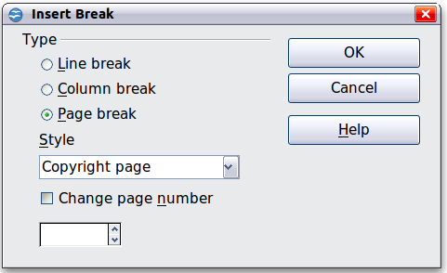
Figure 368: Inserting a page break between the title page and the copyright page
- Type the contents of the copyright page (or leave placeholders). With the insertion point in the last blank paragraph on the page, insert another manual page break, this time setting the page style to Table of Contents page.
- On the Table of Contents page, leave a blank paragraph or two or insert a TOC (Insert > Indexes and Tables > Indexes and Tables). The TOC will not have any contents until you add the subdocuments, but you should see a gray mark or box indicating its location. For more about inserting and formatting TOCs, see Chapter 12 (Tables of Contents, Indexes, and Bibliographies).
Note | Depending on the style definitions for the first paragraph (usually a heading) on the Copyright and TOC pages, you may not need to insert manual page breaks.

Step 6. Insert the Subdocuments into the Master Document
Now we are ready to add the subdocuments.
Tip | Subdocuments are inserted into a master document before the item highlighted in the Navigator. If you insert the last subdocument first, and then insert the other subdocuments before the last one, they will end up in the correct sequence without the necessity of moving them up or down in the list.

- Display the Navigator (click View > Navigator, or press F5, or click the Navigator icon in the Sidebar or main toolbar.
- Be sure the Navigator is showing the master view (see “Error: Reference source not found” on page Error: Reference source not found). Click on the Toggle icon at the upper left to toggle between regular and master views.
- On the Navigator, select Text, then click and hold on the Insert icon, move the mouse pointer down, and click File.
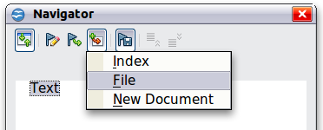
Figure 369: Inserting a subdocument into a master document using the Navigator
A standard File Open dialog box appears. Select the required file (which you created in Step 3) and click OK. This example uses 7 chapters and a preface; we will load Chapter 7 first, as suggested in the Tip above.
The inserted file is listed in the Navigator before the Text item, as shown in Error: Reference source not found.
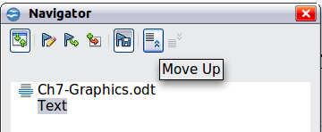
Figure 370: Navigator after inserting one subdocument
- Because the Text section contains the title page and other material, highlight it and click the Move Up icon to move it to the top of the list.
- Highlight the subdocument you just inserted (Chapter 7), then click and hold on the Insert icon, move the mouse pointer, and click File to insert the first subdocument; in this example, Preface. Chapter 7 remains highlighted. Repeat with Chapter 1, Chapter 2, and so on until all the subdocuments have been added to the list. The Navigator will now look something like Error: Reference source not found.
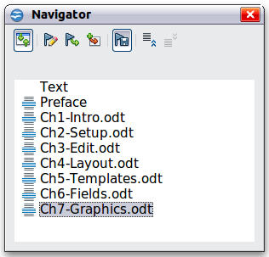
Figure 371. The Navigator showing a series of files in a master document
- Save the master document again.

Step 7. Add Table of Contents, Bibliography, Index
You can generate a table of contents, bibliography, or index for a book, using the master document. You must insert these items into a text section in the master document. For more about these document elements, see Chapter 12 (Creating Tables of Contents, Indexes, and Bibliographies).
Put the insertion point on the page in the first section of text where you want the table of contents to go. Choose Insert > Indexes and Tables > Indexes and Tables to create the table of contents.
If you do not have a Text section at the end of the master document, insert one before the last subdocument, then move this text section down, so it is after the last subdocument. Now, if you have included bibliographic entries in your subdocuments, you can put the insertion point on the page in this last text section where the bibliography is to go and create the bibliography.
If you have included index entries in your subdocuments, put the insertion point on the page in the last text section where the index is to go and create the index.
Figure Error: Reference source not found shows the Navigator after addition of a TOC and index.
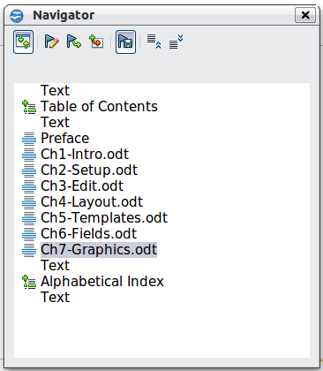
Figure 372: Navigator showing subdocuments, table of contents, and index in a master document

Restarting Page Numbering
The example in the previous section showed a very basic collection of files with sequential page numbering. This is useful for many documents, including e-books, but a typical “printed book” has the following sequence of page numbers:
- No page numbers on cover page or copyright page
- Lower-case Roman numerals in the front matter, starting with i
- Arabic numerals in the body of the document, starting with 1
- Page numbering sequential through the rest of the book
To set up a master document to produce such a book, you need to define a different paragraph style for the heading of the first chapter and assign two special characteristics to it.
Example
Each chapter may start with a Heading 1 paragraph, set up on the Text Flow tab of the Paragraph Style dialog box to start on a new page (Figure Error: Reference source not found). The Page number is set to 0, with the effect that numbering continues from the number of the previous page.
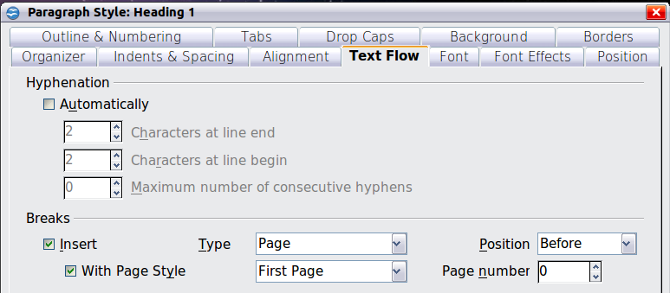
Figure 373: Text Flow tab of Paragraph Style dialog box for Heading 1
Look on the Outline & Numbering tab (Error: Reference source not found) of this dialog box to see what outline level Heading 1 is assigned to. Usually this will be Outline Level 1. The level cannot be changed here because it has been set in Tools > Outline Numbering.
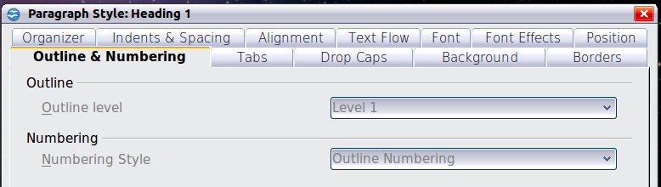
Figure 374: Outline & Numbering tab of Paragraph Style dialog box for Heading 1
Only one paragraph style can be assigned to Outline Level 1 through Tools > Outline Numbering. However, you can assign additional paragraph styles to any outline level by using the Outline & Numbering tab on the Paragraph Style dialog box.
Therefore, you want to define a style called Heading 1 Chapter 1 that is identical in appearance to Heading 1 but has one essential difference: on the Text Flow tab, set the Page number to 1 (Error: Reference source not found). Then, on the Outline & Numbering tab, set the Outline level to Level 1 (Error: Reference source not found). This ensures that the heading will appear in the Table of Contents along with the other chapter headings. (The Numbering Style for this heading is None, as it was not assigned an outline level through the Outline Numbering dialog box.
Now, assign the new style to the first paragraph of Chapter 1, and you’re done.
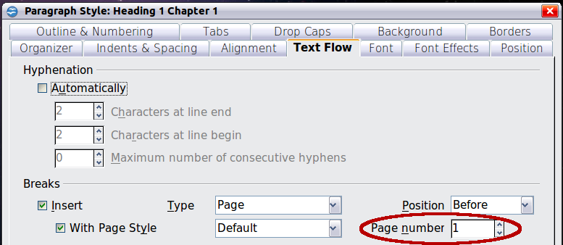
Figure 375: Set the page number to restart at 1 for this heading style
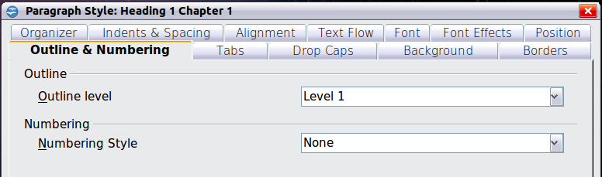
Figure 376: Assign the style to outline level

Editing a Master Document
After creating a master document, you may want to change its appearance or contents.

Changing the Appearance of the Master Document
You can change the styles in the template as your project develops. Do not make changes to styles in the master document or in any of the subdocuments—make those changes in the template.
To update the master document (and all the subdocuments) with changes to the template, just open the master document. You will get two messages: first, to ask if you want to update all links; and second, if you want to apply the changed styles. Answer Yes to both of these messages.

Editing Subdocuments
You cannot save edits made to a subdocument from within the master document. Instead, you must open the subdocument, either by double-clicking on it in the master document’s Navigator, or by opening it from outside the master document. Then you can edit it just as you would edit any other document.
If, while editing a subdocument, you make any changes to the styles that you want to apply to the master document, you must copy those changed styles to the master document, or to its template. A better strategy is to make the changes directly in the master document or its template.
If you change the contents of any subdocument, you need to manually update the table of contents, bibliography, and index from within the master document.

Adding, Deleting, or Renaming Subdocuments
To add a subdocument, follow the method described in “Error: Reference source not found“ on page Error: Reference source not found.
To delete a subdocument, right-click on its filename in the Navigator and choose Delete.
If you rename a subdocument by changing its filename, the next time you update links in the master document, that subdocument will show up as a broken link (shown in red). You can fix this by right-clicking on it in the Navigator, choosing Edit Link, and selecting the renamed file; however, the file name shown in the Navigator does not change (only the link changes). This can be quite confusing, so a better strategy is to delete the subdocument from the Navigator and then add the renamed file.

Cross-referencing between Subdocuments
The methods described earlier in this chapter are all most writers will need when using master documents. However, you might want to include automatically updated cross-references between subdocuments. This section describes how to do so.
The process to create cross-references between subdocuments is time-consuming, but it works.

Preparing Items as Targets for Cross-referencing
Before you can insert a cross-reference to anything that is not automatically shown on the References tab, such as a heading, you must prepare or “set” that heading as an item to be referenced. To do this, you can either use bookmarks or set references.
When you set references, be sure to select the entire text you want to use as the reference, such as a heading or figure number. Keep a list of what you have named the reference fields, and be sure every name is unique. One way to keep track of this information is by putting it in a separate text file or a spreadsheet.
The field names are case-sensitive. You can check the field name by holding the cursor over the referenced item. In our example (Error: Reference source not found), the heading has the field name word count.
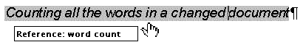
Figure 377: Finding the field name for a heading

Using Bookmarks
Bookmarks are listed in the Navigator and can be accessed directly from there with a single mouse click. To insert a bookmark:
- Select the text you want to bookmark. Click Insert > Bookmark.
- On the Insert Bookmark dialog box, the larger box lists any previously defined bookmarks. Type a name for the new bookmark in the top box. Click OK.

Figure 378: Inserting a bookmark

Setting References
- Click Insert > Cross-reference.
- On the Cross-references tab of the Fields dialog box (Error: Reference source not found), click Set Reference in the Type list. The Selection list shows any references that have been defined. You can leave this page open while you set many headings as references.
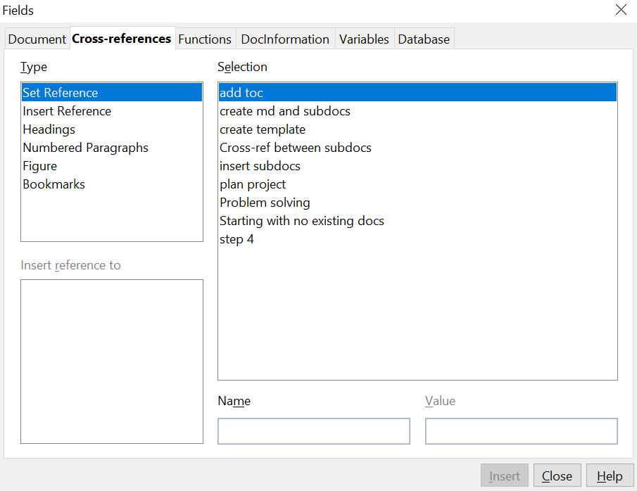

Figure 379: Setting text to be used as a target for a cross-reference
- Click in the document and highlight the text of the first heading to be used as a target for a cross-reference. Click on the Fields dialog box. The text of the heading will appear in the Value box in the lower right of the dialog box. In the Name box, type some text by which you can identify this heading.
- Click Insert. The text you typed in the Name box now appears in the Selection list.
- Repeat steps 3 and 4 as often as required.

Inserting the Cross-references
- Open the master document. In the Navigator, select a subdocument, right-click and choose Edit from the pop-up menu. The subdocument opens for editing.
- In the subdocument, place the cursor where you want the cross-reference to appear. Click Insert > Cross-Reference.
- In the Fields dialog box, on the Cross-references page, select Insert Reference in the Type list on the left-hand side. The Selection list in the middle column shows only the reference field names for the subdocument you are using. Ignore that list and check the list you created manually in step 1.
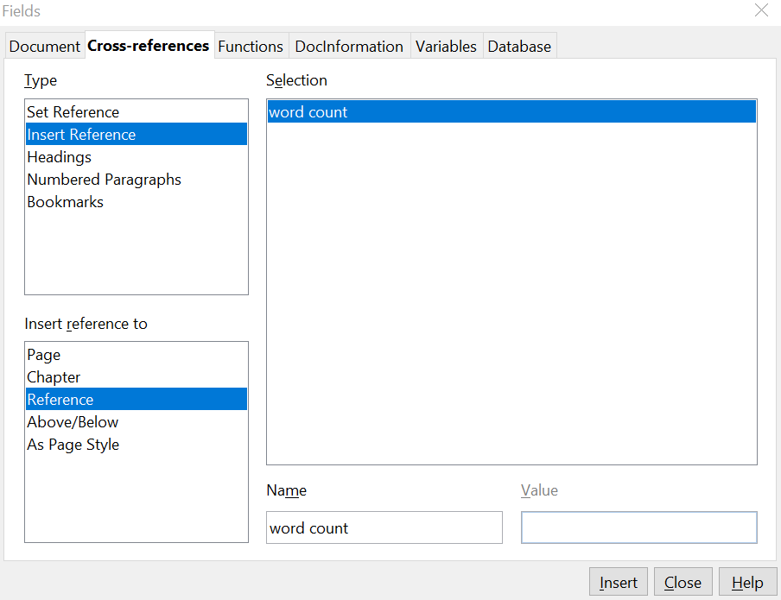

Figure 380. Fields dialog box showing manual entry of field name
- In the Name field in the lower right-hand column, type the name of the reference you set in the subdocument you are referring to. In our example, the reference is in Chapter 3, and its name is word count.
- Click Insert, type any text you want to appear between the reference and page number (such as “on page”), and then insert another reference with the Page format. Nothing will appear in the subdocument except tiny gray bars indicating the fields. When you hover the mouse pointer over one of these fields, you will see the field name.
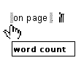
Figure 381: Viewing the field name
(You can turn on the display of field codes by clicking View > Field Names. The two fields shown as gray lines in Error: Reference source not found now look like Error: Reference source not found.)
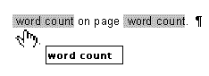
Figure 382. Displaying field codes
- After you have inserted all the cross-references required in the subdocument, save and close it and return to the master document window.
Within the master document, navigate to the page of the subdocument on which you inserted the cross-reference field. You should now see the text of the cross-reference appear in the spot where you inserted it, because within the master document, the subdocument can find the target of that field reference.
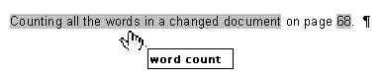
Figure 383. Field contents visible
This technique also works if you open a subdocument directly in step 2 (that is, not from within the master document) and insert a cross-reference field.

Using the Navigator
The Navigator is a very useful tool that helps you move quickly to specific parts of your document. It also provides information about the content of the document and enables you to reorganize some of the content. For example, if each chapter in your final book is a separate document, then in the master document they can be reordered, and the references are renumbered automatically and the table of contents and index can be updated.
In Writer, the Navigator has two distinct forms. One form is used in ordinary text documents and the other in master documents.
In an ordinary text document, the Navigator displays lists of the graphics, tables, index entries, hyperlinks, references, and other items in the document, as shown on the left-hand side of Error: Reference source not found. Click the indicator (+ sign or triangle) by any list to display the contents of the list. You can double-click an entry in the Navigator and jump immediately to that place in the document.
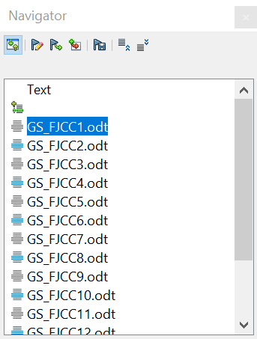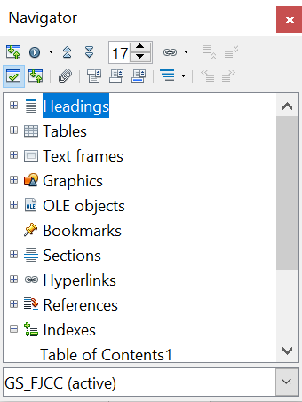

Figure 384. The Navigator for a text document (left) and for a master document (right)
In a master document, you can toggle between the regular and master views by clicking on the Toggle icon at the upper left. In the master view, the Navigator lists the subdocuments and text sections, as shown on the right-hand side of Error: Reference source not found. The use of the Navigator in a master document was covered in more detail earlier in this chapter (see “Step 6. Insert the Subdocuments into the Master Document” on page 382 and “Cross-referencing between Subdocuments” on page 387).

Creating One File from a Master Document and Its Subdocuments
Master documents are .odm files containing linked subdocuments, which are in .odt format. Although linked files are very useful when writing and editing a large document such as a book, sometimes you might need to have a copy of the entire book in one file.
To export a master document to a .odt file (without affecting the original .odm file):
- Open the master document. Choose File > Export from the menu bar.
- On the Export dialog (Error: Reference source not found), type a name for the exported .odt file and choose OpenDocument Text (.odt) from the File format list. Click Export. This step changes the .odm file into a .odt file, with each subdocument in a separate section.
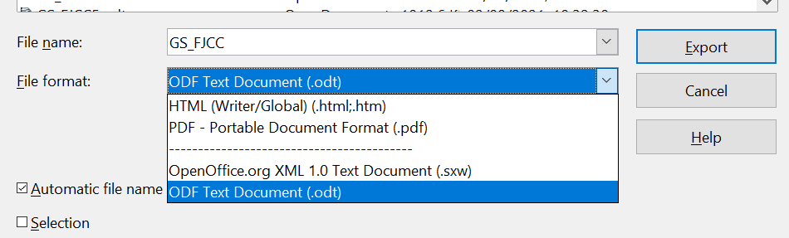

Figure 385: Exporting a master document to an OpenDocument Text (.odt) file
- Close the master document and open the new .odt file, updating all links.
- Choose Edit > Links from the menu bar.
Tip | If the Links command is grayed-out, the cursor is probably in a write-protected part of the document (for example, in one of the linked documents). Move the cursor into a part of the document that is not write-protected; the Links command then becomes available.

- The Edit Links dialog shows all the linked files. Select all the files in the Source file list and click Break Link. This step embeds (includes) the contents of all the subdocuments into one single file (but with each subdocument remaining in a separate section) and removes the write protection on the sections.
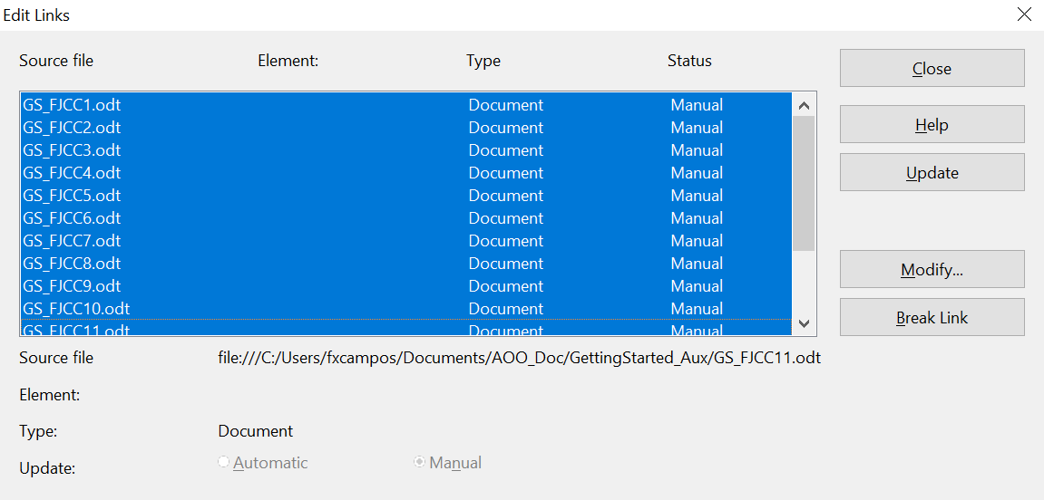

Figure 386: Breaking links to include files in one document
- After breaking the links, you may also wish to remove some or all of the sections. To do this, go to Format > Sections, select the sections you wish to remove, and click Remove. The contents of those sections remain in the document; only the section markers are removed.
Tip | The Help does not mention steps 4 and 5 above, giving only the step for removing the sections. If you have no hidden sections, that technique works fine and is faster. However, if you want to break the links but retain some or all of the sections (particularly hidden sections), the method described in this chapter is safer.

Problem Solving
Some combinations of choices do not work together, and some techniques that affect master documents are not at all obvious. This section describes some problems and what to do about them.

Anchoring Pictures to a Page
The problem
A picture (graphic) anchored “to page” in a subdocument is not displayed in the master document, although it always appears correctly in the subdocument.
Because the master document reorganizes the page flow, page numbers, and cross-references when it collates all the subdocuments together, the absolute reference to a page X in a subdocument is lost in the master document. The picture loses its anchor reference and simply disappears.
The solution
To avoid this problem but keep pictures positioned precisely on a particular page, anchor the pictures as follows:
- Right-click on the picture and choose Picture from the pop-up menu.
- On the Type tab of the Picture dialog box (Error: Reference source not found), set the anchor to To character or To paragraph.
- Under Position, choose suitable horizontal and vertical references to the page. Click OK to save the changes.
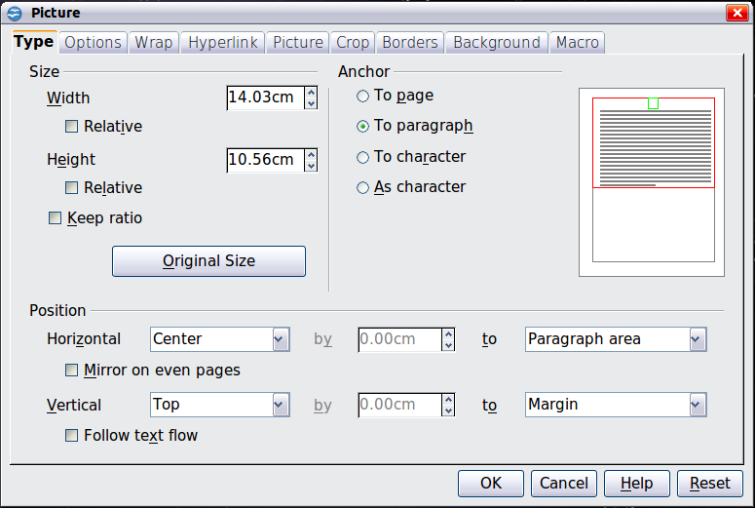
Figure 387. Anchoring a graphic and setting its position on a page

Restarting List Numbering When Using Custom Styles
The problem
When custom numbering styles are used for lists, the first item in the first list in a file continues numbering from the last list in the previous chapter.
The solution
You need to explicitly set the first list item to restart numbering at 1. However, if you right-click on the paragraph and choose Restart numbering, the setting is not saved when the file is saved. (This works for other lists in a document, but not the first.)
Here is the secret:
- Right-click on the first list item in the first list in the document and choose Paragraph, not Restart Numbering.
- On the Paragraph dialog, go to the Outline & Numbering tab.
- Under Numbering, choose Restart at this paragraph and 1 for Start with. Click OK to save.
Note: If you do not explicitly choose 1 for Start with, the setting is not retained. Unfortunately there seems to be no way to build it into a paragraph style.
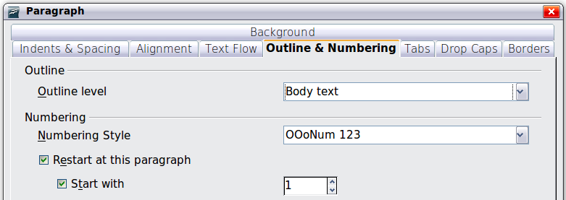

Chapter 14
Working with Fields

Introduction to Fields
Fields are extremely useful features of Writer that are used for a variety of purposes. For example:
- data that changes (such as the current date or the total number of pages)
- data that might change (the name of a product or book under development)
- user-defined numbering sequences
- automatic cross-references
- conditional content (words or paragraphs that are visible or printed in some conditions but not others)
- Index entries are also fields.
This chapter describes some common uses of fields. A full discussion of fields and their use is beyond the scope of this book, but experienced users can find more details in the application Help.
Tip | Fields have a gray background when viewed on screen, unless you have deselected the Field shadings option or changed the color of field shadings on the Appearance tab of the Options—OpenOffice dialog box. This gray background does not show when you print the file to hard copy or PDF.  To turn field shadings on or off quickly, choose View > Field Shadings or press Control+F8.

Quick and Easy Field Entry
You can quickly insert common fields into your document by choosing Insert > Fields from the menu bar and selecting the required field from the list, as shown in Error: Reference source not found.
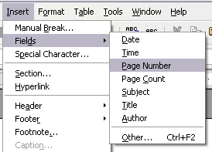Figure 388: Inserting common fields

Using Document Properties to Hold Metadata and Information That Changes
The Properties dialog box for a document, accessed with File > Properties, has six tabs. The information on the General tab and the Statistics tab is generated by the program. Other information (the name of the person on the Created and Modified lines of the General tab) is derived from the User Data tab in Tools > Options.
The Internet tab is relevant only to HTML documents (Writer/Web). The file sharing options on the Security tab are discussed elsewhere in this book.
Use the Description and Custom Properties tabs to hold:
- Metadata (that is, data that provides information about other data) to assist in classifying, sorting, storing, and retrieving documents. Some of this metadata is exported to the closest equivalent in HTML and PDF; some fields have no equivalent and are not exported.
- Information that changes. You can store data for use in fields in your document; for example, the title of the document, contact information for a project participant, or the name of a product might change during the course of a project.
This dialog box can be used in a template, in which field names can serve as reminders to writers of information they need to include.
Later in this chapter, we will see how to use this information in fields. You can return to this dialog box at any time and change the information you entered. When you do so, all the references to that information will change wherever they appear in the document. For example, on the Description tab (Error: Reference source not found) you might need to change the contents of the Title field from the draft title to the production title.
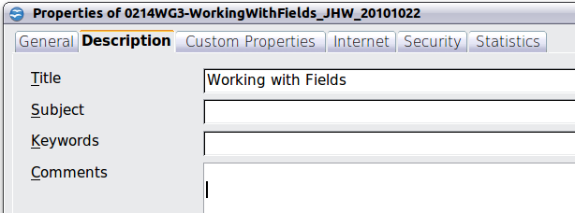
Figure 389: The Description page of the document’s Properties dialog box
To open the Properties dialog box, choose File > Properties.
Use the Custom Properties page (Error: Reference source not found) to store information that doesn't fit in fields supplied on the other pages of this dialog box.
When the Custom Properties tab is first opened in a new document, it may be blank. But if the new document is based on a template, this tab may contain fields.
Click Add to insert a row of boxes into which you can enter your custom properties.
- The Name box includes a drop-down list of typical choices; scroll down to see all of them. If none of the choices meet your needs, you can type a new name into the box.
- In the Type column, you can choose from text, date+time, date, number, duration, or yes/no for each field, but you cannot create new types.
- In the Value column, type or select what you want to appear in the document where this field is used. Choices may be limited to specific data types depending on the selection in the Type column; for example, if the Type selection is Date, the Value for that property is limited to a date.
- To remove a custom property, click the button at the end of the row.

Tip | To change the format of the Date value, go to Tools > Options > Languages and change the Locale setting. Be careful! This change affects all open documents, not just the current one.

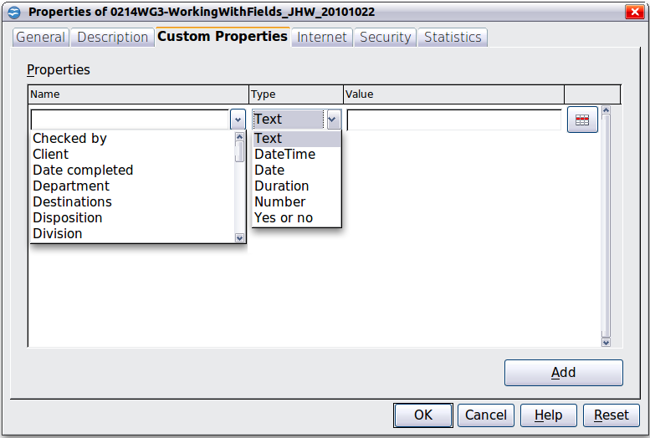
Figure 390: Custom Properties page, showing drop-down lists of names and types

Using Other Fields to Hold Information That Changes
One way people use fields is to hold information that is likely to change during the course of a project. For example, the name of a manager, a product, or even your entire company may change, just before the document is due to be printed. If you have inserted the changeable information as fields, you can change the information in one place, and it will automatically change in all the places where that field occurs.
Writer provides several places where you can store the information referred to by a field. We will look at some of them here.
Seven document properties (Date, Time, Page Number, Page Count, Subject, Title, and Author) are on the Insert > Fields menu (Error: Reference source not found). To insert one of these fields, click on it in the menu. Some of these fields get their information from the Document Properties dialog box (Error: Reference source not found.)
Other document properties are on the DocInformation and Document pages of the Fields dialog box (Error: Reference source not found and Error: Reference source not found), reached by choosing Insert > Fields > Other or pressing Ctrl+F2. Notice the Custom item in the Type list; this is derived from the Custom Properties tab of the Document Properties dialog box (Error: Reference source not found).
To insert one of these fields, select it in the Type list and then select from the Select and Format lists if choices appear. Finally, click Insert.
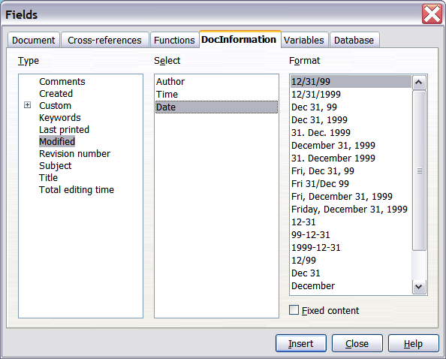
Figure 391: Inserting a Date Modified field using the DocInformation page of the Fields dialog box
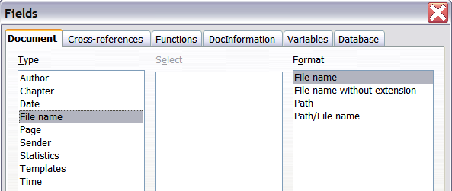
Figure 392: Inserting a File name field using the Document tab of the Fields dialog box
Some of these items are picked up from the User Data tab of the Options (Tools > Options > OpenOffice > User Data) dialog box (covered in Chapter 2, Setting up Writer), so make sure the information on that page is correct.

Tip | Although these fields are often used to hold information that changes, you can make the content unchangeable by selecting the Fixed content option (visible in Error: Reference source not found, lower right) when inserting the field. If necessary, you can come back to this dialog box later and deselect this option to make the field variable again.

Using AutoText to Insert Often-Used Fields
If you use the same fields often, you will want a quick and easy way to insert them. Use AutoText for this purpose. To define an AutoText entry for a field:
- Insert a field into your document, as described previously.
- Select the field, and then choose Edit > AutoText (or press Ctrl+F3).
- On the AutoText dialog box, choose the group where this new entry will be stored (in this example, it is going into My AutoText), type a name for the entry, and change the suggested shortcut if you wish.
- Click the AutoText button and click New to have the entry inserted as a field. Do not choose New (text only) because the AutoText entry will be plain text, not a field. (The selection New does not appear until you have selected a group and typed a name for the entry.) Click Close to close the AutoText dialog box.
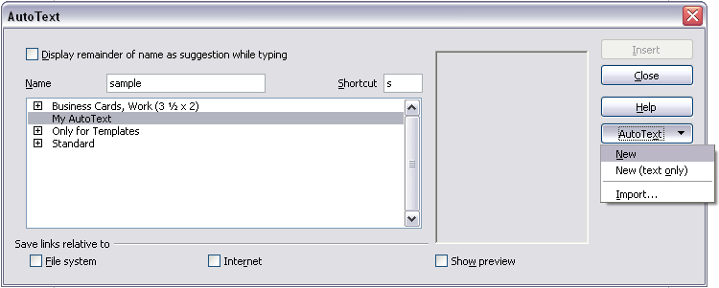Figure 393: Creating a new AutoText entry
Now whenever you want to insert this field at the cursor position, type the shortcut, and then press F3.

Defining Your Own Numbering Sequences
You may want to define your own numbering sequences, for example to use in situations where you do not always want the number at the start of the paragraph or where you want more control than the built-in numbering choices give you.
This topic describes how to create and use a numbering sequence, using a “number range variable” field.

Create a Number Range Variable
To create a number range variable using Arabic (1, 2, 3) numbers:
- Place the insertion point in a blank paragraph in your document.
- Choose Insert > Fields > Other and select the Variables page.
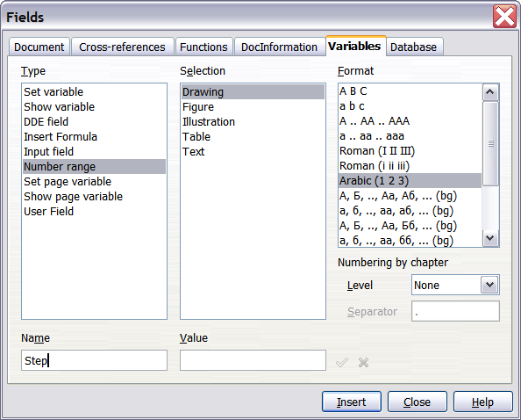
Figure 394: Defining a number range variable
- In the Type list, select Number range. In the Format list, select Arabic (1 2 3). Type whatever you want in the Name field. (We have used Step in this example.)
- Click Insert. The name of the variable (Step) now appears in the Selection list, and a number field (showing 1) appears at the insertion point in your document. The Fields dialog box remains open, so you may need to move it out of the way to see the field in the document.
- Hover the mouse pointer over this number field, and you will see the field code of Step = Step+1. If you click several more times on the Insert button in the Fields dialog box, the numbers 2, 3, 4, and so on will appear in the document.
Now you may want to restart the Step sequence at 1, so you can use the same sequence name more than once in your document (for example, to begin each set of instructions). We will first describe a manual method and then a more convenient method using AutoText. To use the manual method, you need to insert a new field of the same name, while instructing AOO to force the value to 1.
- Open the Fields dialog box to the Variables tab. Make sure the variable name Step appears in the Name box.
- In the Value box, type Step=1, as shown in Error: Reference source not found. Click Insert.
Now hover the mouse pointer over the new field in your document, and you will see the field code of Step = Step=1. To continue with the normal sequence (that is, to have the next item be step 2), you need to delete the contents of the Value box after inserting Step 1.
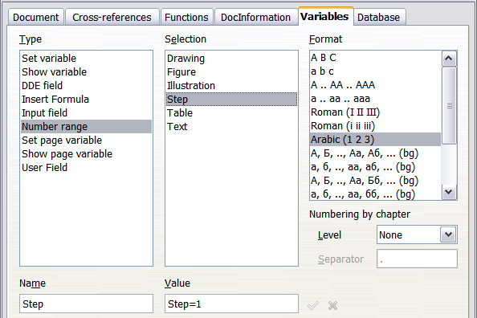
Figure 395: Defining a field to restart a number range variable

Use AutoText to Insert a Number Range Field
You certainly don't want to go through all these steps every time you want to put in a step number. Instead, create two AutoText entries, one for the Step = Step=1 field (call it Step1, for example) and one for the Step = Step+1 field (StepNext). Then insert the fields in the same way you would insert any other AutoText. See “Using AutoText to Insert Often-Used Fields” on page 402.
You can create similar fields for substeps or other sequences that you want to be numbered with letters (a, b, c), Roman numerals (i, ii, iii), or some other sequence. In the Fields dialog box, choose the required format in the Format list when creating the field codes.
Tip | If a user-defined variable is not in use in the document, the icon next to the Value box is active. You can delete the variable by clicking this icon. To remove a variable that is used in the current document, first delete from the document all fields using that variable (or convert them all to text, as described on page Error: Reference source not found), and then remove the variable from the list.

Using Automatic Cross-References
If you type in cross-references to other parts of the document, those references can easily get out of date if you reword a heading, add or remove figures, or reorganize topics. Replace any typed cross-references with automatic ones and, when you update fields, all the references will update automatically to show the current wording or page numbers.
Tip | Some people use Writer’s Hyperlink feature for cross-references, but it has a major disadvantage: the visible text of the hyperlink does not change if you change the text of the item to which it links. For that reason, you are advised to use cross-references in most situations.  The exception is when you are creating a document to be saved as HTML; cross-references do not become hyperlinks in an HTML document.

The Cross-references tab of the Fields dialog box (Error: Reference source not found) lists some items, such as headings, numbered paragraphs, and bookmarks. If figure captions, table captions, user-defined number range variables, and some other items have been defined in a document, that type also appears in the list.
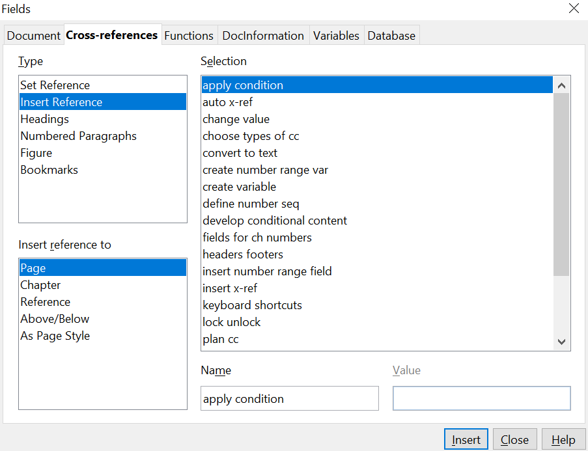

Figure 396: The Cross-references page of the Fields dialog box

Inserting Cross-References
To insert a cross-reference to a heading, figure, or other item shown on the Cross-references tab:
- In your document, place the cursor where you want the cross-reference to appear.
- If the Fields dialog box is not open, choose Insert > Cross-reference. On the Cross-references tab (Error: Reference source not found), in the Type list, click the type of item you are referencing (for example, Heading or Figure).
- You can leave this tab open while you insert any needed cross-references.
- Click on the required item in the Selection list, which shows both automatically created entries (for example Headings) and user-defined references (for example, bookmarks).
- In the Insert reference to list, choose the type of reference required. The choices vary with the item being referenced.
For headings, usually you will choose Reference (to insert the full text of the heading) or Page (to insert the number of the page the heading is on).
For figures, you will usually choose Category and Number (to insert the word “Figure” and its number), Reference (to insert the word “Figure” with its number and the full text of the caption), Page (to insert the number of the page the figure is on), or Numbering (to insert only the figure number).
- Click Insert.
For a full list of the reference formats available, and their use, consult the Help.

Available Formats
For all the types of reference, you can select one of the following formats:
- Page: the page number of the target.
- Chapter: the number of the chapter where the referenced target is located.
- Reference: the full text set as reference.
- Above/Below: Inserts the words above or below depending on the position of the field relative to the referenced target.
- As Page Style: similar to Page, this inserts the page number where the reference is, but using the formatting specified in the page style. This is very useful when putting a reference to a page in front matter, that is, any content, such as a preface, preceding the main text where Roman numerals are usually employed.
If you select Headings or Numbered Paragraphs as Type, the following two additional options become available:
- Number (no context): inserts only the number of the heading or of the numbered paragraph. For example, if referencing a numbered item 2.4, it inserts 4.
- Number (full context): inserts the full number including higher hierarchical levels. For example, if referencing a numbered item 2.4, the full numbering (2.4) is inserted.
Finally, for objects inserted with captions such as a table or a figure, you can choose:
- Category and Number: inserts both the category and number of the referenced object (for example, Figure 6). This is generally the most used formatting for figures and tables.
- Caption Text: inserts the full caption of the referenced object. For example, Figure 6: This is an example figure.
- Numbering: inserts the sequential number of the referenced object, without the category (for example, if referencing Table 2, the field will contain only the number 2).

Preparing Items as Targets for Cross-Referencing
Occasionally you might want to insert a cross-reference to something that is not automatically shown on the Cross-references tab. Before you can insert a cross-reference to such an item, you must prepare the item as a target to be referenced. To do this, you can either use bookmarks or set references.
After a target has been defined, you can cross-reference to it as described on page Error: Reference source not found. For an example of the use of this technique, see “Solving the page count problem” in Chapter 4 (Formatting Pages).

Using Bookmarks
Bookmarks are listed in the Navigator and can be accessed directly from there with a single mouse click. In HTML documents, bookmarks are converted to anchors that you can jump to using a hyperlink.
- Select the text you want to bookmark. Choose Insert > Bookmark.
- On the Insert Bookmark dialog box, the larger box lists any previously defined bookmarks. Type a name for this bookmark in the top box. Click OK.
Figure 397: Inserting a bookmark

Setting References
- Choose Insert > Cross-reference.
- On the Cross-references tab of the Fields dialog box (Error: Reference source not found), select Set Reference in the Type list. The Selection list shows any references that have been defined. You can leave this tab open while you set many items as references.
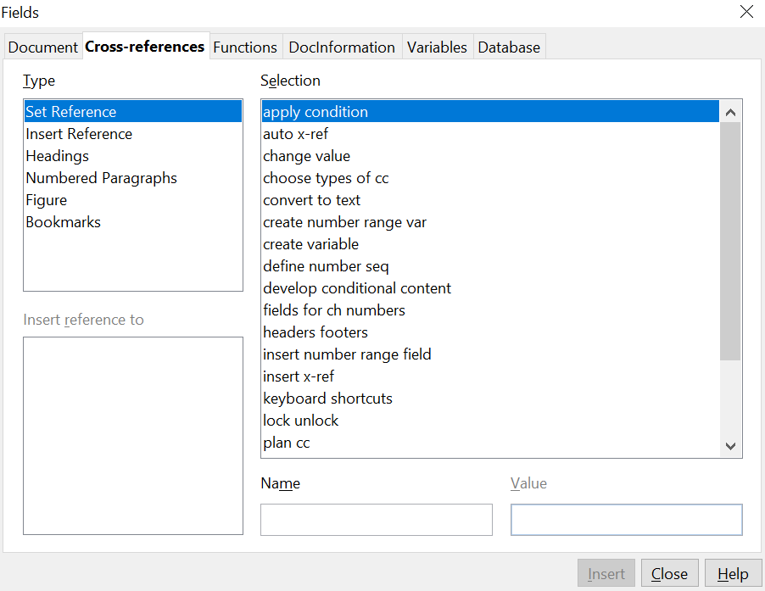

Figure 398: Setting text to be used as a target for a cross-reference
- Click in the document and highlight the text of the first item to set as a target for a cross-reference. Click on the Fields dialog box. The text of the item will appear in the Value box in the lower right. In the Name box, type some text by which you can identify this item.
- Click Insert. The text you typed in the Name box now appears in the Selection list.
- Repeat steps 3 and 4 as often as required.

Using Fields in Headers and Footers
You can insert fields into headers or footers, using techniques described earlier in this chapter:
- To insert a page number, document title, author, creation date and time, current date and time, or total page count field, use document properties (see page 398) or the Insert > Fields menu entry.
- You can insert a cross-reference to a bookmark, heading, or other item.
- If you have used Heading 1 for your chapter titles, you can use a document field to insert the current chapter title, so the header or footer contents change from one chapter to the next. See Error: Reference source not found. (Writer calls chapter titles Chapter names.) If you have used outline numbering on your Heading 1, you can choose whether to include these numbers in the field (Chapter number and name).
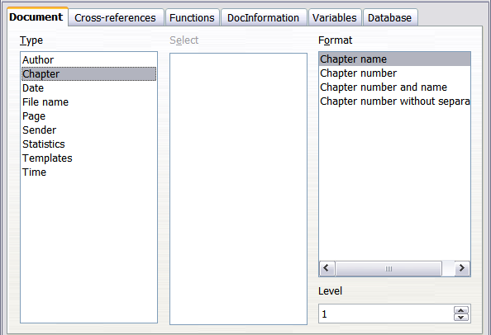
Figure 399: Inserting the current chapter name and number into your document
- You can insert cross-references to other heading levels by specifying a value in the Level box in the lower right of the Document tab of the Fields dialog box (Error: Reference source not found). That is, Level 1 = Heading 1, Level 2 = Heading 2, and so on.
Note | A cross-reference field in the header of a page picks up the first heading of that level on the page, and a field in the footer picks up the last heading of that level.
- To include the chapter number with the page number, position the cursor just before the Page field you inserted. Choose Insert > Fields > Other. On the Document tab of the Fields dialog box, select Chapter in the Type column and Chapter number without separator in the Format column. Click Insert.
Go to the header or footer where you inserted this field, type the character you want to appear between the chapter number and the page number—for example, a period or a dash.
The table of contents will not automatically pick up these chapter numbers, so you will need to make a change on the Indexes and Tables menu item, as described in Chapter 12 (Creating Tables of Contents, Indexes, and Bibliographies).
- You can add a page count to the footer—for example “Page 9 of 12”. Type the word “Page” and a space in front of the Page field. Type a space, the word “of”, and a space after the Page field. Then choose Insert > Fields > Page Count.

Using Fields Instead of Outline Numbering for Appendix Numbering
Chapter 6 (Introduction to Styles) describes how to use paragraph styles to define a hierarchy of headings to be included in a table of contents.
This method has a major limitation: only one paragraph style can be selected for each heading level, and only one numbering sequence can be specified in Tools > Outline Numbering. However, many books contain Appendixes (typically designated A, B, C) in addition to the chapters (typically designated 1, 2, 3).
To solve this problem, you can use one paragraph style (Heading 1) for both chapter and appendix names, and define two number range fields for the chapters and appendixes respectively. The number range field for chapters will use numbers, and the number range field for appendixes will use letters. You can then use the same field in the header or footer of chapters and appendixes.
- Define the first number range variable, as described in “Defining Your Own Numbering Sequences” on page 402. To insert the field into your Heading 1, type Chapter<space>. Choose Insert > Fields > Other. On the Variables tab, select Number range, Chapter, Arabic (1 2 3). Click Insert. You will need to do this manually for each Heading 1 that is to be a chapter title.
- Define and insert a second number range variable for the appendixes, using Number range, Appendix, A B C), as shown in Error: Reference source not found. Type Appendix<space> and then insert the variable. Do this for each Heading 1 that is to be an appendix title.
- When you create the table of contents, the chapters and appendixes will be designated correctly.
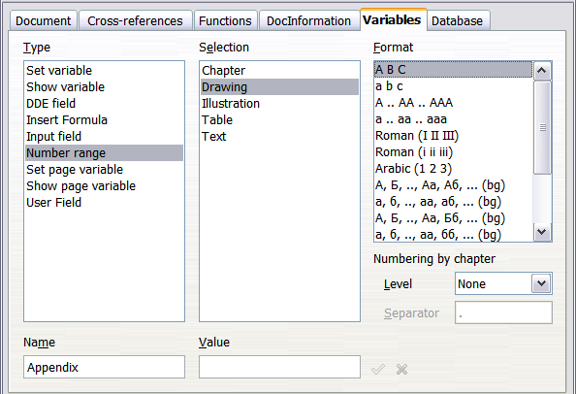Figure 400: Defining a number range variable for Appendixes

Tricks for Working with Fields

Keyboard Shortcuts for Fields
Here are some handy keyboard shortcuts to use when working with fields:
Ctrl+F2 Open the Fields dialog box.
Ctrl+F8 Turn field shadings on or off.
Ctrl+F9 Show or hide field names.
F9 Update fields.

Fixing the Contents of Fields
You can specify Fixed content for many items on the Document and DocInformation pages, so the field contents do not update. For example, you might use a field to insert the creation date of a document, and you would not want that date to change. In another place you might use a date field to show the current date, which you do want to change; in that case, deselect Fixed content when you insert the field.

Converting Fields into Text
Writer does not provide any easy way to convert field contents into text. To do this, you need to copy the field contents and paste them back as unformatted text. This is not a very good solution if you have hundreds of fields that you want to change, but you could use a macro to automate the process.

Developing Conditional Content
Conditional content is text and graphics that are included or excluded in your document depending on a condition you specify.
A simple example is a reminder letter for an overdue account. The first and second reminders might have a subject line of “Reminder Notice”, but the third reminder letter might have the subject “Final Notice” and a different final paragraph.
A more complex example is a software manual for a product that comes in two versions, Pro and Lite. Both product versions have much in common, but the Pro version includes some features that are not in the Lite version. If you use conditional content, you can maintain one file containing information for both versions and print (or create online help) customized for each version. You do not have to maintain two sets of the information that is the same for both versions, so you will not forget to update both versions when something changes.

Choose the Types of Conditional Content to Use
This section describes several Writer features that can help you design and maintain conditional content. You can use one or any combination of these features in the same document.

Conditional Text
With conditional text, you can have two alternative texts (a word, phrase, or sentence). One text will be displayed and printed if the condition you specify is met, and the other will be displayed and printed if the condition is not met. You cannot include graphics or edit the text except in the field dialog (not in the body of the document). You also cannot format part of the text (for example, bolding one word but not the others), but you can format the field to affect all of the field contents (for example, bolding all of the words). You cannot include a cross-reference or other field in the text.

Hidden Text
With hidden text (a word, phrase, or sentence), you have only two choices: show or hide. If the condition you specify is met, the text is hidden; if the condition is not met, the text is displayed. The disadvantages are the same as for conditional text: you cannot include graphics, edit the text in the body of the document, format part of the text, or include a field.

Hidden Paragraphs
Hidden paragraphs are like any other paragraphs, except that they allow you to specify a condition under which the paragraph is not displayed or printed. A blank paragraph can also be hidden—for example, if a database field has no content for the current record. This is very useful when merging an address into a letter: if you allow two lines for the street address and the database record uses only one line, you can prevent the blank line from appearing in your document. You can include graphics, edit the text in the body of the document, format any part of the text, and include fields.

Hidden Sections
Hidden sections are like hidden paragraphs, but they can include more than one paragraph—for example, a heading plus one or more paragraphs. However, a section cannot contain less than a paragraph, so you cannot use this method for single words or phrases. The contents of a hidden section behave just like the contents of any other part of the document, but you can specify a condition under which the section is not displayed or printed. In addition, you can password protect a section.

Plan Your Conditional Content
Conditions are what programmers call logical expressions. You must formulate a logical expression for each condition because a condition is always either true (met) or false (not met). You can use the same condition in many places in your document, for different types of conditional content.
To make conditional content work, you need to:
- Choose or define a variable.
- Define a logical expression (condition) involving the selected variable.

Choose or Define a Variable
You can use the following variables in your condition:
- User-defined variables
- Predefined OpenOffice variables, which use statistical values from the document properties
- User data
- Database field contents—for example from your address book
You cannot use internal variables (for example, page number or chapter name) to formulate conditions.
The examples in this chapter use user-defined variables.

Define a Logical Expression (Condition) Involving the Selected Variable
The condition compares a specified fixed value with the contents of a variable or database field.
To formulate a condition, use the same elements as you would to create a formula: operators, mathematical and statistical functions, number formats, variables, and constants. The possible operators are given in the built-in Help; look in the index under “operators: in formulas”. You can define quite complex expressions, but in most cases a simple condition will do the job.

Create the Variable
To create your variable, choose Insert > Fields > Other. You can use choices found on the DocInformation, Variables, and Database tabs.

DocInformation Fields
“Using Document Properties to Hold Metadata and Information That Changes” on page 398 described how to set up a custom document property. You can use that document property as the variable in your condition statement, or you can create another document property field specifically for conditions.

User-Defined Variable Field
To set up a variable or user field:
- Place the cursor where you want the field to be inserted.
- On the Fields dialog box, select the Variables tab (Error: Reference source not found).
- Select Set variable in the Type list and Text in the Format list. Type a name for the variable in the Name box, and a value in the Value box. I have chosen ProLite for the name (to remind me that this variable is related to the two product versions), and I set the value as Lite because I can remember “If it is the Lite version, then this text should be hidden.”
- Select Invisible, so the field does not show in the document. Click Insert, then click Close.
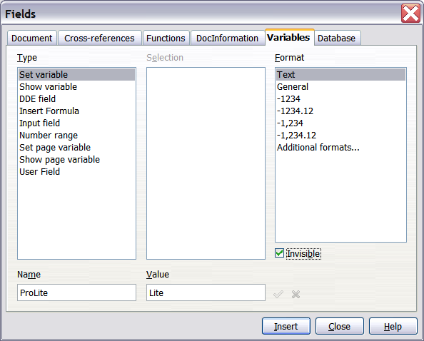
Figure 401: Defining a variable to use with conditional content
- A small gray mark should be visible where you inserted the field. Hover the mouse pointer over this mark and you will see the field formula ProLite = Lite. We will come back to this field later.
Tip | Because the gray mark is so small, you may have trouble finding it again, especially if you have other fields in the document. You may prefer to leave the variable field visible while you work, and change it to invisible just before you create final copy.  At any time, you can place the insertion point just before the field and choose Edit > Fields or right-click the field, and then click Fields on the pop-up menu. On the Edit Fields dialog box (Error: Reference source not found), select or deselect the Invisible option.

Apply the Condition to the Content
Now that you have defined the variable, you can use it in a condition statement. This topic describes some possibilities.

Conditional Text
First, let us set up some conditional text that will insert the words Great Product Lite into the Lite version and Great Product Pro into the Pro version of the manual. You would use this field whenever you want to mention the name of the product.
- Place the cursor where you want one of these phrases to appear. (You can move or delete it later, if you wish.)
- Open the Fields dialog box by clicking Insert > Fields > Other, select the Functions tab, and select Conditional text in the Type list.
- As shown in Error: Reference source not found, type ProLite EQ “Lite” in the Condition box, Great Product Lite in the Then box, and Great Product Pro in the Else box.
Note | These fields are case-sensitive, and quotation marks are required around a text value such as Lite.
- Click Insert to insert the field, then click Close. You should see Great Product Lite in your text.
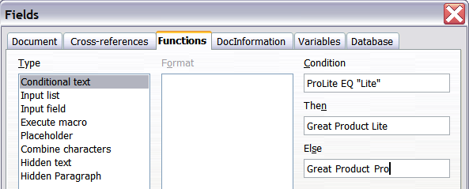
Figure 402: Inserting conditional text
Tip | If you want to insert this field into your text in many places (as you probably would for a product name), create an AutoText entry for it. See “Using AutoText to Insert Often-Used Fields” on page 402 for instructions.

Hidden Text
You might use hidden text for words or short phrases that describe features of Great Product Pro that are not found in the Lite version. You can reuse the same field in several places in your document—for example, by copying and pasting it.
To create a hidden text field:
- Choose Insert > Fields > Other and select the Functions tab.
- Select Hidden text in the Type list, as shown in Error: Reference source not found.
- Type ProLite EQ “Lite” in the Condition box and type the required text in the Hidden text box. Remember, this is the text that is hidden if the condition is true.
- Click Insert to create and insert the field.
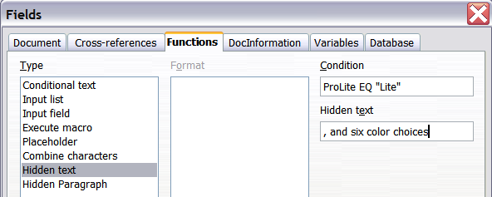
Figure 403: Creating a condition for hidden text

Hidden Paragraphs
Tip | To enable hidden paragraphs, remove the check mark from View > Hidden Paragraphs. When this option is selected, any hidden paragraph you create will always be visible, whether its condition is true or not.
A paragraph is hidden if the condition is true. To hide a paragraph:
- Click in the paragraph to be hidden.
- Choose Insert > Fields > Other and select the Functions tab (Error: Reference source not found).
- Select Hidden paragraph in the Type list.
- For this example, type ProLite EQ “Lite” in the Condition box.
- Click Insert to create and insert the field. If an extra paragraph mark appears, delete it.
To show hidden paragraphs, so you can edit them, do one of the following:
- Choose View > Hidden Paragraphs from the menu bar, so it is checked (shows all hidden paragraphs).
- On the Tools > Options > OpenOffice Writer > Formatting Aids tab, select the Fields: Hidden paragraphs option (shows all hidden paragraphs).
- Double-click in front of the variable that you used to define the condition for hiding the text, and enter a different value for the variable (shows all hidden paragraphs).
- Double-click in front of the hidden text field or the hidden paragraph field, and change the condition statement (changes only the selected hidden paragraph).

Hidden Sections
A conditional section is hidden if the condition is true. To create a conditional section:
- Select the text that you want to be included in the conditional section. (You can edit this text later, just as you can edit any other text.)
- Choose Insert > Section. On the Insert Section dialog box (Error: Reference source not found), select Hide and enter the condition in the with Condition box. You can also give the section a name, if you wish (strongly recommended, so you can find it again easily if you have several sections in your document).
- Click Insert to insert the section into your document.
To show a hidden section, so you can edit it:
- Choose Format > Sections.
- On the Edit Sections dialog box (similar to the Insert Section dialog box), select the section from the list.
- Deselect Hide, and then click OK. You can now edit the contents of the section. Afterward, you can choose Format > Sections again and select Hide to hide the section again.
To show all the hidden sections, so you can edit them, change the value of the variable to something that the conditions will not recognize. In our example, you could change the value to 1.
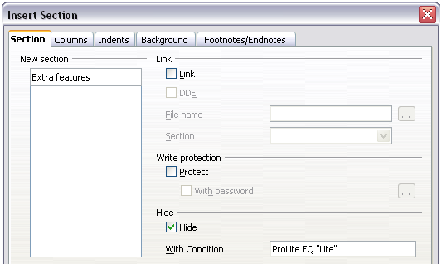
Figure 404: Creating a section to be hidden when a specified condition is met
To make the hidden section a normal part of the document (that is, to remove the section markers, but not the contents of the section):
- Show the hidden section, as described above.
- On the Edit Sections dialog box, select the section from the list.
- Click Remove. The contents of the section are now a normal part of the document.

Change the Value of the Variable
- Find the variable field you created in “Create the Variable” on page 413.
- Click once just in front of this field, then right-click and click Fields on the pop-up menu.
- On the Edit Fields: Variables dialog box (Error: Reference source not found), change the value of the variable to Pro.
- If you have set fields to update automatically, all the conditional and hidden text that uses this variable as a condition will change.
Tip | Conditional text and hidden text can only be edited in the Edit Fields dialog box.

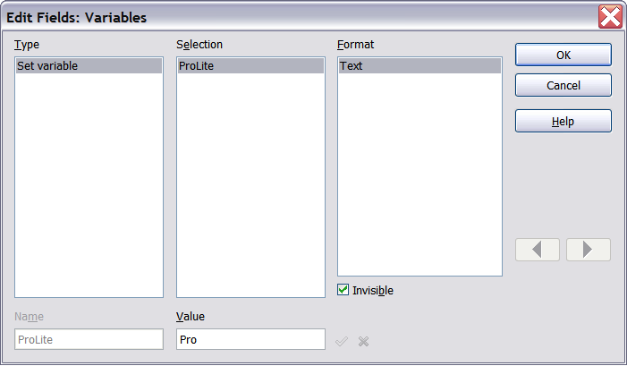
Figure 405: Changing the value of the variable
Tip | To turn on automatic updating of fields, choose Tools > Options > OpenOffice Writer > General, and select Fields under Update: Automatically.

Using Placeholder Fields
A placeholder field prompts you to enter something (text, a table, a frame, a graphic, or an object).
To insert a placeholder field into a document:
- On the Functions tab of the Fields dialog box, select Placeholder in the Type column and select what the placeholder is for in the Format column.
- In the Placeholder box, type the text that you want to appear in the placeholder field.
- In the Reference box, type the text that you want to display as a help tip when you rest the mouse pointer over the field.
Error: Reference source not found shows the results of inserting a placeholder field for a graphic.
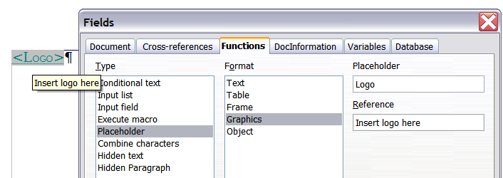
Figure 406: Inserting a placeholder field
Because the <Logo> field is a graphics placeholder, when you click on the field in the document, the Insert picture dialog box opens, prompting you to select a graphic (picture). When you select a picture and click Open, the picture replaces the field in the document.
Similarly, clicking on a table placeholder field opens the Insert Table dialog box, clicking on a frame placeholder field opens the Frame dialog box, and clicking on an object placeholder field opens the Insert OLE Object dialog box. The text placeholder field is different: you simply click on it and type some text in the Placeholder box, which replaces the field.

Using Input Fields and Input Lists
Input field
An input field is a variable that you can click in a document to open a dialog that allows you to edit the text displayed in the field. To insert an input field:
- Choose Insert > Fields > Other and choose the Functions tab.
- Choose Input field in the Type list (Error: Reference source not found).
- Optionally type some text in the Reference box. This text will appear as a tooltip when the users hover a mouse cursor over the field.
- Click Insert. In the small dialog box that opens, type some text for the variable (for example, a brief instruction to the user regarding the purpose of the field); this text can be the same or different from the text in the Reference box in the previous step.
- Click OK.
To edit an input field, click on it in the document. In the small dialog box that opens, edit the text of the field.
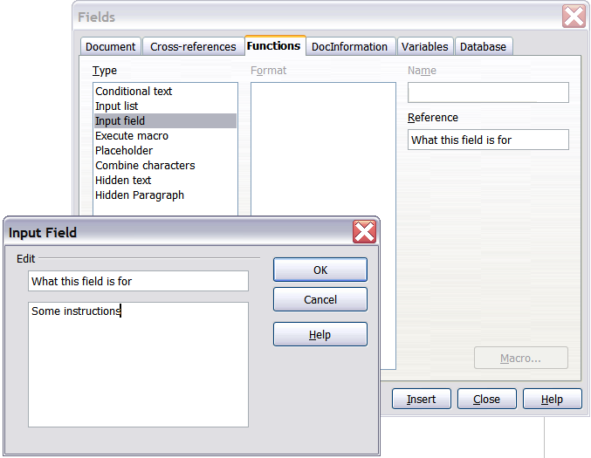Figure 407: Inserting an input field
To edit the field’s reference, right-click on the field and choose Fields from the pop-up menu. This opens the Edit Fields: Functions dialog box.
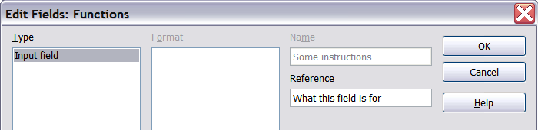Figure 408: Editing an input field
Input list
An input list is a text field that displays one item from a list. To insert an input list field into a document:
- Choose Insert > Fields > Other; on the Functions tab, choose Input list in the Type list.
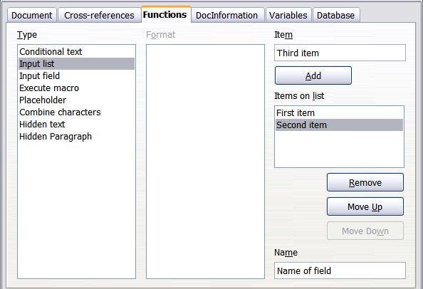Figure 409: Defining an input list field
- Type the names of the list items in the Item box on the upper right, clicking Add after each item. The items then appear in the Items on list box. To change the order of the items, select an item and click the Move Up or Move Down buttons.
- Type the name of the list in the Name field on the lower right.
- Click Insert.
To display the Choose Item dialog box, click the Input list field.
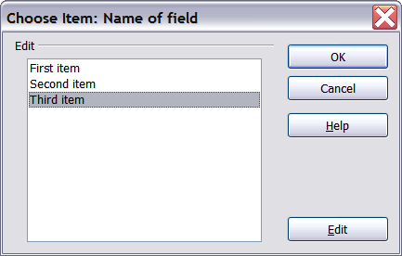
Figure 410: Choosing an item from an input list
To add, edit, and remove items from this list, and change their order in the list, click the Edit button in the Choose Item dialog box. This displays the Edit Fields: Function dialog box.
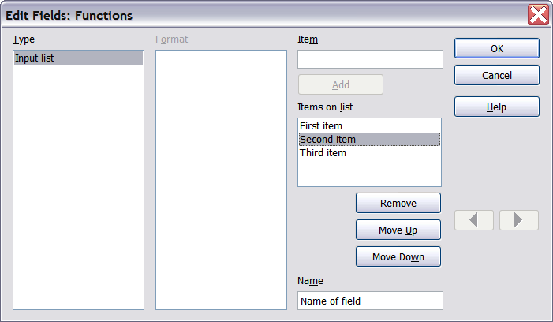Figure 411: Editing the items on an input list
To quickly edit all input fields and lists in a document, press Ctrl+Shift+F9. The first input field or list in the document opens. Clicking OK or Next moves to the next input field or list. After the last input field or list, clicking Next or OK returns you to the document.

Chapter 15
Using Forms in

Introduction to Forms
This chapter covers the use of forms within Writer documents. Most of the information here also applies to forms in other Apache OpenOffice (AOO) components, but there are some differences.
The chapter presents information on using forms in four main sections: setting up a basic form, an example for creating a form, linking a form to a data source, and finally some advanced techniques.

When to Use Forms
A standard text document displays information: a letter, report, or brochure, for example. Typically, the reader may edit everything or nothing in the document. A form has sections that are not to be edited, and other sections that are designed for the reader to make changes. For example, a questionnaire has an introduction and questions (which do not change) and spaces for the reader to enter answers.
OpenOffice offers several ways to enter information into a form, including check boxes, option buttons, text boxes, pull-down lists, and other items, collectively known as form controls.
Forms are used in three ways:
- To create a simple document for the recipient to complete, such as a questionnaire sent out to a group of people who fill it in and return it.
- To link into a database or data source and allow the user to enter information. Someone taking orders might enter the information into a database using a form.
- To view information held in a database or data source. A librarian might call up information about books.
Using forms to access a database offers a fast and easy way to build up complex graphical interfaces for the user. Your form can include not only the fields that link up to the data source but also text, graphics, tables, drawings and other elements.
A typical way to use a simple form is:
- You design the form, then save it when you are happy with it.
- You send the form to others (for example, by email).
- They fill in the form, save it and send it back to you.
- You open the form and see what their answers are.
Tip | By using a data source, or setting a form to update over the web, you can automatically gather data. However, both of those can be complex. If your experience with web content is limited, you might prefer to keep things simple, and forgo this technique.

Alternatives to Using Forms in Writer
The Base component of OpenOffice provides an alternative way to access a data source. There are a lot of similarities between forms in Base and Writer, but one may be better for a particular task than the other. Base is appropriate only if the form accesses a data source; you would not use it for simple forms.
Most other OpenOffice components—Calc, Impress, and Draw—also support forms in almost the same way that Writer does.

Creating a Simple Form
This section explains how to create a simple form without any links to a data source or database, and without advanced customization.

Create a Document
There is nothing special to be done when creating a document to use as a form. Create a new Writer document with File > New > Text document.

Open the Form Toolbars
Two toolbars control form creation: Form Controls and Form Design. Select View > Toolbars > Form Controls and View > Toolbars > Form Design to show them both. The Form Controls toolbar has a button for each of the most commonly used controls.
You can also open the Form Design toolbar from the Form Controls toolbar. Some less commonly used controls are on a third toolbar—More Controls—also opened from the Form Controls toolbar.
You can dock these toolbars in different places on the Writer window, or leave them floating. Figure 412 shows the three toolbars floating.
See “Error: Reference source not found” on page Error: Reference source not found for descriptions of the tools on these toolbars.
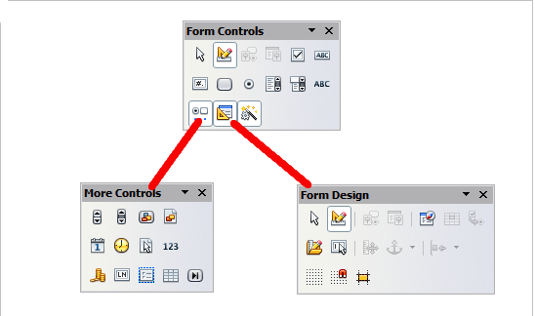
Figure 412: The Form Control, More Controls and Form Design Toolbars

Activate Design Mode
Click the Design Mode On/Off button on the Form Controls toolbar to turn design mode on. (Click it again when you want to turn it off.) This activates the buttons for inserting form controls and selects controls for editing.
When design mode is off, the form behaves as it would for the end user. Buttons can be pressed, check boxes selected, list items selected, and so on.

Insert Form Controls
- To insert a form control into the document, click the control’s icon to select it. The mouse pointer changes to look like this:
- Click in the document where you want the control to appear. (You can move it later.)
- Holding the left mouse button down, drag the control to size it. Some controls have a fixed size symbol followed by the name of the control (for example, Check Box or Option Button).
- The control button remains active, so you can insert several controls of the same type without needing to go back to the toolbar.
- To change to another tool, click its icon on the toolbar.
- To stop inserting controls, click on the Select button on the Form Controls toolbar, or click on any of the controls you have just inserted. The mouse pointer changes back to its normal appearance.
Tip | Holding down Shift when creating a form control makes the control square. If you press Shift when resizing an existing control, its proportions are kept the same.

Note | When you insert a group box, list box, or combo box, a wizard is launched to guide you through the setup. If you prefer not to run the wizard, click the Wizards On/Off button on the Form Controls toolbar.

Configure Controls
After inserting the controls, you need to configure them to look and behave as you want. Right-click on a form control within your document and select Control from the pop-up (context) menu to open the Properties dialog box for the selected control. Double-clicking on a form control also opens this dialog box.
The Properties dialog box has three tabs: General, Data, and Events. For simple forms, only the General tab is of real use. With this tab you can set the look and feel of the control. See “Error: Reference source not found” on page Error: Reference source not found and “Error: Reference source not found” on page Error: Reference source not found for more information, and the descriptions in the Help for details. Configuration for use with a database is discussed in “Error: Reference source not found” on page Error: Reference source not found.
The fields on this dialog box vary with the type of control. For example:
- Some controls have visible labels, such as Push Button and Option Button. The label text can be set.
- The Combo Box contains a list of options to choose from. Set these in the List entries box, which is not visible in the figure.
Notice the scroll bar in this dialog box. You can use the scroll bar or enlarge the dialog box to see additional fields.
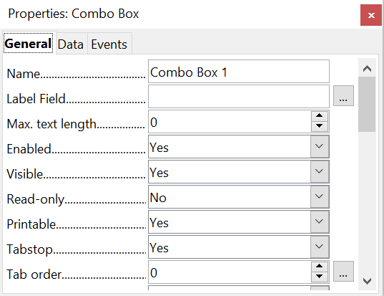

Figure 413: Example of the Properties dialog box for a form control

Use the Form
To use the form, leave design mode by clicking the Design Mode On/Off button to deactivate it. Save the form document.

Form Controls Reference
Form Control Toolbar
Select | Selects a form control to perform some other action on it.
Design mode on/off | Toggles between design mode on (to edit forms) and design mode off (to use forms).
Control | Launches the form control properties dialog box. This dialog box can be kept open as different controls are selected.
Form | Launches form properties dialog box, controlling properties for the form as a whole, such as which data source it connects to.
Check Box | A box that can be selected or deselected on the form. You can label the box.
Text Box | A control to create a box into which the form user can type any text.
Formatted Field | A control allowing numeric formatting options. For example, you can set maximum and minimum values for the number entered, or the number type (decimal places, scientific, currency).
Push Button | Creates a button that can be linked to a macro. The label is the name that appears on the button.
Option Button | Creates an option button (also known as a radio button). When multiple buttons are grouped together, only one can be selected at a time. The easiest way to group multiple buttons is to use the Group Box button on the More Controls toolbar, with wizards enabled.
List Box | Creates a list of options as a pull-down menu that the user can choose from. If wizards are on, creating a list box launches the List Box Wizard. This wizard is only useful if your form is linked to a data source.  If the form is not linked to a data source, turn wizards off and create an empty list box. Then click the control button and, in the List Entries option on the General tab, enter the options you want to appear on the list.
Combo Box | As with a List Box, you set up a list of choices. In addition, a panel at the top either displays the choice made or allows the form user to type in something else. This works the same as the List Box in a simple form, but they are different if the form is connected to a data source.
Label Field | A text label. The difference between this and just typing on the page is that, as a control, you can link a label field to macros so, for example, something happens when the mouse passes over it or clicks on it.
More Controls | Launches the More Controls toolbar.
Form Design | Launches the Form Design toolbar, which can also be opened with View > Toolbars > Form Design.
Wizards On/Off | Some form controls (List Box and Combo Box) have optional wizards. If you do not want the wizard to launch when you create one of these controls, use the Wizards On/Off button to switch wizards off.
More Controls Toolbar
Spin Button | Allows form users to choose a number by cycling through the list of numbers. You can specify maximum, minimum, default, and the step between numbers.  This control is not commonly used in Writer, as the number is not displayed. In Calc, however, a Data tab appears on the Control Properties dialog box, so you can link the spin button to a cell.
Scroll bar | Creates a scroll bar, with a number of options to define the exact appearance.  This control is not commonly used in Writer. In Calc, a Data tab appears on the Control Properties dialog box, allowing you to link the scroll bar to a cell.
Image Button | Behaves exactly like a push button, but displays as an image. Choose the image in the Graphics option on the General tab in the Control Properties dialog box.
Image Control | Only useful when the form is connected to a data source and a field in the data source exists that can hold images. You can add new images to the database or retrieve and display images from it.
Date Field | Stores a date. You need to configure the earliest and latest dates the field will accept, the default date, and the date format. You can add a spinner.
Time Field | Works like a date field but specifies a time.
File Selection | Allows a user to select a file, either by typing the path and name directly or by clicking on a Browse button and choosing the file from a dialog box.
Numeric Field | Displays a number. You need to specify formatting, maximum, minimum, and default values. You can add a spinner.
Currency Field | Works like a numeric field; additionally you can add a currency symbol.
Pattern Field | Pattern fields are useful when the form links into a data source. Specify an Edit Mask to restrict what a user can enter into the field. Specify a Literal Mask to restrict which data is displayed from the data source.
Group Box | The group box control has two different uses depending on whether wizards are on or off.  If wizards are on, creating a group box launches the Group Element wizard. This creates a group of options buttons (in which only one may be selected at a time). In most cases, using a group box is the best way to create a set of option buttons.  If wizards are off, a group box is simply a visual box to group together different controls. It has no effect on the way the controls operate.
Table Control | Table Control is only useful with a data source. If no data source is specified, you will be prompted to choose one in the Table Element Wizard. You then pick the fields to display and, when design mode is off, the data appears in the table. The table also includes controls to step through the records.  Records can be added, deleted, and modified in the table.
Navigation Bar | A navigation bar is the same as the Form Navigation toolbar (View > Toolbars > Form Navigation), but can be placed anywhere in the document and be resized.
Form Design Toolbar
Select | Selects a form control to perform an action on it.
Design mode on/off | Toggles between design mode on (to edit forms) and design mode off (to use forms).
Control | Launches the form control properties dialog box. This dialog box can be kept open as different controls are selected.
Form | Launches the form properties dialog box, controlling properties for the form as a whole, such as which data source it connects to.
Form Navigator | The Form Navigator is a utility displaying all the forms and controls in the current document. It allows you to edit and delete them easily.  If you use the Form Navigator, it's recommended that you give your controls names (in the properties dialog box). The name appears in the navigator so, for example, if you have ten text boxes, you can tell which is which.
Add Field | Add Field is only useful if you have specified a data source for the form. If no data source is specified, an empty box opens.  If you have specified a data source, Add Field opens a list of all the fields in the specified table, which you can then drag and drop onto the page. The fields are placed on the page with the name of the field before them.  This is a quick and easy way to create a form from a data source.
Activation Order | Allows you to specify the order in which focus shifts between controls. You can test the order by leaving design mode and using Tab to switch between the controls.
Open in Design Mode | Opens the current form in design mode (to edit the form rather than entering data into it).
Automatic Control Focus | If activated, focus is set to the first form control.
Position and Size | Launches the Position and Size dialog box, allowing you to specify both by typing in precise values, rather than dragging the control. You can also lock the size or position, so they do not get changed accidentally. For some controls, you can rotate and set the slant and corner radius.
Change Anchor | Just as with a frame, any form control can be anchored to page, paragraph, or character and also anchored as a character (meaning that it behaves like any other character on the page).
Alignment | The Alignment button is disabled unless the control is anchored as a character. You can align a control in different ways, for example so the top of the control lines up with the top of the text or the bottom lines up with the bottom of the text.
Display Grid | Displays a grid of dots on the page, to help you line up controls.
Snap to Grid | When a control is brought close to a grid point or line, it will snap to the grid. This makes it is easier to line up controls.
Guides when Moving | When a control is being moved, lines extend from the control horizontally and vertically to help you position it accurately.

Example: a Simple Form

Create the Document
Open a new document (File > New > Text Document). It is a good idea to write down the outline of the document, without form controls, though of course it can easily be changed later.
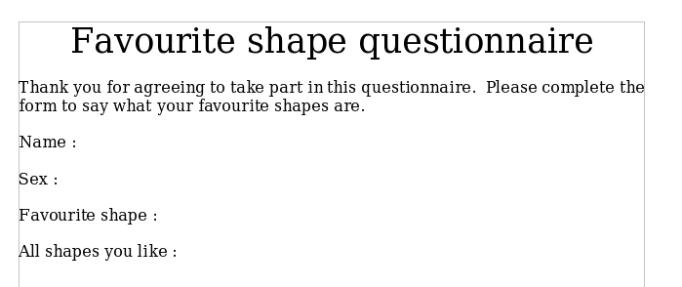Figure 414: Initial document without form controls

Add Form Controls
The next step is to add the form controls to the document. We will have four controls:
- Name is a text box.
- Sex is two option buttons, male or female.
- Favorite shape is a list of options.
- All shapes you like is a series of check boxes.
To add these controls:
- Select View > Toolbars > Form Controls to open the Form Control toolbar.
- If the buttons are not active, click the Design Mode On/Off button to activate them.
- Click the Text Box button , then click in the document and, with the left mouse button held down, drag the shape of the Name text box to approximately the size you want.
- Make sure the Wizards On/Off button is on (shaded with a border). Click the More Controls button to launch the More Controls toolbar.
- On the More Controls toolbar, click the Group Box button . Draw a group box by the Sex: entry. The Group Element Wizard opens.
  - On the first page of the wizard, enter two names for the options fields: Male and Female. Click the >> button after each entry. Click Next >>.
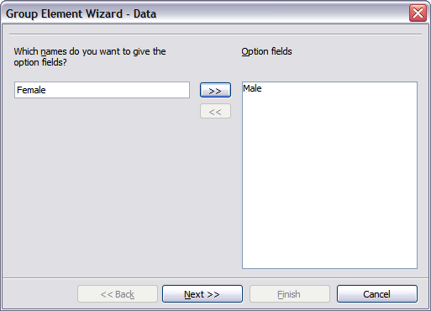Figure 415: Specifying names for option fields
  - On the next page, select the option No, one particular field is not going to be selected. Click Next>>.
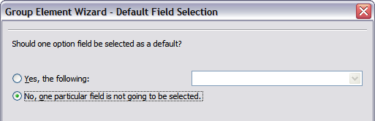Figure 416: Selecting a default field
  - Give a value to your fields. Typically, you would give one field the value 1 and the other field the value 2. If there are more than 2 option fields, you would give them values of 3, 4, and so on. Click Next >>.
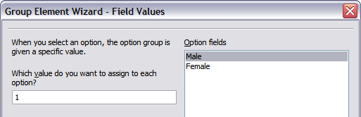Figure 417: Assigning field values
- You can either delete the caption or give a caption to your Group Box. Then click Finish.
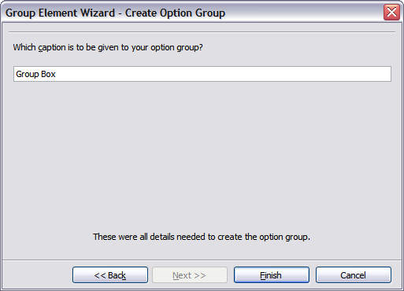Figure 418: Create Caption Option
- Now create the list box. On the Form Controls toolbar, click the Wizards On/Off button to turn wizards off. Click the List Box button and draw a list box by Favorite Shape in the document. This will just be an empty pane for now.
- Finally, create four check boxes by All shapes you like. Click on the Checkbox button and then draw out four check boxes, side by side across the page.
You should now have a document looking something like Figure 419.
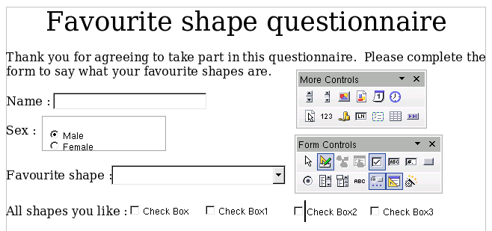Figure 419: Document with form controls

Configure Form Controls
No further configuration is required to the Name and Sex fields, but you can, if you wish, give a name to each control and change the appearance of the controls.
The list box must be configured to add the list of options. The checkboxes must be configured to add in the names (instead of Check Box, Check Box1, and so forth). Here are instructions to configure these controls:
- Be sure design mode is on. Double-click on the List Box control within the document to open the control’s Properties dialog box. Select the General tab.
- In the List Entries box (scroll down if it is not visible), type the names of the shapes (Circle, Triangle, Square, Pentagon) following each entry by Shift + Enter. Press Enter when you finish the list. You should end up with a line saying“Circle”; “Triangle” ; “Square”; “Pentagon”:
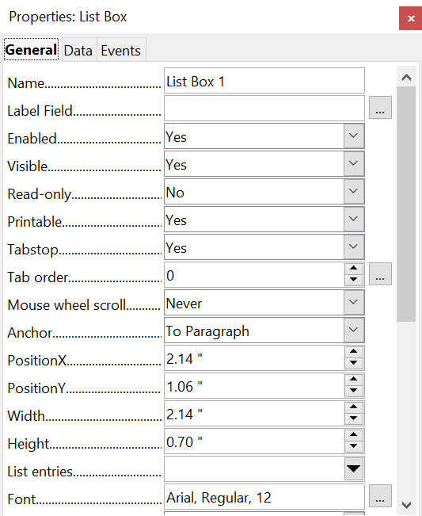

Figure 420: Properties dialog box for a list box
- Click on the first Checkbox. The Properties dialog box stays open but changes to show the properties for the checkbox.
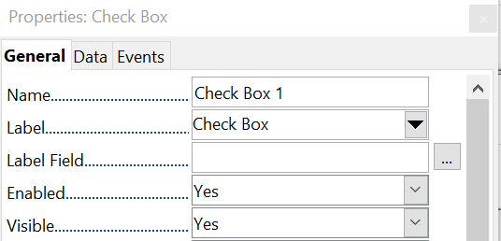

Figure 421: Top part of Properties dialog box for a check box
- Change the Label field from Check Box to Circle and press Enter. The cursor moves to Label Field and the label on the checkbox in the document changes immediately.
- Click on each of the other three check boxes in turn. Change the Label in the Properties dialog box to Triangle, Square, and Pentagon in turn.
- Close the Properties dialog box.
- Turn design mode off and close the two Controls toolbars.
You have now completed the form, which should look something like Figure 418.
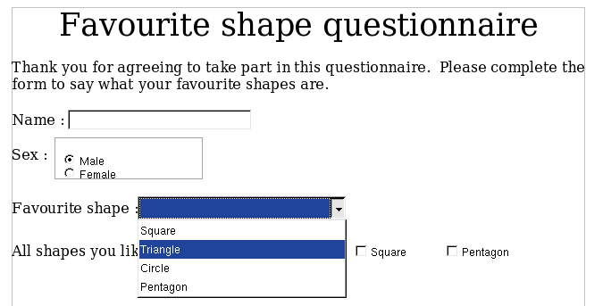Figure 422: Completed form

Finishing Touches
The form is complete, but you are free to make further changes to the document. If you're sending this out to other people to complete, you'd probably want to make the document read-only, thereby ensuring that users would be able to fill in the form, but not able to make any changes to it.
To make the document read-only, select File > Properties > Security > Open file read-only.
Note | If the document is read-only, anyone filling-in the form will need to use File > Save As to save the document.

Accessing Data Sources
The most common use for a form is as the source of input for a database. You can provide a form that allows users to enter information into a contacts database and, because it is part of a Writer document, the form can contain graphics, formatting, tables, and other elements. So, modifying the form is as simple as editing a document.
OpenOffice can access numerous data sources. These include relational databases like MySQL and Oracle, spreadsheets and text files. As a general rule, databases can be accessed for read and write; other data sources, such as spreadsheets, are often read-only.
Tip | To see the list of supported data source types for your operating system, choose File > New > Database. On the first page of the Database Wizard (Figure 416), select Connect to an existing database and then open the drop-down list. An example is shown in Figure 417.

Creating a Database
Chapter 8 (Getting Started with Base) in the Getting Started guide covers in more detail how to create a database, including installing the required Java Runtime Environment (JRE). Here we give a short guide to creating a very simple database with AOO Base.
- Select File > New > Database to start the Database Wizard (Figure 416).
- Select Create a new database and click Next.
- On the next page, select Yes, register the database for me and Open the database for editing. Registering the database just means that it can be accessed from other AOO components such as Writer and Calc. You need to do this if you want to link your forms into it.
- Click Finish and save your new database, giving it a name. Unlike creating other documents in AOO, databases must be saved when you first create them.
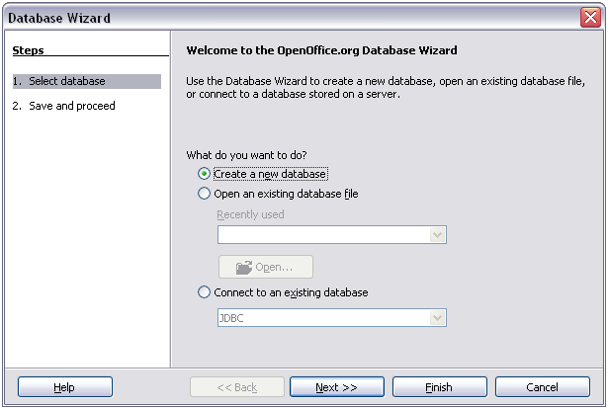Figure 423: Database Wizard
After saving the database, you should see the main Base window (Figure 415), which contains three panels. The left-hand panel is Database, with icons for Tables, Queries, Forms, and Reports.
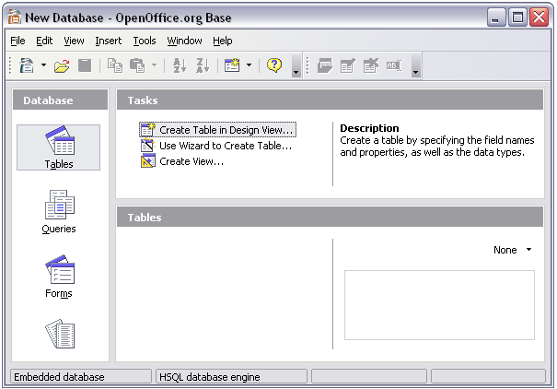Figure 424: Main Base window
The next step is to create a table. Again, this is covered in more detail in Chapter 8 (Getting Started with Base) in the Getting Started guide. Here we are going to create a small table as an example.
- Choose Tables in the left-hand column, then choose Create Table in Design View under Tasks.
- Use the Table Design window to tell Base which fields to create. We will have just three fields: Name, Address, and Telephone.
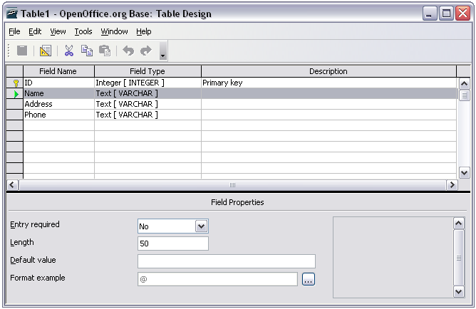Figure 425: Database table design
- On the first line, enter under Field Name ID and set the Field Type to Integer [INTEGER]. In the gray box at the left of the line, right-click and select Primary Key, bringing up a key icon in the box. In the Field Properties at the bottom of the window is an Auto Value option; change this to Yes.
Tip | Setting up the Primary Key field with Auto Value set to Yes is an important step. If this is not done, your form may be much trickier to use, and may even generate errors for the user. Be careful with this step!

- On three lines, enter under Field Name Name, Address, and Telephone. Accept the default Field Type of Text [VARCHAR] and leave Description blank.
- Save the table (File > Save). You will be prompted to name it. The name can be anything you like.
- Finally, save the whole database from the main Base window (File > Save).

Accessing an Existing Data Source
If you have an existing data source, such as a spreadsheet or database, you simply need to tell OpenOffice about it. This is called registering a data source.
To register an existing data source:
- Select File > New > Database to launch the Database Wizard.
- Select Connect to an existing database and choose the type from the drop-down list.
- Click Next and follow the instructions to select the database to register (the exact process varies between different types of data source).
- In Step 3: Save and proceed, check that Yes, register the database for me is selected. Deselect Open the database for editing – you just need to register it, not edit it through Base.
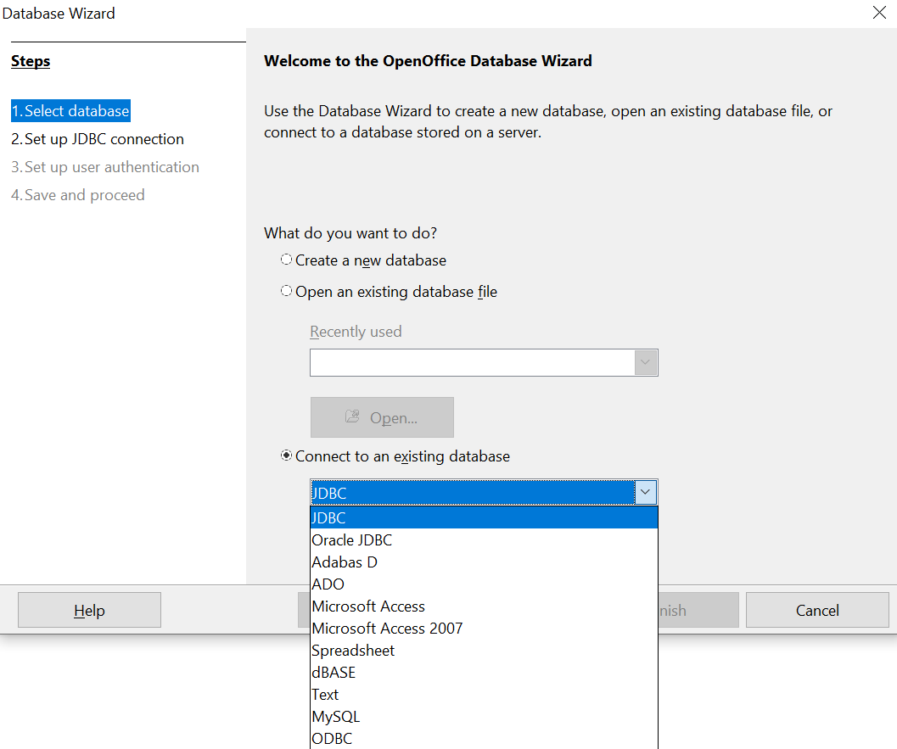

Figure 426: Using the Database Wizard to connect to an existing database

Creating a Form for Data Entry
Whether you created a new database, or already had a data source, it must be registered with OpenOffice (see above). Once registered, linking your form to it is simple. Follow these steps to create a new form and link it to a registered data source.
- Create a new document in Writer (File > New > Text Document).
- Design your form, without putting in the actual fields (you can always change it later).
- Show the Form Controls toolbar (View > Toolbars > Form Controls).
- Click the Design Mode On/Off button to put the document into design mode, if necessary. With design mode off, most of the toolbar buttons are grayed out. If the Design Mode button is also grayed out, click on the Select button to activate it.
- Click the Text Box button . Click in the document and, holding down the left mouse button, drag the mouse to create a text box for the first form field (for example, Name, if you are linking to the database created above).
- Click the Text Box button again and drag the mouse to draw another field. Additional fields, of any type, can be added in the same way (click and drag).
So far, you've followed the same steps you used when you created your first form. Now you can link your form with the data source you registered.
- Click the Form button in the Form Controls toolbar, or right-click on any of the fields you inserted and select Form, to open the Form Properties dialog box.
- In the Form Properties dialog box, click on the Data tab.
  - Set Data Source to be the data source you registered.
  - Set Content Type to be Table.
  - Set Content to be the name of the table you want to access.
  - Close the dialog box.
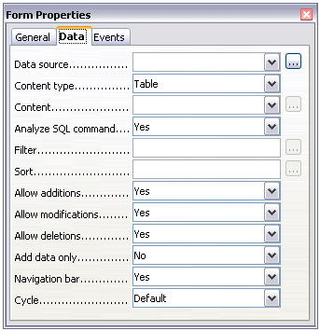Figure 427: Form properties, connecting to a data source
- For each form control in turn, launch the Properties dialog box. Click on the control to select it (so small green boxes appear around it). Then either right-click and select Control or click on the Control button on the Form Controls toolbar.
- In the Properties dialog box, click on the Data tab (Figure 414). If you set up the form correctly, the Data Field option will contain a list of the different fields in the data source (for example, Name, Address, and Telephone). Select the field you want.
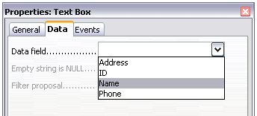Figure 428: Form control properties, Data tab
- Repeat for each control in turn until all have been assigned to a field.
Tip | If you created a database in AOO Base and your Primary Key field had Auto Value set to Yes, that field does not need to be part of the form. If Auto Value was set to No, you will have to include it and have your users enter a unique value into that field whenever they make a new entry.

Entering Data into a Form
Once you have created a form and tied it to a database, you want to use it to enter data into your data source, or modify data already there.
- Make sure that the form is not in design mode. In the Form Controls toolbar, click on the Design Mode On/Off button . If design mode is off, most of the buttons on the toolbar will be grayed out.
- Make sure that the Form Navigation toolbar is on (View > Toolbars > Form Navigation). This toolbar normally appears at the bottom of the window.
Figure 429: Form Navigation toolbar
- If there is existing data in the data source, use the control buttons on the Form Navigation toolbar to look at different records. You can amend data in a record by editing the values in the form. To submit the changes, press the Enter key with the cursor in the last field. The record is saved, and the next record is displayed.
- If there is no data in the form, you can start entering information by typing into the fields of the form. To submit the new record, press the Enter key with the cursor in the last field.
- Other functions can be performed from the Form Navigation toolbar, including deleting a record and adding a new record.

Advanced Form Customization

Linking a Macro to a Form Control
You can set any form control (for example, text box or button) to perform an action when triggered by some event. To see the full list of events, right-click on the form control when the design mode is on, select Control and click on the Events tab.
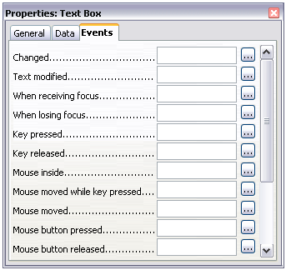
Figure 430: Control properties, Events tab
To assign a macro to an event:
- Create the macro.
- Be sure the form is in design mode. Right-click on the form control, select Control and click on the Events tab.
- Click the browse button to bring up the Assign action dialog box (Figure 413).
- Click the Macro button and select the macro from the list in the Macro Selector dialog box. You return to the Assign action dialog box. Repeat as needed, then click OK to close the dialog box.
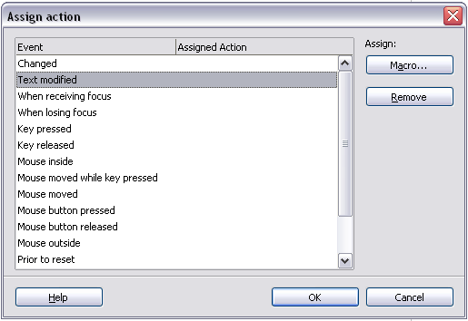
Figure 431: Assign action dialog box
Macros can also be assigned to events relating to the form as a whole. To assign these, right-click on a form control in the document, select Form and click on the Events tab.

Read-Only Documents
Having created your form, you want whoever is using it to be able to access the information stored in the database, or complete the form, without changing the layout. To do this, make the document read-only by selecting File > Properties > Security > Open file read-only.

Fine-Tuning Database Access Permissions
By default, when a database is accessed from a form, any changes can be made to it: records can be added, deleted, and amended. You may not want that behavior. For example, you may want users to be able only to add new records or to be prohibited from deleting existing records.
In design mode, right-click on a form control and select Form from the pop-up menu. On the Data tab of the Form Properties dialog box are a number of options: Allow additions, Allow deletions, Allow modifications and Add data only. Set each of these to Yes or No to control the access users have to the data source.
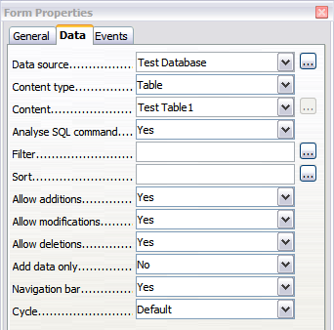Figure 432: Data Properties of a Form
Individual fields can also be protected. This might be useful if you wanted a user to be able to modify some parts of a record but only view others, such as a stock list where item descriptions are fixed and quantities can be modified.
To make an individual field read-only, in design mode, right-click on the form control within the document and select Control from the pop-up menu. Select the General tab and set Read-only to Yes.

Form Control Formatting Options
You can customize the way form controls look and behave in a number of ways. These are all accessed in design mode. Right-click on the form control, select Control from the pop-up menu and select the General tab in the Properties dialog box.
- Set a label for the control in the Label box (not to be confused with the box called Label Field). Some form controls, such as push buttons and option buttons, have visible labels that can be set. Others, such as text boxes, do not.
- Set whether the form control will print out if the document is printed with the Print option.
- Use the Font setting to set the font, typeface, and size for a field’s label or for text typed into a field. This setting does not affect the size of check boxes or option buttons.
- For a text box, you can set the maximum text length. This is very useful when adding records into a database. Every database text field has a maximum length and, if the data entered is too long, AOO displays an error message. By setting the maximum text length of the form control to be the same as that of the database field, this error can be avoided.
- You can set the default option for a form control. By default, a control is blank, or has every option unselected. You can set the control to start with a particular option or list item selected.
- For controls where a password is being entered, setting the Password character (for example, to *) displays only that character, but saves what the user really types.
- You can add additional information and help text for a form control.
- Other formatting controls such as background color, 3-D look, text formatting, scroll bars, and borders allow you to further define how the control appears.

XForms
XForms are a type of web form, developed by the World Wide Web Consortium (W3C). OpenOffice supports the XForms 1.0 open standard for creating web forms with XML.
In OpenOffice, an XForms document is a special type of Writer document. XForms use the same controls as the ordinary forms described in this chapter.
After you create and save an XForms document, you can open the document, fill out the form, and submit the changes to a server.
A detailed discussion of XForms is beyond the scope of this chapter, as it is related more to databases than word processing. A good tutorial introduction is J. David Eisenberg’s XForms and OpenDocument in OpenOffice.org, available from http://opendocument.xml.org/files/xforms_ooo_06_10_25.pdf. Another good resource is Valden Longhurst’s Using XForms and the OpenDocument format in OpenOffice.org and StarOffice, https://wiki.openoffice.org/wiki/Documentation/Using_XForms.

Chapter 16
Customizing Writer

Introduction
This chapter describes common customization's to AOO Writer that you may wish to do.
You can customize menus, toolbars, and keyboard shortcuts, add new menus and toolbars, and assign macros to events. However, you cannot customize context (right-click) menus.
Other customizations can be easily done with extensions installed from the OpenOffice.org website or from other providers.
Note | Customizations to menus and toolbars can be saved in a template. To do so, first save them in a document and then save the document as a template as described in Chapter 10 (Working with Templates).

Customizing Menu Content
In addition to changing the menu font (described in Chapter 2), you can add and rearrange items on the menu bar, add items to menus, and make other changes.
To customize menus:
- Choose Tools > Customize.
- On the Customize dialog box, go to the Menus tab (Figure 433).
- In the Save In drop-down list, choose whether to save this changed menu for the entire Writer application, or for a selected document.
- In the section OpenOffice Writer > Menus, select from the Menu drop-down list the menu that you want to customize. The list includes all the main menus as well as sub-menus, that is menus that are contained under another menu. For example, in addition to File, Edit, View, and so on, there is File | Send and File |Templates. The commands available for the selected menu are shown in the central part of the dialog box.
- To customize the selected menu, click on the Menu or Modify buttons. You can also add commands to a menu by clicking on the Add button. These actions are
- described in the following sections. Use the up and down arrows next to the Entries list to move the selected menu item to a different position.
- When you have finished making all your changes, click OK to save them.
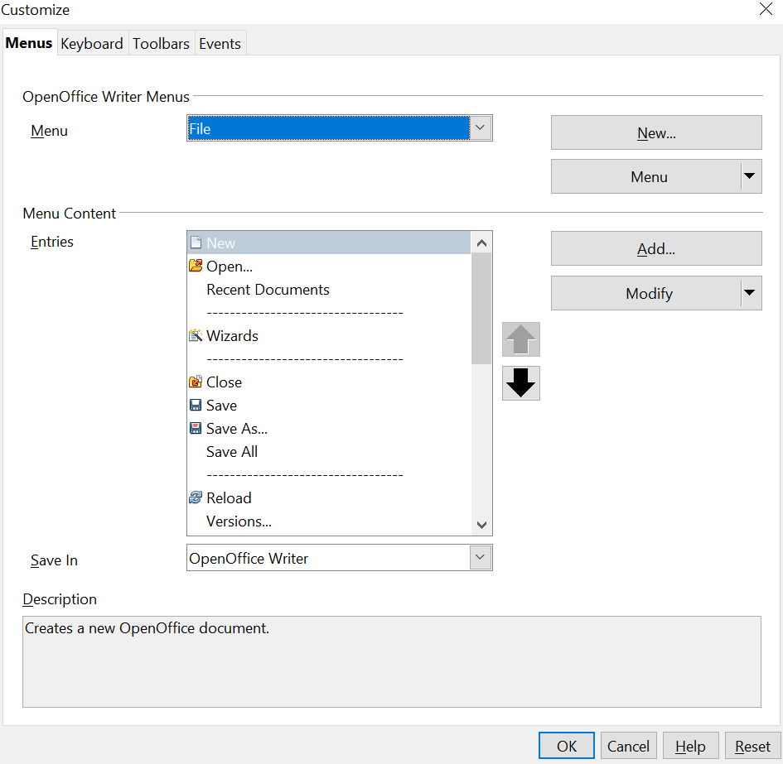

Figure 433. The Menus tab of the Customize dialog box

Creating a New Menu
In the Customize dialog box, click New to display the New Menu dialog box, shown in Figure 434.
- Type a name for your new menu in the Menu name box.
- Use the up and down arrow buttons to move the new menu into the required position on the menu bar.
- Click OK to save.
The new menu now appears on the list of menus in the Customize dialog box. (It will appear on the menu bar itself after you save your customizations.)
After creating a new menu, you need to add some commands to it, as described in “Adding a Command to a Menu” on page 449.
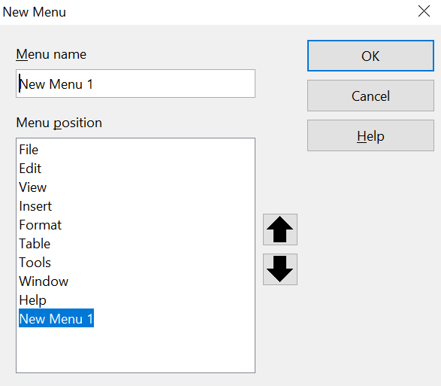
Figure 434: Adding a new menu

Modifying Existing Menus
To modify an existing menu, select it in the Menu list and click the Menu button to drop down a list of modifications: Move, Rename, Delete. Not all of these modifications can be applied to all the entries in the Menu list. For example, Rename and Delete are not available for the supplied menus.
To move a menu (such as File), choose Menu > Move. A dialog box similar to the one shown in Figure 434 (but without the Menu name box) opens. Use the up and down arrow buttons to move the menu into the required position.
To move submenus (such as File | Send), select the main menu (File) in the Menu list and then, in the Menu Content section of the dialog box, select the submenu (Send) in the Entries list and use the arrow keys to move it up or down in the sequence. Submenus are easily identified in the Entries list by a small black triangle on the right-hand side of the name.
In addition to renaming, you can specify a keyboard shortcut that allows you to select a menu command when you press Alt+ an underlined letter in a menu command.
- Select a menu or menu entry.
- Click the Menu button and select Rename.
- Add a tilde (~) in front of the letter that you want to use as an accelerator. For example, to select the Save All command by pressing Alt+V, enter Sa~ve All.

Adding a Command to a Menu
You can add commands to the supplied menus and to menus you have created. On the Customize dialog box, select the menu in the Menu list and click the Add button in the Menu Content section of the dialog box.
On the Add Commands dialog box, select a category and then the command, and click Add. The dialog box remains open, so you can select several commands. When you have finished adding commands, click Close. Back on the Customize dialog box, you can use the up and down arrow buttons to arrange the commands in your preferred sequence.
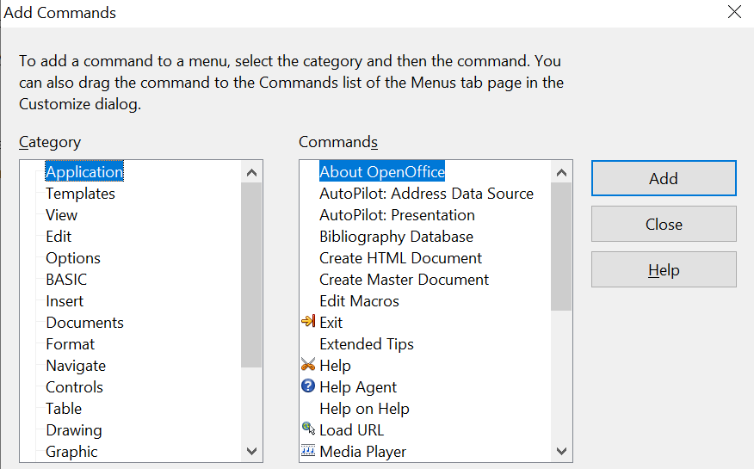

Figure 435: Adding a command to a menu

Modifying Menu Entries
In addition to changing the sequence of entries on a menu or submenu, you can add submenus, rename or delete the entries, and add group separators.
To begin, select the menu or submenu in the Menu list near the top of the Customize page, then select the entry in the Entries list under Menu Content. Click the Modify button and choose the required action from the drop-down list of actions.
Most of the actions should be self-explanatory. Begin a group adds a separator line after the highlighted entry.

Customizing Toolbars
You can customize toolbars in several ways, including choosing which icons are visible and locking the position of a docked toolbar, as described in Chapter 1 (Introducing Writer), and adding or deleting icons (commands) in the list of those available on a toolbar. You can also create new toolbars. This section describes how to create new toolbars and add or delete icons on existing ones.
To get to the toolbar customization dialog box, do any of the following:
- On the toolbar, click the arrow at the end of the toolbar and choose Customize Toolbar.
- Choose View > Toolbars > Customize from the menu bar.
- Choose Tools > Customize from the menu bar and go to the Toolbars tab.
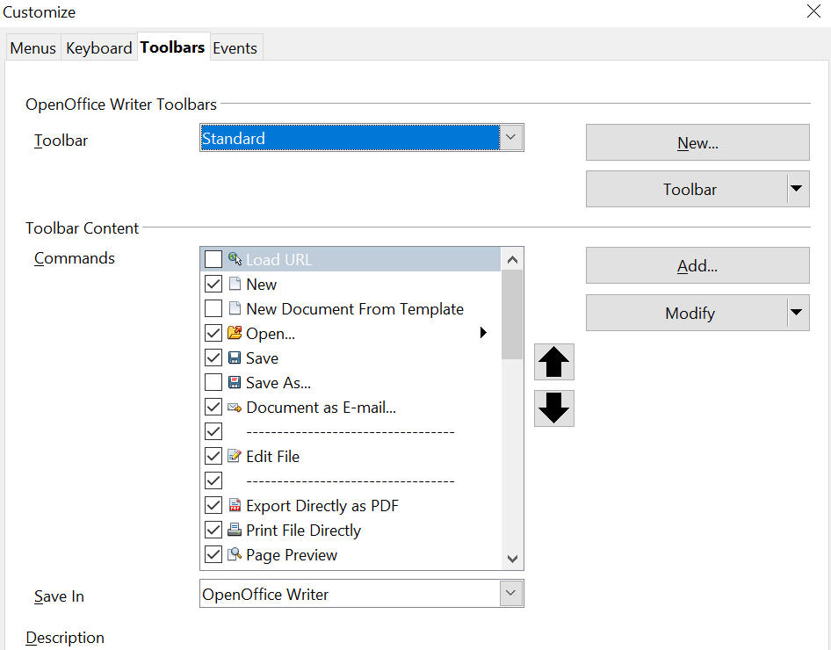
Figure 436. The Toolbars tab of the Customize dialog box

Modifying Existing Toolbars
To modify an existing toolbar:
- In the Save In drop-down list, choose whether to save this changed toolbar for the application (Writer) or for a selected document.
- In the section OpenOffice Writer > Toolbars, select from the Toolbar drop-down list the toolbar that you want to modify.
- Click on the Toolbar or Modify buttons, and add commands to a toolbar by clicking on the Add button. You can also create a new toolbar by clicking on the New button. These actions are described in the following sections.
- When you have finished making all your changes, click OK to save them.

Adding a Command to a Toolbar
If the list of available buttons for a toolbar does not include all the commands you'd like on that toolbar, you can add commands. And of course, when you create a new toolbar, you need to add commands to it.
- On the Toolbars tab of the Customize dialog box, select the toolbar in the Toolbar list and click the Add button in the Toolbar Content section of the dialog box.
- The Add Commands dialog box (Figure 435) is the same as for adding commands to menus. Select a category and then the command, and click Add. The dialog box remains open, so you can select several commands. When you have finished adding commands, click Close. If you insert an item which does not have an associated icon, the toolbar will display the full name of the item: the next section describes how to choose an icon for a toolbar command.
- Back on the Customize dialog box, you can use the up and down arrow buttons to arrange the commands in your preferred sequence.
- When you are done making changes, click OK to save.

Choosing Icons for Toolbar Commands
Toolbar buttons usually have icons, not words, on them, but not all the commands have associated icons.
To choose an icon for a command, select the command in the Toolbar list in the Customize dialog box, and click Modify > Change icon. On the Change Icon dialog box, you can scroll through the available icons, select one, and click OK to assign it to the command.
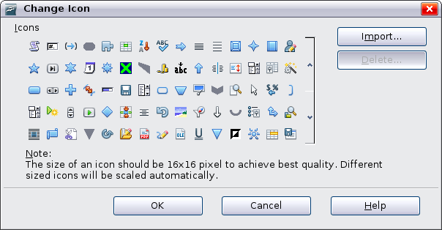Figure 437: Change Icon dialog box
To use a custom icon, create it in a graphics program and import it by clicking the Import button on the Change Icon dialog box. Custom icons must be 16 x 16 or 26 x 26 pixels in size and cannot contain more than 256 colors.

Example: Adding an Insert > Cross-reference Icon to a Toolbar
You can customize OpenOffice so that a single click on an icon automatically opens the dialog for inserting a cross-reference.
- Click the arrow icon at the end of the Standard toolbar. In the drop-down menu, choose Customize Toolbar. The Toolbars tab of the Customize dialog box appears (Figure 436). Click Add.
On the Add Commands dialog box (Figure 438), select Insert in the Category list, then select Cross-reference in the Commands list. Click Add. Now you can see the new icon in the Commands list.
- In the Commands list, click the up or down arrow button to position the new icon where you want it. Click OK and then click Close. Your toolbar now has a new icon to add a cross-reference.
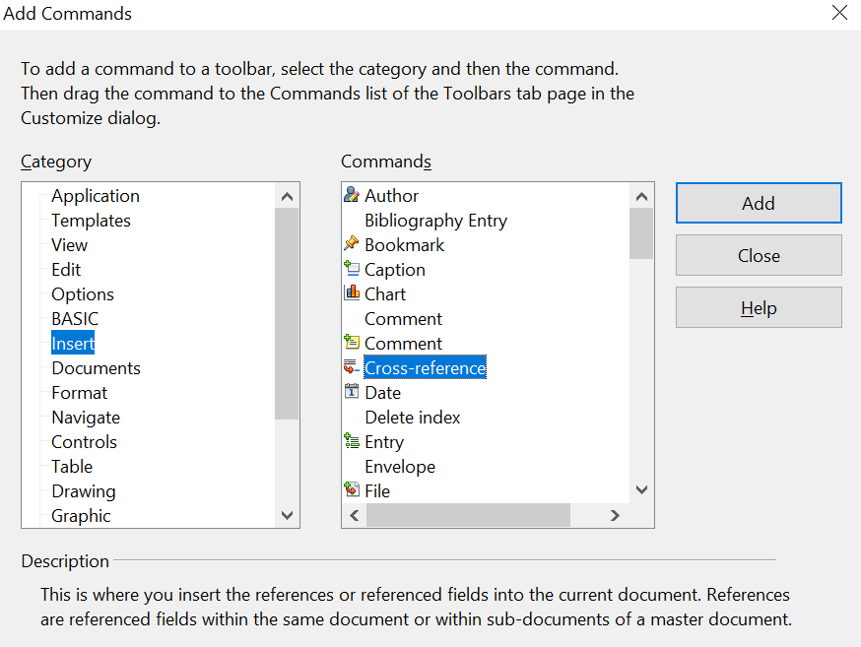

Figure 438: Adding a Cross-reference command to a toolbar

Creating a New Toolbar
To create a new toolbar:
- Choose Tools > Customize > Toolbars from the menu bar.
- Click New. On the Name dialog box, type the name for the new toolbar and choose, from the Save In drop-down list, the location where this changed menu will be stored, for the application (Writer) or for a selected document.
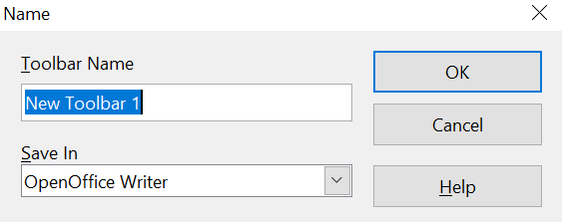
The new toolbar now appears on the list of toolbars in the Customize dialog box. After creating a new toolbar, you need to add some commands to it, as described above.

Assigning Shortcut Keys
In addition to using the built-in keyboard shortcuts (listed in Appendix A), you can define your own. You can assign shortcuts to standard functions or your own macros and save them for use with the entire OpenOffice suite.
Caution | Be very careful when reassigning your operating system’s or OpenOffice’s predefined shortcut keys. Many key assignments are universally understood shortcuts, such as F1 for Help, and are always expected to provide certain results. Although you can easily reset the shortcut key assignments to the defaults, changing some common shortcut keys can cause confusion, frustration, and possible data loss or corruption, especially if other users share your computer.
To adapt shortcut keys to your needs, use the Customize dialog box, as described below.
- Choose Tools > Customize > Keyboard. The Customize dialog box opens.
- To have the shortcut key assignment available in all components of OpenOffice, select the OpenOffice button.
- Next select the required function from the Category and Function lists.
- Now select the desired shortcut keys in the Shortcut keys list at the top of the tab and click the Modify button on the right. The selection now appears in the Keys list on the lower right.
- Click OK to accept the change. Now the chosen shortcut keys will execute the function chosen in step 3 above whenever they are pressed.
Note | All existing shortcut keys for the currently selected Function are listed in the Keys selection box. If the Keys list is empty, it indicates that the chosen key combination is free for use. If it were not, and you wanted to reassign a shortcut key combination that is already in use, you must first delete the existing key. If you do so, do it with caution.  Shortcut keys that are grayed-out in the listing on the Customize dialog box, such as F1 and F10, are not available for reassignment.

Example: Assigning Styles to Shortcut Keys
You can configure shortcut keys to quickly assign styles in your document. Some shortcuts are predefined, such as Ctrl+0 for the Text body paragraph style , Ctrl+1 for the Heading 1 style and Ctrl+2 for Heading 2. You can modify these shortcuts and create your own.
- Click Tools > Customize > Keyboard. The Keyboard tab of the Customize dialog box (Figure 439) opens.
- To have the shortcut key assignment available only for Writer, select Writer in the upper right corner of the tab; otherwise select OpenOffice to make it available to every component.
- Choose the shortcut keys you want to assign a style to. In this example, we have selected Ctrl+9.
- In the Functions section at the bottom of the dialog box, scroll down in the Category list to Styles. Click the + sign to expand the list of styles.
- Choose the category of style. (This example uses a paragraph style, but you can also choose character styles and others.) The Function list will display the names of the available styles for the selected category. The example shows some predefined styles.
- To assign Ctrl+9 to be the shortcut key combination for the List 1 style, select List 1 in the Function list, and then click Modify. Ctrl+9 now appears in the Keys list on the right, and List 1 appears next to Ctrl+9 in the Shortcut keys box at the top.
- Make any other required changes, and then click OK to save these settings and close the dialog box.
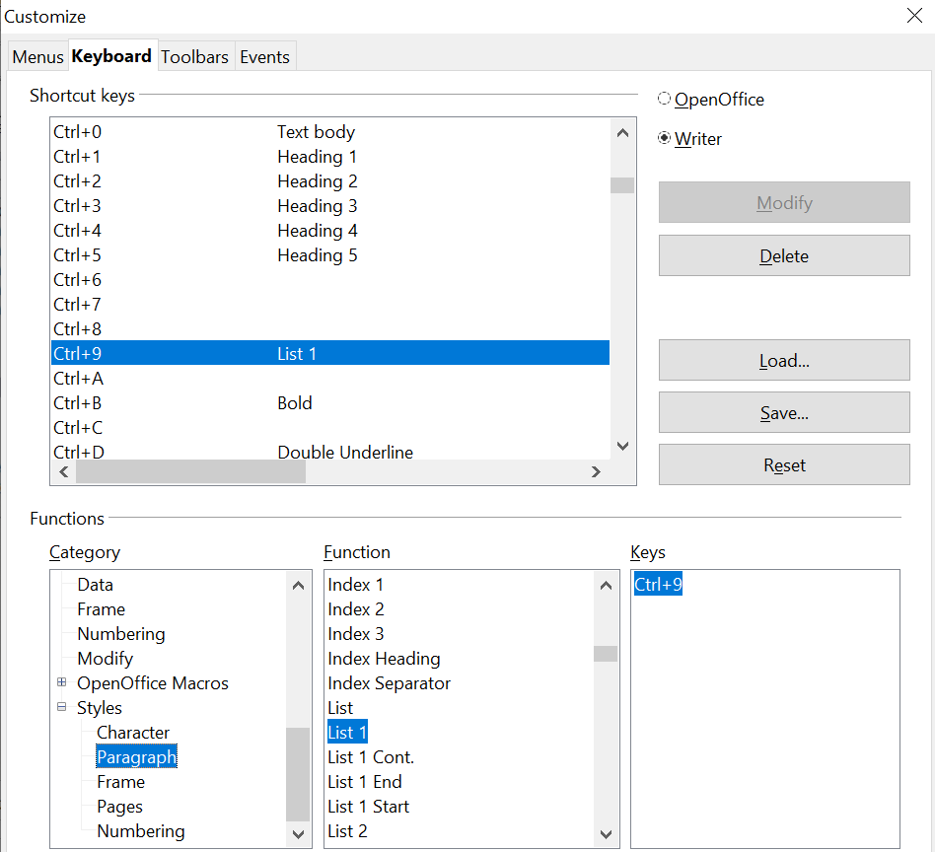
Figure 439. Defining keyboard shortcuts for applying styles

Example: Assigning Macros to Shortcut Keys
A common use for assigning macros to shortcut keys is to enable quick and easy insertion of special characters. This example shows how to set up keyboard shortcuts for inserting en dashes and em dashes. The en dash is approximately the length of the letter N, and the em dash the length of the letter M. The shorter en dash (–) is used to mark ranges and with the meaning “to” in phrases like “Dover–Calais crossing.” The longer em dash (—) is used to separate extra information or mark a break in a sentence.
First, you need to record a macro for inserting each type of dash. Then, you need to assign those macros to shortcut key combinations.
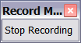
- Choose Tools > Macros > Record Macro to start recording a macro.
A small window is displayed, so you know that OpenOffice is recording.
- Choose Insert > Special Characters to open the Special Characters dialog box. Scroll down until you find the en dash (U+2013) and em dash (U+2014) characters. Select one of them and click OK.
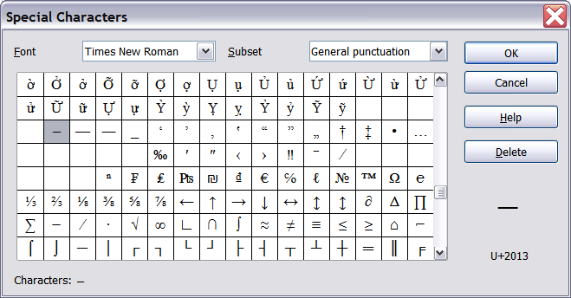Figure 440: Find and choose the en dash.
- Click the Stop Recording button to stop recording, save the macro, and display the OpenOffice Basic Macros dialog box (see Figure 441). Type a descriptive name for the new macro in the Macro name box on the upper left.
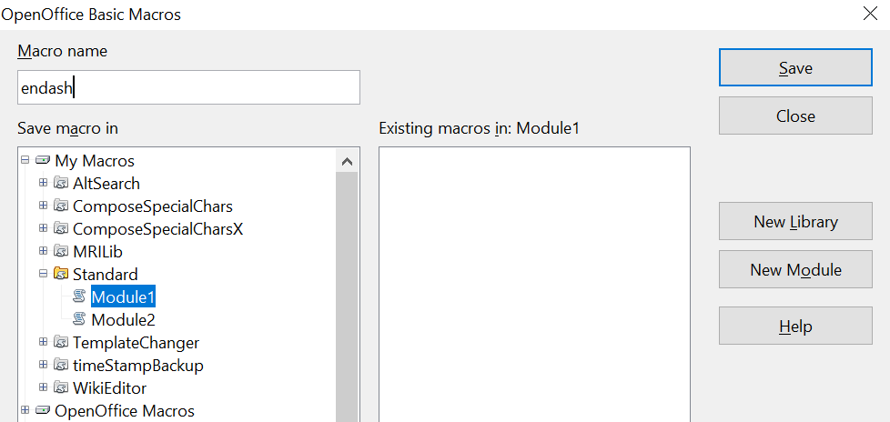
Figure 441: Naming the new macro and storing it
- Be sure to open the library container named My Macros. Find the library named Standard under My Macros. Select Module1 and click Save. The libraries listed under My Macros on your system will likely be different from those shown in the figure, but Standard will always be present.
- Repeat steps 1–4 to create other macros, for example to insert an em dash.
- Choose Tools > Customize > Keyboard tab (Figure 440). In the Shortcut keys list, pick an unused combination (for example, Ctrl+Shift+N for an en dash). In the Category list, scroll down to OpenOffice Macros, click the + sign (or small triangle, depending on your operating system), then click the + (or triangle) next to user and then next to the Standard library and select Module1. In the Function list, pick endash and click the Modify button on the upper right. The selected key combination now appears in the Keys list on the lower right, and endash appears next to Ctrl+Shift+N in the Shortcut keys list.
- Repeat for the em dash macro, then click OK.
Tip | For inserting en and em dashes, and other special characters, you may find extensions such as Compose Special Characters useful. See “Adding Functionality with Extensions” on page 458.

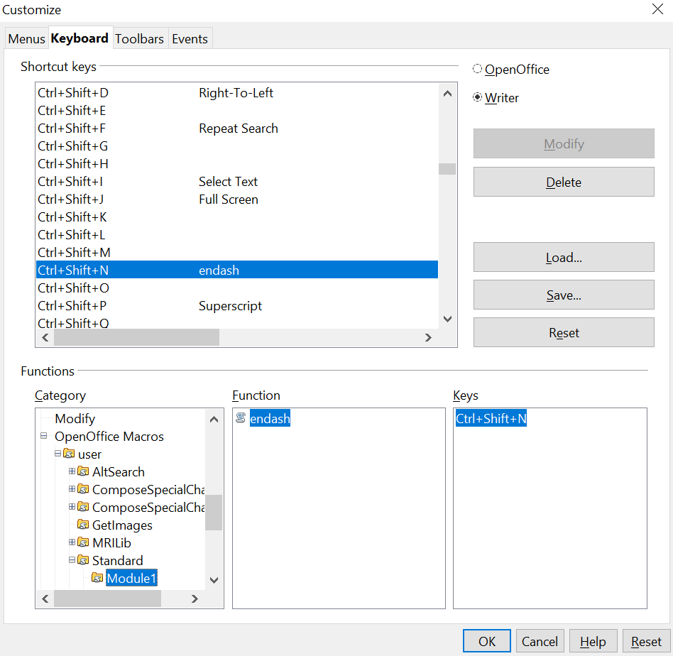

Figure 442: Defining keyboard shortcuts for running macros

Saving Changes to a File
Changes to the shortcut key assignments can be saved in a keyboard configuration file for use at a later time, thus permitting you to create and apply different configurations as the need arises. To save keyboard shortcuts to a file:
- After making your keyboard shortcut assignments, click the Save button near the bottom right of the Customize dialog box (Figure 439).
- In the Save Keyboard Configuration dialog box, select All files from the Save as Type list.
- Next enter a name for the keyboard configuration file in the File name box, or select an existing file from the list. If you need to, browse to find a file from another location.
- Click Save. A confirmation dialog box appears if you are about to overwrite an existing file, otherwise there will be no feedback and the file will be saved.

Loading a Saved Keyboard Configuration
To load a saved keyboard configuration file and replace your existing configuration, click the Load button near the bottom right of the Customize dialog box, and then select the configuration file from the Load Keyboard Configuration dialog box.

Resetting the Shortcut Keys
To reset all the keyboard shortcuts to their default values, click the Reset button near the bottom right of the Customize dialog box. Use this feature with care as no confirmation dialog box will be displayed; the defaults will be set without any further notice or user input.

Assigning Macros to Events
In OpenOffice, when something happens, we say that an event occurred. For example, a document was opened, a key was pressed, or the mouse moved. You can associate a macro with an event, so the macro is run when the event occurs. For example, a common use is to assign the “open document” event to run a macro that performs certain setup tasks for the document. To associate a macro with an event, use the Events tab of the Customize dialog box.

Adding Functionality with Extensions
An extension is a package that can be installed into OpenOffice to add new functionality.
Although individual extensions can be found in different places, the official OpenOffice extension repository is at https://extensions.openoffice.org/. Most extensions are free of charge; others are available for a fee. Check the descriptions to see what licenses and fees apply to the ones that interest you.

Installing Extensions
To install an extension, follow these steps:
- Download an extension and save it anywhere on your computer.
- In OpenOffice, select Tools > Extension Manager from the menu bar. In the Extension Manager dialog box (Figure 437), click Add.
- A file browser window opens. Find and select the extension you want to install and click Open. The extension begins installing. You may be asked to accept a license agreement.
- When the installation is complete, the extension is listed in the Extension Manager dialog box.
Tip | To get extensions that are listed in the repository, you can open the Extension Manager and click the Get more extensions online link. You do not need to download them separately as in step 1 above.

Note | To install a shared extension, you need to have write access to the OpenOffice installation directory. That is, you must have access permissions that allow you to add to or delete from the directory (folder) where OpenOffice has been installed.

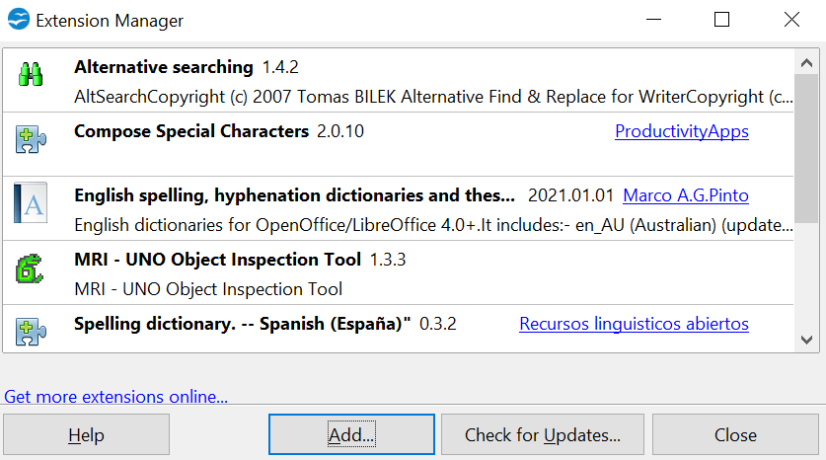

Figure 443: Using the Extension Manager

Using Extensions
This section describes a few of the more important and popular extensions to Writer. All are available from the AOO extensions repository. In each case, you need to first install the extension as described in the previous section.

Template Changer
Adds two new items to the File > Templates menu that allow you to assign a new template to the current document or to a folder of documents. All styles and formatting will be loaded from that template and the document will behave as if it was created using that template. Open source.

Compose Special Characters
Provides a facility for inserting accented and special characters using key combinations. Adds an entry (Compose Character) to the Insert menu, which opens a dialog box where you can view the list of key combinations and choose the keystroke you want to use to run the macro. Once setup is done, simply press the appropriate key combination, followed by the keystroke to run the macro. Open source.

Professional Template Pack II
Provides more than 120 templates for Writer, Calc, and Impress. Available in several languages. After you have installed this extension, you will find the templates under File > New > Templates and Documents. From Oracle. Freeware.

PDF Import for Apache OpenOffice
This extension enables you to make minor modifications to the text of existing PDF files when the original source files do not exist, or you are unable to open the source files. (Whenever possible, modify the source and regenerate the PDF to obtain the best results.)
When the extension is installed, PDF is listed as a choice in the File Type drop-down list in the File > Open dialog box.
Best results can be achieved with the PDF/ODF hybrid file format, which this extension also enables. A hybrid PDF/ODF file is a PDF file that contains an embedded ODF source file. Hybrid PDF/ODF files will be opened in OpenOffice as an ODF file without any layout changes.
Non-hybrid PDF documents open in Draw. Many PDFs can be edited and resaved with no problems. However, depending on the complexity of the layout, the fonts used, the graphics included, and other factors, changes may be difficult to make, font substitution may occur, and the saved result may not preserve the original layout.

Appendix A
Keyboard Shortcuts
Using Writer Without a Mouse

Introduction
You can use OpenOffice.org (OOo) without requiring a pointing device, such as a mouse or trackball, by using its built-in keyboard shortcuts.
OOo has a general set of keyboard shortcuts, available in all components, and a component-specific set directly related to the work of that component. This appendix lists the the default set for Writer. For general shortcuts, see Appendix A of the Getting Started guide.
For help with OOo’s keyboard shortcuts, or using OOo with a keyboard only, search the OOo Help using the “shortcut” or “accessibility” keywords.
In addition to using the built-in keyboard shortcuts listed in this Appendix, you can define your own. See Chapter 16 (Customizing Writer) for instructions.
Note | Some of the shortcuts listed here may not work if your operating system uses the same shortcuts for other tasks.  To get around this problem, assign different keys to these shortcuts by reconfiguring either OOo (see Chapter 16) or your operating system (see system documentation).

Tip for Macintosh users
Some keystrokes are different on a Mac from those used in Windows and Linux. The following table gives some common substitutions for the instructions in this book. For a more detailed list, see the application Help.
Windows/Linux | Mac equivalent | Effect
Right-click | Control+click | Open context menu
Ctrl (Control) | z (Command) | Used with other keys
F5 | Shift+z+F5 | Open the Navigator
F11 | z+T | Open Styles & Formatting window

Opening menus and menu items
Shortcut Keys | Result
Alt+<?> | Opens a menu where <?> is the underlined character of the menu you want to open. For example, Alt+T opens the menu Tools.
Alt+<?>+<*> | Opens a menu item where <?> is the underlined character of the menu you want to open and <*> is the item within that menu. For example, Alt+T+G opens the Gallery menu item in the menu Tools.
Esc | Closes an open menu.

Controlling dialogs
When you open any dialog, one element (such as a button, an option field, an entry in a list box, or a checkbox) is highlighted or indicated by a dotted box around the field or button name. This element is said to have the focus on it.
Shortcut Keys | Result
Enter | Activates selected button. In most cases where no button is selected, Enter is equivalent to clicking OK.
Esc | Closes dialog without saving any changes made while it was open. In most cases, Esc is equivalent to clicking Cancel. When an open drop-down list is selected, Esc closes the list.
Spacebar | Checks an empty checkbox. Clears a checked checkbox.
Up, down arrow keys | Moves focus up and down a list. Increases or decreases value of a variable. Moves focus vertically within a section of dialog.
Right, left arrow keys | Moves focus horizontally within a section of a dialog.
Tab | Advances focus to the next section or element of a dialog.
Shift+Tab | Returns focus to the previous section or element in a dialog.
Alt+Down Arrow | Shows items in a drop-down list.

Stopping macros
Shortcut Keys | Result
Shift+Ctrl+Q | Stops a running macro.

Function keys for Writer
Shortcut keys | Effect
F2 | Opens or closes the Formula Bar.
Ctrl+F2 | Opens the Fields dialog box.
F3 | Inserts the AutoText entry corresponding to the typed shortcut.
Ctrl+F3 | Opens the AutoText dialog box, where you can edit an AutoText entry or create a new entry from the selected text.
F4 | Opens or closes the View Data Sources window.
Shift+F4 | Selects the next frame.
F5 | Opens or closes the Navigator.
Ctrl+Shift+F5 | Opens the Navigator with cursor in page number field.
F7 | Starts the spelling and grammar checker.
Ctrl+F7 | Opens the Thesaurus.
F8 | Turns Extension Selection mode on or off.
Ctrl+F8 | Turns field shadings on or off.
Shift+F8 | Turns Multiple Selection mode on or off.
Ctrl+Shift+F8 | Turns Block Selection mode on or off.
F9 | Updates fields.
Ctrl+F9 | Shows or hides field names.
Shift+F9 | Calculates Table.
Ctrl+Shift+F9 | Opens a dialog box for editing input fields and lists.
Ctrl+F10 | Displays or hides non-printing characters.
F11 | Opens or closes the Styles and Formatting window.
Shift+F11 | Creates a new style from a selection.
Ctrl+Shift+F11 | Updates a style.
F12 | Turns paragraph numbering on or off.
Ctrl+F12 | Inserts or edits a table.
Shift+F12 | Turns bullets on or off.
Ctrl+Shift+F12 | Turns numbering/bullets off.

Shortcut keys for Writer
Shortcut Keys | Effect
Ctrl+A | Selects all content in a document, unless the cursor is in a table (see “Error: Reference source not found” on page Error: Reference source not found).
Ctrl+D | Double underlines selected text or text typed afterwards. Press again to turn off.
Ctrl+E | Centers the paragraph.
Ctrl+F | Opens the Find and Replace dialog box.
Ctrl+J | Justifies the paragraph.
Ctrl+L | Aligns the paragraph to the left.
Ctrl+R | Align the paragraph to the right.
Ctrl+M | Applies default formatting to the selection.
Ctrl+Shift+B | Subscripts selected text or text typed afterwards. Press again to turn off.
Ctrl+Shift+P | Superscripts selected text or text typed afterwards. Press again to turn off.
Ctrl+Y | Redoes last action.
Ctrl+5 | Applies 1.5 line spacing to paragraph.
Ctrl+Plus Key(+) | Calculates the selected text and copies the result to the clipboard.
Ctrl+Hyphen(-) | Inserts a conditional hyphen.
Ctrl+Shift+minus sign (-) | Inserts a non-breaking hyphen (not used for hyphenation).
Ctrl+Shift+X | Removes direct character formats from selected text.
Ctrl+/ (slash) | Inserts a no-width optional line break.
Ctrl+multiplication sign * (only on number pad) | Runs macro field.
Ctrl+Shift+Space | Inserts a non-breaking space (not used for hyphenation and not expanded if text is justified).
Shift+Enter | Inserts a line break without paragraph change.
Ctrl+Enter | Inserts a page break.
Ctrl+Shift+Enter | Inserts a column break in multi-column texts.
Alt+Enter | Inserts a new paragraph without numbering.
Alt+Enter | Inserts a new paragraph directly before or after a section or a table.
Arrow Left | Moves cursor to left.
Shift+Arrow Left | Moves cursor with selection to the left.
Ctrl+Arrow Left | Goes to beginning of word.
Ctrl+Shift+Arrow Left | Selects to the left word by word.
Arrow Right | Moves cursor to right.
Shift+Arrow Right | Moves cursor with selection to the right.
Ctrl+Arrow Right | Goes to end of word.
Ctrl+Shift+Arrow Right | Selects to the right word by word.
Arrow Up | Moves up one line.
Shift+Arrow Up | Selects lines in an upwards direction.
Arrow Down | Moves cursor down one line.
Shift+Arrow Down | Selects lines in a downward direction.
Home | Goes to beginning of line.
Shift+Home | Goes and selects to the beginning of a line.
End | Goes to end of line.
Shift+End | Goes and selects to end of line.
Ctrl+Home | Goes to start of document.
Ctrl+Shift+Home | Goes and selects text to start of document.
Ctrl+End | Goes to end of document.
Ctrl+Shift+End | Goes and selects text to end of document.
Ctrl+PageUp | Switches cursor between text and header.
Ctrl+PageDown | Switches cursor between text and footer.
Insert | Turns Insert mode on or off.
PageUp | Moves up one screen page.
Shift+PageUp | Moves up one screen page with selection.
PageDown | Moves down one screen page.
Shift+PageDown | Moves down one screen page with selection.
Ctrl+Del | Deletes text to end of word.
Ctrl+Backspace | Deletes text to beginning of word.
Ctrl+Shift+Del | Deletes text to end of sentence.
Ctrl+Shift+Backspace | Deletes text to beginning of sentence.
Ctrl+Tab | Uses next suggestion with automatic word completion.
Ctrl+Shift+Tab | Use previous suggestion with automatic word completion.
Alt+W | In the spelling checker dialog box: Calls back the original unknown word into the text box.
Ctrl+double-click or  Ctrl+Shift+F10 | Docks or un-docks the Navigator, Styles and Formatting window, or other windows.

Shortcut keys for tables in Writer
Shortcut Keys | Effect
Ctrl+A | If the active cell is empty, Ctrl+A selects the whole table; otherwise, it selects the contents of the active cell. Press Ctrl+A a second time to select the entire table.
Ctrl+Home | If the active cell is empty, Ctrl+Home moves the cursor to the beginning of the table. Press Ctrl+Home again to move the cursor to the beginning of document.  If the active cell is not empty, Ctrl+Home moves the cursor to the beginning of the active cell. A second press of Ctrl+Home moves the cursor to the beginning of the current table. A third press moves the cursor to the beginning of the document.
Ctrl+End | If the active cell is empty, Ctrl+End moves the cursor to the end of the table. Press Ctrl+End again to move the cursor to the end of document.  If the active cell is not empty, Ctrl+End moves the cursor to the end of the active cell. A second press of Ctrl+End moves the cursor to the end of the current table. A third press moves the cursor to the end of the document.
Ctrl+Tab | Inserts a tab stop (only in tables). Depending on the Window Manager in use, Alt+Tab may be used instead.
Ctrl+Shift+Arrow Up | Jumps to start of table.
Ctrl+Shift+Arrow Down | Jumps to end of table.
Alt+Arrow Keys | Increases or decreases the size of the column or row on the right or bottom cell edge.
Alt+Shift+Arrow Keys | Increases or decreases the size of the column or row on the left or top cell edge.
Ctrl+Alt+Shift+Arrow Keys | Like Alt, but modifies only the active cell.
Alt+Insert | Provides 3 seconds in Insert mode, during which time pressing an arrow key inserts a row or column, or Ctrl+Arrow Key inserts a cell.
Alt+Del | Provides 3 seconds in Delete mode, during which time pressing an arrow key deletes a row or column, or Ctrl+Arrow Key merges the active cell with the neighboring cell.
Ctrl+Shift+T | Removes cell protection from all selected tables. If no table is selected, then cell protection is removed from all of the tables in the document.
Ctrl+Shift+Del | If nothing is selected, the contents of the next cell are deleted. If cells are selected, the whole row(s) of the selection are deleted. If all rows are selected completely or partially, the entire table is deleted.

Shortcut keys for paragraphs and heading levels
Shortcut Keys | Effect
Ctrl+0 (zero) | Applies Text Body paragraph style.
Ctrl+1 | Applies Heading 1 paragraph style.
Ctrl+2 | Applies Heading 2 paragraph style.
Ctrl+3 | Applies Heading 3 paragraph style.
Ctrl+4 | Applies Heading 4 paragraph style.
Ctrl+5 | Applies Heading 5 paragraph style.
Ctrl+Alt+Up Arrow  or Ctrl+Up Arrow | Moves the active paragraph or selected paragraphs up one paragraph.
Ctrl+Alt+Down Arrow or Ctrl+Down Arrow | Moves the active paragraph or selected paragraphs down one paragraph.
Tab | When the cursor is at the beginning of the heading text, moves a heading in format Heading X (X = 1–9) down one level in the outline. Does not affect the applied paragraph style.
Shift+Tab | When the cursor is at the beginning of the heading text, moves a heading in format Heading X (X = 2–10) up one level in the outline. Does not affect the applied paragraph style.
Ctrl+Tab | At the start of a heading: Inserts a tab stop. Depending on the Window Manager in use, Alt+Tab may be used instead.

Shortcut keys for moving and resizing frames, graphics and objects
Shortcut Keys | Effect
Esc | Cursor is inside a text frame and no text is selected: Esc selects the text frame.  Text frame is selected: Esc clears the cursor from the text frame.
F2 or Enter  or any key that produces a character on screen | If a text frame is selected: positions the cursor to the end of the text in the text frame. If you press any key that produces a character on screen, and the document is in edit mode, the character is appended to the text.
Alt+Arrow Keys | Moves the selected object.
Alt+Ctrl+Arrow Keys | Resizes an object by moving the lower right corner.
Alt+Ctrl+Shift+  Arrow Keys | Resizes an object by moving the top left corner.
Ctrl+Tab | Selects the anchor of an object (in Edit Points mode).

If a list style was used with a list item or heading, no dialog box appears.

