Chapter 9
Data Analysis
Using Scenarios, Goal Seek, Solver, and others

Introduction
In addition to its other features, Calc offers several tools that can help you quickly manipulate the information in your spreadsheets. These tools include such tasks as copying and reusing data, creating subtotals automatically, and varying information to help you find the answers you need. All these are divided between the Tools and Data menus.
To a newcomer to spreadsheets, these tools may at first seem overwhelming. If you do not have an immediate need for one of the tools, it is best to focus on what the tool does at a high level and not worry about memorizing the details of its use. When you have a specific problem to solve, you can then work through the details. None of the tools is difficult to use, but even an experienced spreadsheet user is unlikely to remember the details of every tool.
The tools described in this chapter are:
- Consolidate Data – takes groups of similar data and makes a new data set by combining the values from the original groups using functions such as SUM or AVERAGE. The combination can be by position (e. g. combining all the first rows, all the second rows, etc) or by matching labels (e. g. combining rows if they are assigned to the same region or person).
- Subtotals – sorts data by as many as three labels and calculates a value, such as a sum or average, based on all of the values in each group of labels. For example, if data are labeled with the name of a person and a day of the week, you can calculate the sum for each combination of a person and day of the week.
- Scenario – stores a version of a calculation so you can have several Scenarios stored and quickly examine different versions. Imagine you have a budget with several sources of income and expenses. You could make Scenarios for variations in both incomes and expenses and easily examine and discuss each case.
- Multiple Operations – allows you to define a set of values for one or two quantities that go into a calculation and display the calculation's resulting value for each input value. For example, if you calculate a cost that depends on the weight and the length of an item, you could set weights of 1, 2, 3, and 4 grams and lengths of 0.5, 1, 1.5, and 2 cm and get the resulting cost for every combination of the weights and lengths.
- Goal Seek – works backwards from a goal that you set to find the input value that produces the goal. Imagine you have a complex calculation and you want to know what input value produces a certain final value. You could manually adjust the input value until you get close enough to the desired output. Goal Seek automates that process.
- Solver- maximizes, minimizes, or meets a goal with the result of a calculation while respecting constraints that you define. Let's say you have a $1000 credit at a company and you want to spend it on three products: A, B, and C. The products cost $27.45, $13.87, and $54.19, respectively. You have to buy at least 10 of A, 5 of B, and 7 of C to meet your current needs. Your constraints are the minimum number of each item you must buy and the fact that you can only purchase whole numbers of each item. How many of each should you buy to spend exactly $1000? Solver will show you that you can buy 12 of A, 21 of B, and 7 of C to achieve your goal.

If your spreadsheet use is simple, you don't need to master Calc's tools. However, as your data manipulation becomes more sophisticated, those tools can save time when making calculations, especially when you must deal with hypothetical situations. Just as significantly, Calc's tools can help you preserve your work and share it with others —or yourself at a later session.
One function tool not mentioned here is called Pivot Tables. This topic is sufficiently complex that it requires a separate chapter. (See Chapter 8.)

Note | The dialogs used with these tools can block your view of the spreadsheet when you want to select cells with the mouse. To select cells, start by clicking the Shrink/Maximize icon beside the input field to temporarily reduce the size of the tool’s window. That allows you to see the spreadsheet underneath and select the cells required.

Consolidating Data
Data > Consolidate provides a way to combine data from two or more ranges of cells into a new range while simultaneously running one of several functions (such as Sum or Average) on the data. During consolidation, the contents of cells from several sheets can be combined into a single item.
- Open the document containing the cell ranges to be consolidated.
- Choose Data > Consolidate to open the Consolidate dialog. Figure 1 shows this dialog after making the changes described below.
- The Source data range list contains any existing named ranges (created using Data > Define Range) so you can quickly select one to consolidate with other areas.
- If the source range is not named, click in the field to the right of the drop-down list. Then, either type a reference for the first source data range or use the mouse to select the range on the sheet. (You may need to move the Consolidate dialog or click the Shrink icon to reach the required cells.)
- Click Add. The selected range is added to the Consolidation ranges list.
- Select additional ranges and click Add after each selection.
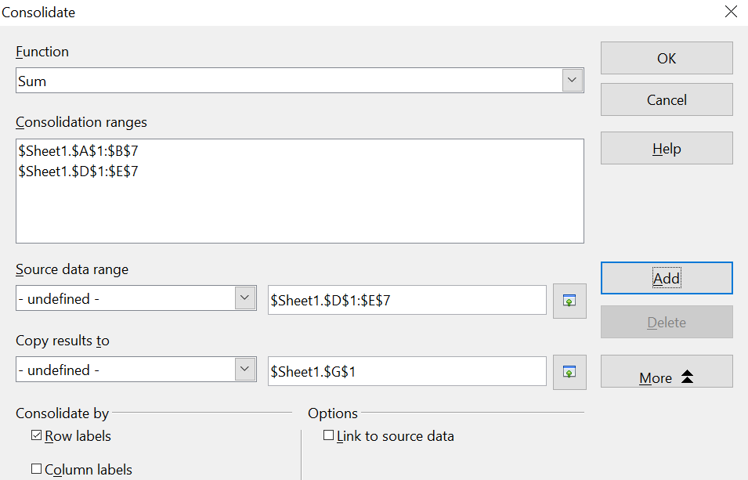

Figure 1: Defining the data to be consolidated
- Specify where to display the result by selecting a target range from the Copy results to drop-down-list.
If the target range is not named, click in the field next to Copy results to and enter the reference of the target range, or select the range using the mouse or position the cursor in the top left cell of the target range. Copy results to uses only the first cell of a target range instead of working with the entire range, as does Source data range.
- Select a function from the Function list to specify how the values of the consolidation ranges will be calculated. The default setting is Sum, which adds the corresponding cell values of the Source data range and gives the result in the target range.
- At this point, you can click More in the Consolidate dialog to access the following additional settings:
  - Select Link to source data to insert formulas that generate results in the target range rather than displaying the actual results. If you link the data, any values subsequently modified in the source range are automatically updated in the target range.
Caution   | The corresponding cell references in the target range are inserted in consecutive rows, which are automatically ordered and then hidden from view. Only the final result, based on the selected function, is displayed.

- Under Consolidate by, select either Row labels or Column labels if the cells of the source data range will not be consolidated by the position of the cell in the range but rather according to a matching row label or column label. Moreover, to consolidate by row labels or column labels, the label must be contained in the selected source ranges. The text in the labels must be identical so rows or columns can be accurately matched. If the row or column label of one source data range does not match any existing in other source data ranges, it is added to the target range as a new row or column. An example of using Row labels is shown below.
- Click OK to consolidate the ranges.
- If you are continually working with the same range, you may want to use Data > Define Range to give it a name.
The consolidation ranges and target range are saved as part of the document. If you later open a document in which consolidation has been defined, this data is still available.
Figure 2 shows a simple example of using Data > Consolidate with the choices from Figure 1. The two Consolidation ranges are next to each other for illustration, but they might well be on separate sheets. Having chosen Consolidate by > Row labels in the dialog, the sum of the Values is calculated for each Name.
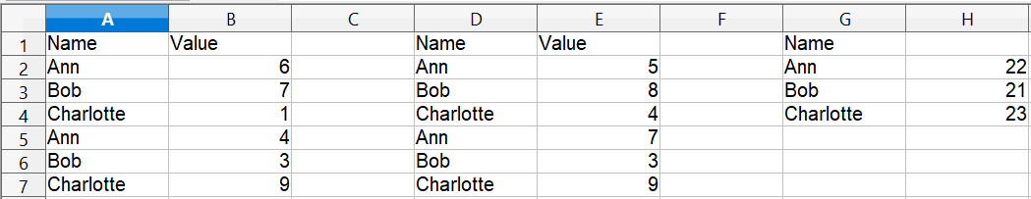

Figure 2: A simple example of Consolidate

Creating Subtotals
SUBTOTAL, listed under the Mathematical category when you use the Function Wizard (Insert > Function)., has a graphical interface accessible from Data > Subtotals.
As the name suggests, SUBTOTAL totals data arranged in an array—that is, a group of cells with labels for columns. Using the Subtotals dialog, you can select up to three arrays and then choose a statistical function to apply to them. When you click OK, Calc adds subtotal and grand total rows to the selected arrays, using the Result and Result2 cell styles to differentiate those entries. By default, matching items throughout your array will be gathered together as a single group above a subtotal.
To insert subtotal values into a sheet:
- Ensure that the columns have labels.
- Select the range of cells you want to calculate subtotals for, and then choose Data > Subtotals.
- In the Subtotals dialog (Figure 3), in the Group by list, select the column by which the subtotals need to be grouped. A subtotal will be calculated for each distinct value in this column.
- In the Calculate subtotals for box, select the columns containing the values for which you want to create subtotals. If the contents of the selected columns change later, the subtotals are automatically recalculated.
- In the Use function box, select the function you want to use to calculate the subtotals.
- Click OK.
If you use more than one group, then you can also arrange the subtotals according to choices made on the dialog’s Options tab (Figure 4), including ascending and descending order or using one of the predefined custom sorts defined in Tools > Options > OpenOffice Calc > Sort Lists.
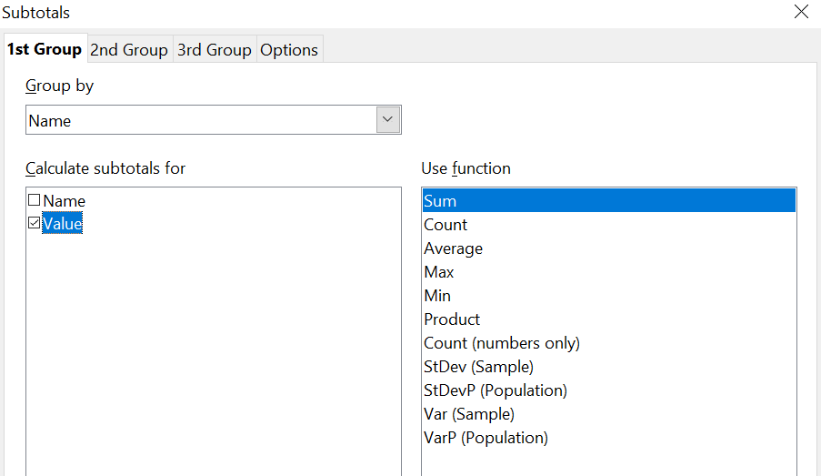

Figure 3: Setting up subtotals
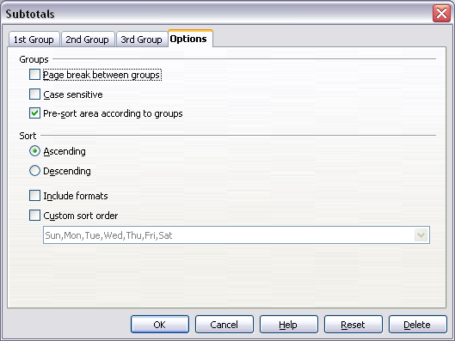
Figure 4: Choosing options for subtotals

Using “What If” Scenarios
Scenarios are a tool to test “what-if” questions. Each scenario is named and can be edited and formatted separately. Only the contents of the currently active scenario are printed when you print the spreadsheet.
A scenario is essentially a saved set of cell values for your calculations. You can easily switch between these sets using the Navigator or a drop-down list, which can be shown beside the changing cells. For example, if you wanted to calculate the effect of different interest rates on an investment, you could add a scenario for each interest rate and quickly view the results. Formulas that rely on values changed by your scenario are updated when the scenario is opened. If all your sources of income used scenarios, you could efficiently build a complex model of your possible income.

Creating Scenarios
Tools > Scenarios opens a dialog with options for creating a scenario.
To create a new scenario:
- Select the cells that contain the values that will change between scenarios. To select multiple ranges, hold down the Ctrl key as you click. Be sure to select at least two cells.
- Choose Tools > Scenarios.
- On the Create Scenario dialog, enter a name for the new scenario that clearly identifies its purpose. For instance, in Figure 5, rather than simply supplying the default name, we could have called the scenario calculate_my_raise.

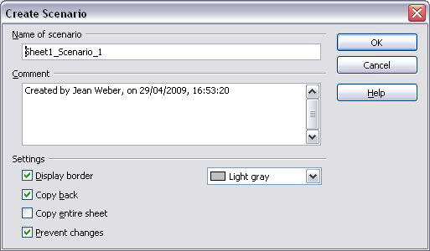
Figure 5: Creating a scenario
- Optionally, you can add information to the Comment box; the example shown uses a default comment. Comment-related information is displayed in the Navigator when you click the Scenarios icon and select the desired scenario.
- Optionally select or deselect the options in the Settings section. See page 8 for more information about these options.
- Click OK to close the dialog. The new scenario is automatically activated.
You can create several scenarios for any given range of cells.

Settings
The lower portion of the Create Scenario dialog contains several options. The default settings, such as Display border shown in Figure 5, are likely suitable in most situations.
Display border
Places a border around the range of cells that your scenario alters. To choose the border color, use the field to the right of this option. The border has a title bar displaying the name of the active scenario. Click the arrow button to the right of the scenario name to open a drop-down list of all the scenarios defined for the cells within the border. You can choose any of the scenarios from this list at any time.
Copy back
Copies any changes you make to the values of scenario cells back into the active scenario. If you do not select this option, the saved scenario values are never changed when you make changes. The actual behavior of the Copy back setting depends on the cell protection, the sheet protection, and the Prevent changes setting (see Table 1 on page 10).
Caution | If you are viewing a scenario which has Copy back enabled and then create a new scenario by changing the values and selecting Tools > Scenarios, you also inadvertently overwrite the values in the first scenario.  This can be avoided. Leave the current values alone, create a new scenario with Copy back enabled, and then change the values only when you are viewing the new scenario.

Copy entire sheet
Adds a sheet to your document that permanently displays the new scenario in full, in addition to creating the scenario and making it selectable on the original sheet.
Prevent changes
Prevents changes to a Copy back-enabled scenario when the sheet is protected but the cells are not. Also prevents changes to the settings described in this section while the sheet is protected. A fuller explanation of the effect this option has in different situations is given below.

Changing Scenarios
Scenarios have two aspects that can be altered independently:
- Scenario properties (the settings described above)
- Scenario cell values (the entries within the scenario border)
The extent to which either of these aspects can be changed is dependent upon both the existing properties of the scenario and the current protection state of the sheet and cells.

Changing Scenario Properties
If the sheet is protected (Tools > Protect Document > Sheet), and Prevent changes is selected then scenario properties cannot be changed.
If the sheet is protected, and Prevent changes is not selected, then all scenario properties can be changed except Prevent changes and Copy entire sheet, which are disabled.
If the sheet is not protected, then Prevent changes does not have any effect, and all scenario properties can be changed.

Changing Scenario Cell Values
Table 1 summarizes the interaction of various settings in preventing or allowing changes in scenario cell values.
Table 1: Prevent changes behavior for scenario cell value changes
Settings | Change allowed
Sheet protection ON  Scenario cell protection OFF  Prevent changes ON  Copy back ON | Scenario cell values cannot be changed.
Sheet protection ON  Scenario cell protection OFF  Prevent changes OFF  Copy back ON | Scenario cell values can be changed, and the scenario is updated.
Sheet protection ON  Scenario cell protection OFF  Prevent changes ON or OFF  Copy back OFF | Scenario cell values can be changed, but the scenario is not updated due to the Copy back setting.
Sheet protection ON  Scenario cell protection ON  Prevent changes ANY SETTING  Copy back ANY SETTING | Scenario cell values cannot be changed.
Sheet protection OFF  Scenario cell protection ANY SETTING  Prevent changes ANY SETTING  Copy back ANY SETTING | Scenario cell values can be changed and the scenario is updated or not, depending on the Copy back setting.

Working with Scenarios Using the Navigator
After scenarios are added to a spreadsheet, you can jump to a particular scenario by selecting it from the list in the Navigator. When you click the Scenarios icon in the Navigator, defined scenarios and any comments entered when the scenarios were created are listed. An example is shown in Figure 6.
- To apply a scenario to the current sheet, double-click the scenario name in the Navigator.
- To delete a scenario, right-click the name in the Navigator and choose Delete.
- To edit a scenario, including its name and comments, right-click the name in the Navigator and choose Properties. The Edit Properties dialog is the same as the Create Scenario dialog (Figure 5).
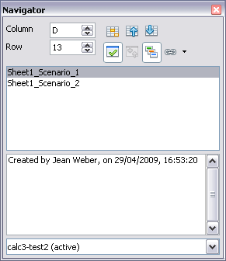
Figure 6: Scenarios in the Navigator

Tracking Values in Scenarios
To learn which values in the scenario affect other values, choose Tools > Detective > Trace Dependents. Arrows point to cells that are directly dependent on the current cell.

Using Other “What If” Tools
Like scenarios, Data > Multiple Operations is a planning tool for “what if” questions. But unlike a scenario, the Multiple Operations tool doesn't present alternate versions in the same cells or with a drop-down list. Instead, the Multiple Operations tool creates a formula array. We call that a separate set of cells showing the results of applying a formula to a list of alternative values for the formula's variables. Even though Multiple Operations isn't listed as a function, it can be considered one. That's because it acts on other functions and thereby allows you to calculate different results without entering and running them separately.
To use the Multiple Operations tool, you need two arrays of cells. The first array contains the original or default values and the formulas applied to them. The formulas must be in a range.
The second array is the formula array. It is created by entering a list of alternative values for one or two original values.
Once alternative values are created, you then use the Multiple Operations tool to specify formulas and the original values used by the formulas. The second array is filled, or in the parlance populated, with the results of using each alternative value instead of the original values.
Multiple Operations can use any number of formulas but only one or two variables. With one variable, the formula array of alternative values for the variables will be in a single column or row. With two variables, you should outline a table of cells such that the alternative values for one variable are arranged as column headings, and the alternative values for the other variable act as row headings.
Setting up multiple operations can be confusing at first. For example, when using two variables, you need to select them carefully to form a meaningful table. Not every pair of variables is useful to add to the same formula array. Yet, even when working with a single variable, a new user can easily make mistakes or forget the relationships between cells in the original array and cells in the formula array. In these situations, Tools > Detective can help to clarify the relations.
Applying some simple design logic can make formula arrays easier to work with. For example, place the original and the formula array close together on the same sheet and use labels for both the rows and columns. These small organizational exercises make working with formula arrays much more comfortable, particularly when correcting mistakes or adjusting results.
Note | If you export a spreadsheet containing multiple operations to Microsoft Excel, the location of the cells containing the formula must be fully defined relative to the data range.

Multiple Operations in Columns or Rows
In your spreadsheet, enter a formula to calculate a result from values that are stored in other cells. Then, set up a cell range containing a list of alternatives for one of the values used in the formula. The Multiple Operations command produces a list of results adjacent to your alternative values by running the formula against each of these alternatives.
Note | Before you choose the Data > Multiple Operations option, be sure to select not only your list of alternative values but also the adjacent cells into which the results should be placed.

In the Formulas field of the Multiple Operations dialog, enter the cell reference to the formula that you wish to use.
The arrangement of your alternative values dictates how you should complete the rest of the dialog. If you have listed them in a single column, you should complete the field for Column input cell. If they are along a single row, complete the Row input cell field. You may also use both in more advanced cases. Both single and double-variable versions are explained below.
The above can be explained best by examples. Cell references correspond to those in the following two figures.
Let’s say you produce toys that you sell for $10 each (cell B1). Each toy costs $2 to make (cell B2), in addition to which you have fixed costs of $10,000 per year (cell B3). How much profit will you make in a year if you sell a particular number of toys?

Calculating with One Formula and One Variable
- To calculate the profit, first, enter any number as the quantity (items sold); in this example, 2000 (cell B4). The profit is found from the formula Profit=Quantity * (Selling price – Direct costs) – Fixed costs. Enter this formula in B5: =B4*(B1-B2)-B3.
- In column D, enter a variety of alternative annual sales figures, one below the other; for example, 500 to 5000, in steps of 500.
- Select the range D2:E11, and thus the values in column D and the empty cells (which will receive the results of the calculations) alongside in column E.
- Choose Data > Multiple Operations.
- With the cursor in the Formulas field of the Multiple operations dialog, click cell B5.
- Set the cursor in the Column input cell field and click cell B4. This means that B4, the quantity, is the variable in the formula, which is to be replaced by the column of alternative values. Figure 7 shows the worksheet and the Multiple operations dialog.
- Click OK. The profits for the different quantities are now shown in column E. See Figure 8.
Tip | You may find it easier to mark the required reference in the sheet if you click the Shrink icon to reduce the Multiple operations dialog to the size of the input field. The icon then changes to the Maximize icon; click it to restore the dialog to its original size.

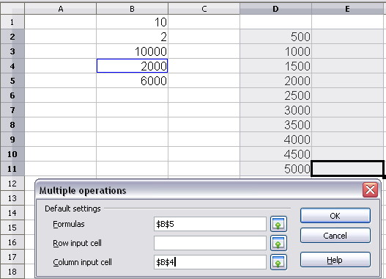
Figure 7: Sheet and Multiple operations dialog showing input
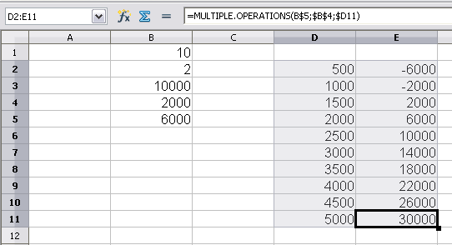
Figure 8: Sheet showing results of multiple operations calculations

Calculating with Several Formulas Simultaneously
- In the sheet from the previous example, delete the contents of column E.
- Enter the following formula in C5: =B5/B4. You are now calculating the annual profit per item sold.
- Select the range D2:F11, thus three columns.
- Choose Data > Multiple Operations.
- With the cursor in the Formulas field of the Multiple operations dialog, select cells B5 and C5.
- Set the cursor in the Column input cell field and click cell B4. Figure 9 shows the worksheet and the Multiple operations dialog.
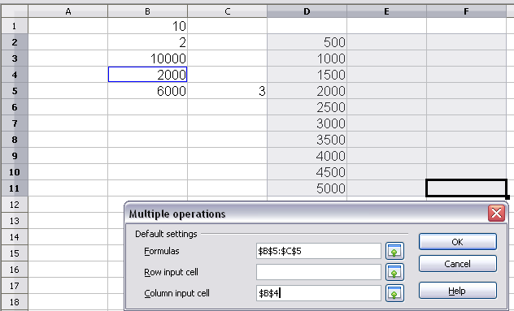
Figure 9: Sheet and dialog showing input
- Click OK. Now, the profits are listed in column E, and the annual profit per item in column F as shown in Figure 10.
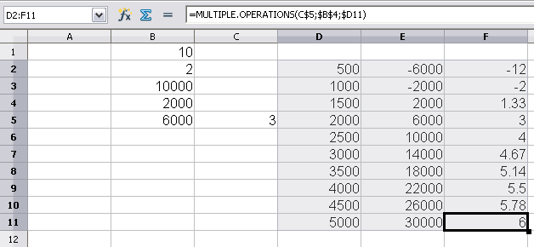
Figure 10: Results of multiple operations calculations

Multiple Operations Across Rows and Columns
You can carry out multiple operations simultaneously for both columns and rows in so-called cross-tables. The formula must use at least two variables, the alternative values for which should be arranged so that one set is along a single row and the other set appears in a single column. These two sets of alternative values will form column and row headings for the results table produced by the Multiple Operations procedure.
Select the range defined by both data ranges (thus including all of the blank cells that are to contain the results) and choose Data > Multiple operations. Enter the cell reference to the formula in the Formulas field. The Row input cell and the Column input cell fields are used to enter the reference to the corresponding cells of the formula.
Caution | The Row input cell field should contain the reference of the variable whose alternative values have been entered along a single row and not the cell reference of the variable which changes down the rows of your results table.

Calculating with Two Variables
You now want to vary not just the quantity produced annually, but also the selling price, and you are interested in the profit in each case.
Expand the table shown in Figure 9. D2 through D11 already contain the numbers 500, 1000 and so on, up to 5000. In E1 through H1 enter the numbers 8, 10, 15 and 20.
- Select the range D1:H11.
- Choose Data > Multiple Operations.
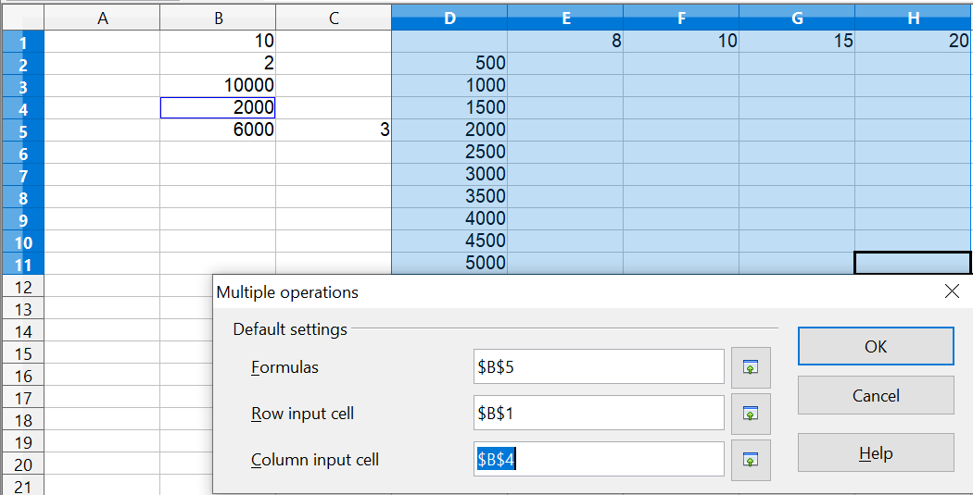
Figure 11: Sheet and dialog showing input
- With the cursor in the Formulas field of the Multiple operations dialog, click cell B5 (profit).
- Set the cursor in the Row input cell field and click cell B1. This means that B1, the selling price, is the horizontally entered variable (with the values 8, 10, 15 and 20).
- Set the cursor in the Column input cell field and click cell B4. This means that B4, the quantity, is the vertically entered variable.
- Click OK. The profits for the different selling prices are now shown in the range E2:H11.
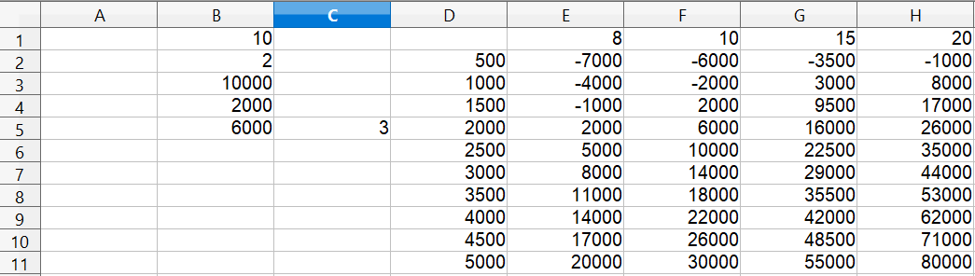
Figure 12: Results of multiple operations calculations

Working Backwards Using Goal Seek
Usually, you create a formula to calculate a result based on existing values. By contrast, using Tools > Goal Seek, you can discover what values will produce the result you want.
To take a simple example, imagine that the Chief Financial Officer of a company is developing sales projections for each quarter of the forthcoming year. She knows what the company’s total income for the year must be to satisfy stockholders. She also has a good idea of the company’s income in the first three quarters because of the contracts that are already signed. For the fourth quarter, however, no definite income is available. So, how much must the company earn in Q4 to reach its goal? The CFO can enter the projected earnings for each of the other three quarters along with a formula that totals all four quarters. Then she runs a goal seek on the empty cell for Q4 sales and receives her answer.
Other uses of goal seek may be more complicated, but the method remains the same. And remember - only one argument can be altered in a single goal seek.

Goal Seek Example
To calculate annual interest (I), create a table with the values for the capital (C), number of years (n), and interest rate (i). The formula is I = C*n*i.
Let us assume that the interest rate i of 7.5% and the number of years n (1) will remain constant. However, you want to know how much the investment capital C would have to be modified to attain a particular return I. For this example, calculate how much capital C would be required if you want an annual return of $15,000.
Enter each of the values mentioned above into adjacent cells (for Capital, C, an arbitrary value like $100,000 or it can be left blank; for number of years, n, 1; for interest rate, i, 7.5%). Enter the formula to calculate the interest, I, in another cell. Instead of C, n, and i, use the reference to the cell with the corresponding value. In our example (Figure 13), this would be =B1*B2*B3.
- Place the cursor in the formula cell (B4) and choose Tools > Goal Seek.
- In the Goal Seek dialog, the correct cell is already entered in the Formula cell field.
- Place the cursor in the Variable cell field. In the sheet, click in the cell that contains the value to be changed; in this example, it is B1.
- Enter the desired result of the formula in the Target value field. In this example, the value is 15000. Figure 13 shows the cells and fields.
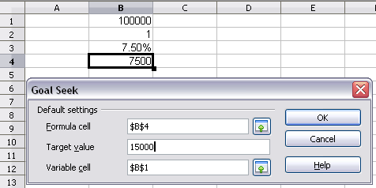
Figure 13: Example setup for goal seek
- Click OK. A dialog appears informing you that the Goal Seek was successful. Click Yes to enter the goal value into the variable cell. The result is shown below.
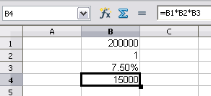
Figure 14: Result of goal seek operation

Using the Solver
Tools > Solver amounts to a more elaborate form of Goal Seek. The difference is that Solver deals with equations with multiple unknown variables. It's specifically designed to minimize, maximize, or reach a target with a result following a set of rules you define.
Each of these rules defines whether an argument in the formula should be greater than, less than, or equal to the figure you enter. If you want the argument to remain unchanged, you must enter a rule that specifically states that the cell should be equal to its current entry. For arguments that you would like to change, you need to have at least one rule for each. If you are trying to maximize or minimize the result, you probably need two rules to define a range of possible values. Otherwise, Solver will use unrealistically large or small values. You can also set constraints that one of the variables or cells must not be bigger than another variable or that one or more variables must be integers (values without decimals) or binary values (where only 0 and 1 are allowed). Without a specific example to think about, setting the constraints in Solver may sound very difficult. In a real situation, the constraints are likely to be obvious. Practical considerations will often be your guide.
Once you have finished setting up the rules, click the Solve button to begin the automatic process of adjusting values and calculating results. Depending on the complexity of the task, this may take some time.

Solver Example
Let's work on the example mentioned in the Introduction: you have a $1000 credit at a company, and you want to spend it on three products: A, B, and C. The products cost $27.45, $13.87, and $54.19, respectively. You have to buy at least 10 of A, 5 of B, and 7 of C to meet your current needs. How many of each product should you buy to spend exactly $1000?
To find the answer using Solver:
- We set up the data as shown in Figure 15. The Solver is flexible enough to accommodate many different data arrangements. Here, there are columns for the Item, Price per item, Quantity, and Cost. The Cost column has an extra cell at the bottom that sums the cost of the individual items. We will want to adjust the quantities in column C to achieve a total cost of $1000.
  - The cells D2:D4 have formulas like =B2 * C2.
  - The cell D5 has the formula =SUM(D2:D4).
- You can enter arbitrary values, which can be 0 or blank, in the cells of column C, the cells whose values will be adjusted. We have chosen to enter the minimum purchase of each product.
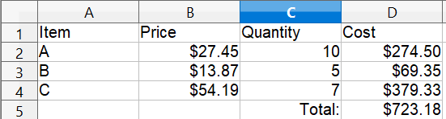

Figure 15: Example setup for Solver
- Choose Tools > Solver. The Solver dialog opens.
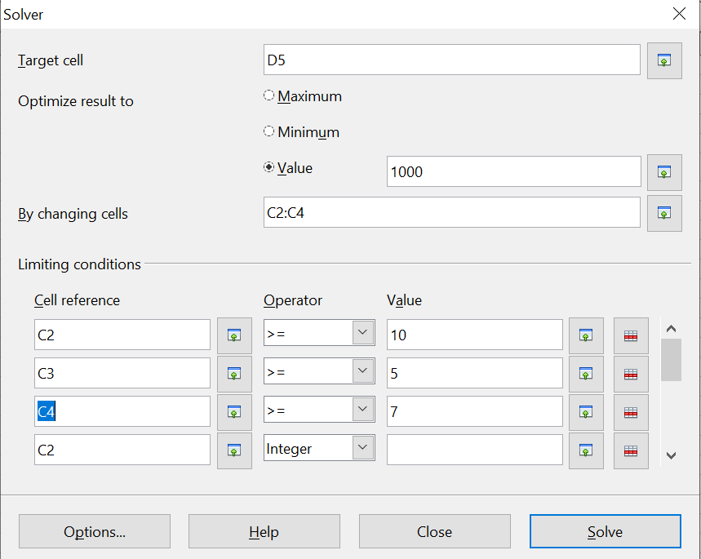

Figure 16: The Solver dialog after filling in values
- Click in the Target cell field. In the sheet, click in the cell that contains the target value or simply type in the cell address. In this example it is cell D5 .
- Select Value of and enter 1000 in the field next to it.
- Click in the By changing cells field and select the cells C2:C4 in the sheet.
- Enter limiting conditions for the variables by selecting the Cell reference, Operator, and Value fields. In this example, we set the cells to be greater than or equal to the minimum order quantity and we have limited C2, C3, and C4 to be integers. Only the integer limitation for C2 is visible in Figure 16, but all three cells have been limited to integers.
- Click OK. A dialog appears informing you that the Solving successfully finished. Click Keep Result to enter the results in the cells with the variable values and the target cell.
Figure 17 shows three different Solver calculations. The first one, in rows 1 – 5, shows the outcome of the process just described. The target value is met exactly with integer quantities in C2:C4.
The calculation in rows 7 – 11 shows the result if the Price of Item C is changed to $54.18. It is no longer possible to meet exactly the $1000 target with integer values in C8:C10. Solver limits two of the Quantities to integers and allows one to take a decimal value to meet the target. You can see that the Item A Quantity is about 20.09.
You can control which Quantity is allowed to take decimal values by changing the specification of the By changing cells box in the Solver dialog shown in Figure 16. In the calculation in rows 7 – 11, the specification was written as C8:C10. Alternatively, you can write each cell address separately, separating them with semicolons. (This is how you would have to enter the cells if they were not contiguous.) The calculation in rows 13 – 17 shows the outcome of specifying C15;C14;C16 in the By changing cells box. Now, the Quantity of Item B, in row 15, is allowed to be a non-integer. The cell that is listed first in the By changing cells specification is the one that takes non-integer values.

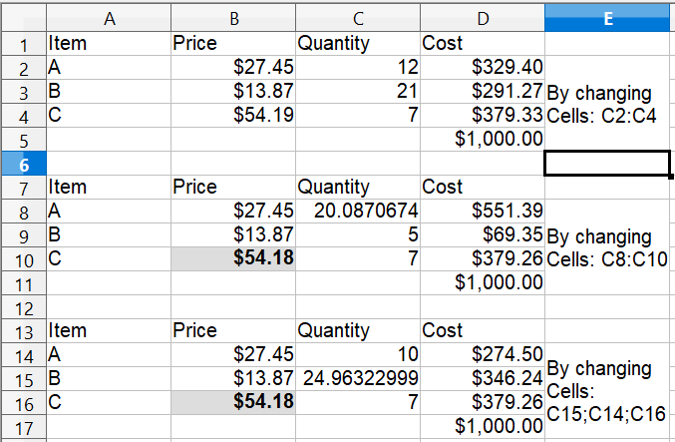

Figure 17: Result of three Solver operations
Note | The default solver supports only linear equations. For nonlinear programming requirements, try the Solver for Nonlinear Programming [Beta]. It is available from the OpenOffice extensions repository. (For more about extensions, see Chapter 14 (Setting up and Customizing Calc.)

