Chapter 10
Linking Calc Data
Sharing data in and out of Calc

Why Use Multiple Sheets?
Chapter 1 introduced using multiple sheets in a spreadsheet. Multiple sheets can help keep information organized; once you link those sheets, you unleash the full power of Calc. Consider this case.
John is having trouble keeping track of his personal finances. He has several bank accounts and the information is scattered and disorganized. He can’t get a good grasp on his finances until he can see everything at once.
To resolve this, John decided to track his finances in OpenOffice Calc. John knows Calc can do simple mathematical computations to help him keep a running tab of his accounts, and he wants to set up a summary sheet so that he can see all of his account balances at once.
This can be accomplished easily.
Note | For users with experience using Microsoft Excel, a Calc sheet is called a sheet or worksheet in Excel. What Excel calls a workbook, Calc calls a spreadsheet (the whole document).

Setting Up Multiple Sheets
Chapter 1 gives a detailed explanation of how to set up multiple sheets in a spreadsheet. Here's a quick review.

Identifying Sheets
When you open a new spreadsheet, by default, three sheets are created: Sheet1, Sheet2, and Sheet3. Sheets in Calc are managed using tabs at the bottom of the spreadsheet, as shown below.
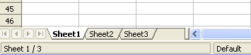Figure 1: Default sheet tabs

Renaming Sheets
Sheets can be renamed at any time. To give a sheet a more meaningful name:
- Enter the name in the name box when you create the sheet, or
- Double-click on the sheet tab, or
- Right-click on a sheet tab, select Rename Sheet from the pop-up menu and replace the existing name.
Note | To save the spreadsheet in Microsoft Excel format, the following characters must not be used in sheet names: \ / ? * [ ] : and ' as the first or last character of the name.

Inserting New Sheets
There are several ways to insert a new sheet. The first step is to select the sheet that precedes or follows the new sheet as shown in Figure 2. Then do any of the following:
- Select Insert > Sheet from the menu bar, or
- Right-click on the tab and select Insert Sheet, or
- Click in an empty space at the end of the line of sheet tabs.

Figure 2: Creating a new sheet
Click here to create a new sheet
Each method opens the Insert Sheet dialog shown below. You can choose to insert the new sheet before or after the selected sheet, name it, and decide how many sheets to insert.
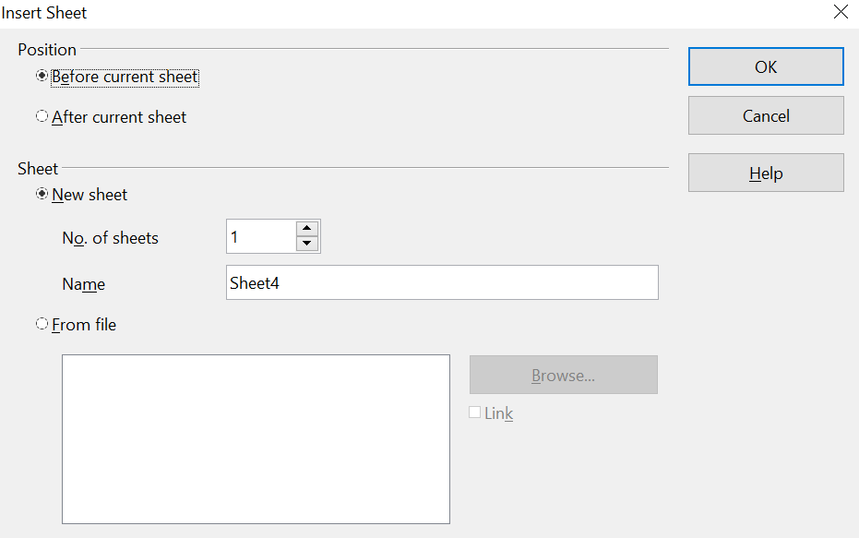
Figure 3. Insert Sheet dialog
To insert just one sheet, choose whether to insert it before or after the currently selected sheet, name the new sheet if desired, and click OK. The new sheet will be selected and visible in the sheet tabs line.
In our example, we need 6 sheets (one for each of the 5 accounts and one as a summary sheet), so we will add 3 more. We also want to name each of these sheets for the account they represent: Summary, Checking Account, Savings Account, Credit Card 1, Credit Card 2, and Car Loan.
We can either insert 3 new sheets and rename all 6 sheets afterward or rename the existing sheets and insert the 3 new sheets individually, renaming each new sheet during the insertion step.
To insert sheets and rename afterwards:
- In the Insert Sheet dialog, choose the position for the new sheets (in this example, we use After current sheet).
- Choose New sheet and 3 as the No. of sheets. (Three sheets are already provided by default.) Because you are inserting more than one sheet, the Name box is unavailable.
- Click OK to insert the sheets.
- For the next steps, see “Renaming Sheets” on page 2.
To insert sheets and name them at the same time:
- Rename the existing sheets Summary, Checking Account, and Savings Account, as described in “Renaming Sheets” on page 2.
- In the Insert Sheet dialog, choose the position for the first new sheet.
- Choose New sheet and 1 as the No. of sheets. The Name box is now available.
- In the Name box, type a name for this new sheet, for example, Credit Card 1.
- Click OK to insert the sheet.
- Repeat steps 1 through 4 for each new sheet, giving them the names Credit Card 2 and Car Loan.
Your sheet tab area should look like Figure 4 below.
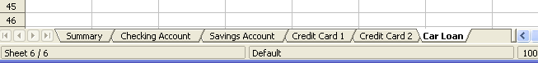Figure 4: Six renamed sheets
Now, we will set up the account ledgers, a simple summary that includes the previous balance plus the current transaction amount. We enter the current transaction for withdrawals as a negative number, so the balance gets smaller. A basic ledger is shown in Figure 5.
This ledger is set up in the sheet named Checking Account. The total balance is added up in cell F3. You can see the equation for it in the formula bar. It is the summary of the opening balance, cell C3, and all subsequent transactions.
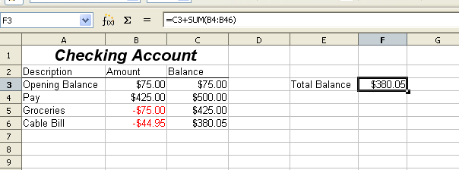Figure 5: Checking ledger

Inserting Sheets From a Different Spreadsheet
On the Insert Sheet dialog, you can add a sheet from a different spreadsheet file by choosing the From file option. Click Browse and select the file; a list of the available sheets will appear in the box. Select the sheet to import. If no sheets appear after having selected the file, you probably selected an invalid file type (not a spreadsheet, for example).
Tip | For a shortcut to inserting a sheet from another file, choose Insert > Sheet from file from the menu bar. The Insert Sheet dialog opens with the From file option preselected, and then the Insert dialog opens on top of it.

The above method adds a sheet from another file as an embedded object – it is contained within the document and is independent of the original sheet. If you prefer, select the Link option to insert the external sheet as a link instead of a copy. This is one of several ways to include “live” data from another spreadsheet. (See also “Linking to External Data” on page 12.) The links can be updated manually to show the current contents of the external file or, depending on the options you have selected in Tools > Options > OpenOffice Calc > General > Updating, whenever the file is opened.
If the sheet is contained in an already open spreadsheet, you can use the Move/Copy command in the other spreadsheet to copy (or move) a sheet to another document.

Referencing Other Sheets in the Spreadsheet
On the Summary sheet, we display the balance from each of the other sheets. If you copy the example in Figure 5 to each account, the current balance will be in cell F3 of each sheet.
There are two ways to enter cell references in other sheets: by entering the formula directly using the keyboard or the mouse. We will look at the mouse method first.

Creating the Reference with the Mouse
On the Summary sheet, set up a place for all five account balances so we know where to put the cell reference. Figure 6 shows a summary sheet with a blank Balance column. We want the reference for the checking account balance in cell B3.
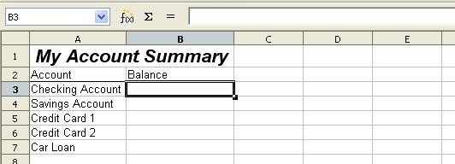Figure 6: Blank summary
To make the cell reference in cell B3, select the cell and follow these steps:
- Click on the = icon next to the input line. The icons change and an equals sign appears in the input line as in Figure 7.
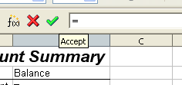
Figure 7: Equal sign in input line
- Now, click on the sheet tab for the sheet containing the cell to be referenced. In this case, that is the Checking Account sheet as shown in Figure 8.
Figure 8: Click on the checking account tab
- Click on cell F3 (where the balance is) in the Checking Account sheet. The phrase ‘Checking Account’.F3 should appear in the input line as in Figure 9.
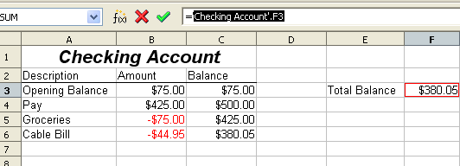Figure 9: Cell reference selected
- Click the green checkmark in the input line to finish.
- The Summary sheet should now look like Figure 10.
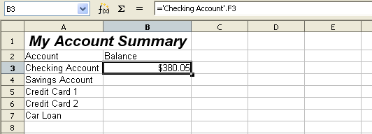Figure 10: Finished checking account reference

Creating the Reference with the Keyboard
From Figure 10, you can deduce how the cell reference is constructed. The reference has two parts: the sheet name (‘Checking Account’) and the cell reference (F3). Notice that they are separated by a period.
Note | The sheet name is in single quotes because it contains a space. The mandatory period (.) always falls outside of any quotes.

You can fill in the Savings Account cell reference simply by typing it in. Assuming the balance is in the same cell (F3) in the Savings Account sheet, the cell reference should be =’Savings Account’.F3 (see Figure 11).
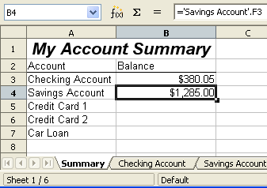Figure 11: Savings account reference

Referencing Other Documents: Links to Sheets in Other Spreadsheets
John decides to keep his family account information in a different spreadsheet file from his own summary. Fortunately, Calc can link different files together. The process is the same as described for different sheets in a single spreadsheet, but we add one more step to indicate which file the sheet is in. For this example, we use two different spreadsheet files.

Creating the Reference Using the Mouse
To create the reference with the mouse, both spreadsheets need to be open. Select the cell in which the formula is going to be entered.
- Click the = icon next to the input line.
- Switch to the other spreadsheet (the process to do this will vary depending on which operating system you are using).
- Select the sheet (Summary) and then the reference cell (B8). See Figure 12.
- Switch back to the original spreadsheet.
- Click on the green check mark on the input line.
Your spreadsheet should now resemble Figure 13.
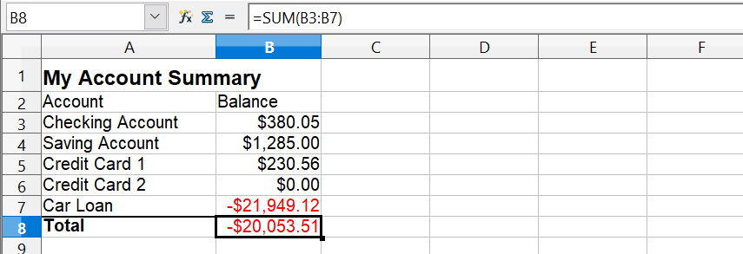

Figure 12: Selecting the Summary reference cell
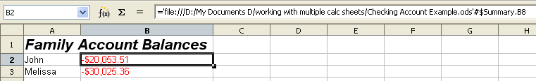Figure 13: Linked files
To better understand the format of the reference, look closely at the input line. Based on this line you can create the reference using the keyboard.

Creating the Reference with the Keyboard
Typing the reference is simple once you know the format the reference takes. The reference has three parts:
- Path and file name
- Sheet name
- Cell
Looking at Figure 13 you can see the general format for the reference is:
=’file:///Path & File Name’#$SheetName.CellName
Note | The reference for a file has three forward slashes /// ; the reference for a hyperlink has two forward slashes //. The format of the path and file name depends on the operating system in use.  If a cell with a reference in it shows #REF it may mean that the link is no longer valid. Check the location of the file and amend the reference to the correct path and name.

Hyperlinks and URLs
Hyperlinks can be used in Calc to jump to a different location from within a spreadsheet to other parts of the current file, to different files, or even to websites.

Relative and Absolute Hyperlinks
Hyperlinks can be stored within your file as either relative or absolute.
A relative hyperlink says, Here is how to get there starting from where you are now (meaning from the folder in which your current document is saved), while an absolute hyperlink says, Here is how to get there no matter where you started.
An absolute link will stop working if the target is moved, but you can move the file containing the link. A relative link will stop working only if the start and target locations change in relation to each other. For instance, if you have two spreadsheets linked to each other in the same folder and you move the entire folder to a new location, a relative hyperlink will not break.
To change the way that OpenOffice stores the hyperlinks in your file, select Tools > Options > Load/Save > General and choose if you want URLs saved relatively when referencing the File System, or the Internet, or both.
Calc will always display an absolute hyperlink. Don’t be alarmed when it does this, even when you have saved a relative hyperlink—this ‘absolute’ target address will be updated if you move the file.
Note | If you save your links as relative to the file system and you are going to upload pages to the Internet, make sure that the folder structure on your computer is the same as the file structure on your web server.

Tip | When you rest the mouse pointer on a hyperlink, a help tip displays the absolute reference since OpenOffice uses absolute path names internally. The complete path and address can only be seen when you view the result of the HTML export (saving the spreadsheet as an HTML file), by loading the HTML file as Text, or by opening it with a text editor.

Creating Hyperlinks
When you type text that can be used as a hyperlink (such as a website address or URL), Calc formats it automatically, creating the hyperlink and applying to the text a color and background shading. If this does not happen, you can enable this feature using Tools > AutoCorrect Options > Options and selecting URL Recognition.
Tip | To change the color of hyperlinks, go to Tools > Options > OpenOffice > Appearance, scroll to Unvisited links and/or Visited links, pick the new colors and click OK. But be very careful. Doing this will change the color for all hyperlinks in all components of OpenOffice—quite possibly not what you want.

You can also insert and modify links using the Hyperlink dialog shown below. To display the dialog, click the Hyperlink icon on the Standard toolbar or choose Insert > Hyperlink from the menu bar. To add a link to existing text, highlight the text before opening the dialog.
On the left side, select one of the four categories of hyperlinks:
- Internet: the hyperlink points to a web address, normally starting with https://
- Mail & News: the hyperlink opens an email message that is pre-addressed to a particular recipient.
- Document: the hyperlink points to a place in either the current document or another existing document.
- New document: the hyperlink creates a new document.
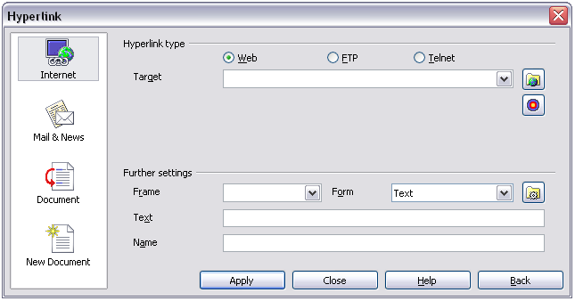
Figure 14. Hyperlink dialog showing details for Internet links
The upper right part of the dialog changes according to the choice made from the left panel for the hyperlink category. While a complete description of all the choices and their interactions is beyond the scope of this chapter, here is a summary of the most common choices used in spreadsheets.
For an Internet hyperlink, choose the type of hyperlink (Web, FTP, or Telnet) and enter the required web address (URL).
For a Mail and News hyperlink, specify whether it is a mail or news link, the receiver address, and the email subject.
For a Document hyperlink, specify the document path (the Open File button opens a file browser); leave this blank if you want to link to a target in the same spreadsheet. Optionally specify the target in the document (for example, a specific sheet). Click on the Target in document icon to open the Navigator, where you can select the target, or if you know the name of the target, you can type it into the box.
For a New Document hyperlink, specify whether to edit the newly created document immediately (Edit now) or create it (Edit later), and enter the file name and the type of document to create (text, spreadsheet, etc.). The Select path button opens a directory picker dialog.
The Further settings section in the bottom right of the dialog is common to all the hyperlink categories, although some choices are more relevant to specific types of links.
- Set the value of Frame to determine how the hyperlink will open. This applies to documents that open in a Web browser.
- Form specifies if the link will be presented as text or as a button. Figure 15 shows a link formatted as a button.
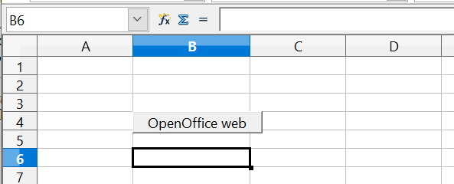
Figure 15: OpenOffice web page hyperlink as button
- Text specifies the text that will be visible to the user. If you do not enter anything here, Calc will use the full URL or path as the link text. Note that if the link is relative and you move the file, this text will not change, though the target will.
- Name is applicable to HTML documents. It specifies text that will be added as a NAME in the HTML code that accomplishes the hyperlink.
- Events button: this button will be activated to allow Calc to react to events for which the user has written a macro. This function is not covered in this chapter.
Note | A hyperlink button is a type of form control. As with all form controls, it can be anchored or positioned by right-clicking on the button in design mode. More information about forms can be found in Chapter 15 of the Writer Guide.  For the button to work , the spreadsheet must not be in design mode. To toggle design mode on and off, view the Form Controls toolbar (View > Toolbars > Form Controls) and click the Design Mode On/Off button . See Chapter 15 of the Writer Guide, Using forms in Writer, for more information on forms and their use in documents.

Editing Hyperlinks
To edit an existing link, place the cursor anywhere in the link and click the Hyperlink icon on the Standard toolbar or select Edit > Hyperlink from the menu bar. The Hyperlink dialog (Figure 14) opens. If the Hyperlink is in button form, the spreadsheet must have Design Mode on to edit the Hyperlink. Make your changes and click Apply. If you need to edit several hyperlinks, you can leave the Hyperlink dialog open until you have edited all of them. Be sure to click Apply after each one. When you are finished, click Close.

Removing Hyperlinks
You can remove the clickable link from hyperlink text—leaving just the text—by right-clicking on the link and selecting Default Formatting. This option is also available from the Format menu. You may then need to re-apply some formatting for it to match the rest of your document.
To completely erase the link text or button from the document, select it and press the Backspace or Delete key.

Linking to External Data
You can insert tables from HTML (web) documents and data located within named ranges from an OpenOffice Calc or Microsoft Excel spreadsheet into a Calc spreadsheet. (To use other data sources, including database files in OpenOffice Base, see “Linking to Registered Data Sources” on page 16.)
You can do this in two ways: using the External Data dialog or using the Navigator. If your file has named ranges or named tables, and you know the name of the range or table you want to link to, using the External Data dialog method is quick and easy. However, if the file has several tables, and you want to pick only one of them, you may not be able to easily determine which is which. In that case, the Navigator method may be easier.

Using the External Data Dialog
- Open the Calc document where the external data will be inserted. This is the target document.
- Select the cell where the upper left-hand cell of the external data will be inserted.
- Choose Insert > Link to External Data.
- On the External Data dialog (Figure 16), type the URL of the source document or click the […] button to open a file selection dialog. Press Enter to get Calc to load the list of available tables.
- In the Available tables/range list, select the named ranges or tables you want to insert. You can also specify that the ranges or tables are updated every (number of) seconds.
- Click OK to close the dialog and insert the linked data.
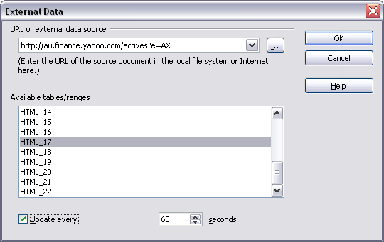Figure 16: Selecting a table or range in a source document from the Web
Note | - The Available tables/ranges list remains empty until you press Enter after typing the URL of the source. If you select the source document using the […] button, pressing Enter is not required.  - The OK button remains unavailable (grayed out) until you select one or more tables/ranges in the list. You can hold down the Ctrl key while clicking on tables/ranges to select more than one.  - No images are imported

Using the Navigator
- Open the OpenOffice Calc spreadsheet in which the external data will be inserted (target document).
- Open the document from which the external data will be taken (source document) using File > Open. If the source document is a Web page, choose Web Page Query (OpenOffice Calc) as the file type. You'll need to scroll down the list of File types to find this entry. (See Figure 17.)
- In the target document, press F5 to open the Navigator.
- At the bottom of the Navigator, select the source document. (In Figure 18, the source is named actives.)
- The Navigator now shows the range names or the tables contained in the source document (the example contains range names; other documents have a list of tables). Click on the + or ▶ next to Range names to display the list.
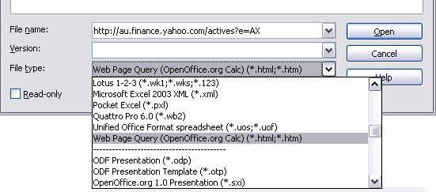
Figure 17: Opening a file using the Web Page Query filter
- In the Navigator, select the Insert as Link drag mode, as shown in Figure 18.
- Select the required range or table and drag it from the Navigator into the target document to the cell where you want the upper left cell of the data range to be.
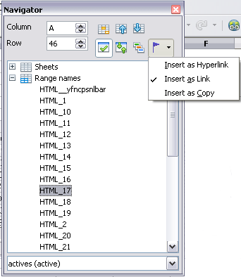
Figure 18: Selecting a data range in a source document, to be inserted as a link
- In the target document, check the Navigator. Instead of a + or ▶ by Range names, it shows a + or ▶ by Linked areas. Click the + or ▶ to see the range name you just dragged into the target document (see Figure 19).
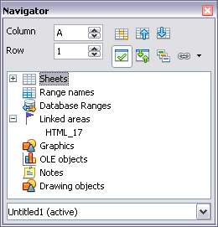
Figure 19: Linked areas in target spreadsheet

How to Find the Required Data Range or Table
The examples above show that the import filter gave names to the data ranges (tables) in the sample web page starting from HTML_1. It also created two additional range names (not visible in the illustration):
HTML_all – designates the entire document
HTML_tables – designates all HTML tables in the document
If the data tables in the source HTML document have been given names (using the ID attribute on the TABLE tag) or the external spreadsheet includes named ranges, those names appear in the list along with the ranges Calc has numbered sequentially. However, if the data range or table you want is not named, how can you tell which one to select?
Go to the source document you opened in Calc. In the Navigator, double-click on a range name or use the Name box, as shown in Figure 20. Using Navigator causes the chosen range to be highlighted on the sheet (see Figure 21).
If the Formula Bar is visible, the range name is also displayed in the Name box at the left-hand end (see Figure 12).
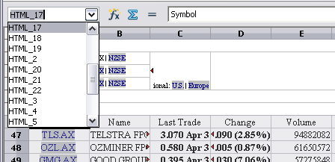
Figure 20: Using the Name box to find a data range name
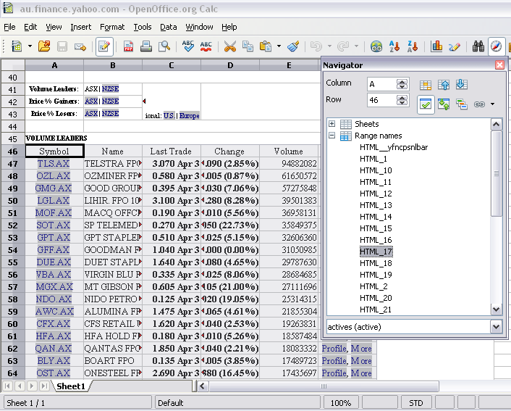

Figure 21: Using the Navigator to find a data range name

Linking to Registered Data Sources
You can access various databases and other data sources and link them to Calc documents.
First, you need to “register” the data source with OpenOffice, which means informing OpenOffice of the data source type and where it's located. The way to do this depends on whether or not the data source is a database in *.odb format.
To register a data source that is in *.odb format:
- Choose Tools > Options > OpenOffice Base > Databases.
- Click the New button (below the list of registered databases) to open the Create Database Link dialog (Figure 22).
- Enter the database file's location or click Browse to open a file browser and select the database file.
- Type a name to use as the registered name for the database and click OK. The database is added to the list of registered databases. The OK button is enabled only when both fields are filled in.
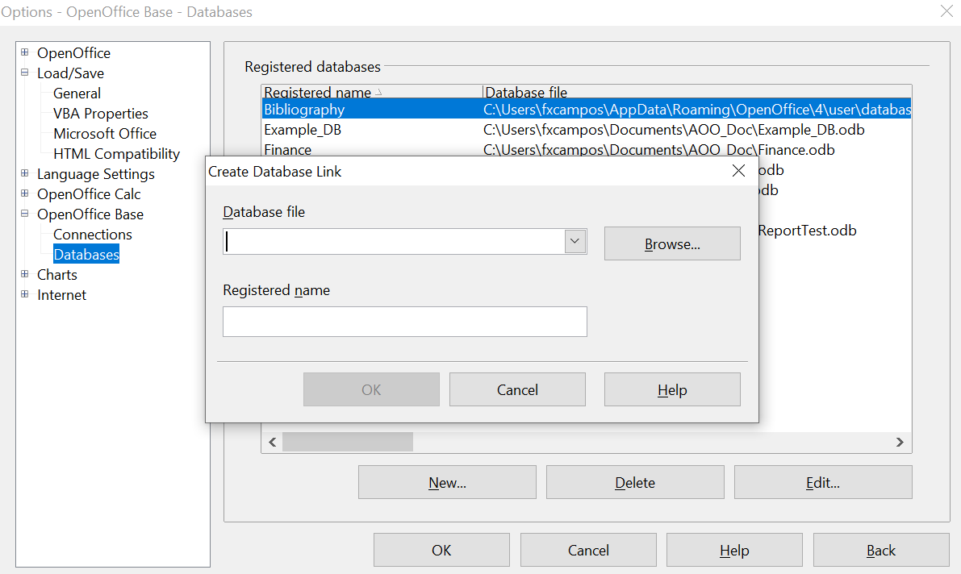

Figure 22: Registering databases
To register a data source that is not in *.odb format:
- Choose File > New > Database to open the Database Wizard.
- Select Connect to an existing database. The choice of database type depends on your operating system. For example, Microsoft Access and other Microsoft products are not available choices when using Linux. In our example, we chose dBASE (See Figure 23).
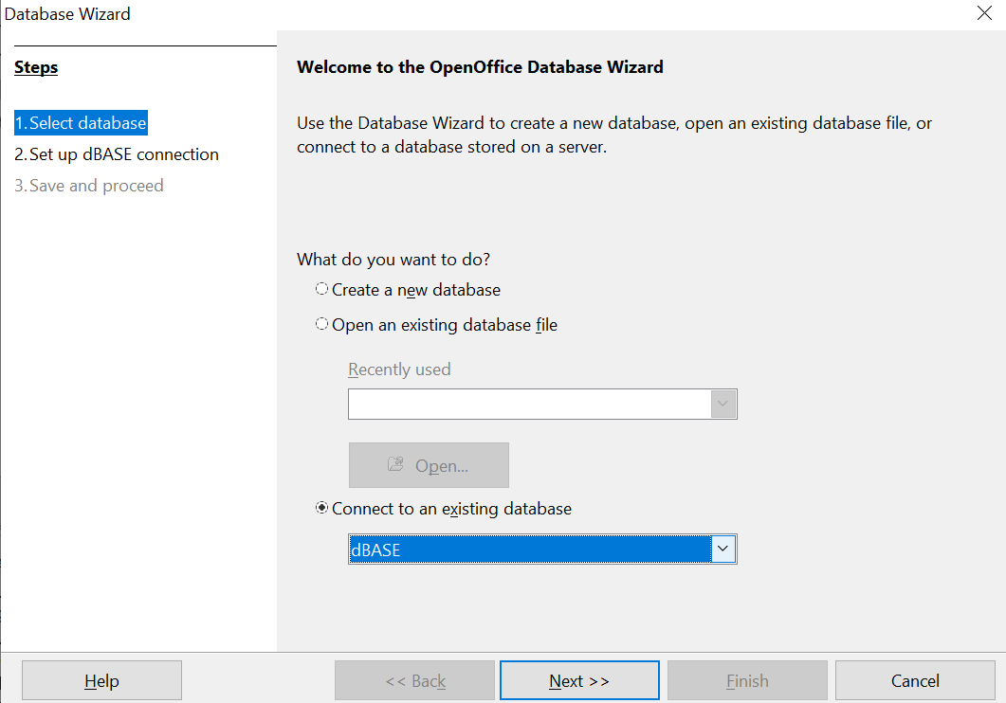

Figure 23: Registering a database using the Database Wizard
- Click Next. Type the path to the database file or click Browse and use the Open dialog to navigate to and select the database file before clicking Open.
- Click Next. Select Yes, register the database for me, but clear the checkbox marked Open the database for editing.
- Click Finish. Name and save the database in the location of your choice. Note: changes made to the *.odb do not affect the original dBASE file.
Once a data source has been registered, it can be used by any OpenOffice component (for example, Calc).

Viewing Data Sources
Open a document in Calc. To view the data sources available, press F4 or select View > Data Sources from the menu bar. The Data Source View pane opens above the spreadsheet. A list of registered databases is in the Data Explorer area on the left. (The built-in Bibliography database is included in the list.)
To view each database, click on the + or ▶ to the left of the name of the database. (This has been done for the Automobile database in Figure 24.) Click on the + or ▶ next to Tables to view the individual tables.
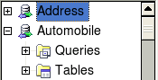
Figure 24: Databases
Now, click on a table to see all the records it contains. The data records are displayed on the right side of the Data Source View pane. To see more columns, click the Explorer On/Off button to hide the Data Explorer area.
At the top of the Data Source View pane, below the Calc toolbars, is the Table Data bar. This toolbar includes buttons for saving records, editing data, finding records, sorting, filtering, and other functions. For more details about this toolbar, see the Help topic in Calc for data source browser.
Below the records is the Form Navigation bar, which shows which record is selected and the total number of records. To the right are five tiny buttons; the first four move backward or forward through the records or to the beginning or end.

Figure 25: Data Source View navigation buttons

Editing Data Sources
Some data sources (such as spreadsheets) cannot be edited in the data source view.
In editable data sources, records can be edited, added, or deleted. If you cannot save your edits, you need to open the database in Base and edit it there; see “Launching Base to Work on Data Sources.” You can also hide columns and make other changes to the display.

Launching Base to Work on Data Sources
You can launch OpenOffice Base from the Data Source View pane. Right-click on a database or the Tables or Queries icons and select Edit Database File. In Base, you can edit, add, and delete tables, queries, forms, and reports.
For more information on using Base, see Chapter 8 (Getting Started with Base) in the Getting Started guide.

Using Data Sources in Calc Spreadsheets
Data from tables in the data source pane can be placed into Calc documents in a variety of ways.
You can select a cell or an entire row in the data source pane and drag and drop the data into the spreadsheet. The data is inserted at the place where you release the mouse button.
An alternative method uses the Data to Text icon and will include the column headings above the data you insert:
- Click the cell of the spreadsheet that you want to be the top left of your data set, including the column names.
- Press F4 to open the database source window and select the table containing the data you want to use.
- Select the rows of data you want to add to the spreadsheet:
  - Click the gray box to the left of the row you want to select if only selecting one row. That row is highlighted.
  - To select multiple adjacent rows, hold down the Shift key while clicking the gray box of the rows you need.
  - To select multiple separate rows, hold down the Control key while selecting the rows. The selected rows are highlighted.
  - To select all the rows, click the gray box in the upper left corner. All rows are highlighted.
- Click the Data to text icon to insert the data into the spreadsheet cells.
You can also drag the data source column headings (field names) onto your spreadsheet to create a form for viewing and editing individual records one at a time. Follow these steps:
- Click the gray box at the top of the column (containing the field name you wish to use) to highlight it.
- Drag and drop the gray box to the cell or cells in the spreadsheet where you want the record to appear.
- Repeat until you have moved all of the fields you need to their appropriate new location.
- Close the Data Source window by pressing F4.
- Save the spreadsheet and click the Edit File button on the Standard toolbar to make the spreadsheet read-only. All of the fields will show the value for the data of the first record you selected.
- Add the Form Navigation toolbar by going to View > Toolbars > Form Navigation. By default this toolbar opens at the bottom of the Calc window, just above the status bar.
- Click the arrows on the Form Navigation toolbar to view the different records in the table. The number in the Record box changes as you move through the records. The data in the fields updates corresponding with the data for that particular record number. You can also search for a specific record, sort and filter records, and do other tasks using this toolbar.

Embedding Spreadsheets
Spreadsheets can be embedded in other OpenOffice files. This is often used in Writer or Impress documents so Calc data can form part of a text document. You can embed the spreadsheet as either an OLE or DDE object. The difference between a DDE object and a Linked OLE object is that a Linked OLE object can be edited from the document in which it is added as a link, but a DDE object cannot. The rest of this chapter discusses the nature of OLE and DDE links.
For example, if a Calc spreadsheet is pasted into a Writer document as a DDE object, the spreadsheet cannot be edited in the Writer document. However, if the original Calc spreadsheet is updated, the changes are automatically made in the Writer document. If the spreadsheet is inserted as a Linked OLE object into the Writer document, then the spreadsheet can be edited in the Writer and in the Calc document, and both documents will remain in sync.

Object Linking and Embedding (OLE)
The major benefit of an OLE (Object Linking and Embedding) object is that its contents are quickly and easily edited by double-clicking on it. You can also insert a link to the object that will appear as an icon rather than an area showing the contents.
OLE objects can be linked to a target document or embedded in the target document. Linking inserts information that will be updated with subsequent changes to the original file, while embedding inserts a static copy of the data. If you want to edit the embedded spreadsheet, double-click on the object.
To embed a spreadsheet as an OLE object in a presentation:
- Place the cursor in the document and location you want the OLE object to be.
- Select Insert > Object > OLE Object. The dialog below opens.
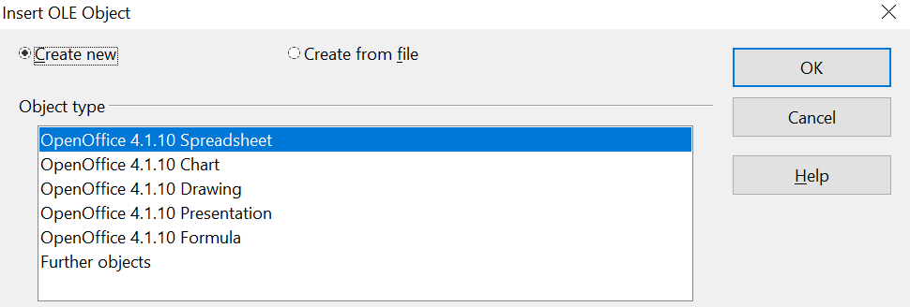
Figure 26: Insert OLE object dialog
- You can either create a new OLE object or create it from a file.
To create a new object:
- Select Create new and select the object type from the available options.
Note | “Further objects” is only available if you are using the Windows operating system.

- Click OK. An empty container is placed in the sheet.
- Double-click on the OLE object to enter the edit mode of the object. The application devoted to handling that type of file will open the object.
Note | If the object inserted is handled by OpenOffice, the transition to the program to manipulate it will be seamless; in other cases, the object opens in a new window, and an option in the File menu becomes available to update the inserted object.

To insert an existing object:
- To create from a file, select Create from file. The dialog changes to look like Figure 27.
- To insert the object as a link, select the Link to file option. Otherwise, the object will be embedded.
- Click Search, select the required file in the Open dialog, then click Open. A section of the inserted file is shown in the document.
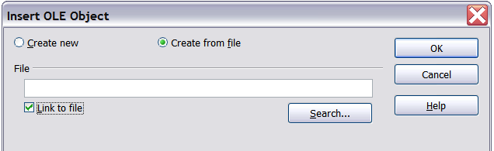Figure 27: Inserting an object as a link

Other OLE Objects
Under Windows, the Insert OLE Object dialog box has an extra entry, Further objects, as shown in Figure 26.
- Double-click on the entry Further objects to open the dialog shown below.
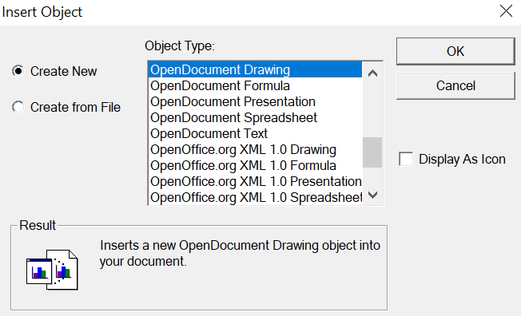
Figure 28: Inserting an OLE object under Windows
- Select Create New to insert a new object of the type selected in the Object Type list or select Create from File to create a new object from a file.
- If you choose Create from File, the dialog shown below opens. Click Browse and choose the file to insert. The inserted file object is editable by the Windows program that created it.
If you want to insert a link to an object instead of inserting an object, select the Display As Icon option.
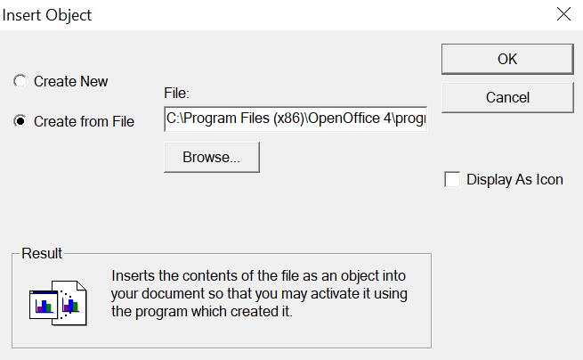
Figure 29: Insert object from a file

Non-linked OLE Object
If the OLE object is not linked, it can be edited in the new document. For instance, if you insert a spreadsheet into a Writer document, you can treat it as a Writer table (with a little more power). To edit it, double-click on it.

Linked OLE Object
When the spreadsheet OLE object is linked, if you change it in Writer, it will change in Calc; if you change it in Calc, it will change in Writer. This can be a very powerful tool if you create reports in Writer using Calc data and want to make a quick change without opening Calc.
Note | You can only edit one copy of a spreadsheet at a time. If you have a linked OLE spreadsheet object in an open Writer document and then open the same spreadsheet in Calc, the Calc spreadsheet will be a read-only copy.

Dynamic Data Exchange (DDE)
DDE is an acronym for Dynamic Data Exchange, a mechanism whereby selected data in document A can be pasted into document B as a linked ‘live’ copy of the original. It would be used, for example, in a report written in Writer containing time-varying data, such as sales results sourced from a Calc spreadsheet. The DDE link ensures that, as the source spreadsheet is updated, so is the report, thus reducing the scope for error and the work involved in keeping the Writer document up to date.
DDE is a predecessor of OLE. With DDE, objects are linked through file reference but not embedded. You can create DDE links within Calc cells in a Calc sheet or in Calc cells in another OpenOffice document, such as in Writer.

DDE Link in Calc
Creating a DDE link in Calc is similar to creating a cell reference. The process is a little different, but the result is the same.
- In Calc, select the cells that you want to make the DDE link to.
- Copy them using Edit > Copy or Ctrl+C.
- Go to the place in the spreadsheet where you want the link to be.
- Select Edit > Paste Special.
- When the Paste Special dialog opens, select the Link option on the bottom left of the dialog (Figure 30). Click OK.
The cells now reference the copied data, and the formula bar shows a reference beginning with {=DDE.
If you now edit the original cells, the linked cells will update.
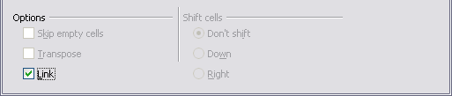
Figure 30: Location of Link option on Paste Special dialog in Calc

DDE Link in Writer
Creating a DDE link from Calc to Writer is similar to creating a link within Calc.
- In Calc, select the cells to make the DDE link to. Copy them.
- Go to the place in your Writer document where you want the DDE link. Select Edit > Paste Special.
- Select DDE Link (Figure 31). Click OK.
Now, the link has been created in Writer. When the Calc spreadsheet is updated, the table in Writer is automatically updated.
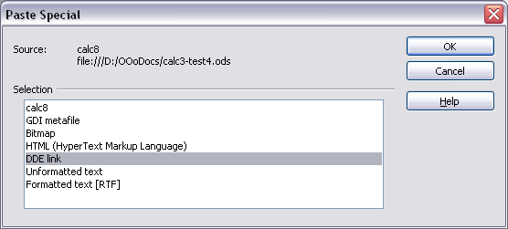Figure 31: Paste Special dialog in Writer, with DDE link selected

