
Impress Guide
Chapter 11
Setting Up and Customizing Impress

Copyright
This document is Copyright © 2007–2011 by its contributors as listed below. You may distribute it and/or modify it under the terms of either the GNU General Public License (http://www.gnu.org/licenses/gpl.html), version 3 or later, or the Creative Commons Attribution License (http://creativecommons.org/licenses/by/3.0/), version 3.0 or later.
All trademarks within this guide belong to their legitimate owners.
Authors
Peter Hillier-Brook Rachel Kartch Jared Kobos
Hazel Russman Jean Hollis Weber Michele Zarri
Feedback
Please direct any comments or suggestions about this document to: authors@documentation.openoffice.org
Publication date and software version
Published 13 May 2011. Based on OpenOffice.org 3.3.

Note for Mac users
Some keystrokes and menu items are different on a Mac from those used in Windows and Linux. The table below gives some common substitutions for the instructions in this chapter. For a more detailed list, see the application Help.
Windows/Linux | Mac equivalent | Effect
Tools > Options menu selection | OpenOffice.org > Preferences | Access setup options
Right-click | Control+click | Open context menu
Ctrl (Control) | z (Command) | Used with other keys
F5 | Shift+z+F5 | Open the Navigator
F11 | z+T | Open Styles & Formatting window

Contents
Copyright 2
Note for Mac users 2
Choosing options that affect all of OOo 4
User Data options 4
Print options 4
Color options 5
Appearance options 5
Choosing options for Impress 6
General options 6
Text objects section 7
New document section 7
Settings section 7
Start presentation section 7
Compatibility section 7
View options 8
Grid options 8
Grid section 8
Resolution section 8
Snap section 9
Snap position section 10
Print options 10
Customizing the user interface 11
Customizing the menu font 11
Customizing menu content 11
Creating a new menu 12
Modifying existing menus 12
Adding a command to a menu 13
Modifying menu entries 14
Customizing toolbars 14
Creating a new toolbar 15
Adding a command to a toolbar 15
Choosing icons for toolbar commands 16
Customizing keyboard shortcuts 16
Saving changes to a file 18
Loading a saved keyboard configuration 18
Resetting the shortcut keys 18
Running macros from key combinations 18
Adding functionality with extensions 18
Installing extensions 19
Using extensions 19
Oracle Presenter Console 20
Professional Template Pack II 20
Oracle Presentation Minimizer 20
Template Changer 20

Choosing options that affect all of OOo
This section covers some of the settings that apply to all the components of OpenOffice.org and are of most interest to users of Impress. Other general options are discussed in Chapter 2 (Setting Up OpenOffice.org) in the Getting Started guide.
- Click Tools > Options (OpenOffice.org > Preferences on a Mac). The list on the left-hand side of the Options – OpenOffice.org dialog box varies depending on which component of OOo is open. The illustrations in this chapter show the list as it appears when Impress is open.
- Click the expansion marker (+ or triangle) by OpenOffice.org on the left-hand side. A list of subsections drops down.
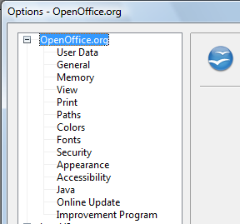
Figure 1: OpenOffice.org options
Note | The Back button has the same effect on all pages of the Options dialog box. It resets the options to the values that were in place when you opened OpenOffice.org.

User Data options
Impress uses the first and last name stored in the User Data page to fill in the Created by and Modified by fields in the document properties, the optional Author field often used in the footer of a presentation, and the name associated with comments. You will want to ensure that your name appears there. To do this:
- In the Options dialog box, click OpenOffice.org > User Data.
- Fill in the form on the OpenOffice.org – User Data page or delete any existing incorrect information.

Print options
On the OpenOffice.org – Print page, set the print options to suit your default printer and your most common printing method.
You can change these settings at any time, either through the Options dialog box or during the printing process (by clicking the Options button on the Print dialog box).
See Chapter 10 (Printing, e-mailing, exporting, and saving slide shows) for more about the options on this page.

Color options
On the OpenOffice.org – Colors page, you can specify colors to use in OOo documents. You can select a color from a color table, edit an existing color, and define new colors. These colors are stored in your color selection palette and are then available in all components of OOo. You can also define colors within Impress by choosing Format > Area on the menu bar, or through the Line and Filling toolbar, but those colors will not be available to other components of OOo.
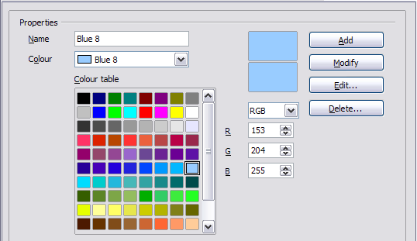Figure 2. Defining colors to use in color palettes in OOo

Appearance options
On the OpenOffice.org – Appearance page, you can specify which items are visible and the colors used to display various elements of the user interface.
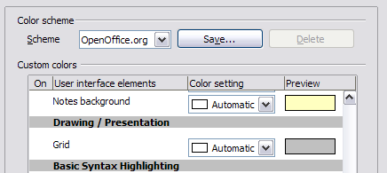
Figure 3. Changing the color of grid points in Impress and Draw
The only choice specific to Impress (and Draw) is the color of the grid points. Scroll down in the page until you find Drawing/Presentation.
To change the default color for grid points, click the down-arrow by the color and select a new color from the pop-up box.
If you wish to save your color changes as a color scheme, click Save, type a name in the Scheme box, then click OK.

Choosing options for Impress
In the Options dialog box, click the expansion marker to the left of OpenOffice.org Impress on the left-hand side. A list of subsections drops down.
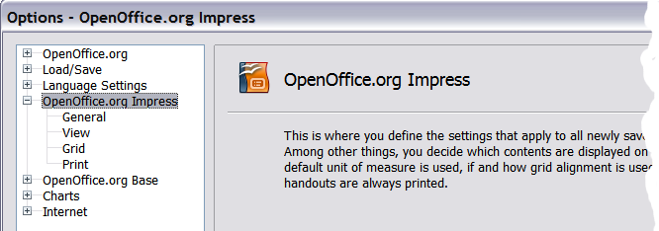Figure 4: Options for Impress

General options
In the Options dialog box, click OpenOffice.org Impress > General.
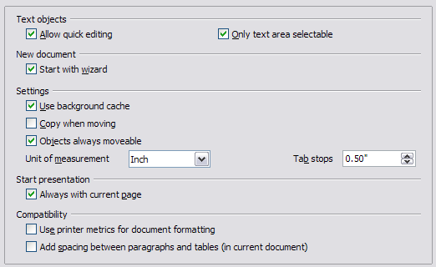
Figure 5: Specifying general options for Impress

Text objects section
Allow quick editing sets Impress to switch immediately to the text editing mode when you click a text object. You can also activate the text editing mode through the Allow Quick Editing icon on the Options toolbar.
Only text area selectable sets Impress to select a text frame when you click on text. In the area of the text frame that is not filled with text, an object behind the text frame can be selected. You can also activate this mode through the Select Text Area Only icon on the Options toolbar.

New document section
Start with Wizard sets Impress to start with the Presentation Wizard when creating a new presentation with File > New > Presentation or other methods.

Settings section
Use background cache sets Impress to use the cache for displaying objects on the master page. This setting speeds up the display. Unmark this box if you want Impress to draw the background every time you display a slide.
Copy when moving automatically creates a copy when you move, rotate or resize an object while holding down the Ctrl key (⌘ key for Mac). The original object will remain in its current position and size.
Objects always movable lets you move an object with the Rotate tool enabled. If this box is not marked, the Rotate tool can only be used to rotate an object.
Unit of measurement determines the unit of measurement for presentations.
Tab stops defines the spacing between tab stops.

Start presentation section
Always with current page specifies that a presentation starts with the current slide. Unmark this box to always start a presentation with the first page.

Compatibility section
The settings in this area are valid for the current document only.
Use printer metrics for document formatting applies printer metrics for printing and for formatting the display on the screen; some formatting will depend on the printer selection or default printer on your computer and may vary if the presentation is moved to a different computer. If this box is not checked, a printer-independent layout is used for screen display and printing.
Add spacing between paragraphs (in current document) calculates the paragraph spacing in Impress exactly as Microsoft PowerPoint does. Microsoft PowerPoint adds the bottom spacing of a paragraph to the top spacing of the next paragraph to calculate the total spacing between both paragraphs. Impress normally uses only the larger of the two spacings.

View options
In the Options dialog box, click OpenOffice.org Impress > View.
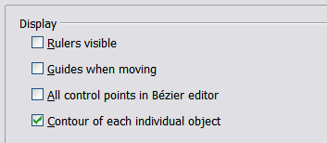
Figure 6: Specifying view options for Impress
Rulers visible displays the rulers at the top and the left of the work area.
Guides when moving displays dotted guides that extend beyond the box containing the selected object and which cover the entire work area, helping you position the object when moving it. You can also use the Guides when moving icon on the Options toolbar.
All control points in Bézier editor displays the control points of all Bézier points if you have previously selected a Bézier curve. If this box is not marked, only the control points of the selected Bézier points will be visible.
Contour of each individual object displays the contour line of each individual object when moving the object. This enables you to see if single objects conflict with other objects in the target position. If you do not mark this box, Impress displays only a square contour that includes all selected objects.

Grid options
The Grid page defines the grid settings for Impress. Using a grid helps you determine the exact position of your objects. You can also set this grid in line with the snap grid.
In the Options dialog box, click OpenOffice.org Impress > Grid.

Grid section
Snap to grid activates the “snap” function.
If you have activated the snap grid but wish to move or create individual objects without snap positions, you can press the Ctrl key to deactivate the snap grid for as long as needed.
Visible grid displays grid points on the screen. These points will not display or print as part of a presentation.

Resolution section
Here you can set the unit of distance for the spacing between horizontal and vertical grid points and subdivisions (intermediate points) of the grid.
Synchronize axes applies any changes to the Resolution or Subdivision settings to both axes.
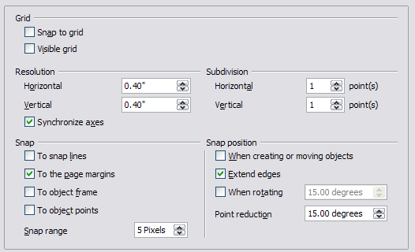
Figure 7: Specifying grid options for Impress

Snap section
A graphic object will be snapped (aligned with an existing reference point) if it is dragged within snap range of that point. Whether the distance is measured from the mouse pointer or from the edge of the object depends on the setting of Contour of each individual object in the View options page.
To snap lines snaps the edge of a dragged object to the nearest snap line when you release the mouse button. You can also use the Snap to Guides icon on the Options toolbar.
To the page margins aligns the contour of the graphic object to the nearest page margin. You can also use the Snap to Page Margins icon on the Options toolbar.
To object frame aligns the contour of the graphic object to the border of the nearest graphic object. You can also use the Snap to Object Border icon on the Options toolbar.
To object points aligns the contour of the graphic object to the points of the nearest graphic object. You can also use the Snap to Object Points icon on the Options toolbar.
Snap range defines the distance within which snapping occurs. Impress snaps to a snap point only if the mouse pointer (or the object contour) is nearer to that point than the distance selected in the Snap range box.

Snap position section
When creating or moving objects restricts graphic objects vertically, horizontally or diagonally (45°) when creating or moving them. You can temporarily deactivate this setting by pressing the Shift key.
Extend edges controls how a square or circle is drawn with the drawing tool. When the Extend edges box is marked, the sides of the square created when the Shift key is pressed before you release the mouse button will be equal to the longer side of the rectangle you have actually drawn. This also applies to the ellipse tool: when the Shift key is pressed before you release the mouse button a circle will be created based on the longest diameter of the ellipse. When the Extend edges box is not marked, a square or a circle will be created based on the shorter side or diameter.
When rotating restricts the rotation of graphic objects within the rotation angle that you select in the When rotating box. If you want to rotate an object outside of the defined angle, press the Ctrl key (Shift key on Mac) when rotating. Release the key when the desired rotation angle is reached.
Point reduction defines the angle for point reduction. When working with polygons, you might find it useful to reduce the number of editing points to make it easier to snap to a desired point.

Print options
In the Options dialog box, click OpenOffice.org Impress > Print.
See Chapter 10 (Printing, e-mailing, exporting, and saving slide shows) for more about the options on this page.
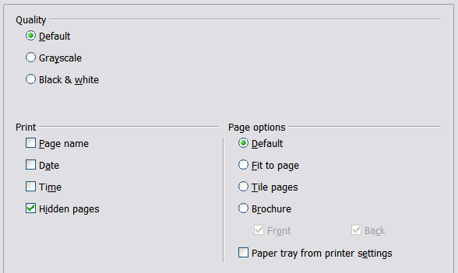
Figure 8: Specifying print options for Impress

Customizing the user interface

Customizing the menu font
If you want to change the menu font from that supplied by OOo to the system font for your operating system, do this:
- Choose Tools > Options > OpenOffice.org > View.
- Check Use system font for user interface and click OK.

Customizing menu content
You can customize menus: add and rearrange items on the menu bar, add items to menus, and make other changes.
- Choose Tools > Customize.
- On the Customize dialog box, pick the Menus page (Figure 9).
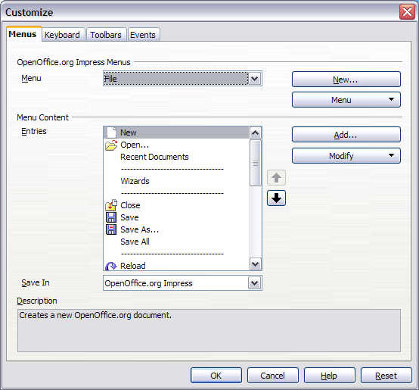Figure 9. The Menus page of the Customize dialog box
- In the Save In drop-down list, choose whether to save this changed menu for Impress or for a selected document (for example, MySlideShow.odp).
- In the section OpenOffice.org Impress Menus, select from the Menu drop-down list the menu that you want to customize.
- To customize the selected menu, click on the Menu or Modify buttons. You can also add commands to a menu by clicking on the Add button. These actions are described in the following sections. Use the up and down arrows next to the Entries list to move the selected menu item to a different position.
- When you have finished making all your changes, click OK to save them.

Creating a new menu
In the Menus page of the Customize dialog box, click New to display the dialog shown in Figure 10.
- Type a name for your new menu in the Menu name box.
- Use the up and down arrow buttons to move the new menu into the required position on the menu bar.
- Click OK to save.
The new menu now appears on the list of menus in the Customize dialog box. (It will appear on the menu bar itself after you save your customizations.)
After creating a new menu, you need to add some commands to it, as described in “Adding a command to a menu” on page 13.
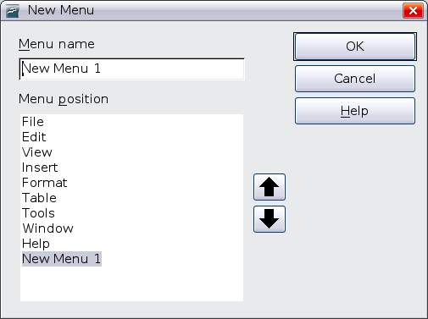Figure 10: Adding a new menu

Modifying existing menus
To modify an existing menu, select it in the Menu list and click the Menu button to drop down a list of modifications: Move, Rename, Delete. Not all of these modifications can be applied to all the entries in the Menu list. For example, Rename and Delete are not available for the menus supplied by OOo.
To move a menu (such as File), choose Menu > Move. A dialog box similar to the one shown in Figure 10 (but without the Menu name box) opens. Use the up and down arrow buttons to move the menu into the required position.
To move submenus (such as File | Send), select the main menu (File) in the Menu list and then, in the Menu Content section of the dialog, select the submenu (Send) in the Entries list and use the arrow keys to move it up or down in the sequence. Submenus are easily identified in the Entries list by a small black triangle on the right hand side of the name.
In addition to renaming, you can specify a keyboard shortcut that allows you to select a menu command when you press Alt+ an underlined letter in a menu command.
- Select a menu or menu entry.
- Click the Modify button and select Rename.
- Add a tilde (~) in front of the letter that you want to use as an accelerator. For example, to select the Save All command by pressing Alt+V (after opening the File menu using Alt+F), enter Sa~ve All.
Caution   | Be careful when using these shortcuts. In the example above, if the File menu is not already open, then pressing Alt+V opens the View menu; if some other menu is open, Alt+V might activate some other command.

Adding a command to a menu
You can add commands to the supplied menus and to menus you have created. In the Customize dialog box, select the menu in the Menu list and click the Add button in the Menu Content section of the dialog.
On the Add Commands dialog, select a category and then the command, and click Add. The dialog remains open, so that you can select additional commands. When you have finished adding commands, click Close. Back in the Customize dialog box, you can use the up and down arrow buttons to arrange the commands in your preferred sequence.
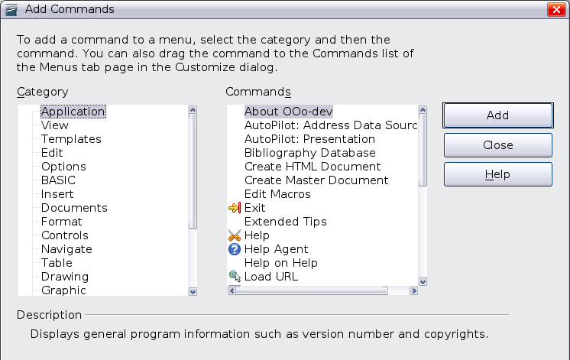
Figure 11: Adding a command to a menu

Modifying menu entries
In addition to changing the sequence of entries on a menu or submenu, you can add submenus, rename or delete the entries, and add group separators.
To begin, select the menu or submenu in the Menu list near the top of the Customize page, then select the entry in the Entries list under Menu Content. Click the Modify button and choose the required action from the drop-down list of actions. Most of the actions should be self-explanatory. Begin a group adds a separator line after the highlighted entry.

Customizing toolbars
You can customize toolbars in several ways, including choosing which icons are visible, and locking the position of a docked toolbar, as described in Chapter 1 (Introducing OpenOffice.org) of the Getting Started guide. This section describes how to create new toolbars and add other icons (commands) to the list of those available on a toolbar.
To get to the toolbar customization dialog, do any of the following:
- On the toolbar, click the arrow at the end of the toolbar and choose Customize Toolbar.
- Choose View > Toolbars > Customize from the menu bar.
- Choose Tools > Customize > Toolbars tab from the menu bar.
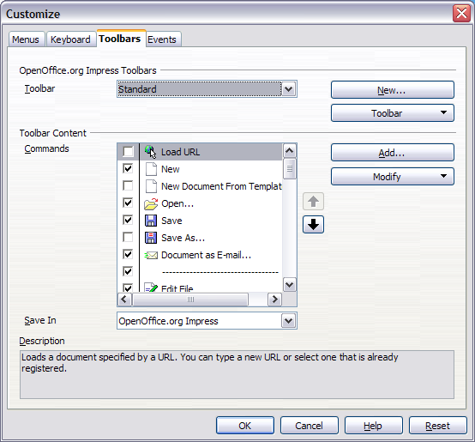Figure 12. The Toolbars page of the Customize window
To customize toolbars:
- In the Save In drop-down list, choose whether to save this changed toolbar for Impress or for a selected document.
- In the OpenOffice.org Impress Toolbars section, select from the Toolbar drop-down list the toolbar that you want to customize.
- Click the Toolbar button on the right to display a drop-down list of choices.
- To display or hide commands, select or deselect the checkboxes in the Toolbar Content – Commands section.
- To change the position of commands on a toolbar, select a command and click the big up and down arrows to the right of the lists.
- You can create a new toolbar by clicking on the New button, or customize existing toolbars by clicking on the Toolbar or Modify buttons, and add commands to a toolbar by clicking on the Add button. These actions are described below.
- When you are done customizing toolbars, click OK to save your changes.

Creating a new toolbar
To create a new toolbar:
- Choose Tools > Customize > Toolbars from the menu bar.
- Click New. In the Name dialog, type the new toolbar's name and choose from the Save In drop-down list where to save this changed menu: for Impress or for a selected document.
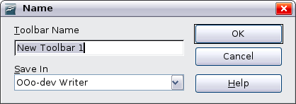
Figure 13: Dialog box used to create a new toolbar
The new toolbar now appears on the list of toolbars in the Customize dialog box. After creating a new toolbar, you need to add some commands to it, as described below.

Adding a command to a toolbar
If the list of available buttons for a toolbar does not include all the commands you want on that toolbar, you can add commands.
- On the Toolbars page of the Customize dialog box, select the toolbar in the Toolbar list and click the Add button in the Toolbar Content section of the dialog.
- The Add Commands dialog is the same as for adding commands to menus. Select a category and then the command, and click Add. The dialog remains open, so you can select additional commands. When you have finished adding commands, click Close. If you insert an item which does not have an associated icon, the toolbar will display the full name of the item; the next section describes how to choose an icon for a toolbar command.
- Back on the Customize dialog box, you can use the up and down arrow buttons to arrange the commands in your preferred sequence.
- When you are done making changes, click OK to save.

Choosing icons for toolbar commands
Toolbar buttons usually have icons, not words, on them, but not all of the commands have associated icons.
To choose an icon for a command, select the command and click Modify > Change icon. On the Change Icon dialog, you can scroll through the available icons, select one, and click OK to assign it to the command.
To use a custom icon, create it in a graphics program and import it into OOo by clicking the Import button on the Change Icon dialog. Custom icons must be 16 x 16 or 26 x 26 pixels in size and cannot contain more than 256 colors.
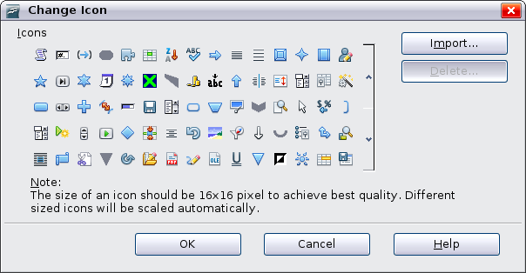Figure 14: Change Icon dialog

Customizing keyboard shortcuts
The Appendix to this book lists the default keyboard shortcuts supplied with Impress. You can change these defaults or add new shortcuts. You can assign shortcuts to standard Impress functions or your own macros and save them for use with Impress only, or with the entire OpenOffice.org suite.
Caution | Be careful when reassigning your operating system’s or OOo’s predefined shortcut keys. Many key assignments are universally understood shortcuts, such as F1 for Help, and are always expected to provide certain results. Although you can easily reset the shortcut key assignments to the OOo defaults, changing some common shortcut keys can cause confusion, frustration and possible data loss or corruption, especially if other users share your computer.
As an example, suppose you wish to assign a shortcut key to easily insert a duplicate slide in your presentation. You could assign the Insert key as a logical shortcut for this purpose, as described below:
- Choose Tools > Customize.
- On the Customize dialog box, pick the Keyboard page (Figure 15).
- As the shortcut key assignment is only relevant with Impress, and not OpenOffice.org in general, select the Impress button (at the upper right corner of the Keyboard tab).
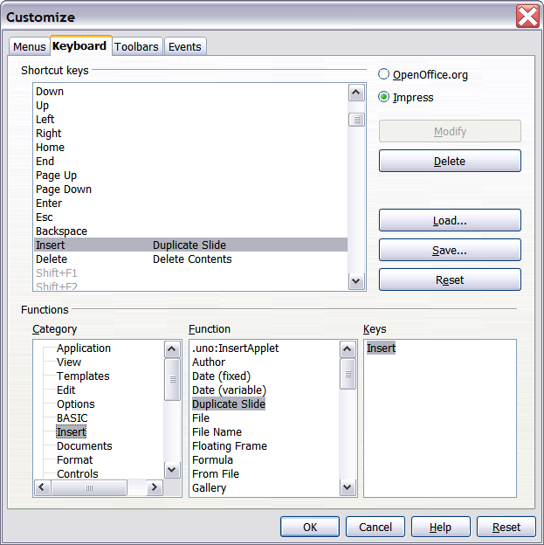
Figure 15: Customizing keyboard shortcuts
- Next select Insert in the Category list and Duplicate Slide in the Function list.
- Now select the shortcut key Insert in the Shortcut keys list and click the Modify button at the upper right.
- Click OK to accept the change. Now the Insert shortcut key will insert a duplicate slide immediately after the currently selected slide.
Note | - All existing shortcut keys for the currently selected Function are listed in the Keys selection box. Since there was no currently assigned shortcut for the Insert > Duplicate Slide function the Keys list was empty. If it had not been, and you wished to reassign a shortcut key combination that was already in use, you would first have had to Delete the existing Key.  - Shortcut keys that are greyed out in the listing on the Customize dialog box, such as F1 and F10, are not available for reassignment.

Saving changes to a file
Changes to the shortcut key assignments (and other configurations) can be saved in a keyboard configuration file for use at a later time, thus permitting you to create and apply different configurations as the need arises. To save keyboard shortcuts to a file:
- After making your keyboard shortcut assignments, click the Save button near the bottom right of the Customize dialog box.
- In the Save Keyboard Configuration dialog box, select All files from the Save as Type list.
- Next enter a name for the keyboard configuration file in the File name box, or select an existing file from the list. If you need to, browse to find a file from another location.
- Click Save. A confirmation dialog box will appear if you are about to overwrite an existing file; otherwise there will be no feedback and the file will be saved.

Loading a saved keyboard configuration
To load a saved keyboard configuration file and replace your existing configuration, click the Load button near the bottom right of the Customize dialog box, and then select the configuration file from the Load Keyboard Configuration dialog box.

Resetting the shortcut keys
To reset all of the keyboard shortcuts to their default values, click the Reset button beneath the Save button on the right side of the Customize dialog box. Use this feature with care as no confirmation dialog box will be displayed; the defaults will be set without any further notice or user input.

Running macros from key combinations
You can also define shortcut key combinations that will run macros. These shortcut keys are strictly user-defined; none are built in. For information on macros, see Chapter 13 (Getting started with macros) in the Getting Started guide.

Adding functionality with extensions
An extension is a package that can be installed into OpenOffice.org to add new functionality.
Although individual extensions can be found in different places, the official OpenOffice.org extension repository is at http://extensions.services.openoffice.org/. Some extensions are free of charge; others are available for a fee. Check the descriptions to see what licenses and fees apply to the ones that interest you.

Installing extensions
To install an extension, follow these steps:
- Download an extension and save it anywhere on your computer.
- In OOo, select Tools > Extension Manager from the menu bar. In the Extension Manager dialog box (Figure 16), click Add.
- A file browser window opens. Find and select the extension you want to install and click Open. The extension begins installing. You may be asked to accept a license agreement.
- When the installation is complete, the extension is listed in the Extension Manager dialog.
Tip | To get extensions that are listed in the repository, you can open the Extension Manager and click the Get more extensions here link.
Note | To install a shared extension, you need write access to the OpenOffice.org installation directory.
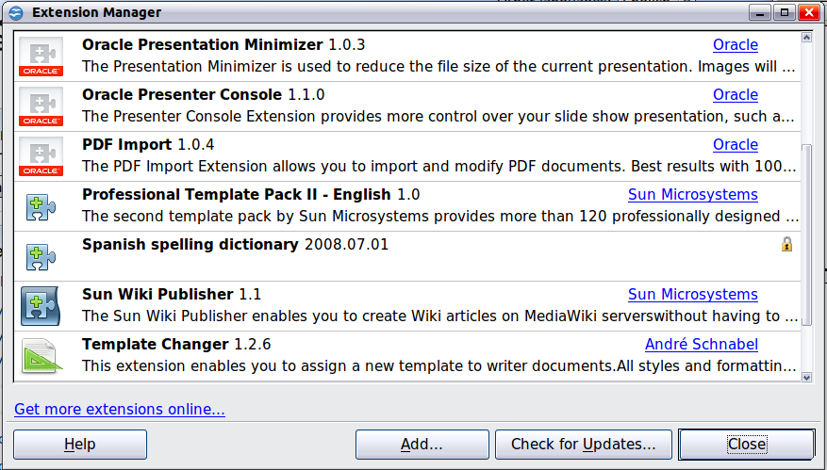
Figure 16: The Extension Manager

Using extensions
This section describes some of the more important and popular extensions to Impress. In each case, you need to first install the extension as described in the previous section.

Oracle Presenter Console
Provides extra control over slide shows (presentations); for example, the presenter has the ability to see the upcoming slide, the slide notes, and a presentation timer—while the audience sees only the current slide. The Presenter Console displays the elements in three easily changeable views:
- The first view displays the current slide, including the effects, and the upcoming slide.
- The second view shows the speaker's notes in large, clear, and scalable type, plus the current and upcoming slide.
- The third view is a slide sorter view with the slide thumbnails.
From Oracle Corp. Open source.
Note | The Presenter Console works only on an operating system that supports multiple displays.

Professional Template Pack II
Provides more than 120 templates for Writer, Calc, and Impress. Available in several languages. After you have installed this extension, you will find the templates under File > New > Templates and Documents. Open source.

Oracle Presentation Minimizer
Reduces the file size of the current presentation. Images are compressed, and data that is no longer needed is removed. Can optimize the image quality size. Presentations designed for screen or projector do not require the same high quality as presentations designed for print. From Oracle Corp. Open source.

Template Changer
Adds two new items to the File > Templates menu that allow you to assign a new template to the current document or to a folder of documents (Impress has only the menu item for assignment to a folder of documents). All styles and formatting will be loaded from that template and the document will behave as if it were created using that template. Open source.

