Chapter 9
Working with Graphics

Introduction
Tables in Apache OpenOffice (AOO) are a useful way to organize and present large amounts of information, for example:
- Technical, financial, or statistical reports
- Product catalogs showing descriptions, prices, characteristics, and photographs of products
- Bills or invoices
- Lists of names with address, age, profession, and other information
Tables can often be used to organize materials, as an alternative to spreadsheets . A well-designed table can help readers understand better what you're trying to say. While you would normally use tables for text or numbers, you can also include other objects, such as pictures, in a table's cells.
Tables can also be used as a page-layout tool; instead of using several Tab characters to position text in areas of a document, tables can do the job. For example, the descriptions under Error: Reference source not found were created in a table with invisible borders. Another, perhaps better, example would be using tables in this fashion in headers and footers to support independent positioning of elements like page number, document title etc. This use of tables is described in detail in Chapter 4 (Formatting Pages).

Creating a Table
Before you insert a table into a document, have an idea of the visual result you're after, as well as an estimate of the number of rows and columns required. Every parameter can be changed; however, thinking ahead can save a lot of time, since changes to fully formatted tables often require significant effort.

Inserting a New Table
To insert a new table, position the cursor where you want the table to appear, then use any of the following methods to open the Insert Table dialog box:
- From the main menu, choose Table > Insert > Table.
- Press Control+F12.
- From the Standard toolbar, click the Table icon
Here you can specify the properties for the new table.
Under Name, you can enter a different name than the AOO-generated default for the table. This might come in handy when using the Navigator to jump to a table quickly.
Under Size, specify the initial number of columns and rows for the new table. You can change either of these later, if necessary.
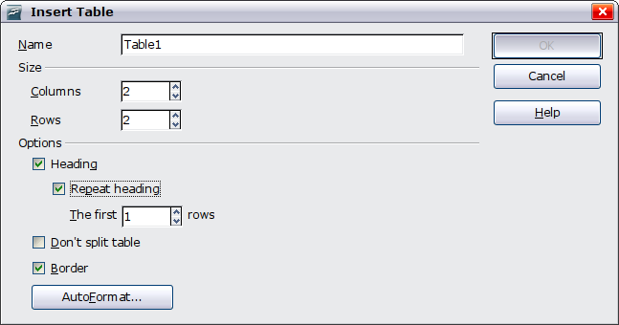Figure 1: Inserting a new table using the Insert Table dialog box
Under Options, set up the initial table characteristics. Selecting the options in this section of the dialog produces the following results:
- Heading — Defines the first row(s) in the table as headings. The default Table Heading paragraph style is applied to the heading rows and thus makes the text centered, bold, and italic. You can edit the AOO-predefined Table Heading paragraph style in the Styles and Formatting deck of the Sidebar to change these default settings. When splitting a table into two tables, the Heading row(s) are copied in the second table.
- Repeat heading — Repeats the heading row(s) of the table at the top of subsequent pages if the table spans more than one page.
- The first … rows —Specifies the number of rows to be repeated. The default is 1.
- Don’t split table — Prevents the table from spanning more than one page. This can be helpful if the table starts near the end of a page, and would look better if it were completely located on the following page. If the table becomes longer than would fit on one page, you will need to either deselect this option or manually split the table.
- Border — Surrounds each cell of the table with a border. This border can be modified or deleted later.
The AutoFormat button opens a dialog box from which you can select one of the many predefined table layouts. See “Automatic Formatting of Tables” on page 20 for more information.
After making your choices, click OK. Writer creates a table as wide as the text area (from the left page margin to the right page margin), with all columns the same width and all rows the same height. You can adjust columns and rows later to suit your needs.
Tip | To directly insert a table with the default properties, click on the little arrow next to the Table icon on the Standard toolbar. A graphic appears where you can choose the table’s size (rows and columns). To create the table, click on the cell that you want to be on the last row of the last column. Holding down the mouse button over the Table icon will also display the graphic.

Creating Nested Tables
You can create tables within tables, nested to a depth only limited by imagination and practicality. Error: Reference source not found demonstrates a simple, two-level example.
To achieve this, simply click in a cell of an existing table and use any of the methods mentioned in “Error: Reference source not found” above.
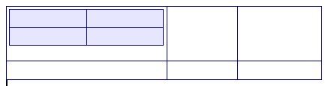Figure 2: Nested table example. The shaded table is nested in a cell of the larger table.

Using AutoCorrect to Create a Table
You can also create a table by typing a series of hyphens (-) or tabs separated by plus signs. Use the plus signs to indicate column dividers, while hyphens and tabs are used to indicate the width of a column.
For example, this character sequence:
+-----------------+---------------+------+
creates a table like this:
Note | This function can be disabled or enabled in Tools > AutoCorrect. On the Options tab, deselect or select Create table.
Caution   | When using tabs instead of a table to line up your data, always make sure that you know how wide they are set, and remember that default tabs may be different when the document is displayed on a different computer, or even when copying the same data in a new document.

Create a Table from Formatted Text
It is possible to create a table from plain text by means of the Table > Convert > Text to Table menu. In order for this command to work effectively, the starting text needs to have clear demarcation between what will become the columns of the table. Paragraph marks indicate the end of a row.
To convert text to a table, start by selecting the text you want to convert and choose Table > Convert > Text to Table to open the dialog shown in Error: Reference source not found.
In the top part of the dialog, select the symbol that separates the columns. This would normally be a tab, but it could be a semicolon or comma if you are importing a CSV file. The other options in this dialog are the same as those in the dialog used to insert a table shown in Error: Reference source not found.
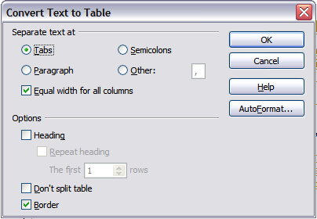Figure 3: Dialog box to configure the text to table conversion

Example
In this example we will convert the following text into a table.
Row 1 Column 1; Row 1 Column 2; Row 1 Column 3
Row 2 Column 1; Row 2 Column 2; Row 2 Column 3
In this case, the separator between elements is a semicolon. By selecting the text and applying the conversion, we obtain the following result.
Row 1 Column 1 | Row 1 Column 2 | Row 1 Column 3
Row 2 Column 1 | Row 2 Column 2 | Row 2 Column 3
Note that, unlike creating a table with other mechanisms, conversion from text to table preserves the paragraph style applied to the original text.
You can also use the Convert menu to perform the opposite operation; that is, to transform a table into plain text. This may be useful when you want to export the table contents into a different program.
To transform a table into text, place the cursor anywhere in the table, choose Table > Convert > Table to Text in the main menu, pick the preferred row separator, and click OK to finish.

Formatting the Table Layout
Formatting a table is, generally speaking, a two-step process: formatting of the table layout (the subject of this section) and formatting of the table text (the subject of the next section).
Formatting the layout normally involves one or more of the following operations: adjusting the size of the table and its position on the page, adding or removing rows or columns, merging and splitting individual cells, changing borders and background.

Default Parameters
If you create a table using the Insert Table dialog box or the Table icon on the Standard toolbar and activate the Heading option, the following defaults are set:
- The cells in the heading row (or rows) use the Table Heading paragraph style. In the default template, the text is centered and set with a bold and italic font.
- The remaining cells use the Table Contents paragraph style, which, in the default template, is identical to the Default paragraph style.
- The default table occupies all the space from margin to margin (text area).
- The default table has thin black borders around each cell (grid).

Resizing and Positioning the Table
Using the default settings, any newly created table will occupy the entire width of the text area. This is sometimes what you want, or you may prefer a smaller table. To quickly resize a table, first move the mouse to either the left or right edge. When the cursor changes shape into a double arrow, drag the border to the new position. This operation only changes the size of the first or last column; it does not change the alignment of the table on the page.
If you need more precise control over the size and position of the table on the page, open the Table Format dialog box by choosing Table > Table Properties or by right-clicking anywhere in the table and choosing Table from the pop-up menu. Select the first page of the dialog box (Table).
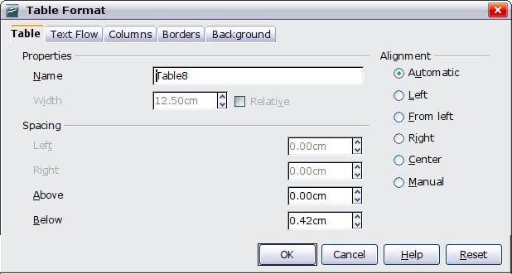
Figure 4: The Table page of the Table Format dialog box
On this page you can set the alignment of the table, choosing from the following options:
- Automatic: the default setting for a table.
- Left: aligns the table with the left margin.
- Right: aligns the table with the right margin.
- From Left: lets you specify under Spacing exactly how far from the left margin the table is placed.
- Center: aligns the table in the middle between the left and right margins. If the table width is greater than the margin, the table will extend outside the margins.
- Manual: lets you specify the distances from both left and right margins under Spacing.
Selecting an alignment option other than Automatic activates the Width field in the Properties section, where you can enter the desired size of the table. Select Relative to see the width as percentage of the text area.
In the Spacing section, use the Above and the Below boxes to modify the separation between the text and the table. When the size of the table is less than the size of the text area, AOO will insert some values in the Left and Right boxes. You can only change both values if you select Manual alignment, and you can change the Left box value only when you select the From Left alignment. Note that the sum of the table width, and the values in the Left and Right boxes, needs to equal the width of the text area.

Resizing Rows and Columns
You can adjust the height of rows and the width of columns in a table in several ways.
- Move the mouse next to the edge of the cell and when a double-headed arrow appears, click and hold the left mouse button, drag the border to the desired position, and release the mouse button.
- On the horizontal ruler, column dividers are marked by a pair of thin gray lines; the vertical ruler indicates row dividers in the same way. You can resize a row or column by holding the mouse button down on the appropriate divider and dragging it to the desired location.
- Use the keyboard as described below.
Selecting Table > Autofit from the main menu also offers resizing options:
- The Optimal Column Width or Optimal Row Height options make the selected columns or rows as narrow as possible while still fitting their contents.
- Selected columns and rows can be distributed evenly to quickly bring them back to all being the same width or height.
For greater control over the width of each column, use the Columns tab of the Table Format dialog box.
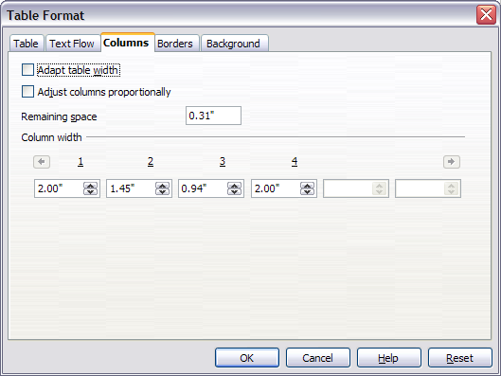Figure 5: Table Format dialog box: Columns page
Right-click on the table and choose Table from the pop-up menu or choose Table > Table Properties from the menu bar. On the Table Format dialog box, select the Columns tab.
- Adapt table width: If a table already stretches to the page margins, it cannot stretch any wider, and the Adapt table width option is not available. If the table is narrower, increasing the width of a column will increase the width of the whole table.
If the table width already extends pasts the margins with the Adapt table width option checked, attempting to change a column width will automatically decrease that column’s size so that the table will now shrink to the page margins while keeping any other column sizes intact.
- Adjust columns proportionally results in all columns changing their widths by the same percentage when one is changed. For example, if you reduce by half the size of a column, all the other columns sizes will be halved.
- Remaining space shows how much further the table can expand before hitting the limit of the margins. This value cannot be edited and will not be negative in the event that the table width is already larger than the space between the left and right margins.
- Under Column width, each individual column can be adjusted. If you have more than six columns, use the arrows at the right and left to view them all.
Rather than start from the Table Format dialog box, it is often more efficient to make rough adjustments to a new table using the mouse, and then fine tune the layout using the Columns page in conjunction with the Table page of the Table Format dialog box.
It is also possible to resize a table using only the keyboard; this is sometimes easier than using the mouse.
- Place the cursor on the cell whose size you want to change.
- Press and hold the Alt key while using the arrow keys to change the size.
To adjust the resizing parameters and behavior for keyboard handling, choose Tools > Options > OpenOffice Writer > Table.
Use the Row and Column values in the Move cells section to determine the amount of change produced by a single keystroke while resizing. In the Behavior of rows/columns section you can choose one of the following three strategies when resizing:
- Fixed: select this if you want the resizing to only affect the adjacent cell, and not the entire table. The width of the table does not change when resizing its cells.
- Fixed, proportional: when resizing a cell with this option selected, all the other cells are also resized proportionally, Also in this case the width of the table remains constant.
- Variable: this is the default value. Resizing a cell affects the table size. For example, when you widen a cell, the width of the table increases.

Inserting Rows and Columns
To insert any number of rows or columns:
- Place the cursor in the row or column where you want to add new rows or columns and right-click.
- On the pop-up menu, choose Row > Insert or Column > Insert. This will display a dialog box where you can select the number of rows or columns to add, and whether they appear before or after the selected one.
- Set Amount to the number of rows or columns to insert, and Position to Before or After.
- Click OK to close the dialog box.
Note | Clicking on the Insert Row icon on the Table toolbar inserts one row below the selected one. Clicking on the Insert Column icon on the Table toolbar inserts a column after (to the right of) the selected one.  Regardless of how they are inserted, new rows or columns have the same formatting as the row or column where the cursor was when the insert command was issued.

You can also quickly insert a row or a column using only the keyboard:
- Place the cursor in the row or column next to the row or column you want to insert.
- Press Alt+Insert to activate keyboard handling.
- Use the arrow keys as desired to add a row or column:
Left to insert a new column to the left of the cell where the cursor is located.
Right to insert a new column to the right of the cell where the cursor is.
Down to insert a new row below the cell where the cursor is.
Up to insert a new row above the cell where the cursor is.

The above keyboard technique can also be used to delete rows or columns by substituting the Alt+Insert keystroke combination in Step 2 with Alt+Delete.

Merging and Splitting Cells
To merge a group of cells into one cell:
- Select the cells to merge.
- Right-click and choose Cell > Merge on the pop-up menu, or choose Table > Merge Cells from the menu bar.
To split a cell into multiple cells:
- Position the cursor inside the cell.
- Right-click and choose Cell > Split on the pop-up menu, or choose Table > Split Cells from the menu bar.
- Select how to split the cell. A cell can be split either horizontally (create more rows) or vertically (create more columns), and you can specify the total number of cells to create.
It is generally a good rule to merge and split cells after completing other layout formatting. This is because some operations such as deleting a column or a row may produce a result difficult to predict when applied to a table with merged or split cells.

Specifying Table Borders
On the Table Format dialog box, select the Borders tab.
With this tab, you can set borders for a whole table or groups of cells within a table. In addition, a shadow can be set for the entire table.
Borders have three components: where they go, what they look like, and how much space is left around them.
- Line arrangement specifies where the borders go. If a group of cells is selected, the border will be applied only to those cells. You can specify individually the style of the border for the outside edges of the selected cells as well as for the cell divisions. Writer provides five default arrangements, but you can just as easily click on the line you want to customize in the User-defined area to get exactly what you want. When multiple cells are selected, the User-defined area allows you to select the edges of the selection as well as the cell dividers. By clicking at the intersection of the lines, you can modify multiple borders simultaneously. For example, in Error: Reference source not found the right edge and horizontal separators are modified with a single operation.
Note | When the selected cells have different styles of border the User-defined area shows the border as a gray line. You can click on the gray line to choose a new border style (first click), leave the border as it is (second click) or delete the border (third click).
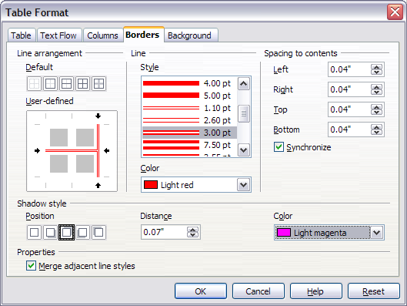Figure 6: Table Format dialog box: Borders page
- Line specifies what the border looks like: the style and color. There are a number of different styles and colors to choose from. The Line Style and Color will apply to those borders highlighted by a pair of black arrows in the User-defined map on the left-hand side of the dialog box.
- Spacing to contents specifies how much space to leave between the border and the cell contents. Spaces can be specified to the left, right, above, and below. Check Synchronize to have the same spacing for all four sides. This spacing is like a padding, and it is not factored in when calculating the text measurements.
- Shadow style properties always apply to the whole table. A shadow has three components: where it is, how far from the table it is cast, and what color it is.
- If Merge adjacent line styles is checked, two cells sharing a common border will have their borders merged, rather than being side by side.
Tip | To reset everything if you are having problems with borders, right-click in the table and choose Table or choose Table > Table Properties from the menu bar. On the Borders tab, select the Set No Borders icon under Line arrangement: Default (the box on the left).

Selecting Background Colors and Graphics
A table background can greatly improve the readability of the data, visually highlight important parts of the table (such as the heading or a specific cell), or just make the table more appealing. You can choose between two types of background when formatting the table: solid color or graphic. The background can be applied to the whole table, to a single cell, or to a row. The background selected for a cell will be in front of, that is layered over, the row background; in similar fashion, the row background will hide the table background.
The row background option is quite handy when you want to create alternate color rows or assign a different background to the heading of the table. The tables in this guide adopt this technique.
To set the background for a cell, row, or table:
- Place the cursor anywhere inside the cell, row or table you want to work with. If you want to apply a background to a group of cells, select the group.
- Right-click and choose Table from the pop-up menu, or choose Table > Table Properties from the main menu.
- In the Table Format dialog box, select the Background tab.
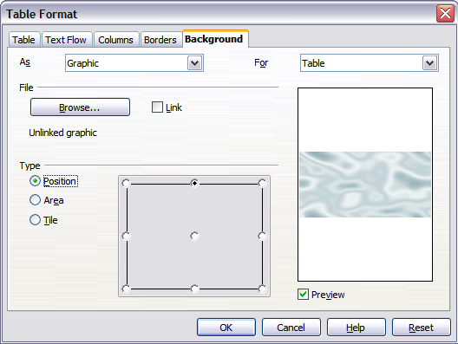Figure 7: Table Format dialog: inserting a graphic background
- In the For section, choose whether to apply the settings to cell, row, or table.
  - If you choose Cell, changes apply only to the selected cells, or the cell where the cursor currently resides. Even when selecting a group of cells, the background settings are applied to each cell individually.
  - If you choose Row, changes affect the entire row where the cursor resides.
  - If you choose Table, changes will set the background for the entire table, regardless of the cursor position or selected cells.
- In the As section, choose whether the background is a color or a graphic.
To apply a color, select the color and click OK. Remember that you can add custom colors by choosing Tools > Options > Colors.
To apply a graphic:
  - First select the graphic from your computer’s file system with the Browse button. (Writer supports numerous graphics formats.)
  - You can use the Link option to link the graphic file. If it is linked, changes to the graphic (for example, if you edit it in a different software package) are reflected in your document. However, you also need to keep the linked graphic file with the document file. If, for example, you email the document without the graphic file, the graphic will no longer be visible.
  - Under Type, select the type of placement for the graphic.
    - If you choose Position, you can select in the position map where the graphic will be displayed in the selected area.
    - If you choose Area, the graphic is stretched to fill the whole area.
    - If Tile, the graphic is tiled (repeated horizontally and vertically) to fill the area.
- If the Preview option is checked, the graphic displays in the pane on the right.
- To apply the graphic, click OK.
Error: Reference source not found shows an example of a table set with a background image, and the first row background colored. As you can see, the row background, by virtue of being superimposed on the row, covers the table background for that row.
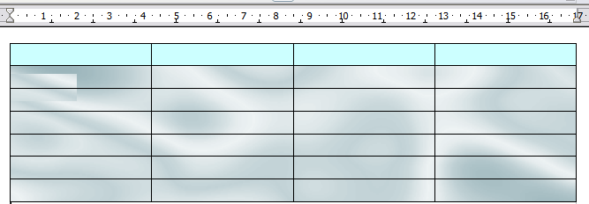
Figure 8: Example of table with different row and table backgrounds

Displaying or Hiding Table Boundaries
A table boundary is a set of pale (usually gray) lines around the cells when viewed on-screen in AOO. These boundaries are not printed; their only function is to help you see where the table cells are.
To display the table the same way on the screen as on the printed page, with no boundary lines, right-click on the table and choose Table Boundaries from the pop-up menu. Repeat this to have the boundaries appear again.
Note | Turning boundaries off does not hide the borders that the table may have.

Tip | You can also turn table boundaries on and off through Tools > Options > OpenOffice > Appearance. On that page, you can display or hide boundaries around text, pages headers and footers, figures, and other parts of a document.

Formatting the Table Text
Once the table layout is satisfactory, you can move on to formatting text in the individual cells. You can apply manual formatting as with any other paragraph in the text, but it's highly recommended, for the sake of consistency and ease of maintenance, that you define your own paragraph and character styles.
Besides the paragraph and character styles, there are other aspects to consider when placing text in a table cell; Always be aware of such factors as text flow, alignment and orientation.
You can format each cell independently of other cells, or you can simultaneously format a group of cells by selecting them before applying the desired formatting.

Specifying Text Flow
On the Text Flow page of the Table Format dialog box (Error: Reference source not found), you can:
- Insert a page or column break either before or after the table. Use the Text Flow: Break option, combined with the Page or Column and the Before or After buttons.
If you insert a page break before the table (that is, start the table on a new page), you can also change the page style that will go with it by checking the With Page Style box and selecting a new page style. As with any page break, you can also reset the page numbers using the Page number box.
- Keep a table on one page by deselecting the Allow table to split across pages and columns option. If this item is deselected, the next item is not active.
- Keep each row on one page by deselecting the Allow row to break across pages and columns option.
- Use the Keep with next paragraph option to keep the table and an immediately following paragraph together, should you have inserted a page break.
- Use the Repeat heading option, and its associated numbers box, to select the number of table heading rows that will be repeated on each page. A complicated table may need two or three heading rows to be easily read and understood.
- Use the Text direction list to select the direction for the text in the cells. The most common setting is Left to right, the norm for Western languages.
Note | The phrase Use superordinate object settings shown in Error: Reference source not found means “use the formatting settings from the paragraph before the table”.

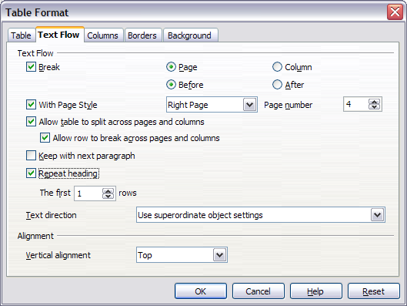Figure 9: Table Format dialog box: Text Flow page
- Select the vertical alignment of the text in the table or the selected cells; the choices are to align with the top of the cell, the center of the cell, or the bottom of the cell. This alignment is in addition to the Left-Right alignment options available on the Table page of the Table Format dialog box.
Note | A table heading row cannot span two pages, but any other row can. A one-row table (often used for page layout purposes), if set up with the default of including a heading, will not break across pages. One solution to this seeming puzzle is to make sure the table is defined without a heading row.

Vertical Alignment
By default, text entered into a table is aligned to the top-left of the cell. You can change the default for the entire table, as described above, or for individually selected cells.
To vertically align the text in specific cells:
- Place the cursor in the cell you wish to change, or click and drag to select multiple cells.
- Right-click in the selected area and choose Cell > Center, Top, or Bottom in the pop-up menu to vertically align the text as desired.

Number Formats
The number format can be set for a whole table or group of cells. For example, cells can be set to display in a particular currency, to four decimal places, or in a particular date format.
Number recognition specifies that numbers in a text table are recognized and formatted as numbers. If number recognition is selected, numbers are automatically bottom-right aligned. The Number recognition option can be enabled under Tools > Options > OpenOffice Writer > Table or by right-clicking on the table and selecting Number Recognition.
Select the cells to format, then right-click and choose Number Format from the pop-up menu. The Number Format dialog box opens that allows you to set options for various categories of numerical data.
- In the Category list, select the category you want, such as currency, date, or text.
- In the Format list, choose a format for the category you just selected.
- For some categories, such as date, you may wish to change the language using the Language list while for other numerical categories the Options section of the dialog box allows you to customize the appearance.
Tip | You will notice that AOO displays the formatting code for the category and format selected in the Format Code section at the bottom of the dialog box. For example, if you select a date format such as 31 Dec 1999 the corresponding code is D MMM YYYY. As you become more experienced with AOO, you can easily customize this formatting code, and even create new user-defined codes.

Rotating Text in a Table Cell
You can rotate text in a table cell by 90 or 270 degrees. Text rotation is useful when you have long headings for narrow columns.
- Select the text to be rotated and then choose Format > Character.
- On the Position page, in the Rotation / scaling section, choose the rotation angle and click OK.
Error: Reference source not found shows a sample table with rotated headings.
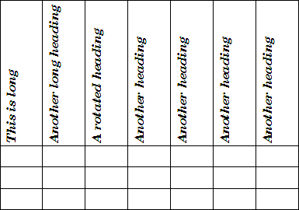
Figure 10: A table with rotated headings
Note | Text rotation within table cells can also be achieved with the use of paragraph styles, discussed in greater detail in Chapter 7 (Working with Styles).

Data Entry and Manipulation in Tables

Moving Between Cells
Within a table, you can use the mouse, the cursor keys, or the Tab key to move between cells.
The cursor keys move to the next cell only if there is no text in the way. For example, pressing the right cursor key will move the cursor to the right within the text in the current cell, then to the next cell.
The Tab key moves directly to the next cell and, if the cursor is in the last cell in the table, creates a new row. Pressing Shift+Tab moves the cursor back a cell.
Tip | To enter a Tab character as part of the text of the cell, press the Control and Tab keys at the same time.

Sorting data in a table
Just as in a spreadsheet, Writer allows data in a table to be sorted. Up to three levels of sorting can be specified (for example, sort first by age numerically, then alphabetically by name within each age).
To sort data in a table:
- Select the table (or part of the table) to be sorted.
- From the menu bar, choose Table > Sort.
- In the Sort dialog box:
  - Decide whether you want to sort in the direction of rows or columns. The default sorting direction is by rows, which results in sorting the data in a column.
  - Select up to three keys to sort on, in the correct order.
  - For each key, select which column or row to sort on, whether the sort is Numeric or Alphanumeric and whether it is Ascending or Descending.
- Click OK to perform the sort.
Note | You have to select all cells that might be affected by the sorting. For example, if you select only the cells of one column, the sort affects that column only, while the others remain unchanged. In such a case, you risk mixing the data of the rows.

Using Spreadsheet Functions in a Table
In a table in a Writer document, you can use some of the mathematical functions that are normally implemented by OpenOffice Calc. For many simple functions, Writer tables can be used as basic spreadsheets.
Just as in a spreadsheet, each table cell is identified by a letter (for the column) and a number (for the row). For example, cell C4 is the cell in the third column from the left and fourth row from the top. When the cursor is in a cell, this cell reference is displayed on the formula bar once formula entry is activated.
Tip | Basic spreadsheet functions in tables are much the same as in OpenOffice Calc. The main difference is that cell references are formatted differently. Cell A2 (first column, second row) is referred to in Calc as A2 (or $A$2 for an absolute reference). In Writer tables, it is referred to as <A2>.

For example, suppose you had two numbers in cells <B1> and <C2> and wanted to display the sum of the two in cell <A1>, as shown in Error: Reference source not found.
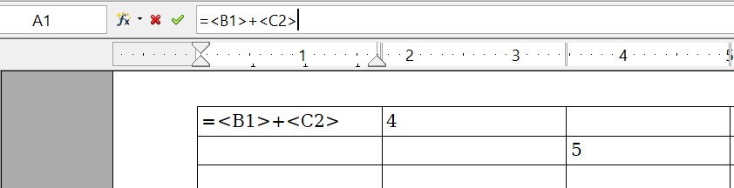

Figure 11: Using spreadsheet functions in a table
Do the following:
- Click in cell <A1> and press the = key. The Formula bar appears automatically, near the top of the screen. In the leftmost side of the bar, you can see the coordinates of the selected cell.
- Click in cell <B1>. The identifiers of this cell are automatically displayed in the Formula bar and inserted into cell <A1>.
- Press the + key.
- Click on cell <C2>. You can see the final formula = <B1>+<C2> displayed both in the selected cell and in the Formula bar.
- Press the Enter key or click the green tick (check mark) on the Formula Bar.
Tip | To display the list of the mathematical functions that you can use in a table:  - Display the Formula toolbar by pressing F2 or by selecting a blank cell and pressing the = key.  - Click and hold the Formula f(x) icon.
In our example, this gives the result 9 in the top left cell. For contiguous cells, you can simply select the cells in the row, column, or the rectangle of rows and columns. Thus, for example, to add a column of numbers, do this:
- Type an equals sign = in an empty cell.
- Select the cells to be added together—in this case the cells from A2 to A5. The formula should be something like =<A2:A5>.
- Press the Enter key or click the green tick (check mark) on the Formula Bar.
- The answer appears in the cell you have selected.
When using a function, you can enter the cells manually or by selecting them. Thus, to add up the four numbers that we added above (A2, A3, A4, A5), do this:
- Type an equals sign = in an empty cell.
- Type sum or select it from the function list f(x).
- Select the cells to be added together. The formula should be something like =sum<A2:A5>.
- Press the Enter key or click the green tick (check mark) on the Formula Bar.
- The answer appears in the cell you have selected.
Caution | Unlike Calc, when inserting or deleting rows or columns of the table, formulas are not updated automatically. If you plan to use complex formulas you should consider embedding a Calc spreadsheet in your Writer document. This is done with the menu item Insert > Object > OLE Object.

Additional Table Operations

Adding a Caption
You can easily add a caption to any table. Writer will keep track of all your captioned tables, automatically number them, and update any links to them.
To add a caption to a table:
- Place the cursor in the table.
- Right-click and choose Caption from the pop-up menu. Alternatively, the Insert > Caption menu option becomes available whenever your cursor is inside a table cell.
- Enter the text for your caption, your category selection, the numbering style, separator, and position (above or below the table).
- Click OK.
Note | Once the category, numbering style and separator are established in the Caption dialog box, you can edit them in the document if you choose. However, doing so may damage the automatic numbering and reference links. If you need to establish the numbering and reference link for the caption, you can decide to leave your caption blank in the Caption dialog box and add it later.
Writer supplies five different category labels for captions: <None>, Drawing, Table, Illustration, and Text.
You can also create your own category labels, formatting, and separators. For example, you might want your tables to be labeled as Fantasia, formatted with Roman numerals, and using a period (‘.’) as a separator, as follows:
Fantasia I. Interesting data
Fantasia II. More interesting data
Fantasia III. Yet more interesting data
To accomplish this:
- Open the Caption dialog box following the instructions above.
- In the Category field, select the text and type the word Fantasia.
- In the Numbering drop-down, select the Roman (I II III) option.
- In the Separator field, select the text and type a period (.) followed by a space.
Note | AOO will use exactly what you type into the Category and Separator fields, so be sure to include any additional spaces or punctuation you want to see in your caption.
Additional options for numbering captions by chapter are available under the Options button in the Captions dialog box. Some of these settings which refer to the outline level will only have an effect if you are using outline level paragraph styles on the chapter headings within your document. See Chapter 7 (Working With Styles) for information.
By adding chapter numbers to your captions, AOO will restart the caption numbering for each chapter it encounters. For example, if the last figure caption you create in chapter 1 is Figure 1.15, and the next figure caption you create is in chapter 2, the numbering will start over at Figure 2.1.
Options available to chapter numbering for captions include the following:
- Use Level to specify the outline levels that triggers a restart of the numbering as well as how many levels of outline numbering are shown before the table number. As an example, consider this. Suppose your document uses Heading 1 style for chapters and Heading 2 style for subheadings, and that this is how you set up your outline numbering. If you want all the tables in a chapter (that is, between two Heading 1 paragraphs) to be numbered sequentially independently of the sub heading they are under, select 1 as Level. If instead you want to restart the numbering at each sub-heading select level 2.
- Use the Separator field to establish the separator between the chapter number and figure number.
- Use Character style to set a character style for the caption. This is useful if the separator of your choice is not a symbol included in the default font type of your document, or if you want the caption to have a special color, size and so on.
- The Apply border and shadow option does not apply to table captions. AOO normally wraps the objects you can add a caption to in a frame, but not for tables.
- Use Caption order to specify whether you want the category or numbering to appear first in the caption.
All the features described above can also be set up to automatically apply to any new tables you create in your document.
To automatically caption all your tables:
- Place the cursor in a table.
- Right-click and choose Caption > AutoCaption from the pop-up menu.
- Select OpenOffice Writer Table and select the settings you want and click OK. This dialog box is covered in more detail in Chapter 2 (Setting up Writer).
When AutoCaption is enabled for tables, any new tables will be captioned according to your selections in the AutoCaption dialog box; however, you will need to add the specific text for each caption into the table manually.

Cross-referencing a Table
You can insert a cross-reference to a captioned table. Clicking on the cross-reference takes the reader directly to the table.
- Position the cursor where you want the cross-reference.
- Choose Insert > Cross-reference from the main menu.
- Set the Type to Table. A list of captioned tables will be shown in the Selection panel; select the one you want to reference.
- In the Format pane, choose how the cross-reference will appear.
  - Page creates a reference of the page number that the caption appears on.
  - Chapter places a reference to the chapter number in which the caption appears. This will only produce an empty space unless you have set up your chapter headings with outline level paragraph styles.
  - Reference inserts the entire caption's category, number and caption text as a reference.
  - Above/Below inserts “above” or “below” depending on whether the table appears above or below the cross-reference.
  - As Page Style creates a reference of the number of the page on which the caption appears, using the page style format.
  - Category and Number creates a cross-reference with only the caption's category and number; for example, Table 1 for the first table.
  - Caption Text creates the reference using the caption text, leaving off the category and number.
  - Numbering inserts only the number of the caption.
- Click Insert to add the cross-reference and click Close to exit the dialog box.

Automatic Formatting of Tables
Using AutoFormat, you can apply an elaborate format to your table with just a few clicks. AutoFormat is somewhat similar to paragraph styles and will enable you to obtain consistent looking tables across your document. You can also create your own table formats and save them as another AutoFormat option.
To apply an AutoFormat, place the cursor anywhere in the table and choose Table > AutoFormat. This opens the dialog box shown in Error: Reference source not found.
Select from the list on the left the Format most suitable for your table and click OK to apply it. Clicking the More button opens another section of the dialog box where you can rename the selected table format scheme as well as decide which parts of the predefined formatting you want to apply to your table. You can selectively apply the number format, the font, the alignment, the border, or the pattern.
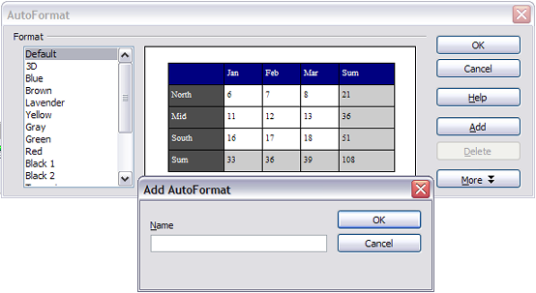Figure 12: The table AutoFormat dialog
To create your own AutoFormat, proceed as follows:
- Create a table and manually format it as you wish, including borders, spacing of text from the top and bottom borders, fonts to be used in the table heading and data cells, and background colors.
- Position the cursor anywhere in the table and then click Table > AutoFormat.
- On the AutoFormat dialog box, click Add and give the table format a name in the Add AutoFormat dialog box and click OK.
- The newly named AutoFormat now appears as an available format. Click OK to close the AutoFormat dialog box.
Tip | This technique does not include table and column widths in the table format. To insert a table with predefined full formatting, save it as AutoText. See “Using AutoText” in Chapter 3 (Working with Text) for instructions.

Creating a Heading Row in an Existing Table
To create a heading row in an existing table that does not have one, you need to apply an AutoFormat that does have a heading defined. (Here is where having some personalized table formats could come in very handy.) Place the cursor anywhere in the table and then click Table > AutoFormat. Choose a format. Click OK. Use the More button and deselect the formatting options you do not want to apply to your table.

Merging and Splitting Tables
One table can be split into two tables, and two tables can be merged into a single table. Tables are split only horizontally (the rows above the split point are put into one table, and those below into another).
To split a table:
- Place the cursor in a cell which will be in the top row of the second table after the split (the table splits immediately above the cursor).
- Right-click and choose Split Table in the pop-up menu. You can also use Table > Split Table from the menu bar.
- A Split Table dialog box pops up. You can select No heading or an alternative formatting for the heading—the top row(s) of the new table.
- Click OK. The table is then split into two tables separated by a blank paragraph.
Note | If cells in one table include formulas using data from the other table, those cells will contain an error message: **Expression is faulty**.
To merge two tables:
- Delete the blank paragraph between the tables. You must use the Delete key (not the Backspace key) to do this.
- Select a cell in the second table.
- Right-click and choose Merge Tables in the pop-up menu. You can also use Table > Merge Table from the menu bar.
Tip | To see clearly where the paragraphs are and to delete them easily, choose View > Nonprinting Characters (Ctrl+F10) or click the ¶ button in the Standard toolbar.

Deleting a Table
To delete a table:
- Click anywhere in the table.
- Choose Table > Delete > Table from the main menu.
Or:
- Select from the end of the paragraph before the table to the start of the paragraph after the table.
- Press the Delete or the Backspace key.
Note | The second method also merges the paragraph after the table with the paragraph before the table, which may not be what you want.

Copying a Table
To copy a table from one part of the document and paste it into another part:
- Click anywhere in the table.
- From the main menu choose Table > Select > Table.
- Press Control+C or click the Copy icon on the Standard toolbar.
- Move the cursor to the target position and click on it to fix the insertion point.
- Press Control+V or click the Paste icon in the Standard toolbar.

Moving a Table
To move a table from one part of a document to another part:
- Click anywhere in the table.
- From the main menu, choose Table > Select > Table.
- Press Control+X or click the Cut icon in the Standard toolbar. (This step removes the contents of the cells but leaves the empty cells, which must be removed in step 6.)
- Move the cursor to the target position and click on it to fix the insertion point.
- Press Control+V or click the Paste icon in the Standard toolbar. (This pastes the cells and their contents and formatting.)
- Return to the original table, click somewhere in it and then choose Table > Delete > Table from the main menu.

Inserting a Paragraph Before or After a Table
To insert a paragraph before a table, position the cursor before any text or other contents in the first (upper left-hand) cell and press Alt+Enter. To insert a paragraph after a table, position the cursor after any text in the last (lower right-hand) cell and press Alt+Enter.

Using Tables as a Page Layout Tool
Tables may be used as a page layout tool to position text in a document instead of using tabs or spaces. For example, the Tip below is formatted as a table.
For more information and tips about using tables in page layout, see Chapter 4 (Formatting Pages).

Tip | When inserting a table used for layout, you may wish to deselect the Heading and Border options (see Error: Reference source not found on page Error: Reference source not found).  To remove the borders from an existing table, right-click on the table, choose Table from the pop-up menu, select the Borders tab (see Error: Reference source not found on page Error: Reference source not found), and select the icon for no borders.

The Table menu and toolbar
All the table commands described in this chapter are conveniently located in the main menu under the Table item and on the Table toolbar, shown in Error: Reference source not found. Not all the icons may appear on your toolbar, depending on the settings for it in Tools > Customize > Toolbars.
Error: Reference source not found describes the effects of using these icons. When you create a table or select an existing table, the Table toolbar may be displayed automatically, or you can manually display it by clicking View > Toolbars > Table. The toolbar can float over the main Writer window (as shown in Error: Reference source not found), or it can be docked along any edge of the main window. See Chapter 1 (Introducing Writer) for more about docking and floating toolbars, and how to hide and display specific tools on a toolbar.
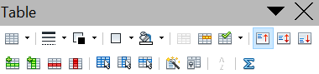
1 | Table | 9 | Top | 17 | Select Column
2 | Line Style | 10 | Center (vertical) | 18 | Select Row
3 | Line Color (border) | 11 | Bottom | 19 | AutoFormat
4 | Borders | 12 | Insert Row | 20 | Table Properties
5 | Background Color | 13 | Insert Column | 21 | Sort
6 | Merge Cells | 14 | Delete Row | 22 | Sum
7 | Split Cells | 15 | Delete Column
8 | Optimize | 16 | Select Table
Figure 13: Table toolbar
1
2
3
4
5
6
7
8
9
10
11
12
13
14
15
16
17
18
19
20
21
22
Table 1: Functions of the icons on the Table toolbar
Name | Description
Table | Opens the Insert Table dialog box where you can set up and insert a table into the document, name the table for use with the Navigator, and set some other options. If you press the small black triangle pointing down next to the icon, you can use the mouse to drag to select the number of rows and columns to include in the table.
Line Style | Opens the Border Style window where you can modify the borderline style.
Line Color (border) | Opens the Border Color window where you can modify the border color.
Borders | Opens the Borders window where you can select which sides of the table or of the selected cells will have a border.
Background Color | Opens the Background toolbar where you can select the background color of the table or of the selected cells.
Merge Cells | Combines the selected cells into a single cell. Refer to Error: Reference source not found on page Error: Reference source not found for an example of using this button.
Split Cells | Opens the Split Cell dialog box where you can define how to split a cell. Refer to Error: Reference source not found on page Error: Reference source not found for an example of using this button.
Optimize | Opens a drop-down menu with four options you can use to let AOO optimize the distribution of the columns or rows or optimize the row height or column width.
Top | Press this button to align the contents of the selected cells to the top of the cell.
Center (vertical) | Press this button to align the contents of the selected cells to the vertical center of the cell.
Bottom | Press this button to align the contents of the selected cells to the bottom of the cell.
Insert Row | Inserts a row below the selected row.
Insert Column | Inserts a column after the selected column.
Delete Row | Deletes the selected row(s) from the table.
Delete Column | Deletes the selected column(s) from the table.
Select Table | Selects the entire table.
Select Column | Selects the column in which the cursor is positioned.
Select Row | Selects the row in which the cursor is positioned.
AutoFormat | Opens the AutoFormat dialog box where you can select among several predefined formatting sets. Each set is characterized by its own fonts, shading, and borders styles. You can also select AutoFormat from the Insert Table dialog box.
Table Properties | Opens the Table Format dialog box where you can control all the properties of the table, for example name, alignment, spacing, column width, borders, and background.
Sort | Opens the Sort dialog box where you can specify the sort criteria for the selected cells.
Sum | Activates the Sum function. Refer to “Error: Reference source not found” on page Error: Reference source not found for an example of using this function.

