
Draw Guide
Chapter 6
Editing Pictures (Raster Graphics)

Copyright
This document is Copyright © 2005–2011 by its contributors as listed below. You may distribute it and/or modify it under the terms of either the GNU General Public License (http://www.gnu.org/licenses/gpl.html), version 3 or later, or the Creative Commons Attribution License (http://creativecommons.org/licenses/by/3.0/), version 3.0 or later.
All trademarks within this guide belong to their legitimate owners.
Contributors
Agnes Belzunce Daniel Carrera Regina Henschel
Bernd Schukat Wolfgang Uhlig Martin Fox
Jean Hollis Weber Claire Wood Linda Worthington
Hazel Russman
Feedback
Please direct any comments or suggestions about this document to:
odfauthors-discuss@lists.odfauthors.org
Acknowledgments
This chapter is based on an original French document written for OpenOffice.org 1.x by Michel Pinquier (translated into English by Alex Thurgood) and previous content revised by Jim Taylor. The chapter was revised for OpenOffice.org 2.0 by Linda, Daniel, Jean, and Agnes, and later translated into German by Bernd, Wolfgang, and Regina. The German translators also added a large amount of new material. The German version of this chapter was then translated into English and updated for OpenOffice.org 3.3 by Martin Fox.
Publication date and software version
Published 5 August 2011. Based on OpenOffice.org 3.3.

Note for Mac users
Some keystrokes and menu items are different on a Mac from those used in Windows and Linux. The table below gives some common substitutions for the instructions in this chapter. For a more detailed list, see the application Help.
Windows/Linux | Mac equivalent | Effect
Tools > Options menu selection | OpenOffice.org > Preferences | Access setup options
Right-click | Control+click | Open context menu
Ctrl (Control) | z (Command) | Used with other keys
F5 | Shift+z+F5 | Open the Navigator
F11 | z+T | Open Styles & Formatting window
Contents
Copyright 2
Note for Mac users 2
Introduction 4
Importing raster and vector graphics 4
To link or to embed? 5
Scanning 5
Pasting from the clipboard 6
Dragging and dropping 6
Inserting from a file 6
Exporting graphics 7
Exporting the entire file 7
Exporting single objects 8
Exporting as a vector graphic 8
Exporting as a raster graphic 8
Modifying raster object properties 10
The picture (editing) toolbar 10
Cropping 12
The graphic filter toolbar 13
Changing colors using the eyedropper 16
Practical example: Changing wrong colors to transparency 17
Effect of the tolerance parameter 18
Color depth 18
Reducing color depth 18
Conversion 20
Convert to a contoured image 20
Convert to a polygon 20
Number of colors 21
Point reduction 21
Fill holes 21
Convert to bitmap 24
Print options with raster graphics 24

Introduction
Earlier chapters of the Draw Guide have dealt only with vector graphics. However, Draw also contains a number of functions for handling raster graphics (bitmaps) such as photographs and scanned pictures, including import, export, and conversion from one format to another.
Draw can read all the usual graphics file formats. It has a subset of the same capabilities as specialized raster graphics programs like Adobe Photoshop or The Gimp.

Importing raster and vector graphics
To import stored graphics files, choose Insert > Picture > From File on the menu bar or click the icon on the Draw toolbar. Draw possesses import filters for many different vector and raster graphics formats. If your file has a nonstandard extension, you must choose the format explicitly when importing it.
Note | A filter for *.svg (scaleable vector graphics) files is available as an extension (http://extensions.services.openoffice.org/en/project/svgimport), but rather than using Insert > Picture > From File just open the *.svg file with File > Open. The SVG graphic is translated during the import into OOo graphics primitives.
If you select the Preview option in the Insert picture dialog (Figure 1), Draw shows a preview of the picture in the box on the right-hand side. This makes it much easier to choose the picture you want and to see whether Draw can import a file of this format.
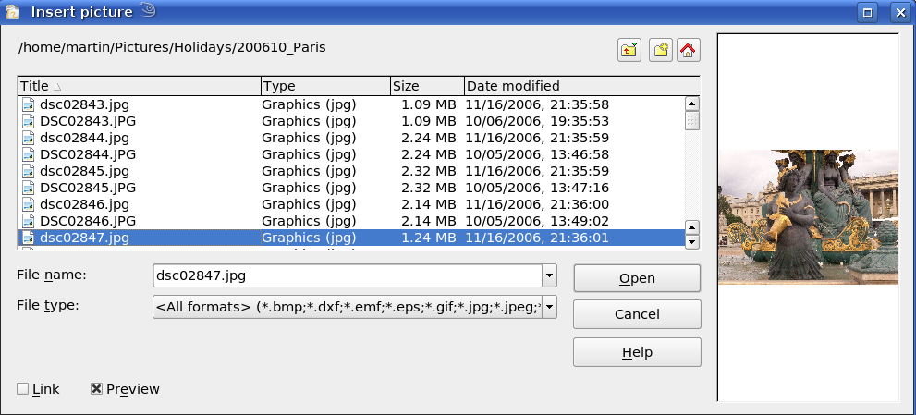
Figure 1: Inserting a picture; notice Link and Preview options in lower left of dialog

To link or to embed?
If you select the Link option in the Insert picture dialog, the graphic is linked rather than embedded. It is not actually inserted into the document; instead, a link to the graphic is created. This link is relative to the folder where the document is stored, even though it shows up in the Edit Links dialog (see Figure 2) as an absolute link. If you store the document and the graphic in the same folder, and transport the folder as a whole to another computer, the graphic will show up in the document as before.
Linked graphics are not changed as a result of any actions carried out within OpenOffice.org. Such changes affect only the view of the graphic in the document and not the graphic itself. In particular, the format of a linked graphic remains unchanged. In contrast, when a raster graphic is embedded in an OOo document, it is converted into PNG format.
Linking keeps the file size of the Draw document small. The picture can be edited or even replaced by another and the link will still function. As long as the new picture is given the same name as the old one, links will be re-established and updated when the document containing the link is next opened. However, some actions do not last beyond the current session (for example, Filter) or are simply not possible on a linked graphic (for example using the color replacer to exchange colors).
Links can easily be removed. The linked picture will then be embedded in the document. To break a link, choose Edit > Links from the main menu bar. In the Edit Links dialog (see Figure 2), choose the link to be broken and then click on the Break Link button.
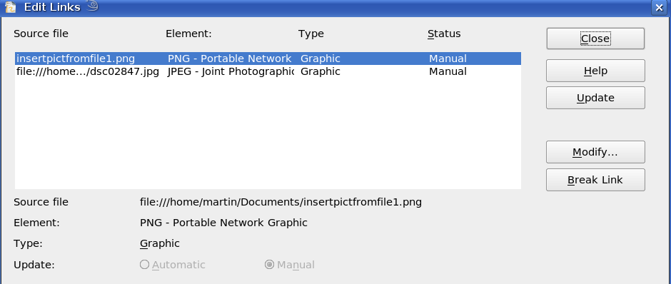Figure 2: Editing links to documents

Scanning
With most scanners you can directly insert a scanned picture into a document. Scanned images are embedded in the document in PNG format.
Make sure that the scanner is supported by the SANE system if you are running a Linux (or other UNIX-like) operating system, or TWAIN if you are using Windows, and that it is already configured on the machine on which OpenOffice.org is running. If more than one scanner or equivalent device is present, you can select the source from Insert > Picture > Scan > Select Source.
To insert an image from the scanner:
- Prepare the image in the scanner and make sure that the scanner is ready.
- Choose Insert > Picture > Scan > Request.
- The rest of the procedure depends on the scanner driver and interface. You will normally be required to specify the resolution, a scan window, and other options. Consult the scanner’s documentation for more information.
- When the image is scanned, Draw places it on the page. At this point it can be edited like any other image.

Pasting from the clipboard
The clipboard offers another way to insert graphics. Depending on the source and the operating system, figures may be in different formats. You can obtain an overview by choosing Edit > Paste Special from the menu bar or by clicking on the Paste icon’s drop-down menu on the main toolbar. The choices on the list vary with the type of graphic on the clipboard.

Dragging and dropping
Drag and drop is also possible in many cases. The exact way that drag and drop works is determined by the operating system in use and the source of the graphic, regardless of whether the graphic is to be embedded or linked. The behavior can be controlled by the use of the Control or Control+Shift keys together.
Draw objects and images which are used frequently can be stored in the Gallery. Objects can be dragged from the Gallery to the Draw surface quite simply. Working with the Gallery is dealt with in Chapter 10 (Advanced Draw Techniques).

Inserting from a file
With this option, you can insert complete pages or single objects from existing Draw or Impress documents into your Draw document. In addition you can insert text in Rich Text Format (RTF), HTML format or plain text. The text will be contained within a text frame. The usual paragraph and character formatting options are available for this text.
Choosing Insert > File brings up the File selection dialog. Select the required file and click Insert. If the file is a Draw or Impress document, the Insert Slides/Objects dialog (Figure 3) opens.
To access single pages or slides of the document, click on the expansion symbol (usually a + or a small triangle, depending on your operating system) to the left of the file name in the selection area. The same method is used to display single objects within slides. Raster graphics (for example, photos) and Metafiles are marked with a , drawing objects with a , and OLE objects with a .
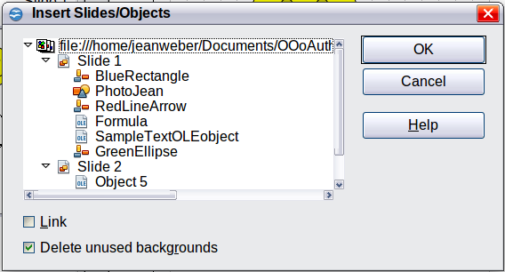
Figure 3: Inserting complete pages or objects on a page
Choose the slides or objects you want to insert; for multiple selections, press the Control or Shift key while clicking on the items. Click OK to insert the selected items.
If the inserted object was named in the source document, it keeps its original name unless the name already exists in the current document. In that case you must give the object a new name before it is inserted. To rename an inserted object, right-click and choose Name from the pop-up menu. Renaming has the advantage that the object is then listed in the Navigator.
You can choose whether to embed or link the selected page or object.

Exporting graphics
Draw saves drawings by default in the *.ODG format. Some programs cannot open these files. To use the drawings in other programs, you can export the graphics in various formats. Choose File > Export and then in the File format pull-down list select the desired format (see Figure 4).
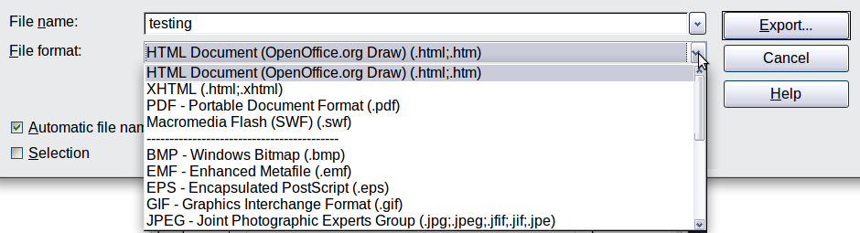
Figure 4: Lower part of the Export dialog

Exporting the entire file
The file format options in the upper area of the File format box (HTML, XHTML, PDF, and Flash) always apply to the complete file. Use of Flash or HTML format causes each page of the Draw document to be exported as a raster graphic. You will no longer be able to access individual objects on the page.
To export a multi-page Draw document as a series of web pages, choose File > Export and select HTML Document as the file type. The HTML Export wizard opens. Follow the prompts to create the web pages. If you wish, the wizard can generate a navigation aid to help in moving from page to page.
If you want to use the objects in other applications, select one of the Metafile formats (JPEG, PNG, TIFF, BMP and so on) in the lower part of the File format list (see Figure 5). With this type of export, only the currently active page is exported.
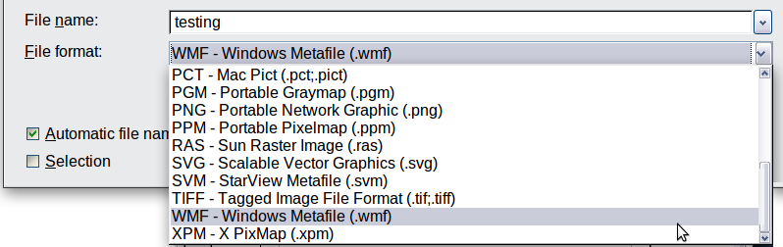
Figure 5: Section of the file selection list

Exporting single objects
In order to export individual drawing objects, you first need to select them. A selection can include more than one object. Take care to choose the Selection option on the Export dialog.

Exporting as a vector graphic
The choice of vector formats is still limited. An export to a DXF format file (Autocad) is not yet possible. Even the export of a graphic to a SVG format file is not yet fully implemented: 2D graphic objects are exported as paths and 3D objects only as preview images. Best supported are the Metafile formats and exporting to one of these is usually successful.

Exporting as a raster graphic
The choice of formats for export as a raster graphic is large enough to support most other applications. In case of doubt, test different formats to see which gives the best results; some programs behave differently depending on the format of the image imported into them.
After typing in a name for the exported file and selecting the file format, you may be able to set options for the exported image—compression, color format, version of Metafile—depending on the format chosen. Some examples of the various option dialogs are shown in Figure 6.
Where the export dialog allows you to specify the image resolution, this does not affect the number of raster points in the image. Rather it inserts information into the picture that tells other programs the dimensions to be used in displaying the image. This means that, among other things, missing raster points can be interpolated when the graphic is opened in the other program.
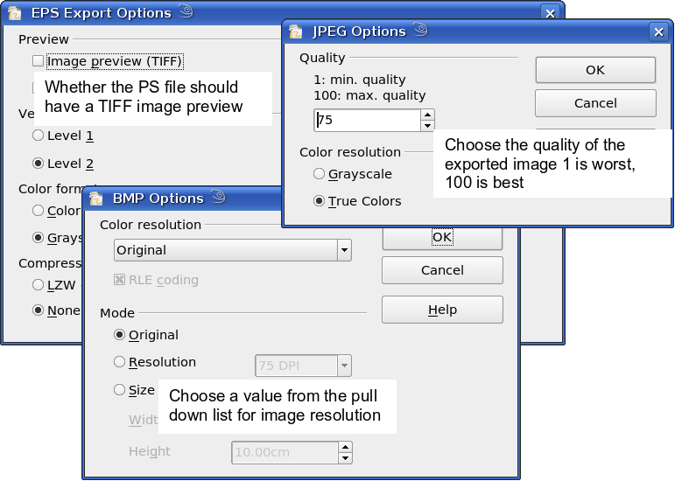
Figure 6: Adjusting format specific properties prior to export
The actual number of pixels used is determined by the screen resolution set up by the operating system and the Drawing scale factor set in Tools > Options > OpenOffice.org Draw > General. This is a limitation of the current user interface; it is possible to set other resolutions using macros.
Embedded raster graphics, or objects that have been converted to a bitmap or Metafile (from the context menu Convert > To Bitmap / To Metafile) may subsequently be saved as a picture; from the context menu choose Save as Picture. This saves the picture without Draw-specific additions such as text elements, borders, or shadows and without the possibility of setting any of the options available when exporting.
Draw objects can easily be imported into Writer, Calc, or Impress documents. For objects used often, this is most simply done by storing them in the Gallery or by using the clipboard. As Writer and Calc do not possess the same range of tools available within Draw, it makes sense to use Draw to produce a complex drawing and then to copy it into the other OOo application. A link to single drawing objects is not possible, but you can incorporate Draw documents in the other modules as linked OLE objects.
Tip | To avoid problems when scaling Draw objects containing text after importing them into Writer, convert the object to a polygon before storing it in the Gallery or copying it to the clipboard. See “Convert to a polygon” on page 20.

Modifying raster object properties
As with other objects, the properties of a raster graphic can be modified. You can format the graphic using the Format menu or the context menu. Use the Picture toolbar to add or change filters using the Graphic Filter Bar; adjust the Lines, Areas and Shadows properties. The Transparency property in the Format menu does not relate to the transparency of the raster graphic itself but to the background area. To set the transparency of the graphic, you must use the Picture toolbar.
Graphics can also have a text element. For more on text, see Chapter 10 (Advanced Draw Techniques).
You can change the position and size of graphics, or rotate them, using the methods described in Chapter 3 (Working with Objects and Object Points). Raster graphics can be flipped (Modify > Flip), but note that some Metafile formats might have problems flipping text.
Graphics included as a member of a group behave like other drawing objects when the properties of the group are modified.
It is a good idea to (re-)name the graphic using Name from the Modify menu or the context menu. Only named objects are visible in the Navigator and only named objects can be directly imported from another file.

The picture (editing) toolbar
If you have enabled the Picture toolbar (in View > Toolbars), it will automatically appear on the screen whenever you select a (bitmap) picture (see Figure 7). It appears either directly under the menu bar in place of the formatting toolbar or as a floating toolbar elsewhere on the screen.
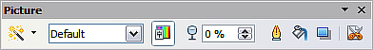
Figure 7: The Picture toolbar
The following table explains the individual functions on the Picture toolbar and illustrates their use with examples.
Filter | Opens the Filter toolbar, which is described in “The graphic filter toolbar” on page 13.
Graphics Mode | Use the Graphics mode menu to change the display of the graphic from normal color to grayscale, black and white, or a watermark. This setting affects only the display and printing of the picture; the picture itself remains unchanged.
Default: | The graphic is displayed unaltered in color.
Grayscale: | The graphic is displayed in 256 shades of gray.
Black/White: | The graphic is displayed in black and white.
Watermark: | The brightness and contrast of the graphic are reduced to the extent that the graphic can be used as a watermark (background).
Color | Use the Color tool to adjust the values of the three RGB colors, the brightness, contrast and the Gamma value. These adjustments do not affect the original picture but the values are stored in Draw as a separate formatting set.
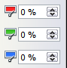 | You can select values from between –100% (no color) to +100% (full intensity); 0% represents the original value of the property.
 | The brightness can be adjusted between –100% (totally black) and +100% (totally white).
 | The contrast can be adjusted between –100% (minimum) and +100% (maximum).
The Gamma value affects the brightness of the middle color tones. Values can range from 0.10 (minimum) to 10 (maximum)
Hint: Try adjusting this value if changing brightness /contrast does not give you the result you want.
Transparency | The degree of transparency of the picture can be adjusted between 0% (opaque) and 100% (fully transparent).
Line | Opens the Line dialog. In this context, line refers to the outline of the border. See also Chapter 4 (Changing Object Attributes).
Area | Opens the Area dialog. Here you can edit color, gradient, hatching and fills of the background area that contains the graphic—not the graphic itself. To see the background, you must set the transparency of the graphic to a suitably high value.
Shadow | Use this tool to set a shadow effect around the graphic.
Crop   | Use this function to crop (trim) an image. When you click on this icon, crop marks appear on the image (Figure 8). Drag one or more of these marks to crop the picture to your desired size. For more accurate cropping, see “Cropping” below.
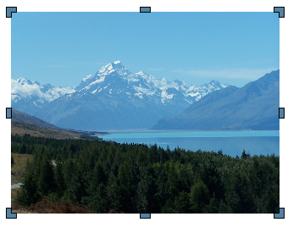
Figure 8: Interactive crop marks on an image

Cropping
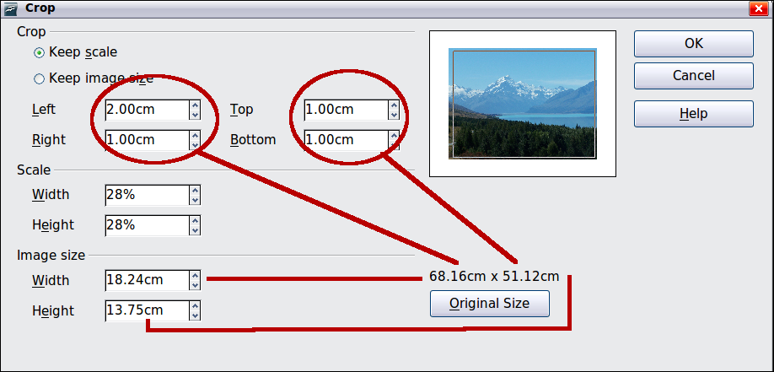
Figure 9: The Crop dialog
More control and accuracy over cropping functions are available via the Format menu. Click Format > Crop Picture and the dialog box in Figure 9 will appear. The fields Left, Right, Top, and Bottom establish the amount to be trimmed off the appropriate edge.
In addition to cropping, you can also enlarge or reduce the size of the graphic by changing the percentage scaling values. The new dimensions of the graphic are shown in the Image Size width and height boxes, which can also be directly adjusted.
In Figure 9 you can see that 2 cm from the left side and 1 cm from the top, bottom, and right side will be trimmed from the original object. The preview pane shows the location of the new edges of the graphic. In addition both height and width have been scaled down by 28%.
- If you choose Keep Scale, the graphic will be cropped to the scales shown in the width and height boxes and the picture reduced in size accordingly.
- If you choose Keep image size, the graphic will be cropped and then enlarged to the original image size.
Take care with these operations: in the Crop dialog the width and height are treated as totally independent values. Changing one without the other can result in significant distortion of the image; this might not be what you want. (The Position and Size dialog on the context menu has an option for keeping the width:height ratio fixed while changing one of the two dimensions.) Changing values in one area (Scale or Image Size) will show up correspondingly in the other area.
Caution   | Any changes made in the Crop dialog change only the view of the picture. The original picture is not changed. If you want to export a cropped graphic, you must do it through File > Export. If you use the option Save as Picture from the context menu, the changes are not exported.

The graphic filter toolbar
Click the Filter icon to open the Filter toolbar. Draw offers eleven filter effects. Filters work on the current view of an object and they can be combined. Filters always apply to the entire graphic; it is not possible to use filters to edit only a part of the object.
Invert reverses (inverts) the colors of an image so that it appears as a color negative of the image.
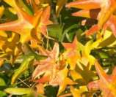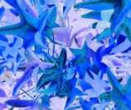
Smooth reduces the contrast between neighboring pixels and produces a slight lack of sharpness. If you use the filter several times in a row, the effect will be strengthened.
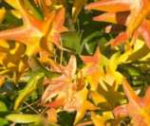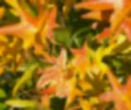
Sharpen increases the contrast between neighboring pixels, emphasizing the brightness difference. This will accentuate the outlines. The effect will be strengthened if you apply the filter several times in a row.
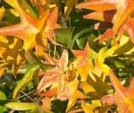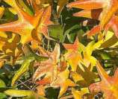
Remove noise compares every pixel with its neighbors and replaces the extreme values (those that deviate in color by a large amount from a mean value) by a pixel with a mean color value. The amount of picture information does not increase, but because there are fewer contrast changes our brains can better recognize the resulting graphic. This filter tends to make the picture also a little more smooth.
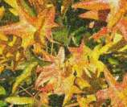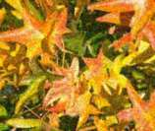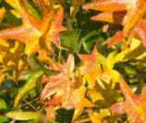
Solarization was originally a photochemical effect. If the location of a photograph is extremely highly lit, you can experience a reversal of color and brightness. Similarly, entry of light during the developing process reverses the brightness values. These phenomena were used for artistic production of pictures.
With this filter you input a threshold brightness value, above which the color values are reversed (middle picture, threshold value 70%). With the Invert option the whole of the resulting picture is inverted in color (right picture).
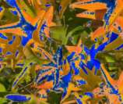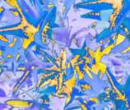
Aging lends pictures a certain “look” resembling that of old photos. The process first produces a grayscale picture from the original and then reduces the intensity of the blue and green color values, so that the final picture appears darker and redder. In the middle example, the aging degree was set to 0%, on the right it was 15%.
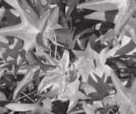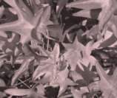
Posterize reduces the number of colors in the picture. The fewer colors, the more flat the picture appears. In the right hand picture below the number of colors was reduced to 8. The results of this filter are not always good.
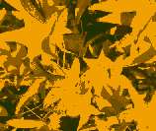
The Pop-Art filter is supposed to change the colors of the picture to a pop-art format, but unfortunately it does not seem to function correctly at present.
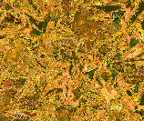
Charcoal sketch makes the picture appear as if it had been drawn with charcoal. The outlines are in black and the original colors are suppressed.
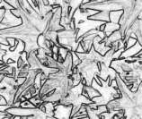
The Relief filter calculates the edges in relief of the picture and produces a picture as if illuminated by a light source, the position of the illuminating light being variable and producing shadows that differ in direction and magnitude.
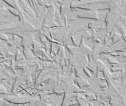
Mosaic takes groups of pixels and converts them into a single color rectangular tile. The whole picture appears to be a mosaic. The center and right pictures below had an element resolution of 5 pixels. The picture on the right also had the Enhance edges option selected; with the greater contrast at the edges, it appears to be a little sharper.
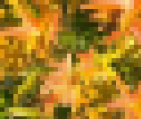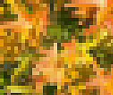
Caution | If your picture is linked, filters are applied only to the current view. The stored picture is not changed. When you close the document, all filtering is lost. You should ensure that you export the picture to create a copy with all the filters applied (File > Export).  If you have embedded the graphic in the document, all filters are applied directly on the embedded graphic and cannot be undone in a subsequent session. If you do not want to retain a filter, you must use Edit > Undo to return to an earlier state of editing. After you save and close the document, the filter effects are permanent.

Changing colors using the eyedropper
Use the eyedropper to change one color in a picture for another or set the color as transparent. The tool always works on the entire picture; you cannot select only a region for editing.
The changes are carried out on the graphic itself and therefore require it to be embedded. Attempts to use the eyedropper tool on a linked graphic result in the following message: This graphic is linked to a document. Do you want to unlink the graphic is order to edit it?
The tool can be used on all raster graphic formats and with many—but not all—Metafile formats.
Note | In OpenOffice.org 3.4, this feature is called the Color Replacer.

Practical example: Changing wrong colors to transparency
Some applications, which cannot correctly handle transparency, show transparent areas with the color Magenta and then store the graphic with this color and without the correct transparency information.
 | Bitmap graphic with area in magenta, which actually should be shown transparent. On the left is the original picture, right is the picture after saving it with MS Paint.
If you receive such a picture, you can recreate the transparency with the eyedropper tool.
Open the Eyedropper dialog with Tools > Eyedropper and click on the picture to be edited. | 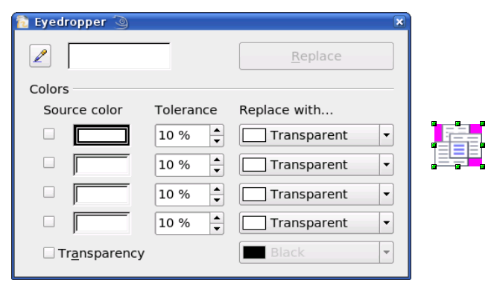
Now click on the icon , to change to the color selection mode. Outside the dialog the cursor changes to a hand. The field next to the icon shows the color immediately under the hand cursor. | 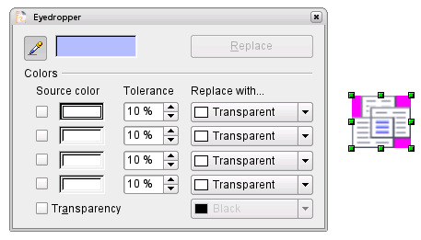
Click on the color to be changed. The first Source Color box is now marked and the color selected appears in the left box. In the Replace with selection list, the option Transparent is already selected. Click on the Replace button at the top right of the box to carry out the changes to the picture. There is no preview of the effect. If the result is not what you wanted, choose Edit > Undo. | 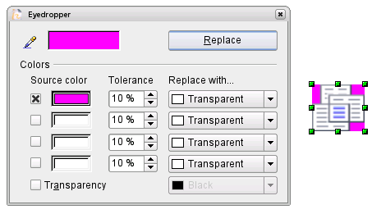
The dialog does not close automatically, so you can carry out further color replacements. Mark first the field for the Source color and choose again the color with the eyedropper. Close the dialog with Ctrl+F4 or the Close icon on the window border. Draw uses a separate Alpha channel for transparency so that pixels of different colors can be made transparent.
It is also possible to carry out the operation in reverse to change a transparent area to a color. Select nothing in the graphic but choose the Transparency option at the lower left of the dialog and the replacement color at the lower right.
The selection list for replacement colors shows all the available colors in the current color palette of the document. You cannot define any new colors here but you can add colors to the available palette before using the eyedropper tool. For more on this topic, see Chapter 8 (Tips and Tricks).

Effect of the tolerance parameter
The tolerance parameter describes how closely a color value in the picture must agree with the source color in order to be replaced. In the figure below, the red color tone at the left edge of the rectangular color palette is used as the source color and a pure blue as the replacement color with several different tolerances. The original is a rectangle with color palette from red to green. Because the eyedropper is not usable on drawings, the rectangle on the left side was converted into a raster graphic (Convert > Bitmap). The picture was then exported in a Enhanced Metafile format and inserted on the right for comparison.
Original
0% smallest value
99% largest value
80%
40%
20%
Note | As shown, the application of transparency and color replacement effects on raster graphics and Metafiles leads to quite different results. This is a known problem, which will be corrected in a future version.

Color depth
It is possible to reduce the color depth in OOo. The tools are available but you must create a separate menu and add the tools to the menu if you wish to have them available (refer to OOo help if you are not sure how to do this). To find the tools, click on Tools > Customize, Toolbars, and Add (Command). The commands are in the category Modify, at the top of the list.

Reducing color depth
Original with a 24 bit pixel depth (=8 bits per channel)
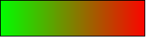
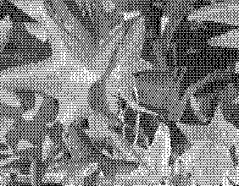 | 1 bit dithered  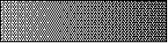  The impression of grayscale is produced by a raster. In reality there are only two colors.
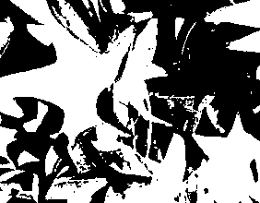 | 1 bit threshold  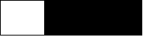  The threshold determines which pixels are black and which are white. You cannot set it directly but you can influence which part of the image is set to black by varying color settings on the picture toolbar—red, green, blue level, brightness, contrast, and/or gamma value—to see what works best for your image. You must export and save the modified image with File > Export and then reopen it, before you finally change the color depth.
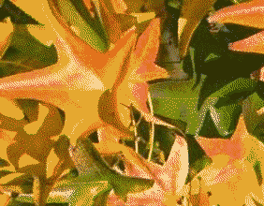 | 4 bit color palette  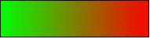  With 4 bits a total of 16 colors can be produced. The color steps are quite fine, because the process does not use the 16 RGB basic colors, but selects from the palette those that best match the colors in the image.
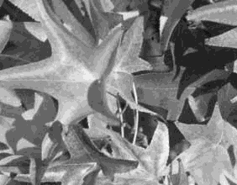 | 4 bit grayscale palette  
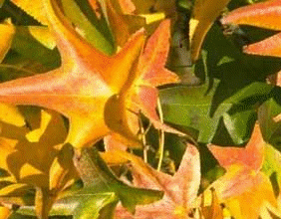 | 8 bit color palette  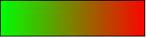  With 8 bits a total of 256 colors can be produced. The image at left is at first glance very difficult to distinguish from the original. A big difference is that the picture file is only one third of the size of the 24 bit version.
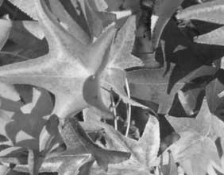 | 8 bit grayscale palette  

Conversion

Convert to a contoured image
Select the picture so you see the green handles. From the context menu or from the Modify menu choose Convert > to Contour. This command creates from the original image a polygon or group of polygons, with four corner points and the image set as a background graphic. In this state you are not able to further edit the graphic. All your modifications must be completed before this point.
The polygon is in fact a vector graphic but the picture remains as a bitmap image. Using a polygon offers possibilities for further change; for example, you can modify the shape or define a transparency gradient.

Convert to a polygon
Select the picture so you see the green handles. From the context menu or from the Modify menu, choose Convert > to Polygon. This command converts areas of the same color into small filled polygons. The total image becomes a vector graphic and can be resized with no loss of image quality or distortion of text. The resulting format will be a Metafile.
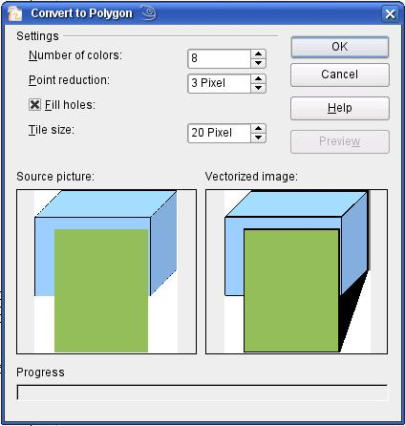
Figure 10: Conversion of a picture to polygons
The Convert to Polygon dialog has a number of settings which can be tested using the Preview button. Because graphics conversion can take some time, depending on the picture and the computer, a progress bar is included at the bottom of the dialog.

Number of colors
Draw considers between 8 and 32 colors in the conversion. The picture can, however, contain fewer colors than 8. For every color occurring in the picture, Draw creates a polygon, which may consist of several disconnected parts. These polygons are then filled with the relevant color.
The algorithm used to reduce the number of colors in the picture to the number specified is not yet optimal. For this reason you may prefer to try reducing the number of colors by changing the color depth or with the Posterize filter (page 15) from the Graphic Filter toolbar (page 13).

Point reduction
Polygons will only be created if they have a size greater than the value given in this setting. The section of the picture below, highly magnified, shows that with a larger point count small flecks of color—typical of irregular color patterns—simply disappear.
2 Pixel 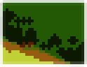 3 Pixel 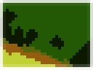

Fill holes
Point reduction can result in small areas or “holes” which are not covered by a polygon. If the Fill holes option is marked, additional square, tiled areas are created with a background color the same as the hole. The Tile size option allows the width in pixels of the width of these square areas to be preset.
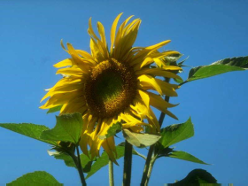  Original picture | Original picture with 16 colors and 0 Pixel point reduction vectorized
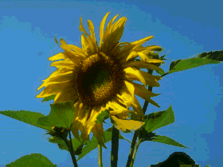  Original picture transformed with the Poster filter and 64 colors … | … and then with 16 colors and 0 pixel point reduction vectorized.
Here the picture is transformed with the Poster filter, but this time with a point reduction of 4 pixels and a tile size of 16 pixels. | The effect below was generated from the picture to the left (posterized and vectorized); the polygons were split with Modify > Break, and a number (in this case 6) of the (foreground) polygons were deleted until the resulting background was achieved.  Note: To select polygons for deletion, click on a curved colored area (the text in the status bar shows “Polygon nnn corners selected”, where nnn is the number of corners of the polygon) and a frame with green handles encloses the area of the polygons selected. Press Delete to delete the polygons. Repeat until you have achieved the desired effect, (which here is to have only the background showing).
If you next ‘split’ the existing Metafile (Modify > Split), access is gained to individual polygons. To be able to operate on these together you should immediately group them after splitting.
With this vectorized form of the image, you can carry out operations familiar from classic drawing programs, for example a curved warping operation. For such transformations, it is much less effort to use a conversion with background tiles so that the edges of the picture are straight.
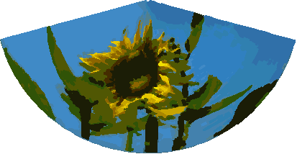
Using the graphic generated in the posterize and vectorize process above, Break and Split it, and then try out some operations using the tools on the Effects toolbar.
To use this tool to vectorize the first letter of a chapter in a special font, convert the graphic to a polygon, using no point reduction or background tiling. Use Modify > Break to generate two polygons. An example is shown below.
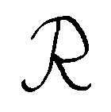 | Original polygon, converted from a Metafile. Break the graphic into two polygons.
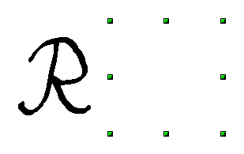 | After the conversion there are two polygons, one with the visible letter and another polygon, not visible because the lines and area filling are all in white. You can select this “invisible” polygon by pressing the Tab button (click on the visible letter first, then press Tab; this moves the current selection to the next object). In the example at the left, the invisible polygon has been moved to the side. If you have Display Grid active and the grid points set to display behind objects, you can see where this invisible polygon is, since it obscures the grid points behind it.
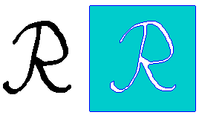 | This invisible polygon encloses the letter. After changing lines and/or area to a different color, the polygon becomes visible.

Convert to bitmap
All drawing objects are vector graphics. Use the command Convert > To Bitmap from the context menu to convert a vector graphic to a raster graphic. Draw creates the raster graphic in PNG format with a color depth of 24 bits. Unfortunately any transparency effects which were created in the vector graphic are lost in this conversion, although the PNG format used in Draw does support transparency. Only if you use the eyedropper tool to set transparency will an Alpha channel also be produced.
To determine the height and width of the converted graphic (number of pixels), Draw considers the dpi setting of the operating system for the screen and the percentage scaling factor set under Tools > Options > OpenOffice.org > View in the section User Interface.
Example:
Width of vector graphic: 1.5 inch
Monitor setting of operating system: 96 dpi ( = 96 dots per inch)
Scaling 130 %
Calculation: 1.5 inch x 96 dpi *130% = 187 pixels
The actual number of pixels will vary somewhat from this value due to rounding. When the format permits, Draw uses a dpi value (in this case 125 dpi) which permits the calculation to be reversed and the picture with this pixel value reproduced with the correct width of 1.5 inch.

Print options with raster graphics
If you have only a black and white printer or are experiencing problems with printing, you should have a look at the following settings.
You can set up printing so that all text and all graphics are printed in grayscale or black and white. The general settings are in Tools > Options > OpenOffice.org Draw > Print in the section Quality (see Figure 11). To set these for the current document only, use Options in the Print dialog (File > Print). With both Black/white printing and Grayscale printing, no background is printed.
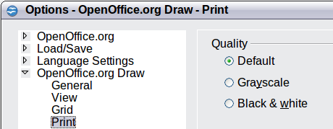
Figure 11: Options - OpenOffice.org Draw - Print
Other options are in Tools > Options > OpenOffice.org > Print (see Figure 12). They relate to page options (scaling) and other printing variables. They affect the size of the print file and the time taken to print the document. With most modern systems you can simply accept the defaults. As different operating systems and printers have their own requirements, you need to tailor the settings to your particular site conditions. Refer to the Help file for more information.
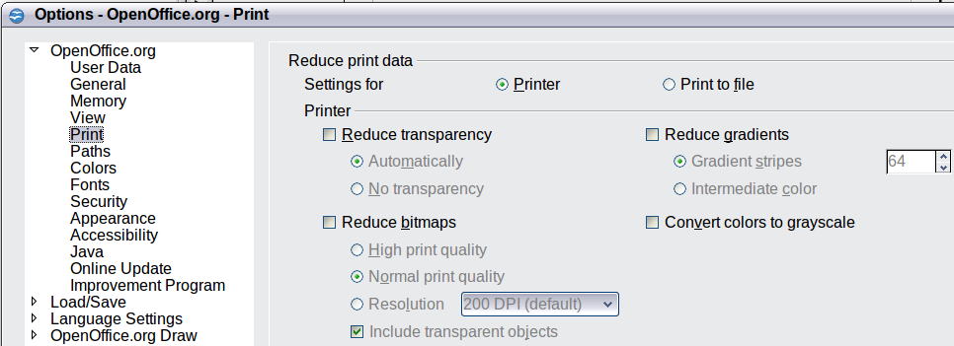
Figure 12: Options - OpenOffice.org - Print dialog

