Draw Guide
Chapter 9
Organization Charts, Flow Diagrams, and More

Copyright
This document is Copyright © 2005–2011 by its contributors as listed in the section titled Authors. You may distribute it and/or modify it under the terms of either the GNU General Public License, version 3 or later, or the Creative Commons Attribution License, version 3.0 or later.
All trademarks within this guide belong to their legitimate owners.
Authors
Agnes Belzunce Daniel Carrera Martin Fox
Regina Henschel Bernd Schukat Wolfgang Uhlig
Jean Hollis Weber Claire Wood Linda Worthington
Hazel Russman Jared Kobos
Feedback
Please direct any comments or suggestions about this document to:
odfauthors-discuss@lists.odfauthors.org
Acknowledgments
The part of this chapter on gluepoints is based on an original French document written for OpenOffice.org 1.x by Michel Pinquier (translated into English by Alex Thurgood) and previous content revised by Jim Taylor. The information was revised for OpenOffice 2.0 by Linda, Daniel, Jean, and Agnes, and later translated into German by Bernd, Regina and Wolfgang; the German revisions were then translated into English and revised for version 3.3 by Martin Fox. Claire Wood and Hazel Russman edited the result.
Publication date and software version
Published 5 August 2011. Based on OpenOffice.org 3.3.

Note for Mac users
Some keystrokes and menu items are different on a Mac from those used in Windows and Linux. The table below gives some common substitutions for the instructions in this chapter. For a more detailed list, see the application Help.
Windows/Linux | Mac equivalent | Effect
Tools > Options menu selection | OpenOffice.org > Preferences | Access setup options
Right-click | Control+click | Open context menu
Ctrl (Control) | z (Command) | Used with other keys
F5 | Shift+z+F5 | Open the Navigator
F11 | z+T | Open Styles & Formatting window

Contents
Copyright 2
Note for Mac users 2
Drawing an organization chart 4
Drawing a flow diagram 6
Glue points and connectors 8
The Connector toolbar 8
Drawing connectors—basics 9
Editing glue points 10
Adding text to connectors 12
Adjusting text to suit the connecting line 13

Drawing an organization chart
Even though Draw does not have an organization chart toolbar, you can draw these charts by drawing rectangles and connector lines (see Figure 1). You can indicate hierarchies by using a color progression from dark to light tones. Your color choices should maintain a good contrast between text color and background so that you can easily read the printed diagram.
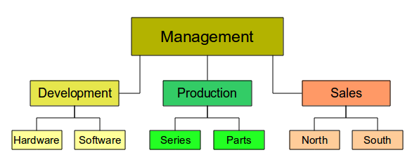
Figure 1: Example of an Organization Chart
Before you begin, prepare a setup page or draft, with snap lines, to assist in drawing the various hierarchies, responsibility paths, and typical boxes that you will use in drawing the chart.
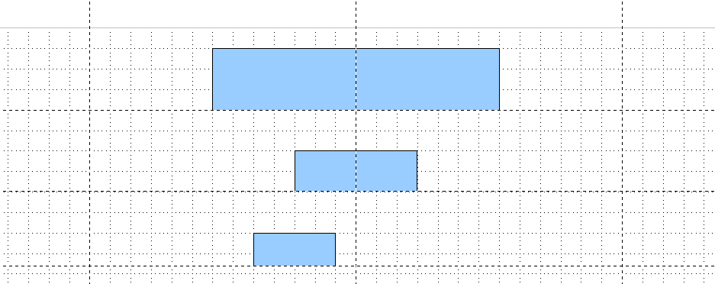Figure 2: Draft with snap lines
Place and dimension the individual boxes according to the size of the overall chart. The exact size (particularly width), position, and color will be fixed later. It is sometimes easier to draw only one box per level; later you can copy and paste this box and then move the copies to the desired positions. Using styles can also be helpful; see the relevant section in Chapter 4 (Changing Object Attributes).
You can also select one or more boxes and use Edit > Duplicate to make copies (see Figure 3). The spacing of the duplicated objects relative to the original can be controlled using the placement fields for the X and Y axes. Note that positive values for X and Y are to the right and downwards from the original object.
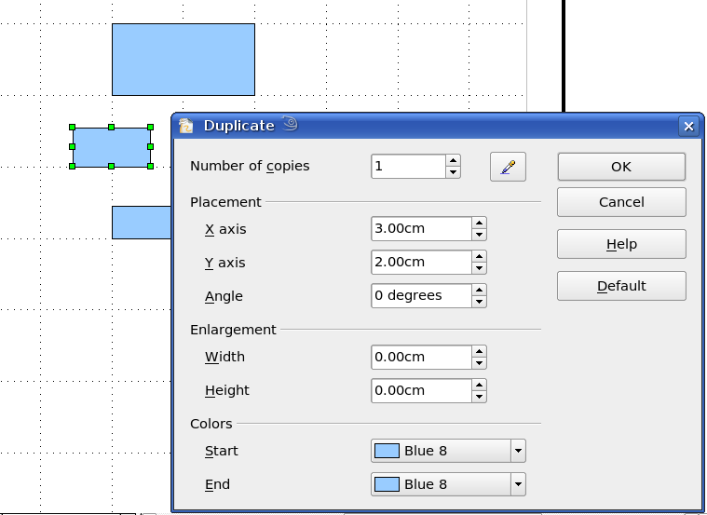
Figure 3: Duplicating an object
Which replication technique you use is up to you. The draft for the example in this chapter should look similar to that in Figure 4.
Figure 4: The finished draft
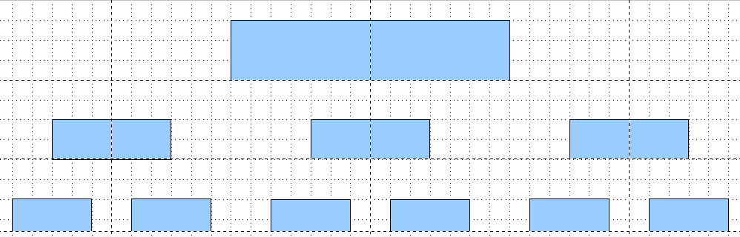
The next step is to add text to the boxes. It is easiest to insert it as a text element within the box as described in Chapter 2 (Drawing Basic Shapes). Activate the  icon on the Options toolbar and then double-click the box to enter text into it. Alternatively, select the box and press F2. You should then see a blinking cursor in the box and the Text Formatting toolbar should be visible.
Set the text formatting and type the text. Depending on the length and format of the text, you may need to adjust the size of the box and the spacing to neighboring boxes or else change the formatting of the text to fit the box. Adjustments can be made initially with the mouse and then fine-tuned with the Position and Size dialog.
Now set up the fill colors and save the drawing. The connections between the boxes are not drawn with ordinary lines but with Draw’s connectors. How to draw these connectors and add text to them is described in “Glue points and connectors” starting on page 8.
You can use dynamic text frames instead of boxes. These have the advantage of automatic line breaks. Figure 5 shows the sequence of text input into a frame, adding borders, and setting the background color. The Line and Filling toolbar may not be visible until you have set a line type for the frame. Set the line type using Format > Line or right-clicking the text frame and selecting Line.
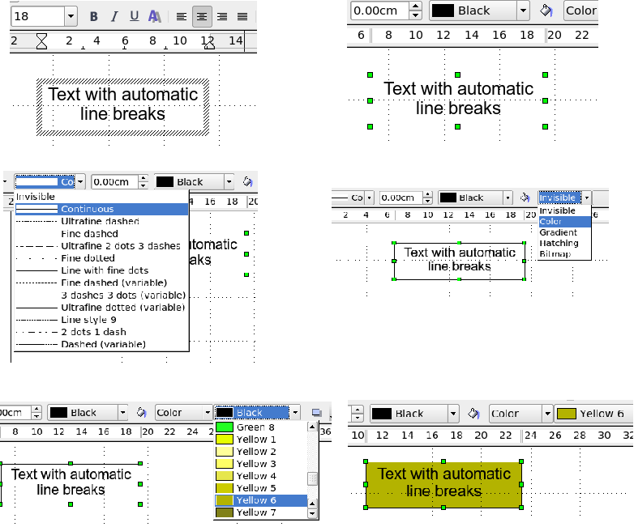
Figure 5: Working with text frames

Drawing a flow diagram
For drawing flow diagrams (also known as flowcharts), Draw offers a separate toolbar (Figure 6); click the flowchart icon on the main Drawing toolbar.
The easiest way to draw a flowchart is to follow the same setup procedure as for organization charts. Select the symbols from the toolbar and drag them into position as described in Chapter 2 (Drawing Basic Shapes). See Figure 7 for an example of a typical flowchart.
The individual symbols must be exactly positioned if the connectors joining them are to form a vertical line. The midpoints of all the symbols that lie in a vertical straight line should have the same X coordinate and those on the same level on a horizontal line should have the same Y coordinate.
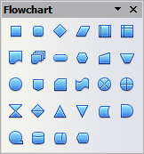
Figure 6: The Flowchart toolbar
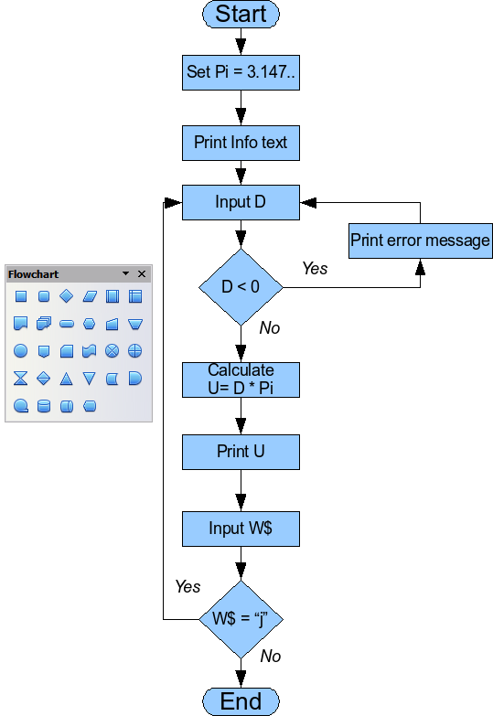
Figure 7: Example of a flow diagram
Select the shapes that are to lie in a vertical straight line and center them with Modify > Alignment > Centered. For those on a horizontal line, select the shapes and center them with Modify > Alignment > Center. You can also set snap lines if you need several vertical lines.
After adding text and setting the fill color, you can join individual symbols together and add text to the connectors. This technique is described in the next section.

Glue points and connectors
These elements were briefly introduced in Chapter 2 (Drawing Basic Shapes). This section describes how to use them.
Connectors are lines or arrows whose ends automatically dock to a connection or glue point on an object. Connectors are particularly useful when drawing organization charts, flow diagrams, and mind-maps. The connecting lines between the symbols remain intact even when the latter are moved or rearranged.

The Connector toolbar
Click on the arrow of the button on the Draw toolbar to open the Connectors toolbar.
If the type of connector you want is not shown, drag the toolbar to make it float, then click on the arrow in the toolbar’s title bar. In the list that appears, click on Visible buttons to open a menu from which you can activate additional types of connector (Figure 8).
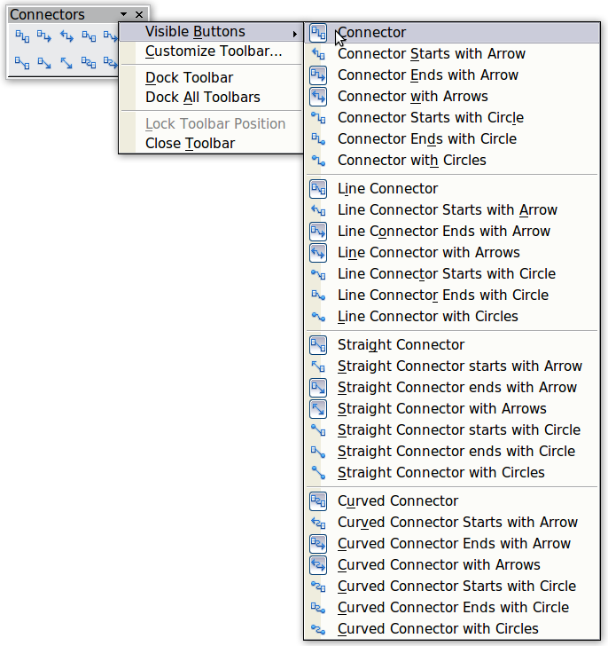
Figure 8: Activating additional connectors

Connector types fall into four groups:
- Standard connectors – the line segments run vertically and horizontally. All angles are right angles. The connector does not bend around the objects it binds.
- Line connectors – consist of a line segment and two smaller horizontal or vertical segments at the ends.
- Straight connectors – consist of a single line.
- Curved connectors – are based on Bézier curves, as described in Chapter 10 (Advanced Draw Techniques).
You can modify all the connector types from the context menu. Select Connector to change from one connector type to another (as well as some other properties). With the Line dialog you can change the appearance of the line (color, arrow style, and line style) but not the connector type.

Drawing connectors—basics
When you choose a connector from the toolbar, the mouse pointer changes to 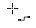. As you move the cursor over an object, the available connection points (also referred to as glue points) become visible. To connect two shapes, move the mouse cursor over a glue point, click and hold down the left mouse button to establish the first point, and then drag the mouse cursor (left button still pressed) to the other glue point and release the mouse button. The ends of the line are now docked and the connection is established (see Figure 9).

Figure 9: Gluing a connector to a shape
You can also attach the beginning or the end of a connector to the middle of an object. This is useful when the final position of the object is not yet determined. When you move the object, Draw automatically selects the optimal location for the connector ends (see Figure 10).
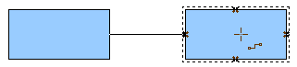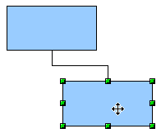
Figure 10: Connector attached to the middle of an object
As with all other objects, connectors have one or more control points to simplify the construction of the drawing. You can use these points to change the shape, length, and proportions of the connector line (see Figure 11).
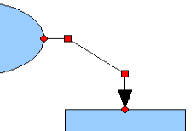Figure 11: Control points of a connector
To remove a connector from an object, either move the end of the connector away from the glue point of the object or simply delete the connector entirely.

Editing glue points
Glue points can be edited using a separate toolbar (see Figure 12). This toolbar appears when you click on the Glue Points icon or select Edit > Glue Points from the main menu.
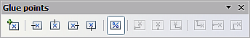
Figure 12: The Glue points toolbar
The following briefly describes the function of each button on this toolbar.
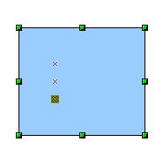
Use this button to insert a new glue point into an object you have drawn. If the object is filled, you can place a glue point anywhere inside the object or on its frame. With unfilled objects you can place a glue point only on the outside frame but you can then drag it inside the object provided that the Glue Points icon on the Drawing toolbar is still active .
The glue points that you add remain visible as long as the Glue Points icon is active. They appear as small blue crosses. A selected glue point has a gray square behind the cross. You can move a selected glue point with the mouse or delete it with the Del key.
Use these four buttons to choose one or more directions permitted for a connector to join to a particular glue point.
Activate Glue Points and then choose the direction. If, for example, you activate only the button, every connector will be forced to come to that glue point from the left side.
In the left-hand drawing below is a glue point in the circle with a left entry and one in the square with a right entry. The effect of this when adding a connector between the two glue points is shown in the right-hand drawing..
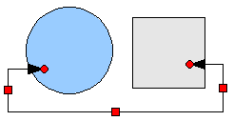
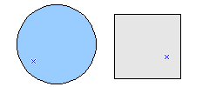
If you are in glue point editing mode and you add another direction to a glue point (for example by activating the button), Draw tries to optimize the length of the connector. For the example above, the connection inside the circle would change as shown below.
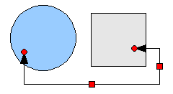
If the Glue Point Relative button is active (as it is by default) the glue point will move when you change the size of the object, as shown below.
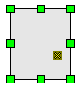
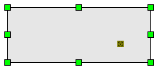
If the Glue Point Relative button is deactivated, the remaining buttons on the toolbar, previously grayed out, become active. With these buttons you can decide how a glue point will be placed when the size of the object is changed.
These buttons determine how the horizontal position of a glue point changes when you resize the object containing the glue point. You can choose whether the glue point remains at a fixed distance from the left edge of the object, from a vertical line through the middle, or from the right edge of the object when you change the size of the object. If the width of the object becomes less than that distance, the glue point is attached to the object frame.
The following example shows what happens when an object’s width is changed and the glue point is set to be a fixed distance to the left frame.
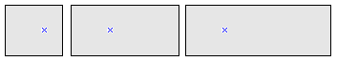
These buttons determine in a similar manner the vertical position of a glue point when the size of the object is changed.

Adding text to connectors
To add text to a connector, double-click the connector. The end and control points become active and the familiar flashing text cursor appears (the cursor position is determined by the most recent setting). The Text Formatting toolbar also appears (under the menu bar). Use this toolbar to set the text properties; you can directly insert the text.
If you draw a connector and then click on it, only the end points and control points become visible. In spite of this, a connector has its own object frame—in this case an invisible one. You can picture it easily by imagining a rectangle enclosing the start and end points of the connector (Figure 13).
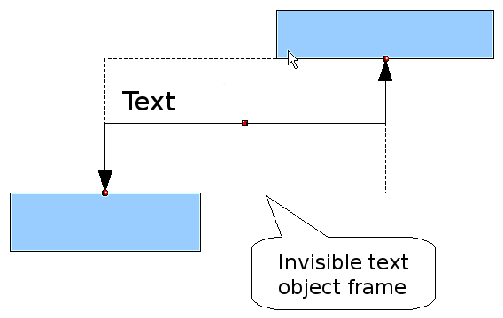
Figure 13: Object frame of a connector
When you add text to a connector, the location of the text is relative to this rectangle. The exact position of the text can be set in the Text dialog (Figure 14). This dialog appears when you double-click on text and then choose Text from the pop-up menu or when you single-click on the connector and select Format > Text from the menu bar.
Take particular note of the Spacing to borders and Text anchor sections in the Text dialog. In the Text anchor section you can see the possible locations for the text. In the example below the text is anchored at the top left. In the Spacing to borders section at the lower left, negative values of spacing will position the text outside the frame.
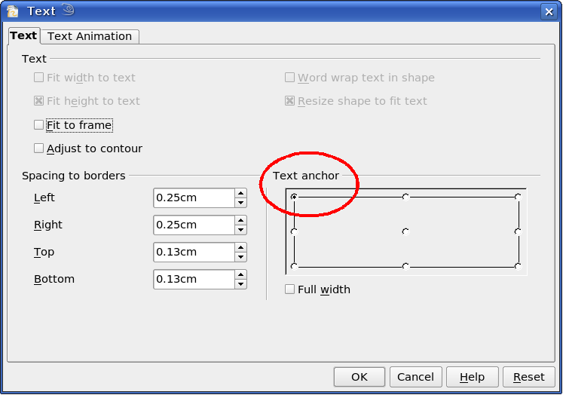
Figure 14: The Text dialog

Adjusting text to suit the connecting line
If you want the text to follow the slope or curve of a line, you need to activate and use the Fontwork tool. To add this tool to the Draw toolbar:
- Choose Tools > Customize from the menu bar.
- On the Toolbars tab, select Drawing from the Toolbars pull-down list. In the Toolbar content section, click Add.
- On the Add Commands dialog, select Format from the left-hand list and the command Fontwork. Click Add, then Close to return to the Customize dialog.
- In the list of commands under Toolbar Content, move the Fontwork icon 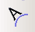 to the location you want by using the up/down arrows, and then click OK.
To write slanting text, follow these steps:
- Add the text to the connector as described earlier. The anchor location of the text is not important at this stage.
- Select the object with the text (in this case the connector) and click on the Fontwork icon to open the Fontwork dialog.
- To make the text lie along the inclined line, click the Rotate icon and set the distance to the line you wish.
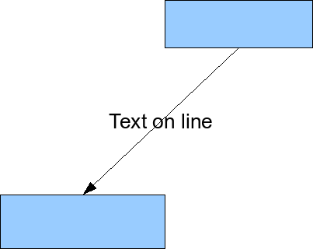
Figure 15: Adding text to an inclined line, Step 1
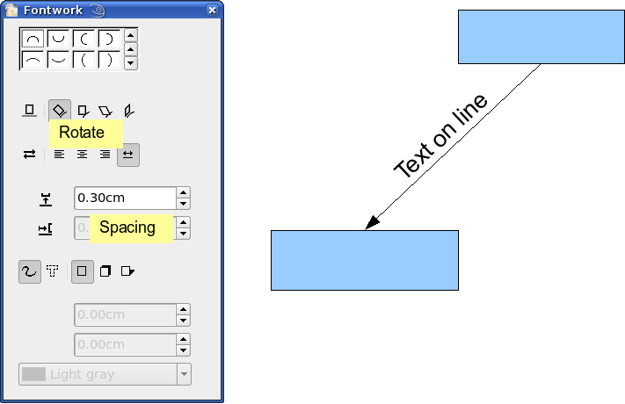
Figure 16: Adding text to an inclined line, Step 2
The Fontwork dialog provides many other possibilities for manipulating text. You can, for example, rotate the text 180 degrees with the Orientation icon (which was done in the example above) or place the text under the line by assigning a negative value to the spacing between text and line.
In addition, you can use the Fontwork dialog to generate curved text that follows the shape of a curved line. Experiment a little to investigate some of the possibilities.

