“MyMusic”

Data Base Application

User's Guide

Version 1.0

Abstract
This document describes purpose and how such a database application looks like, design (table, query, view, relations), forms and reports functionality

Specification Owner | Larysa Zaporozhets | LarysaHitekSchool@openoffice.org
Marketing (MA)
User Experience (UX)
Development(DEV) | Larysa Zaporozhets | LarysaHitekSchool@openoffice.org
Quality Assurance (QA)
Document History
Version | Author | Comment
Draft <Date> | <Name> | <Comment>
26/07/09 | Larysa Zaporozhets | First draft 0.1
Contents
1. Goal
2. Detailed specification
2.1 Base design
2.2. Relational Model
2.3 Form, designed to enter, view and deletion data
2.3.1 View the form
2.3.2 How to enter data properly to the form

2.3.3 How to delete data properly from the form

2.4 Queries

2.5 Reports

3. References

1. Goal

Database “MyMusic” was developed in order to help user easy maintain his home music collection information. In this database application the user can use one form in order to combine all necessary information to view and manipulate data. Reports and Queries serves to present information in desirable view.

2. Detailed specification

Creation of this specification serves to provide necessary information for the application to function, how a connection between tables have been established, details of the forms, reports and queries.

2.1 Base design

The application was created for user's conveniences in mind and simplicity to work with this database. Application is able to support private collection information and keep all available information about any musical composition in one form. User can add and delete information.
Definitions, Acronyms and Abbreviations were made understandable and based on common sense.
Application contains 7 tables. Main menu of OpenOffice.org Base allows opening, viewing and partially correcting the information.

TABLE SONG
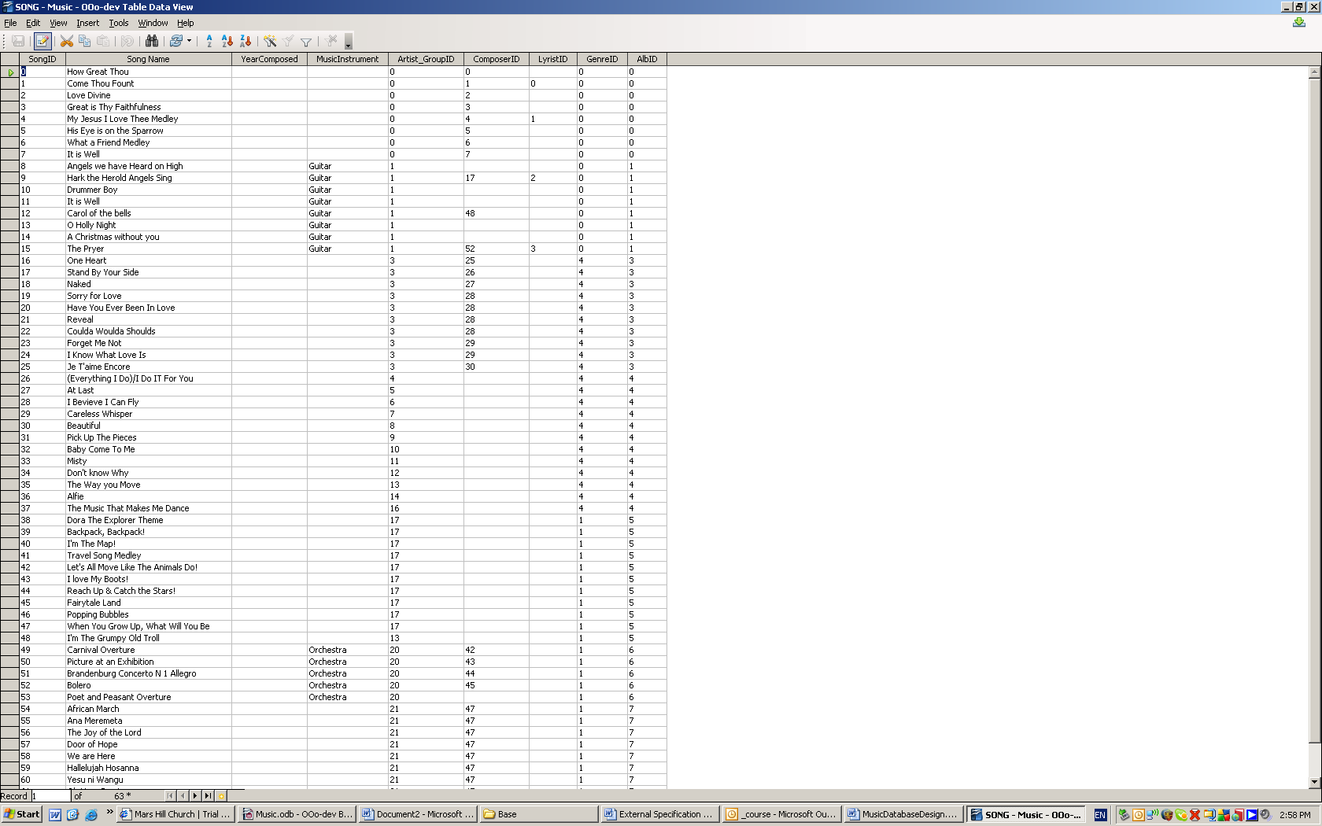

Table stores information about various songs.

Song (ID, Song Name, YearComposed, Music Instrument)
ID: Default Setting
Name: Entry required: Yes Data type: VCHAR (100)
YearComposed: Entry required: No Data type: INTEGER (10)
Music Instrument: Entry required: No Data type: VCHAR (50)
Artist_GroupID: Auto Value
ComposerID: Auto Value
LyristID: Auto Value
GenreID: Auto Value

TABLE ALBUM

Table stores information about an album
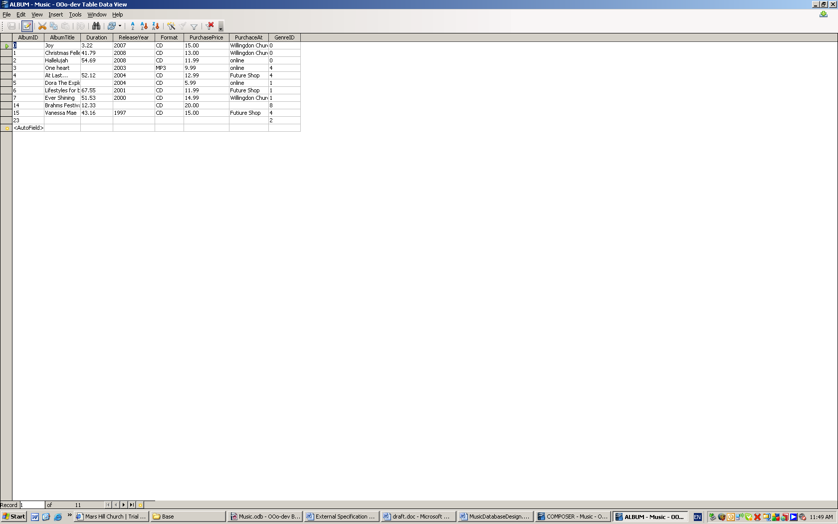

Album (ID, AlbumTitle, Duration, Release Year, Format, Purchase At, Purchase Price, GenreID)
ID: Default setting
AlbumTitle: Entry required: Yes Data type: VCHAR (50)
Duration:Time of playing in MM,SS format. Entry required: No Data type: Decimal (5:2)
Release Year: Entry required: No Data type: INTEGER (10)
Format: This field is used for format entry. There are many formats as CD, MP3, DVD-Audio, HDCD, etc. Entry required: No Data type: VCHAR (5)
PurhcaseAt: User can use this field to entry store or person name to memorize source of the album. Entry required: No Data type: VCHAR (20)
PurchasePrice: Entry required: No Data type: Decimal (5:2)
GenreID: AutoValue

TABLE ARTIST_GROUP
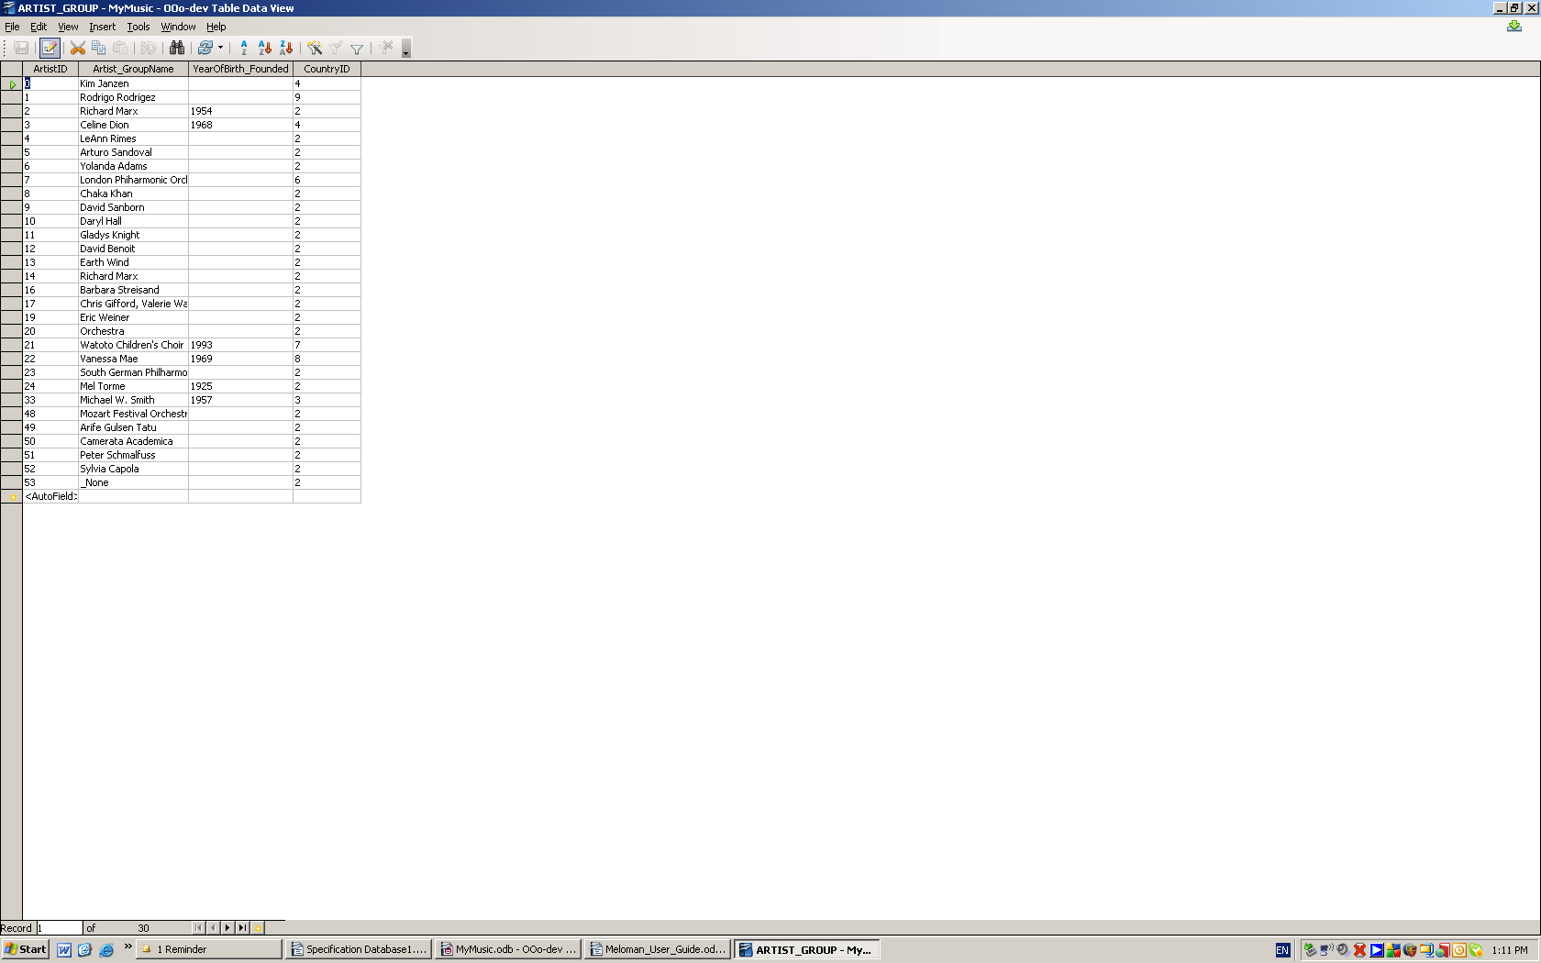

Table stores information about an artist or a music group.

Artist_Group (ID, Name, YearOfBirth_Founded, CountryID)
ID: Default setting
Artist_GroupName: Entry required: Yes Data type: VCHAR (50)
YearOfBirth_Founded: Entry required: No Data type: INTEGER (10)
CountryID: Auto Value

TABLE COMPOSER

Table stores information about a composer.
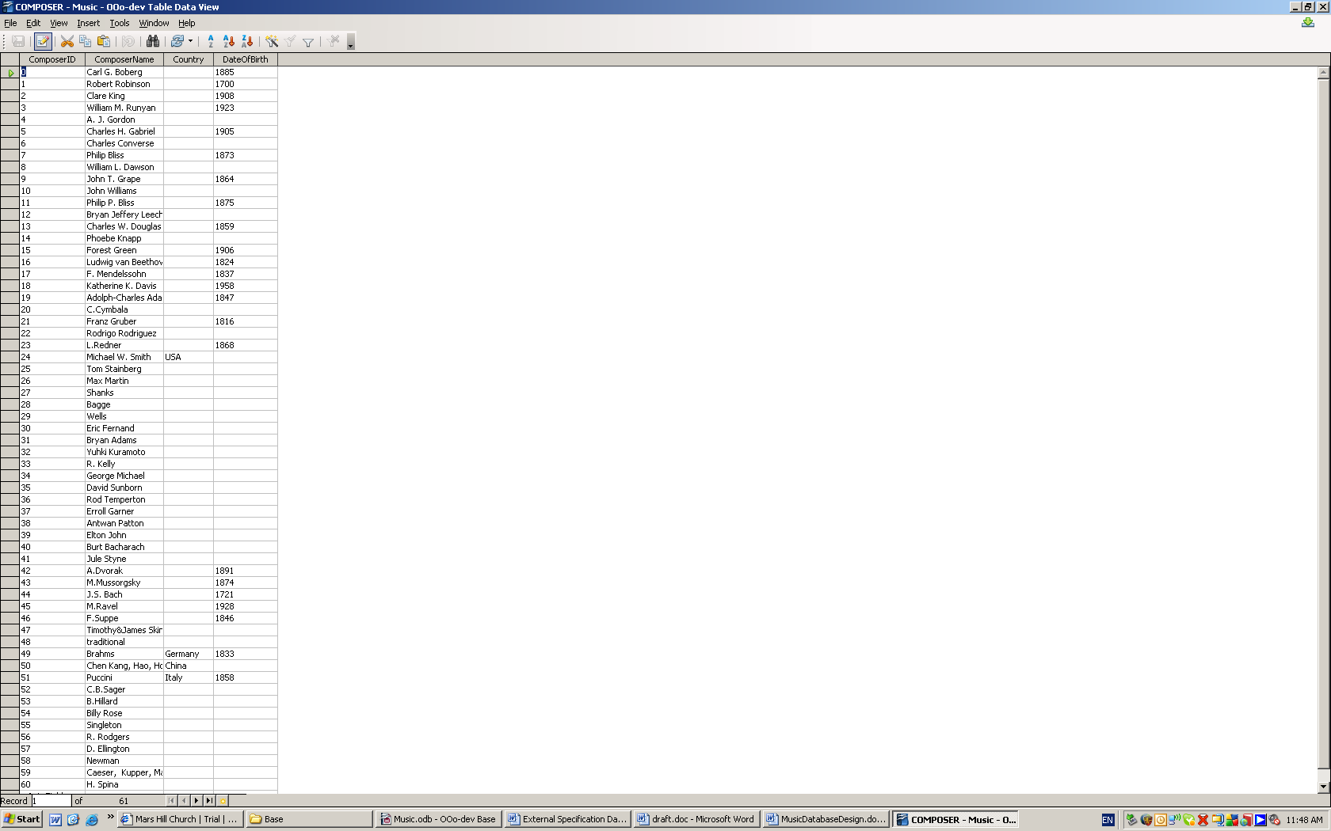

Composer (ID, ComposerName, DateOfBirth (means year of birth), CountryID)
ID: Default setting
ComposerName: Entry required: Yes Data type: VCHAR (50)
DateOfBirth: Entry required: No Data type: INTEGER (10)
CountryID: Auto Value

TABLE LYRIST
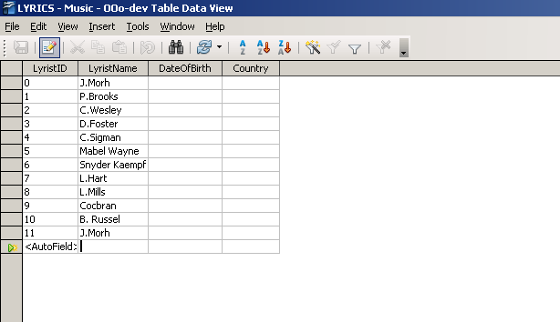

Table stores information about a song lyrist.

Lyrist (ID, LyristName, DateOfBirth (means year of birth), CountryID)
ID: Default setting
LyristName: Entry required: Yes Data type: VCHAR (50)
DateOfBirth: Entry required: No Data type: INTEGER (10)
CountryID: Auto Value

TABLE GENRE
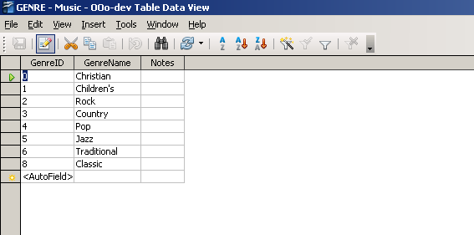

Table stores information about music genre (such as jazz, pop, classic etc.)

Genre (ID, GenreName, Notes)
ID: Default setting
GenreName: Entry required: No Data type: VCHAR (50)
Notes: Entry required: No Data type: VCHAR (200)

TABLE Country
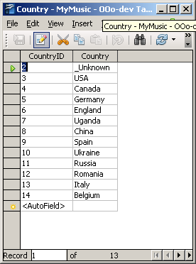
Table contains list of countries.

Country (ID, Country)
ID: Default setting
Country: Entry required: Yes Data type: VCHAR (50)

2.2. Relational Model
In our relational model we have one main table song which has one-to-many relations
with other tables using ID as foreign keys.

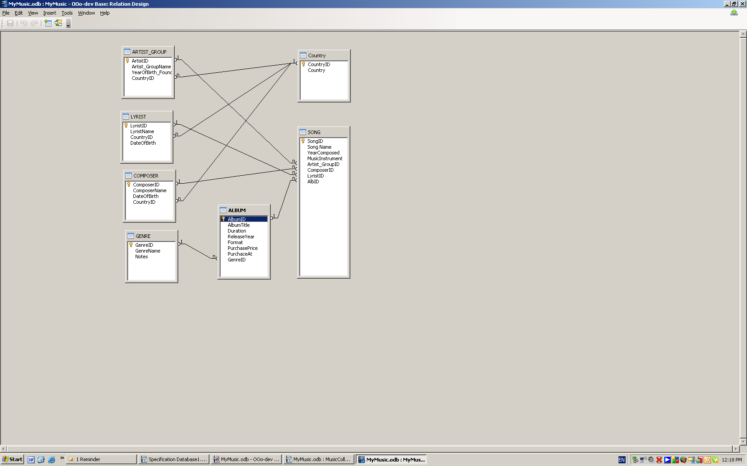

2.3 Form, designed to enter, view and deletion data

One form was created according to our design for user’s convenience which can be used for viewing and correction of data. This form combine all information contained in 7 tables.

2.3.1 View the form

In order to view the information user can use tabulation or buttons “Next Record”, “Previous Record” at the bottom of the form.

FORM “MusicCollection”
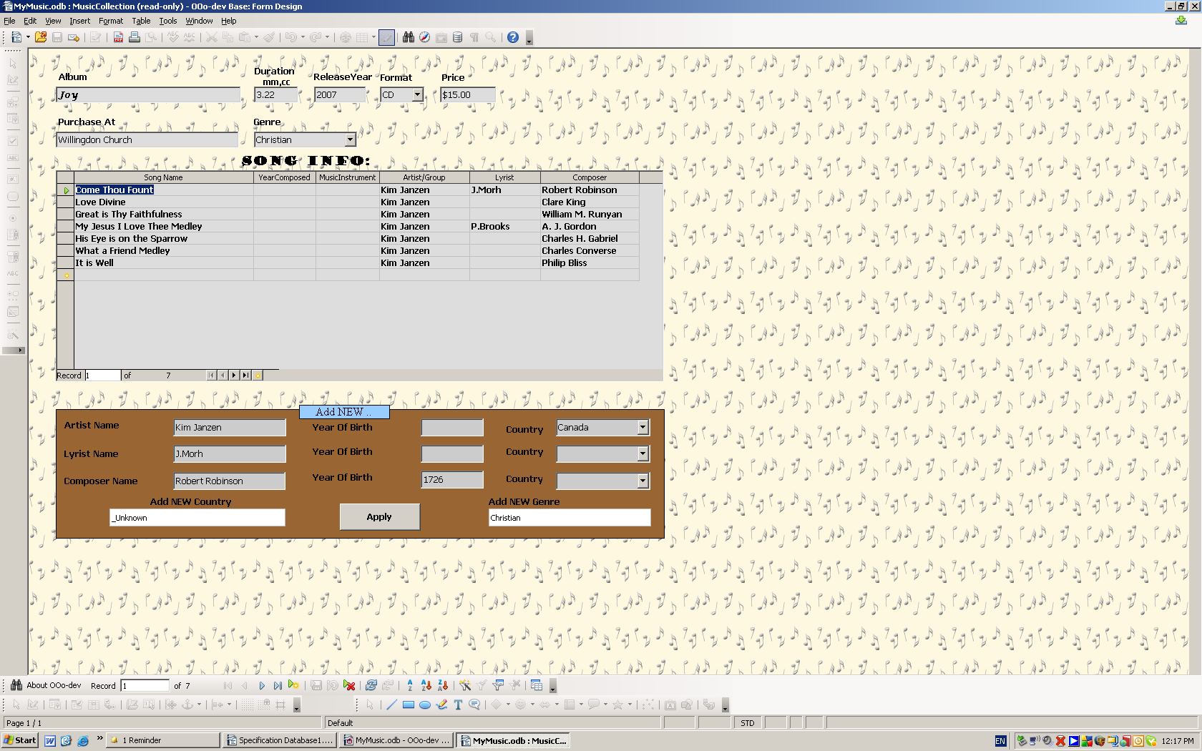

2.3.2 How to enter data properly to the form

Entering data starts from filling “Album Title” and all information about album. Field “Genre” contain drop-down list of genres to choose from.
Next step is entering data in table “SONG INFO” which allows user to fill out “SongName”, “YearComposed”, “MusicInstrument” (preferably using for classic records), “Artist/Group”, “Lyrist”, “Composer”. Last three fields are list boxes which allows user to choose particular name.
In case user wants to add new “Artist/Group”, “Lyrist”, “Composer” names he should fill out form below table “SONG” and after every fill press button “Refresh” at the bottom of the window. Floating HELP message of SONG INFO table reminds user “For new info fill out form below”.
In order to add new Country or new Genre the user is asked to press “Apply” button after entering desired information.
For data navigating user should use buttons “First record”, “Previous record”, “Next record”, “Last record”, “New record”, “Delete record”, Refresh”.

2.3.3 How to delete data properly from the form

In order to delete information about particular album user has to delete record by record from “SONG INFO” table and then delete Album from “Album Name” field.

2.4 Queries

Queries serve one purpose to extract data from base in desirable view. In “Music” data base we created four queries:
- CountSongs – allows user to know how big his collection is in term of songs
- QueryAlbumGenre - allows to view album’s name and genre
- Song_asc – user has ability to view info about songs which sorted in alphabetic order (for example, what album particular song belongs to)
- SortbyArtist – allows sorting songs by particular Artist. To do so user should type name of Artist in field “Value” and press button “OK”
- SummaryAlbum – contains information about particular Album. To do so user should type name of Album in field “Value” and press button “OK”.

2.5 Reports

Reports serve to present information from database in compact and readable view.
There are few dynamic reports available:
- AlbumGenre - present album’s name and genre information
- SortbyArtist – allows view songs of particular Artist. To do so user should type name of Artist in field “Value” and press button “OK”
- Song_asc - allows view songs of particular Album in alphabetical order
- Summary – report major information such as Song, Composer, Lyrist, Album,
Ascending by Album Name

3. References

http://wiki.services.openoffice.org/wiki/Database
http://www.linuxbeacon.com/doku.php/articles:ooobaseprimer
http://documentation.openoffice.org/manuals/oooauthors2/0110GS-GettingStartedWithBase.pdf

