MELOMAN

Open Office 3.1

Data Base Application

Internal Design Specification

Version 1.0

Revision History
Date | Version | Description | Author
August 7, 2009 | 1.0 | Data Base Architecture Document | Vladimir Seredkine

Table of Contents
1. Introduction 5
1.1 Purpose 5
1.2 Scope 5
1.3 Definitions, Acronyms, and Abbreviations 5
1.4 References 7
1.5 Overview 7
2. Architectural Representation 7
2.1 General overview 7
2.2 Database structure 8
2.2.1 Database model 8
2.2.2 Concepts 8
2.2.3 Database structure 9
3. Architectural Goals and Constraints 9
4. Logical View of database tables 10
5. Logical View of Entry Forms 13
5.1 Navigation buttons of Tool Bar for all Entry Forms 13
5.2 ENTRY MEDIA TYPE Form (Collection Database branch) 14
5.2.1 Access method 14
5.2.2 Navigation buttons of Tool Bar 14
5.2.3 Window layout 14
5.2.4 Actions 14
5.3 ENTRY LOCATION Form (Collection Database branch) 15
5.3.1 Access method 15
5.3.2 Navigation buttons of Tool Bar 15
5.3.3 Window layout 15
5.3.4 Actions 16
5.4 ENTRY MEDIA LIST Form (Collection Database branch) 16
5.4.1 Access method 16
5.4.2 Navigation buttons of Tool Bar 16
5.4.3 Window layout 17
5.4.4 Actions 17
5.5 Table Entry Media List Form (Collection Database branch) 17
5.5.1 Access method 18
5.5.2 Navigation through the Table 18
5.5.3 Table layout 18
5.5.4 Actions 18
5.6 ENTRY LANGUAGE Form 19
5.6.1 Access method 19
5.6.2 Navigation buttons of Tool Bar 19
5.6.3 Window layout 19
5.6.4 Actions 20
5.7 ENTRY MUSIC TYPE Form 20
5.7.1 Access method 20

5.7.2 Navigation buttons of Tool Bar 20
5.7.3 Window layout 21
5.7.4 Actions 21

5.8 2-ENTRY MUSIC GENRE Form 21
5.8.1 Access method 21
5.8.2 Navigation buttons of Tool Bar 22
5.8.3 Window layout 22
5.8.4 Actions 22
5.9 ENTRY COUNTRY Form (Music World Database branch) 22
5.9.1 Access method 23
5.9.2 Navigation buttons of Tool Bar 23
5.9.3 Window layout 23
5.9.4 Actions 23
5.10 3-ENTRY ALBUMS Form (Music World Database branch) 23
5.10.1 Access method 24
5.10.2 Navigation buttons of Tool Bar 24
5.10.3 Window layout 24
5.10.4 Actions 24
5.11 Table Entry Albums Form (Music World Database branch) 25
5.11.1 Access method 25
5.11.2 Navigation through the Table 25
5.11.3 Table layout 26
5.11.4 Actions 26
5.12 1-ENTRY PERFORMERS & PERSONS Form (Music World Database branch) 27
5.12.1 Access method 27
5.12.2 Navigation buttons of Tool Bar 27
5.12.3 Window layout 27
5.12.4 Actions 28
5.13 Table Entry Performers & Persons Form (Music World Database branch) 28
5.13.1 Access method 29
5.13.2 Navigation through the Table 29
5.13.3 Table layout 29
5.13.4 Actions 29
5.14 4-ENTRY MUSIC ITEMS Form (Main Database form) 30
5.14.1 Access method 30
5.14.2 Navigation buttons of Tool Bar 30
5.14.3 Window layout 30
5.14.4 Actions 31
5.15 Table Entry Music Items Form 32
5.15.1 Access method 32
5.15.2 Navigation through the Table 32
5.15.3 Window layout 33
5.15.4 Actions 33
6 Approximate list of queries shall be available to design 34
7 Approximate list of reports shall be available to design 34

Internal Design Specification

Introduction
The purpose of this document is to outline the architecture and design of the MELOMAN Data Base Project. It will serve as the work document for developers to implement the solution.
It will also be used by QA team to prepare the test plans. The MELOMAN Data Base Internal Design Specification is devoted to any developer or qualified Open Office data base user to understand conception and structure of the Data Base application and all Data Base structural details.
The document will describe the overall architecture as well as each individual component.

Purpose
This document provides a comprehensive architectural overview of the MELOMAN Data Base Structure, using a number of different architectural views to depict different aspects of the Data Base Application. It is intended to capture and convey the significant architectural decisions which have been made on the Data Base application conception under specific research.

Scope
The main idea of MELOMAN Data Base is to collect, keep and use information about Music World in one Data Base. The data could be load from different sources and could be used by a music collector, disk jokey or other person who connected to Music World and need to find any information about musical compositions quickly and exactly. The MELOMAN Data Base application should be able to support private collection information and keep all available information about any musical composition and about any performer or person who took a part in it's creation. After the definite investigation of Music World and similar applications with purpose to simplify and not overload the product this Data Base cover just the most important information about music compositions and skips such things as prices, manufacturing, producers, record format, playing duration and other not so much important things which can be put in Notes, History and Biography fields if a User wants.

Definitions, Acronyms and Abbreviations

Abbreviation | Description
User | Any user which can use the MELOMAN Data Base Application
Music Item | Single Musical Composition, such as: Song, Melody, Overture, Sinfonia, Aria, Sonata, Toccata etc, which has definitely beginning and end, duration time and cannot be separated. Music Item might be belong to an Album (see: Album definition) but not always. It could be a single never issued as a part of album.  If a Music Item belongs to two or more albums for the Meloman project it considered that the Music Item belongs to the most earliest official issued album even if the Music Item was issued earlier before as a single.
Media | Something which can keep records, such as: CD, DVD, Vinyl Disk, Video Tape etc., should be easy to remove and keep in collection.
Media Type | Any type of media which existing nowadays:CD disk,CD MP3 disk,DVD MP3 disk,Vinyl disk,Cassette,Flash card...
Location | Location of medias which carrying collection music items (records). It could be any place where media located in current moment, ex.: in collection,Shelf #1, Box #10, my friend <Name>, URL, on sale, coming by mail, etc.
Music Type | General description of musical composition which User determines for himself or follows common definition, such as: Song, Instrumental Composition, Symphony, Chorus, Opera, Ballet etc It could be different genres or styles
Music Genre (Genre) | Any Genre or Style or their combination to which Musical Composition belong according to original source or user determines for himself or follows common or somebodies definition, such as: Pop, Disco, Classic, Latin, Disco/Pop, Rock, Pop/Rock, Hard rock , Jazz, Folk, Classic Rock etc
Album name (Album) | Name of officially issued set of music items, ex.: name of concert, name of album, name of performance, name of opera etc. Usually this set is issued by Performer but sometimes an album can be issued by others and even with various performers. In both cases sets of Music Items considered issued once and forever and Music Items inside cannot be change by others.  Sometimes Performers issued albums under the same name in different places with a little bit different contents. In this case priority has the album of native country. Music Items which not included in native country album and first time appeared in foreign album are considered to be belong to foreign issued album.  Sometimes different albums of different Performers have the same name.  All these cases demands from User to put an additional info to the main name of the album because the Album name should be unique in MELOMAN application. For cases described above see samples of Album names below:  Help! (The Beatles) (UK release);  Help! (The Beatles) (USA release);  Help! (War Child);  Music (Madonna);  The Music (The Music band).
Music name | Name of Music Item (Musical Composition) usually unique but sometimes could have well-known name in other language which should be perform in bracket if it possible
Performer | It means group (“ABBA”, "Rolling Stones", "Pink Floyd" etc. ), team (Orchestra, Chorus), artist, singer, musician etc. which performs a Music Item.
Person | Any person who performed or took a part of creation a Music Item, ex.: Singer, Artist, Composer, Lyrics Author, Musician, Producer, etc.
Name | Common known, well-known, usually short name of Performer or Person. It could be real short name or nickname, or sometimes abbreviation of full name, ex.: rock group BTO has full name as Bachman-Turner Overdrive.
Original Name | Real official name, birth name or full name of a Person and also could be a full name of a team or a group (See Name).
Birth year | Year when a Person was born or Performer as a group or team was created
Composer | One or many Persons who composed music for Music Item.
Text Author | One or many Persons who wrote lyrics for Music Item.
Text | Propel text of lyrics for Music Item created by Text Author
Language | Language of lyrics Text used in Music Item. Sometimes it could be in two languages.
Life end year | Year when a Person died or Performer as a group or a team finished it's existence
Year | Any year from 1600 to 2050 which has to be used in MELOMAN Data Base.
Country | Any name of a country has to be used in MELOMAN Data Base.
History | Historical and any other available data about a Music Item
Notes to Album | Historical and any other available data such as track listing and credits about an album
Biography and History | Biographical and historical data about Person or Performer.
Photo Image | Any photo or other image of Person or Performer
Photo Image info | Information or data which helps to find photo or digital image of Person or Performer
Cover Image | Any photo or other image of Album cover. Usually it is unique image even if it had reissue or transferring on other media.
Photo Image info | Information or data which helps to find photo or digital image of Album cover
Media code | The inventory number of media under which it registered in collection and created by User. Can be performed by letters and numbers
Registration Date | Date of media registration in collection with Media code by User
Media Name | Name of media which performed on it's cover or name of media which could be given be User if it custom made media. And also could not have name at all
Record # | Number of record on Media
Quality | Means quality Music Item record or whole Media. It could be high or with sound distortion, or with scratches, etc.
From | Date from which Media is out of collection

References
- OpenOffice.org, Getting Started with Base
- OpenOffice.org, User Guide for 2.x, Chapter 7: Databases and Data Sources, pp 364-391

Overview
- The purpose of the Music Data Base project and application (called MELOMAN) is to gather all information and requests for getting User's desire and concerning User's Music Collection within a common framework, articulated around a centralized OpenOfficedatabase.
- Prior to this application, the information is spread among several different sources with data variety problems and lack of cohesion and regimentation.
- Initial import of data from existing sources is not in the scope of this project. All data in MELOMAN Data Base is just a sample and have been input during creation of the application, testing and adjusting. But all data is real and collected mostly from Internet web sites. It's User's responsibility to adjust MELOMAN application according to his(her) Music Collection or desired information from Music World and to remove or leave existing Database data.

Architectural Representation

General overview
The project is created according to Open Office Management task, and using OpenOffice 3.1 Data Base files to store User's information about his(her) Music Collection and as much as possible related data. The application’s look and feel must comply with the existing standards for data base applications.

Database structure

Database model

There are 11 Data Base tables to be created:
- Music Items table;
- Albums table;
- Performers & Persons table;
- Media List table;
- Media Type table;
- Location table;
- Music Genre table;
- Music Type table;
- Country table;
- Language table;
- Year table.
They are related to each other as shown on diagram (see 2.2.3). Each table should be stored through OpenOffice 3.1 Database – Tables interface. All tables shouldn't be protected and can be modified anytime.

Concepts

As it is shown in 'MELOMAN' Database Structure (see 2.2.3) the Music Items table is the main table which is carrying almost all information about each musical composition (Music Item). There are two main separated branches of interactive related tables which provide info service to Music Items table:

- Collection branch: Media List table, Media Type table, Location table.

- Music World branch: Albums table, Performers & Persons table,, Country table,, Year table.

Three tables: Music Type table, Music Genre table, Language table are neutral and can be used or not in both database branches.

These two branches Database Structure allows to collect, keep and use Music Items data for two different ideas:

- Support information about custom collection of music records;

- Collect all available knowledge about Music Item in one Database.

Thus User can develop both Database branches or leave one of them and to be concentrated on another one. So the 'MELOMAN' Database application could be useful not for music collector only but for wide amount of other people who is not music collector but related to Music World by various aspects.

Database structure
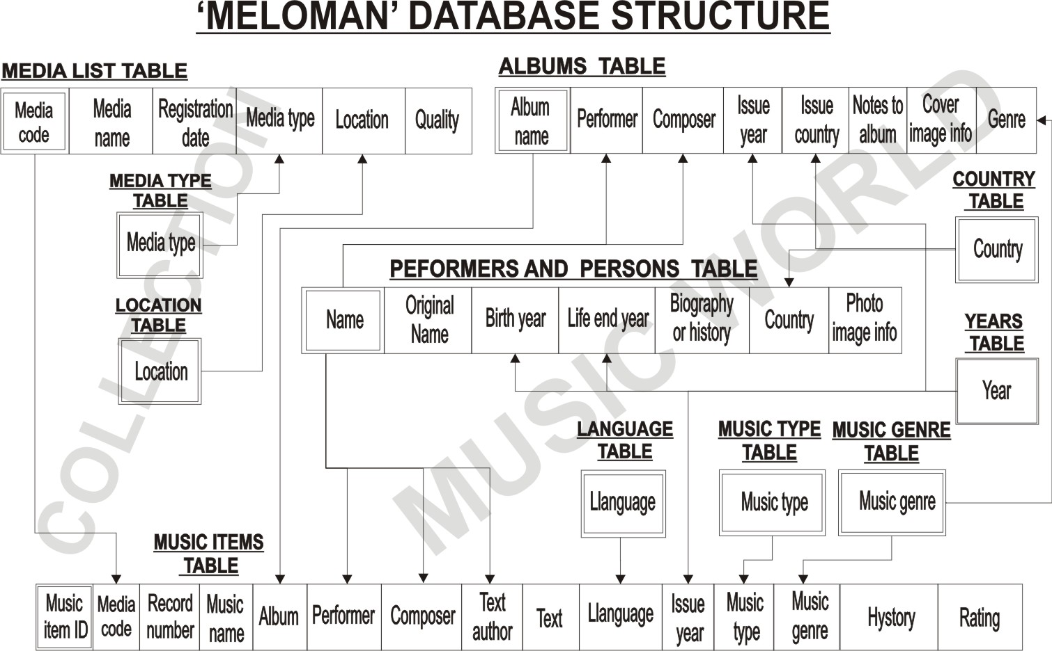

Architectural Goals and Constraints

- The goal is to collect by the easiest way maximum available information about any musical compositions created in the world with purpose to use this information later with hundreds options of queries and reports which are allowed to be created by OpenOffice. Base.
- The 'MELOMAN' Database application is convenient easy to use application that will allow User to:
  - Create in Database a new Music Item, new Media with records, new Album, new Performer or Peron and others;
  - Modify any information inside the tables besides Primary key fields;
  - Delete any information inside the tables including Primary key fields
- There are suggested simple rules to be read and followed by any User before he (she) starts working with Database which are described in User's Guide and will help to keep 'MELOMAN' Database in perfect condition.
- Any User must learn OpenOffice. Base interface to control MELOMAN' Database tables through Entry forms and create new queries and reports.
- Because we are using a database with related tables some fields of some tables should be filled before it will be allowed to input full information for new Music Item.

Logical View of database tables

MEDIA TYPE TABLE
Control Type | Name | Data Type | Min # of Char | Max # of Char | Mandatory | Default | Notes
Edit Field | Media type | Text | 1 | 50 | Yes | Blank | Primary Key

LOCATION TABLE
Control Type | Name | Data Type | Min # of Char | Max # of Char | Mandatory | Default | Notes
Edit Field | Location | Text | 1 | 50 | Yes | Blank | Primary Key
Edit Field | From | Date | 0 | 8 | No | Blank

MEDIA LIST TABLE
Control Type | Name | Data Type | Min # of Char | Max # of Char | Mandatory | Default | Notes
Edit Field | Media code | Text | 1 | 10 | Yes | Blank | Primary Key
Edit Field | Media name | Text | 1 | 200 | No | Blank
Edit Field | Media type | Text | 1 | 20 | No | Blank
Edit Field | Location | Text | 1 | 50 | No | Blank
Edit Field | Registration date | Date | 0 | 8 | No | Blank
Edit Field | Quality | Text | 1 | 50 | No | Blank

LANGUAGE TABLE
Control Type | Name | Data Type | Min # of Char | Max # of Char | Mandatory | Default | Notes
Edit Field | Language | Text | 1 | 50 | Yes | Blank | Primary Key

MUSIC GENRE TABLE
Control Type | Name | Data Type | Min # of Char | Max # of Char | Mandatory | Default | Notes
Edit Field | Music Genre | Text | 1 | 50 | Yes | Blank | Primary Key

MUSIC ITEM TABLE
Control Type | Name | Data Type | Min # of Char | Max # of Char | Mandatory | Default | Notes
AutoID Field | Musical Item ID | Integer | 1 | 10 | Yes | Blank | Primary Key
Edit Field | Media code | Text | 1 | 10 | No | Blank
Edit Field | Record # | Numeric | 1 | 3 | No | Blank
Edit Field | Music Name | Text | 1 | 100 | No | Blank
Edit Field | Album Name | Text | 1 | 200 | No | Blank
Edit Field | Issue year | Numeric | 4 | 4 | No | Blank
Edit Field | Performer | Text | 1 | 200 | No | Blank
Edit Field | Composer | Text | 1 | 200 | No | Blank
Edit Field | Text Author | Text | 1 | 200 | No | Blank
Edit Field | Language | Text | 1 | 20 | No | Blank
Edit Field | Music Type | Text | 1 | 50 | No | Blank
Edit Field | Genre | Text | 1 | 50 | No | Blank
Edit Field | Rating | Numeric | 1 | 1 | No | Blank
Edit Field | Text | Text | 1 | 4000 | No | Blank
Edit Field | History | Text | 1 | 100000 | No | Blank

MUSIC TYPE TABLE
Control Type | Name | Data Type | Min # of Char | Max # of Char | Mandatory | Default | Notes
Edit Field | Music Type | Text | 1 | 50 | Yes | Blank | Primary Key

ALBUM TABLE
Control Type | Name | Data Type | Min # of Char | Max # of Char | Mandatory | Default | Notes
Edit Field | Album Name | Text | 1 | 100 | Yes | Blank | Primary Key
Edit Field | Genre | Text | 1 | 50 | No | Blank
Edit Field | Issue country | Text | 1 | 50 | No | Blank
Edit Field | Performer | Text | 1 | 200 | No | Blank
Edit Field | Composer | Text | 1 | 200 | No | Blank
Edit Field | Notes to Album | Text | 1 | 50000 | No | Blank
Edit Field | Issue year | Numeric | 4 | 4 | No | Blank
Edit Field | Cover Image Info | Text | 1 | 500 | No | Blank

YEAR TABLE
Control Type | Name | Data Type | Min # of Char | Max # of Char | Mandatory | Default | Notes
Edit Field | Year | Numeric | 4 | 4 | Yes | Blank | Primary Key

COUNTRY TABLE
Control Type | Name | Data Type | Min # of Char | Max # of Char | Mandatory | Default | Notes
Edit Field | Country | Text | 1 | 50 | Yes | Blank | Primary Key

PERFORMERS & PERSONS TABLE
Control Type | Name | Data Type | Min # of Char | Max # of Char | Mandatory | Default | Notes
Edit Field | Name | Text | 1 | 200 | Yes | Blank | Primary Key
Edit Field | Original Name | Text | 1 | 500 | No | Blank
Edit Field | Country | Text | 1 | 50 | No | Blank
Edit Field | Biography & History | Text | 1 | 120000 | No | Blank
Edit Field | Birth year | Numeric | 4 | 4 | No | Blank
Edit Field | Life end year | Numeric | 4 | 4 | No | Blank
Edit Field | Photo Image Info | Text | 1 | 1500 | No | Blank

Logical View of Entry Forms

Navigation buttons on Tool Bar for all Entry Forms

Find Record Button: First Record Button:
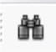


Previous Record Button: Next Record Button:



Last Record Button: New Record Button:



Delete Record Button:



ENTRY MEDIA TYPE Form (Collection Database branch)
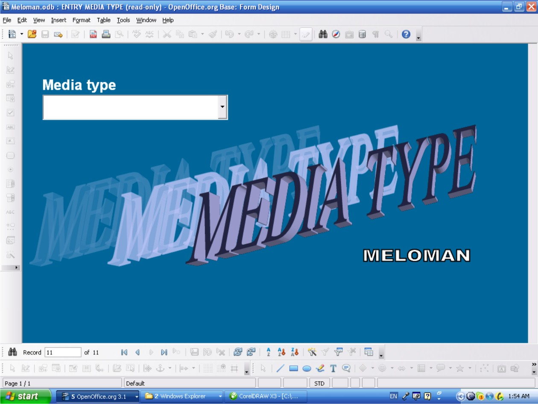

Access method
- Double click on 'ENTRY MEDIA TYPE' form in “Forms” area of Database interface
- Via click “Forms” image button after launch the application.

Navigation buttons of Tool Bar
- See p.5.1.

Window layout
- Field:
  - 'Media Type' is a text combo box field, mandatory if enter new record.
  - list button returns the list of existing 'Media Type' records in A-Z order and must be used for checking existing records only not for entry a new record.

Actions
- “New Record” button allows to enter new record
- “Delete Record” button allows to delete any record

- Any record can be changed if after changes it doesn't duplicate record already existed. On duplication the appropriate warning message must be displayed.
- Exit the form: click Close Window button (Red button with white cross at top right corner of the window)
It fails if entering 'Media Type' name already existed and the appropriate warning message must be displayed.

ENTRY LOCATION Form (Collection Database branch)
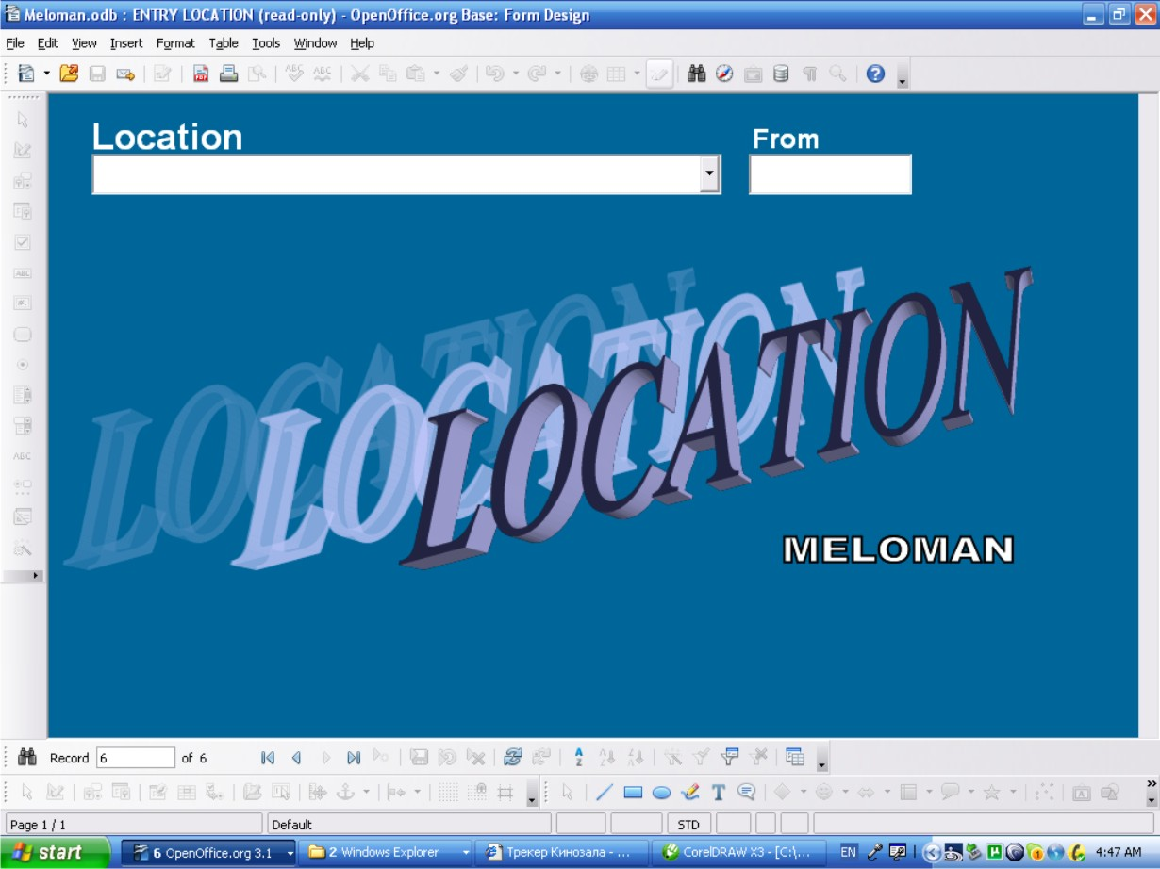

Access method
- Double click on 'ENTRY LOCATION' form in “Forms” area of Database interface
- Via click “Forms” image button after launch the application.

Navigation buttons of Tool Bar
- See p.5.1.

Window layout
- Fields:
  - 'Location' is a text combo box field, mandatory if enter a new record.
  - 'Location' field list box button returns the list of existing 'Location' records in A-Z order and must be used for checking existing records only not for entry a new record.
  - 'From” is date field not mandatory.

Actions
- “New Record” button allows to enter a new record
- “Delete Record” button allows to delete any record
- Any record can be changed if after changes 'Location' field doesn't duplicate record already existed in this field. On duplication the appropriate warning message must be displayed.
- Exit the form: Close Window button (Top right corner of the window)
It fails if you enter 'Location' name already existed and the appropriate warning message must be displayed.

ENTRY MEDIA LIST Form (Collection Database branch)
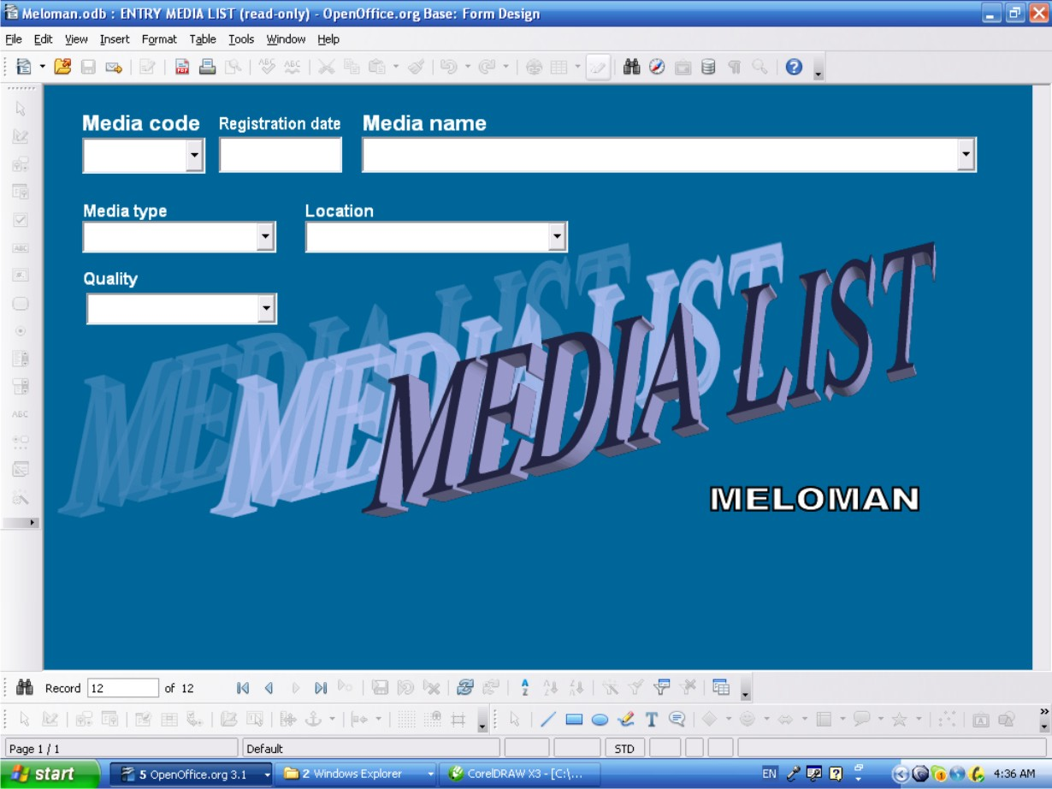

Access method
- Double click on 'ENTRY MEDIA LIST' form in “Forms” area of Database interface
- Via click “Forms” image button after launch the application.

Navigation buttons of Tool Bar
- See p.5.1.

Window layout
- Fields:
  - 'Media code' is a text combo box field, mandatory if enter a new record.
  - 'Media code' field list button returns the list of existing 'Media code' records in A-Z order and must be used for checking existing record only not for entry a new record.
  - 'Registration date” is date field not mandatory.
  - 'Media name' is a text combo box field, not mandatory.
  - 'Media name' field list button returns the list of existing 'Album name' records in the Database in A-Z order and should be used if new 'Media Name' is close to 'Album name'.
  - 'Media type' is a text list box field, mandatory if enter a new record and should be filled from list box only..
  - 'Media type' field list button returns the list of existing 'Media type' records in A-Z order.
  - 'Location' is a text list box field, not mandatory.
  - 'Location' field list button returns the list of existing 'Location' records in A-Z order.
  - 'Quality' is a text combo box field, not mandatory.
  - 'Quality' field list button returns the list of existing 'Quality' records in A-Z order.

Actions
- “New Record” button allows to enter a new record
- “Delete Record” button allows to delete any record
- Any record can be changed if after changes it doesn't duplicate 'Media code' record already existed. On duplication the appropriate warning message must be displayed.
- Exit the form: Close Window button (Top right corner of the window)
It fails if entering 'Media code' name already existed and the appropriate warning message must be displayed.

Table Entry Media List Form (Collection Database branch)
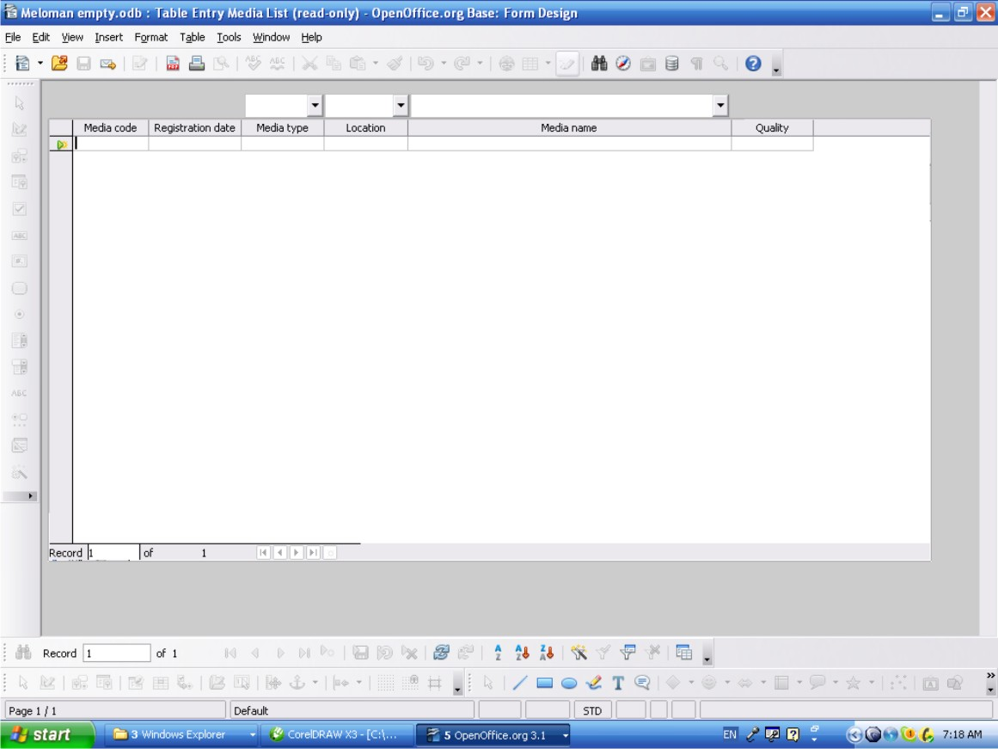

Sometimes Table Entry form is more convenient then GUI form so this form just for User's option to use.
Also this form can be used to delete records (rows) by group.

Access method
- Double click on 'Table Entry Media List' form in “Forms” area of Database interface
- Via click “Forms” image button after launch the application.

Navigation through the Table
- All sells of the table are available to edit. Copy-and-Paste method also available between cells.
- The last bottom row is for entry a new record.
- Up and down navigation is available by <Page Up> and <Page Down> keys and by scroll bars on right side and bottom of the table if they appeared.
- All navigation buttons are available and have the same functions as shown in p.5.1.

Table layout
- Columns (Database Fields):
  - 'Media code' column has text cells, mandatory if enter a new record.
  - 'Registration date” column has date cells, not mandatory.
  - 'Media type' column has text cells, mandatory if enter a new record and should be filled from list box only..
  - List box button upon 'Media type' column returns the list of existing 'Media type' records in A-Z order and allows to enter in any cell of 'Media type' column.
  - 'Location' column has text cells, not mandatory.
  - List box button upon 'Location' column returns the list of existing 'Location' records in A-Z order and allows to enter in any cell of 'Location' column.
  - 'Media name' column has text cells, not mandatory.
  - List box button upon 'Media name'' column returns the list of existing 'Media name' records in A-Z order and allows to enter in any cell of 'Media name'' column.
  - 'Quality' column has text cells, not mandatory.

Actions
- The last bottom row is the “New Record” row allows to enter a new record.
- For deleting action multiple selection of rows available by clicking rows on left column with pressed <Shift> or <Ctrl> keys.
- Right click on any row of left table column allows to delete (whole row) any record or group of records if selected.
- Any cell can be edited if after changes it doesn't duplicate 'Media code' record already existed. On duplication the appropriate warning message must be displayed.
- Exit the form: Close Window button (Top right corner of the window)
- All actions above can be done by navigation buttons which are available and have the same functions as shown in p.5.1.

It fails if entering 'Media code' name already existed and the appropriate warning message must be displayed.

ENTRY LANGUAGE Form
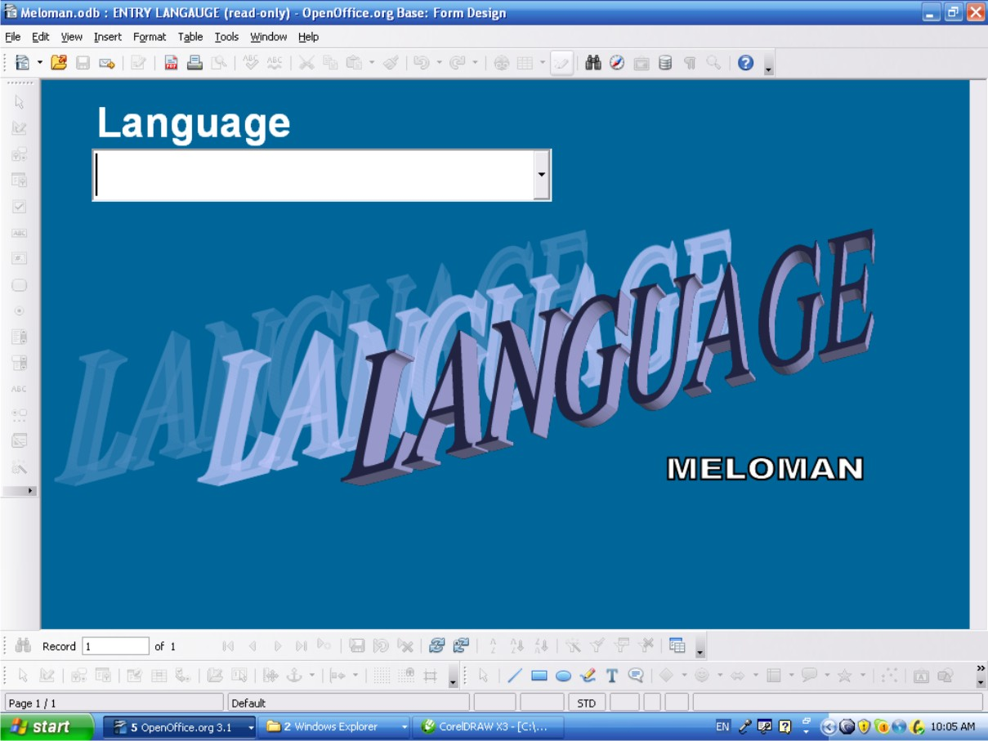

Access method
- Double click on 'ENTRY LANGUAGE' form in “Forms” area of Database interface
- Via click “Forms” image button after launch the application.

Navigation buttons of Tool Bar
- See p.5.1.

Window layout
- Field:
  - 'Language' is a text combo box field, mandatory if enter new record.
  - 'Language' field list button returns the list of existing 'Language' records in A-Z order and must be used for checking existing records only not for entry a new record.

Actions
- “New Record” button allows to enter new record
- “Delete Record” button allows to delete any record
- Any record can be changed if after changes it doesn't duplicate record already existed. On duplication the appropriate warning message must be displayed.
- Exit the form: Close Window button (Red button with white cross at top right corner of the window)
It fails if entering 'Language' name already existed and the appropriate warning message must be displayed.

ENTRY MUSIC TYPE Form
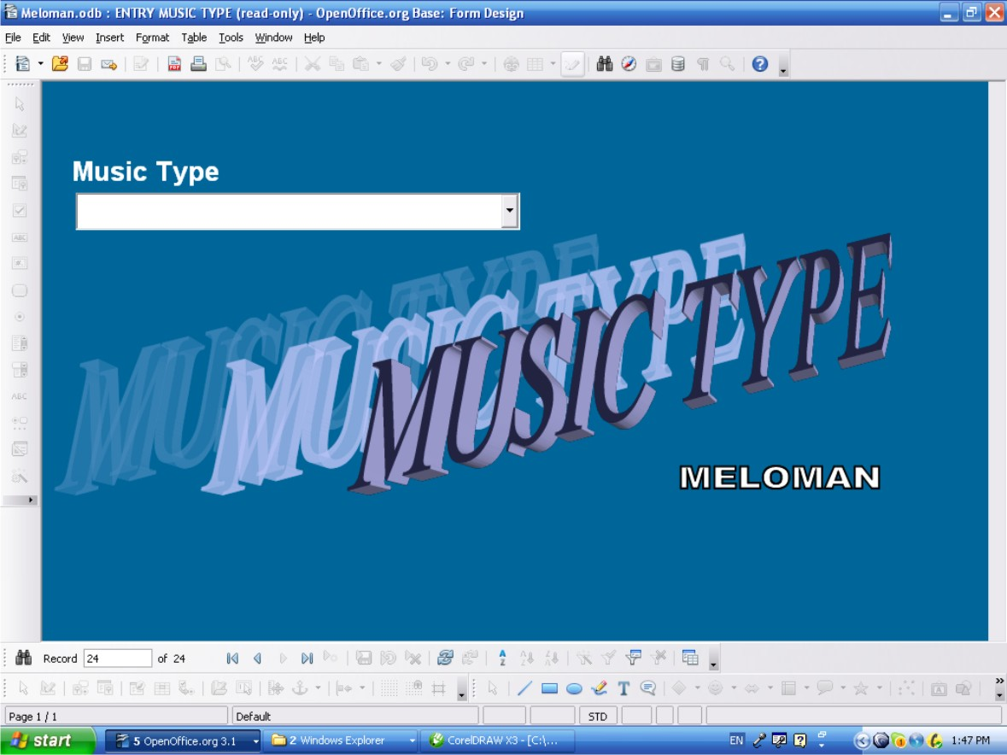

Access method
- Double click on 'ENTRY MUSIC TYPE' form in “Forms” area of Database interface
- Via click “Forms” image button after launch the application.

Navigation buttons of Tool Bar
- See p.5.1.

Window layout
- Field:
  - 'Music Type' is a text combo box field, mandatory if enter new record.
  - 'Music Type' field list button returns the list of existing 'Music Type' records in A-Z order and must be used for checking existing records only not for entry a new record.

Actions
- “New Record” button allows to enter new record
- “Delete Record” button allows to delete any record
- Any record can be changed if after changes it doesn't duplicate record already existed. On duplication the appropriate warning message must be displayed.
- Exit the form: Close Window button (Red button with white cross at top right corner of the window)
It fails if entering 'Music Type' name already existed and the appropriate warning message must be displayed.

2-ENTRY MUSIC GENRE Form
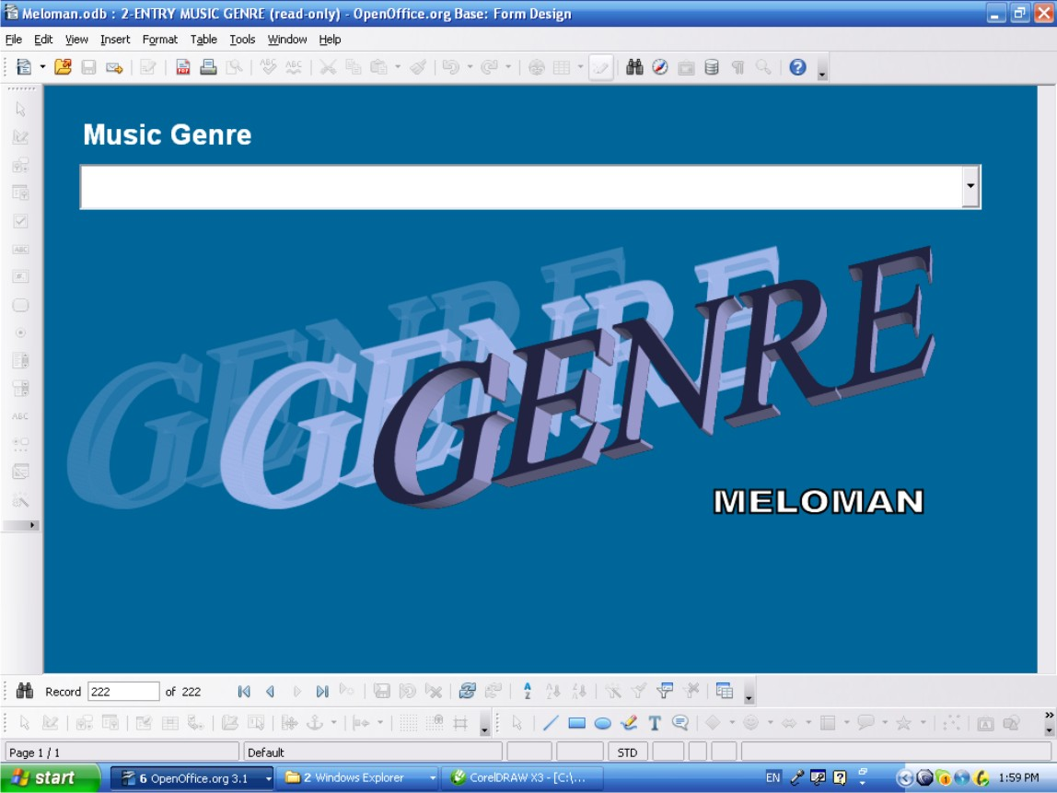

Access method
- Double click on '2-ENTRY MUSIC GENRE' form in “Forms” area of Database interface
- Via click “Forms” image button after launch the application.

Navigation buttons of Tool Bar
- See p.5.1.

Window layout
- Field:
  - 'Genre' is a text combo box field, mandatory if enter new record.
  - “Genre' field list button returns the list of existing 'Music Type' records in A-Z order and must be used for checking existing records only not for entry a new record.

Actions
- “New Record” button allows to enter new record
- “Delete Record” button allows to delete any record
- Any record can be changed if after changes it doesn't duplicate record already existed. On duplication the appropriate warning message must be displayed.
- Exit the form: Close Window button (Red button with white cross at top right corner of the window)
It fails if entering 'Genre' name already existed and the appropriate warning message must be displayed..

ENTRY COUNTRY Form (Music World Database branch)
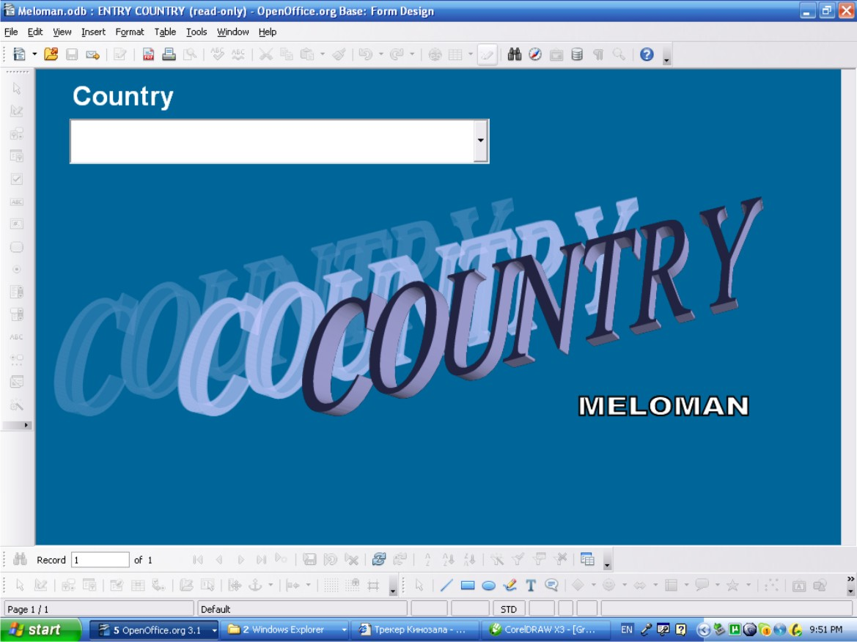

Access method
- Double click on 'ENTRY COUNTRY' form in “Forms” area of Database interface
- Via click “Forms” image button after launch the application.

Navigation buttons of Tool Bar
- See p.5.1.

Window layout
- Field:
  - 'Country' is a text combo box field, mandatory if enter a new record.
  - “Country' field list button returns the list of existing 'Country' records in A-Z order and must be used for checking existing records only not for entry a new record.

Actions
- “New Record” button allows to enter a new record
- “Delete Record” button allows to delete any record
- Any record can be changed if after changes it doesn't duplicate record already existed. On duplication the appropriate warning message must be displayed.
- Exit the form: Close Window button (Red button with white cross at top right corner of the window).
It fails if entering 'Country' name already existed and the appropriate warning message must be displayed.

3-ENTRY ALBUMS Form (Music World Database branch)
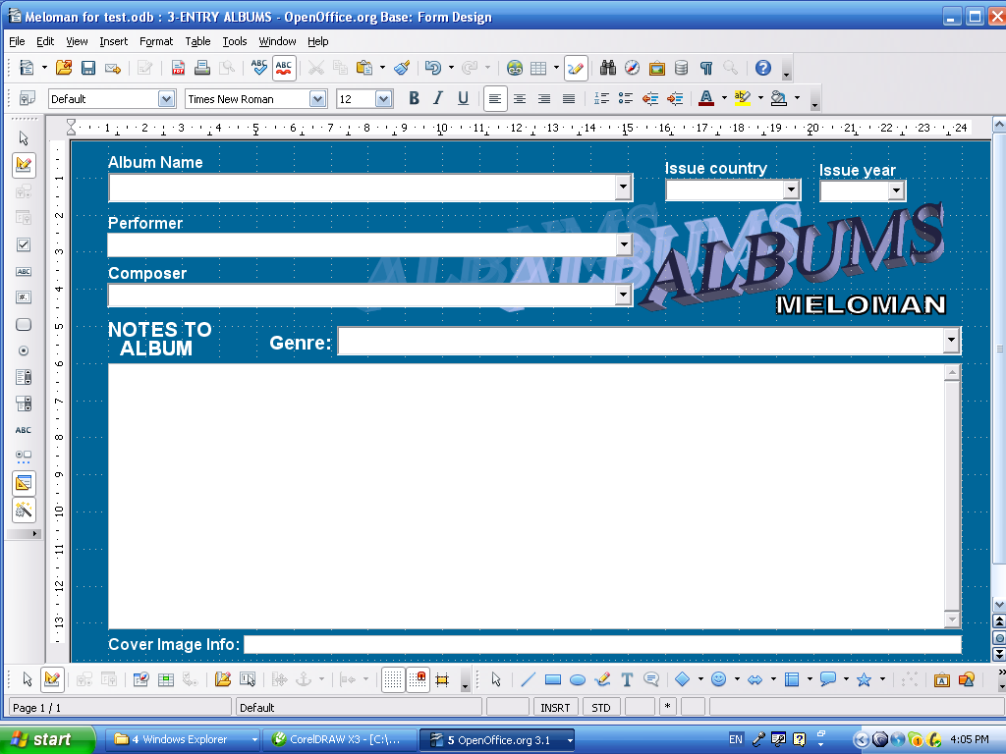

Access method
- Double click on '3-ENTRY ALBUMS' form in “Forms” area of Database interface
- Via click “Forms” image button after launch the application.

Navigation buttons of Tool Bar
- See p.5.1.

Window layout
- Fields:
  - 'Album Name' is a combo box field, mandatory if enter a new record.
  - 'Issue country' text list box field, not mandatory.
  - 'Issue country'' field list button returns the list of existing 'Country' records in A-Z order.
  - 'Issue year' is a number combo box field, not mandatory.
  - 'Issue year' field list button returns the list of years from 1600 to 2050.
  - 'Performer' is a text combo box field, not mandatory.
  - 'Performer' field list button returns the list of existing 'Name' field records of 'Performers & Persons' Database table in A-Z order.
  - 'Composer' is a text combo box field, not mandatory.
  - 'Composer' field list button returns the list of existing 'Name' field records of 'Performers & Persons' Database table in A-Z order.
  - 'Genre' is a text combo box field, not mandatory.
  - 'Genre' field list button returns the list of existing 'Music Genre' field records of 'Music Genre' Database table in A-Z order.
  - 'NOTES TO ALBUM' is a multi-line text field, not mandatory.
  - 'Cover image info' field is a text box field, not mandatory.

Actions
- “New record” button allows to enter a new record
- “Delete Record” button allows to delete any record
- Any record can be changed if after changes it doesn't duplicate 'Album Name' field record already existed. On duplication the appropriate warning message must be displayed.
- Exit the form: Close Window button (Red button with white cross at top right corner of the window).

It fails if entering 'Album Name' name already existed and the appropriate warning message must be displayed.

It fails if:
- entering in 'Issue country' field does not have parent name in 'Country' table;
- entering in 'Issue year' field other year then 1600-2050;
- entering in 'Performer' field does not have parent name in ''Name' field of 'Performer & Person' table;
- entering in 'Composer' field does not have parent name in ''Name' field of 'Performer & Person' table;
- entering in 'Genre' field does not have parent name in 'Music Genre' table;
and the appropriate warning message must be displayed.

Table Entry Albums Form (Music World Database branch)
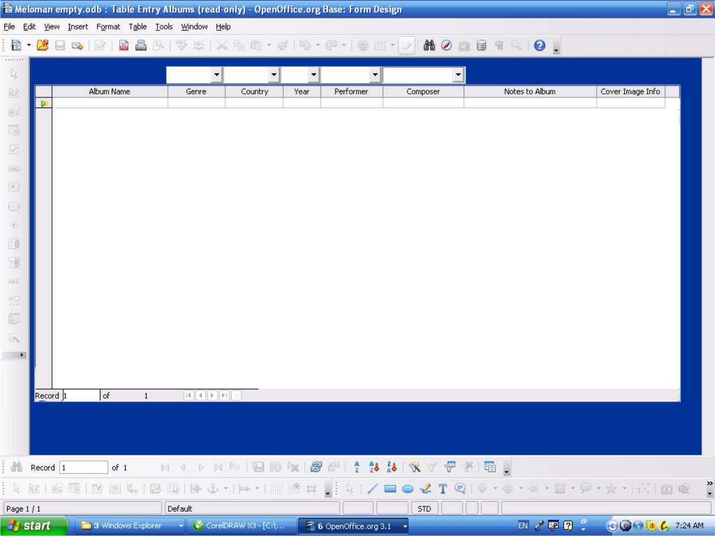
Sometimes Table Entry form is more convenient then GUI form so this form just for User's option to use.
Also this form can be used to delete records (rows) by group.

Access method
- Double click on 'Table Entry Albums' form in “Forms” area of Database interface
- Via click “Forms” image button after launch the application.

Navigation through the Table
- All sells of the table are available to edit. Copy-and-Paste method also available between cells.
- The last bottom row is for entry a new record.
- Up and down navigation is available by <Page Up> and <Page Down> keys and by scroll bars on right side and bottom of the table if they appeared.
- All navigation buttons are available and have the same functions as shown in p.5.1.

Table layout
- Columns (Database Fields):
  - 'Album Name' column has text cells, mandatory if enter a new record.
  - 'Genre' column has text cells, not mandatory.
  - List box button upon 'Genre' column returns the list of existing 'Music Genre' records in A-Z order and allows to enter in any cell of 'Genre' column.
  - 'Country' column has text cells, not mandatory.
  - List box button upon 'Country' column returns the list of existing 'Country' records in A-Z order and allows to enter in any cell of 'Country' column.
  - 'Year' column has number cells, not mandatory.
  - List box button upon 'Year'' column returns the list of 1600-2500 years and allows to enter in any cell of 'Year'' column.
  - 'Performer' column has text cells, not mandatory.
  - List box button upon 'Performer' column returns the list of existing 'Name' field records of 'Performers & Persons' Database table in A-Z order and allows to enter in any cell of 'Performer' column.
  - ''Composer' column has text cells, not mandatory.
  - List box button upon 'Composer' column returns the list of existing 'Name' field records of 'Performers & Persons' Database table in A-Z order and allows to enter in any cell of 'Composer' column.
  - 'Notes to Album' column has text cells, not mandatory.
  - 'Cover Image Info' column has text cells, not mandatory.

Actions
- The last bottom row is the “New Record” row allows to enter a new record.
- For deleting action multiple selection of rows available by clicking rows on left column with pressed <Shift> or <Ctrl> keys.
- Right click on any row of left table column allows to delete (whole row) any record or group of records if selected.
- Any cell can be edited if after changes it doesn't duplicate 'Album Name' record already existed. On duplication the appropriate warning message must be displayed.
- Exit the form: Close Window button (Red button with white cross at top right corner of the window).
- All actions above can be done by navigation buttons which are available and have the same functions as shown in p.5.1.

It fails if entering 'Album Name' name already existed and the appropriate warning message must be displayed.

It fails if:
- entering in 'Genre' column cell does not have parent name in 'Music Genre' table;
- entering in 'Country' column cell does not have parent name in 'Country' table;
- entering in 'Year' column cell other year then 1600-2050;
- entering in 'Performer' column cell does not have parent name in ''Name' field of 'Performer & Person' table;
- entering in 'Composer' column cell does not have parent name in ''Name' field of 'Performer & Person' table;
and the appropriate warning message must be displayed.

1-ENTRY PERFORMERS & PERSONS Form (Music World Database branch)
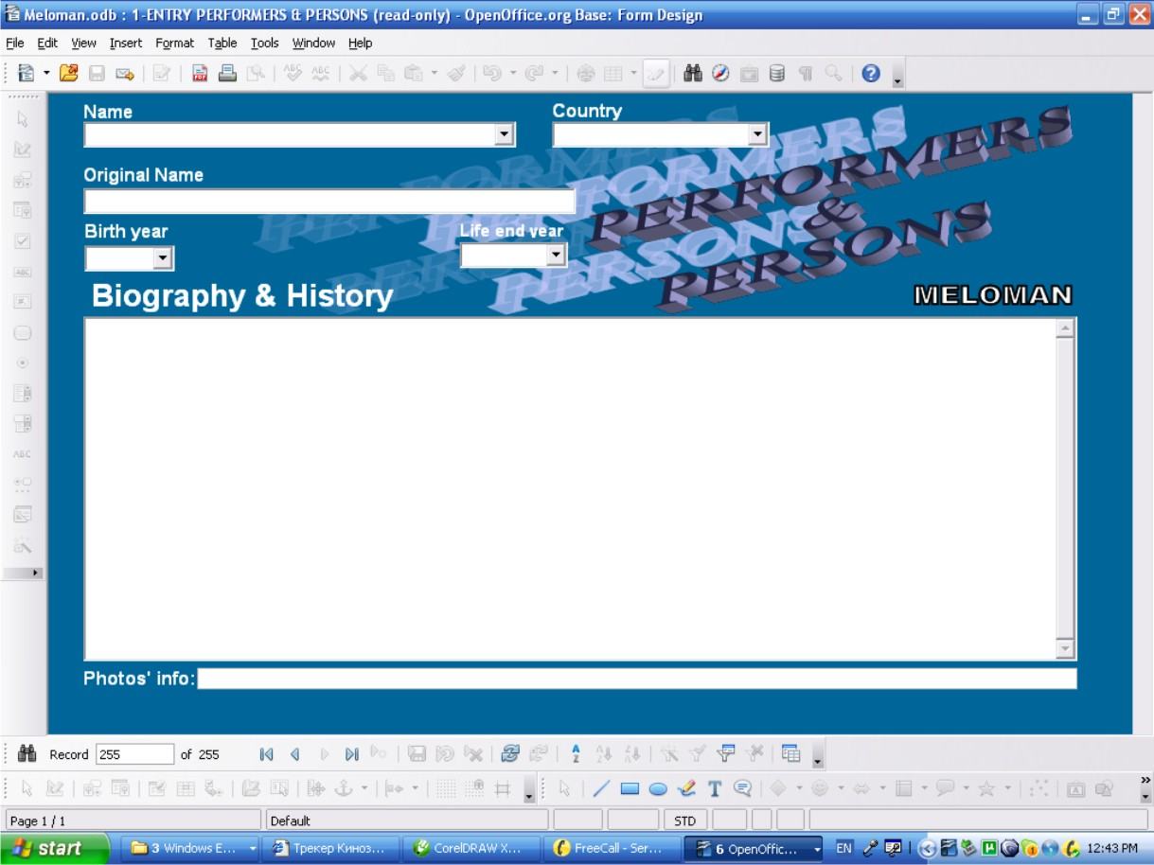

Access method
- Double click on '1-ENTRY PERFORMERS & PERSONS' form in “Forms” area of Database interface
- Via click “Forms” image button after launch the application.

Navigation buttons of Tool Bar
- See p.5.1.

Window layout
- Fields:
  - 'Name' is a text combo box field, mandatory if enter a new record.
  - “Name' field list button returns the list of existing 'Name' field records in A-Z order and must be used for checking existing records only or input from the list with editing. Existing records not for entry as a new record.
  - 'Country' is a text list box field, not mandatory.
  - 'Country'' field list button returns the list of existing 'Country' records in A-Z order.
  - 'Original Name' is a text box field, not mandatory.
  - 'Birth year' is a number combo box field, not mandatory.

  - 'Birth year' field list button returns the list of years from 1600 to 2050.
  - 'Life end year' is a number combo box field, not mandatory.
  - 'Life end year' field list button returns the list of years from 1600 to 2050.
  - 'Biography & History' is a multi-line text field, not mandatory.
  - 'Photos' info' is a text box field, not mandatory.

Actions
- “New record” button allows to enter a new record
- “Delete Record” button allows to delete any record
- Any record can be changed if after changes it doesn't duplicate 'Name' field record already existed. On duplication the appropriate warning message must be displayed.
- Exit the form: Close Window button (Red button with white cross at top right corner of the window).

It fails if entering 'Name' name already existed and the appropriate warning message must be displayed.
It fails if:
- entering in 'Country' field does not have parent name in 'Country' table;
- entering in 'Birth year' field other year then 1600-2050;
- entering in 'Life end year' field other year then 1600-2050;
and the appropriate warning message must be displayed.

Table Entry Performers & Persons Form (Music World Database branch)
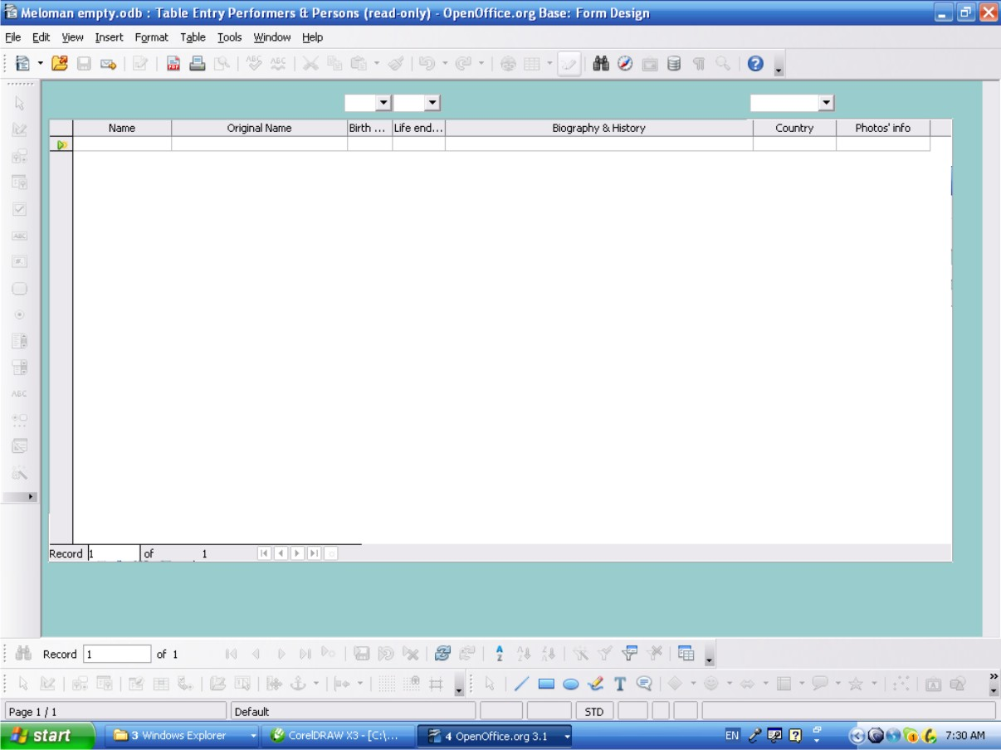

Sometimes Table Entry form is more convenient then GUI form so this form just for User's option to use.
Also this form can be used to delete records (rows) by group.

Access method
- Double click on 'Table Entry Performers & Persons' form in “Forms” area of Database interface
- Via click “Forms” image button after launch the application.

Navigation through the Table
- All sells of the table are available to edit. Copy-and-Paste method also available between cells.
- The last bottom row is for entry a new record.
- Up and down navigation is available by <Page Up> and <Page Down> keys and by scroll bars on right side and bottom of the table if they appeared.
- All navigation buttons are available and have the same functions as shown in p.5.1.

Table layout

- Columns (Database Fields):
  - 'Name' column has text cells, mandatory if enter a new record.
  - 'Original Name' column has text cells, not mandatory.
  - 'Birth year' column has number cells, not mandatory.

  - List box button upon 'Birth year' column returns the list of 1600-2500 years and allows to enter in any cell of 'Birth year' column.
  - 'Life end year' column has number cells, not mandatory.
  - List box button upon 'Life end year' column returns the list of 1600-2500 years and allows to enter in any cell of 'Life end year' column.
  - 'Biography & History' column has text cells, not mandatory.
  - 'Country' column has text cells, not mandatory.
  - 'Photos' info' column has text cells, not mandatory.

Actions

- The last bottom row is the “New Record” row allows to enter a new record.
- For deleting action multiple selection of rows available by clicking rows on left column with pressed <Shift> or <Ctrl> keys.
- Right click on any row of left table column allows to delete (whole row) any record or group of records if selected.
- Any cell can be edited if after changes it doesn't duplicate 'Name' record already existed. On duplication the appropriate warning message must be displayed.
- Exit the form: Close Window button (Red button with white cross at top right corner of the window).
- All actions above can be done by navigation buttons which are available and have the same functions as shown in p.5.1.

It fails if entering 'Name' name already existed and the appropriate warning message must be displayed.

It fails if:
- entering in 'Birth year' column cell other year then 1600-2050;
- entering in 'Life end year' column cell other year then 1600-2050;
- entering in 'Country' column cell does not have parent name in ''Country' table;
and the appropriate warning message must be displayed.

4-ENTRY MUSIC ITEMS Form (Main Database form)

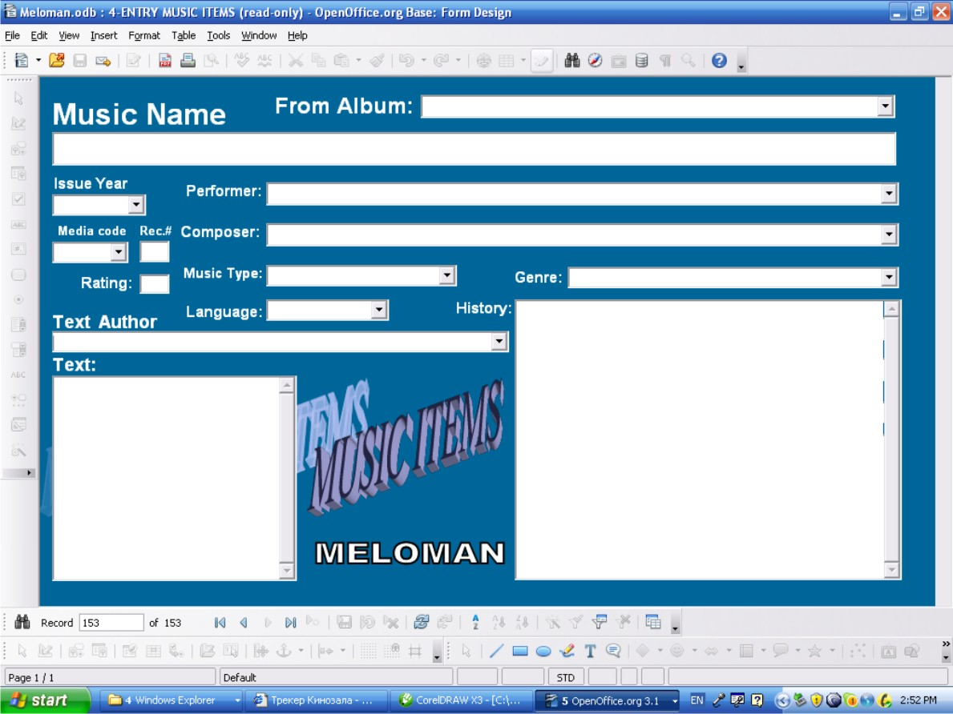

Access method
- Double click on '4-ENTRY MUSIC ITEMS' form in “Forms” area of Database interface
- Via click “Forms” image button after launch the application.

Navigation buttons of Tool Bar
- See p.5.1.

Window layout
- Fields:
  - 'From Album' is a text combo box field, not mandatory.

  - 'From Album' field list button returns the list of existing 'Album Name' records in A-Z order.
  - 'Music Name' field is a text box field, not mandatory.
  - 'Issue Year' is a number combo box field, not mandatory.
  - 'Issue Year' field list button returns the list of years from 1600 to 2050.
  - 'Performer' is a text combo box field, not mandatory.

  - 'Performer' field list button returns the list of existing 'Name' field records of 'Performers & Persons' Database table in A-Z order.
  - 'Composer' is a text combo box field, not mandatory.
  - 'Composer' field list button returns the list of existing 'Name' field records of 'Performers & Persons' Database table in A-Z order.
  - 'Media code' is a text combo box field, not mandatory.
  - 'Media code' field list button returns the list of existing 'Media code' field records of 'Media List' Database table in A-Z order.
  - 'Rec.#' is a number box field allows 0-999 numbers to enter, not mandatory.
  - 'Rating' is a number box field allows 0-9 numbers to enter, not mandatory.
  - 'Music Type' is a text combo box field, not mandatory.
  - 'Music Type' field list button returns the list of existing 'Music Type' field records of 'Music Type'' Database table in A-Z order.
  - 'Genre' is a text combo box field, not mandatory.
  - 'Genre' field list button returns the list of existing 'Music Genre' field records of 'Music Genre' Database table in A-Z order.
  - 'Language' is a text combo box field, not mandatory.
  - 'Language' field list button returns the list of existing 'Language' field records of 'Language ' Database table in A-Z order.
  - 'History' is a multi-line text field, not mandatory.
  - 'Text Author' is a text combo box field, not mandatory.
  - 'Text Author'' field list button returns the list of existing 'Name' field records of 'Performers & Persons' Database table in A-Z order.
  - 'Text' is a multi-line text field, not mandatory.

Actions
- “New record” button allows to enter a new record
- “Delete Record” button allows to delete any record
- Any record field can be changed or deleted
- Exit the form: Close Window button (Red button with white cross at top right corner of the window).

It fails if:
- entering in 'From Album' field does not have parent name in 'Album Name' field of 'Albums' table;
- entering in 'Issue year' field other year then 1600-2050;
- entering in 'Performer' field does not have parent name in ''Name' field of 'Performer & Person' table;
- entering in 'Composer' field does not have parent name in ''Name' field of 'Performer & Person' table;
- entering in 'Media code' field does not have parent name in ''Nadia Code' field of 'Media List' table;

- entering in 'Music Type' field does not have parent name in 'Music Type' table;
- entering in 'Genre' field does not have parent name in 'Music Genre' table;
- entering in 'Language' field does not have parent name in 'Language' table;
- entering in 'Text Author' field does not have parent name in ''Name' field of 'Performer & Person' table;
and the appropriate warning message must be displayed.

Table Entry Music Items Form
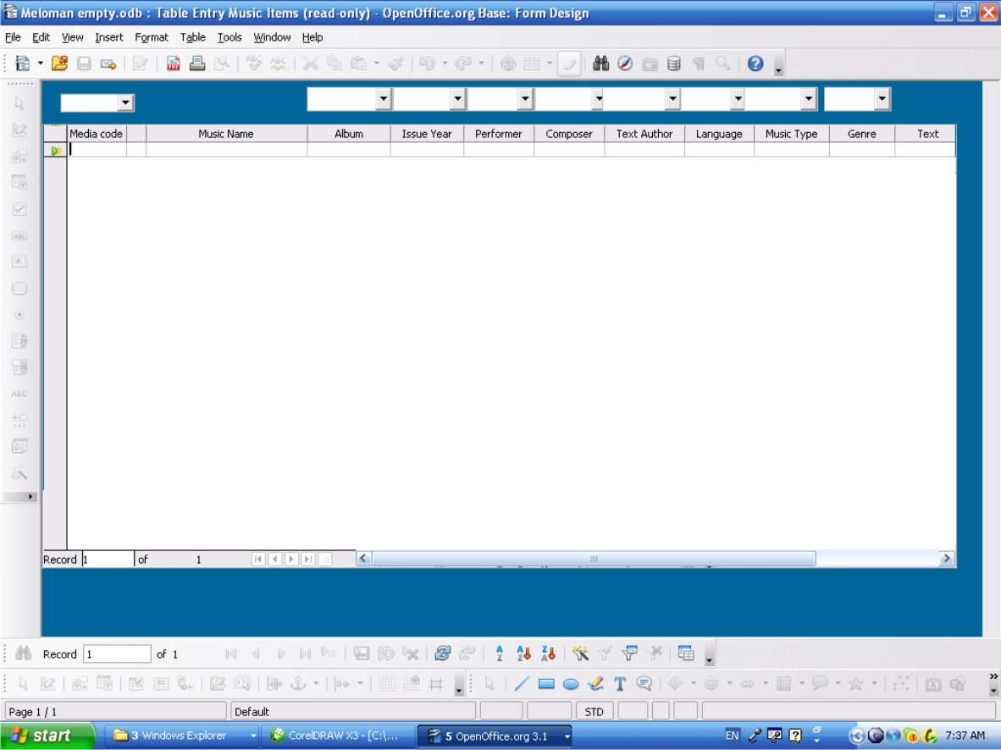
Sometimes Table Entry form is more convenient then GUI form so this form just for User's option to use.
Also this form can be used to delete records (rows) by group.

Access method
- Double click on 'Table Entry Music Items' form in “Forms” area of Database interface
- Via click “Forms” image button after launch the application.

Navigation through the Table
- All sells of the table are available to edit. Copy-and-Paste method also available between cells.
- The last bottom row is for entry a new record.
- Up and down navigation is available by <Page Up> and <Page Down> keys and by scroll bars on right side and bottom of the table if they appeared.
- All navigation buttons are available and have the same functions as shown in p.5.1.

Table layout

- Columns (Database Fields):

  - 'Media code' column has text cells, not mandatory.

  - List box button upon 'Media code' column returns the list of existing 'Media Code' field records of 'Media List' table in A-Z order and allows to enter in any cell of 'Media code' column.
  - 'Record #' column has number cells, not mandatory
  - 'Music Name' column has text cells, not mandatory.
  - 'Album' column has text cells, not mandatory.
  - List box button upon 'Album' column returns the list of existing 'Album Name' field records of 'Albums' table in A-Z order and allows to enter in any cell of 'Album' column.
  - 'Issue Year' column has number cells, not mandatory.
  - List box button upon 'Issue Year'' column returns the list of 1600-2500 years and allows to enter in any cell of 'Issue Year'' column.
  - 'Performer' column has text cells, not mandatory.
  - List box button upon 'Performer' column returns the list of existing 'Name' field records of 'Performers & Persons' Database table in A-Z order and allows to enter in any cell of 'Performer' column.
  - ''Composer' column has text cells, not mandatory.
  - List box button upon 'Composer' column returns the list of existing 'Name' field records of 'Performers & Persons' Database table in A-Z order and allows to enter in any cell of 'Composer' column.
  - 'Text Author' column has text cells, not mandatory.
  - List box button upon 'Text Author' column returns the list of existing 'Name' field records of 'Performers & Persons' Database table in A-Z order and allows to enter in any cell of 'Text Author' column.
  - 'Language' column has text cells, not mandatory.
  - List box button upon 'Language' column returns the list of existing 'Language' records in A-Z order and allows to enter in any cell of 'Language' column.
  - 'Music Type' column has text cells, not mandatory.
  - List box button upon 'Music Type' column returns the list of existing 'Music Type' records in A-Z order and allows to enter in any cell of 'Music Type' column.
  - 'Genre' column has text cells, not mandatory.
  - List box button upon 'Genre' column returns the list of existing 'Music Genre' records in A-Z order and allows to enter in any cell of 'Genre' column.
  - 'Text' column has text cells, not mandatory.
  - 'Rating' column has number cells, not mandatory.
  - 'History' column has text cells, not mandatory.

Actions
- The last bottom row is the “New Record” row allows to enter a new record.
- For deleting action multiple selection of rows available by clicking rows on left column with pressed <Shift> or <Ctrl> keys.
- Right click on any row of left table column allows to delete (whole row) any record or group of records if selected.
- Any cell can be edited or data can be deleted.

- Exit the form: Close Window button (Red button with white cross at top right corner of the window).
- All actions above can be done by navigation buttons which are available and have the same functions as shown in p.5.1.

It fails if:
- entering in 'Media code' column cell does not have parent name in 'Media List' table;
- entering in 'Album' column cell does not have parent name in 'Albums' table;
- entering in 'Issue Year' column cell other year then 1600-2050;
- entering in 'Performer' column cell does not have parent name in ''Name' field of 'Performer & Person' table;
- entering in 'Composer' column cell does not have parent name in ''Name' field of 'Performer & Person' table;
- entering in 'Text Author' column cell does not have parent name in ''Name' field of 'Performer & Person' table;
- entering in 'Language' column cell does not have parent name in 'Language' table;
- entering in 'Music Type' column cell does not have parent name in 'Music Type' table;
- entering in 'Genre' column cell does not have parent name in 'Music Genre' table;
and the appropriate warning message must be displayed.

Approximate list of queries shall be available to design

- Albums List which Database has Information;
- List of all Collection Music Items with names of performers, media and record numbers in A-Z order;
- List of all Collection Music Items with names of performers, media and record numbers and sorted by media;
- Composers list with collection Music Items, media and record number;
- List of all Collection Music Items with names of performers, media and record numbers and sorted by Genres-which Database has;
- List of Collection Music Items with names of performers, media and record numbers with choice of specific Genre (Ex.: Pop, Rock, Classic, Disco, Country etc.);
- Lyrics authors list with collection Music Items, media and record number;
- Media List with it's name and location;
- List of collection Music Items belong to and sorted by any albums with media and record numbers;
- List of collection Music Items issued as singles and not belong to any albums;
- Performers list with collection Music Items with media and record number;
- List of favorite music compositions according to rating in collection.

Approximate list of reports shall be available to design
- Reports from queries listed in p.6 above;
- List of all Albums with note to them which Database has;
- List of all Performers and Persons with their biography and history which Database has;
- List of all Music Items with their lyrics;
- List of all Music Items with their history.

