SECTION – I: Mandatory Information

Location: Guwahati, Dispur - State Capital of Assam, INDIA

How to reach: Guwahati, Assam, the gateway to the northeast is well connected with the rest of India by air, rail and road. The Lokapriya Gopinath Bordoloi International Airport at Guwahati is 18 km from the city center and is well connected to New Delhi, Kolkata, Mumbai and Chennai. Indian Airlines, Jet Airways, Air Deccan, Kingfisher Airlines, SpiceJet and Indigo fly operate regular flights to Guwahati from New Delhi, Kolkata, Mumbai and Chennai. Air India also operates an international weekly flight between Bangkok and Guwahati.
Proposed Dates:
- Main conference, November 10 – 12, 2009
(B) Tourist trips: (either or all options available)

(i) Tourist Trip (Option – I): November 13 – 16, 2009

(a) Kaziranga National Park – A World Heritage Site.
Kaziranga is 217 kms from Guwahati and 96 kms from Jorhat by road. The nearest airport is Rowriah(Jorhat). Tourists can either fly to Jorhat or can go by surface to Kaziranga from Guwahati.

(b) Manas Wild Life Sanctuary – UNESCO World Heritage Site
Manas is 176 kms from Guwahati by road.

(ii) Tourist Trip (Option – II): November 13 – 16,2009

(a) Cherapunjee - It is credited as the wettest place on earth.
Cherapunjee is 56 Km from Shillong and can be reached by taxi.

(b) Shillong – Scotland of the East known for its famous Waterfalls
(Elephant Falls, Crinoline Falls, Sweet Falls, Bishop and Beadon Waterfalls)
Shillong 115 Km from Guwahati and can be reached by taxi.

(ii) Tourist Trip (Option – III): November 13 – 18, 2009

(a) Tezpur-Nameri-Bhalukpung- Bomdila-Tawang
Day 01: Bomdila: Early morning drive to Bomdila (350 km). Enroute visit Tipi famous for Orchids. Over night stay at hotel.
Day02:Tawang
Morning drive to Tawang (190 km) the land of the Monpa Tribes and the major center of the Mahayana Buddhists is standing on the spur of a hill over 12000 ft. above the sea level. On the way to Tawang lies the world's second highest pass - the Sela Pass (14000 feet) which runs through a small ridge and along a placid Lake called the Paradise Lake. Over night stay at Tourist Lodge or Circuit House.
Day 03: Full day at Tawang.
Visit more than 300 years old monastery (locally called Gompa) is considered to be the second largest monastery of the world 12 km on the North West of Tawang, Brandung Chung Ani Gompa, the monastery of the nuns. Over night stay at Tawang.
Day04:Tawang - Nameri
Morning drive to Nameri National Park. Check into Eco Camp. Post lunch free for Angling or Trekking or Rafting. Over night stay at Nameri.
Day 05: Nameri – Guwahati
Return to Guwahati.

Weather:
The weather at Guwahati and adjoining areas during November is the most pleasant one with temperatures ranging from a minimum of 14 degrees Celsius at night and maximum 24 degrees Celsius at daytime. There will be no rainfall in November.

POSSIBLE VENUES for the OooCon 2009 International Conference:
The conference venues will be:
- Indian Institute of Technology Guwahati (IITG)
- Rajiv Gandhi Indoor Stadium, Amingaon, Guwahati
- Desbhakta Tarunram Phukan Indoor Stadium, Amingaon, Guwahati
- Assam Administrative Staff College, Khanapara, Guwahati
- Maniram Dewan Trade Center, Guwahati

Conference Facilities:
The following facilities will be made available to all the attendees for the conference period in all the venues and hotels:
- Free Broadband Internet Access on WiFi /WLAN
- Free VoIP Telephone Numbers
- Free Video Conferencing / Streaming facilities
- Sufficient Power Sockets (220 V AC. 50Hz)
- Free Lunch and Snacks between conference sessions
- Free OpenOffice.org Kit with DVD and high quality print Manual
- Free UBUNTU DVD with latest version with all patches
- Free dedicated volunteer support for every delegate
- Cultural Shows on all conference evenings with Free Dinner

Local events that are taking place in parallel (or right before/after):
- Children’s Day, November 14, 2009
- The 11th Annual International Conference of Society for Emergency Medicine in India (EMCON), November 18 – 22, 2009 http://emcon2009guwahati.com/
- International Trade Fair (IITF), New Delhi, November 14 – 28, 2009

Team Leads (main contact persons):
Mahendra Kumar Yadava, md@amtron.in
Prof. Gautam Barua gb@iitg.ernet.in
Anupam Barman, anupam.barman@amtron.in
Monoj Baruah, monoj.baruah@amtron.in
Biju Phukan Bhagabati, bijuphukan.bhagabati@amtron.in
Team Members for OooCon 2009:

(All members are committed to planning the conference during the last four weeks before OooCon 2009):
PROF. GAUTAM BARUAH, DIRECTOR, IIT GUWAHATI
MAHENDRA KUMAR YADAVA, MD AMTRON
ANUPAM BARMAN, SYSTEM CONSULTANT, AMTRON
MONOJ BARUAH, PROJECT MANAGER, AMTRON
BIJU PHUKAN BHAGABATI, TECHNICAL OFFICER, AMTRON
RANGALAL MAZUMDAR, GENERAL MANAGER (BO), AMTRON
SANJIB SARMAH, MANAGER, AMTRON
SHYAMAL BHUYAN, DM, AMTRON
BABITA GOSWAMI, ADDITIONAL MANAGER, AMTRON
MUKUL KALITA, ADDITIONAL MANAGER, AMTRON
ARUP BARMAN, DM, AMTRON
ANUPAM SARMA, MD OFFICE INCHARGE, AMTRON
GAUTAM DAS, HW ENGINEER, AMTRON
RAJIB RANJAN DAS, DM, AMTRON
JYOTI PRASAD, DM, AIIL
DR. AMRIT PAL SINGH, GAUHATI UNIVERSITY
DR. ABHIJIT SARMA, GAUHATI UNIVERSITY
DR. HERAMBA BAILUNG, IASST
NIRANJAN BHAGOBATY, IASST
UTPAL HAZARIKA, ISS

Names of local OpenOffice.org developers:
Core Project Developers:
Anupam Barman - System Consultant, AMTRON
Monoj Baruah - Project Manager, AMTRON
Prof. Sukumar Nandi, IIT Guwahati
Dr. Abhijit Sharma, Gauhati University
Biju Phukan Bhagabati – Technical Officer, AMTRON
Niranjan Bhagagobaty – Sr. Instructor, IASST

Names of Potential Corporate Sponsors:
(A) Hardware Vendors/Partners
Intel
WIPRO
HP
Sun
HCL
IBM

(B) Software Vendors/Partners
TCS
SUSE
REDHAT
UBUNTU
GOOGLE

(C) Telecom / Network Vendors/Partners
AIRTEL
AIRCEL
BSNL
POWERGRID
RELIANCE
SIFY
TULIP
VODAFONE

(D) Infrastructure Vendors/Partners
IL&FS
SREI
ZOOM

(E) Social/Community Partners
Aids Control Society, Assam
NEWSLIVE, Assam

Associations with Reputed Organizations

- Indian Institute of Technology (IIT), Guwahati
- Institute of Advanced Study in Science & Technology (IASST), Guwahati, Assam
- Gauhati University, Assam
- Dibrugarh University, Assam
- Silchar University, Assam
- Tezpur University, Assam
- Assam Engineering College, Guwahati, Assam
- Assam Engineering Institute, Guwahati, Assam
- National Institute of Technology, Silchar, Assam
- Guwahati Medical College & Hospital, Guwahati, Assam
- Assam Medical College & Hospital, Guwahati, Assam

Large local OpenOffice.org Deployments:
(A) Government of Assam:
Assam is one of the seven sisters of the north eastern states of India which has adopted the use of OpenOffice.org in the various Departments of the Government of Assam. Website: www.assam.gov.in

(B) Assam Electronics Development Corporation Ltd. (AMTRON)

Assam Electronics Development Corporation Ltd (AMTRON), established in 1984, is the nodal agency of the IT Department, Government of Assam for the implementation of all e-Governance and IT projects in the state. AMTRON is a key driver of Open Source and Openoffice.org in Assam, and a visible force in this sector in India. AMTRON now deploys 80% OF ITS PROJECTS ON Open source/Linux, and 100% projects on OpenOffice.org.

AMTRON was given the onerous responsibility of providing state of the art communications, accreditation and media facilities for the 33rd National Games held from Feb 9-18, 2007. More than 10,000 athletes participated in the event and were provided with accommodation, travel, food at 22 different stadiums in Guwahati. Media facilities included Wifi Hotspots, Cyber Cafes, VOIP telephones & Faxes, Video streaming, Scanning & Printing, News Desks with OpenOffice.org and two large call centers. Website: http://www.amtron.in

(C) Indian Institute of Technology (IITG) Guwahati

The Indian Institute of Technology Guwahati (IITG) is one of the most prestigious and premier institutions in the country in the field of Engineering and Technology. The institute (is located in the beautiful environs on the bank of the Brahmaputra River (which is considered as the only Male River in the world). The Institute has got a full-fledged Computer Science Department and also the Department of Electronics. The Institute is actively promoting open source technologies. One of the major contributions of the Institute has been development of UNICODE for Assamese and Bodo languages. This has greatly helped in deployment of these languages in the LINUX platform recently by the community.

Prof. Gautam Barua, Director of IITG himself is a great supporter of the Open Office and has been in the field of UNIX/Linux from the very early days of the initiatives. He is one of the pioneering champions of open source in the country.

Promoting of OpenOffice.org, ODF, ODA

(A) Education projects:

(i) Rajiv Gandhi Computer Literacy Programme (RGCLP)
950 Schools are being provided with training on OpenOffice.org and Ubuntu throughout the state.

(ii) Government of Assam constituted the Anundoram Barooah Award for HSLC 1st Division Holders since 2005, under which students securing more than 60% in the 10th standard in the schools, receive one desktop system along with OpenOffice.org on Linux. Around 55,000 students have benefited from this prestigious award directly.

(B) Community projects:

Government of Assam is setting up Community Service Centers in the state at more than 500 locations to provide access to services like Internet, e-governance portals and training on OpenOffice.org and Linux (Ubuntu & RedHat).

(C) Network projects:

Assam State Wide Area Network (ASWAN) is a project of the Assam Government to provide last mile connectivity throughout the state. Services based on the network are based on Open Source Technologies such as web-hosting, email, VoIP, etc. AMTRON has set up the Guwahati Metropolitan Area Network (MAN) providing Internet Services through OFC backbone.

(D) Data Center project:

The Assam Government has its Data Center located at AMTRON, which provides a paperless document and work-flow management system based on linux supporting only ODF/PDF documents since April 2006.

AMTRON GETS THE WORLD IS OPEN AWARD FOR EFADMS: In an exuberant evening featuring the Best of Open Source in India, RedHat presents for the first time "SKOCH – REDHAT: The World is Open Award 2008" to AMTRON for their "Electronic File Approval and Document Management System (EFADMS)" in the category - "AUTOMATION" at the India Habitat Center, New Delhi. Sri Anupam Barman, System Consultant (ASWAN) received the award from Mr. Nandu Pradhan, President & MD, REDHAT INDIA amidst a cultural extravaganza of dance ballet incorporating Kathak, Salsa, Flamenco, Kathakali and Russian folk dancers choreographed by Gitanjali Lal, symbolizing collaboration at The India Habitat Center, New Delhi on 18th March 2008. The other eminent persons present during the felicitation ceremony were Dr. D. B. Pathak, IIT Mumbai, Dr. K. C. Chakrabarty, Chairman & MD, Punjab National Bank, Mr. R. Chandrashekhar, Additional Secretary, Department of IT, Government of India.

(E) ODF Initiatives Abroad:

(i) German Foreign Office comes out in favor of Open Document Format
At the first international workshop of users of the Open Document Format (ODF) in Berlin to which the Foreign Office of the Federal Republic had invited about 150 users and political observers, Brazil and India, in addition to German cities such as Munich, emerged as leading proponents of open standards in the office area. Brazil was making “intensive use” of free software, Deivi Kuhn of Serpro, a company founded at the behest of the Brazilian government, which coordinates the use of open source in the up-and-coming developing nation, declared. The ODF standard adopted by the International Organization for Standardization (ISO) was mandatory when it came to state interoperability standards for e-government, he observed. It was a good tool for securing user freedoms and access to knowledge, he added.The development in India was happening along similar lines, M K Yadava of the IT development company Amtron from the federal state of Assam pointed out. With regard to the use of open software standards and ODF the region in the northeast of the subcontinent was a model state, he declared. Thus PCs with Linux and OpenOffice.org were being handed out to students, while the migration of government offices to the free office suite was currently in progress. According to Mr. Yadava the IT guidelines made ODF mandatory; the hardware infrastructure was being arranged accordingly, he observed. For making telephone calls government offices and agencies availed themselves of a VoIP application based on the free software Asterisk, he said.Mr. Yadava declared ODF to be a way out of the current file format chaos that went hand-in-hand with a high risk of data loss. In other parts of India too there is no longer any way around the Open Document Format. “We no longer accept Word documents,” Yatindra Singh, a judge at the High Court in Allahabad, declared.
http://www.heise.de/english/newsticker/news/98208

(ii) ODF Workshop in Pretoria, South Africa:
http://www.odfworkshop.com/agenda.html

(iii) AMTRON features in 2007 Northeast Asia Hi-Tech Fair (20-22 September, 2007, Shenyang, China) for Open Source Technologies:
List of Indian IT companies: http://www.indiachinaonline.org/List-of-Indian-IT.html
List of Members from AMTRON: http://www.indiachinaonline.org/Composition.html

Special visa or entry requirements, e.g. vaccinations:

Visa
Applying for a Visa is mandatory. A Vaccination is not required to our knowledge, but to be on the safe side, you should also contact the Indian Missions in your country.
Foreign Nationals desirous of coming into India are required to possess a valid passport of their country and a valid Indian Visa.There is no provision of 'Visa on Arrival' in India and no fee is charged for immigration facilities at the airports. Foreign passengers should ensure that they are in possession of valid Indian Visa before they start their journey to India except nationals of Nepal and Bhutan who do not require visa to enter India and nationals of Maldives who do not require visa for entry in India for a period up to 90 days (a separate Visa regime exists for diplomatic/official passport holders).
The Consular Passport and Visa (CPV) Division of the Ministry of External Affairs is responsible for issuance of Indian visas to the foreign nationals for their visit for various purposes. This facility is granted through various Indian missions abroad.
Visa fees are non-refundable and subject to change without notice. The High Commission reserves the right on granting and deciding type/duration of visa irrespective of the fees tendered at the time of making application. Granting of Visa does not confer the right of entry to India and is subject to the discretion of the Immigration Authorities.
Specific Visas are granted for a variety of purposes. Listed below in a tabular form are the types of visa; categorized on the basis of purpose of staying in India.

Type | Period | Documents Required
Tourist Visa | 6 months | Docs supporting the applicant’s financial standing
Business Visa | One or more years | Letter from the sponsoring organization
Student Visa | For the duration of the academic course of study or for a period of five years whichever is less | Proof of admission to recognized Universities/Institutions in India
Transit Visa | Maximum for 15 Days | Evidence of onward travel to a destination outside India
Conference Visa | For the duration of the Conference | Letter of invitation from the organizer of the conference
Visa Application Form
Visa application form is available at the office of Indian Embassy in the country where the NRI/PIO resides. Visa form for nationals of Pakistan and Bangladesh are generally different. All NRIs/PIOs, including children (who don’t possess OCI or PIO card) need to apply for Visa in separate visa forms.
Procedure for obtaining Visa
Visas can be applied for in person or by post at the High Commission of India based in the country from where the candidate intends to depart for India. Specific visas are granted for a variety of purposes that are aforementioned.
Requirements for Visa
Generally the following documents are required for obtaining Indian Visa. However, the requirement may vary from country to country.
- Original passport valid for at least 6 months
- Visa fee
- Two passport size photographs
- Supporting documents, where necessary
- Duly completed application form

Visa for NRIs and PIOs
Persons of Indian Origins and Non-Resident Indians who possess either OCI (Overseas Indian Citizenship) or PIO card don’t need Indian Visa. OCI and PIO give them the freedom to visit India without visa. OCI and PIO cards are multi-purpose life long visa for visiting India.

However, those NRIs and PIOs who don’t have OCI or PIO card can apply for and get Indian visa through the procedure mentioned above. For more details visit our Section on 'Indian Missions/Embassies Abroad'

Travel Costs:

The organizers would try their best to offer special discounted prices for both international and local flights as well as sightseeing tours.

(A) Round Trip Airfare to Guwahati City

- New York – New Delhi/Mumbai – Guwahati: 600 € onwards
- Europe – New Delhi/Mumbai – Guwahati: 700 € onwards
- Cape Town – New Delhi/Mumbai – Guwahati: 800 € onwards
- Beijing – New Delhi – Guwahati: 800 € onwards
- Tokyo – New Delhi – Guwahati: 1600 € onwards
- Sydney – Kolkata – Guwahati: 800 €onwards
Travel sponsorship will be provided for special contributors from developing countries and the handicapped.

Local Trips and Sightseeing cost:

  - Option I/II (3 Nights 4 Days): 250 € per person
  - Option III (4 Nights 5 Days) : 300 € per person

Attendees will have the option to choose both/either of the packages. Packages are not mandatory. However, the organizers will try to provide sponsorship to hardship attendees as recommended by the Ooo Community and Organizing Committee members.

Internal Transport Links (within Guwahati city):
The organizers will arrange free transport by shuttle bus/taxi between all venues/hotels and also provide free pick up and drop in at the airport before and after the conference. Volunteers will be provided to accompany the visitors for local sightseeing tours also.

External Transport Links:

Nearest Airport: It is the Lokapriya Gopinath Bordoloi International Airport, 18 Km from Guwahati city.

Flight Connections to Guwahati:

(A) Flight Schedule from New Delhi:
Departure  (Delhi) | Airlines | Days | Arrival  (Guwahati) | Flight Num
05:30 | Indigo | Daily | 07:50 | 6E201,
07:45 | Indian | Tue/Thu/Sat | 11:05 | IC880
09:55 | Air Sahara | Daily | 12:05 | S2311
10:15 | Jet Airways | Mon/Wed/Fri | 12:25 | 9W601
10:15 | Jet Airways | Tue/Thu/Sat/Sun | 13:40 | 9W602
10:30 | Kingfisher | Tue/Thu/Sat | 13:05 | IT3334
10:30 | Kingfisher | Mon/Wed/Fri/Sun | 13:45 | IT3334
10:45 | Indian | Wed/Sun | 13:00 | IC889
11:15 | Indian | Mon/Fri | 13:30 | IC879
11:25 | Spice Jet | Tue/Thu/Sat | 14:00 | SG881
11:25 | Spice Jet | Mon/Wed/Fri/Sun | 14:45 | SG882
13:40 | Jet Airways | Daily | 15:50 | 9W607

(B) Flight Schedule from Mumbai:

Departure  (Mumbai) | Airlines | Days | Arrival  (Guwahati) | Flight Num
06:50 | Jet Airways | Daily | 11:20 | 9W201
09:20 | Indigo | Daily | 14:20 | 6E321,
10:40 | Kingfisher | Daily | 13:55 | IT162

(C) Flight Schedule from Kolkata:

Departure  (Kolkata) | Airlines | Days | Arrival  (Guwahati) | Flight Num
06:10 | Air Sahara | Daily | 07:15 | S2361
06:20 | Kingfisher | Daily | 08:10 | IT4569
08:15 | Alliance Air | Mon/Tue/Wed/Sun | 10:55 | CD7703
09:50 | Indian | Daily | 11:00 | IC229
10:10 | Jet Airways | Daily | 11:20 | 9W201
10:45 | Kingfisher | Daily Ex Sun | 11:55 | IT431
10:50 | Indigo | Daily | 12:10 | 6E207,
10:55 | Air Sahara | Daily | 12:10 | S2363
12:35 | Spice Jet | Daily | 13:35 | SG528
13:00 | Indigo | Daily | 14:20 | 6E321,
13:50 | Jet Airways | Tue/Thu/Sat/Sun | 16:00 | 9W619
13:55 | Kingfisher | Sun | 15:05 | IT431
17:15 | Alliance Air | Mon/Tue/Wed/Sun | 18:40 | CD7729
18:00 | Jet Airways | Daily Ex Sun | 19:10 | 9W627

Flight connections from Guwahati:

(A) Flight Schedule to New Delhi

Departure  (Guwahati) | Airlines | Days | Arrival  (Delhi) | Flight Num
11:00 | Indigo | Daily | 13:25 | 6E202,
11:45 | Indian | Tue/Thu/Sat | 13:50 | IC880
13:15 | Jet Airways | Mon/Wed/Fri | 16:50 | 9W601
13:35 | Kingfisher | Tue/Thu/Sat | 16:50 | IT3334
14:15 | Indian | Mon/Fri | 17:40 | IC879
14:15 | Kingfisher | Mon/Wed/Fri/Sun | 16:50 | IT3334
14:20 | Jet Airways | Tue/Thu/Sat/Sun | 16:50 | 9W602
14:30 | Spice Jet | Tue/Thu/Sat | 17:55 | SG881
15:15 | Spice Jet | Mon/Wed/Fri/Sun | 17:55 | SG882
15:30 | Air Sahara | Daily | 17:45 | S2312
16:30 | Jet Airways | Daily | 18:45 | 9W608
16:40 | Indian | Wed/Sun | 18:55 | IC890

(B) Flight Schedule to Mumbai

Departure  (Guwahati) | Airlines | Days | Arrival  (Mumbai) | Flight Num
07:45 | Air Sahara | Daily | 12:05 | S2702
15:15 | Kingfisher | Daily | 18:35 | IT165
15:30 | Indigo | Daily | 20:20 | 6E322

(C) Flight Schedule to Kolkata

Departure  (Guwahati) | Airlines | Days | Arrival  (Kolkata) | Flight Num
07:45 | Air Sahara | Daily | 09:00 | S2702
11:40 | Indian | Daily | 12:50 | IC230
12:00 | Jetair | Daily | 13:10 | 9W207
12:40 | Indigo | Daily | 14:00 | 6E208,
13:30 | Alliance Air | Mon/Tue/Wed/Sun | 16:10 | CD7704
14:05 | Spice Jet | Daily | 15:10 | SG527
15:25 | Air Sahara | Daily | 16:35 | S2364
15:30 | Indigo | Daily | 16:50 | 6E322,
16:00 | Kingfisher | Daily | 17:10 | IT432
16:35 | Jet Airways | Tue/Thu/Sat/Sun | 18:45 | 9W620
17:40 | Kingfisher | Tue/Thu/Sat | 20:10 | IT4576
17:50 | Kingfisher | Mon/Wed/Fri/Sun | 20:10 | IT4559
19:05 | Alliance Air | Mon/Wed/Sun | 20:35 | CD7730
19:40 | Alliance Air | Tue | 21:10 | CD7730
19:40 | Jetair | Daily Ex Sun | 20:50 | 9W628

Accommodation:
Hotel Rooms will be available in 3-Star and above standard hotels with rentals starting from 60 € per night for a single room and 120 € for a double room. The organizers will take care of the hotel bookings at discounted rates for the convenience of the attendees. Lunch will be provided free during the conference days. On the first day, the organizers would like to invite all attendees to a welcome dinner.

Cultural evenings would be organized on all the nights of the conference. Assam is known for its rich cultural heritage and hospitality.
Selected Hotels:
(A) Luxury 4 Star Hotels:
- Hotel Dynasty http://www.hoteldynastyindia.com/
- Hotel Rajmahal http://www.rajmahalhotel.com/

(B) Luxury 3 Star Hotels:
- Hotel Vishwaratna http://www.vishwaratnahotel.com/
- Hotel Brahmaputra Ashok http://hotelbrahmaputraashok.com/

(B) Luxury 2 Star Hotels:
- Landmark Hotel http://www.asiarooms.com/india/guwahati/landmark.html

SECTION – II: Why should the Community award OooCon 2009 to your team?

Dear OpenOffice.org Community,

Assam Electronics Development Corporation Ltd (AMTRON) is representing the Guwahati OpenOffice.org community and is pleased to propose Guwahati, Assam (INDIA) as the second OpenOffice.org Conference outside of Europe in this year 2009.

AMTRON is a big promoter of OpenOffice.org and hopes to contribute for its cause. The Government of Assam has continuously shown its patronage towards OpenOffice.org since the year 2006 and with this initiative, the IT Department through its nodal agency – AMTRON has been capable of taking up major projects in open source and promoting OpenOffice.org in offices, schools, colleges and universities within and outside Assam. We are regularly holding seminars and workshops on ODF/ OpenOffice.org and LINUX. We are also keenly focused on developing and providing local language support on LINUX to the local communities. In India we are one of the most committed lot on the OpenOffice.org and LINUX.

The Government of India has launched the National eGovernance Plan (NeGP), which is one of the biggest government driven IT & ICT initiative in the world covering State Wide Area Networks, citizen-centric service delivery windows, Data centers and other requisite infrastructure. In Assam, AMTRON is the nodal agency for implemnattion of these programmes; and most of it is happening on Open source, Open standards, ODF and 100% OpenOffice.org.

Holding of the OooCon2009 at Guwahati would usher a new era in not only in Assam, but also in India and and the rest of the South East Asia. Almost 25-30% of the population working in the IT Industry in India belongs to Assam and the North East India. OooCon2009 at Guwahati would rightly put the focus on developing countries where the Governments are fast adopting OpenOffice.org as the best possible solution to roll out major IT initiatives for the citizens, school children and the employees.

Guwahati is the gateway to several exciting tourist spots such as Shillong, Darjeeling and Gangtok. In Assam itself there are two great World Heritage Sites, namely Kaziranga National Park and the Manas Wild Life Sanctuary. Guwahati can be considered as a feast for the OpenOffice.org conference attendees and has the required infrastructure to be one of the best locations worldwide. Guwahati is one of the world's 100 fastest growing cities, and fast becoming a metropolis.

Interestingly, Dispur is the capital of the Indian state of Assam which is situated within the Guwahati city. Guwahati is one of the most rapidly growing cities in the world with many world class commercial centers and educational institutes. During past few decades it has experienced unprecedented spatial expansion and also steep rise in population. In fact according to a survey done by a UK media, Guwahati is among the first 100 fastest growing city of the world and is 5th fastest growing among Indian cities. It is situated in between the southern bank of the mighty river Brahmaputra and the foothills of the Shillong plateau.

Guwahati is capable of providing significant growth in new market trends and aims at strengthening the OpenOffice.org community in Assam and other states of India to bridge the digital divide. By organizing the International Conference on OpenOffice.org this year, the people of Assam would feel very proud in extending the boundaries to the world of OpenOffice.org and its contributors and provide many business opportunities for this region and India as a whole.

We wish the OpenOffice.org Community a chance to experience the wonders of this region during the conference.
Vote for Guwahati, and let's celebrate a grand OpenOffice.org conference 2009!

Yours sincerely,

Mahendra Kumar Yadava
Anupam Barman
Monoj Baruah
for the Guwahati OOo community
Supplementary Information:

Option for OooCon 2009 and 2010:
We will be very happy to be considered as the winning contender for the OOoCon 2009. However, in case we fall short of getting selected for this year, we shall be glad enough to extend this offer for the 2010 event also. Even as we are hoping that the OOo Community will judiciously consider us to host this prestigious event this year itself thus giving us the opportunity to offer our best to the Open Office community.

ABOUT ASSAM:
Assam is a northeastern state of India with its capital at Dispur, in the outskirts of the city Guwahati. Located south of the eastern Himalayas, Assam comprises the Brahmaputra and the Barak river valleys and the Karbi Anglong and the North Cachar Hills with an area of 30,285 square miles (78,438 km²). Assam currently is almost equivalent to the size of Ireland or Austria. Assam is surrounded by the rest of the Seven Sister States: Arunachal Pradesh, Nagaland, Manipur, Mizoram, Tripura and Meghalaya. These states are connected to the rest of India via a narrow strip in West Bengal called the Siliguri Corridor or "Chicken's Neck". Assam also shares international borders with Bhutan and Bangladesh; and cultures, peoples and climate with South-East Asia. Assam is known for Assam tea, petroleum resources, Assam silk and for its rich biodiversity. It has successfully conserved the one-horned Indian rhinoceros from near extinction, along with the tiger and numerous species of birds, and it provides one of the last wild habitats for the Asian elephant. It is becoming an increasingly popular destination for wild-life tourism, and Kaziranga and Manas are both World Heritage Sites. A land of high rainfall, Assam is endowed with lush greenery and the mighty river Brahmaputra, whose tributaries and oxbow lakes provide the region with a unique hydro-geomorphic and aesthetic environment.

The word Assam is derived from the Sanskrit word "Asom" meaning 'peerless'. The ancient history refers to Assam as Pragjyotishpur, until in 1228 the Ahoms from North Thailand invaded this land and established a kingdom, which came to be known as Assam.

The irresistible tourist attraction of Assam lies in her immense green stillness, the lush green forest, and the bewildering variety of wildlife. Assam is the home of the One Horned Rhinoceros (Rhinocerus unicornis); and Kaziranga National Park is one of the amazing natural beauties in the world. Kaziranga National Park, a unique spot of bio-diversity where one can encounter the majestic Royal Bengal Tiger, One Horned Rhinoceros, Water Buffalo, Swamp Deer, Asiatic Elephant, more than 600 species of avifauna

The magic land Assam is a verdant land of the eternal blue hills, a treasure of flora and fauna, a mystic land of tea, the home of one horned rhino "unicorn", together with a numbers of fairs and festivals.

International Events in Guwahati

The following are a few of the major international events held in Guwahati, Assam are:

- The 2nd Asom International Trade Fair, held in Jan 2009

- International Tea Festival, held in November 2008

- The Asian Women Boxing Championships, held in September 2008

- International Leadership Conference (ILC), held in August 2008

- International Ramayana Conference, held in January 2008

- International Conference on Northeast India and its Transnational Neighborhood, held in January 2008

- The 33rd National games, held in Feb 2007

Attractions in and around Guwahati

Assam State Zoo is a unique zoo cum botanical garden housing some of the most endangered species of the wild such as the Goldel Langur, Hoolock Gibbon, Clouded Leopard, Brow Antlered Deer. It also houses rhino, tiger, aviary and reptiles.

Kamakhya Temple, which is situated at the top of the Nilachal Hill at about 800 feet above the sea level.�The entire temple complex not only comprises of many other temples but also a whole set of people connected with them. Apart from the�main devi temple, it also comprises of some other major temples of devi Kali, Tara, Bagala, Chinnamasta, Bhuvanesvari, Bhairavi and Dhumavati. There are some other temples of various goddess can be seen in the complex. They are the Sitala Temple, the Lalita Kanta Temple, The jaya Durga Temple, the Vana Durga Temple, the Rajarajesvari Temple, the Smasanakali temple, the kail temple of Abhayananda dharmashala and the Sankhesvari temple. There are five temples of Lord Shiva in the Kamakhya complex. They belongs to different forms of Lord Shiva like Kamesvara (Umananda), Siddhesvara, Amratokesvara (Heruka), Aghpra, and kotilinga (Tatpurusa).� The complex also contains three temples of Lord Visnu. They are as the Kedara (Kamalesvara), situated near the northern side of the main temple, as the Gadadhara, situated in the north-western direction of the Kamakhya temple, and as Pandunath, which is situated in the eastern foothills of Nilachal also kinown as Pandu.

Srimanta Sankardev Kalakhetra is a cultural venue comprising of an open stadium where most cultural programmes are held through out the Year.

Gandhi Mandap The Gandhi Mandap located at Sarania Hills in Guwahati, Assam, is a memorial to Mahatma Gandhi, Father of the Nation. This memorial was built in 1969. A comprehensive exhibition on the life of the Mahatma (Great Soul) and a library are other notable features of this memorial.
Brahmaputra River Cruise: An Exclusive Night Club (Kamakazi) on the boats on the Brahmaputra is something not to be missed.

Festivals of Assam

Bihu denotes a set of three different largely secular festivals of Assam. Though they owe their origins to ancient rites and practices they have taken definite urban features and have become popular festivals in urban and commercialized milieus in the recent decades. Bihu is also used to imply Bihu dance and Bihu folk songs.
The word Bihu is derived from visuvan that describes a number of festivals in India that are associated with the March equinox.^{[1]} In Assam, the Rongali Bihu draws from many different traditions—Austro-Asiatic, Sino-Burmese and Indo-Aryan—and is celebrated with particular fervor. Celebrations begin in the middle of April and generally continue for a month. In addition there are two other Bihus: Kongali Bihu in October (associated with the September equinox) and Bhogali Bihu in January (associated with the January solstice).
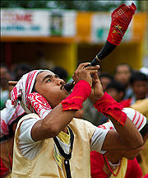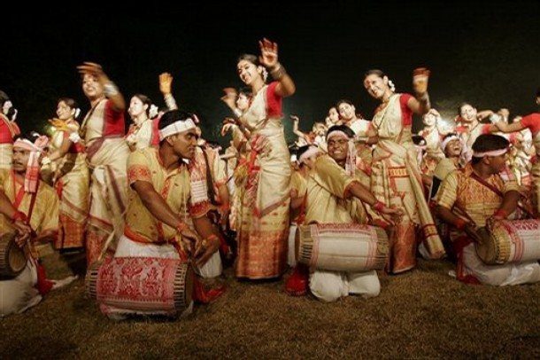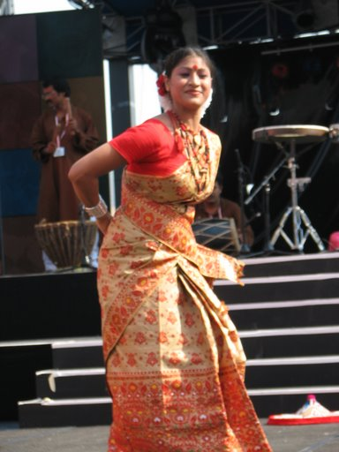

Rongali Bihu
Rongali Bihu (mid-April, also called Bohag Bihu), the most popular Bihu celebrates the onset of the Assamese New Year (around April 15) and the coming of Spring. This marks the first day of the Hindu solar calendar and is also observed in Bengal, Kerala, Manipur, Nepal, Orissa, Punjab and Tamil Nadu though called by different names. It's a time of merriment and feasting and continues for several days. The farmers prepare the fields for cultivation of paddy and there is a feeling of joy around. The ladies make pitha, larus (traditional food made of rice and coconut) and Jolpan which gives the real essence of the season. The first day of the bihu is called goru bihu or cow bihu, where the cows are washed and worshipped, which falls on the last day of the previous year, usually on April 14. This is followed by manuh (human) bihu on April 15, the New Year Day. The folk songs associated with the Bohag Bihu are called Bihugeets or Bihu songs.

Kongali Bihu
Kongali Bihu (mid-October, also called Kati-Bihu) has a different flavour as there is less merriment and the atmosphere has a sense of constrain and solemnity. During this time of the year, the paddy in the fields are in the growing stage and the granaries of the farmers are almost empty. On this day, earthen lamps (saki) are lit at the foot of the household tuloxi plant, the granary, the garden (bari) and the paddy fields. To protect the maturing paddy, cultivators whirl a piece of bamboo and recite rowa-khowa chants and spells o ward off pests and the evil eye. The Bodo people light lamps at the foot of the siju (spurge) tree. This Bihu is also associated with the lighting of akaxi gonga or akaxbonti, lamps at the tip of a tall bamboo pole, to show the souls of the dead the way to heaven, a practice that is common to many communities in Asia and Europe.^{[8]} There is also exchange of sweets and greetings at this time.

Bhogali Bihu
Main article: Bhogali Bihu
Bhogali Bihu (mid-January, also called Magh Bihu) comes from the word Bhog that is eating and enjoyment. It is a harvest festival and marks the end of harvesting season. Since the ganaries are full, there is a lot of feasting and eating during this period. On the eve of the day called uruka, i.e., the last day of pausa, menfolk, more particularly young men go to the field, preferably near a river, build a makeshift cottage called Bhelaghar with the hay of the harvest fields and the Meji, the most important thing for the night. During the night, they prepare food and there is community feasting everywhere. The entire night (called Uruka) is spent around a Meji with people singing bihu songs, beating Dhol, a typical kind of drums or playing games. Boys roam about in the dark stealing firewood and vegetables for fun. The next morning they take bath and burn the main Meji. People gather around the Meji and throw Pithas (ricecake or pancake), betel nuts, sesame, mah to it while burning it at the same time. They offer their prayers to the God of Fire and mark the end of the harvesting year. Thereafter they come back home carrying pieces of half burnt firewood for being thrown among fruit trees for favourable results. All the trees in the compound are tied to bamboo strips or paddy stems. Different types of sports like Buffalo-fight, Egg-fight, Cock-fight, Nightingale-fight etc. are held throughout the day. There are other conventional festivals observed by various ‘enthno- cultural’ groups. Me-dam-me-phi , Ali-aye-ligang , Porag, Garja, Hapsa Hatarnai, Kherai are few among them.

Photo Gallery of Venues:
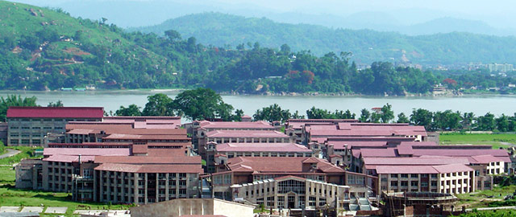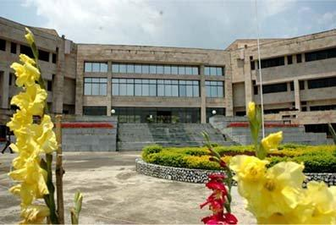
IIT Guwahati Academic Complex
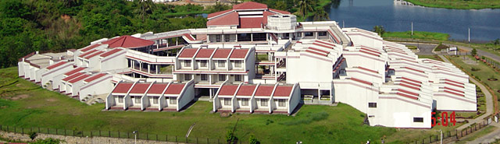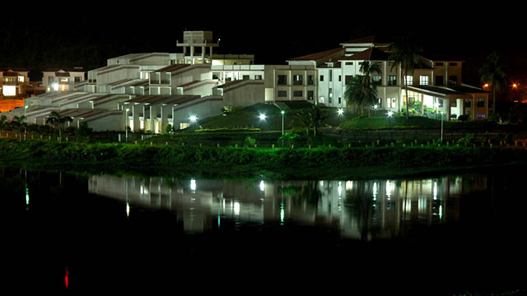
a) IIT Guwahati Guest House – All rooms with AC, ISD/STD and LAN/WAN b) At Night

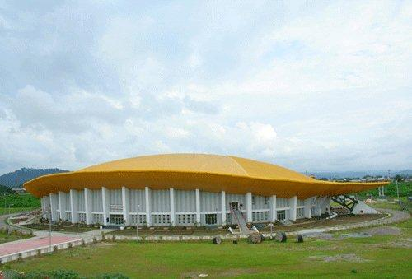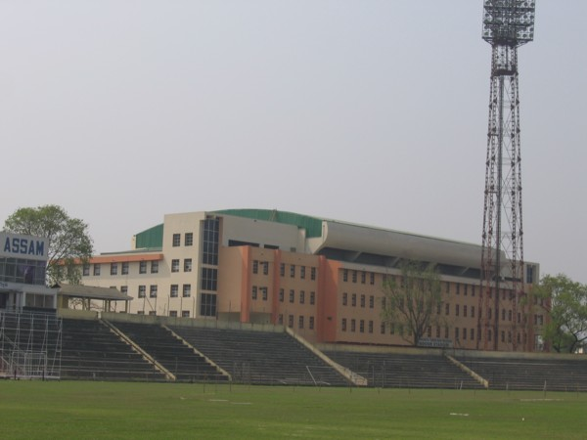
Rajiv Gandhi Indoor Stadium Deshbhakta Tarunram Phukan Indoor Stadium

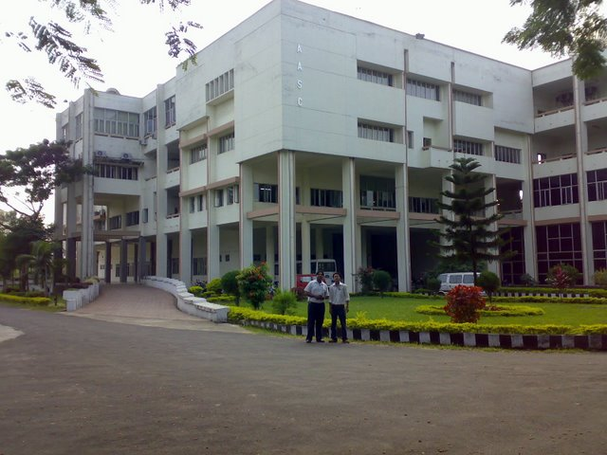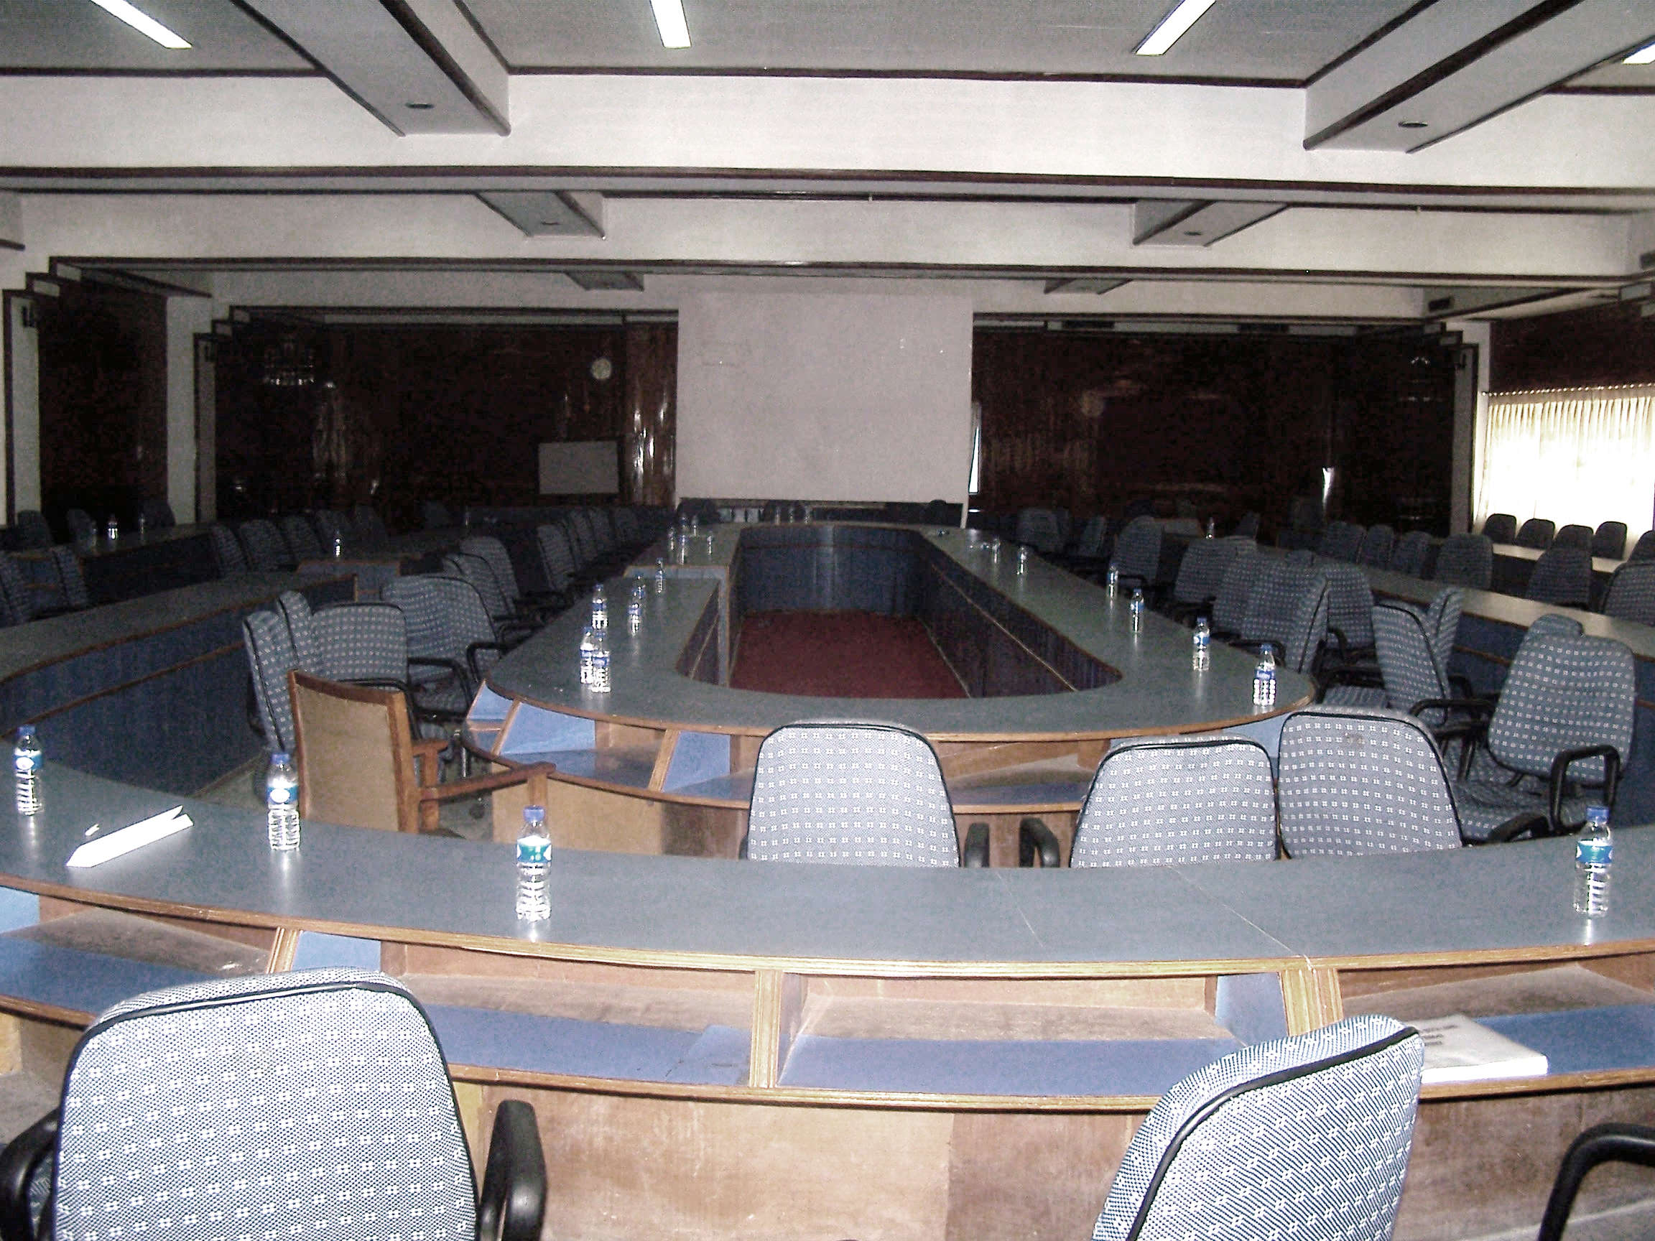
Administrative Staff College ASC Conference Hall
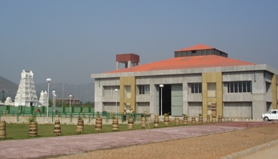
Maniram Dewan Trade Center, Guwahati

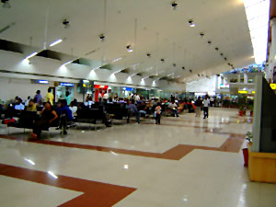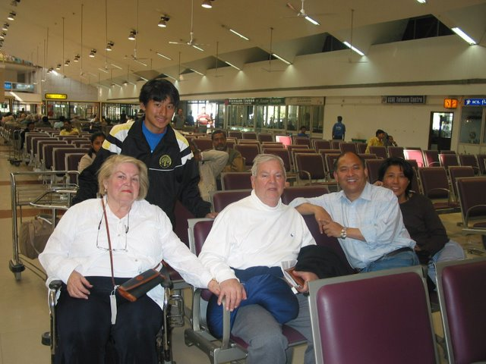
Lokapryia Gopinath Bordoloi International Airport, Borjhar, Guwahati, Assam

Thanks

