Software Specification Document

OpenOffice.org
Link CSV/Text files into HSQL databases

Specification Status
Last Change | Nov 27, 2006
Status

Abstract
In business processes, it's often necessary to exchange data between completely different applications. One common, widely-used, simple file-based format is CSV: text files containing multiple rows of homogenous data.
OpenOffice.org can already process such data in Calc, by interpreting the data therein as spreadsheet data, and in Base, by accessing it as relational database table. Especially the latter feature is rather limited, as it's not possible to update the data, or build more complex data models, for instance including relational integrity.
HSQLDB, the default database engine used by OpenOffice.org Base, features linkage of CSV/Text files, handling them as if they were native HSQL tables, including applicability of the full power of the HSQL database engine.
This document describes an user interface, implemented for OpenOffice.org Base, which allows to conveniently manage those linked tables in an HSQL database.

i-Team Members
Role | First Name, Last Name, Initials | E-Mail Address
Project Lead | Frank Schönheit (FS) | frank.schoenheit@sun.com
Specification Owner | Frank Schönheit (FS) | frank.schoenheit@sun.com
User Experience | Bettina Haberer (BH) | bettina.haberer@sun.com
Development | Frank Schönheit (FS) | frank.schoenheit@sun.com
Quality Assurance | Marc Neumann (MSC) | marc.neumann@sun.com
Documentation | Uwe Fischer | uwe.fischer@sun.com
Other roles

Contents
Abstract 1
i-Team Members 1
References and Reference Documents 3
Glossary 3
1 Detailed Specification 4
1.1 Background 4
1.1.1 Separation of Table Definition From File Specification 4
1.2 A New Table Type 4
1.2.1 Changed Behavior 5
1.3 Linked Table Editor 6
1.3.1 Table Settings 6
1.3.2 Line Settings 7
1.3.3 Field Settings 9
1.3.4 Guessing the Table Structure 10
1.4 Error Conditions 10
1.4.1 Unsupported Character Sets 10
2 Migration 10
3 Configuration 10
4 File Format 10
5 Open Issues 10
6 Future Tasks 10
7 User Interface Tables 11
Document Change History 13

References and Reference Documents
Reference Document | Check | Location (URL)
Specification Process Entry Check |  | N/A
Product Requirement,, RFE, issue (required) |  | <Please enter location here>
Product Concept Document |  | N/A
Competitive Analysis |  | N/A
Test Case Specification (required) |  | <Please enter location here>
Software Specification Rules | N/A | N/A
Database Application Specification | N/A | http://dba.openoffice.org/specifications/Database_application.sxw
HSQLDB: 100% Java Database | N/A | http://hsqldb.org
HSQLDB: Text Tables | N/A | http://hsqldb.org/doc/guide/ch06.html

Glossary
Term | Definition
database document | a file, usually ending with .odb, containing a database which can be loaded in OpenOffice.org Base. A database document might contain actual data, or only information on how to connect to the (remote) database.
text table | a feature of the HSQL database engine. Looks like a native HSQL table to the user, but is internally fed from a comma separated file outside the HSQL database. Most features of the HSQL engine can be applied to text tables, too, including primary keys and indexes to be defined on the table, and relationships defining referential integrity.
linked text table | Within the scope of this document, linked text table is used as synonym for text table.
table column | Database table data is organized as in columns and rows: Every row contains n values, where n is fix for all rows, and the k-th value of every row has the same attributes (such as type, length, nullability, etc.).  A table column is defined by the totality of all those attributes for a given k.
table field | used synonymously for table column
table designer | refers to the UI component which, in current (2.0.4) OpenOffice.org versions is used to edit a table structure. Available by choosing “Edit” from the context menu of a database table.

Detailed Specification
Everything said herein applies only to database documents with an embedded HSQL database (this is OpenOffice.org's default database document type). Database documents connecting to a different database type are not affected by any of the changes described in this specification.

Background
HSQLDB itself already allows to link CSV/Text tables. This specification describes only a user interface to conveniently allow users to use this HSQLDB feature.
As a consequence, we will, at least not in the first run, not offer options and features which are currently not available in HSQLDB. For instance, both the CSV import in OpenOffice.org Calc and the database connection settings for a Text/CSV database document allow the user to specify a quoting character for text fields. HSQLDB currently uses a fixed quoting character, name the double quotes. So, when linking a text file into a HSQL database, the user will not be able to choose a quoting character.

Separation of Table Definition From File Specification
Another paradigm which users know when using text files in either OpenOffice.org Calc or in dedicated Text/CSV database documents is that specifying the source file is sufficient. In particular, OpenOffice.org will then automatically recognize the table structure (Calc offers little more control here in tweaking it than Base does).
In HSQLDB, the table definition is separated from the file specification. That is, you first define the table structure, and then specify the file whose content should be used as source for this table.
Our user interface will hide this difference, nevertheless, it should be kept in mind when considering the feature as a whole.

A New Table Type
Linked tables will be considered a new type of tables, complementing the existing “views” and “normal tables”, which are already differentiated in both UI and handling.
- new icon, used wherever table trees are displayed
Illustration 1: Icons for linked tables, in normal and high-contrast mode
TODO: proper icons
- new task in the “Tasks” pane of the “Tables” section of the application main window, as shown in item 1 of Illustration 2.
  - selecting this task starts up the Linked Table Editor, which is described in chapter 1.3: Linked Table Editor
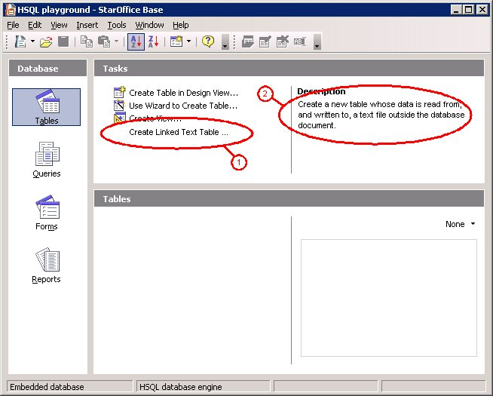Illustration 2: The main application window
TODO: proper icon
- new menu entry in the Insert menu: "Linked Text Table...", inserted right after "View (Simple) ..."
- the “Standard” toolbar's drop-down icon to create new objects also gets a new entry "Linked Text Table ...", inserted right after "View (Simple) ..."

Changed Behavior
There's a number of actions a user can execute in Base, which exhibit different behavior when applied to a linked text table:
- deleting a table
  - If a text table is deleted by any means, the existent "Confirm Deletion" dialog's text will be changed as shown in Illustration 3.
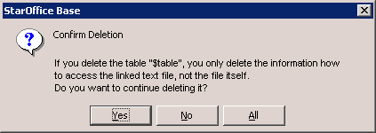Illustration 3: Confirmation for deleting a linked text table (mockup)
    - The "All" button will only be available if there are more tables to delete, no matter whether they're linked text tables or not.
- editing a table
  - If the "Edit" command is invoked for an existing linked text table, the Linked Table Editor dialog will be invoked, instead of the usual table editor.

Linked Table Editor
- central instance for managing linked tables is the “Linked Table Editor”, comprised of 3 tab pages
- invoked when
  - a new linked text table is created by any means (menu, toolbar, task pane)
  - the Edit command is applied to an existing linked text table by any means (context menu, menu, toolbar)
    - Note that this implies that the default table designer is not available for linked text tables.

Text File Settings

- shown in Illustration 4
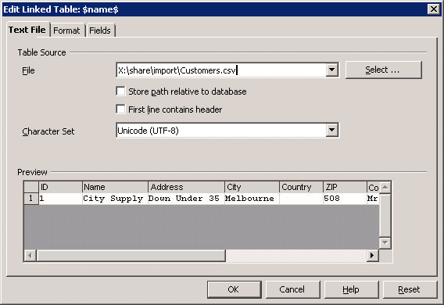Illustration 4: Text File Settings in the Linked Table Editor (mockup)
- contains settings which apply to the table, i.e. the underlying text file, as a whole
- "File"
  - points to the text file which is linked into the database
  - auto-completion feature as known from the OpenOffice.org File/Open dialog
- "Select"
  - opens a File/Open dialog, allowing to choose the text file which is linked into the database
    - only selection of existing files is allowed
  - upon confirming the dialog with OK
    - the path of the chosen text file is inserted into the "File" input field
    - the table structure is guessed as described in 1.3.4 Guessing the Table Structure, if and only if the dialog is invoked to create a new linked text table
- "Store path relative to database"
  - forces the path to the text file to be stored as a relative path
  - Consequently, when moving the database together with the text file, the database will continue to work when this option is checked
  - The path is still stored as absolute path when it cannot be expressed as relative path
    - e.g. 'cause the database document and the linked file reside on different volumes
- "First line contains header"
  - usually used when the first line contains the column names
  - effectively, checking this means the first line is completely ignored, as the column names/types are defined separately by the user
- "Character set"
  - contains a list of all character sets known to OpenOffice.org
  - defines which character set should be used when reading from and writing to the file, to translate the file's 8-byte characters into Unicode characters
  - default when invoked for a new linked text table is "Unicode (UTF-8)"
- Preview
  - same contol as in the "Link to external Data" / "Text Import" dialog in OpenOffice.org Calc
  - shows a preview how the table would look like with the current settings
  - works on actual data from the selected text file.
  - changes in the "Character set" and "First line contains header" settings are reflected immediately in the preview
  - changes in the "File" selection are reflected when
    - the "File" control loses the focus
    - the "File" control content is automatically added after browsing for a file using the "Select" button

Line Settings
- shown in Illustration 5
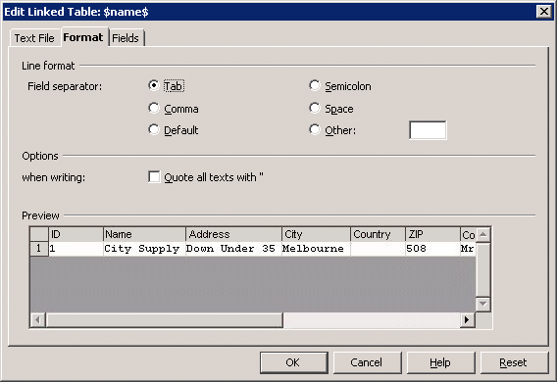Illustration 5: Format Settings in the Linked Table Editor (mockup)
- contains settings which affect the format of the data read from / written to the text file
- "Field Separator"
  - defines which character is used to separate the data of single fields within one line in the text file
  - "Tab", "Semicolon", "Comma", "Space" denote the respective usual characters
  - "Other" allows free selection of another character
    - The input field related to the "Other" radio button is enabled if and only if the button is checked
  - "Default" chooses the database-wide default field separator
    - In newly created databases, this separator is a comma
    - the default field separator can be defined for a HSQL database as a whole
      - there is no UI for this default field separator
      - for advanced users only (!):
        - controlled by an HSQLDB-internal property textdb.fs
        - can be changed by using Tools / SQL and entering SET PROPERTY "textdb.fs" '<field_separator>'.
- Quote all texts with "
  - enforces the quoting of all text column content when writing data to the text file
    - quoting character are the usual double quotes
  - if not set, text column content is quoted only when needed (e,g, when the text contains the character used for field separation)
- Preview
  - shows a preview how the table would look like with the current settings
  - works on actual data from the selected text file.
  - Changes in the "Field Separator" setting are reflected immediately in the preview

Field Settings
- shown in Illustration 6
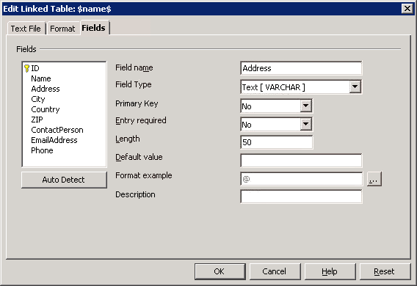Illustration 6: Field Settings in the Linked Table Editor (mockup)
- contains settings which define the types and attributes of the table columns, and thus the table structure as a whole.
- field list
  - occupies the left side of the page
  - lists the names of fields in the current table definition
  - selecting a field
    - fills the right-hand-side controls with the attributes for this field
  - fields being part of the primary key of the table are marked with the usual primary key symbol, as shown in Illustration 6.
- "Auto Detect"
  - attempts to detect the format of the linked text table
  - see 1.3.4 Guessing the Table Structure
- Field details
  - occupies the right side of the page
  - not described in detail here: Those controls are nearly exactly the same as in
    - the Table Wizard on the "Set types and formats" page
    - the ordinary table designer's "Field properties" section
    - addition to the other places where those controls are used
      - additional Yes/No entry “Primary key”:
        - controlling whether the given column should be part of the primary key
        - located after the “Field Type” entry
      - additional “Description” entry, allowing free text input
        - specifies the description to be associated with a column
        - exact the same semantics as the “Description” column in the ordinary table designer's field list

Guessing the Table Structure
When the dialog is used to create a new linked text table, or the "Auto Detect" button is pressed, OpenOffice.org attempts to automatically detect the format of the text table, pointed to by the "File" input box.
- using the current settings of the following
  - the "First line contains header" checkbox
  - the "Character set" list box
  - the "Field separator" setting
- after detection, the following will be reset with the detected data, overwriting any previous settings there:
  - the field list
  - the preview

Error Conditions

Unsupported Character Sets
TODO

Migration
N/A
The whole feature only implements user interface for back-end functionality which is already existent.

Configuration
N/A – no new/changed configuration settings

File Format
N/A – no changed/extended file format

Open Issues
Issue | Initials | Date
Should the CSV settings be remembered per data source? Per session? Per User? | FS | August 18, 2006

Future Tasks
Task | Issue / URL
It might be useful to have some “Paste Special” functionality, which pastes a table in the clipboard as linked table. That is, when a table is in the clipboard, the “Paste Special” dialog would contain an additional format “Linked Table Definition”. When chosen, a dialog would open asking for the .csv file to base the new linked table on. Then, a new linked table with the structure of the table in the clipboard would be created.
This would ease duplication of linked tables, since the new table would have all properties equaling the properties of the clipboard table.
Also, the functionality could be available for arbitrary tables in the clipboard, not only linked tables.
People might want to define indexes on a linked table. HSQLDB is capable of doing this, for the moment we spared it.

User Interface Tables
User Interface Elements of: Illustration 2
# | Type | Properties |  | Comment
1 |  | String English  Create Linked Text Table ... | String German  Verknüpfte Text-Tabelle anlegen ...
2 |  | String English  Create a new table whose data is read from, and written to, a text file outside the database document. | String German  Erstellen Sie eine Tabelle, deren Daten von einer außerhalb des Datenbank-Dokumentes liegenden Text-Datei gelesen und in diese geschrieben werden. | As usual with task pane items, “Create Linked Text Table ...” has an associated help text, which is displayed on the right hand side of the task pane, as soon as the user hovers over the respective item.
User Interface Elements of: Illustration 3
# | Type | Properties |  | Comment
<#> |  | String English  If you delete the table "$table", you only delete the information how to access the linked text file, not the file itself.\nDo you want to continue deleting it? | String German  Wenn Sie die Tabelle "$table$" löschen, wird nur die Information, wie auf die verknüpfte Text-Datei zugegriffen werden soll, nicht die Datei selber gelöscht.\nWollen Sie damit fortfahren, sie zu löschen? | $table$ will, at runtime, be replaced with the concrete table name.
User Interface Elements of: Illustration 4
# | Type | Properties |  | Comment
<#> |  | Properties  TODO: list this dialog's strings here
<#> |  | String English | String German
User Interface Elements of: Illustration 5
# | Type | Properties |  | Comment
<#> |  | Properties  TODO: list this dialog's strings here
<#> |  | String English | String German
User Interface Elements of: Illustration 6
# | Type | Properties |  | Comment
<#> |  | Properties  TODO: list this dialog's strings here
<#> |  | String English | String German
Menu/Toolbar Items
# | Type | Properties |  | Comment
<#> |  | String English  Linked Text Table ... | String German  Verknüpfte Text-Tabelle ... | That's a new entry in the top-level "Insert" menu, as well as the drop down menu in the "New Object" item in the "Standard" toolbar.

Document Change History
Rev. | Change | Initials | Date
0.1 | first revision | FS | August 21, 2006
0.2 | - first public revision  - changed "Enforce text quoting" to "Quote all texts with "", moved to section "Table Source"  - exchanged "Default" and "Other" in the "Line Format" section  - Linked Table Editor now comprised of tab pages, instead of one big dialog | FS | November 27, 2006
0.3 | - added some future tasks  - added declaration of the table's primary key to the “Fields” page  - added declaration of a column's “Description”  - mentioned that preview control is consistent with the one from the "Text Import" dialog in OpenOffice.org Calc  - renamed "Table" page to "Text File" | FS | November 27, 2006

