Software Specification Document

OpenOffice.org
Queries in Queries

Specification Status
Last Change | Oct 11, 2006
Status

Abstract
Database queries are an essential feature of any database management system to provide the user with the possibility to customize the view to her data. A database query assembles, filters, and sorts information spread over multiple tables of the relational database.
While up to OpenOffice.org 2.0.4, it is possible to base queries on tables only, with the implementation of the “Queries in Queries” feature the user can base queries on other queries as well, treating them as if they were a server-side table.

i-Team Members
Role | First Name, Last Name, Initials | E-Mail Address
Project Lead | Frank Schönheit (FS) | frank.schoenheit@sun.com
Specification Owner | Frank Schönheit (FS) | frank.schoenheit@sun.com
User Experience | Bettina Haberer (BH) | bettina.haberer@sun.com
Development | Frank Schönheit (FS) | frank.schoenheit@sun.com
Quality Assurance | Marc Neumann (MSC) | marc.neumann@sun.com
Documentation | Uwe Fischer (UFI) | uwe.fischer@sun.com

Contents
Abstract 1
i-Team Members 1
References and Reference Documents 3
Glossary 4
1 Detailed Specification 4
1.1 Example Structure 4
1.2 General 5
1.2.1 Limitations 6
1.3 Query Designer 6
1.4 Query and Table Names 7
1.4.1 Saving queries and tables 8
1.4.2 connecting to a remote database 9
1.5 Miscellaneous 10
2 Migration 12
3 Configuration 12
4 File Format 12
5 Open Issues 12
6 Future Tasks 12
Document Change History 13

References and Reference Documents
Reference Document | Check | Location (URL)
Specification Process Entry Check |  | N/A
Product Requirement,, RFE, issue (required) |  | Issue 51143
Product Concept Document |  | N/A
Competitive Analysis |  | N/A
Test Case Specification (required) |  | Test Case Specification
Software Specification Rules | N/A | N/A

Glossary
Term | Definition
database document | a file, usually ending with .odb, containing a database which can be loaded in OpenOffice.org Base. A database document might contain actual data, or only information on how to connect to the (remote) database.
query | Within the scope of this document, if not stated otherwise, a query is a SQL-SELECT-statement which is stored within a database document.
view | a SQL-SELECT-statement which is stored in a database.
data source browser | the componen used to browse through registered database documents while still displaying a main document. Accessible inside Text and Spreadsheet documents by pressing F4, this will open the data source browser docked at the top of the document window.
sub query | a query whose name appears in the FROM part of an SQL statement
inner query | synonymic for sub query
outer query | a query containing a inner query

Detailed Specification

Example Structure
- sample structure used in this document is the following rudimentary order management database
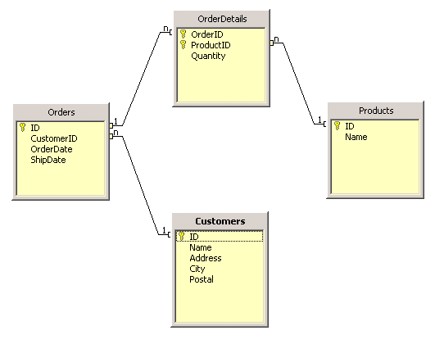Illustration 1: structure of the sample database used across this document

General
- users will be able to create queries based on other existing queries
- example
  - query “AllOrders”:
SELECT "Customers"."Name" AS "CustomerName", "Orders"."OrderDate", "Orders"."ShipDate", "OrderDetails"."Quantity", "Products"."Name" AS "ProductName"
FROM "OrderDetails" "OrderDetails", "Orders" "Orders", "Products" "Products", "Customers" "Customers"
WHERE ( "OrderDetails"."OrderID" = "Orders"."ID" AND "OrderDetails"."ProductID" = "Products"."ID" AND "Orders"."CustomerID" = "Customers"."ID" )
would create a query, based on the 4 existent tables, showing human-readable information about all existing orders.
  - query “UnshippedOrders”
SELECT * FROM "AllOrders" WHERE "AllOrders"."ShipDate" IS NULL
would create a second query, based on the first one, displaying all not-yet-shipped orders
- recursive queries in queries are possible, e.g.
  - SELECT * FROM “UnshippedOrders”
- technical realization:
  - allow SELECT * FROM <query>, where OpenOffice.org replaces <query> with the actual statement of the query before the command is sent to the database
- parameters contained in inner queries will be respected by OOo; example:
  - inner query be SELECT * FROM "Product Orders" WHERE ProductID = :product_id,named “Orders for Product”
  - outer query be SELECT * FROM "Product Orders" WHERE "ShipDate” IS NULL
  - executing the outer query will result in OpenOffice.org Base asking the user for the “product_id” parameter
  - if the outer query were to contain parameters, too, they'd be respected, too

Limitations
- a query which cannot be understodd by OOo's SQL parser cannot use other queries, since parsing is a pre-requisite for substituting sub query name with
  - consequently, queries which cannot be parsed will be sent to the database without substitution, and thus provoke a database error message
- queries which have the “Run SQL Direct” setting in the query designer switched on will not undergo any query name substitution, and this provoke a database error message when they contain sub queries.

Query Designer
- “Add Tables” dialog will be changed to show both queries and tables, as in shown in Illustration 2 below.
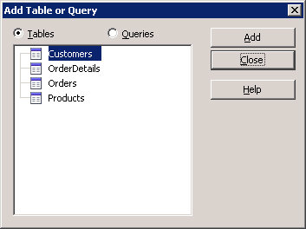Illustration 2: the renewed "Add Tables" dialog
  - the title will be changed from “Add Tables” to “Add Table or Query”
  - the previously existent fixed line and fixed text, both labeling the list box, will be removed
  - additional radio buttons will be placed at the top, which allow switching between the tables and the queries list
  - queries will be displayed with the same icon which is used for them in Base' main window
- the “Add Tables” button in the “Design” toolbar will be renamed to “Add Table or Query”
- in the lower pane of the designer, the row header previously named “Table” will not be renamed, since this would unnecessarily widen the respective column
- if the query designer is used for creating a view, none of the described changes takes place, since views cannot be based on queries

User Interface Elements of: Illustration 2
# | Type | Properties |  | Comment
<#> |  | Control Properties  Dialog Title: Add Table or Query
<#> |  | String English  Add Table or Query | String German  Tabelle oder Abfrage hinzufügen
<#> |  | Control Properties  Enabled: yes  Initially Selected: yes
<#> |  | String English  Tables | String German  Tabellen
<#> |  | Control Properties  Enabled: yes  Initially Selected: no
<#> |  | String English  Queries | String German  Abfragen

- When switching on “Direct SQL” mode in the SQL view, no changes happen to the SQL statement
  - in particular, if the current statement is e.g. SELECT * FROM "AllOrders" WHERE "AllOrders"."ShipDate" IS NULL, “AllOrders” will not be replaced with the actual statement of the AllOrders query.
  - as a result, executing the query based on another query will fail in “Direct SQL” mode
- when trying to add a query which does not describe a result set (e.g. a query which contains an UPDATE or INSERT statement)
  - the error message from Illustration 3 is shown
  - the query is not added
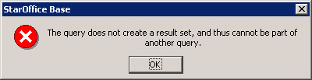Illustration 3: Error message displayed when a non-SELECT query is added to another query
User Interface Elements of: Illustration 3
# | Type | Properties |  | Comment
<#> |  | Control Properties
<#> |  | String English  The query does not create a result set, and thus cannot be part of another query. | String German  Die Abfrage erzeugt keine Ergebnismenge, und kann deswegen nicht Teil einer anderen Abfrage sein.

- In the upper pane of the query designer, the windows representing the tables/views/queries which the query is based on will
  - get an icon denoting the object type (table/query/view), being the very same icon as is used in the "Add Table or Query" dialog

Query and Table Names
- Queries and tables now share a common namespace, thus must have distinct names. Consequently,
  - saving a query, created either manually or with the query wizard, having the name of an existing table is forbidden
  - saving a table, created either manually or with the table wizard, having the name of an existing query is forbidden
  - creating a view with the name of an existing query is forbidden
  - where the “name” of a table is its complete name, including (if supported by the underlying database) catalog and/or schema
- characters known as quoting characters are forbidden in query names
  - “quoting characters” are: double quotation mark (“), single quotation mark ('), accent grave (`), accent d'acut (')

Saving queries and tables
- When saving a query with a name containing forbidden characters, the usual SQL error box is raised, with the texts shown in Illustration 4.
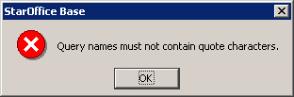Illustration 4: Error message: No quote characters allowed in query names
User Interface Elements of:
# | Type | Properties |  | Comment
<#>
<#> |  | String English  Query names must not contain quote characters. | String German  Abfragenamen dürfen keine Zitatzeichen enthalten.

- When saving a query with a name conflicting with the name of an existing table, the usual SQL error box is raised, with the texts shown in Illustration 5.
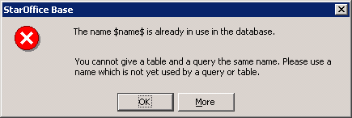Illustration 5: Error message: query and table name conflict
User Interface Elements of: Illustration 5
# | Type | Properties |  | Comment
<#>
<#> |  | String English  The name '$name$' is already in use in the database. | String German  Der Name '$name$' wird bereits in der Datenbank benutzt. |  | $name$ will be replaced with the actual name as entered by the user.
<#>
<#> |  | String English  You cannot give a table and a query the same name. Please use a name which is not yet used by a query or table. | String German  Es ist nicht möglich, einer Tabelle und einer Abfrage den selben Namen zu geben. Bitte wählen Sie einen Namen, der noch nicht für eine Abfrage oder Tabelle benutzt wird.

- When saving a table or view with the name of an existent query (for a database which does have neither catalog nor schema support), the same error message as shown in Illustration 5 above.
- Views converted from existing queries (“Create as view” in a query's context menu) are also checked for name collisions, in case of a collision the error message as shown in Illustration 5 is raised.

connecting to a remote database
- When connecting to a remote database from inside a database document, there's a potential name collision between
  - server-side tables (potentially changed/created by third parties)
  - queries in the database document
- Those collisions will be reported as warning, when connecting to the database, as seen in Illustration 6 below.
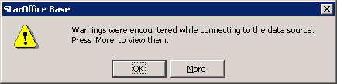Illustration 6: generic message to report warnings upon connecting to a database
User Interface Elements of: Illustration 6
# | Type | Properties |  | Comment
<#>
<#> |  | String English  Warnings were encountered while connecting to the data source. Press “More” to view them. | String German  Beim Verbindungsaufbau sind Warnungen aufgetreten. Drücken Sie “Mehr”, um sie anzuzeigen.
- Pressing the “More” button will open the usual SQL error details dialog as shown in Illustration 7.
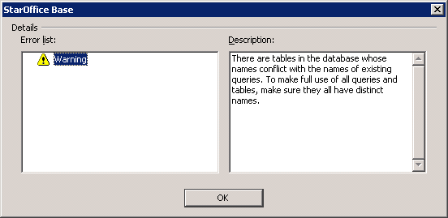Illustration 7: warning details on conflicting names
User Interface Elements of: Illustration 7
# | Type | Properties |  | Comment
<#>
<#> |  | String English  There are tables in the database whose names conflict with the names of existing queries. To make full use of all queries and tables, make sure they all have distinct names. | String German  Die Datenbank enthält Tabellen, deren Namen mit den Namen von existierenden Abfragen kollidieren. Um alle Tabellen und Abfragen voll nutzen zu können, stellen Sie sicher, dass sie alle unterschiedliche Namen haben.

- When connecting to such a database from inside the data source browser, the same warning will be issued
- Lookup precedence: If there's a table and a query with the same name, the query will be found first.
  - example: Imagine a table “European Customers”, and a table “European Customers”. The statement SELECT * FROM “European Customers” will find the query then.

Miscellaneous
- “Create as View”, applied to a query which contains a sub query, will create a view where the sub queries are substituted with their constituting SQL statement
  - except when the outer query to which “Create as View” is applied has the “Run SQL Direct” option set
- since in the “Add Table or Query” dialog, queries and views are close together, users could be confused from the fact that they both share the same icon. Thus, the view icon will be changed as follows
# | Type | Icon |  | Comment
<#> |  | Normal | High Contrast

- Sometimes, outer queries might fail to execute for whatever reason. Usually, database engines then display the SQL command leading to the error – which is not the same command as the user thinks she just executed, since OOo Base substituted the inner query with its constituting statement.
In such cases, OOo Base will append an information showing the original statement, to be presented to the user in the usual SQL error dialog behind the “More” button, as shown in Illustration 8
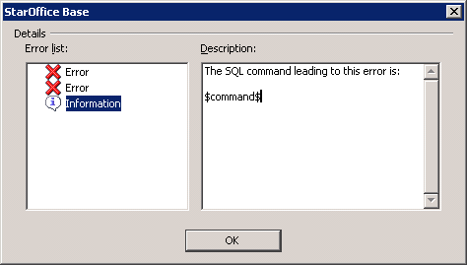Illustration 8: information displayed when executing a (possibile substituted) SQL failed
User Interface Elements of: Illustration 8
# | Type | Properties |  | Comment
<#>
<#> |  | String English  The SQL command leading to this error is:\n\n$command$ | String German  Das SQL-Kommando, welches zu diesem Fehler führte, ist:\n\n$command$ |  | $command$ will be replaced with the actual statement of the outer query.
- Consider the following queries
  - “orders1” defined as SELECT * FROM “orders2”
  - “orders2” defined as SELECT * FROM “orders1”
  - executing any of those is impossible since there's a cyclic reference
  - cylcles of even higher order (not only two involved queries) are possible
  - preventing the creating of such queries is very difficult, and potentially expensive
  - when the user tries to execute such a query, the error message from Illustration 9 is shown
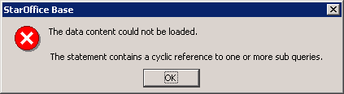Illustration 9: Error message when trying to execute a query with cyclic sub query references
User Interface Elements of: Illustration 9
# | Type | Properties |  | Comment
<#> |  | Control Properties
<#> |  | String English  The statement contains a cyclic reference to one or more sub queries. | String German  Der SQL-Ausdruck enthält eine zyklische Referenz zu einer oder mehr Unterabfragen.

Migration
- opening existing database documents containing data (i.e. with an embedded HSQLDB database) poses the same risk of name conflicts as connecting to a remote database:
  - there might be existing tables with the same name as existing queries
  - upon connecting to this database, the same warning will be issued as described in chapter “1.4.2 connecting to a remote database“

Configuration
- N/A:
  - no new/changed/removed configuration required by this feature

File Format
- N/A:
  - no new/changed/removed file format particles required by this feature

Open Issues
Issue | Initials | Date

Future Tasks
This section lists issues which arose during designing the feature described in this document, which should be solved in future (but not necessarily in the scope of the feature)
Description | Issue
BH suggests to improve the warning display in a way that the user sees the warning immediately, in the first dialog, not only behind the “More” button
creating a query based on another query with non-unique column names fails | issue 67008
updatability of simple queries such as "SELECT * FROM <query>" where <query> is "SELECT * FROM <table>" | issue 67010

Document Change History
Rev. | Change | Initials | Date
0.1 | initial revision | FS | Apr 21, 2006
0.2 | - new open issues, gained from discussion in users@dba.openoffice.org  - sketched alternative technical solutions  - singular in German title of “Add Table or Query” dialog | FS | Apr 24, 2006
0.3 | - re-written the document, now the technical realization is substituting query names with sub selects, instead of storing queries as views | FS | May 3, 2006
0.4 | - “Add Tables” dialog will not be changed if query designer is used to create a view  - new open issues  - removed the statement that this is available for HSQLDB only (was a rudiment of the old version)  - elaborated that no automatic statement expansion happens when switching on “Direct SQL” mode (thanks to Andrew Jensen for raising this)  - creating views also needs a name collision check  - “duplicate names” warning also when connecting from inside the data source browser  - added dedicated “Limitations” chapter  - parameters in inner queries are respected  - new chapter “Miscellaneous”  - new chapter “Future Tasks”  - recursive queries in queries are possible as well | FS | May 12, 2006
0.5 | - slight change of the “... is already in use ...” string  - open issue: disallow non-SELECT statements as inner queries?  - explicitly state that wizard-created tables and queries also have the same naming-restrictions as manually created ones  - changed icon for views  - open issue: unparsable queries added to other queries (in the query designer): how to react?  - better layout for the “Query names must not contain quote characters.” error dialog | FS | June 1, 2006
0.6 | - open issue: updatability of outer queries  - removed the open issues about column-less columns in query designer (fixed meanwhile)  - when executing a outer query, and this fails, the unsubstituted statement is now shown additional to the error message raised by the database engine  (issue raised by Andrew Jensen in users@dba.openoffice.org) | FS | June 19, 2006
0.7 | - added error message for cyclic sub query references  - added error message for adding non-SELECT queries in the query designer | FS | July 3, 2006
1.0 | - future task: “creating a query based on another query with non-unique column names fails”  - future task: “updatability of simple queries such as "SELECT * FROM <query>" where <query> is "SELECT * FROM <table>"”  - promoted from “Preliminary” to “Standard” | FS | July 4, 2006
1.0.1 | - added table/view/query icons to the "Table Window"s in the Query Designer (issue 69246) | FS | October 11, 2006

