Software Specification Document

Openoffice.org
Support Hyperlinks for graphic and autoshapes in Calc

Specification Status
Last Change | Jul 2, 2007
Status

Abstract
To improve MS Excel interoperability, support for associating hyperlinks for graphic and autoshape objects will be added. Additionally the Microsoft Excel filter will import those associations where they exist when reading an Excel workbook.

i-Team Members
Role | First Name, Last Name, Initials | E-Mail Address
Project Lead | Niklas Nebel (NN) | nn@openoffice.org
Specification Owner | Noel Power (NP) | npower@openoffice.org
User Experience | Goetz Wohlberg (GW) | gw@openoffice.orig
Development | Daniel Rentz (DR) | dr@openoffice.orig
Quality Assurance | Oliver Craemer (OC) | oc@openoffice.orig
Documentation | Uwe Fischer (UFI) | ufi@openoffice.orig
Other roles | <First Name, Last Name (Initials)> | <User@openoffice.org>
<State reason here, if one role is not represented in i-Team.>

Contents
Abstract 1
i-Team Members 1
References and Reference Documents 3
Acronyms and Abbreviations 4
1 Detailed Specification 5
2 Migration 7
3 Configuration 7
4 File Format 8
5 Open Issues 8
Document Change History 8

References and Reference Documents
Reference Document | Check | Location (URL)
Specification Process Entry Check |  | N/A
Product Requirement,, RFE, issue (required) |  | i66550
Competitive Analysis |  | here
Test Case Specification (required) |  | hyperlink-test
Software Specification Rules | N/A | N/A

Acronyms and Abbreviations
Acronym / Abbreviation | Definition
<WYSIWYG> | <What You See Is What You Get>

Detailed Specification

Goals
To improve MS Excel interoperability by
- Adding support for associating hyperlinks for graphic and autoshape objects to Openoffice.org
- Enhance the Excel filter to import those associations where they exist when reading an Excel workbook.

User Scenarios
- User right clicks on an object (autoshape or image) that has NO hyperlink associated with it: The drawing object is (if editable) is marked and a new context menu item “Hyperlink...” is displayed (see fig 1.). To edit the object, the user needs to click STRG+ left mouse click
- User right clicks on an object (autoshape or image) that HAS a hyperlink associated with it: The drawing object is (if editable) is marked and a new context menu items “Hyperlink...”, “Remove Hyperlink” & “Open Hyperlink” are displayed (see figure 2.)
- User left-clicks on an object (autoshape or image) that has a hyperlink associated with it: Hyperlink is opened.
- User hovers mouse over object (autoshape or image) that has a hyperlink associated with it: Mouse pointer changes from arrow to hand (RefPointer) and a tooltip displayed showing the hyperlink url
- User wishes to assign a hyperlink to an object (autoshape or image): User selects object, right click and selects the “Hyperlink...” item from the context menu. The hyperlink dialog is opened and the user can select a variety of url types. Note: Since this is an existing dialog which is un-modified from it's standard behavior, this dialog will not be discussed further in this document.
- User hovers mouse over object (autoshape or image) that has a hyperlink & macro associated with it: Mouse pointer changes from arrow to hand (RefPointer) and a tooltip displayed showing the hyperlink url.
- User wishes to remove a hyperlink associated with the object (autoshape or image): User right clicks object and selects the “Remove hyperlink” context menu item.
- User left-clicks on an object (autoshape or image) that has a hyperlink & macro associated with it: Hyperlink is opened but the macro is NOT run (this behaviour is consistent with MS Excel and desirable from an interoperability point of view).
Issue: There should be visual feedback if the user left-clicks an object with hyperlink associated. In example MS Office inverts the object by the left-click.
- Users can also associate hyperlinks via menue: Select object (autoshape or image) and select menu “Insert – Hyperlink”

UI Specification
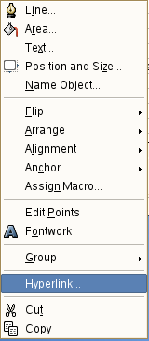Figure 1: Shows proposed hyperlink context menu items (when no binding exists)
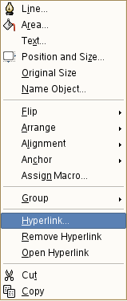Figure 2: Shows proposed hyperlink context menu items (when binding exists)

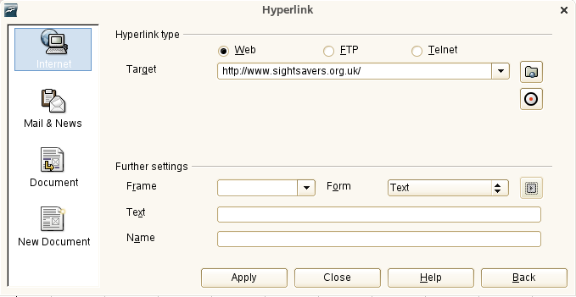Figure 3: Shows proposed hyperlink assigment dialog

Table 2: User Interface elements of Figure 2
# | Type | Properties |  | Comment
<#> |  | Properties
<#> |  | String English  ~Hyperlink... | String German  <Enter String Here>
<#> |  | Properties
<#> |  | String English  ~Remove Hyperlink | String German  <Enter String Here>
<#> |  | Properties
<#> |  | String English  ~Open Hyperlink | String German  <Enter String Here>

Migration
N/A no known migration issues

Configuration
N/A no configuration necessary

File Format
N/A no known issues.

Competitive Analysis
Microsoft Excel allows both macros and hyperlinks to be assigned to images and autoshapes. To better support interoperability OpenOffice.org needs to offer similar functionality.

Future Tasks
The Excel filter should be modified to export hyperlink bindings for autoshape and image (graphic) objects.
To be discussed: For consistency we should extend this feature to all other apps as well.
Next open issue is to find a better visual presentation if you left click an object with associated hyperlink

Open Issues
Issue | Initials | Date
<...>

Document Change History
Rev. | Change | Initials | Date
1 | Initial feedback added | GW | Sep 15, 2006
2 | Future Issues added | GW | Sep 29, 2006
3 | Separate specs for macro and hyperlinks | DR | Jul 02, 2007
<...>

