Software Specification Document

OpenOffice.org
Extend AutoSum Capabilities in Calc

Specification Status
Last Change | Jun 22, 2007
Status
Abstract
OpenOffice.org Calc's capabilities to sum up cell values automatically are extended. The cell range used for summation is specified by the user. All values in the marked area are summed up column- and/or rowwise and the result is inserted automatically as a sum formula.

i-Team Members
Role | First Name, Last Name, Initials | E-Mail Address
I-Team Lead | Thomas Benisch (TBE) | thomas.benisch@sun.com
Specification Author | Thomas Benisch (TBE) | thomas.benisch@sun.com
User Experience | Frank Loehmann (FL) | frank.loehmann@sun.com
Development | Thomas Benisch (TBE) | thomas.benisch@sun.com
Quality Assurance | Frank Stecher (FST) | frank.stecher@sun.com
Documentation | Uwe Fischer (UFI) | uwe.fischer@sun.com
Other roles | <First Name, Last Name (Initials)> | <User@openoffice.org>
<State reason here, if one role is not represented in i-Team.>

Contents
Abstract 1
i-Team Members 1
References and Reference Documents 3
Acronyms and Abbreviations 3
1 Detailed Specification 4
1.1 Current AutoSum behaviour 4

1.2 Extended AutoSum capabilities 5
1.2.1 Extended AutoSum behaviour 5

1.2.2 Detailed description of the algorithm 7
1.2.2.1 Sum area 7
1.2.2.2 Criteria for summing up columns and rows 7
1.2.2.3 Sum formula 8
1.2.2.4 Result area 8
1.2.2.5 Mark area 8
1.2.2.6 Cursor position 8
1.2.2.7 Multi-selection 8
2 Migration 8
3 Configuration 8
4 File Format 8
5 Open Issues 8
Document Change History 9

References and Reference Documents
Reference Document | Check | Location (URL)
Specification Process Entry Check |  | N/A
Product Requirement, RFE, issue [Required] |  | i51564
Product Concept Document |  | N/A
Competitive Analysis |  | N/A
IDL Specification |  | N/A
Test Case Specification [Required] |  | Calc_Autosums.html
Software Specification Rules | N/A | N/A
Acronyms and Abbreviations
Acronym / Abbreviation | Definition
SUM | OOo Calc function to sum up values of cells.
SUBTOTAL | OOo Calc function to sum up only values of visible cells in the selected/defined cell range.

Detailed Specification

Current AutoSum behaviour
The OpenOffice.org Calc AutoSum feature allows the user to sum up cell values automatically.
If the user sets the cursor to the next empty cell of a row or column, which contains a series of values, and presses the “Sum” button in the formula bar, OpenOffice.org Calc automatically sums up the values and inserts the result as a sum formula at the cursor position (see example 1). In addition, the sum area, which is the cell range used for the calculation is highlighted. The proposed formula can be modified by the user by entering a different formula in the input field of the formula bar or by defining another cell range by using drag & drop. If the user presses the “Accept” button, the formula is inserted at the cursor position. The whole action can also be cancelled by pressing the “Cancel” button. When the user marks several empty cells, the result is inserted automatically into each cell without any user interaction.
For determining the sum area a heuristic search algorithm is used. If the cell above the cursor position contains a value, the algorithm searches upward until it finds a cell with no value. If the cell above the cursor position contains no value, the algorithm searches to the left. If this also fails, more advanced strategies are used. After the sum area has been determined, the sum formula is simply obtained by using the SUM function. In the case, that the sum area contains filters, the SUBTOTAL function is used instead of the SUM function. If the sum area already contains cells with a formula that sums up cell values of that range, the cells with the intermediate result are used for calculating the total sum of the range.

Example 1
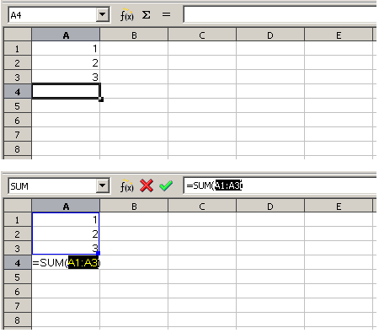Figure 1: Summing up a range of values by selecting the cell where the result should appear (top). After pressing the 'Sum' button (bottom) the sum formula is inserted.
In order to sum up the values in the range A1:A3 the user sets the cursor to the empty cell A4 and presses the 'Sum' button. As a result the sum formula =SUM(A1:A3) is inserted into the cell A4. The proposed sum formula can be modified by the user and must be confirmed by pressing the 'Accept' button.

Extended AutoSum capabilities

Extended AutoSum behaviour
The described behaviour also has its limitations, e.g. the search algorithm stops if there's an empty cell in the middle of a range it tries to sum up. Therefore competitor's products offer more capabilities for the user, namely the cells which should be summed up can be specified by the user. For that purpose the user marks the cell range which should be summed up and then presses the “Sum” button. The result is inserted at the next empty cell below the marked cell range when summing up vertically and right to the marked cell range when summing up horizontally (see example 2). If the marked area contains an empty cell at the bottom or at the right, the result will be inserted in the empty cell (see example 3). If several rows or columns in a cell range are summed up, the result is inserted at the next empty range below or right to the marked area. If the marked cell range contains an empty row at the bottom or an empty column at the right, the result will be inserted there (see example 4).

Example 2
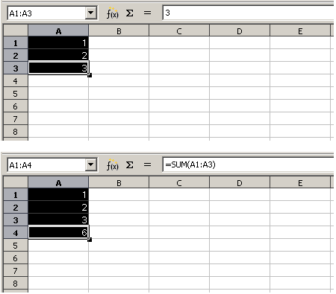Figure 2: Summing up a range of values by marking the cells that need to be added (top). After pressing the 'Sum' button (bottom) the sum formula is inserted.
The user marks the cell range A1:A3 for summation. After pressing the 'Sum' button, the sum formula =SUM(A1:A3) is inserted automatically in the empty cell A4 below the marked cell range. The marked area is expanded in order to include the result cell A4. In addition, the cursor position is also set to A4.

Example 3
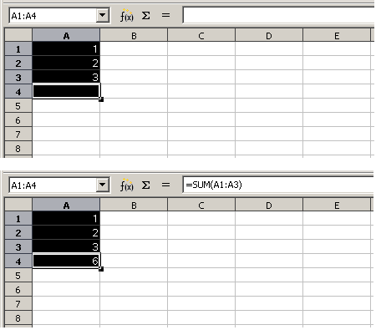Figure 3: Summing up a range of values by marking the cells that need to be added and a destination cell (top). After pressing the 'Sum' button (bottom) the sum formula is inserted.
The user marks the cell range A1:A4 which includes the cells A1:A3 that need to be added and the empty cell A4 for the result. After pressing the 'Sum' button the sum formula =SUM(A1:A3) is inserted automatically in the cell A4.

Example 4
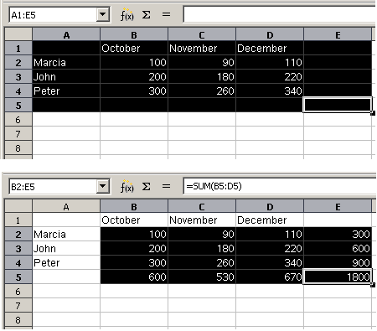Figure 4: Summing up several rows and columns of a marked cell range (top). After pressing the 'Sum' button (bottom) the sum formulas are inserted.
The user marks the cell range A1:E5. After pressing the 'Sum' button, the rows and columns of the sum area B2:D4 are summed up automatically. The sum formulas are inserted in the empty row at the bottom of the mark range (B5:E5) and the empty column at the right of the mark range (E2:E5). As the row at the top of the mark range (A1:E1) and the column at the left of the mark range (A1:A5) don't contain any values, those cells are not included in the calculation. In addition, those cells are removed from the mark range.

Detailed description of the algorithm

Sum area
In principal the sum area is given by the cell range which is marked by the user. Nevertheless rows at the top or columns at the left of the marked cell range which don't contain any values are not taken into account for summation. This is called the reduced mark area. In addition an empty row at the bottom or an empty column at the right of the reduced mark area is not included in the calculation and removed from the sum area.

Criteria for summing up columns and rows
If a column of the sum area contains data and the reduced mark area has an empty row at the bottom, the column is summed up. If there's no empty row at the bottom, but the column has at least two cells and the reduced mark area doesn't have an empty column at the right, the column is also summed up,
A row of the sum area is summed up, if the row contains data and the reduced mark area has an empty column at the right. If there's no empty column at the right, but the row has at least two cells and the sum area has only this single row, the row is also summed up.

Sum formula
The sum formula is calculated for each column and row of the sum area seperately. In the simplest case the sum formula is given by the SUM function and the range of the column or row as parameter. If the sum area contains filters, the SUBTOTAL function is used instead of the SUM function.
In more complex cases, a column or row of the sum area contains cells with a formula that already sums up some values of that column or row. In this case the cells with the intermediate result are used for calculating the total sum of that column or row.

Result area
If the reduced mark area contains an empty row at the bottom or an empty column to the right, the sum formula will be inserted there. Otherwise the sum formula is inserted at the next empty range below or right to the marked cell range.

Mark area
After inserting the sum formula the mark area is adjusted to the reduced mark area, so that the user has a better indication of the cell range which was effectively summed up. If the last column or row of the reduced mark area is not empty, the mark area is expanded, so that the cells with the inserted sum formulas are also included in the mark range.

Cursor position
The cursor is set to the bottom right cell of the mark area.

Multi-selection
In the case of a multi-selection, that means that several cell ranges are marked, each marked cell range is handled separately.

Migration
No migration involved.

Configuration
No configuration involved.

File Format
No file format changes.

Open Issues
Issue | Initials | Date
None | FL | May 31, 2007

Document Change History
Rev. | Change | Initials | Date
1 | First draft | TBE | May 22, 2007
2 | Review | FL | May 31, 2007
3 | Added link to test case specification | TBE | June 20, 2007
4 | Set status to standard | TBE | June 22, 2007
<...>

