Improve UI for Linking Frames
OOo Later

Document - ID | Specification Owner | Last Change | Status
 | Frank Loehmann | 26. July 05 | Draft
Conforms to
Applies to | OO Later
Task ID(s) | i52488
Category | Feature

Abstract
The usability of the GUI to connect frames to share their contents is poor. This spec. reworks the GUI and the behavior of connecting frames.

i-Team Members (The specification owner is part of the i-Team)
 | Name | E-mail Address
User Experience | Frank Loehmann | frank.loehmann@sun.com
Development
Quality Assurance
Documentation

Approved for Implementation
 | Approved by | Date
User Experience | Frank Loehmann | 8. June 05
Development
Quality Assurance
Documentation
String Review | not nessesary | -

Document Change History
Rev. Level | Change | Initials | Date
1.0 | Final Draft | FL | 26.07.05

Contents
1 Motivation 1
2 User Scenarios 1
3 Goals 1
4 Requirements 1
5 Competitive Analyses 1
6 Detailed Specification 2

Motivation
Improve the usability of connecting frames.

User Scenarios
Scenario 1: User A works on a student news paper for their school. When creating a text flow from frame A to frame B to frame C, she has to select the new connected end frame to be able to choose the link frame tool from the tool bar again.

Goals
Make it easier to connect more than two frames in a row.

Requirements
Changed GUI behavior.

Competitive Analyses
The competition connects one frame to another in nearly the same way OOo 1.1 does.
OpenOffice.org 1.1 behaves like follows:
Start situation: Three frames in the Writer document on the same page
- Frame A contains more text than it could show. The frame itself is selected.
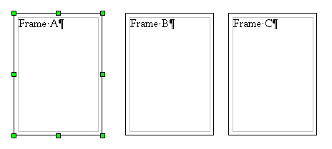
- Click on the Link Frames button and select
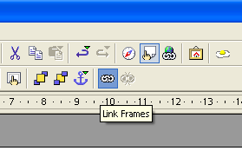
- Select Frame B (Mouse over feedback thru dotted border) is given
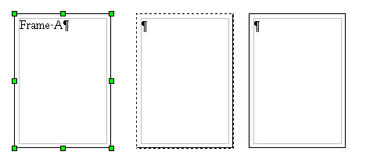
- Frame A and B are connected and frame A is still selected. Thus user cannot connect frame c to the first two frames because of the still selected A frame. She has to select frame B first, before the connecting tool is re-enabled to continue connecting C in a row to A and B..
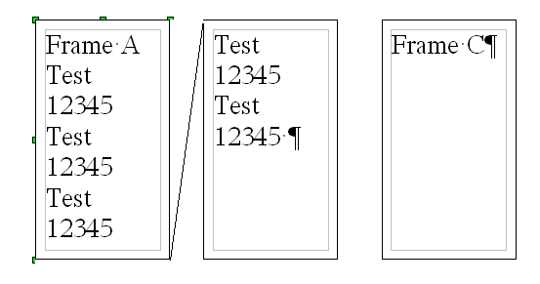

Detailed Specification
Linking a Writer frame to a currently selected one, transfers the selection to that newly connected frame. Thus the Link Frame tool in the Frame toolbar is enabled right after linking process has been finished. Thus the user can directly chose the connection tool and connect another frame to the linked frames.
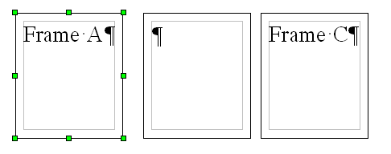Illustration 1: Initial status of frame A, frame B and frame C
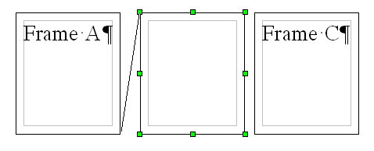Illustration 2: Frame B is selected after linking of B has been finished

