Testing Personal Music Data Base

Issue # 1

Summary: “Media, Format, Location, Country and Publisher Date Entry” form
No name of country (just entered in “Country” data sheet) in list box of “Country” field of “Publisher' data sheet.

Description:
- Open “Media, Format, Location, Country and Publisher Data entry” form.
- Click a New Record button on the Navigation Bar at the bottom of the form or position cursor at the empty record located after last entered record in “Country”data sheet.
- Enter name of country. Save. Click a Save Record button on the Navigation Bar or just press
<Tab> after you enter name of country. Cursor should be on the next row.
- Go to “Publisher” data sheet. Position cursor at the empty record located after last entered record.
- Enter name of publisher. Press <Tab>. Open list box in Country field. There is no name of
country you just entered in “Country” data sheet.

Recomendation:
To add in “User guide” explanation how User should enter data in “Media, Format, Location,
Country and Publisher Data Entry” form:

- Enter name of country. Save. Click a Save Record button on the Navigation Bar or just press
<Tab> after you enter name of country. Cursor should be on the next row.
- Go to “Publisher” data sheet. Position cursor at the empty record located after last entered record.
- Click Refresh button on the Navigation Bar.
- Enter name of publisher. Press <Tab>. Open list box in Country field. Choose name of country you just entered in Country data sheet.

Issue # 2

Summary: “Music Set Data Entry Form”.
Not possible to delete record in “Music Item Data Entry Subform” if Status added (in “Music Item Status Data Entry Subform”)

Description:
1.Open “Music Set Data Entry Form”.
2.Click a New Record button on the Navigation Bar at the bottom of the form or position cursor at the empty record located after last entered record.
3.Enter Music Set Name.
4.Move cursor to the Music Item Entry Subform.
5.Enter music item description
6.Add status in Music Item Status Data Entry Subform.
7.Locate cursor back to the Music Item Entry Subform at the last record you just entered (with status).
8.Click Delete Record button on the Navigation Bar at the bottom of the form.
9.Warning message appears. Click “Yes”
10.Error message appears. You are not allowed to delete record in Music Item Entry Subform with its subform (Music Item Status Data Entry subform). See picture below:

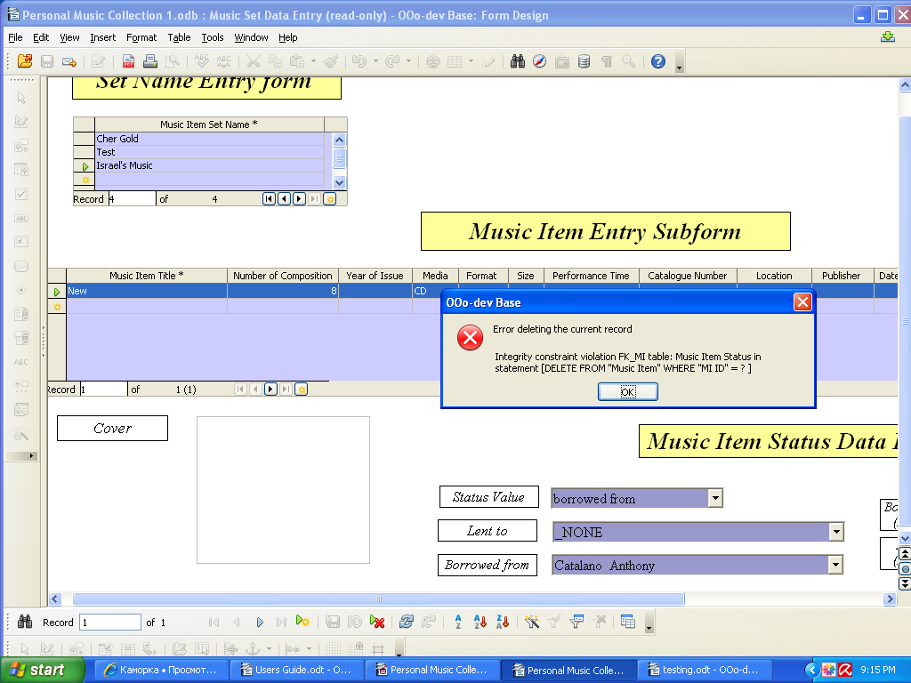

Issue #3

Summary: Not possible to delete record in “Set Name Entry Form” if data entered in “Music Item Data Entry Subform” and status added (or not).

Description:

1.Open “Music Set Data Entry Form”.
2.Click a New Record button on the Navigation Bar at the bottom of the form or position cursor at the empty record located after last entered record.
3.Enter Music Set Name.
4.Move cursor to the Music Item Entry Subform.
5.Enter music item description
6.Add status ( if you needed) in Music Item Status Data Entry Subform.
7.Locate cursor back to the Music Item Entry Subform. Click New Record button on the Navigation Bar at the bottom of the form or position cursor at the empty record located after last entered record.
8.Enter next music item description. Click Save Record button or place cursor at the next row.
9.Locate cursor back to Sate Name Entry form at the last record you just entered.
10.Click Delete Record button on the Navigation Bar at the bottom of the form.
11.Warning message appears. Click “Yes”
12.Error message appears. You are not allowed to delete record in Set Name Entry Form with its subform (Music Item Entry subform). See picture below:
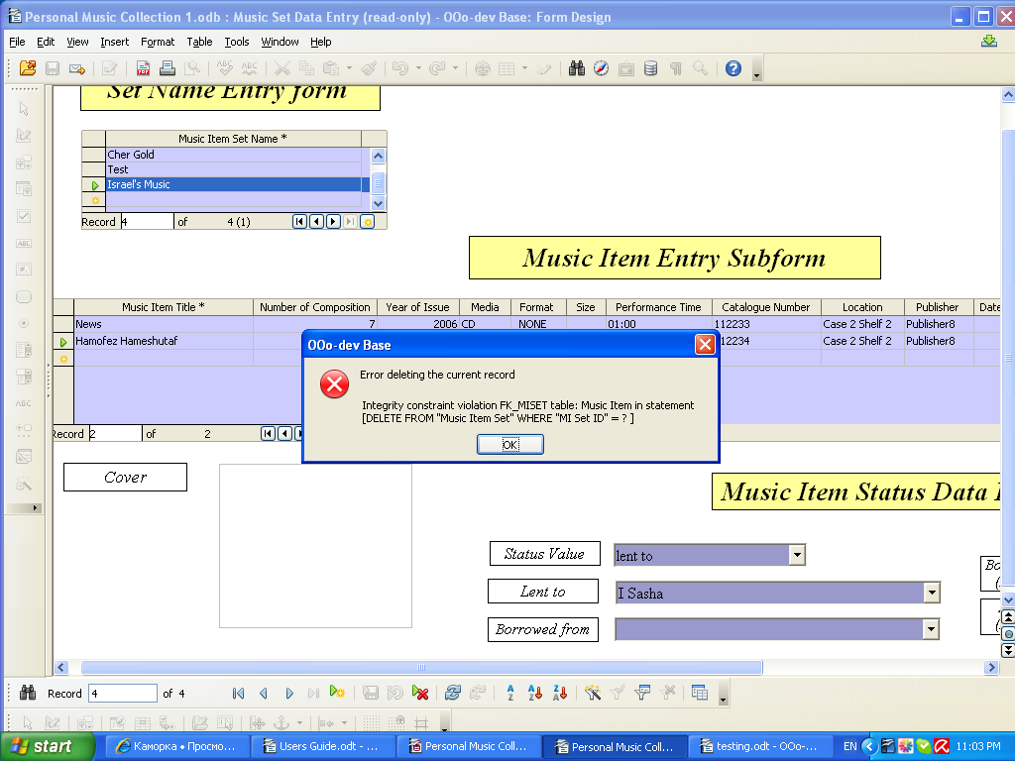

Issue # 4

Summary: “Performer Data Entry” form
Not possible to delete record in “List of Performer Members”

Precondition: Person has to be entered in “Person Data Entry” form

Description:
1.Open “Performer Data Entry Form”
2.Enter Performer Nick in mandatory field.
3.Choose any person in “List of Performer Members” tab “Person's first name, last name”field.
4. Navigate cursor on any name just entered in “List of Performer Members”
5.Click “Delete Record” button on the Navigation Bar at the bottom of the form.
6.Warning message appears. Click “Yes”.
7.Check the name of the person you just deleted in list box of List of Performer Members. It still exists.
8.Double check the name of the person you just deleted in Person Data Entry Form. Click “Find Record” button on the Navigation Bar at the bottom of the form, enter the name of this person- the name of deleted person still exists.

By the way. How is it possible to delete person from your database? You don't have any comments in your User's Guide.

In Person Data Entry form you can't see list of all persons of your DataBase. You have to know name of person and you can find him (her) using “Find Record” button.

Issue # 5

Summary: “Performer Data Entry” form
Not possible to delete record in “Performer Data Entry Form”

Precondition: Person has to be entered in “Person Data Entry” form.

Description:
1.Open “Performer Data Entry Form”
2.Enter Performer Nick in mandatory field.
3.Choose any person in “List of Performer Members” tab “Person's first name, last name”field. Save the record.
4.Navigate cursor on “Performer Nick” field.
5.Click “Delete Record” button on the Navigation Bar at the bottom of the form.
6.Warning message appears. Click “Yes”.
7.Error message appears. See picture below.

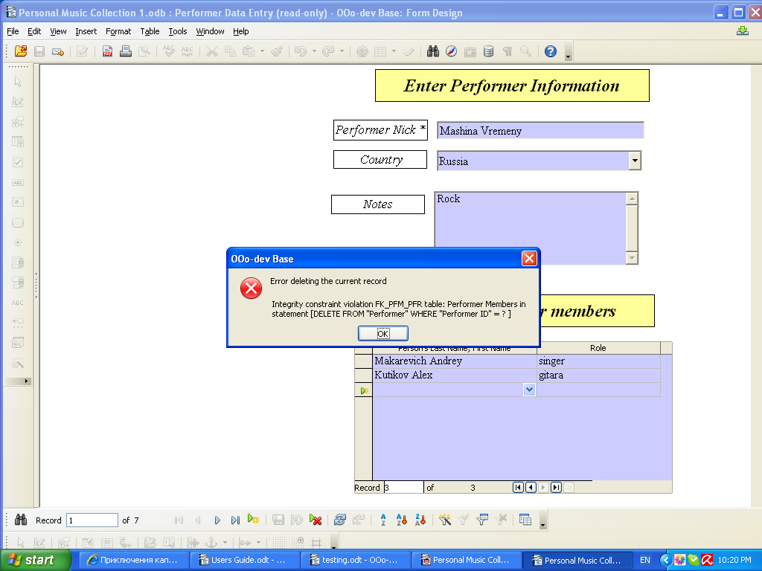

Issue # 6.

Summary: “Person Data Entry Form”
Not possible to delete name of person from Person Data Entry Form if this person is performer member. .

Precondition: Person has to be entered in “Person Data Entry” form. The same person has to be chosen in List of Performer Members.

Description:

1.Open Person Data Entry Form
2.Enter any name in Person Data Entry Form. Save the record. Close the form.
3.Open “Performer Data Entry Form”
4.Enter Performer Nick in mandatory field.
5.Choose the same person in “List of Performer Members” tab “Person's first name, last name”field you entered in Person Data Entry Form. Save the record.
6.Open Person Data Entry Form.
7.Click “Find Record” button on the Navigation Bar at the bottom of the form, choose searching parameter (just entered name).
6.Click “Delete Record” button on the Navigation Bar at the bottom of the form.
7.Warning message appears. Click “Yes”.
8.Error message appears. See picture below.

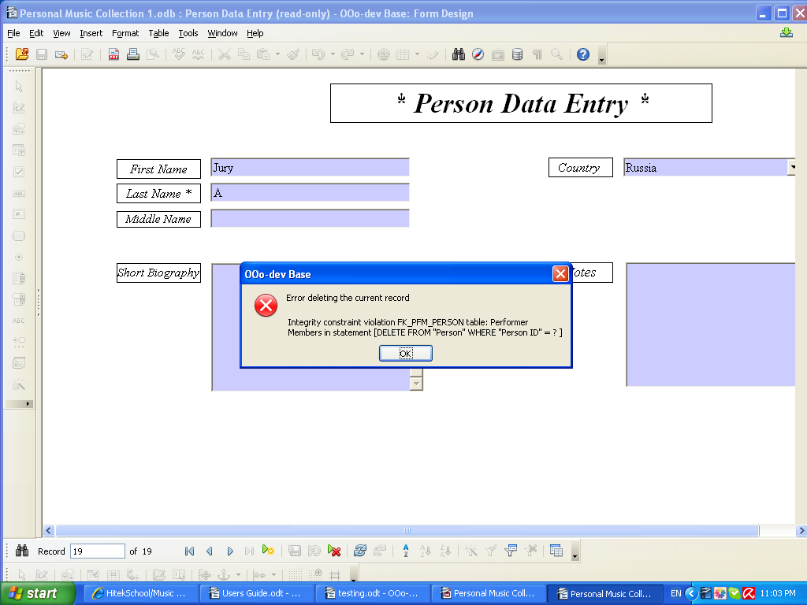

Issue 7.

Summary: Music Item Data Entry Form.
Description in User's Guide doesn't correspond to content of Music Item Data Entry Form.

Precondition: User's Guide: This form is designed for entering Music Item and its Description for the Music Item that is not a part of a Set.

Description:
- Open “Music Item Data Entry Form”
- The second row is “MI Set”. You can choose name of music set from list box. This is mislead user.

Issue 8.

Summary: Music Item Data Entry Form.
Not possible to change minutes in Total Performance Time field.

Description:
1. Open “Music Data Entry Form”.
- Fill in mandatory field.
- Navigate cursor on dialog box of Total Performance Time field. Try to change minutes. It doesn't work. You can choose only hours of performance time.

Issue 9.

Summary: Musical Composition and Description Data Entry Form.
Difficulty of filling date in Musical Composition and Description Data Entry Form.

Precondition: Music Item Title has to be entered in Music Item Data Entry Form.

Description:

1. Open Musical Composition and Description Data Entry Form.
2. Click New Record button on the Navigation Bar at the bottom of the form
3. Fill all known needed fields in Musical Composition Description Tab. (let's say we don't have name of composer)
4. Click Save Record button. Don't close Musical Composition and Description Data Entry Form.
5. Open Person Data Entry Form
6. Enter needed information about person (composer). Save the record. Close Person Data Entry Form.
7. Go to Musical Composition and Description Data Entry Form.
8. Navigate cursor on Composer field of “Musical Composition Description”form. Open List box. There is no name of person (composer) just entered in Person Data Entry Form. There is also no value “ _NONE” (so you can make a mistake).
9. Click Refresh button. Your record disappears. You have to find record (click “Find Record” button) and after to finish to fill the record. And you also have “Language”, “Author”... fields. If you need to enter information for this field... ( You have to explain in User's guide how user can enter data he (she) doesn't have for this form at a moment of filing the form).

Issue # 10

Summary: Query qry 5_3_2 MIContent by CompTitle
Query qry 5_3_2 doesn't show MIContent by CompTitle.

Precondition: Musical Composition and Description Data Entry form has to be filled, Composer field entered.

Description:
1. Open Query qry 5_3_2 MIContent by CompTitle.
2. Enter Value: “Item Title”, click OK.
There is no “Composer” column in entered Query.
See Picture below.

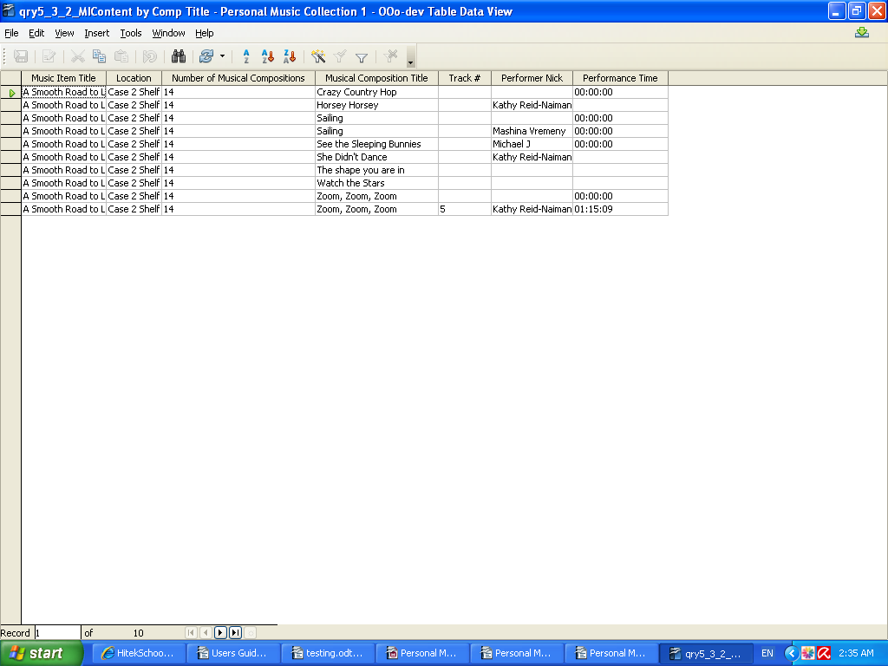

Issue # 11

Summary: Musical Composition and Description Data Entry Form.
Not possible to delete record from “Musical Composition Description” tab if
“Musical Composition entry form” is filled in.

Description:

1. Open Musical Composition and Description Data Entry Form.
- Click New Record button on the Navigation Bar at the bottom of the form
- Fill all known needed fields in Musical Composition Description Tab.
- Click “Save Record” button.
- Choose Music Item Title in “Musical Composition Entry” subform. Fill other needed information in.
- Save the record. Click “ Save Record” button.
- Navigate cursor to “Musical Composition Title” text box. Or if you want to delete record you
entered before, use button “Find Record”. The cursor should be placed at the “Musical Composition Title” Text Box. After your search was successfully completed you will be returned to the form with ordered record.
- Click “Delete Record”
- Warning message appears. Click “Yes”.
- Error message appears. See picture below.

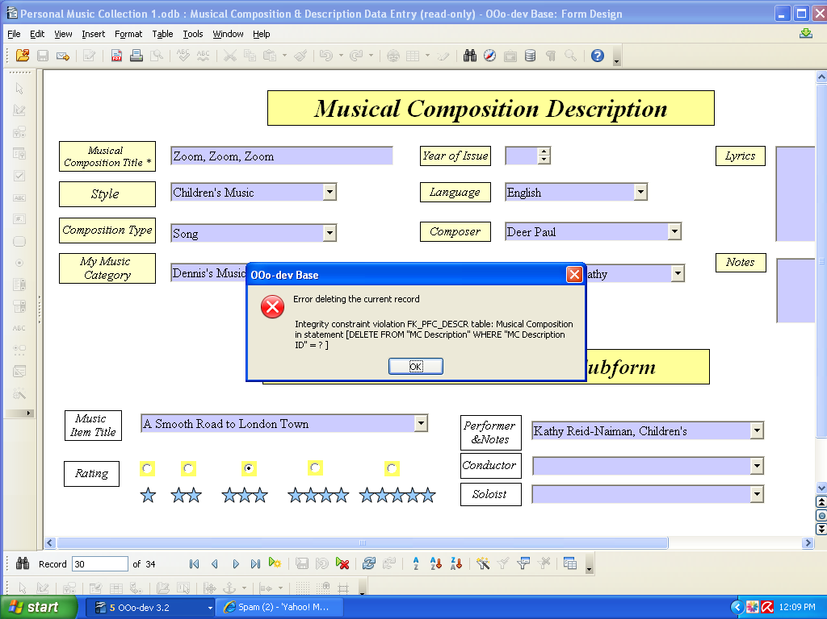

Issue # 12

Summary: “Musical Composition and Description Data Entry” Form.
No record with the value “ _NONE” in “Composer” field.

Precondition: Composer's name has to be entered in “Person Data Entry” form.

Description:

- Open Musical Composition and Description Data Entry Form.
- Click New Record button on the Navigation Bar at the bottom of the form.
- Open list box of “Composer” field. There is no record with the value “ _NONE”.
If you enter some name by mistake you have to delete all this record end enter the record one more time.

Issue # 13

Summary: “Musical Composition and Description Data Entry” Form.
No record with the value “ _NONE” in “Author” field.

Precondition:
Author's name has to be entered in “Person Data Entry” form.

Description:

1. Open Musical Composition and Description Data Entry Form.
2. Click New Record button on the Navigation Bar at the bottom of the form.
3. Open list box of “Author” field. There is no record with the value “ _NONE”.
If you enter some name by mistake you have to delete all this record end enter the record one more time.

Issue # 14

Summary: “Musical Composition and Description Data Entry” Form.
No record with the value “ _NONE” in “Performer and Notes” field in
“Musical Composition Entry Subform”

Precondition:
Performer's name has to be entered in “Performer Data Entry” form.

Description:

1. Open Musical Composition and Description Data Entry Form.
2. Click New Record button on the Navigation Bar at the bottom of the form.
3. Fill “Musical Composition Title” field in.
4. Save the record.
5. Navigate cursor to “Performer and Notes” field in “Musical Composition Entry Subform”
3. Open list box of “Performer and Notes” field. There is no record with the value “ _NONE”.
If you enter some name by mistake you have to delete all this record end enter the record one more time.

Issue # 15

Summary: “Musical Composition and Description Data Entry” Form.
No record with the value “ _NONE” in “Conductor” field in
“Musical Composition Entry Subform”

Precondition:
Conductor's name has to be entered in “Person Data Entry” form.

Description:

1. Open Musical Composition and Description Data Entry Form.
2. Click New Record button on the Navigation Bar at the bottom of the form.
3. Fill “Musical Composition Title” field in.
4. Save the record.
5. Navigate cursor to “Conductor” field in “Musical Composition Entry Subform”
3. Open list box of “Conductor” field. There is no record with the value “ _NONE”.
If you enter some name by mistake you have to delete all this record end enter the record one more time.

Issue # 16

Summary: “Musical Composition and Description Data Entry” Form.
No record with the value “ _NONE” in “Soloist” field in
“Musical Composition Entry Subform”

Precondition:
Soloist's name has to be entered in “Person Data Entry” form.

Description:

1. Open Musical Composition and Description Data Entry Form.
2. Click New Record button on the Navigation Bar at the bottom of the form.
3. Fill “Musical Composition Title” field in.
4. Save the record.
5. Navigate cursor to “Soloist” field in “Musical Composition Entry Subform”
3. Open list box of “Soloist” field. There is no record with the value “ _NONE”.
If you enter some name by mistake you have to delete all this record end enter the record one more time.

Issue # 17

Summary: “Music Item Data Entry” Form.
No record with the value “ _NONE” in “Performer and Notes” field in
“Musical Composition Data Entry Subform”

Precondition:
Performer's name has to be entered in “Performer Data Entry” form.

Description:

1. Open Music Item Data Entry Form.
2. Click New Record button on the Navigation Bar at the bottom of the form.
3. Fill “Music Item Title” (mandatory field) field in.
4. Navigate cursor to “Performer and Notes” field in “Musical Composition Data Entry” Subform
5. Open list box of “Performer and Notes” field. There is no record with the value “ _NONE”.
If you enter some name by mistake you have to delete all this record end enter the record one more time.

Issue # 18

Summary: “Music Item Data Entry” Form.
No record with the value “ _NONE” in “MC Description” field in
“Musical Composition Data Entry”Subform

Precondition:
“MC Description” has to be entered in “Musical Composition and Description Data Entry” Form.

Description:

1. Open Music Item Data Entry Form.
2. Click New Record button on the Navigation Bar at the bottom of the form.
3. Fill “Music Item Title” (mandatory field) field in.
4. Navigate cursor to “MC Description” field in “Musical Composition Data Entry” Subform
5. Open list box of “MC Description” field. There is no record with the value “ _NONE”.
If you enter some name by mistake you have to delete all this record end enter the record one more time.

Issue # 19

Summary: “Music Item Data Entry” Form.
Not possible to delete record from “Music Item Data Entry” Form if Music Item Status added in “Music Item Status Data Entry Subform”

Description:
1. Open Music Item Data Entry Form.
2. Click New Record button on the Navigation Bar at the bottom of the form.
3. Fill “Music Item Title” (mandatory field) field in.
4. Save Record.
5. Navigate cursor to “Music Item Status Data Entry Subform”.
6. Fill needed information in. Save Record.
7. Place cursor to “Music Item Title” field.
8. Click “Delete Record”
9. Warning message appears. Click “Yes”.
10. Error message appears. See picture below.

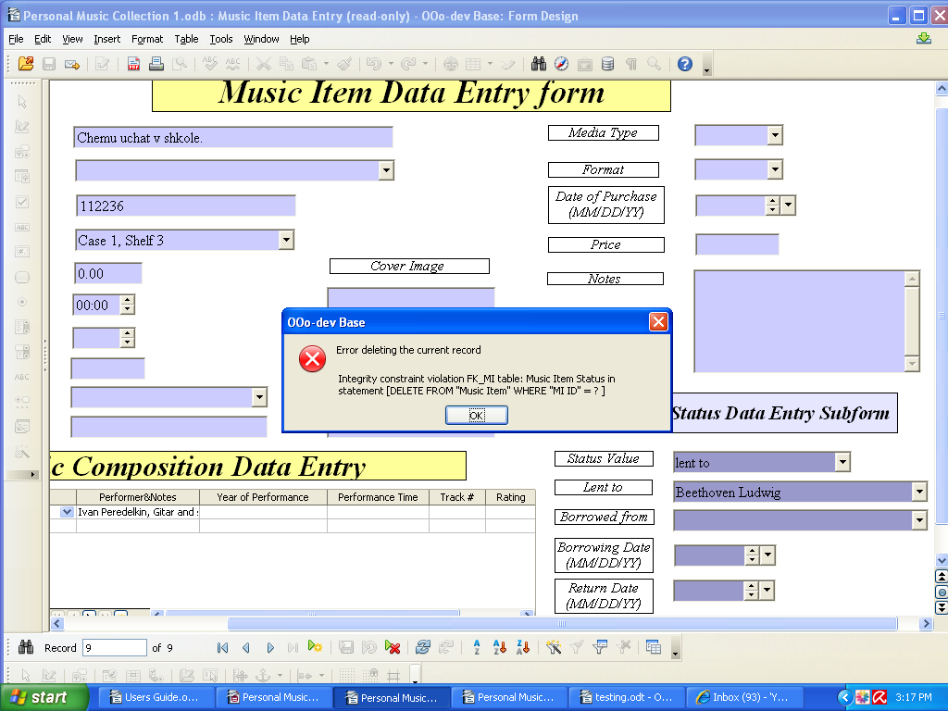

Issue # 20

Summary: “Music Item Data Entry” Form.
Not possible to delete record from “Music Item Data Entry” Form if Music Item Status added in “Music Item Status Data Entry Subform”

Precondition:
“MC Description” has to be entered in “Musical Composition and Description Data Entry” Form.

Description:
1. Open Music Item Data Entry Form.
2. Click New Record button on the Navigation Bar at the bottom of the form.
3. Fill “Music Item Title” (mandatory field) field in.
5. Navigate cursor to “Music Composition Data Entry” Subform.
6. Fill needed information in. Save Record.
7. Place cursor to “Music Item Title” field.
8. Click “Delete Record”
9. Warning message appears. Click “Yes”.
10. Error message appears. See picture below.

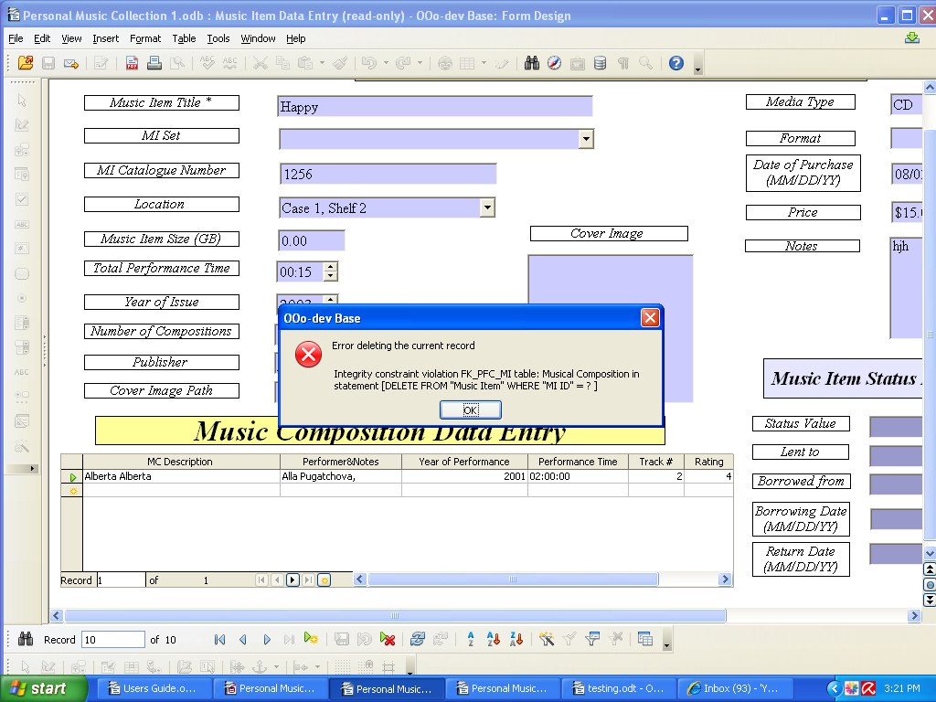

In my opinion it will take long, long time to fill “Music Item Data Entry Form”.
If you will have huge list of musical composition (you enter this information in “Musical Composition and Description Form”) you have to choose names of musical compositions for every Music Item of your collection from thousands compositions. I think to choose composition from the list it is not a good idea. Or in User's guide better to add in description for “Musical Composition & Description Data Entry Form” : “You must fill “Music Item Title” in Musical Composition Entry Subform in”. So you will not need to choose musical composition from thousands compositions.

I think two forms “ Music Item Data Entry” and “Musical Composition and Description Data Entry”
duplicate each other. In “Music Item Data Entry” form you have to enter information (about Musical
Composition) that you can find in “Musical Composition and Description Data Entry” form.
In “Musical Composition and Description Data Entry” form you have to enter information (about Musical Item) that you can find in “Musical Item Data Entry” form. Is it not easier to create one form?

