MELOMAN

Open Office 3.1

Data Base Application

User's Guide

Version 1.0

Revision History
Date | Version | Description | Author
08/10/09 | 1.0 | User's Guide for MELOMAN Data Base | Vladimir Seredkine

Table of Contents
1. Introduction 7

1.1 Purpose 7

1.2 Scope 7

1.3 Definitions, Acronyms, and Abbreviations 7

1.4 References 9

1.5 Overview 9

1.6 Database structure 10

1.6.1.Database tables 10
1.6.2.Database structure diagram 10
2. Getting started 11

2.1 Navigation buttons on Tool Bar for all Entry Forms 11

2.2 Basic records 13

2.3 'Copy & Paste' method 13
3. Collection Database branch support 14

3.1 ENTRY MEDIA TYPE Form (Collection Database branch) 14

3.1.1.Access method 14
3.1.2 Navigation buttons on Tool Bar 14
3.1.3 Window layout 14
3.1.4 Actions 15

3.2 ENTRY LOCATION Form (Collection Database branch) 15

3.2.1.Access method 15
3.2.2 Navigation buttons on Tool Bar 16
3.2.3 Window layout 16
3.2.4 Actions 16

3.3 ENTRY MEDIA LIST Form (Collection Database branch) 17

3.3.1.Access method 17
3.3.2 Navigation buttons on Tool Bar 17
3.3.3 Window layout 17
3.3.4 Actions 18

3.4 Table Entry Media List Form (Collection Database branch) 18

3.4.1.Access method 18
3.4.2 Navigation through the table 18
3.4.3 Table layout 19
3.4.4 Actions 19

3.5 4-ENTRY MUSIC ITEMS Form (Basic Records minimum filling) 20

3.5.1.Access method 20
3.5.2 Navigation buttons on Tool Bar 21
3.5.3 Window layout 21
3.5.4 Actions 21

3.6 Table Entry Music Items Form (Basic Records minimum filling) 21

3.6.1 Access method 21
3.6.2 Navigation through the table 21
3.6.3 Table layout 22
3.6.4 Actions 22
4. Enriching collection Music Items 23

4.1 1-ENTRY PERFORMERS & PERSONS Form (Enriching Music Items) 23

4.1.1.Access method 23
4.1.2 Navigation through the table 24
4.1.3 Window layout 21
4.1.4 Actions 24

4.2 Table Entry Performers & Persons Form (Enriching Music Items) 25

4.2.1 Access method 25
4.2.2 Navigation through the table 25
4.2.3 Table layout 25
4.2.4 Actions 26

4.3 ENTRY LANGUAGE Form (Enriching Music Items) 26

4.3.1 Access method 27
4.3.2 Navigation buttons on Tool Bar 27
4.3.3 Window layout 27
4.3.4 Actions 27

4.4 ENTRY MUSIC TYPE Form (Enriching Music Items) 27
4.4.1 Access method 14
4.4.2 Navigation buttons on Tool Bar 27
4.4.3 Window layout 28
4.4.4 Actions 28

4.5 2-ENTRY MUSIC GENRE Form (Enriching Music Items) 29

4.5.1 Access method 29
4.5.2 Navigation buttons on Tool Bar 29
4.5.3 Window layout 30
4.5.4 Actions 30

4.6 3-ENTRY ALBUMS Form (Enriching Music Items) 30

4.6.1 Access method 31
4.6.2 Navigation buttons on Tool Bar 31
4.6.3 Window layout 31
4.6.4 Actions 31

4.7 Table Entry Albums Form (Enriching Music Items) 31

4.7.1 Access method 31
4.7.2 Navigation through the table 31
4.7.3 Table layout 32
4.7.4 Actions 32

4.8 4-ENTRY MUSIC ITEMS Form (Full Basic Records) 33

4.8.1 Access method 33
4.8.2 Navigation buttons on Tool Bar 34
4.8.3 Window layout 34
4.8.4 Actions 34

4.9 Table Entry Music Items Form (Full Basic Records) 35
4.9.1 Access method 35
4.9.2 Navigation through the table 36
4.9.3 Table layout 36
4.9.4 Actions 37
5. Welcome to the Music World 39

5.1 ENTRY COUNTRY Form (Music World Database branch) 39

5.1.1 Access method 40
5.1.2 Navigation buttons on Tool Bar 40
5.1.3 Window layout 40
5.1.4 Actions 40

5.2 3-ENTRY ALBUMS Form (Music World Database branch) 40

5.2.1 Access method 40
5.2.2 Navigation buttons on Tool Bar 41
5.2.3 Window layout 41
5.2.4 Actions 42

5.3 Table Entry Albums Form (Music World Database branch) 42

5.3.1 Access method 42
5.3.2 Navigation through the table 42
5.3.3 Table layout 43
5.3.4 Actions 44

5.4 1-ENTRY PERFORMERS & PERSONS Form (Music World Database branch) 44

5.4.1 Access method 44
5.4.2 Navigation buttons on Tool Bar 44
5.4.3 Window layout 45
5.4.4 Actions 45

5.5 Table Entry Performers & Persons Form (Music World Database branch) 46

5.5.1 Access method 47
5.5.2 Navigation through the table 47
5.5.3 Table layout 47
5.5.4 Actions 47
6. Four simple steps to support MELOMAN Database 48

6.1 Famous and old Music Item 48

6.1.1 Step 1: Checking Performer and Persons (Option 1) 49
6.1.2 Step 1: Checking Performer and Persons (Option 2) 49
6.1.3 Notes to errors for Step 1 53
6.1.4 Step 2: Checking Genres of Music Item and Album 54
6.1.5 Step 3: Checking Music Item's Album 55
6.1.6 Step 4: Filling the Basic Record of Music Items Table 56

6.2 Just Issued New Music Item 59

6.2.1 Step 1: Checking Performers and Persons 61
6.2.2 Step 2: Checking Genres of Music Item and Album 69
6.2.3 Step 3: Checking Music Item's Album 70
6.2.4 Step 4: Filling the Basic Record of Music Items Table 72
7. List of queries and reports supplied with MELOMAN Database application 76
8. List of samples supplied with MELOMAN Database application 76

User's Guide

Introduction
This document allows to familiarize a potential User with the MELOMAN Data Base Application. It could be interesting to a Music Collector or to any other person who likes to collect information in one place with purpose quickly find later any desired information about Music World in various different options. The Application is easy to use and easy to adjust for different purposes according to a music fan desires and available information.

Purpose
There are two main purposes kept in mind during design the MELOMAN Data Base Application:
- Make the Database useful for any Music Collector to any kind of music collection;
- Load from Music World any available data about music collection items and it's creators but not for collection only. The application allows to collect and keep data about any music composition created anytime in the world even if it is not in collection yet.

Scope
The main idea of MELOMAN Data Base is to collect, keep and use information about Music World in one Data Base. The data could be load from different sources and could be used by a music collector, disk jokey or other person who connected to Music World and need to find any information about musical compositions quickly and exactly. The MELOMAN Data Base application is able to support private collection information and keep all available information about any musical composition and about any performer or person who took a part in it's creation.
After the definite investigation of Music World and similar applications with purpose to simplify and not overload the product this Data Base cover just the most important information about music compositions and skips such things as prices, manufacturing, producers, record format, playing duration, exact date and other not so much important things which can be put in Notes, History and Biography fields if a User wants.
Also this document does not follow purpose to teach User how to use OpenOffice.Base. If User wants to learn more about OpenOffice.Base he(she) has to apply to documents listed in 1.4 References of present User's Guide.

Definitions, Acronyms and Abbreviations
Before start acquaintance with the MELOMAN Data Base Application it is suggested to read the following abbreviations to understand exactly the terms which are used in this document. It was very important to simplify some various definitions into one term and explain what does it mean in this application. For example, it is really difficult to find difference between Style and Genre of music, or various sources gives different definition to music Album. So read and keep in mind during working with MELOMAN the following:

Abbreviation | Description
User | Any user which can use the MELOMAN Data Base Application
Music Item | Single Musical Composition, such as: Song, Melody, Overture, Sinfonia, Aria, Sonata, Toccata etc, which has definitely beginning and end, duration time and cannot be separated. Music Item might be belong to an Album (see: Album definition) but not always. It could be a single never issued as a part of an album.  If a Music Item belongs to two or more albums for the Meloman project it considered that the Music Item belongs to the most earliest official issued album even if the Music Item was issued earlier before as a single.
Media | Something which can keep records, such as: CD, DVD, Vinyl Disk, Video Tape etc., should be easy to remove and keep in collection.
Media Type | Any type of media which existing now-days:CD disk,CD MP3 disk,DVD MP3 disk,Vinyl disk,Cassette,Flash card...
Location | Location of medias which carrying collection music items (records). It could be any place where media located in current moment, ex.: in collection,Shelf #1, Box #10, my friend <Name>, URL, on sale, coming by mail, etc.
Music Type | General description of musical composition which user determines for himself or follows common definition, such as: Song, Instrumental Composition, Symphony, Chorus, Opera, Ballet etc It could be different genres or styles
Music Genre (Genre) | Any Genre or Style or their combination to which Musical Composition belong according to original source or user determines for himself or follows common or somebodies definition, such as: Pop, Disco, Classic, Latin, Disco/Pop, Rock, Pop/Rock, Hard rock , Jazz, Folk, Classic Rock etc
Album name (Album) | Name of officially issued set of music items, ex.: name of concert, name of album, name of performance, name of opera etc. Usually this set is issued by Performer but sometimes an album can be issued by others and even with various performers. In both cases sets of Music Items considered issued once and forever and Music Items inside cannot be change by others.  Sometimes Performers issued albums under the same name in different places with a little bit different contents. In this case priority has the album of native country. Music Items which not included in native country album and first time appeared in foreign album are considered to be belong to foreign issued album.  Sometimes different albums of different Performers have the same name.  All these cases demands from User to put an additional info to the main name of the album because the Album name should be unique in MELOMAN application. For cases described above see samples of Album names below:  Help! (The Beatles) (UK release);  Help! (The Beatles) (USA release);  Help! (War Child);  Music (Madonna);  The Music (The Music band).
Music name | Name of Music Item (Musical Composition) usually unique but sometimes could have well-known name in other language which should be perform in bracket if it possible
Performer | It means group (“ABBA”, "Rolling Stones", "Pink Floyd" etc. ), team (Orchestra, Chorus), artist, singer, musician etc. which performs a Music Item.
Person | Any person who performed or took a part of creation a Music Item, ex.: Singer, Artist, Composer, Lyrics Author, Musician, Producer, etc.
Name | Common known, well-known, usually short name of Performer or Person. It could be real short name or nickname, or sometimes abbreviation of full name, ex.: rock group BTO has full name as Bachman-Turner Overdrive.
Original Name | Real official name, birth name or full name of a Person and also could be a full name of a team or a group (See Name).
Birth year | Year when a Person was born or Performer as a group or team was created
Composer | One or many Persons who composed music for Music Item.
Text Author | One or many Persons who wrote lyrics for Music Item.
Text | Properly text of lyrics for Music Item created by Text Author
Language | Language of lyrics Text used in Music Item. Sometimes it could be in two languages.
Life end year | Year when a Person died or Performer as a group or a team finished it's existence
Year | Any year from 1600 to 2050 which has to be used in MELOMAN Data Base.
Country | Any name of a country has to be used in MELOMAN Data Base.
History | Historical and any other available data about a Music Item
Notes to Album | Historical and any other available data such as track listing and credits about an album
Biography and History | Biographical and historical data about Person or Performer.
Photo Image | Any photo or other image of Person or Performer
Photo Image info | Information or data which helps to find photo or digital image of Person or Performer
Cover Image | Any photo or other image of Album cover. Usually it is unique image even if it had reissue or transferring on other media.
Photo Image info | Information or data which helps to find photo or digital image of Album cover
Media code | The inventory number of media under which it registered in collection and created by User. Can be performed by letters and numbers
Registration Date | Date of media registration in collection with Media code by User
Media Name | Name of media which performed on it's cover or name of media which could be given by User if it custom made media and also could not have name at all
Record # | Number of record on Media or Album's record if it is not in collection yet
Quality | Means quality Music Item record or whole Media. It could be high or with sound distortion, or with scratches, etc.
From | Date from which Media is out of collection

References
- OpenOffice.org, Getting Started with Base
- OpenOffice.org, User Guide for 2.x, Chapter 7: Databases and Data Sources, pp 364-391
The above document can be used by a User to learn more about OpenOffice Database and design new queries and reports.

Overview
As it is shown in 'MELOMAN' Database Structure (see 2.2.3) the Music Items table is the main table which is carrying almost all information about each musical composition (Music Item). There are two main separated branches of interactive related tables which provide info service to Music Items table:
- Collection branch: Media List table, Media Type table, Location table.
- Music World branch: Albums table, Performers & Persons table, Country table, Year table.
Three tables: Music Type table, Music Genre table, Language table are neutral and can be used or not used in both database branches.
This two branches Database Structure allows to collect, keep and use Music Items data for two different ideas:
- Support information about custom collection of music records;
- Collect all available knowledge about Music Item in one Database.

- Thus User can develop both Database branches or leave one of them and be concentrated on another one. So the 'MELOMAN' Database application could be useful not for music collector only but for wide amount of other people who is not music collector but related to Music World by various aspects.

Database structure

Database tables
There are 11 Data Base tables:
- Music Items table;
- Albums table;
- Performers & Persons table;
- Media List table;
- Media Type table;
- Location table;
- Music Genre table;
- Music Type table;
- Country table;
- Language table;
- Year table.
They are related to each other as shown on diagram (see 1.6.2). More information about each table is available in “MELOMAN OpenOffice 3.1 Data Base Internal Design Specification” document.

Database structure diagram
The following Database Structure diagram shows all tables and their relationship. Typing in rectangles shows name of all fields which will appear in entry forms.

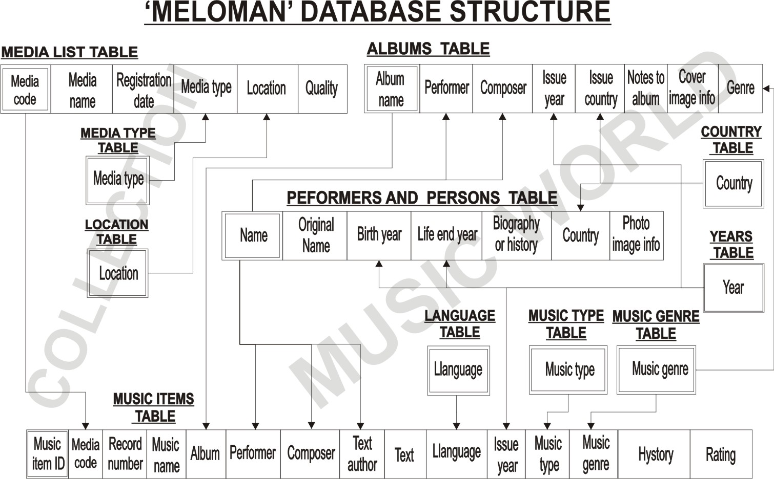

Getting started
The MELOMAN Database Application is based on OpenOffice.org 3.1.0 which has database management system and allowed to create the present product. To begin to work with MELOMAN the OpenOffice.org 3.1.0 should be install on User's computer. If it is not installed the installation software should be download from http://download.openoffice.org/.
The MELOMAN Database Application is performed just one file named Meloman.odb and User can locate this file in any convenient place of his(her) computer.
The simplest way to open MELOMAN Database Application is just double click on Meloman.odb file. A User can also open Meloman.odb going through OpenOffice.org 3.1.0 interface.
If User received the following screen the MELOMAN Database Application is ready to be explored:
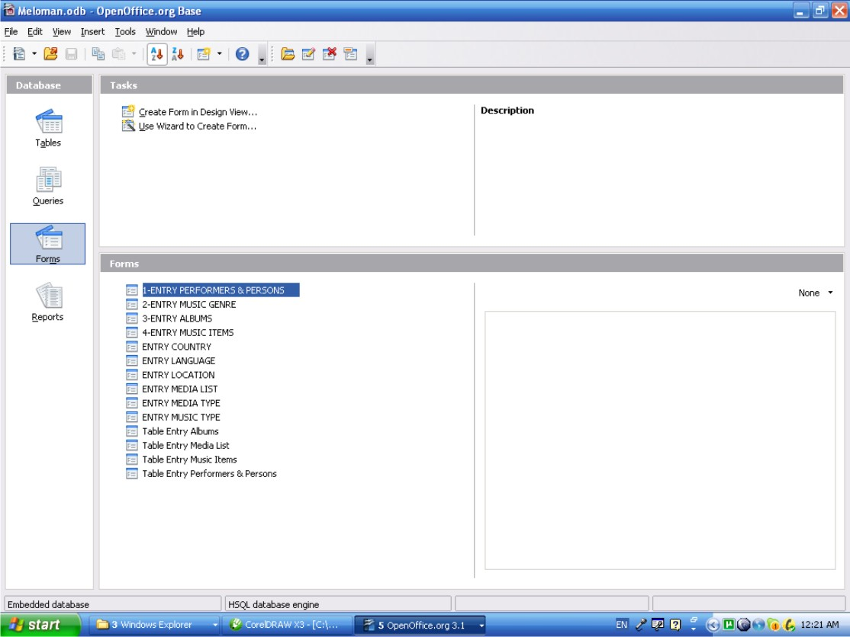

There are 14 forms in 'Forms' area: 10 GUI entry forms and 4 table entry forms. These forms allow to control all information in Database.

Navigation buttons on Tool Bar for all Entry Forms
Before start to work with application User has to know minimum database buttons to navigate through the information of tables. If double click any form it will be open with tool bar at bottom area with navigation buttons. Let's double click on '4-ENTRY MUSIC ITEMS' form and learn all buttons which are needed to navigate through table records. The following picture should explain everything which User need to start:

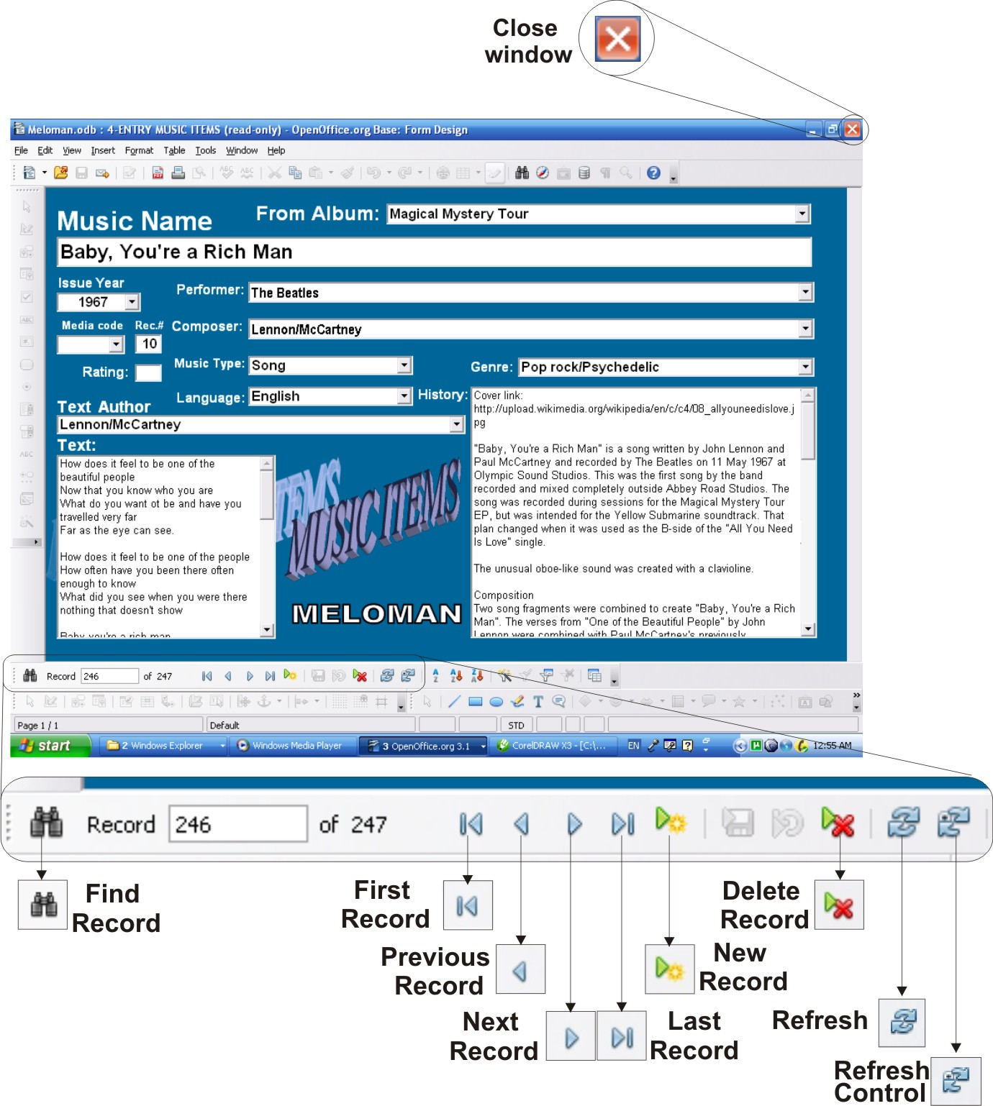

Basic records

As shown on the bottom of diagram (See p.1.6.2) the “Music Items” table is the main table of the database. Records of “Music Items” table are called 'Basic Records' because they are going to be used in both branches of the database. There is one fully loaded “Music Items” table record shown on picture p.2.1. It doesn't mean that User needs to fill all the fields of this table. There is no mandatory field in “Music Items” table. To keep record in database it is enough to fill just one any field of '4-ENTRY MUSIC ITEMS' entry form. It's User's choice what fields have to be filled. All fields which have incoming arrows on the diagram (See p.1.6.2) should be filled from drop down lists. Although it is allowed to type in any field but the application doesn't allow to input in related fields data which is not existing in related table and the appropriate warning message will be displayed that parent data is not found.

For example:
If User wants to input Music Item with Hebrew language and during filling the record cannot find in Language drop list word 'Hebrew' he(she) has to open 'ENTRY LANGUAGE' form and make new record with word 'Hebrew'. Then User should close 'ENTRY LANGUAGE' form with 'Save' option and click 'Refresh Control' button in '4-ENTRY MUSIC ITEMS' (If 'Refresh Control' button is dim click any field with drop list button).
If '4-ENTRY MUSIC ITEMS' form was closed before with 'Save' option User has to go to 'Last Record' and continue filling record with word 'Hebrew' in 'Language' field.
If '4-ENTRY MUSIC ITEMS' form was closed before with 'No Save' option User has to go to 'New Record' and fill record again and now he(she) can fill 'Language' field with word 'Hebrew'.

'Copy & Paste' method

Almost all information for MELOMAN Database application supposed to be got from Internet web sites. This information (especially web site links and articles) which is going to be input in fields without incoming arrow (See diagram p.1.6.2) mostly should be loaded by 'Copy & Paste' method. It means text in outside sources should be highlighted then right click - 'Copy', click the field to be filled in the form and right click – 'Paste'.
If pasted data is too big the application will not allowed to input it and during saving the form the appropriate warning message will be displayed. So, User have to reduce the size of copying data.
Of cause User can type in fields without incoming arrow (See diagram p.1.6.2) any data if it is not going out of field size limits.
'Copy & Paste' method is also available between cells inside all table entry forms which sometimes increase speed of entering data in times compare to GUI entry forms.
This method is available to use in back way: copy from database field and paste to other places outside of the Database. It is recommended for following situations:
- If User needs to get photo of performer or person he(she) should open one of 1-ENTRY PERFORMERS & PERSONS or Table Entry Performers & Persons forms find needed performer or person copy (triple click) link from 'Photos' Info' field and paste in in Internet browser 'Address' field and press <Enter>. The same way has to be used for albums cover images.
- If User needs to get article or lyrics text he(she) should open accordingly needed entry form find needed data in one of multi-line field and copy it in OpenOffice.Writer page or other Editor application page.

Collection branch support

If User wants just keep records about his(her) music collection minimum two fields should be filled in Basic Record:
- Music Name;
- Media code.
All other fields are optional to fill and it depends of User's desire how much information about collection Music Items he(she) wants to keep in the Database.

Let's look at entry forms fields of minimum information to support music collection:

- 'Music Name' field is independent field and always ready for input.

- 'Media code' field related to 'Media List' table (See diagram p.1.6.2), so 'Media List' table should have enough information to fill 'Media code' field in 'Music Items' table.

- 'Media Type' field of 'Media List' table related to 'Media Type' table (See diagram p.1.6.2), so 'Media Type' table should have enough information to fill 'Media Type field in 'Media List' table.

- 'Location' field of 'Media List' table related to 'Location' table (See diagram p.1.6.2), so 'Location' table should have enough information to fill 'Location' field in 'Media List' table.

Now let's see collection branch forms in detail.

ENTRY MEDIA TYPE Form (Collection Database branch)

Access method
- Double click on 'ENTRY MEDIA TYPE' form in “Forms” area of Database interface (See picture on PAGE 9). The form shows 'First Record' of 'Media Type' table. Click drop down list button of 'Media Type' field. There is the whole list of media type names which 'Media Type' table has.
If User find needed media type name he(she) should click 'Close window' button (Don't click anything in the list! If it happened don't save form when close the window!).
If User doesn't find needed media type name he(she) should double click “New Record” button and type in 'Media Type' field new media type name. Click 'Close window' button

Navigation buttons on Tool Bar
- See PAGE 12.

Window layout
- Field:
  - 'Media Type' is a text combo box field, mandatory if enter new record.
  - List button returns the list of existing 'Media Type' records in A-Z order and must be used for checking existing records only not for entry a new record.

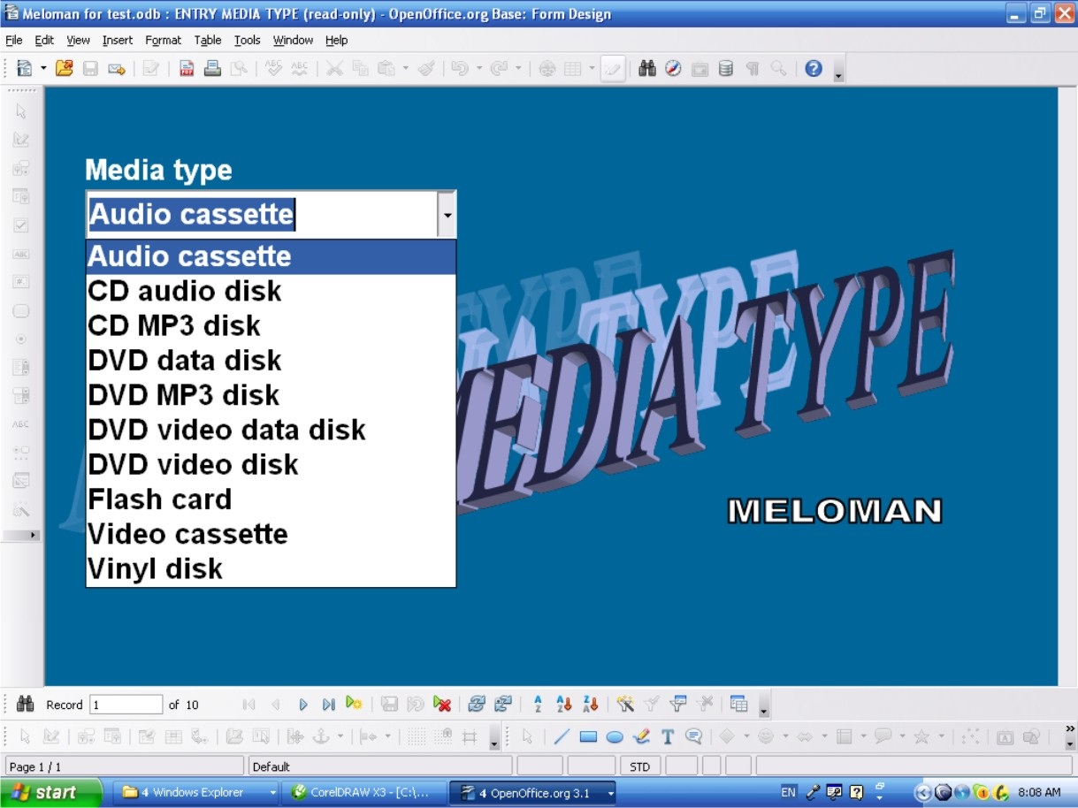

Actions
- “New Record” button allows to enter new record
- “Delete Record” button allows to delete any record
- Any record can be edited if after changes it doesn't duplicate record already existed. On duplication the appropriate warning message will be displayed.
- Exit the form: click Close Window button (Red button with white cross at top right corner of the window)
It fails if entering 'Media Type' name already existed and the appropriate warning message will be displayed.

ENTRY LOCATION Form (Collection Database branch)

Access method
- Double click on 'ENTRY LOCATION' form in “Forms” area of Database interface (See picture on PAGE 9). The form shows 'First Record' of 'Location' table. Click drop down list button of 'Location' field. There is the whole list of locations which 'Location' table has.
If User find needed location name he(she) should click 'Close window' button (Don't click anything in the list! If it happened don't save form when close the window!).
If User doesn't find needed location name he(she) should double click “New Record” button and type in 'Location' field new location name. User can also add date in 'From' field if he(she) needs.

- Click 'Close window' button

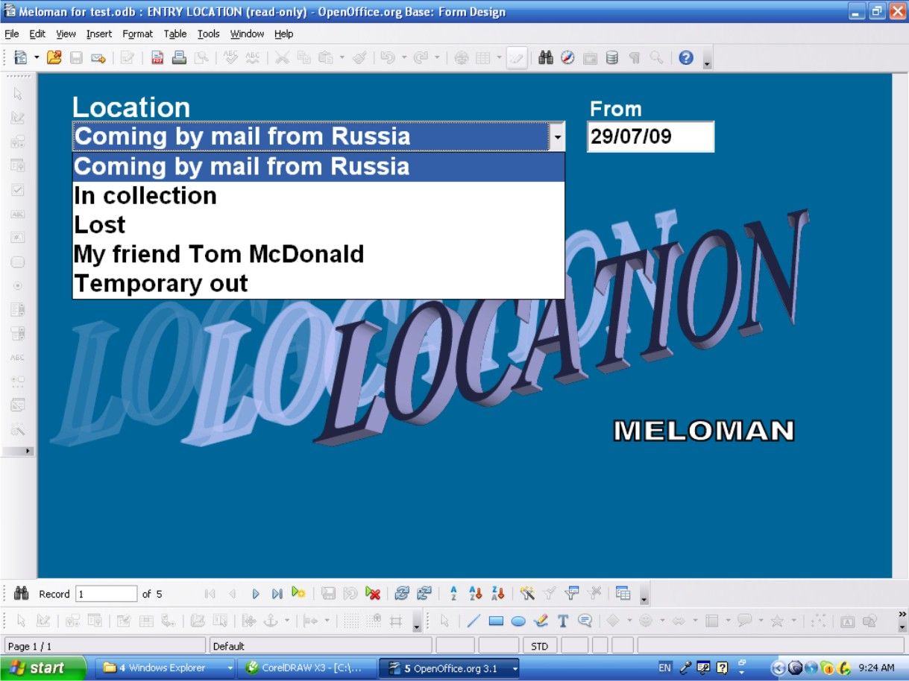

Navigation buttons on Tool Bar
- See PAGE 12.

Window layout
- Fields:
  - 'Location' is a text combo box field, mandatory if enter a new record.
  - 'Location' field list box button returns the list of existing 'Location' records in A-Z order and must be used for checking existing records only not for entry a new record.
  - 'From” is date field not mandatory.

Actions
- “New Record” button allows to enter a new record
- “Delete Record” button allows to delete any record
- Any record can be changed if after changes 'Location' field doesn't duplicate record already existed in this field. On duplication the appropriate warning message will be displayed.
- Exit the form: Click 'Close Window' button (Top right corner of the window)
It fails if you enter 'Location' name already existed and the appropriate warning message will be displayed.

ENTRY MEDIA LIST Form (Collection Database branch)

Access method
- Double click on 'ENTRY MEDIA LIST' form in “Forms” area of Database interface (See picture on PAGE 9). The form shows 'First Record' of 'Media List' table. Click drop down list button of 'Media code' field. There is the whole list of media codes which 'Media List'' table has.
If User find needed media code he(she) should click 'Close window' button (Don't click anything in the list! If it happened don't save form when close the window!).
If User doesn't find needed location name he(she) should double click “New Record” button and fill at least 'Media code' and 'Media type” in according fields of new media. User can also fill all other fields if he(she) needs. Click 'Close window' button

Navigation buttons on Tool Bar
- See PAGE 12.

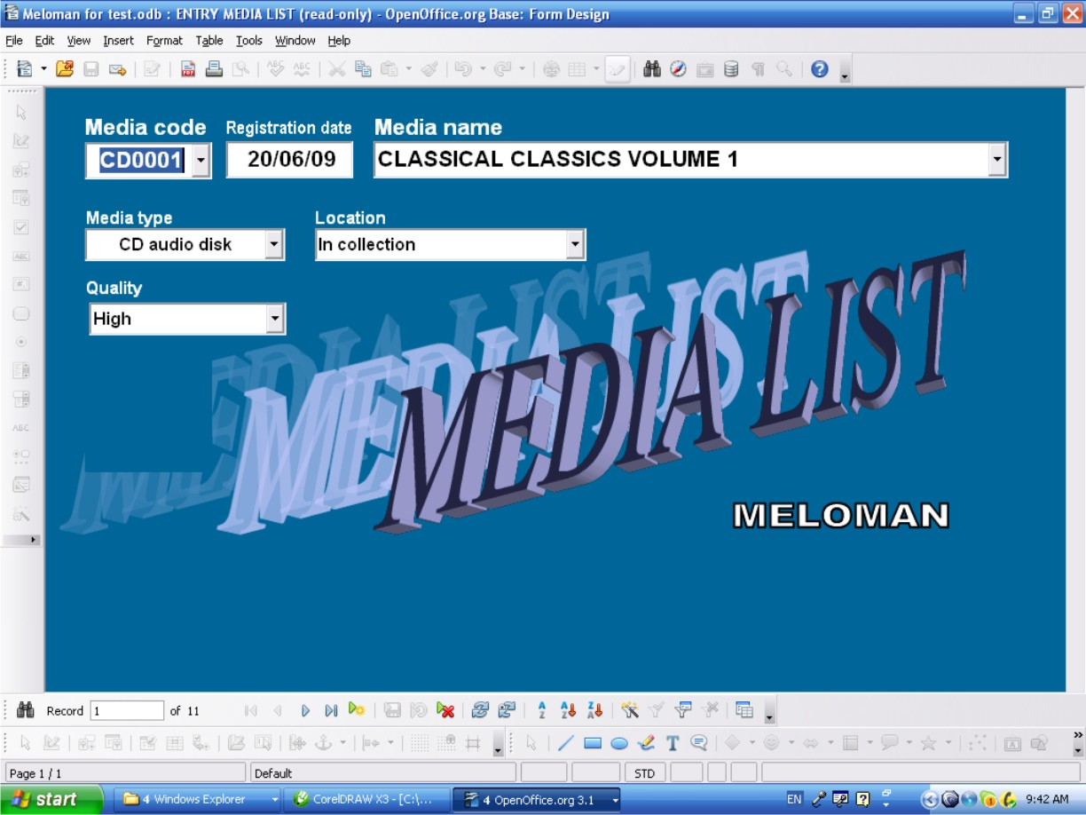

Window layout
- Fields:
  - 'Media code' is a text combo box field, mandatory if enter a new record.
  - 'Media code' field list button returns the list of existing 'Media code' records in A-Z order and must be used for checking existing record only not for entry a new record.
  - 'Registration date” is date field not mandatory.
  - 'Media name' is a text combo box field, not mandatory.
  - 'Media name' field list button returns the list of existing 'Album name' records in the Database in A-Z order and should be used if new 'Media Name' is close to 'Album name'.
  - 'Media type' is a text list box field, mandatory if enter a new record and should be filled from list box only..
  - 'Media type' field list button returns the list of existing 'Media type' records in A-Z order.
  - 'Location' is a text list box field, not mandatory.
  - 'Location' field list button returns the list of existing 'Location' records in A-Z order.
  - 'Quality' is a text combo box field, not mandatory.
  - 'Quality' field list button returns the list of existing 'Quality' records in A-Z order.

Actions
- “New Record” button allows to enter a new record
- “Delete Record” button allows to delete any record
- Any record can be edited if after changes it doesn't duplicate 'Media code' record already existed. On duplication the appropriate warning message will be displayed.
- Exit the form: Close Window button (Top right corner of the window)
It fails if entering 'Media code' name already existed and the appropriate warning message must be displayed.

Table Entry Media List Form (Collection Database branch)

Sometimes Table Entry form is more convenient then GUI form so this form just for User's option to use.
Also this form can be used to delete records (rows) by group.

Access method
- Double click on 'Table Entry Media List' form in “Forms” area of Database interface

Navigation through the Table
- All sells of the table are available to edit. Copy-and-Paste method also available between cells.
- The last bottom row is for entry a new record.
- Up and down navigation is available by <Page Up> and <Page Down> keys and by scroll bars on right side and bottom of the table if they appeared.
- All navigation buttons are available and have the same functions as shown on PAGE 12

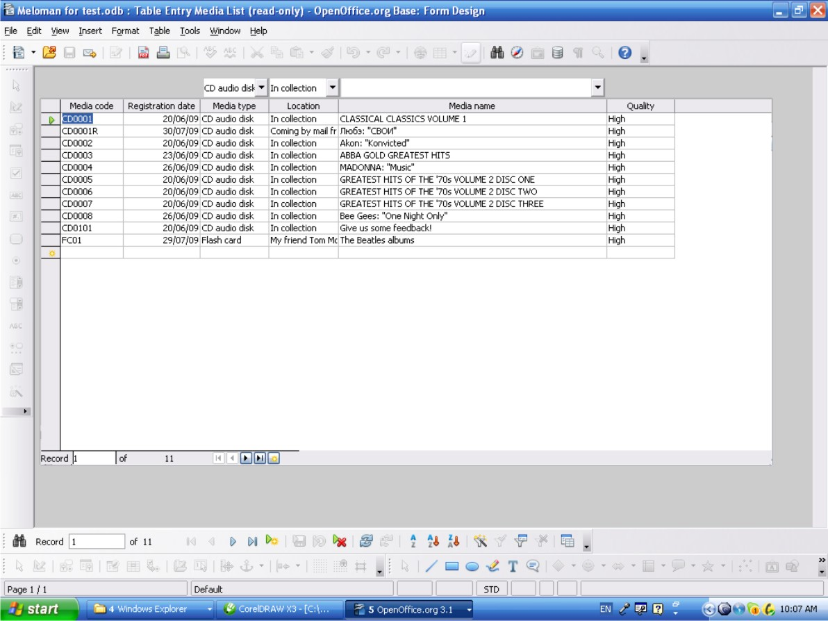

Table layout
- Columns (Database Fields):
  - 'Media code' column has text cells, mandatory if enter a new record.
  - 'Registration date” column has date cells, not mandatory.
  - 'Media type' column has text cells, mandatory if enter a new record and should be filled from list box only..
  - List box button upon 'Media type' column returns the list of existing 'Media type' records in A-Z order and allows to enter in any cell of 'Media type' column.
  - 'Location' column has text cells, not mandatory.
  - List box button upon 'Location' column returns the list of existing 'Location' records in A-Z order and allows to enter in any cell of 'Location' column.
  - 'Media name' column has text cells, not mandatory.
  - List box button upon 'Media name'' column returns the list of existing 'Media name' records in A-Z order and allows to enter in any cell of 'Media name'' column.
  - 'Quality' column has text cells, not mandatory.

Actions
- The last bottom row is the “New Record” row allows to enter a new record.
- For deleting action multiple selection of rows available by clicking rows on left column with pressed <Shift> or <Ctrl> keys.
- Right click on any row of left table column allows to delete (whole row) any record or group of records if selected.
- Any cell can be edited if after changes it doesn't duplicate 'Media code' record already existed. On duplication the appropriate warning message must be displayed.
- Exit the form: Close Window button (Top right corner of the window)
- All actions above can be done by navigation buttons which are available and have the same functions as shown on PAGE10

It fails if entering 'Media code' name already existed and the appropriate warning message will be displayed.

4-ENTRY MUSIC ITEMS Form (Basic Records minimum filling)
Now User can finish minimum record option of his(her) music collection:
Sample of possible result is shown on the following picture:
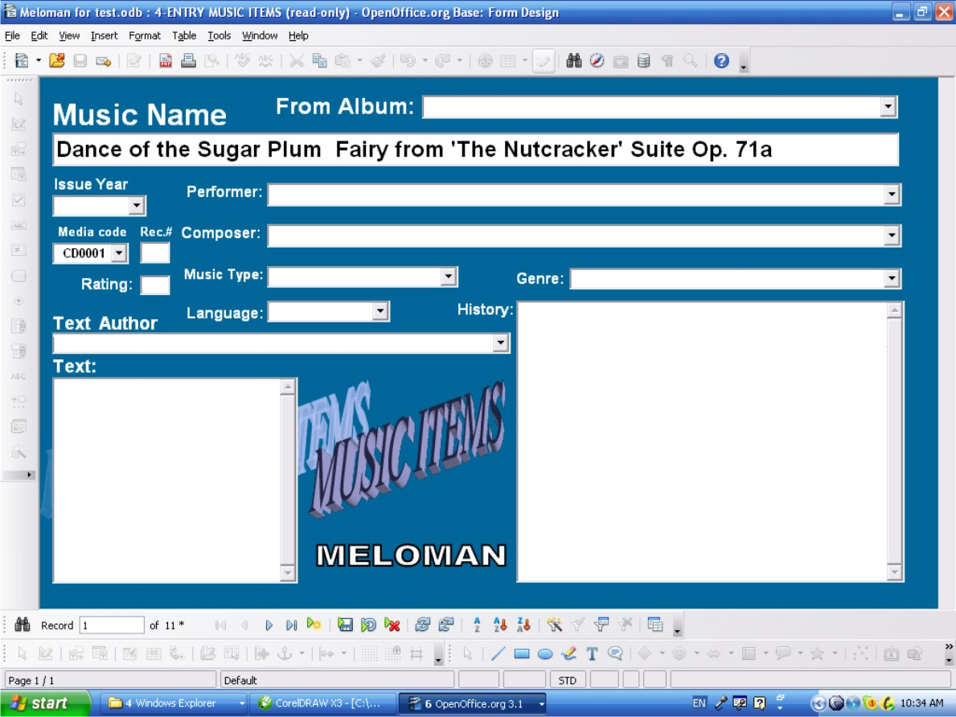

Access method
- Double click on '4-ENTRY MUSIC ITEMS' form in “Forms” area of Database interface (See picture on PAGE 9). The form shows 'First Record' of 'Music Items' table. Click drop down list button of 'Media code' field and make according choice of 'Media code'.
- User should also fill 'Music Name' field. This is minimum filling for Basic Record.

Navigation buttons on Tool Bar
- See PAGE 12

Window layout
- Fields:

  - 'Music Name' field is a text box field, not mandatory.
  - 'Media code' is a text combo box field, not mandatory.

Actions
- “New record” button allows to enter a new record
- “Delete Record” button allows to delete any record
- Any record field can be edited or deleted
- Exit the form: Click 'Close Window' button (Red button with white cross at top right corner of the window).

It fails if:
- entering in 'Media code' field does not have parent name in ''Media Code' field of 'Media List' table;
and the appropriate warning message will be displayed.

Table Entry Music Items Form (Basic Records minimum filling)

Sometimes Table Entry form is more convenient then GUI form so this form just for User's option to use.
Also this form can be used to delete records (rows) by group or copy & past record if User has the same Music Item(s) on another Media.

Access method

- Double click on 'Table Entry Music Items' form in “Forms” area of Database interface (See picture on PAGE 9). The form shows table view of 'Music Items' table. Click drop down list button of 'Media code' field and make according choice of 'Media code'.

- User should also fill 'Music Name' field. This is minimum filling for Basic Record.

Navigation through the Table
- All sells of the table are available to edit. Copy-and-Paste method also available between cells.
- The last bottom row is for entry a new record.
- Up and down navigation is available by <Page Up> and <Page Down> keys and by scroll bars on right side and bottom of the table if they appeared.
- All navigation buttons are available and have the same functions as shown on PAGE 12.
Sample of possible result is shown on the following picture:

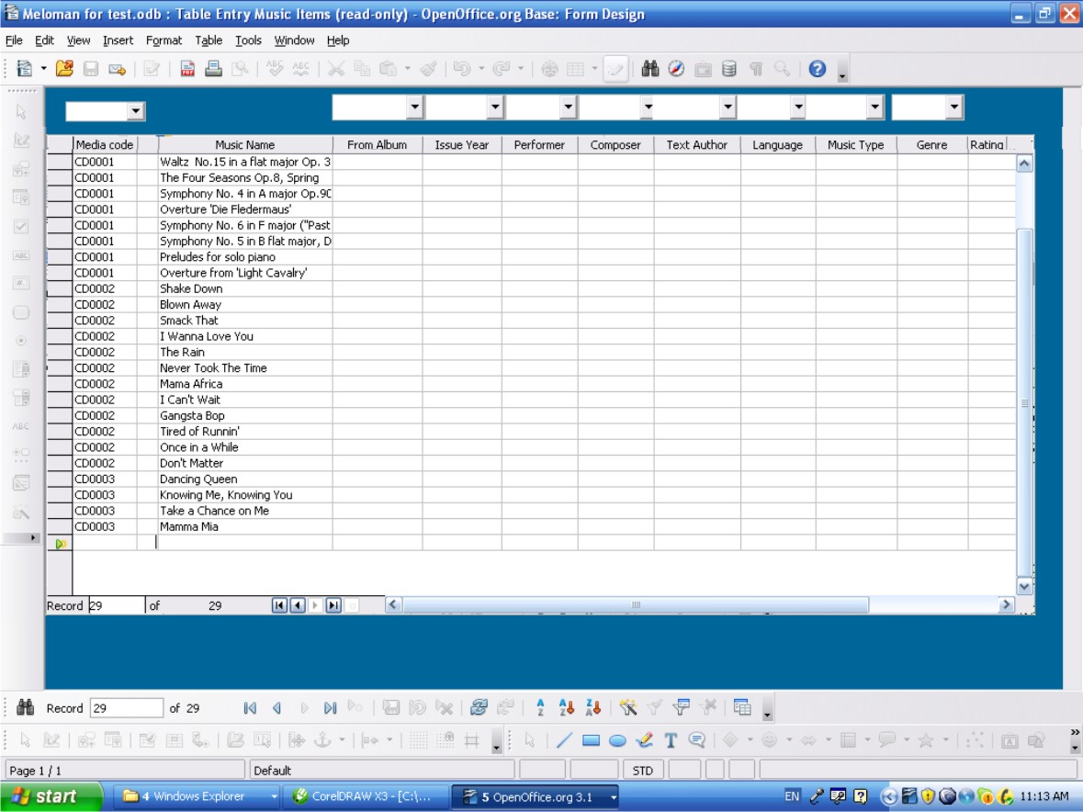

Table layout
- Columns (Database Fields):
  - 'Media code' column has text cells, not mandatory.
  - List box button upon 'Media code' column returns the list of existing 'Media Code' field records of 'Media List' table in A-Z order and allows to enter in any cell of 'Media code' column.
  - 'Music Name' column has text cells, not mandatory.

Actions
- The last bottom row is the “New Record” row allows to enter a new record.
- For deleting action multiple selection of rows available by clicking rows on left column with pressed <Shift> or <Ctrl> keys.
- Right click on any row of left table column allows to delete (whole row) any record or group of records if selected.
- Any cell can be edited or data can be deleted.
- Exit the form: click 'Close Window' button (Red button with white cross at top right corner of the window).
- All actions above can be done by navigation buttons which are available and have the same functions as shown on PAGE 12.
It fails if:
- entering in 'Media code' column cell does not have parent name in 'Media List' table;
and the appropriate warning message will be displayed.

Enriching collection Music Items

'Music Items' collection in p.3 look very poor. But User can add more information to existing Basic Records and input new records with more extended information.
First of all without any extra actions User can fill the following fields of Basic Records:

- 'Record #' field;
- 'Rating' field;
- 'Text' field;
- 'History' field.

ATTENTION: Don't use 'Table Entry Music Items' form to fill Text' and 'History' fields. To fill these fields use the '4-ENTRY MUSIC ITEMS' form only.

To fill all other field of Basic Records User has to input minimum information in related tables (See diagram p.1.6.2),
For example:
Apparently it is supposed that a User wants to have Performer name to each collection Music Items. If User wants to input Music Item with Performer name he(she) has to put this name from 'Performer' drop down list. If Performer name in the list is not found User has to make new record in '1-ENTRY PERFORMERS & PERSONS' form just fill at least the 'Name' field, close '1-ENTRY PERFORMERS & PERSONS' form with 'Save' option and click 'Refresh Control' button in '4-ENTRY MUSIC ITEMS' form (If 'Refresh Control' button is dim click any field with drop list button). If '4-ENTRY MUSIC ITEMS' form was closed before with 'Save' option User has to go to 'Last Record' and continue filling record with Performer's name in 'Performer:' field. If '4-ENTRY MUSIC ITEMS' form was closed before with 'No Save' option User has to go to 'New Record' and fill record again and now he(she) can fill Performer's name in 'Performer:' field.
To enrich Music Items only User has to fill just 'Name' field of '1-ENTRY PERFORMERS & PERSONS' form.
Now let's see '1-ENTRY PERFORMERS & PERSONS' form in detail.

1-ENTRY PERFORMERS & PERSONS Form (Enriching Music Items)

Access method

- Double click on '1-ENTRY PERFORMERS & PERSONS' form in “Forms” area of Database interface (See picture on PAGE 9). The form shows 'First Record' of 'Performers and Persons' table. Click drop down list button of 'Name' field. There is the whole list of Performers and Persons names which 'Performers and Persons'' table has.
If User find needed Performer or Person name he(she) should click 'Close window' button (Don't click anything in the list! If it happened don't save form when close the window!).
If User doesn't find needed Performer or Person name he(she) should double click “New Record” button and type in 'Name' field new Performer or Person name. It is recommended to type exactly name of Performer or Person as it printed in original source. Click 'Close window' button.

Navigation buttons on Tool Bar
- See PAGE 12.

Window layout
- Fields:
  - 'Name' is a text combo box field, mandatory if enter a new record.
  - “Name' field list button returns the list of existing 'Name' field records in A-Z order and must be used for checking existing records only or input from the list with editing. Existing records not for entry as a new record.

Actions
- “New record” button allows to enter a new record
- “Delete Record” button allows to delete any record
- Any record can be changed if after changes it doesn't duplicate 'Name' field record already existed. On duplication the appropriate warning message must be displayed.
- Exit the form: click 'Close Window' button (Red button with white cross at top right corner of the window).
It fails if entering 'Name' name already existed and the appropriate warning message will be displayed.
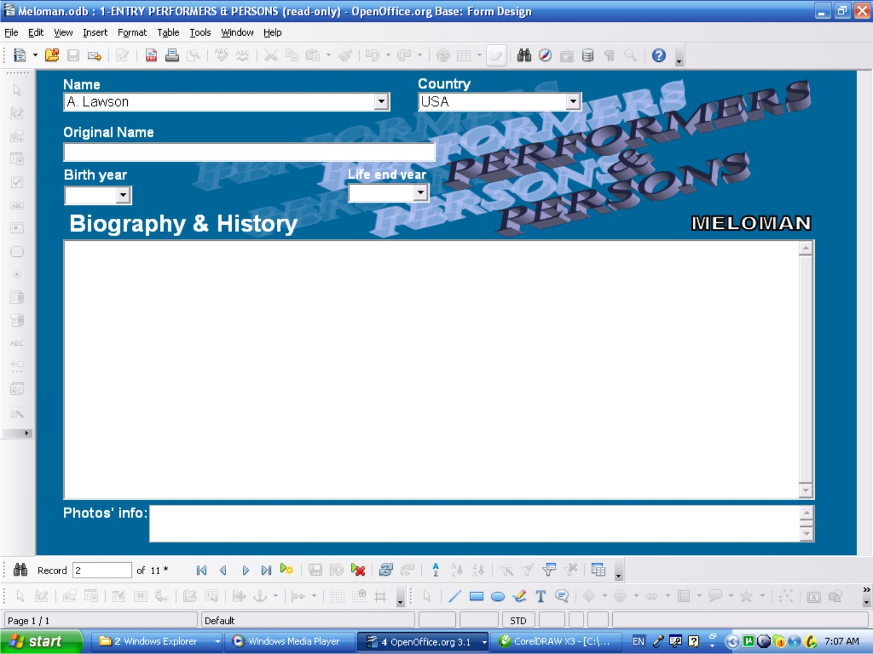

Table Entry Performers & Persons Form (Enriching Music Items)
Sometimes Table Entry form is more convenient then GUI form so this form just for User's option to use.
Also this form can be used to delete records (rows) by group.

Access method

- Double click on 'Table Entry Performers & Persons' form in “Forms” area of Database interface (See picture on PAGE 9). The form shows table view of 'Performers & Persons' table. The 'Name' field is sorted in A-Z order and User can check is needed Performer or Person in the table or not.

Navigation through the Table
- All sells of the table are available to edit. Copy-and-Paste method also available between cells.
- The last bottom row is for entry a new record.
- Up and down navigation is available by <Page Up> and <Page Down> keys and by scroll bars on right side and bottom of the table if they appeared.
- All navigation buttons are available and have the same functions as shown on PAGE 12.

Table layout
- Columns (Database Fields):
  - 'Name' column has text cells, mandatory if enter a new record.

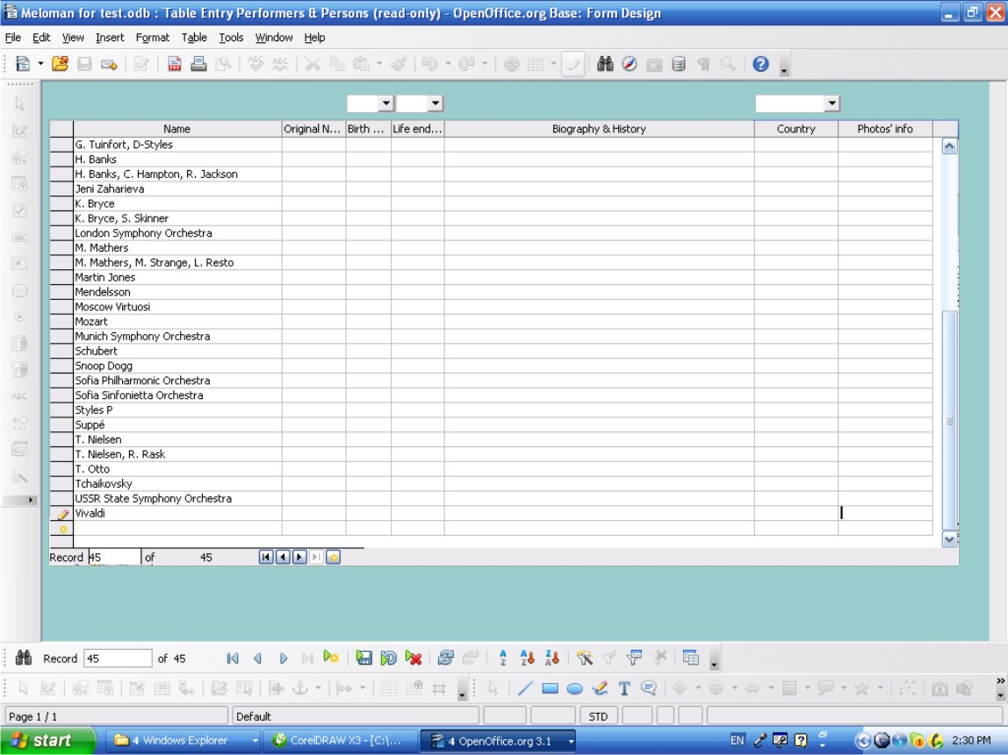

Actions
- The last bottom row is the “New Record” row allows to enter a new record.
It is recommended to type exactly name of Performer or Person as it printed in original source.
- For deleting action multiple selection of rows available by clicking rows on left column with pressed <Shift> or <Ctrl> keys.
- Right click on any row of left table column allows to delete (whole row) any record or group of records if selected.
- Any cell can be edited if after changes it doesn't duplicate 'Name' record already existed. On duplication the appropriate warning message will be displayed.
- Exit the form: click 'Close Window' button (Red button with white cross at top right corner of the window).
- All actions above can be done by navigation buttons which are available and have the same functions as shown ion PAGE 12.

It fails if entering 'Name' name already existed and the appropriate warning message will be displayed.

ENTRY LANGUAGE Form (Enriching Music Items)
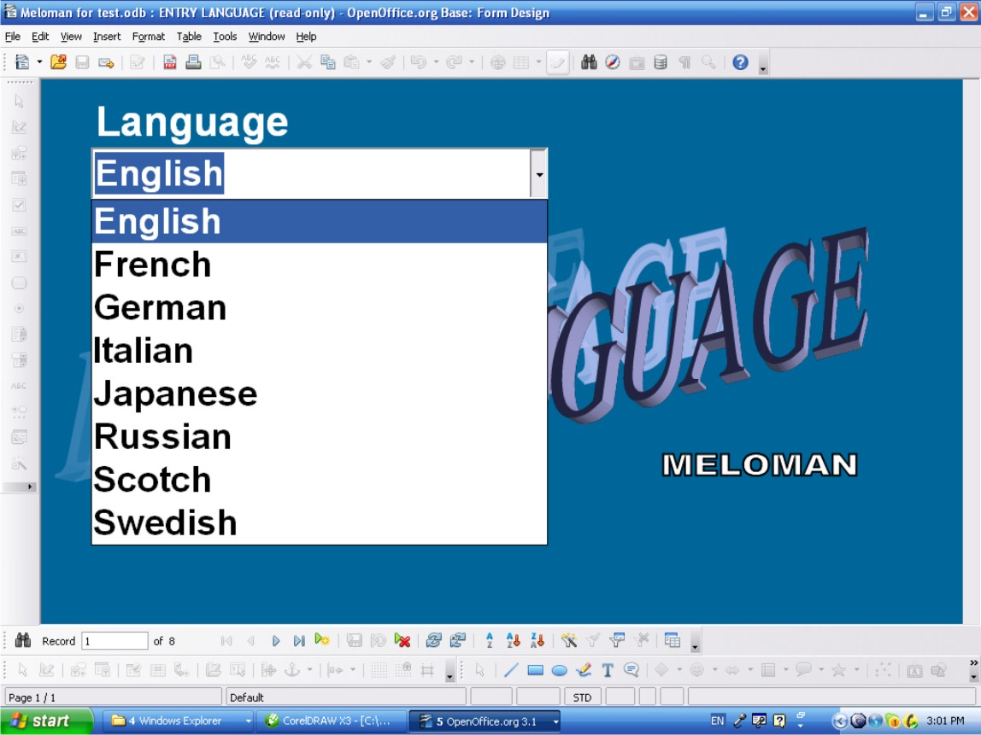

Access method
- Double click on 'ENTRY LANGUAGE' form in “Forms” area of Database interface (See picture on PAGE 9). The form shows 'First Record' of 'Language' table. Click drop down list button of 'Language' field. There is the whole list of languages names which 'Language' table has.
- If User find needed language he(she) should click 'Close window' button (Don't click anything in the list! If it happened don't save form when close the window!).
If User doesn't find needed language name he(she) should double click “New Record” button and type in 'Language' field new Language name. Click 'Close window' button

Navigation buttons on Tool Bar
- See PAGE 12.

Window layout
- Field:
  - 'Language' is a text combo box field, mandatory if enter new record.
  - 'Language' field list button returns the list of existing 'Language' records in A-Z order and must be used for checking existing records only not for entry a new record.

Actions
- “New Record” button allows to enter new record
- “Delete Record” button allows to delete any record
- Any record can be changed if after changes it doesn't duplicate record already existed. On duplication the appropriate warning message must be displayed.
- Exit the form: click 'Close Window' button (Red button with white cross at top right corner of the window)
It fails if entering 'Language' name already existed and the appropriate warning message will be displayed.

ENTRY MUSIC TYPE Form (Enriching Music Items)

Access method
- Double click on 'ENTRY MUSIC TYPE' form in “Forms” area of Database interface (See picture on PAGE 9). The form shows 'First Record' of 'Music Type' table. Click drop down list button of 'Music Type' field. There is the whole list of music types names which 'Music Type' table has.
- If User find needed Music Type name he(she) should click 'Close window' button (Don't click anything in the list! If it happened don't save form when close the window!).
If User doesn't find needed Music Type name he(she) should double click “New Record” button and type in 'Music Type' field new Music Type name. Click 'Close window' button

Navigation buttons on Tool Bar
- See PAGE 12.

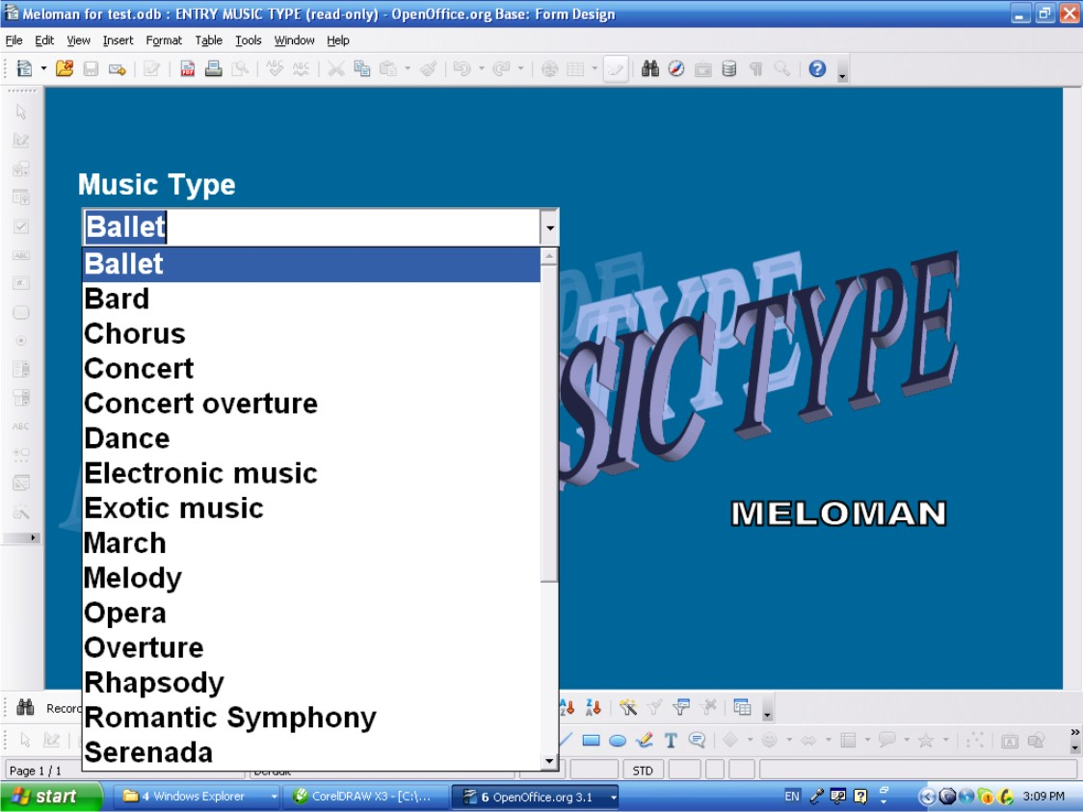

Window layout
- Field:
  - 'Music Type' is a text combo box field, mandatory if enter new record.
  - 'Music Type' field list button returns the list of existing 'Music Type' records in A-Z order and must be used for checking existing records only not for entry a new record.

Actions
- “New Record” button allows to enter new record
- “Delete Record” button allows to delete any record
- Any record can be changed if after changes it doesn't duplicate record already existed. On duplication the appropriate warning message must be displayed.
- Exit the form: Close Window button (Red button with white cross at top right corner of the window)
It fails if entering 'Music Type' name already existed and the appropriate warning message will be displayed.

2-ENTRY MUSIC GENRE Form (Enriching Music Items)

Access method

- Double click on '2-ENTRY MUSIC GENRE'' form in “Forms” area of Database interface (See picture on PAGE 9). The form shows 'First Record' of 'Music Genre' table. Click drop down list button of 'Music Genre' field. There is the whole list of music genres names which 'Music Genre' table has.
- If User find needed Music Genre name he(she) should click 'Close window' button (Don't click anything in the list! If it happened don't save form when close the window!).
If User doesn't find needed Music Genre name he(she) should double click “New Record” button and type in 'Music Genre' field new Music Genre name. Click 'Close window' button

Navigation buttons on Tool Bar
- See PAGE 12.

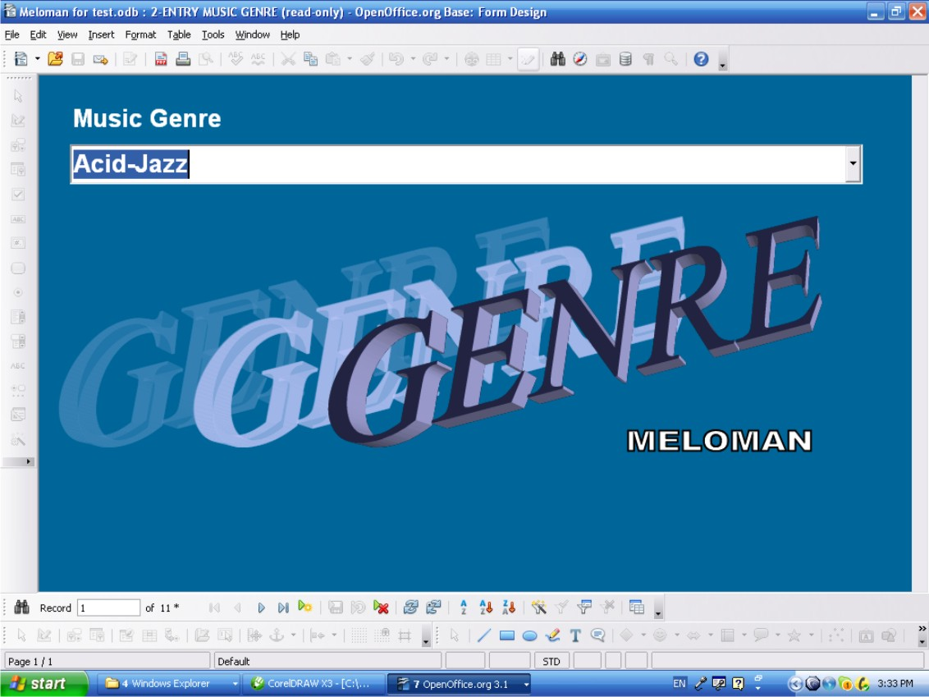

Window layout
- Field:
  - 'Genre' is a text combo box field, mandatory if enter new record.
  - “Genre' field list button returns the list of existing 'Music Type' records in A-Z order and must be used for checking existing records only not for entry a new record.

Actions
- “New Record” button allows to enter new record
- “Delete Record” button allows to delete any record
- Any record can be changed if after changes it doesn't duplicate record already existed. On duplication the appropriate warning message must be displayed.
- Exit the form: click 'Close Window' button (Red button with white cross at top right corner of the window)
It fails if entering 'Genre' name already existed and the appropriate warning message must be displayed.

3-ENTRY ALBUMS Form (Enriching Music Items)
This form belong to Music World Database branch. It means Albums Table doesn't carry any information about User's collection and related to collection only through Basic Records. So if User has any full album on some media he(she) has to input name of the album in 'Media name' field of 'Media List' form. Drop down list will help to fill 'Media name' field.
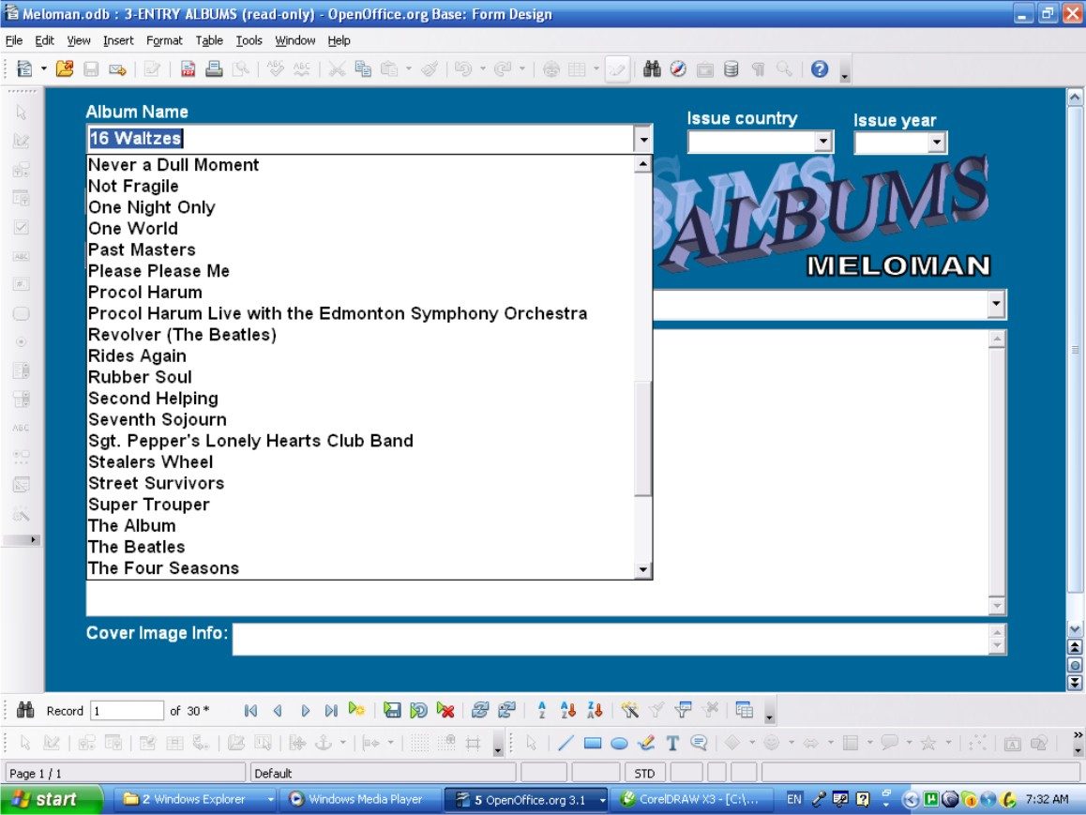

Access method
- Double click on '3-ENTRY ALBUMS' form in “Forms” area of Database interface (See picture on PAGE 9). The form shows 'First Record' of 'Albums' table. Click drop down list button of 'Album Name' field. There is the whole list of albums names which 'Albums'' table has.
If User find needed Album name he(she) should click 'Close window' button (Don't click anything in the list! If it happened don't save form when close the window!).
If User doesn't find needed Performer or Person name he(she) should double click “New Record” button and type in 'Album Name' field new Album name. Click 'Close window' button.

Navigation buttons on Tool Bar
- See PAGE 12.

Window layout
- Fields:
  - 'Album Name' is a text box field, mandatory if enter a new record.

Actions
- “New record” button allows to enter a new record
- “Delete Record” button allows to delete any record
- Any record can be changed if after changes it doesn't duplicate 'Album Name' field record already existed. On duplication the appropriate warning message will be displayed.
- Exit the form: Click “Close Window” button (Red button with white cross at top right corner of the window).
It fails if entering 'Album Name' name already existed and the appropriate warning message will be displayed.

Table Entry Albums Form (Enriching Music Items)
Sometimes Table Entry form is more convenient then GUI form so this form just for User's option to use.
Also this form can be used to delete records (rows) by group.
This form belong to Music World Database branch. It means Albums Table doesn't carry any information about User's collection and related to collection only through Basic Records. So if User has any full album on some media he(she) has to input name of the album in 'Media name' field of 'Media List' form. Drop down list will help to fill 'Media name' field.

Access method
- Double click on 'Table Entry Albums' form in “Forms” area of Database interface (See picture on PAGE 9). The form shows table view of 'Albums' table. The 'Album Name' field is sorted in A-Z order and User can check is needed Album Name in the table or not.

Navigation through the Table
- All sells of the table are available to edit. Copy-and-Paste method also available between cells.
- The last bottom row is for entry a new record.
- Up and down navigation is available by <Page Up> and <Page Down> keys and by scroll bars on right side and bottom of the table if they appeared.
- All navigation buttons are available and have the same functions as shown on PAGE 12.

Table layout
- Columns (Database Fields):
  - 'Album Name' column has text cells, mandatory if enter a new record.

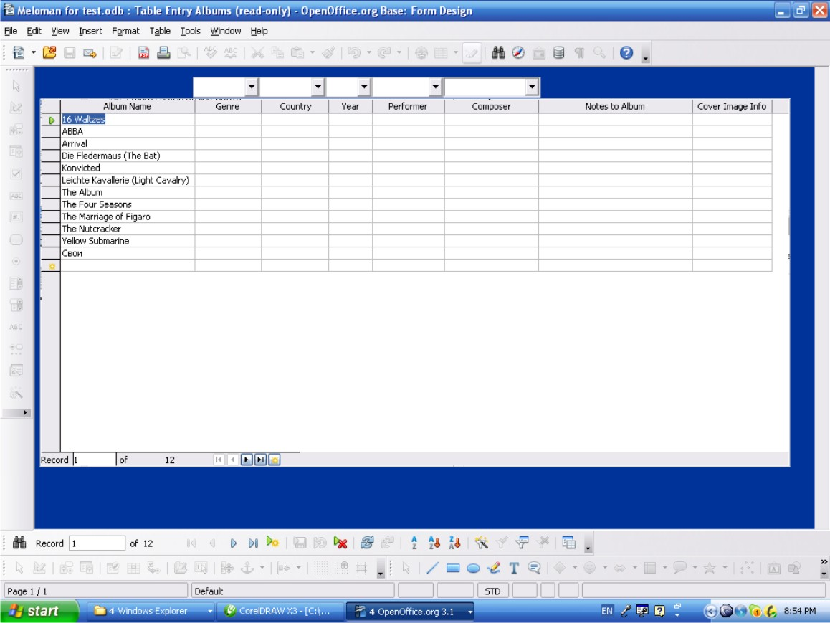

Actions
- The last bottom row is the “New Record” row allows to enter a new record.
- For deleting action multiple selection of rows available by clicking rows on left column with pressed <Shift> or <Ctrl> keys.
- Right click on any row of left table column allows to delete (whole row) any record or group of records if selected.
- Any cell can be edited if after changes it doesn't duplicate 'Album Name' record already existed. On duplication the appropriate warning message must be displayed.
- Exit the form: click 'Close Window' button (Red button with white cross at top right corner of the window).
- All actions above can be done by navigation buttons which are available and have the same functions as shown on PAGE 12.

It fails if entering 'Album Name' name already existed and the appropriate warning message must be displayed.

4-ENTRY MUSIC ITEMS Form (Full Basic Records)
After above simple preparation or checking Language Table, Music Type table, Music Genre table, , Performers & Persons table and Album table a User can fill all fields of Music Items table records and enjoy full information about his(her) music collection.
Sample of possible result is shown on the following picture:

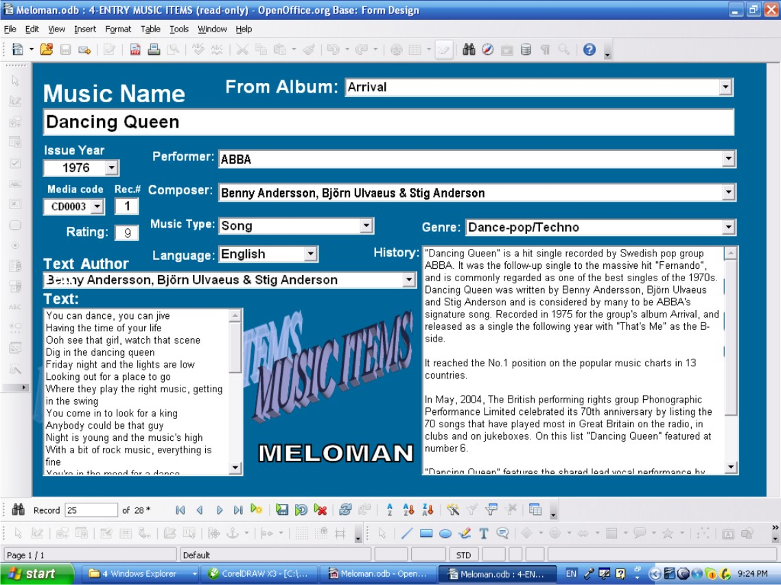

Access method

- Double click on '4-ENTRY MUSIC ITEMS' form in “Forms” area of Database interface (See picture on PAGE 9). The form shows 'First Record' of 'Music Items' table.
- Click drop down list button of 'From Album' field and make according choice from albums list if Music Item belong to any Album.
- Click drop down list button of 'Performer:' field and make according choice from performers or persons list.
- Click drop down list button of 'Composer:' field and make according choice from performers or persons list.
- Click drop down list button of 'Music Type:' field and make according choice from music types list.
- If a Music Item has lyrics click drop down list button of 'Language:' field and make according choice from languages.
- Click drop down list button of 'Genre:' field and make according choice from genres list.
- If a Music Item has lyrics click drop down list button of 'Text Author' field and make according choice from performers or persons list.

- Also User can fill 'Rec.#' field and 'Rating:' field.
- Not always but frequently additional information is available, such as issue year, lyrics text, history of creating and further life of a Music Item So User can fill 'Issue Year', 'Text:' and 'History' field

Navigation buttons on Tool Bar
- See PAGE 12.

Window layout
- Fields:
  - 'From Album' is a text combo box field, not mandatory.
  - 'From Album' field list button returns the list of existing 'Album Name' records in A-Z order.
  - 'Music Name' field is a text box field, not mandatory.
  - 'Issue Year' is a number combo box field, not mandatory.
  - 'Issue Year' field list button returns the list of years from 1600 to 2050.
  - 'Performer' is a text combo box field, not mandatory.
  - 'Performer' field list button returns the list of existing 'Name' field records of 'Performers & Persons' Database table in A-Z order.
  - 'Composer' is a text combo box field, not mandatory.
  - 'Composer' field list button returns the list of existing 'Name' field records of 'Performers & Persons' Database table in A-Z order.
  - 'Media code' is a text combo box field, not mandatory.
  - 'Media code' field list button returns the list of existing 'Media code' field records of 'Media List' Database table in A-Z order.
  - 'Rec.#' is a number box field allows 0-999 numbers to enter, not mandatory.
  - 'Rating' is a number box field allows 0-9 numbers to enter, not mandatory.
  - 'Music Type' is a text combo box field, not mandatory.
  - 'Music Type' field list button returns the list of existing 'Music Type' field records of 'Music Type'' Database table in A-Z order.
  - 'Genre' is a text combo box field, not mandatory.
  - 'Genre' field list button returns the list of existing 'Music Genre' field records of 'Music Genre' Database table in A-Z order.
  - 'Language' is a text combo box field, not mandatory.
  - 'Language' field list button returns the list of existing 'Language' field records of 'Language ' Database table in A-Z order.
  - 'History' is a multi-line text field, not mandatory.
  - 'Text Author' is a text combo box field, not mandatory.
  - 'Text Author'' field list button returns the list of existing 'Name' field records of 'Performers & Persons' Database table in A-Z order.
  - 'Text' is a multi-line text field, not mandatory.

Actions
- “New record” button allows to enter a new record
- “Delete Record” button allows to delete any record
- Any record field can be changed or deleted
- Exit the form: click 'Close Window' button (Red button with white cross at top right corner of the window).

It fails if:
- entering in 'From Album' field does not have parent name in 'Album Name' field of 'Albums' table;
- entering in 'Issue year' field other year then 1600-2050;
- entering in 'Performer' field does not have parent name in ''Name' field of 'Performer & Person' table;
- entering in 'Composer' field does not have parent name in ''Name' field of 'Performer & Person' table;
- entering in 'Media code' field does not have parent name in ''Media Code' field of 'Media List' table;
- entering in 'Music Type' field does not have parent name in 'Music Type' table;
- entering in 'Genre' field does not have parent name in 'Music Genre' table;
- entering in 'Language' field does not have parent name in 'Language' table;
- entering in 'Text Author' field does not have parent name in ''Name' field of 'Performer & Person' table;
and the appropriate warning message will be displayed.

Table Entry Music Items Form (Full Basic Records)
Sometimes Table Entry form is more convenient then GUI form so this form just for User's option to use.
Also this form can be used to delete records (rows) by group or to copy and paste records (rows) if User has the same Music Items on different media.

Access method
- Double click on 'Table Entry Music Items' form in “Forms” area of Database interface (See picture on PAGE 9). The form shows table view of 'Music Items' table. Click cell on last row (New Record row) of 'Media code' column.
- Click drop down list button of 'Media code' field (upon 'Media code' column) and make according choice of 'Media code'.
- Click next right cell on last row ('Record #' column) and enter record number of Music Item on certain media.
- Click drop down list button of 'From Album' field (upon 'From Album' column) and make according choice from albums list if Music Item belong to any Album.
- Click drop down list button of 'Issue Year' field (upon 'Issue Year' column) and make according choice from years list if the issue year is known
- Click drop down list button of 'Performer' field (upon 'Performer' column) and make according choice from performers or persons list.
- Click drop down list button of 'Composer' field (upon 'Composer' column) and make according choice from performers or persons list.
- If a Music Item has lyrics click drop down list button of 'Text Author' field (upon 'Text Author'' column) and make according choice from performers or persons list.
- If a Music Item has lyrics click drop down list button of 'Language' field (upon 'Language' column) and make according choice from languages.
- Click drop down list button of 'Music Type' field (upon 'Music Type' column) and make according choice from music types list.
- Click drop down list button of 'Genre' field (upon 'Genre' column) and make according choice from genres list.
- Also User can fill ''Rating' field (cell in 'Rating' column).

- ATTENTION: Don't use 'Table Entry Music Items' form to fill 'Text' and 'History' fields. To fill these fields use the '4-ENTRY MUSIC ITEMS' form only.

Navigation through the Table
- All sells of the table are available to edit. Copy-and-Paste method also available between cells.
- The last bottom row is for entry a new record.
- Up and down navigation is available by <Page Up> and <Page Down> keys and by scroll bars on right side and bottom of the table if they appeared.
- All navigation buttons are available and have the same functions as shown on PAGE 12.

Sample of possible result is shown on the following picture:

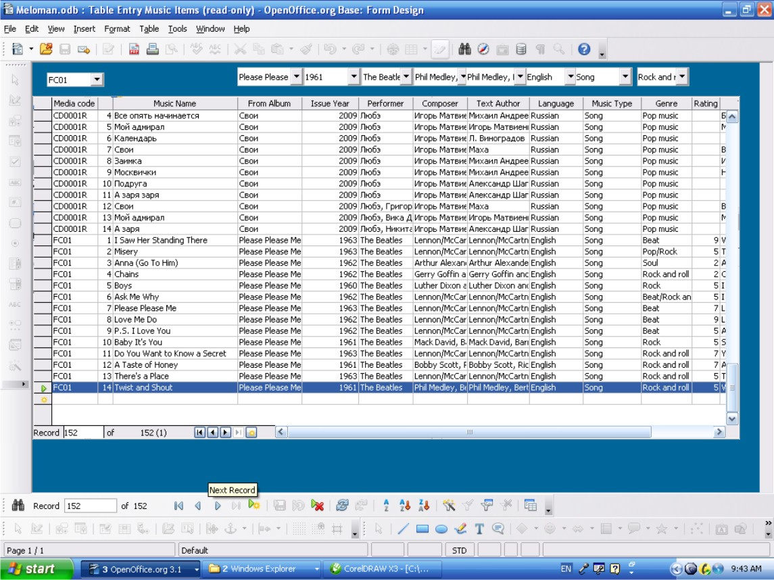

Table layout
- Columns (Database Fields):
  - 'Media code' column has text cells, not mandatory.
  - List box button upon 'Media code' column returns the list of existing 'Media Code' field records of 'Media List' table in A-Z order and allows to enter in any cell of 'Media code' column.
  - 'Record #' column has number cells, not mandatory
  - 'Music Name' column has text cells, not mandatory.
  - 'From Album' column has text cells, not mandatory.

  - List box button upon 'From Album' column returns the list of existing 'Album Name' field records of 'Albums' table in A-Z order and allows to enter in any cell of 'From Album' column.
  - 'Issue Year' column has number cells, not mandatory.
  - List box button upon 'Issue Year'' column returns the list of 1600-2500 years and allows to enter in any cell of 'Issue Year'' column.
  - 'Performer' column has text cells, not mandatory.
  - List box button upon 'Performer' column returns the list of existing 'Name' field records of 'Performers & Persons' Database table in A-Z order and allows to enter in any cell of 'Performer' column.
  - ''Composer' column has text cells, not mandatory.
  - List box button upon 'Composer' column returns the list of existing 'Name' field records of 'Performers & Persons' Database table in A-Z order and allows to enter in any cell of 'Composer' column.
  - 'Text Author' column has text cells, not mandatory.
  - List box button upon 'Text Author' column returns the list of existing 'Name' field records of 'Performers & Persons' Database table in A-Z order and allows to enter in any cell of 'Text Author' column.
  - 'Language' column has text cells, not mandatory.
  - List box button upon 'Language' column returns the list of existing 'Language' records in A-Z order and allows to enter in any cell of 'Language' column.
  - 'Music Type' column has text cells, not mandatory.
  - List box button upon 'Music Type' column returns the list of existing 'Music Type' records in A-Z order and allows to enter in any cell of 'Music Type' column.
  - 'Genre' column has text cells, not mandatory.
  - List box button upon 'Genre' column returns the list of existing 'Music Genre' records in A-Z order and allows to enter in any cell of 'Genre' column.
  - 'Rating' column has number cells, not mandatory.
  - 'Text' column has text cells, not mandatory.
  - 'History' column has text cells, not mandatory.

Actions

- The last bottom row is the “New Record” row allows to enter a new record.
- For deleting action multiple selection of rows available by clicking rows on left column with pressed <Shift> or <Ctrl> keys.
- Right click on any row of left table column allows to delete (whole row) any record or group of records if selected.
- Any cell can be edited or data can be deleted.
- Exit the form: Close Window button (Red button with white cross at top right corner of the window).
- All actions above can be done by navigation buttons which are available and have the same functions as shown on PAGE10

It fails if:
- entering in 'Media code' column cell does not have parent name in 'Media List' table;
- entering in 'From Album' column cell does not have parent name in 'Albums' table;
- entering in 'Issue Year' column cell other year then 1600-2050;
- entering in 'Performer' column cell does not have parent name in ''Name' field of 'Performer & Person' table;

- entering in 'Composer' column cell does not have parent name in ''Name' field of 'Performer & Person' table;
- entering in 'Text Author' column cell does not have parent name in ''Name' field of 'Performer & Person' table;
- entering in 'Language' column cell does not have parent name in 'Language' table;
- entering in 'Music Type' column cell does not have parent name in 'Music Type' table;
- entering in 'Genre' column cell does not have parent name in 'Music Genre' table;
and the appropriate warning message must be displayed.

Welcome to the Music World

This part of User's Guide devoted to the people who wants to keep all available music world information in one place. The MELOMAN OpenOffice.Base application gives this opportunity to a User and becomes not Music Collection only but we can call it as a Custom Music Encyclopedia.
So in this case User can keep Music Items in Database even if they are not in collection Just don't fill 'Media code' field in 'Music Items' form and in this case 'Record #' fields could be used as an Album's record number.
Of cause User can play with loaded information in full range of OpenOffice.Base abilities and can create hundreds of different varieties of queries and reports and still can work with collection Music Items only even if Database has hundred of other Music Items which are not in collection.

ENTRY COUNTRY Form (Music World Database branch)
First of all the Music World Database branch uses one more Database table: 'Country' table.
If User knows approximately which countries will be involved in Database he(she) can fill this table by one time. Anyway any country can be added in the table any time. It's recommended to use one name for countries which have many names. Ex.: Holland and Netherlands, UK and Great Britain, USA and United States. It's for User's choice.

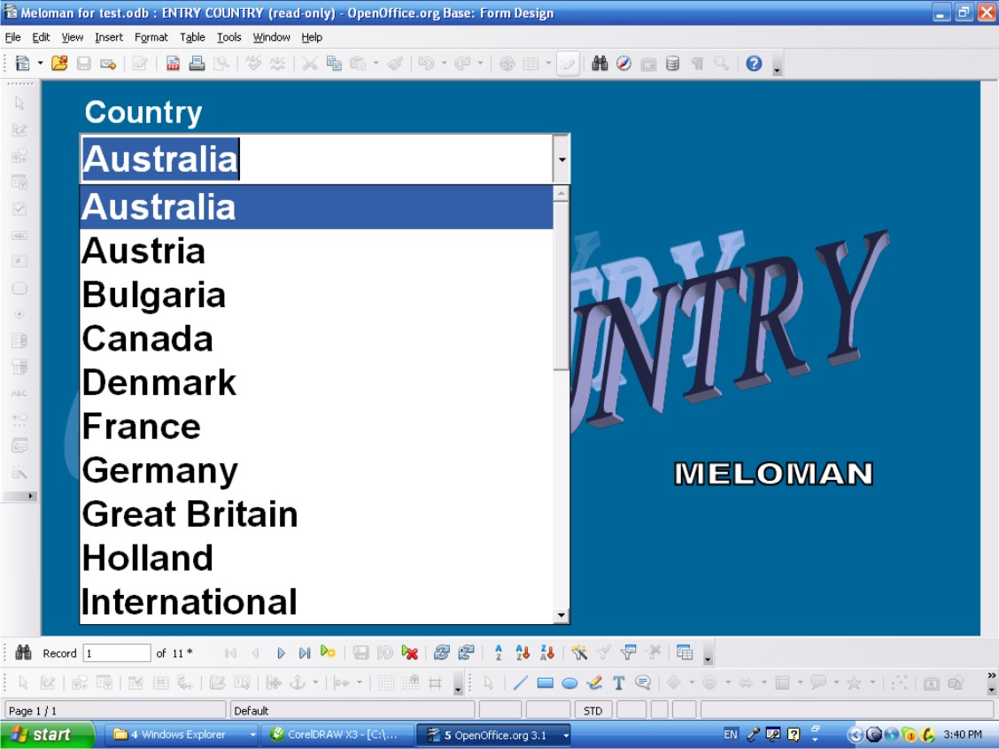

Access method
- Double click on 'COUNTRY'' form in “Forms” area of Database interface (See picture on PAGE 9). The form shows 'First Record' of 'Country' table. Click drop down list button of 'Country' field. There is the whole list of countries names which 'Country' table has.
- If User find needed country name he(she) should click 'Close window' button (Don't click anything in the list! If it happened don't save form when close the window!).
If User doesn't find needed country name he(she) should double click “New Record” button and type in 'Country field new Country name. Click 'Close window' button

Navigation buttons on Tool Bar
- See PAGE 12.

Window layout
- Field:
  - 'Country' is a text combo box field, mandatory if enter a new record.
  - “Country' field list button returns the list of existing 'Country' records in A-Z order and must be used for checking existing records only not for entry a new record.

Actions
- “New Record” button allows to enter a new record
- “Delete Record” button allows to delete any record
- Any record can be changed if after changes it doesn't duplicate record already existed. On duplication the appropriate warning message must be displayed.
- Exit the form: Close Window button (Red button with white cross at top right corner of the window).
It fails if entering 'Country' name already existed and the appropriate warning message must be displayed.

3-ENTRY ALBUMS Form (Music World Database branch)

This form has been used already in p.4.6 to enrich Music Items existing in Database or to input new Music Items with full Basic Record.
Because '3-ENTRY ALBUMS' form belongs to Music World Database branch it doesn't carry any information about User's collection and related to collection only through Basic Records. If User has any full album on some media he(she) has to input name of the album in 'Media name' field of 'Media List' form. Drop down list will help to fill 'Media name' field using Albums Table.
Now User can add more information in '3-ENTRY ALBUMS' form.

Access method
- Double click on '3-ENTRY ALBUMS' form in “Forms” area of Database interface (See picture on PAGE 9). The form shows 'First Record' of 'Albums' table. Click drop down list button of 'Album Name' field. There is the whole list of albums names which 'Albums' table has.
If User find needed Album name he(she) should click 'Close window' button (Don't click anything in the list! If it happened don't save form when close the window!).
If User doesn't find needed Album name he(she) should double click “New Record” button and type in 'Album Name' field new Album name. Click 'Close window' button.

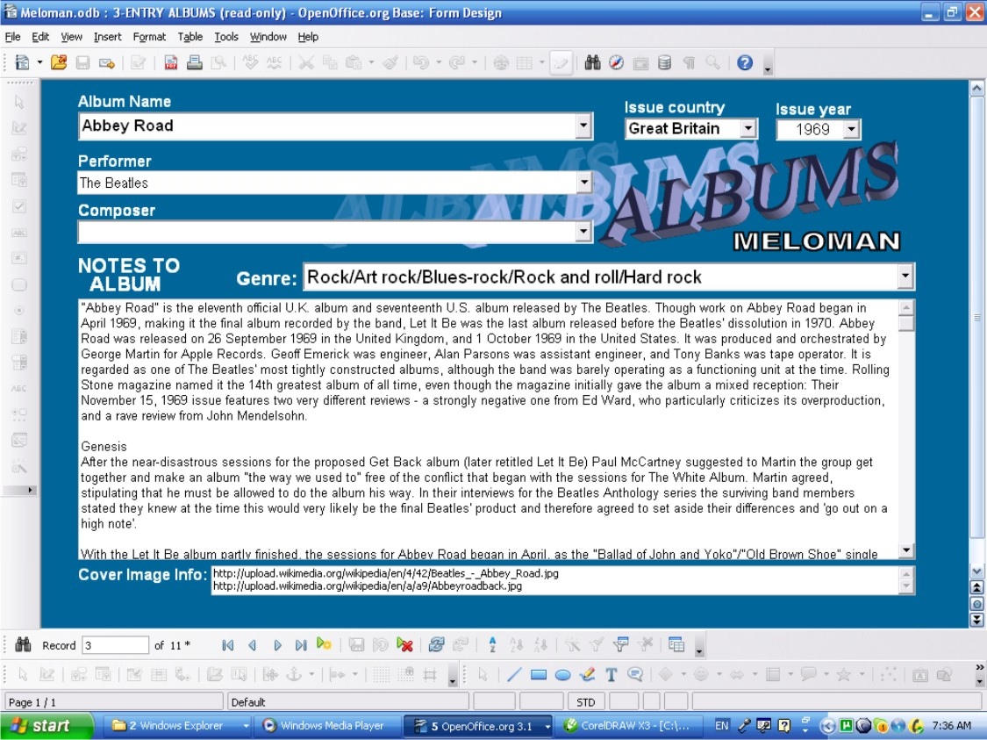

Navigation buttons on Tool Bar
- See PAGE 12.

Window layout
- Fields:
  - 'Album Name' is a text box field, mandatory if enter a new record.
  - 'Issue country' text list box field, not mandatory.
  - 'Issue country'' field list button returns the list of existing 'Country' records in A-Z order.
  - 'Issue year' is a number combo box field, not mandatory.
  - 'Issue year' field list button returns the list of years from 1600 to 2050.
  - 'Performer' is a text combo box field, not mandatory.
  - 'Performer' field list button returns the list of existing 'Name' field records of 'Performers & Persons' Database table in A-Z order.
  - 'Composer' is a text combo box field, not mandatory.
  - 'Composer' field list button returns the list of existing 'Name' field records of 'Performers & Persons' Database table in A-Z order.
  - 'Genre' is a text combo box field, not mandatory.
  - 'Genre' field list button returns the list of existing 'Music Genre' field records of 'Music Genre' Database table in A-Z order.

  - 'NOTES TO ALBUM' is a multi-line text field, not mandatory.
  - 'Cover image info' field is a multi-line text box field, not mandatory.

Actions
- “New record” button allows to enter a new record
- “Delete Record” button allows to delete any record
- Any record can be changed if after changes it doesn't duplicate 'Album Name' field record already existed. On duplication the appropriate warning message must be displayed.
- Exit the form: Close Window button (Red button with white cross at top right corner of the window).

It fails if entering 'Album Name' name already existed and the appropriate warning message will be displayed.
It fails if:
- entering in 'Issue country' field does not have parent name in 'Country' table;
- entering in 'Issue year' field other year then 1600-2050;
- entering in 'Performer' field does not have parent name in ''Name' field of 'Performer & Person' table;
- entering in 'Composer' field does not have parent name in ''Name' field of 'Performer & Person' table;
- entering in 'Genre' field does not have parent name in 'Music Genre' table;
and the appropriate warning message will be displayed.

Table Entry Albums Form (Music World Database branch)
Sometimes Table Entry form is more convenient then GUI form so this form just for User's option to use.
Also this form can be used to delete records (rows) by group.
This form has been used already in p.4.7 to enrich Music Items existing in Database or to input new Music Items with full Basic Record.
Because 'Entry Albums Form' form belongs to Music World Database branch it doesn't carry any information about User's collection and related to collection only through Basic Records.
If User has any full album on some media he(she) has to input name of the album in 'Media name' field of 'Media List' form. Drop down list will help to fill 'Media name' field using Albums Table.
Now User can add more information in 'Table Entry Albums Form' form.

Access method
- Double click on 'Table Entry Albums' form in “Forms” area of Database interface (See picture on PAGE 9). The form shows table view of 'Albums' table. The 'Album Name' field is sorted in A-Z order and User can check is needed Album Name in the table or not.
- ATTENTION: Don't use 'Table Entry Albums' form to fill 'Notes to Album' field. To fill these field use the '3-ENTRY ALBUMS' form only.

Navigation through the Table
- All sells of the table are available to edit. Copy-and-Paste method also available between cells.
- The last bottom row is for entry a new record.
- Up and down navigation is available by <Page Up> and <Page Down> keys and by scroll bars on right side and bottom of the table if they appeared.
- All navigation buttons are available and have the same functions as shown on PAGE 12.

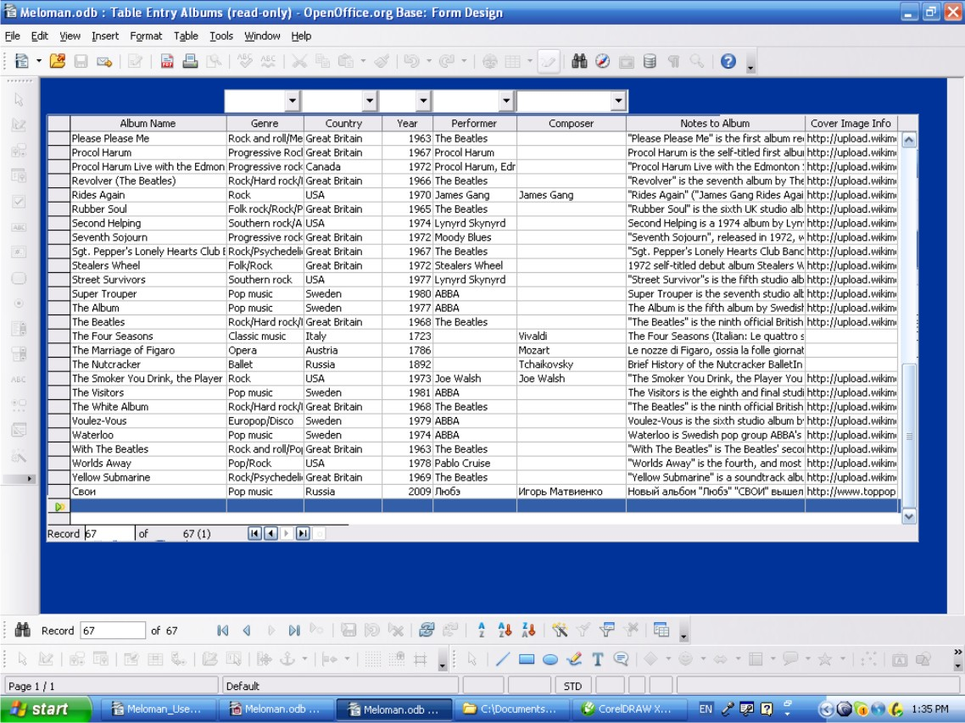

Table layout
- Columns (Database Fields):
  - 'Album Name' column has text cells, mandatory if enter a new record.
  - 'Genre' column has text cells, not mandatory.
  - List box button upon 'Genre' column returns the list of existing 'Music Genre' records in A-Z order and allows to enter in any cell of 'Genre' column.
  - 'Country' column has text cells, not mandatory.
  - List box button upon 'Country' column returns the list of existing 'Country' records in A-Z order and allows to enter in any cell of 'Country' column.
  - 'Year' column has number cells, not mandatory.
  - List box button upon 'Year'' column returns the list of 1600-2500 years and allows to enter in any cell of 'Year'' column.
  - 'Performer' column has text cells, not mandatory.
  - List box button upon 'Performer' column returns the list of existing 'Name' field records of 'Performers & Persons' Database table in A-Z order and allows to enter in any cell of 'Performer' column.
  - ''Composer' column has text cells, not mandatory.
  - List box button upon 'Composer' column returns the list of existing 'Name' field records of 'Performers & Persons' Database table in A-Z order and allows to enter in any cell of 'Composer' column.
  - 'Notes to Album' column has text cells, not mandatory, not to be used for entering data.
  - 'Cover Image Info' column has text cells, not mandatory.

Actions
- The last bottom row is the “New Record” row allows to enter a new record.
- For deleting action multiple selection of rows available by clicking rows on left column with pressed <Shift> or <Ctrl> keys.
- Right click on any row of left table column allows to delete (whole row) any record or group of records if selected.
- Any cell can be edited if after changes it doesn't duplicate 'Album Name' record already existed. On duplication the appropriate warning message must be displayed.
- Exit the form: Close Window button (Red button with white cross at top right corner of the window).
- All actions above can be done by navigation buttons which are available and have the same functions as shown on PAGE 12.

It fails if entering 'Album Name' name already existed and the appropriate warning message will be displayed.

It fails if:
- entering in 'Genre' column cell does not have parent name in 'Music Genre' table;
- entering in 'Country' column cell does not have parent name in 'Country' table;
- entering in 'Year' column cell other year then 1600-2050;
- entering in 'Performer' column cell does not have parent name in ''Name' field of 'Performer & Person' table;
- entering in 'Composer' column cell does not have parent name in ''Name' field of 'Performer & Person' table;
and the appropriate warning message will be displayed.

1-ENTRY PERFORMERS & PERSONS Form (Music World Database branch)
This form has been used already in p.4.1 to enrich Music Items existing in Database or to input new Music Items with full Basic Record.
Now User can add more information in '1-ENTRY PERFORMERS & PERSONS' form.

Access method

- Double click on '1-ENTRY PERFORMERS & PERSONS' form in “Forms” area of Database interface (See picture on PAGE 9). The form shows 'First Record' of 'Performers and Persons' table. Click drop down list button of 'Name' field. There is the whole list of Performers or Persons names which 'Performers and Persons' table has.
If User find needed Performer or Person name he(she) should click 'Close window' button (Don't click anything in the list! If it happened don't save form when close the window!).
If User doesn't find needed Performer or Person name he(she) should double click “New Record” button and type in 'Name' field new Performer or Person name. Click 'Close window' button.

Navigation buttons on Tool Bar
- See PAGE 12.

Window layout
- Fields:
  - 'Name' is a text combo box field, mandatory if enter a new record.
  - “Name' field list button returns the list of existing 'Name' field records in A-Z order and must be used for checking existing records only or input from the list with editing. Existing records not for entry as a new record.
  - 'Country' is a text list box field, not mandatory.
  - 'Country'' field list button returns the list of existing 'Country' records in A-Z order.
  - 'Original Name' is a text box field, not mandatory.
  - 'Birth year' is a number combo box field, not mandatory.
  - 'Birth year' field list button returns the list of years from 1600 to 2050.
  - 'Life end year' is a number combo box field, not mandatory.
  - 'Life end year' field list button returns the list of years from 1600 to 2050.
  - 'Biography & History' is a multi-line text field, not mandatory.
  - 'Photos' info' is a multi-line text box field, not mandatory.
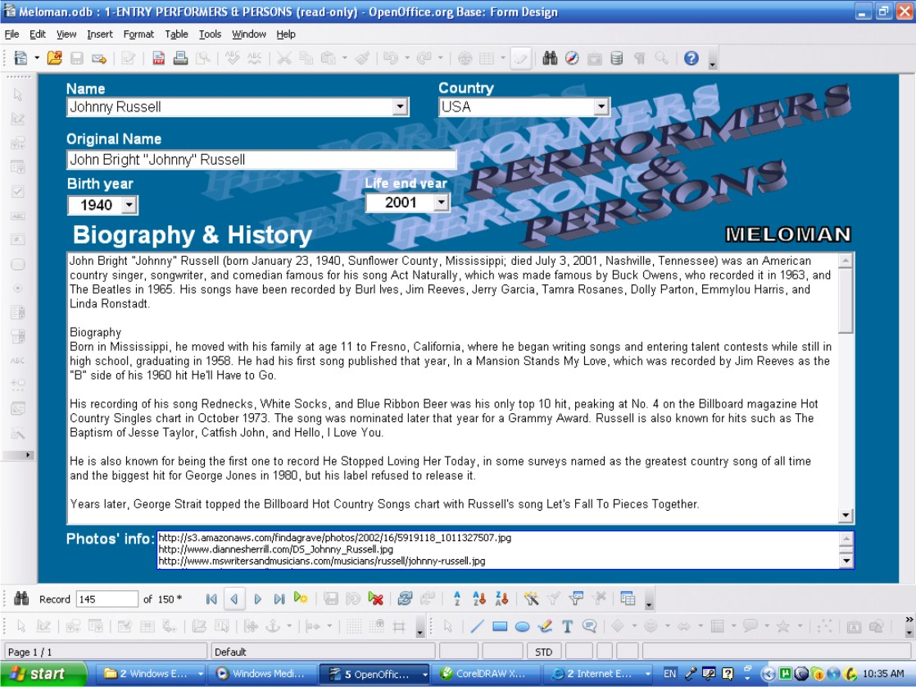

Actions
- “New record” button allows to enter a new record
- “Delete Record” button allows to delete any record

- Any record can be changed if after changes it doesn't duplicate 'Name' field record already existed. On duplication the appropriate warning message must be displayed.
- Exit the form: Close Window button (Red button with white cross at top right corner of the window).

It fails if entering 'Name' name already existed and the appropriate warning message will be displayed.

It fails if:
- entering in 'Country' field does not have parent name in 'Country' table;
- entering in 'Birth year' field other year then 1600-2050;
- entering in 'Life end year' field other year then 1600-2050;
and the appropriate warning message will be displayed.

Table Entry Performers & Persons Form (Music World Database branch)
Sometimes Table Entry form is more convenient then GUI form so this form just for User's option to use.
Also this form can be used to delete records (rows) by group.
This form has been used already in p.4.2 for enriching Music Items existing in Database or to input new Music Items with full Basic Record.
Now User can add more information in 'Table Entry Performers & Persons' form.
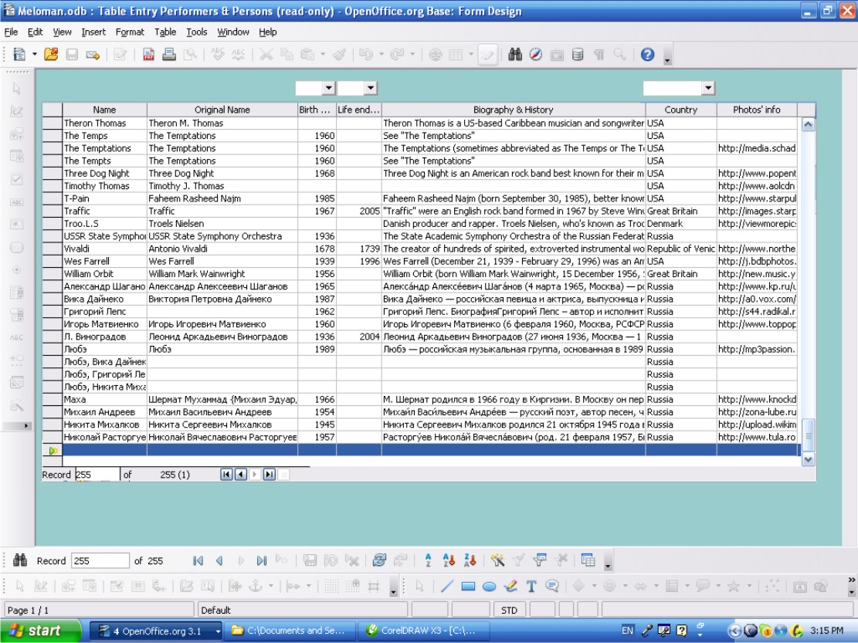

Access method
- Double click on 'Table Entry Performers & Persons' form in “Forms” area of Database interface (See picture on PAGE 9). The form shows table view of 'Performers & Persons' table. The 'Name' field is sorted in A-Z order and User can check is needed Performer or Person in the table or not.
- ATTENTION: Don't use 'Table Entry Performers & Persons' form to fill 'Biography & History' field. To fill these field use the '1-ENTRY PERFORMERS & PERSONS' form only.

Navigation through the Table
- All sells of the table are available to edit. Copy-and-Paste method also available between cells.
- The last bottom row is for entry a new record.
- Up and down navigation is available by <Page Up> and <Page Down> keys and by scroll bars on right side and bottom of the table if they appeared.
- All navigation buttons are available and have the same functions as shown in on PAGE 12.

Table layout
- Columns (Database Fields):
  - 'Name' column has text cells, mandatory if enter a new record.
  - 'Original Name' column has text cells, not mandatory.
  - 'Birth year' column has number cells, not mandatory.
  - List box button upon 'Birth year' column returns the list of 1600-2500 years and allows to enter in any cell of 'Birth year' column.
  - 'Life end year' column has number cells, not mandatory.
  - List box button upon 'Life end year' column returns the list of 1600-2500 years and allows to enter in any cell of 'Life end year' column.
  - 'Biography & History' column has text cells, not mandatory, not for entering new data.
  - 'Country' column has text cells, not mandatory.
  - 'Photos' info' column has text cells, not mandatory.

Actions
- The last bottom row is the “New Record” row allows to enter a new record.
- For deleting action multiple selection of rows available by clicking rows on left column with pressed <Shift> or <Ctrl> keys.
- Right click on any row of left table column allows to delete (whole row) any record or group of records if selected.
- Any cell can be edited if after changes it doesn't duplicate 'Name' record already existed. On duplication the appropriate warning message must be displayed.
- Exit the form: Close Window button (Red button with white cross at top right corner of the window).
- All actions above can be done by navigation buttons which are available and have the same functions as shown in p.4.1.

It fails if entering 'Name' name already existed and the appropriate warning message will be displayed.
It fails if:
- entering in 'Birth year' column cell other year then 1600-2050;
- entering in 'Life end year' column cell other year then 1600-2050;
- entering in 'Country' column cell does not have parent name in ''Country' table;
and the appropriate warning message will be displayed.

Four simple steps to support

MELOMAN Database

This part of User's Guide shows the simple technology how to add new Music Item without any problems. There are four simple steps to enter data about new music item. And that is why our first entry forms on PAGE 9 have names beginning from 1..., 2..., 3... , 4....which means steps of entering.
There are two samples below explaining “Four steps” method to add new Music Items:
- Part 6.1 devoted to pretty famous and old Music Item;
- Part 6.2 devoted to pretty new and not so famous Music Item
These samples are based on real musical compositions and it is recommended to follow the same way if User wants to load full information about Music Items in MELOMAN Database.
Of cause User can fill any field of any entry form anytime but if he(she) cannot find in any drop list desired data to input he(she) has to open accordingly other entry form, enter new record with this data, close it and return again to previous form, click 'Refresh Control' button (If 'Refresh Control' button is dim click any field with drop list button). and return to the record where desired data has not been found in drop list before but now it has. So, the following “Four steps” method will help User to save time working with MELOMAN Database application.

Famous and old Music Item
As a sample it's taken following Music Item:

Name: It Won't Be Long
Performer: The Beatles

Let's say we don't know anything else about this musical composition. We just know it is very old thing created approximately 40 years ago.
First of all let do quick search in Internet.
We are lucky: after quick search in Internet in Wikipedia we found special article devoted to “It Won't Be Long” Music Item:
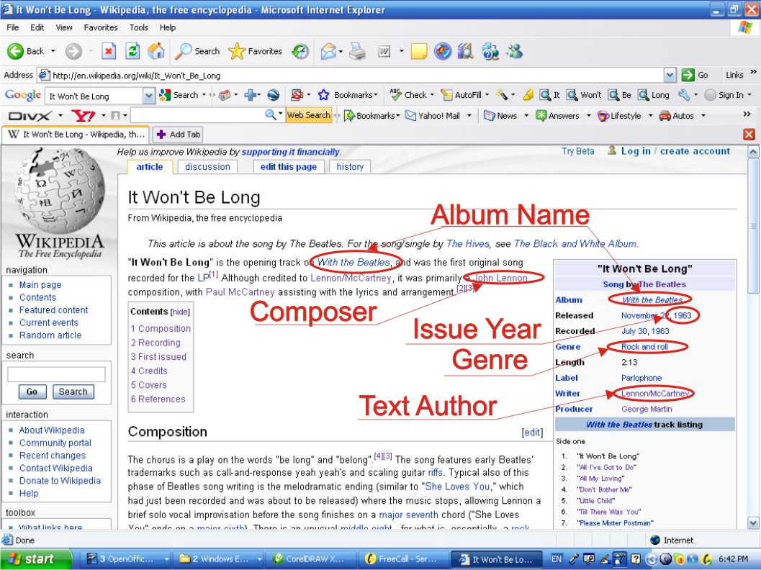

In this article we can find a lot of things to load in our Database but first Step devoted to Performers and Persons, so let do that first.

Step 1: Checking Performer and Persons (Option 1)

- Double click on '1-ENTRY PERFORMERS & PERSONS' form in “Forms” area of Database interface (See picture on PAGE 9). The form shows 'First Record' of 'Performers and Persons' table. Keeping in mind that all Entry Forms are ready to edit let's go to new record to make sure ourselves not to distort existing data.
- Click 'New Record' button;
- Click drop down list button of 'Name' field. There is the whole list of Performers or Persons names which 'Performers and Persons' table has in A-Z order. We are lucky :we found 'The Beatles' in our Database:
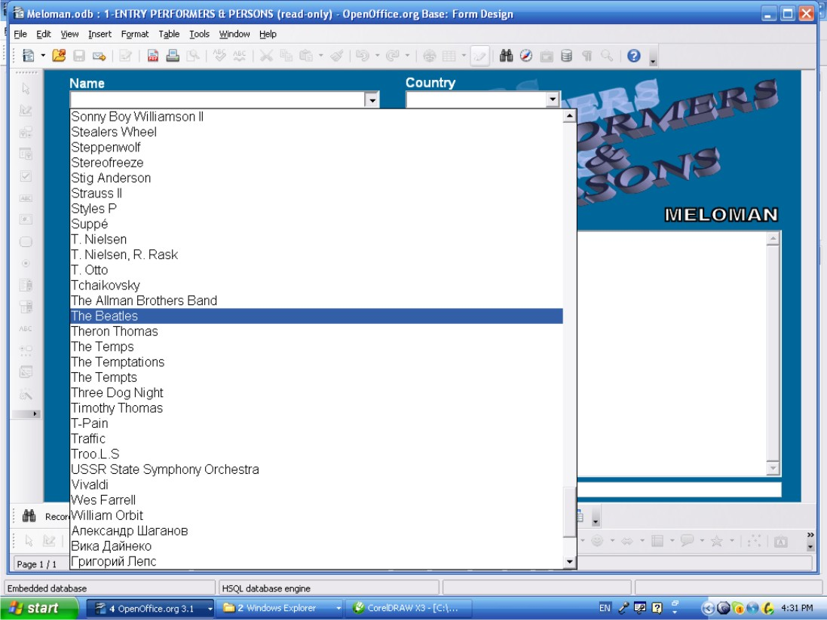
- Click 'Close Window' button
This option to check Performer is quick but not efficient. We've just learnt that we have Performer 'The Beatles' in our Database but we've not seen how much information we have.

Step 1: Checking Performer and Persons (Option 2)

- Double click on '1-ENTRY PERFORMERS & PERSONS' form in “Forms” area of Database interface (See picture on PAGE 9). The form shows 'First Record' of 'Performers and Persons' table. Keeping in mind that all Entry Forms are ready to edit let's go to new record to make sure ourselves not to distort existing data.
- Click 'New Record' button;
- Click 'Name' field;
- Click 'Find Record' button;
- In 'Search for' field of 'Record Search' window type “beatles” (We don't need input full name sometimes enough to type just part of name);

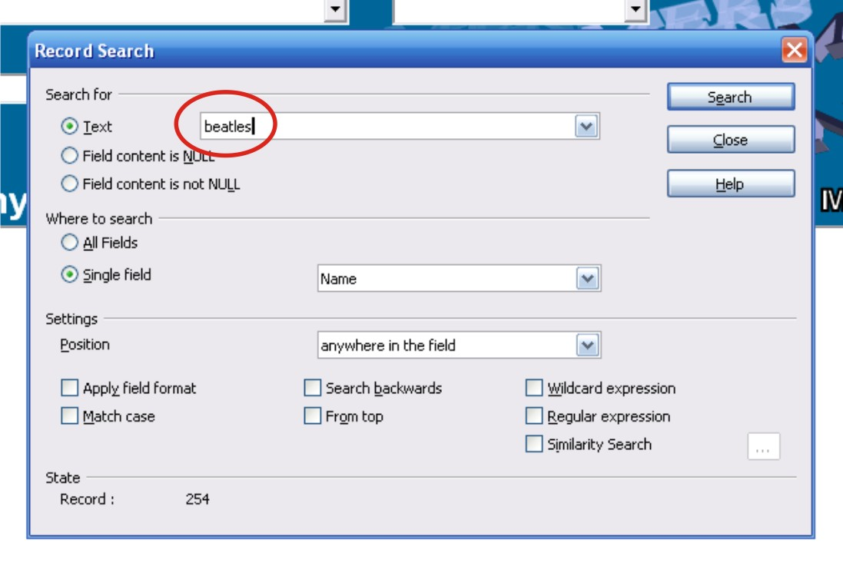
- Click 'Search' button of 'Record Search' window;
- Close 'Record Search' window;
- Me are lucky: the record with performer 'The Beatles' is found:
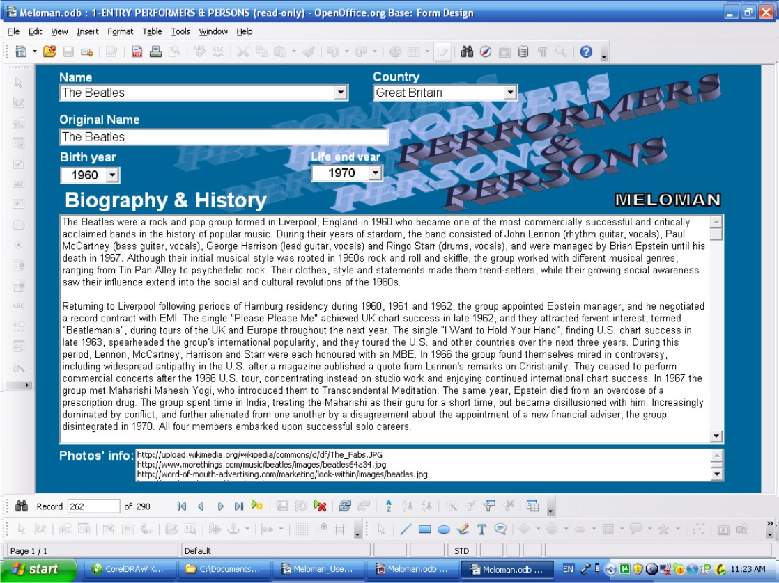
As we can see we have full information about Performer 'The Beatles'. And we don't need to input more information.

From the article we've learnt that composer of “Won't Be Long” Music Item is John Lennon.
We will use Option 2 to check do we have in Database Person with name “John Lennon” or not.

- Click 'New Record' button;
- Click 'Name' field;
- Click 'Find Record' button;
- In 'Search for' field of 'Record Search' window type or copy and paste from the article “John Lennon”:
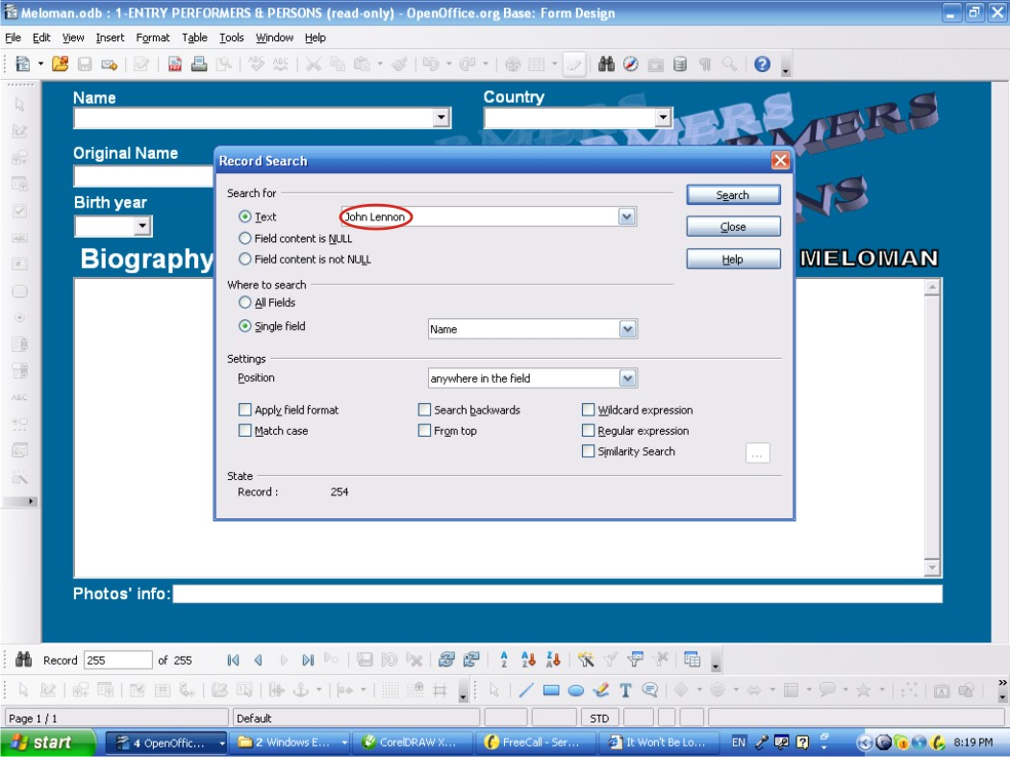
- Click 'Search' button of 'Record Search' window;
- Close 'Record Search' window;
- Me are lucky: the record with person 'John Lennon' is found:

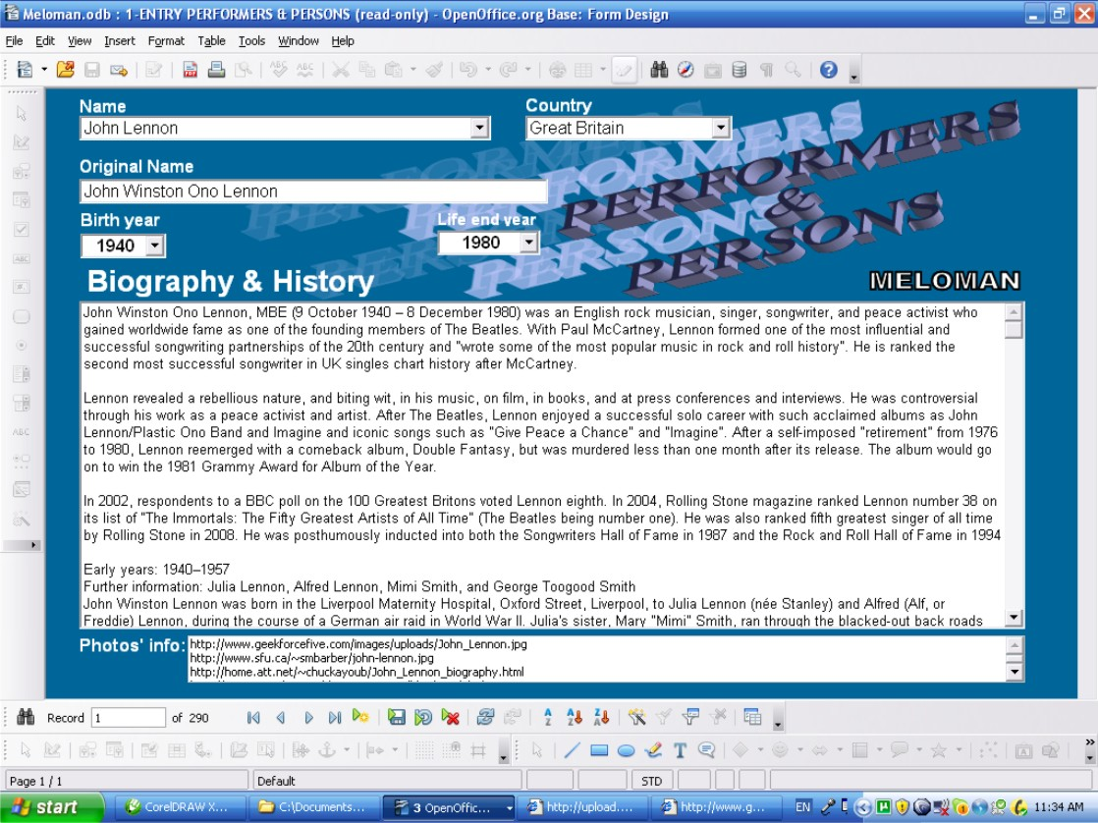

- As we can see we have full information about person 'John Lennon'.

From the article we've learnt that text writer of “Won't Be Long” Music Item are “Lennon/McCartney”. Actually it is two persons and usually we don't have full information in Database for two or more persons simultaneously and in 'Biography & History' field leaving note: “See separately”. But these two guys is so famous that let's check them using Option 2 do we have in Database performers of persons under name “Lennon/McCartney” or not.
- Click 'New Record' button;
- Click 'Name' field;
- Click 'Find Record' button;
- In 'Search for' field of 'Record Search' window type or copy and paste from the article “Lennon/McCartney”:
- Click 'Search' button of 'Record Search' window;
- Close 'Record Search' window;
- Me are lucky: the record with person 'Lennon/McCartney' is found:
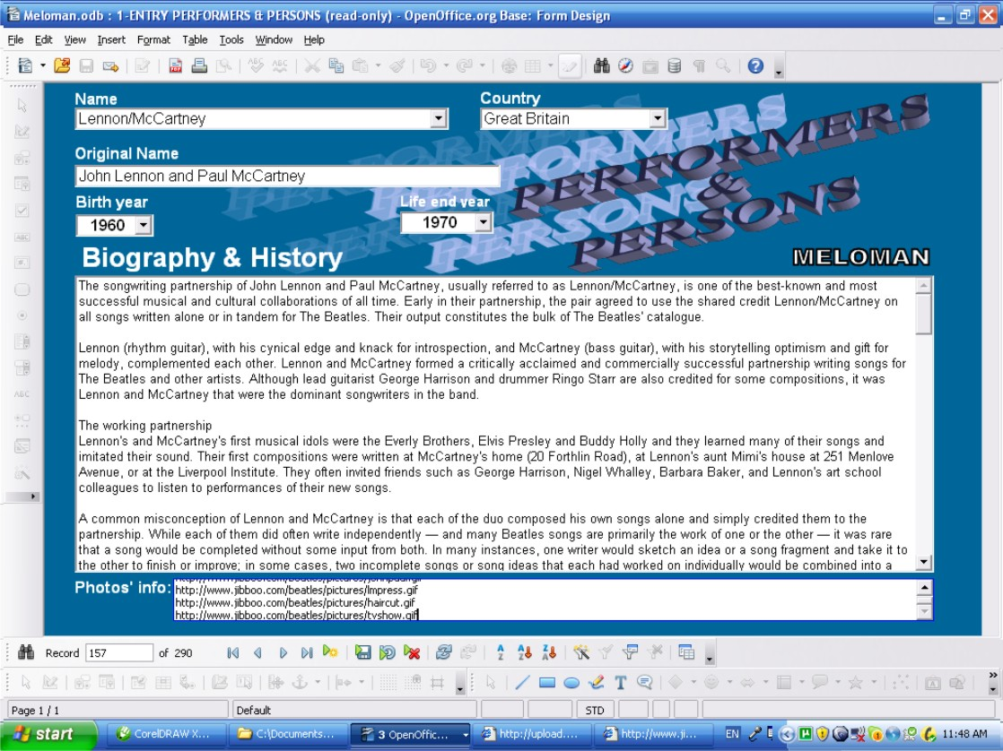
- As we can see we have full information about persons with name 'Lennon/McCartney'. But without any problems we could use Option 1 to check 'Lennon/McCartney' name.
So by Step 1 we made ourselves sure that we have in Database all Performers and Persons related to “Won't Be Long” Music Item:
- Performer: The Beatles;
- Composer: John Lennon;
- Text Author: Lennon/McCartney.
Of cause if we remember that we have 'these names in 'Persons & Performers' table in our Database we can skip Step 1.

Notes to errors for Step1:

1. If after clicking 'New Record' button an Error Message appears, like this:
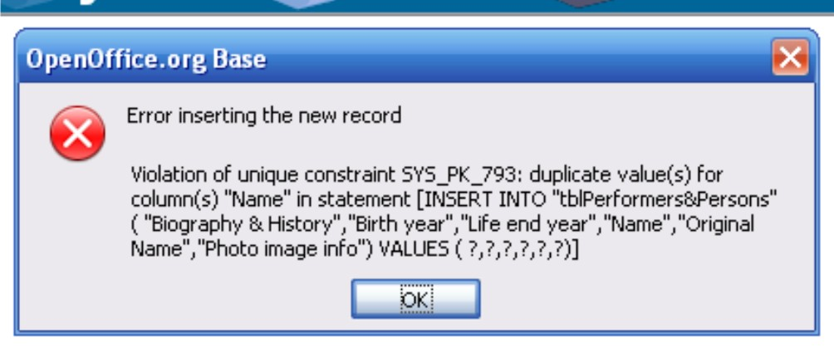
It means we are trying input name which already existing in 'Performers & Persons' table.

- Click 'OK' button in the window. Error Message appears, like this:
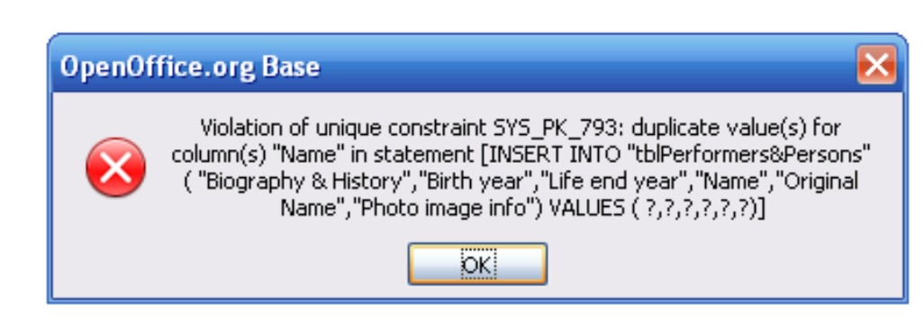
- Click 'OK' button in the window. Highlight and delete entering name in 'Name' field.
We have to check existing name: Is this name really the same which we've been trying to enter?
If we need to enter the same name for different persons we can make unique the second name just adding space to the end of name. It looks the same but it will be different for the application.

2. If any time using navigation buttons an Error Message appears, like this:
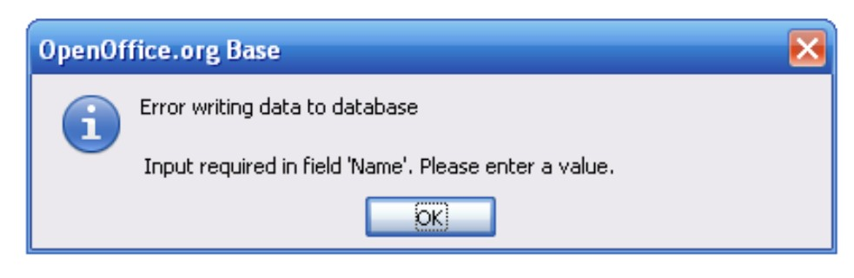
It means that we created new record but didn't filled the 'Name' field. In this case we have to input new name in 'Name' field;
If we don't need to input any new name exit the form by following:
- Click “Close Window' button and click “No” button in appeared 'OpenOffice.org X.X' window asking about save changes.

Step 2: Checking Genres of Music Item and Album
Next step to find genre or style of “It Won't Be Long” Music Item and check: do we have this Genre Name in our Database or not.

We are lucky again because in Internet Wikipedia article devoted to “It Won't Be Long” Music Item:which we found we've learnt that “It Won't Be Long” Music Item belongs to 'Rock and roll' genre. Let's check this genre in our Database.

- Double click on '2-ENTRY MUSIC GENRE' form in “Forms” area of Database interface (See picture on PAGE 9). The form shows 'First Record' of 'Music Genre' table. Keeping in mind that all Entry Forms are ready to edit let's go to new record to make sure ourselves not to distort existing data.
- Click 'New Record' button;
- Click drop down list button of 'Music Genre' field. There is the whole list of Music Genre names which 'Music Genre table has in A-Z order.
We are lucky :we found 'Rock and roll' Genre in our Database:
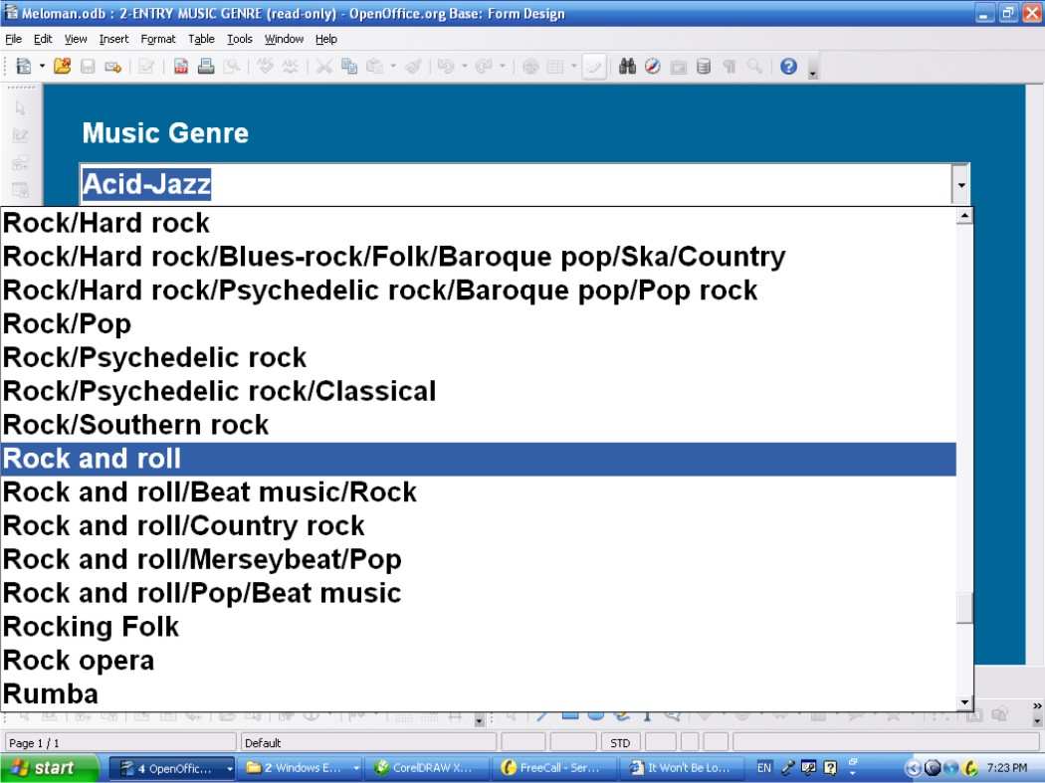
So we don't need to input new Genre name in 2-ENTRY MUSIC GENRE' form.
- Click 'Close Window' button;
Of cause if we remember that we have 'Rock and roll' Genre in our Database we can skip Step 2.

Step 3: Checking Music Item's Album
Next step to find Album which “It Won't Be Long” Music Item belong to and check do we have this Album in our Database or not.

In the article we found that “It Won't Be Long” Music Item belongs to the album which named “With the Beatles”. Let's check this Album in our Database. Because 'Albums' is not simple table let use Option 2 to check album named “With the Beatles”.

- Double click on '3-ENTRY ALBUMS' form in “Forms” area of Database interface (See picture on PAGE 9). The form shows 'First Record' of 'Albums' table. Keeping in mind that all Entry Forms are ready to edit let's go to new record to make sure ourselves not to distort existing data.
- Click 'New Record' button;
- Click 'Album Name' field;
- Click 'Find Record' button;
- In 'Search for' field of 'Record Search' window type or copy and paste from the article “With the Beatles”.
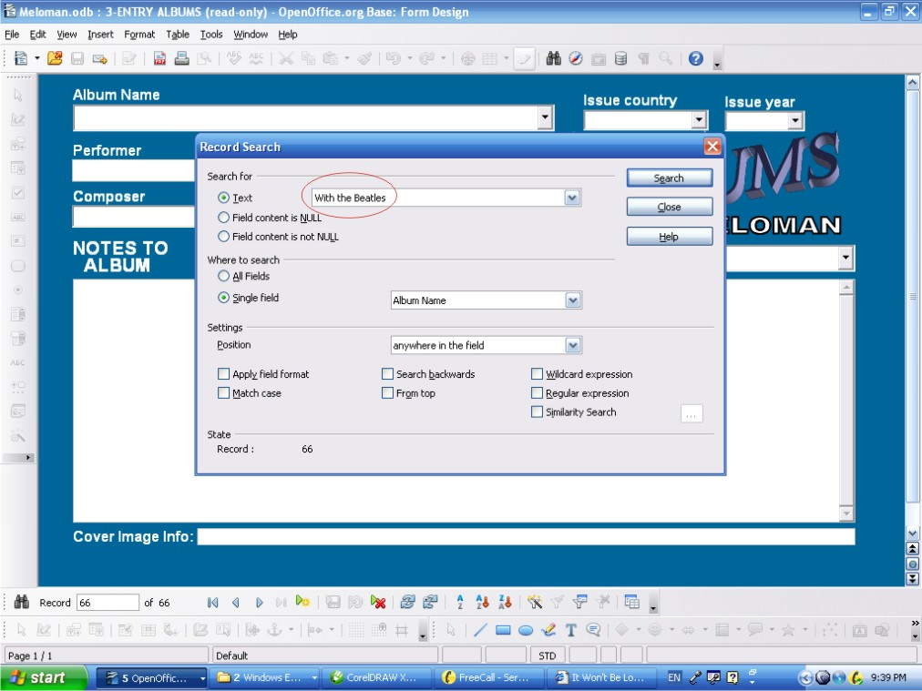

- Click 'Search' button of 'Record Search' window;
- Me are lucky: the record with album named '“With the Beatles” is found:

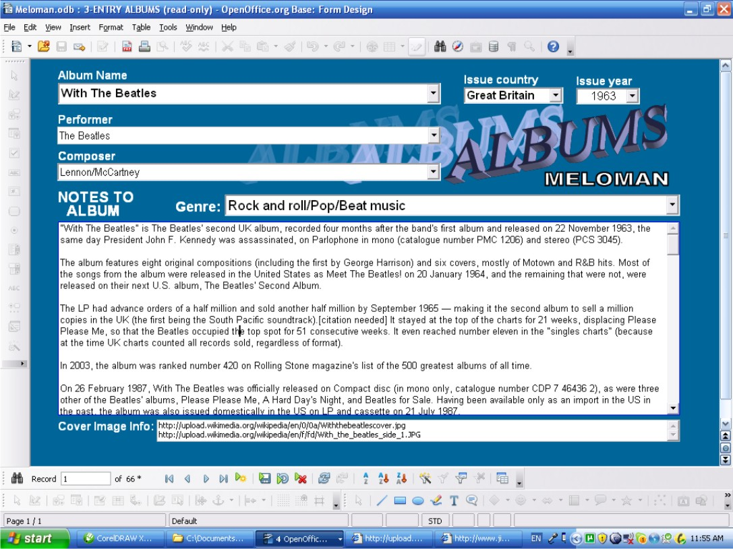
As we can see we have full information about the album named '“With the Beatles”. And we don't need to input more information in 'Albums' table.

Step 4: Filling the Basic Record of Music Items Table.

By 1-3 Steps we have made ourselves sure that we have all needed data in our Database to fill the Basic Record for “It Won't Be Long” Music Item by The Beatles. Let's begin to fill the Basic Record.

- Double click on '4-ENTRY MUSIC ITEMS' form in “Forms” area of Database interface (See picture on PAGE 9). The form shows 'First Record' of 'Music Items' table. Keeping in mind that all Entry Forms are ready to edit let's go to new record to make sure ourselves not to distort existing data.
- Click 'New Record' button;
Let's go from top to bottom of the window:
- Click drop down list button of 'From Album' field. There is the whole list of Albums names which 'Album' table has in A-Z order. Find and click album named '“With the Beatles”.
Other way: to begin to type in 'From Album:' field “With the Beatles”. After typing first letter “W” the full name “With the Beatles” will appear in the field.
- Click 'Music Name' field and type or copy from the article and paste “It Won't Be Long” ;
- Click drop down list button of 'Issue Year' field find and click year 1963 or type 1963 direct in the field. This issue year we have found in the article.
- By the same way as filled 'From Album:' field fill 'Performer:' field by “The Beatles”;
- By the same way as filled 'From Album:' field fill 'Composer:' field by “John Lennon”;

- By the same way as filled 'From Album:' field fill 'Music Type:' field by “Song” because it is song;
- By the same way as filled 'From Album:' field fill 'Genre:' field by “Rock and roll”;
- By the same way as filled 'From Album:' field fill 'Language:' field by “English”;
- By the same way as filled 'From Album:' field fill 'Text Author' field by “Lennon/McCartney”;
- Also put rating: click 'Rating:' field and type for example: “5”.
We don't need to fill 'Media code' and 'Rec.#' fields because it is not collection Music Item yet.
After all above filling fields we have received the following picture:

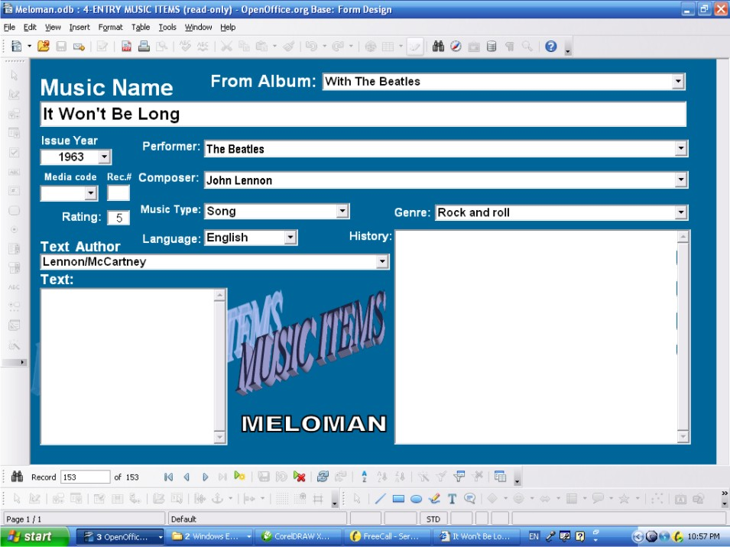
Now let's go to our window with article which we found in Internet and highlight the whole text of the article or part of it which we want to keep in our Database:
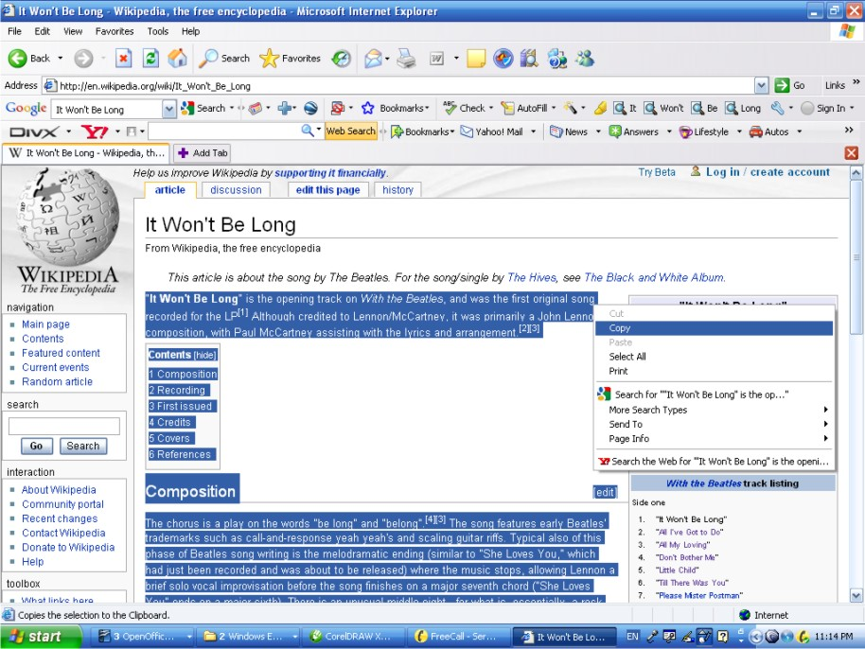

- Right click and in appeared menu click 'Copy”;
- Return to '4-ENTRY MUSIC ITEMS' form window and click on 'History' field;
- Right click and in appeared menu click 'Paste”. Article will appear in 'History:' field;
- Clean up from unnecessary details and not important data of pasted article inside 'History:' field;
Note: Don't worry about pictures and other bitmaps which could be highlighted in original article. The 'History:' field will automatically ignored them and all original incoming fonts will be transferred in Arial font.
Now we received the following picture:
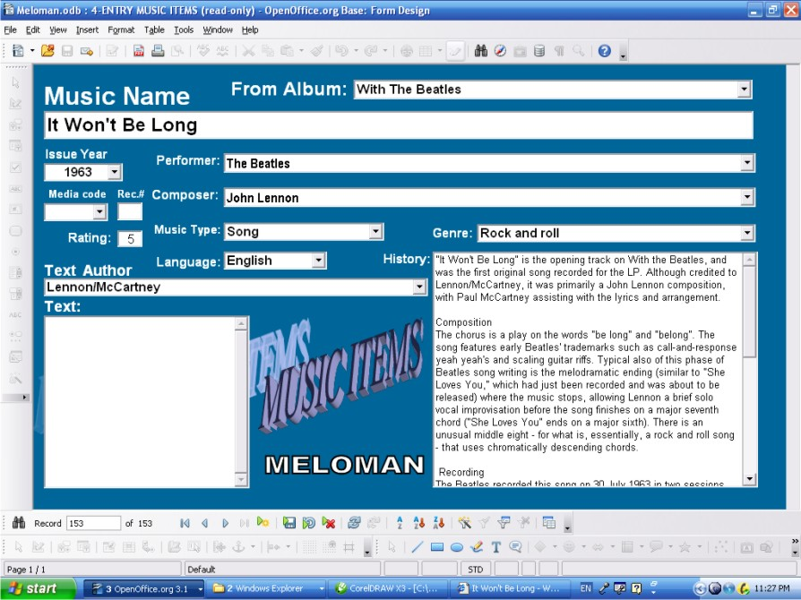
The last field which is not filled yet is 'Text:' field. So, to find the lyrics of “It Won't Be Long” Music Item we have to make another search in Internet. After some search we found the following:

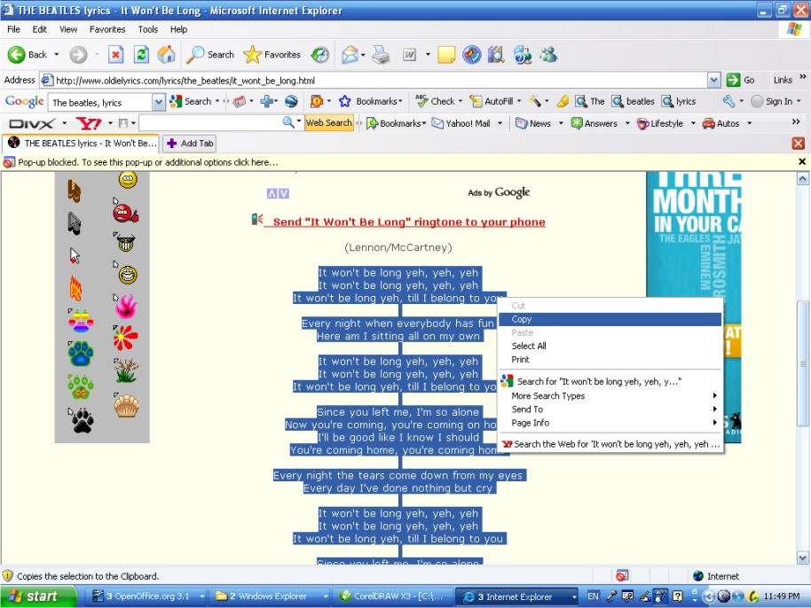

- By the same steps as we did for the 'History' field paste the lyrics to 'Text:” field;
And at least we have got fully filled Basic Record of Music Items table for “It Won't Be Long” Music Item by The Beatles.

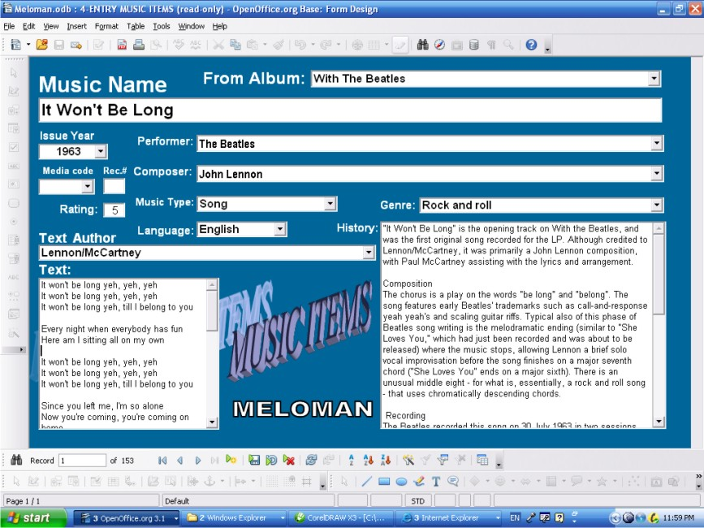

- Click “Close Window' button and click “Yes” button in appeared 'OpenOffice.org X.X' window asking about save changes.

ATTENTION: Closing any Entry Forms with saving doesn't mean we save changes on the disk. It means changes save in Database. All changes will be saved on the disk during exit from OpenOffice.Base.

Just Issued New Music Item

As a sample it's taken following Music Items:
Just bought CD with Album “Fast & Furious” which supposed to be collection Audio CD.
The first track and our new Music Item in the album is:
Name: Bang
Performer: Rye Rye Feat. M.I.A.
Composers and Writers are: R. Berrain, M. Arulpragasm, C. Smith

First of all let do quick search in Internet. We didn't find article about 'Bang' Music Item but we have figured out in some places that the 'Bang' Music Item belongs to Hip Hop genre.
After some search in Internet in Wikipedia we found special article devoted to Rey Rey:

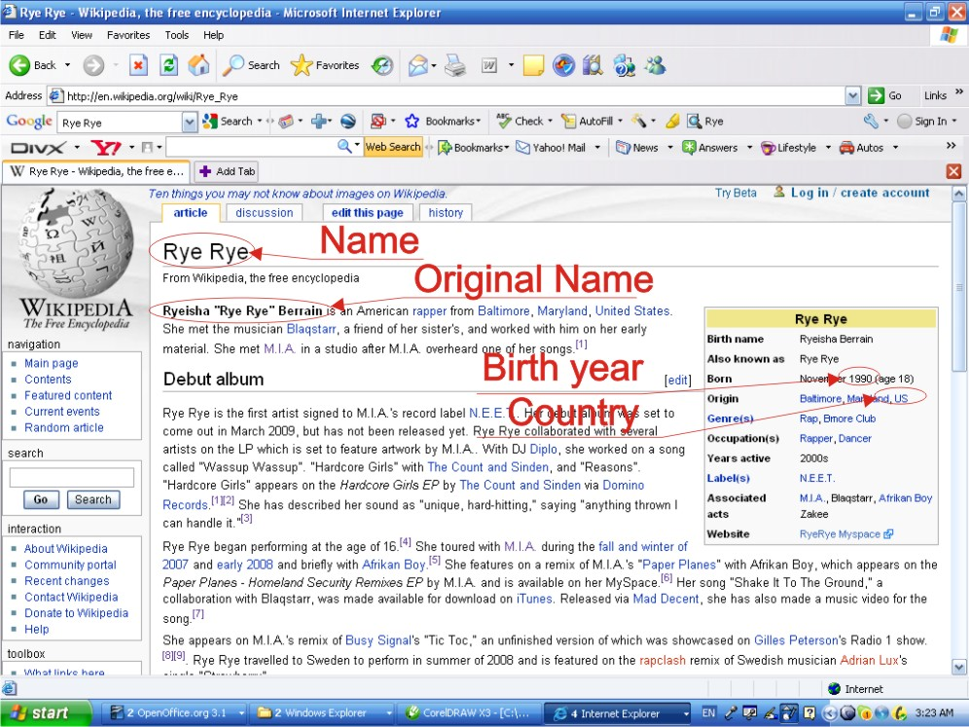
Because Rye Rye featured M.I.A. and M.I.A. took part in the Music Item creating and performing we have to find something about M.I.A . And we have found the following article about M.I.A.:
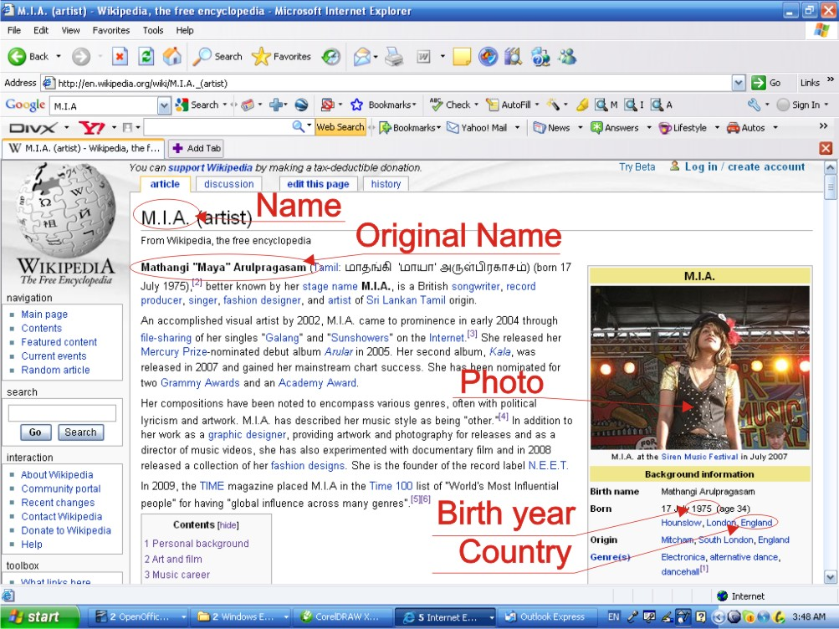
So let start Step 1. Notes to errors for Step1 see PAGE 53.

Step 1: Checking Performers and Persons
Actually we don't need to check our Database for Music Item (“Bang” by Rye Rye) because it is so new that we definitely know there is nothing in our Database about this Music Item. We need to input in our Database new data: Anyway the MELOMAN application doesn't allow to duplicate name of performer or person.
First of all we have to input Performer as written in the album: “Rye Rye Feat. M.I.A.”
- Double click on '1-ENTRY PERFORMERS & PERSONS' form in “Forms” area of Database interface (See picture on PAGE 9). The form shows 'First Record' of 'Performers and Persons' table. Keeping in mind that all Entry Forms are ready to edit let's go to new record to make sure ourselves not to distort existing data.
- Click 'New Record' button;
- Click 'Name' field and type “Rye Rye Feat. M.I.A.“;
We don't need to fill other fields of the record because this Performer name has two persons. And we are going to input separated records devoted to them. This record we are going to use just for 'Performer' field of 'Bang' Basic Record.
Let create two new records for “Rye Rye“ and “M.I.A.“.
- Click 'New Record' button;
- Click 'Name' field and type “Rye Rye“;
- Click 'New Record' button;
- Click 'Name' field and type “M.I.A.“;
- Click 'New Record' button;
- Click 'Name' field and type “R. Berrain, M. Arulpragasm, C. Smith“;
We don't need to fill other fields of the record because this Performer name has three persons. And we are going to input separated records devoted to them. This record we are going to use just for 'Composer' and 'Text Author' fields of 'Bang' Basic Record.
These three names mean three different persons who appeared in Music World. So, let create three different records for each of them.
- Click 'New Record' button;
- Click 'Name' field and type “R. Berrain“;
- Click 'New Record' button;
- Click 'Name' field and type “M. Arulpragasm“;
- Click 'New Record' button;
- Click 'Name' field and type “C. Smith“;
Now let's return to the record with Rye Rye name:
- Click 'Name' field;
- Click 'Find Record' button;
- In 'Search for' field of 'Record Search' window type “Rye Rye” (replacing everything in this field if it appears);
- Click 'Search' button of 'Record Search' window;
- Close 'Record Search' window;
Record with “Rye Rye” name will be open. All other fields are empty but we are ready to fill them because we found the article devoted to Rye Rye.
- Click drop down list button of 'Country' field. There is the whole list of countries names which 'Country' table has in A-Z order. Find and click country name '“USA”.
Other way: to begin to type in 'Country' field “USA”. After typing first letter “U” the full name “USA” will appear in the field.
- Highlight original name of Rye Rye from the article and paste it in 'Original Name' field of the record;
- Type or choose from the drop list for 'Birth Year' field the year “'1990” as the article mentions.

- We don't need to fill 'Life end year' field because Rye Rye is very young and of cause still alive.
Now let's go to our window with article devoted to Rye Rye which we found in Internet and highlight the whole text of the article or part of it which we want to keep in our Database:

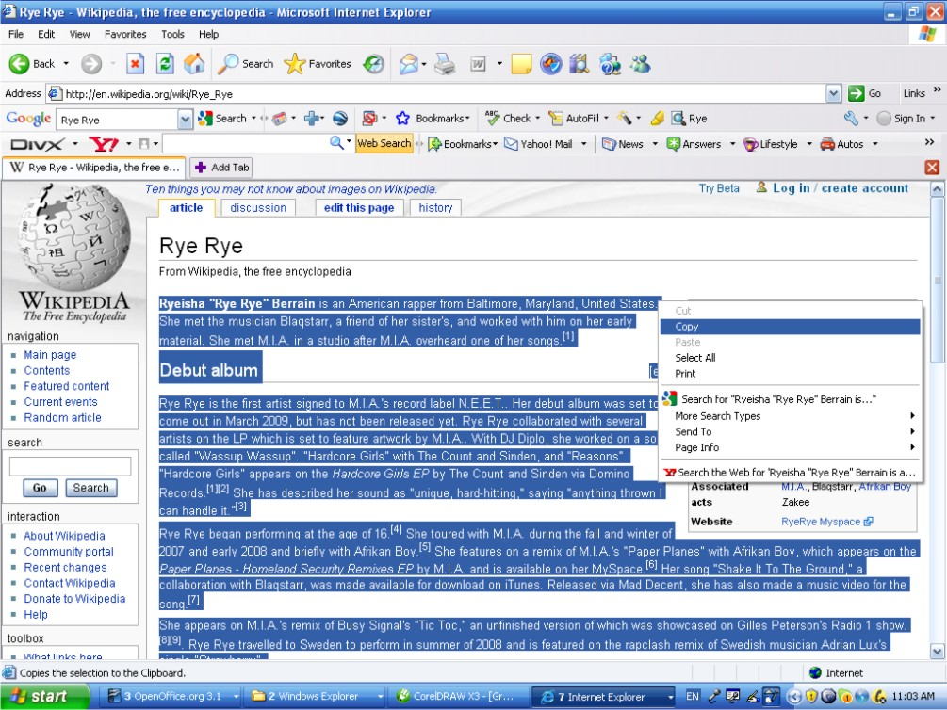
- Right click and in appeared menu click 'Copy”;
- Return to 'Performers & Persons' form window and click on 'Biography & History' field;
- Right click and in appeared menu click 'Paste”. Article will appear in 'Biography & History' field;
- Clean up from unnecessary details and not important data of pasted article inside ' Biography & History field;
Note: Don't worry about pictures and other bitmaps which could be highlighted in original article. The 'Biography & History' field will automatically ignored them and all original incoming fonts will be transferred in Arial font.
Now we received the following picture of 'Performers & Persons' form:
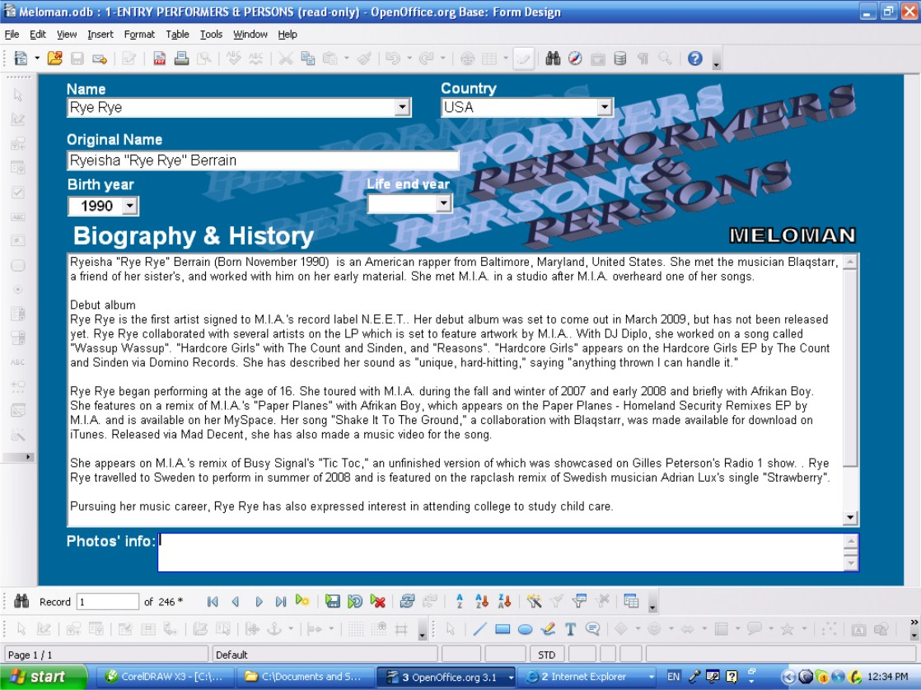

The last field which is not filled yet is 'Photos' info:' field. The article devoted to Rye Rye doesn't have any photo of the girl. So, to find photo of Rye Rye we have to make another search in Internet. After some search we found the following photos:
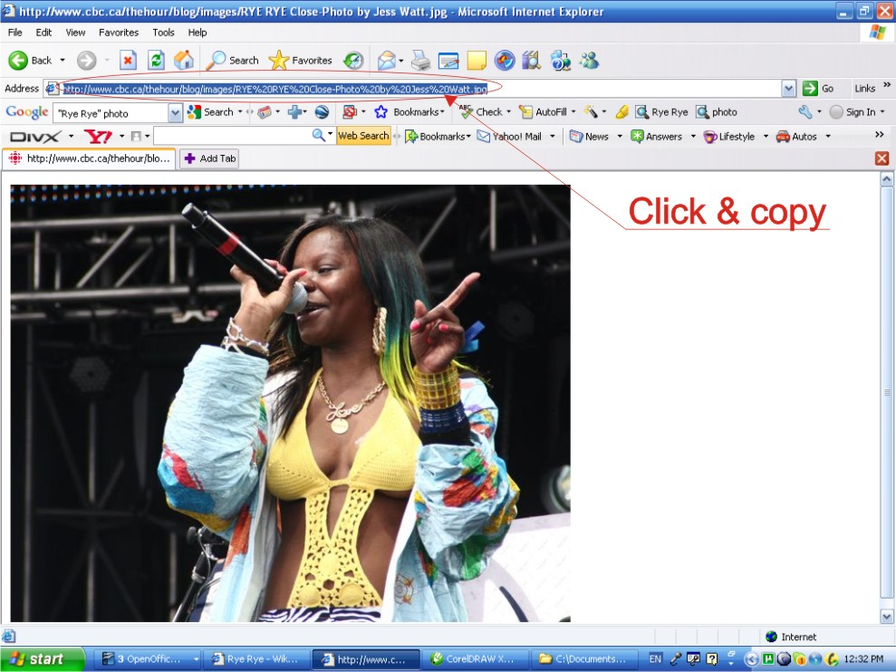

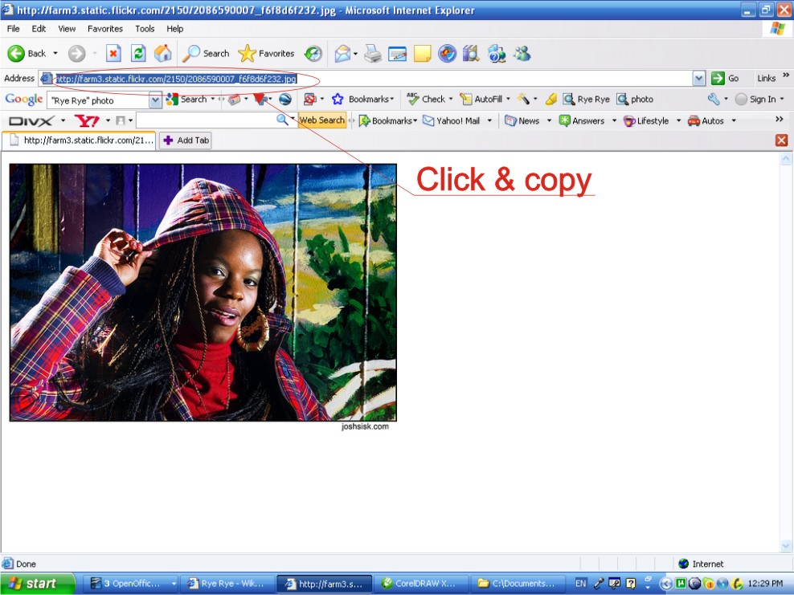

- Click link in 'Address' field of Internet browser (See photos above);
- Right click and in appeared menu click 'Copy”;
- Return to 'Performers & Persons' form window and click on 'Photos' info:' field;
- Right click and in appeared menu click 'Paste”. The link will appear in 'Photos' info: field;
- Do the same steps for second photo leaving some space after first link in 'Photos' info: field;
Notes:
We can input in “Photos' info:” field as many photos links as we can find starting every next link on a new line.
To restore any photo we have to go back way: Highlight (triple click) any Photo's link in 'Photos' info:' field, copy and paste into 'Address' field of Internet browser and press <Enter>. The photo will appear in 1-2 sec.
Now we received the following picture of 'Performers & Persons' form for Rye Rye:
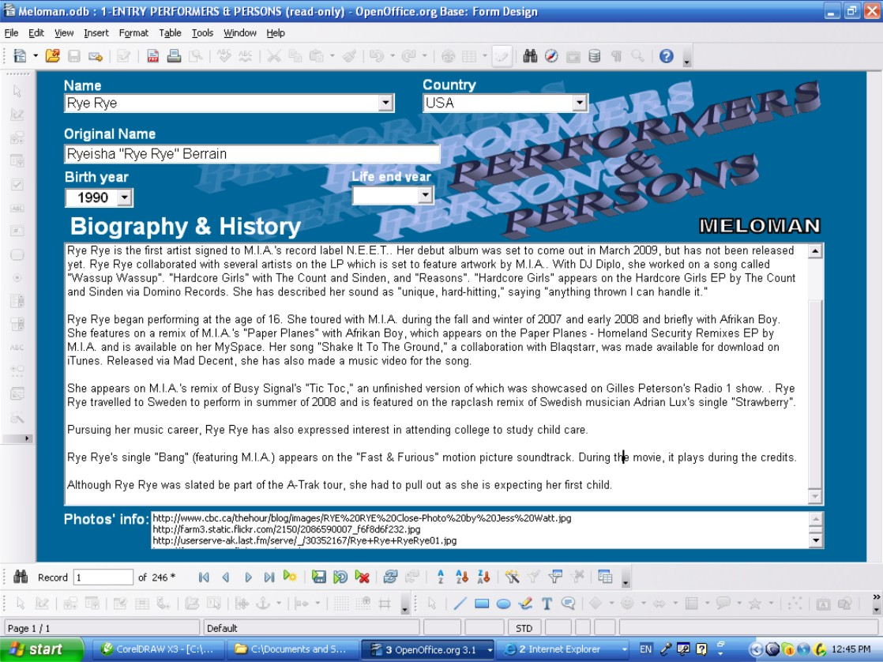
Now let's do the same steps of loading 'Performers & Persons' form for record with name of person “M.I.A.”:
- Click 'Name' field;
- Click 'Find Record' button;
- In 'Search for' field of 'Record Search' window type “M.I.A.” (replacing everything in this field if it appears);
- Click 'Search' button of 'Record Search' window;
- Close 'Record Search' window;
Record with “M.I.A.” name will be open. All other fields are empty but we are ready to fill them because we found the article devoted to M.I.A..

We can repeat all the steps which me did before for Rye Rye. But in this case we have M.I.A. photo already in the the article which we have found. We just need click several times on photo and find the original link.
After all steps we received the following record of 'Performers & Persons' form for M.I.A.:
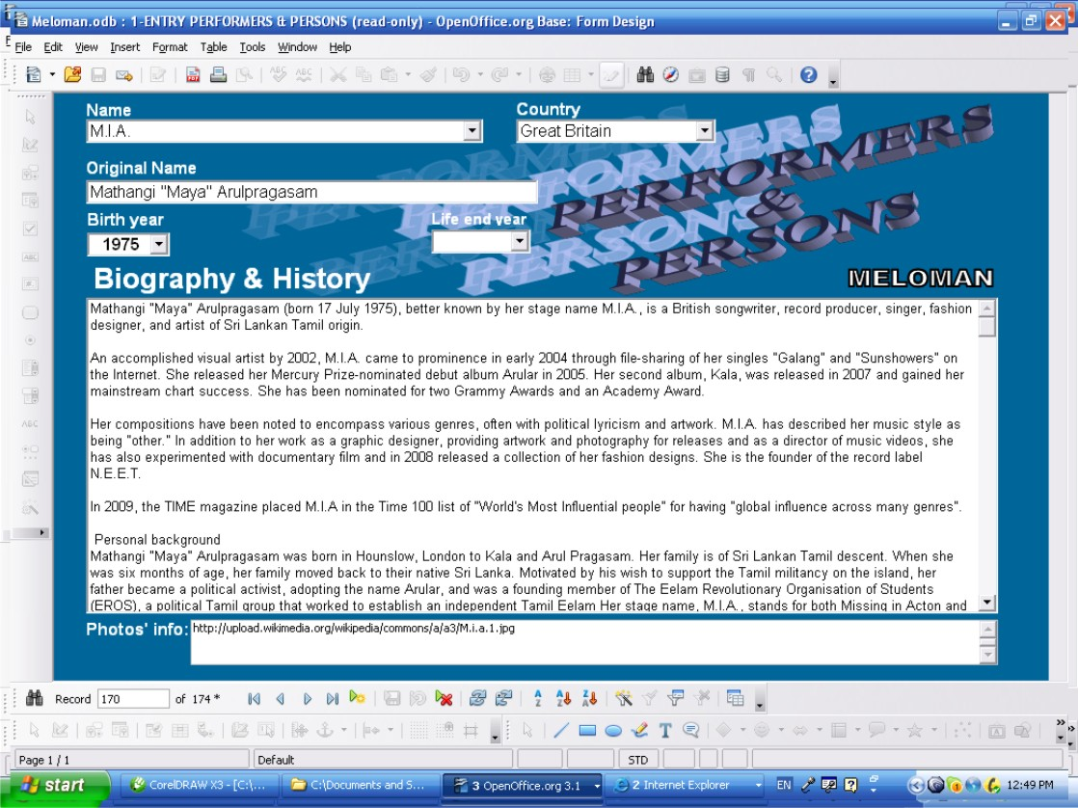
The next name of person which printed in the album for “Bang” Music Item is R. Berrain. Reading the article about Rye Rye we've got that R. Berrain is just another name of Rye Rye. So, we have to copy everything from all fields of Rye Rye record into according fields of R. Berrain record.

Now let's return to the record with Rye Rye name:
- Click 'Name' field;
- Click 'Find Record' button;
- In 'Search for' field of 'Record Search' window type “Rye Rye” (replacing everything in this field if it appears);
- Click 'Search' button of 'Record Search' window;
- Close 'Record Search' window;
Record with “Rye Rye” name will be open. All fields are filled but for copy we first of all need 'Biography & History' field because we have made some changes inside the field and it is not exactly the article from web site and now is unique.
- Highlight all data in 'Biography & History' field right click and choose 'Copy' from appeared menu.

Now let's find to the record with R. Berrain name:
- Click 'Name' field;
- Click 'Find Record' button;
- In 'Search for' field of 'Record Search' window type “R. Berrain” (replacing everything in this field if it appears);
- Click 'Search' button of 'Record Search' window;
- Close 'Record Search' window;
Record with “R. Berrain” name will be open. All other fields are empty.
- Click 'Biography & History' field;
- Right click and choose 'Paste' from appeared menu. The data from 'Biography & History' field of Rye Rye record will appear in 'Biography & History' field of R. Berrain record. We can finish filling of R. Berrain record as we did before for Rye Rye record.
But let see how it easy to do in 'Table Entry Performers & Persons' form:

Click “Close Window' button and click “Yes” button in appeared 'OpenOffice.org X.X' window asking about save changes.

- Double click on 'Table Entry Performers & Persons' form in “Forms” area of Database interface (See picture on PAGE 9). The form shows first page of 'Performers and Persons' entry table.
- Click any place on 'Name' column;
- Click 'Find Record' button;
- In 'Search for' field of 'Record Search' window type “R. Berrain” (replacing everything in this field if it appears);
- Click 'Search' button of 'Record Search' window;
- Close 'Record Search' window;
Now you can easy Copy & Paste data from Rye Rye record to R. Berrain record as shown below:
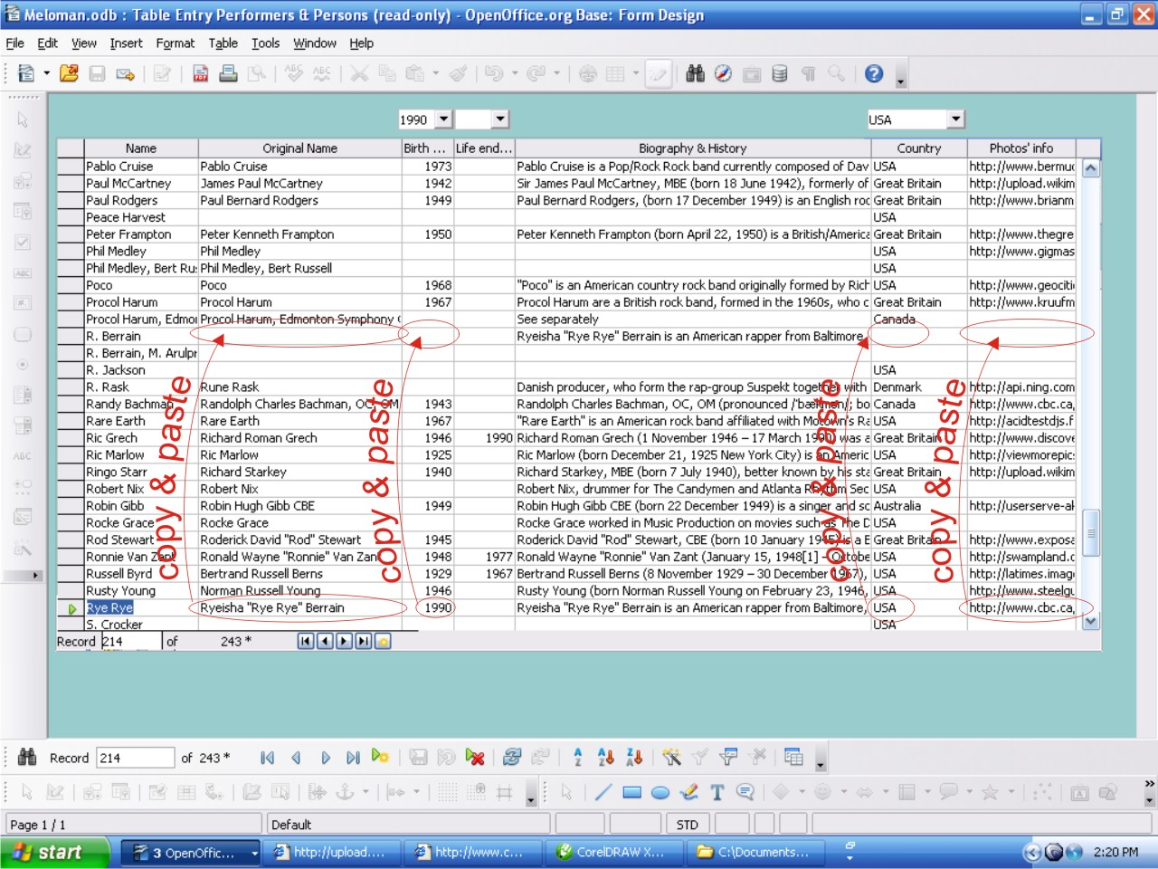

When we finish Copy & Paste operations from Rye Rye record to R. Berrain record it's not time to close 'Table Entry Performers & Persons' form because the next name of person which is printed in the album for “Bang” Music Item is M. Arulpragasm. Reading the article about M.I.A. we've got that M. Arulpragasm is just another name of M.I.A.. So, we have to copy everything from all fields of M.I.A. record into according fields of M. Arulpragasm record.
- Click any place on 'Name' column;
- Click 'Find Record' button;
- In 'Search for' field of 'Record Search' window type “R. Berrain” (replacing everything in this field if it appears);
- Click 'Search' button of 'Record Search' window;
- Close 'Record Search' window;
Now you can easy Copy & Paste data from Rye Rye record to R. Berrain record as shown below:
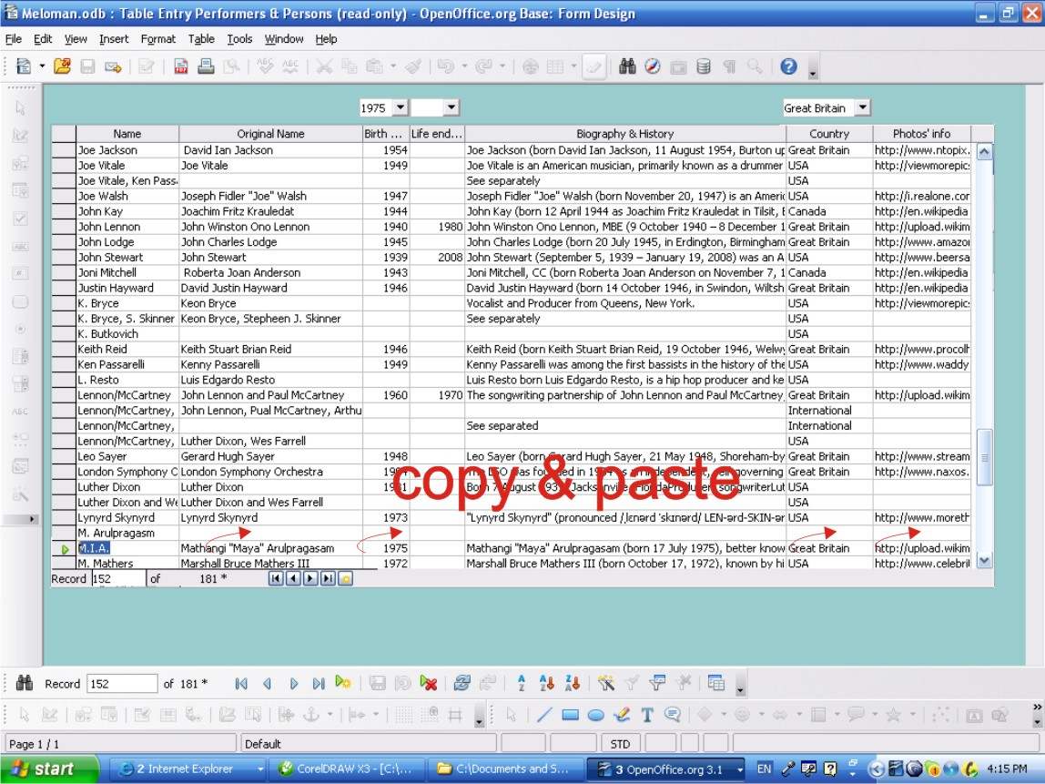

ATTENTION: Don't use ''Table Entry Performers & Persons' form to fill or Copy & Paste into 'Biography & History' field. To fill these field use the 1-ENTRY PERFORMERS & PERSONS' form only.

- Click “Close Window' button and click “Yes” button in appeared 'OpenOffice.org X.X' window asking about save changes.

Now we have to finish copying fields of M.I.A. record into according fields of M. Arulpragasm record. There is just 'Biography & History' field left
- Double click on '1-ENTRY PERFORMERS & PERSONS' form in “Forms” area of Database interface (See picture on PAGE 9). The form shows 'First Record' of 'Performers and Persons' table.
- Click 'New Record' button;
- Click 'Name' field “M.I.A.“;
- Click 'Find Record' button;
- In 'Search for' field of 'Record Search' window type “M.I.A.” (replacing everything in this field if it appears);
- Click 'Search' button of 'Record Search' window;
- Close 'Record Search' window;
Record with “M.I.A.” name will be open. All fields are filled but for copy we just need 'Biography & History' field because we have copied already all other fields in 'Table Entry Performers & Persons' form.
- Highlight all data in 'Biography & History' field right click and choose 'Copy' from appeared menu.

Now let's find to the record with M. Arulpragasm name:

- Click 'Name' field;
- Click 'Find Record' button;
- In 'Search for' field of 'Record Search' window type “M. Arulpragasm” (replacing everything in this field if it appears);
- Click 'Search' button of 'Record Search' window;
- Close 'Record Search' window;
Record with “M. Arulpragasm” name will be open. All fields are filled besides 'Biography & History' field.
- Click 'Biography & History' field;
- Right click and choose 'Paste' from appeared menu. The data from 'Biography & History' field of M.I.A. record will appear in 'Biography & History' field of M. Arulpragasm record.

Now in our Database we have full information about two persons who created the “Bang” Music Item and we can find them under any of both name which they appear in the Music World, they are:
- Rye Rye who has another name:R. Berrain;
- M.I.A. who has another name:M. Arulpragasm.
But we have the third person under name C. Smith who also took a part in creation of the “Bang” Music Item. After some investigation in Internet we can figure out that C. Smith is a person with real name Clifford Smith and more famous as Method Man. Very famous American rapper, author of 48 rap lyrics albums and 427 songs. So we have to input all information about this person in our Database as we did for Rye Rye and M.I.A.
To save place in this User's Guide this process is not shown and let say it is already done.
Thus:
Click “Close Window' button and click “Yes” button in appeared 'OpenOffice.org X.X' window asking about save changes.

We have finished Step 1 for a new Music Item “Bang”.

Step 2: Checking Genres of Music Item and Album
Step 2 is to find genre or style of the “Bang” Music Item and check: do we have this Genre Name in our Database or not.
During investigation in Step 1 we learnt already that the “Bang” Music Item belongs to Hip Hop genre. We also remember that we have this name of Genre in our Database. So we could skip this step and start next one but we know that the next step is devoted to album and we didn't find on the cover of CD we bought what genre the whole album belong to. Let's try to find more information in Internet with the purpose to find genre name of the album. By this way we will finish Step 2 and prepare ourselves to Step 3.
After some search in Internet we've found in Wikipedia article devoted to our album:
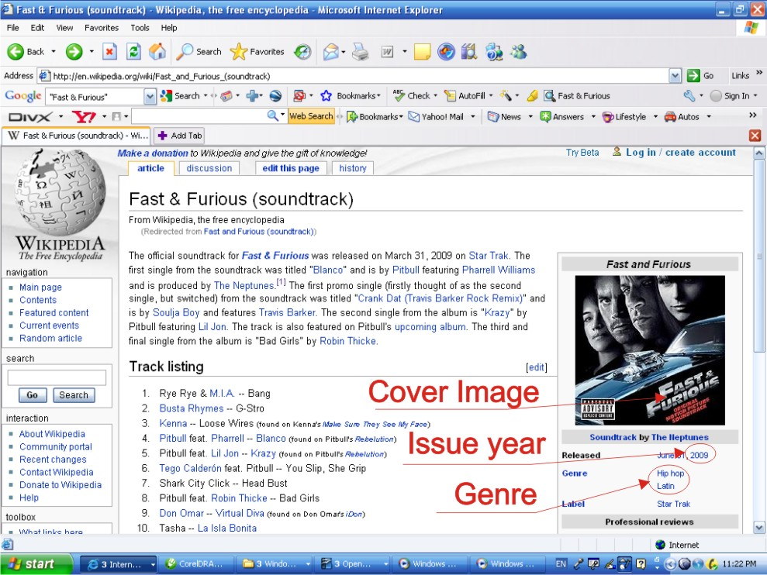

Wow! Actually it is not an album. It is a soundtrack! But let consider our new CD as the album. Anyway in our Database we don't have other place to keep information then Albums Table.
So, we found genre of the album, it is “Hip hop/Latin”. We don't remember do we have this Genre Name in our 'Music Genre” table. So, we have to check:

- Double click on '2-ENTRY MUSIC GENRE' form in “Forms” area of Database interface (See picture on PAGE 9). The form shows 'First Record' of 'Music Genre' table. Keeping in mind that all Entry Forms are ready to edit let's go to new record to make sure ourselves not to distort existing data.
- Click 'New Record' button;
- Click drop down list button of 'Music Genre' field. There is the whole list of Music Genre names which 'Music Genre table has in A-Z order.
Unfortunately :we didn't find 'Hip hop/Latin' Genre in our Database:

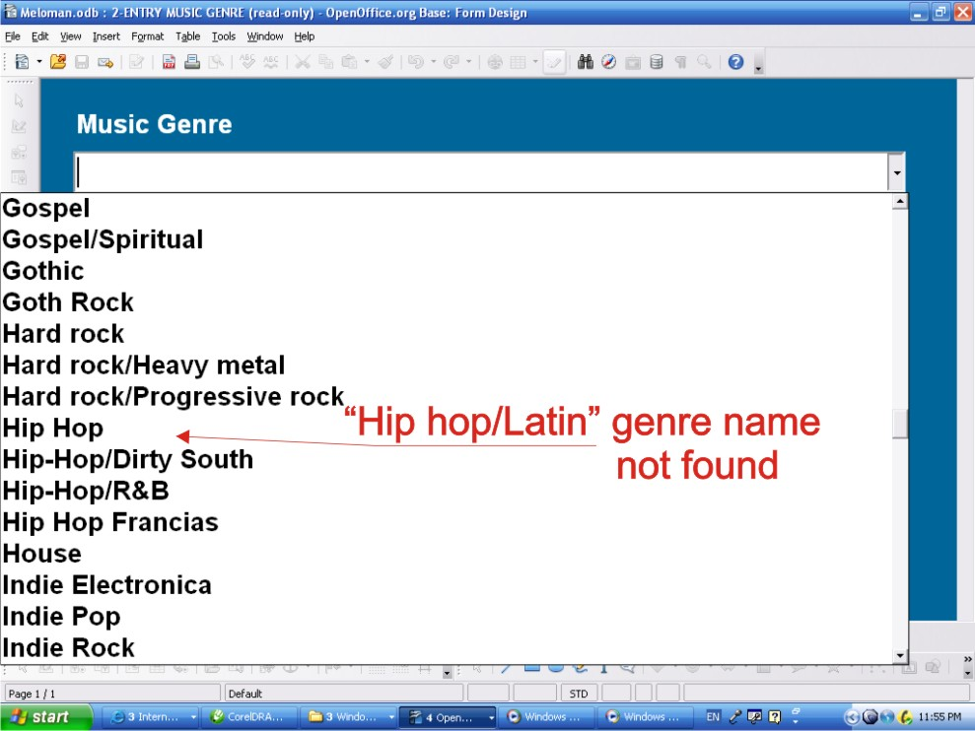

So we need to input new Genre name in 2-ENTRY MUSIC GENRE' form.

- Type 'Hip hop/Latin' in “Music Genre' field;
- Click 'Close Window' button;

Now we have finished Step 2.

Step 3: Checking Music Item's Album
We know that the “Bang” Music Item belongs to album named “Fast & Furious” because we've just bought this album on CD for our collection. Also we definitely know that we don't have the name of this album in our Database because we've never heard about this album before. So in this case Step 3 includes the process to input in our Database all available information about
“Fast & Furious” album. Some information we have on the cover of the album, some information we've got in the article during Step 2.

Let's start to fill a new Albums Table record.

- Double click on '3-ENTRY ALBUMS' form in “Forms” area of Database interface (See picture on PAGE 9). The form shows 'First Record' of 'Albums' table. Keeping in mind that all Entry Forms are ready to edit let's go to new record to make sure ourselves not to distort existing data.
- Click 'New Record' button;
- Click 'Album Name' field and type “Fast & Furious“;
- Click drop down list button of 'Country' field. There is the whole list of countries names which 'Country' table has in A-Z order. Find and click country name '“USA”.
Other way: to begin to type in 'Country' field “USA”. After typing first letter “U” the full name “USA” will appear in the field.
- Type or choose from the drop list for 'Issue Year' field the year “2009” as the article and CD cover mention.
For next two fields 'Performer' and 'Composer' there are two options for User:
- Leave these two fields empty because there are many performers and composers in this album (Compare to previous sample where The Beatles was one performer for the whole album);
- Input in one of them or in both fields all performers or composers of the album. In this case User has to close and save this Albums record. Open and input accordingly new record in 'Performers & Persons' form. Close it. Then open this record again and input performers or composers accordingly in these two fields.
It's recommended to input performer and composer in these two fields if they perform or composed all Music Items in album. So let leave them empty for this album.
- Click drop down list button of 'Genre: field. There is the whole list of genres names which 'Music Genre' table has in A-Z order. Find and click genre name '“Hip hop/Latin”.
Now let's go to our window with article devoted to our album which we found in Internet during Step 2 and highlight the whole text of the article or part of it which we want to keep in our Database:
- Right click and in appeared menu click 'Copy”;
- Return to 'Albums' form window and click on 'NOTES TO ALBUM' field;
- Right click and in appeared menu click 'Paste”. Article will appear in 'NOTES TO ALBUM' field;
- Clean up from unnecessary details and not important data of pasted article inside 'NOTES TO ALBUM' field;
Note: Don't worry about pictures and other bitmaps which could be highlighted in original article. The 'NOTES TO ALBUM' field will automatically ignored them and all original incoming fonts will be transferred in Arial font.

The last field which is not filled yet is 'Cover Image Info:' field. The article devoted to our album has already cover image of the album.
Click on this image several times to find original link of this image.
- Click link in 'Address' field of Internet browser;
- Right click and in appeared menu click 'Copy”;
- Return to 'Albums' form window and click on 'Cover Image Info:' field;
- Right click and in appeared menu click 'Paste”. The link will appear in 'Cover Image Info:' field;
We can input in “Cover Image Info:” field as many cover images links as we can find starting every next link on a new line.
Note:
To restore the image we have to go back way: Highlight Cover Image link in 'Cover Image Info:' field, copy and paste into 'Address' field of Internet browser and press <Enter>. The photo will appear in 1-2 sec.
Now we received the following picture of 'Albums' form for “Fast & Furious” album:

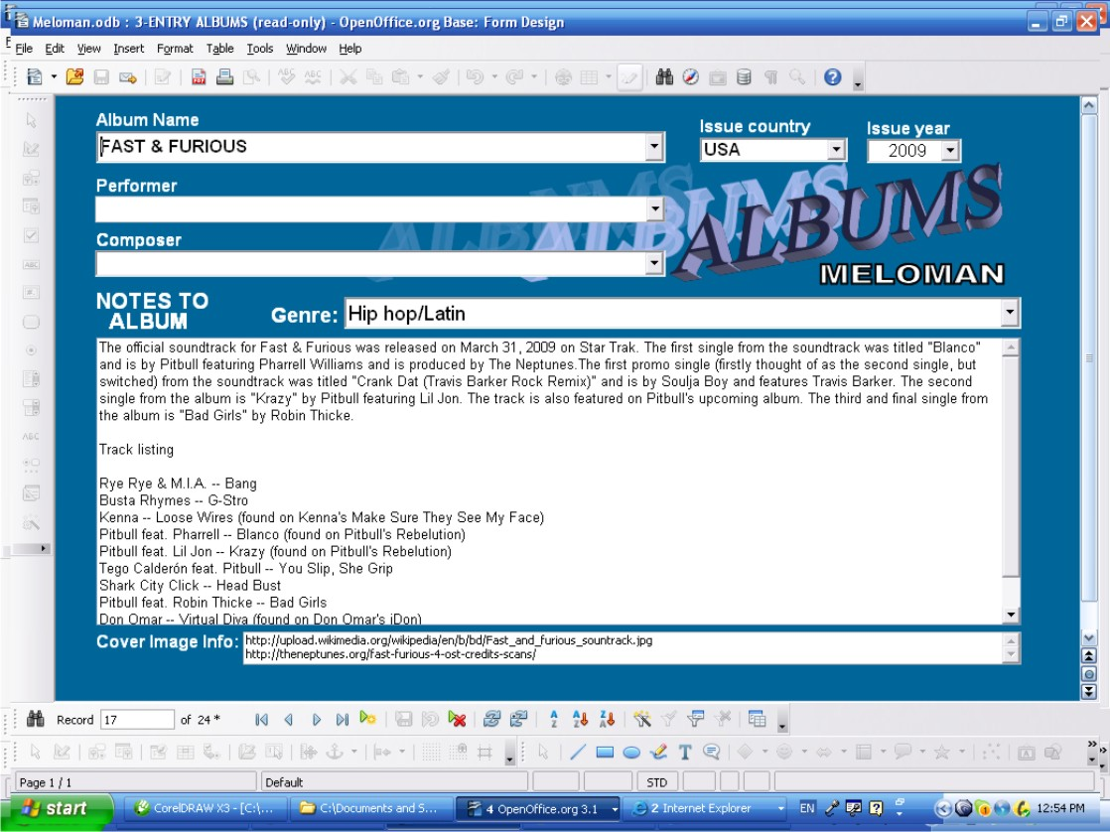

Step 4: Filling the Basic Record of Music Items Table.

By 1-3 Steps we have made ourselves sure that we have all needed data in our Database to fill the Basic Record for the “Bang” Music Item by Rye Rye and input all available information about the album and about all performers and persons who created this Music Item.
Before we begin to fill the Basic Record we have to register our new CD in our collection.
Let's do it:

- Double click on 'ENTRY MEDIA LIST' form in “Forms” area of Database interface (See picture on PAGE 9). The form shows 'First Record' of 'Media List' table. Keeping in mind that all Entry Forms are ready to edit let's go to new record to make sure ourselves not to distort existing data.
- Click 'New Record' button;
Let's go to fill the fields from top to bottom of the window:
- Click drop down list button of 'Media code' field. There is the whole list of Media codes which 'Media List' table has in A-Z order.
- Find and click last code of audio CD, foe example it would be '“CD0008”.
- Change in 'Media code' field last figure “8” into “9”. So. We've got new media code: “CD0009”
- Click 'Registration date' field and type current date, let type '08/01/09';
- Click drop down list button of 'Media name' field. There is the whole list of Albums which 'Albums' table has in A-Z order.
- Find and click album named '“FAST & FURIOUS”.
Other way: to begin to type in 'From Album:' field “FAST & FURIOUS”. After typing first letter “F” the full name “FAST & FURIOUS” will appear in the field.

Because of “FAST & FURIOUS” is just the name of the album but not a full name of our CD let's add more data from CD cover and type In 'Media Name' field after “FAST & FURIOUS” and some spaces the rest information fro CD cover: “Original Motion Picture Soundtrack”.
- Click drop down list button of 'Media type' field. There is the whole list of media type names which 'Media Type' table has in A-Z order.
- Find and click “CD audio disk”;
- Click drop down list button of 'Location' field. There is the whole list of possible media locations which 'Location' table has in A-Z order.
- Find and click “In collection”; ;
- Click 'Quality' field and type “High”.
So, we have filled all the fields of the 'ENTRY MEDIA LIST' form record and it looks like below:
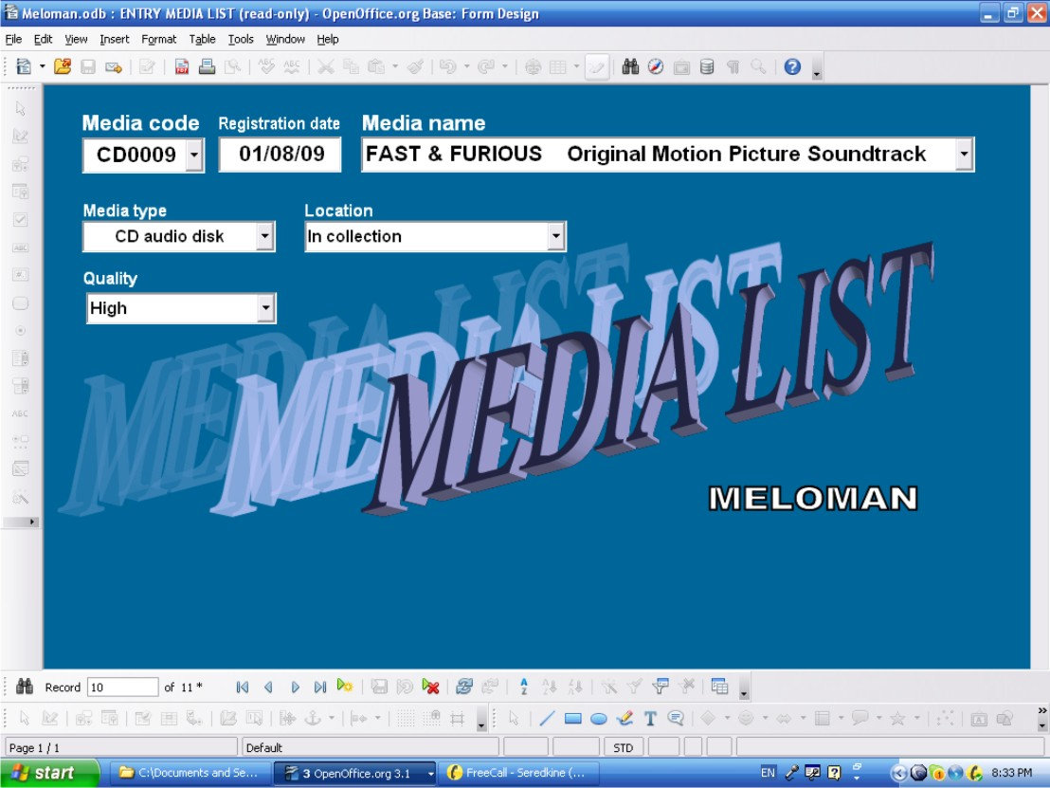
Click “Close Window' button and click “Yes” button in appeared 'OpenOffice.org X.X' window asking about save changes.

Let's start to fill the basic record for the first track of just bought CD named as soundtrack “Fast & Furious” . The track has name “Bang”, performed by “Rye Rye Feat. M.I.A.” and composed and written by R. Berrain, M. Arulpragasm, C. Smith.

- Double click on '4-ENTRY MUSIC ITEMS' form in “Forms” area of Database interface (See picture on PAGE 9). The form shows 'First Record' of 'Music Items' table. Keeping in mind that all Entry Forms are ready to edit let's go to new record to make sure ourselves not to distort existing data.
- Click 'New Record' button;

Let's go from top to bottom of the form:
- Click drop down list button of 'From Album' field. There is the whole list of Albums names which 'Album' table has in A-Z order. Find and click album named '“FAST & FURIOUS”.
Other way: to begin to type in 'From Album:' field “FAST & FURIOUS”. After typing first letter “F” the full name “FAST & FURIOUS” will appear in the field.
- Click 'Music Name' field and type “Bang” ;
- Click drop down list button of 'Issue 'Year' field find and click year “2009” or type “2009” direct in the field.
- Click drop down list button of 'Issue 'Media code' field find and click year “CD0009” because our new CD we registered under this media code;
- Click 'Rec.#' and type “1” because this Music Item is the first track in our new CD;
We can also input rating of the Music Item:
- Click 'Rating:' and type for example “3” (not so high);
- By the same way as filled 'From Album:' field fill 'Performer:' field by “Rye Rye feat. M.I.A.”;
- By the same way as filled 'From Album:' field fill 'Composer:' field by “R. Berrain, M. Arulpragasm, C. Smith”;
- By the same way as filled 'From Album:' field fill 'Music Type:' field by “Soundtrack” because it is soundtrack;
- By the same way as filled 'From Album:' field fill 'Genre:' field by “Hip Hop”;
- By the same way as filled 'From Album:' field fill 'Language:' field by “English”;
- By the same way as filled 'From Album:' field fill 'Text Author' field by “R. Berrain, M. Arulpragasm, C. Smith”;

This Music Item is new and doesn't have history but we can use 'History:' field to keep some other articles concerning to this Music Item. It could be interview with performer, composer or producer and so on. In our case we have copied and pasted from Internet the comments done on March 16, 2009.by some Anthony Coleman. We also can leave the 'History:' field empty or input a note like: “Not found yet”.
Concerning to lyrics of the 'Bang' Music Item even this is new soundtrack but lyrics is found very quickly:
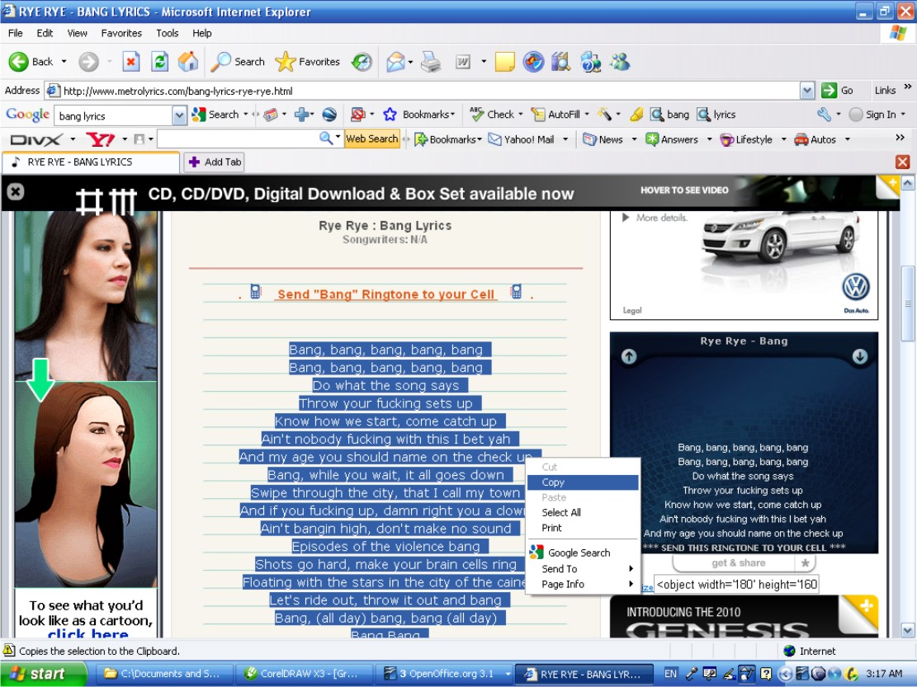

- Highlight the whole text of the lyrics we found as shown on the picture above;
- Right click and in appeared menu click 'Copy”;
- Return to '4-ENTRY MUSIC ITEMS' form window and click on 'Text:' field;
- Right click and in appeared menu click 'Paste”. Whole text of lyrics will appear in 'Text:' field;

Note: During Copy and Paste into 'History:' or 'Text:' fields all photos and other bitmaps are automatically ignored and all original incoming fonts will are transferred into Arial font.

Now we have got fully filled Basic Record of Music Items table for “Bang” Music Item by Rye Rye:
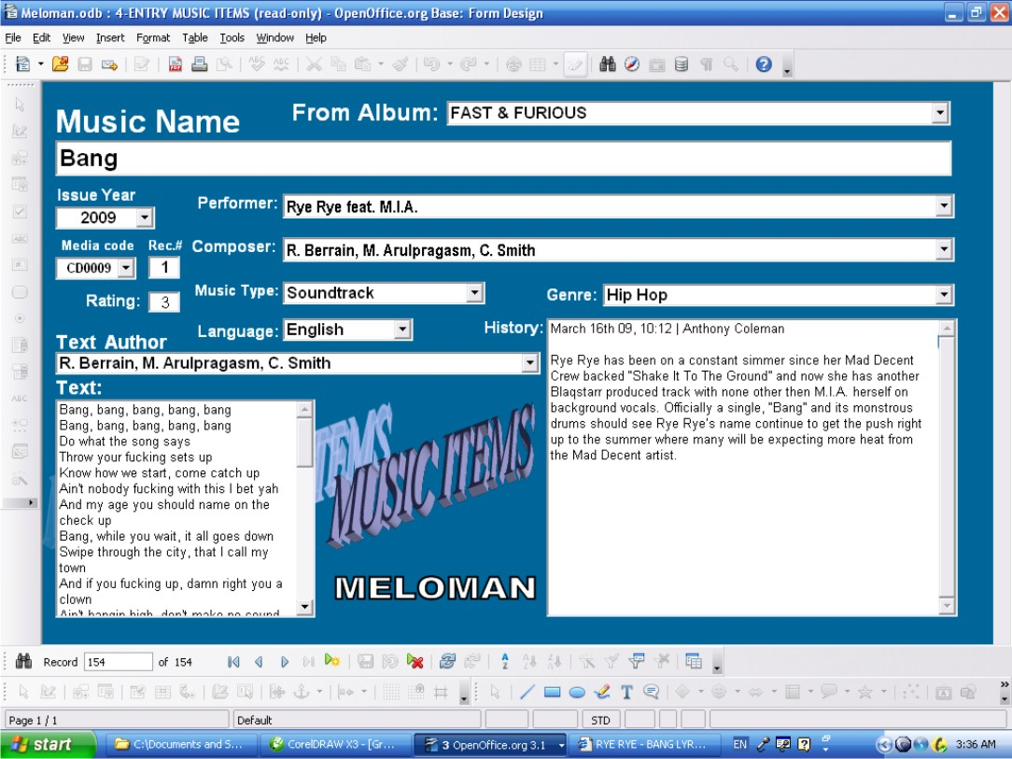

- Click “Close Window' button and click “Yes” button in appeared 'OpenOffice.org X.X' window asking about save changes.

ATTENTION: Closing any Entry Forms with saving doesn't mean that we save changes on the disk. It means changes are saved in Database. All changes will be saved on the disk during exit from OpenOffice.Base.

List of queries and reports supplied with MELOMAN Database application
Queries:
- Albums List with Database Information;
- List of all Collection Music Items with names of performers, media and record numbers in A-Z order;
- List of all Collection Music Items with names of performers, media and record numbers and sorted by media;
- Composers list with collection Music Items, media and record number;
- List of all Collection Music Items with names of performers, media and record numbers and sorted by Genres;
- List of Collection Music Items with names of performers, media and record numbers with choice of specific Genre (Ex.: Pop, Rock, Classic, Disco, Country etc.);
- Lyrics authors list with collection Music Items, media and record number;
- Media List with it's name and location;
- List of collection Music Items belong to and sorted by any albums with media and record numbers;
- List of collection Music Items issued as singles and not belong to any albums;
- Non-collection Music Items list
- Performers list with collection Music Items with media and record number;
- List of favorite music compositions according to rating in collection;
- List of Performers and Person with information about photos

Reports:

- Reports from queries listed in p.7 above;
- List of all Albums with note to them which Database has;
- List of all Performers and Persons with their biography and history which Database has;
- List of all Music Items with their lyrics;
- List of all Music Items with their history.

List of samples supplied with MELOMAN Database application

- Collection CD: ABBA GOLD GREATEST HITS
- Collection CD: Akon: "Konvicted"
- Collection CD: Bee Gees: "One Night Only"
- Collection CD: CLASSICAL CLASSICS VOLUME 1
- Collection CD: Give us some feedback!
- Collection CD: GREATEST HITS OF THE '70s VOLUME 2 DISC ONE
- Collection CD: GREATEST HITS OF THE '70s VOLUME 2 DISC TWO
- Collection CD: GREATEST HITS OF THE '70s VOLUME 2 DISC THREE
- Collection CD: MADONNA: "Music"
- Collection CD: Любэ: "СВОИ" (in Russian)
- Database bonus information: 15 albums “The Beatles”

