Software Specification Document

OpenOffice.org
Touchpoints to new dictionaries online

Specification Status
Last Change | Jun 20, 2008
Status
Abstract
As further dictionaries are available as extensions on the extension repository web site it helps the user to get quick access to them without the need to quit an application of OpenOffice.org.
Thus in the sub menu of Tools / Language a further entry will exist, which leads to the dictionaries on the web site.
Furthermore the dictionary language list box in the 'Spelling and Grammar' dialog will show a further entry also leading to this web site.
Also in the 'Edit Modules' dialog an additional link will lead to the same web site.
As it is planned to remove the currently existing document for installing further dictioanries under File / Wizards / Install new dictionaries... it makes sense to remove that menu item also. Esspecially, because no wizard is involved.

i-Team Members
Role | First Name, Last Name, Initials | E-Mail Address
I-Team Lead | Thomas Lange, TL | tl@openoffice.org
Specification Author | Bettina Haberer, BH | bh@openoffice.org
User Experience | Bettina Haberer, BH | bh@openoffice.org
Development | Thomas Lange, TL | tl@openoffice.org
Quality Assurance | Stefan Baltzer, SBA | sba@openoffice.org
Documentation | Uwe Fischer, UFI | ufi@openoffice.org
Other roles | <First Name, Last Name (Initials)> | <User@openoffice.org>
<State reason here, if one role is not represented in i-Team.>

Contents
Abstract 1
i-Team Members 1
References and Reference Documents 3
Acronyms and Abbreviations 3
1 Detailed Specification 4
1.1 Removed File Menu Entry 4
1.2 New Submenu Entry under Tools / language 5
1.3 Link to the Extension Repository Web Site to get more Dictionaries 6
2 Migration 7
3 Configuration 7
4 File Format 7
5 Open Issues 7
Document Change History 7

References and Reference Documents
Reference Document | Check | Location (URL)
Specification Process Entry Check |  | N/A
Product Requirement, RFE, issue [Required] |  | Issue 89981
Product Concept Document |  | <Please enter location here>
Competitive Analysis |  | <Please enter location here>
IDL Specification |  | <Please enter location here>
Test Case Specification [Required] |  | http://qa.openoffice.org/ooQAReloaded/TestcaseSpecifications/OpenOffice.org_3.0/Global/touchpoints_to_new_dictionaries.html
Software Specification Rules | N/A | N/A
<Other, e.g. references to related specs>
Acronyms and Abbreviations
Acronym / Abbreviation | Definition
<WYSIWYG> | <What You See Is What You Get>

Detailed Specification

Removed File Menu Entry
In OpenOffice.org 3.0 the current menu entry File / Wizards / contains a document with a macro allowing to install further dictionaries.
As this document will be removed in OpenOffice.org 3.0, the menu entry will be removed also.

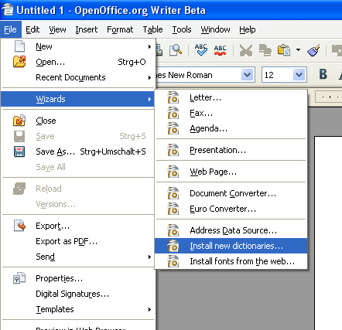
Figure 1: Former place to find new dictionaries: File / Wizards / Install new dictionaries...

New Submenu Entry under Tools / language
Instead of the former place for installing new dictionaries there will be a new menu entry in the tools menu for a quicker access to the dictionaries online.

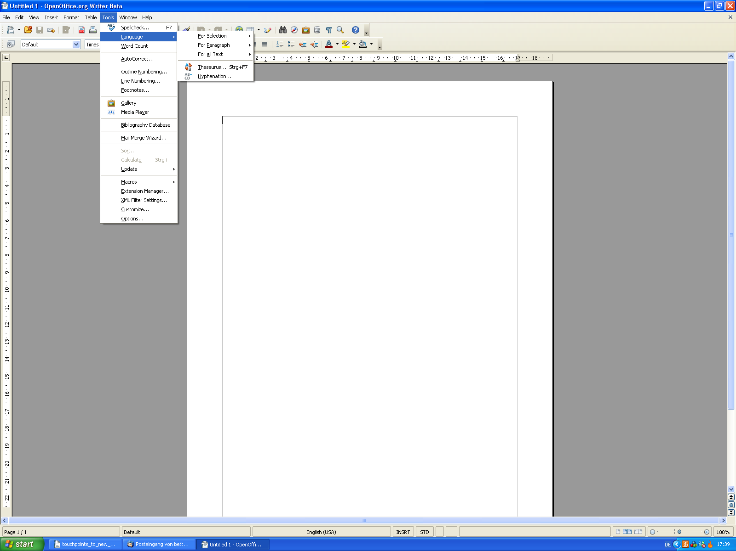
Figure 2: Accessing further dictionaries online from within the Tools / Language sub menu.
More Dictionaries Online...

The mockup shows in the submenu under Tools / Language a further entry 'More Dictionaries Online...'. This entry is visible with a splitter under the entry 'Hyphenation...'. This applies also to the other applications.
After a mouse click on this entry the browser opens at this link: http://extensions.services.openoffice.org/taxonomy/term/88

- “More Dictionaries Online” - Menu Properties |  |  |  | Comment
Menu Title: | Tools / Language |  |  | EN-US
Menu Position: | Under 'Hyphenation...'
Menu Items:
Items | Sub Items |  |  | Comment
More Dictionaries Online... |  |  |  | Calls the Extension Repository web site listing the available dictionaries.
Extended Tip Help Text: | Connects to the OpenOffice.org Extensions web site where you can download more dictionaries. |  |  | EN-US

Link to the Extension Repository Web Site to get more Dictionaries
Under Tools / Options / Language Settings / Writing Aids / Edit the 'Edit Modules' dialog opens.
Here an additional link will be integrated leading to the extension repository web site listing the dictionaries. At mouse over this link a tip help shows the URL http://extensions.services.openoffice.org/taxonomy/term/88.
At click on it the browser opens at the above mentioned URL.

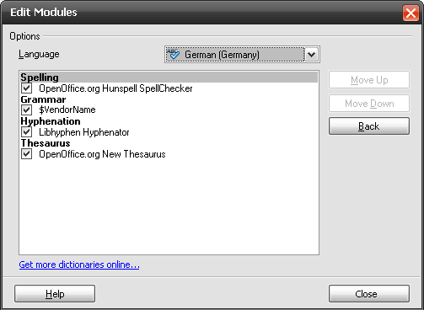
Drawing 1: The 'Edit Modules' dialog with an additional link to further dictionaries.

- Link Properties |  | Comment
Enabled: | Yes
Disabled: | No
Press: | Calls the Extension Repository web site listing the available dictionaries.
Link Text: | Get more dictionaries online... | EN-US
Tip Help Text: | http://extensions.services.openoffice.org/taxonomy/term/88

The same link will be integrated in the 'Options'-dialog of the 'Spelling and Grammar' dialog.

Both dialogs keep open after mouse click on the browser, the user has to close them himself. In case the user has made some changes in the dialog an automatic close of the dialogs could brake the workflow.

Migration
Not relevant.

Configuration
Not relevant.

File Format
Not relevant.

Open Issues
Issue | Initials | Date
<State Issue here, State “None”, if all issues are solved> |  | <Format: Dec 31, 2000>
<...>

Document Change History
Rev. | Change | Initials | Date
1 | Initial Specification | BH | 26.05.2008
2
3
<...>

