Software Specification Document

OpenOffice.org Writer
Smart Tags

Specification Status
Last Change | Jul 27, 2007
Status
Abstract
A smart tag scans the text of a document thru an API (i.e. for stock symbols like “SUNW”) and could offer functionality for such a recognized text via a context menu. Smart tags can be provided by extensions. This first version will support Writer text documents only and is only visible in the product if at least one Smart Tag has been installed.
i-Team Members
Role | First Name, Last Name, Initials | E-Mail Address
I-Team Lead | Frank Meies | frank.meies@sun.com
Specification Author | Frank Loehmann | frank.loehmann@sun.com
User Experience | Frank Loehmann | frank.loehmann@sun.com
Development | Frank Meies | frank.meies@sun.com
Quality Assurance | Michael Ruess | michael.ruess@sun.com
Documentation | Uwe Fischer | Uwe.fischer@sun.com

Contents
Abstract 1
i-Team Members 1
References and Reference Documents 3
Acronyms and Abbreviations 3
1 Detailed Specification 4
1.1 Option Dialog for Smart Tags 4
1.2 Smart Tag Interaction in Text 5
1.2.1 Only a Single Smart Tag for a Recognized Text 5
1.2.2 Multiple Smart Tags Available for Recognized Text 6
1.2.3 Context Menu for Text 7
1.3 Behavior of Links and SmartTags in Writer 8
1.4 Appearance Color Settings 8
1.5 Default Smart Tags 9
2 Migration 9
3 Configuration 9
4 File Format 9
5 Open Issues 9
6 Dialog Elements for Future Versions 10
Document Change History 10

References and Reference Documents
Reference Document | Check | Location (URL)
Specification Process Entry Check |  | N/A
Product Requirement, RFE, issue [Required] |  | I75130
Product Concept Document |  | <Please enter location here>
Competitive Analysis |  | <Please enter location here>
IDL Specification |  | <Please enter location here>
Test Case Specification [Required] |  | <Please enter location here>
Software Specification Rules | N/A | N/A
Spec: Behavior of Hyperlinks in OOo Documents |  | http://specs.openoffice.org/appwide/hyperlinks/Behavior_of_Hyperlinks_in_OOo_Documents.odt
Acronyms and Abbreviations
Acronym / Abbreviation | Definition
<WYSIWYG> | <What You See Is What You Get>

Detailed Specification
Smart tags are using so called recognizers to scan the textual content of a document to match a pattern. If a text part has been identified by those recognizers, the text get marked in the document and offers special interaction via a context menu. This menu offers functionality provided by the smart tag plus some standard entries provided by OOo.
General smart tag behavior:
- Smart Tag feature is only visible, if at least one Smart Tag is installed.
- The Smart tags feature is turned on by default.
- Smart tags are then marked by a magenta underlining in the text of a Writer document.
- Smart tags recognized text parts will not be spelled by online spelling.
- Mouse over shows a bubble help to guide the user to click Ctrl+left click to show the smart tag context menu.
- Control + left mouse click on those text parts opens up a special Smart Tag context menu.

Option Dialog for Smart Tags
The following Smart Tags tab page is shown as a new tab page in the AutoCorrect dialog. The properties button is only enabled, if the selected smart tag offers a properties dialog.
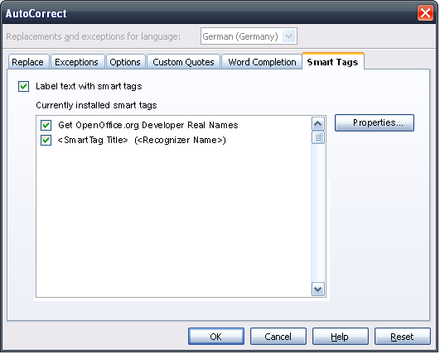Illustration 1: AutoCorrect dialog in Writer gets extended by a new tab page "Smart Tags"

- “Smart Tags” - Tab Page |  | Comment
Titel: | Smart Tags |  | EN-US
Titel: | Smarttags |  | DE

- Label text with smart tags” - CheckBox Properties |  | Comment
Enabled: | Always
Disabled: | Never
Checked: | By Default
CheckBox Label: | Label text with smart tags |  | EN-US
CheckBox Label: | Text mit Smarttags versehen |  | DE

- “Smart Tags” - ListBox Properties |  | Comment
Enabled: | Yes
Disabled: | If #2 is unchecked
Items: | <List of all currently installed Smart Tags | EN-US, DE
Item Selected: | No. 1
Sorting by Drag & Drop: | No
ListBox Label: | Currently installed smart tags |  | EN-US
ListBox Label: | Aktuell installierte Smarttags |  | e.g. DE

- “Properties” - Button Properties |  | Comment
Enabled: | If the selected smart tag in the rich list box (#3) has an own settings dialog.
Press: | Calls the settings dialog of a smart tag.
Button Label: | Properties... |  | EN-US
Button Label: | Einstellungen... |  | e.g. DE

Smart Tag Interaction in Text
A Smart Tag provides a menu (see illustration below) called by Ctrl + left mouse click or via a sub menu in the context menu of text.

Only a Single Smart Tag for a Recognized Text
- Then the Smart Tag menu consist of three parts.
  - The first part is the Smart Tags header and can not be selected. This header ends with a separator below.
  - The second part shows the Smart Tag actions provided by this Smart Tag. Text shown here is defined by the Smart Tag
  - The third part also divided by a separator is static and allows to call the Smart Tag options dialog.
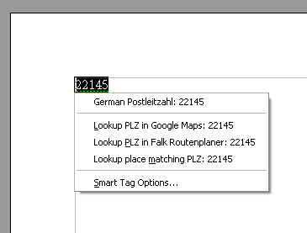Illustration 2: Smart Tag menu called via Ctrl+Click in Writer

- Smart Tag Menu - Menu Properties |  |  |  |  | Comment
Menu Title: | Smart Tag Options... |  |  |  | EN-US
Menu Title: | Smarttag Optionen... |  |  |  | DE
Menu Position: | At the end of the context menu
Menu Items:
Items | Sub Items | Sub Items | KBD Shortcuts | Icon | Comment
Smart Tag Options...,  Smarttag Optionen... |  |  | none |  | Calls the Tools-AutoCorrect.Smart Tags dialog.

Multiple Smart Tags Available for Recognized Text
In case of multiple Smart Tags available for a text, the Smart Tag menu is show slightly different to offer all available Smart Tags.
- The Smart Tag menu in case of multiple Smart Tags consist of two parts.
  - The first part shows the names of all available Smart Tags. This section ends with a separator below.
    - The sub menu for each Smart Tag consists of two sections
      - The first part is the Smart Tags header and can not be selected. This header ends with a separator below.
      - The second part shows the Smart Tag actions provided by this Smart Tag. Text shown here is defined by the Smart Tag
  - The second part also divided by a separator is static and allows to call the Smart Tag options dialog.
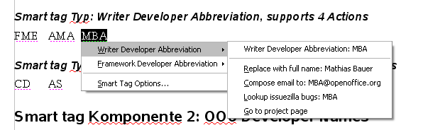Illustration 3: Smart Tag menu for more multiple available Smart Tags

Context Menu for Text
The right mouse click context menu of a Smart Tag is extended by a an entry “Open Smart Tag menu” to access the functionality of a Smart Tag. The sub menu shown is equal to the normal Smart Tag menu except the missing entry to call the Smart Tag option dialog.
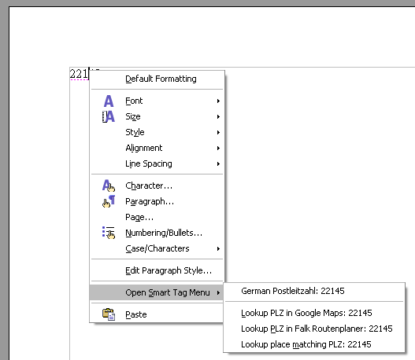Illustration 4: Context Menu of a Smart Tag in Writer

- Smart Tag Menu - Menu Properties |  |  |  |  | Comment
Menu Position: | In front of the Cut, Copy & Paste entries. Or at the end of the menu if those are not show.
Menu Items:
Items | Sub Items | Sub Items | KBD Shortcuts | Icon | Comment
Open Smart Tag Menu,  Smarttag Menü öffnen | <See Smart Tag Menu definition above> |  | none |  | Calls the Smart Tag menu.

Behavior of Links and SmartTags in Writer
Writer provides a tip help above Smart Tags in text document. Ctrl-left mouse click opens the SmartTag menu. Furthermore the behavior of hyperlinks has been changed to this Ctrl-click behavior. Please find details in the following spec: http://specs.openoffice.org/appwide/hyperlinks/Behavior_of_Hyperlinks_in_OOo_Documents.odt

Appearance Color Settings
The appearance settings in Tools-Options will be extended by a setting to define the underlining color used for smart tags.
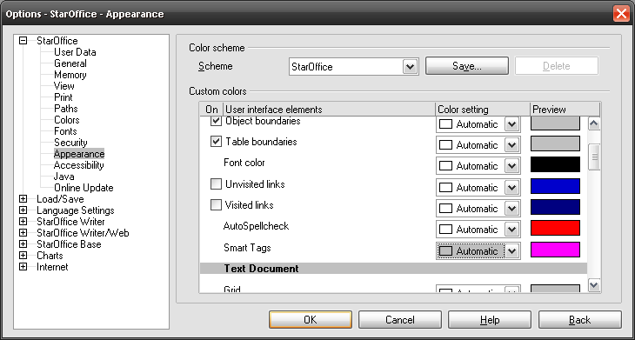Illustration 5: The color for highlighting Smart Tags in text can be change in Tools-Options-StarOffice-Appearance

- “Custom Colors” - ListBox Properties |  | Comment
Enabled: | always
Items: | - Smart Tags ; Smarttags | EN-US, DE
Other: | Additional item for the General section. Position: Below AutoSpellcheck. Entry
ListBox Label: | Custom Colors | EN-US

Default Smart Tags
There are no Smart Tags being delivered with OOo 2.3. The Smart Tag feature is initially not visible in the product, unless a Smart Tag has been installed as an OOo extension.

Migration
Not relevant. New feature.

Configuration
Configuration | Group | Setting | Type | Default | Comment
UI.xcs | ColorScheme | new group SmartTags |  |  | String: “Specifies the settings for smart tags.”
UI.xcs | ColorScheme/SmartTags | Color | int |  | String: “Specifies the color of smart tags.”
UI.xcu | ColorScheme/SmartTags | Color | nil
Common.xcs |  | new group SmartTags |  |  | String: “Contains settings for smart tags.”
Common.xcs | SmartTags | new group Writer |  |  | String: “Contains Writer specific settings for smart tags.”
Common.xcs | SmartTags/Writer | RecognizeSmartTags | Boolean | True | String: “Specifies whether smart tag recognization is enabled.”
Common.xcs | SmartTags/Writer | ExcludedSmartTagTypes | string-list |  | String: “A list of excluded smart tag types.”
GenericCommands.xcu | Commands | .uno:OpenSmartTagMenuOnCursor | string |  | String: “Open Smart Tag Menu”

File Format
Not relevant. Currently Smart Tags and already recognized text will not be saved with the document,

Open Issues
Issue | Initials | Date
- Smart tags can also be shown as buttons in text. <FL: This design makes sense if we have action buttons and if we save smart tags with the document> | FL | April 20, 2007
- Ctrl + Click for links in edit mode for Calc and Draw/Impress | FL | April 20, 2007
- Add link to Smart Tag options dialog to Smart Tag Menu accessed from the normal context menu for text. | FL | May 20, 2007

Dialog Elements for Future Versions
- Show Smart Tag option buttons” - CheckBox Properties |  | Comment
CheckBox Label: | Show Smart Tag option buttons in text |  | EN-US
CheckBox Label: | Smarttags Optionen als Schaltflächen im Text anzeigen |  | e.g. DE

- “Download more Smart Tags” - Label Properties |  | Comment
Label: | Download more smart tags... |  | EN-US
Label: | Weitere Smarttags herunterladen... |  | e.g. DE

- Show AutoCorrect option buttons in text” - CheckBox Properties |  | Comment
Enabled: | always
Disabled: | never
Checked: | default
CheckBox Label: | Show AutoCorrect option button in text |  | EN-US
CheckBox Label: | AutoKorrektur Optionen als Schaltflächen im Text anzeigen |  | e.g. DE
Document Change History
Rev. | Change | Initials | Date
1 | Draft of Spec. | FL | 20. April, 2007
2 | Final | FL | 22. May, 2007
3 | Change“Ctrl-Click” -> “Ctrl-Click” see i79263 | FL | 05. July, 2007
4 | Ctrl-click only in edit mode | FL | 17. July, 2007
5 | Move Smart Tag Definition to separate spec. | FL | 25. July, 2007

