Software Specification Document

OpenOffice.org Calc
Enhanced Data Input

Specification Status
Last Change | Oct 9, 2007
Status
Abstract
Entering data into a spreadsheet is an important but time consuming task. So every keyboard input and mouse click which can be saved makes it faster to accomplish this task. Furthermore it reduces input errors and makes this task much more comfortable for the user. Entering data could be done column or row wise. This specification improves the row wise method. Therefore the Return key works like a carriage return-line feed on a type writer and allows to return to the column where the input started, but just a row below the current row.
i-Team Members
Role | First Name, Last Name, Initials | E-Mail Address
I-Team Lead | Niklas Nebel (NN) | niklas.nebel@sun.com
Specification Author | Frank Loehmann (FL) | frank.loehmann@sun.com
User Experience | Frank Loehmann (FL) | frank.loehmann@sun.com
Development | Thomas Benisch (TBE) | thomas.benisch@sun.com
Quality Assurance | Frank Stecher (FST) | frank.stecher@sun.com
Documentation | Uwe Fischer (UFI) | uwe.fischer@sun.com

Contents
Abstract 1
i-Team Members 1
References and Reference Documents 3
Acronyms and Abbreviations 3
1 Detailed Specification 4
1.1 Row wise data input (Issue 15546) 4
2 Migration 4
3 Configuration 4
4 File Format 4
5 Open Issues 4
Document Change History 5

References and Reference Documents
Reference Document | Check | Location (URL)
Specification Process Entry Check |  | N/A
Product Requirement, RFE, issue [Required] |  | i15546
Product Concept Document |  | <Please enter location here>
Competitive Analysis |  | <Please enter location here>
IDL Specification |  | <Please enter location here>
Test Case Specification [Required] |  | Test Case Specification
Software Specification Rules | N/A | N/A
<Other, e.g. references to related specs>
Acronyms and Abbreviations
Acronym / Abbreviation | Definition

Detailed Specification

Row wise data input (Issue 15546)
The user can press the Tab key to leave the edit mode of the current cell and to jump to the next cell to the right. This allows a row wise input into a spreadsheet. When the Return key is pressed after a cycle of row wise data input, the input selection returns to the columns, where this input cycle has begun and selects the cell below the source cell to open a new row to input data.
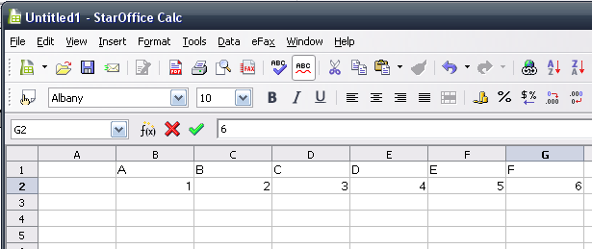Illustration 1: Row wise data input
3. New row for inputting gets selected
2. Return key confirms input and jumps to cell B3
1. Data input started here. Tab key jumps to next cell to the right

Migration
None, new feature.

Configuration
None.

File Format
None, new UI feature.

Open Issues
Issue | Initials | Date
None.

Document Change History
Rev. | Change | Initials | Date
1 | Initial Spec | FL | August 02, 2007
2 | Updated specification | TBE | October 9, 2007

