Automated locale settings under Windows
OpenOffice.org 2.0.1

Document - ID | Specification Owner | Last Change | Status
 | Falko Tesch | 11/8/05 | Final
Conforms to | SIPA
Applies to | Setup/Installation
Task ID(s) | I42730, i48123
Category | Feature

Abstract
The goal is to make Thai (and other language) users to be able to use the OOo binary in their language out-of-the-box. So there will be no need for Thai (or other language) specific versions of OOo. To accomplish this, the setup program should consider the user's system locale and configure the installation accordingly.

i-Team Members (The specification owner is part of the i-Team)
 | Name | E-mail Address
User Experience | Falko Tesch | falko@sun.com
Development | Oliver Specht | oliver.specht@sun.com
Quality Assurance | Helge Delfs | Helge.delfs@sun.com
Documentation | Uwe Fischer | uwe.fischer@sun.com
Customer | James Clark (SIPA) | jjc@sipa.or.th

Approved for Implementation
 | Approved by | Date
User Experience | Falko Tesch | falko@sun.com
Development | Oliver Specht | oliver.specht@sun.com
Quality Assurance | Helge Delfs | Helge.delfs@sun.com
Documentation | Uwe Fischer | uwe.fischer@sun.com
Customer | James Clark (SIPA) | jjc@sipa.or.th
String Review | Falko Tesch | falko@sun.com

Document Change History
Rev. Level | Change | Initials | Date
1.0 | first draft |  | 30.09.05
1.1 | Final status | FT | 14.10.05
1.2 | Corrected the QA and Documentation responsible | SBA | 08.11.05

Contents
Glossary 1
1 Motivation 1
2 Goals 1
3 Requirements and Dependencies 1
3.1 Requirements 1
4 Detailed Specification 2
5 Notes 3
6 References 3

Glossary
Term | Description
<Term 1>

Motivation
The goal is to make Thai (and other language) users to be able to use the OOo binary in their language out-of-the-box. So there will be no need for Thai (or other language) specific versions of OOo. To accomplish this, the setup program should consider the user's system locale and configure the installation accordingly.
An example of the configurations (when the system locale is Thai) are :
Tools/Options/Language Settings
Languages
Locale setting : Thai
CTL : Thai
Complex Text Layout
Use sequence checking: enable
The setup program should also set the default font for CTL appropriately for the user's platform.

Goals
Enhance OpenOffice.org awareness on correct locale settings under Windows without changing the current behavior.

Requirements and Dependencies

Requirements
Reading out the Windows system User Locale, System Locale and UI Locale.

Detailed Specification
Windows provides three different locales under “Start – Programs – Control Settings – Regional and Language Options”:
- The User Locale:
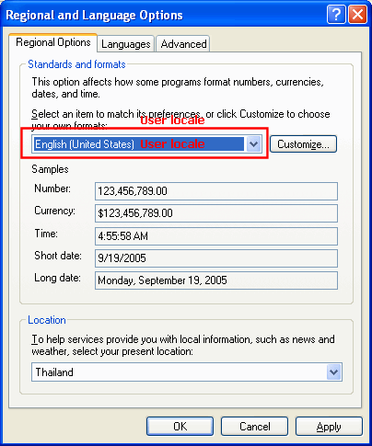
- The UI Locale
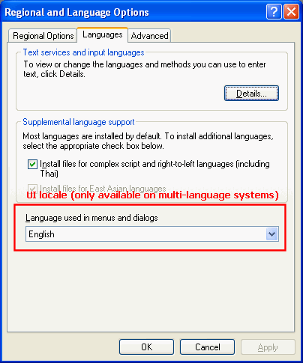
- The System Locale
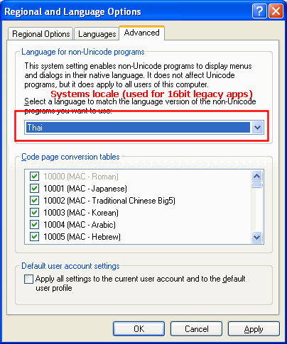
Currently OpenOffice.org reads out the user locale and the UI locale to determine the locale settings (UI and program) of OpenOffice.org. this behavior must not be changed.
In addition to determine the most accurate locale settings in special cases (see example below) OpenOffice.org needs to read out all three locale settings and apply them as follows:
If the script of the Windows System Locale is from the Western, CJK or CTL script group and from a different script group than the script group containing the script of the Windows User Locale, then the script group containing the script of the Windows System Locale must be enabled in OpenOffice.org (this is always a no-op for the Western script group) and the default language for this script group must be set to match the Window System Locale.
Example:
OpenOffice.org installs on a Windows system with a English US User Locale and a Thai System Locale. OpenOffice.org will automatically enable CTL support and choose Thai as the default CTL language while using US English as the default Western language.
Note: The detection of UI language must not be altered. Since this is a Windows only feature this current behavior of OpenOffice.org 2.0 for Unix will not be altered by this specification.

Notes
This feature might also be implemented for Unix systems.

References
This specification covers to related issues:
42730 48123

