Software Specification Document

OpenOffice.org Calc
Manual Sorting in Data Pilot Tables

Specification Status
Last Change | Nov 7, 2007
Status
Abstract
Manual sorting of fields in Data Pilot tables was not possible. This specification describes the new possibility to manually sort Data Pilot via drag & drop or cut/copy & paste.

i-Team Members
Role | First Name, Last Name, Initials | E-Mail Address
I-Team Lead | Niklas Nebel (NN) | niklas.nebel@sun.com
Specification Author | Frank Loehmann (FL) | frank.loehmann@sun.com
User Experience | Frank Loehmann (FL) | frank.loehmann@sun.com
Development | Niklas Nebel (NN) | niklas.nebel@sun.com
Quality Assurance | Frank Stecher (FST) | frank.stecher@sun.com
Documentation | Uwe Fischer (UFI) | uwe.fischer@sun.com

Contents
Abstract 1
i-Team Members 1
References and Reference Documents 3
Acronyms and Abbreviations 3
1 Detailed Specification 4
1.1 General Sorting Behavior in Data Pilot Tables 4
1.2 Manual Sorting of Data Pilot Fields 5
1.3 Insertion Behavior 5
2 Migration 6
3 Configuration 6
4 File Format 6
5 Open Issues 7
Document Change History 7

References and Reference Documents
Reference Document | Check | Location (URL)
Specification Process Entry Check |  | N/A
Product Requirement, RFE, issue [Required] |  | 32307
Product Concept Document |  | <Please enter location here>
Competitive Analysis |  | <Please enter location here>
IDL Specification |  | <Please enter location here>
Test Case Specification [Required] |  | http://www.openoffice.org/nonav/issues/showattachment.cgi/49464/Datapilot.html
Software Specification Rules | N/A | N/A
Related Field Option specification |  | http://specs.openoffice.org/calc/compatibility/fieldoptions.sxw.
Acronyms and Abbreviations
Acronym / Abbreviation | Definition
<WYSIWYG> | <What You See Is What You Get>

Detailed Specification

General Sorting Behavior in Data Pilot Tables
Data Pilot tables are sorted ascending by default. The sorting order can be changed to Descending or Manual using the Data Field Options dialog shown below. If the user changes the ascending or descending sorting order by drag & drop or cut & paste via clipboard, the sorting order in the Data Filed Options is set to manual.
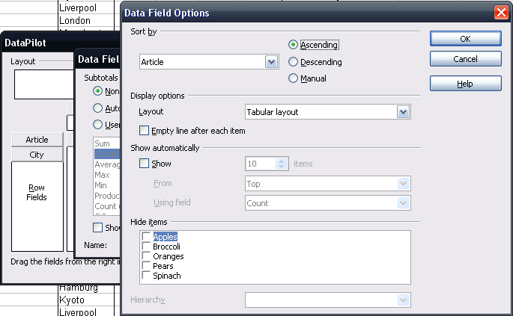Illustration 1: Data Field Options dialog uses ascending sorting by default and changes to Manual if the user changes the sorting order by drag & drop or via clipboard

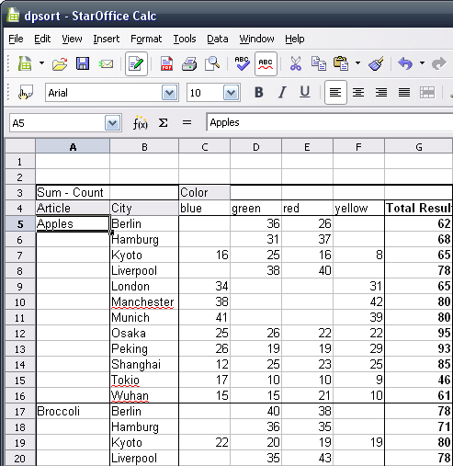Illustration 2: Data Pilot table with default (ascending) sorting order

Manual Sorting of Data Pilot Fields
The Data Pilot table can be sorted manually by drag & drop a Data Pilot field (see Illustration 3, below) or cut/copy & paste of those fields via clipboard. Inside Data Pilot tables a copy will always be processed as a cut, because it is not allowed to duplicate Data Pilot fields.

Insertion Behavior
The cut Data Pilot field will be inserted in front of the currently selected Data Pilot field of the same group. When using drag & drop the insertion cursor indicates (see Illustration 3, below) the current insertion position. The insertion cursor does not check if it is a valid insertion position for the dragged field. On drop of the field, Calc determines the insertion position which is always in front of the currently selected field.
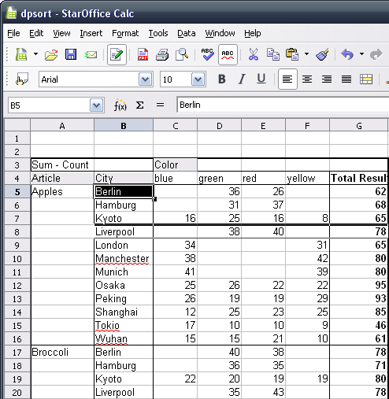Illustration 3: Drag & Drop to sort City column manually (see insertion cursor inside the highlighted orange area)

Migration
When loading a file from a version which didn't evaluate the stored sort order, the visible order of items in a Data Pilot table may change when the table is refreshed. When dragging items before refreshing, the result will be based on the new order, not the visible (old) one.

Configuration
None.

File Format
None.

Open Issues
Issue | Initials | Date
<State Issue here, State “None”, if all issues are solved> |  | <Format: Dec 31, 2000>
<...>

Document Change History
Rev. | Change | Initials | Date
1 | Initial draft of specification | FL | September 28, 2007
2 | Standard | FL | November 07, 2007
3
<...>

Feedback could be further improved at this point by a new preview showing only valid insertion points and giving feedback on moving the insertion cursor, even in large spreadsheets.

