Software Specification Document

OpenOffice.org 2.0.4 and higher
OpenOffice.org NetBeans Integration: Debug Components

Specification Status
Last Change | Feb 26, 2007
Status | - PRELIMINARY  status is the initial conception of a specification.  - STANDARD  A specification with status Standard is considered to be stable and has the approval of the i-Team.  - OBSOLETE  An Obsolete specification is a specification that has been identified unnecessary. For example due to; technology changes or changes in other standards or specifications.

Abstract
The intention of the OpenOffice.org NetBeans Integration: Debug Components is to simplify the debugging process of all components that can be developed with the NetBeans Integration Plug-In. To debug a component in NetBeans there are several steps that have to be done manually. Debugging will be automated with this part of the integration.
i-Team Members
Role | First Name, Last Name, Initials | E-Mail Address
Project Lead | Jürgen Schmidt (jsc) | juergen.schmidt@sun.com
Specification Owner | Steffen Grund (sg) | steffen.grund@sun.com
User Experience
Development | Steffen Grund (sg) | steffen.grund@sun.com
Quality Assurance | Thorsten Bosbach (tbo) | thorsten.bosbach@sun.com
Documentation
Other roles
Based on a verbal agreement between Lutz Höger and Jürgen Schmidt, we decided that a team member of the office user experience team isn't necessary because this specification is off topic of normal office features and address developers only and provides an integration in an external application (NetBeans IDE).

Contents
Abstract 1
i-Team Members 1
References and Reference Documents 3
Acronyms and Abbreviations 4
1 Detailed Specification 5
2 Open Issues 6
Document Change History 6

References and Reference Documents
Give references to any documentation relevant with regards to this specification.
Before writing a specification make sure that the items of the Specification Process Entry Check have been addressed.
Reference Document | Check | Location (URL)
Specification Process Entry Check |  | N/A
Product Requirement,, RFE, issue (required) |  | <Please enter location here>
Product Concept Document |  | <Please enter location here>
Competitive Analysis |  | <Please enter location here>
Test Case Specification (required) |  | <Please enter location here>
Software Specification Rules | N/A | N/A
<Other, e.g. references to related specs>

Acronyms and Abbreviations
State any acronyms and or abbreviations used in this specification in the table below.
Acronym / Abbreviation | Definition
SDK | Software Development Kit
deploy/deployment | Means the installation of office extension packages into an office installation
nbm | NetBeans module/plugin, comparable with an office extensions package, means a plugin extending the base functionality of NetBeans with some new functions.

Detailed Specification
These are the steps that now have to be done manually to debug a component:
- Build/Deploy component
- Start Office with Java in debug mode: “-Xdebug...”
- Start the Java virtual machine inside of the Office
- Connect NetBeans to the JavaVM
All these steps will be automated, hidden from the user. A local folder containing the user installation of the Office will be created inside of the build folder of the component project. First, because this folder has certainly write access, second, because a clean build will erase the folder and thus reset any changes the developer may have made to the Office.

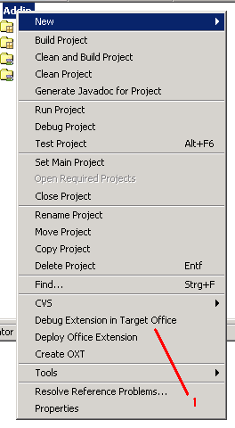Figure 1: Conext menu of a component

Table 1: User Interface elements of
# | Type | Properties |  | Comment
1 |  | Control Properties  Features: The context menu of the component shows the entry to debug the component.
1 |  | Debug Extension in Target Office

Clicking on the “debug extension” action should do all the necessary steps of the 5 topics mentioned. The end of this action will be an OpenOffice.org window with the extension registered. The developer must now do something with the Office to execute the code of the extension – e.g. start a macro. Execution will stop on any breakpoints that are set inside of the code in NetBeans.

Open Issues
Questions and unsolved will arise during the creation process of the specification. Make sure that no open issue are left, when the specification gets the state “Standard”
Issue | Initials | Date
<State Issue here, State “None”, if all issues are solved> |  | <Format: Dec 31, 2000>
<...>

Document Change History
Rev. | Change | Initials | Date
1 |  |  | <Format: Dec 31, 2000>
2
3
<...>

