Software Specification Document

OpenOffice.org Integrated Development Environment (IDE)
Translation Inside Dialog IDE

Specification Status
Last Change | 21. December 2006
Status

Abstract
Localization of software products is very important for a higher acceptance of the software. Therefore the OpenOffice.org (OOo) Dialog IDE will be extended to handle translation of GUIs build with the internal dialog IDE. New languages for a dialog can be created and switched on the fly by using the new Translation toolbar.
i-Team Members
Role | First Name, Last Name, Initials | E-Mail Address
Project Lead | Andreas Bregas (AB) | andreas.bregas@sun.com
Specification Owner | Frank Loehmann (FL) | frank.loehmann@sun.com
User Experience | Frank Loehmann (FL) | frank.loehmann@sun.com
Development | Andreas Bregas (ABR) | andreas.bregas@sun.com
Quality Assurance | Jörg Skottke (JSK) | joerg.skottke@Sun.COM
Documentation | Uwe Fischer (UFI) | uwe.fischer@sun.com
Other roles | Kay Koll (KK) | kay.koll@sun.com

Contents
Abstract 1
i-Team Members 1
References and Reference Documents 3
Acronyms and Abbreviations 3
1 Detailed Specification 4
1.1 Translation Toolbar 4
1.2 Icons 5
1.3 Language Resources Switching in Dialog IDE 5
1.4 Manage Languages of a Graphical User Interface 6
1.4.1 Dialog to Manage Languages 6
1.4.1.1 No Language Resources Present - Case A 7
1.4.1.2 Present Language Resources - Case B 8
1.4.2 Deleting Resources in Manage Language Dialog 9
1.4.3 Add a Language to Resources 10
1.4.3.1 Set Default Language / Create Initial Resources - Case A 10
1.4.3.2 Add Interface Language - Case B 11
2 Migration 13
3 Configuration 13
4 File Format 13
5 Open Issues 13
Document Change History 13

References and Reference Documents
Reference Document | Check | Location (URL)
Specification Process Entry Check |  | N/A
Product Requirement,, RFE, issue (required) |  | i72282
Product Concept Document |  | <Please enter location here>
Competitive Analysis |  | <Please enter location here>
Test Case Specification (required) |  | http://www.openoffice.org/nonav/issues/showattachment.cgi/41563/tUpdtBasicDialogI18n.txt
Software Specification Rules | N/A | N/A
<Other, e.g. references to related specs>
Acronyms and Abbreviations
Acronym / Abbreviation | Definition
GUI | Graphical User Interface
UI | User Interface
IDE | Integrate Development Environment  or  Integrated Design Environment

Detailed Specification

Translation Toolbar
The dialog IDE will be extended by a new Translation toolbar (#2). This toolbar manages the different GUI languages. Furthermore the GUI language could be switched on the fly using the GUI language list box in the Translation toolbar.
The Translation toolbar (#2) is automatically visible if there is more than one GUI language present for the current dialog. The toolbar is docked by default like shown in Illustration 1 and can be turned on/off manually in the View-Toolbars menu. If the toolbar is shown in context of a single GUI language, i.e. turned on manually via the entry in the view menu, or for a read-only library, or if all modules of all libraries are shown, the listbox for the current GUI language and the manage language buttons (#2 and #1) is disabled too.
The Manage GUI Language button on the Translation toolbar is always enabled and calls the Manage GUI Language dialog. Furthermore the Toolbox (#1) toolbar has a new button "Add new GUI language" to add a new language to the dialog resources regardless if the Translation toolbar is shown.
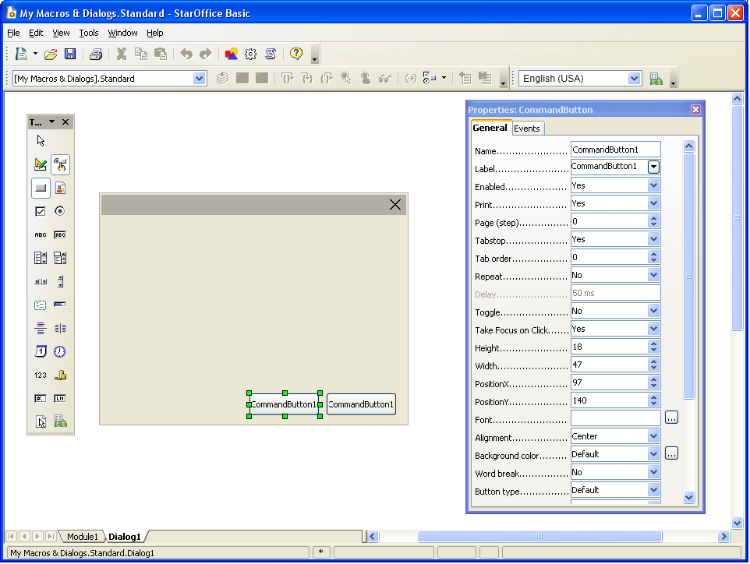Illustration 1: New Translation Toolbar on its default position
Strings for Button in Toolbox (#1)
# | Item | English | German | Translation Comments | Comments
1 | Add User Interface Button (Tooltip) | Manage Language | Sprache verwalten
Strings for Translation Toolbar (#2)
# | Item | English | German | Translation Comments | Comments
2 | Current user Interface Drop Down Listbox (Tool Tip) | Current Language | Aktuelle Sprache |  | Disabled
2 | Listbox content A | <Not localized> | <Nicht lokalisiert> |  | Shown if no language/locale resources are present
2 | Listbox content B | [Default Language] | [Standardsprache] |  | Extension for language defined as default in the Manage language dialog
2 | Manage User Interface Button (Tool Tip) | Manage Language | Sprache verwalten |  | Same string used in #1

Icons
The following icon is used in both toolbars.
Icon | 16x16 | 26x26 | 16x16 (High Contrast) | 26x26 (High Contrast)
Translation toolbar and
Toolbox toolbar

Language Resources Switching in Dialog IDE
The language drop down listbox in the Translation toolbar (also see 1.1 Translation Toolbar) allows to switch the user interface language on the fly. The currently shown language entry defines the resources used for all interfaces oft the current library inside the dialog IDE. So if a text is edited inside the IDE, this text is being changed in the corresponding resources of that language.
If the current library does not contain any language resources, this Language listbox shows the text "<Not localized>". This could happen, if the Language toolbar is manually activate via the View - Toolbars menu.

Manage Languages of a Graphical User Interface

Dialog to Manage Languages
The following dialogs manage the language resources for a module. There are two cases the dialog has to deal with. Case A is that the user wants to add a GUI language, but there are no resources present in his module (i.e. he did not create resources from his current user interface strings) or there are no strings present in his module at all. In case B the user already has resources for at least one language and wants to add a language to his resources.
Strings for Manage User Interface Languages Dialog (Case A + B)
# | Item | English | German | Translation Comments | Comments
1 | Dialog Title | Manage User Interface Languages [$LIBRARYNAME] | Verwalten der Sprachen der Benutzerschnittstelle [$LIBRARYNAME] |  | [$LIBRARYNAME] is being replaced by the physical name of the currently edited library.
2 | Listbox Label | Present languages | Verfügbare Sprachen
3 | Add Button | Add... | Hinzufügen...
4 | Delete Button | Delete | Löschen |  | Button is disabled if no language resource is selected. If pressed the currently selected language resource gets deleted after the confirmation message, described in 1.4.2, has been confirmed.
5 | Make Default Button | Default | Standard |  | Disabled if there is no selection and if there are not at least two languages resource present.
6 | Text | The default language is used if no localization for a user interface locale is present. Furthermore all strings from the default language are copied to resources of newly added languages. | Die Standardsprache wird angezeigt, wenn für die Sprache der Benutzerschnittstelle keine spezielle Lokalisierung vorhanden ist. Weiterhin werden alle Texte der Standardsprache in neu angelegte Sprachressourcen kopiert.
7 | Help Button | Help | Hilfe |  | Standard translation
8 | Close Button | Close | Schließen |  | Standard translation

No Language Resources Present - Case A
The following dialog is shown to manage languages if no resources are available for a user interface of a module. In this case the a string is shown in the Present Languages listbox to guide the user to press the Add button. If the Add button gets pressed, the dialog described below in 1.4.3.1 Set Default Language / Create Initial Resources - Case A is called.
Interaction description:
- The dialog title (#1) shows the name of the current library
- The "Add" (#3) button in case A calls the dialog described 1.4.3.1 Set Default Language / Create Initial Resources - Case A on page 10
- The "Delete" (#4) button is disabled
- The "Make Default" (#5) button is disabled
- The "Help" (#7) button calls the help system with the corresponding help text.
- The "Close" (#8) button and the dialog closer closes the dialog.
- The text "<Press 'Add' to create language resources>" is only shown if no resources are present for the current library.
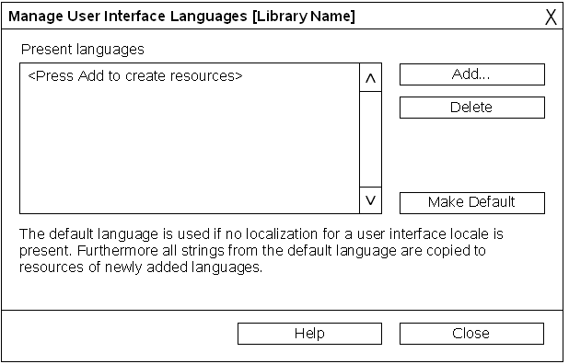Illustration 2: Dialog to manage the user interface language of a module
Strings for Manage User Interface Languages Dialog (Case A only)
# | Item | English | German | Translation Comments | Comments
2 | Listbox | <Press 'Add' to create language resources> | <'Hinzufügen' Schaltfläche klicken, um Sprachressourcen anzulegen> |  | Shown if there are currently no resources present.

Present Language Resources - Case B
The following dialog is shown if linguistic resources are present for the user interface. The listbox (#1) lists all languages where resources are present in the current edited library.
Interaction description:
- The dialog title (#1) shows the name of the current library.
- The "Add" (#3) button in case B calls the dialog described in 1.4.3.2 Add Interface Language - Case B on page 11.
- The "Delete" (#4) button is only enabled, if one or more language(s) is/are selected in the listbox (#2).
- The "Make Default" (#5) button is only enabled, if one language is selected in the listbox (#2). If this language is already the default language will not be checked.
- The "Help" (#7) button calls the help system with the corresponding help text.
- The "Close" (#8) button and the dialog closer closes the dialog. Please note that on close the actions/changes made in this dialog are not be withdrawn.
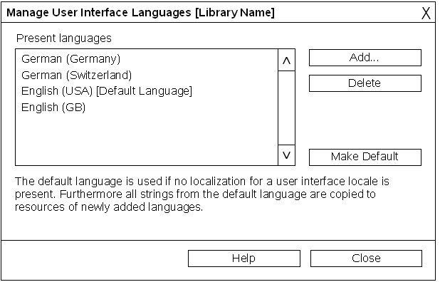Abbildung 3: Dialog to manage the user interface language of a module with present language resources
Strings for Manage User Interface Languages Dialog (Case B only)
# | Item | English | German | Translation Comments | Comments
1 | Listbox content B | [Default Language] | [Standardsprache] |  | Extension used for the language defined as default.

Deleting Resources in Manage Language Dialog
If the Delete button is pressed in the Manage User Interface dialog the following request dialog is needed.
Interaction description:
- The "Delete" button (#3) deletes the currently selected language resources.
- The "Cancel" button and the dialog closer aborts the process and closes the message box.
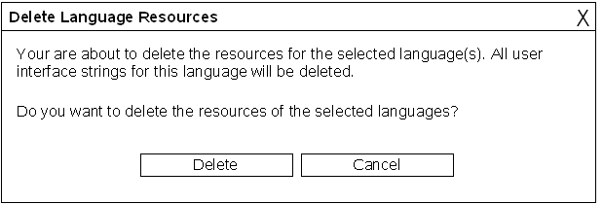Illustration 4: Confirmation Dialog when deleting languages
Strings for Confirmation Dialog
# | Item | English | German | Translation Comments | Comments
1 | Dialog Title | Delete Language Resources | Sprachressourcen löschen
2 | Text | Your are about to delete the resources for the selected language(s). All user interface strings for this language(s) will be deleted./n/nDo you want to delete the resources of the selected language(s)? | Sie sind im Begriff die Ressourcen der selektierten Sprache(n) zu löschen. Alle Texte der Benutzerschnittstelle in dieser Sprache(n) werden dabei gelöscht./n/nMöchten Sie die Ressourcen der selektierten Sprache(n) löschen?
3 | Button | Delete | Löschen
4 | Button | Cancel | Abbrechen |  | Standard translation

Add a Language to Resources
Depending on the case (A or B) one of the following dialog is called.
Strings for both
# | Item | English | German | Translation Comments | Comments
4 | OK Button | OK | OK |  | Standard translation
5 | Cancel Button | Cancel | Abbrechen |  | Standard translation
6 | Help Button | Help | Hilfe |  | Standard translation

Set Default Language / Create Initial Resources - Case A
The following dialog is shown if no resources are present for the current library.
Interaction description:
- The listbox (#2) show the OOo list of languages.
  - By default the current system language is preselected.
  - No multi selection
  - or de-selection is possible.
- The OK (#4) button confirms the dialog and assigns all current strings to resources of this language.
- The "Help" (#7) button calls the help system with the corresponding help text.
- The "Cancel" (#5) button and the dialog closer aborts the process and closes the dialog. Then no language is been set as default.
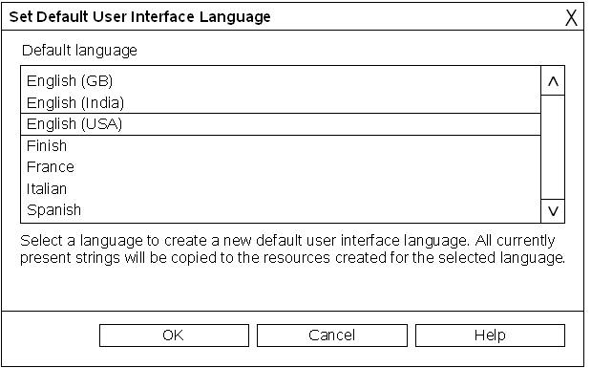Illustration 5: Dialog to assign non resource based strings to a language
Srings for Set User Interface dialog
# | Item | English | German | Translation Comments | Comments
1 | Dialog Title | Set Default User Interface Language | Standardsprache für Benutzerschnittstelle festlegen
2 | Listbox Label | Default language | Standardsprache
2 | Listbox Content | -- | -- |  | Language list taken from OOo.
3 | Text | Select a language to define the default user interface language. All currently present strings will be assigned to the resources created for the selected language. | Selektieren Sie eine Sprache, um die Standardsprache für die Benutzerschnittstelle festzulegen. Die aktuellen Texte der Benutzerschnittstelle werden dann dieser neu angelegten Sprachressourcen zugewiesen.

Add Interface Language - Case B
Interaction description:
- The listbox (#2)
  - Shows the complete list of available languages.
  - All languages already added to the language resources are not shown in this list.
- The OK (#4) button confirms the dialog and creates resources for all newly checked languages in the language resources of the current library.
- The "Help" (#7) button calls the help system with the corresponding help text.
- The "Cancel" (#5) button and the dialog closer aborts the process and closes the dialog. Then none of the checked languages would be added to the language resources of the current library. This does not affect the already added languages show disabled and checked.
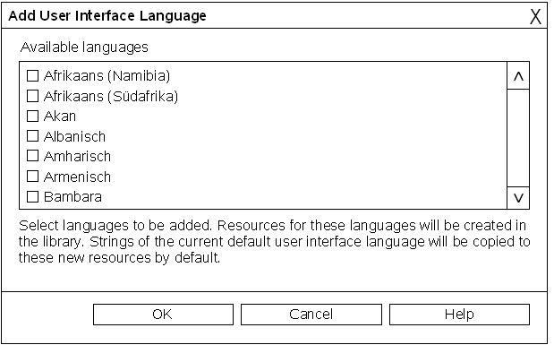Abbildung 6: Dialog to select languages being added to the resources
Srings for
# | Item | English | German | Translation Comments | Comments
1 | Dialog Title | Add User Interface Languages | Sprachen zur Benutzerschnittstelle hinzufügen
2 | Text | Select languages to be added. Resources for these languages will be created in the library. Strings of the current default user interface language will be copied to these new resources by default. | Wählen Sie die Sprachen, die hinzugefügt werden sollen. Es werden dann Ressourcen für diese Sprachen in der Bibliothek angelegt. Die Texte der aktuellen Standardsprache werden dabei in die neu angelegten Sprachressourcen kopiert.
3 | Label | Available languages | Verfügbare Sprachen

Migration
None, because in the past OOo did not support resources for libraries.

Configuration
<Start typing here ----- If this part is irrelevant state a reason for its absence!>

File Format
<Start typing here ----- If this part is irrelevant state a reason for its absence!>

Open Issues
Issue | Initials | Date
Do we need an additional language icon in the property browser to state which field is resource dependent and relevant for translation. | FL | Nov. 30, 2006
<...>

Document Change History
Rev. | Change | Initials | Date
1 | Initial Draft | FL | 11. October 2006
2 | Second Draft | FL | 20. November 2006
3 | Third Draft | FL | 23. November 2006
4 | Finalization | FL | 30. November 2006
5 | Changed some German strings | FL | 20. December 2006

