OpenOffice.org Error Reporter UI Specification
OpenOffice.org 2.0

Document - ID | Specification Owner | Last Change | Status
 | Christian Jansen | April 28, 2006 | Final
Conforms to
Applies to | OpenOffice.org
Task ID(s) | 20078
Category | Feature

Abstract
The OpenOffice.org Error Reporting Tool and the document recovery features are combined into one work flow. When OpenOffice.org crashes the documents will be saved and users get informed abut the upcoming recovery process, followed by sending out an error report.

i-Team Members (The specification owner is part of the i-Team)
 | Name | E-mail Address
User Experience | Christian Jansen (CJ) | Cj@openoffice.org
Development | Hennes Rohling (HRO) | Hro@openoffice.org
Quality Assurance | Joost Andrae (JA) | Ja@openoffice.org
Documentation | Uwe Fischer (UFI) | Ufi@openoffice.org

Approved for Implementation
 | Approved by | Date
User Experience | Christian Jansen (CJ) | 15.03.2004
 | Fran Loehmann (FL) | 15.03.2004
Development | Hennes Rohling (HRO) | 15.03.2004
Quality Assurance | Joost Andrae (JA) | 15.03.2004
Documentation | Uwe Fischer (UFI) | 15.03.2004
String Review | Elizabeth Matthis | 05-28-2004,10.11.04
String Review | Elizabeth Matthis | Jan 12, 2005

Document Change History
Rev. Level | Change | Initials | Date
1.0 | Initial specification | CJ | April 15, 2004
1.1 | Help Buttons Removed | CJ | Sept 27, 2004
1.2 | Add Beta section for issues to be fixed within Beta of OOo 2.0 | FL | Nov 10, 2004
1.3 | Change Beta section | FL | Nov 12, 2004
1.4 | Removed extensions in file list and changed strings in dialog for saving documents | CJ | Nov 15, 2004
1.5 | Dialog for saving documents enhanced by adding a path. | CJ | Jan 10, 2005
1.6 | After Beta Changes finalized | CJ | Jan 12, 2005
1.7 | Made some changes to GUI text | FL | Jan 20, 2005
1.8 | Corrected English typo 'occured' -> 'occurred' | EM | Feb 23, 2005
1.9 | Text changes for issue i51464 | FL | Aug. 26, 2005
2.0 | Changes for OOo 2.03 Added | CJ | April 28, 2006
2.1 | Enhancement: say nothing about error report, in case it was disabled.  (new and changed strings in chapter  “6.2.1. Document Recovery Dialog”) | AS | 20.11.06

Contents
Glossary 1
1 Motivation 1
2 User Scenarios 1
3 Goals 1
4 Requirements and Dependencies 1
4.1 Requirements 1
4.2 Technical Dependencies 1
5 Competitive Analyses 1
6 Detailed Specification 2
6.1 Workflow Chart 2
6.2 Sending Out An Error Report with Document Recovery 3
6.2.1 Document Recovery Dialog 6
6.2.2 Pressing Cancel During Recovery 8
6.2.3 Pressing Cancel if Recovery Process Has Already Been Finished or During Error Report Process (#41091) 9
6.2.4 Dialogs for saving documents which causes a crash during recovery 9
6.3 Sending Out An Error Report without Document Recovery 14
7 References 16

Glossary
Term | Description
<Term 1>

Motivation
The current document recovery behavior of OpenOffice.org 1.1 is not transparent for users. When OpenOffice.org a warning appears which is too scary for users. Additionally the user gets confused by the order of the appearing dialogs. In OpenOffice.org 1.1 first the Error Report appears followed by the document recovery. This is in opposite to the behavior users expect, because for them are the documents which seem to be lost much more interesting then sending out an Error Report.

User Scenarios
During the work with OpenOffice.org occurred an error. This error caused OpenOffice.org to crash. User A wants to continue the work without loosing any document content.

Goals
The whole document recovery shall be as comprehensible and non frightening for the user as possible. This feature has to be nice in detail, because in the moment of a crash the user is in a stress situation cause by OpenOffice.org. It is very important to take the user by the hand and to guide him thru the process of document recovery.

Requirements and Dependencies

Requirements
Currently the recovery dialog is a bit terse. I recommend text along the lines of ?The last time OOo terminated, the file ?xxxx? had been edited, but those edits had not been saved. If you would like to recover this lost work select ?Yes?. If you want to revert to the last saved version, select ?NO? or ?Cancel?. Also currently each recovered file generates its own pop-up window. For OO.o 2.0, all file recovery should be centralized in one dialog.

Technical Dependencies
N/a

Competitive Analyses
http://www.microsoft.com/office/previous/xp/columns/itcolumn05.asp

Detailed Specification

Workflow Chart
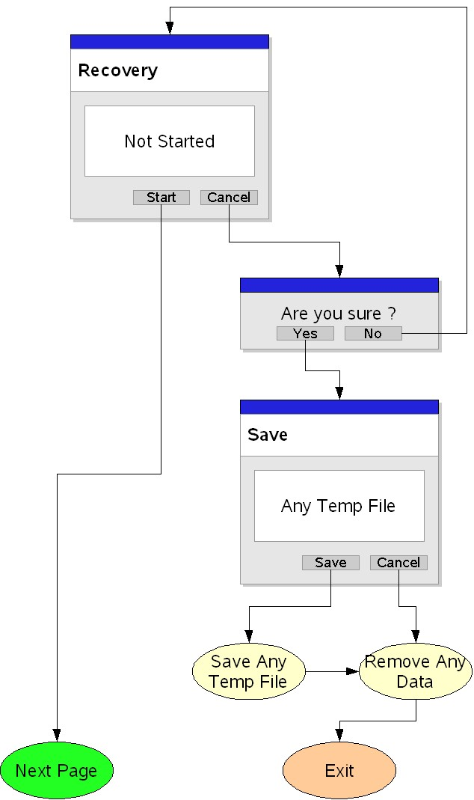Illustration 1 Interrupt recovery process via Cancel button, before process has been started
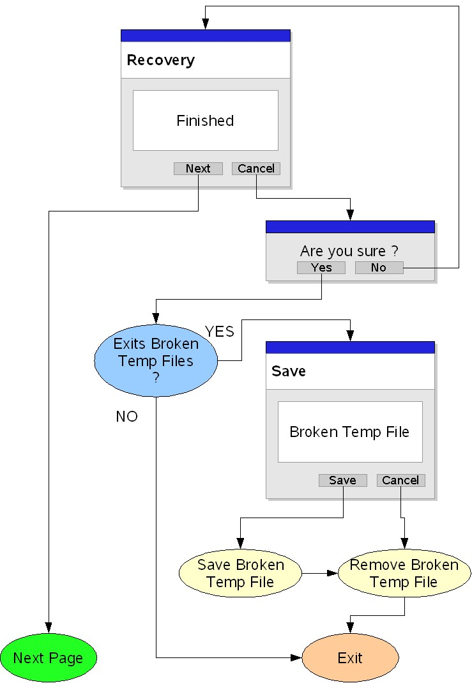Illustration 2 Abort recovery process via Cancel button once it has been finished (next step would be the error reporter)
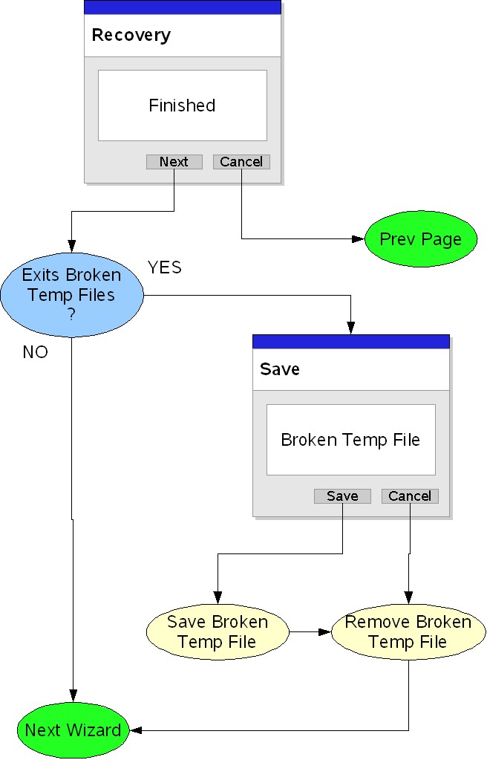Illustration 3 Pressing the next button after recovery process has been finished (next step would be the error reporter). Check if broken temp files do exist.

Sending Out An Error Report with Document Recovery
When OpenOffice.org 2.0 crashes an introduction dialog (Figure 1) shall appear. All crashes occurred before opening one document and all crashed occurred after closing the last document are ignored by the error reporter. This introduction dialog provides users important information what to do next and how OpenOffice.org will behave during document recovery. The dialog shall appear when all OpenOffice.org windows are open. The dialog shall appear in on top of all OpenOffice.org windows. The to be recovered files shall be listed in a read only list and each filename shall display its assigned document icon. No extension shall be displayed at this time.
Clicking the OK button, closes all office windows and calls an progress indicator. This indicator shall visualized the progress of saving When saved, all existing OpenOffice.org windows and the introduction dialog shall be closed. Followed by this the Document Recovery wizard gets automatically started. (Figure 3).

Figure 1 Dialog which appears when OpenOffice.org crashes. Deviating from the mockup shown above, the list box background is gray to underline that no input has to be made (i.e. select files to be recovered).
String list
Item | English | German | Comments
Titlebar | %PRODUCTNAME %PRODUCTVERSION | %PRODUCTNAME %PRODUCTVERSION
Text | %PRODUCTNAME Document Recovery | %PRODUCTNAME Dokumentwiederherstellung
Text | Due to an unexpected error, %PRODUCTNAME has crashed. All the documents you were working on will be saved now. The next time %PRODUCTNAME is launched, your documents will be recovered automatically. | Durch einen unerwarteten Fehler ist %PRODUCTNAME abgestürzt. Alle Dateien an denen Sie gearbeitet haben werden gespeichert. Beim nächsten Start von %PRODUCTNAME werden Ihre Dokumente automatisch wieder hergestellt
Label | The following documents will be recovered: | Die folgenden Dokumente werden wiederhergestellt:
Button | OK | OK

The progress bar dialog shall look like shown in Figure 2. Above the progress a text shall be stated providing information about the performed action. The progress shall restarted for each file.
Important: The closer shall be inactive so that the user can't abort the saving process.
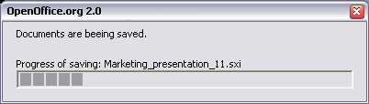Figure 2 Progress during saving the documents
String list
Item | English | German | Comments
Title bar | %PRODUCTNAME %PRODUCTVERSION | %PRODUCTNAME %PRODUCTVERSION
Text | Your documents are being saved. | Ihre Dokumente werden gespeichert.
Text | Saving: | Speichern:

When saving is finished the progress dialog shall be closed automatically
After an automatic launch first the splash screen, than Document Recovery Wizard shall be displayed.
Figure 3 shows a mock up of the first dialog page of the Document Recovery Wizard. The recovery process shall be visualized in the dialog as follows:
- The list control shall be filled with a list of file names having the state 'not recovered yet'
- The Document Recovery dialog is shown before OOo starts to recover the previously saved documents
- The recovery process of each document shall be visualized by a progress bar
- Successfully recovered documents shall be marked with a 'Successfully recovered' string and a green check mark.
- If OpenOffice.org had only a chance to recover an AutoSaved Document a yellow check mark and the string 'AutoSaved Document recovered' shall appear.
- If the recovery process failed this shall be visualized by an 'X' – shaped symbol and a string called 'Recovery failed'.
Important: If recovery fails because OpenOffice.org crashes during recovering a document OpenOffice.org shall automatically restarted again. The document which causes the crash shall automatically be added to the list marked by the string 'Recovery failed'. This assures that OpenOffice.org crashes not again and again. When a recovery failed the user shall have the option to save the document therefor OpenOffice.org displays a dialog when all other documents are recovered. From this dialog users have the possibility to save the document (Figure 4-5).
- During the recovery progress the document status shall display 'Recovery in progress'

Document Recovery Dialog

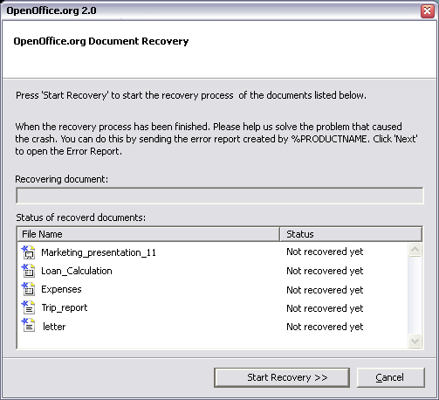Figure 3 First appearance of Document Recovery dialog before start of recovery process - Start Recovery button is defaulted. Deviating from the mockup shown above, the list box background is gray to underline that no input has to be made (i.e. select files to be recovered). - screenshot outdated -
String list
Item | English | German | Comments
Titlebar | %PRODUCTNAME %PRODUCTVERSION | %PRODUCTNAME %PRODUCTVERSION
Text | %PRODUCTNAME Document Recovery | %PRODUCTNAME Dokumentwiederherstellung
Text | Press 'Start Recovery' to start the recovery process of the documents listed below.\n\nThe 'Status' column shows whether the document could be recovered. | Klicken Sie auf 'Wiederherstellung starten', um mit dem Wiederherstellungsprozess der weiter unten aufgelisteten Dokumente zu beginnen.\n\nDie 'Status' Spalte zeigt Informationen über den Wiederherstellungsprozess der einzelnen Dokumente an.
Label | Recovering: | Wiederherstellen:
Button Label | ~Start ~Recovery > | ~Wiederherstellung starten > | DEFAULT
Button Label | ~Cancel | ~Abbrechen

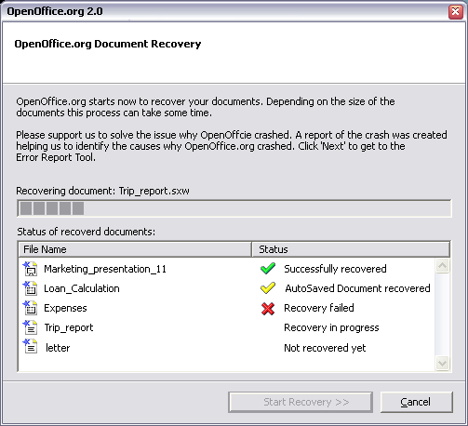Figure 4 Recovery in process – Start Recovery button is disabled - screenshot outdated -

String list
Item | English | German | Comments
Titlebar | %PRODUCTNAME %PRODUCTVERSION | %PRODUCTNAME %PRODUCTVERSION
Text | %PRODUCTNAME Document Recovery | %PRODUCTNAME Dokumentwiederherstellung
Text | %PRODUCTNAME %PRODUCTVERSION starts now to recover your documents. Depending on the size of the documents this process can take some time.\n\n | %PRODUCTNAME %PRODUCTVERSION beginnt jetzt mit der Wiederherstellung Ihrer Dokumente. Dieses kann abhängig von der Größe der Dokumente einige Zeit in Anspruch nehmen.\n\n
Text | A report of the crash was created helping us to identify the cause why %PRODUCTNAME crashed. Click 'Next' to get to the Error Report Tool or press 'Cancel' to skip this step. | Es wurde ein Fehlerbericht erstellt, der uns bei der Identifizierung des Problems in %PRODUCTNAME hilft. Betätigen Sie die Schaltfläche 'Weiter', um zum Fehlerbericht zu gelangen oder 'Abbrechen', um diesen Schritt zu überspringen. | Used in case Error Report feature is ON.
Button Label | ~Next > | ~Weiter > | DEFAULT  in case Error Report feature is ON.
Button Label | ~Cancel | ~Abbrechen
Text | Recover of your documents was finished.\nClick 'Finish' to see your documents. | Die Wiederherstellung Ihrer Dokumente wurde abgeschlossen.\nBetätigen Sie die Schaltfläche 'Fertig', um zu den wiederhergestellten Dokumenten zu gelangen. | Used in case Error Report feature is OFF.
Button Label | ~Finish | ~Fertig | DEFAULT  in case Error Report feature is OFF.
Button Label | ~Cancel | ~Abbrechen | Disabled in case Error Report feature is OFF.

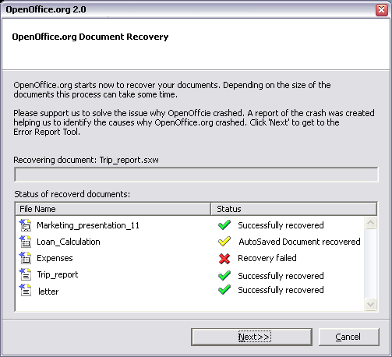Figure 5 Recovery process has been finished. Now 'Next >' button is shown and defaulted

Pressing Cancel During Recovery
Pressing Cancel before the process has been started rises a warning (Figure 9). This warning shall give two choices
1.: Clicking Yes (Default): This closes the warning and rises the dialog specified in 6.2.4.
2.: Clicking No: Closes the warning, and the user returns to the document recovery; recovery will be continued automatically.

Figure 6
Item | English | German | Comments
Heading | %PRODUCTNAME %PRODUCTVERSION | %PRODUCTNAME %PRODUCTVERSION
Text | Are you sure you want to cancel the %PRODUCTNAME document recovery? | Sind Sie sicher, dass Sie die Dokumentwiederherstellung abbrechen wollen?
Button Label (Default) | Yes | Ja
Button Label | No | Nein

Pressing Cancel if Recovery Process Has Already Been Finished or During Error Report Process (#41091)
Pressing Cancel after recovery process has been finished (like status shown in Figure 5 Recovery process has been finished. Now 'Next >' button is shown and defaulted) rises no extra warning dialog, because the process has already been finished and could not be canceled anymore. Dialogs for saving documents which causes a crash during recovery
As described above, a dialog appears (Figure 4) if a recovery fails or the user has decided to abort the recovery process before it has been started. The dialog text is the same in both cases, because it is irrelevant if the program or the user has interrupted the process. This dialog shall appear above the wizard. The dialog lists all documents which causes the failure and allows the user to save them in a folder of users choice. The default path will be “$ Workingdir” Clicking 'Change...' opens the system folder browse dialog (Figure 5).
The file name list shall be read only.
Figure 7 Dialog for saving defect files
String list
Item | English | German | Comments
Titlebar | %PRODUCTNAME %PRODUCTVERSION | %PRODUCTNAME %PRODUCTVERSION
Text | The automatic recovery process was interrupted.\n\nThe documents listed below will be saved in the folder noted below if you click 'Save'. Click 'Cancel' to close the wizard without saving the documents. | Der automatische Wiederherstellungsprozess wurde abgebrochen.\n\nKlicken Sie auf 'Speichern', um die unten aufgelisteten Dokumente in den unten angegebene Ordner zu speichern. 'Abbrechen' verlässt den Assistenten ohne zu speichern.
Label | Documents | Dokumente
Edit Field Label | ~Save to | ~Speichern in
Button Label | Chan~ge... | Ä~ndern...
Button Label | ~Save | Speichern | DEFAULT
Button Label | ~Cancel | ~Abbrechen

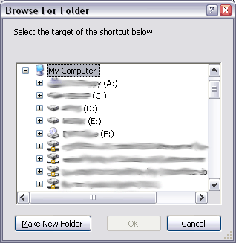Figure 8 Windows XP System browse for folders dialog.

Clicking 'Next' in the 'OpenOffice.org Document Recovery' jumps in case of running the first time to the instruction page of the Error Reporting Tool (Figure 6). The dialogs of the OpenOffice.org 1.1 Error Report are specified in []. When no documents have to be recovered before the Error Report appears, the Error report shall look like describes in chapter 6.2.
Figure 9 Welcome dialog of the Error Report (StarOffice 8 version)
String list
Item | English | German | Comments
Titlebar | %PRODUCTNAME %PRODUCTVERSION | %PRODUCTNAME %PRODUCTVERSION
 | Welcome to the %PRODUCTNAME %PRODUCTVERSION Error Report | Willkommen beim %PRODUCTNAME %PRODUCTVERSION Fehlerbericht.
 | This error report tool gathers information about how %PRODUCTNAME is working and sends it to Sun Microsystems to help improve future versions.\n\nIt's easy - just send the report without any further effort on your part by clicking 'Send' in the next dialog, or you can briefly describe how the error occurred and then click 'Send'. If you want to see the report, click the 'Show Report' button. No data will be sent if you click 'Do Not Send'.\n\nCustomer Privacy\nThe information gathered is limited to data concerning the state of %PRODUCTNAME %PRODUCTVERSION when the error occurred. Other information about passwords or document contents is not collected.\n\nThe information will only be used to improve the quality of %PRODUCTNAME and will not be shared with third parties.\nFor more information on Sun Microsystems' privacy policy, visit\nhttp://www.sun.com/privacy/ | Dieses Fehlerbericht-Programm sammelt Informationen über den Zustand von %PRODUCTNAME und übermittelt sie an Sun Microsystems, um zukünftige Versionen zu verbessern.\n\nDas Senden der Daten geht ganz einfach. Zum Versenden, klicken Sie im nächsten Dialog 'Senden'. Wenn Sie sich den Fehlerbericht ansehen wollen, klicken Sie auf 'Bericht anzeigen'. Es werden keine Daten versendet, wenn Sie 'Nicht Senden' klicken.\n\nDatenschutz\nDie gesammelten Informationen über den Zustand von %PRODUCTNAME %PRODUCTVERSION beziehen sich nur auf den Fehler, der entstanden ist. Andere Informationen, wie z.B. Kennwörter oder der Dokumenteninhalt, werden nicht gesammelt.\n\nAlle Informationen werden ausschließlich für die Verbesserung von %PRODUCTNAME genutzt und werden nicht an dritte weitergegeben.\n\nMehr Information zu Datenschutz-Richtlinien von Sun Microsystems finden Sie unter\nhttp://www.sun.de/Datenschutz/
Button Label | < ~Back | < ~Zurück
Button Label | ~Next > | ~Weiter > | DEFAULT
Button Label | ~Cancel | ~Abbrechen
Note: The original dialog is specified in [] this list list only the changes

Figure 10 Sending out an Error Report.

String list
Item | English | German | Comments
Title | %PRODUCTNAME %PRODUCTVERSION | %PRODUCTNAME %PRODUCTVERSION
Text | Sending the Error Report | Fehlerbericht versenden
Text | In the space below, you can enter a title for your report and describe the action you were trying to carry out when the error occurred. Then click 'Send'. | In den folgenden Feldern, können Sie einen Titel für Ihren Bericht angeben sowie beschreiben, welche Aktion Sie ausgeführt haben, als der Fehler auftrat. Dann klicken Sie auf 'Senden'.
 | ~Which type of document (e.g. presentation) were you using when the error occurred? | ~Mit welchem Dokumenttyp (z.B. Präsentation) haben Sie gearbeitet als, der Fehler auftrat?
 | ~How were you using %PRODUCTNAME when the error occurred? (optional) | ~Beschreiben Sie, wobei der Fehler aufgetreten ist. (optional)
Button Label | < ~Back | < ~Zurück
Button Label | S~end | S~enden | DEFAULT
Button Label | Do ~Not Send | ~Nicht Senden

Sending Out An Error Report without Document Recovery
It is possible that no recovery has to be performed before sending out an Error Report in this case the workflow is the same but the dialogs are looking a little bit different and contain other information.
When OpenOffice.org crashes the following dialog appears. Originally specified in []
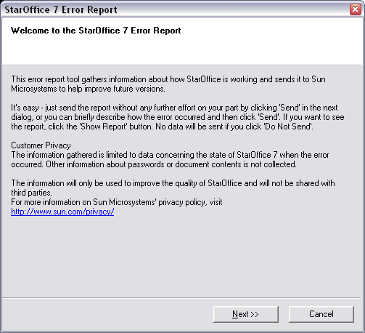Figure 11 Screen shot is taken in StarOffice 7 no changes are necessary for OpenOffice.org 2.0, StarOffice 8
Clicking the Next button jumps to the dialog (Figure 9) where users can enter additional information. This dialog is specified in []

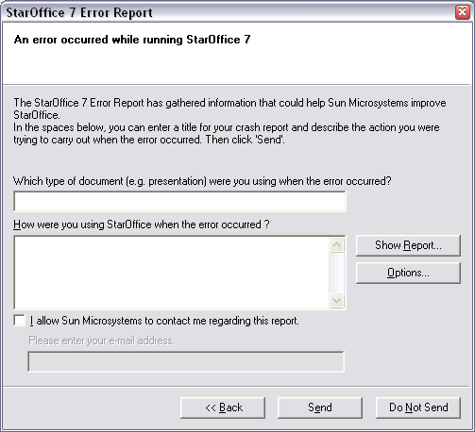Figure 12 Screen shot taken from StarOffice 7

References
OpenOffice.org Error Report Specification - http://porting.openoffice.org/files/documents/14/1154/crash_report_generator_ui_specification_ooo.sxw
Microsoft Office Document Recovery - http://www.microsoft.com/office/previous/xp/columns/itcolumn05.asp
OpenOffice.org 2.0 Auto Recovery Specification -
http://specs.openoffice.org/appwide/recovery/Autorecovery.sxw

Error Reporter 1.0 User Interface Specification, http://porting.openoffice.org/files/documents/14/1154/crash_report_generator_ui_specification_ooo.sxw
Error Report Welcome dialog: http://porting.openoffice.org/files/documents/14/1154/crash_report_generator_ui_specification_ooo.sxw#7.2.Welcome Dialog|outline
Error Report Welcome dialog: http://porting.openoffice.org/files/documents/14/1154/crash_report_generator_ui_specification_ooo.sxw#7.2.Welcome Dialog|outline
Error Report Main dialog: http://porting.openoffice.org/files/documents/14/1154/crash_report_generator_ui_specification_ooo.sxw#7.2.Welcome Dialog|outline#7.4.The Main Dialog|outline

