Software Specification Document

OpenOffice.org Writer
Custom Document Properties

Specification Status
Last Change | Nov 23, 2009
Status
Abstract
Current implementation supports only four text field info1 to 4. The new implementation allows to create user defined name value pairs of a certain data type. This is important for document management in companies.
i-Team Members
Role | First Name, Last Name, Initials | E-Mail Address
I-Team Lead | Peter Burow (PB) | peter.burow@sun.com
Specification Author | Frank Loehmann (FL) | frank.loehmann@sun.com
User Experience | Frank Loehmann (FL) | frank.loehmann@sun.com
Development | Peter Burow (PB) | peter.burow@sun.com
Quality Assurance | Hasan Ilter (HI) | hasan.ilter@sunc.com
Documentation | Uwe Fischer (UFI) | uwe.fischer@sun.com

Contents
Abstract 1
i-Team Members 1
References and Reference Documents 3
Acronyms and Abbreviations 3
1 Detailed Specification 4
1.1 Custom Document Properties Dialog 4
1.2 Type Mismatch and Automatic Type Cast 7
2 Migration 8
3 Configuration 8
4 File Format 8
5 Open Issues 8
Document Change History 8

References and Reference Documents
Reference Document | Check | Location (URL)
Specification Process Entry Check |  | N/A
Product Requirement, RFE, issue [Required] |  | i86606
Product Concept Document |  | <Please enter location here>
Competitive Analysis |  | <Please enter location here>
IDL Specification |  | <Please enter location here>
Test Case Specification [Required] |  | http://qa.openoffice.org/ooQAReloaded/TestcaseSpecifications/OpenOffice.org_3.0/Framework/Document_Custom_Properties.html
Software Specification Rules | N/A | N/A
<Other, e.g. references to related specs>
Acronyms and Abbreviations
Acronym / Abbreviation | Definition
<WYSIWYG> | <What You See Is What You Get>

Detailed Specification
The Custom Properties tab page will be enhanced to handle data types.

Custom Document Properties Dialog
The Custom Properties dialog tab page offers a new UI to deal with name/value pairs of the data types text, date, number and 'yes or no' for boolean.
The add button adds a new property line to the dialog. The default type is text. The cursor is placed in the name field. The name filed uses the most recently used feature.
Document custom properties are loaded and saved with a document.
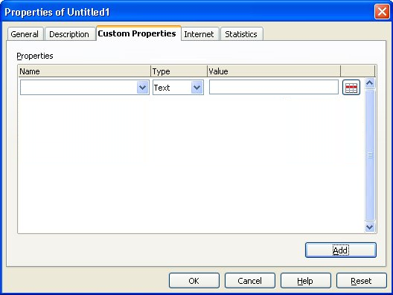Illustration 1: Default properties dialog
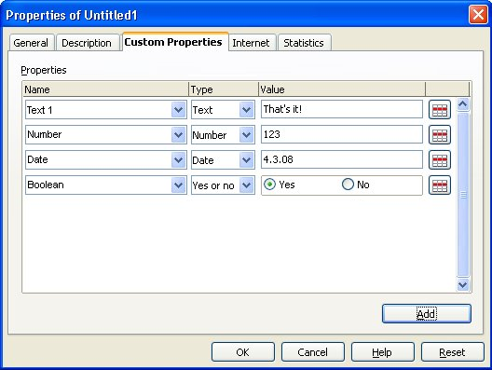Illustration 2: Enhanced custom properties dialog with some data entered
Note: During runtime the order is chronological. When loading the document from a file, the data is sorted alphabetically in ascending order by the Name field.
- “Properties” - Dialog Properties |  | Comment
State: | Modal
Type: | Dialog
Closable: | Yes
Resizable: | No
Other: | Tabbed Dialog
Titel: | Properties of %DOCUMENTNAME | EN-US
- “Properties” - ListBox Properties |  | Comment
Label: | ~Properties | EN-US
- “Name” - ListBox Properties |  | Comment
Enabled: | Always
Disabled: | Never
Most Recently Used | Enabled
Max. Row Count:
Rows Visible: | 7
Items: | - Checked by  - Client  - Date completed  - Department  - Destinations  - Disposition  - Division  - Document number  - Editor  - E-Mail  - Forward to  - Group  - Info  - Language  - Mailstop  - Matter  - Office  - Owner  - Project  - Publisher  - Purpose  - Received from  - Recorded by  - Recorded date  - Reference  - Source  - Status  - Telephone number  - Typist  - URL | EN-US
Item Selected: | None
Sorting by Drag & Drop: | No
ListBox Label: | Name | EN-US
- “Type” - DropDown Listbox Properties |  | Comment
Enabled: | Always
Disabled: | Never
Max. Row Count: | 5
Rows Visible: | 5
Items: | - Date  - Number  - Text  - Yes or no
Item Selected: | 3
Sorting by  Drag & Drop: | No
Other: | No
DropDown  ListBox Label: | Type | EN-US
- “Value” - TextField Properties |  | Comment
Enabled: | Always
Disabled: | Never
Read Only: | No
Initial String: | Empty if new, or value loaded from document
String Preselected: | No
Caret Position: | 0
Characters Not Allowed:
TextField Label: | Value | EN-US
- “Yes” - Boolean Value RadioButton Properties |  | Comment
Visisble: | If type = boolean
Selected: | No
RadioButton Label: | Yes | EN-US
- “No” - Boolean Value RadioButton Properties |  | Comment
Visible | If type = boolean
Selected: | Yes
RadioButton Label: | No | EN-US
- “Remove property” - Button Properties |  | Comment
Enabled: | Always
Disabled: | Newer
Press: | Remove corresponding property or reset last one like shown in illustration 1.
Button Label: |  | EN-US
- “Add” - Button Properties |  | Comment
Enabled: | Always
Disabled: | Never
Press: | Add a new property at the end of that list
Button Label: |  | <Icon only button>

Type Mismatch and Automatic Type Cast
The following dialog is shown, if the user leaves the edit mode of a property and the type does not match. (i.e. text in a number field). The OK button changes the type of that property to text.
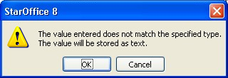Illustration 3: Set type to text
- “%PRODUCTNAME %PRODUCTNUMBER” - Warning Dialog Properties |  | Comment
State: | Modal
Type: | Dialog
Closable: | Yes
Resizable: | No
Titel: | %PRODUCTNAME %PRODUCTNUMBER | EN-US
- “Text” - Text Properties |  | Comment
Label: | The value entered does not match the specified type. The value will be stored as text. | EN-US
- “OK” - Button Properties |  | Comment
Enabled: | Always
Disabled: | Never
Press: | Confirms dialog and changes Type to text
Button Label: | OK | EN-US
- “Cancel” - Button Properties |  | Comment
Enabled: | Always
Disabled: | Never
Press: | Cancel dialog and returns to Value edit in the listbox.
Button Label: | Cancel | EN-US

Migration
None.

Configuration
None.

File Format
None.

Open Issues
Issue | Initials | Date
Add a sort option in properties list box | FL | March 04, 2008

Changes for OpenOffice.org 3.3
Two data types have been added to the list of supported properties: DateTime and Duration.
To support date and time the related dialog controls are used now. Duration is shown in a read only text edit and can only be edited with the dialog shown in Illustration 5.
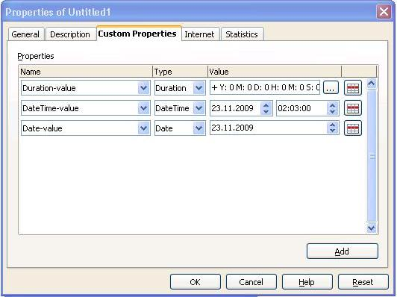Illustration 4: Custom properties page
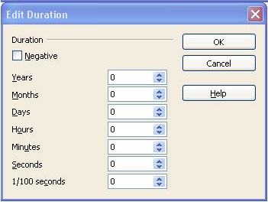Illustration 5: Duration dialog

Document Change History
Rev. | Change | Initials | Date
1 | Create specification | FL | October 22, 2007
2 | Finalization of specification | FL | March 04, 2008
3 | Finalization of specification | FL | March 07, 2008
4 | Correct mock-ups | FL | March 31, 2008
5 | Changes in OOo 3.3 | OS | 23.11.09

