Software Specification Document

OpenOffice.org
Introduction of an overline font effect

Specification Status
Last Change | Dec 16, 2008
Status
Abstract
Introduce a new font effect that draws a line above a selected character or group of characters. The line style and colour may be selected by the user, with the same options available as for the underline font effect.

i-Team Members
Role | First Name, Last Name, Initials | E-Mail Address
I-Team Lead | Martin Whitaker (MTW) | martinwhitaker@openoffice.org
Specification Author | Martin Whitaker (MTW) | martinwhitaker@openoffice.org
User Experience | Frank Loehmann (FL) | frank.loehmann@sun.com
Development | Martin Whitaker (MTW)  Frank Meies (FME) | martinwhitaker@openoffice.org  fme@openoffice.org
Quality Assurance | Stefan Baltzer (SBA) | sba@openoffice.org
Documentation | Uwe Fischer (UFI) | ufi@openoffice.org
Other roles

Contents
Abstract 1
i-Team Members 1
References and Reference Documents 3
Acronyms and Abbreviations 3
1 Detailed Specification 4
1.1 New character attributes overline and overline color 4
1.2 Setting the overline attributes using the GUI 4
1.2.1 Via dialogues 4
1.2.2 Via context menus 8
1.2.3 Via toolbars 8
1.3 Setting the overline attributes using the UNO-API 8
1.4 Visual effect 9
1.5 File import 9
1.6 File export 9
2 Migration 9
3 Configuration 10
4 File Format 10
4.1 ODF 10
4.2 HTML 10
5 Open Issues 11
Document Change History 11

References and Reference Documents
Reference Document | Check | Location (URL)
Specification Process Entry Check |  | N/A
Product Requirement, RFE, issue [Required] |  | i5991
Product Concept Document |  | <Please enter location here>
Competitive Analysis |  | <Please enter location here>
IDL Specification |  | <Please enter location here>
Test Case Specification [Required] |  | Overlined_Text
Software Specification Rules | N/A | N/A
<Other, e.g. references to related specs>
Acronyms and Abbreviations
Acronym / Abbreviation | Definition
GUI | Graphical User Interface

Detailed Specification

New character attributes overline and overline color
In order to support overlined text, the new attributes overline and overline color are introduced for characters and for character styles. The value range for overline is the same as for the existing underline character attribute. The value range for overline color is the same as for the existing underline color character attribute.
If the values of the new attributes overline and overline color are not set for a character, the character inherits the values from its character style.

Setting the overline attributes using the GUI

Via dialogues
The new overline and overline color attributes can be accessed via the “Font Effects” pane in all dialogues that include this pane. The new layout of this pane is illustrated below:
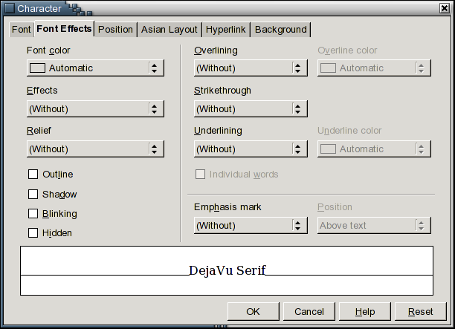Illustration 1: New layout of Font Effects pane (highlighted area is only shown if CJK support is activated)
In summary, the changes to the “Font Effects” pane are:
- The list box that was previously labelled “Color” has been relabelled “Underline color”
- Two new list boxes, labelled “Overlining” and “Overline color” have been added.
  - The function and behaviour of the new list boxes is identical to that of the list boxes labelled “Underlining” and “Underline color”, with the exception that they allow the user to select values for the overline and overline color attributes rather than for the underline and underline color attributes.
- The controls have been reordered, and separators have been added, with the aim of improving clarity.
The strings for the new controls are:
- “Overlining” - DropDown Listbox Properties |  | Comment
Enabled: | Always
Disabled: | Newer
Max. Row Count: | -
Rows Visible: | 7
Items: | - (Without)  - Single  - Double  - Bold  - Dotted  - Dotted (Bold)  - Dash  - Dash (Bold)  - Long Dash  - Long Dash (Bold)  - Dot Dash  - Dot Dash (Bold)  - Wave  - Wave (Bold)  - Double Wave
Item Selected: | 1
Sorting by  Drag & Drop: | Disabled
DropDown  ListBox Label: | Overlining | EN-US
- “Overline Color” - DropDown Listbox Properties |  | Comment
Enabled: | If value of control #1 is not equal “1” (Without)
Disabled: | Newer
Max. Row Count: | -
Rows Visible: | 7
Items: | List of available colors
Item Selected: | 1 (Automatic)
Sorting by  Drag & Drop: | Disabled
DropDown  ListBox Label: | Overline color | EN-US
- “Underlining” - DropDown Listbox Properties |  | Comment
Enabled: | Always
Disabled: | Newer
Max. Row Count: | -
Rows Visible: | 7
Items: | - (Without)  - Single  - Double  - Bold  - Dotted  - Dotted (Bold)  - Dash  - Dash (Bold)  - Long Dash  - Long Dash (Bold)  - Dot Dash  - Dot Dash (Bold)  - Wave  - Wave (Bold)  - Double Wave
Item Selected: | 1
Sorting by  Drag & Drop: | Disabled
DropDown  ListBox Label: | Underlining | EN-US
- “Underline Color” - DropDown Listbox Properties |  | Comment
Enabled: | If value of control #3 is not equal “1” (Without)
Disabled: | Newer
Max. Row Count: | -
Rows Visible: | 7
Items: | List of available colors
Item Selected: | 1 (Automatic)
Sorting by  Drag & Drop: | Disabled
DropDown  ListBox Label: | Underline color | EN-US

The new tab order is:
- “Font color” list box
- “Effects” list box
- “Relief” list box
- “Outline” check box
- “Shadow” check box
- “Blinking” check box
- “Hidden” check box
- “Overlining” list box
- “Overline color” list box
- “Strikethrough” list box
- “Underlining” list box
- “Underline color” list box
- “Individual words” check box
- “Emphasis mark” list box
- “Position” list box
For consistency, the position of the preview field has been similarly moved in the “Font”, “Position”, and “Asian Layout” panes. For the “Position” and “Asian Layout” panes, there are no further changes. For the “Font” pane, the informative text that appeared below the preview field has been moved to above the preview field as illustrated below:
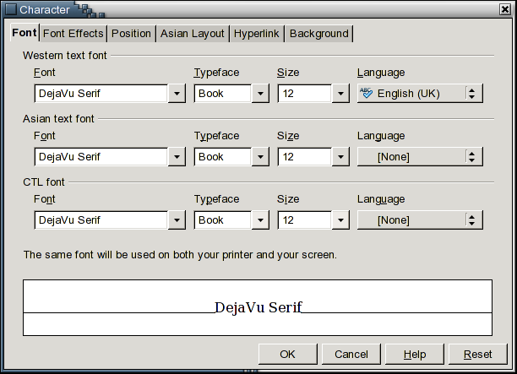Illustration 2: Revised layout of Font pane

Via context menus
The new overline and overline color attributes can be accessed via all text context menus that have a “Style” sub-menu. The revised layout of one such menu (from Writer) is illustrated below:
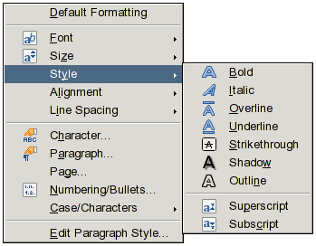Illustration 3: Revised layout of Style text context menu

In all cases, a new “Overline” menu item appears immediately above the underline menu item(s). Left clicking on the “Overline” menu item toggles the overline attribute between the values single and none.

Via toolbars
The new overline and overline color attributes can be accessed via the new “Overline” toolbar button, which is included in the “Format” command category. Left clicking on this button toggles the overline attribute between the values single and none.
The “Overline” toolbar button is not included by default in any toolbar.

Setting the overline attributes using the UNO-API
The new overline and overline color attributes can be accessed via the UNO-API through the new properties CharOverline, CharOverlineColor, and CharOverlineHasColor in the service com.sun.star.style.CharacterProperties. These properties are described in the following table:
New properties of com.sun.star.style.CharacterProperties
CharOverline | [ optional ] short – contains the value of the overline type. Possible values are specified by com.sun.star.awt.FontUnderline.
CharOverlineColor | [ optional ] long – contains the value of the overline colour. Possible values are specified by com.sun.star.awt.Color.
CharOverlineHasColor | [ optional ] boolean – true if CharOverlineColor is used for an overline.

NOTE: I suggest deprecating the name com.sun.star.awt.FontUnderline and replacing it by com.sun.star.awt.FontLineStyle.

Visual effect
When the new overline attribute for a character is set to a value other than none, the effect is the same as if the underline attribute had been set to the same value, with the exception that the resulting line is drawn above the character rather than below. The line is positioned to lie just below the top of the character cell (determined from the font metrics).
If the overline attribute is set to the same value for a sequence of characters having the same font metrics, the resulting line will be continuous across all characters in that sequence, with the exception that if the “Individual words” check box is ticked in the “Font effects” pane, the line will be broken over any white space in the sequence.
If the overline attribute is set to the same value for a sequence of characters having different font metrics, the resulting line will be discontinuous wherever a change in character cell height occurs in the sequence.
NOTE: In this respect, behaviour is consistent with the strikethrough font effect rather than with the underline font effect.
The overline color attribute has the same effect on the colour of the overline font effect as the underline color attribute has on the underline font effect.
The overline font effect is independent of, and can be applied simultaneously with, all other font effects.
Some examples of the overline font effect are illustrated below:
Illustration 4: Examples of the overline font effect

File import
The new overline attributes are set to the closest supported values when loading or importing from the following file types:
- ODF
They are set to null values when loading or importing from any other file type.
NOTE: Import from HTML files is not supported because CSS style import is not currently implemented by any application.

File export
The new overline attributes are preserved using the closest supported values when saving or exporting to the following file types:
- ODF
- PDF
- HTML (from Writer only)
They are not preserved when saving or exporting to any other file type.
When saving or exporting to ODF or PDF files, all attributes are preserved. When saving or exporting to HTML files, any non-null overline type is converted to a single overline and the overline colour is lost.
NOTE: HTML export is only supported for Writer because CSS style export is not currently implemented by any other application.

Migration
If an older version of OpenOffice.org (i.e. one that doesn't incorporate this enhancement) is used to load or import an ODF file containing overlined text, the overline attributes will be discarded.
If an older version of OpenOffice.org is used to load or import a HTML file containing overlined text, the overline will be replaced by an underline (this is the current OpenOffice.org behaviour).

Configuration
This enhancement does not affect the configuration.

File Format

ODF
NOTE: The following text assumes my proposal for extending ODF to support overlined text is accepted by the OASIS TC. There are two fallback options:
- The OASIS TC adopts an alternative method of representing overlined text. In this case, this specification will be amended to use that method.
- The OASIS TC decides not to support overlined text. In this case, this specification will be amended to define a custom XML schema that can be used to extend ODF to support overlined text.
The new overline attribute is stored using a combination of the following ODF properties:
- style:text-overline-type
- style:text-overline-style
- style:text-overline-width
The new overline color attribute is stored using the following ODF property:
- style:text-overline-color
The existing attribute accessed via the “Individual words” checkbox in the “Font Effects” pane is additionally stored using the following ODF property:
- style:text-overline-mode

HTML
The new overline attribute is stored using the following CSS property/value:
- text-decoration:overline
The new overline color attribute cannot be stored in HTML files.

Open Issues
Issue | Initials | Date
Should com.sun.star.awt.FontUnderline be renamed to com.sun.star.awt.FontLineStyle | MTW | May 22, 2008
<...>

Document Change History
Rev. | Change | Initials | Date
1 | First draft. | MTW | May 03, 2008
2 | UX review. Added new Font Effects tab mock-up and string tabels. | FL | May 14, 2008
3 | Replaced Font Effects tab mock-up with screenshot of prototype implementation, updated description of Font Effects tab changes for new layout, changed position of overline entry in text context menu. | MTW | May 22, 2008
4 | Added missing i-Team members. | MTW | May 26, 2008
5 | Added Test case link | SBA | Dec, 15, 2008
6 | Set Specification status to “Srtandard” | SBA | Dec. 16, 2008

