Software Specification Document

OpenOffice.org
Signed Extensions

Specification Status
Last Change | 2008-25-01
Status
Abstract
Extensions are often distributed via internet. Downloading extensions from unsafe locations may put users at risk to obtain malicious software. By using signatures users can verify the publisher of the extension and be sure that it has not been modified by a third party or been damaged during transmission.

i-Team Members
Role | First Name, Last Name, Initials | E-Mail Address
I-Team Lead | Joachim Lingner | jl@openoffice.org
Specification Author | Bettina Haberer, Joachim Lingner | bh@openoffice.org, jl@openoffice.org,
User Experience | Bettina Haberer | bh@openoffice.org
Development | Joachim Lingner | jl@openoffice.org
Quality Assurance | Frank Stecher | fst@openoffice.org
Documentation | Uwe Fischer | ufi@openoffice.org
Other roles | <First Name, Last Name (Initials)> | <User@openoffice.org>
<State reason here, if one role is not represented in i-Team.>

Contents
Abstract 1
i-Team Members 1
References and Reference Documents 3
Acronyms and Abbreviations 3
1 Detailed Specification 4
1.1 Signing an Extension 4
1.1.1 The Signature Dialog 4
1.1.2 Distribution of the tool 4
1.2 Verification of the Signature during Installation (GUI) 4
1.3 Verification of the Signature during an Update of an Extension 7
1.4 Verification of the Signature during Installation (Console) 8
1.5 Changes to the Extension Manager Dialog 9
2 Migration 9
3 Configuration 9
4 File Format 10
5 Open Issues 10
Document Change History 10

References and Reference Documents
Reference Document | Check | Location (URL)
Specification Process Entry Check |  | N/A
Product Requirement, RFE, issue [Required] |  | <Please enter location here>
Product Concept Document |  | <Please enter location here>
Competitive Analysis |  | <Please enter location here>
IDL Specification |  | <Please enter location here>
Test Case Specification [Required] |  | <Please enter location here>
Software Specification Rules | N/A | N/A
<Other, e.g. references to related specs>
Acronyms and Abbreviations
Acronym / Abbreviation | Definition
<WYSIWYG> | <What You See Is What You Get>

Detailed Specification

For more details about the already existing feature digital signatures for documents and the very similar user interface with it's functions have a look at the specification
http://specs.openoffice.org/appwide/security/Electronic_Signatures_and_Security.sxw and
http://specs.openoffice.org/appwide/security/Electronic_Signatures_and_Security_PP1.sxw.

Signing an Extension
Signing will be done by using the “signext” tool. It will bring up a dialog which allows to add and view signatures.
Note: Providing a pure command-line tool is currently no objective for this initial release of the feature. The reasons are:
- The signing tool will use the existing architecture used for signing documents. This architecture is not designed to provide “none – GUI” signing.
- Signing requires that one possesses a valid certificate and the corresponding private key. The private key must be kept secret. Therefore the private key may not be shared with too many people, otherwise one risks that the key will become known or misused. In that case signing is useless. Therefore some systems allow a strong protection of the use of the key. For example, on Windows one will be asked to enter a password in a dialog before the signing operation continues. That is, user interaction will be required.

The Signature Dialog
Running the tool will result in showing a dialog.
BH@BH: Mockup with changed Title?, fixed text above list box and below need to be adapted.
Done

Figure 1

String list figure 1

Distribution of the tool
The signing tool should be distributed in OOo rather then the SDK because, because it it possible in OOo to create extensions from Basic. The user may want to sign those extensions.

Verification of the Signature during Installation (GUI)
When an extension is being installed and this extension contains a signature, the a dialog is shown which shows information about all signatures. It also displays information about the validity of the signatures and the certificates. The user can proceed with the installation by pressing the “Install” button. By pressing “Do not install” or the escape key the operation will be cancelled.
The dialog is similar to the one used for signing. Particularly the functionality of the “View certificate” dialog is exactly the same.

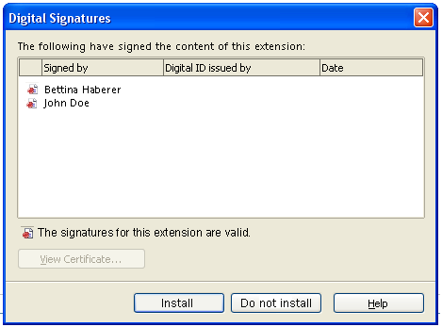
Figure 1: The 'Digital Signatures' dialog showing the 'Signed by' list and status line.

Case A: All the existing signatures are valid, thus the appropriate icon is shown.

String list figure 2:

Item | English | Comments
Fixtext | The following have signed the content of this extension: | Default text
Fixtext: Case A, | The signatures for this extension are valid.
Button | ~Install
Button | ~Do not install

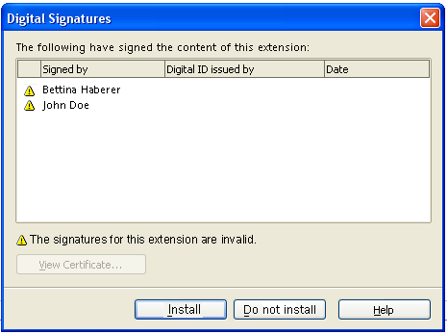
Figure 2: The status visible, when the signatures for the extension are invalid.

Case B: If at least one of several existing signatures is invalid, the status is shown as above.

String list figure 3:
Item | English | Comments
Fixtext: Case B, | The signatures for this extension are invalid.
Figure 3: The certificate could not be validated.

Case C: The certification path of the certificate used for signing the extension could not verified.

String list figure 4:

Item | English | Comments
Fixtext: Case C, | The certificate could not be validated.

Verification of the Signature during an Update of an Extension
If an extension is updated and the new version contains an extension signature then the signature dialog is shown. It is the same dialog that is displayed when adding an extension. That is, the user determines by clicking the “Install” or “Do not install” if the extension is eventually installed.
Future enhancement: The extension update comprises two steps – removing of the installed version and installing of the new version. The signature dialog is only displayed when installing the new version. At that time the previous version has already been uninstalled. If the user chooses to not install the new version then neither the old nor the new version will be installed. This is similar to extensions which show their licenses during the update. The enhancement is to show a dialog asking the user if he/she will keep the previous version in case installing the new extension was cancelled.
The following table shows the cases when the Signature Dialog will be displayed.

Case | Installed extension | New version which will update the installed version | Show signature dialog | Show warning
1 | not signed | not signed | - | -
2 | signed | not signed | - | yes
3 | not signed | signed | yes | -
4 | signed | signed | yes | -

Case 2: We should show a warning that says:
“The new version of extension name_of_extension is not signed although the installed version is.”

Future enhancement: In the future more and more extensions will be signed. Then users may be annoyed about all the dialogs popping up during the update and about having to agree to each update (by pressing the “Install” button. Although it is for their own good, they may see it as a hassle. To remedy this we could provide a setting (options page) which allows that the extensions are installed automatically without showing the signature dialog. However, this would happen only as long as the new extension is signed by the same entities as the already installed extension. Also all signatures must be valid.

BH@JL: It is useful to remove the old extension, if the user decides to install the new extension without cancelling the installation. But the user should have the opportunity to cancel the action. And in that case the old extension must not be removed, the user should at least be able to keep the old status. He should not be forced to download the extension again. Imagine, he has paid for it, the extension repository can also include extensions one has to pay for. Now he is forced to download and pay again...We really need to be able to restore the older extension for target 3.0.

Verification of the Signature during Installation (Console)
When a signed extension is being installed without the Extensions Manager Dialog (using unopkg add ...) then the user will be informed about who signed the extension and if the signature and certificates are valid.

The output should read as follows. The numbers at the beginning are not written. They are used for reference the lines later:
1 The extension DISPLAY_NAME was signed by:
2 Name of the signer,
3 Issuer
4 The signature and the certificate are valid.

If the extension has multiple signatures then the lines 2 through 4 are repeated for every signature. Then there will also a line 5 which gives a summary:
5 The signatures of the extensions and the certificates are valid.
------------------------------------------------------------------
Line 4 changes according to the following table:

Case | Validity of signed content | Validity of certificate
1 | valid | valid
2 | valid | invalid
3 | invalid | valid
4 | invalid | invalid

String table for the cases 1 - 4
1 | The signature and the certificate are valid.
2 | The signature is valid. The certificate is not valid.
3 | The signature is invalid (content was modified). The certificate is valid.
4 | The signature is invalid (content was modified) The certificate is valid.

String table for line 5 for the 4 cases.

1 | The signatures of the extensions and the certificates are valid.
2 | All signature are valid. At least one certificate is not valid.
3 | At least one signature is invalid (content was modified). All certificates are valid.
4 | At least one signature is invalid (content was modified) At least one certificate is valid.

BH@BH: Adjust strings in both dialogs.

Changes to the Extension Manager Dialog
There will be no changes. That is, it will be not displayed if the extension was signed. The reason is, that it is legitimate that the content of the extension (after installation) can be changed. For example, the extension may choose to save some preferences data in the directory where the extension has been unzipped. This invalidates the extension signature. There is no way (that is, with reasonable effort) to determine that the extension is modified. And even if one could detect it, the user may not relate it to one of its actions. For example, provided we could detect a change then we would bring up a dialog telling that the extension signature will be lost. The user may not understand it, because he/she is not aware of having done something which may have caused this. This is different with signed documents. Then the dialog comes up when the user clicks the save button.

Migration
<Start typing here ----- If this part is irrelevant state a reason for its absence!>

Configuration
<Start typing here ----- If this part is irrelevant state a reason for its absence!>

File Format
<Start typing here ----- If this part is irrelevant state a reason for its absence!>

Open Issues
Issue | Initials | Date
<State Issue here, State “None”, if all issues are solved> |  | <Format: Dec 31, 2000>
<...>

Document Change History
Rev. | Change | Initials | Date
1 |  |  | <Format: Dec 31, 2000>
2
3
<...>

