Software Specification Document

OpenOffice.org/StarOffice
Start Center

Specification Status
Last Change | 1. Jul 2008
Status
Abstract
OpenOffice.org is separated into single applications like Writer, Calc, Draw and Impress, which could be started directly from the operating system start panel. If the OpenOffice.org executable is started directly OOo shows the start module, always shown if no document is loaded. The start module has no value for the user on start-up, but keeps OOo loaded if the last document has been closed and a new one is generated.
The plain start module makes it difficult start OOo from a link on the desktop to gain visibility or on the Macintosh platform.
So a new start center is needed to welcome the user. This start center could be further extended from version to version. This first step defines the integration into the operating system and a first welcome dialog within the former backing window.
i-Team Members
Role | First Name, Last Name, Initials | E-Mail Address
I-Team Lead | Stephan Schäfer (SSA) | stephan.schaefer@sun.com
Specification Author | Frank Loehmann (FL) | frank.loehmann@sun.com
User Experience | Frank Loehmann (FL) | frank.loehmann@sun.com
Development | Philipp Lohmann (PL)  Ingo Schmidt-Rosbiegal  Carsten Driesner (CD) | philipp.lohmann@sun.com  Ingo.Schmidt@Sun.COM  carsten.driesner@sun.com
Quality Assurance | Olaf Felka (OF) | olaf.felka@sun.com
Documentation | Uwe Fischer (UFI) | uwe.fischer@sun.com
Program Manager | Martin Hollmichel (MH) | martin.hollmichel@sun.com
Graphic Design | Stella Schulze (STS) | stella.schulze@sun.com

Contents
Abstract 1
i-Team Members 1
References and Reference Documents 3
Acronyms and Abbreviations 3
1 Detailed Specification 4
1.1 Operating System Integration 4
1.1.1 All Platforms 4
1.1.1.1 Launch Center 4
1.1.2 Windows 4
1.1.2.1 Desktop Link 4
1.1.2.2 Setup Wizard 6
1.2 OOo Start Center 7
1.2.1 Windows/Unix Platform (Issue i20073) 7
1.2.2 Mac Platform (Issue: 85963) 10
1.3 File – New – From Template Dialog 11
2 Migration 11
3 Configuration 11
4 File Format 11
5 Open Issues 12
Document Change History 12
6 Future Feature Specifications 13
6.1 Application Background 13

References and Reference Documents
Reference Document | Check | Location (URL)
Specification Process Entry Check |  | N/A
Product Requirement, RFE, issue [Required] |  | I85963, i20073, i3146, i62909
Product Concept Document |  | <Please enter location here>
Competitive Analysis |  | <Please enter location here>
IDL Specification |  | <Please enter location here>
Test Case Specification [Required] |  | http://www.openoffice.org/issues/createattachment.cgi?id=85963
Software Specification Rules | N/A | N/A
Star Module Specification |  | http://specs.openoffice.org/appwide/start_module/StartModule.sxw
Acronyms and Abbreviations
Acronym / Abbreviation | Definition
Start module | See specification: http://specs.openoffice.org/appwide/start_module/StartModule.sxw

Detailed Specification
The following specification defines the behavior of the new start center and the extended system integration for OpenOffice.org.

Operating System Integration
There are several touch points where the link to the new start center should be added.

All Platforms

Launch Center
The integration to the operating system's launch center (i.e. the Start menu on Windows) gets extended by a new link to start OpenOffice.org with the start center open.
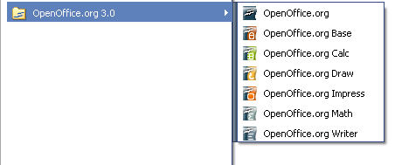Illustration 1: Windows start menu group for OpenOffice.org now showing link to main executable
- “OpenOffice.org” - Link Properties |  | Comment
Text | $PRODUCTNAME
Icon Tip Help: | The office productivity suite compatible to the open and standardized ODF document format. Supported by Sun Microsystems. | EN-US
Link: | soffice.exe:<ADD SLOT ID>

Windows

Desktop Link
A link to start OpenOffice.org from the operating systems desktop is being created during the setup of OOo. An option in setup application allows to suppress the creation of the desktop link during the setup (see setup section below for details).
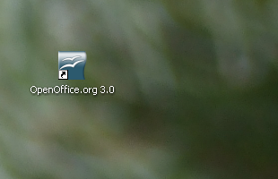Illustration 2: Link to OpenOffice.org executable on the desktop
The tip help shown on a mouse over promotes the use of the open and standardized Open Document Format (ODF).
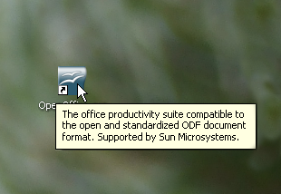Illustration 3: Mouse over tip help
- “OpenOffice.org 3.0” - Link Properties |  | Comment
Text | $PRODUCTNAME $PRODUCTVERSION
Icon Tip Help: | The office productivity suite compatible to the open and standardized ODF document format. Supported by Sun Microsystems. | EN-US
Link: | soffice.exe:<ADD SLOT ID>

Setup Wizard
The setup wizard shows a new option to create a link to OOo application during the installation. See section above for details about the link created on desktop.
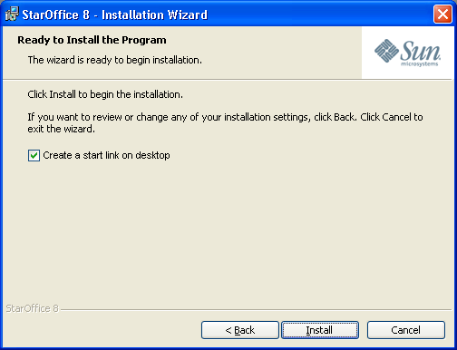Illustration 4: Setup installation wizard shows an option to create a start link for OOo on the desktop
- OOo start link” - CheckBox Properties |  | Comment
Enabled: | Always
Disabled: | Never
Tri-State: | Never
Checked: | By default
CheckBox Label: | Create a start ~link on desktop | EN-US

OOo Start Center
The start center will be shown only at startup and only on circumstances that would hitherto have shown the Start Module (this is no document was opened and no special command line arguments were given).
The new start center will consist of a short welcome message and various buttons allowing the user to create a new document for one of the installed applications. Buttons for document types belonging to a not installed application will be disabled.
Additionally a button for opening an existing document, another one for recently edited documents as well as one for opening a document from a template are added at the lower end of the dialog.
On startup the installed applications are queried and their icons loaded. For each installed application the corresponding button is enabled. If there are more buttons than the background bitmap allows the dialog will be extended downward and its background will be white in the extended space.

Windows/Unix Platform (Issue i20073)
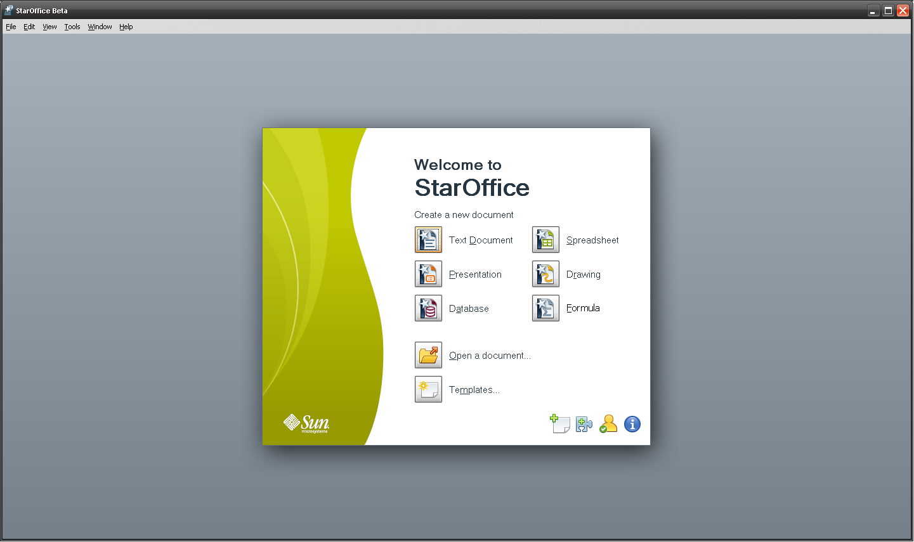Illustration 5: Start center
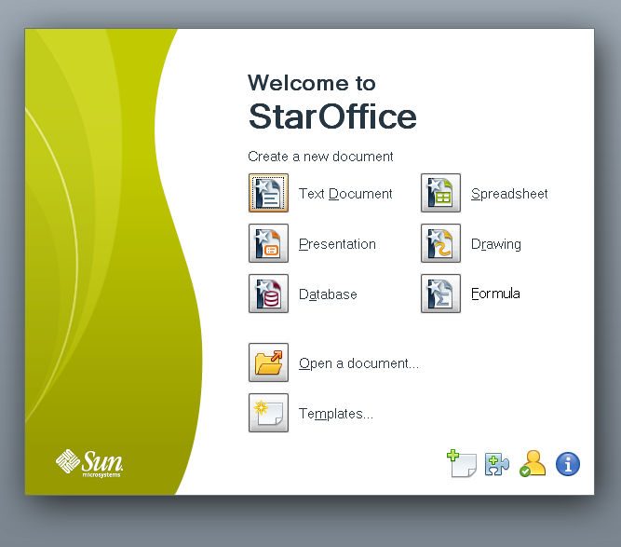Illustration 6: Start-Center details
- “Welcome 1” - Label Properties |  | Comment
Label: | Welcome to | EN-US
- “Welcome 2” - Label Properties |  | Comment
Label: | %PRODUCTNAME | EN-US
- “Header 1” - Label Properties |  | Comment
Label: | Create a new document | EN-US
- “Writer” - Button Properties |  | Comment
Enabled: | If corresponding application is currently installed
Disabled: | If corresponding application is currently not installed
Press: | Starts corresponding application
Button Label: | ~Text Document | EN-US
- “Impress” - Button Properties |  | Comment
Enabled: | If corresponding application is currently installed
Disabled: | If corresponding application is currently not installed
Press: | Start corresponding application
Button Label: | ~Presentation | EN-US
- “Database” - Button Properties |  | Comment
Enabled: | If corresponding application is currently installed
Disabled: | If corresponding application is currently not installed
Press: | Starts corresponding application
Button Label: | ~Database | EN-US
- “Calc” - Button Properties |  | Comment
Enabled: | If corresponding application is currently installed
Disabled: | If corresponding application is currently not installed
Press: | Starts corresponding application
Button Label: | ~Spreadsheet | EN-US
- “Draw” - Button Properties |  | Comment
Enabled: | If corresponding application is currently installed
Disabled: | If corresponding application is currently not installed
Press: | Starts corresponding application
Button Label: | ~Drawing | EN-US
- “Templates” - Button Properties |  | Comment
Enabled: | Always
Disabled: | If corresponding application is currently not installed
Press: | New – From Template dialog
Button Label: | Templates... | EN-US
- “Open” - Button Properties |  | Comment
Enabled: | Always
Disabled: | Never
Press: | Shows File-Open dialog
Button Label: | ~Open a document... | EN-US
- “Recent” - Button Properties |  | Comment
Enabled: | If recent documents list is not empty
Disabled: | If recent documents list is empty
Press: | Shows New – From Template dialog with Recent Work section open
Button Label: | Open a recent document... | EN-US
- “Extensions” - Button Properties |  | Comment
Enabled: | Always
Disabled: | Never
Press: | Open OOo extension site in systems default browser
Button Label: |  | EN-US
Tip Help
- “Registration” - Button Properties |  | Comment
Visible | If program has not been registered
Disabled: | Never
Press: | Open registration site in systems default browser
Button Label: |  | EN-US
Tip Help
- “Information” - Button Properties |  | Comment
Enabled: | Always
Disabled: | Never
Press: | Open OOo web page or a special welcome page.
Button Label: |  | EN-US
Tip Help

Mac Platform (Issue: 85963)
The following mock-up shows the start center like displayed on the Mac platform.
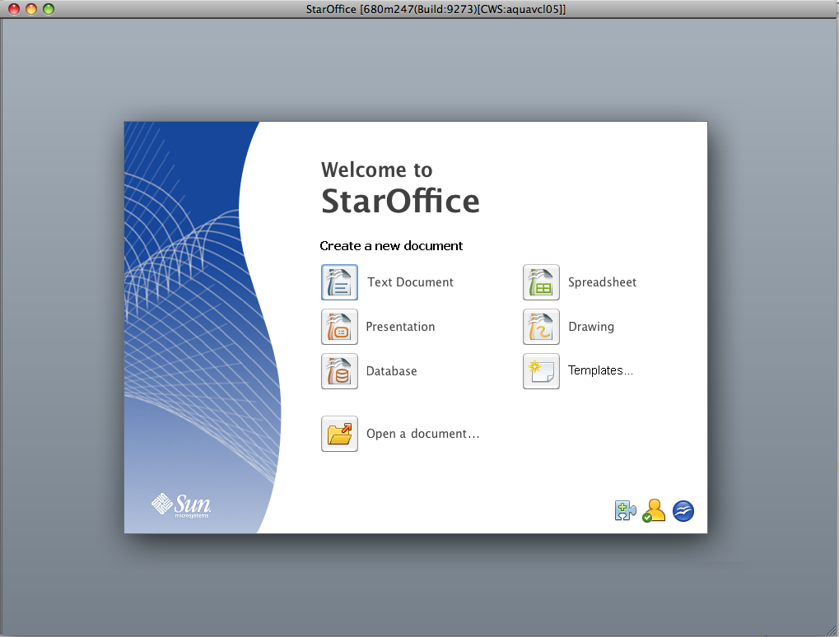Illustration 7: Start Center on Mac (Beta Version) (image outdated)

File – New – From Template Dialog
The file new from template dialog shows a new section “Recent Work” were all the documents from the recent file menu are listed. This section is defaulted, when “Open recent documents” is called in the start center.
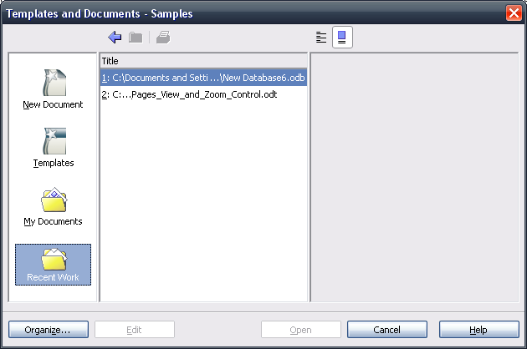Illustration 8: New Recent Work Section in Templates and Documents dialog
- “Recent Work” - Label Properties |  | Comment
Label: | ~Recent Work | EN-US

Migration
No relevant.

Configuration
No relevant.

File Format
No relevant.

Open Issues
Issue | Initials | Date
Icon for Recent Document | FL | February 29, 2008
Need possibility to localize URLs & standardized use of language parameters | FL | February 19, 2008
Final URLs? | FL | February 19, 2008
Tip Helps | FL | February 29, 2008
Desktop link should always start a start center | FL | March 18, 2008
Document Change History
Rev. | Change | Initials | Date
1. | Initial Specification | FL | February 8, 2008
2. | Mac platform definition added | FL | February 13, 2008
3. | New start center mock-ups by STS | FL | February 13, 2008
4. | New Mock-ups | FL | February 19, 2008
5. | Set up application & new mock-ups | FL | February 29, 2008
6. | Add heading “Create a new document”, change naming for start center entries (remove “New...”) and add Templates... button to new documents section. | FL | March 10, 2008
7. | Recent button | FL | June 10, 2008

Future Feature Specifications

Application Background
The gradient background shown inside the backing window of the start center is also shown in Writer and Impress.
