Search Toolbar Specification
OpenOffice.org 3.x

Document - ID | Specification Owner | Last Change | Status
 | OOo | Apri 14, 2009 | draft
Conforms to
Applies to | Swriter, Salc, Impress, Draw
Task ID(s)
Category | Feature

Abstract
The Search tool bar is tool bar which will provider search quickly text feature, it includes searching text, backwards searching, forward searching, Match of lowercase or uppercase, Match the Whole word and Closer button. It can be closed by mouse or pressing a Keyboard shortcut.

i-Team Members
 | Name | E-mail Address
User Experience
Development | Shizhoubo  Carsten Driesner | robertzhou@openoffice.org  carsten.driesner@sun.com
Quality Assurance
Documentation

Approved for Implementation
 | Approved by | Date
Development
Quality Assurance
Documentation
String Review

Document Change History
Rev. Level | Change | Initials | Date

Contents
Glossary 1
1 Motivation 1
2 User Scenarios 1
3 Goals 1
4 Requirements and Dependencies 2
4.1 Requirements 2
4.2 Technical Dependencies 2
5 Competitive Analysis 2
5.1 Google Chrome 2
5.2 Mozilla 2
6 Detailed Specification 2
6.1 Static Text info 3
6.2 Edit Controller 3
6.3 Next Button 3
6.4 Previous Button 4
6.5 Search All Button 4
6.6 Match Case Button 4
6.7 Whole Word Button 5
6.8 Dynamic Text Info1 5
6.9 Dynamic Text Info2 5
6.10 Close Button 5
7 Future Tasks 5
8 Notes 6
9 References 6

Glossary
Term | Description
Search Tool bar | The Search Tool bar is a lockedup bar like status bar. And it is above the status bar
Title Lable | It describe what the search action is like “find”
Edit Controller | This is edit controller which provide input for users
Next Button | This is a button which provide backwards searching
Previous Button | This is a button which provide forwards searching
Search All | This is a radio button which search all content of document and hightlight all searching text
Match Case Check Box | This is a button which can match lowercase or uppercase for searching text
Whole Words Check Box | This is a button which can match the Whole Words for searching text
Tip Message Lable | This is a lable wihich show information of the count of the searching text
Tip Message Lable | This is a button which show the tip message describle not find searching text
Close Button | This is a button which can close the search tool bar

Motivation
The motivation for this feature is to enhance the speed of searching text ,and the search tool bar does not hide the content of the document.

User Scenarios
Currently OpenOffice.org users must use the search dialog to search text, when the users want to see content which the search dialog hides, he has to move the search dialog via mouse.

Goals
The goal for OpenOffice.org 3.x is to provide a tool bar which gives uses the possibility to apply frequently used for searching text. The search tool bar will provide a simple, shortcut way to searching text, without opening the search dialog.

Requirements and Dependencies

Requirements
Provide a tool bar which gives users the possibility to apply frequently used commands without the opening search dialog.

Technical Dependencies
Implementation of the search tool bar depend on these searching algorithms of the current search dialog. It won't interfere with the search dialog.

Competitive Analysis

Google Chrome
The Google Chrome Search tool bar (Figure 1). it is located below the address tool bar and can't be moved. The search tool bar can made visible by pressing Ctrl+F. The search tool bar is very simple and only provides searching text and not change something like match case. It includes backward, forward searching and count of the searching text. The Search tool bar organized into a number of buttons or label which are arranged from the left to the right with it.

Figure 1 Screen shot of the Google Chrome(dialog is searching text).

Mozilla

Mozillas Search Tool bar(Figure 2) , It is located at the above of the status bar and can't be moved .The Search tool bar can be made visible by pressing Ctrl+F.
The Search tool bar is organized into a number of buttons which are arranged from the left to the right with it. The mouse can be used to click the buttons and every button has a state.

Figure 1 Screen shot of the Mozilla Search tool bar

Detailed Specification
The OpenOffice Search Tool Bar(Figure3) shall be located at the above of the status bar. And it can't be moved. It can made visible by pressing Ctrl+F1. It is make up of the tool bar item , of course , these tool bar item can be BUTTON_SYMBOLTEXT or BUTTON_SYMBOL.

Find:
Next
Previous
Search all
Match case
Whole word
Count info
Not found info
Close

Figure 3 Search Tool bar image

The Search Tool Bar includes fellowing ten tool bar item
- Static Text info
- Edit Controller
- Next Button
- Previous Button
- Search All Button
- Match Case Button
- Whole Word Button
- Dynamic Text Info1
- Dynamic Text Info2
- Close Button

Static Text info
The static text info only describe information to explain what the edit controller input. It name “Find”, it only is static text and showed in the searching tool bar. It should support multilingual property.

Item | English | Chinese | Comments
Tool bar item | Find | 查找

Edit Controller
The Edit Controller is Edit Text, users can input searching text in the edit Text, and it always is showed in the searching tool bar. When users did not find searching text in current document, the edit text background color should be set gray which mean not find searching text. Like following image of red line mark
office
Find:
Next
Previous
Search all
Match case
Whole word
Count info
Not found info
Close

Figure 1 States of the “Edit Text” when “office” string no to be exist

Next Button
The is a simple tool bar item with BUTTON_SYMBOLTEXT type. Users can use to find backward searching text in the current document. When the searching text is showed at end of the document, the The Dynamic Text Info2 will shown “ reached end of document,continue form top” information like following red line mark

office
Find:
Next
Previous
Search all
Match case
Whole word
reached end of document ..
Close

Figure 2 the dynamic text info1 show “reached end of document,continue from top”

Previous Button
The is a simple tool bar item with BUTTON_SYMBOLTEXT type. Users can use to find forwards searching text in the current document. When the searching text is showed at top of the document, the The Dynamic Text Info2 will shown “ reached top of document,continue form end” information like following red line mark
office
Find:
Next
Previous
Search all
Match case
Whole word
reached top of document...
Close
Figure 3 the dynamic text info1 show “reached top of document,continue form end”

Search All Button
The Button is a tool bar item with BUTTON_SYMBOLTEXT type,when users click it, the searching text will be shown hightlight and selected(like following Figure7 image). The “search all button” need not changed states.
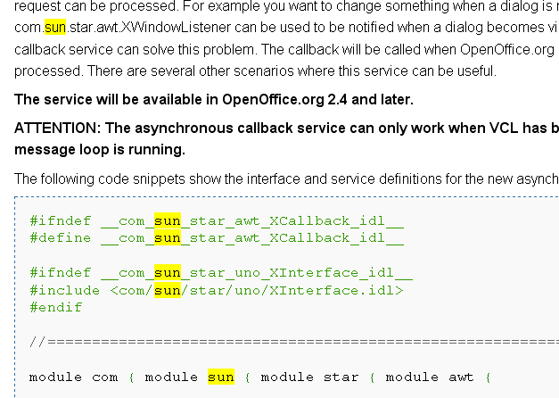
Figure 4 the “sun”string is shown heightlight

Match Case Button
The Match Case Button is a check box button, after the check box is selected, searching text will match case to find in the current document, when searching text may not exist, The Dynamic Text Info2 will shown “ phrase not found” information. Like following red line mark.
dialog
Find:
Next
Previous
Search all
Match case
Whole word
phrase not found
Close

Figure 5 the image of the not found searching text

Whole Word Button
The Whole Word Button is a check box button, after it is selected , searching text will match the whole word to find in the current document. When the whole word searching text not exist , he Dynamic Text Info2 will shown “ phrase not found” information. Like following red line mark.

following
Find:
Next
Previous
Search all
Match case
Whole word
phrase not found
Close

Figure 6 the image of the not found searching text

Dynamic Text Info1
The Dynamic Text info2 is a dynamic string, is show information which means to show count of searching text in the current documents. When user use only “Search all” to find string, the Dynamic Text info2 will be shown , and tell user count of the searching text in the current document. Like following image of red line mark.

sun
Find:
Next
Previous
Search all
Match case
Whole word
22 times
Close

Dynamic Text Info2
The Dynamic Text info2 is a dynamic string, is show information which remain following informations to users.
“phrase not found “, “ reached top of document,continue form end”, “reached end of document,continue form top” . What the dynamic text is depend to result of searching text.
But the Dynamic Text1 and Text1 would support multilingual property.

Close Button
The is tool bar item with only BUTTON_SYMBOL type, it can close the search tool bar.

Future Tasks
-

Notes
-

References

