Software Specification Document

OpenOffice.org
Preview Document in Web Browser

Specification Status
Last Change | 9. Feb. 2009
Status

Abstract
Make the current document previewed by browser as web page, in order to see the effect of display before release. Added a new menu item in the File menu which named 'Preview in Web Browser'. This menu item can make the current document browsed in web page. text, picture and media that can be edited in the document are all can be browsed successful. It is just browse,so some files can not edit or have their original function but are recognized as a picture. Every application include Text document, Spreadsheet and presentation can use this function.

i-Team Members
Role | First Name, Last Name, Initials | E-Mail Address
Project Lead | Carsten Driesner | carsten.driesner@sun.com
Specification Owner | Liu Tao | liutao@openoffice.org
User Experience | Frank Loehmann | frank.loehmann@sun.com
Development | Liu Tao  Carsten Driesner | liutao@openoffice.org  Carsten.driesner@sun.com
Quality Assurance | Stefan Baltzer | Stefan.baltzer@sun.com
Documentation | Uwe Fischer | uwe.fischer@sun.com
Other roles | None

Contents
Abstract 1
i-Team Members 1
References and Reference Documents 3
Acronyms and Abbreviations 3
1 Detailed Specification 4
2 Migration 7
3 Configuration 7
4 File Format 7
5 Open Issues 7
Document Change History 7

References and Reference Documents
Reference Document | Check | Location (URL)
Specification Process Entry Check |  | N/A
Product Requirement,, RFE, issue (required) |  | <Please enter location here>
Product Concept Document |  | <Please enter location here>
Competitive Analysis |  | <Please enter location here>
Test Case Specification (required) |  | <Please enter location here>
Software Specification Rules | N/A | N/A
File Menu Specification |  | http://specs.openoffice.org/appwide/menus/FileMenu.sxw

Acronyms and Abbreviations
Acronym / Abbreviation | Definition
<WYSIWYG> | <What You See Is What You Get>

Detailed Specification
Added a new menu item in the File menu which named 'Preview in Web Browser'. This menu item can make the current document browsed in web page. text, picture and media that can be edit in the document are all can be browsed successful. It is just browse,so some files can not edited or have their original function but are recognized as a picture. Every main application include Writer, Writer/WEB, Calc, Draw and Impress offer this new function.
When invoking 'Preview in Web Browser' a HTML file is written using OOo build-in HTML filters to write the HTML document. Firstly,save the document as HTML format. Then save the old setting and detect the filter. Create temp file name with leading chars and extension. Save document to temp file.In the next step the browser is started with the HTML file as parameter.
When 'Preview in Web Browser' is clicked the current document will be saved to the TEMP directory using the filter
- HTML Document (OpenOffice.org Writer) (.html)
- HTML Document (OpenOffice.org Calc) (.html)
- impress_html_Export
The method ExecMisc_Impl() in the Class sfxViewShell opens the browser. After the document is saved the system default browser is invoked using ExecMisc_Impl(). The formerly saved file in the TEMP directory is passed as parameter.
For example, In the Text document, this function can be described as follows:
- Open a new Text document then input or insert some elements such as words , table picture and media file.
string table describe the user interface strings
Language | English | German
String | Preview in Web Browser | Vorschau in Web-Browser
- Select the menu item “Preview in Web Browser” that have added in the File menu. To implement this function.
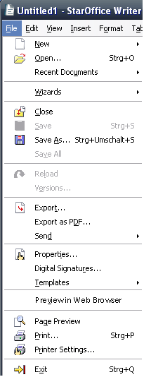
- This file can be browsed as a web page.
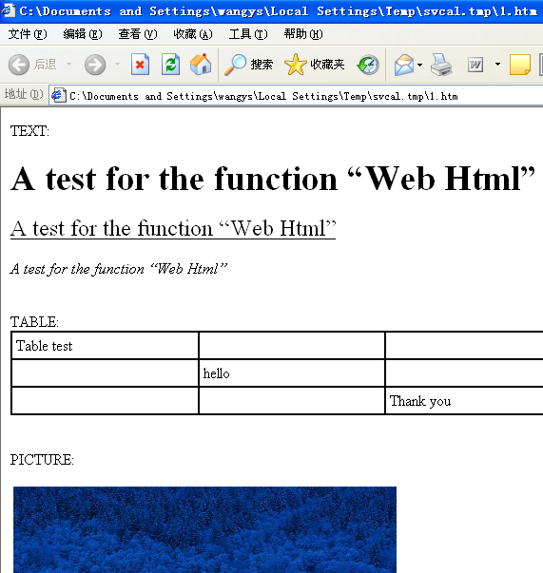Illustration 1: The first part of screen shot about the web page
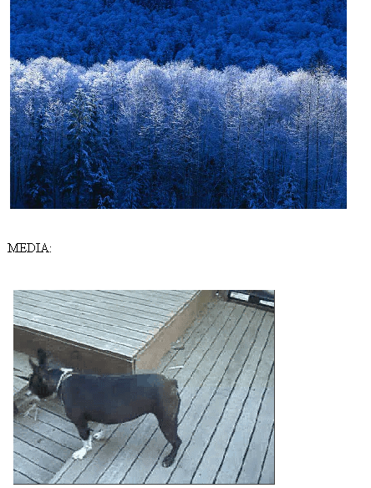Illustration 2: The second part of screen shot about the web page
This example is using Windows system and the IE browser. The Linux system and the Firefox browser also can implement this function.

Migration
n/a

Configuration
n/a

File Format
n/a

Open Issues
Issue | Initials | Date
<State Issue here, State “None”, if all issues are solved> |  | <Format: Dec 31, 2000>
<...>

Document Change History
Rev. | Change | Initials | Date
1 | Change Wording and position of menu entry in File menu | FL | April 2, 2007
2
3
<...>

