Software Specification Document

OpenOffice.org Calc
Insertion of Cells in a Spreadsheet via Drag & Drop

Specification Status
Last Change | Aug 10, 2007
Status
Abstract
Often a cell or a plurality of cells has to be moved via drag & drop to a new column or row inside the same or new spreadsheet. The new target cells for the data moved is often not empty, so that an insertion would be helpful to accomplish the task without inserting new rows/columns or cells in advance.

i-Team Members
Role | First Name, Last Name, Initials | E-Mail Address
I-Team Lead | Niklas Nebel (NN) | niklas.nebel@sun.com
Specification Author | Frank Loehmann (FL) | frank.loehmann@sun.com
User Experience | Frank Loehmann (FL) | frank.loehmann@sun.com
Development | Thomas Benisch (TBE) | thomas.benisch@sun.com
Quality Assurance | Frank Stecher (FST) | frank.stecher@sun.com
Documentation | Uwe Fischer (UFI) | uwe.fischer@sun.com

Contents
Abstract 1
i-Team Members 1
References and Reference Documents 3
Acronyms and Abbreviations 3
1 Detailed Specification 4
1.1 Insertion of Cells via Drag & Drop in a Table of a Spreadsheet 4
1.2 Keyboard Short Cut to Activate Insertion D&D Mode 4
1.3 Insert Drag & Drop of a Selection of Cells 4
1.3.1 Insertion Direction 5
1.3.1.1 Within the Same Table 5
1.3.1.2 To Other Table/Spreadsheet 5
1.3.2 Insertion Behavior 6
1.3.2.1 Insert Move D&D to Same Row/Column 6
1.3.2.2 Insert Move Drop to Other Rows/Columns 7
1.3.2.3 Insert Copy Drop 8
1.4 Insert Drag & Drop of Whole Columns 10
1.4.1 Insert Move Drop of Whole Columns in Same Table 10
1.4.2 Insert Move Drop of Whole Columns to a Different Table 11
1.4.3 Insert Copy Drop of Whole Columns 12
1.5 Insert Drag & Drop of Whole Rows 13
1.5.1 Insert Move Drop of Whole Rows in Same Table 13
1.5.2 Insert Move Drop of Whole Rows in Different Table 14
1.5.3 Insert Copy Drop of Whole Rows 15
2 Migration 16
3 Configuration 16
4 File Format 16
5 Open Issues 16
Document Change History 16

References and Reference Documents
Reference Document | Check | Location (URL)
Specification Process Entry Check |  | N/A
Product Requirement, RFE, issue [Required] |  | i7180
Product Concept Document |  | <Please enter location here>
Competitive Analysis |  | <Please enter location here>
IDL Specification |  | <Please enter location here>
Test Case Specification [Required] |  | Test Case Specification
Software Specification Rules | N/A | N/A
<Other, e.g. references to related specs>
Acronyms and Abbreviations
Acronym / Abbreviation | Definition
D&D | Drag & Drop

Detailed Specification
The insert Drag & Drop (D&D) mode behaves basically the same like the standard D&D overwrite mode. It also offers a move (default), copy (Ctrl modifier key pressed) or link mode (Ctrl + Shift keys pressed). There is only one difference in case of moving data within the same row. Then the moved data (source cell area) is filled up with the data shifted to the left/up by the inserted source data. Please find a detailed description of all different cases below.

Insertion of Cells via Drag & Drop in a Table of a Spreadsheet
The normal D&D overwrite cursor consists of a surrounding box (see Illustration 1, below). The new insertion mode shows a different D&D preview cursor (see Illustration 2 and 3, below).
Overwrite:
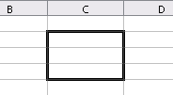Illustration 1:Overwrite D & D cursor
Insert:
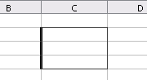Illustration 2: Vertical insertion mode
Illustration 3: Horizontal insertion mode

Keyboard Short Cut to Activate Insertion D&D Mode
The ALT key activates the insert mode if a D&D action is performed. The cursor (as described below) gives feedback if the mode is active

Insert Drag & Drop of a Selection of Cells
The behavior of inserting cells in rows or columns depend on the selected source and target area. Therefore the following cases can be distinguished.

Insertion Direction
D&D of a plurality of cells uses an automatic detection to decide if the cells are inserted in rows vertically or horizontally when the drop is processed. Vertical insertion means, that the target cells are shifted to the right,. Horizontal insertion means, that the target cells are shifted down.

Within the Same Table
Illustration 4: Determination when to insert vertical or horizontal
a: horizontal distance from source to target in cells
b: vertical distance from source to target in cells
Therefore the horizontal (a) and the vertical (b) distance in cells is counted from the source to the target cell area. The cells are inserted vertically at the target area, if (a) is larger than (b). Otherwise the cells are inserted horizontally.

To Other Table/Spreadsheet
If the selection is dropped to a different table, the insertion direction (horizontally/vertically) is determined by the ratio of the selected cell area.
Illustration 5: Source cell area
a: Source width in cells
b: Source height in cells
If (b) is larger than (a), then the cells are inserted vertically otherwise the selection is inserted horizontally.

Insertion Behavior

Insert Move D&D to Same Row/Column
The move drop is the default action also if the insertion mode is activated. Insertion of cells via D&D inside the same row/column will behave different when moving the cells. In that case the rows/columns will be shifted to the source cell area like described below.
Illustration 6: Insert drop to same row (A)
A
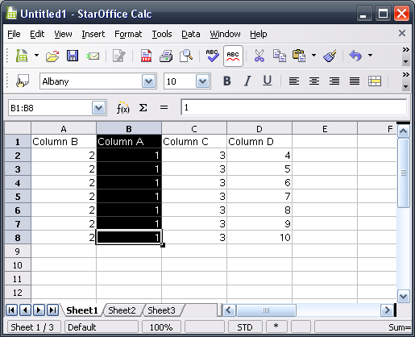Illustration 7: Result of insertion drop to same row

Insert Move Drop to Other Rows/Columns
The move drop to other rows/columns does not shift the cells to the source cell area.
Illustration 8: Move drop to other rows
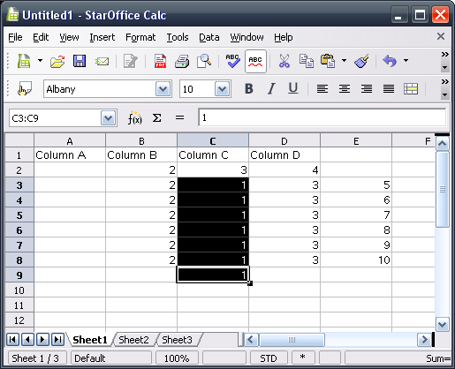Illustration 9: Result of the move drop

Insert Copy Drop
The copy drop could be activated by holding down the Ctrl key during the insert D&D.
Illustration 10: Insert copy drop (A)
A
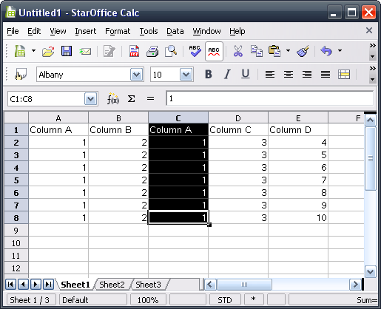Illustration 11: Result of the copy drop

Insert Drag & Drop of Whole Columns

Insert Move Drop of Whole Columns in Same Table
The move drop is the default action also if the insertion mode is activated.
Illustration 12: Preview of a move drop (A)
A
Move also removes the then empty (Column A) and shifts the columns to the left.
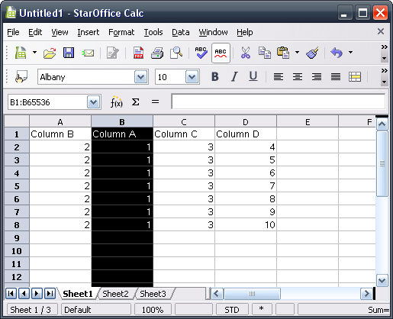Illustration 13: Result of the move drop of a whole column

Insert Move Drop of Whole Columns to a Different Table
D&D to a different table (or spreadsheet) will not shift any cells in the source area. Just the source cell data get removed.

Insert Copy Drop of Whole Columns
The copy drop could be activated by holding down the CTRL key during the insert D&D.
Illustration 14: Copy insertion drop (A)
A
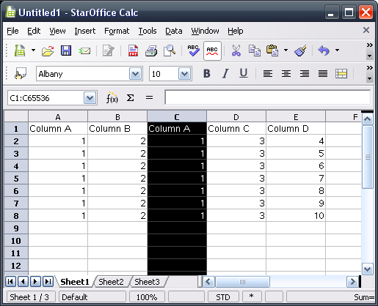Illustration 15: Result of inserting Column A between Column B and D

Insert Drag & Drop of Whole Rows

Insert Move Drop of Whole Rows in Same Table
The move drop is the default action also if the insertion mode is activated.
Illustration 16: Move drop of a complete row (A)
A
Move also removes the then empty (Row Header) and shifts the columns to the top.
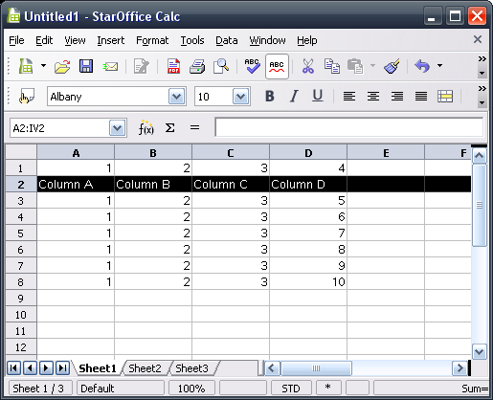Illustration 17: Result of this drop

Insert Move Drop of Whole Rows in Different Table
D&D to a different table (or document) will not shift any cells in the source area. Just the source cell data gets removed.

Insert Copy Drop of Whole Rows
Illustration 18: Copy drop of whole rows (A)
A
Illustration 19: Result of dropping whole rows

Migration
None, new feature.

Configuration
None.

File Format
None, new UI feature.

Open Issues
Issue | Initials | Date
<State Issue here, State “None”, if all issues are solved> |  | <Format: Dec 31, 2000>
<...>

Document Change History
Rev. | Change | Initials | Date
1 | Initial Spec | FL | July 04, 2007
2 | Add mock-ups | FL | July 11, 2007
3 | Overwork draft | FL | July 16, 2007
4 | Set status to standard | TBE | August 10, 2007

