Software Specification Document

Openoffice.org
Options for Bar Charts

Specification Status
Last Change | Oct 18, 2007
Status
Abstract
Several settings are not available for other chart types but column and bar charts, such as overlapping and spacing between the bars This specific functionality is described here.
i-Team Members
Role | First Name, Last Name, Initials | E-Mail Address
I-Team Lead | Björn Milcke | bm@openoffice.org
Specification Author | Björn Milcke | bm@openoffice.org
User Experience | Matthias Müller-Prove | mmp@openoffice.org
Development | Björn Milcke | bm@openoffice.org
Quality Assurance | Thomas Klarhöfer | kla@openoffice.org
Documentation | Uwe Fischer | ufi@openoffice.org
Other roles | <First Name, Last Name (Initials)> | <User@openoffice.org>
<State reason here, if one role is not represented in i-Team.>

Contents
Abstract 1
i-Team Members 1
References and Reference Documents 3
Acronyms and Abbreviations 3
1 Detailed Specification 4
1.1 Spacing (Gap Width) 6
1.2 Overlap 6
1.3 Show Bars Attached to Different Axes Side-by-side 6
2 Migration 7
3 Configuration 7
4 File Format 7
5 Open Issues 8
Document Change History 8

References and Reference Documents
Reference Document | Check | Location (URL)
Specification Process Entry Check |  | N/A
Product Requirement, RFE, issue [Required] |  | Issue 26795 (see 1.3)
Product Concept Document |  | <Please enter location here>
Competitive Analysis |  | <Please enter location here>
IDL Specification |  | <Please enter location here>
Test Case Specification [Required] |  | http://www.openoffice.org/nonav/issues/showattachment.cgi/48996/TCS_Display_Bars.htm
Software Specification Rules | N/A | N/A
<Other, e.g. references to related specs>
Acronyms and Abbreviations
Acronym / Abbreviation | Definition
Bar chart | For simplicity all subtypes of column charts and bar charts are named bar chart in this specification

Detailed Specification
There are several functions only available for bar charts which are discussed in separate sections. The dialog in which those settings can be made is shown here. This is the tab-page “Options” of the Object Properties dialog of a data series of type “bar chart” or “column chart”. The options only apply to two-dimensional charts.
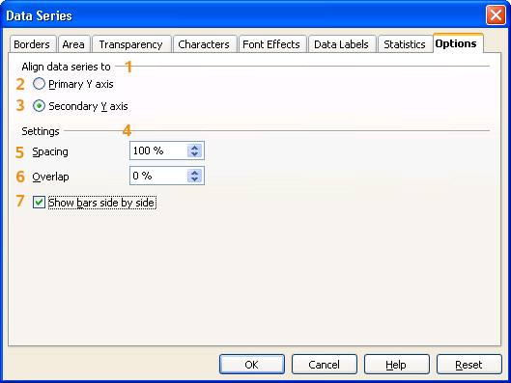Figure 1: Options Tab Page for Data Series of type Bar or Column
The controls #1 to #3 are available also for other chart types and apply to the currently selected data series. The controls #4 to #7 are only available for bar charts and describe a relation between all data series of the same chart type, thus the dialog shows the same values for all these data series.

#0 “Options” - Tab Page Properties |  | Comment
Titel: | Options |  | EN-US
Titel: | Optionen |  | DE
#1 “Align data series to” - Label Properties |  | Comment
Label: | Align data series to |  | EN-US
Label: | Datenreihe ausrichten an |  | DE
#2 “Primary Y axis” - RadioButton Properties |  | Comment
Enabled: | Always
Selected: | When the selected data series is attached to the primary y axis
RadioButton Label: | ~Primary Y axis |  | EN-US
RadioButton Label: | ~Primärer Y-Achse |  | DE
#3 “2nd Y axis” - RadioButton Properties |  | Comment
Enabled: | Always
Selected: | When the selected data series is attached to the second y axis
RadioButton Label: | ~Secondary Y axis |  | EN-US
RadioButton Label: | ~Sekundärer Y-Achse |  | DE
#4 “Settings” - Label Properties |  | Comment
Label: | Settings |  | EN-US
Label: | Einstellungen |  | DE
#5 “Spacing” - SpinField Properties |  | Comment
Enabled: | Always
Min. Value: | 0
Max. Value: | 600
Start Value: | Default is 100
Steps: | 1
Measurement Unit: | %
SpinField Label: | ~Spacing |  | EN-US
SpinField Label: | ~Abstand |  | DE
#6 “Overlap” - SpinField Properties |  | Comment
Enabled: | Always
Min. Value: | -100
Max. Value: | 100
Start Value: | Default is 0
Steps: | 1
Measurement Unit: | %
SpinField Label: | ~Overlap |  | EN-US
SpinField Label: | ~Überlappung |  | DE (changed)
#7 “Show Bars side by side” - CheckBox Properties |  | Comment
Enabled: | If there is at least one attached series on each of both y-axes
Tri-State: | No
Checked: | When there are separate groups of bars for the primary and secondary axes. | If all bars are shown side-by-side, this box is unchecked.
CheckBox Label: | Show ~bars side by side |  | EN-US
CheckBox Label: | ~Balken nebeneinander darstellen |  | DE

Spacing (Gap Width)
The spacing s can be a value between 0% and 600%. Let w be the available space for a category, and n be the number of bars in one group consisting of all bars of one category. Such a group has an additional space on its left and right side of d each, where with(where b is the width of one bar), so there is half the spacing on either side. So, the distance of the rightmost bar of one group to the leftmost bar of the next group is equal to the total spacing .
Figure 2: The effect of different settings for "Spacing"
Proof: assuming that n+s is not 0.

Overlap
The overlap o is a value between -100% and 100%. It denotes the amount of space that two neighboring bars of the same category group overlap each other. Values less than 0% lead to a distance between the bars. Taking also the spacing s from the previous section into account, we get a refinement for b.
Figure 3: The effect of different settings for "Overlap"

Show Bars Attached to Different Axes Side by Side
If two axes are shown in a bar chart, and some data series are attached to the first one, while some other data series are attached to the second one, both sets of data series are shown independently , one box overlapping the other. For an illustration see Figure 4.
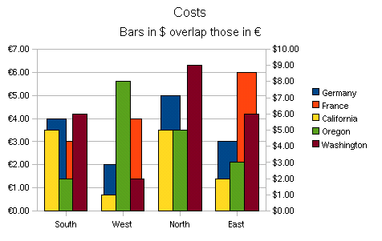Figure 4: Two bars are attached to the left y axis and three to the second one. The bars are grouped by this means.
As a result, bars attached to the first y-axis are partly or completely hidden by bars attached to the second y-axis. To avoid this, there is an option to display bars side by side, as if they were attached only to one axis.
To enable this setting the option “Show Bars side by side” must be checked in the dialog. Figure 5 illustrates the effect.
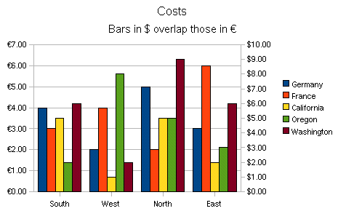Figure 5: Although the bars are attached to different y axes they are shown side-by-side.

Migration
This specification describes existing functionality and one additional feature, the un-grouping of bars (see 1.3). No migration is necessary for the new feature.

Configuration
Nothing needed here.

File Format
For the new feature described in 1.3 an XML attribute is needed to store the grouping. This is the extract of the XML proposal that is integrated in the upcoming OpenDocument 1.2 standard. (see http://lists.oasis-open.org/archives/office/200702/msg00079.html).
Chart: show bars attached to different y axes side by side

The section 15.30.5 about Bar Chart Properties needs to be expanded:

group-bars-per-axis

With bar charts, the property chart:group-bars-per-axis can be used to
display bars side by side even if they are attached to different y axes.
The property can be used within the style at the plot-area element. If
false, all bars on the same x axis are handled as one group and are
displayed side by side. If true, only bars attached to the same x and y
axis are handled as one group.
This is the RNG particle for the new feature:
<define name="style-chart-properties-attlist" combine="interleave">
<optional>
<attribute name="chart:group-bars-per-axis">
<ref name="boolean"/>
</attribute>
</optional>
</define>

The XML property "chart:group-bars-per-axis" corresponds to control #7 in figure with reverse semantics. When #7 is checked, the property is "false" and when #7 is unchecked, the property is "true".

Open Issues
Issue | Initials | Date
<State Issue here, State “None”, if all issues are solved> |  | <Format: Dec 31, 2000>
<...>

Document Change History
Rev. | Change | Initials | Date
1 | Added explanations for Spacing and Overlap | BM | Aug 16, 2007
2 | Spec review with TrackChanges switched on | MMP | Aug 17, 2007
3 | Reworked version approved by BM and MMP, existing changed strings are marked with yellow cell background. | BM | Sep 27, 2007
4 | Lost control numbering replaced by manual numbers, ed. note removed, comment about XML property added | BM | Sep 27, 2007
5 | Check box name was incorrectly cited in section 1.3. Now it is a field that refers to the name in the table. | BM | Sep 28, 2007
6 | Added link to test case specification and set to standard | IHA | Oct 18, 2007
7 | Updated screen shot to new text | BM | Oct 25, 2007

