Software Specification Document

OpenOffice.org
Asian Typography tab page for Chart

Specification Status
Last Change | May 25, 2009
Status
Abstract
A new tab page “Asian Typography” is now available for Title, Legend, Axes and Data Series. It contains an option to enable or disable the spacing between the different types of text.

i-Team Members
Role | First Name, Last Name, Initials | E-Mail Address
I-Team Lead | Ingrid Halama (IHA) | iha@openoffice.org
Specification Author | Wei Zhao | weiz@openoffice.org
User Experience | Frank Loehmann (FL) | fl@openoffice.org
Development | Wei Zhao | weiz@openoffice.org
Quality Assurance | Thomas Klarhöfer (TK) | kla@openoffice.org
Documentation | Uwe Fischer (UFI) | ufi@openoffice.org
Test Automation | Helge Delfs (HDE) | hde@openoffice.org

Contents
Abstract 1
i-Team Members 1
References and Reference Documents 2
Acronyms and Abbreviations 2
1 Detailed Specification 3
2 Migration 5
3 Configuration 5
4 File Format 5
5 Open Issues 5
Document Change History 5

References and Reference Documents
Reference Document | Check | Location (URL)
Specification Process Entry Check |  | N/A
Product Requirement, RFE, issue [Required] |  | 92128
Product Concept Document |  | <Please enter location here>
Competitive Analysis |  | <Please enter location here>
IDL Specification |  | <Please enter location here>
Test Case Specification [Required] |  | http://www.openoffice.org/nonav/issues/showattachment.cgi/62511/Asian_Typo_for_Chart.htm
Software Specification Rules | N/A | N/A
Acronyms and Abbreviations
Acronym / Abbreviation | Definition

Detailed Specification
This tab page “Asian Typography” is used for Title, Legend, Axes and Data Series, as these chart elements may contain the different types of text. The tab page is shown, when the enhanced language support for Asian languages is enabled under Tools->Options->Language Settings->Languages. There are three options on the tab page “Asian Typography”, but the first two options are disabled, only the last one is enabled within Chart.
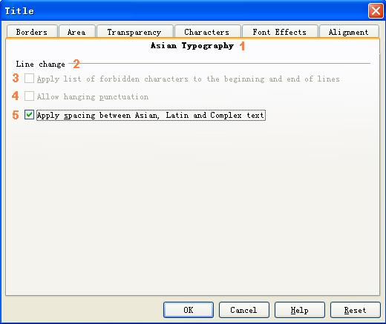
Figure 1: Asian Typography Tab Page for Title

- “Asian Typography” - Tab Page Properties |  | Comment
Titel: | Asian Typography |  | EN-US
Titel: |  |  | DE

#2 “Line change” - Fixed Line Properties |  | Comment
Label: | Line change |  | EN-US
Label: |  |  | DE

#3 “Apply list of forbidden characters to the beginning and end of lines” - CheckBox Properties |  | Comment
Enabled: | Always disabled
Tri-State: | No
Checked:
CheckBox Label: | ~Apply list of forbidden characters to the beginning and end of lines |  | EN-US
CheckBox Label: |  |  | DE

#4 “Allow hanging punctuation” - CheckBox Properties |  | Comment
Enabled: | Always disabled
Tri-State: | No
Checked:
CheckBox Label: | Allow hanging ~punctuation |  | EN-US
CheckBox Label: |  |  | DE

#5 “Apply spacing between Asian, Latin and Complex text” - CheckBox Properties |  | Comment
Enabled: | Always
Tri-State: | No
Checked: | When the spacing between Asian, Latin and Complex text exists.
CheckBox Label: | Apply ~spacing between Asian, Latin and Complex text |  | EN-US
CheckBox Label: |  |  | DE

The spacing between Asian, Latin and Complex text is on by default. If user set underline to these texts, the line will discontinuous(see figure 2).
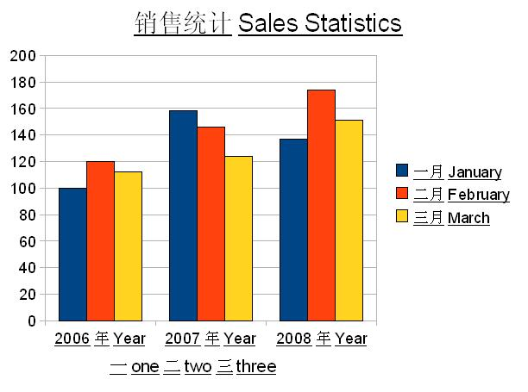
Figure 2: spacing between text

If user enter into the object properties dialog of Title, Legend, Axes or Data Series, and then switch to the tab page “Asian Typography”, click the check box “Apply spacing between Asian, Latin and Complex text” to uncheck it, exit the dialog with OK. The spacing between text will disappear, and the underlining now is continuous(see figure 3).
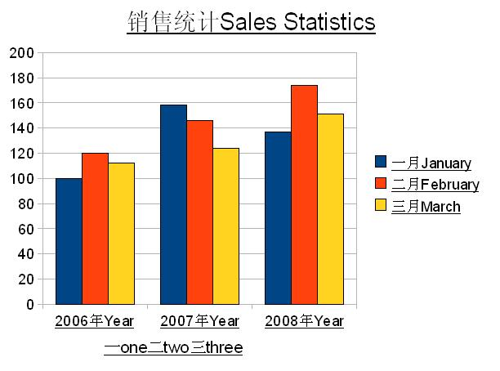
Figure 3: non-spacing between text

Migration
No migration is necessary.

Configuration
There is no information stored into the configuration for this feature.

File Format
When control #5 is not checked the information is stored with the attribute 'style:text-autospace=”none”' at the auto style of the regarding element. When control #5 is checked no additional information is written to the file as this is the default. ODF also allows files to contain 'style:text-autospace=”ideograph-alpha”'. This means the same as the absence of the attribute.

Open Issues
Issue | Initials | Date
None |  | Sep 23, 2008
Document Change History
Rev. | Change | Initials | Date
1 | Created this document and added contents | weiz | Sep 23, 2008
2 | Added further i-team member, added Data Series, added content for chapters Migration, Configuration and FileFormat. | iha | Sep 23, 2008
3 | Changed test automation member | iha | Feb 17, 2009
4 | Added link to test case specification + set to standard | iha | May 25, 2009

