Software Specification Document

OpenOffice.org
Axis Positioning

Specification Status
Last Change | Nov 24, 2008
Status
Abstract
This specification describes the positioning of axes including the positioning of axes labels and interval marks inside the chart.
i-Team Members
Role | First Name, Last Name, Initials | E-Mail Address
I-Team Lead | Ingrid Halama (IHA) | iha@openoffice.org
Specification Author | Ingrid Halama (IHA) | iha@openoffice.org
User Experience | Frank Loehmann (FL) | fl@openoffice.org
Development | Ingrid Halama (IHA) | iha@openoffice.org
Quality Assurance | Thomas Klarhöfer (TK) | kla@openoffice.org
Documentation | Uwe Fischer (UFI) | ufi@openoffice.org
Test Automation | Joerg Sievers (JSI) | jsi@openoffice.org

Contents
Abstract 1
i-Team Members 1
References and Reference Documents 2
Acronyms and Abbreviations 2
1 Detailed Specification 3
2 Migration 9
3 Configuration 9
4 File Format 10
5 Open Issues 10
Document Change History 10

References and Reference Documents
Reference Document | Check | Location (URL)
Specification Process Entry Check |  | N/A
Product Requirement, RFE, issue [Required] |  | 85625 ,
Product Concept Document
Competitive Analysis
IDL Specification
Test Case Specification [Required] |  | automatic tests
Software Specification Rules | N/A | N/A
Axis Scale |  | http://specs.openoffice.org/chart/ChartAxisScale.odt
Acronyms and Abbreviations
Acronym / Abbreviation | Definition
Crossing axis | The crossing axis for all x axes is the primary y axis.  The crossing axis for all y axis is the primary x axis.  (For z axis this feature is not defined.)
Value axis | An axis where values are displayed. These are the y axes of all chart types and the x axis in an xy- chart.
Category axis | An axis where categories are displayed. These are the x axes of all chart types except the xy-chart.
Default file format | Setting in Tools->Options->Load/Save->General->ODF format version

Detailed Specification
The positioning of an axis can be changed on a new tab page 'Positioning' in the axis properties dialog.
The new positioning tab page is available for all axes except the z axis.
1
2
3
4
6
7
8
9
10
11
12
13
14
15
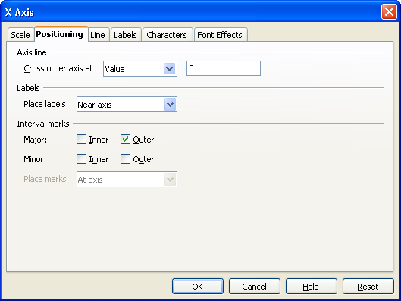Illustration 1: The 'Positioning' tab page of the '*-Axis' dialog when crossing axis is a value axis
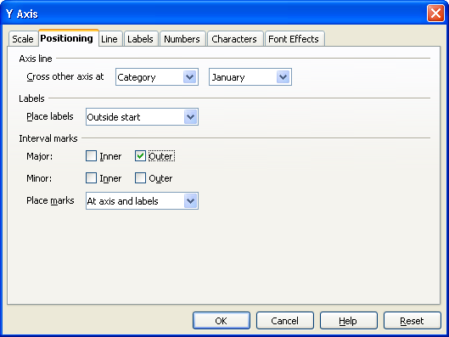Illustration 2: The 'Positioning' tab page of the '*-Axis' dialog when crossing axis is a category axis
5

- “Positioning” - Label Properties |  | Comment
Title: | Positioning |  | EN-US

- “Axis line” - Label Properties |  | Comment
Label: | Axis line |  | EN-US
Disabled | Disabled when the default file format is less than ODF 1.2.

- “Cross other axis at” - ListBox Properties |  | Comment
Enabled: | Disabled when the default file format is less than ODF 1.2.
Max. Row Count: | 3
Rows Visible: | 1
Items: | - Start ;  - End ;  - Value ;  - Category ; | EN-US
Item Selected: | 3
Sorting by Drag & Drop: | disabled
Other: | When the crossing axis is a value axis then item number 4 is removed from the list.  When the crossing axis is a category axis the the item number 3 is removed from the list.
ListBox Label: | ~Cross other axis at |  | EN-US
- Value - TextField Properties |  | Comment
Enabled: | Shown and enabled when the crossing axis is a value axis and in #3 item 3 is selected.  Disabled when the default file format is less than ODF 1.2.
Read Only: | No
Initial String: | 0
String Preselected: | No
Caret Position: | 0
Characters Not Allowed:
Echo characters (Password Field)
Other: | This is a FormattedField. The numberformat is taken from the crossing axis.
TextField Label:

- Category - ComboBox Properties |  | Comment
Enabled: | Shown and enabled when the crossing axis is a category axis and in #3 item 3 is selected.  Disabled when the default file format is less than ODF 1.2.
Max. Row Count: | 65535. If a chart does contain more than 65535 categories only the first 65535 are listed and can be selected.
Rows Visible: | 1
Items: | The content is dynamic. The categories from the crossing axis are contained.
Item Selected: | 1
Sorting by Drag & Drop: | Disabled
Other:
ListBox Label:

- “Labels” - Label Properties |  | Comment
Label: | Labels |  | EN-US
 | Disabled when the default file format is less than ODF 1.2.

- “Place labels” - ListBox Properties |  | Comment
Enabled: | Disabled when the default file format is less than ODF 1.2.
Max. Row Count: | 4
Rows Visible: | 1
Items: | - Near axis ;  - Near axis (other side) ;  - Outside start ;  - Outside end ; | EN-US
Item Selected: | 1
Sorting by Drag & Drop: | Disabled
Other:
ListBox Label: | ~Place labels |  | EN-US

- “Interval marks” - Label Properties |  | Comment
Label: | Interval marks |  | EN-US

- “Major” - Label Properties |  | Comment
Label: | Major: |  | EN-US

- “Major Inner” - CheckBox Properties |  | Comment
Enabled: | Always
Tri-State: | Never
Checked: | Not checked per default
Other:
CheckBox Label: | ~Inner |  | EN-US

- “Major Outer” - CheckBox Properties |  | Comment
Enabled: | Always
Tri-State: | Never
Checked: | Checked per default
Other:
CheckBox Label: | ~Outer |  | EN-US

- “Minor” - Label Properties |  | Comment
Label: | Minor: |  | EN-US

- “Minor Inner” - CheckBox Properties |  | Comment
Enabled: | Always
Tri-State: | Never
Checked: | Not checked per default
Other:
CheckBox Label: | I~nner |  | EN-US

- “Minor Outer” - CheckBox Properties |  | Comment
Enabled: | Always
Tri-State: | Never
Checked: | Not checked per default
Other:
CheckBox Label: | O~uter |  | EN-US

- “Place marks” - ListBox Properties |  | Comment
Enabled: | When the selected entry in #7 is item 3 or item 4 and -  when #7 item 3 is selected, in #3 not item 1 is selected -  when #7 item 4 is selected, in #3 not item 2 is selected.  Disabled when the default file format is less than ODF 1.2.
Max. Row Count: | 3
Rows Visible: | 1
Items: | - At labels ;  - At axis ;  - At axis and labels ; | EN-US
Item Selected: | 3
Sorting by Drag & Drop: | Disabled
Other:
ListBox Label: | Place ~marks |  | EN-US

Axis line positioning
The user can now choose where the axis line should be painted:
Illustration 5: x axis crosses other axis at start
Illustration 6: x axis crosses other axis at end
Illustration 4: x axis crosses other axis at value 0
Illustration 3: y axis is crossing other axis at Category 2
Axis label placement
The user now can choose where the axis labels should be painted:
Illustration 7: Place labels "Near axis"
Illustration 8: Place labels "Near axis (other side)"
Illustration 9: Place labels "Outside start"
Illustration 10: Place labels "Outside end"
“Near axis” is the default setting. When the axis line is positioned at the start or at the end of the crossing axis then the labels are placed outside (Illustration 11 and 12). Otherwise the labels are placed on that side with lower values (Illustration 7).
Illustration 11: Place labels "Near axis" while y axis crosses other axis at start
Illustration 12: Place labels "Near axis" while y axis crosses other axis at end

Interval marks
Interval marks are always painted in front of grid lines.
If major interval marks are shown, the minor interval marks are not painted on the major interval positions. If the major interval marks are not shown, the minor interval marks are painted also on the major interval positions.
Iinterval marks are painted with the same color and line style as the axis line.
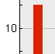Inner marks
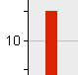Outer marks
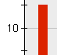Inner and outer marks
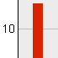No marks

Interval mark placement
When the axis line and the axis label are placed on different positions the user can choose where the interval marks are placed:
Illustration 13: Place marks "At axis and labels"
Illustration 14: Place marks "At labels"
Illustration 15: Place marks "At axis"

Migration
Files that do not include an attribute chart:axis-position or files with an ODF version less than ODF 1.2 need to be migrated to the new feature during import. The file is migrated in such a way that the visible placement of the axis labels and the interval marks is the same in the new display as in the old display. Bars and areas also start at the same reference value. When in older versions there might have been two lines for the axis (one at the edge of the diagram and one at the reference value), there is now only one line at the reference value.

Configuration
There is no information stored into the configuration for this feature.

File Format
- The value from control #3 is stored in an attribute “chart:axis-position” at the auto style at an chart:axis element. Possible values are:
start <-> when item 1 is selected
end <-> when item 2 is selected
when item 3 is selected see next section
- The value from control #4 respective #5 is stored in the attribute “chart:axis-position” at the auto style at an chart:axis element. When control #4 is shown the according double value is stored. When control #5 is shown the position of the selected entry is stored.
- The value from control #7 is stored in an attribute “chart:axis-label-position” at the auto style at an chart:axis element. Possible values are:
near-axis <-> when item 1 is selected (this is the default thus it is not exported to the file)
near-axis-other-side <-> when item 2 is selected
outside-start <-> when item 3 is selected
outside-end <-> when item 4 is selected
- The value from control #15 is stored in an attribute “chart:tick-mark-position” at the auto style at an chart:axis element. Possible values are:
at-labels <-> when item 1 is selected
at-axis <-> when item 2 is selected
at-labels-and-axis <-> when item 3 is selected (this is the default thus it is not exported to the file)

Open Issues
Issue | Initials | Date

Document Change History
Rev. | Change | Initials | Date
1 | Initial revision | IHA | Sep 16, 2008
2 | Corrected numbering problem | IHA | Sep 25, 2008
3 | Small correction in section File Format | IHA | Sep 26, 2008
4 | OASIS TC has approved the file format changes today for ODF 1.2 → I adapted the version info accordingly. | IHA | Nov 17, 2008
5 | Corrected numbering | IHA | Nov 19, 2008
6 | Changed description for 'Max. Row Count' for control 5 | IHA | Nov 19, 2008
7 | Added link to test scripts → set to standard | IHA | Nov 24, 2008

