Software Specification Document

OpenOffice.org
Axis Scale

Specification Status
Last Change | Nov 29, 2010
Status
Abstract
This specification describes the scaling of axes inside the chart.

i-Team Members
Role | First Name, Last Name, Initials | E-Mail Address
I-Team Lead | Ingrid Halama (IHA) | iha@openoffice.org
Specification Author | Ingrid Halama (IHA) | iha@openoffice.org
User Experience | Frank Loehmann (FL) | fl@openoffice.org
Development | Ingrid Halama (IHA) | iha@openoffice.org
Quality Assurance | Thomas Klarhöfer (TK) | kla@openoffice.org
Documentation | Uwe Fischer (UFI) | ufi@openoffice.org
Test Automation | Oliver Craemer (OC) | oc@openoffice.org

Contents
Abstract 1
i-Team Members 1
References and Reference Documents 2
Acronyms and Abbreviations 2
1 Detailed Specification 3
1.1 Value Axis 3
1.2 Category and Date Axis 9
2 Migration 14
3 Configuration 14
4 File Format 14
5 Open Issues 14
Document Change History 15

References and Reference Documents
Reference Document | Check | Location (URL)
Specification Process Entry Check |  | N/A
Product Requirement, RFE, issue [Required] |  | 85625 , i25706
Product Concept Document |  | <Please enter location here>
Competitive Analysis |  | <Please enter location here>
IDL Specification |  | <Please enter location here>
Test Case Specification [Required] |  | automatic tests
Software Specification Rules | N/A | N/A
Axis Positioning |  | http://specs.openoffice.org/chart/ChartAxisPositioning.odt
Acronyms and Abbreviations
Acronym / Abbreviation | Definition
Value axis | An axis where values are displayed. These are the y axes of all chart types and the x axis in an xy- chart.
Category axis | An axis where categories are displayed as text. These could be the x axes of all chart types except the xy-chart.
Date axis | An axis where categories are displayed as dates. These could be the x axes of all chart types except the xy-chart and net chart.
Default file format | Setting in Tools->Options->Load/Save->General->ODF format version

Detailed Specification
The scaling of an axis can be changed on the tab page 'Scale' in the axis properties dialog.
The scale tab page is available for all axes except the z axis.
Different controls are available dependent on whether the axis is a value axis, a category axis or a date axis.

Value Axis
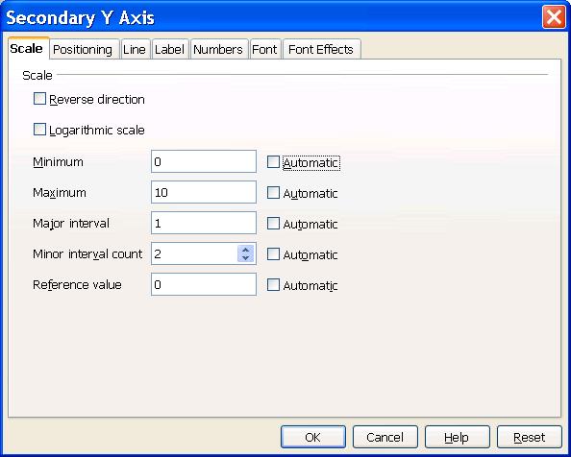
2
3
4
5
6
7
8
9
10
11
12
13
14
15
16
17
18
1

- “Scale” - Label Properties |  | Comment
Title: | Scale |  | EN-US

- Reverse” - CheckBox Properties |  | Comment
Enabled: | Always
Tri-State: | Never
Checked: | Not checked per default
Other:
CheckBox Label: | ~Reverse direction |  | EN-US

- “Minimum” - Label Properties |  | Comment
  - Logarithmic” - CheckBox Properties |  | Comment
  Enabled: | Enabled for value axes
  Tri-State: | Never
  Checked: | Not checked per default
  Other:
  CheckBox Label: | ~Logarithmic scale |  | EN-US
Label: | ~Minimum |  | EN-US
Enabled: | Enabled for value axes

- Minimum value - TextField Properties |  | Comment
Enabled: | When #6 is not checked and the axis is a value axis
Read Only: | No
Initial String: | Depends on the data contained in the chart
String Preselected: | No
Caret Position: | End of string
Characters Not Allowed: | Depends on the number format set at this axis
Echo characters (Password Field)
Other: | This is a FormattedField. The numberformat is taken from this axis.
TextField Label:

- Automtic Minimum - CheckBox Properties |  | Comment
Enabled: | Enabled for value axes
Tri-State: | Never
Checked: | Per default
Other:
CheckBox Label: | ~Automatic |  | EN-US

- “Maximum” - Label Properties |  | Comment
Label: | Ma~ximum |  | EN-US
Enabled: | Enabled for value axes

- Maximum value - TextField Properties |  | Comment
Enabled: | When #9 is not checked and the axis is a value axis
Read Only: | No
Initial String: | Depends on the data contained in the chart
String Preselected: | No
Caret Position: | End of string
Characters Not Allowed: | Depends on the number format set at this axis
Echo characters (Password Field)
Other: | This is a FormattedField. The numberformat is taken from this axis.
TextField Label:

- Automatic Maximum - CheckBox Properties |  | Comment
Enabled: | Enabled for value axes
Tri-State: | Never
Checked: | Per default
Other:
CheckBox Label: | A~utomatic |  | EN-US

- “Major interval” - Label Properties |  | Comment
Label: | Ma~jor interval |  | EN-US
Enabled: | Enabled for value axes

- “Major interval value” - TextField Properties |  | Comment
Enabled: | When #12 is not checked and the axis is a value axis
Read Only: | No
Initial String: | Depends on the data contained in the chart
String Preselected: | No
Caret Position: | End of string
Characters Not Allowed: | Depends on the number format set at this axis
Echo characters (Password Field)
Other: | This is a FormattedField. The numberformat is that from the axis, except when the number format at the axis is data-time then the interval can be entered in time format and when the axis has a date format then the interval can be entered with standard format.
TextField Label:

- Automatic Major Interval - CheckBox Properties |  | Comment
Enabled: | Enabled for value axes
Tri-State: | Never
Checked: | Per default
Other:
CheckBox Label: | Au~tomatic |  | EN-US

- “Minor interval count” - Label Properties |  | Comment
Label: | Minor interval ~count |  | EN-US
Enabled: | Enabled for value axes

- “Minor interval count” - SpinField Properties |  | Comment
Enabled: | When #15 is not checked and the axis is a value axis
Min. Value: | 1
Max. Value: | 100
Start Value: | 1
Steps: | 1
Measurement Unit:
Other:
SpinField Label:

- Minor interval count” - CheckBox Properties |  | Comment
Enabled: | Enabled for value axes
Tri-State: | Never
Checked: | Per default
Other:
CheckBox Label: | Aut~omatic |  | EN-US

- “Reference value” - Label Properties |  | Comment
Label: | Reference ~value |  | EN-US
Enabled: | Enabled and shown  a) when the default file format is less than ODF1.2 and the axis is a value axis  or b) when the default file format is greater than ODF1.1 and this is a secondary y axis where a series is attached of type bar, column or area.

- “Reference value” - TextField Properties |  | Comment
Enabled: | Like #16 but in addition disabled when #18 is checked.
Read Only: | No
Initial String: | Depends on the data contained in the chart
String Preselected: | No
Caret Position: | End of string
Characters Not Allowed: | Depends on the number format set at this axis
Echo characters (Password Field)
Other:
TextField Label:
TextField Label: | <Label in your native language> |  | e.g. DE

- Automatic reference value” - CheckBox Properties |  | Comment
Enabled: | Like #16
Tri-State: | Never
Checked: | Per default
Other:
CheckBox Label: | Automat~ic |  | EN-US

Category and Date Axis

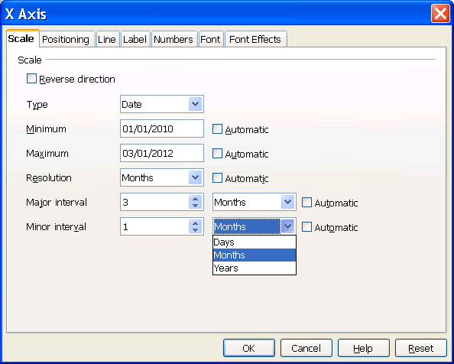
19
20
21
22
23
24
25
26
27
28

- “Type” - Label Properties |  | Comment
Label: | T~ype |  | EN-US

- “Type Listbox” - DropDown ListBox Properties |  | Comment
Enabled: | always
Max. Row Count: | 3
Rows Visible: | 3
Items: | - Automatic  - Text  - Date | EN-US, DE
Item Selected: | 1
Sorting by Drag & Drop: | disabled

- “Resolution” - Label Properties |  | Comment
Label: | R~esolution |  | EN-US
Visible: | Visible in case 'Date' is selected in Listbox #20

- “Resolution Listbox” - DropDown Listbox Properties |  | Comment
Enabled: | Enabled if #23 is visible and not checked
Max. Row Count: | 3
Rows Visible: | 3
Items: | - Days  - Months  - Years
Item Selected: | 1, depends on the underlying data
Sorting by  Drag & Drop: | disabled
Other: | Visible in case 'Date' is selected in Listbox #20

- “Resolution Checkbox” - CheckBox Properties |  | Comment
Enabled: | Visible and enabled for date axis (3 is selected for #20)
Tri-State: | Never
Checked: | Per default
Other:
CheckBox Label: | Automat~ic |  | EN-US

- “Major Interval” - Label Properties |  | Comment
Label: | Ma~jor interval |  | EN-US
Visible: | Visible in case 'Date' is selected in Listbox #20

- “Major Interval” - SpinField Properties |  | Comment
Enabled: | Enabled if #27 is visible and not checked
Min. Value: | 1
Max. Value: | 100
Start Value: | 1
Steps: | 1
Measurement Unit:
Visible: | Visible in case 'Date' is selected in Listbox #20

- “Major Interval Listbox” - DropDown Listbox Properties |  | Comment
Enabled: | Enabled if #27 is visible and not checked
Max. Row Count: | 3
Rows Visible: | 3
Items: | - Days  - Months  - Years
Item Selected: | 1, depends on the underlying data
Sorting by  Drag & Drop: | disabled
Other: | Visible in case 'Date' is selected in Listbox #20

- “Major Interval Checkbox” - CheckBox Properties |  | Comment
Enabled: | Visible and enabled for date axis (3 is selected for #20)
Tri-State: | Never
Checked: | Per default
Other:
CheckBox Label: | Au~tomatic |  | EN-US

- “Minor Interval” - Label Properties |  | Comment
Label: | Minor inter~val |  | EN-US
Visible: | Visible in case 'Date' is selected in Listbox #20

- “Minor Interval” - SpinField Properties |  | Comment
Enabled: | Enabled if #31 is visible and not checked
Min. Value: | 1
Max. Value: | 100
Start Value: | 1
Steps: | 1
Measurement Unit:
Visible: | Visible in case 'Date' is selected in Listbox #20

- “Minor Interval Listbox” - DropDown Listbox Properties |  | Comment
Enabled: | Enabled if #31 is visible and not checked
Max. Row Count: | 3
Rows Visible: | 3
Items: | - Days  - Months  - Years
Item Selected: | 1, depends on the underlying data
Sorting by  Drag & Drop: | disabled
Other: | Visible in case 'Date' is selected in Listbox #20

- “Minor Interval Checkbox” - CheckBox Properties |  | Comment
Enabled: | Visible and enabled for date axis (3 is selected for #20)
Tri-State: | Never
Checked: | Per default
Other:
CheckBox Label: | Aut~omatic |  | EN-US

Error messages

If you try to close the dialog or switch to another tab page in the following cases a warning is displayed to the user:

Error Condition | English message text | German message text
If the minimum value is greater or equal to the maximum value | The minimum must be lower than the maximum. Check your input. | Das Minimum muss kleiner als das Maximum sein. Bitte überprüfen Sie die Eingabe.
If one number entry field is empty | Numbers are required. Check your input. | Es werden Zahlenwerte benötigt. Bitte überprüfen Sie die Eingabe.
In case of logarithmic scaling you get a warning if minimum or maximum value is not positive | The logarithmic scale requires positive numbers. Check your input. | Für die logarithmische Darstellung werden positive Zahlenwerte benötigt. Bitte überprüfen Sie die Eingabe.
If the value in the major interval field is not a positive number | The major interval requires a positive number. Check your input. | Das Hauptintervall benötigt einen positiven Zahlenwert. Bitte überprüfen Sie die Eingabe.
For date axis if the minor interval is greater than the major interval | The major interval needs to be greater than the minor interval. Check your input.
For date axis if the time unit of the minor or major interval is greater than the time resolution | The major and minor interval need to be greater or equal to the resolution. Check your input.

In all other cases values are corrected automatically if necessary.
Functionality of 'Minimum' and 'Maximum'
Defines the start value and the end value of the axis.
Functionality of “Major interval”
The major interval for a linear scaled axis is simply the distance between two major interval marks.
The major interval for logarithmic scales behaves like this: 1 is a distance of one order of magnitude. 2 is a distance of 2 orders of magnitude etc. That means log(x2) - log (x1) = major interval, where x1 is one major tick and x2 is the next one.
For example typically you want to have major tickmarks at 1, 10 ,100, 1000 and so on. You have to set it to 1, because of: log(100) - log (10) = 1.
Functionality of “Minor interval count”
The number of minor intervals per major interval is selected by a spin button.
Functionality of 'Reference value'
The reference value defines the origin of the graphical representation of a data point (e.g. the beginning of all bars in a bar chart). If this origin is higher than the value of the data point, the graphical representation of the data point is painted in negative direction (e.g. the bar of a bar chart is painted from top to bottom).
When the default file format is greater than ODF1.1 then the origin of the graphical representation of a data point is given by the position of the x axis when the series is attached to the primary y axis.
Illustration 1: Reference = 0
Illustration 2: Reference = 3
Illustration 3: Reference = 9 (Minimum=0, Maximum=7)
Illustration 4:
x-axis crossing other axis at 4

Functionality of 'Logarithmic scale'
The checkbox 'Logarithmic scale' defines if the scaling of an axis is linear or logarithmic. The default (unchecked) is linear scaling. When switching 'Logarithmic scale' on or off the values in the other fields are not changed.

Functionality of 'Reverse direction'
The check box 'Reverse direction' defines where the lower and where the higher values are displayed at the axis. The unchecked state is the mathematical direction. That means for cartesian coordinate systems that the x-axis shows the lower values on the left and the y-axis shows the lower values at the bottom. For polar coordinate systems the mathematical angle axis direction is counterclockwise and the radial axis is from inner to outer.

Migration
See migration chapter in the Axis Positioning specification.

Configuration
There is no information stored into the configuration for this feature.

File Format
No fileformat changes for this feature.

Open Issues
Issue | Initials | Date

Document Change History
Rev. | Change | Initials | Date
1 | Initial revision | IHA | Sep 17, 2008
2 | OASIS TC has approved the file format changes today for ODF 1.2 → I adapted the version info accordingly. | IHA | Nov 17, 2008
3 | Added link to test scripts → set to standard | IHA | Nov 24, 2008
4 | Add scaling for date axis issue 25706 | IHA | Nov 23, 2010
 | Changed some texts and check box positions according to Franks feedback | IHA | Nov 29, 2010

