Individual configurable font size for default fonts
OpenOffice.org 2.0 and 2.0.2 and 2.0.3

Document - ID | Specification Owner | Last Change | Status
 | Falko Tesch | March 31, 2006 | Final
Conforms to | SIPA
Applies to | All modules
Task ID(s) | OOo 2.0.0  i42725, i55300, i55301  OOo 2.0.2  i59408, i59410  OOo 2.0.3  i59426
Category | Feature

Abstract
OOo hard-codes a default font size of 10 points or 12 points in a number of places (see the attached patch). For most Thai fonts, 10 points or 12 points is unreadable small. Thai characters have four vertical levels (base, one diacritic below and two diacritics above). When Thai characters are mixed with Latin characters, the relative sizes of Thai and Latin characters are usually chosen so that the bottom of below diacritics is lower than the bottom of Latin descenders, and the top of the second level Thai diacritics is higher than the top of Latin ascenders.
The (not unreasonable) normal convention for Thai fonts is that in an N point font the distance from the bottom of the below-diacritic to the top of the second above-diacritic is N points. Thai typesetting would typically use a 16 point default font size. Thai fonts typically contain Latin characters as well:
The Latin characters in a 16 point Thai font would be about the same size as the characters in a normal 12-point Western font.

i-Team Members (The specification owner is part of the i-Team)
 | Name | E-mail Address
User Experience | Falko Tesch | falko@sun.com
Development | Oliver Specht | oliver.specht@sun.com
Quality Assurance | Hasan Ilter | Hasan.ilter@sun.com
Documentation | Uwe Fischer | uwe.fischer@sun.com
Customer | James Clark (SIPA) | jjc@sipa.or.th

Approved for Implementation
 | Approved by | Date
User Experience | Falko Tesch  Matthias Müller-Prove | 10/14/05  01/18/06
Development | Oliver Specht  Niklas Nebel | 10/14/2005  01/18/06
Quality Assurance | Hasan Ilter | 10/14/2005
Documentation | Uwe Fischer | 10/14/2005
Customer | James Clark (SIPA) | 10/14/2005
 |  | 10/14/2005
String Review | Falko Tesch | 10/14/2005

Document Change History
Rev. Level | Change | Initials | Date
1.0 | First draft | FT | 27.09.05
1.1 | Feedback added | FT | 30.09.05
1.2 | Added additional text for Calc section | FT | 11.10.05
1.3 | Final status | FT | 14.10.05
1.4 | Corrected Task Ids  Corrected the QA and Documentation responsible | SBA | 08.11.05
1.5 | Update spec. an set new default font size according to issue i59410 | FL | 27.12.05
1.6 | Calc font size is 10 point again for OOo 2.0.2 (section 3.3, row 68); Niklas Nebel | NN | 17.01.06
 | added approval dates according to version 1.3 to 10/14/2005  review and approved of Niklas changes by Matthias Müller-Prove | MMP | 01/18/06
1.7 | Add changes for OOo 2.0.3 Impress | FL | March 31, 2006

Contents
Glossary 1
1 Motivation/User Scenario 1
2 Requirements and Dependencies 1
2.1 Requirements 1
3 Detailed Specification 1
3.1 General Changes 1
3.2 Relative Font Size Changes 1
3.3 Calc specific issues 2
3.4 Draw and Impress specific issues (issue 59426) 2
3.5 UI change in Writer 3
4 Future Tasks 4
5 Notes 4
6 References 4

Glossary
Term | Description
<Term 1>

Motivation/User Scenario
OOo hard-codes a default font size of 10 points or 12 points in a number of places . For most Thai fonts, 10 points or 12 points is unreadable small. Thai characters have four vertical levels (base, one diacritic below and two diacritics above). When Thai characters are mixed with Latin characters, the relative sizes of Thai and Latin characters are usually chosen so that the bottom of below diacritics is lower than the bottom of Latin descenders, and the top of the second level Thai diacritics is higher than the top of Latin ascenders.
The (not unreasonable) normal convention for Thai fonts (Angsana New) is that in an N point font the distance from the bottom of the below-diacritic to the top of the second above-diacritic is N points. Thai typesetting would typically use a 16 point default font size. Thai fonts typically contain Latin characters as well: the Latin characters in a 16 point Thai font would be about the same size as the characters in a normal 12-point Western font.

Requirements and Dependencies

Requirements
The font Angsana New must be provided within the Thai language pack or at least must be available on the chosen system per default. For cases where it is not, the font fallback mechanism must cover this.
Note: The above will not cover the font-size but only the font type.

Detailed Specification

General Changes
Define a special setting in all applications that will choose Angsana New in 16 point as the default font and font-size for Thai language.
Create a reasonable fallback font and size in case Angsana New is not installed on the system. Special care must be taken on the substitutional fonts size to avoid too big replacement fonts.

Relative Font Size Changes
Currently the following happens if the user changes the font-size through the (Text) Formatting Toolbar in Writer:
It changes the font-size of all scripts. So a change from 12 to 16 points will change the default font-size for the Western, the CJK and the CTL fonts.
This behavior is good and should be kept in principle.
Though it does not cover the current idea of being able to have different font-sizes for different scripts as defaults.
The default behavior described above must take this in account by not simply changing all fonts to the chosen font-size but to keep the relations in between them.
In case multiple font-scripts are selected and font size is changed than this will override any possible relative font-sizes.
Example: If CTL (Thai) font has the default size of 16 points while the default Western font-size is 12 points changing the Western font to 16 point (+50%) must result in changing the CTL font to 27 points (+50%). If the ratio would create a non-integer font-size for some fonts OO.org will choose the next full integer to display the font (we should use the same algorithm we already use for using percentage values for font-sizes in styles).
Most important, OO.org must internally keep the original relative value from all fonts to be able to go back to the original sizes.

Calc specific issues
Since Calc uses 10 pt. as the default font size, the Thai font “Angsana New” will be set to 15 pt. (= 50% bigger). This affects text in cells only!
To determine the correct settings Calc will look after the current set locale for CTL language in OpenOffice.org.
To allow the user to edit this setting these changes will also be available from the document template of the spreadsheet.
Update for 2.0.2: As the 15 point size causes problems with row heights (i59408), this change is cancelled: The default font size will be 10 point for all languages again.

Draw and Impress specific issues (issue 59426)
The default font sizes for Thai are too small in OOo 2.0.2. To get an equivalent sized Thai font, all default CTL font sizes, for Thai only, are corrected using the factor 1.33 (i.e. a 44pt header in a western font becomes 58 (exact value is 58,67). Those are defined in the Graphical styles and the Auto Layouts (Impress only) shown below. This change will only affect all newly created documents.
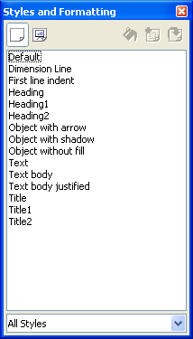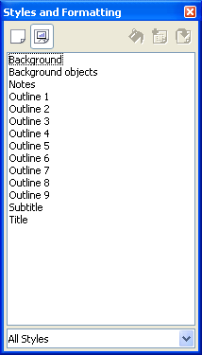

UI change in Writer
To allow the user to overcome the set defaults at least in Writer the current UI of defining a default font ("Tools – Options – OpenOffice.org Writer – Basic Fonts (...)") must be enhanced by adding the font size to it. (see Figure 1 for a mock-up).
Functionality: A change in sizes within this dialog will behave and affect exactly the same areas as it already does when the user changes the font type itself. Only this time the size of the according font will be changed.

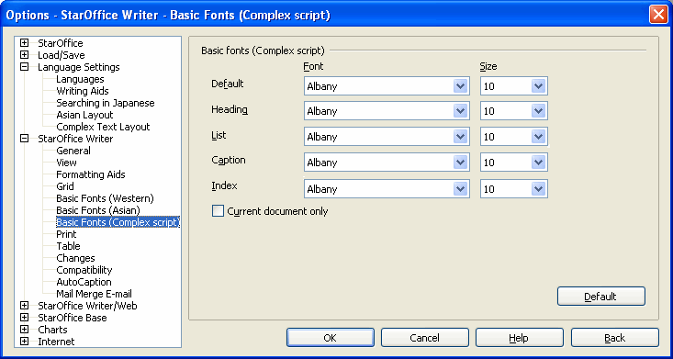Figure 1: New font size setting for default fonts in Writer

String list
Item | English | German | Comments
Description | Font | Schriftart | Please take string from "Format – Character" dialog
Description | Size | Schriftgrad | Please take string from "Format – Character" dialog

Tab Order
Keep from existing dialog.
Key Board Shortcuts
No new ones.

Future Tasks
For the moment only Writer has a UI for manually set/override the font size. This should also be implemented in Impress and Calc in future releases.

Notes
none

References
<Give references to related documentation, such as engineering designs, technical specs, and other sources for related units. Also include links to documents that other sections in this spec need to refer to, such as user opinions usability test reports.>

Default has been changed from 18 to 16 base on customer feedback according to issue i59410
Default has been changed from 18 to 16 base on customer feedback according to issue i59410

