Thai sequence input checking default setting
OpenOffice.org 2.0

Document - ID | Specification Owner | Last Change | Status
 | Falko Tesch | 08.11.05 | Final
Conforms to | SIPA
Applies to | All modules
Task ID(s) | i48117
Category | Feature

Abstract
Thai sequence input checking works great, but at the moment users have to go into Language Settings|Complex Text Layout and turn on both "Sequence checking" and "Restricted" to make it active. Most Thai users won't realize they need to do this. Sequence checking is an absolutely basic feature that Thai users expect normally to be active. Word enables it by default. Nokia phones have it always turned on (for writing SMSs), and don't even allow you to turn it off.

i-Team Members (The specification owner is part of the i-Team)
 | Name | E-mail Address
User Experience | Falko Tesch | falko@sun.com
Development | Oliver Specht | Olover.specht@sun.com
Quality Assurance | Helge Delfs | Helge.Delfs@sun.com
Documentation | Uwe Fischer | uwe.fischer@sun.com
Customer | James Clark (SIPA) | jjc@sipa.or.th

Approved for Implementation
 | Approved by | Date
User Experience | Falko Tesch | falko@sun.com
Development | Oliver Specht | Oliver.specht@sun.com
Quality Assurance | Helge Delfs | Helge.Delfs@sun.com
Documentation | Uwe Fischer | Uwe.Fischer@sun.com
Customer | James Clark (SIPA) | jjc@sipa.or.th
String Review | Falko Tesch | falko@sun.com

Document Change History
Rev. Level | Change | Initials | Date
1.0 | First draft | FT | 21.09.05
1.1 | Final status | FT | 14.10.05
1.2 | Corrected the QA and Documentation responsible | SBA | 08.11.05

Contents
Glossary 1
1 Motivation/User Scenario 1
2 Requirements and Dependencies 1
2.1 Requirements 1
3 Detailed Specification 1
3.1 Functionality of "Type and replace": 1
4 Future Tasks 2
5 Notes 2
6 References 2

Glossary
Term | Description
<Term 1>

Motivation/User Scenario
Thai people are used to have the program aid them in detected illegal input sequences. They also are used in having another aid that automatically correct mistakes they make in input, but want to have this tool to be turned off in some cases.

Requirements and Dependencies

Requirements
For adding "Type and Replace" functionality code from SIPA is needed. This feature also is needed by 42661

Detailed Specification
When the default language for CTL script is Thai, Laotian, Khmer or Vietnamese then "Tools – Options – Language Settings – Complex Scripts – Sequence checking" must be turned on by default.
It must be turned of for all other CTL languages.
The default setting for "Strict" as an option of "Sequence checking" is must be always turned on together with activating "Sequence checking". If the user turns it off it must stay of until a) the user turns it on again or b) "Sequence checking" was turned off and on in the meantime than it need to be turned back on.
A new entry "Type and replace" will be added as another option to "Sequence checking". Its default settings are the same as with "Strict", being on per default and always being turned on together with turning on "Sequence checking".

Special Case
In case the user sets a language at “Tools - Options - Language settings - Languages” to one of the CTL that require sequence checking (see above) and than changing to the “Tools - Options - Language settings - Complex Text Layout” tab page she will see sequence checking not checked!
In this case sequence checking will be still turned on when the user does not alter setting on this tab page and closes/saves the dialog afterwards. Only in case of any change on this tab page the represented status of the UI will concur with the saved one.
This issue has to stay this way for technical reasons and is subject to change in later versions of OpenOffice.org.

Functionality of "Type and replace":
"Type and replace" will enhance automatic sequence checking the way that it not only will withdraw the user from inputting illegal characters but also will make sensible replacements in case there are any indicated by the users input.
A mock-up of this new feature is documented in Figure 1.
Example:
The user input the following (illegal) sequence: [kor kai][mai ek][mai to]
If sequence checking is turned off, the output cannot be displayed properly on some (all?) platforms.
If only sequence checking is turned on, the output is: [kor kai][mai ek] (the [mai to] is rejected)
If "Type and replace" is additionally enabled than the output is: [kor kai][mai to] (the [mai to] replaces the [mai ek]).
So the program tries to find a reasonable output to what the user just typed in. While a [mai ek] cannot go along with a [mai to] sharing a single consonant, it's most likely that the user wanted to override the initial input [mai ek] with a [mai to].

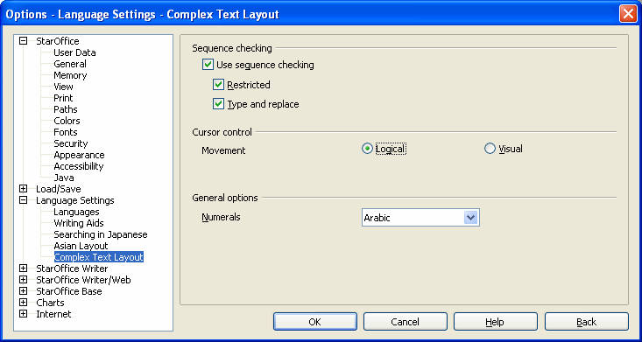Figure 1: Type and replace added to options dialogue
String list
Item | English | German | Comments
Check box | ~Type and replace | Automatisches Ersetzen

Future Tasks

Notes
<Questions will arise during the writing of the specification. State these in here.>

References
<Give references to related documentation, such as engineering designs, technical specs, and other sources for related units. Also include links to documents that other sections in this spec need to refer to, such as user opinions usability test reports.>

