Improve Double Click Behavior
of Slide Preview in Impress / Draw
OOo Later

Document - ID | Specification Owner | Last Change | Status
 | Frank Loehmann | 27. July 05 | Draft
Conforms to
Applies to | OO Later
Task ID(s) | i52599
Category | Feature

Abstract
The slide preview, visible on the left side of the new three pain view of Impress 2.0, does not support double clicking. This spec. redefines the double click behavior.

i-Team Members (The specification owner is part of the i-Team)
 | Name | E-mail Address
User Experience | Frank Loehmann | frank.loehmann@sun.com
Development
Quality Assurance
Documentation

Approved for Implementation
 | Approved by | Date
User Experience | Frank Loehmann | 26. July 05
Development
Quality Assurance
Documentation
String Review | not nessesary | -

Document Change History
Rev. Level | Change | Initials | Date
1.0 | Final draft | FL | 27.07.05

Contents
1 Motivation 1
2 User Scenarios 1
3 Requirements 1
4 Detailed Specification 1

Motivation
Improve the usability of slide preview in new multi pane view of Impress.

User Scenarios
Scenario 1: User A works on a long presentation. She uses the outline view of the document frequently. She is looking for a chart, she had previously imported, to add some explaining text. While working in the outline view, she sees the chart right in the slide preview on the left side of the application. Intuitive she tries to double click this slide to get to chart she is looking for, but nothing happens. Instead of what she expected, the heading of that slide is selected in the outliner. She would expect to switch the Outline view to the normal Drawing view instead, to add free form text right below the chart.

Requirements
Changed GUI behavior.

Detailed Specification
The following behavior changes:

Impress
A double click on a slide preview icon
    - in the Normal view
      - sets the focus into the Normal document view
    - in the Outline view
      - switches the document view to the Normal view and sets the focus into the document view
A single click on a slide preview icon
    - in the Outline view
      - still selects the text of the slide's main heading in the Outline view
The blue focus rectangle in the slide preview pane
  - always corresponds to the current cursor selection in the Outline view. Thus the slide preview icon is selected, were the cursor is currently placed in the outline view.
  - The black dotted focus rectangle is only shown, if the focus is on the slide preview pane. Then this dotted rectangular could be used for traveling via keyboard from slide to slide.
Accessibility:
    - Travelling via F6 key sets the focus to the preview pane and not to the closer of the pane

Draw
A double click on a slide preview icon
    - in the Normal view sets the focus into the Normal document view
Accessibility:
    - Travelling via F6 key sets the focus to the preview pane and not to the closer of the pane
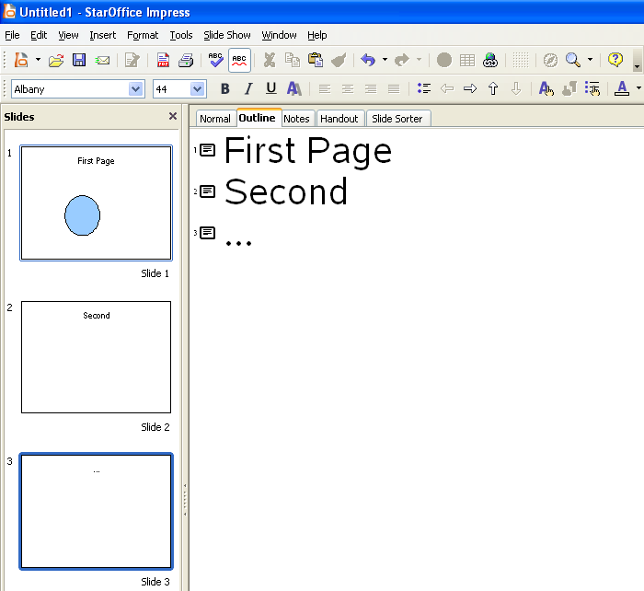Illustration 1: Slide preview (marked red) docked on the left side (default position)

