Software Specification Document

OpenOffice.org Impress
Custom Animation User Interface

Specification Status
Last Change | Feb 25, 2008
Status
Abstract
The user interface for custom animation now also supports adding user drawn motion path effects and the feature to edit the path of existing motion path effects.

i-Team Members
Role | First Name, Last Name, Initials | E-Mail Address
I-Team Lead | Christian Lippka | Christian.Lippka@sun.com
Specification Author | Christian Lippka | Christian.Lippka@sun.com
User Experience | Christian Jansen | Christian.Jansen@sun.com
Development | Christian Lippka | Christian.Lippka@sun.com
Quality Assurance | Christian Günther | Christian.Guehnter@sun.com
Documentation | Uwe Fischer | Uwe.Fischer@sun.com

Contents
Abstract 1
i-Team Members 1
References and Reference Documents 3
Acronyms and Abbreviations 3
1 Detailed Specification 4
1.1 Time line 4
1.2 Behavior based effects 4
1.3 Full compatibility with PowerPoint 4
1.4 Smoother and modern rendering 4
1.5 Effects 4
1.5.1 Effect categories 4
1.5.2 Basic 4
1.5.3 Subtle 4
1.5.4 Moderate 4
1.5.5 Exciting 5
1.6 Effect Types 5
1.6.1 Entrance effects 5
1.6.1.1 Emphasis effects 5
1.6.2 Exit effects 5
1.6.3 Motion Paths effects 5
1.7 Menu Entries 5
1.8 Toolbars 6
1.9 User Interface of the Custom Animation Pane 6
1.9.1 Effect context menu 10
1.9.2 Animation Effect dialog 12
1.10 Effect Properties dialog 15
1.10.1 Effect Page Content 15
1.11 Timing Properties Page 23
1.11.1.1 Text Animation page 25
1.12 Slide Transition Pane 27
1.13 Motion path 28
1.13.1 Creation 28
1.13.2 Editing 29
2 Migration 29
3 Configuration 29
4 File Format 29
5 Open Issues 29
Document Change History 29

References and Reference Documents
Reference Document | Check | Location (URL)
Specification Process Entry Check |  | N/A
Product Requirement, RFE, issue [Required] |  | Issue 41800
Product Concept Document |  | <Please enter location here>
Competitive Analysis |  | <Please enter location here>
IDL Specification |  | <Please enter location here>
Test Case Specification [Required] |  | <Please enter location here>
Software Specification Rules | N/A | N/A
<Other, e.g. references to related specs>
Acronyms and Abbreviations
Acronym / Abbreviation | Definition
Synchronized Multimedia Integration Language (SMIL, pronounced "smile") | SMIL is an XML-based language that allows authors to write interactive multimedia presentations. Its a W3C recommended standard  http://www.w3.org/TR/smil20/cover.html

Detailed Specification

Time line
The prior presentation engine stored the effects at each shape. This introduced the limitation that there can be only one effect per shape. The time line is a sequence of effects that is stored at each slide. The time line gives the user a choice to add more than one effect per shape. Also the prior presentation engine only allowed the user to chose for the whole slide if the effects are started automatically or after a user input. This is now selectable for each effect in the time line. Also subsequent effects can be started at the same time, allowing to have more than one effect running at the same time. Effects can also start a selectable time after a previous effect had started.

Behavior based effects
The behavior based effects allow the core to create complex effects by combining a set of basic behaviors. This gives us the ability to have far more and exciting effects as in the previous presentation engine.

Full compatibility with PowerPoint
The new presentation engine supports all features from PowerPoint, up to PowerPoint 2003. Due to system constrains, not all features will be visually compatible. But there will be no information loss on round trip from PowerPoint to OpenOffice.org format and back.

Smoother and modern rendering
By using the new canvas we will introduce features like double buffering, hardware accelerated rendering, alpha blending and anti aliased geometry rendering.

Effects
An effect describes a predefined behavior of a shape during an animation.

Effect categories
Each effect is in one of the following categories depending on its visual appearance.

Basic
This category contains the most common effects used during a presentation.

Subtle
This category contains more unusual effects that give a subtle expression to the audience.

Moderate
This category contains more unusual effects that give a moderate expression to the audience.

Exciting
This category contains more unusual effects that give a exciting expression to the audience.

Effect Types
Effects are grouped into four types.

Entrance effects
Entrance effects transform a shape from an invisible state to a visible state. Shapes that have an entrance effect as their first associated effect in the time line are hidden when the page becomes visible during a presentation. Shapes that are visible because of an effect prior to the current entrance effect are made invisible right before the entrance effect is executed. After the entrance effect is executed, the shape stays visible until its visible state is altered by another effect.

Emphasis effects
Emphasis effects perform an animation that highlights a shape for a specific period of time. If a shape is invisible prior to effect execution, it becomes visible right before the emphasis effect is executed. The shape stays visible after the emphasis effect until its visible state is altered by another effect.

Exit effects
Exit effects transform a shape from a visible state to an invisible state. If a shapes is invisible prior to effect execution, it becomes visible right before the exit effect is executed. After the exit effect is executed, the shape stays invisible until its visible state is altered by another effect.

Motion Paths effects
Motion path effects move a shape along a predefined path during effect execution. If a shape is invisible prior to effect execution, it becomes visible right before the motion path effect is executed. After the motion path effect is executed, the shape stays visible until its visible state is altered by another effect.

Menu Entries
The slide show menu will contain the menu items “Custom Animation...” and “Slide Transition...” to activate the corresponding pane.
Slide Show
Slide Show
Slide Show Settings...
Rehearse Timings
---------------------------------
Interaction
Custom Animation...
Slide Transition...
---------------------------------
Show/Hide Slide
Custom Slide Show...

The menu entry “Animation” is confusing in this context, it will be renamed to “Animated Image” and be placed inside the “Insert” menu
Insert
...
Special Character...
Hyperlink
Animated Image
---------------------------------
...

The shape context menu entry “Effects” will be renamed to “Custom Animation...”
The toolbar entry for “Animation Effects” will be renamed to “Custom Animation...”
The slide context menu entry “Slide Transition” will be renamed to “Slide Transition...”
String List
Item | English | German | Comments
Menu | Animation Schemes... | Animationsschemas...
Menu | Custom Animation... | Benutzerdefinierte Animation...
Menu | Slide Transition... | Folienübergang...
Menu | Animated Image... | Animiertes Bild...

Toolbars
The following items shall be removed form the Slide View toolbar:
- “Slide Effects”,
- “Transition Speed”,
- “Auto Transition” and
- “Time”
The functionality will be replaced by the Slide Transition Pane.

User Interface of the Custom Animation Pane
The Custom Animation Pane (Figures 1 & 2) will be accessible from the menu “Custom Animation...” inside the “Slide Show” Menu. By default this pane appears empty & deactivated with a short description explaining how to apply an effect.
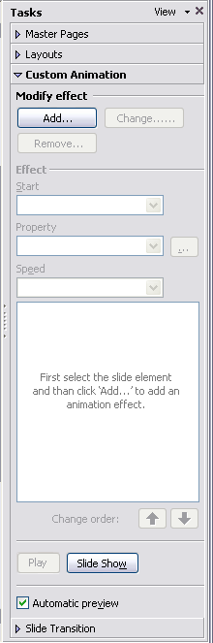Figure 1 Default appearance of the Custom Animation pane
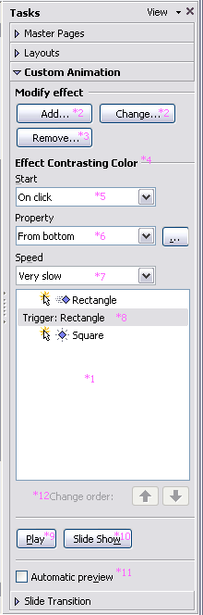Figure 2 Custom Animation pane with some effects applied

The Custom Animation Pane contains the following elements:
Animation List (*1)
The animation list control contains the animation sequences for a slide. Each slide has one main animation sequence which is executed after the slide is made visible during a slide show. There may be other animation sequences that have a shape as a trigger. These animation sequences are visually separated by a tab rider (*8) with the name of the shape that triggers this animation sequence. An animation sequence is build upon effects. The effects are listed in the order they are added, and include icons that indicate timing in relation to other effects. The effects are noted on the slide by a non-printing numbered tag that correlates to the effect in the list. This tag does not show up in the slide show view. Each entry in the list has four columns (Figure 3).
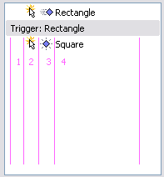Figure 3 Columns showing animation states
Column 1
If the current effect also animates its text paragraphs, there is a '+' sign shown. If the user clicks on that sign, separate effects for the shape and each paragraphs are shown and can be edited. In that case, the first entry of these effects show a '-' sign. If this is pressed, the effects collapse to one again and a '+' is shown instead.
Column 2
This column shows an icon with a mouse pointer if the effect is started after mouse click and a clock if the effect is started after the previous effect.
Column 3
This column shows an icon for the effect.
Column 4
This column shows the name of the shape for this effect and optionally the first characters of the shapes text. If the effect is performed on a special paragraph, only the first characters of this paragraph is shown.
Adding or Changing an Animation Effect (*2)
These buttons are active or inactive depending on the the selected element in the slide or the panel. The table below lists the states of what is active
 | Add... | Change... | Remove
Element selected in slide window | X
Element selected in pane | X | X | X
Nothing select in slide window
X = Active
If the selected shape has the focus, the name of the button is “Add Effect”, if the Animation List control has the focus, the name of the button is “Change Effect”. If the button is pressed, the animation effect dialog is executed.
After the user selected an effect, a new effect is added for the selected shape or an already existing and selected effect is changed. If more than one shape get a new effect, the first new created effect will start after mouse click and all other effects start at the same time with the previous. If the Auto Preview (*11) box is checked, the added or changed effect is animated as a preview.
Remove (*3)
This button is only active when there is at least one effect selected in the Animation List control. If the button is pressed, the selected effects are removed from the animation sequence.
Start (*5)
This control displays the start property of the selected effect. If no effect is selected, this control is disabled. If more than one effect is selected with ambiguous start properties, no value is selected. The user can select one of the following values
- On Click
If this value is selected, the animation sequence stops at the end of the effect. Clicking next calls the next effect.
- With previous
If this value is selected, the second animation effect starts and ends at the same time as the previous
- After previous
If this value is selected, the second animation will be triggert automatically (time shift is possible), if the first animation sequence finished.
Property (*6)
Some effects have additional settings, e.g. Direction or Color. If the current selected effect has such additional settings, the most common can be changed from here. Clicking the '...' Button opens the Effect Options dialog.
Speed (*7)
This control lets the user change the duration of the selected effect. The following values can be chosen
- Very Slow
- Slow
- Medium
- Fast
- Very Fast
Play (*9)
This button is enabled if an effect is selected inside the animation list. On click, the effect will be animated as a preview in the current view.
Slide Show (*10)
This button is a shortcut to start the slide show from the current slide.
Auto Preview (*11)
If this box is checked, added or changed effects are animated as a preview in the current view.

String List of the Custom Animation pane
Item | English | German | Comments
Title | Custom Animation | Benutzerdefinierte Animation
Sub-Title | Effect | Effekt
Button | Add... | Hinzufügen...
Button | Change... | Ändern...
Button | Remove | Entfernen
Label | Start | Starten
combo box Value | On click | Beim Klicken
combo box Value | With previous | Mit Vorheriger
combo box Value | After previous | Nach Vorheriger
Label | Property | Eigenschaft
Button | ... | ... | Tool Tip Label: Effect Options; Effektoptionen
Label | Speed | Geschwindigkeit
combo box Value | Very slow | Sehr langsam
combo box Value | Slow | Langsam
combo box Value | Medium | Mittel
combo box Value | Fast | Schnell
combo box Value | Very fast | Sehr schnell
Sub-Title | Modify effect | Effekt ändern
Label | Trigger | Auslöser
Button | Play | Wiedergabe | CJ: We shall have icon and text
Button | Slide Show | Bildschirmpräsentation | CJ: We shall have icon and text
Check box | Automatic preview | Automatische Vorschau
Label | Change order: | Reihenfolge ändern:
Label | First select the slide element and then click 'Add...' to add an animation effect. | Erst ein Element auf dieser Folie auswählen und dann auf 'Hinzufügen...' klicken, um die Animation hinzuzufügen.

Effect context menu
Upon right click on an effect inside the animation list, the following context menu is opened. The table below shows the content:

√ Start On Click
√ Start With Previous
√ Start After Previous
--------------------------
Effect Options...
Timing...
Remove

- The options Start On Click, Start With Previous and Start After Previous gives the user quick access to the Start property of the selected effect.
- Effect Options opens the Effect Properties dialog for the selected effect and initially shows the Effect page.
- Timing opens the Effect Properties dialog for the selected effect and initially shows the Timing page.
Remove deletes the selected effect from the time line.

String List of the “Effect” context menu
Item | English | German | Comments
Menu | Start On Click | Beim Klicken
Menu | Start With Previous | Mit Vorheriger
Menu | Start After Previous | Nach Vorheriger
Menu | Effect Options... | Effektoptionen...
Menu | Timing... | Anzeigedauer...
Menu | Remove | Entfernen

Animation Effect dialog
The Animation Effect (Figure 4) dialog lets the user select an animation effect. All available effects are presets that are stored in the xml configuration of the OpenOffice.org installation. Only the Motion Path tab features three entries that let the user create his own motion trails.
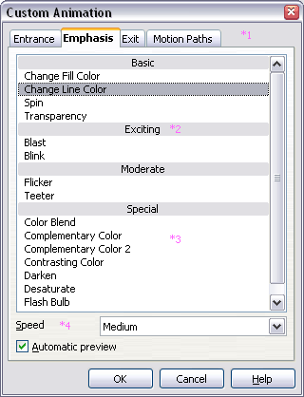Figure 4 Animation Effect Dialog

Effect Type (*1)
This rider lets the user select the type of effects to show inside this dialog. The following pages can be selected
- Entrance
- Emphasis
- Exit
- Motion Paths
Effect Categories (*2)
This control lets the user select the category of effects to show inside this dialog. For the effect types Entrance, Emphasis and Exit, the following categories can be selected
- Basic
- Exciting
- Moderate
- Special
For the effect type Motion Paths, the following categories can be selected
- Basic
- Lines & Curves
- Special
Effect List (*3)
This control lists the effect with the type selected with (*1) and the category selected with (*2). The effects have an icon representing the type of effect and a name. The effects list shall be sorted alphabetically.
Speed (*4)
This control lets the user select a duration for the effect. The following selections are possible
- Very Slow
- Slow
- Medium
- Fast
- Very Fast
Auto Preview (*5)
If this box is checked, a selected effect is animated as a preview in the current view.
Item | English | German | Comments
Window | Custom Animation | Benutzerdefinierte Animation
Tab control | Entrance | Eingang
Title | Basic | Einfach
Title | Subtle | Subtil
Title | Moderate | Angemessen
Title | Exciting | Aufregend
Tab control | Emphasis | Hervorgehoben
Tab control | Exit | Beenden
Tab control | Motion Paths | Animationspfade
Label | Speed | Geschwindigkeit
Checkbox | Automatic preview | Automatische Vorschau
List Entry | Curve | Kurvenobjekt
List Entry | Polygon | Polygon
List Entry | Freeform Line | Freihandlinie

Effect Properties dialog
The Effect Properties (Figure ) dialog consist of three pages, the Effect page, the Timing page and the Text Animation page. The Text Animation page is not visible for effects on shape that do not have a text. The title of the Effect Properties dialog is the name of the effect which properties are shown. The effects properties dialog can be reached from “...” at the Properties drop down, by context menu on an applied effect located in the Custom Animation pane.
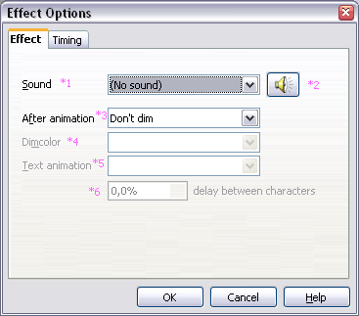Figure 5 Effect page

Effect Page Content
Sound (*1)
This control lets the user select a sound from the Gallery and the following entries:
- <No Sound>
If this entry is selected, no sound is played during animation of the effect.
- <Stop Previous Sound>
If this entry is selected, the sound of the previous effect is stopped as soon as this effect is animated.
- Other Sound...
If this entry is selected, a file open dialog is shown and the user can select a sound file that will be played during animation of the effect.
Sound Button (*2)
If a sound is selected, this button is enabled and plays the selected sound on click. If no sound is selected, this button is disabled.
After animation (*3)
This control lets the user select an after effect that is executed directly after the animation of the effect. The box contains a list of colors of the current color table for the document and the following entries:
- <Don't Dim>
If this entry is selected, no after effect is executed.
- <Hide After Animation>
If this entry is selected, the shape is hidden after the animation is executed.
- <Hide On Next Mouse Click>
If this entry is selected, the shape is hidden after the next mouse click.
- <Dim with colors>
If this entry is selected, the color dialog shows up and lets the user select a custom color for the dim after effect.
Animate text (*4)
This control is only enabled if the shape for the current effect contains text and includes the following entries:
- All at once
If this entry is selected, the text is animated all at once.
- Word by word
If this entry is selected, the text is animated word by word.
- Letter by letter
If this entry is selected, the text is animated letter by letter.
Delay (*5)
This control is only enabled if the Animate text (*4) has either 'Word by word' or 'Letter by letter' selected. Its percent value sets the delay between animation of the words or letters during animation. Depending on the selection in (*4), %s in (*6) is replaced by either 'words' or 'letters'.
Settings
If the current effect has some additional settings, Fe. direction, the Enhancements section is moved down and a new section Settings is created at the top of the page and lets the user change the special effect settings.
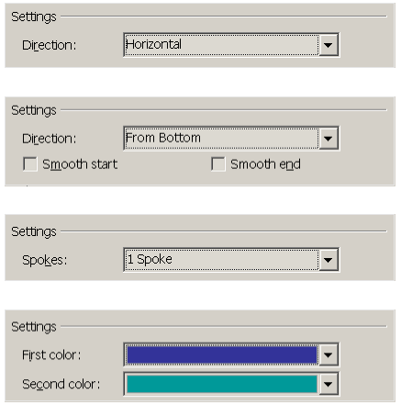

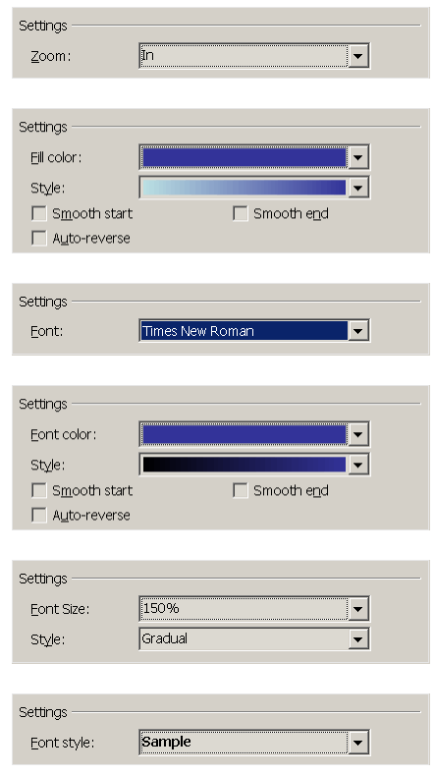

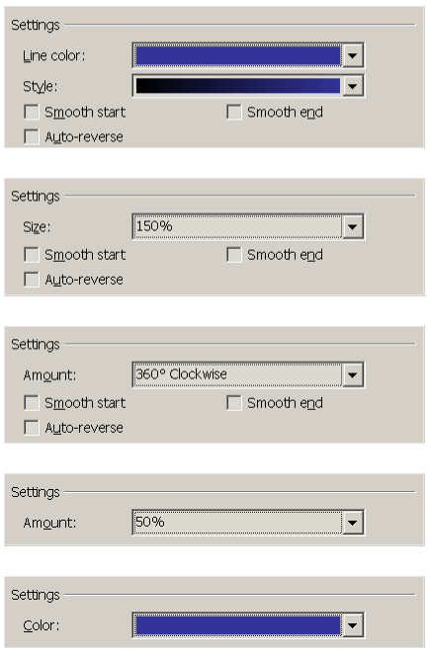
Item | English | German | Comments
Dialog | Effect Options | Effektoptionen
Tab control | Effect | Effekte
Fixedline | Settings | Einstellungen
Fixedline | Erweiterungen | Enhancements
Label | Sound | Klang
Combo box Value | (No sound) | (Ohne Klang)
Combo box Value | (Stop previous sound) | (Vorherigen Klang anhalten)
Combo box Value | Other sound... | Anderer Klang...
Label | After animation | Nach der Animation
Combo box Value | Do not dim | Nicht abblenden
Combo box Value | Dim with color | Mit Farbe abblenden
Combo box Value | Hide after animation | Nach Animation ausblenden
Combo box Value | Hide on next animation | Mit nächster Animation ausblenden
Label | Dim color | Abblendfarbe
Label | Text animation | Text animieren
Combo box Value | All at once | Alle gleichzeitig
Combo box Value | Word by word | Wortweise
Combo box Value | Letter by letter | Zeichenweise
Metricfield Unit | % | % | Unit percentage
Label | Delay between characters | Verzögerung zwischen Buchstaben
Label | Direction | Richtung
Combo box Value | Horizontal | Horizontal
Combo box Value | Vertical | Vertikal
Combo box Value | In | In
Combo box Value | In from screen center | Von Bildschirmmitte nach innen
Combo box Value | In slightly | Etwas nach innen
Combo box Value | Out | Aus
Combo box Value | Out from screen center | Von unteren Bildschirmbereich nach außen
Combo box Value | Out slightly | Etwas nach außen
Combo box Value | Across | Quer
Combo box Value | Down | Nach unten
Combo box Value | Up | Nach oben
Combo box Value | From bottom | Von unten
Combo box Value | From left | Von links
Combo box Value | From top | Von oben
Combo box Value | From right | Von rechts
Combo box Value | From bottom-left | Von unten links
Combo box Value | From bottom-right | Von unten rechts
Combo box Value | From top-left | Von oben links
Combo box Value | From top-right | Von oben rechts
Combo box Value | Horizontal in | Horizontal in
Combo box Value | Horizontal out | Horizontal aus
Combo box Value | Vertical in | Vertikal in
Combo box Value | Vertical out | Vertikal aus
Combo box Value | Left down | Links nach unten
Combo box Value | Left up | Links nach oben
Combo box Value | Right up | Rechts nach oben
Combo box Value | Right down | Rechts nach unten
Combo box Value | To bottom | Nach unten
Combo box Value | To left | Nach links
Combo box Value | To right | Nach rechts
Combo box Value | To top | Nach oben
Combo box Value | To bottom-left | Nach unten links
Combo box Value | To bottom-right | Nach unten rechts
Combo box Value | To top-left | Nach oben links
Combo box Value | To top-right | Nach oben rechts
Check box | Accelerated start | Beschleunigter Start
Check box | Decelerated end | Verlangsamtes Ende
Label | Spokes | Speichen
Combo box Value | 1 Spoke | 1 Speiche
Combo box Value | 2 Spokes | 2 Speichen
Combo box Value | 3 Spokes | 3 Speichen
Combo box Value | 4 Spokes | 4 Speichen
Combo box Value | 8 Spokes | 8 Speichen
Label | First color | Erste Farbe
Label | Second color | Zweite Farbe
Label | Zoom | Zoom
Label | Fill color | Füllfarb
Label | Style | Formatvorlage
Check box | Reverse automatically | Automatisch umkehren
Label | Font | Schriftart
Label | Font color | Schriftfarbe
Label | Font size | Schriftgrad
Label | Style | Art
Checkbox Value | Instant | Augenblicklich
Checkbox Value | Gradual | Schrittweise
Label | Typeface | Schriftschnitt
Label | Line color | Linienfarbe
Label | Size | Schriftgrad
Label | Amount | Betrag
Combo box Value | Quarter spin | Vierteldrehung
Combo box Value | Half spin | Halbe Drehung
Combo box Value | Full spin | Komplette Drehung
Combo box Value | Two spins | Zwei Drehungen
Combo box Value | Clockwise | Im Uhrzeigersinn
Combo box Value | Counter-clockwise | Gegen den Uhrzeigersinn
Label | Color | Farbe
Combo box Value | Sample | Beispiel
Combo box Value | Tiny | Winzig
Combo box Value | Smaller | Kleiner
Combo box Value | Larger | Größer
Combo box Value | Extra large | Riesengroß
Combo box Value | Both | Beide
Combo box Value | Bold | Fett
Combo box Value | Italic | Kursiv
Combo box Value | Underlined | Unterstrichen

Timing Properties Page
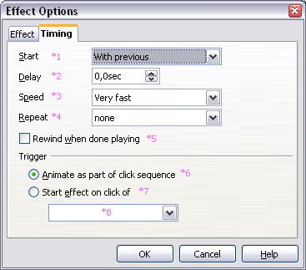Figure 6Timing page
Start (*1)
This control lets the user change the Start property with the following values
- On Click
The current effect is animated after a mouse click
- With Previous
The current effect is animated at the same time the previous animation starts.
- After Previous
The current effect is animated as soon as the previous effect finished its animation
Delay (*2)
This metric field with the unit 's' lets the user select a delay in seconds after that the effect is animated after it has been triggered.
Speed (*3)
This control lets the user select the duration of an effect by entering the duration in seconds or by choosing one of the following predefined entries
- 5 Seconds (Very Slow)
- 3 Seconds (Slow)
- 2 Seconds (Medium)
- 1 Second (Fast)
- 0,5 Seconds (Very Fast)
Repeat (*4)
This control lets the user select if and how often the effect is repeated. He can enter the amount of repeats or select from one of the following predefined entries
- (none)
Equals to 0, the effect is not repeated.
- Until Next Click
The animation of the effect is repeated until the next time the user clicks with the mouse.
- Until End Of Slide
The animation of the effect is repeated as long as the current slide is animated.
Rewind when done playing (*5)
If this check box is checked, the animated shape returns to its starting state after the animation is executed.
Trigger (*6,*7,*8)
These controls lets the user select whether this shape is part of the normal click sequence (*6) or is triggered when the user clicks on a shape (*7). If radio button (*7) is selected, the drop down list box (*8) is enabled and contains the names of all shapes from the current page.
Item | English | German | Comments
Tab control | Timing | Anzeigedauer
Label | Start | Starten
combo box Value | On click | Beim Klicken
combo box Value | With previous | Mit Vorheriger
combo box Value | After previous | Nach Vorheriger
Label | Delay | Verzögerung
Metricfield Unit | sec | Sek | Unit seconds
Label | Repeat | Wiederholen
combo box Value | none | Keine
combo box Value | Until next click | Bis zum nächsten Klick
combo box Value | Until end of slide | Bis zum Ende der Folie
Check box | Rewind when done playing | Nach der Wiedergabe zurückspulen
Fixedline | Trigger | Auslösen
Radiobutton | Animate as part of click sequence | Animation als Teil der Klickreihenfolge
Radiobutton | Start effect on click of | Effekt starten beim Klicken auf

Text Animation page

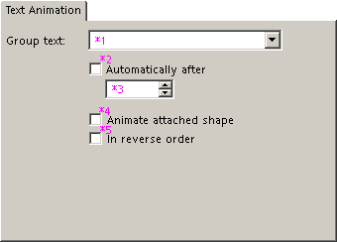Figure 7 Text Animation Page

Item | English | German | Comments
Tab control | Text Animation | Textanimation
Label | Group text | Texte gruppieren
combo box Value | As one object | Als einzelnes Objekt
combo box Value | All paragraphs at once | Alle Absätze auf einmal
combo box Value | By 1st level paragraphs | Nach 1. Abschnittsebene
combo box Value | By 2nd level paragraphs | Nach 2. Abschnittsebene
combo box Value | By 3rd level paragraphs | Nach 3. Abschnittsebene
combo box Value | By 4th level paragraphs | Nach 4. Abschnittsebene
combo box Value | By 5th level paragraphs | Nach 5. Abschnittsebene
Check box | Automatically after | Automatisch nach
Metricfield Unit | sec | Sek | Unit seconds
Check box | Animate attached shape | Angefügte Form animieren
Check box | In reverse order | In umgekehrter Reihenfolge

Group Text (*1)
This control lets the user choose the behavior about how multiple paragraphs are animated.
- As One Object
All paragraphs are animated as one object.
- All paragraphs at once
All paragraphs are animated at once, but can be animated with different effects.
- By 1st level paragraphs
The 1st level paragraphs including their sub levels are animated one after another.
Automatically after (*2)
This control is only enabled if “By 1st level paragraphs” is selected in (*1). If this box is checked, the paragraphs are automatically animated one after the other. If a value is entered in (*3), the animation of subsequent paragraphs are delayed by this value in seconds.
Animate attached shape (*4)
If this box is unchecked, the shape will not be animated by this effect, only the text is animated.
In reverse order (*5)
if this box is checked, the paragraphs are animated in reverse order. This control is disabled, if “As One Object” is selected in (*1)

Slide Transition Pane
The Slide Transition pane will be accessible from the menu “Slide Transition” inside the “Slide Show” Menu. The Slide Transition pane lets the user choose from one of the available slide transition effects.
Figure 8Slide Transition Pane
Transition list (*1)
This list contains all available transitions. When automatic preview is enabled (this shall be the default)selecting a transition effect shows its preview at the current slide The effects list shall be sorted alphabetically.
CJ: Animation Schemes do provide sections like a Recently used list, we shall have this in Slide Transitions, too.
Speed (*2)
This control lets the user select the duration of a transition by entering the duration in seconds or by choosing one of the following predefined entries
- 5 Seconds (Very Slow)
- 3 Seconds (Slow)
- 2 Seconds (Medium)
- 1 Second (Fast)
- 0,5 Seconds (Very Fast)
Sound (*3)
This control lets the user select a sound from the Gallery or one of the following entries:
- <No Sound>
If this entry is selected, no sound is played during the transition.
- <Stop Previous Sound>
If this entry is selected, a previously started sound is stopped as soon as the transition starts.
- Other Sound...
If this entry is selected, a file open dialog is shown and the user can select a sound file that will be played during animation of the effect.
Loop until next sound (*4)
If checked, the sound from the transition is looped as long as no other sound is played.
On mouse click (*5)
If checked, it is possible to advance to the next slide with a mouse click.
Automatically after (*6)
If checked, the slide is automatically advanced after a period of time in seconds defined by (*7)
Duration (*7)
This control is only enabled if (*6) is selected. If enabled it lets the user select the duration in seconds until the slide is automatically advanced.
Apply to All Slides (*8)
This button applies the selected transition to all slides in the current presentation document.
Play (*9)
This button animates the current slide transition as a preview in the current view.
Slide Show (*10)
This button is a shortcut to start the slide show from the current slide.
Auto Preview (*11)
If this box is checked, selected transitions are automatically previewed in the current view.

Motion path

Creation
From the Custom Animation Create dialog the user can add motion path effects to the time line of the current slide. Except for the first section with the title “User paths” and the entries “Curve”, “Polygon” and “Freeform Line”, predefined shapes from the xml configuration of the OpenOffice.org installation are set as a path for the created effect. If one of the first section is selected the dialog is closed and the user can draw the selected type of path. If the drawing is finished and not canceled, the created path is removed from the document and inserted as a motion path effect.

- “<Label>” - Create Motion Path ListBox Entries |  | Comment
ListBox Entry: | User paths | EN-US
ListBox Entry: | Curve | EN-US
ListBox Entry: | Polygon | EN-US
ListBox Entry: | Freeform Line | EN-US

Editing
If the Custom Animation Panel is visible, the motion path of all effects of the current slide are drawn as a transparent overlay on the slide. All paths are visible all the time so animations with consequent paths can be created easily. A motion path can be selected by clicking on the path inside the slide. A selected path will support handles, it can be moved and resized like a shape. A double click on a path starts the point edit modus. The point edit modus can also be started via its menu entry or its keyboard shortcut F8. In the point edit modus the points and control points of the path can be edited the same way a polygon shape can be edited in point edit mode.

Migration
<Start typing here ----- If this part is irrelevant state a reason for its absence!>

Configuration
<Start typing here ----- If this part is irrelevant state a reason for its absence!>

File Format
The format for storing custom animations and slide transitions is documented in the OASIS specification for Open Document Format for Office Applications (OpenDocument)

Open Issues
Issue | Initials | Date
<State Issue here, State “None”, if all issues are solved> |  | <Format: Dec 31, 2000>
<...>

Document Change History
Rev. | Change | Initials | Date
1 | Took internal specification of the Custom Animations and converted to new specification template and added Motion path | CL | July 5th, 2007
2
3
<...>

